Name | Class | Date
AP BIOLOGY · 3.1 to 3.3

Enzymes and cellular energy
Teacher’s copy: every blank filled in. Each numbered block matches a chapter of the guide, and of the lesson slides. Write in the gaps, answer the cues, annotate the figures, and sum up each section in your own words.
BY THE END YOU CAN
Explain how the shape and charge of an active site make an enzyme specific to its substrate 3.1.A
Explain how an enzyme speeds up a reaction by lowering its activation energy, and why it leaves ΔG unchanged 3.1.A
Explain how heat and extreme pH change an enzyme's structure, and when that change can be undone 3.2.A
Predict how temperature, pH, substrate and product concentrations and inhibitors change the rate of a reaction 3.2.B
Describe why a living cell needs a constant input of energy, and how ATP couples an uphill reaction to a downhill one 3.3.A
Explain why energy pathways run in small steps, and what the same pathways in every domain of life tell us 3.3.B

01 The active site fits one substrate | 3.1.A
CUES  Predict: A molecule has exactly the substrate's shape, but its two charges are the other way round. What happens at the active site?  C: It is pushed away, because like charges repel. Shape is not enough. Each of its charges now faces a like charge in the site, and like charges repel, so it never settles in. Offer the enzyme the Look-alike in the figure to see it.  What is meant by enzyme?  A protein that speeds up one chemical reaction in a cell and comes out of it unchanged, ready to work again.  What is meant by active site?  The pocket on an enzyme where the substrate binds and the reaction happens. Its shape and its charges match the substrate.  What is meant by substrate?  The molecule an enzyme acts on. It binds in the active site and is turned into products.  What is meant by specific?  Acting on one substrate, or a few very similar ones, because only they fit the active site.  What is meant by induced fit?  The change in shape of an active site as the substrate binds. The site closes around the substrate and strains its bonds. | NOTES  1 An enzyme is a biological catalyst: a protein that makes one reaction go faster and is not used up by it.  2 A small pocket in the fold, lined by just a few of those amino acids, is the active site.  3 The molecule the enzyme works on is its substrate.  4 A substrate binds only if two things match: its shape fits the site, and its charges are opposite to the charged R groups lining it.  5 That double check is why an enzyme is specific.  6 As the substrate settles in, the site shifts to grip it more tightly, which strains the bond that is about to break: induced fit.  7 Enzyme names usually end in -ase and name the substrate: lactase splits lactose, lipase splits lipids.  8 The enzyme lets go of the products unchanged and binds the next substrate.  Your own notes  ANNOTATE THE FIGURE  Label each part and say what it does: flexible loops, the folded chain, active site, charged R groups, substrate.  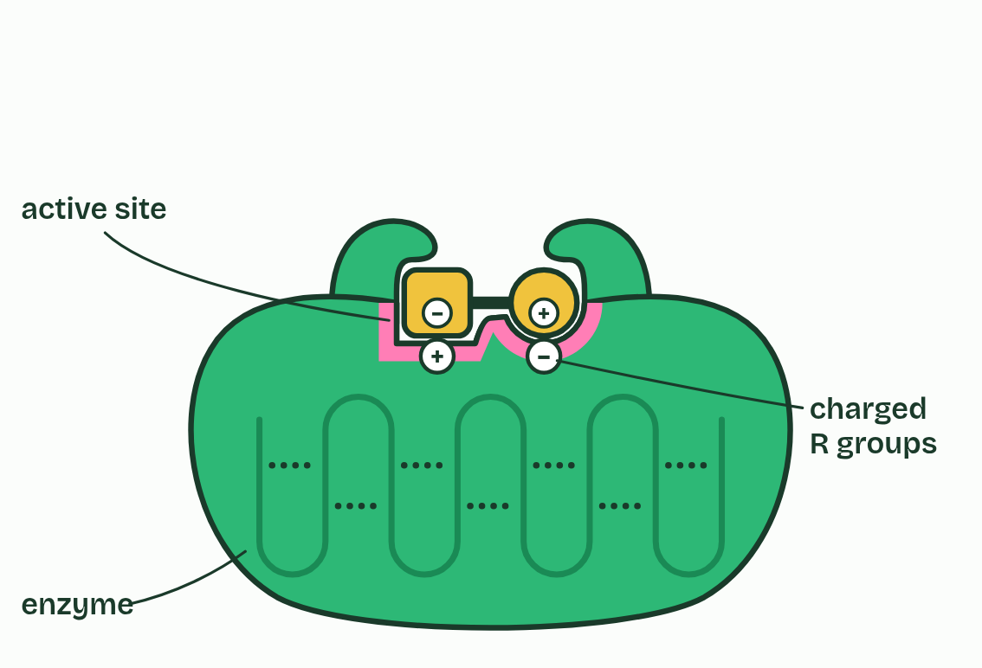  1 Flexible loops: Two loops of the chain beside the active site. As the substrate settles in they swing in and close round it, which strains the bond that is about to break: induced fit.  2 The folded chain: An enzyme is a protein: a chain of amino acids folded into one precise 3D shape. Hydrogen bonds and ionic bonds between R groups (the dashed lines) hold the fold, and the fold makes the active site. Break enough of them and the site loses its shape.  3 Active site: The pocket where the substrate binds and reacts, lined by just a few of the enzyme's amino acids. Its shape, and the charges of the R groups lining it, match one substrate.  4 Charged R groups: Side chains of two amino acids lining the site: one positive, one negative. The substrate carries the opposite charges in the same places, so it is pulled in and held.  5 Substrate: Its square half fits the square end of the site and its round half the round end, and each of its charges sits over an opposite charge. It binds, the loops close round it, and the bond in its middle is strained.
  SPOT THE MISTAKE
  What do students often get wrong about enzyme structure? Write the mistake, then put it right.
  The substrate and the active site are not "the same shape". They are complementary: the site is the mold and the substrate fills it, as a hand fills a glove. And the site is not a rigid lock. It moves as the substrate binds.
SUMMARY
Sum up section 01 in two or three sentences of your own.
• Enzyme names usually end in -ase and name the substrate: lactase splits lactose, lipase splits lipids.
• Shape and charge both have to match, or there is no binding and no reaction.
• The enzyme lets go of the products unchanged and binds the next substrate.

02 Enzymes lower the activation energy | 3.1.A
CUES  Predict: An enzyme is added to a reaction with ΔG = −20 kJ/mol. What is ΔG now?  B: −20 kJ/mol: the enzyme does not change it. The enzyme lowers the peak, not the start or the finish. Play the figure to step 4: both routes begin at the same level and end at the same level, so ΔG is −20 kJ/mol either way. Only the activation energy drops.  What is meant by activation energy?  The energy reactants must take in before a reaction can start: enough to strain and begin to break their bonds.  What is meant by ΔG?  The change in free energy in a reaction. Negative when free energy is released (exergonic), positive when it must be put in (endergonic). | NOTES  1 So even a reaction that releases energy overall must first be pushed over a hump, while old bonds strain and start to break. That push is the activation energy.  2 The free energy of the reactants and of the products, and so the difference between them, ΔG, are the same with or without it.  3 The enzyme lowers the activation energy. It supplies no energy of its own.  4 The reactant must pass over a hump before it can become products. Here the products end up lower: this reaction releases energy.  5 At the top of the hump the bond is stretched and about to break. Getting there takes the activation energy, and at 37 °C few collisions have that much.  6 With the enzyme the route is lower: the active site holds the substrate in place and strains its bond, so less energy is needed.  Your own notes  ANNOTATE THE FIGURE  Number the 5 steps on the figure and note what happens at each: 1 hump; 2 activation energy; 3 lower; 4 ΔG is the same; 5 many more.  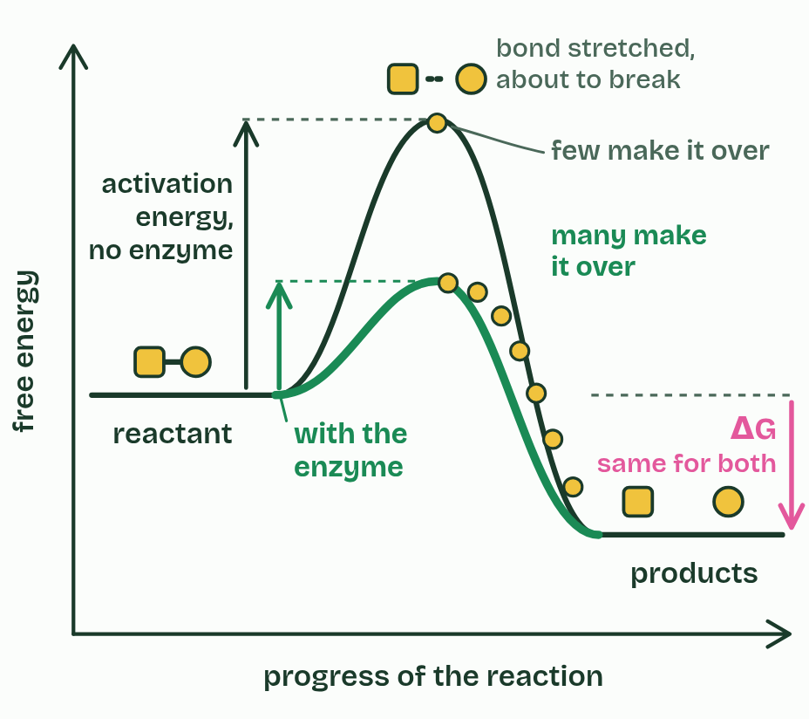  1 The reactant must pass over a hump before it can become products. Here the products end up lower: this reaction releases energy.  2 At the top of the hump the bond is stretched and about to break. Getting there takes the activation energy, and at 37 °C few collisions have that much.  3 With the enzyme the route is lower: the active site holds the substrate in place and strains its bond, so less energy is needed.  4 The start and the finish have not moved, so ΔG is the same with or without the enzyme. The enzyme changes the route, never the destination.  5 A lower peak means many more molecules have enough energy to cross it each second, so the reaction runs far faster.
  SPOT THE MISTAKE
  A student writes: “Breaking bonds releases energy.” Spot the mistake, then put it right.
  "Breaking bonds releases energy" is wrong, and it costs marks every year. Breaking a bond always takes energy in. Energy is released when new, more stable bonds form, and the enzyme only lowers the cost of getting started.
SUMMARY
Sum up section 02 in two or three sentences of your own.
• The enzyme lowers the activation energy. It supplies no energy of its own.
• ΔG does not change, so an enzyme cannot make an uphill reaction go by itself.

03 More substrate, more collisions, up to a limit | 3.2.B
CUES  Predict: A reaction has reached its plateau: more substrate no longer speeds it up. Which change would raise the rate?  B: Adding more of the enzyme. At the plateau every active site is busy, so the number of sites is the limit. More enzyme means more sites. Try it: push the substrate high, then switch from 3 enzymes to 6, and watch the graph.  What is meant by saturated?  Working flat out: every active site is occupied all the time, so more substrate cannot raise the rate. | NOTES  1 Once there is so much substrate that every active site is refilled the moment it empties, the enzyme is saturated and the rate levels off at its maximum.  Your own notes  ANNOTATE THE FIGURE  The figure shows it as 3 enzymes and 6 enzymes. Note what changes each time.  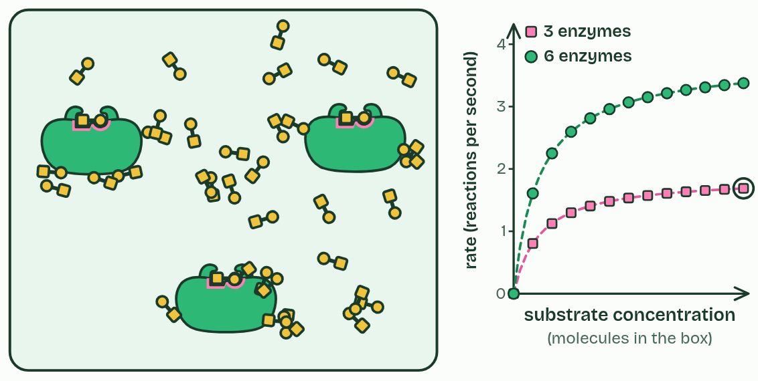  1 3 enzymes  2 6 enzymes  REMEMBER IT  The five things that change an enzyme's rate spell SPITE
  S  Spicy | P  Peppers | I  Irritate | T  Tired | E  Eyes
  Substrate  how much there is | pH  charges in the site | Inhibitors  block or bend the site | Temperature  collisions, then unfolding | Enzyme  how much there is
  SPOT THE MISTAKE
  What do students often get wrong about substrate and enzyme concentration? Write the mistake, then put it right.
  The plateau is not the enzyme being used up or denatured. Every enzyme molecule is still there and still working, flat out. Add more enzyme and the rate climbs again.
SUMMARY
Sum up section 03 in two or three sentences of your own.
• Low substrate: the rate is limited by how often substrate meets a free site.
• High substrate: every site is busy, and the rate is limited by the amount of enzyme.

04 Heat makes it faster, then breaks it | 3.2.A 3.2.B
CUES  Predict: Salivary amylase is held at 70 °C for ten minutes, then cooled back to 37 °C. What is its rate now?  C: Far lower than normal: it stays unfolded. At 70 °C the chains unfold, and as they cool most of them tangle with each other instead of refolding, so their active sites are gone for good. Compare the cold side: drag the slider down to 5 °C and the enzyme is slow but whole.  What is meant by denatured?  Changed in shape because the weak bonds holding the folded chain have broken, so the active site no longer works. The amino acid sequence is not changed.  What is meant by optimum?  The temperature, or pH, at which an enzyme works fastest. | NOTES  1 An enzyme whose structure has been disrupted like this is denatured.  2 The temperature where the two effects balance and the rate peaks is the optimum.  3 Rising side: more collisions, and more of them with enough energy.  4 Falling side: denaturation, faster the hotter it gets.  5 Each enzyme's optimum suits the place it works.  Your own notes  ANNOTATE THE FIGURE  The figure shows it at temperature 10, 37, 49 and 68. Note what changes each time.  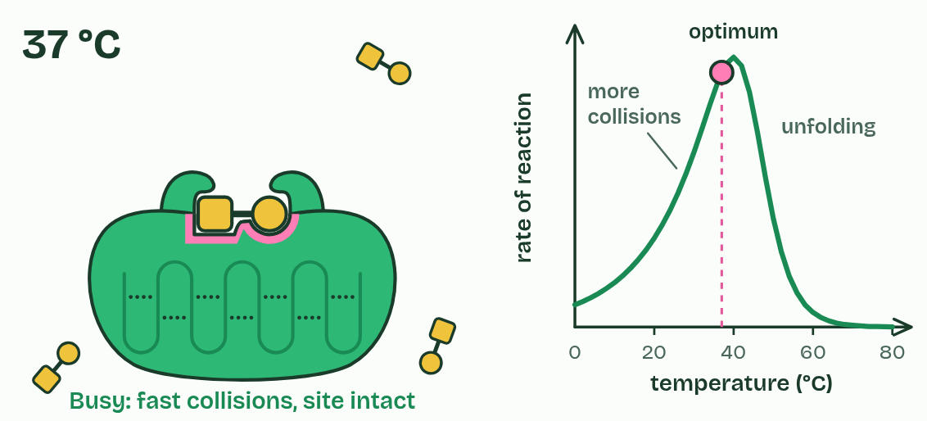  1 Temperature 10  2 Temperature 37  3 Temperature 49  4 Temperature 68  ANNOTATE THE FIGURE  Annotate this still from the animation (Watch it happen: collisions, heat and inhibitors): what is happening, and why?  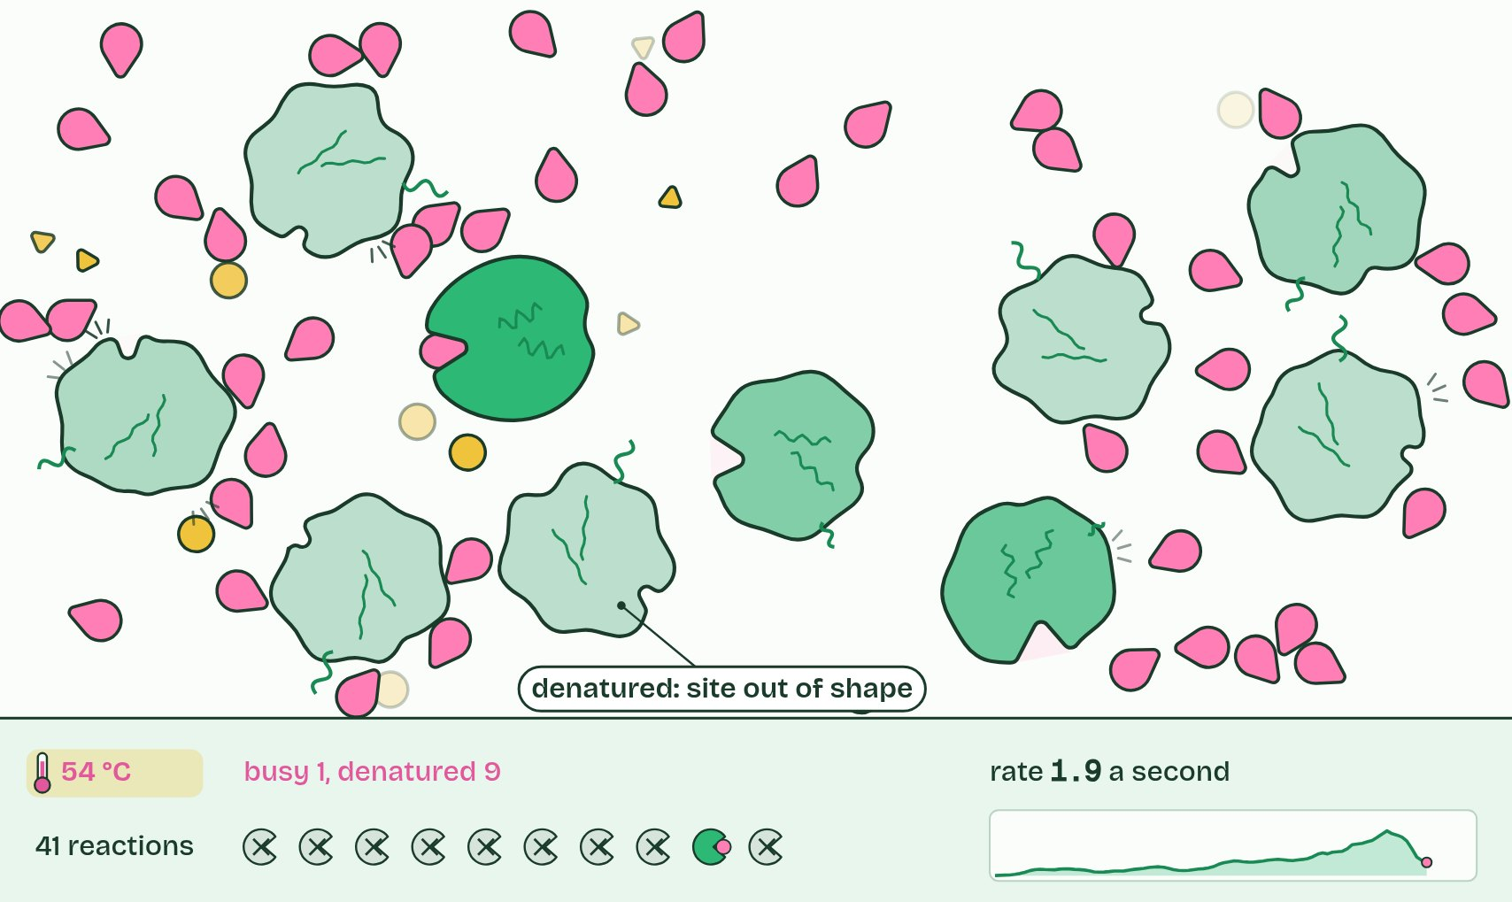  1 Molecules move at random, and most collisions miss the active site.  2 A successful collision: it binds and reacts, and the enzyme is unchanged.  3 Too hot: enzymes denature. Active sites lose their shape, and the rate falls.
  SPOT THE MISTAKE
  What do students often get wrong about temperature? Write the mistake, then put it right.
  Cold does not denature an enzyme. At 5 °C it is slow because it and its substrate move slowly, but its shape is intact, and it works normally once warmed. Write "denatured" for the hot side only (or an extreme pH).
SUMMARY
Sum up section 04 in two or three sentences of your own.
• Rising side: more collisions, and more of them with enough energy.
• Falling side: denaturation, faster the hotter it gets.
• Each enzyme's optimum suits the place it works.

05 pH changes the charges in the site | 3.2.A 3.2.B
CUES  Predict: Amylase is put in a buffer at pH 5 for a minute, then moved back to pH 7. What is its rate now?  A: About normal: its site's charges come back. At pH 5 some carboxyl groups in the site pick up H+ and lose their charge, so the substrate is held less well. Nothing is broken: back at pH 7 they give the H+ up again, the charges return and so does the rate. Only a pH far from the optimum breaks the bonds that hold the fold. Slide the figure from 7 to 4 and on down to 2 to see the difference. | NOTES  1 So every enzyme has an optimum pH, and it suits the place the enzyme works: pepsin in the acid of the stomach, trypsin in the small intestine, where alkaline juice from the pancreas has neutralized that acid.  Your own notes  ANNOTATE THE FIGURE  The figure shows it at pH 2, 4, 7, 10 and 13. Note what changes each time.  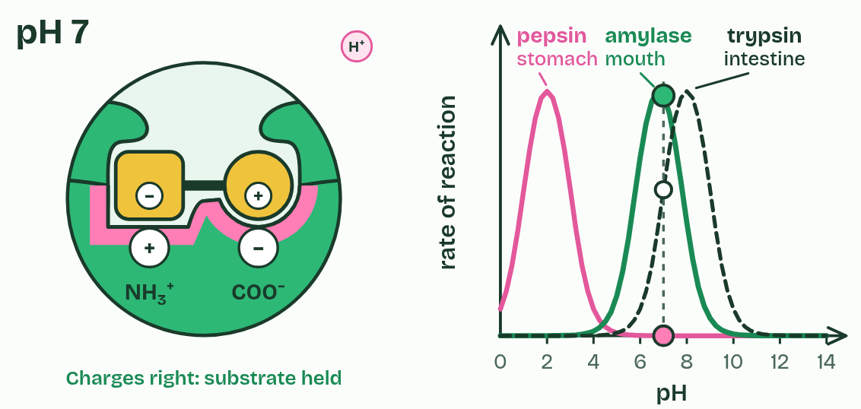  1 pH 2  2 pH 4  3 pH 7  4 pH 10  5 pH 13
  SPOT THE MISTAKE
  A student writes: “Enzymes work best at pH 7.” Spot the mistake, then put it right.
  "Enzymes work best at pH 7" is not true of all of them: pepsin barely works at pH 7. And one pH unit is not a small change. It is ten times the H+.
SUMMARY
Sum up section 05 in two or three sentences of your own.
• A little off the optimum: charges in the site change, and the effect reverses when the pH returns.
• Far off it: the bonds holding the fold break, and the enzyme denatures.

06 Inhibitors block the site, or bend it | 3.2.B
CUES  Predict: Two reactions are slowed by inhibitors. You add a large excess of substrate to both. One gets back almost its full rate; the other does not. What does the one that recovered contain?  B: A competitive inhibitor, outnumbered by substrate. A competitive inhibitor takes turns with the substrate for the same site, so flooding the mixture with substrate wins nearly every site back. A noncompetitive one holds its enzymes out of shape whatever the substrate does. Choose each type in the figure and drag the substrate up.  What is meant by competitive inhibitor?  An inhibitor that binds in the active site itself, because its shape resembles the substrate's, so the two compete for the site.  What is meant by noncompetitive inhibitor?  An inhibitor that binds somewhere other than the active site and changes the enzyme's shape, so the active site works less well.  What is meant by allosteric site?  A binding site on an enzyme other than the active site. A molecule binding there changes the enzyme's shape, and so its activity. | NOTES  1 A competitive inhibitor looks enough like the substrate to fit the active site, and while it sits there the substrate cannot bind.  2 A noncompetitive inhibitor binds somewhere else, at an allosteric site.  3 Noncompetitive: a lower maximum rate, whatever the substrate concentration.  Your own notes  ANNOTATE THE FIGURE  The figure shows it as None, Competitive and Noncompetitive. Note what changes each time.  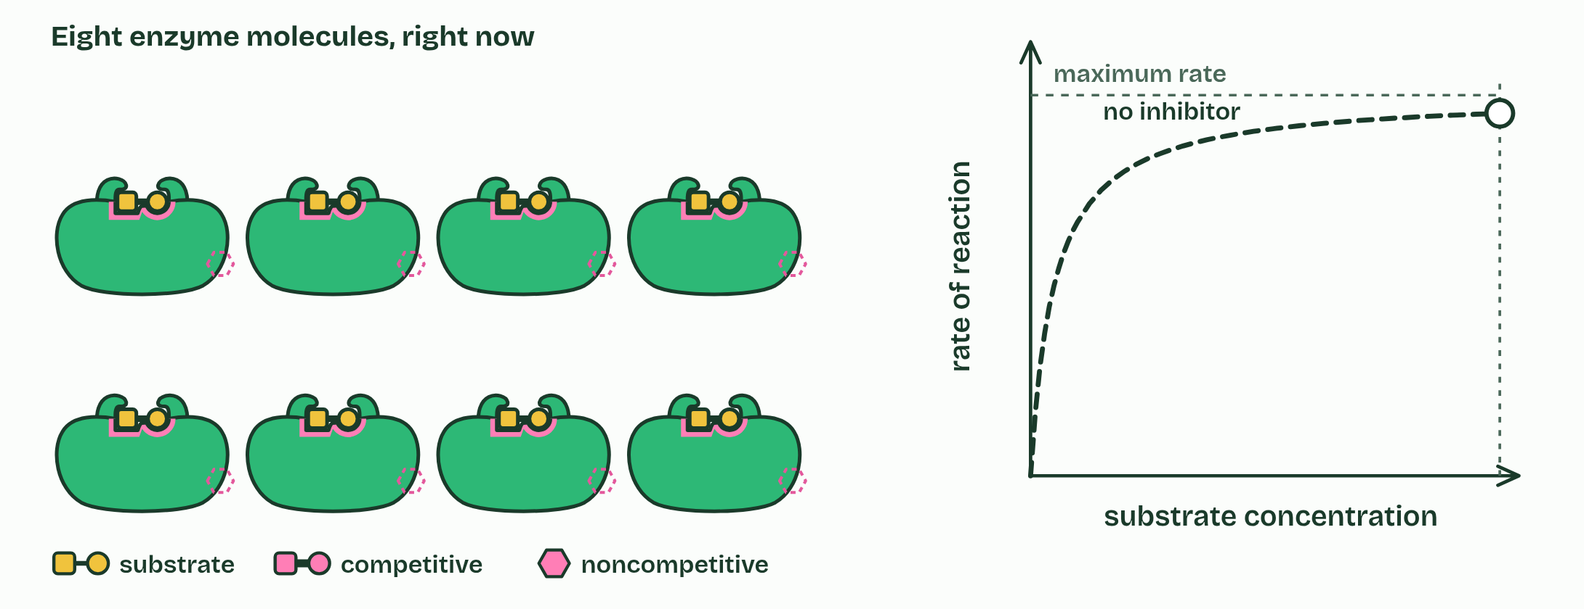  1 None  2 Competitive  3 Noncompetitive  REMEMBER IT  Two kinds of inhibitor, and where the second binds
  C  Copycat | N  Nope | A  Another
  Competitive  takes the active site; more substrate wins | Noncompetitive  bends the site; max rate drops | Allosteric site  a site that is not the active site
  SPOT THE MISTAKE
  What do students often get wrong about inhibitors? Write the mistake, then put it right.
  Cyanide is often given as an allosteric inhibitor. It is not one: it binds the iron and copper center of cytochrome c oxidase, the very place where oxygen should bind at the end of the electron transport chain. And a competitive inhibitor does not lower the maximum rate. It raises the substrate concentration needed to reach it.
SUMMARY
Sum up section 06 in two or three sentences of your own.
• Competitive: same maximum rate, but more substrate is needed to reach it.
• Noncompetitive: a lower maximum rate, whatever the substrate concentration.

07 Staying alive takes a constant supply of energy | 3.3.A
CUES  Predict: Reaction X has ΔG = +20 kJ/mol. Which of these would make it run in a cell?  C: Coupling X to ATP hydrolysis (−31). An enzyme only lowers the activation energy and heat only speeds up collisions: neither changes ΔG, so X stays uphill. Coupled to ATP hydrolysis, the pair has ΔG = +20 − 31 = −11 kJ/mol, downhill, so it runs. More product would push X backwards.  What is meant by exergonic?  Releasing free energy: the products hold less free energy than the reactants, and ΔG is negative.  What is meant by endergonic?  Needing free energy put in: the products hold more free energy than the reactants, and ΔG is positive.  What is meant by coupling?  Linking a reaction that releases energy to one that needs it, so that together they release energy and run. | NOTES  1 An exergonic reaction releases free energy (ΔG is negative), like the breakdown of glucose.  2 An endergonic reaction needs free energy put in (ΔG is positive), like building a protein.  3 A cell runs an endergonic reaction by coupling it to an exergonic one, and the usual partner is the hydrolysis of ATP, the cell's energy currency.  4 Making glutamine from glutamate and ammonia is uphill: ΔG = +14 kJ/mol. On its own it hardly happens.  5 Splitting ATP into ADP and phosphate is downhill: ΔG = −31 kJ/mol. The products are more stable than ATP was.  6 The enzyme glutamine synthetase couples them: ATP hands its end phosphate to glutamate. Glutamyl phosphate is unstable, ready to react.  Your own notes  ANNOTATE THE FIGURE  The figure shows it as Energy flowing in and Energy cut off. Note what changes each time.  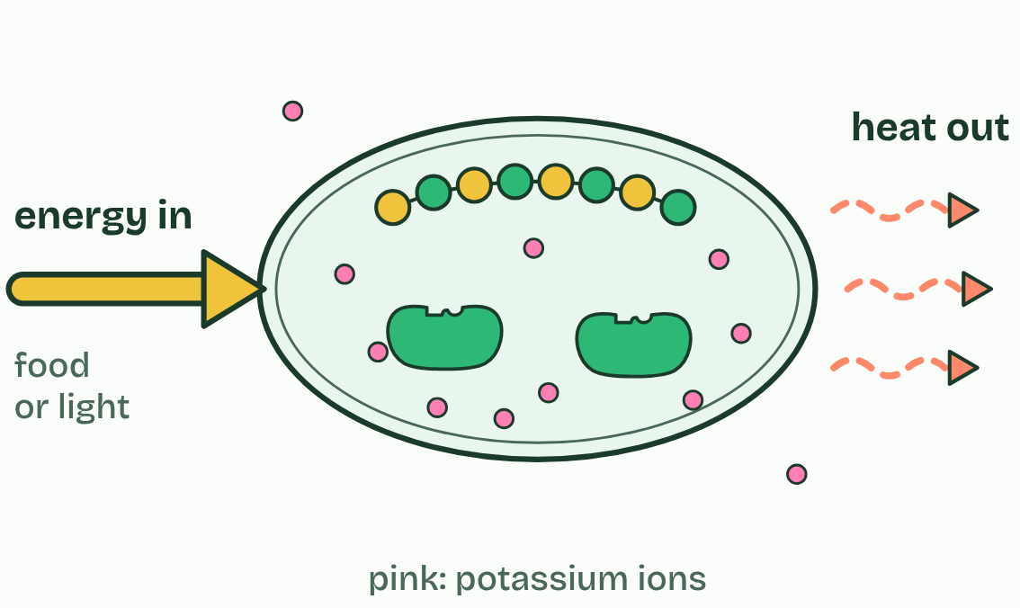  1 Energy flowing in  2 Energy cut off  ANNOTATE THE FIGURE  Number the 4 steps on the figure and note what happens at each: 1 uphill; 2 downhill; 3 couples; 4 −17 kJ/mol.  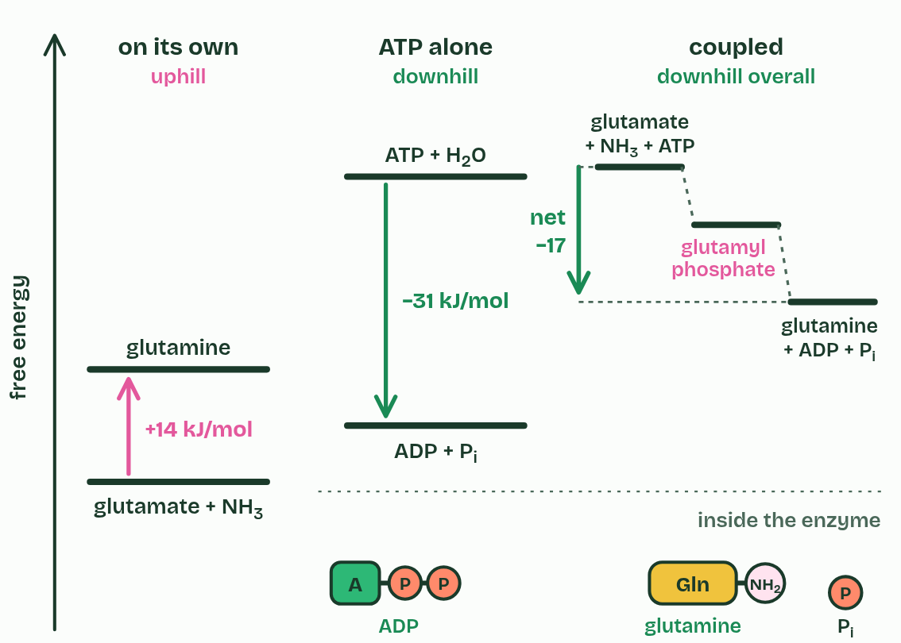  1 Making glutamine from glutamate and ammonia is uphill: ΔG = +14 kJ/mol. On its own it hardly happens.  2 Splitting ATP into ADP and phosphate is downhill: ΔG = −31 kJ/mol. The products are more stable than ATP was.  3 The enzyme glutamine synthetase couples them: ATP hands its end phosphate to glutamate. Glutamyl phosphate is unstable, ready to react.  4 Ammonia takes the phosphate's place, making glutamine. Overall +14 − 31 = −17 kJ/mol: downhill, so it runs. Respiration then rebuilds the ATP.  REMEMBER IT  Which way the energy goes: read the first two letters. EXergonic, energy EXits; ENdergonic, energy ENters.
  E  Exits | E  Enters
  Exergonic  energy leaves; ΔG negative | Endergonic  energy goes in; ΔG positive
  SPOT THE MISTAKE
  What do students often get wrong about cellular energy? Write the mistake, then put it right.
  Energy is not stored in ATP's last phosphate bond like a spring, released when the bond snaps. Breaking any bond takes energy in. ATP hydrolysis releases energy because the products, ADP and phosphate, are more stable than ATP and water were: they hold less free energy.
SUMMARY
Sum up section 07 in two or three sentences of your own.
• Energy in must exceed energy lost, to keep order and to do work.
• Coupled to ATP hydrolysis, an uphill step becomes part of a downhill pair.

08 Pathways go in small steps, shared by all life | 3.3.A 3.3.B
CUES  Predict: The end product of a pathway builds up in a cell. What happens to the first enzyme of that pathway?  D: It is slowed: the product binds it elsewhere. Feedback inhibition: the end product binds an allosteric site on the first enzyme and bends its active site, so the whole pathway slows. Play the top figure to step 3, then step 4, when the product has been used and lets go.  What is meant by metabolic pathways?  A series of reactions in which the product of each step is the substrate of the next, each step catalyzed by its own enzyme.  What is meant by feedback inhibition?  Control in which the end product of a pathway inhibits an enzyme early in the pathway, so the product limits its own production. | NOTES  1 They use metabolic pathways: chains of reactions, each catalyzed by its own enzyme, where the product of one step is the substrate of the next.  2 When the end product builds up, it binds an allosteric site on the pathway's first enzyme and switches it off: feedback inhibition.  3 A pathway: each product is the next enzyme's substrate, so threonine is turned into isoleucine step by step (three steps here; the real pathway has five).  4 The cell makes more isoleucine than it is using, and it builds up.  5 Isoleucine binds an allosteric site on enzyme 1 and bends its active site. The first step stops, so the whole pathway stops.  6 As the cell uses isoleucine to build proteins, the level falls, isoleucine lets go, and the pathway runs again: negative feedback.  Your own notes  ANNOTATE THE FIGURE  Number the 4 steps on the figure and note what happens at each: 1 each product is the next enzyme's substrate; 2 builds up; 3 allosteric site; 4 lets go.  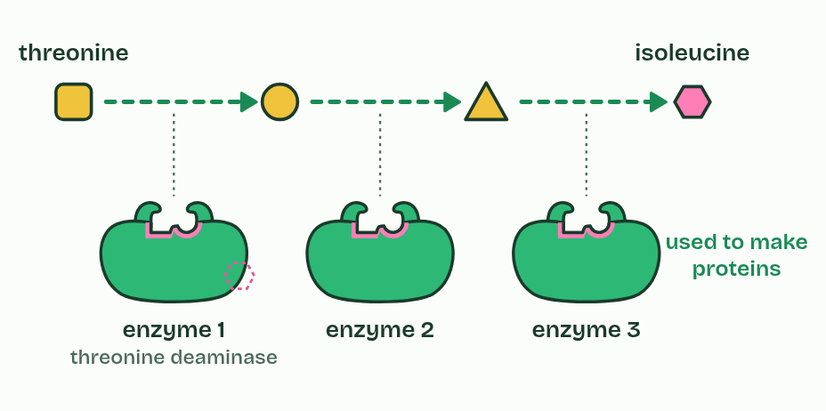  1 A pathway: each product is the next enzyme's substrate, so threonine is turned into isoleucine step by step (three steps here; the real pathway has five).  2 The cell makes more isoleucine than it is using, and it builds up.  3 Isoleucine binds an allosteric site on enzyme 1 and bends its active site. The first step stops, so the whole pathway stops.  4 As the cell uses isoleucine to build proteins, the level falls, isoleucine lets go, and the pathway runs again: negative feedback.  ANNOTATE THE FIGURE  Number the 3 steps on the figure and note what happens at each: 1 run on ATP, glycolysis; 2 one common ancestor; 3 already had.  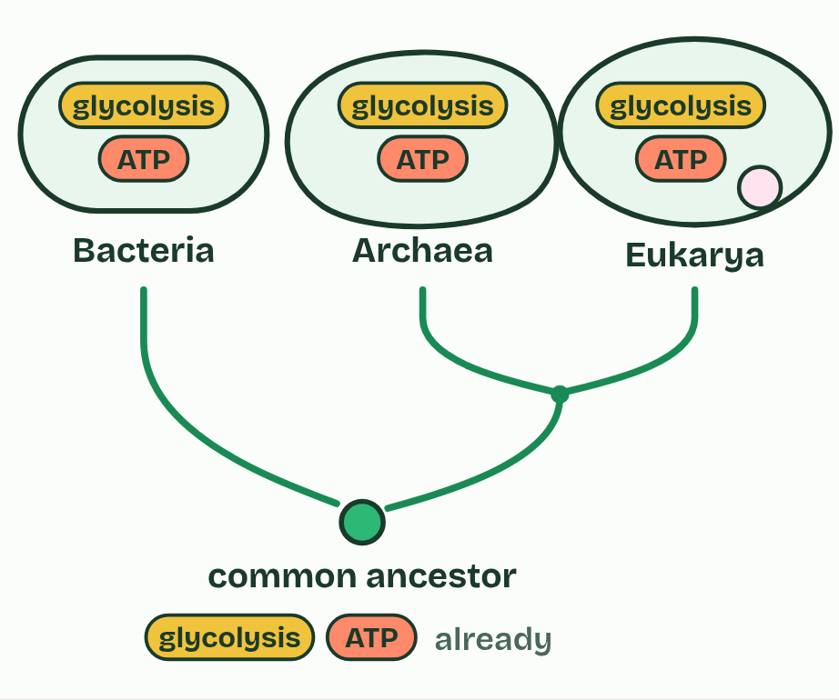  1 Bacteria, archaea and eukaryotes all run on ATP, and all break glucose down by versions of glycolysis, several of whose enzymes have closely similar sequences in all three.  2 All three groups trace back to one common ancestor. Archaea and eukaryotes share a more recent one as well.  3 The simplest explanation: the ancestor already had ATP and glycolysis, and every line of descent kept them. Shared, conserved pathways are evidence of common ancestry.
  SPOT THE MISTAKE
  What do students often get wrong about energy pathways? Write the mistake, then put it right.
  Feedback inhibition does not destroy the first enzyme. The end product binds reversibly: as its level falls it lets go, and the enzyme works again. That is what makes it a switch.
SUMMARY
Sum up section 08 in two or three sentences of your own.
• The product of one step is the substrate of the next.
• The end product inhibits the first enzyme: negative feedback.
• Conserved pathways in every domain are evidence of common ancestry.

Check yourself
The check for this guide is online: a fresh paper of past-paper style questions from the exam bank on 3.1 to 3.3 each time, marked as you go, and saved to your Exam practice progress when you are signed in. Open the link:
biologybybradford.com/exam-maker/sit?program=ap&units=U3&ced=3.1,3.2,3.3&paper=quiz&marks=15&src=ep

