Name | Class | Date
AP BIOLOGY · 3.1 to 3.3

Enzymes and cellular energy
Notes to fill in alongside the guide. Each numbered block matches a chapter of the guide, and of the lesson slides. Write in the gaps, answer the cues, annotate the figures, and sum up each section in your own words.
BY THE END YOU CAN
Explain how the shape and charge of an active site make an enzyme specific to its substrate 3.1.A
Explain how an enzyme speeds up a reaction by lowering its activation energy, and why it leaves ΔG unchanged 3.1.A
Explain how heat and extreme pH change an enzyme's structure, and when that change can be undone 3.2.A
Predict how temperature, pH, substrate and product concentrations and inhibitors change the rate of a reaction 3.2.B
Describe why a living cell needs a constant input of energy, and how ATP couples an uphill reaction to a downhill one 3.3.A
Explain why energy pathways run in small steps, and what the same pathways in every domain of life tell us 3.3.B

01 The active site fits one substrate | 3.1.A
CUES  Predict: A molecule has exactly the substrate's shape, but its two charges are the other way round. What happens at the active site?  What is meant by enzyme?  What is meant by active site?  What is meant by substrate?  What is meant by specific?  What is meant by induced fit? | NOTES  1 An ________ is a biological catalyst: a protein that makes one reaction go faster and is not used up by it.  2 A small pocket in the fold, lined by just a few of those amino acids, is the _______________.  3 The molecule the enzyme works on is its ____________.  4 A substrate binds only if two things match: its ________ fits the site, and its _________ are opposite to the charged R groups lining it.  5 That double check is why an enzyme is ___________.  6 As the substrate settles in, the site shifts to grip it more tightly, which strains the bond that is about to break: _______________.  7 ________ names usually end in -ase and name the substrate: lactase splits lactose, lipase splits lipids.  8 The ________ lets go of the products unchanged and binds the next substrate.  Your own notes  ANNOTATE THE FIGURE  Label each part and say what it does: flexible loops, the folded chain, active site, charged R groups, substrate.  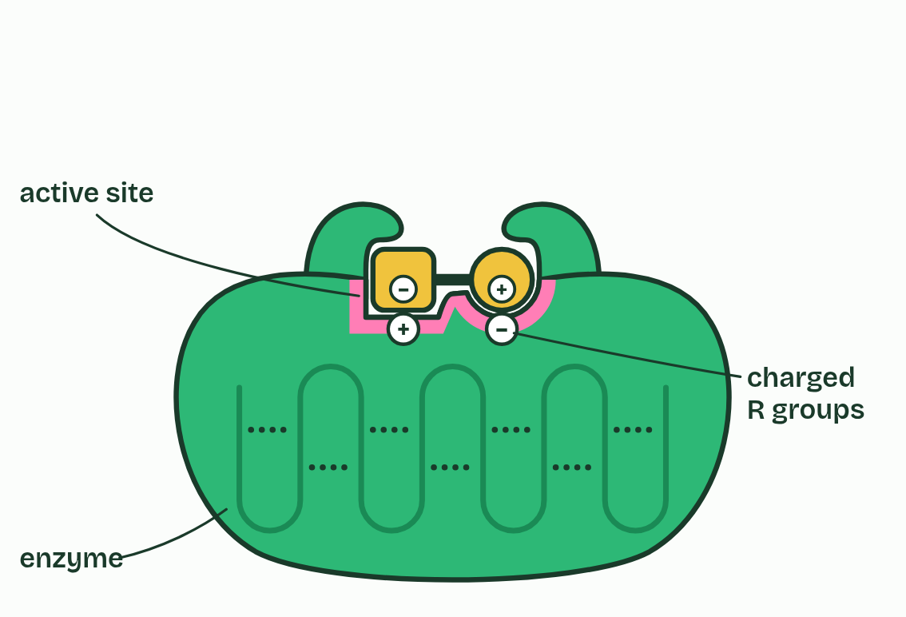
  SPOT THE MISTAKE
  What do students often get wrong about enzyme structure? Write the mistake, then put it right.
  The mistake
  Put it right
SUMMARY
Sum up section 01 in two or three sentences of your own.

02 Enzymes lower the activation energy | 3.1.A
CUES  Predict: An enzyme is added to a reaction with ΔG = −20 kJ/mol. What is ΔG now?  What is meant by activation energy?  What is meant by ΔG? | NOTES  1 So even a reaction that releases energy overall must first be pushed over a hump, while old bonds strain and start to break. That push is the _______________________.  2 The free energy of the reactants and of the products, and so the difference between them, ________, are the same with or without it.  3 The enzyme lowers the _______________________. It supplies no energy of its own.  4 The reactant must pass over a ________ before it can become products. Here the products end up lower: this reaction releases energy.  5 At the top of the hump the bond is stretched and about to break. Getting there takes the _______________________, and at 37 °C few collisions have that much.  6 With the enzyme the route is ________: the active site holds the substrate in place and strains its bond, so less energy is needed.  Your own notes  ANNOTATE THE FIGURE  Number the 5 steps on the figure and note what happens at each: 1 hump; 2 activation energy; 3 lower; 4 ΔG is the same; 5 many more.  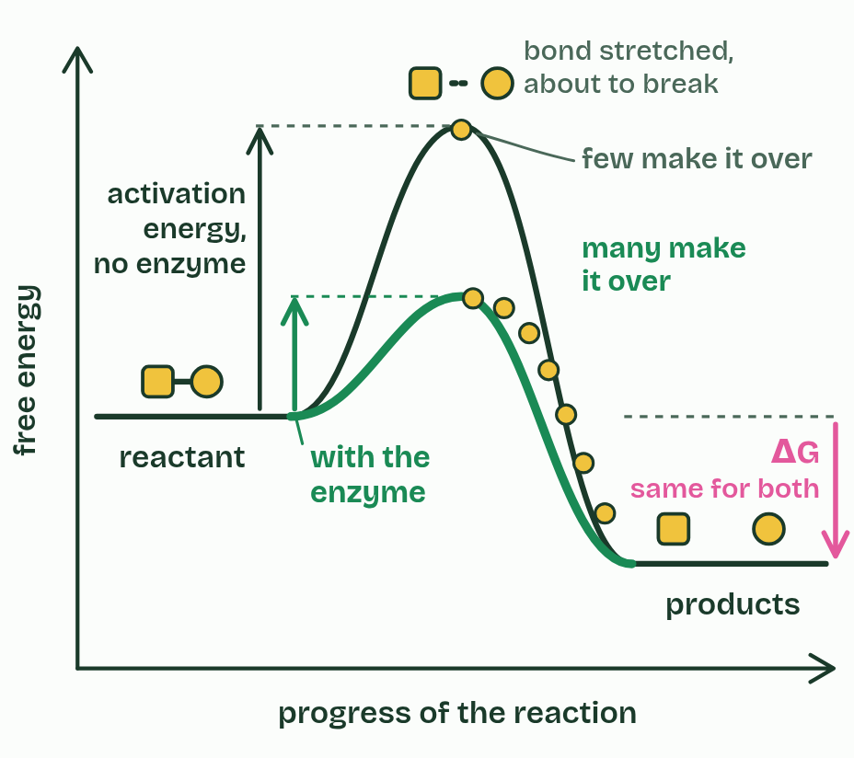
  SPOT THE MISTAKE
  A student writes: “Breaking bonds releases energy.” Spot the mistake, then put it right.
  The mistake
  Put it right
SUMMARY
Sum up section 02 in two or three sentences of your own.

03 More substrate, more collisions, up to a limit | 3.2.B
CUES  Predict: A reaction has reached its plateau: more substrate no longer speeds it up. Which change would raise the rate?  What is meant by saturated? | NOTES  1 Once there is so much substrate that every active site is refilled the moment it empties, the enzyme is ____________ and the rate levels off at its maximum.  Your own notes  ANNOTATE THE FIGURE  The figure shows it as 3 enzymes and 6 enzymes. Note what changes each time.  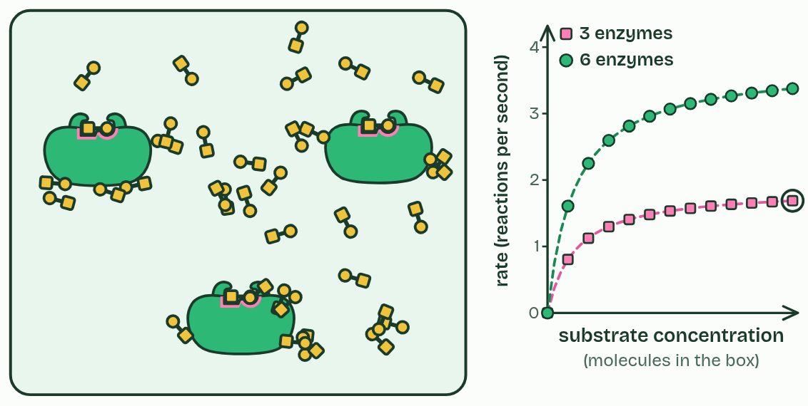  REMEMBER IT  The five things that change an enzyme's rate spell SPITE
  S  Spicy | P  Peppers | I  Irritate | T  Tired | E  Eyes
  S | P | I | T | E
  SPOT THE MISTAKE
  What do students often get wrong about substrate and enzyme concentration? Write the mistake, then put it right.
  The mistake
  Put it right
SUMMARY
Sum up section 03 in two or three sentences of your own.

04 Heat makes it faster, then breaks it | 3.2.A 3.2.B
CUES  Predict: Salivary amylase is held at 70 °C for ten minutes, then cooled back to 37 °C. What is its rate now?  What is meant by denatured?  What is meant by optimum? | NOTES  1 An enzyme whose structure has been disrupted like this is ____________.  2 The temperature where the two effects balance and the rate peaks is the _________.  3 Rising side: __________________________________.  4 Falling side: __________________________________.  5 Each enzyme's _________ suits the place it works.  Your own notes  ANNOTATE THE FIGURE  The figure shows it at temperature 10, 37, 49 and 68. Note what changes each time.  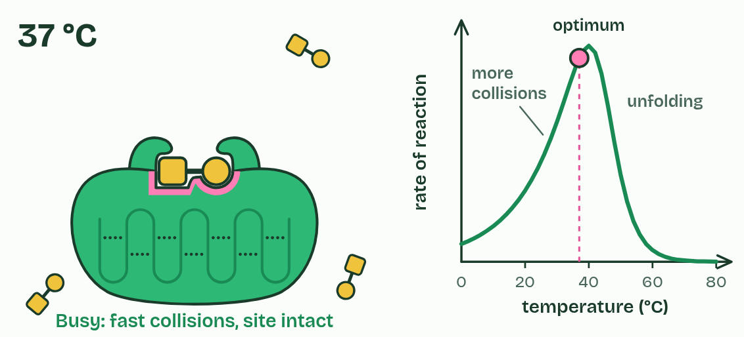  ANNOTATE THE FIGURE  Annotate this still from the animation (Watch it happen: collisions, heat and inhibitors): what is happening, and why?  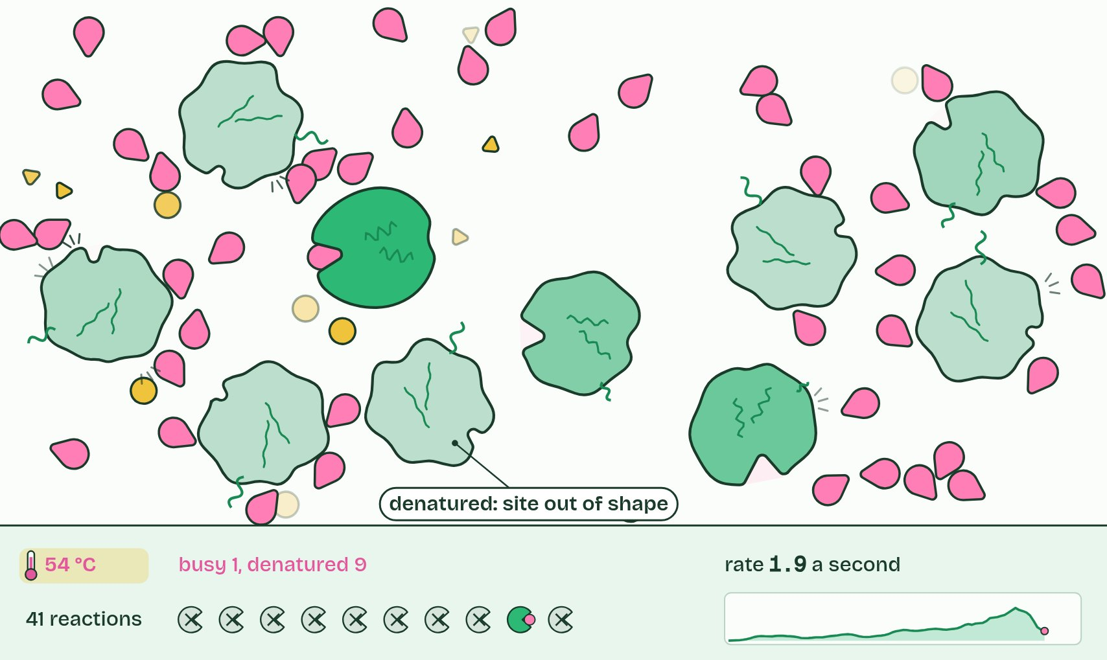
  SPOT THE MISTAKE
  What do students often get wrong about temperature? Write the mistake, then put it right.
  The mistake
  Put it right
SUMMARY
Sum up section 04 in two or three sentences of your own.

05 pH changes the charges in the site | 3.2.A 3.2.B
CUES  Predict: Amylase is put in a buffer at pH 5 for a minute, then moved back to pH 7. What is its rate now? | NOTES  1 So every enzyme has an ______________, and it suits the place the enzyme works: pepsin in the acid of the stomach, trypsin in the small intestine, where alkaline juice from the pancreas has neutralized that acid.  Your own notes  ANNOTATE THE FIGURE  The figure shows it at pH 2, 4, 7, 10 and 13. Note what changes each time.  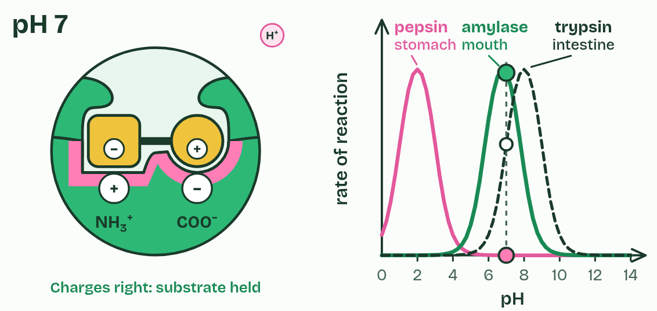
  SPOT THE MISTAKE
  A student writes: “Enzymes work best at pH 7.” Spot the mistake, then put it right.
  The mistake
  Put it right
SUMMARY
Sum up section 05 in two or three sentences of your own.

06 Inhibitors block the site, or bend it | 3.2.B
CUES  Predict: Two reactions are slowed by inhibitors. You add a large excess of substrate to both. One gets back almost its full rate; the other does not. What does the one that recovered contain?  What is meant by competitive inhibitor?  What is meant by noncompetitive inhibitor?  What is meant by allosteric site? | NOTES  1 A ____________________________ looks enough like the substrate to fit the active site, and while it sits there the substrate cannot bind.  2 A ________________________________ binds somewhere else, at an ____________________.  3 Noncompetitive: __________________________________.  Your own notes  ANNOTATE THE FIGURE  The figure shows it as None, Competitive and Noncompetitive. Note what changes each time.  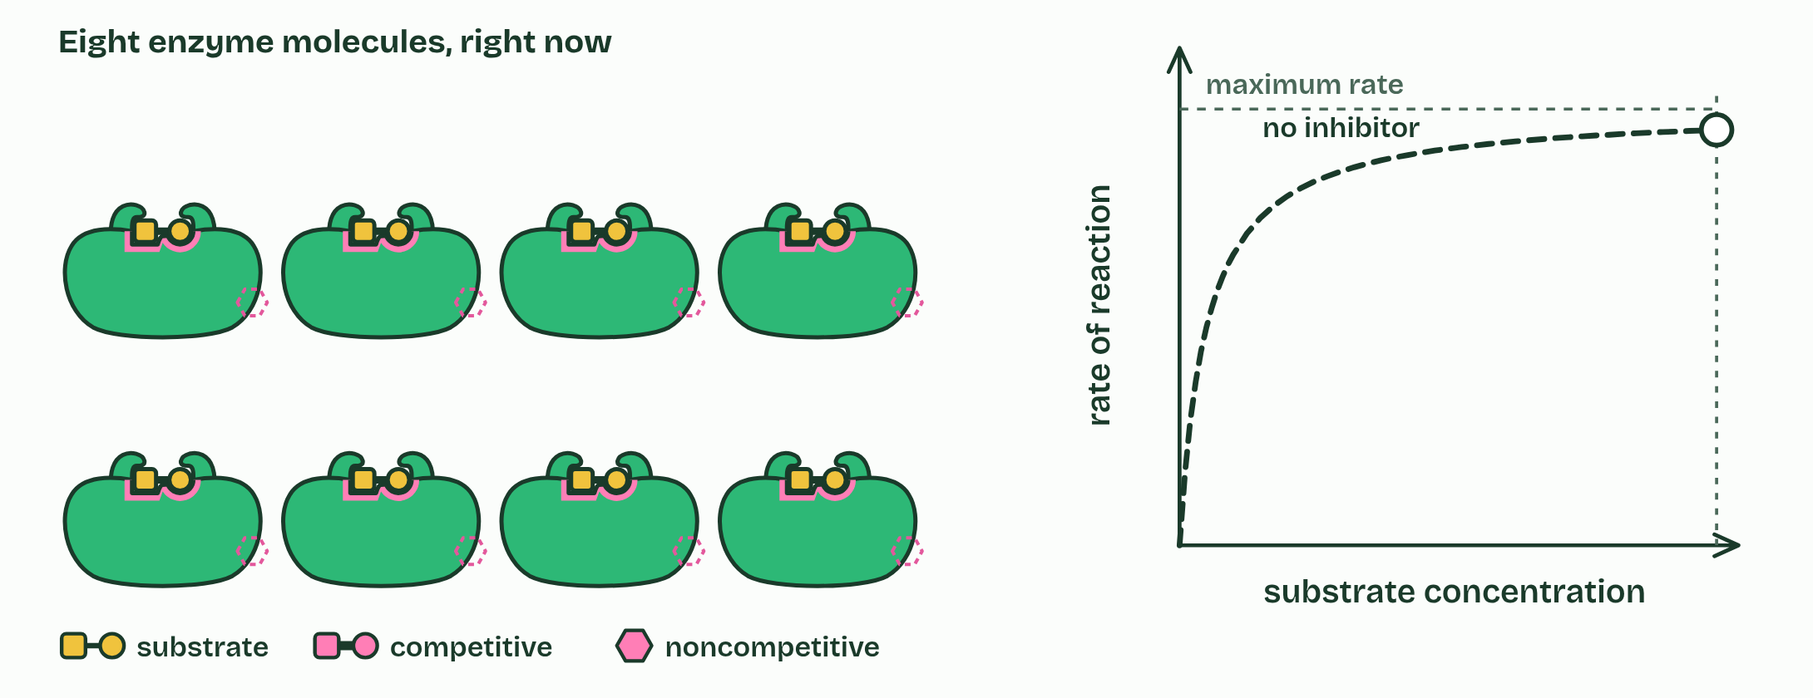  REMEMBER IT  Two kinds of inhibitor, and where the second binds
  C  Copycat | N  Nope | A  Another
  C | N | A
  SPOT THE MISTAKE
  What do students often get wrong about inhibitors? Write the mistake, then put it right.
  The mistake
  Put it right
SUMMARY
Sum up section 06 in two or three sentences of your own.

07 Staying alive takes a constant supply of energy | 3.3.A
CUES  Predict: Reaction X has ΔG = +20 kJ/mol. Which of these would make it run in a cell?  What is meant by exergonic?  What is meant by endergonic?  What is meant by coupling? | NOTES  1 An ____________ reaction releases free energy (ΔG is negative), like the breakdown of glucose.  2 An ______________ reaction needs free energy put in (ΔG is positive), like building a protein.  3 A cell runs an endergonic reaction by ___________ it to an exergonic one, and the usual partner is the hydrolysis of ATP, the cell's energy currency.  4 Making glutamine from glutamate and ammonia is ________: ΔG = +14 kJ/mol. On its own it hardly happens.  5 Splitting ATP into ADP and phosphate is ___________: ΔG = −31 kJ/mol. The products are more stable than ATP was.  6 The enzyme glutamine synthetase _________ them: ATP hands its end phosphate to glutamate. Glutamyl phosphate is unstable, ready to react.  Your own notes  ANNOTATE THE FIGURE  The figure shows it as Energy flowing in and Energy cut off. Note what changes each time.  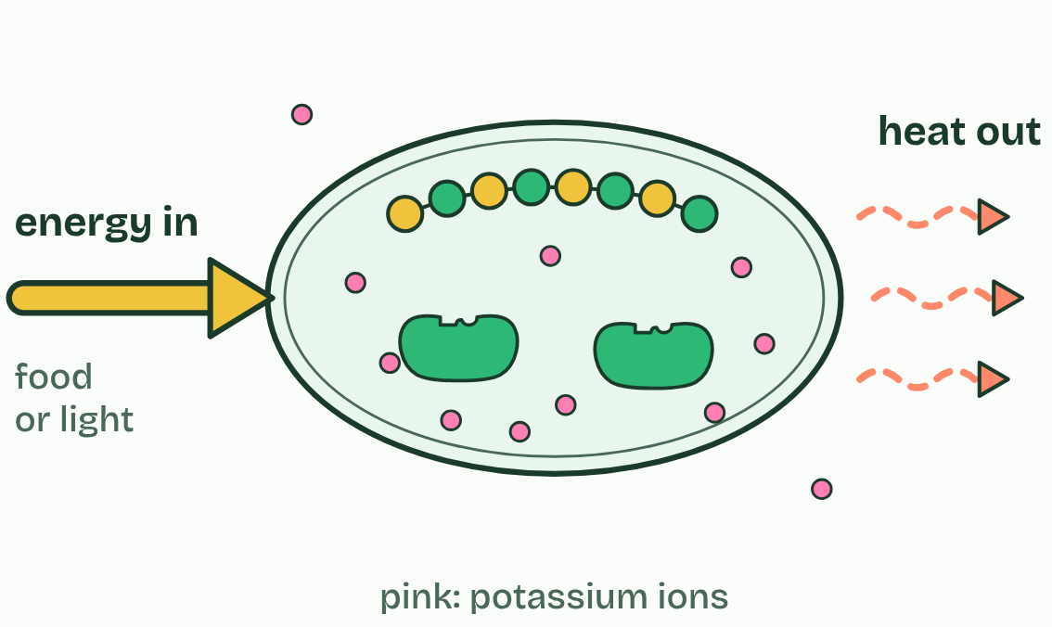  ANNOTATE THE FIGURE  Number the 4 steps on the figure and note what happens at each: 1 uphill; 2 downhill; 3 couples; 4 −17 kJ/mol.  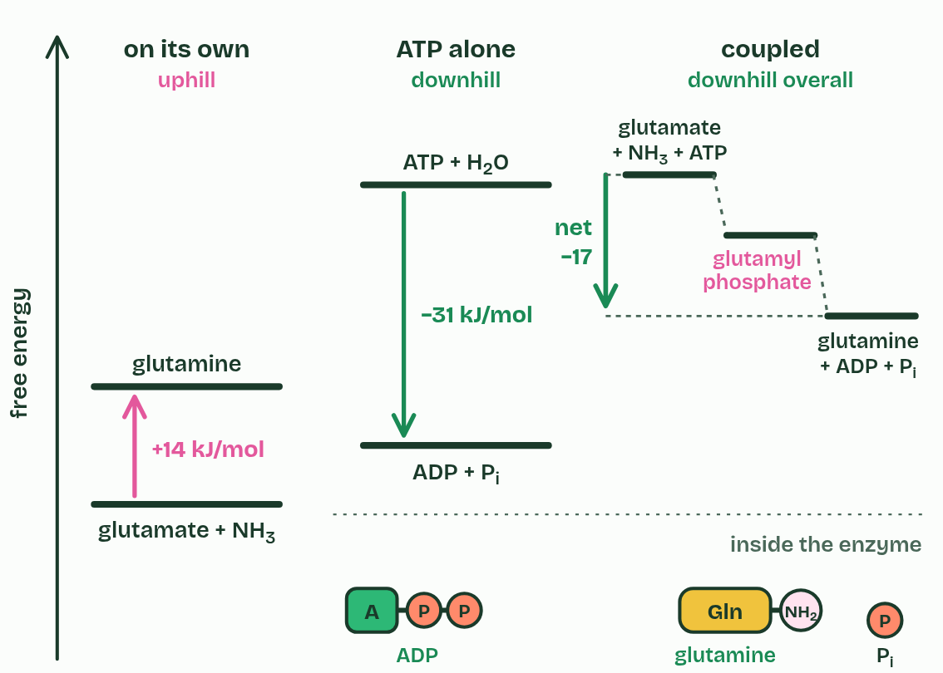  REMEMBER IT  Which way the energy goes: read the first two letters. EXergonic, energy EXits; ENdergonic, energy ENters.
  E  Exits | E  Enters
  E | E
  SPOT THE MISTAKE
  What do students often get wrong about cellular energy? Write the mistake, then put it right.
  The mistake
  Put it right
SUMMARY
Sum up section 07 in two or three sentences of your own.

08 Pathways go in small steps, shared by all life | 3.3.A 3.3.B
CUES  Predict: The end product of a pathway builds up in a cell. What happens to the first enzyme of that pathway?  What is meant by metabolic pathways?  What is meant by feedback inhibition? | NOTES  1 They use ________________________: chains of reactions, each catalyzed by its own enzyme, where the product of one step is the substrate of the next.  2 When the end product builds up, it binds an allosteric site on the pathway's first enzyme and switches it off: __________________________.  3 A pathway: __________________________________, so threonine is turned into isoleucine step by step (three steps here; the real pathway has five).  4 The cell makes more isoleucine than it is using, and it ____________.  5 Isoleucine binds an ____________________ on enzyme 1 and bends its active site. The first step stops, so the whole pathway stops.  6 As the cell uses isoleucine to build proteins, the level falls, isoleucine _________, and the pathway runs again: negative feedback.  Your own notes  ANNOTATE THE FIGURE  Number the 4 steps on the figure and note what happens at each: 1 each product is the next enzyme's substrate; 2 builds up; 3 allosteric site; 4 lets go.  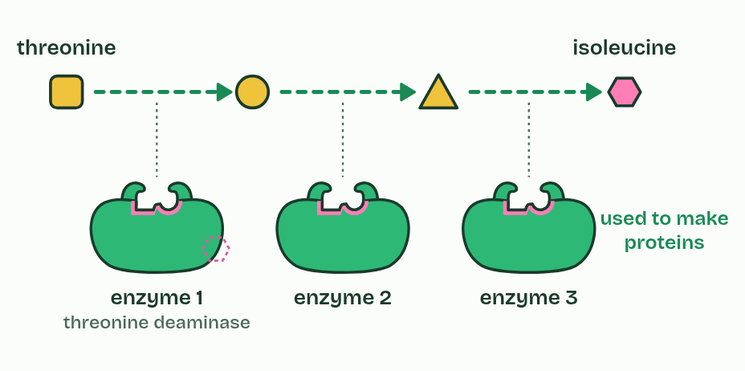  ANNOTATE THE FIGURE  Number the 3 steps on the figure and note what happens at each: 1 run on ATP, glycolysis; 2 one common ancestor; 3 already had.  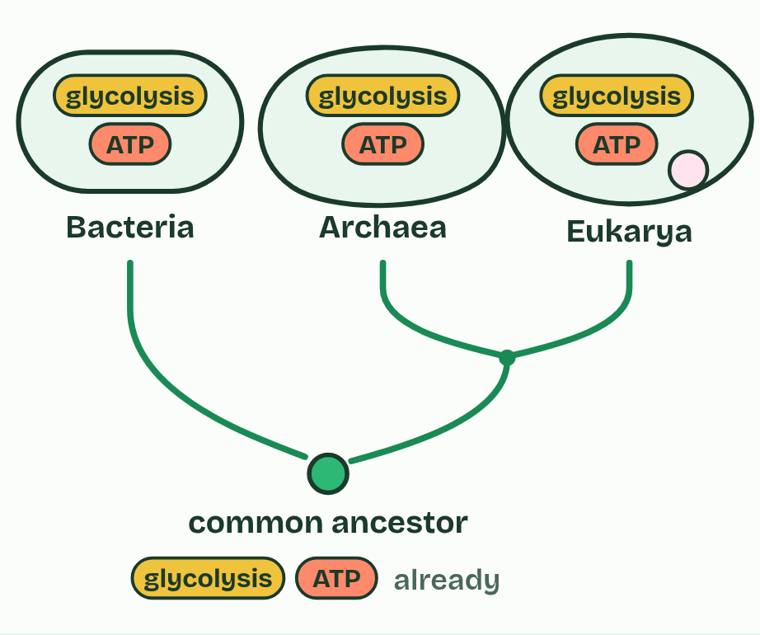
  SPOT THE MISTAKE
  What do students often get wrong about energy pathways? Write the mistake, then put it right.
  The mistake
  Put it right
SUMMARY
Sum up section 08 in two or three sentences of your own.

Check yourself
The check for this guide is online: a fresh paper of past-paper style questions from the exam bank on 3.1 to 3.3 each time, marked as you go, and saved to your Exam practice progress when you are signed in. Open the link:
biologybybradford.com/exam-maker/sit?program=ap&units=U3&ced=3.1,3.2,3.3&paper=quiz&marks=15&src=ep

