Name | Class | Date
IB BIOLOGY · A1.1

Water
Teacher’s copy: every blank filled in. Each numbered block matches a chapter of the guide, and of the lesson slides. Write in the gaps, answer the cues, annotate the figures, and sum up each section in your own words.
BY THE END YOU CAN
Explain why water is the medium for life: where the first cells arose, and where life's processes still happen A1.1.1
Explain how unequal sharing of electrons makes water polar, and draw hydrogen bonds between water molecules with partial charges A1.1.2
Explain how cohesion lets water be pulled up xylem under tension, and lets animals live on its surface A1.1.3
Explain how adhesion draws water through soil and plant cell walls by capillary action A1.1.4
Explain why water is the medium for metabolism and transport, and why some molecules work because they do not dissolve A1.1.5
Compare water with air for buoyancy, viscosity, thermal conductivity and specific heat capacity, using the black-throated loon and the ringed seal A1.1.6
Outline how asteroids may have brought Earth's water, and why gravity and cool temperatures kept it A1.1.7
Explain why the search for life elsewhere looks for liquid water in a star's Goldilocks zone A1.1.8

01 Life began in water, and still runs in it | A1.1.1
CUES  Predict: A packet of dry bean seeds sits in a cupboard for three years. What is happening to the metabolism inside each seed?  B: It has almost stopped: with so little water, enzymes and substrates cannot meet to react. Almost stopped. A dry seed holds only about a tenth of its mass as water, too little for most reactions. Soak it, and within hours water floods in, its enzymes start working and the seed begins to germinate. Metabolism needs water as its medium, which is what this statement means.  What is meant by medium?  The material in which something happens or is carried. Water is the medium for life: cells are mostly water, and most of their chemistry happens in it.  What is meant by metabolism?  All the chemical reactions that go on in a living cell.  What is meant by cytoplasm?  The fluid inside a cell, outside the nucleus, where many metabolic reactions take place.  What is meant by aqueous solution?  A mixture in which substances are dissolved in water.  What is meant by blood plasma?  The pale yellow liquid part of blood. About 90% of it is water, and it carries dissolved substances round the body. | NOTES  1 Water is the medium for life, and the chemistry it carries, metabolism, still happens in it today.  2 Its cytoplasm is an aqueous solution, and most of the reactions of metabolism take place in it. Blood plasma, about 90% water, and xylem sap carry dissolved substances round bodies and plants.  3 Liquid water appeared very early, over 4 billion years ago.  4 The first cells lived in it, more than 3.5 billion years ago, and for about three billion years every living thing stayed there.  5 Plants and animals reached land only in the last 500 million years or so.  6 Even there, life carries its water inside it: cells, blood plasma and xylem sap are all mostly water.  Your own notes  ANNOTATE THE FIGURE  Number the 4 steps on the figure and note what happens at each: 1 water; 2 first cells; 3 land; 4 carries.  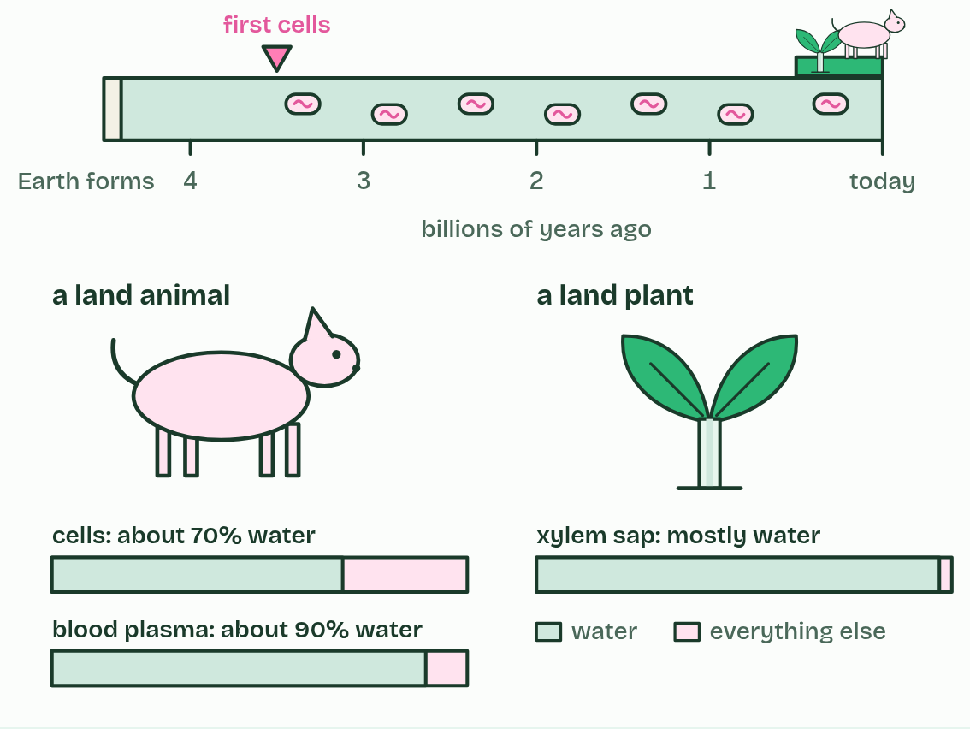  1 Liquid water appeared very early, over 4 billion years ago.  2 The first cells lived in it, more than 3.5 billion years ago, and for about three billion years every living thing stayed there.  3 Plants and animals reached land only in the last 500 million years or so.  4 Even there, life carries its water inside it: cells, blood plasma and xylem sap are all mostly water.
  SPOT THE MISTAKE
  A student writes: “Land animals live without water.” Spot the mistake, then put it right.
  "Land animals live without water." They do not: they carry it inside them, and every reaction in their cells still happens in water.
SUMMARY
Sum up section 01 in two or three sentences of your own.
• Water is the medium for life, and the chemistry it carries, metabolism, still happens in it today.
• Its cytoplasm is an aqueous solution, and most of the reactions of metabolism take place in it. Blood plasma, about 90% water, and xylem sap carry dissolved substances round bodies and plants.

02 A lopsided molecule makes hydrogen bonds | A1.1.2
CUES  Predict: Water boils in a kettle. Which bonds break as it turns to steam?  C: The hydrogen bonds between molecules, so the steam is still made of water molecules. Only the hydrogen bonds. Boiling and evaporation separate whole molecules from one another, and the covalent bonds, about twenty times stronger, stay as they are. Breaking all those hydrogen bonds is why water needs so much heat to boil or evaporate, and why sweat cools you. The dry lab puts a number on it.  What is meant by covalent bonds?  A bond in which two atoms share a pair of electrons.  What is meant by polar covalent bond?  A covalent bond in which the electrons are shared unequally, so one end is slightly negative and the other slightly positive.  What is meant by partial charges?  Charges smaller than a whole electron's, written δ+ and δ−. The molecule as a whole stays neutral.  What is meant by polar molecule?  A molecule with one side slightly negative and the other slightly positive.  What is meant by hydrogen bond?  The weak attraction between a slightly positive hydrogen of one molecule and a slightly negative atom, here oxygen, of another.  What is meant by latent heat of vaporisation?  The energy needed to turn 1 g of a liquid into a gas without changing its temperature. | NOTES  1 A water molecule is one oxygen atom joined to two hydrogen atoms by covalent bonds, and it is bent, with about 104.5° between the two bonds.  2 Oxygen is more electronegative: it pulls on the shared electrons harder than hydrogen does, so they spend more time near the oxygen. That makes each O–H bond a polar covalent bond.  3 The oxygen end gains a small negative charge and each hydrogen a small positive one: partial charges, written δ− and δ+.  4 The molecule is bent, so one side is negative and the other positive, and the whole thing is a polar molecule.  5 The δ+ hydrogen of one molecule is pulled towards the δ− oxygen of its neighbour, and that attraction is a hydrogen bond.  6 Each gram that evaporates takes about 2.4 kJ, the latent heat of vaporisation.  7 Draw it the IB way: solid lines for covalent bonds, dashed lines for hydrogen bonds.  Your own notes  ANNOTATE THE FIGURE  Number the 6 steps on the figure and note what happens at each: 1 bent; 2 electrons; 3 partial; 4 hydrogen bond; 5 four; 6 Draw it like this.  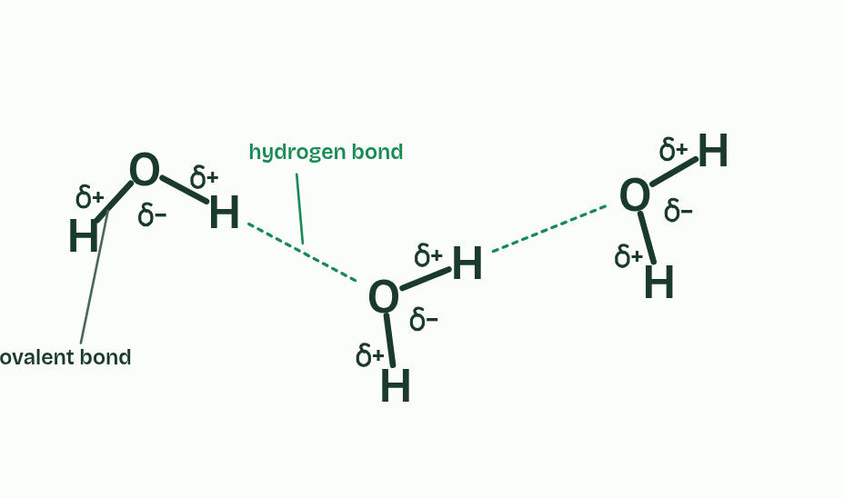  1 One water molecule: an oxygen with two hydrogens, bent, with about 104.5° between the bonds.  2 The shared electrons (the pink cloud) crowd round the oxygen and thin out round each hydrogen.  3 So the oxygen is slightly negative and each hydrogen slightly positive: partial charges, not whole ones.  4 A second molecule turns its oxygen to face a hydrogen of the first, and a dashed line joins them: a hydrogen bond.  5 One molecule can make up to four: two through its hydrogens and two to its oxygen.  6 The notation the exam wants: letters, solid lines for covalent bonds, dashed lines for hydrogen bonds, and δ signs. Draw it like this.  ANNOTATE THE FIGURE  Number the 3 steps on the figure and note what happens at each: 1 polar; 2 hydrogen bond; 3 break and form.  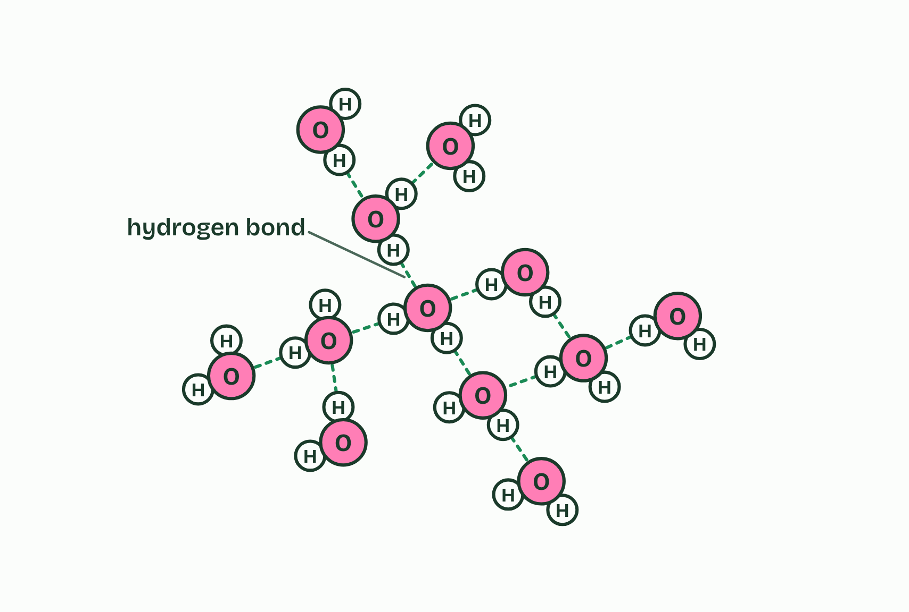  1 Each water molecule is polar: the oxygen is slightly negative and the hydrogens slightly positive.  2 A slightly positive hydrogen is attracted to the oxygen of another molecule: a hydrogen bond.  3 Each bond lasts only a moment. They break and form all the time as the molecules move; in liquid water most molecules are held by several at once.  REMEMBER IT  What hydrogen bonds give water
  C  Cats | A  Avoid | T  Taking | S  Showers
  Cohesion  water sticks to water (chapter 3) | Adhesion  water sticks to polar or charged surfaces (chapter 4) | Thermal  slow to warm, and takes a lot of heat to evaporate (here and chapter 6) | Solvent  dissolves polar and charged substances (chapter 5)
  SPOT THE MISTAKE
  A student writes: “A hydrogen bond is the bond between O and H inside a water molecule.” Spot the mistake, then put it right.
  "A hydrogen bond is the bond between O and H inside a water molecule." Those are covalent bonds. A hydrogen bond is between molecules.
SUMMARY
Sum up section 02 in two or three sentences of your own.
• Draw it the IB way: solid lines for covalent bonds, dashed lines for hydrogen bonds.
• Write δ+ and δ−, never a bare + or −: the molecule is neutral overall.

03 Water holds on to itself | A1.1.3
CUES  Predict: Ground pepper floats on a bowl of water. You touch the middle of the surface with a finger dipped in washing-up liquid. What does the pepper do?  A: It shoots out to the edge of the bowl, dragged by the clean surface that is still pulling all round. It shoots outwards. Soap molecules crowd into the surface where you touch it and weaken the hydrogen bonding there, so the surface tension falls in the middle. The clean surface all round still pulls strongly and drags the water, and the pepper on it, to the edges. Detergent in a pond does the same to a pond skater: with less surface tension to stand on, it sinks.  What is meant by cohesion?  The attraction between molecules of the same substance. In water it is caused by hydrogen bonds.  What is meant by surface tension?  The tendency of a liquid's surface to resist being broken, because the molecules at the surface are pulled together and inwards.  What is meant by transpiration?  The loss of water vapour from a plant, mostly through pores in its leaves.  What is meant by xylem?  The tubes that carry water and dissolved minerals up a plant.  What is meant by tension?  A pulling force. Water in the xylem is pulled up the plant, not pushed. | NOTES  1 Hydrogen bonds make water molecules stick to one another. That is cohesion.  2 The surface molecules cling together and the surface acts like a stretched film that resists being broken. That is surface tension, and water's is higher than that of almost any other common liquid.  3 In a leaf, water evaporates from the wet walls of cells and leaves as vapour through small pores, which is transpiration.  4 That pulls water out of the xylem.  5 The water is under tension: it is being pulled, not pushed.  Your own notes  ANNOTATE THE FIGURE  Number the 5 steps on the figure and note what happens at each: 1 dimple; 2 every direction; 3 sideways and inwards, surface tension; 4 hairs; 5 larva.  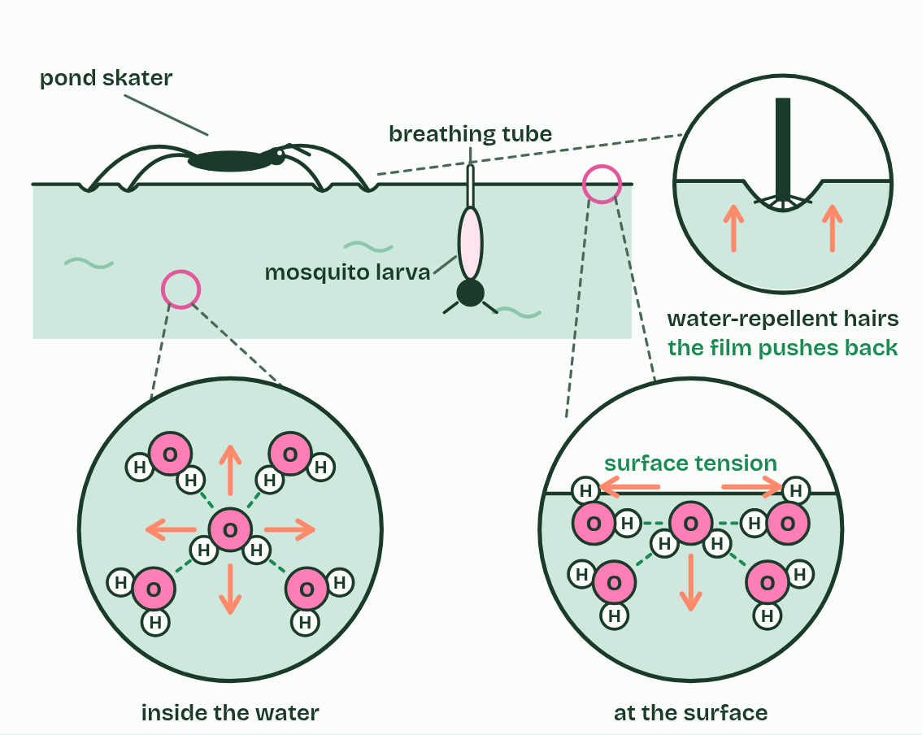  1 A pond skater stands on water. Its long legs spread its weight, and each foot makes a small dimple in the surface.  2 Inside the water, each molecule is pulled by its neighbours equally in every direction, so it stays where it is.  3 At the surface there are no neighbours above: the pull is sideways and inwards, and the surface holds together like a stretched film. That is surface tension.  4 Close up, water-repellent hairs on the foot press the film into a dimple without breaking it, and the film pushes back up.  5 A mosquito larva hangs from the underside of the film and breathes through a tube that pokes through it.  ANNOTATE THE FIGURE  Annotate this still from the animation (Watch it happen: pulling water up a stem): what is happening, and why?  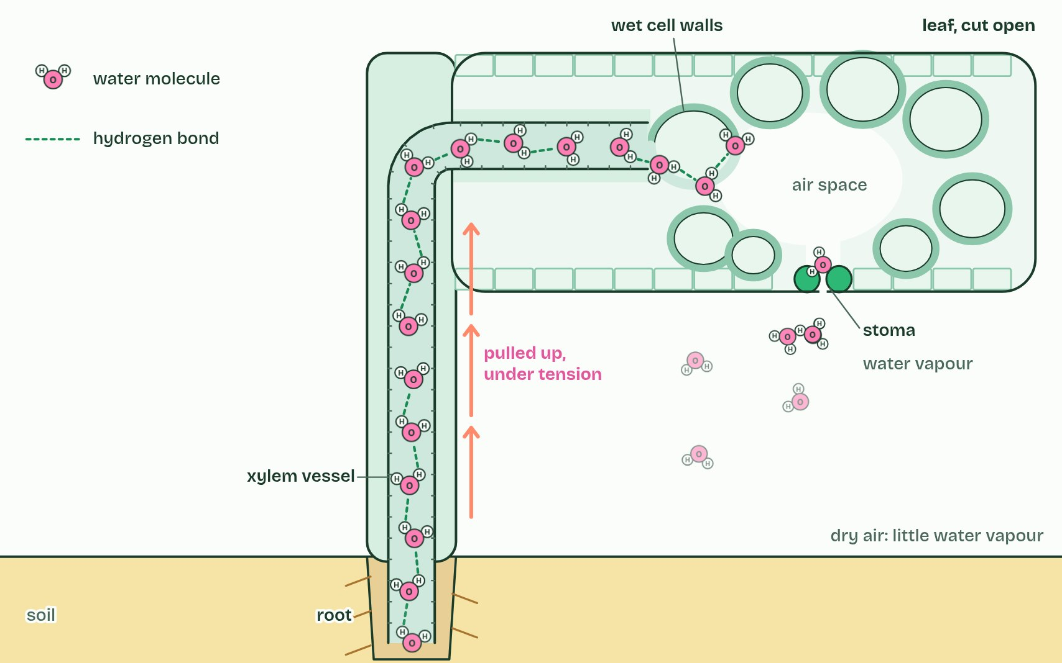  1 Water evaporates from the wet cell walls in the leaf and escapes through a stoma.  2 Each molecule that leaves pulls on the next: hydrogen bonds hold the column together.  3 The whole column is pulled up from the roots, under tension.
  SPOT THE MISTAKE
  A student writes: “Capillary action lifts water to the top of a tree.” Spot the mistake, then put it right.
  "Capillary action lifts water to the top of a tree." In a xylem vessel, capillary action alone would lift water only a metre or so at most, and far less in wider vessels. The pull comes from evaporation in the leaves, passed down the column by cohesion.
SUMMARY
Sum up section 03 in two or three sentences of your own.
• Hydrogen bonds make water molecules stick to one another. That is cohesion.
• The surface molecules cling together and the surface acts like a stretched film that resists being broken. That is surface tension, and water's is higher than that of almost any other common liquid.
• In a leaf, water evaporates from the wet walls of cells and leaves as vapour through small pores, which is transpiration.
• That pulls water out of the xylem.

04 Water clings to polar surfaces | A1.1.4
CUES  Predict: Three cups in a row: red water, an empty cup, blue water. A strip of paper towel bridges each full cup and the empty one. What is in the middle cup a few hours later?  C: Purple water, rising until the levels even out, because water creeps along paper from both sides. Purple water. Paper towel is cellulose. Water adheres to its fibres and creeps up and along the strip by capillary action, cohesion pulling the rest behind, and drips into the empty cup until the levels even out. Both colours arrive and mix. The same process keeps the walls of a leaf's cells wet and moves water through soil.  What is meant by adhesion?  The attraction between water and a different material that is polar or charged, through hydrogen bonds or ionic attractions.  What is meant by cellulose?  The carbohydrate that makes plant cell walls, built from long chains of glucose and covered in OH groups.  What is meant by capillary action?  The movement of water along a narrow space against gravity, caused by adhesion to the walls and cohesion between the water molecules. | NOTES  1 Water is attracted to other materials too, as long as they are polar or carry a charge. That is adhesion: hydrogen bonds or ionic attractions pull water on to the surface.  2 So does cellulose, which is covered in OH groups, and so do the charged surfaces of clay and humus in soil.  3 Water adheres to the walls and creeps up them, and cohesion drags the rest of the water along behind. This is capillary action.  4 Water is attracted to the polar glass wall and forms bonds with it: adhesion. The water’s edge curves up where it meets the glass.  5 Cohesion drags more water up behind the edge, and the column rises until its weight balances the pull.  6 The narrower the tube, the higher the water climbs.  Your own notes  ANNOTATE THE FIGURE  Number the 5 steps on the figure and note what happens at each: 1 adhesion; 2 Cohesion; 3 narrower; 4 below; 5 soil, cellulose.  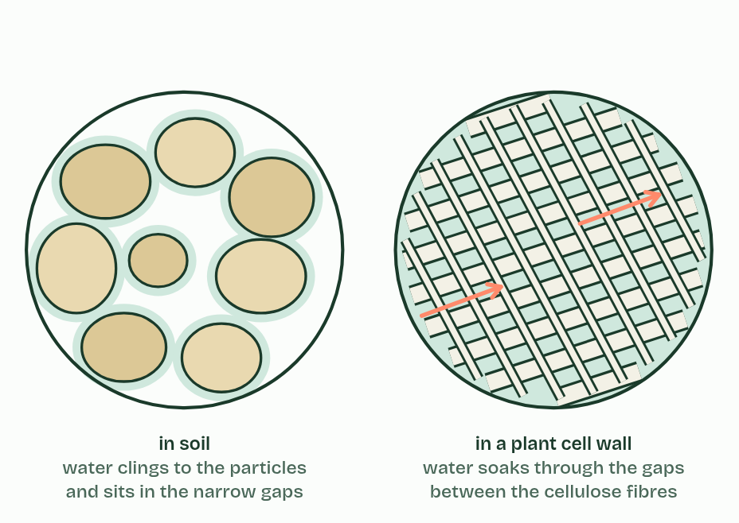  1 Water is attracted to the polar glass wall and forms bonds with it: adhesion. The water’s edge curves up where it meets the glass.  2 Cohesion drags more water up behind the edge, and the column rises until its weight balances the pull.  3 The narrower the tube, the higher the water climbs.  4 Wax has nothing for water to cling to: with no adhesion the surface curves down and sits below the level outside.  5 The same pull holds water between soil particles and soaks it through the gaps in a cellulose cell wall.  REMEMBER IT  Cohesion or adhesion?
  C  Clones | A  Anything
  Cohesion  water clings to its clones: other water molecules | Adhesion  water clings to anything polar or charged: glass, cellulose, soil
  SPOT THE MISTAKE
  A student writes: “Cohesion and adhesion are the same thing.” Spot the mistake, then put it right.
  "Cohesion and adhesion are the same thing." Cohesion is water to water. Adhesion is water to a different material that is polar or charged. Capillary action needs both.
SUMMARY
Sum up section 04 in two or three sentences of your own.
• Water is attracted to other materials too, as long as they are polar or carry a charge. That is adhesion: hydrogen bonds or ionic attractions pull water on to the surface.
• So does cellulose, which is covered in OH groups, and so do the charged surfaces of clay and humus in soil.
• Water adheres to the walls and creeps up them, and cohesion drags the rest of the water along behind. This is capillary action.

05 The solvent cells run in | A1.1.5
CUES  Predict: Fish get all their oxygen from water. Oxygen molecules (O2) are non-polar. How does the oxygen get into the water?  C: Small non-polar molecules dissolve a little, and a little is enough to reach the gills. A little dissolves. A litre of water at 20 °C holds only about 9 mg of oxygen, about a thirtieth of the oxygen in a litre of air. Small non-polar molecules such as oxygen slip in between water molecules in small amounts. It is enough for fish, which pass a great deal of water over large gills. Warm water holds even less, which is why fish gasp at the surface in a heatwave.  What is meant by solution?  A mixture of a solute dissolved in a solvent.  What is meant by solute?  A substance that dissolves in a solvent.  What is meant by solvent?  The liquid that a solute dissolves in. Water is the solvent in cells.  What is meant by solvation?  The surrounding of dissolved ions or molecules by water molecules (or another solvent).  What is meant by hydrophilic?  Attracted to water. Polar and charged substances are hydrophilic.  What is meant by hydrophobic?  Not attracted to water. Non-polar substances are hydrophobic.  What is meant by enzymes?  A protein that speeds up a chemical reaction in a cell without being used up. | NOTES  1 A solution is a solute dissolved in a solvent.  2 Each dissolved particle ends up wrapped in water molecules, which is called solvation.  3 Substances that are polar or charged are hydrophilic.  4 Substances that are non-polar, such as fats, oils and waxes, are hydrophobic: water molecules bond to each other instead, which pushes the non-polar molecules together, as oil forms droplets.  5 Most enzymes catalyse reactions in aqueous solution, in the cytoplasm and in the fluids inside organelles, where dissolved enzymes and substrates move about and collide.  Your own notes  ANNOTATE THE FIGURE  Number the 5 steps on the figure and note what happens at each: 1 ions; 2 oxygen, hydrogens; 3 shell; 4 hydrogen bonds; 5 non-polar.  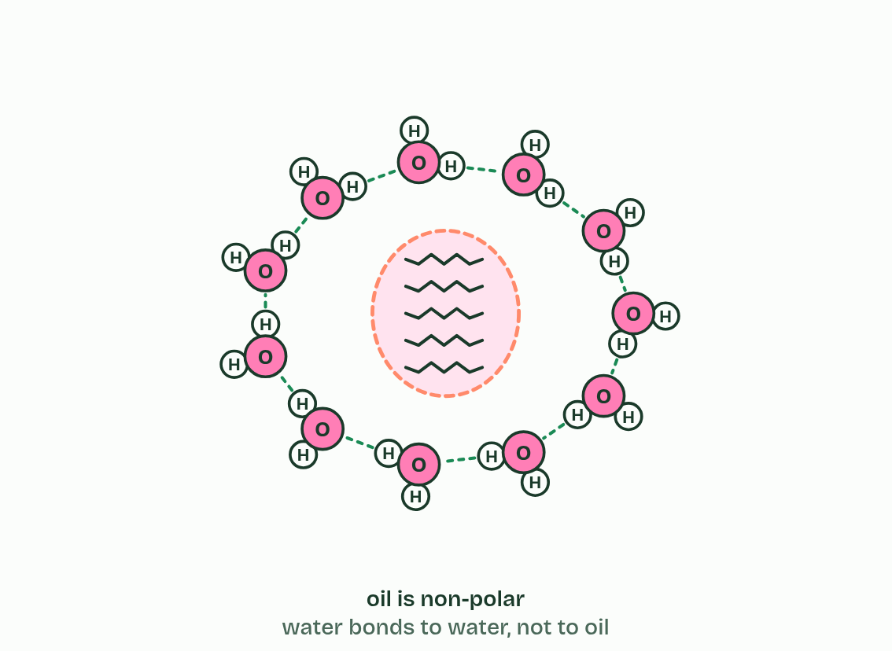  1 A grain of salt is a lattice of ions, sodium (Na+) and chloride (Cl−), held together by their opposite charges.  2 Water molecules turn to face the ions, oxygen towards Na+ and hydrogens towards Cl−, and together they pull ions loose.  3 Dissolved: every ion is wrapped in its own shell of water molecules and drifts away from the rest.  4 A sugar is covered in OH groups, which make hydrogen bonds with water, so it dissolves too.  5 Oil molecules are non-polar. Water bonds to water, not to oil, so the oil is pushed together into a droplet.  ANNOTATE THE FIGURE  Label the key parts and add a note on what it shows.  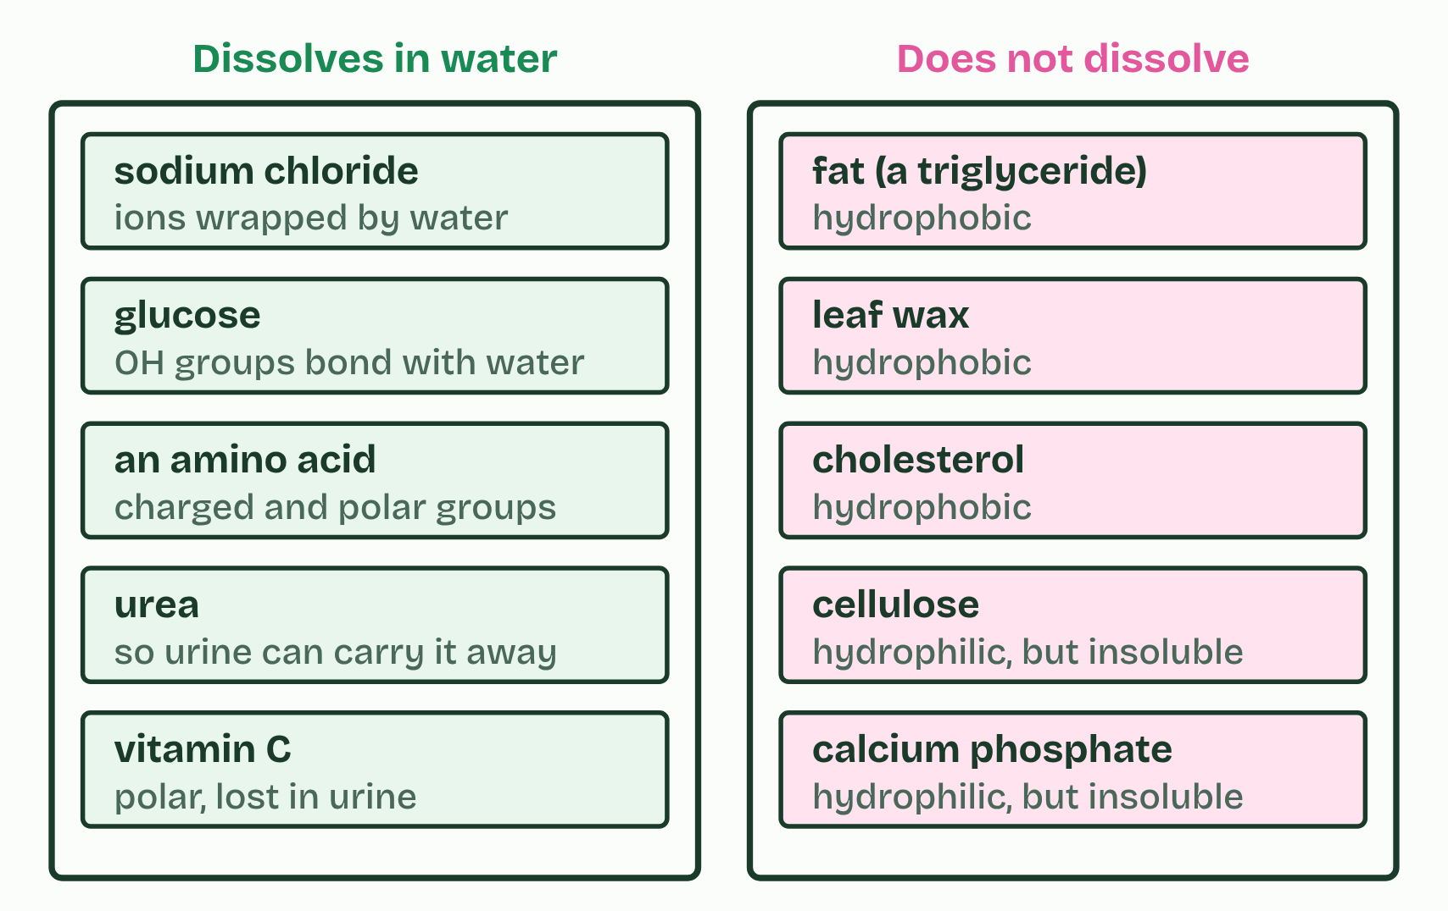  Ten substances sorted: five dissolve in water and five do not. The five that do not are useful because of it: wax keeps water in the leaf, fat stores energy and insulates, cholesterol is part of membranes, cellulose makes cell walls that must not dissolve, and calcium phosphate makes bones that last.
  SPOT THE MISTAKE
  A student writes: “Water is the universal solvent.” Spot the mistake, then put it right.
  "Water is the universal solvent." It dissolves more substances than any other common liquid, but not everything: fats, waxes, cellulose and bone mineral do not dissolve, and life depends on that.
SUMMARY
Sum up section 05 in two or three sentences of your own.
• A solution is a solute dissolved in a solvent.
• Each dissolved particle ends up wrapped in water molecules, which is called solvation.
• Substances that are polar or charged are hydrophilic.
• Substances that are non-polar, such as fats, oils and waxes, are hydrophobic: water molecules bond to each other instead, which pushes the non-polar molecules together, as oil forms droplets.

06 Life in water, life in air | A1.1.6
CUES  Predict: Ringed seal pups are born in snow caves on the sea ice, with thick woolly fur but almost no blubber. What happens to a young pup that has to stay in the sea for a long time?  B: It chills fast: soaked fur holds no air, and water draws heat away about 23 times faster than air does. It chills fast. The woolly fur keeps a pup warm in the snow cave because it traps air, a poor conductor of heat. Soaked, it holds water instead, and the pup has almost no blubber yet. The sea, at about −1.8 °C, is indeed warmer than the winter air, but water draws heat away so much faster that the pup loses heat far more quickly in it. That is why the snow caves matter.  What is meant by buoyancy?  The upward push of a fluid on an object in it. In water it is almost as large as the object's weight; in air it is tiny.  What is meant by viscosity?  How much a fluid resists flowing past or round an object.  What is meant by drag?  The force that resists movement through a fluid.  What is meant by thermal conductivity?  How fast heat flows through a material. Water conducts heat much faster than air.  What is meant by specific heat capacity?  The energy needed to warm 1 g of a substance by 1 °C. Water's is unusually high.  What is meant by blubber?  A thick layer of fat under the skin of a seal or whale that insulates it. | NOTES  1 It lives on and under the sea ice, keeps breathing holes open with its claws, and is kept warm in the water by a thick layer of blubber.  2 Viscosity. Water is about 55 times as viscous as air, and far denser, so a body moving through it meets much more drag. Streamlined shapes save energy.  Your own notes  ANNOTATE THE FIGURE  The figure shows it as Buoyancy, Viscosity, Heat flow and Heat capacity. Note what changes each time.  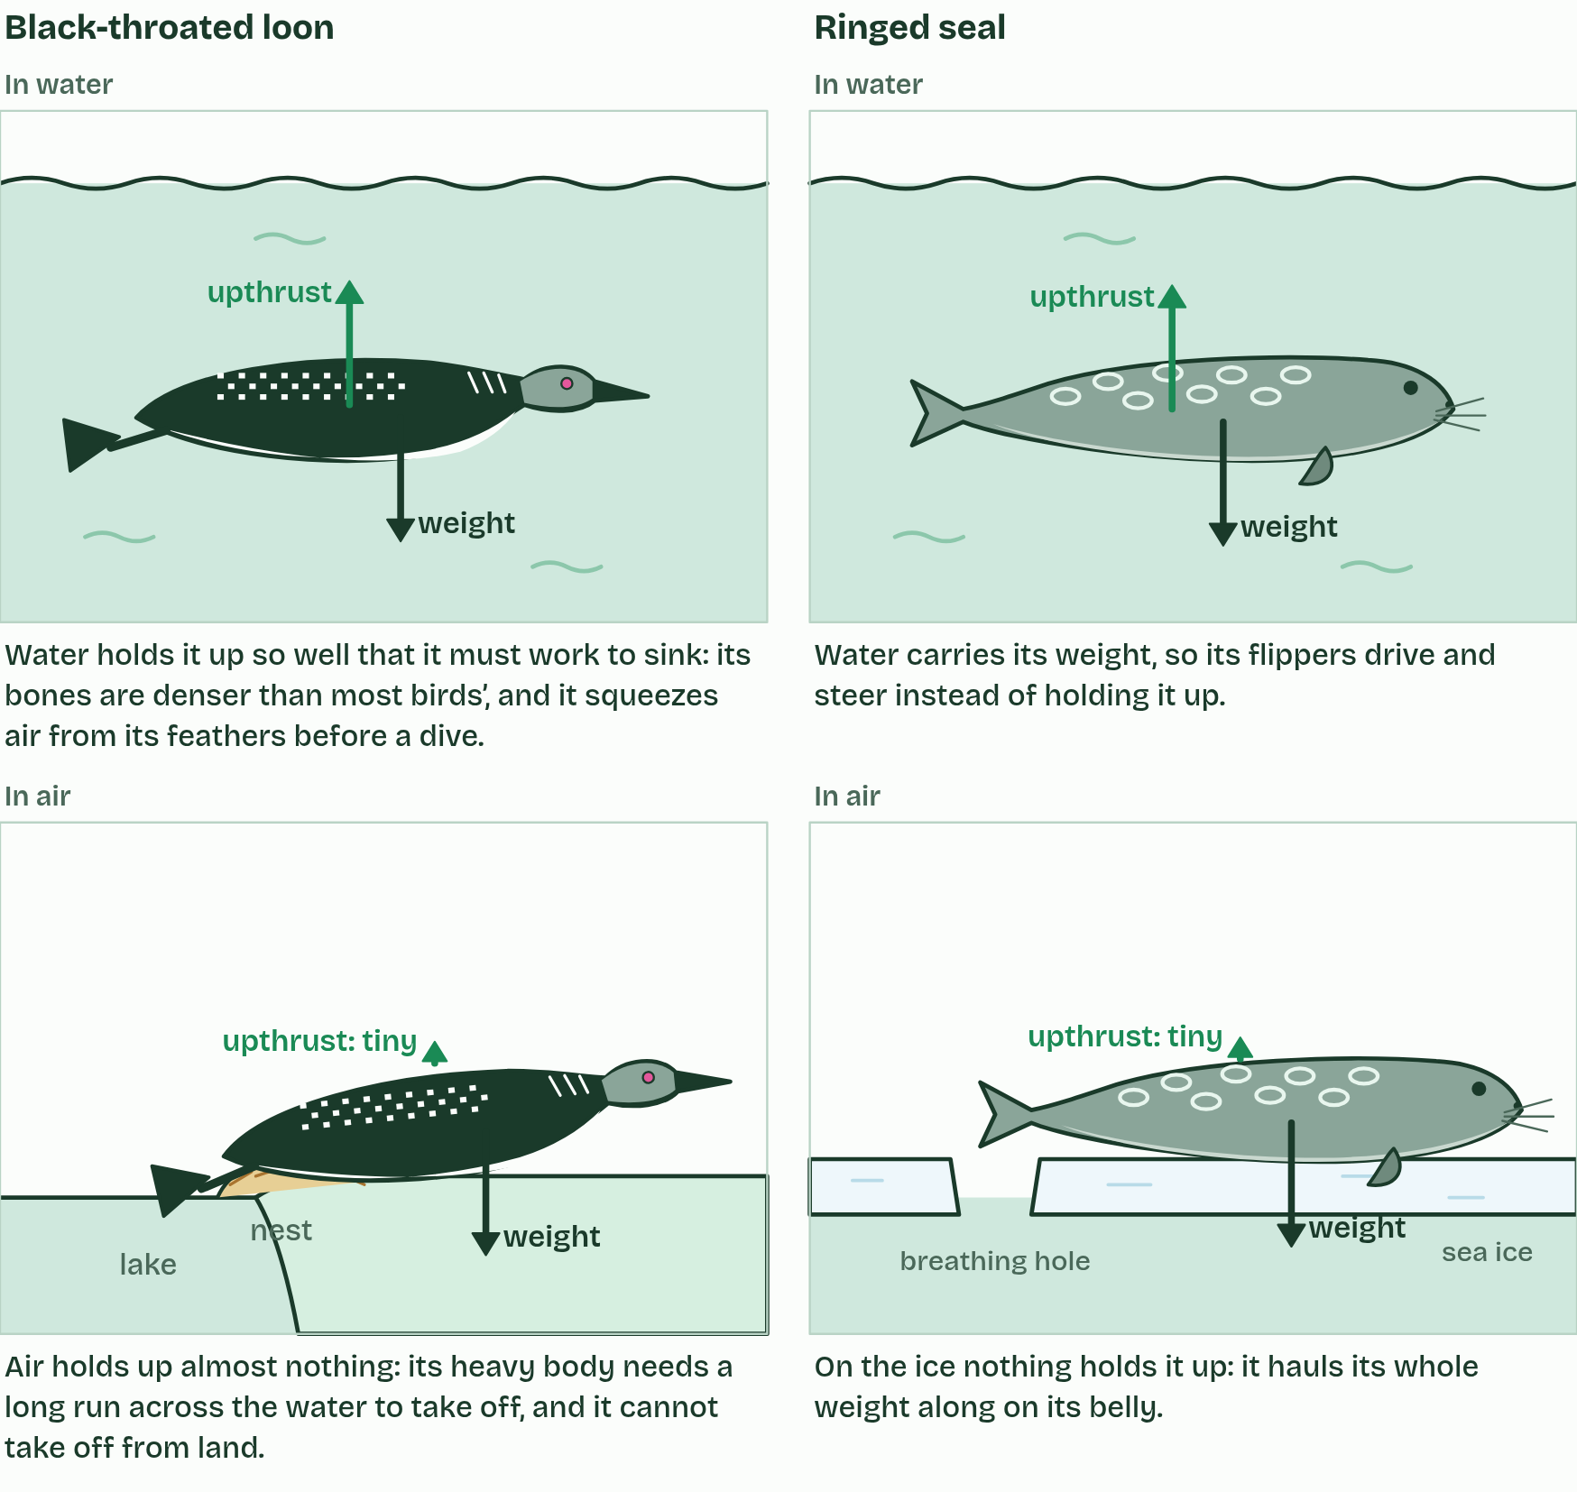  1 Buoyancy  2 Viscosity  3 Heat flow  4 Heat capacity  REMEMBER IT  The four properties A1.1.6 compares
  B  Big | V  Vessels | T  Turn | S  Slowly
  Buoyancy  water holds a body up | Viscosity  water resists movement: more drag | Thermal conductivity  water draws heat from a body fast | Specific heat capacity  water's temperature changes slowly
  SPOT THE MISTAKE
  A student writes: “Thermal conductivity and specific heat capacity are the same.” Spot the mistake, then put it right.
  "Thermal conductivity and specific heat capacity are the same." Water is high in both: it drains heat from a warm body quickly, while its own temperature hardly changes.
SUMMARY
Sum up section 06 in two or three sentences of your own.
• Buoyancy. Water is over 800 times as dense as air, so it pushes up on a body with almost as much force as the body weighs. Air hardly supports a body at all.
• Viscosity. Water is about 55 times as viscous as air, and far denser, so a body moving through it meets much more drag. Streamlined shapes save energy.
• Thermal conductivity. Water conducts heat about 23 times as fast as air, so a warm body loses heat far faster in water than in air at the same temperature. Animals in cold water need thick insulation.
• Specific heat capacity. It takes about 4.2 J to warm 1 g of water by 1 °C, about four times as much as for 1 g of air, and a litre of water holds about 3,500 times as much heat for each degree as a litre of air. Much of the energy goes into breaking hydrogen bonds before the molecules can move faster. So lakes and seas change temperature slowly, from day to night and season to season, and make a stable habitat.

07 Water from space, kept by gravity | A1.1.7 HL
CUES  Predict: Venus is almost the same size and mass as Earth, but closer to the Sun. Why are there no oceans on Venus?  A: It is too hot for water vapour to condense into liquid, so any water stayed in the air as vapour. Too hot. Venus's gravity is nearly as strong as Earth's, so gravity is not the problem. Its surface is about 460 °C today, so its water stayed as vapour and has since been lost. A planet needs both: enough gravity, and temperatures low enough for water to condense.  What is meant by asteroids?  A rocky body left over from the formation of the Solar System, most of them orbiting the Sun between Mars and Jupiter.  What is meant by hypothesis?  An explanation that can be tested with evidence, but has not been proved.  What is meant by condense?  Change from a gas to a liquid. | NOTES  1 Much of its water is thought to have come from space. Asteroids crashed into the young planet, and some of them had water locked inside their minerals.  2 That is the hypothesis this statement asks for.  3 Temperatures low enough for water to condense. Earth is far enough from the Sun, and cooled enough, for water vapour to condense into liquid water. It rained out to form oceans that have lasted about four billion years.  4 Asteroids crash into it. Some carry water locked inside their minerals, and they bring it to the planet.  5 The water turns to vapour and fills the air. Earth’s gravity holds it, and the rest of the atmosphere, in.  6 Earth cools until the temperature is low enough for the vapour to condense. It rains, and oceans form.  Your own notes  ANNOTATE THE FIGURE  Number the 5 steps on the figure and note what happens at each.  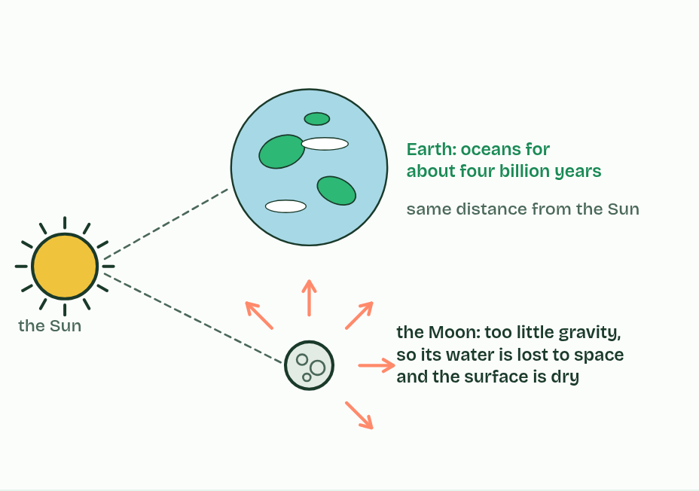  1 The young Earth, about 4.5 billion years ago, is hot, with no oceans.  2 Asteroids crash into it. Some carry water locked inside their minerals, and they bring it to the planet.  3 The water turns to vapour and fills the air. Earth’s gravity holds it, and the rest of the atmosphere, in.  4 Earth cools until the temperature is low enough for the vapour to condense. It rains, and oceans form.  5 The Moon, at the same distance from the Sun, has too little gravity to hold water, and stays dry. Earth’s oceans have lasted about four billion years.  REMEMBER IT  Why Earth kept its water
  G  Grip | C  Chill
  Gravity  holds water vapour and air to the planet | Cool enough to condense  temperatures low enough for vapour to become liquid
  SPOT THE MISTAKE
  A student writes: “Earth kept its water because it has an atmosphere.” Spot the mistake, then put it right.
  "Earth kept its water because it has an atmosphere." The atmosphere is itself held by gravity. The two reasons to learn are gravity and temperatures low enough to condense water.
SUMMARY
Sum up section 07 in two or three sentences of your own.
• Gravity. Earth is massive enough for its gravity to hold water vapour and the rest of the atmosphere. The Moon, with about a hundredth of Earth's mass, could not, and has almost no water: only a little ice in craters that sunlight never reaches.
• Temperatures low enough for water to condense. Earth is far enough from the Sun, and cooled enough, for water vapour to condense into liquid water. It rained out to form oceans that have lasted about four billion years.

08 Not too hot, not too cold: the Goldilocks zone | A1.1.8 HL
CUES  Predict: A star gives out much less energy than the Sun. Where would its Goldilocks zone be?  C: Much closer to the star, so that a planet there still receives enough energy to keep water liquid. Much closer. A planet must be near a dim star to receive enough energy to keep water liquid. Round red dwarfs, the commonest stars in our galaxy, the zone is so close that a planet's year there lasts only days or weeks.  What is meant by extraterrestrial?  Beyond Earth.  What is meant by goldilocks zone?  The band of distances from a star at which a planet's surface could be warm enough for water not to freeze and cool enough for it not to boil away. Also called the habitable zone.  What is meant by exoplanets?  A planet that orbits a star other than the Sun. | NOTES  1 All the life we know needs liquid water as its medium (chapters 1 and 5), so the search for extraterrestrial life starts by looking for liquid water.  2 The Goldilocks zone, also called the habitable zone, is the band of distances round a star where a planet's surface is warm enough for water not to freeze and cool enough for it not to boil away, so water could stay liquid.  3 Astronomers have now found more than 5,000 planets round other stars, called exoplanets.  4 A star warms the planets round it. The pale band is its Goldilocks zone: the distances at which a planet’s surface could keep liquid water.  5 Venus is closer than the zone’s inner edge. It is too hot: water would boil away as vapour.  6 Mars is beyond the outer edge, and small. It is too cold: its water is frozen and its air is thin.  Your own notes  ANNOTATE THE FIGURE  Number the 4 steps on the figure and note what happens at each: 1 Goldilocks zone; 2 too hot; 3 too cold; 4 just right.  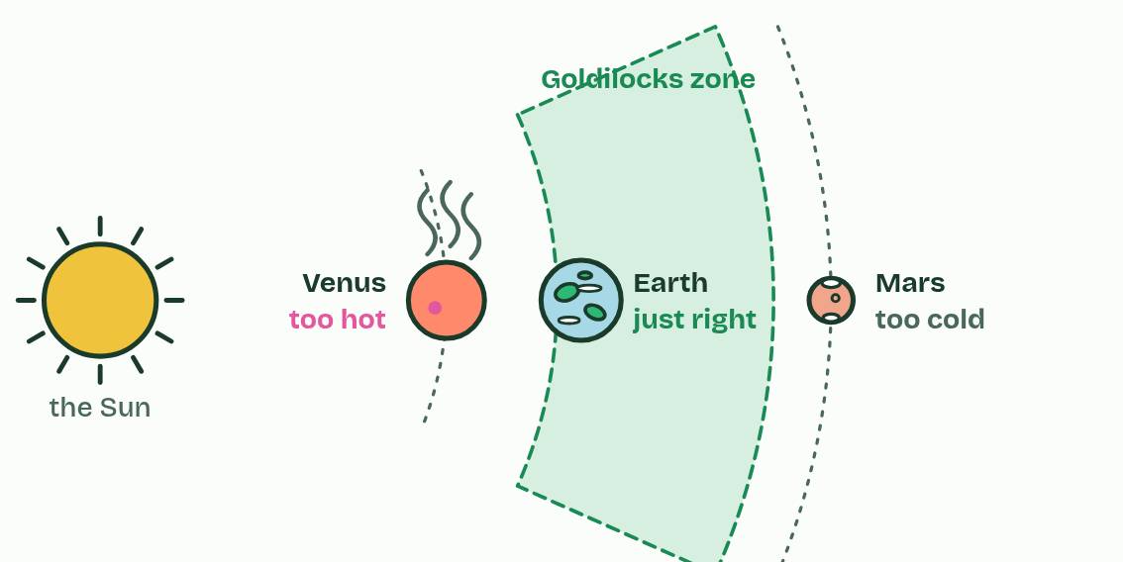  1 A star warms the planets round it. The pale band is its Goldilocks zone: the distances at which a planet’s surface could keep liquid water.  2 Venus is closer than the zone’s inner edge. It is too hot: water would boil away as vapour.  3 Mars is beyond the outer edge, and small. It is too cold: its water is frozen and its air is thin.  4 Earth is inside the zone: just right for liquid oceans.  ANNOTATE THE FIGURE  Annotate this still from the animation (Watch it happen: finding the zone): what is happening, and why?  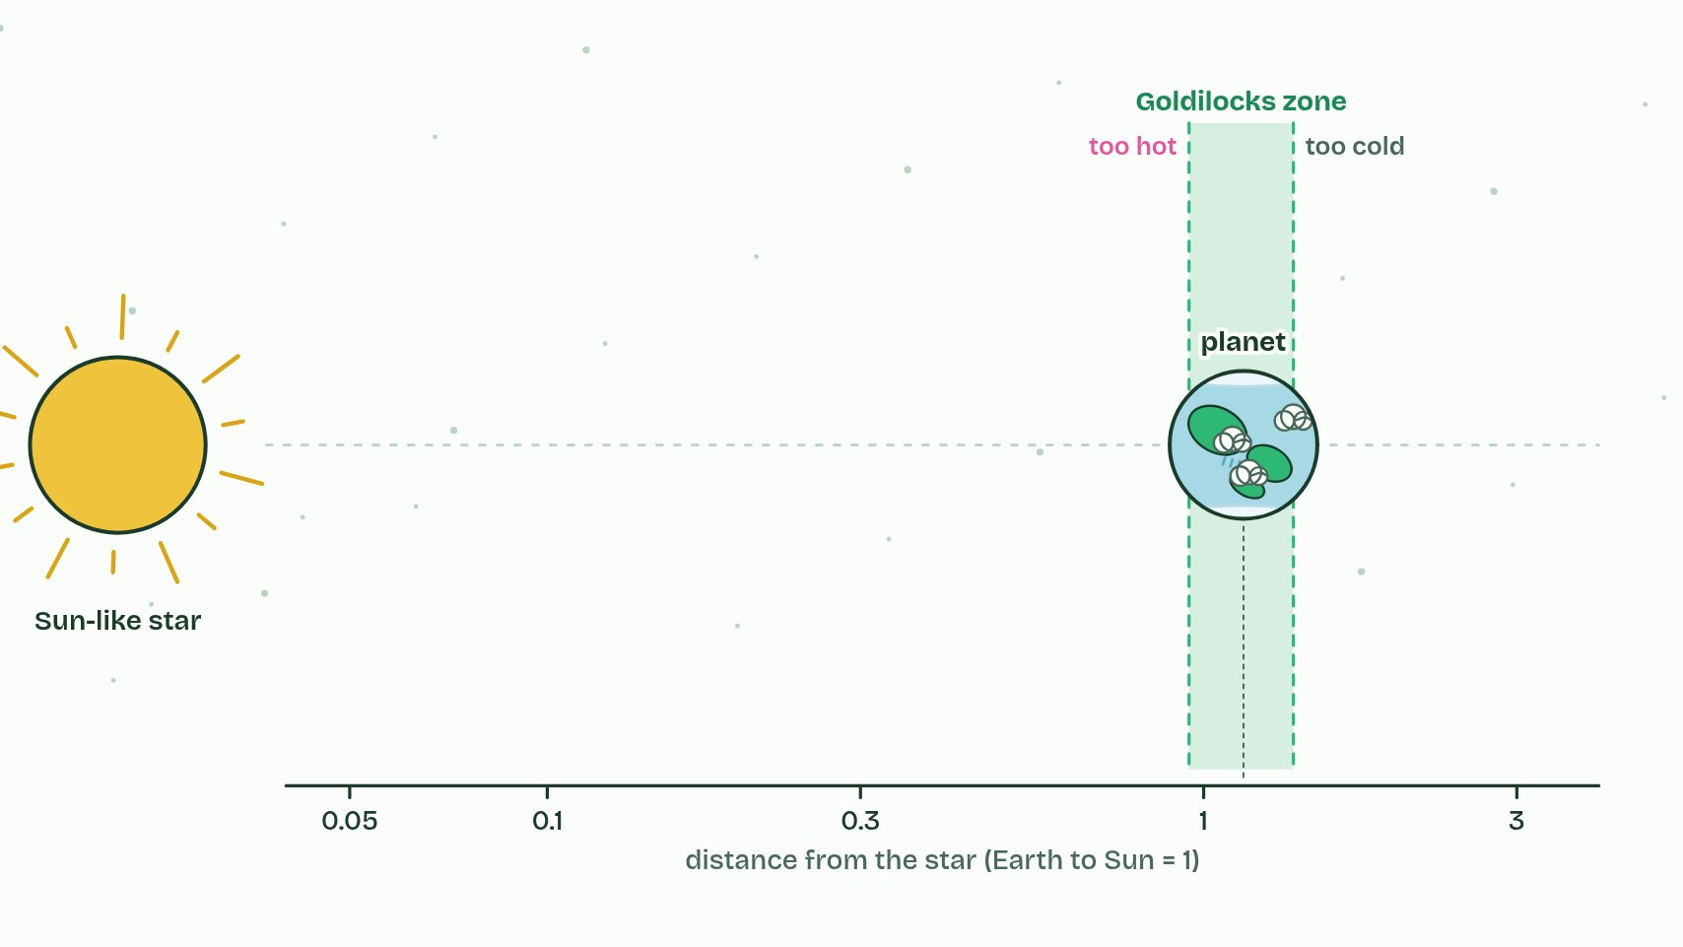  1 Too close, and water boils away.  2 Too far, and it freezes.  3 In between, in the Goldilocks zone, water can stay liquid.
  SPOT THE MISTAKE
  A student writes: “Every star's Goldilocks zone is at Earth's distance.” Spot the mistake, then put it right.
  "Every star's Goldilocks zone is at Earth's distance." It moves with the star's brightness.
SUMMARY
Sum up section 08 in two or three sentences of your own.
• All the life we know needs liquid water as its medium (chapters 1 and 5), so the search for extraterrestrial life starts by looking for liquid water.
• The Goldilocks zone, also called the habitable zone, is the band of distances round a star where a planet's surface is warm enough for water not to freeze and cool enough for it not to boil away, so water could stay liquid.
• Astronomers have now found more than 5,000 planets round other stars, called exoplanets.

Check yourself
The check for this guide is online: a fresh paper of past-paper style questions from the exam bank on A1.1 each time, marked as you go, and saved to your Exam practice progress when you are signed in. Open the link:
biologybybradford.com/exam-maker/sit?topics=A1.1&level=HL&paper=quiz&marks=15&src=ep

