Name | Class | Date
IB BIOLOGY · A1.1

Water
Notes to fill in alongside the guide. Each numbered block matches a chapter of the guide, and of the lesson slides. Write in the gaps, answer the cues, annotate the figures, and sum up each section in your own words.
BY THE END YOU CAN
Explain why water is the medium for life: where the first cells arose, and where life's processes still happen A1.1.1
Explain how unequal sharing of electrons makes water polar, and draw hydrogen bonds between water molecules with partial charges A1.1.2
Explain how cohesion lets water be pulled up xylem under tension, and lets animals live on its surface A1.1.3
Explain how adhesion draws water through soil and plant cell walls by capillary action A1.1.4
Explain why water is the medium for metabolism and transport, and why some molecules work because they do not dissolve A1.1.5
Compare water with air for buoyancy, viscosity, thermal conductivity and specific heat capacity, using the black-throated loon and the ringed seal A1.1.6
Outline how asteroids may have brought Earth's water, and why gravity and cool temperatures kept it A1.1.7
Explain why the search for life elsewhere looks for liquid water in a star's Goldilocks zone A1.1.8

01 Life began in water, and still runs in it | A1.1.1
CUES  Predict: A packet of dry bean seeds sits in a cupboard for three years. What is happening to the metabolism inside each seed?  What is meant by medium?  What is meant by metabolism?  What is meant by cytoplasm?  What is meant by aqueous solution?  What is meant by blood plasma? | NOTES  1 Water is the ________ for life, and the chemistry it carries, ______________, still happens in it today.  2 Its ____________ is an ______________________, and most of the reactions of metabolism take place in it. ________________, about 90% water, and xylem sap carry dissolved substances round bodies and plants.  3 Liquid ________ appeared very early, over 4 billion years ago.  4 The _______________ lived in it, more than 3.5 billion years ago, and for about three billion years every living thing stayed there.  5 Plants and animals reached ________ only in the last 500 million years or so.  6 Even there, life _________ its water inside it: cells, blood plasma and xylem sap are all mostly water.  Your own notes  ANNOTATE THE FIGURE  Number the 4 steps on the figure and note what happens at each: 1 water; 2 first cells; 3 land; 4 carries.  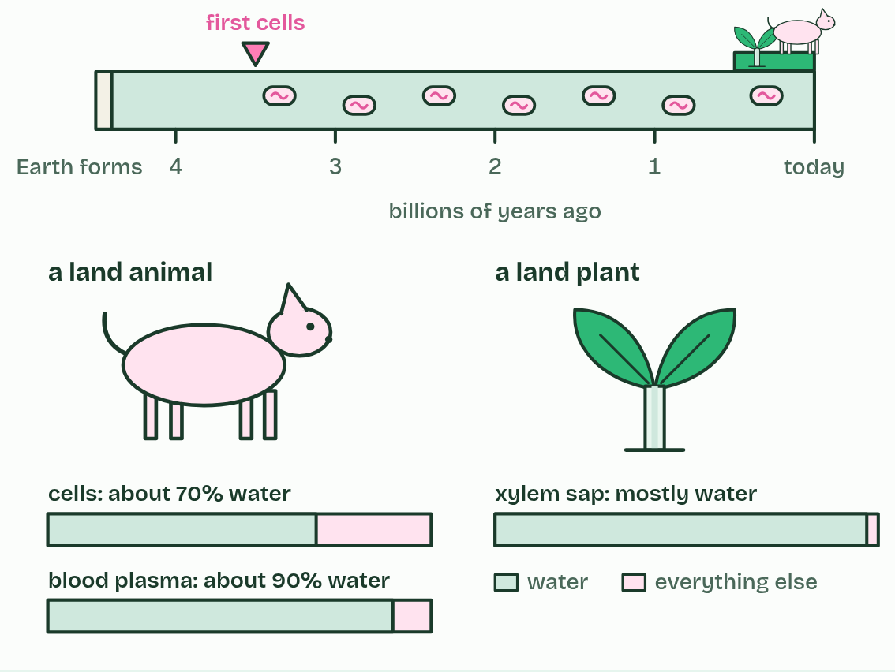
  SPOT THE MISTAKE
  A student writes: “Land animals live without water.” Spot the mistake, then put it right.
  The mistake
  Put it right
SUMMARY
Sum up section 01 in two or three sentences of your own.

02 A lopsided molecule makes hydrogen bonds | A1.1.2
CUES  Predict: Water boils in a kettle. Which bonds break as it turns to steam?  What is meant by covalent bonds?  What is meant by polar covalent bond?  What is meant by partial charges?  What is meant by polar molecule?  What is meant by hydrogen bond?  What is meant by latent heat of vaporisation? | NOTES  1 A water molecule is one oxygen atom joined to two hydrogen atoms by ___________________, and it is bent, with about 104.5° between the two bonds.  2 Oxygen is more electronegative: it pulls on the shared electrons harder than hydrogen does, so they spend more time near the oxygen. That makes each O–H bond a __________________________.  3 The oxygen end gains a small negative charge and each hydrogen a small positive one: ____________________, written δ− and δ+.  4 The molecule is bent, so one side is negative and the other positive, and the whole thing is a ___________________.  5 The δ+ hydrogen of one molecule is pulled towards the δ− oxygen of its neighbour, and that attraction is a __________________.  6 Each gram that evaporates takes about 2.4 kJ, the __________________________________.  7 Draw it the IB way: solid lines for ___________________, dashed lines for hydrogen bonds.  Your own notes  ANNOTATE THE FIGURE  Number the 6 steps on the figure and note what happens at each: 1 bent; 2 electrons; 3 partial; 4 hydrogen bond; 5 four; 6 Draw it like this.  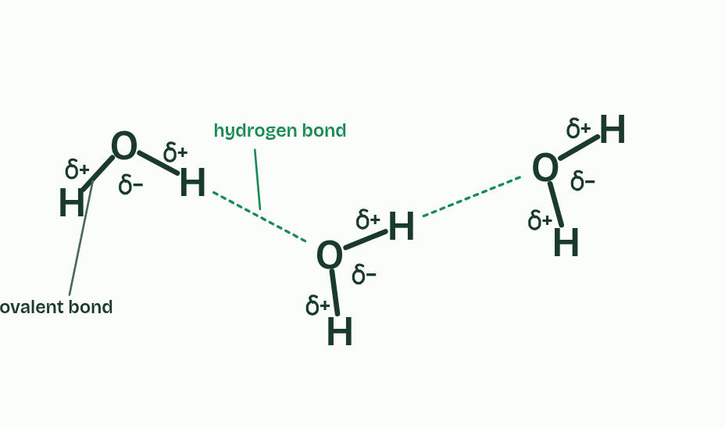  ANNOTATE THE FIGURE  Number the 3 steps on the figure and note what happens at each: 1 polar; 2 hydrogen bond; 3 break and form.  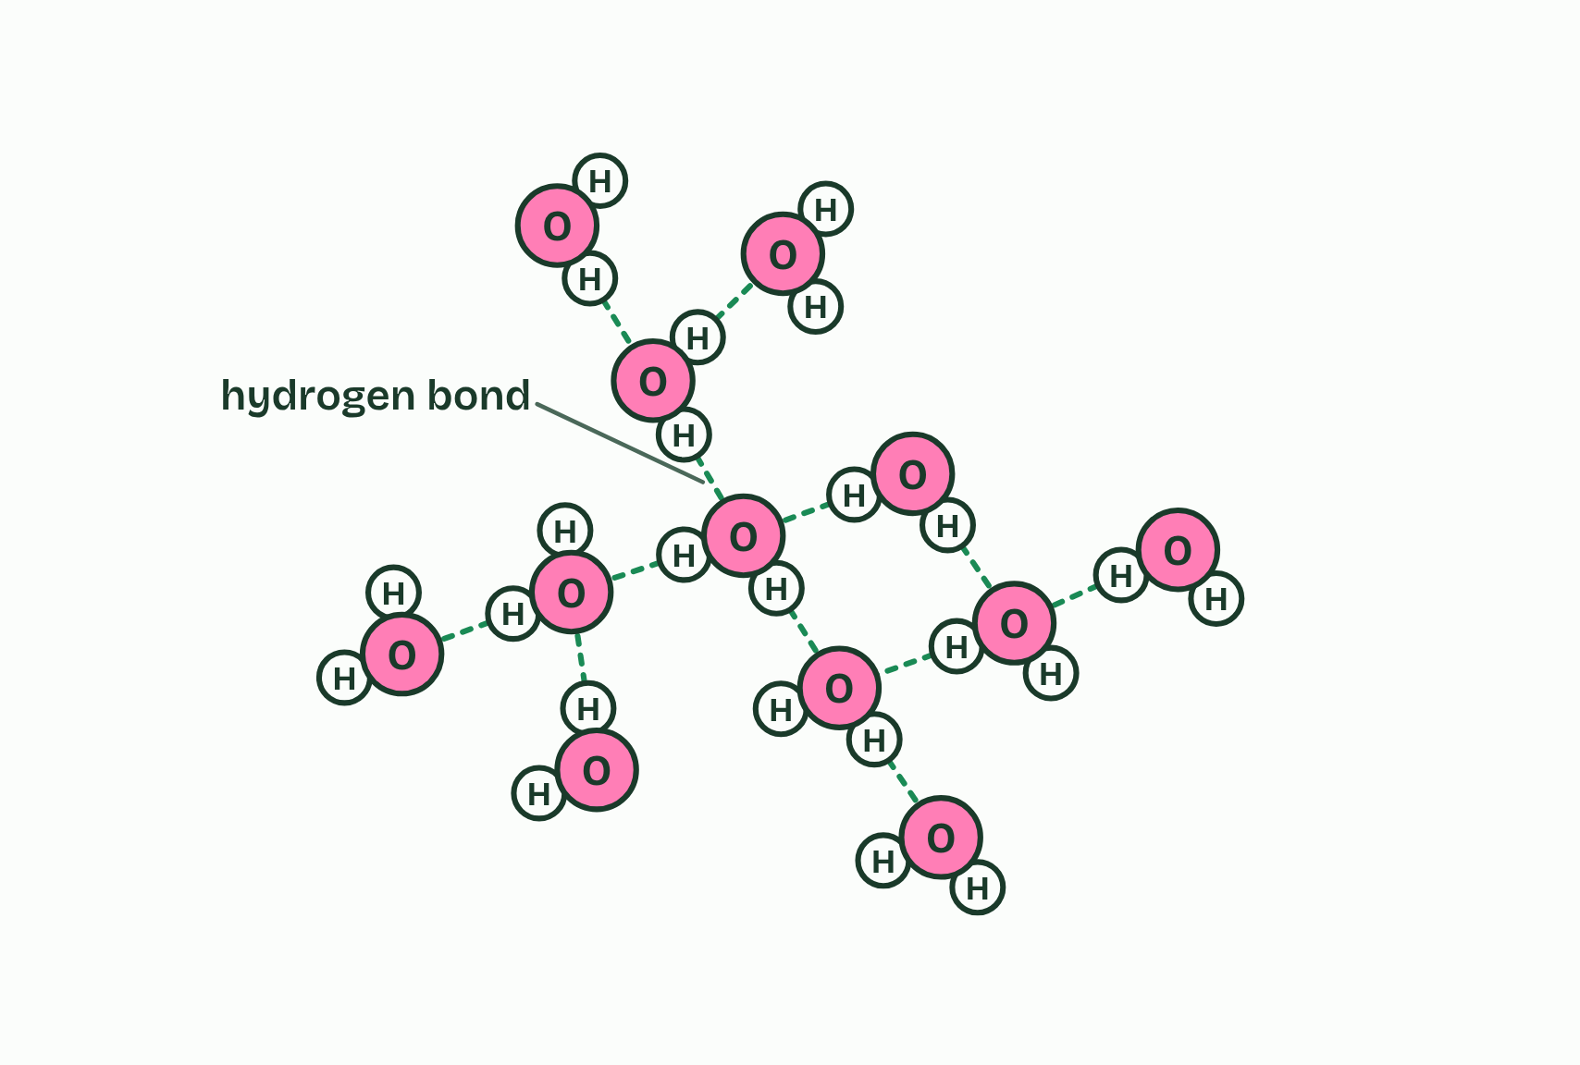  REMEMBER IT  What hydrogen bonds give water
  C  Cats | A  Avoid | T  Taking | S  Showers
  C | A | T | S
  SPOT THE MISTAKE
  A student writes: “A hydrogen bond is the bond between O and H inside a water molecule.” Spot the mistake, then put it right.
  The mistake
  Put it right
SUMMARY
Sum up section 02 in two or three sentences of your own.

03 Water holds on to itself | A1.1.3
CUES  Predict: Ground pepper floats on a bowl of water. You touch the middle of the surface with a finger dipped in washing-up liquid. What does the pepper do?  What is meant by cohesion?  What is meant by surface tension?  What is meant by transpiration?  What is meant by xylem?  What is meant by tension? | NOTES  1 Hydrogen bonds make water molecules stick to one another. That is ___________.  2 The surface molecules cling together and the surface acts like a stretched film that resists being broken. That is ____________________, and water's is higher than that of almost any other common liquid.  3 In a leaf, water evaporates from the wet walls of cells and leaves as vapour through small pores, which is __________________.  4 That pulls water out of the ________.  5 The water is under _________: it is being pulled, not pushed.  Your own notes  ANNOTATE THE FIGURE  Number the 5 steps on the figure and note what happens at each: 1 dimple; 2 every direction; 3 sideways and inwards, surface tension; 4 hairs; 5 larva.  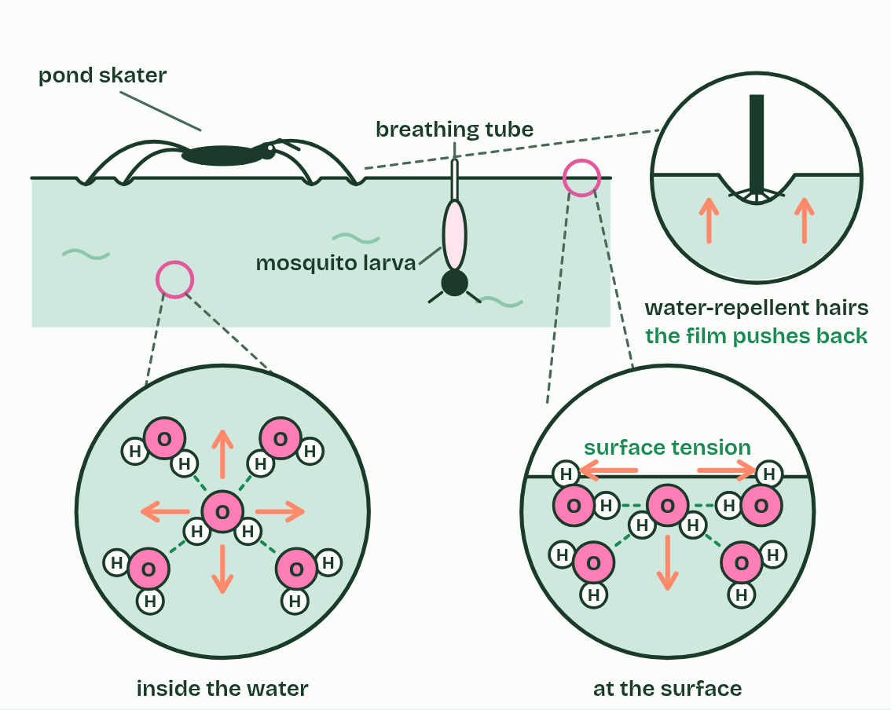  ANNOTATE THE FIGURE  Annotate this still from the animation (Watch it happen: pulling water up a stem): what is happening, and why?  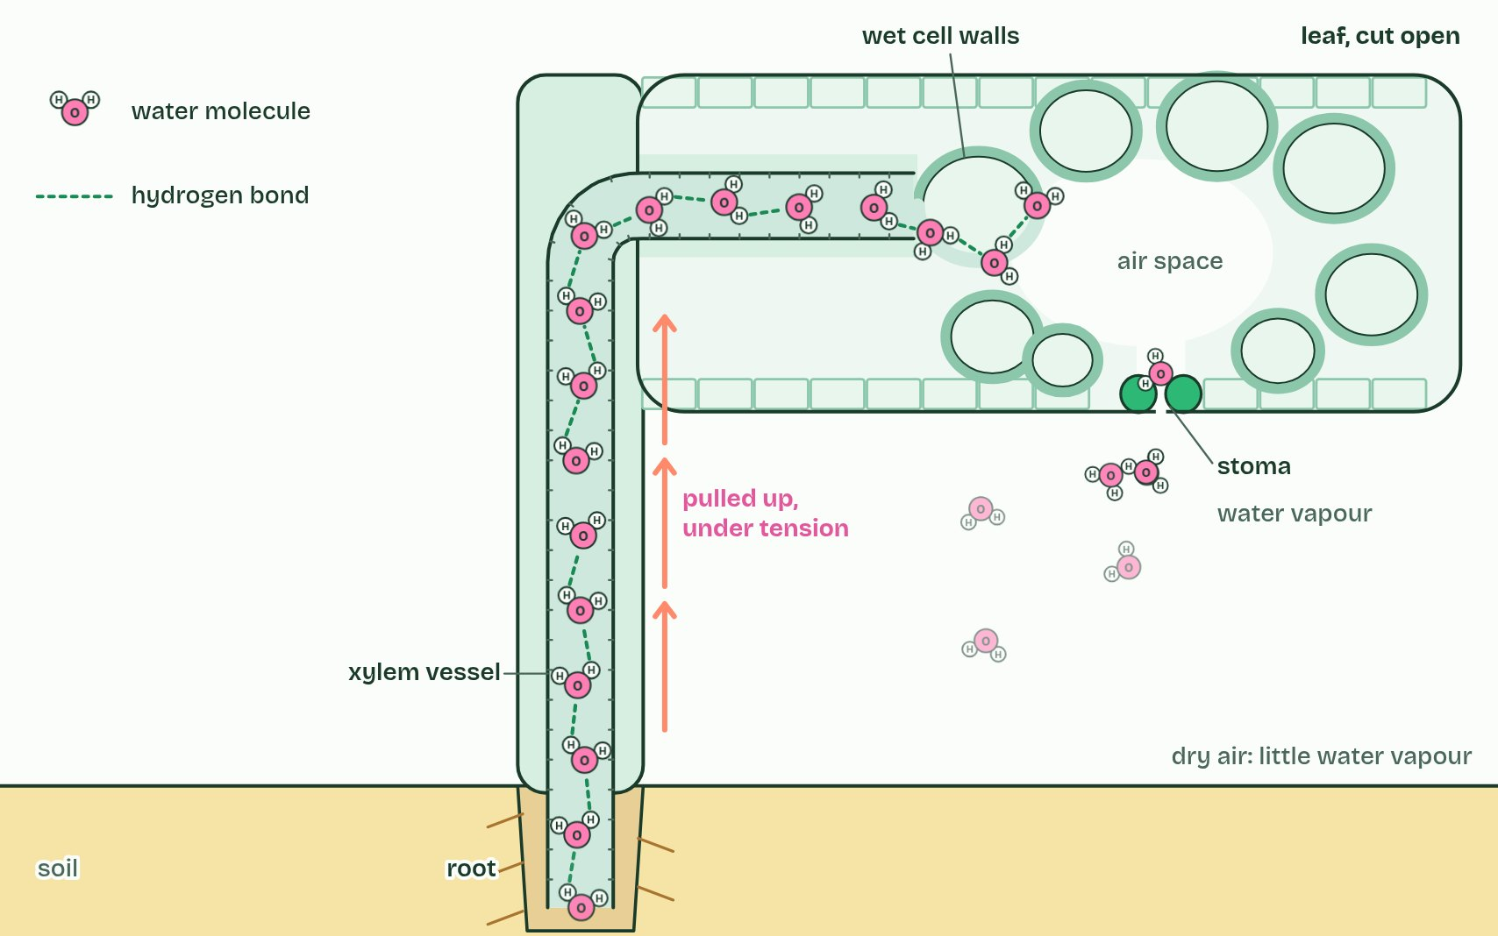
  SPOT THE MISTAKE
  A student writes: “Capillary action lifts water to the top of a tree.” Spot the mistake, then put it right.
  The mistake
  Put it right
SUMMARY
Sum up section 03 in two or three sentences of your own.

04 Water clings to polar surfaces | A1.1.4
CUES  Predict: Three cups in a row: red water, an empty cup, blue water. A strip of paper towel bridges each full cup and the empty one. What is in the middle cup a few hours later?  What is meant by adhesion?  What is meant by cellulose?  What is meant by capillary action? | NOTES  1 Water is attracted to other materials too, as long as they are polar or carry a charge. That is ___________: hydrogen bonds or ionic attractions pull water on to the surface.  2 So does ____________, which is covered in OH groups, and so do the charged surfaces of clay and humus in soil.  3 Water adheres to the walls and creeps up them, and cohesion drags the rest of the water along behind. This is ______________________.  4 Water is attracted to the polar glass wall and forms bonds with it: ___________. The water’s edge curves up where it meets the glass.  5 ___________ drags more water up behind the edge, and the column rises until its weight balances the pull.  6 The ___________ the tube, the higher the water climbs.  Your own notes  ANNOTATE THE FIGURE  Number the 5 steps on the figure and note what happens at each: 1 adhesion; 2 Cohesion; 3 narrower; 4 below; 5 soil, cellulose.  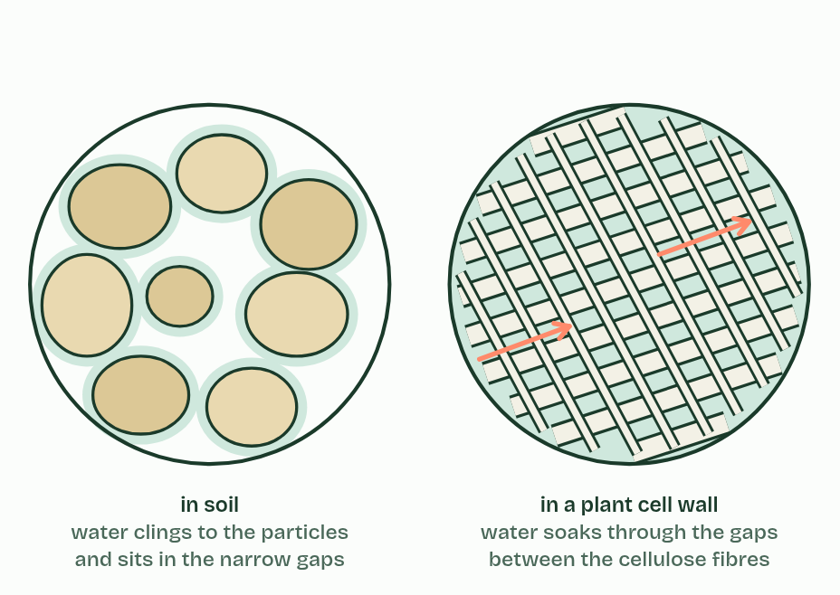  REMEMBER IT  Cohesion or adhesion?
  C  Clones | A  Anything
  C | A
  SPOT THE MISTAKE
  A student writes: “Cohesion and adhesion are the same thing.” Spot the mistake, then put it right.
  The mistake
  Put it right
SUMMARY
Sum up section 04 in two or three sentences of your own.

05 The solvent cells run in | A1.1.5
CUES  Predict: Fish get all their oxygen from water. Oxygen molecules (O2) are non-polar. How does the oxygen get into the water?  What is meant by solution?  What is meant by solute?  What is meant by solvent?  What is meant by solvation?  What is meant by hydrophilic?  What is meant by hydrophobic?  What is meant by enzymes? | NOTES  1 A ___________ is a ________ dissolved in a _________.  2 Each dissolved particle ends up wrapped in water molecules, which is called ____________.  3 Substances that are polar or charged are _______________.  4 Substances that are non-polar, such as fats, oils and waxes, are _______________: water molecules bond to each other instead, which pushes the non-polar molecules together, as oil forms droplets.  5 Most _________ catalyse reactions in aqueous solution, in the cytoplasm and in the fluids inside organelles, where dissolved enzymes and substrates move about and collide.  Your own notes  ANNOTATE THE FIGURE  Number the 5 steps on the figure and note what happens at each: 1 ions; 2 oxygen, hydrogens; 3 shell; 4 hydrogen bonds; 5 non-polar.  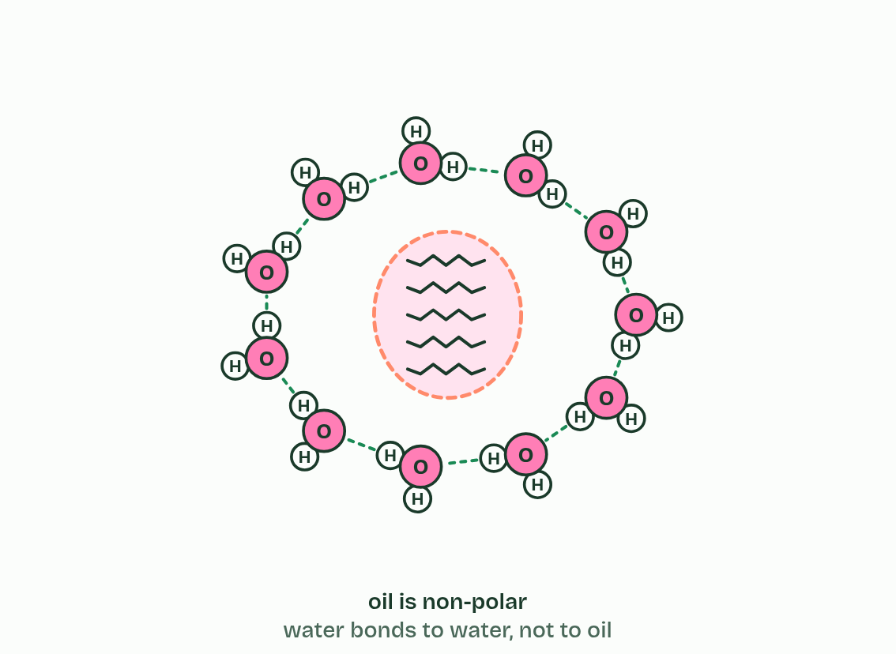  ANNOTATE THE FIGURE  Label the key parts and add a note on what it shows.  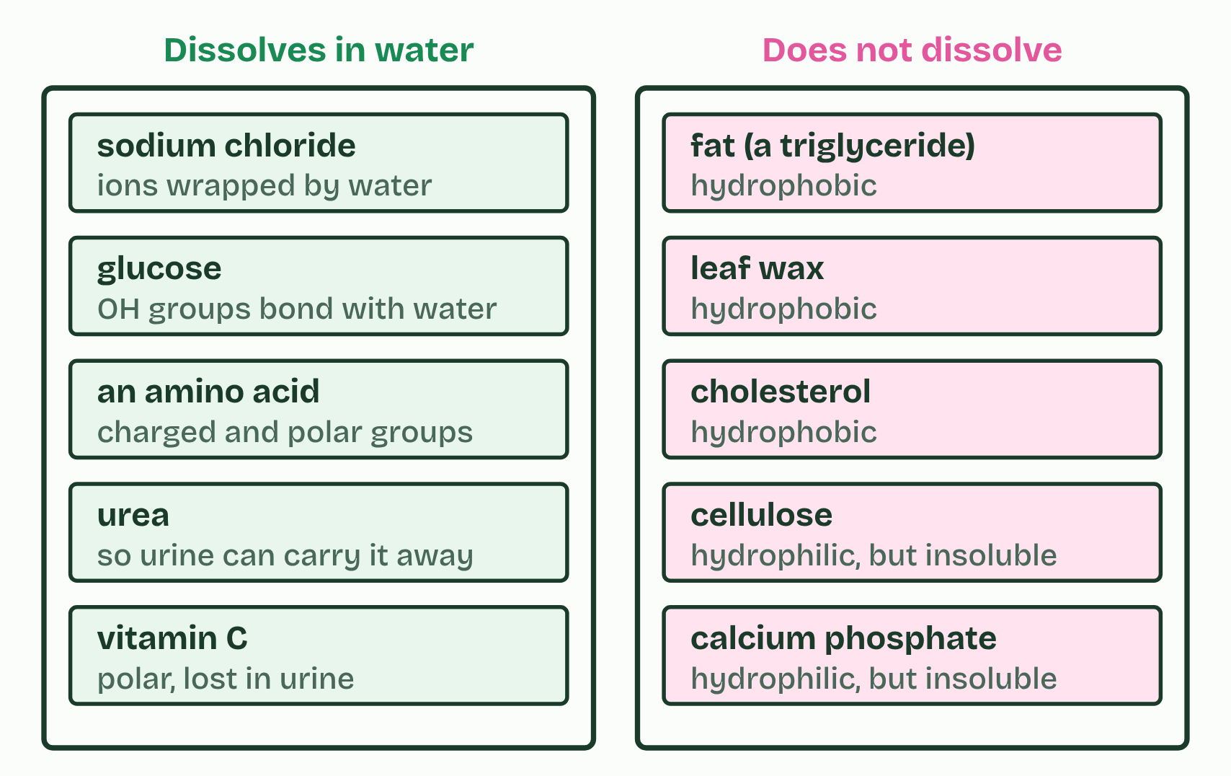
  SPOT THE MISTAKE
  A student writes: “Water is the universal solvent.” Spot the mistake, then put it right.
  The mistake
  Put it right
SUMMARY
Sum up section 05 in two or three sentences of your own.

06 Life in water, life in air | A1.1.6
CUES  Predict: Ringed seal pups are born in snow caves on the sea ice, with thick woolly fur but almost no blubber. What happens to a young pup that has to stay in the sea for a long time?  What is meant by buoyancy?  What is meant by viscosity?  What is meant by drag?  What is meant by thermal conductivity?  What is meant by specific heat capacity?  What is meant by blubber? | NOTES  1 It lives on and under the sea ice, keeps breathing holes open with its claws, and is kept warm in the water by a thick layer of _________.  2 Viscosity. Water is about 55 times as viscous as air, and far denser, so a body moving through it meets much more ________. Streamlined shapes save energy.  Your own notes  ANNOTATE THE FIGURE  The figure shows it as Buoyancy, Viscosity, Heat flow and Heat capacity. Note what changes each time.  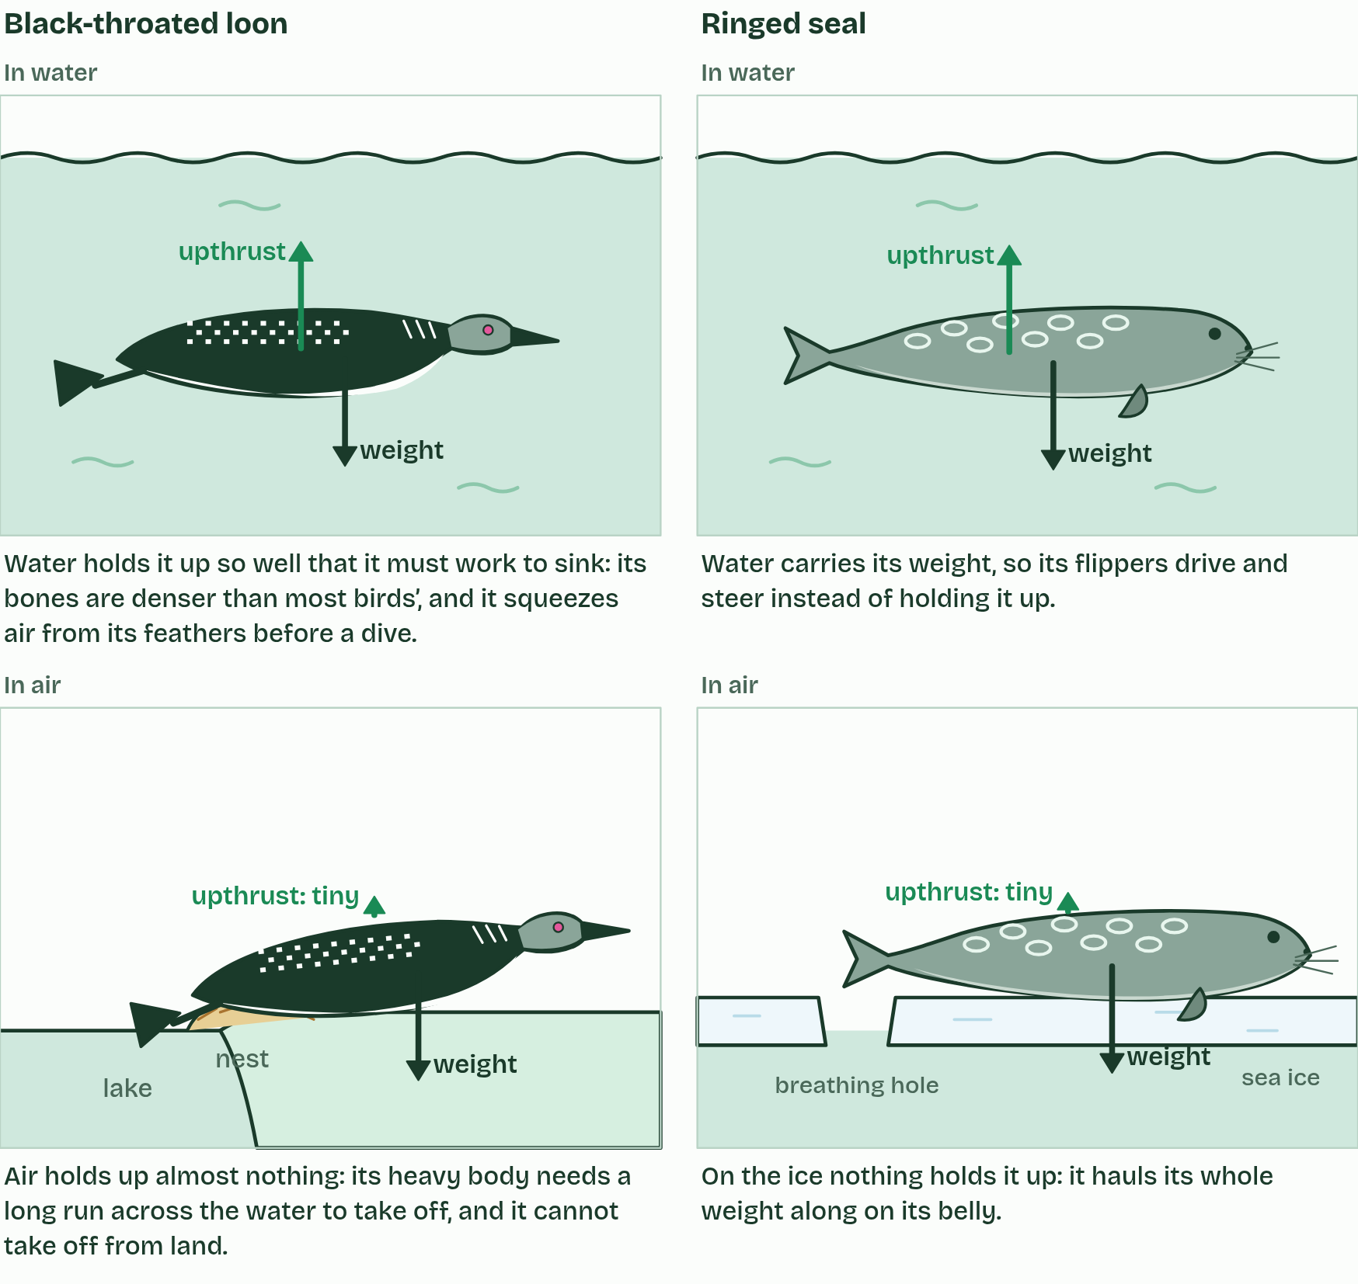  REMEMBER IT  The four properties A1.1.6 compares
  B  Big | V  Vessels | T  Turn | S  Slowly
  B | V | T | S
  SPOT THE MISTAKE
  A student writes: “Thermal conductivity and specific heat capacity are the same.” Spot the mistake, then put it right.
  The mistake
  Put it right
SUMMARY
Sum up section 06 in two or three sentences of your own.

07 Water from space, kept by gravity | A1.1.7 HL
CUES  Predict: Venus is almost the same size and mass as Earth, but closer to the Sun. Why are there no oceans on Venus?  What is meant by asteroids?  What is meant by hypothesis?  What is meant by condense? | NOTES  1 Much of its water is thought to have come from space. ____________ crashed into the young planet, and some of them had water locked inside their minerals.  2 That is the ______________ this statement asks for.  3 Temperatures low enough for water to condense. Earth is far enough from the Sun, and cooled enough, for water vapour to ___________ into liquid water. It rained out to form oceans that have lasted about four billion years.  4 ____________ crash into it. Some carry water locked inside their minerals, and they bring it to the planet.  5 The water turns to vapour and fills the air. Earth’s _________ holds it, and the rest of the atmosphere, in.  6 Earth cools until the temperature is low enough for the vapour to ___________. It rains, and oceans form.  Your own notes  ANNOTATE THE FIGURE  Number the 5 steps on the figure and note what happens at each.  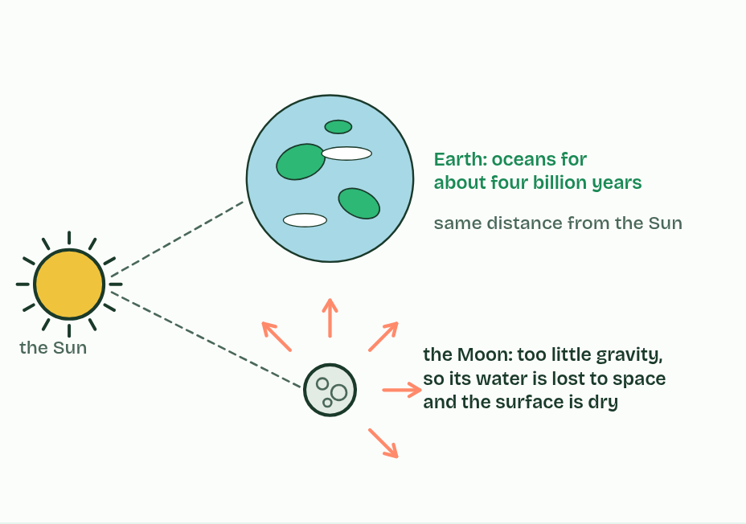  REMEMBER IT  Why Earth kept its water
  G  Grip | C  Chill
  G | C
  SPOT THE MISTAKE
  A student writes: “Earth kept its water because it has an atmosphere.” Spot the mistake, then put it right.
  The mistake
  Put it right
SUMMARY
Sum up section 07 in two or three sentences of your own.

08 Not too hot, not too cold: the Goldilocks zone | A1.1.8 HL
CUES  Predict: A star gives out much less energy than the Sun. Where would its Goldilocks zone be?  What is meant by extraterrestrial?  What is meant by goldilocks zone?  What is meant by exoplanets? | NOTES  1 All the life we know needs liquid water as its medium (chapters 1 and 5), so the search for ______________________ life starts by looking for liquid water.  2 The ____________________, also called the habitable zone, is the band of distances round a star where a planet's surface is warm enough for water not to freeze and cool enough for it not to boil away, so water could stay liquid.  3 Astronomers have now found more than 5,000 planets round other stars, called ______________.  4 A star warms the planets round it. The pale band is its ____________________: the distances at which a planet’s surface could keep liquid water.  5 Venus is closer than the zone’s inner edge. It is _________: water would boil away as vapour.  6 Mars is beyond the outer edge, and small. It is ___________: its water is frozen and its air is thin.  Your own notes  ANNOTATE THE FIGURE  Number the 4 steps on the figure and note what happens at each: 1 Goldilocks zone; 2 too hot; 3 too cold; 4 just right.  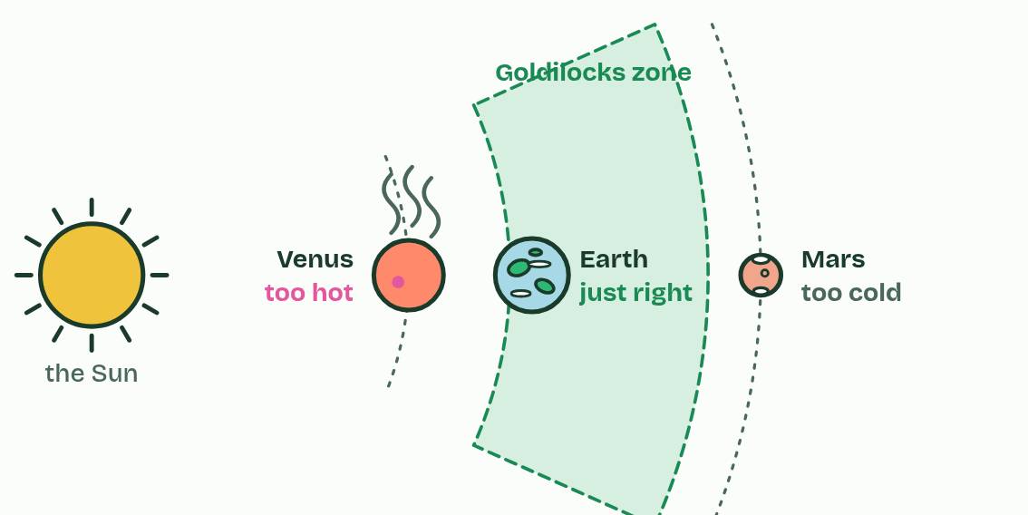  ANNOTATE THE FIGURE  Annotate this still from the animation (Watch it happen: finding the zone): what is happening, and why?  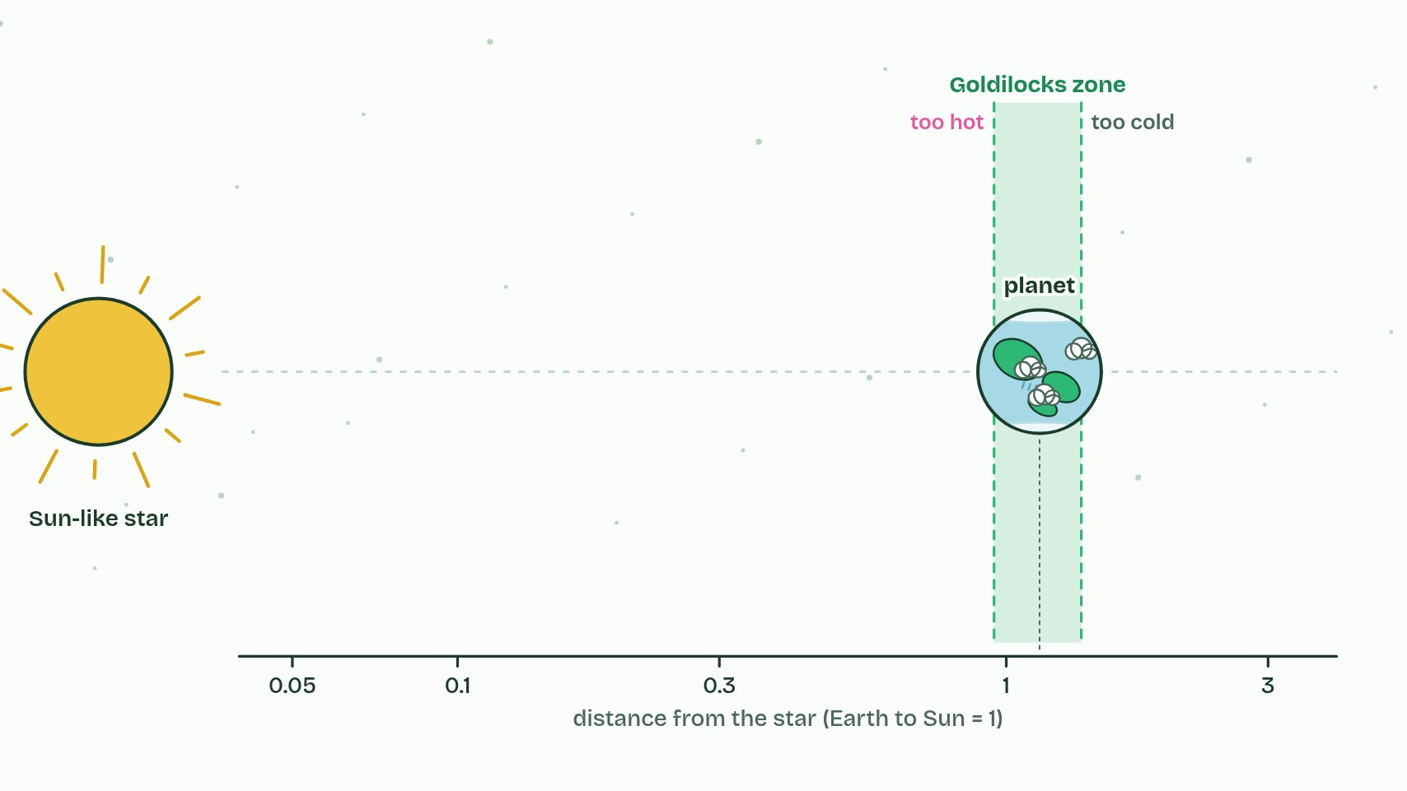
  SPOT THE MISTAKE
  A student writes: “Every star's Goldilocks zone is at Earth's distance.” Spot the mistake, then put it right.
  The mistake
  Put it right
SUMMARY
Sum up section 08 in two or three sentences of your own.

Check yourself
The check for this guide is online: a fresh paper of past-paper style questions from the exam bank on A1.1 each time, marked as you go, and saved to your Exam practice progress when you are signed in. Open the link:
biologybybradford.com/exam-maker/sit?topics=A1.1&level=HL&paper=quiz&marks=15&src=ep

