Name | Class | Date
IB BIOLOGY · A1.2

Nucleic acids
Teacher’s copy: every blank filled in. Each numbered block matches a chapter of the guide, and of the lesson slides. Write in the gaps, answer the cues, annotate the figures, and sum up each section in your own words.
BY THE END YOU CAN
Explain why DNA is the genetic material of every living organism, and why RNA viruses do not break the rule A1.2.1
Draw a nucleotide as a circle, a pentagon and a rectangle, each joined in the right place A1.2.2
Explain how condensation builds a strand with a strong sugar–phosphate backbone, and draw a short strand of RNA A1.2.3, A1.2.5
Name the bases of DNA and RNA, and explain how complementary pairing lets DNA be copied and read A1.2.4, A1.2.8
Draw two antiparallel strands joined by hydrogen bonds between A and T, and C and G A1.2.6
Give three differences between DNA and RNA, and sketch ribose against deoxyribose A1.2.7
Explain why DNA can store limitless information, and why one genetic code in all life points to a common ancestor A1.2.9, A1.2.10
Explain what the 5′ and 3′ ends are, and why nucleotides are only ever added at the 3′ end A1.2.11
Explain why a purine always pairs with a pyrimidine, and what that does for the helix A1.2.12
Describe a nucleosome, and use molecular visualisation software to see how histones hold DNA A1.2.13
Explain how Hershey and Chase's results support the conclusion that DNA, not protein, is the genetic material A1.2.14
Use Chargaff's data to falsify the tetranucleotide hypothesis, and explain why one result can falsify what many cannot prove A1.2.15

01 Every living thing keeps its instructions in DNA | A1.2.1
CUES  Predict: A virus is found whose genes are made of RNA. Does that break the rule that DNA is the genetic material of all living organisms?  B: No: viruses are not counted as living organisms. No. A virus has no cells and no metabolism of its own, and it can only be copied inside a host cell, so biologists do not count it as alive. The rule is about living things, and in every one studied so far the genetic material is DNA. In an RNA virus the genes really are RNA: there is no hidden DNA original.  What is meant by genetic material?  The molecule that carries the instructions an organism inherits. It is copied each time a cell divides and passed from parents to offspring.  What is meant by DNA?  Deoxyribonucleic acid: the nucleic acid that is the genetic material of all living organisms.  What is meant by nucleic acids?  Polymers built from nucleotides. DNA and RNA are the two nucleic acids.  What is meant by RNA?  Ribonucleic acid: the other nucleic acid. It has several jobs in cells, and in some viruses it is the genetic material.  What is meant by viruses?  Tiny particles of genetic material inside a protein coat. A virus has no cells and can only be copied inside a host cell.  What is meant by gene?  A stretch of a DNA molecule: a particular base sequence that carries one piece of information. | NOTES  1 The molecule that holds those instructions is its genetic material.  2 In every living organism studied, the genetic material is DNA, short for deoxyribonucleic acid.  3 DNA belongs to the nucleic acids.  4 The other one, RNA, does many jobs in the cell (chapter 6), and a few viruses use it to carry their genes: influenza, measles and the coronavirus that causes COVID-19 are RNA viruses.  5 A gene is one stretch of its base sequence, and a single DNA molecule carries many genes.  Your own notes  ANNOTATE THE FIGURE  Label each part and say what it does: bacterium, yeast cell, plant cell, animal cell, phage, influenza virus, coronavirus.  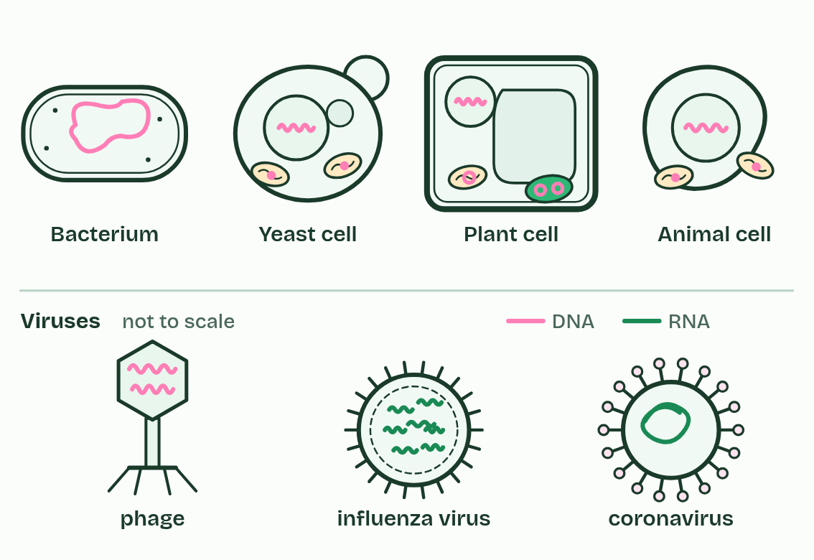  1 Bacterium: DNA, one long loop, loose in the cytoplasm: there is no nucleus.  2 Yeast cell: DNA in the nucleus, and a little in each mitochondrion.  3 Plant cell: DNA in the nucleus, and small loops in mitochondria and chloroplasts.  4 Animal cell: DNA in the nucleus, and a little in each mitochondrion.  5 Phage: A virus that infects bacteria. Its DNA lies inside a protein coat.  6 Influenza virus: RNA inside a protein coat, with a fatty envelope. It has no cells and makes nothing for itself: it can only be copied inside a host cell.  7 Coronavirus: RNA inside a protein coat, with a fatty envelope. It has no cells and makes nothing for itself: it can only be copied inside a host cell.
  SPOT THE MISTAKE
  What do students often get wrong about DNA as the genetic material? Write the mistake, then put it right.
  "DNA" and "gene" are not two words for one thing. DNA is the molecule; a gene is one stretch of its base sequence, and one DNA molecule carries many genes.
SUMMARY
Sum up section 01 in two or three sentences of your own.
• The molecule that holds those instructions is its genetic material.
• In every living organism studied, the genetic material is DNA, short for deoxyribonucleic acid.
• DNA belongs to the nucleic acids.
• The other one, RNA, does many jobs in the cell (chapter 6), and a few viruses use it to carry their genes: influenza, measles and the coronavirus that causes COVID-19 are RNA viruses.

02 Three parts, one monomer | A1.2.2
CUES  Predict: How many different nucleotides does a cell use to build DNA?  C: Four: the sugar and phosphate are the same, only the base differs. Four. Every DNA nucleotide has the same phosphate and the same sugar, deoxyribose; only the base differs, and DNA has four bases. RNA has its own four, built on ribose, so a cell's nucleic acids use eight nucleotides in all.  What is meant by polymers?  Long molecules built from many copies of a small unit, joined in a chain.  What is meant by monomer?  One small unit of a polymer. The monomer of a nucleic acid is the nucleotide.  What is meant by nucleotide?  The monomer of nucleic acids: a phosphate group, a pentose sugar and a nitrogenous base joined together.  What is meant by phosphate group?  A phosphorus atom with oxygen atoms round it. In a cell it carries a negative charge.  What is meant by pentose?  A sugar with five carbon atoms.  What is meant by nitrogenous base?  A ring of carbon and nitrogen atoms that is the part of a nucleotide that varies. Its order along a strand is the message. | NOTES  1 Nucleic acids are polymers.  2 The small unit, the monomer, is the nucleotide.  3 A nucleotide has three parts joined by covalent bonds: a phosphate group, a pentose sugar and a nitrogenous base.  4 One ring round all three marks one nucleotide.  Your own notes  ANNOTATE THE FIGURE  Number the 4 steps on the figure and note what happens at each: 1 three parts; 2 sugar; 3 circle, pentagon, rectangle; 4 phosphorus.  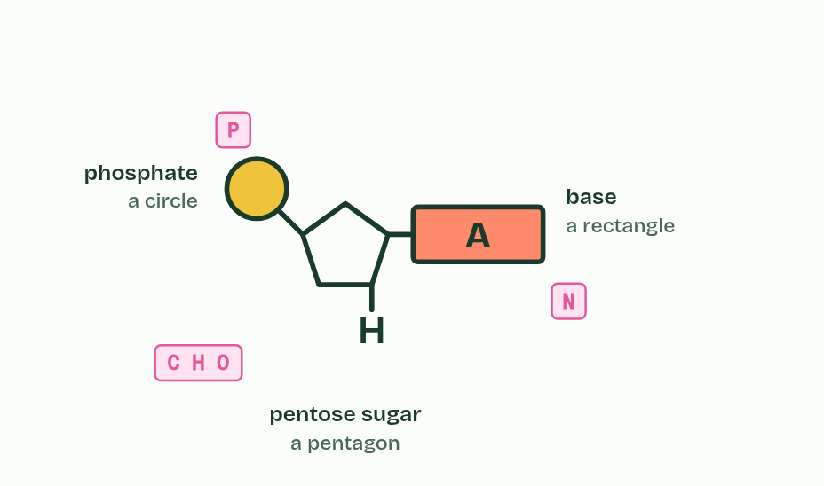  1 A nucleotide is built from three parts.  2 The sugar sits in the middle, bonded to both of the others.  3 The IB draws them as a circle, a pentagon and a rectangle, in these positions.  4 Nitrogen comes from the base and phosphorus from the phosphate.
  SPOT THE MISTAKE
  What do students often get wrong about components of a nucleotide? Write the mistake, then put it right.
  A nucleotide is not a base. Each nucleotide contains one base, along with a sugar and a phosphate. And the base is bonded to the sugar, never to the phosphate.
SUMMARY
Sum up section 02 in two or three sentences of your own.
• Draw it the IB way. A circle for the phosphate, a pentagon for the sugar and a rectangle for the base.
• The sugar is in the middle: the circle is at the upper left of the pentagon, on a short stalk, and the rectangle is at its right-hand corner.
• One ring round all three marks one nucleotide.

03 Building a strand with a strong backbone | A1.2.3 A1.2.5
CUES  Predict: How many water molecules are released when 10 nucleotides join into one strand?  A: 9. Nine. Each bond releases one water molecule, and ten nucleotides in a row have nine bonds between them: n nucleotides make n − 1 bonds and release n − 1 water molecules. Taking the strand apart again by hydrolysis would use nine water molecules.  What is meant by condensation?  A reaction that joins two molecules and releases a molecule of water.  What is meant by hydrolysis?  A reaction in which a bond is broken by adding a molecule of water.  What is meant by strand?  One chain of nucleotides, also called a polynucleotide.  What is meant by covalent bond?  A bond in which two atoms share a pair of electrons. Covalent bonds are strong.  What is meant by sugar–phosphate backbone?  The chain of alternating sugars and phosphates, joined by covalent bonds, that runs along a nucleic acid strand. | NOTES  1 Nucleotides join by condensation, as in the sugars and lipids of B1.1.  2 The reverse is hydrolysis: water is added back and the bond breaks, which is how your digestion takes the nucleic acids in food apart.  3 Repeat the join and you build a strand: sugar, phosphate, sugar, phosphate.  4 Every link is a covalent bond, so the strand is one continuous chain of covalently bonded atoms.  5 That is the sugar–phosphate backbone: strong, and it fixes the order of the nucleotides along it.  Your own notes  ANNOTATE THE FIGURE  Number the 5 steps on the figure and note what happens at each: 1 nucleotide; 2 Condensation; 3 water; 4 backbone; 5 together.  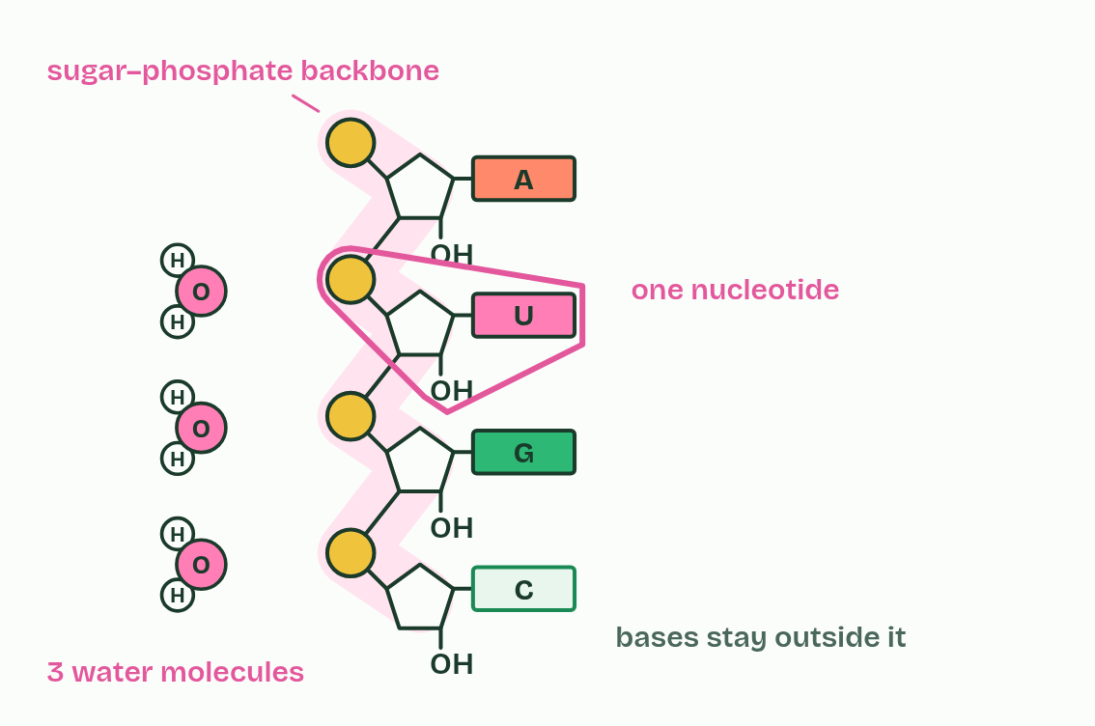  1 One nucleotide.  2 Condensation: the phosphate bonds to the sugar above, and water leaves.  3 Each new bond releases one water molecule.  4 Sugar, phosphate, sugar, phosphate: a covalently bonded backbone.  5 One nucleotide is a circle, a pentagon and a rectangle together.  ANNOTATE THE FIGURE  Number the 4 steps on the figure and note what happens at each.  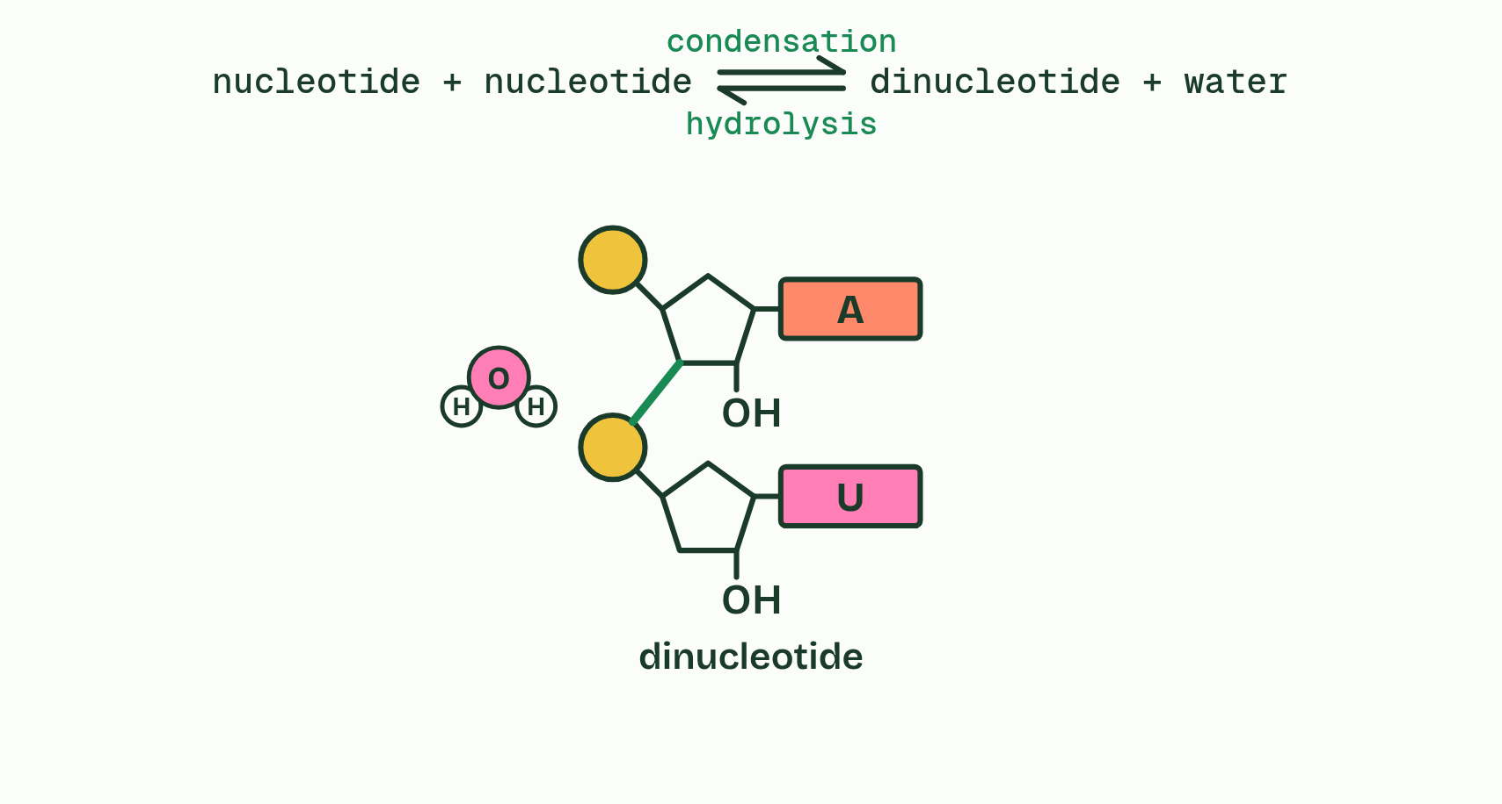  1 Two nucleotides, each a phosphate, a sugar and a base.  2 The phosphate of one and the sugar of the other face each other.  3 They leave as water, and a sugar-phosphate bond joins the sugar of one to the phosphate of the next: condensation, making a dinucleotide.  4 Add water and the bond splits again, the H to one nucleotide and the OH to the other: hydrolysis.
  SPOT THE MISTAKE
  What do students often get wrong about sugar–phosphate bonding and RNA? Write the mistake, then put it right.
  Hydrogen bonds do not hold a strand together. Inside a strand every link is covalent. Hydrogen bonds only come in between two strands (chapter 4), which is why the two strands of DNA can be parted without breaking either.
SUMMARY
Sum up section 03 in two or three sentences of your own.
• Nucleotides join by condensation, as in the sugars and lipids of B1.1.
• The reverse is hydrolysis: water is added back and the bond breaks, which is how your digestion takes the nucleic acids in food apart.
• Repeat the join and you build a strand: sugar, phosphate, sugar, phosphate.
• Every link is a covalent bond, so the strand is one continuous chain of covalently bonded atoms.

04 Four letters that pair | A1.2.4 A1.2.8
CUES  Predict: One strand of a DNA molecule reads A A T G C. The strands separate and each is copied. What does the strand built against it read, and the strand built against that one?  B: T T A C G, then A A T G C. Pairing makes a complementary copy, and the complement of the complement is the original. So every molecule made by copying has the same sequence as the one it came from: this is how complementary pairing keeps genetic information exact through replication. (U belongs in RNA, not in a DNA copy.)  What is meant by adenine?  One of the four bases of DNA, written A. It pairs with thymine (uracil in RNA).  What is meant by cytosine?  One of the four bases of DNA, written C. It pairs with guanine.  What is meant by guanine?  One of the four bases of DNA, written G. It pairs with cytosine.  What is meant by thymine?  A base found in DNA, written T. It pairs with adenine.  What is meant by uracil?  A base found in RNA, written U, in the place of thymine. It pairs with adenine.  What is meant by base sequence?  The order of the bases along a strand of DNA or RNA.  What is meant by complementary base pairing?  The rule that each base pairs with one particular other base: A with T (or U), and C with G.  What is meant by hydrogen bonds?  Weak attractions between a slightly positive hydrogen atom on one molecule and a slightly negative atom on another.  What is meant by replication?  Copying a DNA molecule to make two molecules with the same base sequence.  What is meant by template?  A strand that new nucleotides pair with, so the new strand has the complementary sequence.  What is meant by transcription?  Making an RNA copy of a gene, using one DNA strand as the template.  What is meant by translation?  Making a chain of amino acids by reading the codons of messenger RNA. | NOTES  1 DNA uses four bases: adenine (A), cytosine (C), guanine (G) and thymine (T).  2 RNA has A, C and G too, but uracil (U) takes the place of thymine.  3 The order of the bases along a strand is the message, like letters spelling words: the base sequence.  4 Bases pair across between two strands by complementary base pairing: A with T (or with U when RNA is involved), and C with G.  5 Complementarity rests on hydrogen bonds.  6 In replication the hydrogen bonds break and the strands separate, while the covalent backbones stay whole.  7 Each strand is a template: free nucleotides pair with its exposed bases, and each new strand is complementary to its template.  8 In transcription, one strand of a gene is the template for an RNA copy, with an RNA base opposite each DNA base and U opposite A.  Your own notes  ANNOTATE THE FIGURE  The figure shows it as Which base fits each slot?, Paired: only A with T and G with C form hydrogen bonds, Copy it: two molecules with the same sequence and Read it: messenger RNA, read by a transfer RNA. Note what changes each time.  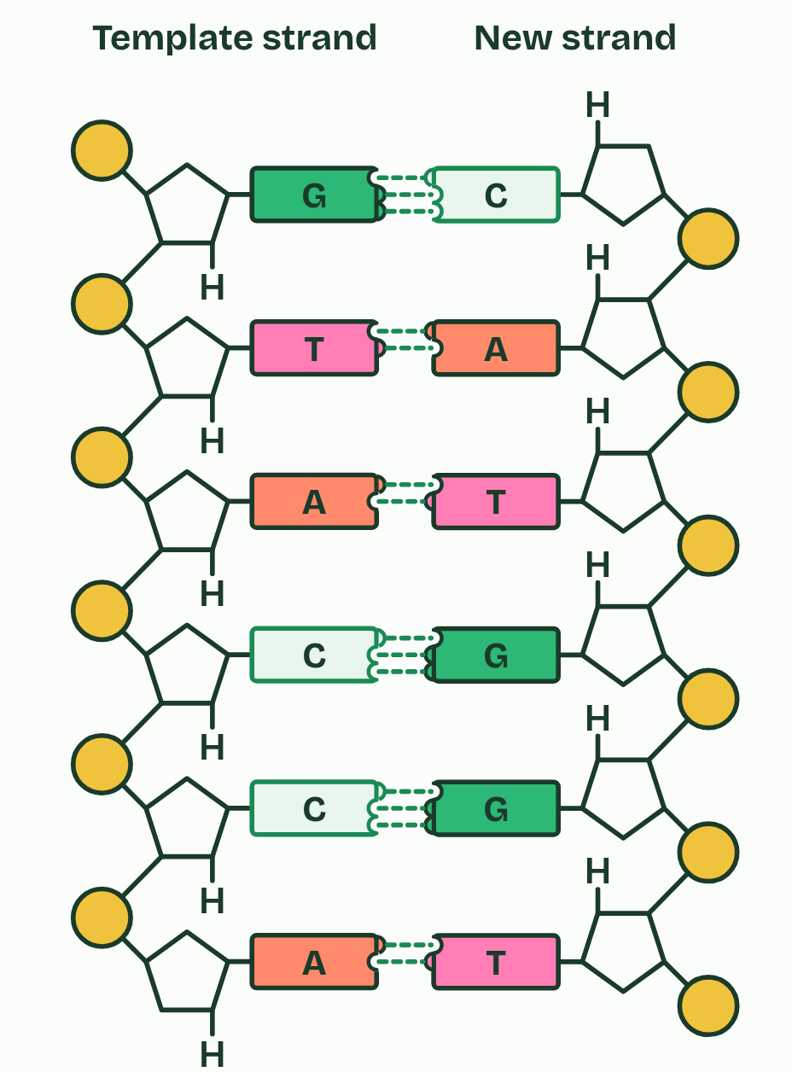  1 Which base fits each slot?  2 Paired: only A with T and G with C form hydrogen bonds  3 Copy it: two molecules with the same sequence  4 Read it: messenger RNA, read by a transfer RNA  REMEMBER IT  Which base pairs with which
  A  Apples | T  Tree | C  Cars | G  Garage
  Adenine  pairs with thymine (uracil in RNA) | Thymine  in DNA only | Cytosine  pairs with guanine | Guanine  pairs with cytosine
  SPOT THE MISTAKE
  What do students often get wrong about bases and complementary pairing? Write the mistake, then put it right.
  Complementary does not mean identical. The two strands of one molecule have different sequences; it is the two molecules made by copying that are identical. And in RNA, uracil takes the place of thymine, not of adenine.
SUMMARY
Sum up section 04 in two or three sentences of your own.
• DNA uses four bases: adenine (A), cytosine (C), guanine (G) and thymine (T).
• RNA has A, C and G too, but uracil (U) takes the place of thymine.
• The order of the bases along a strand is the message, like letters spelling words: the base sequence.
• Bases pair across between two strands by complementary base pairing: A with T (or with U when RNA is involved), and C with G.

05 Two strands, one helix | A1.2.6
CUES  Predict: To be copied, the two strands of DNA must come apart. Why does pulling them apart not break the strands themselves?  C: Weak hydrogen bonds join the two strands, while each strand is a chain of strong covalent bonds. The bonds between the strands are hydrogen bonds: weak one by one, so the strands can be unzipped. The bonds along each strand are covalent, so each strand, and the sequence it carries, stays whole. Both strands then serve as templates (chapter 4).  What is meant by base pair?  Two bases, one from each strand, held together by hydrogen bonds: A with T or G with C.  What is meant by antiparallel?  Running in opposite directions, like the two lanes of a road.  What is meant by double helix?  The shape of DNA: two strands wound round each other in a spiral. | NOTES  1 A pair of bases facing each other is a base pair.  2 The strands are antiparallel: they run in opposite directions, like the two lanes of a road.  3 The pair of strands winds into a double helix.  Your own notes  ANNOTATE THE FIGURE  The figure shows it as Flat: the ladder the exam asks for and Twisted into a double helix. Note what changes each time.  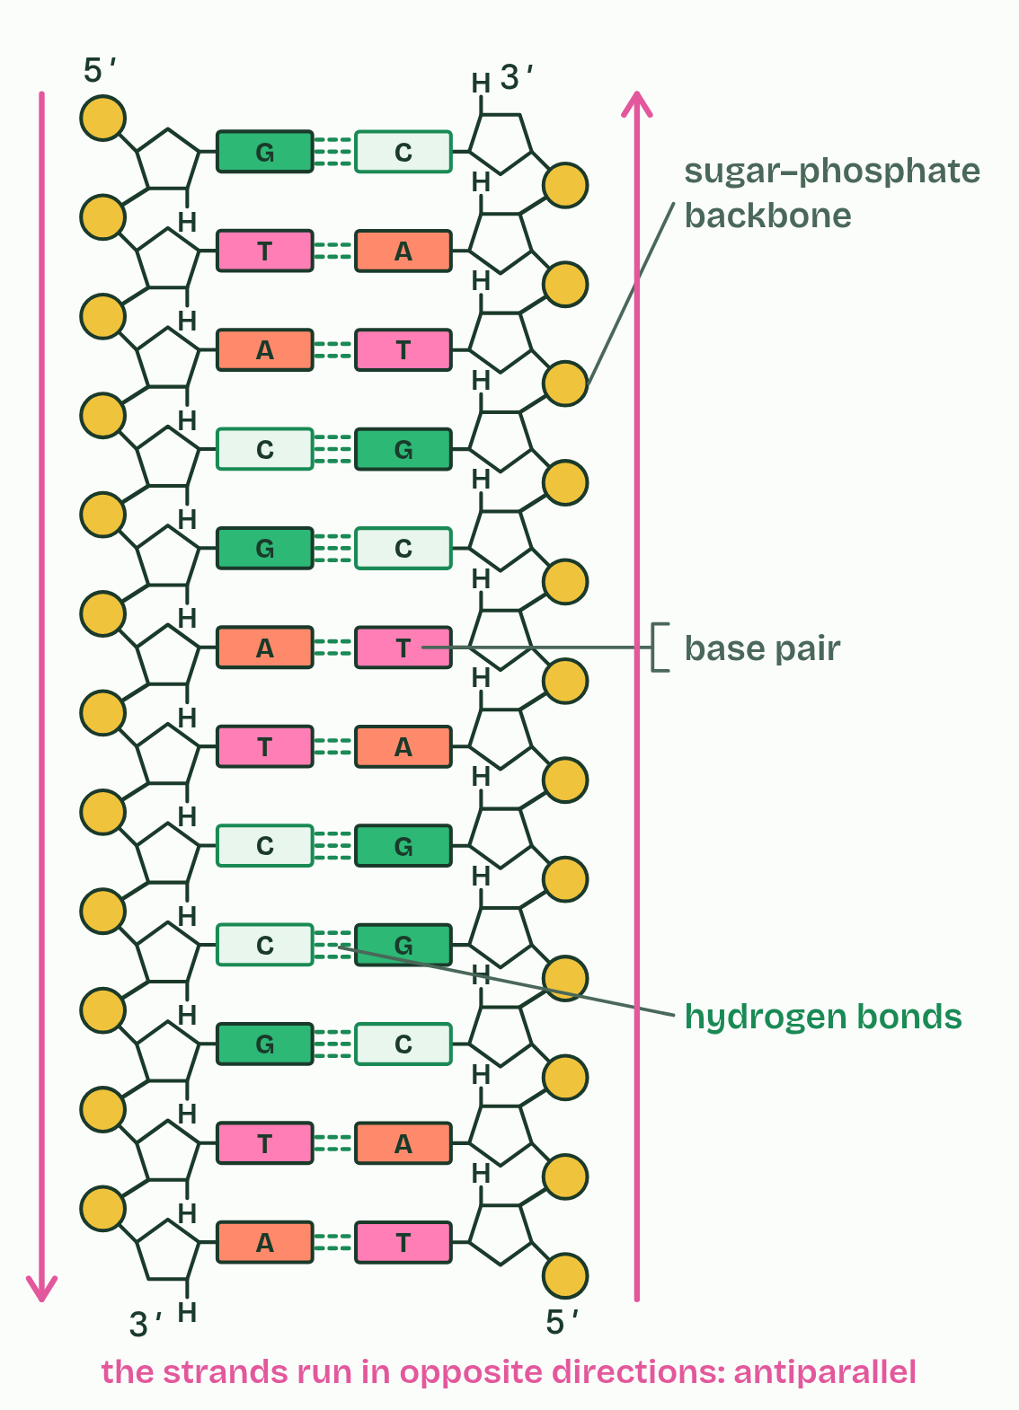  1 Flat: the ladder the exam asks for  2 Twisted into a double helix
  SPOT THE MISTAKE
  What do students often get wrong about the double helix? Write the mistake, then put it right.
  Antiparallel does not mean twisted, or that the bases are opposite each other. It means the two strands run in opposite directions.
SUMMARY
Sum up section 05 in two or three sentences of your own.
• A pair of bases facing each other is a base pair.
• The strands are antiparallel: they run in opposite directions, like the two lanes of a road.
• The pair of strands winds into a double helix.

06 DNA and RNA compared | A1.2.7
CUES  Predict: A sample of nucleic acid is single-stranded and contains thymine but no uracil. What is it most likely to be?  A: DNA, from one of the few viruses with single-stranded DNA. Thymine is the clue: it is a DNA base. Most DNA is double-stranded, but a few viruses carry single-stranded DNA, so the number of strands is the least reliable of the three differences. The sugar would settle it: deoxyribose means DNA.  What is meant by deoxyribose?  The pentose sugar in DNA. It has an H on carbon 2 where ribose has an OH.  What is meant by ribose?  The pentose sugar in RNA. It has an OH on carbon 2.  What is meant by messenger RNA?  RNA that is a copy of a gene and is taken to a ribosome to be translated.  What is meant by transfer RNA?  RNA that brings an amino acid to the ribosome. It folds back on itself and pairs with itself in places.  What is meant by ribosomal RNA?  RNA that is part of every ribosome. | NOTES  1 DNA makes up the chromosomes, with more in mitochondria and chloroplasts. Messenger RNA is a copy of a gene, taken to a ribosome. Transfer RNA brings amino acids to the ribosome. Ribosomal RNA is part of every ribosome.  2 Strands. DNA has two, wound into a double helix. RNA usually has one, which can fold back and pair with itself in places: transfer RNA does.  3 Sugar. DNA has deoxyribose. RNA has ribose.  Your own notes  ANNOTATE THE FIGURE  The figure shows it as DNA and RNA. Note what changes each time.  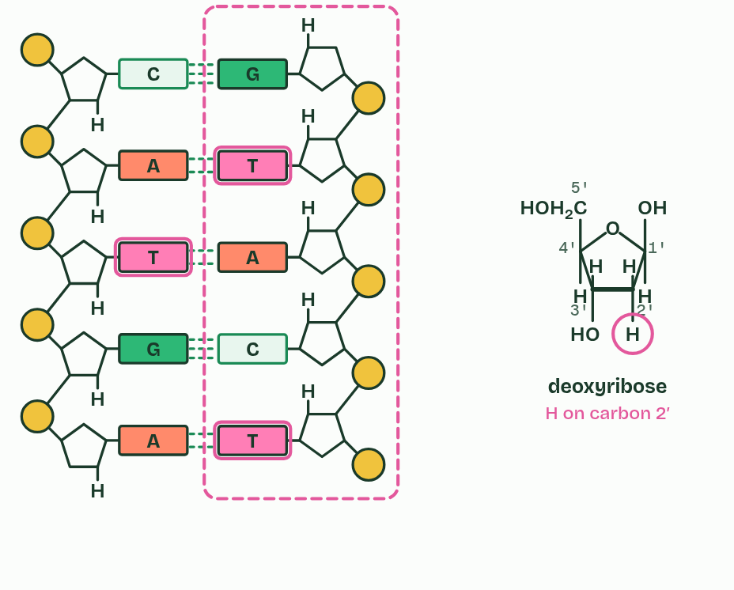  1 DNA  2 RNA  REMEMBER IT  The three differences between DNA and RNA
  S  Some | B  Bananas | S  Split
  Sugar  deoxyribose in DNA, ribose in RNA | Bases  thymine in DNA, uracil in RNA | Strands  two in DNA, usually one in RNA
  SPOT THE MISTAKE
  What do students often get wrong about differences between DNA and RNA? Write the mistake, then put it right.
  Deoxyribose still has its ring oxygen: the missing oxygen is the one on carbon 2. And RNA is not always a straight single strand: transfer RNA folds and pairs with itself.
SUMMARY
Sum up section 06 in two or three sentences of your own.
• Strands. DNA has two, wound into a double helix. RNA usually has one, which can fold back and pair with itself in places: transfer RNA does.
• Bases. DNA has A, C, G and T. RNA has A, C, G and U.
• Sugar. DNA has deoxyribose. RNA has ribose.

07 Endless sequences, one code | A1.2.9 A1.2.10
CUES  Predict: How many different sequences of three bases can DNA's four bases make?  B: 64. Four choices for the first base, four for the second and four for the third: 4 × 4 × 4 = 64. (12 adds when it should multiply; 81 is 3 to the power 4, the right numbers the wrong way round.) Each extra base multiplies the possibilities by four again, which is why the capacity of DNA is limitless.  What is meant by genetic code?  The rules by which a sequence of bases in messenger RNA is translated into a sequence of amino acids, three bases at a time.  What is meant by codon?  A group of three bases in messenger RNA that stands for one amino acid.  What is meant by universal common ancestor?  The single ancestral population from which all living organisms are thought to be descended.  What is meant by conserved?  Kept the same through long periods of evolution. | NOTES  1 The genetic code is the set of rules by which a sequence of bases in messenger RNA is translated into a sequence of amino acids, three bases at a time.  2 Each group of three is a codon.  3 The best explanation for one shared code is that all life inherited it from a universal common ancestor.  4 A code shared like that is conserved across life, and it is evidence of that shared ancestry.  Your own notes  ANNOTATE THE FIGURE  The figure shows it at bases in the sequence 0, in the sequence 1, in the sequence 2, in the sequence 3, in the sequence 4, in the sequence 5, in the sequence 6 and in the sequence 7. Note what changes each time.  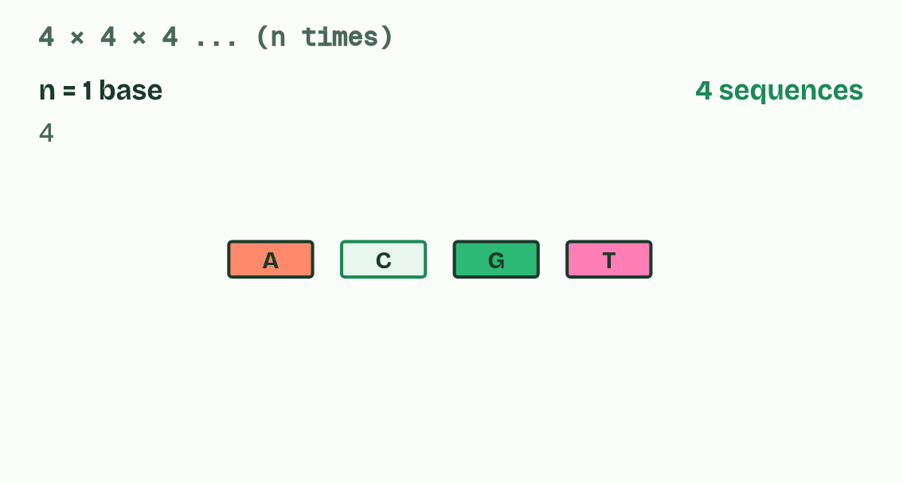  1 Bases in the sequence 0  2 Bases in the sequence 1  3 Bases in the sequence 2  4 Bases in the sequence 3  5 Bases in the sequence 4  6 Bases in the sequence 5  7 Bases in the sequence 6  8 Bases in the sequence 7  ANNOTATE THE FIGURE  The figure shows it as Bacterium, Yeast, Wheat, Human cell and Human mitochondrion. Note what changes each time.  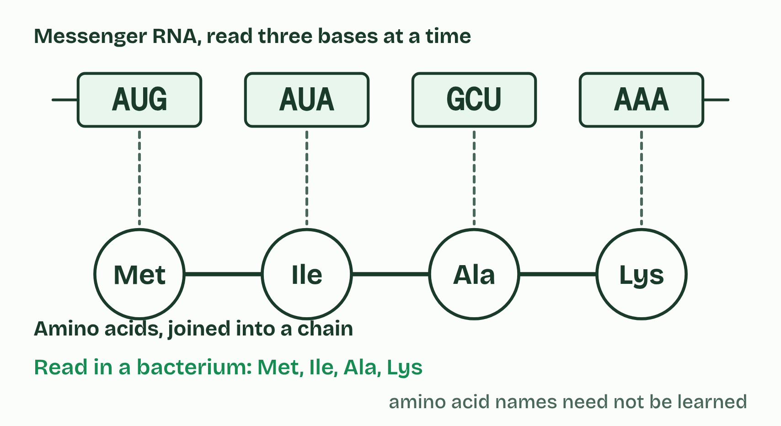  1 Bacterium  2 Yeast  3 Wheat  4 Human cell  5 Human mitochondrion
  SPOT THE MISTAKE
  What do students often get wrong about information storage and the genetic code? Write the mistake, then put it right.
  A universal code does not mean every organism has the same DNA. The dictionary is shared; the books written with it are different.
SUMMARY
Sum up section 07 in two or three sentences of your own.
• The genetic code is the set of rules by which a sequence of bases in messenger RNA is translated into a sequence of amino acids, three bases at a time.
• Each group of three is a codon.
• The best explanation for one shared code is that all life inherited it from a universal common ancestor.
• A code shared like that is conserved across life, and it is evidence of that shared ancestry.

08 Every strand has a direction | A1.2.11 HL
CUES  Predict: One DNA strand reads 5′-ATGC-3′. Written 5′ to 3′, what is its partner?  C: 5′-GCAT-3′. The partner pairs base by base, T A C G, but runs the other way: 3′-TACG-5′. Read from its own 5′ end, that is 5′-GCAT-3′. (5′-CGTA-3′ is the first strand backwards, with no pairing at all.)  What is meant by directionality?  A strand has two different ends, so it runs one way: from its 5′ end to its 3′ end.  What is meant by 5′ end?  The end of a strand with a free phosphate on a 5′ carbon.  What is meant by 3′ end?  The end of a strand with a free OH on a 3′ carbon. New nucleotides are added here. | NOTES  1 So every link in the backbone runs the same way, and the strand has directionality.  2 One end has a free phosphate on a 5′ carbon, the 5′ end.  3 The other has a free OH on a 3′ carbon, the 3′ end.  4 Translation. A ribosome moves along messenger RNA from its 5′ end towards its 3′ end, so the codons are read in that order.  Your own notes  ANNOTATE THE FIGURE  Number the 5 steps on the figure and note what happens at each: 1 1′ to 5′; 2 5′, 3′; 3 3′ end; 4 antiparallel; 5 one direction.  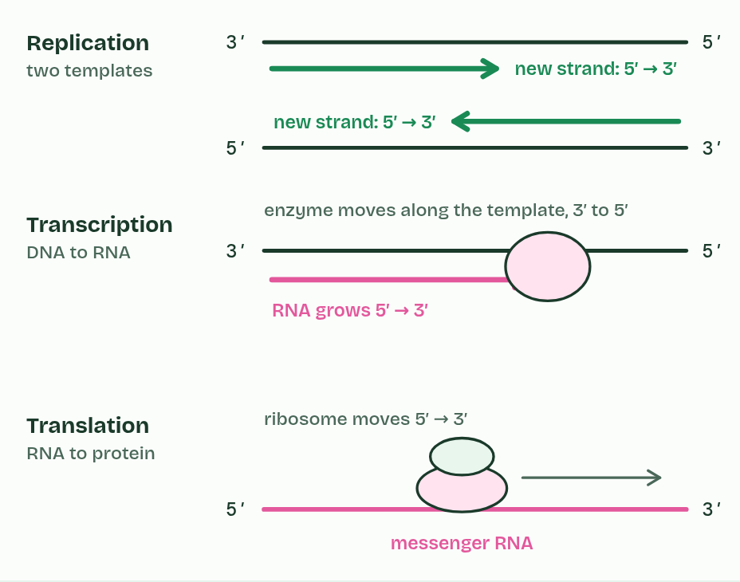  1 Carbons 1′ to 5′.  2 Each phosphate links a 5′ carbon to the 3′ carbon before it.  3 New nucleotides join only at the 3′ end.  4 The strands are antiparallel: one runs 5′ to 3′, the other 3′ to 5′.  5 So DNA is copied, transcribed and read in one direction.
  SPOT THE MISTAKE
  What do students often get wrong about directionality? Write the mistake, then put it right.
  5′ and 3′ name carbon atoms in the sugar. They are not positions along a gene. And new strands are built 5′ to 3′, which means their templates are read 3′ to 5′.
SUMMARY
Sum up section 08 in two or three sentences of your own.
• Replication. Each new strand is built 5′ to 3′, so the two antiparallel templates are copied in opposite directions. (How that works at a replication fork is D1.1.)
• Transcription. RNA is built 5′ to 3′, so the enzyme moves along the template strand in that strand's 3′ to 5′ direction.
• Translation. A ribosome moves along messenger RNA from its 5′ end towards its 3′ end, so the codons are read in that order.

09 A big base with a small one | A1.2.12 HL
CUES  Predict: 30% of the bases in a sample of double-stranded DNA are adenine. What percentage are purines?  B: 50%. 50%, whatever the sequence. Every base pair is one purine and one pyrimidine, so purines are always half the bases in double-stranded DNA: here 30% adenine and 20% guanine. In symbols, A + G = C + T. Chapter 12 picks this up.  What is meant by purines?  Bases with two rings fused together, one of six atoms and one of five. Adenine and guanine are purines.  What is meant by pyrimidines?  Bases with a single ring of six atoms. Cytosine, thymine and uracil are pyrimidines. | NOTES  1 Bases come in two shapes. Purines (adenine and guanine) have two rings fused together, one of six atoms and one of five. Pyrimidines (cytosine, thymine and uracil) have one ring of six.  Your own notes  ANNOTATE THE FIGURE  The figure shows it as A with T, G with C, A with G, C with T and A with C. Note what changes each time.  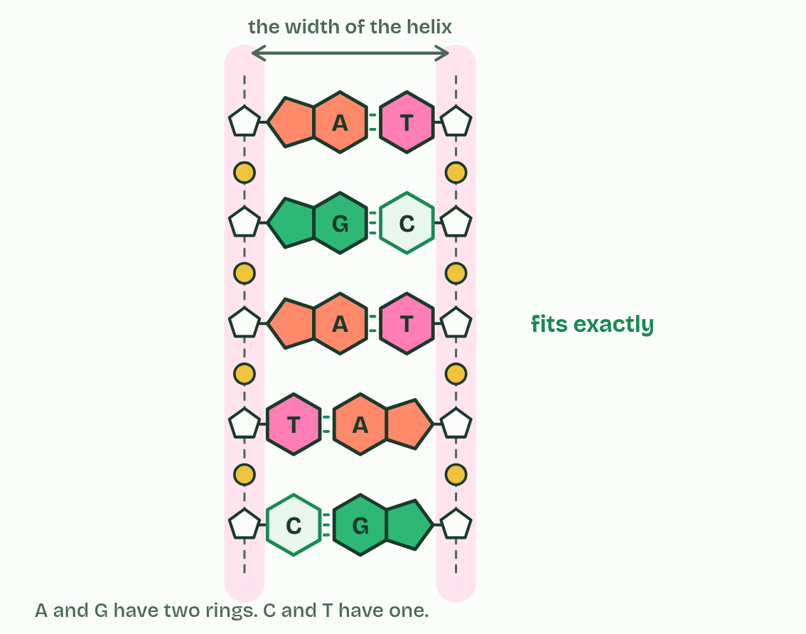  1 A with T  2 G with C  3 A with G  4 C with T  5 A with C  REMEMBER IT  Which bases are purines
  P  Pure | A  As | G  Gold | C  CUT
  Purines  two rings | Adenine  a purine | Guanine  a purine | Pyrimidines  cytosine, uracil, thymine: one ring
  SPOT THE MISTAKE
  What do students often get wrong about purine-to-pyrimidine bonding? Write the mistake, then put it right.
  There is no "big pair" and "small pair". Every pair is one big base and one small one, so every pair is the same size.
SUMMARY
Sum up section 09 in two or three sentences of your own.
• Bases come in two shapes. Purines (adenine and guanine) have two rings fused together, one of six atoms and one of five. Pyrimidines (cytosine, thymine and uracil) have one ring of six.
• Bases come in two shapes.
• Every base pair in DNA is one purine and one pyrimidine: A with T, G with C.
• That matters.

10 Wound on a spool | A1.2.13 HL
CUES  Predict: A chemical is added that cancels the negative charges on DNA's phosphate groups. What would you expect to happen to the nucleosomes?  C: The DNA would come away from the histones more easily. The DNA would loosen. Histones are rich in positively charged amino acids (lysine and arginine), and DNA's phosphate groups are negatively charged, so the two attract. Because the backbone is on the outside and every base pair is the same width (chapter 9), histones can hold any sequence. Take away the negative charges and the attraction goes. Cells do something like this on purpose, tagging histones to loosen or tighten the wrapping (D2.2).  What is meant by histones?  Proteins that DNA is wound around in the nuclei of eukaryotic cells.  What is meant by nucleosome?  A core of eight histone proteins with DNA wrapped round it, and one more histone attached to the linker DNA to hold it in place.  What is meant by linker DNA?  The stretch of DNA that leads into and out of a nucleosome and runs on to the next one. | NOTES  1 In eukaryotes, the DNA in the nucleus is wound around proteins called histones.  2 A nucleosome is a core of eight histone proteins with DNA wrapped round it, just under two turns, and one more histone attached to the linker DNA where the DNA enters and leaves, holding the wrapped DNA in place.  3 DNA and histone proteins.  4 Eight histones form a core.  5 The DNA wraps round the core, just under two turns.  6 A ninth histone, on the linker DNA, holds it in place.  Your own notes  ANNOTATE THE FIGURE  Number the 5 steps on the figure and note what happens at each: 1 histone; 2 Eight; 3 two turns; 4 ninth; 5 Nucleosomes.  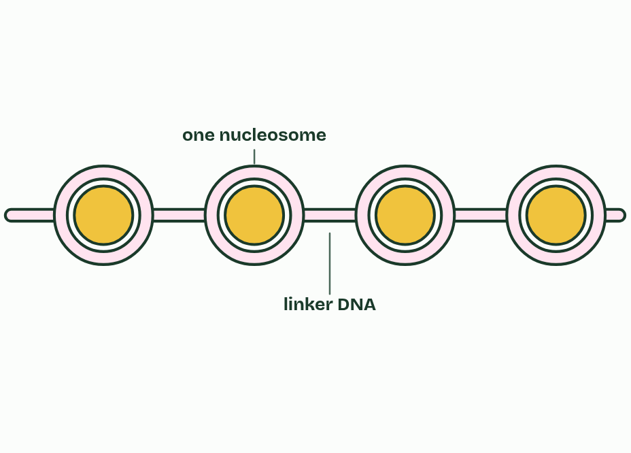  1 DNA and histone proteins.  2 Eight histones form a core.  3 The DNA wraps round the core, just under two turns.  4 A ninth histone, on the linker DNA, holds it in place.  5 Nucleosomes along the DNA, like beads on a string.
  SPOT THE MISTAKE
  What do students often get wrong about structure of a nucleosome? Write the mistake, then put it right.
  The DNA is not wrapped round one histone, and the ninth histone is not in the core: eight in the core, one on the linker DNA. Histones hold DNA by charge, not by base pairing.
SUMMARY
Sum up section 10 in two or three sentences of your own.
• In eukaryotes, the DNA in the nucleus is wound around proteins called histones.
• A nucleosome is a core of eight histone proteins with DNA wrapped round it, just under two turns, and one more histone attached to the linker DNA where the DNA enters and leaves, holding the wrapped DNA in place.

11 Hershey and Chase: which one carries the genes? | A1.2.14 HL
CUES  Predict: After blending and spinning, where will most of the radioactivity be in each batch?  C: Sulfur-35 in the liquid, phosphorus-32 in the pellet. Almost only the DNA goes in. The protein coats, carrying the sulfur-35, are shaken off and stay in the liquid; the bacteria, now holding the phage DNA with its phosphorus-32, sink to the pellet. The DNA that went in is what made the new phages: phosphorus-32 turned up in the next generation of phages, and sulfur-35 hardly at all. These results are evidence that DNA, not protein, is the genetic material of T2.  What is meant by bacteriophage?  A virus that infects bacteria. T2, the one used here, is a protein coat with DNA inside.  What is meant by radioisotope?  A form of an element whose atoms give out radiation, so they can be detected and followed.  What is meant by pellet?  The solid that collects at the bottom of a tube after centrifuging. Here it was the bacteria.  What is meant by supernatant?  The liquid above the pellet after centrifuging. | NOTES  1 Alfred Hershey and Martha Chase used a bacteriophage called T2, a virus that infects the bacterium E. coli.  2 Protein contains sulfur, in the amino acids cysteine and methionine, but almost no phosphorus.  3 DNA contains phosphorus, in its phosphate groups, but no sulfur.  4 A radioisotope gives itself away by its radiation.  5 A centrifuge then spun the mixture: the heavier bacteria formed a pellet at the bottom, and the light phage coats stayed in the liquid above, the supernatant.  Your own notes  ANNOTATE THE FIGURE  Annotate this still from the animation (Hershey and Chase: the film): what is happening, and why?  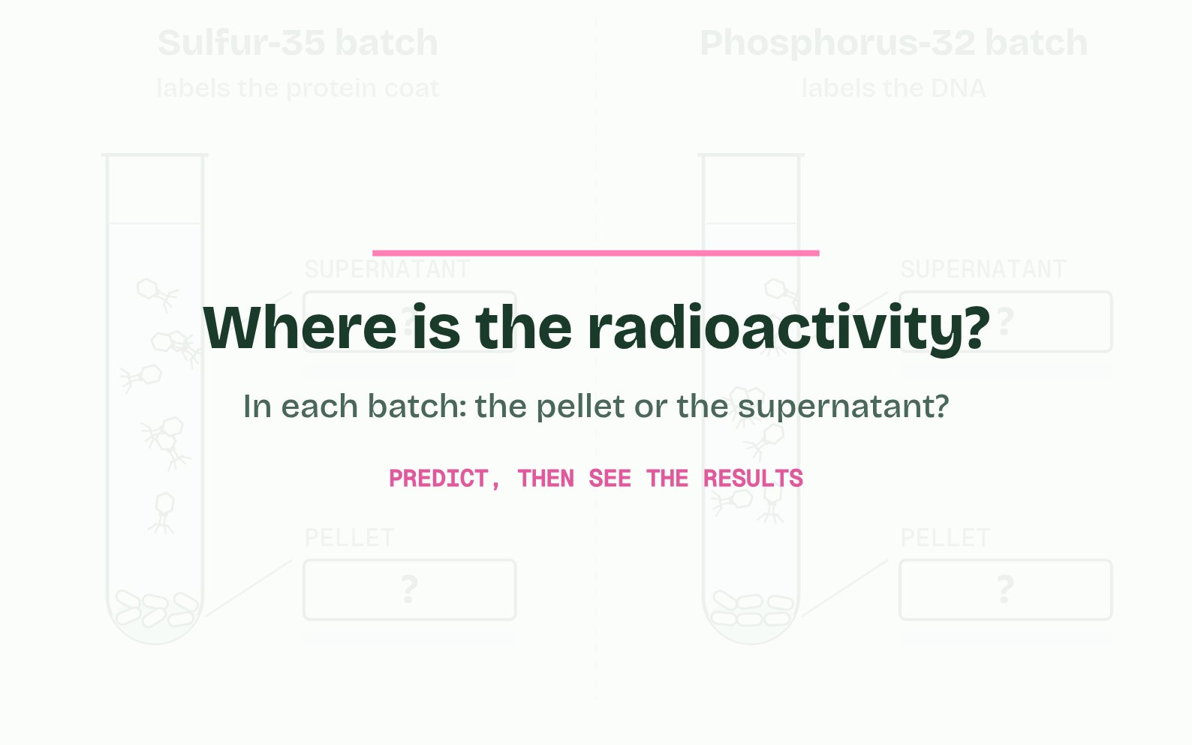  1 Sulfur is in protein, not DNA, so it labels the protein coat. Phosphorus is in DNA, so it labels the DNA.  2 It injects its DNA into the bacterium. The empty protein coat stays outside.  3 A few minutes later, a blender shakes the coats off the bacteria.  4 The heavy bacteria sink into a pellet. The light coats stay in the liquid above, the supernatant.  5 Where is the radioactivity? Predict before the results.
  SPOT THE MISTAKE
  What do students often get wrong about evidence from the Hershey–Chase experiment? Write the mistake, then put it right.
  Sulfur labels the protein, phosphorus the DNA: swapping them is the commonest slip. The pellet is the bacteria, not the viruses. And the results supported the conclusion that DNA is the genetic material of T2; saying the same of all life is a generalisation, which is chapter 12's subject.
SUMMARY
Sum up section 11 in two or three sentences of your own.
• Alfred Hershey and Martha Chase used a bacteriophage called T2, a virus that infects the bacterium E. coli.
• A radioisotope gives itself away by its radiation.
• A centrifuge then spun the mixture: the heavier bacteria formed a pellet at the bottom, and the light phage coats stayed in the liquid above, the supernatant.

12 Chargaff's numbers: one result can falsify | A1.2.15 HL
CUES  Predict: The tetranucleotide hypothesis says every DNA molecule is 25% of each base. Which result would be enough, on its own, to falsify it?  B: One species whose DNA is reliably measured as 30% adenine. One reliable contradiction is enough to reject a claim about all DNA. Human DNA is about 30% adenine and 20% guanine, not 25% of each, and the proportions vary between species. A thousand species with A equal to T cannot prove anything about every species, and do not even test the 25% prediction; a species at exactly 25% agrees with the hypothesis, so it cannot falsify it.  What is meant by tetranucleotide hypothesis?  The early idea that DNA is a dull repeat of the four nucleotides in equal amounts, so 25% of each base in every species.  What is meant by problem of induction?  The problem that no number of observations can make a general claim certain, because the next one might differ.  What is meant by certainty of falsification?  A single reliable result that contradicts a hypothesis shows with certainty that the hypothesis is wrong. | NOTES  1 The leading idea until then was the tetranucleotide hypothesis, from the early 1900s: that DNA is a monotonous repeat of the four nucleotides in equal amounts.  Your own notes  ANNOTATE THE FIGURE  The figure shows it as Bases, Ratios, The hypothesis and Add a virus. Note what changes each time.  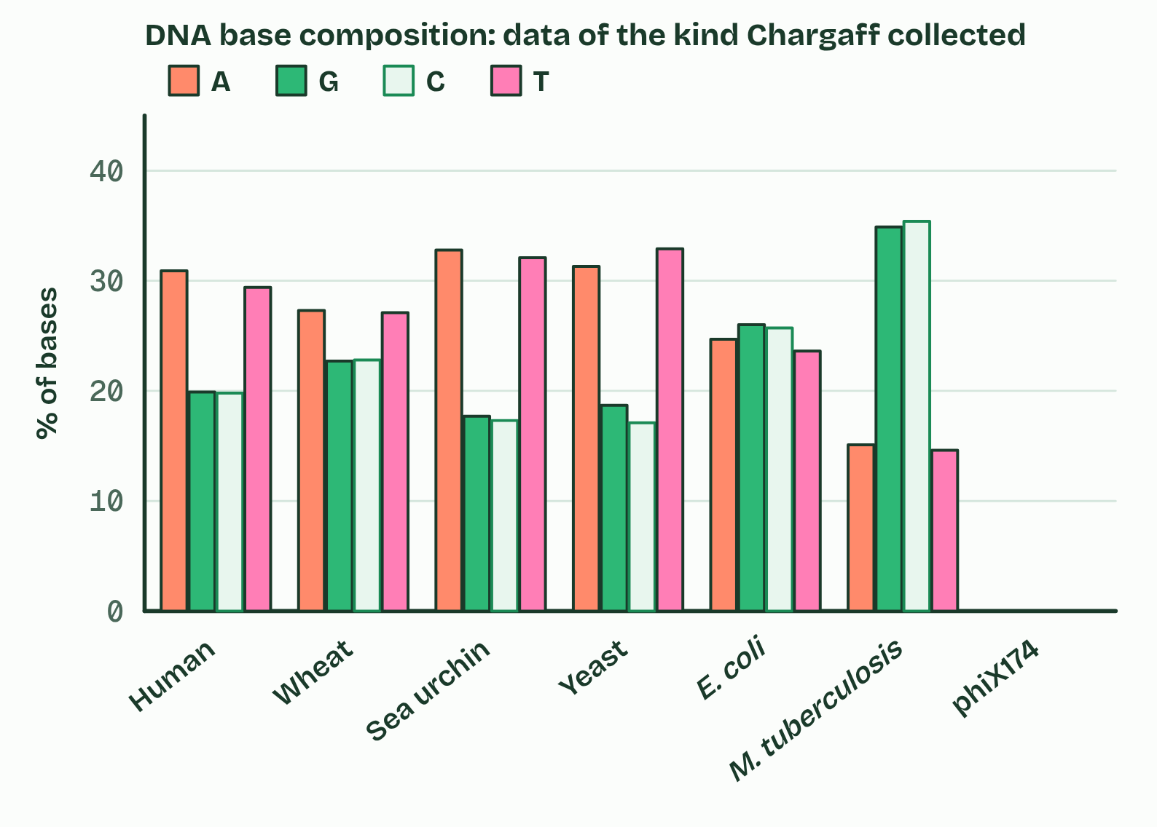  1 Bases  2 Ratios  3 The hypothesis  4 Add a virus
  SPOT THE MISTAKE
  What do students often get wrong about chargaff's data? Write the mistake, then put it right.
  Chargaff's rule is A = T and G = C. It is not A = G, and not A + T = G + C. It holds for double-stranded DNA, not for one strand on its own.
SUMMARY
Sum up section 12 in two or three sentences of your own.
• The leading idea until then was the tetranucleotide hypothesis, from the early 1900s: that DNA is a monotonous repeat of the four nucleotides in equal amounts.
• From the late 1940s Erwin Chargaff took DNA from many organisms, broke it into its bases, separated them and measured how much of each there was.
• He found two things.
• The leading idea until then was the tetranucleotide hypothesis, from the early 1900s: that DNA is a monotonous repeat of the four nucleotides in equal amounts.

Check yourself
The check for this guide is online: a fresh paper of past-paper style questions from the exam bank on A1.2 each time, marked as you go, and saved to your Exam practice progress when you are signed in. Open the link:
biologybybradford.com/exam-maker/sit?topics=A1.2&level=HL&paper=quiz&marks=15&src=ep

