Name | Class | Date
IB BIOLOGY · A1.2

Nucleic acids
Notes to fill in alongside the guide. Each numbered block matches a chapter of the guide, and of the lesson slides. Write in the gaps, answer the cues, annotate the figures, and sum up each section in your own words.
BY THE END YOU CAN
Explain why DNA is the genetic material of every living organism, and why RNA viruses do not break the rule A1.2.1
Draw a nucleotide as a circle, a pentagon and a rectangle, each joined in the right place A1.2.2
Explain how condensation builds a strand with a strong sugar–phosphate backbone, and draw a short strand of RNA A1.2.3, A1.2.5
Name the bases of DNA and RNA, and explain how complementary pairing lets DNA be copied and read A1.2.4, A1.2.8
Draw two antiparallel strands joined by hydrogen bonds between A and T, and C and G A1.2.6
Give three differences between DNA and RNA, and sketch ribose against deoxyribose A1.2.7
Explain why DNA can store limitless information, and why one genetic code in all life points to a common ancestor A1.2.9, A1.2.10
Explain what the 5′ and 3′ ends are, and why nucleotides are only ever added at the 3′ end A1.2.11
Explain why a purine always pairs with a pyrimidine, and what that does for the helix A1.2.12
Describe a nucleosome, and use molecular visualisation software to see how histones hold DNA A1.2.13
Explain how Hershey and Chase's results support the conclusion that DNA, not protein, is the genetic material A1.2.14
Use Chargaff's data to falsify the tetranucleotide hypothesis, and explain why one result can falsify what many cannot prove A1.2.15

01 Every living thing keeps its instructions in DNA | A1.2.1
CUES  Predict: A virus is found whose genes are made of RNA. Does that break the rule that DNA is the genetic material of all living organisms?  What is meant by genetic material?  What is meant by DNA?  What is meant by nucleic acids?  What is meant by RNA?  What is meant by viruses?  What is meant by gene? | NOTES  1 The molecule that holds those instructions is its ______________________.  2 In every living organism studied, the genetic material is ________, short for deoxyribonucleic acid.  3 DNA belongs to the __________________.  4 The other one, ________, does many jobs in the cell (chapter 6), and a few _________ use it to carry their genes: influenza, measles and the coronavirus that causes COVID-19 are RNA viruses.  5 A ________ is one stretch of its base sequence, and a single DNA molecule carries many genes.  Your own notes  ANNOTATE THE FIGURE  Label each part and say what it does: bacterium, yeast cell, plant cell, animal cell, phage, influenza virus, coronavirus.  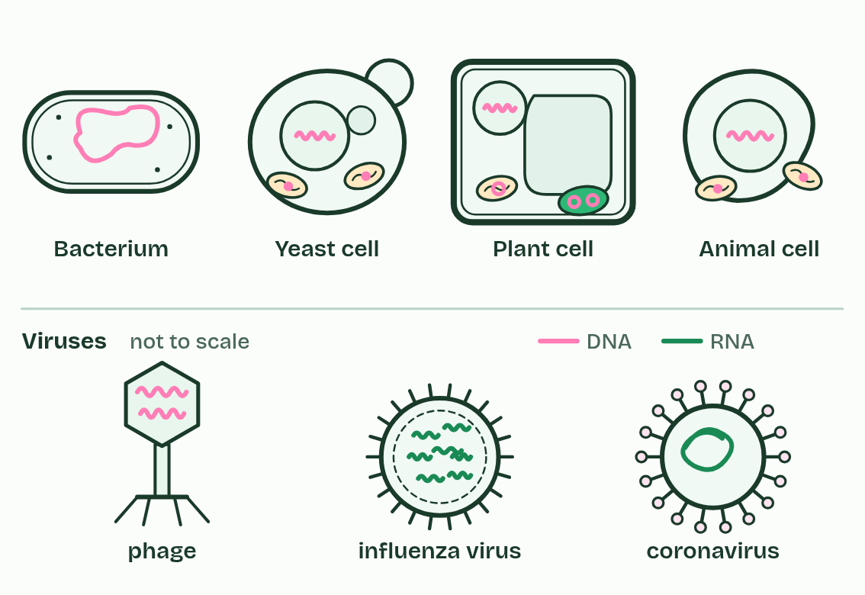
  SPOT THE MISTAKE
  What do students often get wrong about DNA as the genetic material? Write the mistake, then put it right.
  The mistake
  Put it right
SUMMARY
Sum up section 01 in two or three sentences of your own.

02 Three parts, one monomer | A1.2.2
CUES  Predict: How many different nucleotides does a cell use to build DNA?  What is meant by polymers?  What is meant by monomer?  What is meant by nucleotide?  What is meant by phosphate group?  What is meant by pentose?  What is meant by nitrogenous base? | NOTES  1 Nucleic acids are ___________.  2 The small unit, the _________, is the ______________.  3 A nucleotide has three parts joined by covalent bonds: a ____________________, a _________ sugar and a ______________________.  4 One ring round all three marks one ______________.  Your own notes  ANNOTATE THE FIGURE  Number the 4 steps on the figure and note what happens at each: 1 three parts; 2 sugar; 3 circle, pentagon, rectangle; 4 phosphorus.  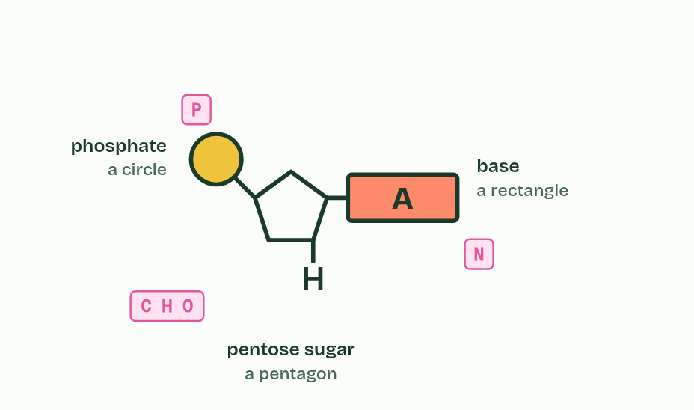
  SPOT THE MISTAKE
  What do students often get wrong about components of a nucleotide? Write the mistake, then put it right.
  The mistake
  Put it right
SUMMARY
Sum up section 02 in two or three sentences of your own.

03 Building a strand with a strong backbone | A1.2.3 A1.2.5
CUES  Predict: How many water molecules are released when 10 nucleotides join into one strand?  What is meant by condensation?  What is meant by hydrolysis?  What is meant by strand?  What is meant by covalent bond?  What is meant by sugar–phosphate backbone? | NOTES  1 Nucleotides join by ________________, as in the sugars and lipids of B1.1.  2 The reverse is ______________: water is added back and the bond breaks, which is how your digestion takes the nucleic acids in food apart.  3 Repeat the join and you build a ________: sugar, phosphate, sugar, phosphate.  4 Every link is a __________________, so the strand is one continuous chain of covalently bonded atoms.  5 That is the ________________________________: strong, and it fixes the order of the nucleotides along it.  Your own notes  ANNOTATE THE FIGURE  Number the 5 steps on the figure and note what happens at each: 1 nucleotide; 2 Condensation; 3 water; 4 backbone; 5 together.  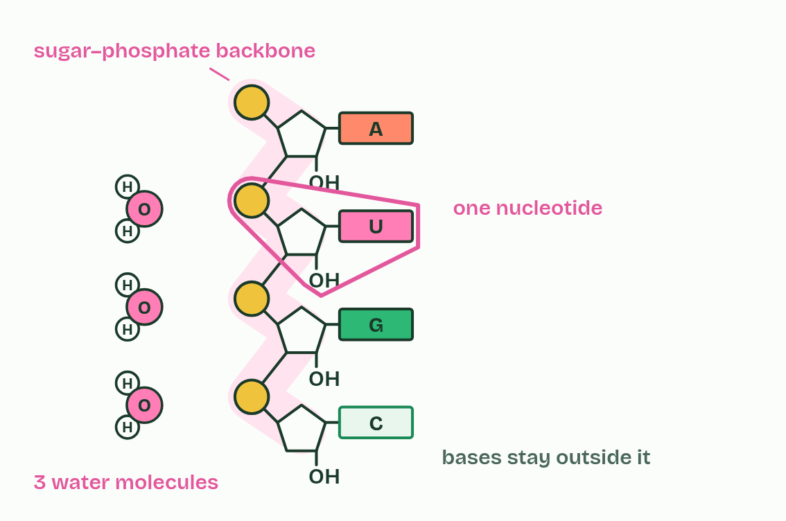  ANNOTATE THE FIGURE  Number the 4 steps on the figure and note what happens at each.  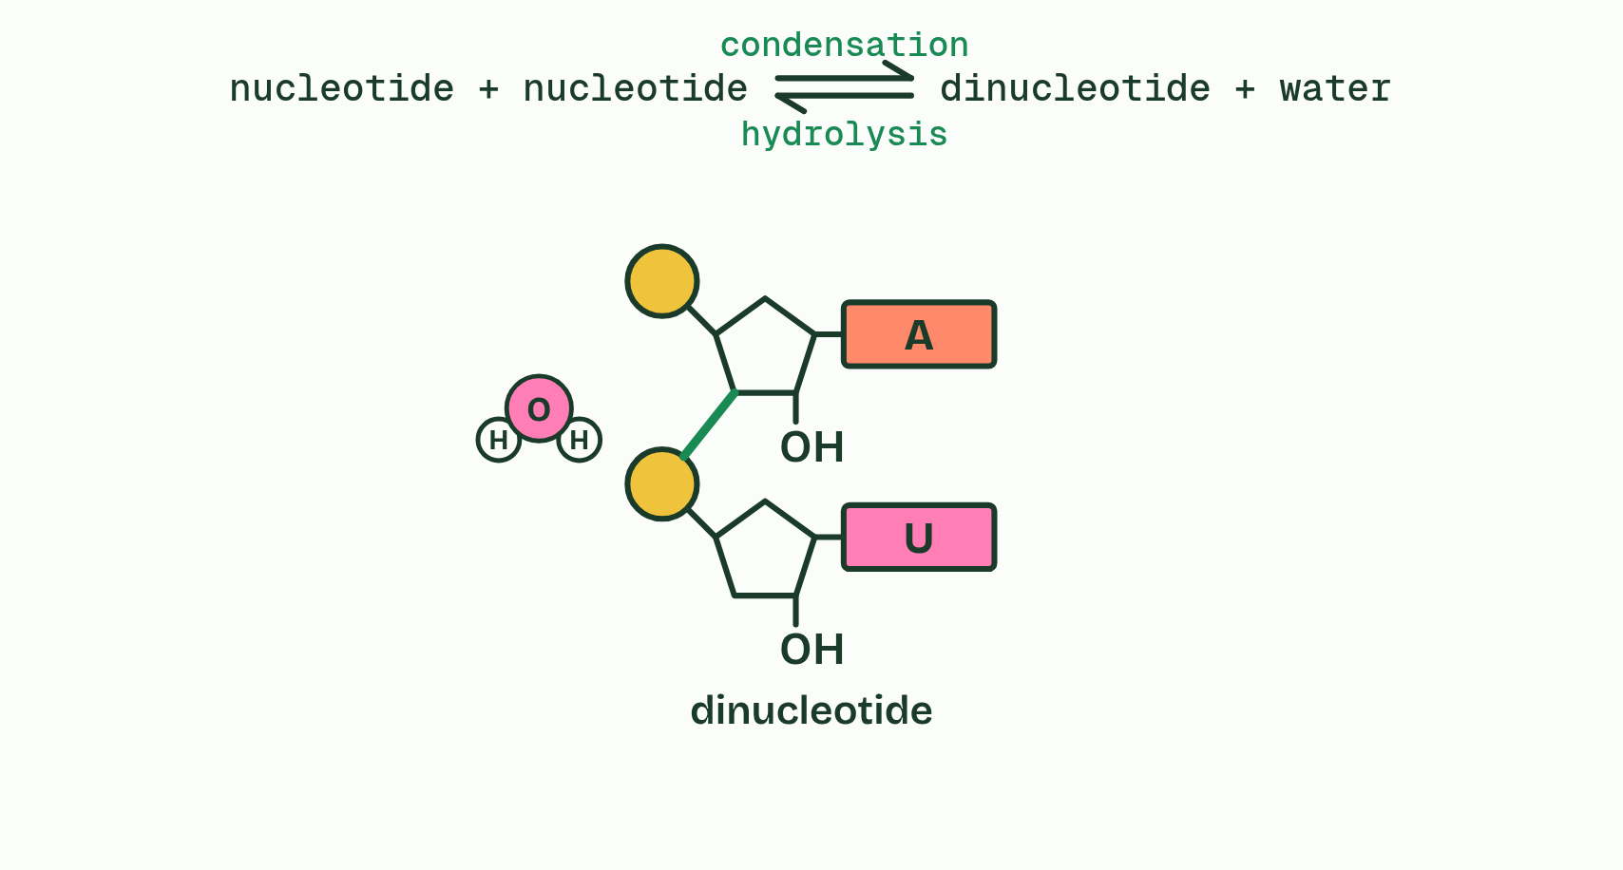
  SPOT THE MISTAKE
  What do students often get wrong about sugar–phosphate bonding and RNA? Write the mistake, then put it right.
  The mistake
  Put it right
SUMMARY
Sum up section 03 in two or three sentences of your own.

04 Four letters that pair | A1.2.4 A1.2.8
CUES  Predict: One strand of a DNA molecule reads A A T G C. The strands separate and each is copied. What does the strand built against it read, and the strand built against that one?  What is meant by adenine?  What is meant by cytosine?  What is meant by guanine?  What is meant by thymine?  What is meant by uracil?  What is meant by base sequence?  What is meant by complementary base pairing?  What is meant by hydrogen bonds?  What is meant by replication?  What is meant by template?  What is meant by transcription?  What is meant by translation? | NOTES  1 DNA uses four bases: _________ (A), ___________ (C), _________ (G) and _________ (T).  2 RNA has A, C and G too, but ________ (U) takes the place of thymine.  3 The order of the bases along a strand is the message, like letters spelling words: the __________________.  4 Bases pair across between two strands by __________________________________: A with T (or with U when RNA is involved), and C with G.  5 Complementarity rests on ___________________.  6 In _______________ the hydrogen bonds break and the strands separate, while the covalent backbones stay whole.  7 Each strand is a ___________: free nucleotides pair with its exposed bases, and each new strand is complementary to its template.  8 In __________________, one strand of a gene is the template for an RNA copy, with an RNA base opposite each DNA base and U opposite A.  Your own notes  ANNOTATE THE FIGURE  The figure shows it as Which base fits each slot?, Paired: only A with T and G with C form hydrogen bonds, Copy it: two molecules with the same sequence and Read it: messenger RNA, read by a transfer RNA. Note what changes each time.  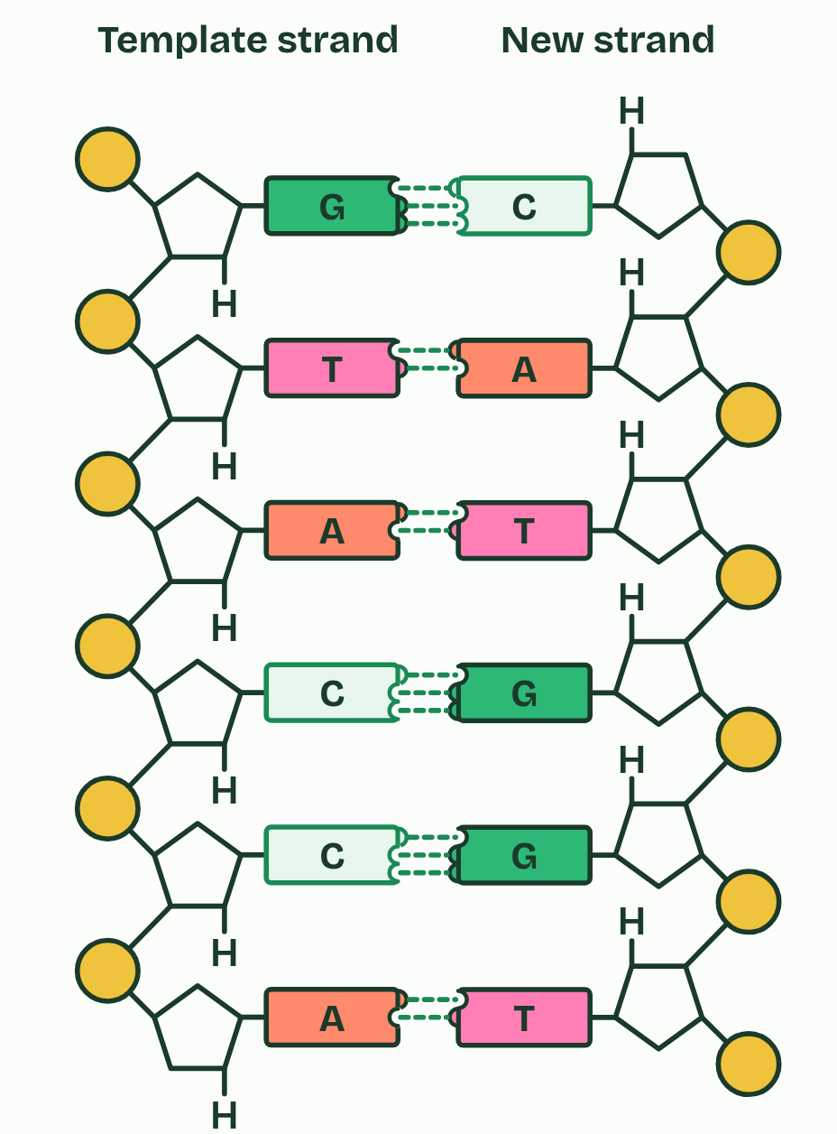  REMEMBER IT  Which base pairs with which
  A  Apples | T  Tree | C  Cars | G  Garage
  A | T | C | G
  SPOT THE MISTAKE
  What do students often get wrong about bases and complementary pairing? Write the mistake, then put it right.
  The mistake
  Put it right
SUMMARY
Sum up section 04 in two or three sentences of your own.

05 Two strands, one helix | A1.2.6
CUES  Predict: To be copied, the two strands of DNA must come apart. Why does pulling them apart not break the strands themselves?  What is meant by base pair?  What is meant by antiparallel?  What is meant by double helix? | NOTES  1 A pair of bases facing each other is a ____________.  2 The strands are ________________: they run in opposite directions, like the two lanes of a road.  3 The pair of strands winds into a ________________.  Your own notes  ANNOTATE THE FIGURE  The figure shows it as Flat: the ladder the exam asks for and Twisted into a double helix. Note what changes each time.  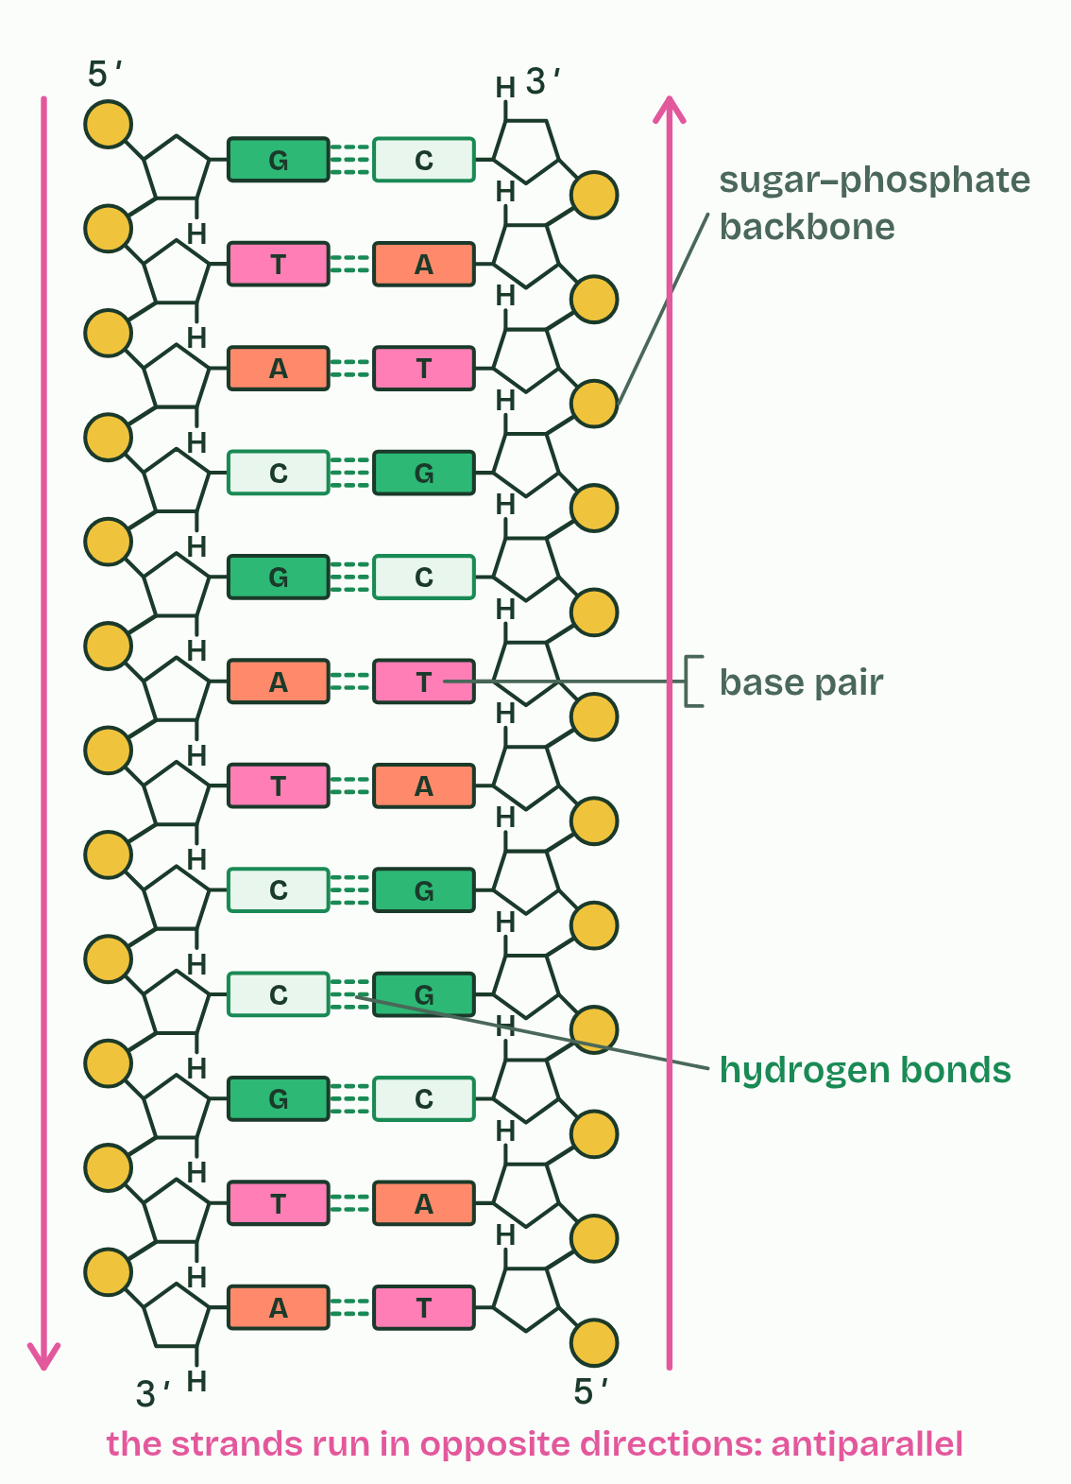
  SPOT THE MISTAKE
  What do students often get wrong about the double helix? Write the mistake, then put it right.
  The mistake
  Put it right
SUMMARY
Sum up section 05 in two or three sentences of your own.

06 DNA and RNA compared | A1.2.7
CUES  Predict: A sample of nucleic acid is single-stranded and contains thymine but no uracil. What is it most likely to be?  What is meant by deoxyribose?  What is meant by ribose?  What is meant by messenger RNA?  What is meant by transfer RNA?  What is meant by ribosomal RNA? | NOTES  1 DNA makes up the chromosomes, with more in mitochondria and chloroplasts. __________________ is a copy of a gene, taken to a ribosome. ________________ brings amino acids to the ribosome. __________________ is part of every ribosome.  2 Strands. DNA has two, wound into a double helix. RNA usually has one, which can fold back and pair with itself in places: ________________ does.  3 Sugar. DNA has _______________. RNA has ________.  Your own notes  ANNOTATE THE FIGURE  The figure shows it as DNA and RNA. Note what changes each time.  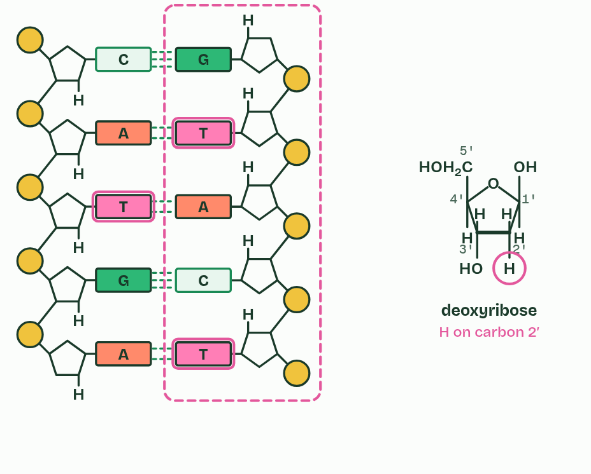  REMEMBER IT  The three differences between DNA and RNA
  S  Some | B  Bananas | S  Split
  S | B | S
  SPOT THE MISTAKE
  What do students often get wrong about differences between DNA and RNA? Write the mistake, then put it right.
  The mistake
  Put it right
SUMMARY
Sum up section 06 in two or three sentences of your own.

07 Endless sequences, one code | A1.2.9 A1.2.10
CUES  Predict: How many different sequences of three bases can DNA's four bases make?  What is meant by genetic code?  What is meant by codon?  What is meant by universal common ancestor?  What is meant by conserved? | NOTES  1 The ________________ is the set of rules by which a sequence of bases in messenger RNA is translated into a sequence of amino acids, three bases at a time.  2 Each group of three is a ________.  3 The best explanation for one shared code is that all life inherited it from a __________________________________.  4 A code shared like that is ____________ across life, and it is evidence of that shared ancestry.  Your own notes  ANNOTATE THE FIGURE  The figure shows it at bases in the sequence 0, in the sequence 1, in the sequence 2, in the sequence 3, in the sequence 4, in the sequence 5, in the sequence 6 and in the sequence 7. Note what changes each time.  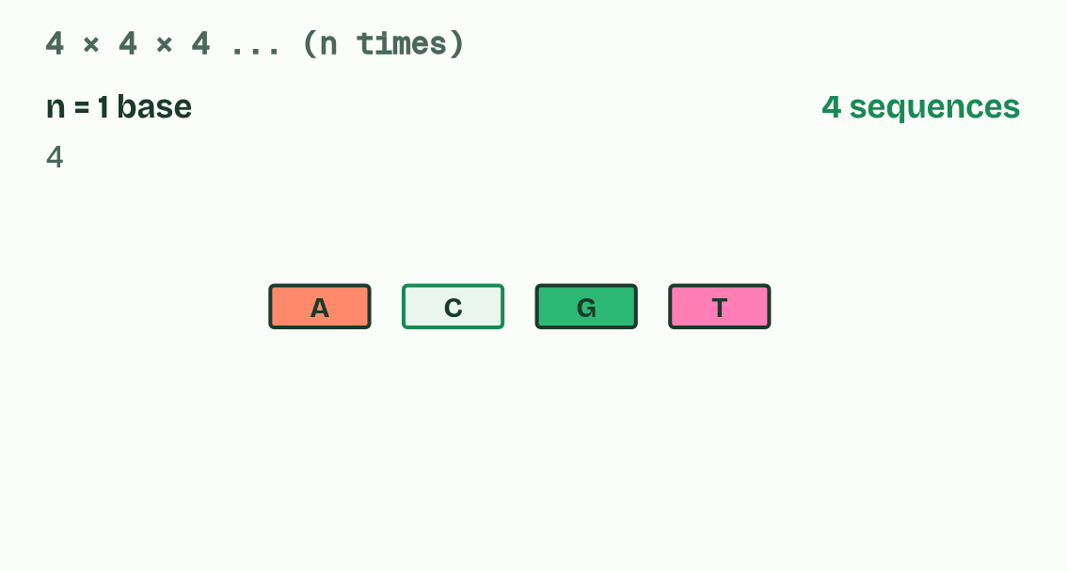  ANNOTATE THE FIGURE  The figure shows it as Bacterium, Yeast, Wheat, Human cell and Human mitochondrion. Note what changes each time.  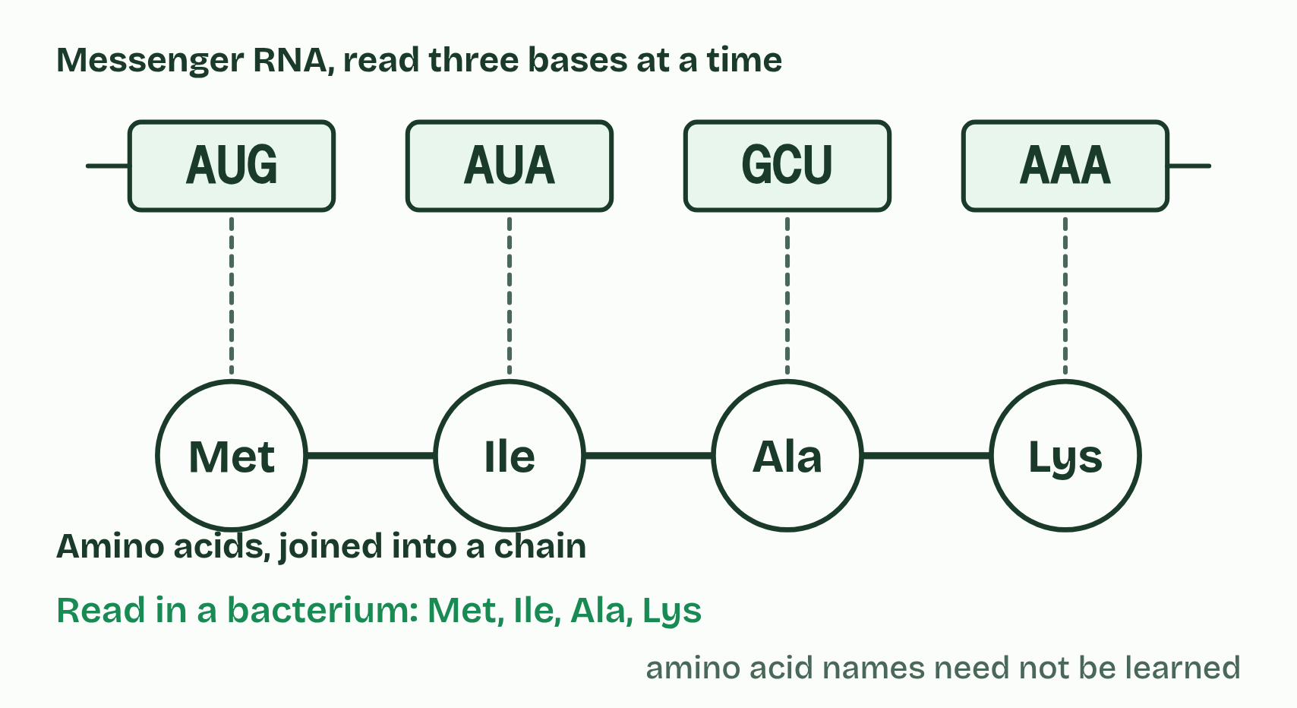
  SPOT THE MISTAKE
  What do students often get wrong about information storage and the genetic code? Write the mistake, then put it right.
  The mistake
  Put it right
SUMMARY
Sum up section 07 in two or three sentences of your own.

08 Every strand has a direction | A1.2.11 HL
CUES  Predict: One DNA strand reads 5′-ATGC-3′. Written 5′ to 3′, what is its partner?  What is meant by directionality?  What is meant by 5′ end?  What is meant by 3′ end? | NOTES  1 So every link in the backbone runs the same way, and the strand has ___________________.  2 One end has a free phosphate on a 5′ carbon, the ________.  3 The other has a free OH on a 3′ carbon, the ________.  4 Translation. A ribosome moves along messenger RNA from its ________ towards its 3′ end, so the codons are read in that order.  Your own notes  ANNOTATE THE FIGURE  Number the 5 steps on the figure and note what happens at each: 1 1′ to 5′; 2 5′, 3′; 3 3′ end; 4 antiparallel; 5 one direction.  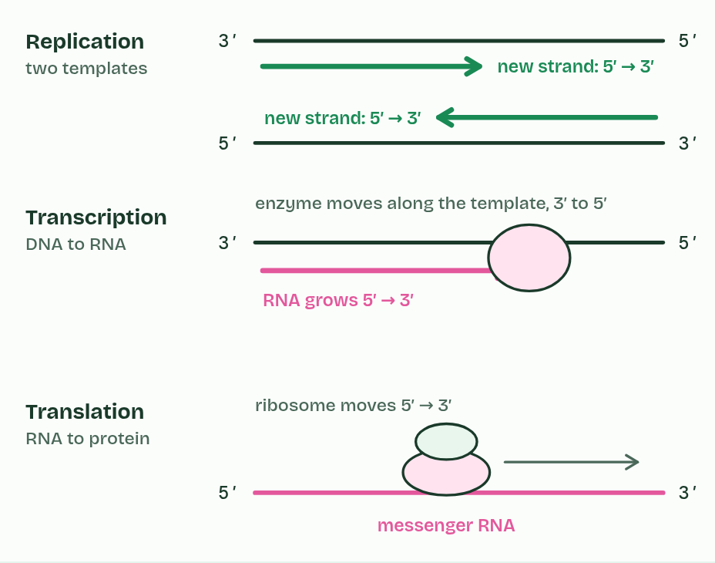
  SPOT THE MISTAKE
  What do students often get wrong about directionality? Write the mistake, then put it right.
  The mistake
  Put it right
SUMMARY
Sum up section 08 in two or three sentences of your own.

09 A big base with a small one | A1.2.12 HL
CUES  Predict: 30% of the bases in a sample of double-stranded DNA are adenine. What percentage are purines?  What is meant by purines?  What is meant by pyrimidines? | NOTES  1 Bases come in two shapes. _________ (adenine and guanine) have two rings fused together, one of six atoms and one of five. _______________ (cytosine, thymine and uracil) have one ring of six.  Your own notes  ANNOTATE THE FIGURE  The figure shows it as A with T, G with C, A with G, C with T and A with C. Note what changes each time.  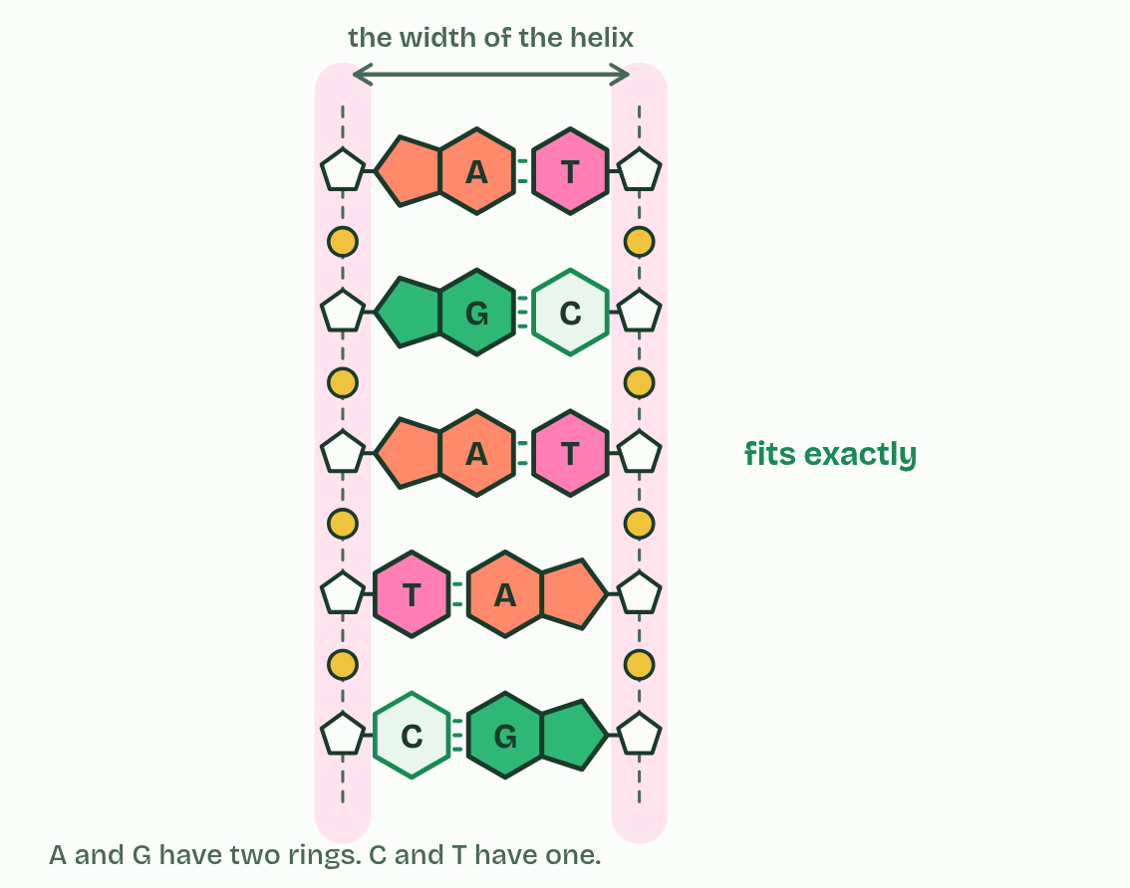  REMEMBER IT  Which bases are purines
  P  Pure | A  As | G  Gold | C  CUT
  P | A | G | C
  SPOT THE MISTAKE
  What do students often get wrong about purine-to-pyrimidine bonding? Write the mistake, then put it right.
  The mistake
  Put it right
SUMMARY
Sum up section 09 in two or three sentences of your own.

10 Wound on a spool | A1.2.13 HL
CUES  Predict: A chemical is added that cancels the negative charges on DNA's phosphate groups. What would you expect to happen to the nucleosomes?  What is meant by histones?  What is meant by nucleosome?  What is meant by linker DNA? | NOTES  1 In eukaryotes, the DNA in the nucleus is wound around proteins called ___________.  2 A ______________ is a core of eight histone proteins with DNA wrapped round it, just under two turns, and one more histone attached to the ______________ where the DNA enters and leaves, holding the wrapped DNA in place.  3 DNA and _________ proteins.  4 ________ histones form a core.  5 The DNA wraps round the core, just under ____________.  6 A ________ histone, on the linker DNA, holds it in place.  Your own notes  ANNOTATE THE FIGURE  Number the 5 steps on the figure and note what happens at each: 1 histone; 2 Eight; 3 two turns; 4 ninth; 5 Nucleosomes.  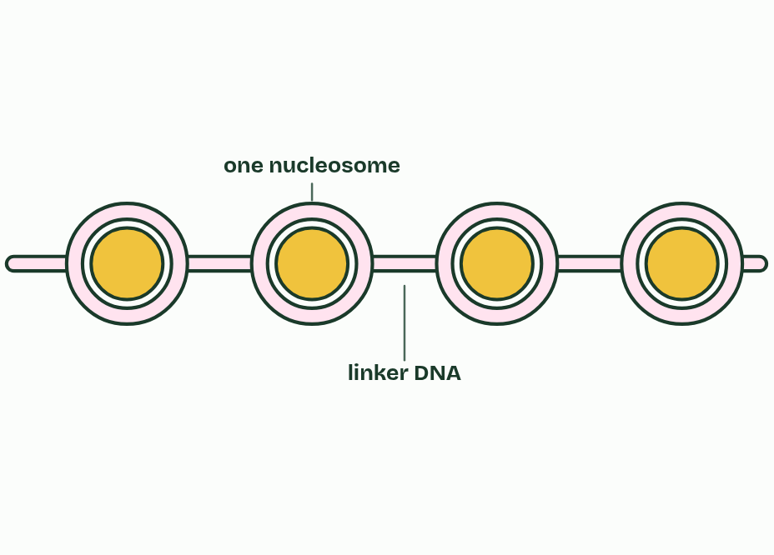
  SPOT THE MISTAKE
  What do students often get wrong about structure of a nucleosome? Write the mistake, then put it right.
  The mistake
  Put it right
SUMMARY
Sum up section 10 in two or three sentences of your own.

11 Hershey and Chase: which one carries the genes? | A1.2.14 HL
CUES  Predict: After blending and spinning, where will most of the radioactivity be in each batch?  What is meant by bacteriophage?  What is meant by radioisotope?  What is meant by pellet?  What is meant by supernatant? | NOTES  1 Alfred Hershey and Martha Chase used a __________________ called T2, a virus that infects the bacterium E. coli.  2 Protein contains ________, in the amino acids cysteine and methionine, but almost no phosphorus.  3 DNA contains ______________, in its phosphate groups, but no sulfur.  4 A ________________ gives itself away by its radiation.  5 A centrifuge then spun the mixture: the heavier bacteria formed a ________ at the bottom, and the light phage coats stayed in the liquid above, the _______________.  Your own notes  ANNOTATE THE FIGURE  Annotate this still from the animation (Hershey and Chase: the film): what is happening, and why?  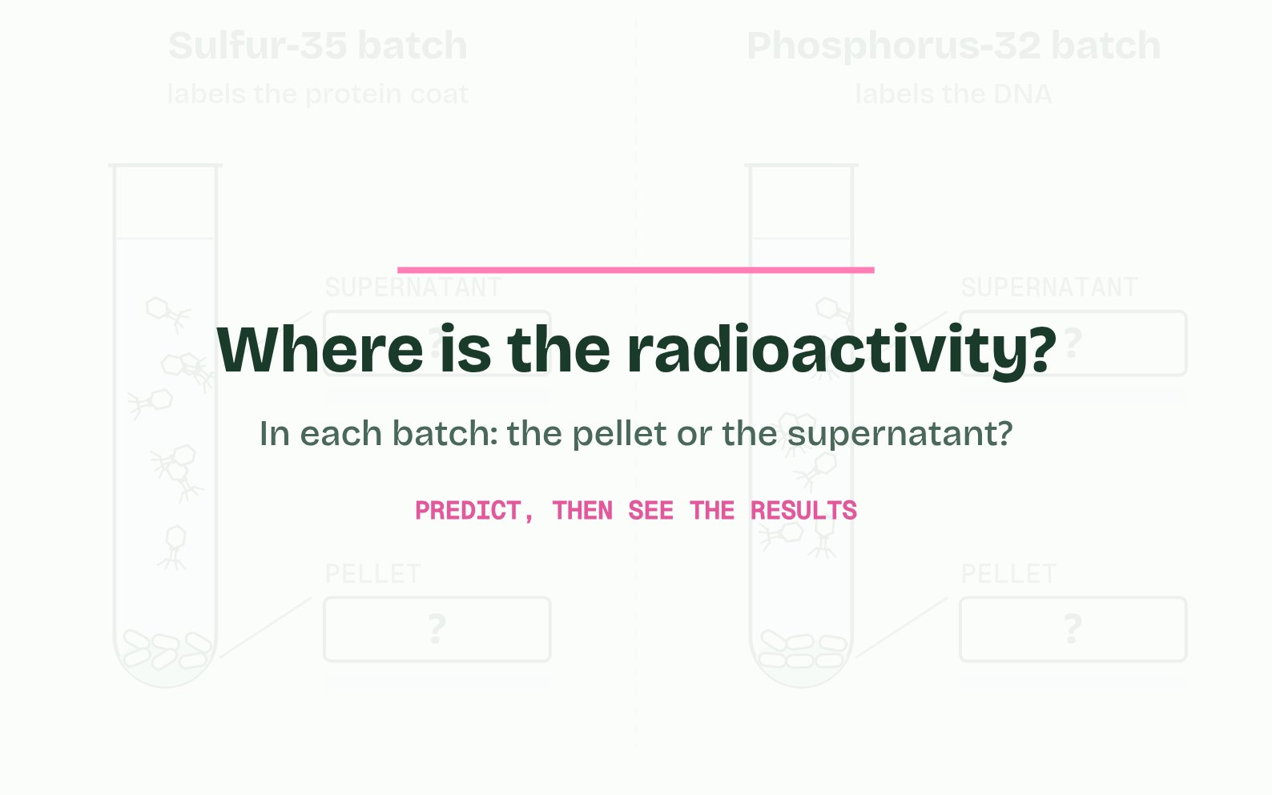
  SPOT THE MISTAKE
  What do students often get wrong about evidence from the Hershey–Chase experiment? Write the mistake, then put it right.
  The mistake
  Put it right
SUMMARY
Sum up section 11 in two or three sentences of your own.

12 Chargaff's numbers: one result can falsify | A1.2.15 HL
CUES  Predict: The tetranucleotide hypothesis says every DNA molecule is 25% of each base. Which result would be enough, on its own, to falsify it?  What is meant by tetranucleotide hypothesis?  What is meant by problem of induction?  What is meant by certainty of falsification? | NOTES  1 The leading idea until then was the __________________________________, from the early 1900s: that DNA is a monotonous repeat of the four nucleotides in equal amounts.  Your own notes  ANNOTATE THE FIGURE  The figure shows it as Bases, Ratios, The hypothesis and Add a virus. Note what changes each time.  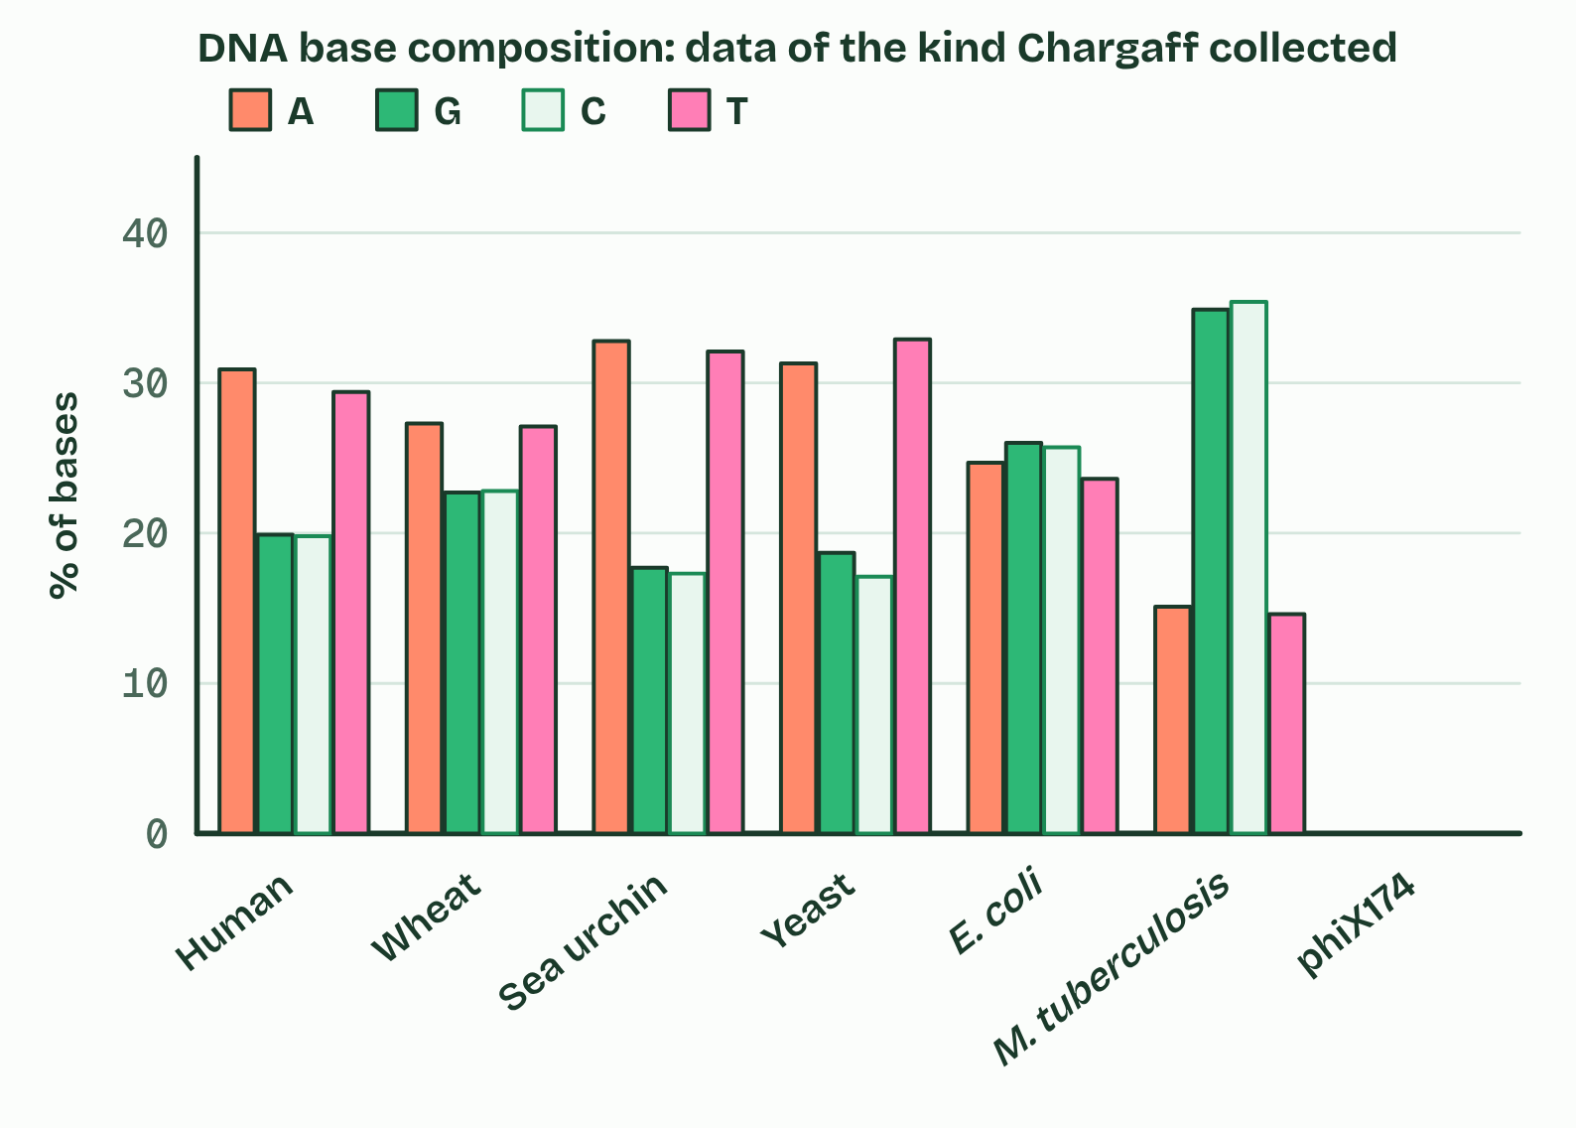
  SPOT THE MISTAKE
  What do students often get wrong about chargaff's data? Write the mistake, then put it right.
  The mistake
  Put it right
SUMMARY
Sum up section 12 in two or three sentences of your own.

Check yourself
The check for this guide is online: a fresh paper of past-paper style questions from the exam bank on A1.2 each time, marked as you go, and saved to your Exam practice progress when you are signed in. Open the link:
biologybybradford.com/exam-maker/sit?topics=A1.2&level=HL&paper=quiz&marks=15&src=ep

