Name | Class | Date
IB BIOLOGY · A3.1

Diversity of organisms
Teacher’s copy: every blank filled in. Each numbered block matches a chapter of the guide, and of the lesson slides. Write in the gaps, answer the cues, annotate the figures, and sum up each section in your own words.
BY THE END YOU CAN
Explain why variation between organisms is a defining feature of life, and how Linnaeus used shared traits to define a species A3.1.1, A3.1.2
Name an organism with a binomial name written to the rules, and say what two species of one genus share A3.1.3
State the biological species concept, give challenges to it, and explain why gradual speciation makes the line between populations and species arbitrary A3.1.4, A3.1.5
Say that species differ in chromosome number, using humans (46) and chimpanzees (48), and why diploid numbers are even A3.1.6
Classify chromosomes in a karyogram by banding, length and centromere position, and evaluate the evidence that human chromosome 2 arose from a fusion A3.1.7
Describe a genome, how SNPs give diversity within a species, and why variation between species is much larger A3.1.8, A3.1.9
Compare genome sizes of different groups from a database and judge whether size measures complexity A3.1.10
Describe how whole genome sequencing has become faster and cheaper, and give current and future uses A3.1.11
Explain why the biological species concept fails for asexual species and for bacteria that pass genes sideways A3.1.12
Explain why parents with different chromosome numbers are unlikely to have fertile offspring A3.1.13
Build and test a dichotomous key for local organisms A3.1.14
Explain how DNA barcodes and environmental DNA identify the species in a habitat rapidly A3.1.15

01 No two beetles are alike, and we sort them anyway | A3.1.1 A3.1.2
CUES  Predict: Identical twins share all their DNA. Are they identical in every trait?  B: No: fingerprints, scars and tans differ even so. No. Twins share their DNA, but traits are shaped by the environment too: a scar or a tan is picked up during life, and even fingerprints differ. Organisms are never alike in every trait, even when their genes match.  What is meant by variation?  Differences between individuals of one species, or between groups of organisms.  What is meant by species?  A group of organisms that share a set of traits. In the morphological species concept, the traits are the form and structure of the body.  What is meant by morphology?  The form and structure of an organism: its shape, its parts and how they look.  What is meant by morphological species concept?  The idea, used by Linnaeus, that a species is a group of organisms sharing a distinctive set of physical traits. | NOTES  1 Even identical twins differ, in their fingerprints, their scars and their tans. This variation is a defining feature of life, and it has patterns.  2 To him a species was a group of organisms with the same body form and structure, its morphology.  3 This is the morphological species concept.  4 It is a working definition: a tool for grouping what biologists find, which can be improved or replaced.  5 Patterns in variation are the basis for naming and classifying organisms.  6 Linnaeus grouped organisms by shared physical traits: the morphological species concept.  Your own notes  ANNOTATE THE FIGURE  The figure shows it as Shuffled, By colour and By body shape. Note what changes each time.  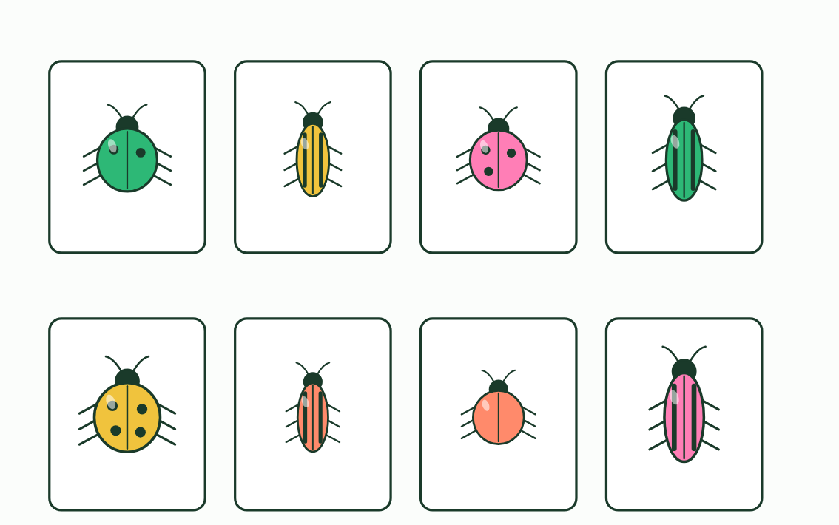  1 Shuffled  2 By colour  3 By body shape
  SPOT THE MISTAKE
  What do students often get wrong about variation and species? Write the mistake, then put it right.
  Variation inside a species is not a flaw in the definition. If every member were identical, natural selection would have nothing to act on. A species is a group of similar organisms, never identical ones.
SUMMARY
Sum up section 01 in two or three sentences of your own.
• No two individuals are identical in every trait.
• Patterns in variation are the basis for naming and classifying organisms.
• Linnaeus grouped organisms by shared physical traits: the morphological species concept.

02 A name with two parts | A3.1.3
CUES  Predict: Two animals are named Panthera tigris and Panthera onca. What can you say about them?  C: Two species in one genus, so they share similar traits. Two species in one genus. The genus is the same (Panthera) and the species names differ (tigris, the tiger, and onca, the jaguar), so they are separate species that share similar traits.  What is meant by binomial system?  The system of naming each species with two parts: its genus, then its species name.  What is meant by genus?  A group of closely related species. The first part of a binomial name. | NOTES  1 The answer, from Linnaeus, is the binomial system: every species gets a two-part name.  2 The first part is the genus.  3 Write it right Tap the correct way to write each name.  4 A binomial name has two words, written in italics.  5 The first word is the genus, with a capital letter. The second names the species, in lower case.  6 Species in one genus have similar traits: lion, tiger and leopard share the genus Panthera.  Your own notes  ANNOTATE THE FIGURE  Number the 4 steps on the figure and note what happens at each: 1 binomial; 2 genus, species; 3 similar traits; 4 initial.  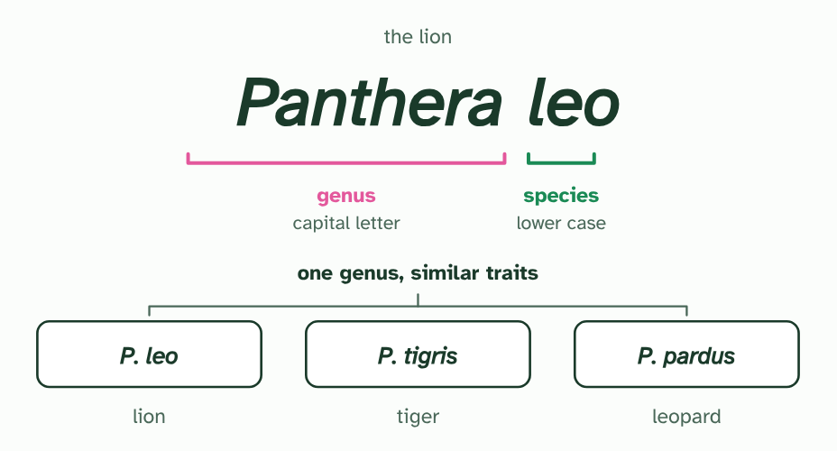  1 A binomial name has two words, written in italics.  2 The first word is the genus, with a capital letter. The second names the species, in lower case.  3 Species in one genus have similar traits: lion, tiger and leopard share the genus Panthera.  4 After the first full use you may shorten the genus to its initial: P. leo.  REMEMBER IT  The four rules of a binomial name
  G  Green | S  Sloths | I  Inch | A  Along
  Genus first  with a capital letter | Species second  all in lower case | Italics  underlined if handwritten | Abbreviate  the genus to its initial after first use
  SPOT THE MISTAKE
  What do students often get wrong about binomial naming? Write the mistake, then put it right.
  The species name never stands alone: leo means nothing without its genus, because other genera have species with the same second word. And the capital belongs to the genus only: Homo sapiens, never Homo Sapiens.
SUMMARY
Sum up section 02 in two or three sentences of your own.
• The answer, from Linnaeus, is the binomial system: every species gets a two-part name.
• The first part is the genus.

03 Can they breed? | A3.1.4 A3.1.5
CUES  Predict: Two kinds of snail live on islands 500 km apart, and none has ever crossed the sea. Can the biological species concept say whether they are one species?  C: Not directly: they have never met, so other evidence is needed. Not directly. The test asks whether they could breed and have fertile young, and that has never been tried. Scientists use other evidence: how alike the snails’ bodies and DNA are, and how long ago the islands were separated. Never having bred is not the same as being unable to.  What is meant by biological species concept?  The idea that a species is a group of organisms that can breed with each other and produce fertile offspring.  What is meant by speciation?  The splitting of one species into two or more. | NOTES  1 The biological species concept says a species is a group of organisms that can breed and produce fertile offspring.  2 A species concept is a working definition, a tool that helps scientists group what they find, and it is replaced when a better tool comes along.  3 One more problem comes from how species form. Speciation, the splitting of one species into two or more, usually happens gradually (you saw it in A4.1).  4 Biological species concept: organisms that can breed and produce fertile offspring.  5 Speciation is gradual, so the line between populations and species can be arbitrary.  Your own notes  ANNOTATE THE FIGURE  Number the 4 steps on the figure and note what happens at each: 1 same group, one from each; 2 young; 3 fertile; 4 separate species.  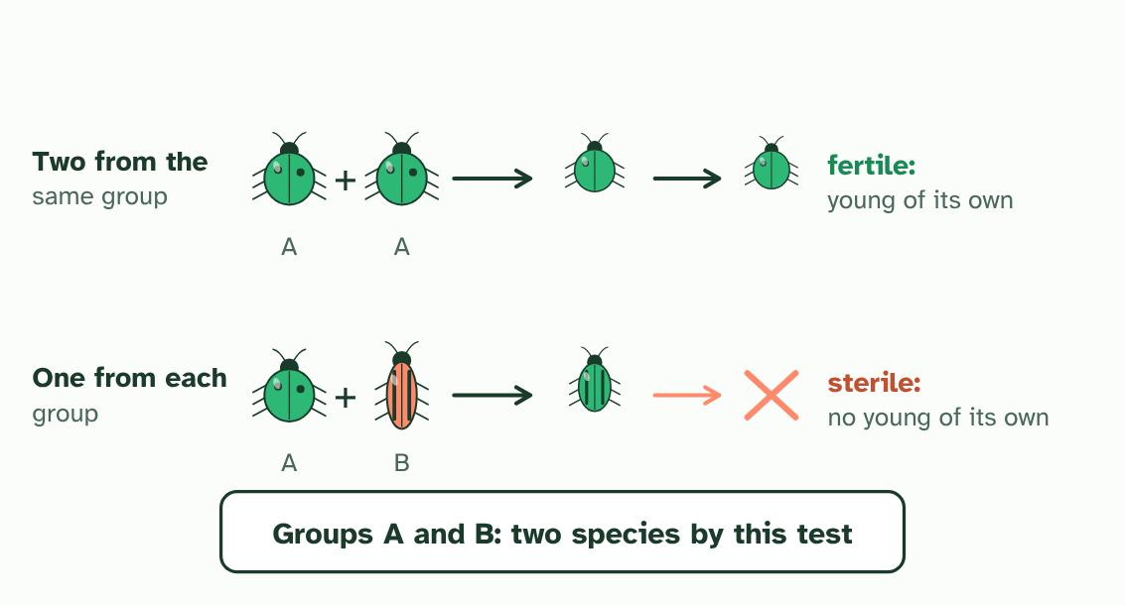  1 A breeding test: two beetles from the same group, and a pair with one from each (imagined beetles).  2 Both pairs have young. Mating alone does not decide it.  3 Only the first pair’s young are fertile. The mixed pair’s young cannot have young of their own.  4 By the biological species concept, A and B are separate species.  ANNOTATE THE FIGURE  Annotate this still from the animation (Watch it happen: one population becomes two): what is happening, and why?  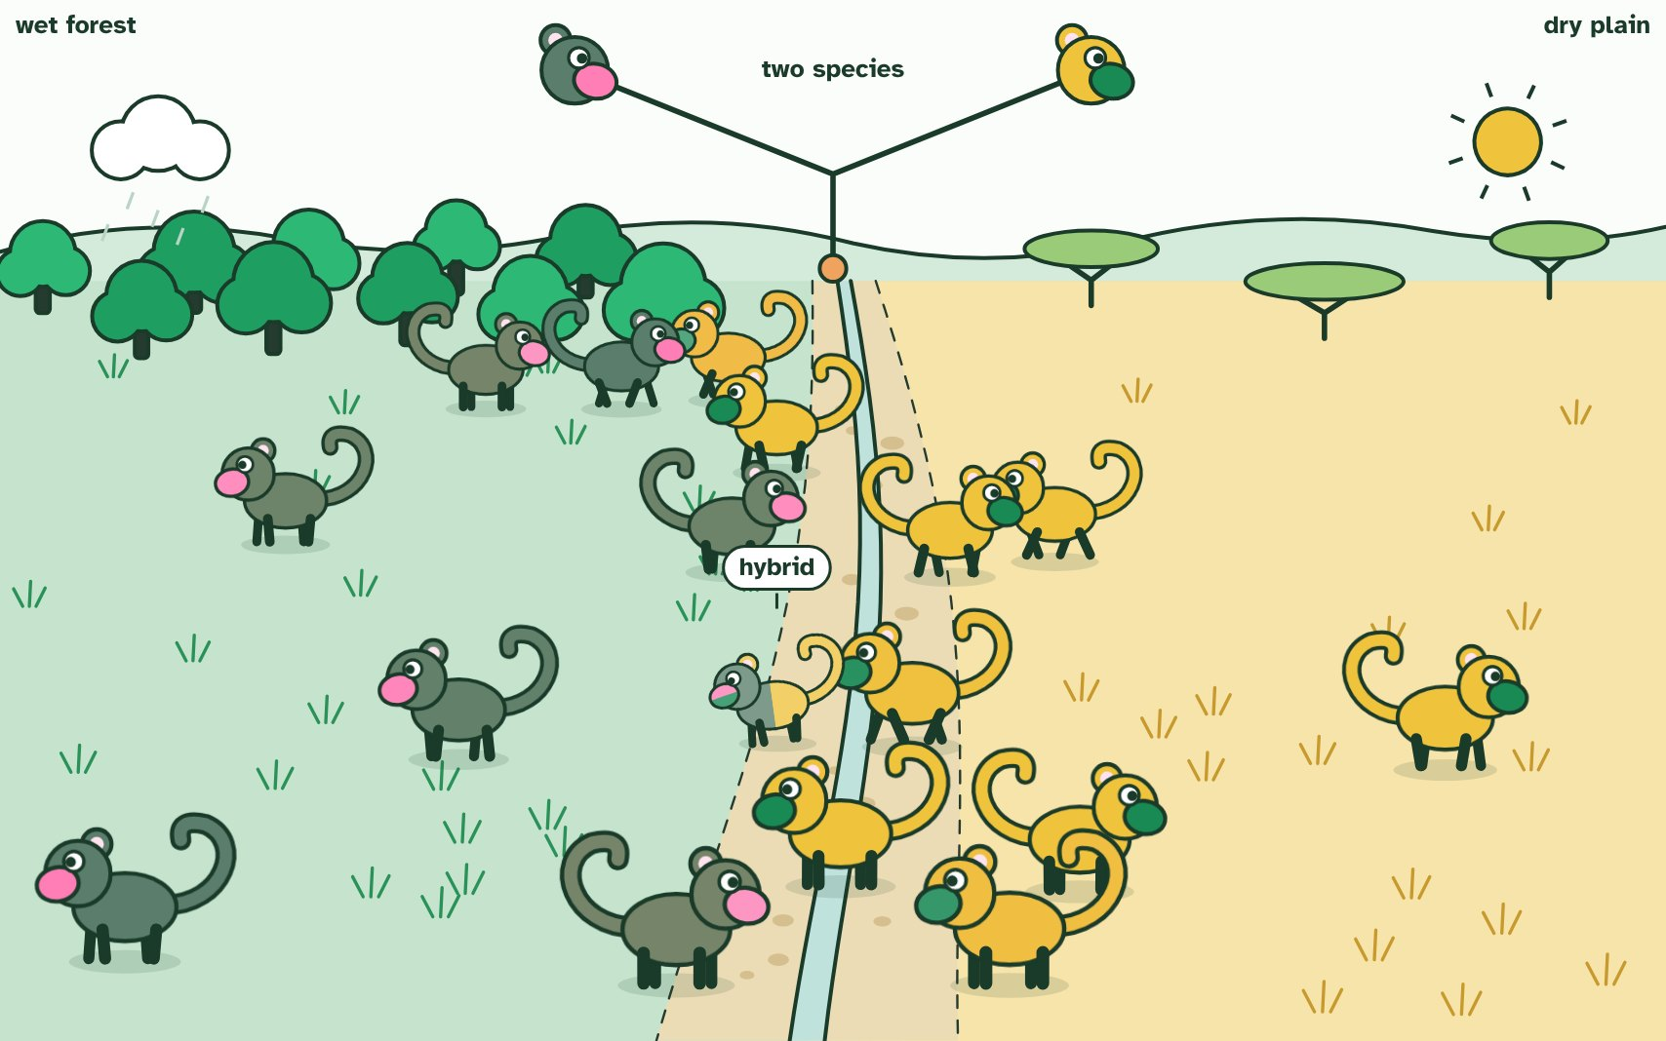  1 One population: any two can meet and mate, so genes flow across the valley.  2 Different selection each side: coats match the ground, displays drift apart.  3 Hybrids are rare, weak and often sterile, so the two never merge: two species.
  SPOT THE MISTAKE
  What do students often get wrong about the biological species concept? Write the mistake, then put it right.
  The test is whether they could produce fertile offspring, not whether they do. Two populations that never meet may be one species, and two that never meet may be two. Looking at their traits and DNA is often the best that can be done.
SUMMARY
Sum up section 03 in two or three sentences of your own.
• Biological species concept: organisms that can breed and produce fertile offspring.
• Competing definitions exist, and any concept is a working definition.
• Speciation is gradual, so the line between populations and species can be arbitrary.

04 Every species has its own count | A3.1.6
CUES  Predict: Why does a diploid cell always have an even number of chromosomes?  A: One of each pair comes from each parent, so the total is even. Each parent supplies one chromosome of every kind, so the chromosomes match up in pairs. Two sets always make an even number: 23 + 23 = 46 in a human, 24 + 24 = 48 in a chimpanzee.  What is meant by chromosome?  A long molecule of DNA wrapped with proteins. It carries many genes.  What is meant by diploid?  Having two copies of each chromosome, one from each parent.  What is meant by homologous chromosomes?  A matching pair of chromosomes, one from each parent, carrying the same genes in the same places.  What is meant by haploid?  Having one copy of each chromosome, as in a sperm or an egg. | NOTES  1 A chromosome is a molecule of DNA wrapped up with proteins.  2 A human body cell has 46 chromosomes.  3 A chimpanzee’s has 48.  4 A body cell is diploid, with two copies of each chromosome, one inherited from each parent.  5 The two that match are homologous chromosomes, so chromosomes come in pairs: 23 pairs in a human, 24 in a chimpanzee.  6 The sex cells are haploid, with one from each pair: 23 in a human egg or sperm.  7 Diploid cells have an even number, because chromosomes come in homologous pairs.  Your own notes  ANNOTATE THE FIGURE  Number the 4 steps on the figure and note what happens at each: 1 4 pairs; 2 46; 3 48; 4 not, even.  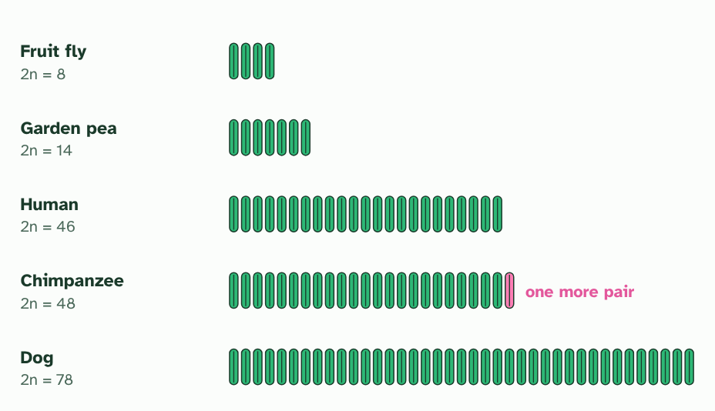  1 A fruit fly has 8 chromosomes in its body cells: 4 pairs. A garden pea has 14: 7 pairs. Different species, different numbers.  2 A human has 46: 23 pairs.  3 A chimpanzee has 48: 24 pairs, one more pair than a human.  4 A dog has 78. More chromosomes does not mean a bigger or more complex animal. Every number is even, because chromosomes come in pairs.
  SPOT THE MISTAKE
  What do students often get wrong about chromosome numbers? Write the mistake, then put it right.
  Chromosome number is not the number of genes, and it is not the amount of DNA. A chromosome can be long or short and can carry many genes or few. A dog has more chromosomes than a human, which tells you nothing about which is the more complex.
SUMMARY
Sum up section 04 in two or three sentences of your own.
• Each species has a characteristic number of chromosomes: 46 in humans, 48 in chimpanzees.
• Diploid cells have an even number, because chromosomes come in homologous pairs.

05 Laying out the chromosomes | A3.1.7
CUES  Predict: If two chromosomes had fused end to end, what would you expect in the middle of the new, longer chromosome?  C: Telomere DNA, normally found only at a chromosome’s end. Telomere DNA. Telomeres cap the ends of chromosomes, so two chromosomes joined end to end would leave two caps in the middle. Human chromosome 2 has such a stretch exactly where the join would be.  What is meant by karyotype?  The full set of chromosomes of a cell, as seen in the lab.  What is meant by karyogram?  A photograph or drawing of the chromosomes of one cell, arranged in matching pairs and ordered by size. | NOTES  1 How do biologists compare chromosomes? They make a karyotype: the full set of one cell’s chromosomes.  2 Photographed and arranged in pairs, the picture is a karyogram.  3 To arrange them, match each chromosome with its partner using three clues: its length, its banding pattern and the position of its centromere, the pinched point where its two arms meet.  4 The two ape chromosomes, placed end to end, match human chromosome 2 in length and in banding.  5 Human chromosome 2 has DNA typical of a chromosome end (a telomere) in the middle, where a join would be.  6 And it carries the remains of a second centromere, switched off.  7 A karyogram arranges chromosomes in pairs by length, banding pattern and centromere position.  Your own notes  ANNOTATE THE FIGURE  Number the 4 steps on the figure and note what happens at each: 1 dividing; 2 stained, photographed; 3 length, banding pattern, centromere position; 4 longest.  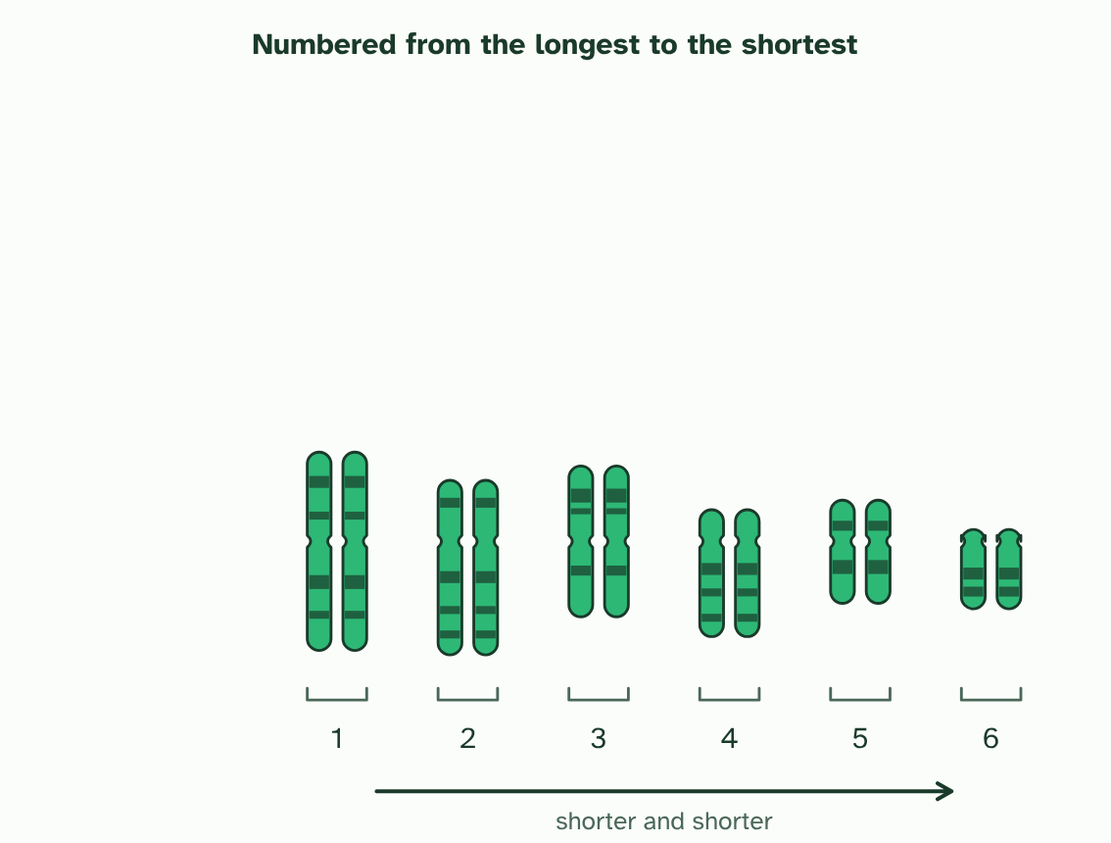  1 A cell is stopped part-way through dividing, when its chromosomes are short and thick.  2 The chromosomes are stained, so dark bands show, and photographed.  3 Each is cut out and matched with its partner by length, banding pattern and centromere position.  4 The pairs are lined up with the centromeres in a row and numbered from the longest: a karyogram. (Simplified: six pairs.)  ANNOTATE THE FIGURE  Number the 3 steps on the figure and note what happens at each: 1 length, centromere position, bands; 2 longest first; 3 chromosome 2.  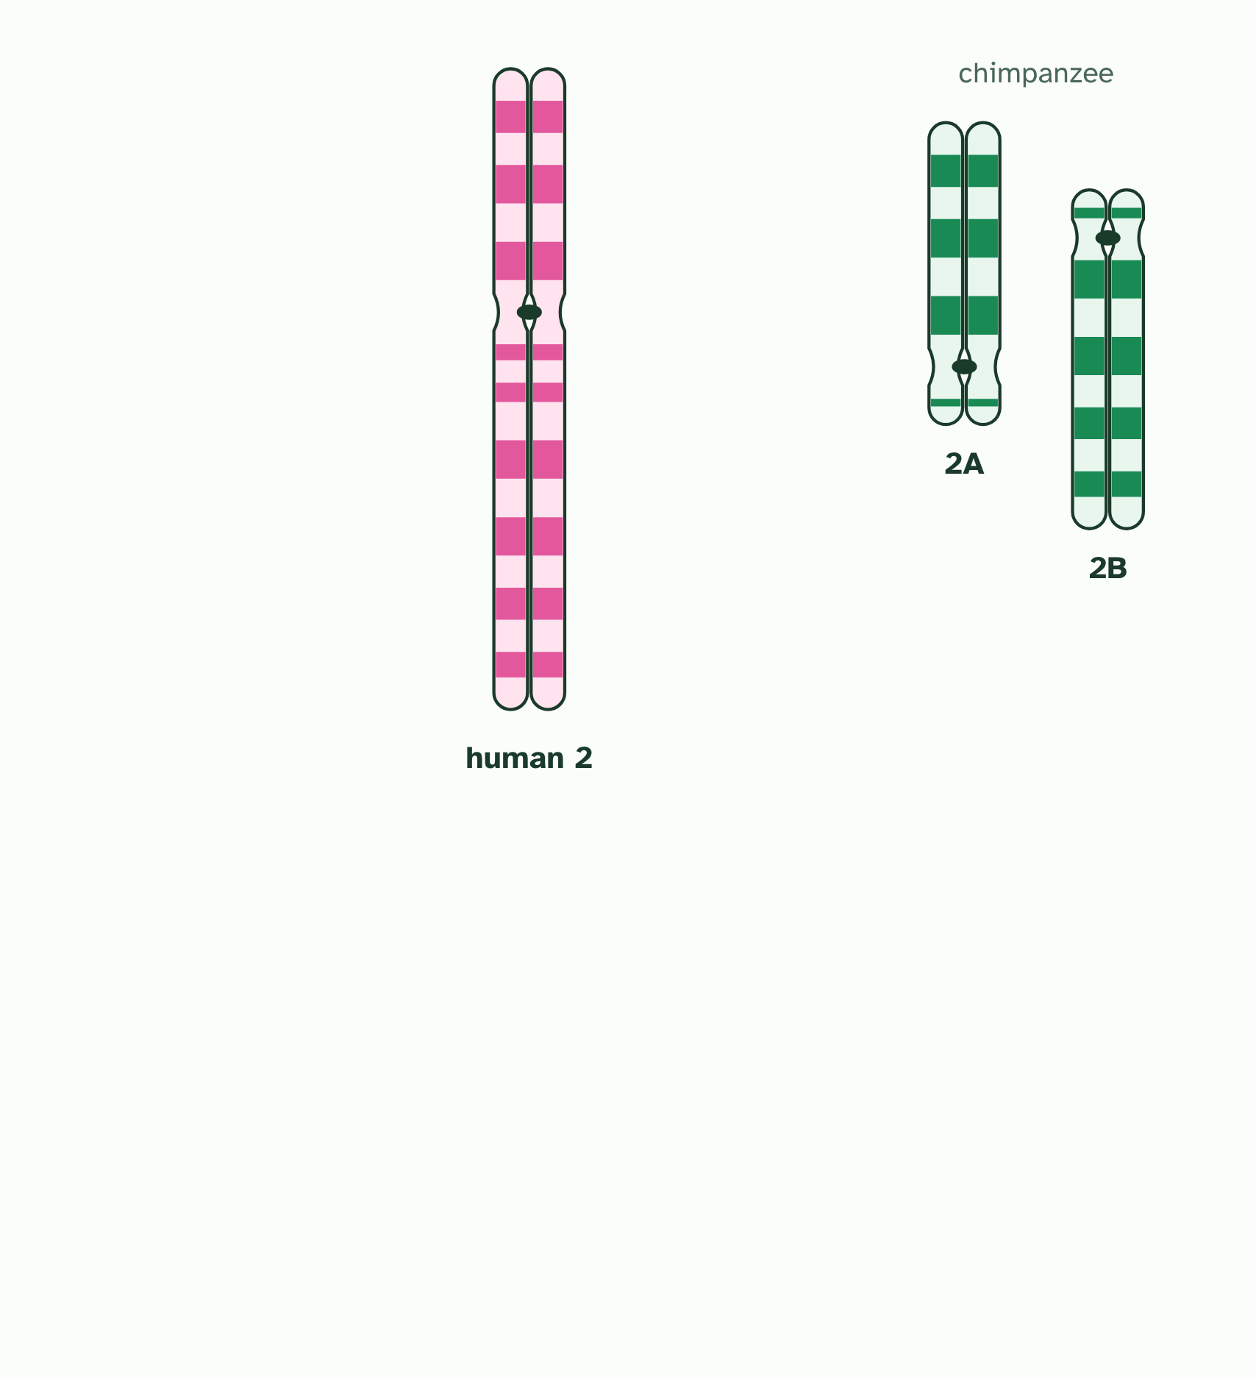  1 Chromosomes from one cell, condensed and doubled. Pair them by length, centromere position and bands.  2 A pair matches on all three. A karyogram puts the pairs in order, longest first.  3 Human chromosome 2 beside two chimpanzee chromosomes, 2A and 2B. Do they fit together?  ANNOTATE THE FIGURE  Number the 3 steps on the figure and note what happens at each: 1 length, centromere position, bands; 2 longest first; 3 chromosome 2.  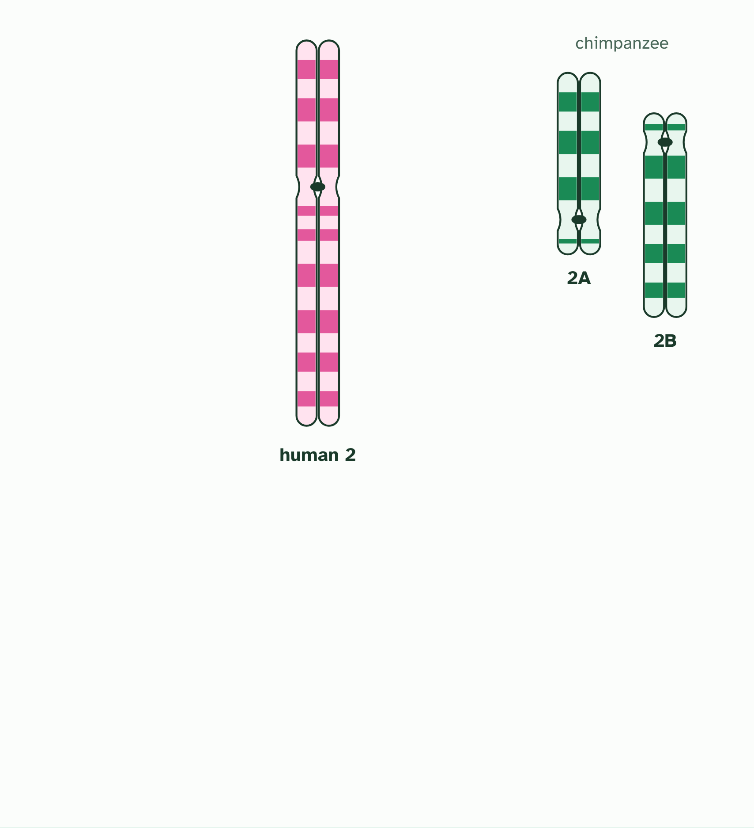  1 Chromosomes from one cell, condensed and doubled. Pair them by length, centromere position and bands.  2 A pair matches on all three. A karyogram puts the pairs in order, longest first.  3 Human chromosome 2 beside two chimpanzee chromosomes, 2A and 2B. Do they fit together?
  SPOT THE MISTAKE
  What do students often get wrong about karyotyping and karyograms? Write the mistake, then put it right.
  The evidence supports the hypothesis from several directions, but nobody watched the fusion. And it does not mean humans came from chimpanzees: both lines come from a shared ancestor, which was neither.
SUMMARY
Sum up section 05 in two or three sentences of your own.
• A karyogram arranges chromosomes in pairs by length, banding pattern and centromere position.
• Human chromosome 2 matches two ape chromosomes end to end, has telomere DNA in its middle and a remnant second centromere.
• A testable hypothesis makes a prediction that evidence could contradict.

06 One genome, many versions | A3.1.8 A3.1.9
CUES  Predict: Two unrelated people have their whole genomes read and compared. About how different are they?  B: One base in a thousand differs: they share about 99.9%. About one base in a thousand. Humans share nearly all of their genome, and the small differences, mostly SNPs, are what make each genome unique. Between species the differences are far larger.  What is meant by genome?  All the genetic information of an organism: its genes, the DNA between them and the DNA of its organelles.  What is meant by single nucleotide polymorphism?  A single base in the genome that differs between individuals of one species, found in many of them. Short form: SNP. | NOTES  1 Your genome is all the genetic information you carry: your genes, the DNA between them, and the small loops of DNA in your mitochondria.  2 At about one place in a thousand, one base differs: a single nucleotide polymorphism, or SNP (said “snip”).  3 Genomes differ in their overall size, which is the total amount of DNA, and in base sequence.  4 A genome is all the genetic information of an organism.  5 Members of one species share most of their genome; SNPs give some diversity.  Your own notes  ANNOTATE THE FIGURE  Number the 3 steps on the figure and note what happens at each: 1 pink; 2 single nucleotide polymorphism; 3 far more.  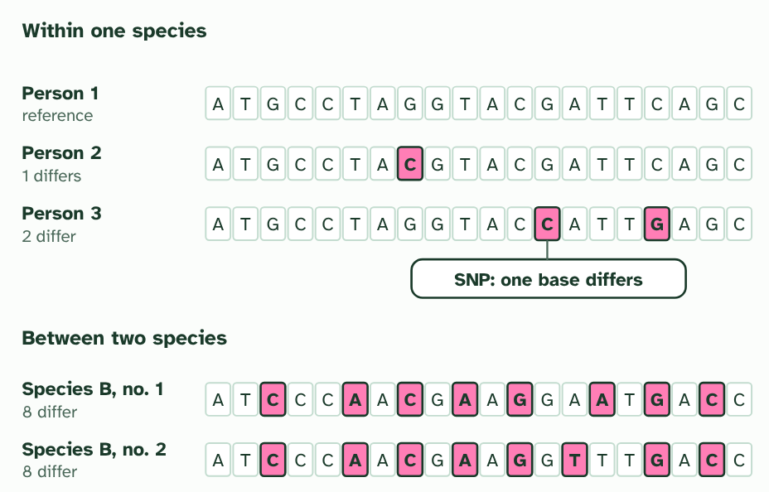  1 One short stretch of the genome in three people. Bases that differ from person 1 are pink: very few.  2 A difference at a single base is a single nucleotide polymorphism, or SNP. Together, SNPs make each person’s genome their own.  3 The same stretch in another species: far more differences. (Simplified: real differences are much rarer in both cases, but the pattern holds.)
  SPOT THE MISTAKE
  What do students often get wrong about genomes within and between species? Write the mistake, then put it right.
  A SNP is a place in the genome where individuals differ, not a gene and not a disease. Having a SNP is normal: we all carry thousands, and many have no known effect.
SUMMARY
Sum up section 06 in two or three sentences of your own.
• A genome is all the genetic information of an organism.
• Members of one species share most of their genome; SNPs give some diversity.
• Variation between species is much larger than variation within a species.

07 Big genome, small organism | A3.1.10
CUES  Predict: A student says: “The organism with the biggest genome must be the most complex.” Which fact shows this is wrong?  A: A fish and a flowering plant have genomes bigger than ours. A fish and a flowering plant have genomes bigger than ours, and neither is more complex than a human. If size measured complexity, a lungfish would beat a mammal. The extra DNA is mostly non-coding or repeated. | NOTES  1 Genome size is not a valid measure of how complex an organism is.  2 A bacterium’s genome is millions of base pairs. A human’s is about three billion. (Mb is millions, Gb billions of base pairs.)  3 The Australian lungfish’s genome is more than ten times a human’s.  4 The flowering plant Paris japonica has one of the biggest genomes known. Size is not a measure of how complex an organism is.  Your own notes  ANNOTATE THE FIGURE  Number the 3 steps on the figure and note what happens at each: 1 three billion; 2 ten times; 3 not.  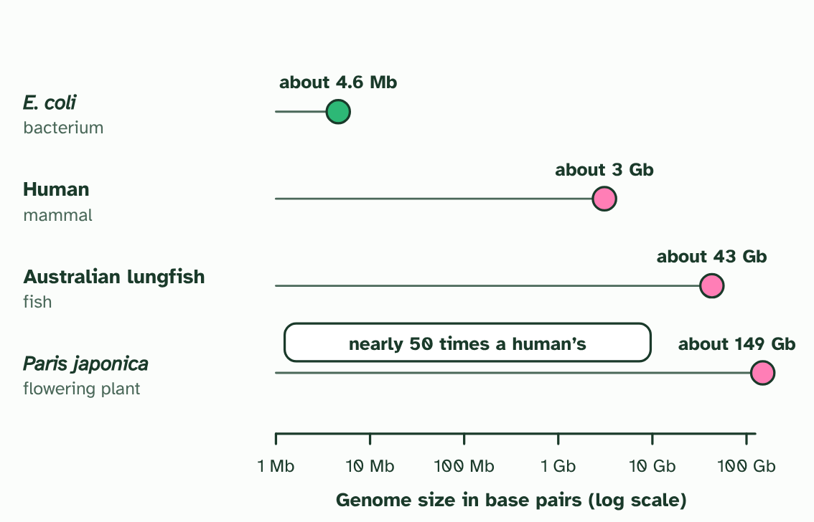  1 A bacterium’s genome is millions of base pairs. A human’s is about three billion. (Mb is millions, Gb billions of base pairs.)  2 The Australian lungfish’s genome is more than ten times a human’s.  3 The flowering plant Paris japonica has one of the biggest genomes known. Size is not a measure of how complex an organism is.  ANNOTATE THE FIGURE  Label the key parts and add a note on what it shows.  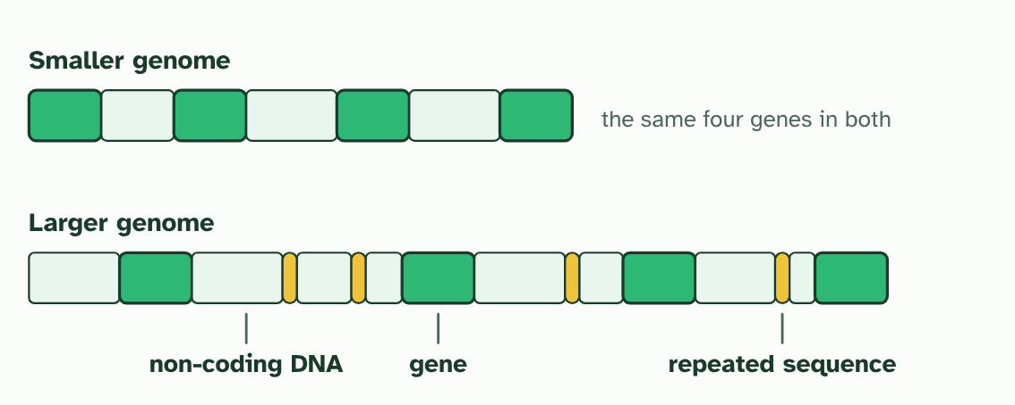  The same four genes can sit in a small genome or a large one. The difference is mostly DNA that does not code for a protein.
  SPOT THE MISTAKE
  What do students often get wrong about comparing genome sizes? Write the mistake, then put it right.
  A bigger genome is not a more advanced one. When you see a big number, ask what the DNA is made of, and count genes if you can, not just base pairs.
SUMMARY
Sum up section 07 in two or three sentences of your own.
• Genome size varies enormously between groups of organisms.
• Genome size is not a measure of complexity: much DNA is non-coding or repeated.

08 Reading a whole genome | A3.1.11
CUES  Predict: How has the cost of sequencing a human genome changed since the first one was done?  C: It has fallen steeply, and sequencing has become far faster. It has fallen steeply, and the time has fallen too, from years to days. That is why genome sequencing has moved from a few big projects to something used across research and medicine.  What is meant by whole genome sequencing?  Reading the order of every base in an organism’s genome.  What is meant by personalised medicine?  Treatment chosen to suit a person’s own genome. | NOTES  1 Whole genome sequencing reads the order of every base in an organism’s genome.  2 In the future, a doctor may use a patient’s own genome to choose the medicine and dose most likely to work for them: personalised medicine.  3 Whole genome sequencing is getting faster and cheaper.  4 Current use: research into evolutionary relationships. Future use: personalised medicine.  Your own notes  ANNOTATE THE FIGURE  Number the 3 steps on the figure and note what happens at each: 1 years, billions; 2 fell steeply; 3 comparing species, personalised medicine.  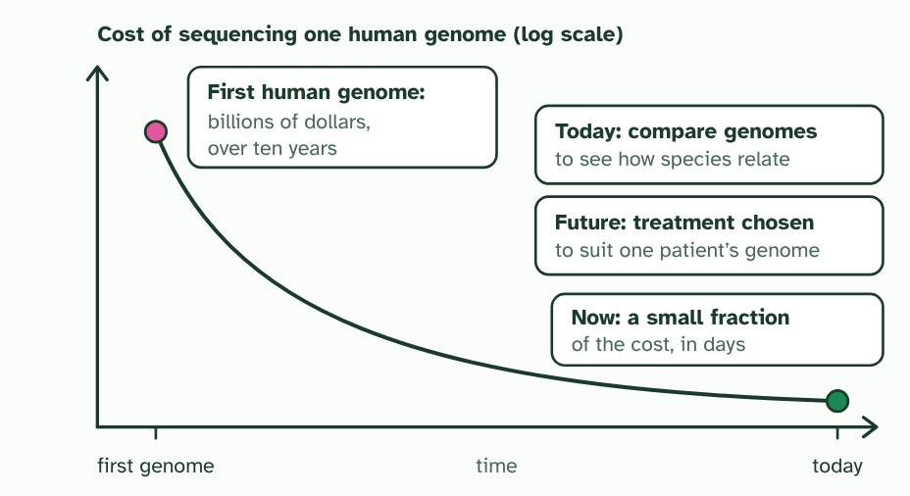  1 The first human genome was a huge international effort: years of work and billions of dollars.  2 Sequencing machines improved, and the cost and the time fell steeply. (The shape is drawn to show the trend, not exact values.)  3 Cheap, fast genomes bring uses within reach: comparing species now, and personalised medicine in the future.
  SPOT THE MISTAKE
  What do students often get wrong about whole genome sequencing? Write the mistake, then put it right.
  A genome is a text, not an explanation. Reading every base does not tell you what every gene does, and a genome does not fix your future: many traits depend on the environment too. It also raises questions of privacy. Who should be allowed to see yours?
SUMMARY
Sum up section 08 in two or three sentences of your own.
• Whole genome sequencing is getting faster and cheaper.
• Current use: research into evolutionary relationships. Future use: personalised medicine.

09 When the species rule breaks | A3.1.12 HL
CUES  Predict: A bacterium carries a plasmid with an antibiotic-resistance gene. It touches a bacterium of a different species. What can happen?  B: A copy of the plasmid can pass across with no cell dividing. A copy of the plasmid can pass across. This is horizontal gene transfer: the second bacterium now has the gene without being anyone’s offspring, and the gene has crossed a species line.  What is meant by horizontal gene transfer?  The passing of genes between living organisms that are not parent and offspring, with no reproduction.  What is meant by conjugation?  Bacteria in contact passing a copy of a plasmid from one cell to another.  What is meant by plasmid?  A small ring of DNA in a bacterium, separate from its main chromosome. | NOTES  1 In horizontal gene transfer they pass sideways, between cells that are already alive.  2 In conjugation two bacteria touch and a copy of a plasmid passes across.  3 Horizontal gene transfer moves genes between species, so gene pools are not closed.  4 A bacterium reproduces by copying itself: two identical cells, with no partner and nothing to test.  5 Two bacteria of different species. One carries a plasmid, a small ring of DNA, with a gene on it.  6 The cells touch and a bridge forms. A copy of the plasmid passes across.  Your own notes  ANNOTATE THE FIGURE  Number the 4 steps on the figure and note what happens at each: 1 copying itself; 2 different species, plasmid; 3 copy; 4 sideways.  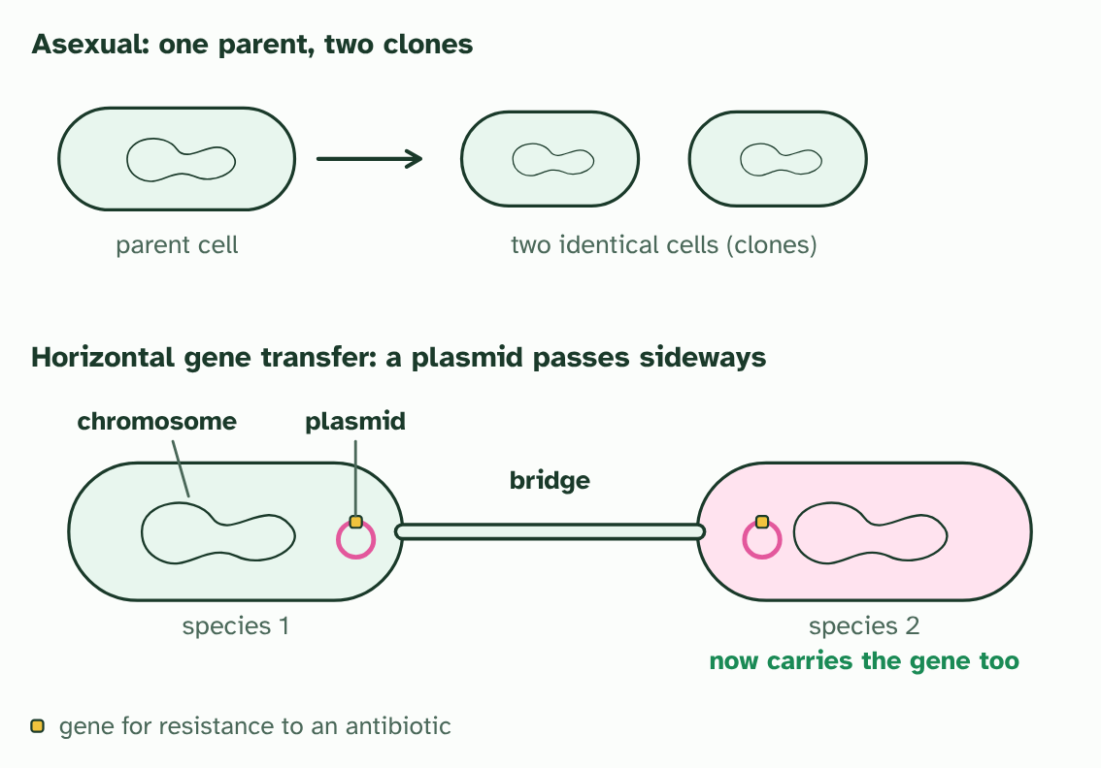  1 A bacterium reproduces by copying itself: two identical cells, with no partner and nothing to test.  2 Two bacteria of different species. One carries a plasmid, a small ring of DNA, with a gene on it.  3 The cells touch and a bridge forms. A copy of the plasmid passes across.  4 The second species now has the gene. No new cell was made: the gene moved sideways.  REMEMBER IT  Where the species concept struggles
  F  Five | A  Apes | H  Hug | G  Grumpy | A  Aunts | H  Happily
  Fossils  no breeding test is possible | Apart  populations that never meet | Hybrids  some different species have fertile young | Gradual  no single day when one species becomes two | Asexual  no partners to breed with | Horizontal transfer  genes jump between species
  SPOT THE MISTAKE
  What do students often get wrong about asexual species and horizontal gene transfer? Write the mistake, then put it right.
  Horizontal gene transfer is not reproduction: no new cell is made. And asexual does not mean unclassifiable. Bacteria and other asexual organisms still fall into recognisable groups, just not groups defined by breeding.
SUMMARY
Sum up section 09 in two or three sentences of your own.
• The biological species concept fits poorly where organisms reproduce asexually.
• Horizontal gene transfer moves genes between species, so gene pools are not closed.

10 The number that has to match | A3.1.13 HL
CUES  Predict: A hybrid cell has 63 chromosomes. Could every one of them have an equal partner at meiosis?  A: No: with an odd number, at least one has no partner. No. An odd number of chromosomes cannot all form pairs, so at least one has no partner. When the unpaired chromosomes are shared out, gametes tend to be unbalanced, which is why the mule is sterile. | NOTES  1 Gametes like that rarely work, so cross-breeding between closely related species is unlikely to produce fertile offspring when their chromosome numbers differ.  2 Two imagined species. Q has one long chromosome where P has two short ones, so they have different chromosome numbers.  3 A hybrid gets both sets: five chromosomes, an odd number. One cannot have an equal partner.  4 At meiosis each chromosome looks for its match. Two pair neatly, but the long one is left matching two at once.  5 Some ways of sharing them out give complete sets. Others give a gamete with part of the genome twice and part missing. With many such mismatches, most gametes fail.  Your own notes  ANNOTATE THE FIGURE  Number the 4 steps on the figure and note what happens at each: 1 imagined; 2 both sets; 3 two; 4 twice, missing.  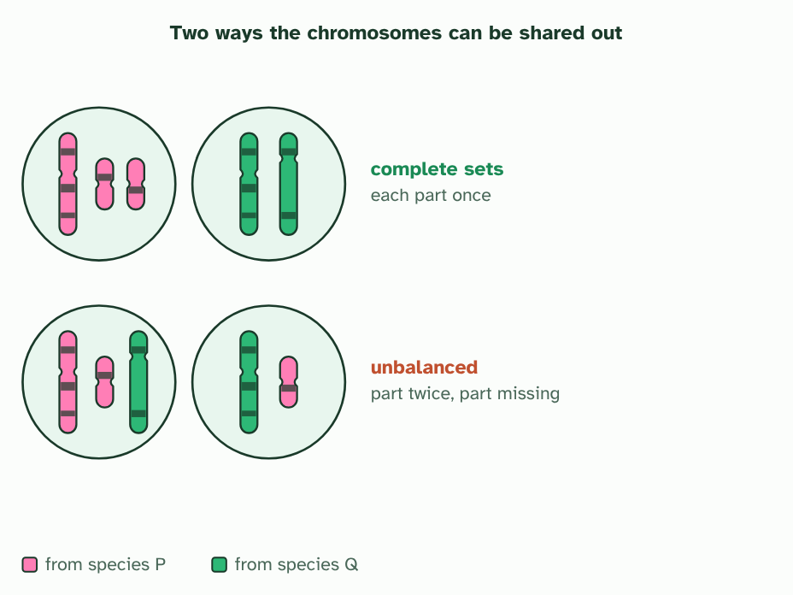  1 Two imagined species. Q has one long chromosome where P has two short ones, so they have different chromosome numbers.  2 A hybrid gets both sets: five chromosomes, an odd number. One cannot have an equal partner.  3 At meiosis each chromosome looks for its match. Two pair neatly, but the long one is left matching two at once.  4 Some ways of sharing them out give complete sets. Others give a gamete with part of the genome twice and part missing. With many such mismatches, most gametes fail.
  SPOT THE MISTAKE
  What do students often get wrong about chromosome number as a shared trait? Write the mistake, then put it right.
  A hybrid’s chromosome number is the sum of the two gametes, not of the two parents’ body cells: 32 + 31 = 63 for the mule, not 64 + 62.
SUMMARY
Sum up section 10 in two or three sentences of your own.
• Chromosome number is a trait shared within a species.
• Hybrids of parents with different numbers have chromosomes with no partner, so they are usually sterile.

11 Building a key | A3.1.14 HL
CUES  Predict: Which feature is best for a key that tells the leaves of different trees apart?  C: Whether the edge is toothed or smooth. The edge. It is easy to see and does not change much with the season or the leaf’s age. Colour changes through the year, and size depends on the age of the leaf and the tree’s conditions, so neither makes a reliable question.  What is meant by dichotomous key?  A tool for identifying organisms: a series of choices between two statements, each leading to the next choice or to a name. | NOTES  1 To name an organism you have not met, use a dichotomous key.  2 A dichotomous key uses paired choices that lead to one name.  3 Every step is a question with two answers. A leaf made of leaflets leads to one more question, and then to horse chestnut or ash.  4 A leaf in one piece leads to the next question. Deep lobes: oak.  5 Each remaining question uses an edge that is easy to see: spiny, toothed, or neither. Every leaf reaches exactly one name.  6 Check a key by following one leaf through it: holly is no to leaflets, no to deep lobes and yes to a spiny edge.  Your own notes  ANNOTATE THE FIGURE  Number the 4 steps on the figure and note what happens at each: 1 two; 2 Deep lobes; 3 edge; 4 no, no, yes.  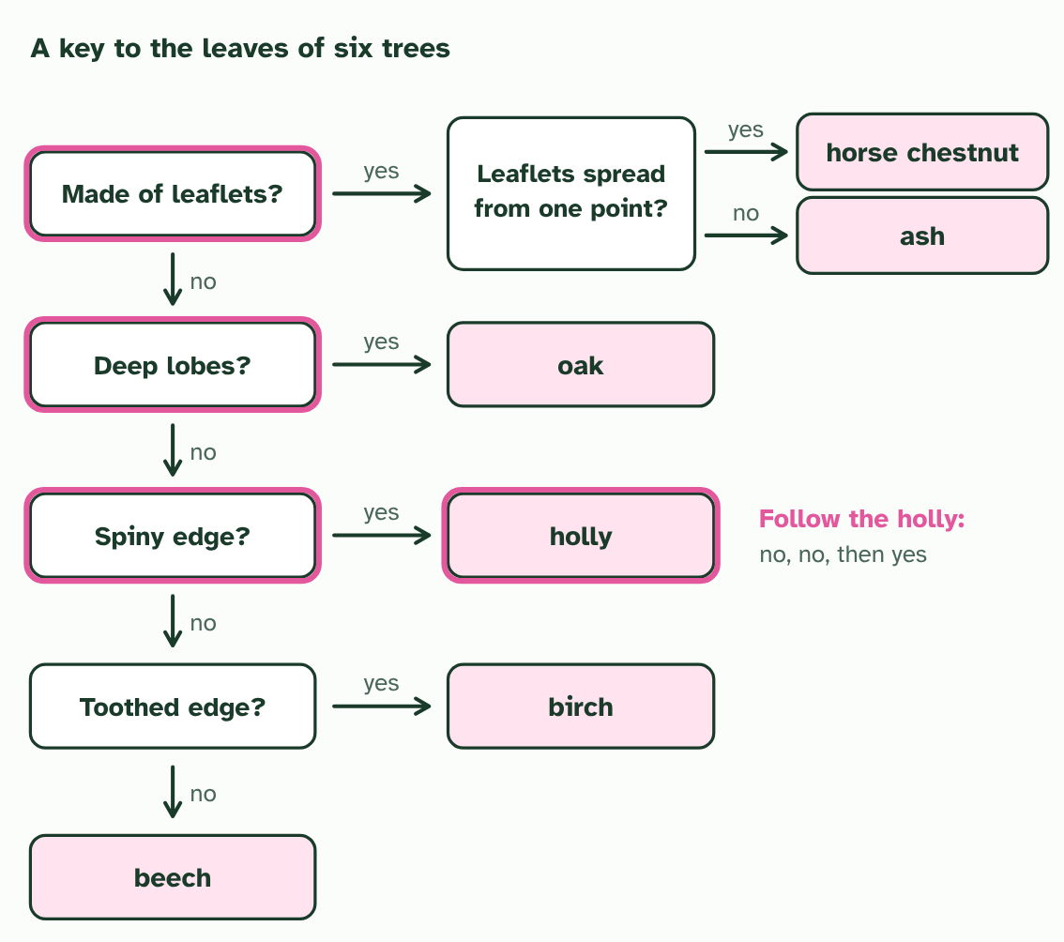  1 Every step is a question with two answers. A leaf made of leaflets leads to one more question, and then to horse chestnut or ash.  2 A leaf in one piece leads to the next question. Deep lobes: oak.  3 Each remaining question uses an edge that is easy to see: spiny, toothed, or neither. Every leaf reaches exactly one name.  4 Check a key by following one leaf through it: holly is no to leaflets, no to deep lobes and yes to a spiny edge.  ANNOTATE THE FIGURE  Number the 2 steps on the figure and note what happens at each: 1 dichotomous key; 2 splits.  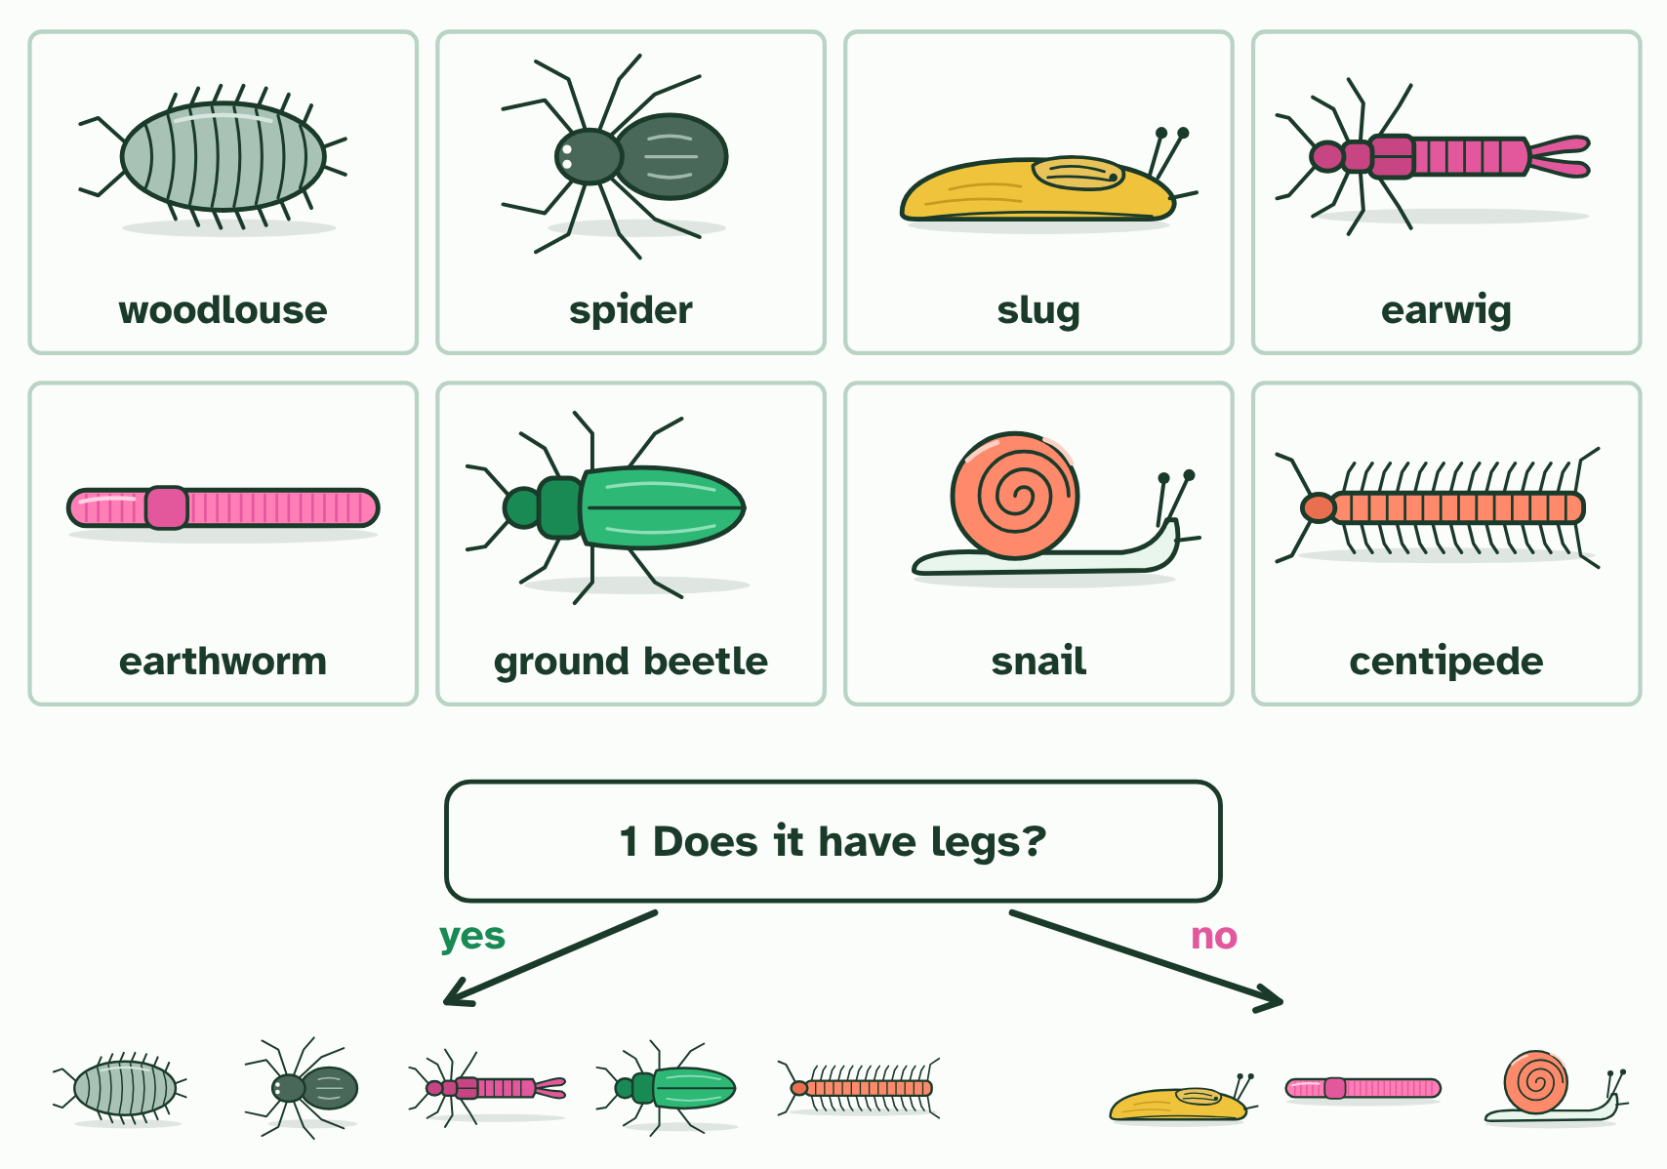  1 Eight animals from leaf litter and soil. A dichotomous key tells them apart with questions that each have two answers.  2 Each question splits the group in two; the next question splits each part again, until each animal is alone with its name.  ANNOTATE THE FIGURE  Number the 2 steps on the figure and note what happens at each: 1 dichotomous key; 2 splits.  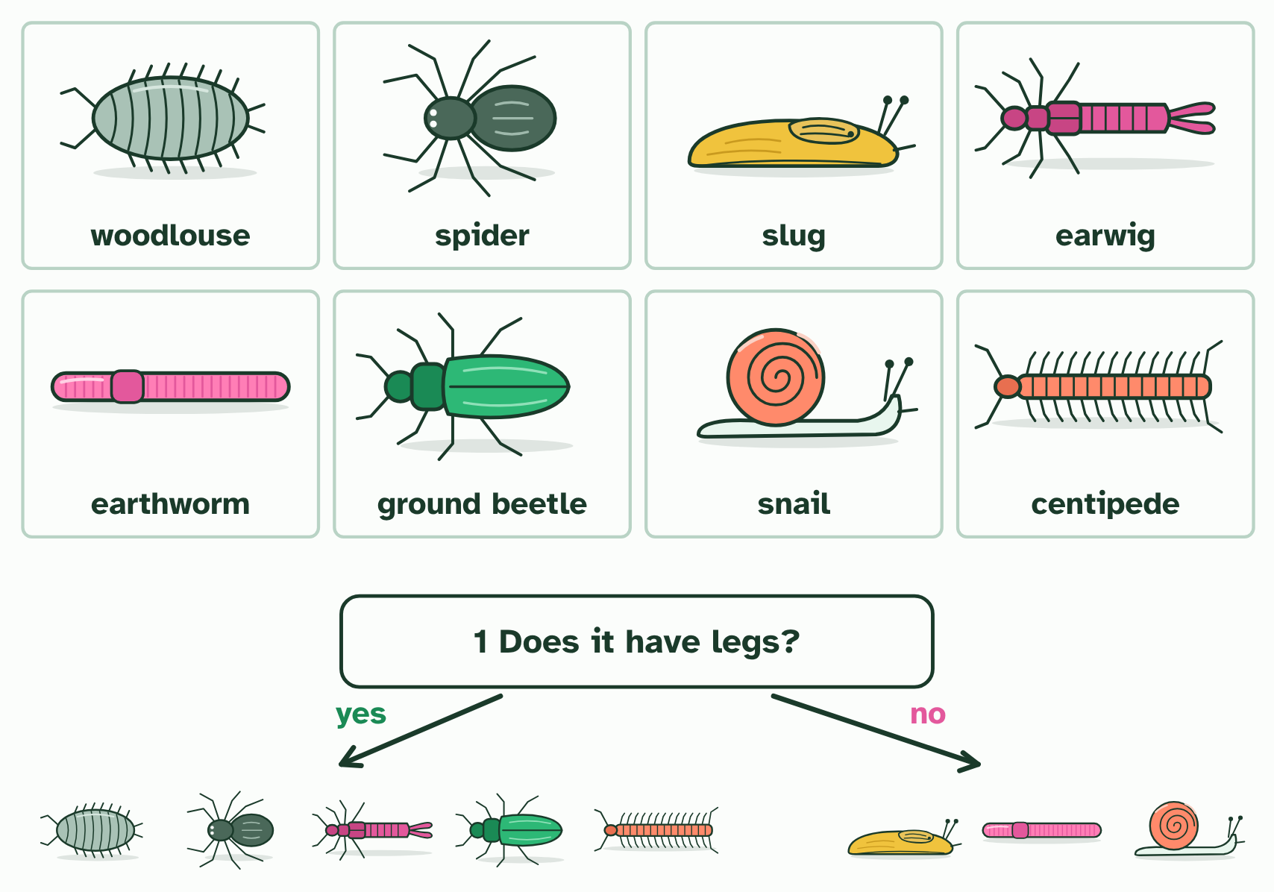  1 Eight animals from leaf litter and soil. A dichotomous key tells them apart with questions that each have two answers.  2 Each question splits the group in two; the next question splits each part again, until each animal is alone with its name.
  SPOT THE MISTAKE
  What do students often get wrong about dichotomous keys? Write the mistake, then put it right.
  Never harm what you study. Photograph organisms, take only a leaf from a plant that has many, and put animals back where you found them. Never taste or touch a plant or fungus you cannot name.
SUMMARY
Sum up section 11 in two or three sentences of your own.
• A dichotomous key uses paired choices that lead to one name.
• Choose features that are visible, countable and do not change.
• Test a key on someone else, then fix it where it fails.

12 Barcodes from the soil | A3.1.15 HL
CUES  Predict: A water sample from a pond is barcoded and matched. What can the result tell you?  B: Which listed species have left DNA in the water. Which species in the reference library have left DNA in the water. It does not give numbers or ages, and it cannot name a species the library lacks, but it can be done quickly from one bottle of water.  What is meant by environmental DNA?  DNA taken from a sample of water, soil or air, shed by the organisms that live there, instead of from an organism that has been caught.  What is meant by DNA barcode?  A short stretch of DNA that is very alike within a species and different between species, used to identify it. | NOTES  1 But every animal leaves traces of itself in the water: skin cells, mucus, droppings. Environmental DNA (eDNA) is the DNA collected from a sample of water, soil or air, not from an animal you have caught.  2 To tell whose DNA it is, scientists read a DNA barcode: a short stretch of DNA, a few hundred base pairs long, that is alike in members of one species and different between species.  3 The steps are always the same: collect a sample, extract the DNA, make millions of copies of the barcode region with PCR, read their sequences, and match each sequence against a reference library of barcodes from known species.  4 A barcode is a short stretch of DNA with two ends the same in every species and a middle that differs between species.  5 Because the ends match everywhere, one pair of primers can copy the barcode from any species in a mixed sample.  6 A barcode read from a sample is matched against the library. Here it is identical to one species’ barcode.  Your own notes  ANNOTATE THE FIGURE  Number the 4 steps on the figure and note what happens at each.  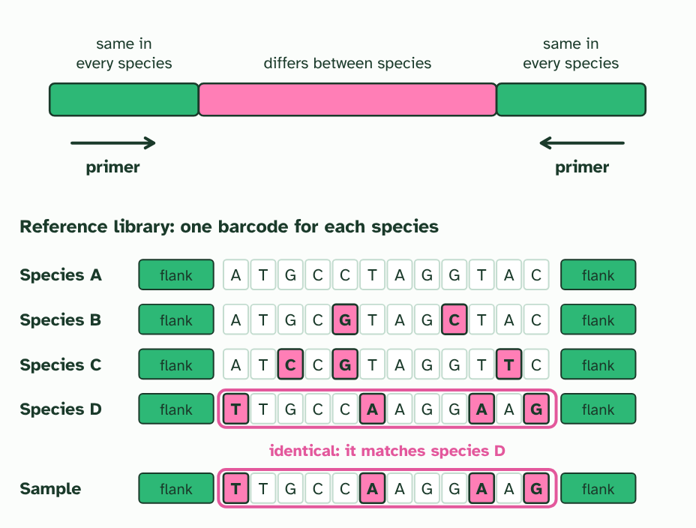  1 A barcode is a short stretch of DNA with two ends the same in every species and a middle that differs between species.  2 Because the ends match everywhere, one pair of primers can copy the barcode from any species in a mixed sample.  3 Each species in the reference library has its own barcode. Pink marks where a barcode differs from species A. (Letters invented.)  4 A barcode read from a sample is matched against the library. Here it is identical to one species’ barcode.  ANNOTATE THE FIGURE  Annotate this still from the animation (Watch it happen: a sample becomes a species list): what is happening, and why?  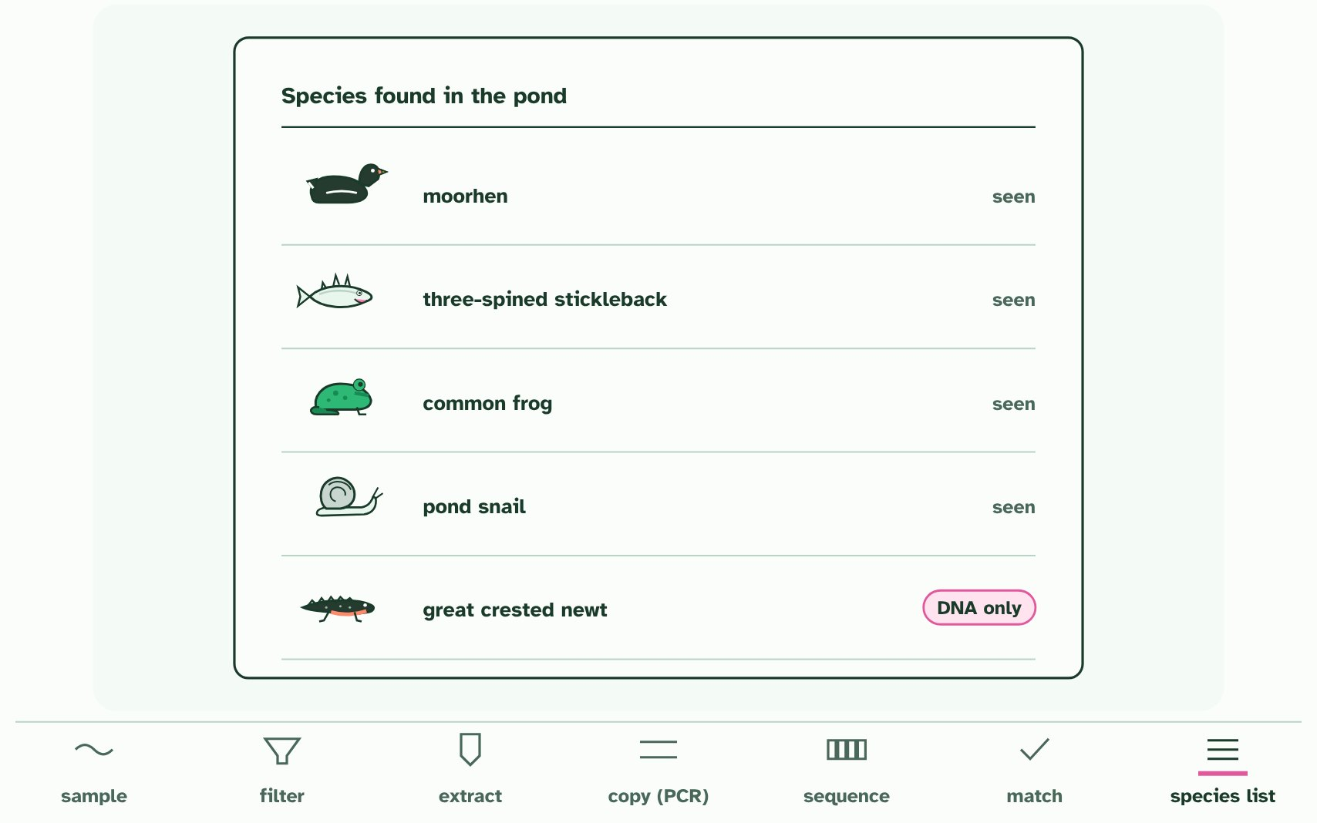  1 Collect a sample: a bottle of pond water. The DNA in it is environmental DNA (eDNA).  2 Push the water through a fine filter. Cells and DNA from every species are caught on it.  3 Extract the DNA from the filter: a mixture from every species living there.  4 PCR copies one short stretch, the barcode, from every species at once. The primers fit ends that all of them share; the barcode between them differs.  5 Sequence the copies: each read is one barcode’s base sequence.  6 Match each read to a reference library of barcodes from identified species.  7 A list of the species present, from one bottle of water, much faster than searching and trapping. One of them nobody saw.  REMEMBER IT  Steps of an eDNA survey
  C  Cats | E  Eat | A  Any | S  Sausage | M  Mostly
  Collect  a sample of water or soil | Extract  the DNA from it | Amplify  the barcode region with PCR | Sequence  the copies | Match  them to a reference library
  SPOT THE MISTAKE
  What do students often get wrong about DNA barcodes and environmental DNA? Write the mistake, then put it right.
  eDNA tells you what has left DNA there, not how many, and not that it still lives there. And it can only name species that are in the reference library: a species missing from it gives no match.
SUMMARY
Sum up section 12 in two or three sentences of your own.
• A barcode is a short, variable stretch of DNA flanked by sequences shared by all species.
• eDNA plus barcodes gives a rapid species list for a habitat.

Check yourself
The check for this guide is online: a fresh paper of past-paper style questions from the exam bank on A3.1 each time, marked as you go, and saved to your Exam practice progress when you are signed in. Open the link:
biologybybradford.com/exam-maker/sit?topics=A3.1&level=HL&paper=quiz&marks=15&src=ep

