Name | Class | Date
IB BIOLOGY · A3.1

Diversity of organisms
Notes to fill in alongside the guide. Each numbered block matches a chapter of the guide, and of the lesson slides. Write in the gaps, answer the cues, annotate the figures, and sum up each section in your own words.
BY THE END YOU CAN
Explain why variation between organisms is a defining feature of life, and how Linnaeus used shared traits to define a species A3.1.1, A3.1.2
Name an organism with a binomial name written to the rules, and say what two species of one genus share A3.1.3
State the biological species concept, give challenges to it, and explain why gradual speciation makes the line between populations and species arbitrary A3.1.4, A3.1.5
Say that species differ in chromosome number, using humans (46) and chimpanzees (48), and why diploid numbers are even A3.1.6
Classify chromosomes in a karyogram by banding, length and centromere position, and evaluate the evidence that human chromosome 2 arose from a fusion A3.1.7
Describe a genome, how SNPs give diversity within a species, and why variation between species is much larger A3.1.8, A3.1.9
Compare genome sizes of different groups from a database and judge whether size measures complexity A3.1.10
Describe how whole genome sequencing has become faster and cheaper, and give current and future uses A3.1.11
Explain why the biological species concept fails for asexual species and for bacteria that pass genes sideways A3.1.12
Explain why parents with different chromosome numbers are unlikely to have fertile offspring A3.1.13
Build and test a dichotomous key for local organisms A3.1.14
Explain how DNA barcodes and environmental DNA identify the species in a habitat rapidly A3.1.15

01 No two beetles are alike, and we sort them anyway | A3.1.1 A3.1.2
CUES  Predict: Identical twins share all their DNA. Are they identical in every trait?  What is meant by variation?  What is meant by species?  What is meant by morphology?  What is meant by morphological species concept? | NOTES  1 Even identical twins differ, in their fingerprints, their scars and their tans. This ____________ is a defining feature of life, and it has patterns.  2 To him a _________ was a group of organisms with the same body form and structure, its ______________.  3 This is the __________________________________.  4 It is a ________________________: a tool for grouping what biologists find, which can be improved or replaced.  5 Patterns in ____________ are the basis for naming and classifying organisms.  6 Linnaeus grouped organisms by shared physical traits: the __________________________________.  Your own notes  ANNOTATE THE FIGURE  The figure shows it as Shuffled, By colour and By body shape. Note what changes each time.  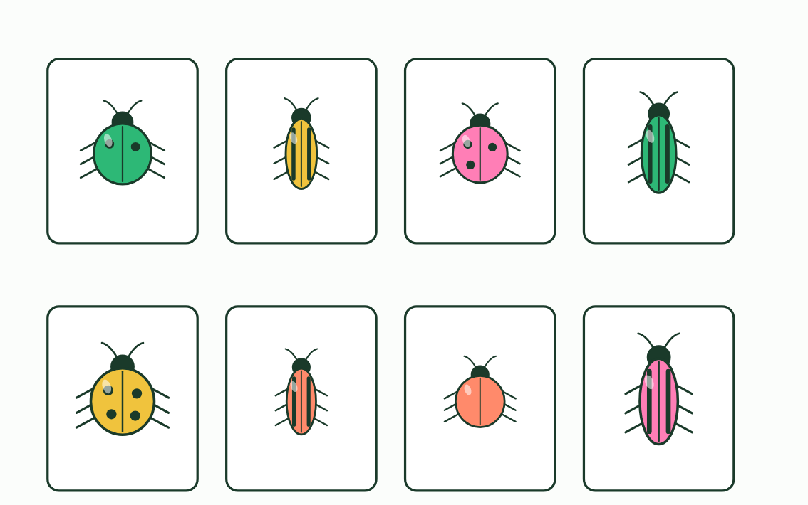
  SPOT THE MISTAKE
  What do students often get wrong about variation and species? Write the mistake, then put it right.
  The mistake
  Put it right
SUMMARY
Sum up section 01 in two or three sentences of your own.

02 A name with two parts | A3.1.3
CUES  Predict: Two animals are named Panthera tigris and Panthera onca. What can you say about them?  What is meant by binomial system?  What is meant by genus? | NOTES  1 The answer, from Linnaeus, is the ____________________: every species gets a two-part name.  2 The first part is the ________.  3 ___________________ Tap the correct way to write each name.  4 A ___________ name has two words, written in italics.  5 The first word is the ________, with a capital letter. The second names the _________, in lower case.  6 Species in one genus have ___________________: lion, tiger and leopard share the genus Panthera.  Your own notes  ANNOTATE THE FIGURE  Number the 4 steps on the figure and note what happens at each: 1 binomial; 2 genus, species; 3 similar traits; 4 initial.  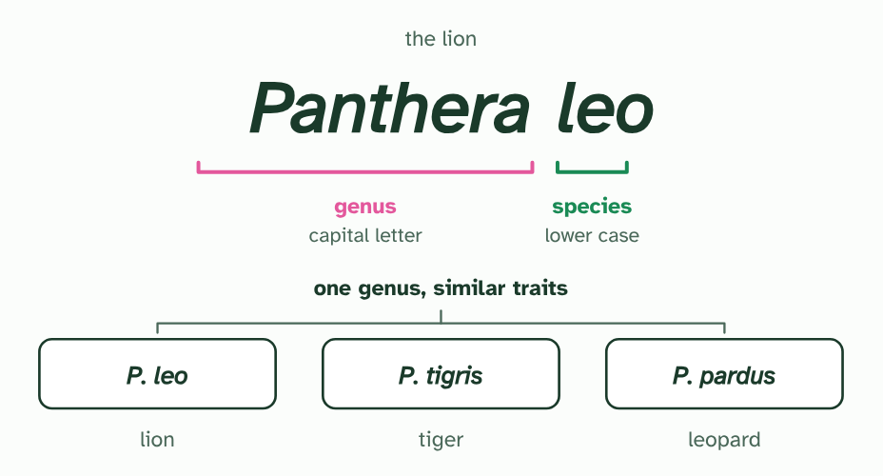  REMEMBER IT  The four rules of a binomial name
  G  Green | S  Sloths | I  Inch | A  Along
  G | S | I | A
  SPOT THE MISTAKE
  What do students often get wrong about binomial naming? Write the mistake, then put it right.
  The mistake
  Put it right
SUMMARY
Sum up section 02 in two or three sentences of your own.

03 Can they breed? | A3.1.4 A3.1.5
CUES  Predict: Two kinds of snail live on islands 500 km apart, and none has ever crossed the sea. Can the biological species concept say whether they are one species?  What is meant by biological species concept?  What is meant by speciation? | NOTES  1 The __________________________________ says a species is a group of organisms that can breed and produce _________ offspring.  2 A species concept is a ________________________, a tool that helps scientists group what they find, and it is replaced when a better tool comes along.  3 One more problem comes from how species form. ______________, the splitting of one species into two or more, usually happens gradually (you saw it in A4.1).  4 __________________________________: organisms that can breed and produce fertile offspring.  5 ______________ is gradual, so the line between populations and species can be arbitrary.  Your own notes  ANNOTATE THE FIGURE  Number the 4 steps on the figure and note what happens at each: 1 same group, one from each; 2 young; 3 fertile; 4 separate species.  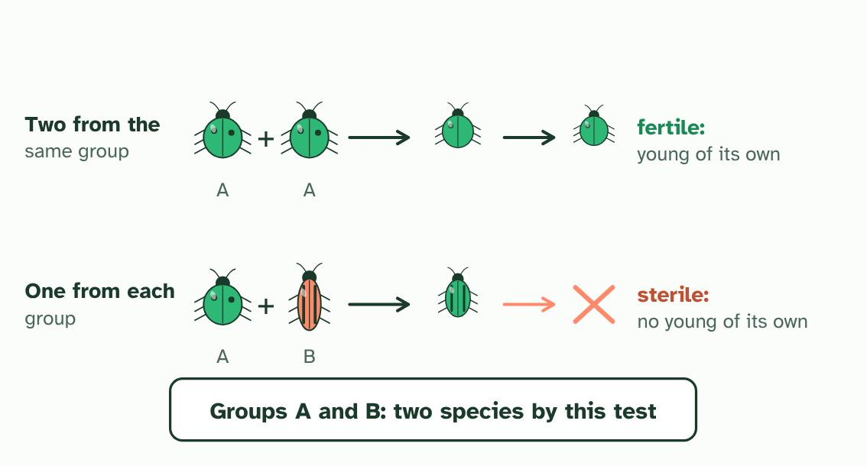  ANNOTATE THE FIGURE  Annotate this still from the animation (Watch it happen: one population becomes two): what is happening, and why?  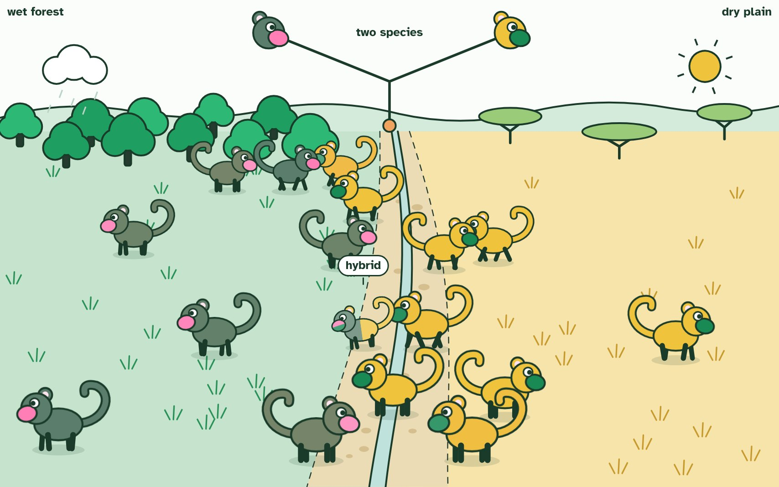
  SPOT THE MISTAKE
  What do students often get wrong about the biological species concept? Write the mistake, then put it right.
  The mistake
  Put it right
SUMMARY
Sum up section 03 in two or three sentences of your own.

04 Every species has its own count | A3.1.6
CUES  Predict: Why does a diploid cell always have an even number of chromosomes?  What is meant by chromosome?  What is meant by diploid?  What is meant by homologous chromosomes?  What is meant by haploid? | NOTES  1 A ______________ is a molecule of DNA wrapped up with proteins.  2 A human body cell has ________ chromosomes.  3 A chimpanzee’s has ________.  4 A body cell is _________, with two copies of each chromosome, one inherited from each parent.  5 The two that match are ______________________________, so chromosomes come in pairs: 23 pairs in a human, 24 in a chimpanzee.  6 The sex cells are _________, with one from each pair: 23 in a human egg or sperm.  7 _________ cells have an even number, because chromosomes come in homologous pairs.  Your own notes  ANNOTATE THE FIGURE  Number the 4 steps on the figure and note what happens at each: 1 4 pairs; 2 46; 3 48; 4 not, even.  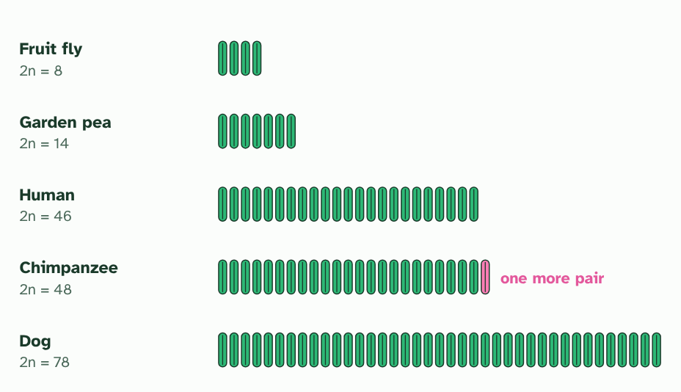
  SPOT THE MISTAKE
  What do students often get wrong about chromosome numbers? Write the mistake, then put it right.
  The mistake
  Put it right
SUMMARY
Sum up section 04 in two or three sentences of your own.

05 Laying out the chromosomes | A3.1.7
CUES  Predict: If two chromosomes had fused end to end, what would you expect in the middle of the new, longer chromosome?  What is meant by karyotype?  What is meant by karyogram? | NOTES  1 How do biologists compare chromosomes? They make a ____________: the full set of one cell’s chromosomes.  2 Photographed and arranged in pairs, the picture is a ____________.  3 To arrange them, match each chromosome with its partner using three clues: its ________, its ____________________ and the position of its ______________, the pinched point where its two arms meet.  4 The two ape chromosomes, placed end to end, match human chromosome 2 in ________ and in _________.  5 Human chromosome 2 has DNA typical of a chromosome ________ (a telomere) in the middle, where a join would be.  6 And it carries the remains of a _______________________, switched off.  7 A ____________ arranges chromosomes in pairs by length, banding pattern and centromere position.  Your own notes  ANNOTATE THE FIGURE  Number the 4 steps on the figure and note what happens at each: 1 dividing; 2 stained, photographed; 3 length, banding pattern, centromere position; 4 longest.  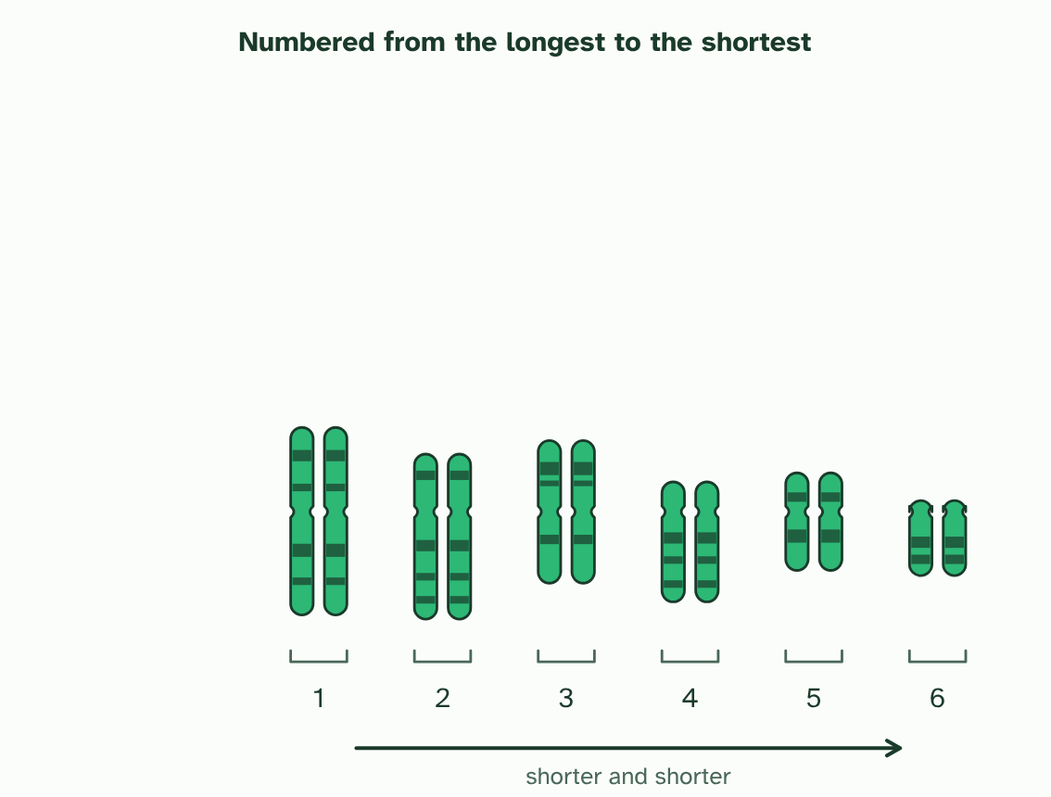  ANNOTATE THE FIGURE  Number the 3 steps on the figure and note what happens at each: 1 length, centromere position, bands; 2 longest first; 3 chromosome 2.  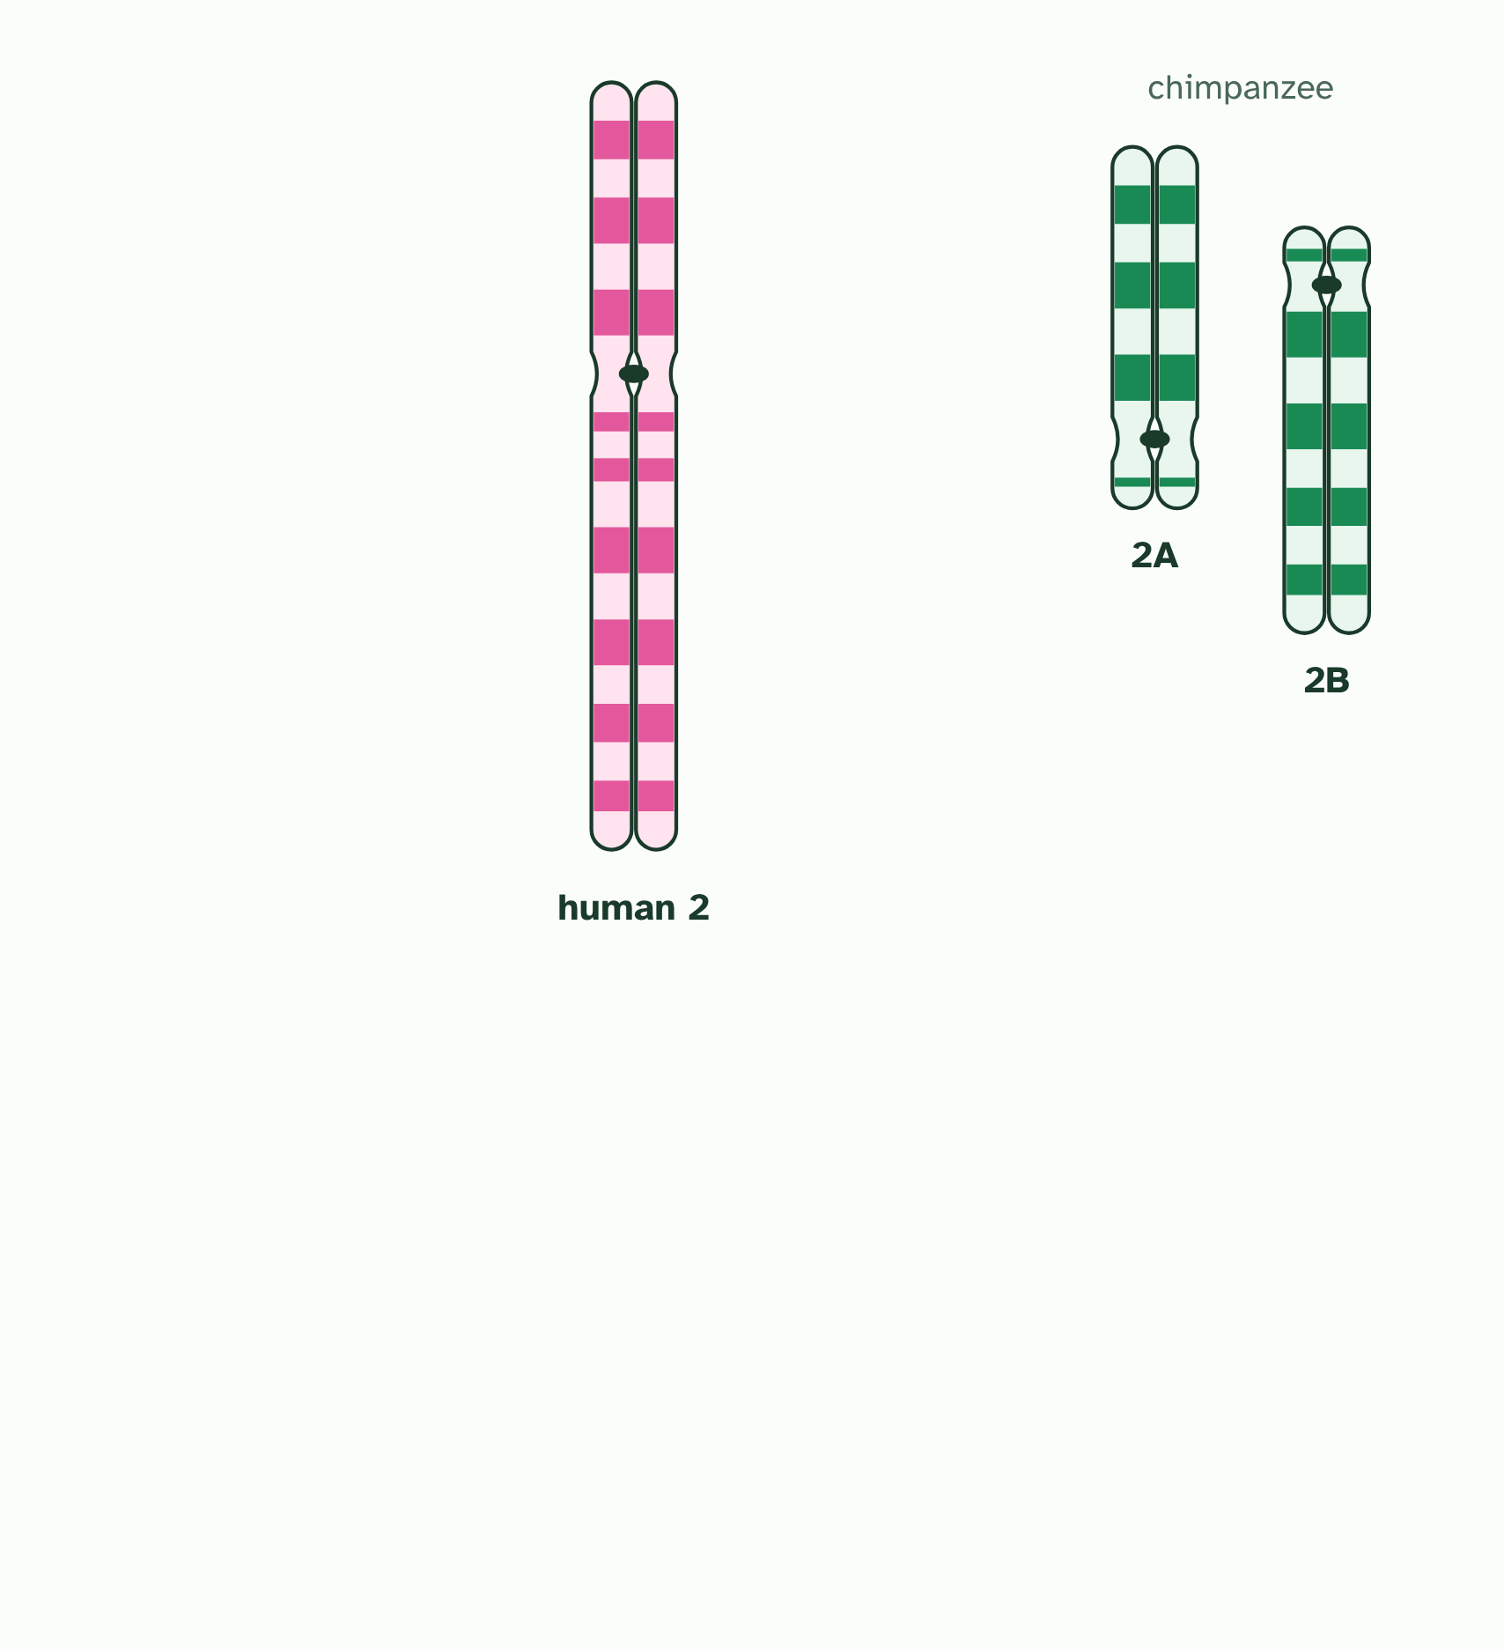  ANNOTATE THE FIGURE  Number the 3 steps on the figure and note what happens at each: 1 length, centromere position, bands; 2 longest first; 3 chromosome 2.  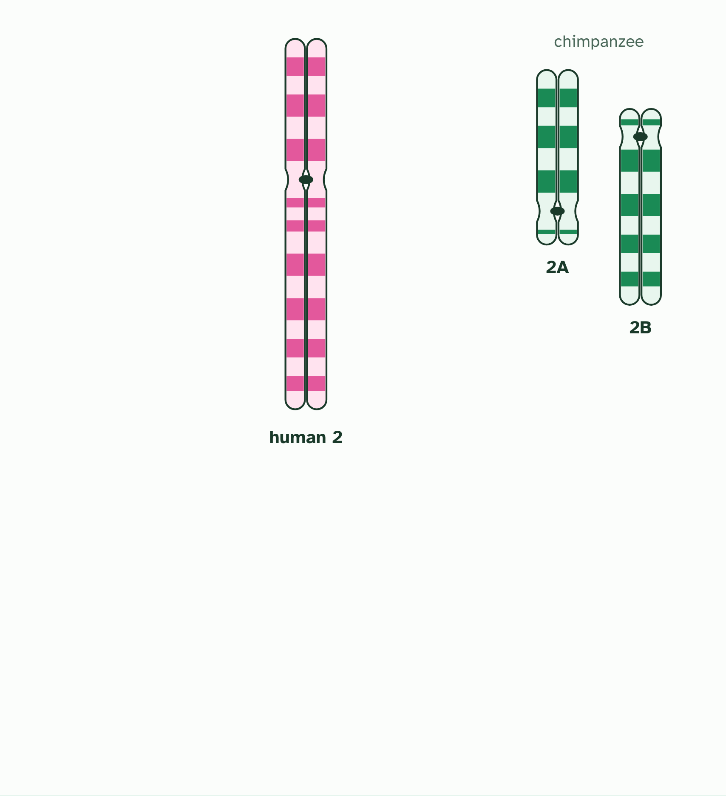
  SPOT THE MISTAKE
  What do students often get wrong about karyotyping and karyograms? Write the mistake, then put it right.
  The mistake
  Put it right
SUMMARY
Sum up section 05 in two or three sentences of your own.

06 One genome, many versions | A3.1.8 A3.1.9
CUES  Predict: Two unrelated people have their whole genomes read and compared. About how different are they?  What is meant by genome?  What is meant by single nucleotide polymorphism? | NOTES  1 Your ________ is all the genetic information you carry: your genes, the DNA between them, and the small loops of DNA in your mitochondria.  2 At about one place in a thousand, one base differs: a __________________________________, or SNP (said “snip”).  3 Genomes differ in their overall ________, which is the total amount of DNA, and in __________________.  4 A ________ is all the genetic information of an organism.  5 Members of one species share most of their ________; SNPs give some diversity.  Your own notes  ANNOTATE THE FIGURE  Number the 3 steps on the figure and note what happens at each: 1 pink; 2 single nucleotide polymorphism; 3 far more.  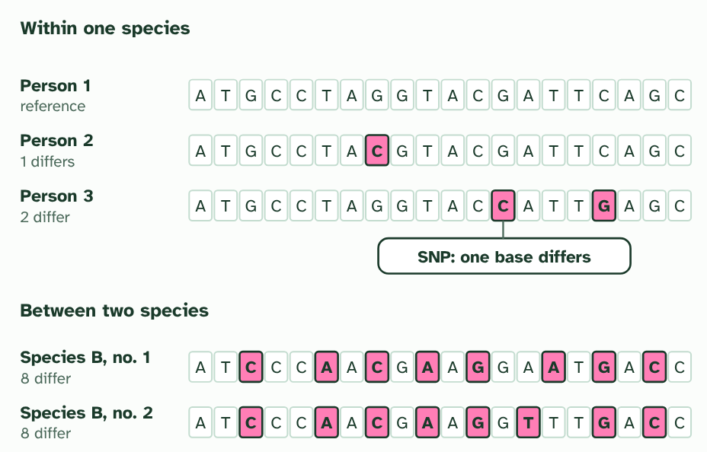
  SPOT THE MISTAKE
  What do students often get wrong about genomes within and between species? Write the mistake, then put it right.
  The mistake
  Put it right
SUMMARY
Sum up section 06 in two or three sentences of your own.

07 Big genome, small organism | A3.1.10
CUES  Predict: A student says: “The organism with the biggest genome must be the most complex.” Which fact shows this is wrong? | NOTES  1 Genome size is ________ a valid measure of how complex an organism is.  2 A bacterium’s genome is millions of base pairs. A human’s is about __________________. (Mb is millions, Gb billions of base pairs.)  3 The Australian lungfish’s genome is more than ____________ a human’s.  4 The flowering plant Paris japonica has one of the biggest genomes known. Size is ________ a measure of how complex an organism is.  Your own notes  ANNOTATE THE FIGURE  Number the 3 steps on the figure and note what happens at each: 1 three billion; 2 ten times; 3 not.  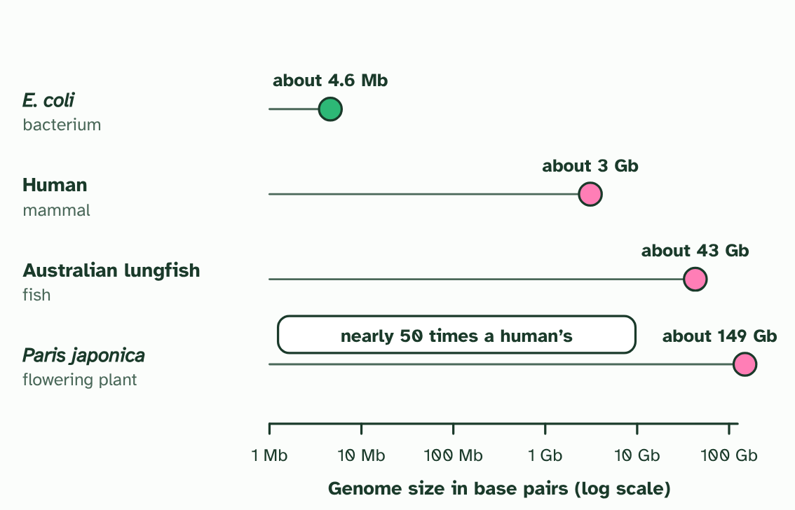  ANNOTATE THE FIGURE  Label the key parts and add a note on what it shows.  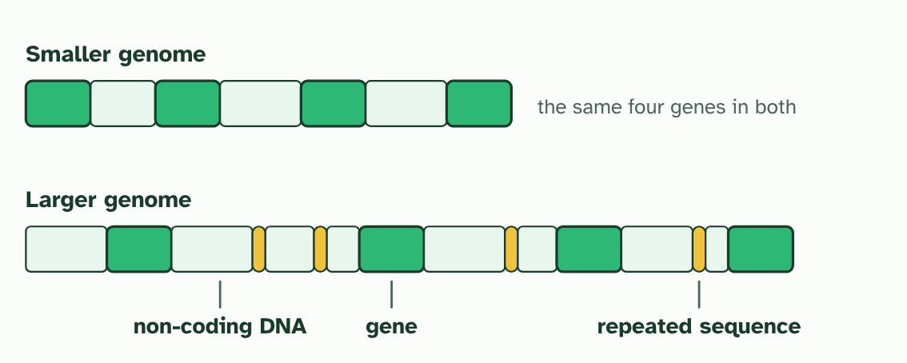
  SPOT THE MISTAKE
  What do students often get wrong about comparing genome sizes? Write the mistake, then put it right.
  The mistake
  Put it right
SUMMARY
Sum up section 07 in two or three sentences of your own.

08 Reading a whole genome | A3.1.11
CUES  Predict: How has the cost of sequencing a human genome changed since the first one was done?  What is meant by whole genome sequencing?  What is meant by personalised medicine? | NOTES  1 _______________________________ reads the order of every base in an organism’s genome.  2 In the future, a doctor may use a patient’s own genome to choose the medicine and dose most likely to work for them: ____________________________.  3 _______________________________ is getting faster and cheaper.  4 Current use: research into evolutionary relationships. Future use: ____________________________.  Your own notes  ANNOTATE THE FIGURE  Number the 3 steps on the figure and note what happens at each: 1 years, billions; 2 fell steeply; 3 comparing species, personalised medicine.  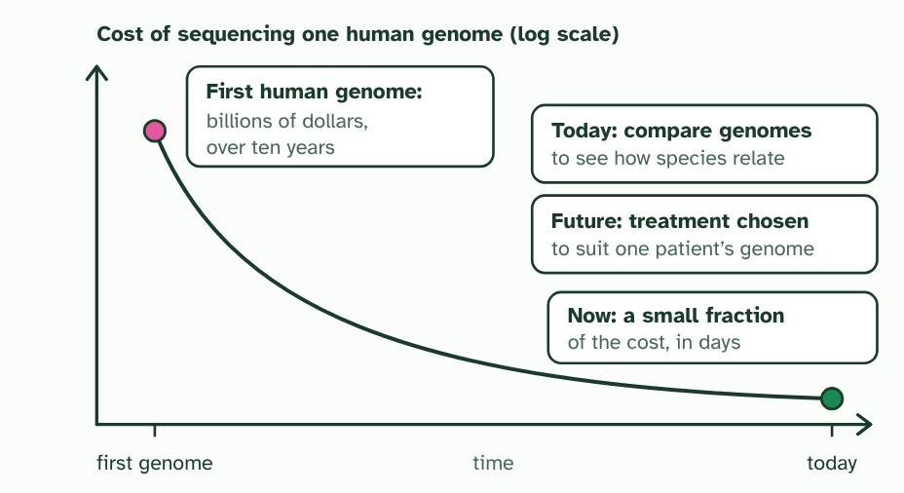
  SPOT THE MISTAKE
  What do students often get wrong about whole genome sequencing? Write the mistake, then put it right.
  The mistake
  Put it right
SUMMARY
Sum up section 08 in two or three sentences of your own.

09 When the species rule breaks | A3.1.12 HL
CUES  Predict: A bacterium carries a plasmid with an antibiotic-resistance gene. It touches a bacterium of a different species. What can happen?  What is meant by horizontal gene transfer?  What is meant by conjugation?  What is meant by plasmid? | NOTES  1 In ________________________________ they pass sideways, between cells that are already alive.  2 In _______________ two bacteria touch and a copy of a _________ passes across.  3 ________________________________ moves genes between species, so gene pools are not closed.  4 A bacterium reproduces by ___________________: two identical cells, with no partner and nothing to test.  5 Two bacteria of _______________________. One carries a _________, a small ring of DNA, with a gene on it.  6 The cells touch and a bridge forms. A ________ of the plasmid passes across.  Your own notes  ANNOTATE THE FIGURE  Number the 4 steps on the figure and note what happens at each: 1 copying itself; 2 different species, plasmid; 3 copy; 4 sideways.  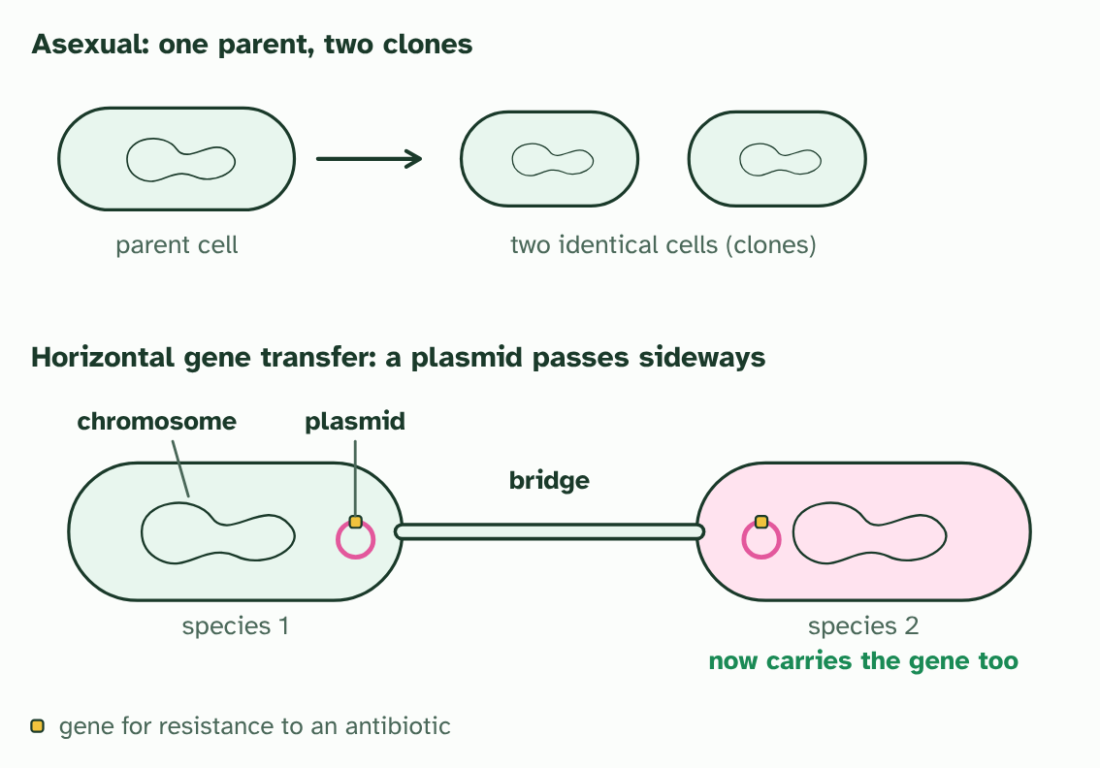  REMEMBER IT  Where the species concept struggles
  F  Five | A  Apes | H  Hug | G  Grumpy | A  Aunts | H  Happily
  F | A | H | G | A | H
  SPOT THE MISTAKE
  What do students often get wrong about asexual species and horizontal gene transfer? Write the mistake, then put it right.
  The mistake
  Put it right
SUMMARY
Sum up section 09 in two or three sentences of your own.

10 The number that has to match | A3.1.13 HL
CUES  Predict: A hybrid cell has 63 chromosomes. Could every one of them have an equal partner at meiosis? | NOTES  1 Gametes like that rarely work, so __________________________________.  2 Two ___________ species. Q has one long chromosome where P has two short ones, so they have different chromosome numbers.  3 A hybrid gets ____________: five chromosomes, an odd number. One cannot have an equal partner.  4 At meiosis each chromosome looks for its match. Two pair neatly, but the long one is left matching ________ at once.  5 Some ways of sharing them out give complete sets. Others give a gamete with part of the genome ________ and part _________. With many such mismatches, most gametes fail.  Your own notes  ANNOTATE THE FIGURE  Number the 4 steps on the figure and note what happens at each: 1 imagined; 2 both sets; 3 two; 4 twice, missing.  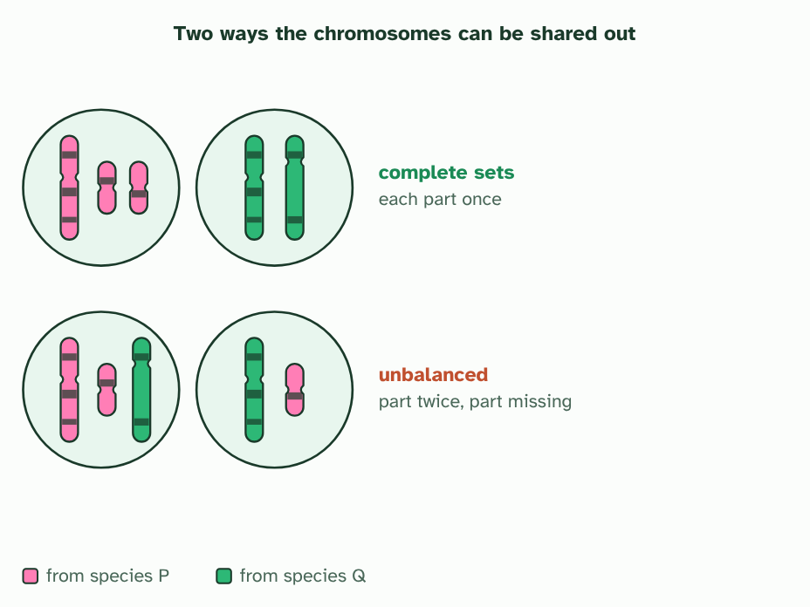
  SPOT THE MISTAKE
  What do students often get wrong about chromosome number as a shared trait? Write the mistake, then put it right.
  The mistake
  Put it right
SUMMARY
Sum up section 10 in two or three sentences of your own.

11 Building a key | A3.1.14 HL
CUES  Predict: Which feature is best for a key that tells the leaves of different trees apart?  What is meant by dichotomous key? | NOTES  1 To name an organism you have not met, use a ____________________.  2 A ____________________ uses paired choices that lead to one name.  3 Every step is a question with ________ answers. A leaf made of leaflets leads to one more question, and then to horse chestnut or ash.  4 A leaf in one piece leads to the next question. ______________: oak.  5 Each remaining question uses an ________ that is easy to see: spiny, toothed, or neither. Every leaf reaches exactly one name.  6 Check a key by following one leaf through it: holly is ________ to leaflets, ________ to deep lobes and ________ to a spiny edge.  Your own notes  ANNOTATE THE FIGURE  Number the 4 steps on the figure and note what happens at each: 1 two; 2 Deep lobes; 3 edge; 4 no, no, yes.  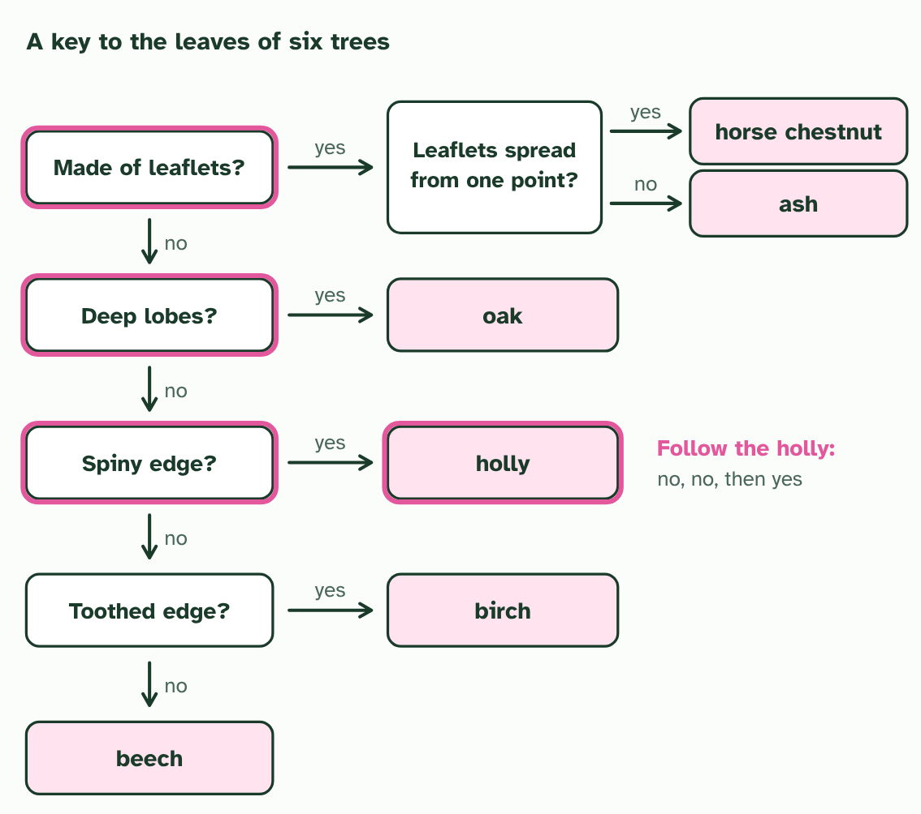  ANNOTATE THE FIGURE  Number the 2 steps on the figure and note what happens at each: 1 dichotomous key; 2 splits.  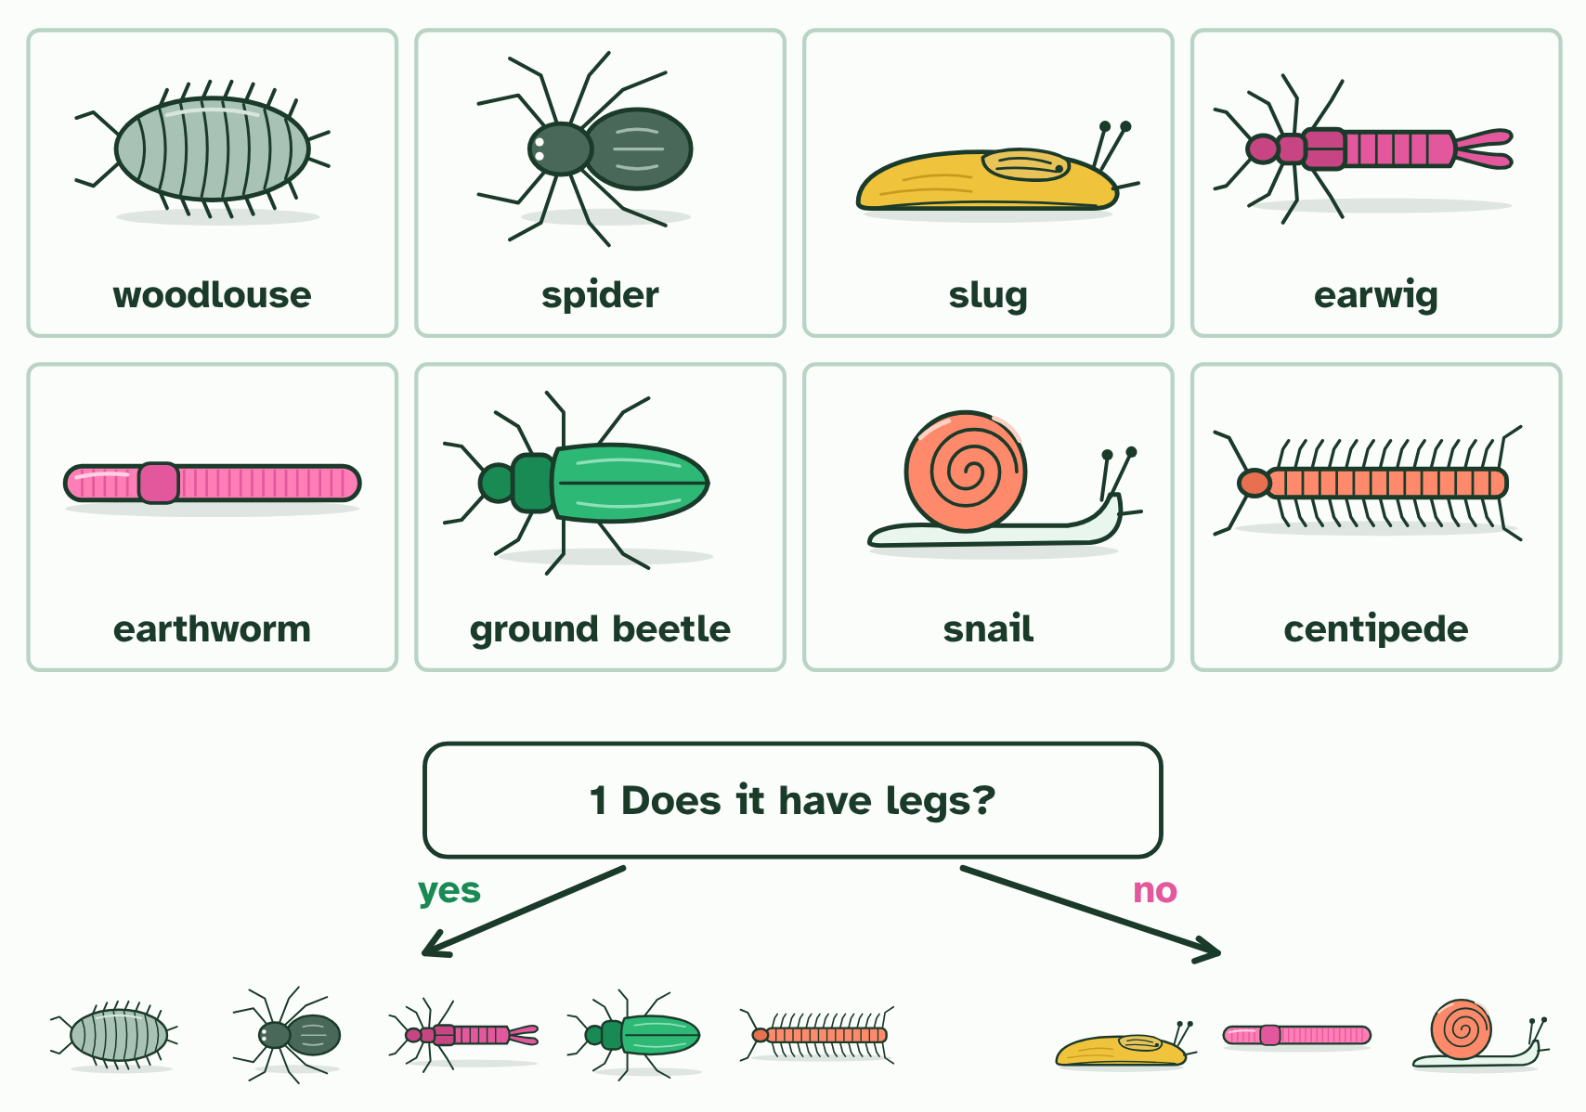  ANNOTATE THE FIGURE  Number the 2 steps on the figure and note what happens at each: 1 dichotomous key; 2 splits.  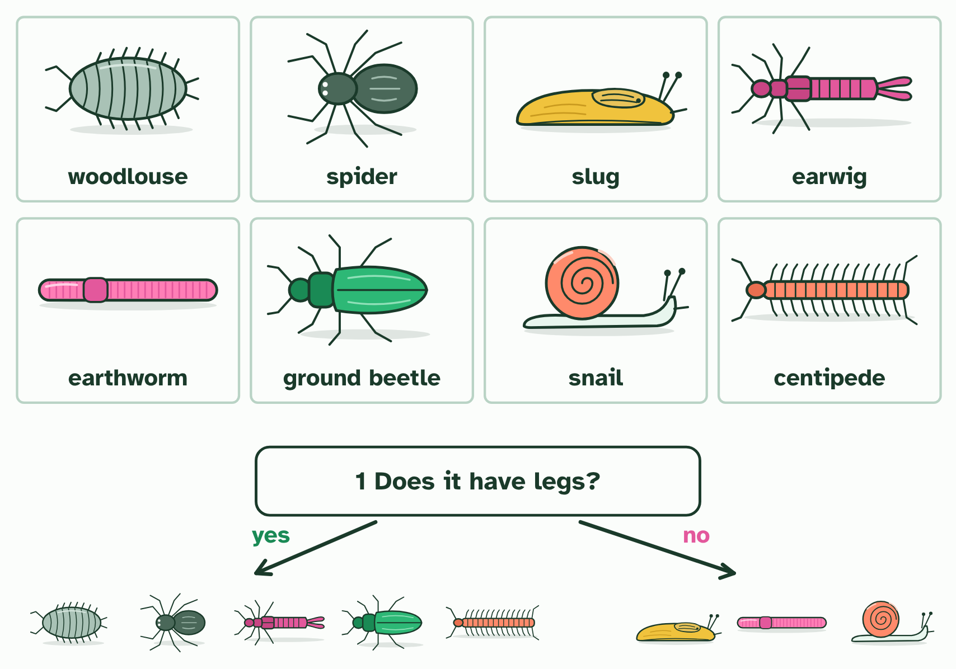
  SPOT THE MISTAKE
  What do students often get wrong about dichotomous keys? Write the mistake, then put it right.
  The mistake
  Put it right
SUMMARY
Sum up section 11 in two or three sentences of your own.

12 Barcodes from the soil | A3.1.15 HL
CUES  Predict: A water sample from a pond is barcoded and matched. What can the result tell you?  What is meant by environmental DNA?  What is meant by DNA barcode? | NOTES  1 But every animal leaves traces of itself in the water: skin cells, mucus, droppings. _______________________ (eDNA) is the DNA collected from a sample of water, soil or air, not from an animal you have caught.  2 To tell whose DNA it is, scientists read a _______________: a short stretch of DNA, a few hundred base pairs long, that is alike in members of one species and different between species.  3 The steps are always the same: collect a sample, extract the DNA, make millions of copies of the barcode region with PCR, read their sequences, and match each sequence against a _______________________ of barcodes from known species.  4 A barcode is a short stretch of DNA with __________________________________ and a __________________________ between species.  5 Because the ends match everywhere, one pair of _________ can copy the barcode from any species in a mixed sample.  6 A barcode read from a sample is _________ against the library. Here it is identical to one species’ barcode.  Your own notes  ANNOTATE THE FIGURE  Number the 4 steps on the figure and note what happens at each.  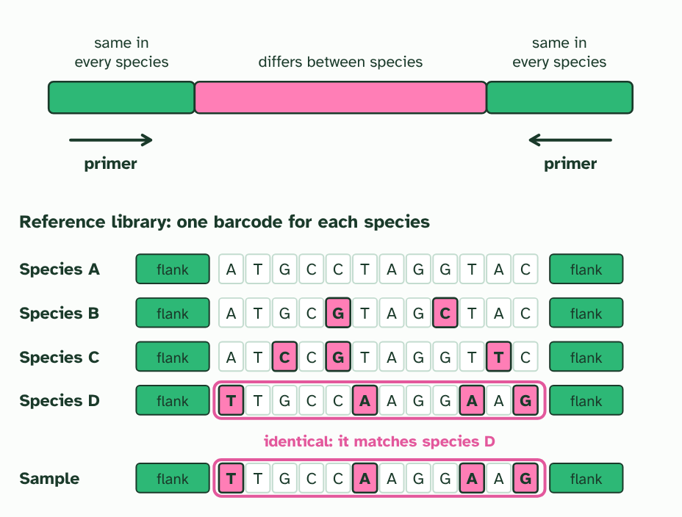  ANNOTATE THE FIGURE  Annotate this still from the animation (Watch it happen: a sample becomes a species list): what is happening, and why?  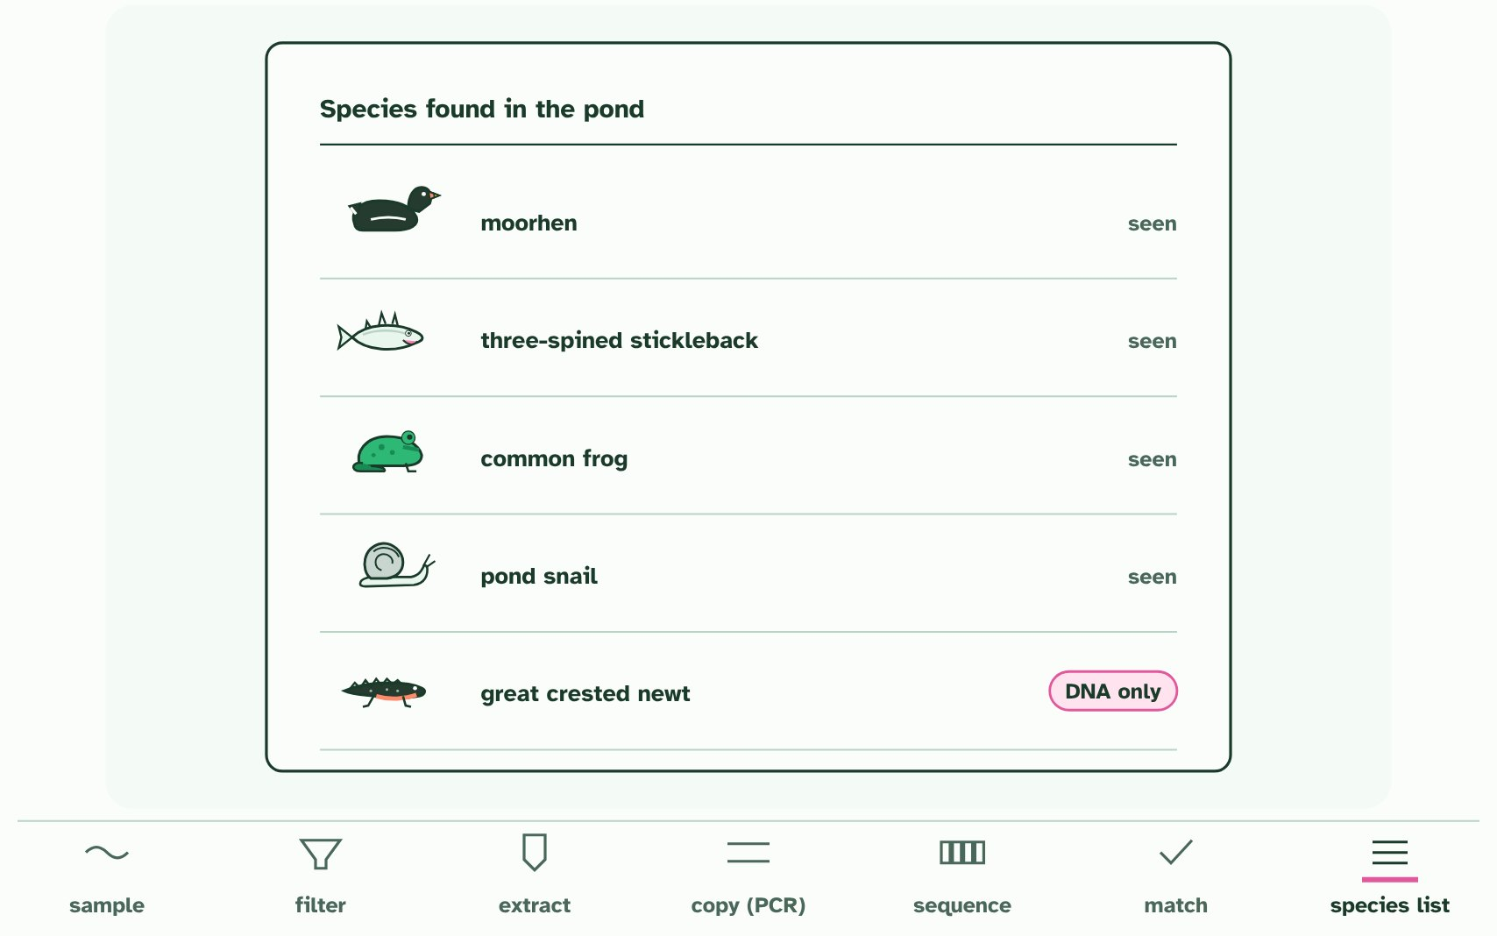  REMEMBER IT  Steps of an eDNA survey
  C  Cats | E  Eat | A  Any | S  Sausage | M  Mostly
  C | E | A | S | M
  SPOT THE MISTAKE
  What do students often get wrong about DNA barcodes and environmental DNA? Write the mistake, then put it right.
  The mistake
  Put it right
SUMMARY
Sum up section 12 in two or three sentences of your own.

Check yourself
The check for this guide is online: a fresh paper of past-paper style questions from the exam bank on A3.1 each time, marked as you go, and saved to your Exam practice progress when you are signed in. Open the link:
biologybybradford.com/exam-maker/sit?topics=A3.1&level=HL&paper=quiz&marks=15&src=ep

