Name | Class | Date
IB BIOLOGY · A3.2

Classification and cladistics
Teacher’s copy: every blank filled in. Each numbered block matches a chapter of the guide, and of the lesson slides. Write in the gaps, answer the cues, annotate the figures, and sum up each section in your own words.
BY THE END YOU CAN
Explain why classification is needed, and what it makes possible A3.2.1
Describe why the traditional hierarchy of taxa does not always match evolution, and why a fixed ranking is arbitrary A3.2.2
Explain why a classification that follows evolutionary relationships lets you predict the features of its members A3.2.3
Define a clade, and say what evidence best places organisms in one A3.2.4
Explain how the molecular clock estimates when clades diverged, and why it only gives estimates A3.2.5
Build a cladogram from sequence data using parsimony, and say why different criteria can give different trees A3.2.6
Read a cladogram: its root, nodes and terminal branches, its clades and common ancestors A3.2.7
Use the figwort family to show how cladistics tests a classification, and why a claim can be falsified A3.2.8
Explain how rRNA sequences led to the three domains, and what was new about them A3.2.9

01 Why sort life at all? | A3.2.1 HL
CUES  Predict: Which is the best reason for classifying organisms?  B: There are too many species to study one by one, and a group lets what we know about one guide the rest. The second. Sorting makes millions of species manageable, and it lets what is found out about one species guide the study of its group. Names are useful but they do not do that, and ranking species from simple to advanced is not what classification is for: no living species is more advanced than another.  What is meant by classification?  Sorting organisms into groups, and groups into larger groups, by what they have in common. | NOTES  1 So we sort them. Classification turns the diversity of life from a heap into a map.  2 It helps you name and find an organism: once you know which group a beetle or a fern belongs to, you know where to look it up and what it is probably like.  3 And it makes further study possible.  4 Classification is needed because there are too many species to study one at a time.  Your own notes  ANNOTATE THE FIGURE  Number the 3 steps on the figure and note what happens at each: 1 any way you like; 2 flies; 3 has a backbone.  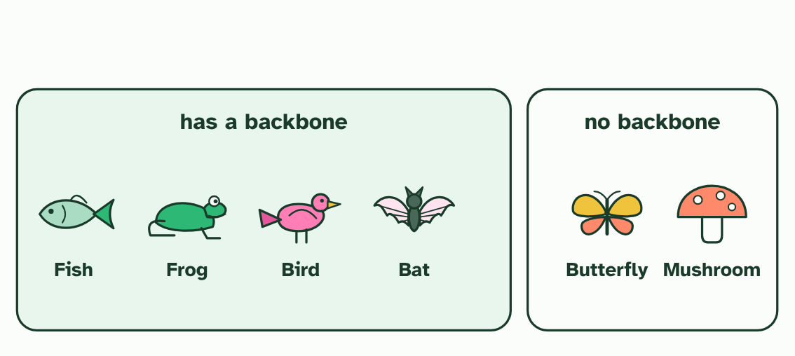  1 Six organisms, to sort any way you like.  2 Rule one: flies. The bat, the bird and the butterfly go together.  3 Rule two: has a backbone. Now the bat sits with the fish and the frog, and the butterfly has left it. Same six, different groups.
  SPOT THE MISTAKE
  What do students often get wrong about why we classify? Write the mistake, then put it right.
  Classification is not just naming. A name tells you nothing about a species. A group tells you what to expect from it.
SUMMARY
Sum up section 01 in two or three sentences of your own.
• Classification is needed because there are too many species to study one at a time.
• Once organisms are classified, a broad range of further study becomes possible.
• Different rules give different groups, so the rule matters.

02 When the boxes do not fit | A3.2.2 HL
CUES  Predict: A taxonomist finds that a group in the old system leaves out one species that descends from the same common ancestor as the rest. What does that show?  C: The group does not follow the pattern of divergence. The group does not follow the pattern of divergence. A group that leaves out a descendant of its own ancestor splits a family in two, however alike its members look. That is the problem with the old class Reptilia, which leaves out the birds.  What is meant by hierarchy of taxa?  The traditional ranks of classification, one inside the next: kingdom, phylum, class, order, family, genus, species.  What is meant by taxon?  Any named group of organisms, at any rank. The plural is taxa.  What is meant by cladistics?  A method of classifying organisms into clades, groups made of an ancestor and all its descendants, with no fixed ranks.  What is meant by paradigm shift?  A big change in the basic ideas and methods of a field of science, when the old ones can no longer cope with the evidence. | NOTES  1 Naturalists have long sorted life into a hierarchy of taxa.  2 A taxon is a named group.  3 Ranks are also arbitrary.  4 A family of beetles and a family of mammals need not be alike in age or in how much they differ, so a rank measures nothing fixed. Cladistics offers another way: unranked groups that follow the branching.  Your own notes  ANNOTATE THE FIGURE  Number the 4 steps on the figure and note what happens at each.  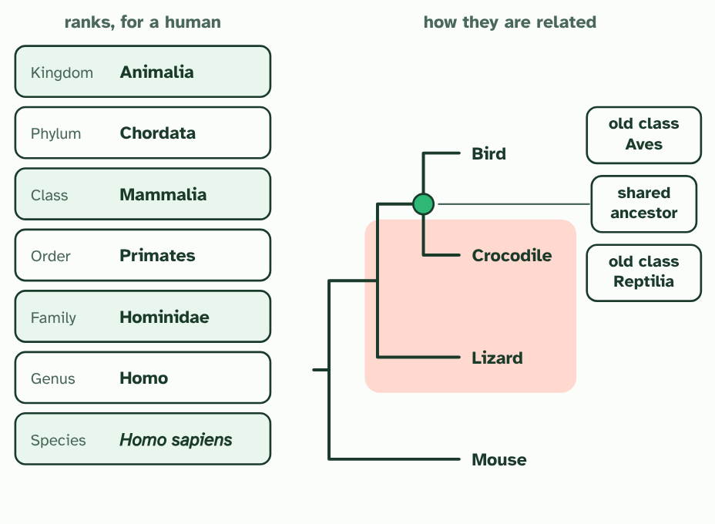  1 The traditional ranks: each one nests inside the next, from kingdom down to species.  2 Now the branching tree of descent for four vertebrates, built from DNA (simplified).  3 The old classes. Reptilia holds the crocodile and the lizard, and Aves holds the bird on its own.  4 But the crocodile and the bird share an ancestor that the lizard does not. The old class cuts that family in two.  ANNOTATE THE FIGURE  Number the 4 steps on the figure and note what happens at each: 1 Normal science; 2 do not fit; 3 new idea; 4 paradigm shift.  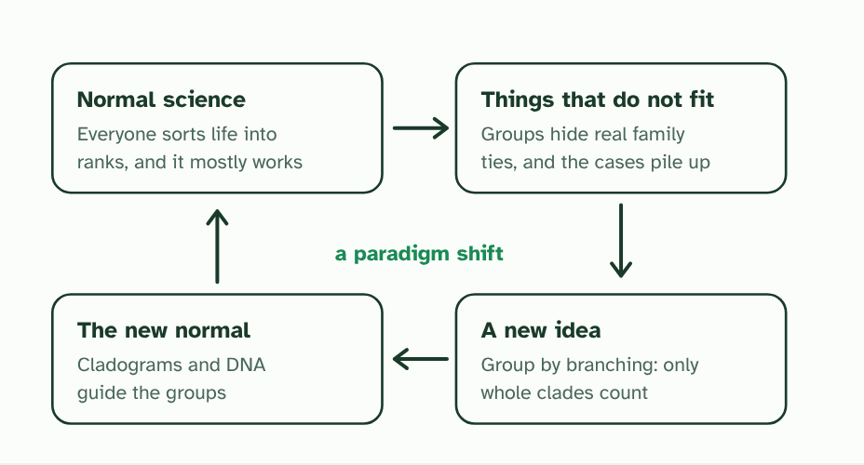  1 Normal science: a framework everyone shares. For classification, the ranks.  2 Cases that do not fit build up, such as groups that split a family in two.  3 A new idea replaces the rule for grouping: use the branching tree, and group only whole clades.  4 The new idea becomes the new normal. A change in the basic ideas of a field is a paradigm shift.  REMEMBER IT  The ranks, from the top
  K  King | P  Philip | C  Came | O  Over | F  For | G  Good | S  Soup
  Kingdom  the biggest group | Phylum  a major body plan | Class  mammals, birds, insects | Order  primates, carnivores | Family  cats, dogs, apes | Genus  close species together | Species  one kind of organism
SUMMARY
Sum up section 02 in two or three sentences of your own.
• Naturalists have long sorted life into a hierarchy of taxa.
• A taxon is a named group.
• A family of beetles and a family of mammals need not be alike in age or in how much they differ, so a rank measures nothing fixed. Cladistics offers another way: unranked groups that follow the branching.

03 Groups that are family trees | A3.2.3 HL
CUES  Predict: A newly found frog falls inside a clade whose other members all make a toxin in their skin. Which statement is best?  C: It probably makes the toxin, but a feature can be lost, so the prediction needs testing. The second. Membership of the clade makes the toxin likely, because it was probably present in the common ancestor. It is not certain, since a line can lose a feature, and that is why a prediction is tested and not simply assumed.  What is meant by common ancestor?  An ancestor shared by two or more organisms: the point where their lines split. | NOTES  1 The ideal classification follows that family tree, so that every member of a group has evolved from one common ancestor, and none of that ancestor's descendants are left out.  2 The ideal classification follows evolutionary relationships: all members of a group descend from one common ancestor.  3 Hair and milk appeared once, on the branch leading to the mammals. Every descendant of that ancestor inherits them, unless a line loses them.  4 A newly found animal. Its DNA says it is the mouse's closest relative: it joins the tree there (a made-up animal).  5 It sits inside the mammal clade, so you can predict its features before you have studied it.  Your own notes  ANNOTATE THE FIGURE  Number the 3 steps on the figure and note what happens at each: 1 mammals; 2 joins the tree; 3 predict.  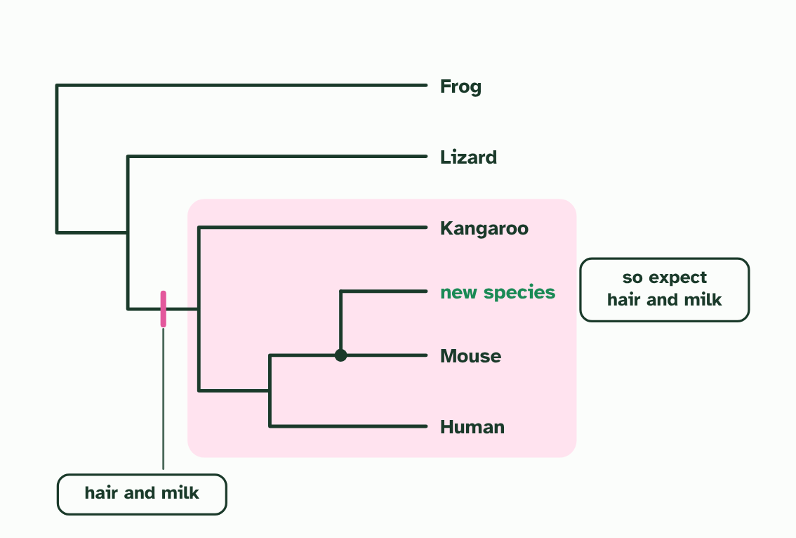  1 Hair and milk appeared once, on the branch leading to the mammals. Every descendant of that ancestor inherits them, unless a line loses them.  2 A newly found animal. Its DNA says it is the mouse's closest relative: it joins the tree there (a made-up animal).  3 It sits inside the mammal clade, so you can predict its features before you have studied it.
  SPOT THE MISTAKE
  What do students often get wrong about classification that follows relationships? Write the mistake, then put it right.
  A prediction is a good bet, not a promise. A feature can be lost along a branch: snakes belong to a group of four-limbed animals, but their ancestors lost the legs. That is why a prediction is then tested.
SUMMARY
Sum up section 03 in two or three sentences of your own.
• The ideal classification follows evolutionary relationships: all members of a group descend from one common ancestor.
• Features of one member can be predicted for the rest, because they are shared within the group.

04 A clade is an ancestor and all its descendants | A3.2.4 HL
CUES  Predict: A tree shows an ancestor X with four descendants, P, Q, R and S. Someone proposes the group P, Q and R. Is it a clade?  A: No, because S also descends from X and is left out. No. A clade holds the ancestor and all of its descendants, and S descends from X as well. P, Q and R do share X, but the group is missing a descendant, so it does not follow the branching.  What is meant by clade?  A group made of one common ancestor and all of its descendants.  What is meant by morphological?  The shape and structure of an organism's body. | NOTES  1 A clade is a common ancestor together with every organism that descends from it.  2 The most objective evidence comes from the base sequences of genes or the amino acid sequences of proteins.  3 A sequence is a long string that can be compared position by position, and anyone counting the differences gets the same answer. Morphological traits can also place organisms in clades, but they need a judgement about which features count, and they can mislead when unrelated lines evolve similar structures.  4 Sequence evidence is the most objective, and morphological traits can also be used.  Your own notes  ANNOTATE THE FIGURE  Label each part and say what it does: node E, the root, node D, node C, node B, node A, the old reptiles.  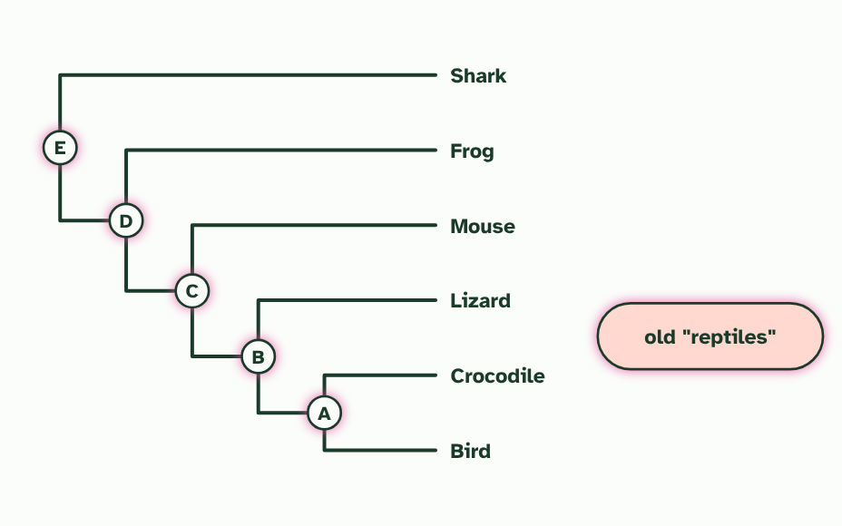  1 Node E, the root: every organism on the tree. The whole tree is always a clade.  2 Node D: add the frog and the ring holds every descendant of node D, so it is a clade too.  3 Node C: add the mouse and the ring still holds everything that descends from this ancestor. Still a clade.  4 Node B: the lizard, the crocodile and the bird all descend from this ancestor, and it has no other descendants. The bird is inside this clade.  5 Node A: the crocodile and the bird, and nothing else, descend from this ancestor. Together they are a clade.  6 The old reptiles: the lizard and the crocodile only. They share their ancestor with the bird, which is left out, so this group is not a clade. Leave out even one descendant and it fails.
  SPOT THE MISTAKE
  What do students often get wrong about clades? Write the mistake, then put it right.
  A clade is not decided by how organisms look, how big the group is or what rank it once had. Only descent counts. A group of look-alikes that leaves out a relative is not a clade.
SUMMARY
Sum up section 04 in two or three sentences of your own.
• A clade is one common ancestor plus all of its descendants.
• Sequence evidence is the most objective, and morphological traits can also be used.

05 Differences that count the years | A3.2.5 HL
CUES  Predict: A clock is calibrated on mammals that breed every few years. It is then used to date a split between two lines of insects that breed several times a year. What will the estimate probably be?  C: Too old, because the insects probably collected changes faster each year. Too old. With more generations each year there are more chances for changes to build up, so the insects gather differences faster than the mammal clock allows for. The same number of differences stands for fewer years than the clock says.  What is meant by molecular clock?  A way of estimating when two clades diverged from a common ancestor, from the number of differences that have built up in their gene or protein sequences. | NOTES  1 A straight line through the points is the molecular clock.  2 The result is an estimate, never a date.  3 Two pairs of species whose split is dated from fossils: 5 differences at 10 million years and 15 at 30 million (made-up numbers).  4 The differences grow steadily with time, so a straight line through the points is the molecular clock.  5 A pair with no fossil date differs at 6 places. Read across to the clock, then down: about 12 million years.  6 If this pair's lines collected changes twice as fast, the same 6 differences would mean about 6 million years. The clock gives an estimate, not a date.  Your own notes  ANNOTATE THE FIGURE  Number the 4 steps on the figure and note what happens at each: 1 dated from fossils; 2 molecular clock; 3 no fossil date; 4 twice as fast.  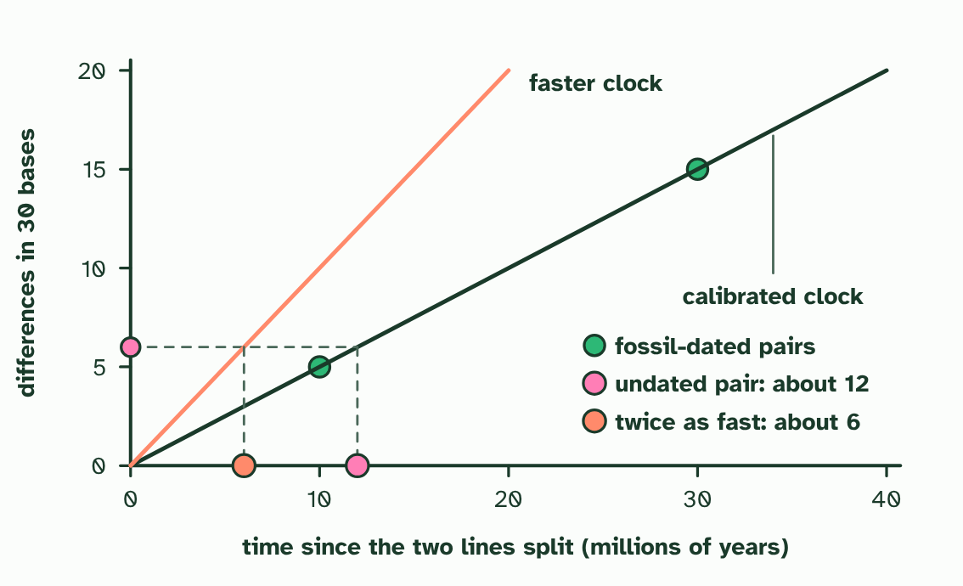  1 Two pairs of species whose split is dated from fossils: 5 differences at 10 million years and 15 at 30 million (made-up numbers).  2 The differences grow steadily with time, so a straight line through the points is the molecular clock.  3 A pair with no fossil date differs at 6 places. Read across to the clock, then down: about 12 million years.  4 If this pair's lines collected changes twice as fast, the same 6 differences would mean about 6 million years. The clock gives an estimate, not a date.  ANNOTATE THE FIGURE  Annotate this still from the animation (Watch it happen: two lines collect changes): what is happening, and why?  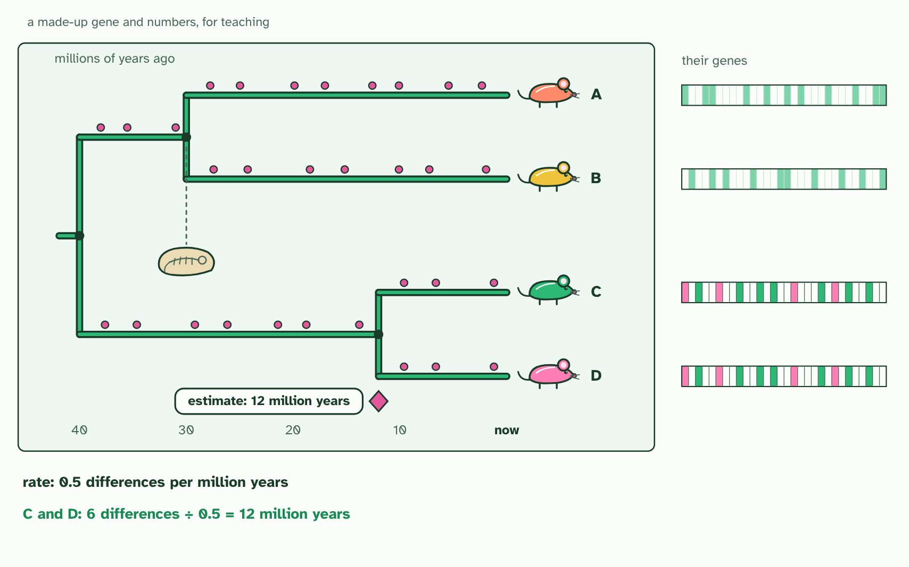  1 One ancestor species, and one of its genes: a stretch of 30 bases, drawn as boxes.  2 Its descendants split into new species. In every line, mutations build up in the gene at a fairly steady rate: the ticks of a clock.  3 Today there are four species, A to D. Each gene now differs from the ancestor's, in its own places.  4 A dated fossil shows that A and B split 30 million years ago. Their genes differ at 15 bases.  5 So this clock runs at 15 ÷ 30 = 0.5 differences per million years.  6 C and D differ at 6 bases: 6 ÷ 0.5 = about 12 million years since they split.  7 Only an estimate: generation time, population size and selection all change how fast differences build up. Try the settings.  REMEMBER IT  What shifts the clock
  G  Gerbils | P  Play | S  Sports
  Generation time  short generations copy DNA more often each year | Population size  chance spreads changes differently | Selection pressure  selection removes some changes, keeps others
  SPOT THE MISTAKE
  What do students often get wrong about the molecular clock? Write the mistake, then put it right.
  A molecular clock is not a watch. It gives an average rate, calibrated against fossils, and different genes and different lines can tick at different rates. That is why scientists quote a range and not a single date.
SUMMARY
Sum up section 05 in two or three sentences of your own.
• A straight line through the points is the molecular clock.
• Two pairs of species whose split is dated from fossils: 5 differences at 10 million years and 15 at 30 million (made-up numbers).
• The differences grow steadily with time, so a straight line through the points is the molecular clock.
• A pair with no fossil date differs at 6 places. Read across to the clock, then down: about 12 million years.
• If this pair's lines collected changes twice as fast, the same 6 differences would mean about 6 million years. The clock gives an estimate, not a date.

06 The tree with the fewest changes | A3.2.6 HL
CUES  Predict: Three possible trees need 14, 11 and 11 changes. What does parsimony tell you?  A: The two trees that need 11 are tied, so more data is needed to choose between them. The two 11-change trees tie as most parsimonious. Parsimony cannot choose between them, so a scientist adds data, such as more positions or a second gene, and counts again. A tie is also a reminder that a cladogram is a hypothesis.  What is meant by cladogram?  A branching diagram that shows the proposed order in which groups split from common ancestors.  What is meant by parsimony?  Choosing, from all possible trees, the one that explains the observed differences with the smallest number of changes. | NOTES  1 A cladogram is a hypothesis about the order of splits.  2 The rule used here is parsimony: choose the tree that accounts for the sequence differences with the fewest changes.  3 A made-up stretch of six sites in one gene. Pink marks where a species differs from the orangutan, the outgroup.  4 Three trees could join the human, chimpanzee and gorilla. Sites 4 and 6 differ in only one species, so they cost one change on every tree and cannot choose between them.  5 Parsimony picks the tree that explains the data with the fewest changes: tree 1, with the human and chimpanzee as closest relatives.  Your own notes  ANNOTATE THE FIGURE  Number the 4 steps on the figure and note what happens at each.  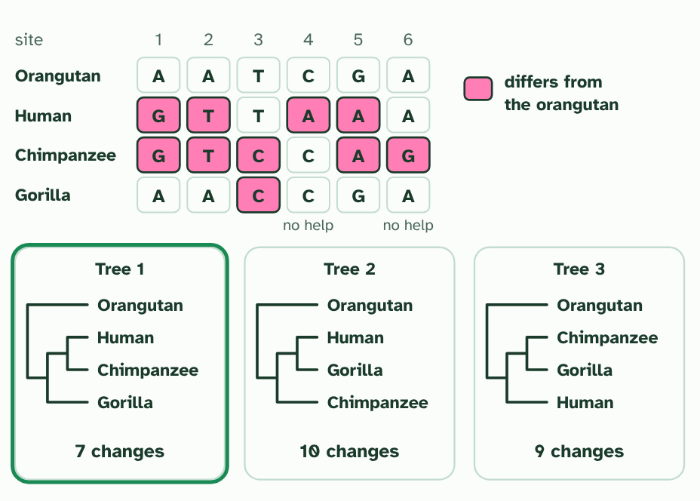  1 A made-up stretch of six sites in one gene. Pink marks where a species differs from the orangutan, the outgroup.  2 Three trees could join the human, chimpanzee and gorilla. Sites 4 and 6 differ in only one species, so they cost one change on every tree and cannot choose between them.  3 Count the changes each tree needs to explain all six sites. Tree 1 needs 7, tree 2 needs 10 and tree 3 needs 9.  4 Parsimony picks the tree that explains the data with the fewest changes: tree 1, with the human and chimpanzee as closest relatives.  ANNOTATE THE FIGURE  Number the 2 steps on the figure and note what happens at each.  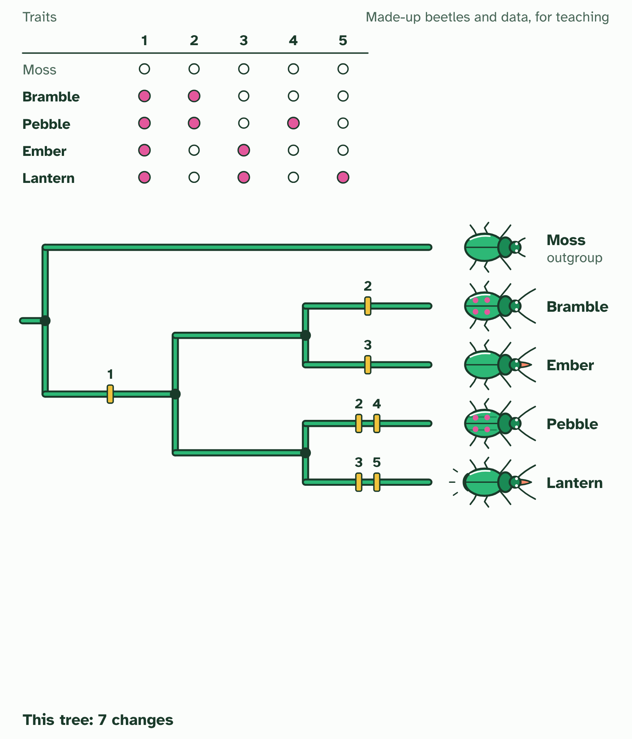  1 The table gives each beetle's traits (made up for teaching). Moss is the outgroup: its states are taken as the ancestral ones.  2 One tree, with a bar on each branch where a trait changes: 7 changes. Can you find a tree that needs fewer?  ANNOTATE THE FIGURE  Number the 2 steps on the figure and note what happens at each.  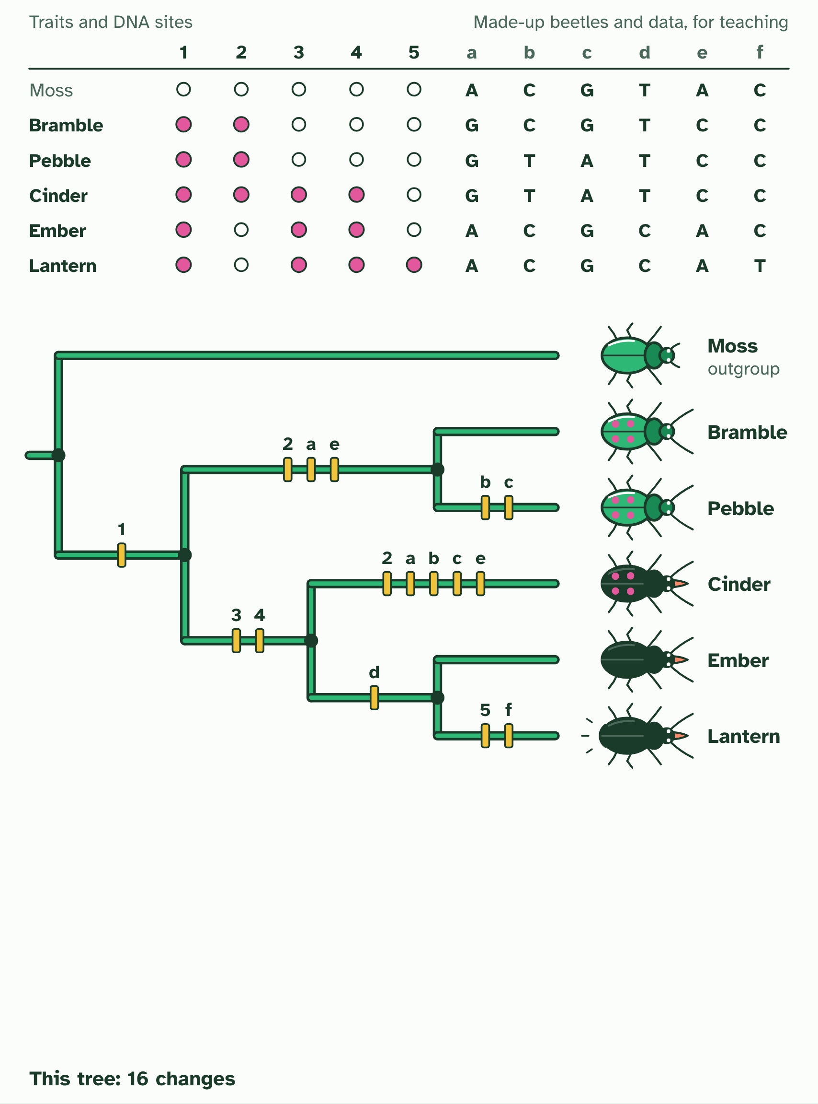  1 The table gives each beetle's traits (made up for teaching). Moss is the outgroup: its states are taken as the ancestral ones.  2 One tree, with a bar on each branch where a trait changes: 16 changes. Can you find a tree that needs fewer?
  SPOT THE MISTAKE
  What do students often get wrong about building a cladogram? Write the mistake, then put it right.
  The most parsimonious tree is the most probable, not the certain one. Two trees can tie on the count, and then more data, more positions or another gene, is needed to choose between them.
SUMMARY
Sum up section 06 in two or three sentences of your own.
• A cladogram is a hypothesis about the order of splits.
• The rule used here is parsimony: choose the tree that accounts for the sequence differences with the fewest changes.

07 Reading a cladogram | A3.2.7 HL
CUES  Predict: In a cladogram, species X and Y branch from node 1, and node 1 and species Z branch from node 2. Which statement is correct?  B: X is closer to Y than to Z, because X and Y share a more recent ancestor. X is closer to Y than to Z. X and Y share node 1, which is more recent than node 2, the ancestor they share with Z. Neither X nor Y is the ancestor of the other: node 1 is a hypothetical ancestor of both.  What is meant by root?  The base of a cladogram: the common ancestor of every group on the tree.  What is meant by node?  A branching point on a cladogram. It stands for a hypothetical common ancestor of the groups beyond it.  What is meant by terminal branch?  The line from the last node out to a tip, which is a species or group being compared.  What is meant by sister groups?  Two groups that branch from the same node, so each is the other's closest relative. | NOTES  1 The base is the root.  2 Each fork is a node, which stands for a hypothetical common ancestor: it must have existed to explain the split, but it need not be a known fossil.  3 Each line out to a tip is a terminal branch.  4 Two groups that branch from the same node are sister groups.  Your own notes  ANNOTATE THE FIGURE  Label each part and say what it does: clade, root, node, terminal branch, sister groups.  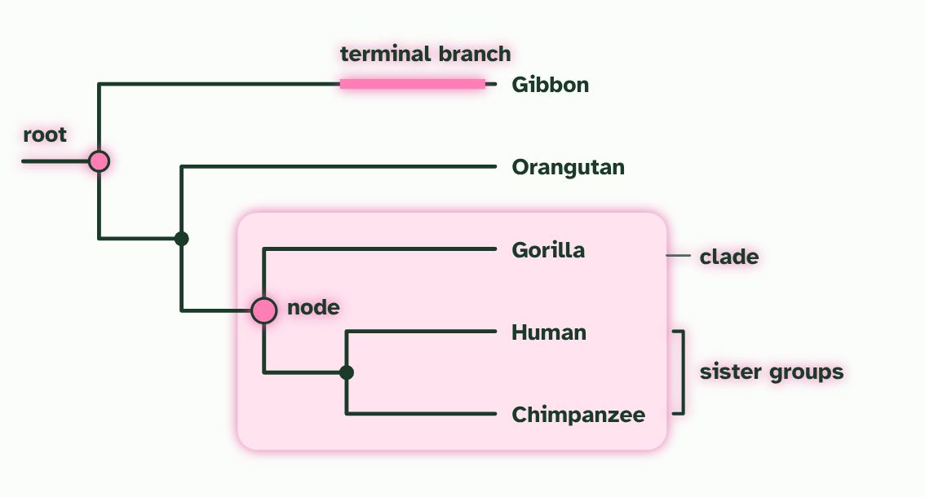  1 Clade: an ancestor (the node at the left edge of the ring) and all of its descendants. The gorilla, human and chimpanzee make one.  2 Root: the common ancestor of every organism on the tree, at its base. Everything else descends from it.  3 Node: a branching point. It stands for a hypothetical common ancestor: a species that must have existed to explain the split, though we may never find it.  4 Terminal branch: the line from the last node out to a tip. A tip is one species, or one group, being compared.  5 Sister groups: the two groups that branch from the same node, so each is the other's closest relative. Here, human and chimpanzee.  ANNOTATE THE FIGURE  Label the key parts and add a note on what it shows.  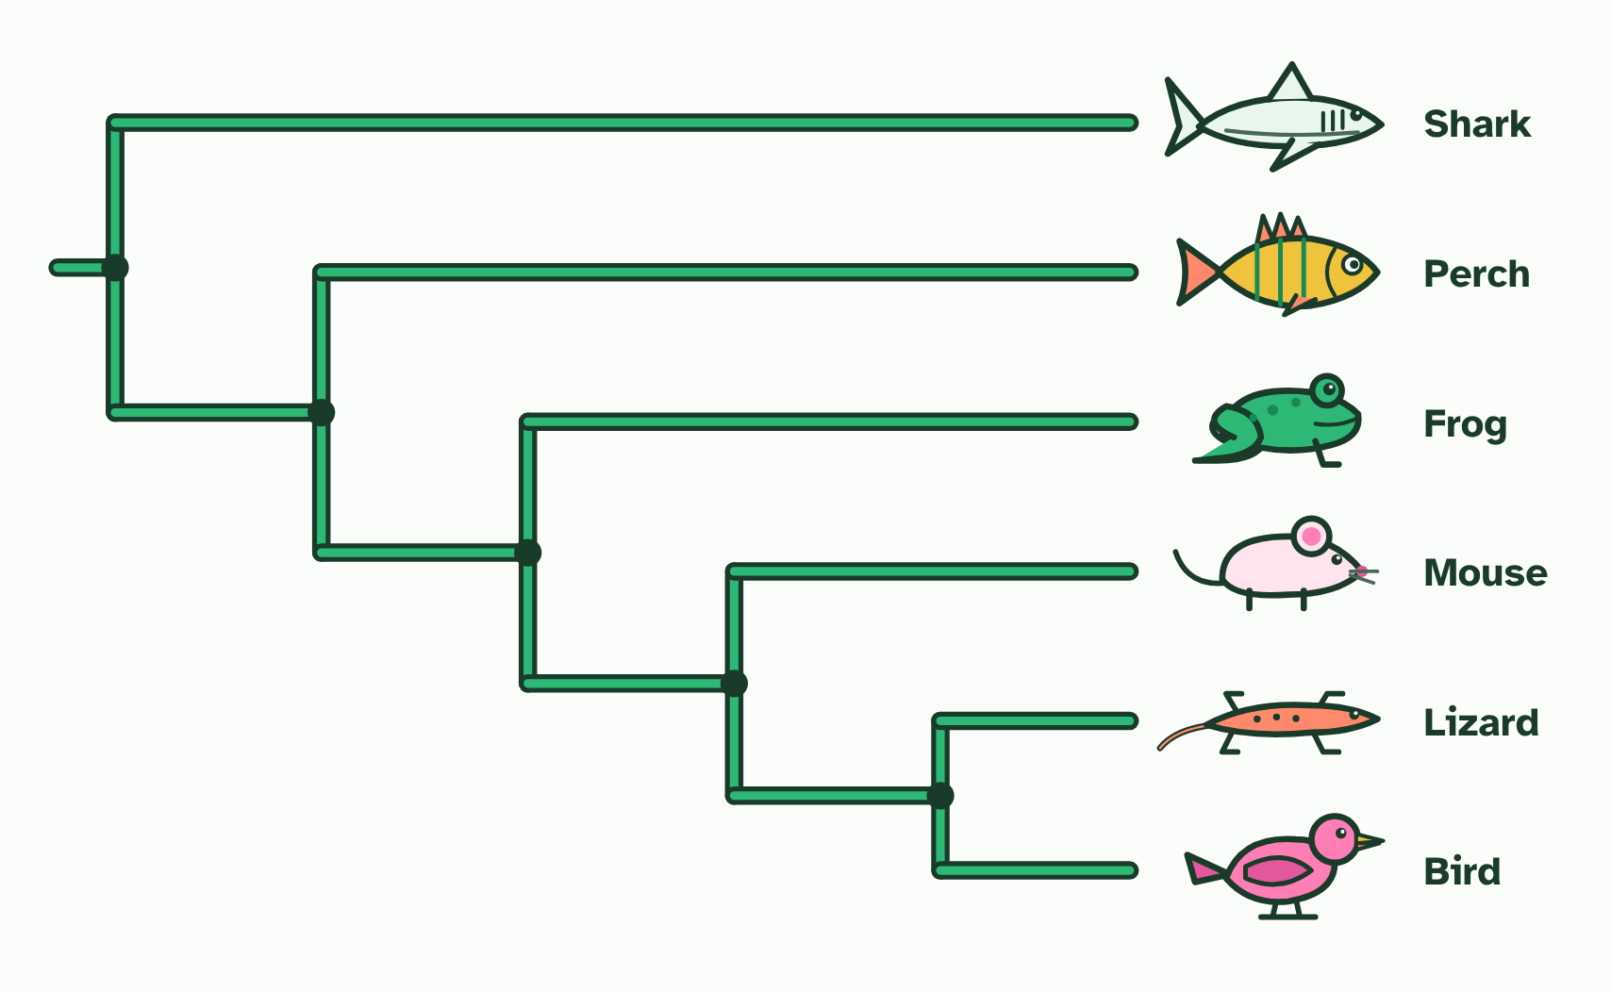  Answer questions about a cladogram: common ancestors, clades and which pairs are closest relatives.  REMEMBER IT  The parts of a cladogram
  R  Rabbits | N  Nibble | T  Tasty | C  Carrots | S  Slowly
  Root  the base: ancestor of everything | Node  a fork: a hypothetical ancestor | Terminal branch  the line out to a tip | Clade  an ancestor and all its descendants | Sister groups  two groups from one node
  SPOT THE MISTAKE
  What do students often get wrong about analysing cladograms? Write the mistake, then put it right.
  The order of the tips means nothing, because every node can be spun like a mobile. Tips at the top are not more advanced, and a tip is never the ancestor of another tip: humans did not evolve from chimpanzees, they share an ancestor. In this course, only the branching order carries meaning.
SUMMARY
Sum up section 07 in two or three sentences of your own.
• The base is the root.
• Each fork is a node, which stands for a hypothetical common ancestor: it must have existed to explain the split, but it need not be a known fossil.
• Each line out to a tip is a terminal branch.
• Two groups that branch from the same node are sister groups.

08 Testing the boxes | A3.2.8 HL
CUES  Predict: Chloroplast DNA places two plants with almost identical flowers in different clades. What is the best explanation?  C: Their flowers probably evolved separately, by convergent evolution. Their flowers probably evolved separately. Similar structures can arise in unrelated lines, so a classification built on them can be false. DNA is the more objective evidence, and where the two disagree, sequences are used to decide.  What is meant by convergent evolution?  Unrelated lines evolving similar features, often because they face similar demands, so the likeness does not come from a common ancestor.  What is meant by falsified?  Shown to be false by evidence. | NOTES  1 Plants in different lines had evolved flowers that look alike, by convergent evolution.  2 New evidence tested it and it was falsified.  3 Grouped by flower structure: six plants with similar flowers sit together as the figwort family (a simplified sketch).  4 Grouped by chloroplast DNA instead. The same plants now fall into several different clades, with other plants between them.  5 Only a small clade is still the figwort family. The flower resemblance was convergence, so the old family was not a real clade.  Your own notes  ANNOTATE THE FIGURE  Number the 3 steps on the figure and note what happens at each: 1 flower structure; 2 chloroplast DNA; 3 convergence.  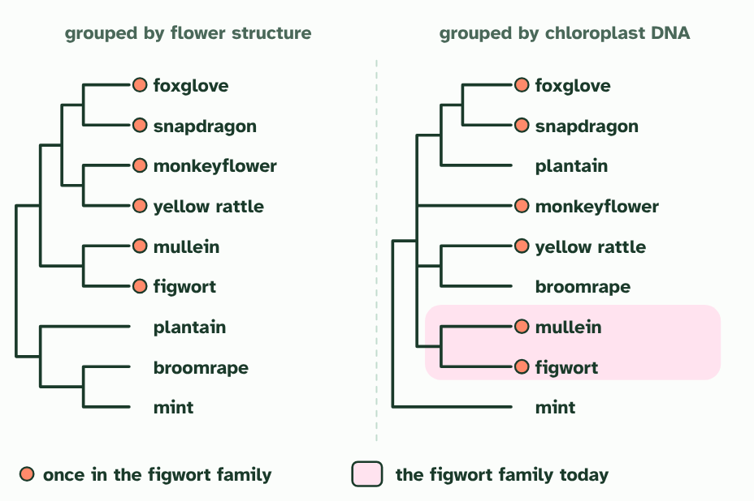  1 Grouped by flower structure: six plants with similar flowers sit together as the figwort family (a simplified sketch).  2 Grouped by chloroplast DNA instead. The same plants now fall into several different clades, with other plants between them.  3 Only a small clade is still the figwort family. The flower resemblance was convergence, so the old family was not a real clade.
SUMMARY
Sum up section 08 in two or three sentences of your own.
• Plants in different lines had evolved flowers that look alike, by convergent evolution.
• New evidence tested it and it was falsified.

09 A new level above kingdom | A3.2.9 HL
CUES  Predict: Why was rRNA a good choice for comparing all of life?  A: Every organism has ribosomes, so every organism has rRNA that can be compared. Every organism has ribosomes, and so has rRNA genes, so the same molecule can be compared across bacteria, archaea and eukaryotes. That is what allowed one tree of all life. rRNA does not code for proteins: it is part of the ribosome that makes them.  What is meant by rRNA?  The RNA that is part of ribosomes. Every organism has it, so its base sequence can be compared across all of life.  What is meant by domains?  The highest level of classification, above kingdom: Bacteria, Archaea and Eukarya. | NOTES  1 Then, in 1977, Carl Woese and George Fox compared rRNA base sequences from many organisms, and the picture changed.  2 Life falls into three great branches, now called domains: Bacteria, Archaea and Eukarya (organisms whose cells have nuclei).  3 The tree from rRNA sequences: three main branches, the domains Bacteria, Archaea and Eukarya. Relationships inside each domain are not shown.  4 Archaea look like bacteria under a microscope, but their rRNA shows they share a more recent ancestor with Eukarya.  5 A new top level of classification, above kingdom, proposed in 1977.  Your own notes  ANNOTATE THE FIGURE  Number the 3 steps on the figure and note what happens at each: 1 rRNA sequences, domains; 2 Eukarya; 3 above kingdom.  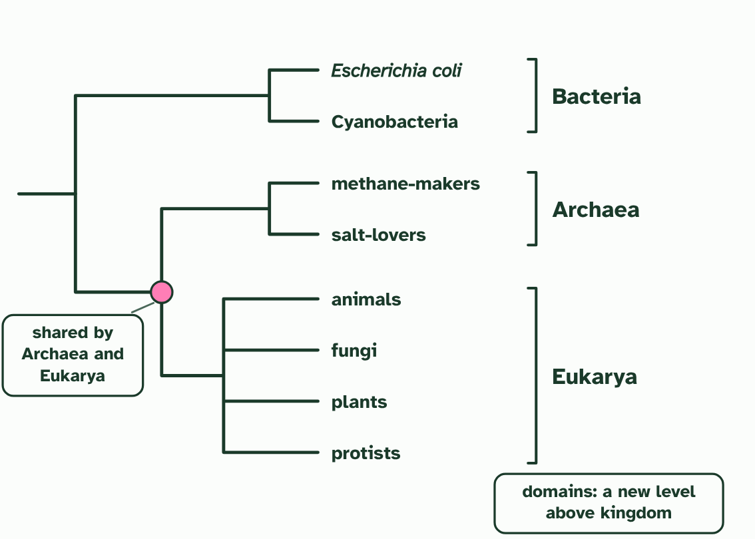  1 The tree from rRNA sequences: three main branches, the domains Bacteria, Archaea and Eukarya. Relationships inside each domain are not shown.  2 Archaea look like bacteria under a microscope, but their rRNA shows they share a more recent ancestor with Eukarya.  3 A new top level of classification, above kingdom, proposed in 1977.  ANNOTATE THE FIGURE  Annotate this still from the animation (Watch it happen: the tree of life from rRNA): what is happening, and why?  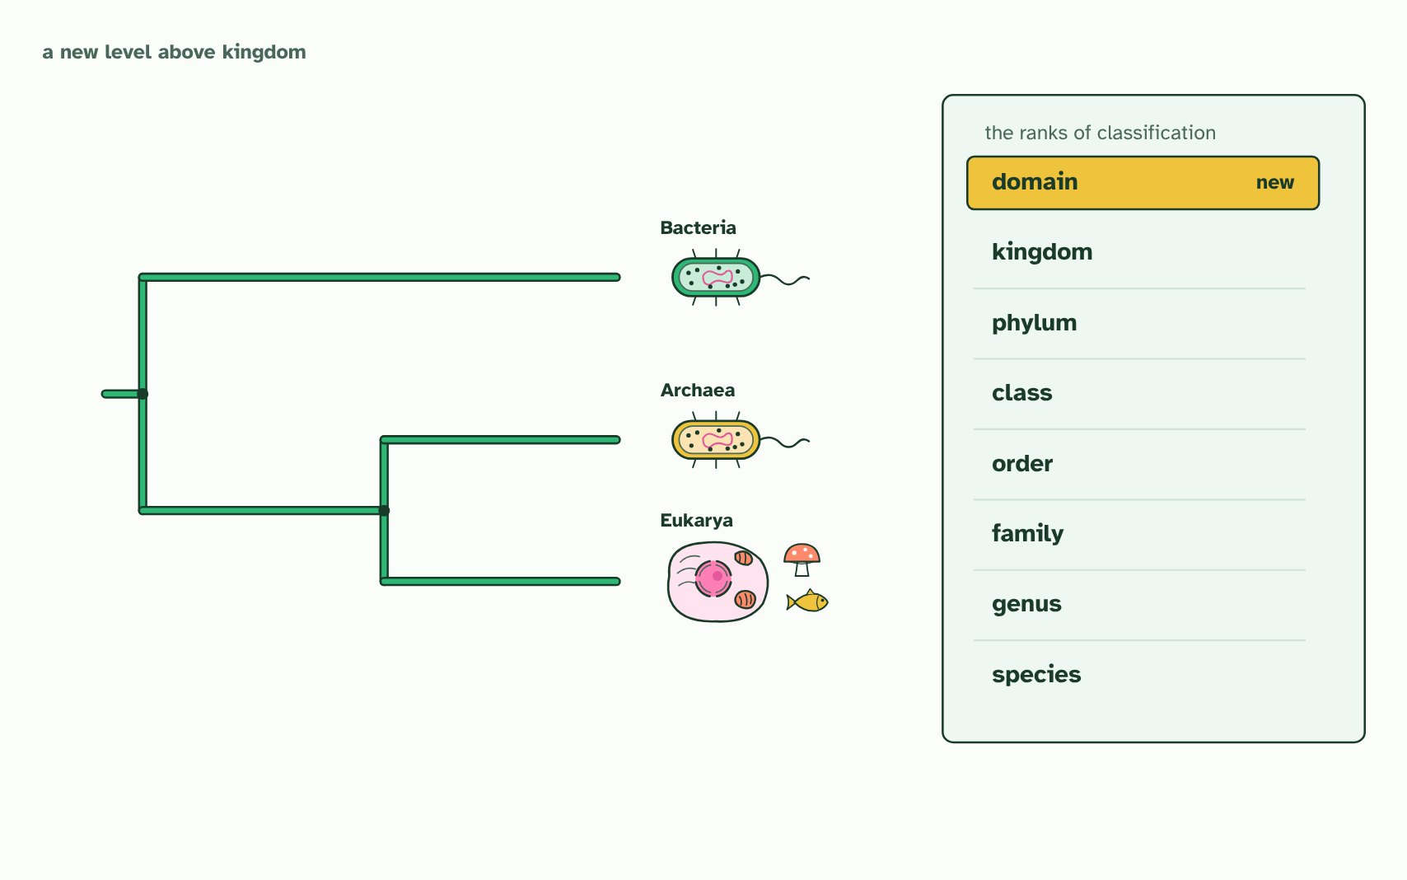  1 Before 1977, life was sorted by its cells: prokaryotes, with no nucleus, and eukaryotes, with one. All prokaryotes looked alike, so they were grouped together.  2 Carl Woese compared the base sequence of ribosomal RNA, which every cell has. Some prokaryotes, the archaea, differed from bacteria at many bases.  3 In this made-up stretch the archaeon differs from the bacterium at 9 bases but from the eukaryote at 7: not a bacterium at all, and a little nearer to us.  4 So the tree of life has three main branches, the three domains: Bacteria, Archaea and Eukarya. Archaea and eukaryotes share a more recent common ancestor.  5 So the tree of life has three main branches, the three domains: Bacteria, Archaea and Eukarya. Archaea and eukaryotes share a more recent common ancestor.  6 Woese and Fox proposed the three groups in 1977: a new level above kingdom. In 1990 they were named domains.  7 Every organism is now classed first by its domain, then kingdom, phylum, class, order, family, genus and species.
  SPOT THE MISTAKE
  What do students often get wrong about the three domains? Write the mistake, then put it right.
  "Prokaryote" does not name a clade. Bacteria and Archaea are both prokaryotes, but neither is the other's closest relative. Many archaea live in hot springs and salty lakes, but not all do: some live in the guts of animals.
SUMMARY
Sum up section 09 in two or three sentences of your own.
• Then, in 1977, Carl Woese and George Fox compared rRNA base sequences from many organisms, and the picture changed.
• Life falls into three great branches, now called domains: Bacteria, Archaea and Eukarya (organisms whose cells have nuclei).

Check yourself
The check for this guide is online: a fresh paper of past-paper style questions from the exam bank on A3.2 each time, marked as you go, and saved to your Exam practice progress when you are signed in. Open the link:
biologybybradford.com/exam-maker/sit?topics=A3.2&level=HL&paper=quiz&marks=15&src=ep

