Name | Class | Date
IB BIOLOGY · A3.2

Classification and cladistics
Notes to fill in alongside the guide. Each numbered block matches a chapter of the guide, and of the lesson slides. Write in the gaps, answer the cues, annotate the figures, and sum up each section in your own words.
BY THE END YOU CAN
Explain why classification is needed, and what it makes possible A3.2.1
Describe why the traditional hierarchy of taxa does not always match evolution, and why a fixed ranking is arbitrary A3.2.2
Explain why a classification that follows evolutionary relationships lets you predict the features of its members A3.2.3
Define a clade, and say what evidence best places organisms in one A3.2.4
Explain how the molecular clock estimates when clades diverged, and why it only gives estimates A3.2.5
Build a cladogram from sequence data using parsimony, and say why different criteria can give different trees A3.2.6
Read a cladogram: its root, nodes and terminal branches, its clades and common ancestors A3.2.7
Use the figwort family to show how cladistics tests a classification, and why a claim can be falsified A3.2.8
Explain how rRNA sequences led to the three domains, and what was new about them A3.2.9

01 Why sort life at all? | A3.2.1 HL
CUES  Predict: Which is the best reason for classifying organisms?  What is meant by classification? | NOTES  1 So we sort them. ___________________ turns the diversity of life from a heap into a map.  2 It helps you __________________ an organism: once you know which group a beetle or a fern belongs to, you know where to look it up and what it is probably like.  3 And it makes __________________ possible.  4 ___________________ is needed because there are too many species to study one at a time.  Your own notes  ANNOTATE THE FIGURE  Number the 3 steps on the figure and note what happens at each: 1 any way you like; 2 flies; 3 has a backbone.  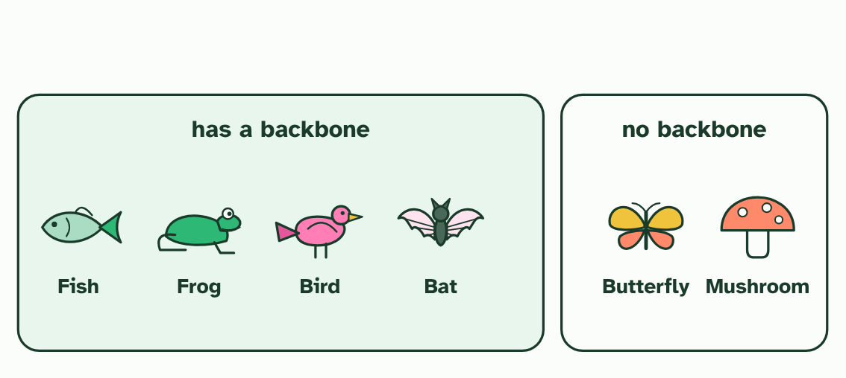
  SPOT THE MISTAKE
  What do students often get wrong about why we classify? Write the mistake, then put it right.
  The mistake
  Put it right
SUMMARY
Sum up section 01 in two or three sentences of your own.

02 When the boxes do not fit | A3.2.2 HL
CUES  Predict: A taxonomist finds that a group in the old system leaves out one species that descends from the same common ancestor as the rest. What does that show?  What is meant by hierarchy of taxa?  What is meant by taxon?  What is meant by cladistics?  What is meant by paradigm shift? | NOTES  1 Naturalists have long sorted life into a _______________________.  2 A ________ is a named group.  3 Ranks are also ____________.  4 A family of beetles and a family of mammals need not be alike in age or in how much they differ, so a rank measures nothing fixed. ______________ offers another way: unranked groups that follow the branching.  Your own notes  ANNOTATE THE FIGURE  Number the 4 steps on the figure and note what happens at each.  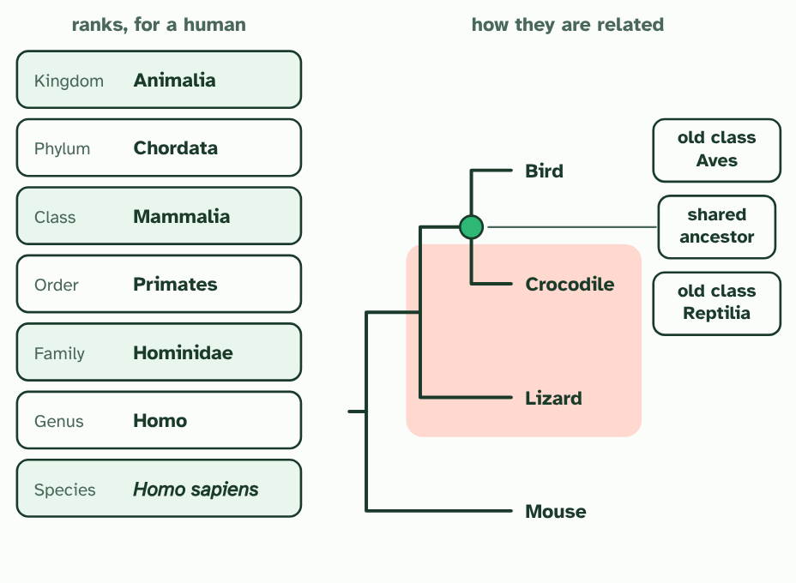  ANNOTATE THE FIGURE  Number the 4 steps on the figure and note what happens at each: 1 Normal science; 2 do not fit; 3 new idea; 4 paradigm shift.  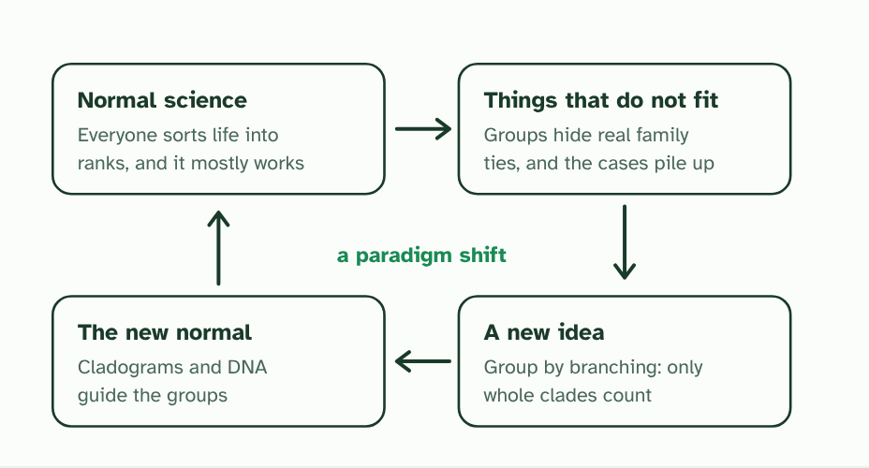  REMEMBER IT  The ranks, from the top
  K  King | P  Philip | C  Came | O  Over | F  For | G  Good | S  Soup
  K | P | C | O | F | G | S
SUMMARY
Sum up section 02 in two or three sentences of your own.

03 Groups that are family trees | A3.2.3 HL
CUES  Predict: A newly found frog falls inside a clade whose other members all make a toxin in their skin. Which statement is best?  What is meant by common ancestor? | NOTES  1 The ideal classification follows that family tree, so that every member of a group has evolved from one ____________________, and none of that ancestor's descendants are left out.  2 The ideal classification follows evolutionary relationships: all members of a group descend from one ____________________.  3 Hair and milk appeared once, on the branch leading to the _________. Every descendant of that ancestor inherits them, unless a line loses them.  4 A newly found animal. Its DNA says it is the mouse's closest relative: it ___________________ there (a made-up animal).  5 It sits inside the mammal clade, so you can _________ its features before you have studied it.  Your own notes  ANNOTATE THE FIGURE  Number the 3 steps on the figure and note what happens at each: 1 mammals; 2 joins the tree; 3 predict.  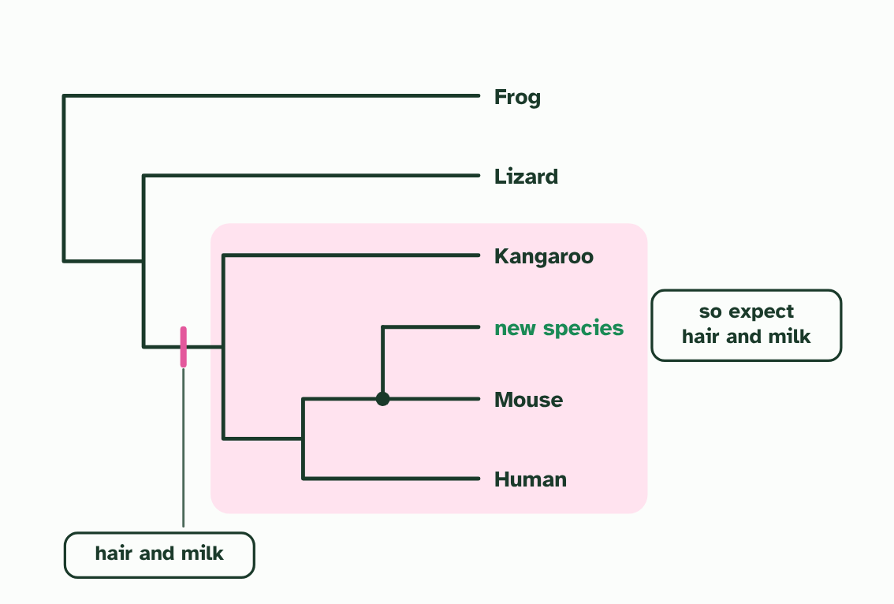
  SPOT THE MISTAKE
  What do students often get wrong about classification that follows relationships? Write the mistake, then put it right.
  The mistake
  Put it right
SUMMARY
Sum up section 03 in two or three sentences of your own.

04 A clade is an ancestor and all its descendants | A3.2.4 HL
CUES  Predict: A tree shows an ancestor X with four descendants, P, Q, R and S. Someone proposes the group P, Q and R. Is it a clade?  What is meant by clade?  What is meant by morphological? | NOTES  1 A ________ is a common ancestor together with every organism that descends from it.  2 The most ____________ evidence comes from the base sequences of genes or the amino acid sequences of proteins.  3 A sequence is a long string that can be compared position by position, and anyone counting the differences gets the same answer. __________________ traits can also place organisms in clades, but they need a judgement about which features count, and they can mislead when unrelated lines evolve similar structures.  4 Sequence evidence is the most objective, and __________________ traits can also be used.  Your own notes  ANNOTATE THE FIGURE  Label each part and say what it does: node E, the root, node D, node C, node B, node A, the old reptiles.  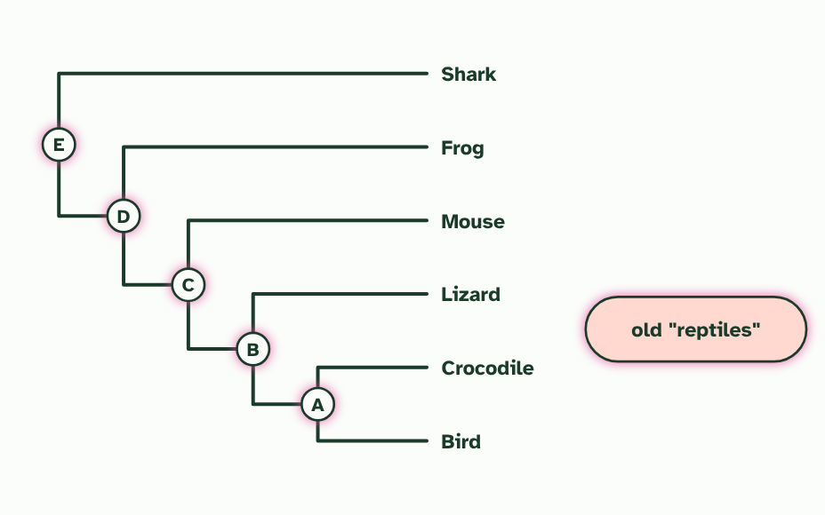
  SPOT THE MISTAKE
  What do students often get wrong about clades? Write the mistake, then put it right.
  The mistake
  Put it right
SUMMARY
Sum up section 04 in two or three sentences of your own.

05 Differences that count the years | A3.2.5 HL
CUES  Predict: A clock is calibrated on mammals that breed every few years. It is then used to date a split between two lines of insects that breed several times a year. What will the estimate probably be?  What is meant by molecular clock? | NOTES  1 A straight line through the points is the ____________________.  2 The result is an ___________, never a date.  3 Two pairs of species whose split is ________________________: 5 differences at 10 million years and 15 at 30 million (made-up numbers).  4 The differences grow steadily with time, so a straight line through the points is the ____________________.  5 A pair with ___________________ differs at 6 places. Read across to the clock, then down: about 12 million years.  6 If this pair's lines collected changes __________________, the same 6 differences would mean about 6 million years. The clock gives an estimate, not a date.  Your own notes  ANNOTATE THE FIGURE  Number the 4 steps on the figure and note what happens at each: 1 dated from fossils; 2 molecular clock; 3 no fossil date; 4 twice as fast.  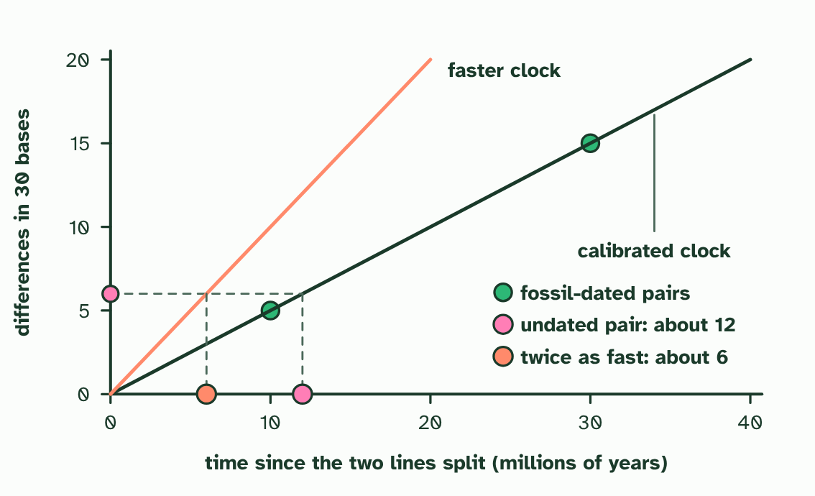  ANNOTATE THE FIGURE  Annotate this still from the animation (Watch it happen: two lines collect changes): what is happening, and why?  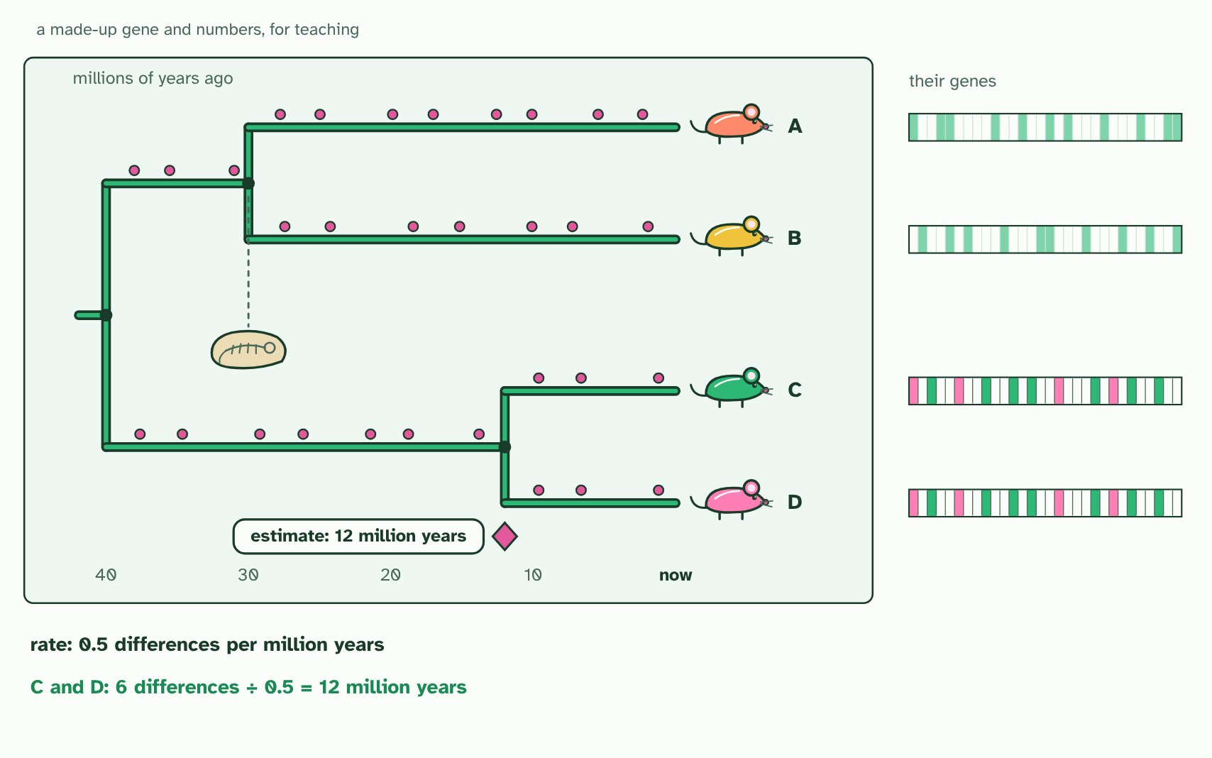  REMEMBER IT  What shifts the clock
  G  Gerbils | P  Play | S  Sports
  G | P | S
  SPOT THE MISTAKE
  What do students often get wrong about the molecular clock? Write the mistake, then put it right.
  The mistake
  Put it right
SUMMARY
Sum up section 05 in two or three sentences of your own.

06 The tree with the fewest changes | A3.2.6 HL
CUES  Predict: Three possible trees need 14, 11 and 11 changes. What does parsimony tell you?  What is meant by cladogram?  What is meant by parsimony? | NOTES  1 A ____________ is a hypothesis about the order of splits.  2 The rule used here is ____________: choose the tree that accounts for the sequence differences with the fewest changes.  3 A made-up stretch of six sites in one gene. Pink marks where a species __________________________________, the outgroup.  4 Three trees could join the human, chimpanzee and gorilla. Sites 4 and 6 differ in only _______________, so they cost one change on every tree and cannot choose between them.  5 ____________ picks the tree that explains the data with the fewest changes: tree 1, with the human and chimpanzee as closest relatives.  Your own notes  ANNOTATE THE FIGURE  Number the 4 steps on the figure and note what happens at each.  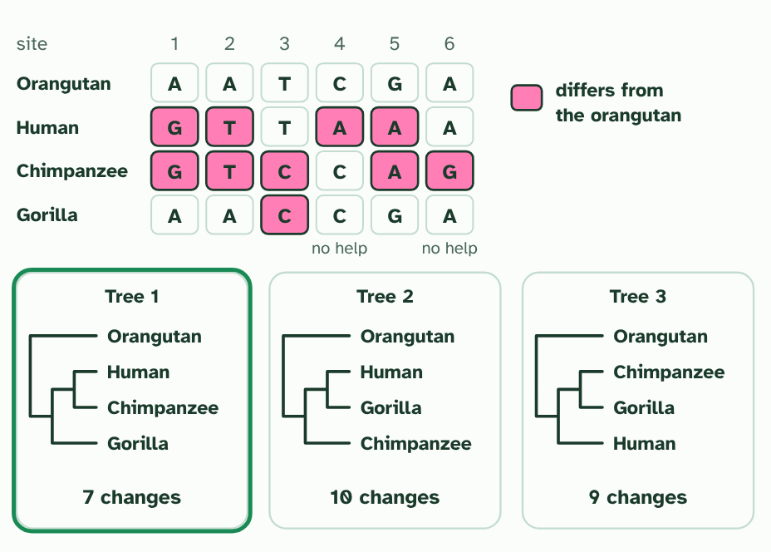  ANNOTATE THE FIGURE  Number the 2 steps on the figure and note what happens at each.  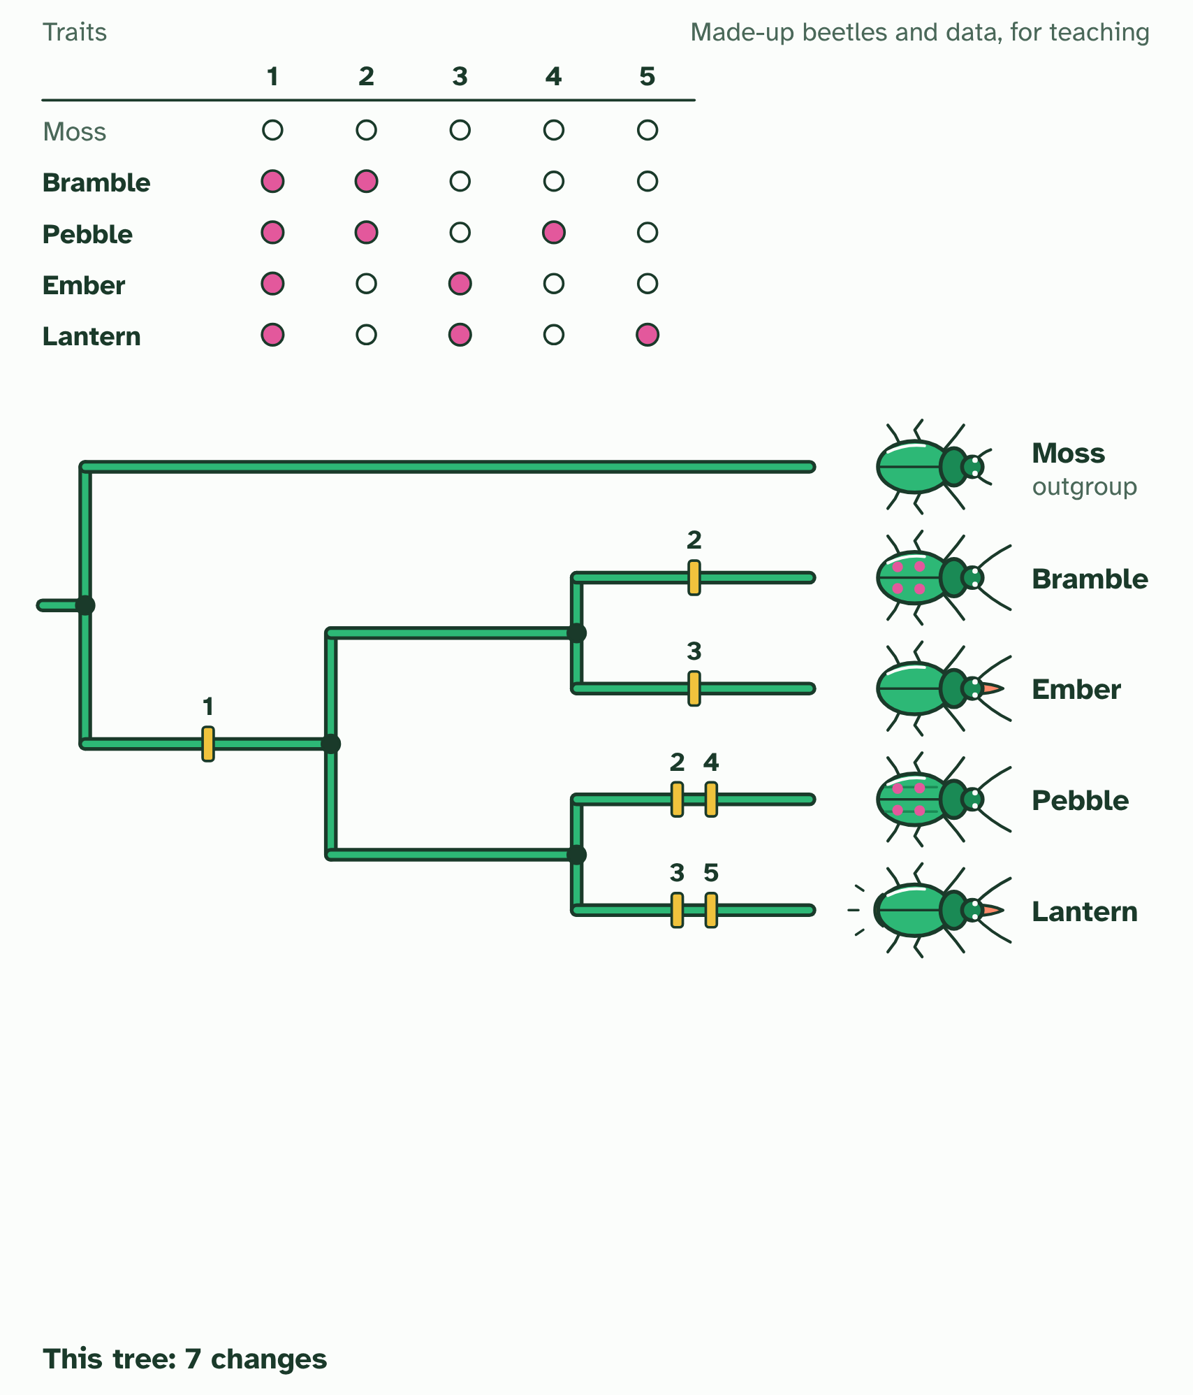  ANNOTATE THE FIGURE  Number the 2 steps on the figure and note what happens at each.  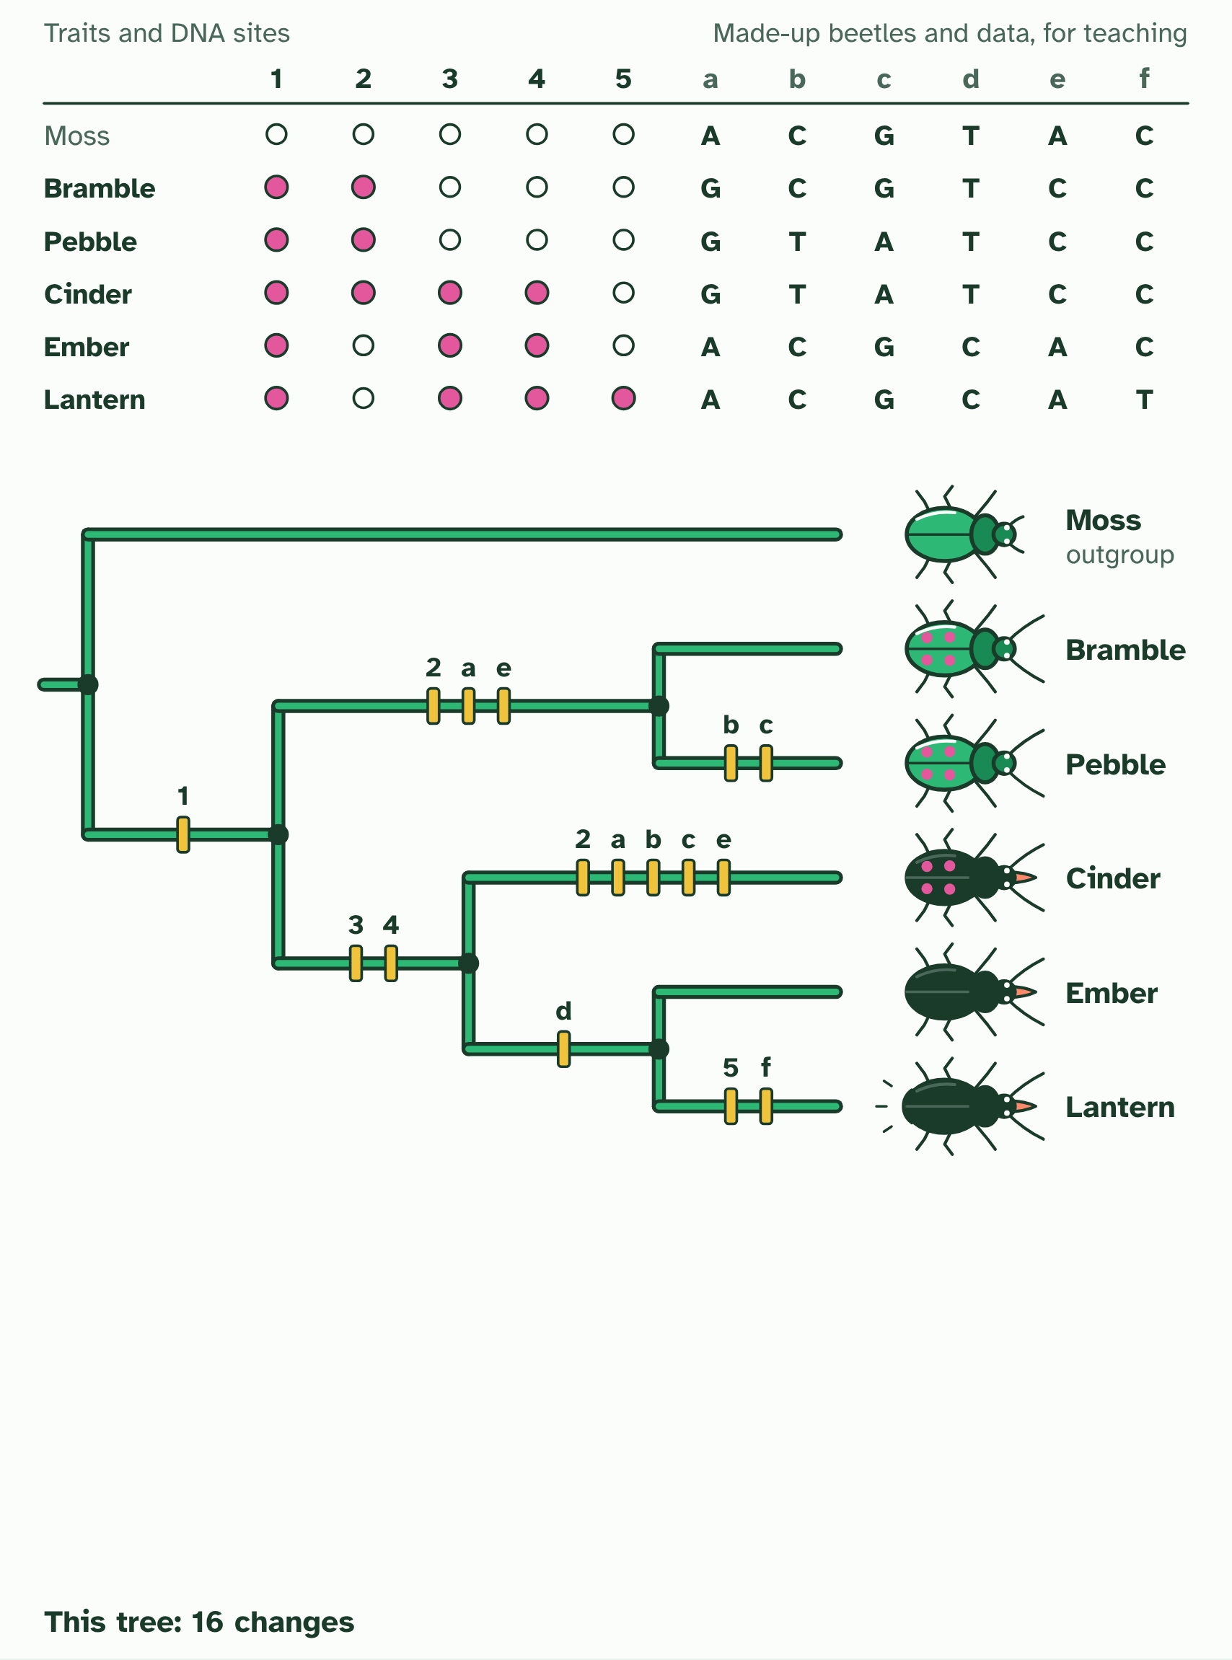
  SPOT THE MISTAKE
  What do students often get wrong about building a cladogram? Write the mistake, then put it right.
  The mistake
  Put it right
SUMMARY
Sum up section 06 in two or three sentences of your own.

07 Reading a cladogram | A3.2.7 HL
CUES  Predict: In a cladogram, species X and Y branch from node 1, and node 1 and species Z branch from node 2. Which statement is correct?  What is meant by root?  What is meant by node?  What is meant by terminal branch?  What is meant by sister groups? | NOTES  1 The base is the ________.  2 Each fork is a ________, which stands for a ________________ common ancestor: it must have existed to explain the split, but it need not be a known fossil.  3 Each line out to a tip is a ____________________.  4 Two groups that branch from the same node are __________________.  Your own notes  ANNOTATE THE FIGURE  Label each part and say what it does: clade, root, node, terminal branch, sister groups.  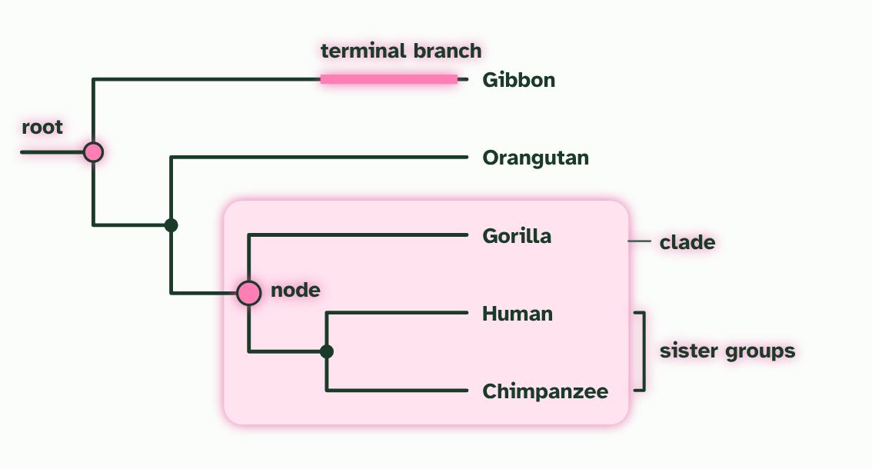  ANNOTATE THE FIGURE  Label the key parts and add a note on what it shows.  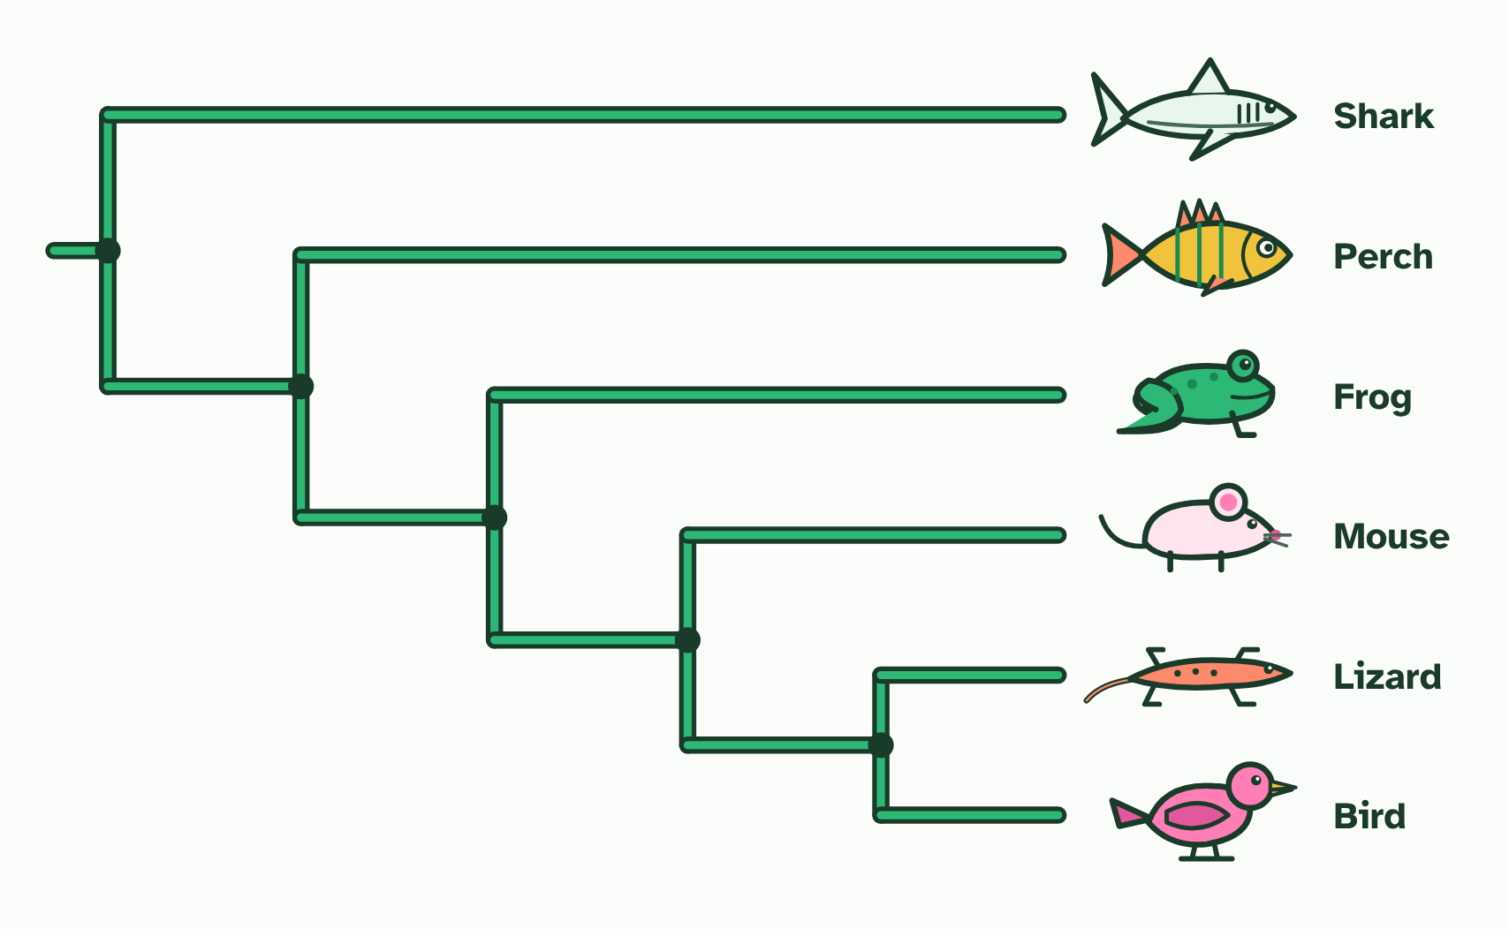  REMEMBER IT  The parts of a cladogram
  R  Rabbits | N  Nibble | T  Tasty | C  Carrots | S  Slowly
  R | N | T | C | S
  SPOT THE MISTAKE
  What do students often get wrong about analysing cladograms? Write the mistake, then put it right.
  The mistake
  Put it right
SUMMARY
Sum up section 07 in two or three sentences of your own.

08 Testing the boxes | A3.2.8 HL
CUES  Predict: Chloroplast DNA places two plants with almost identical flowers in different clades. What is the best explanation?  What is meant by convergent evolution?  What is meant by falsified? | NOTES  1 Plants in different lines had evolved flowers that look alike, by ___________________________.  2 New evidence tested it and it was ____________.  3 Grouped by ______________________: six plants with similar flowers sit together as the figwort family (a simplified sketch).  4 Grouped by ____________________ instead. The same plants now fall into several different clades, with other plants between them.  5 Only a small clade is still the figwort family. The flower resemblance was _______________, so the old family was not a real clade.  Your own notes  ANNOTATE THE FIGURE  Number the 3 steps on the figure and note what happens at each: 1 flower structure; 2 chloroplast DNA; 3 convergence.  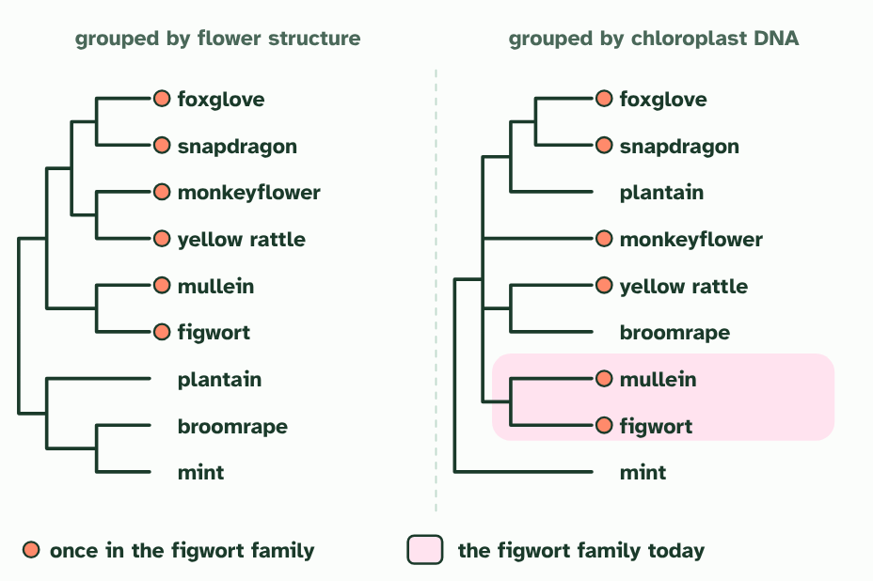
SUMMARY
Sum up section 08 in two or three sentences of your own.

09 A new level above kingdom | A3.2.9 HL
CUES  Predict: Why was rRNA a good choice for comparing all of life?  What is meant by rRNA?  What is meant by domains? | NOTES  1 Then, in 1977, Carl Woese and George Fox compared ________ base sequences from many organisms, and the picture changed.  2 Life falls into three great branches, now called _________: Bacteria, Archaea and Eukarya (organisms whose cells have nuclei).  3 The tree from ___________________: three main branches, the _________ Bacteria, Archaea and Eukarya. Relationships inside each domain are not shown.  4 Archaea look like bacteria under a microscope, but their rRNA shows they share a more recent ancestor with _________.  5 A new top level of classification, __________________, proposed in 1977.  Your own notes  ANNOTATE THE FIGURE  Number the 3 steps on the figure and note what happens at each: 1 rRNA sequences, domains; 2 Eukarya; 3 above kingdom.  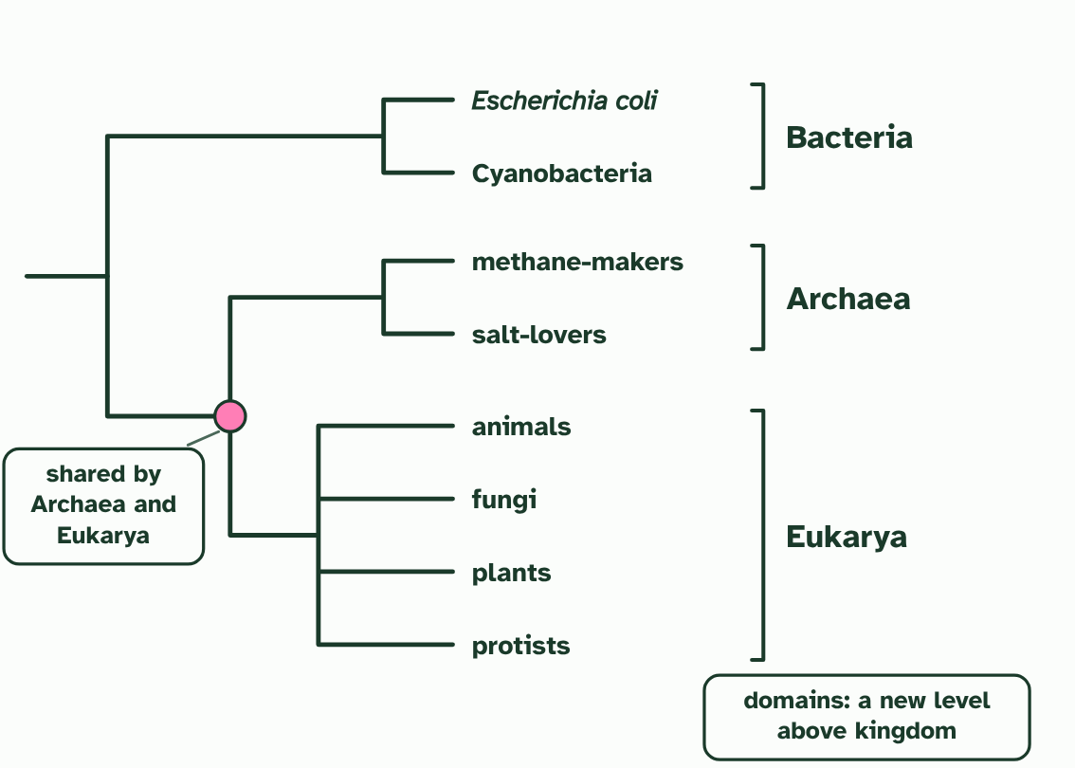  ANNOTATE THE FIGURE  Annotate this still from the animation (Watch it happen: the tree of life from rRNA): what is happening, and why?  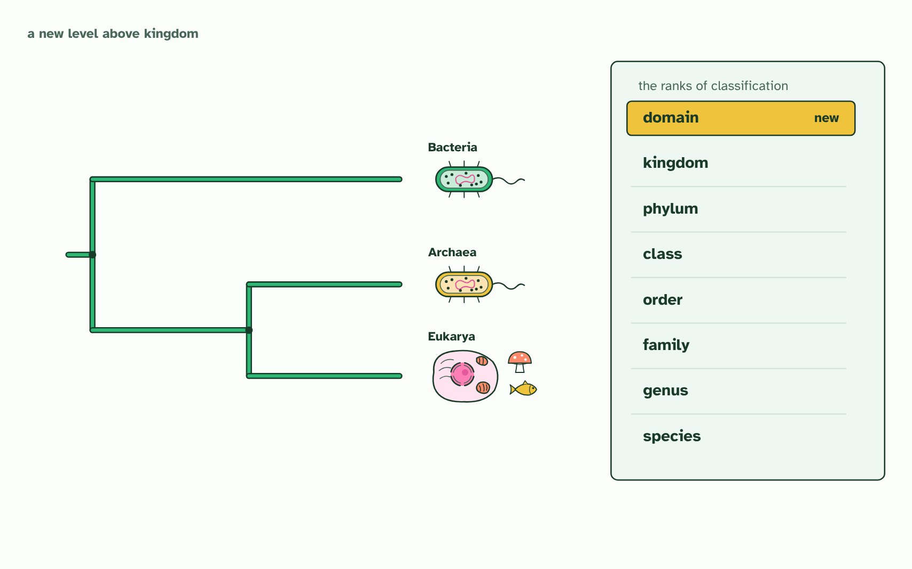
  SPOT THE MISTAKE
  What do students often get wrong about the three domains? Write the mistake, then put it right.
  The mistake
  Put it right
SUMMARY
Sum up section 09 in two or three sentences of your own.

Check yourself
The check for this guide is online: a fresh paper of past-paper style questions from the exam bank on A3.2 each time, marked as you go, and saved to your Exam practice progress when you are signed in. Open the link:
biologybybradford.com/exam-maker/sit?topics=A3.2&level=HL&paper=quiz&marks=15&src=ep

