Name | Class | Date
IB BIOLOGY · A4.1

Evolution and speciation
Teacher’s copy: every blank filled in. Each numbered block matches a chapter of the guide, and of the lesson slides. Write in the gaps, answer the cues, annotate the figures, and sum up each section in your own words.
BY THE END YOU CAN
Explain why evolution is a change in the heritable characteristics of a population, and why a change gained in one lifetime is not A4.1.1
Use differences in base and amino acid sequences to judge which species share the most recent common ancestor A4.1.2
Explain how crops and domestic animals show how quickly heritable characteristics can change A4.1.3
Name the bones of the pentadactyl limb and tell homologous structures from analogous ones made by convergent evolution A4.1.4, A4.1.5
Explain why splitting is the only way new species arise, and why gradual change in one line is not speciation A4.1.6
Explain how reproductive isolation and differential selection split bonobos from common chimpanzees A4.1.7
Compare allopatric and sympatric speciation, and explain how adaptive radiation fills vacant niches A4.1.8, A4.1.9
Explain why a mule is sterile, and how hybridisation and polyploidy make a new plant species at once A4.1.10, A4.1.11

01 Evolution is a change in what a population inherits | A4.1.1
CUES  Predict: A gardener clips a hedge into a perfect cube every year for 40 years. Seeds from the hedge are sown. What shape do the seedlings grow into?  C: The usual shape for the species: clipping never touched their alleles. The usual shape. Clipping changes the hedge's body, not the alleles in its pollen and ovules, so nothing about it reaches the seeds. Only changes to the alleles in gametes can be inherited, which is why only they count as evolution.  What is meant by heritable characteristics?  Characteristics passed from parents to offspring in their genes, as alleles.  What is meant by population?  All the organisms of one species living in one area at the same time, able to breed with each other. | NOTES  1 Evolution is not something one animal does in its lifetime. It is a change, over generations, in the heritable characteristics of a population.  2 Each dot is one finch. Beak depth varies, and the variation is heritable: chicks resemble their parents.  3 A drought leaves only big, hard seeds. Most finches with shallow beaks starve.  4 The survivors breed and pass on their alleles, deep-beak alleles included.  5 The next generation's beaks are deeper on average: the population has evolved. (Numbers simplified from the real study.)  6 A beak chipped on a hard seed is not passed on: the chick hatches with a whole beak. An acquired change is not evolution.  Your own notes  ANNOTATE THE FIGURE  Number the 5 steps on the figure and note what happens at each: 1 varies; 2 starve; 3 alleles; 4 evolved; 5 acquired.  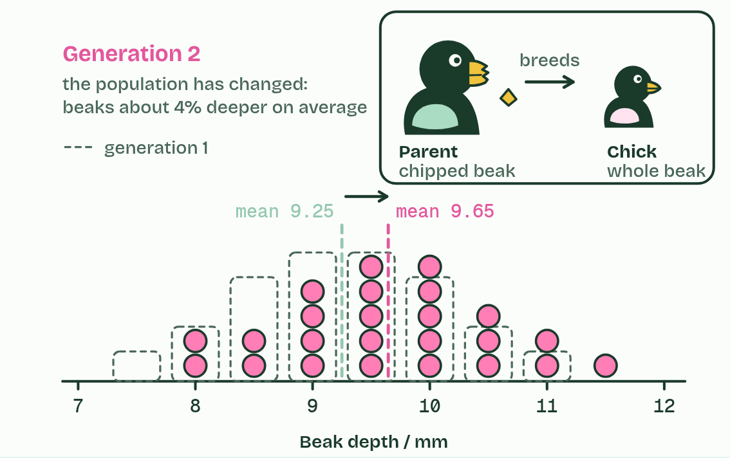  1 Each dot is one finch. Beak depth varies, and the variation is heritable: chicks resemble their parents.  2 A drought leaves only big, hard seeds. Most finches with shallow beaks starve.  3 The survivors breed and pass on their alleles, deep-beak alleles included.  4 The next generation's beaks are deeper on average: the population has evolved. (Numbers simplified from the real study.)  5 A beak chipped on a hard seed is not passed on: the chick hatches with a whole beak. An acquired change is not evolution.  ANNOTATE THE FIGURE  Annotate this still from the animation (Watch it happen: a population changes): what is happening, and why?  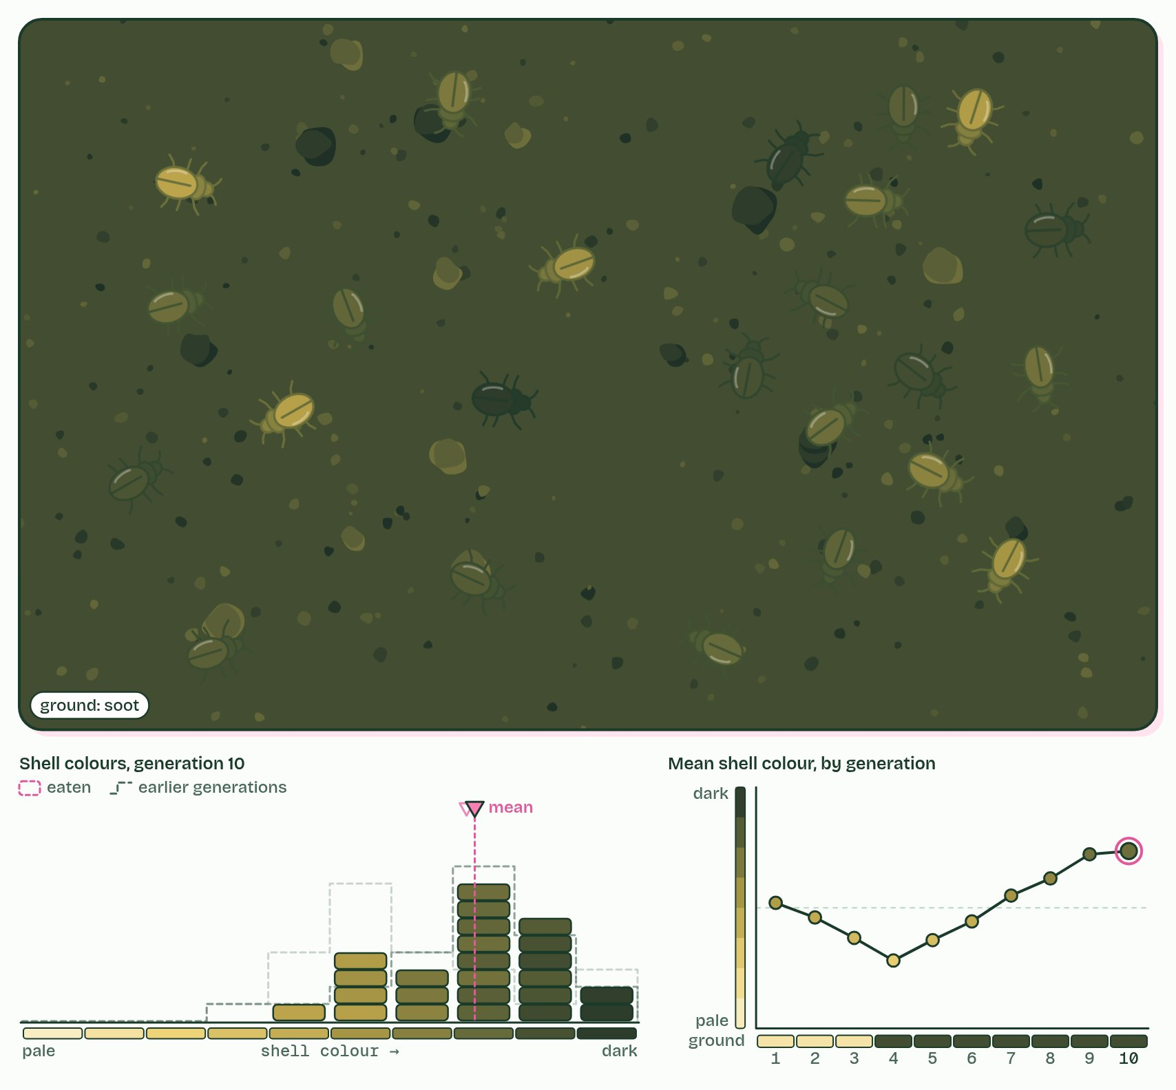  1 Birds spot the beetles that stand out. The best hidden survive and breed.  2 Then soot from a fire darkens the ground. Now the pale beetles stand out.  3 No beetle ever changed its shell. The population changed: that is evolution.
  SPOT THE MISTAKE
  What do students often get wrong about what evolution is? Write the mistake, then put it right.
  A change gained during a life is not passed on: a finch's chipped beak, a weightlifter's muscles, a giraffe stretching for leaves. None of these changes the alleles in eggs or sperm. Lamarck thought such changes were inherited; they are not, and they are not evolution.
SUMMARY
Sum up section 01 in two or three sentences of your own.
• Evolution is not something one animal does in its lifetime. It is a change, over generations, in the heritable characteristics of a population.
• Each dot is one finch. Beak depth varies, and the variation is heritable: chicks resemble their parents.
• A drought leaves only big, hard seeds. Most finches with shallow beaks starve.
• The survivors breed and pass on their alleles, deep-beak alleles included.
• The next generation's beaks are deeper on average: the population has evolved. (Numbers simplified from the real study.)

02 Sequences remember common ancestors | A4.1.2
CUES  Predict: Before you compare: which species' sequence will differ from the human one at the most positions?  D: Frog. The frog. Our line split from the chimpanzee's about 6 to 7 million years ago, from the mouse's about 90 million, from the birds' about 310 million and from the amphibians' about 350 million. The frog's line has had longest for differences to build up. | NOTES  1 Fewer differences: a more recent common ancestor.  Your own notes  ANNOTATE THE FIGURE  The figure shows it as Bases and Amino acids. Note what changes each time.  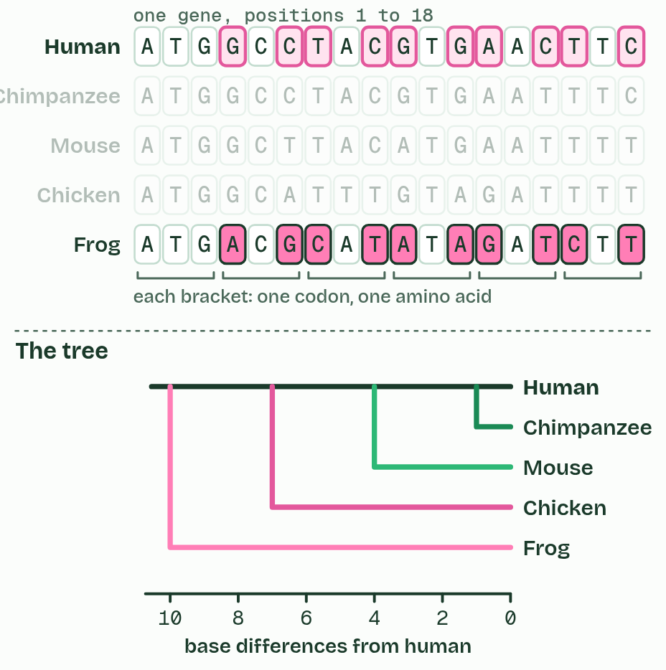  1 Bases  2 Amino acids
  SPOT THE MISTAKE
  What do students often get wrong about evidence from sequences? Write the mistake, then put it right.
  Similar sequences do not mean one living species came from the other. Humans did not evolve from chimpanzees: both evolved from an ancestor that lived about 6 to 7 million years ago, and both lines have changed since.
SUMMARY
Sum up section 02 in two or three sentences of your own.
• Fewer differences: a more recent common ancestor.
• Different genes and different proteins give largely the same branching pattern, and so does the fossil record. Independent lines of evidence agreeing is what makes this powerful.

03 Six vegetables, one wild weed | A4.1.3
CUES  Predict: Kohlrabi and Brussels sprouts look nothing alike. A grower lets them cross-pollinate. What happens?  B: Seeds form and grow into fertile plants: one species. They cross easily and the offspring are fertile, which is why seed growers keep the cultivars far apart. However different they look, they are still one species with one gene pool.  What is meant by selective breeding?  Humans choosing which plants or animals breed, so the characteristics they want become commoner in each generation. Also called artificial selection. | NOTES  1 Over the last few thousand years, farmers kept seed only from the plants they liked best. This is selective breeding.  2 Wild cabbage: leaves, buds at the tip and along the stem, and yellow flowers.  3 Selected for leaves: kale. Selected for a big terminal bud: cabbage.  4 Selected for side buds: Brussels sprouts. Selected for a swollen stem: kohlrabi.  5 Selected for flower stalks and buds: broccoli and cauliflower. All six can still interbreed: one species.  Your own notes  ANNOTATE THE FIGURE  Number the 4 steps on the figure and note what happens at each: 1 leaves; 2 leaves, terminal bud; 3 side buds, stem; 4 flower stalks and buds, one species.  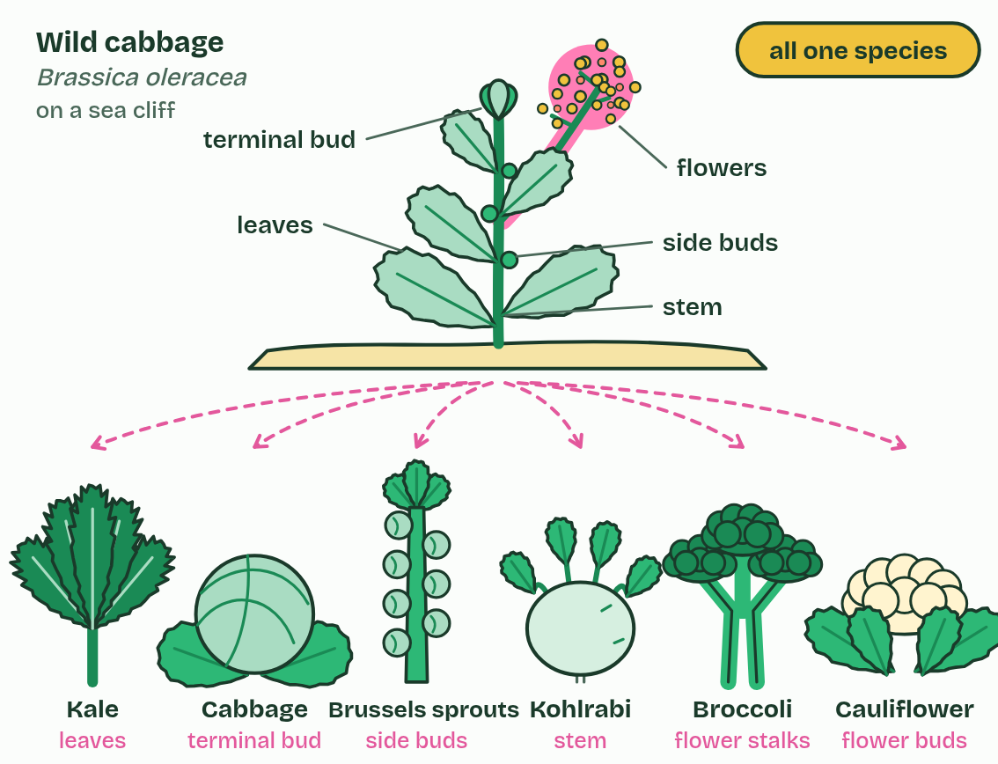  1 Wild cabbage: leaves, buds at the tip and along the stem, and yellow flowers.  2 Selected for leaves: kale. Selected for a big terminal bud: cabbage.  3 Selected for side buds: Brussels sprouts. Selected for a swollen stem: kohlrabi.  4 Selected for flower stalks and buds: broccoli and cauliflower. All six can still interbreed: one species.  REMEMBER IT  The three lines of evidence for evolution in A4.1
  D  Darwin’s | B  Big | H  Hunch
  DNA and protein sequences  fewer differences, closer relatives | Breeding  big heritable changes, fast | Homologous structures  one bone plan, many jobs
  SPOT THE MISTAKE
  What do students often get wrong about evidence from selective breeding? Write the mistake, then put it right.
  Dog breeds and cabbage cultivars look like different species but are not: a chihuahua and a Great Dane share one gene pool, which their alleles can still cross through dogs of in-between sizes. Selective breeding shows how fast heritable characteristics can change. It is not an example of new species forming.
SUMMARY
Sum up section 03 in two or three sentences of your own.
• Over the last few thousand years, farmers kept seed only from the plants they liked best. This is selective breeding.
• Wild cabbage: leaves, buds at the tip and along the stem, and yellow flowers.
• Selected for leaves: kale. Selected for a big terminal bud: cabbage.
• Selected for side buds: Brussels sprouts. Selected for a swollen stem: kohlrabi.
• Selected for flower stalks and buds: broccoli and cauliflower. All six can still interbreed: one species.

04 Same bones, different jobs, and the reverse | A4.1.4 A4.1.5
CUES  Predict: A bat's wing and a bird's wing: homologous or analogous?  C: Both: homologous as forelimbs, analogous as wings for flight. Both. As forelimbs they share the pentadactyl plan from a common ancestor: homologous. But that ancestor could not fly, so wings evolved separately in bats (skin stretched over long fingers) and birds (feathers on a shortened hand): as wings, analogous.  What is meant by pentadactyl limb?  The limb plan of amphibians, reptiles, birds and mammals: one upper bone, two lower bones, wrist or ankle bones, then up to five digits.  What is meant by homologous structures?  Structures built on one plan inherited from a common ancestor, whatever job each one now does.  What is meant by analogous structures?  Structures that do the same job but evolved separately in each line, so they were not inherited in that form from a common ancestor.  What is meant by convergent evolution?  Unrelated lines evolving similar features because they face similar demands, such as flight or swimming. | NOTES  1 Inside, they are built from the same bones in the same order: one upper arm bone, two in the forearm, a block of wrist bones, a row of palm bones, then the digits. This shared plan is the pentadactyl limb, and structures built on a plan inherited from a common ancestor are homologous structures.  2 Features with the same function but different evolutionary origins are analogous structures, and they arise by convergent evolution: unrelated lines meeting similar demands with similar solutions.  Your own notes  ANNOTATE THE FIGURE  Label each part and say what it does: humerus, radius and ulna, carpals, metacarpals, phalanges.  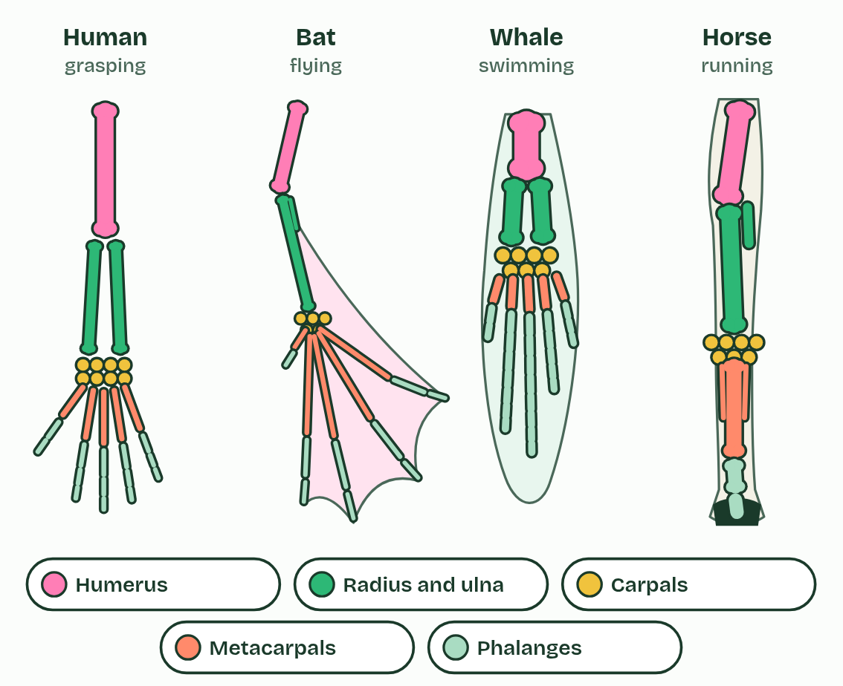  1 Humerus: One upper arm bone, in every limb. Short and thick in the whale, a strut for the wing in the bat.  2 Radius and ulna: Two forearm bones. In the horse they have fused into one strong support, with only the top of the ulna (the point of the elbow) still clear; in the bat the ulna is a thin splint.  3 Carpals: A block of small wrist bones: eight in your wrist. In the horse they make the joint people call its knee.  4 Metacarpals: The palm bones. Very long in the bat, holding the wing out. The horse stands on one, the cannon bone, with two thin splint bones beside it: what is left of two more.  5 Phalanges: The finger bones. Long and spread in the bat, extra ones in the whale, and in the horse just three in a single digit, the last inside the hoof.  REMEMBER IT  The pentadactyl limb, shoulder to fingertip
  H  Hungry | R  Rats | C  Chew | M  My | P  Pencils
  Humerus  upper arm, one bone | Radius and ulna  forearm, two bones | Carpals  wrist | Metacarpals  palm | Phalanges  fingers
  SPOT THE MISTAKE
  What do students often get wrong about homologous and analogous structures? Write the mistake, then put it right.
  Penguin, turtle and whale flippers are often given as analogous structures, but all three are forelimbs with the pentadactyl bones inside: homologous as limbs, with only the flipper shape converging. And "pentadactyl" names the plan, not a count: the horse has one digit left, on the same plan.
SUMMARY
Sum up section 04 in two or three sentences of your own.
• Inside, they are built from the same bones in the same order: one upper arm bone, two in the forearm, a block of wrist bones, a row of palm bones, then the digits. This shared plan is the pentadactyl limb, and structures built on a plan inherited from a common ancestor are homologous structures.
• Features with the same function but different evolutionary origins are analogous structures, and they arise by convergent evolution: unrelated lines meeting similar demands with similar solutions.

05 New species arise only by splitting | A4.1.6
CUES  Predict: A line of snails changes its shell shape steadily for two million years and never splits. The oldest and newest shells look so different that fossil experts give them different names. How many species has the line added to the Earth?  B: None: at every moment there was still only one species. None. At every moment there was one species of these snails, so the count never went up. The two names are a convenience for describing change along one line. Gradual change within one line is evolution, but only a split adds a species.  What is meant by species?  A group of organisms that can interbreed and produce fertile offspring. This is the biological species concept, the one used most.  What is meant by speciation?  How new species arise: one existing species splits into two or more groups that can no longer interbreed. | NOTES  1 A species, in the definition biologists use most, is a group of organisms that can interbreed and produce fertile offspring.  2 Speciation happens when that sharing stops.  3 One species: every population can interbreed with every other.  4 A barrier divides it into two populations. Gene flow stops, but for now they are still one species.  5 Each population changes separately until they cannot interbreed: two species.  6 The lower species changes gradually but never splits: still one species, so the count stays at two.  Your own notes  ANNOTATE THE FIGURE  Number the 6 steps on the figure and note what happens at each: 1 One species; 2 Gene flow stops; 3 cannot interbreed; 4 gradually; 5 splits; 6 extinction.  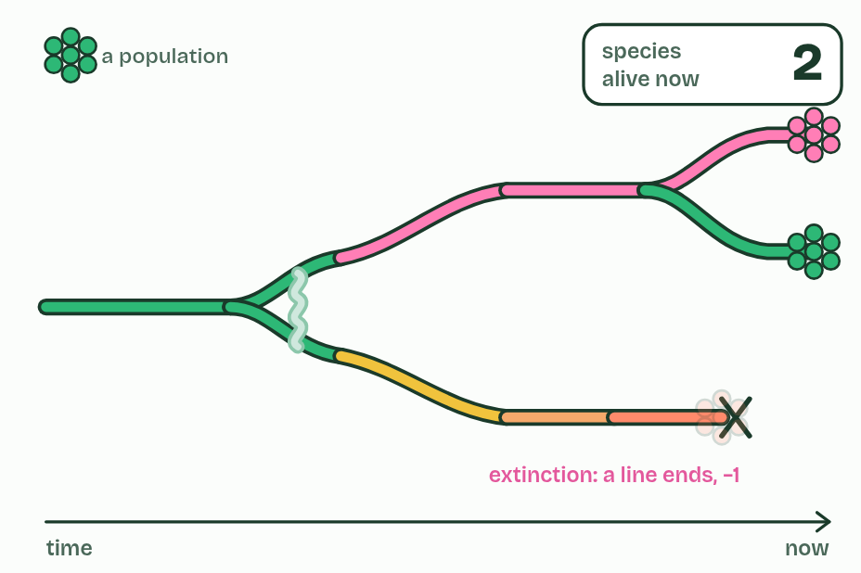  1 One species: every population can interbreed with every other.  2 A barrier divides it into two populations. Gene flow stops, but for now they are still one species.  3 Each population changes separately until they cannot interbreed: two species.  4 The lower species changes gradually but never splits: still one species, so the count stays at two.  5 The upper species splits again: three.  6 The lower species dies out: extinction takes the count back to two.  ANNOTATE THE FIGURE  Annotate this still from the animation (Watch it happen: one population becomes two): what is happening, and why?  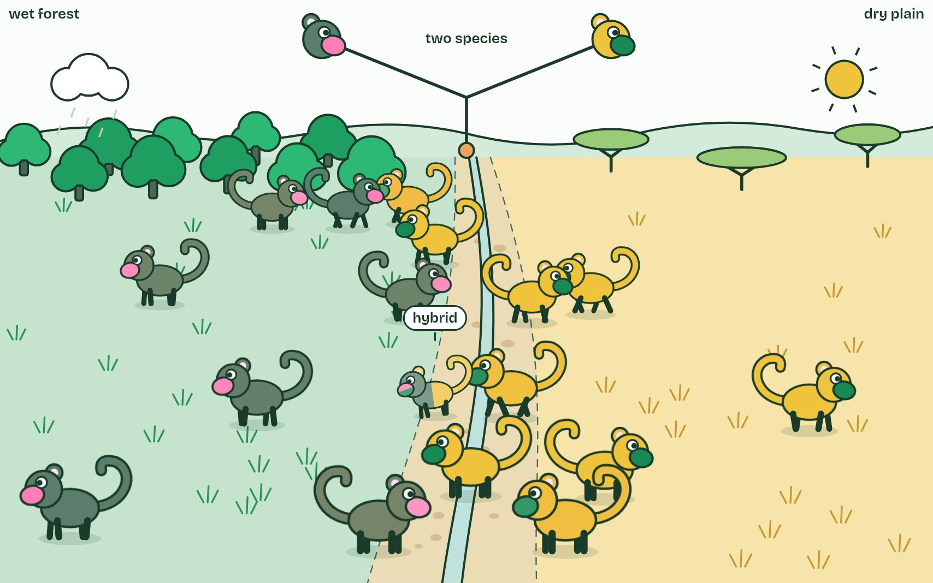  1 One population: any two can meet and mate, so genes flow across the valley.  2 Different selection each side: coats match the ground, displays drift apart.  3 Hybrids are rare, weak and often sterile, so the two never merge: two species.
  SPOT THE MISTAKE
  What do students often get wrong about speciation? Write the mistake, then put it right.
  A species that changes gradually without splitting is still one line. It has evolved, but no species has been added, so that is not speciation. Play the figure to step 4.
SUMMARY
Sum up section 05 in two or three sentences of your own.
• A species, in the definition biologists use most, is a group of organisms that can interbreed and produce fertile offspring.
• Speciation happens when that sharing stops.

06 One river, two apes | A4.1.7
CUES  Predict: Suppose the river had divided the apes but the forests on both banks were identical. What would you expect after a million years?  B: Some differences, from mutation and drift, but less divergence. Some differences. Mutations and drift still differ on each side, so the populations slowly drift apart, but with no differential selection nothing pushes them in different directions. Try it in the dry lab: the control has the same food on both islands.  What is meant by reproductive isolation?  When two populations no longer interbreed, so no alleles pass between them.  What is meant by geographical isolation?  Reproductive isolation caused by a physical barrier, or distance, that keeps populations apart.  What is meant by differential selection?  Natural selection favouring different characteristics in different populations, because their environments differ. | NOTES  1 First, reproductive isolation: the populations must stop interbreeding, so alleles no longer pass between them.  2 A sea, a mountain range or a river can do it: geographical isolation.  3 Second, differential selection: different conditions on each side favour different characteristics, so the populations diverge.  4 Long ago: one population of ancestral apes, north of the Congo River.  5 Perhaps in a dry spell, the river runs low and a few apes reach the south bank.  6 The water rises. Neither side can cross: no gene flow between the populations.  Your own notes  ANNOTATE THE FIGURE  Number the 5 steps on the figure and note what happens at each: 1 ancestral apes; 2 south bank; 3 no gene flow; 4 differential selection; 5 two species.  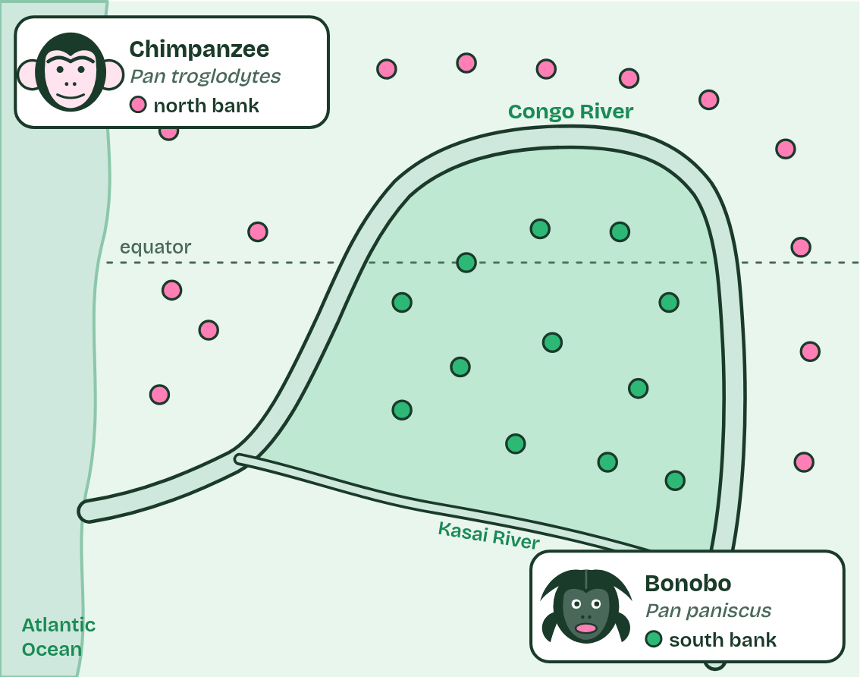  1 Long ago: one population of ancestral apes, north of the Congo River.  2 Perhaps in a dry spell, the river runs low and a few apes reach the south bank.  3 The water rises. Neither side can cross: no gene flow between the populations.  4 Different conditions on each bank: differential selection favours different behaviour and bodies.  5 Over about 1 to 2 million years they diverge into two species: chimpanzees north, bonobos south.
  SPOT THE MISTAKE
  What do students often get wrong about reproductive isolation and differential selection? Write the mistake, then put it right.
  The river did not make the apes change. It stopped gene flow. Different selection on each side, with mutation and chance, did the changing.
SUMMARY
Sum up section 06 in two or three sentences of your own.
• First, reproductive isolation: the populations must stop interbreeding, so alleles no longer pass between them.
• A sea, a mountain range or a river can do it: geographical isolation.
• Second, differential selection: different conditions on each side favour different characteristics, so the populations diverge.

07 Apart or together: two routes to a new species | A4.1.8 HL
CUES  Predict: Two populations of a cricket share one meadow. One sings and mates in spring, the other in late summer. Which kind of isolation is this, and which route to speciation?  B: Temporal isolation: sympatric speciation. Temporal isolation, and sympatric, because they live in the same place. Nothing separates them but the time of year when they breed, which is enough to stop gene flow.  What is meant by allopatric speciation?  Speciation in populations kept apart by geography: a sea, a mountain range, a river, or sheer distance.  What is meant by sympatric speciation?  Speciation within one area: the groups could meet, but stop interbreeding, for example because they breed at different times, choose different mates or, in plants, have doubled their chromosomes.  What is meant by temporal isolation?  Isolation because populations breed at different times of day or year.  What is meant by behavioural isolation?  Isolation because populations court or choose mates differently, so they do not mate with each other. | NOTES  1 In allopatric speciation ("other homeland") a geographical barrier does it: a sea, a mountain range, or a river, as for the bonobos.  2 In sympatric speciation ("same homeland") the groups live side by side, and something else keeps them from mating.  3 They may breed at different times (temporal isolation) or choose mates differently (behavioural isolation).  4 Two populations, each of one species: finches on an island, flies on hawthorn trees.  5 Left: the sea rises and splits the island. Right: apple trees arrive and some flies switch to them; no barrier.  6 Left: different seeds each side select different beaks. Right: apple flies mate earlier, on apples. Gene flow stops in both.  Your own notes  ANNOTATE THE FIGURE  Number the 4 steps on the figure and note what happens at each: 1 one species; 2 splits, switch; 3 Gene flow stops; 4 geography, timing and behaviour.  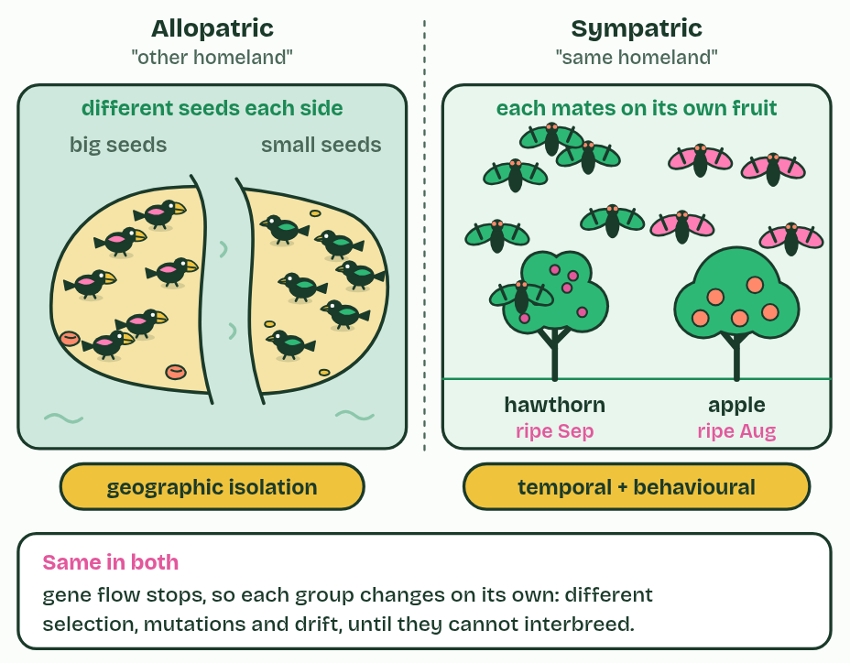  1 Two populations, each of one species: finches on an island, flies on hawthorn trees.  2 Left: the sea rises and splits the island. Right: apple trees arrive and some flies switch to them; no barrier.  3 Left: different seeds each side select different beaks. Right: apple flies mate earlier, on apples. Gene flow stops in both.  4 Both groups diverge. What stopped gene flow differs: geography, or timing and behaviour.  REMEMBER IT  Three kinds of reproductive isolation
  G  Grumpy | B  Birds | T  Tweet
  Geographic  a barrier between them | Behavioural  different courtship | Temporal  breed at different times
  SPOT THE MISTAKE
  What do students often get wrong about allopatric and sympatric speciation? Write the mistake, then put it right.
  Sympatric does not mean the groups never meet; it means they could meet and still do not mate. It is rarer than allopatric in animals, because any interbreeding mixes their alleles again. In plants it is common, by polyploidy (chapter 9).
SUMMARY
Sum up section 07 in two or three sentences of your own.
• In allopatric speciation ("other homeland") a geographical barrier does it: a sea, a mountain range, or a river, as for the bonobos.
• In sympatric speciation ("same homeland") the groups live side by side, and something else keeps them from mating.
• They may breed at different times (temporal isolation) or choose mates differently (behavioural isolation).

08 One ancestor, many niches | A4.1.9 HL
CUES  Predict: Suppose the first finches had landed on islands already full of small birds of many kinds. What would you expect?  A: Fewer finch species: most niches would already be filled. Fewer. A finch with a beak suited to insects would compete with established insect-eaters, which already do that job well, so selection would not favour it. Vacant niches are what let a radiation happen.  What is meant by adaptive radiation?  One ancestral species giving rise, fairly quickly, to many species, each suited to a different way of life (niche).  What is meant by vacant niches?  A niche is the role of a species in its ecosystem: what it eats, where and when it lives, how it interacts with others. A vacant niche is one no species is filling. | NOTES  1 When a species reaches a place with food and ways of life that nothing else is using, its descendants can split again and again, each line adapting to a different way of life. This is adaptive radiation.  2 The unused ways of life are vacant niches.  3 A seed-eating finch arrives on islands with vacant niches: foods no other small bird is using.  4 The first split: one line takes to eating insects, with a thin, pointed beak.  5 The rest split into ground finches and tree finches.  6 Each line splits again, each species with a beak suited to its food.  Your own notes  ANNOTATE THE FIGURE  Number the 5 steps on the figure and note what happens at each: 1 vacant niches; 2 insects; 3 ground finches, tree finches; 4 suited to its food; 5 little competition.  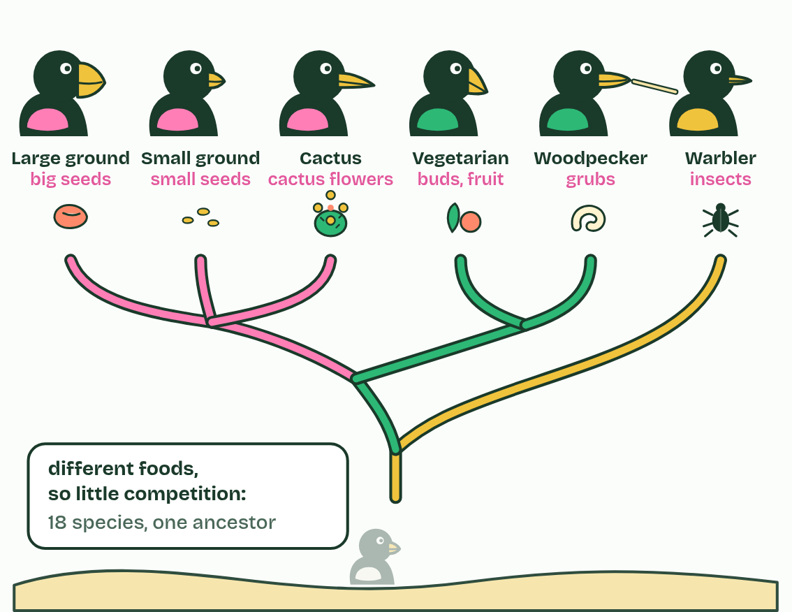  1 A seed-eating finch arrives on islands with vacant niches: foods no other small bird is using.  2 The first split: one line takes to eating insects, with a thin, pointed beak.  3 The rest split into ground finches and tree finches.  4 Each line splits again, each species with a beak suited to its food.  5 Different foods mean little competition: many related species live side by side.
  SPOT THE MISTAKE
  What do students often get wrong about adaptive radiation? Write the mistake, then put it right.
  The finches did not grow new beaks because they needed them. In each population, birds whose beaks happened to suit an unused food survived and bred better: natural selection acting on variation that was already there.
SUMMARY
Sum up section 08 in two or three sentences of your own.
• When a species reaches a place with food and ways of life that nothing else is using, its descendants can split again and again, each line adapting to a different way of life. This is adaptive radiation.
• The unused ways of life are vacant niches.

09 The mule's dead end, the plant's way out | A4.1.10 HL A4.1.11 HL
CUES  Predict: Redshank (2n = 44) is crossed with one of its parents, pale persicaria (2n = 22). How many chromosomes do the offspring have, and are they fertile?  B: 33: three sets that cannot pair evenly, so sterile. 33. A redshank gamete carries 22 and a pale persicaria gamete 11. The offspring have three sets of 11, and an odd number of sets cannot pair evenly at meiosis, so they are sterile. That is why the new polyploid is reproductively isolated from its parents straight away.  What is meant by hybridisation?  Mating between two different species, producing a hybrid.  What is meant by polyploid?  Having more than two complete sets of chromosomes.  What is meant by abrupt speciation?  A new species formed in one or a few generations, as when a hybrid plant doubles its chromosomes, rather than by gradual divergence. | NOTES  1 Before, courtship usually prevents hybridisation: many animals choose mates by songs, dances, colours or scents that belong to their own species, and ignore the rest.  2 But if its chromosome number doubles, every chromosome gains an identical partner, meiosis works, and the plant is fertile. It is a polyploid, and it cannot breed successfully with either parent: a new species in a generation or two.  3 This is abrupt speciation.  4 A horse gamete (32 chromosomes) and a donkey gamete (31) make a mule with 63. A few of each set are drawn.  5 At meiosis, matching chromosomes pair up, but horse and donkey sets differ in number and arrangement: some cannot pair.  6 So the gametes get unbalanced sets and do not work: the mule is sterile.  Your own notes  ANNOTATE THE FIGURE  Number the 6 steps on the figure and note what happens at each: 1 mule; 2 number and arrangement; 3 unbalanced; 4 sterile; 5 doubles; 6 polyploid.  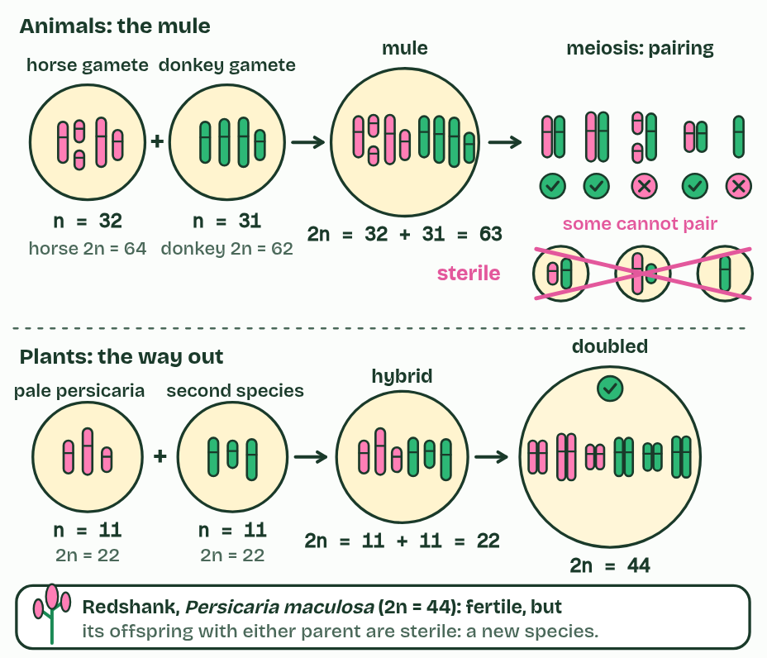  1 A horse gamete (32 chromosomes) and a donkey gamete (31) make a mule with 63. A few of each set are drawn.  2 At meiosis, matching chromosomes pair up, but horse and donkey sets differ in number and arrangement: some cannot pair.  3 So the gametes get unbalanced sets and do not work: the mule is sterile.  4 Two smartweed species make a hybrid with 11 + 11 = 22. No chromosome has a matching partner: sterile, like the mule.  5 The chromosome number doubles to 44: every chromosome now has an identical partner, so meiosis works.  6 A fertile polyploid whose offspring with either parent are sterile: a new species, made in a generation or two.
  SPOT THE MISTAKE
  What do students often get wrong about hybrids and polyploidy? Write the mistake, then put it right.
  The hybrid's number is the sum of the gametes, not of the parents: 32 + 31 = 63 for the mule, 11 + 11 = 22 for the smartweed hybrid. Doubling then gives 44. Japanese knotweed, the invasive garden weed, is a polyploid too, but it belongs to a different genus (Reynoutria, also called Fallopia); name a Persicaria for this example.
SUMMARY
Sum up section 09 in two or three sentences of your own.
• Before, courtship usually prevents hybridisation: many animals choose mates by songs, dances, colours or scents that belong to their own species, and ignore the rest.
• But if its chromosome number doubles, every chromosome gains an identical partner, meiosis works, and the plant is fertile. It is a polyploid, and it cannot breed successfully with either parent: a new species in a generation or two.
• This is abrupt speciation.

Check yourself
The check for this guide is online: a fresh paper of past-paper style questions from the exam bank on A4.1 each time, marked as you go, and saved to your Exam practice progress when you are signed in. Open the link:
biologybybradford.com/exam-maker/sit?topics=A4.1&level=HL&paper=quiz&marks=15&src=ep

