Name | Class | Date
IB BIOLOGY · A4.1

Evolution and speciation
Notes to fill in alongside the guide. Each numbered block matches a chapter of the guide, and of the lesson slides. Write in the gaps, answer the cues, annotate the figures, and sum up each section in your own words.
BY THE END YOU CAN
Explain why evolution is a change in the heritable characteristics of a population, and why a change gained in one lifetime is not A4.1.1
Use differences in base and amino acid sequences to judge which species share the most recent common ancestor A4.1.2
Explain how crops and domestic animals show how quickly heritable characteristics can change A4.1.3
Name the bones of the pentadactyl limb and tell homologous structures from analogous ones made by convergent evolution A4.1.4, A4.1.5
Explain why splitting is the only way new species arise, and why gradual change in one line is not speciation A4.1.6
Explain how reproductive isolation and differential selection split bonobos from common chimpanzees A4.1.7
Compare allopatric and sympatric speciation, and explain how adaptive radiation fills vacant niches A4.1.8, A4.1.9
Explain why a mule is sterile, and how hybridisation and polyploidy make a new plant species at once A4.1.10, A4.1.11

01 Evolution is a change in what a population inherits | A4.1.1
CUES  Predict: A gardener clips a hedge into a perfect cube every year for 40 years. Seeds from the hedge are sown. What shape do the seedlings grow into?  What is meant by heritable characteristics?  What is meant by population? | NOTES  1 Evolution is not something one animal does in its lifetime. It is a change, over generations, in the __________________________________ of a ______________.  2 Each dot is one finch. Beak depth ________, and the variation is heritable: chicks resemble their parents.  3 A drought leaves only big, hard seeds. Most finches with shallow beaks ________.  4 The survivors breed and pass on their _________, deep-beak alleles included.  5 The next generation's beaks are deeper on average: the population has _________. (Numbers simplified from the real study.)  6 A beak chipped on a hard seed is not passed on: the chick hatches with a whole beak. An ___________ change is not evolution.  Your own notes  ANNOTATE THE FIGURE  Number the 5 steps on the figure and note what happens at each: 1 varies; 2 starve; 3 alleles; 4 evolved; 5 acquired.  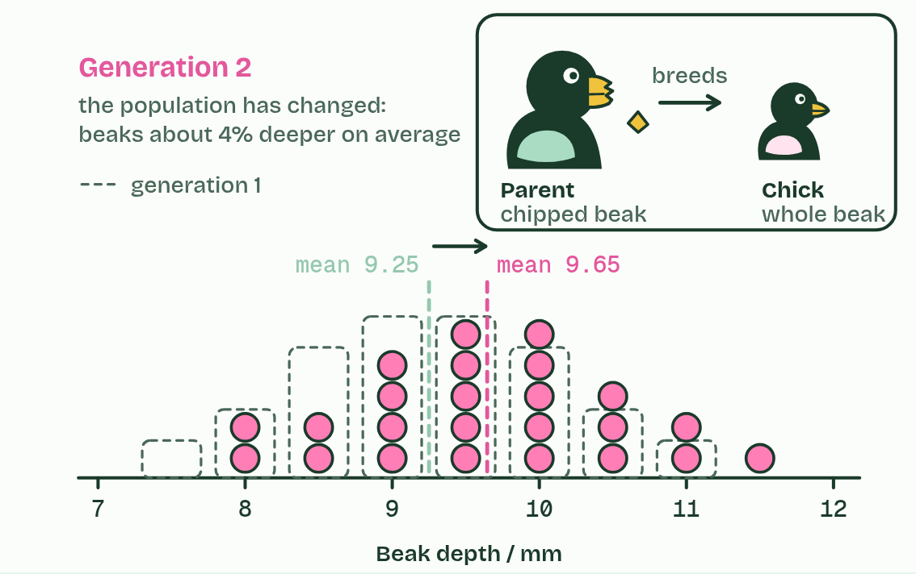  ANNOTATE THE FIGURE  Annotate this still from the animation (Watch it happen: a population changes): what is happening, and why?  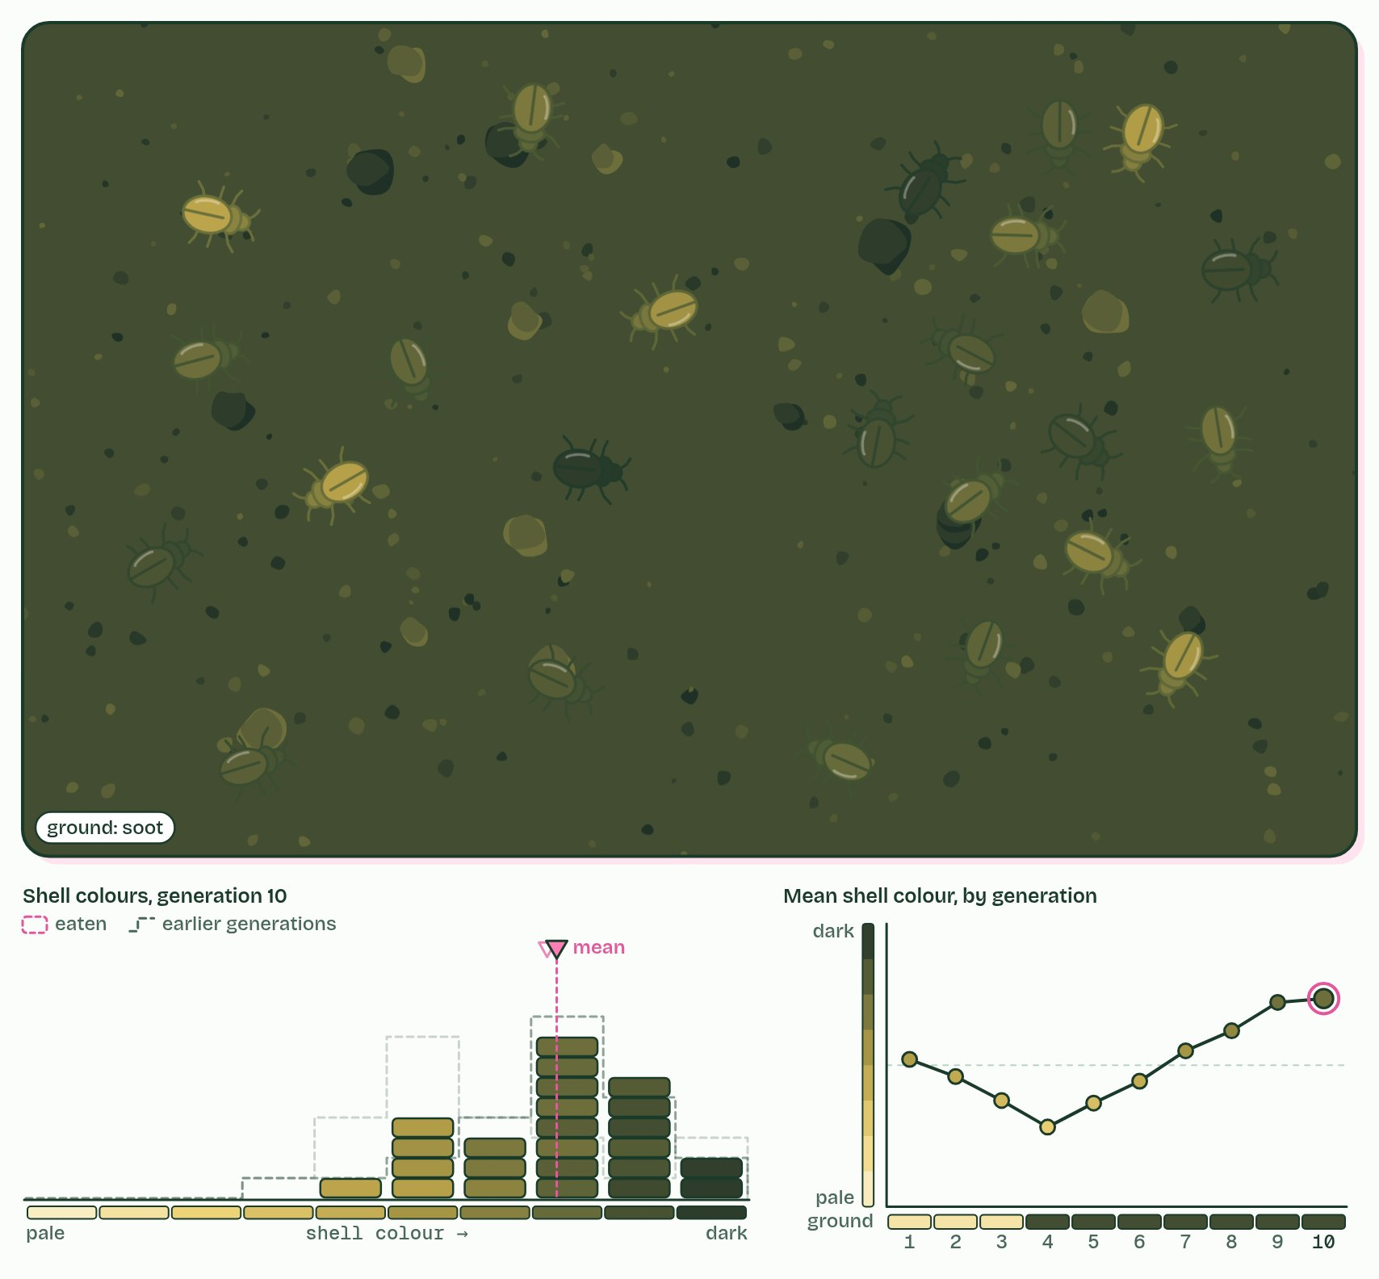
  SPOT THE MISTAKE
  What do students often get wrong about what evolution is? Write the mistake, then put it right.
  The mistake
  Put it right
SUMMARY
Sum up section 01 in two or three sentences of your own.

02 Sequences remember common ancestors | A4.1.2
CUES  Predict: Before you compare: which species' sequence will differ from the human one at the most positions? | NOTES  1 Fewer differences: __________________________________.  Your own notes  ANNOTATE THE FIGURE  The figure shows it as Bases and Amino acids. Note what changes each time.  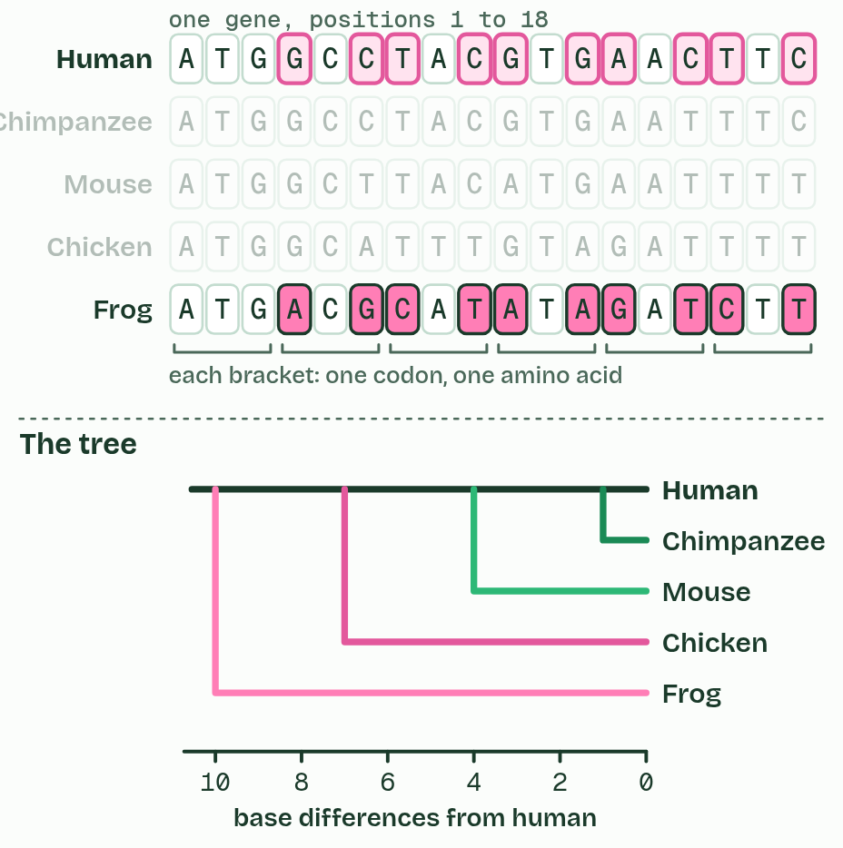
  SPOT THE MISTAKE
  What do students often get wrong about evidence from sequences? Write the mistake, then put it right.
  The mistake
  Put it right
SUMMARY
Sum up section 02 in two or three sentences of your own.

03 Six vegetables, one wild weed | A4.1.3
CUES  Predict: Kohlrabi and Brussels sprouts look nothing alike. A grower lets them cross-pollinate. What happens?  What is meant by selective breeding? | NOTES  1 Over the last few thousand years, farmers kept seed only from the plants they liked best. This is ________________________.  2 Wild cabbage: ________, buds at the tip and along the stem, and yellow flowers.  3 Selected for ________: kale. Selected for a big ________________: cabbage.  4 Selected for ____________: Brussels sprouts. Selected for a swollen ________: kohlrabi.  5 Selected for ______________________________: broccoli and cauliflower. All six can still interbreed: _______________.  Your own notes  ANNOTATE THE FIGURE  Number the 4 steps on the figure and note what happens at each: 1 leaves; 2 leaves, terminal bud; 3 side buds, stem; 4 flower stalks and buds, one species.  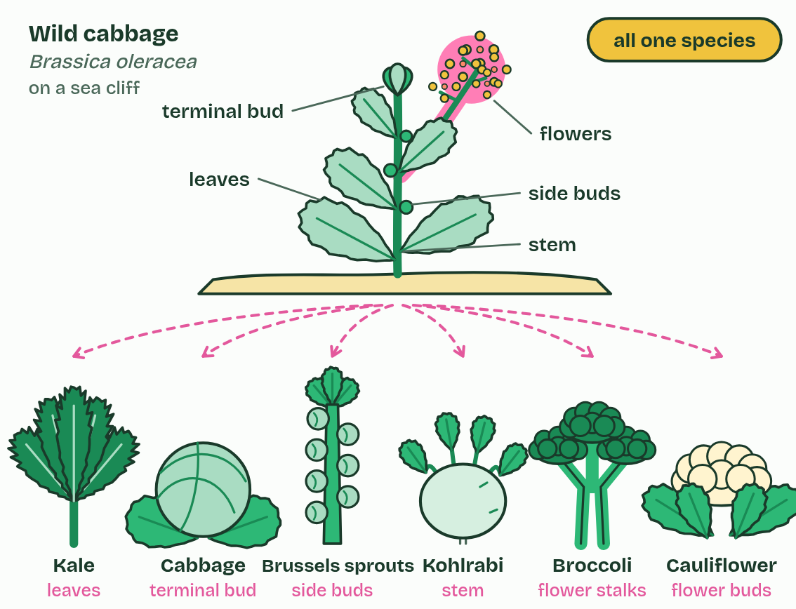  REMEMBER IT  The three lines of evidence for evolution in A4.1
  D  Darwin’s | B  Big | H  Hunch
  D | B | H
  SPOT THE MISTAKE
  What do students often get wrong about evidence from selective breeding? Write the mistake, then put it right.
  The mistake
  Put it right
SUMMARY
Sum up section 03 in two or three sentences of your own.

04 Same bones, different jobs, and the reverse | A4.1.4 A4.1.5
CUES  Predict: A bat's wing and a bird's wing: homologous or analogous?  What is meant by pentadactyl limb?  What is meant by homologous structures?  What is meant by analogous structures?  What is meant by convergent evolution? | NOTES  1 Inside, they are built from the same bones in the same order: one upper arm bone, two in the forearm, a block of wrist bones, a row of palm bones, then the digits. This shared plan is the ______________________, and structures built on a plan inherited from a common ancestor are ____________________________.  2 Features with the same function but different evolutionary origins are ___________________________, and they arise by ___________________________: unrelated lines meeting similar demands with similar solutions.  Your own notes  ANNOTATE THE FIGURE  Label each part and say what it does: humerus, radius and ulna, carpals, metacarpals, phalanges.  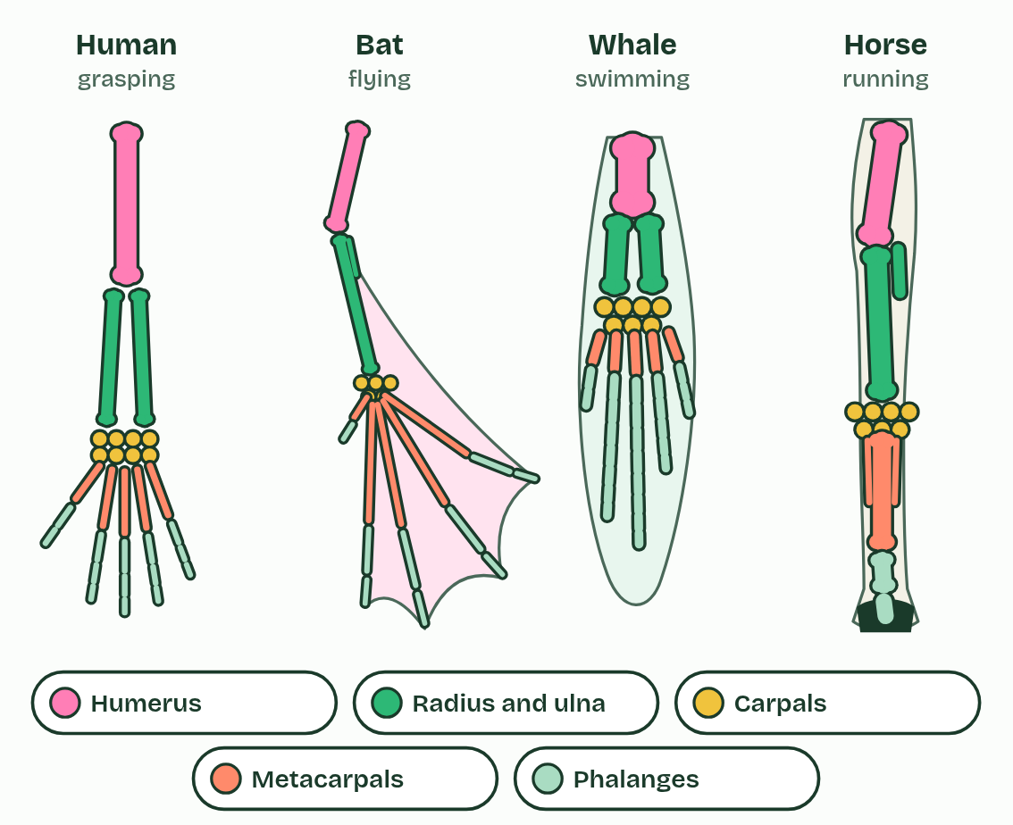  REMEMBER IT  The pentadactyl limb, shoulder to fingertip
  H  Hungry | R  Rats | C  Chew | M  My | P  Pencils
  H | R | C | M | P
  SPOT THE MISTAKE
  What do students often get wrong about homologous and analogous structures? Write the mistake, then put it right.
  The mistake
  Put it right
SUMMARY
Sum up section 04 in two or three sentences of your own.

05 New species arise only by splitting | A4.1.6
CUES  Predict: A line of snails changes its shell shape steadily for two million years and never splits. The oldest and newest shells look so different that fossil experts give them different names. How many species has the line added to the Earth?  What is meant by species?  What is meant by speciation? | NOTES  1 A _________, in the definition biologists use most, is a group of organisms that can interbreed and produce fertile offspring.  2 ______________ happens when that sharing stops.  3 _______________: every population can interbreed with every other.  4 A barrier divides it into two populations. ____________________, but for now they are still one species.  5 Each population changes separately until they _______________________: two species.  6 The lower species changes ____________ but never splits: still one species, so the count stays at two.  Your own notes  ANNOTATE THE FIGURE  Number the 6 steps on the figure and note what happens at each: 1 One species; 2 Gene flow stops; 3 cannot interbreed; 4 gradually; 5 splits; 6 extinction.  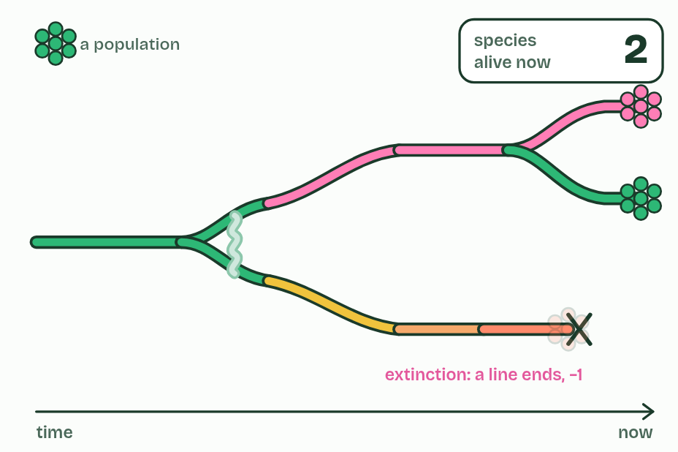  ANNOTATE THE FIGURE  Annotate this still from the animation (Watch it happen: one population becomes two): what is happening, and why?  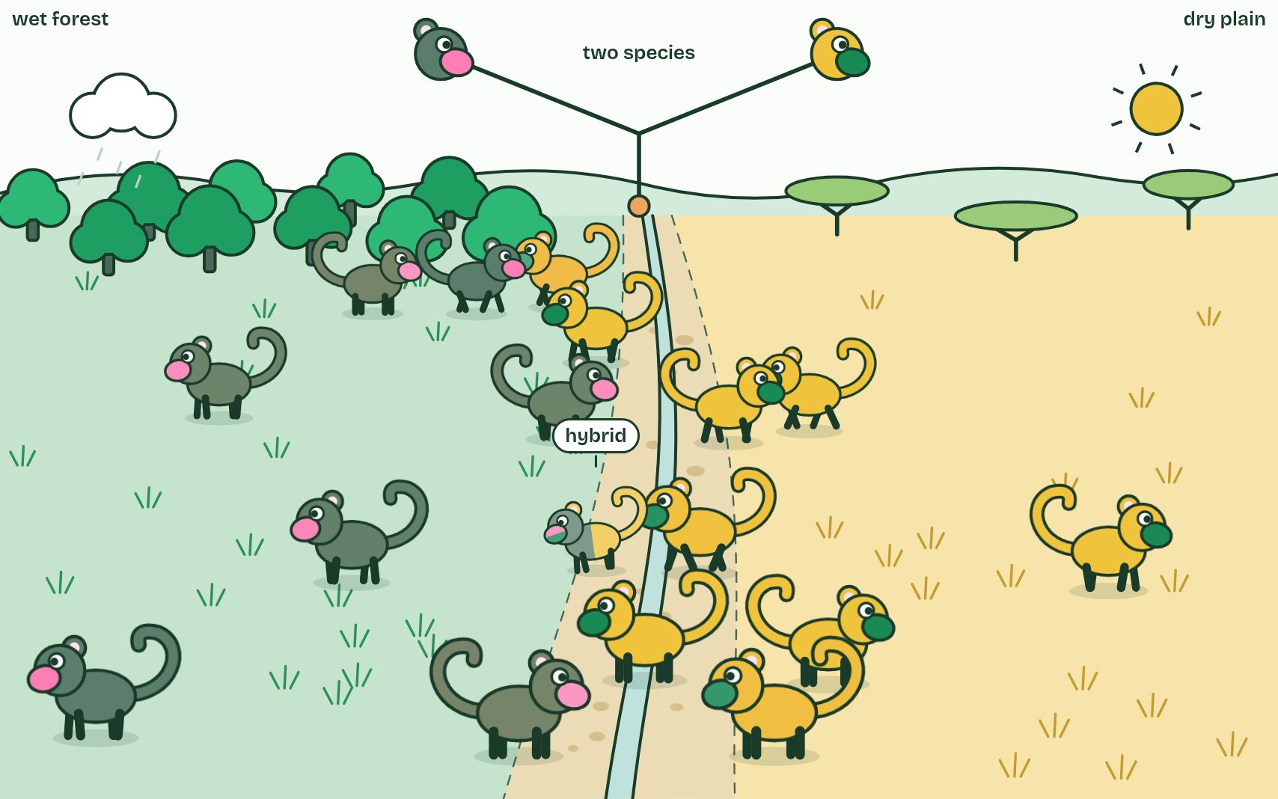
  SPOT THE MISTAKE
  What do students often get wrong about speciation? Write the mistake, then put it right.
  The mistake
  Put it right
SUMMARY
Sum up section 05 in two or three sentences of your own.

06 One river, two apes | A4.1.7
CUES  Predict: Suppose the river had divided the apes but the forests on both banks were identical. What would you expect after a million years?  What is meant by reproductive isolation?  What is meant by geographical isolation?  What is meant by differential selection? | NOTES  1 First, ______________________________: the populations must stop interbreeding, so alleles no longer pass between them.  2 A sea, a mountain range or a river can do it: ______________________________.  3 Second, ______________________________: different conditions on each side favour different characteristics, so the populations diverge.  4 Long ago: one population of ___________________, north of the Congo River.  5 Perhaps in a dry spell, the river runs low and a few apes reach the ______________.  6 The water rises. Neither side can cross: ________________ between the populations.  Your own notes  ANNOTATE THE FIGURE  Number the 5 steps on the figure and note what happens at each: 1 ancestral apes; 2 south bank; 3 no gene flow; 4 differential selection; 5 two species.  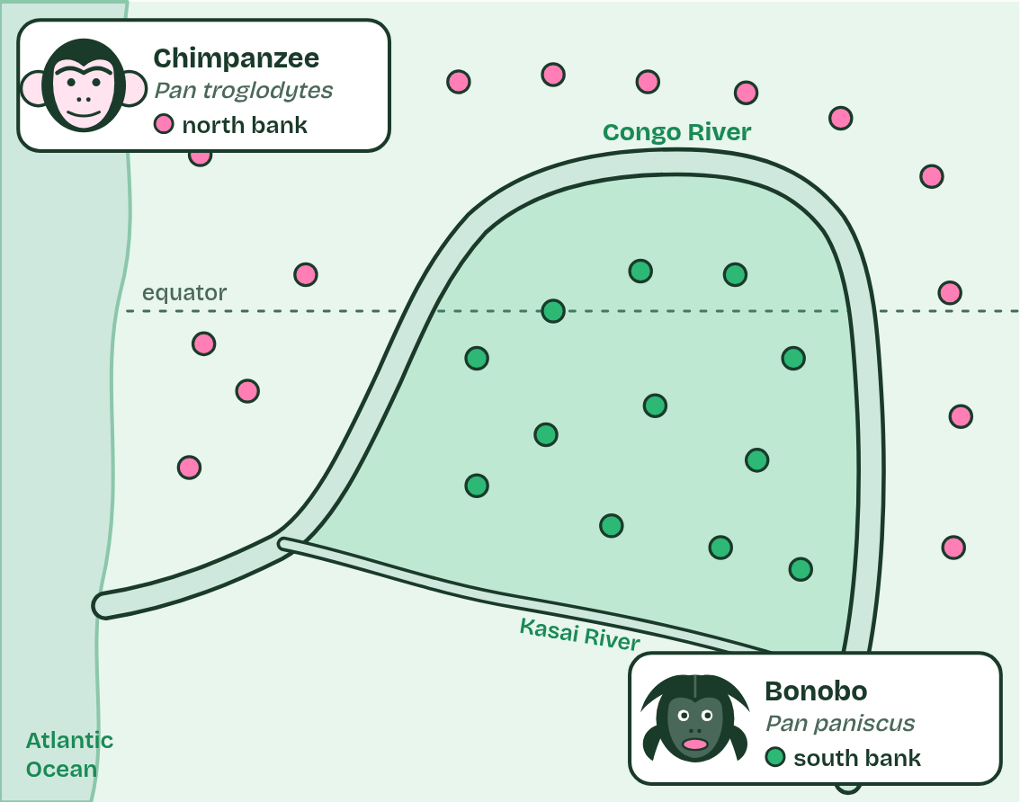
  SPOT THE MISTAKE
  What do students often get wrong about reproductive isolation and differential selection? Write the mistake, then put it right.
  The mistake
  Put it right
SUMMARY
Sum up section 06 in two or three sentences of your own.

07 Apart or together: two routes to a new species | A4.1.8 HL
CUES  Predict: Two populations of a cricket share one meadow. One sings and mates in spring, the other in late summer. Which kind of isolation is this, and which route to speciation?  What is meant by allopatric speciation?  What is meant by sympatric speciation?  What is meant by temporal isolation?  What is meant by behavioural isolation? | NOTES  1 In ____________________________ ("other homeland") a geographical barrier does it: a sea, a mountain range, or a river, as for the bonobos.  2 In ___________________________ ("same homeland") the groups live side by side, and something else keeps them from mating.  3 They may breed at different times (________________________) or choose mates differently (____________________________).  4 Two populations, each of _______________: finches on an island, flies on hawthorn trees.  5 Left: the sea rises and ________ the island. Right: apple trees arrive and some flies ________ to them; no barrier.  6 Left: different seeds each side select different beaks. Right: apple flies mate earlier, on apples. ____________________ in both.  Your own notes  ANNOTATE THE FIGURE  Number the 4 steps on the figure and note what happens at each: 1 one species; 2 splits, switch; 3 Gene flow stops; 4 geography, timing and behaviour.  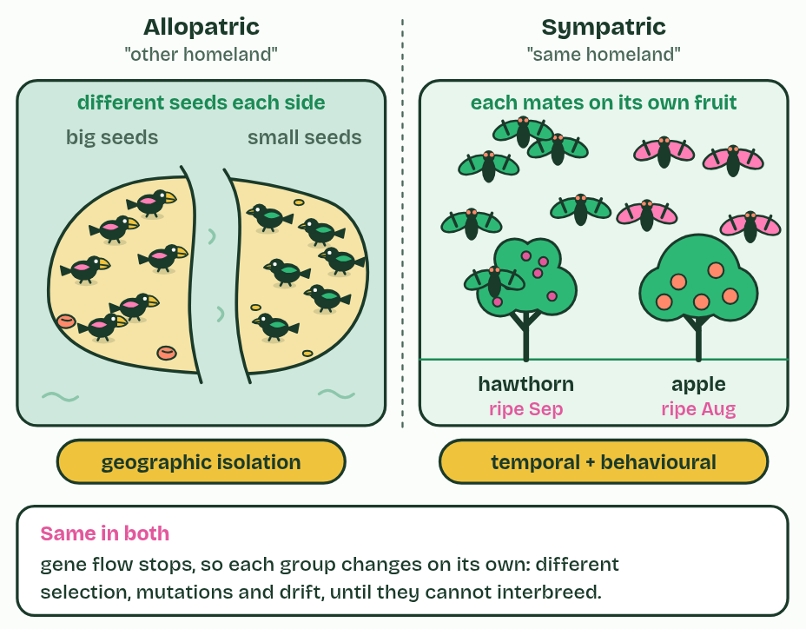  REMEMBER IT  Three kinds of reproductive isolation
  G  Grumpy | B  Birds | T  Tweet
  G | B | T
  SPOT THE MISTAKE
  What do students often get wrong about allopatric and sympatric speciation? Write the mistake, then put it right.
  The mistake
  Put it right
SUMMARY
Sum up section 07 in two or three sentences of your own.

08 One ancestor, many niches | A4.1.9 HL
CUES  Predict: Suppose the first finches had landed on islands already full of small birds of many kinds. What would you expect?  What is meant by adaptive radiation?  What is meant by vacant niches? | NOTES  1 When a species reaches a place with food and ways of life that nothing else is using, its descendants can split again and again, each line adapting to a different way of life. This is ________________________.  2 The unused ways of life are __________________.  3 A seed-eating finch arrives on islands with __________________: foods no other small bird is using.  4 The first split: one line takes to eating _________, with a thin, pointed beak.  5 The rest split into ___________________ and ________________.  6 Each line splits again, each species with a beak ________________________.  Your own notes  ANNOTATE THE FIGURE  Number the 5 steps on the figure and note what happens at each: 1 vacant niches; 2 insects; 3 ground finches, tree finches; 4 suited to its food; 5 little competition.  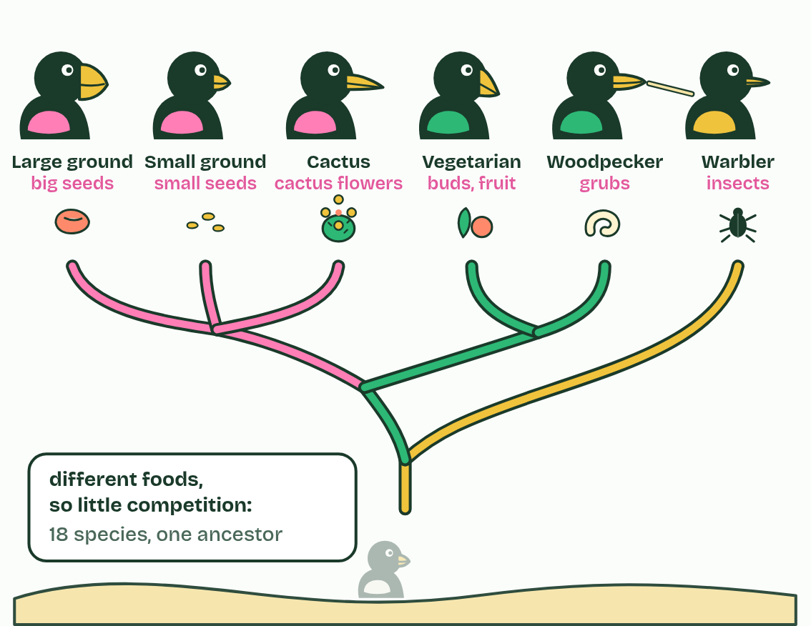
  SPOT THE MISTAKE
  What do students often get wrong about adaptive radiation? Write the mistake, then put it right.
  The mistake
  Put it right
SUMMARY
Sum up section 08 in two or three sentences of your own.

09 The mule's dead end, the plant's way out | A4.1.10 HL A4.1.11 HL
CUES  Predict: Redshank (2n = 44) is crossed with one of its parents, pale persicaria (2n = 22). How many chromosomes do the offspring have, and are they fertile?  What is meant by hybridisation?  What is meant by polyploid?  What is meant by abrupt speciation? | NOTES  1 Before, courtship usually prevents __________________: many animals choose mates by songs, dances, colours or scents that belong to their own species, and ignore the rest.  2 But if its chromosome number doubles, every chromosome gains an identical partner, meiosis works, and the plant is fertile. It is a ____________, and it cannot breed successfully with either parent: a new species in a generation or two.  3 This is _______________________.  4 A horse gamete (32 chromosomes) and a donkey gamete (31) make a ________ with 63. A few of each set are drawn.  5 At meiosis, matching chromosomes pair up, but horse and donkey sets differ in ______________________________: some cannot pair.  6 So the gametes get ______________ sets and do not work: the mule is sterile.  Your own notes  ANNOTATE THE FIGURE  Number the 6 steps on the figure and note what happens at each: 1 mule; 2 number and arrangement; 3 unbalanced; 4 sterile; 5 doubles; 6 polyploid.  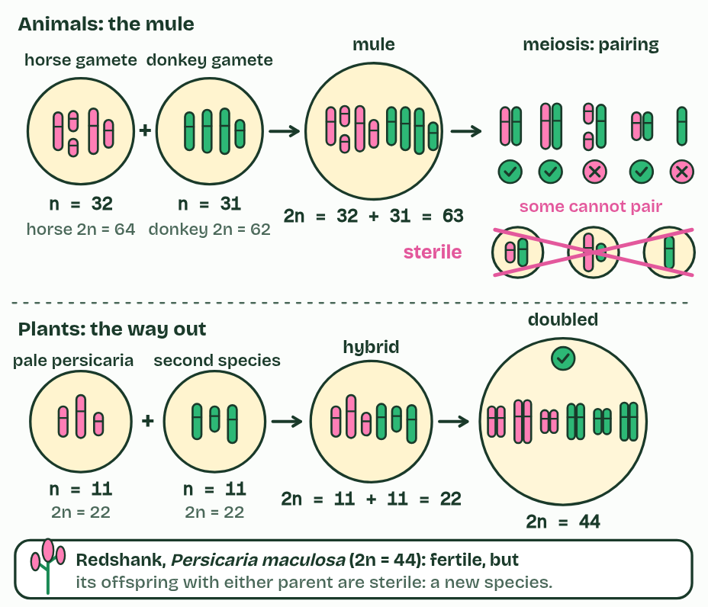
  SPOT THE MISTAKE
  What do students often get wrong about hybrids and polyploidy? Write the mistake, then put it right.
  The mistake
  Put it right
SUMMARY
Sum up section 09 in two or three sentences of your own.

Check yourself
The check for this guide is online: a fresh paper of past-paper style questions from the exam bank on A4.1 each time, marked as you go, and saved to your Exam practice progress when you are signed in. Open the link:
biologybybradford.com/exam-maker/sit?topics=A4.1&level=HL&paper=quiz&marks=15&src=ep

