Name | Class | Date
IB BIOLOGY · B1.1

Carbohydrates and lipids
Teacher’s copy: every blank filled in. Each numbered block matches a chapter of the guide, and of the lesson slides. Write in the gaps, answer the cues, annotate the figures, and sum up each section in your own words.
BY THE END YOU CAN
Explain how carbon's four covalent bonds let it build chains, branches and rings B1.1.1
Describe how condensation joins monomers into polymers and hydrolysis splits them, saying where the water goes B1.1.2, B1.1.3
Tell pentoses from hexoses and alpha from beta glucose in ring diagrams, and link glucose's properties to its uses B1.1.4
Explain how coiling, branching and size suit starch and glycogen to storing energy B1.1.5
Explain how alternating beta glucose gives cellulose straight chains, bundled by hydrogen bonds B1.1.6
Explain how glycoproteins let cells recognise each other, using the ABO blood groups B1.1.7
Explain why lipids are hydrophobic, and how condensation builds triglycerides and phospholipids B1.1.8, B1.1.9
Compare saturated, monounsaturated and polyunsaturated fatty acids and explain their melting points B1.1.10
Explain why triglycerides suit long-term energy storage and insulation, and compare them with carbohydrates as stores B1.1.11
Explain how amphipathic phospholipids form a bilayer in water B1.1.12
Identify a steroid from its four rings and explain how oestradiol and testosterone cross the bilayer B1.1.13

01 Chains, branches and rings | B1.1.1
CUES  Predict: A drawing shows a carbon atom with a double bond to an oxygen, a single bond to another carbon and single bonds to two hydrogens. What is wrong with it?  B: It has five bonds’ worth: the double bond counts as two. Count the double bond as two: 2 + 1 + 1 + 1 = 5, one more than carbon can make. Take away one hydrogen and every carbon has exactly four. Checking each carbon for four bonds is the quickest way to catch an error in any molecule you draw.  What is meant by covalent bond?  A bond in which two atoms share a pair of electrons. The shared pair holds the atoms together.  What is meant by double bond?  Two pairs of electrons shared between the same two atoms. It uses two of a carbon atom’s four bonds.  What is meant by carbon compound?  A molecule built on a skeleton of carbon atoms, with other atoms attached to it.  What is meant by chain?  A row of carbon atoms joined end to end. It is unbranched if it is a single row, and branched if a side chain comes off it.  What is meant by ring?  Carbon atoms (sometimes with an oxygen atom) joined in a closed loop, as in glucose. | NOTES  1 A covalent bond is a pair of electrons shared by two atoms, and the shared pair holds them together.  2 A carbon atom has four electrons in its outer shell to share, so it can make up to four covalent bonds: four single bonds, or a double bond plus two single bonds.  3 A carbon compound can have a chain, either unbranched, like the tail of a fatty acid, or branched; a single ring, like glucose; or several rings fused together, as in a steroid.  4 Carbon makes four bonds in total, and a double bond counts as two.  Your own notes  ANNOTATE THE FIGURE  Number the 5 steps on the figure and note what happens at each: 1 covalent bond; 2 four; 3 double bond; 4 chains; 5 rings.  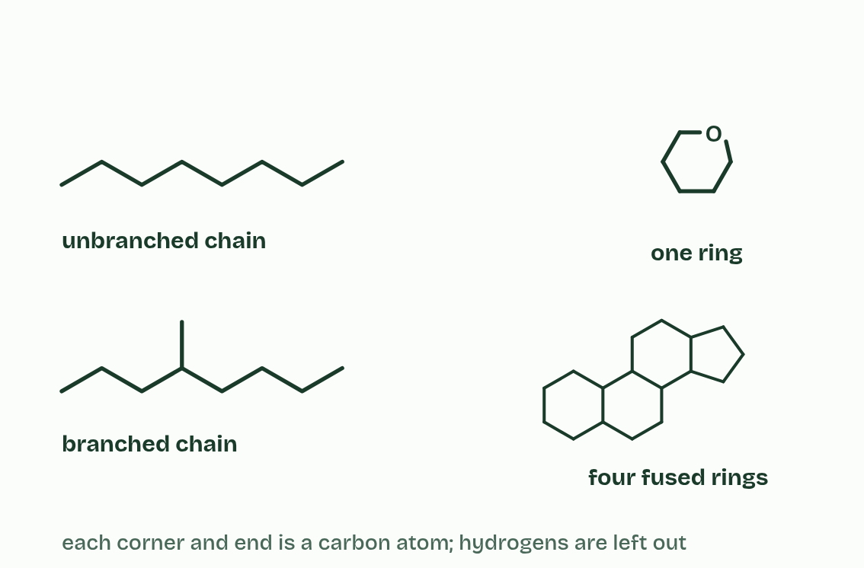  1 A covalent bond is a pair of electrons shared by two atoms.  2 Carbon has four electrons to share, so it makes four bonds.  3 A double bond shares two pairs: it uses two of carbon’s four.  4 Carbon bonds to carbon, so it builds chains, straight or branched,  5 and rings, one or several fused together.  ANNOTATE THE FIGURE  Label each part and say what it does: kilo (k), × 1000., centi (c), ÷ 100., milli (m), ÷ 1000., micro (µ), ÷ 1 000 000., nano (n), ÷ 1 000 000 000..  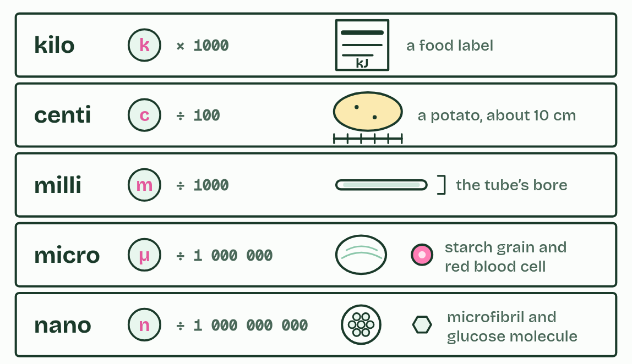  1 kilo (k), × 1000.: A food label gives energy in kilojoules (kJ). One kilojoule is a thousand joules.  2 centi (c), ÷ 100.: A potato is about 10 cm long: ten centimetres.  3 milli (m), ÷ 1000.: A thin glass tube used for melting point tests is about 1 mm across the bore.  4 micro (µ), ÷ 1 000 000.: A starch grain from a potato cell is tens of micrometres across. A red blood cell is about 8 µm.  5 nano (n), ÷ 1 000 000 000.: A cellulose microfibril is about 3 nm wide. One glucose molecule is under 1 nm across.
  SPOT THE MISTAKE
  What do students often get wrong about carbon compounds? Write the mistake, then put it right.
  A double bond is not one bond: it uses two of carbon’s four. Count it twice when you check a drawing.
SUMMARY
Sum up section 01 in two or three sentences of your own.
• Carbon makes four bonds in total, and a double bond counts as two.
• Three skeletons to recognise in a drawing: a chain (straight or branched), a single ring and fused rings.

02 Water out to build, water in to break | B1.1.2 B1.1.3
CUES  Predict: Ten glucose molecules are joined into one unbranched chain. How many water molecules were released?  C: 9. Nine. One water leaves for every bond, and a chain of ten units has nine bonds between them. Digesting it back to glucose by hydrolysis uses nine water molecules.  What is meant by polymers?  A molecule made of many similar small units, the monomers, joined in a chain by covalent bonds.  What is meant by monomers?  The small units that join together to make a polymer, such as a glucose molecule in starch.  What is meant by macromolecules?  Very large molecules, such as starch, proteins and DNA.  What is meant by condensation reaction?  A reaction that joins two molecules and releases a molecule of water. An OH group from one and an H from the other leave together as water.  What is meant by polysaccharides?  Polymers of monosaccharides: starch, glycogen and cellulose are examples.  What is meant by glycosidic bonds?  The covalent bond between two sugar units, with an oxygen atom bridging the two rings.  What is meant by hydrolysis?  A reaction that splits a molecule by adding water. The water is split: its H goes to one product and its OH to the other. | NOTES  1 Many of life’s large molecules are polymers: long chains of similar small units called monomers.  2 Very large molecules like these are macromolecules.  3 Monomers are joined by a condensation reaction.  4 Three families of polymer are built this way. Polysaccharides are monosaccharides joined by glycosidic bonds.  5 Hydrolysis runs the other way: hydro means water and lysis means splitting.  Your own notes  ANNOTATE THE FIGURE  Number the 5 steps on the figure and note what happens at each: 1 monomers; 2 Condensation; 3 glycosidic bond; 4 polymer; 5 Hydrolysis.  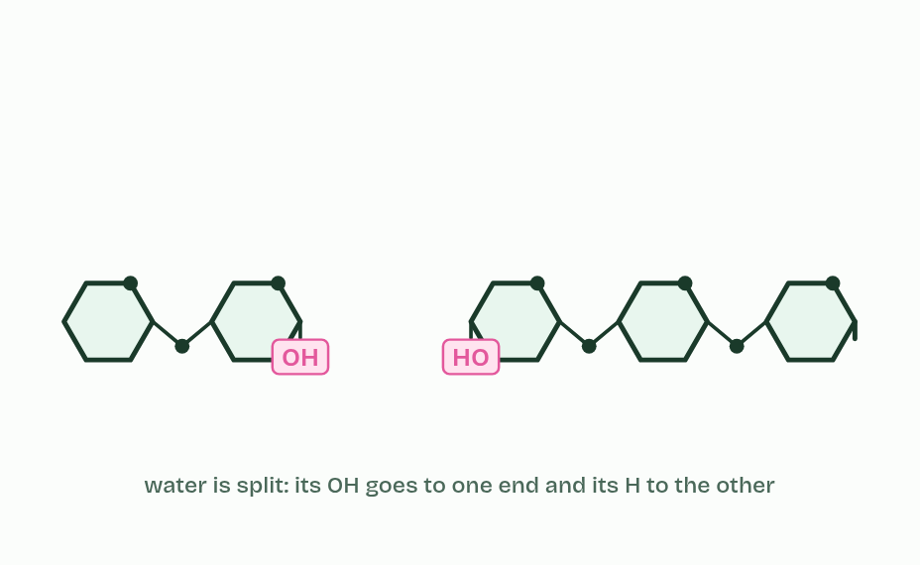  1 Two monomers: alpha glucose. Watch the OH groups that face each other.  2 Condensation: an OH and an H leave together as a molecule of water.  3 A covalent glycosidic bond now joins them.  4 Repeat it and a chain grows: a polymer. Polysaccharides, polypeptides and nucleic acids are all built like this.  5 Hydrolysis runs it backwards: water is split, its H to one monomer and its OH to the other.  ANNOTATE THE FIGURE  Number the 4 steps on the figure and note what happens at each: 1 alpha glucose; 2 carbon 1, carbon 4; 3 water, 1,4 glycosidic bond, condensation; 4 hydrolysis.  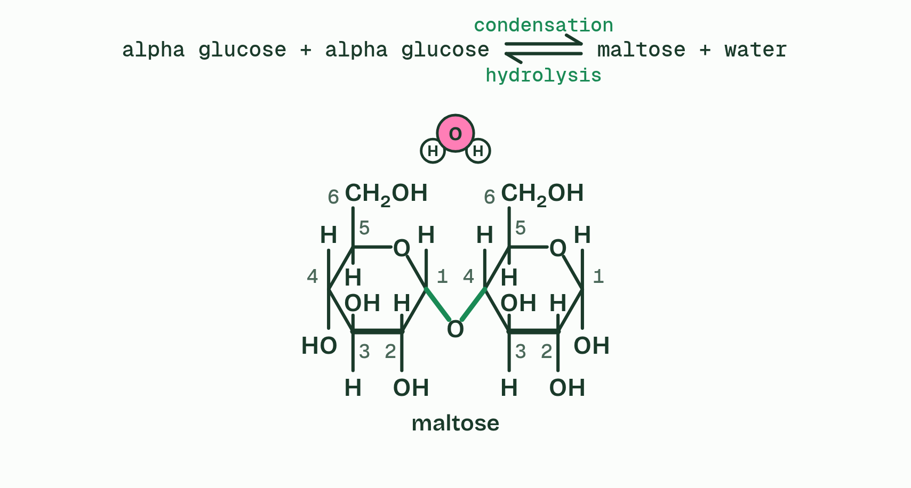  1 Two alpha glucose molecules, their carbons numbered.  2 The OH on carbon 1 of one and the H from the OH on carbon 4 of the other face each other.  3 They leave as water, and a 1,4 glycosidic bond joins the rings: condensation, making maltose.  4 Add water and the bond splits again, the H to one sugar and the OH to the other: hydrolysis.
  SPOT THE MISTAKE
  What do students often get wrong about condensation and hydrolysis? Write the mistake, then put it right.
  Condensation releases water and hydrolysis uses it. And in hydrolysis the water is not simply added: it is split, and its H and OH end up in the two new ends.
SUMMARY
Sum up section 02 in two or three sentences of your own.
• Many of life’s large molecules are polymers: long chains of similar small units called monomers.
• Very large molecules like these are macromolecules.
• Monomers are joined by a condensation reaction.
• Three families of polymer are built this way. Polysaccharides are monosaccharides joined by glycosidic bonds.

03 Glucose: small, soluble and stable | B1.1.4
CUES  Predict: Sugar C in the second figure has a five-sided ring. Is it a pentose or a hexose?  A: A hexose: four ring carbons and two outside it make six. A hexose. Its ring is four carbons and an oxygen, and two more carbons sit outside the ring as CH2OH groups: six in all. It is fructose. Count carbons, not corners: ribose also has a five-sided ring, but only one carbon outside it, so it is a pentose.  What is meant by monosaccharide?  A single sugar unit, the monomer of carbohydrates. Glucose, fructose and ribose are monosaccharides.  What is meant by pentose?  A monosaccharide with five carbon atoms, such as ribose and deoxyribose.  What is meant by hexose?  A monosaccharide with six carbon atoms, such as glucose and fructose.  What is meant by alpha (α) glucose?  The form of glucose with the OH on carbon 1 below the ring, opposite the CH2OH group. It makes starch and glycogen.  What is meant by beta (β) glucose?  The form of glucose with the OH on carbon 1 above the ring, on the same side as the CH2OH group. It makes cellulose.  What is meant by isomers?  Molecules with the same atoms arranged differently, so they have the same formula but different structures. | NOTES  1 A monosaccharide is one sugar unit, the monomer of carbohydrates.  2 In cells most monosaccharides exist as rings. They are named by their number of carbon atoms: a pentose has five (ribose, deoxyribose) and a hexose has six (glucose, fructose).  3 Glucose comes in two forms with the same formula, C₆H₁₂O₆: alpha (α) glucose and beta (β) glucose.  4 They are isomers.  Your own notes  ANNOTATE THE FIGURE  The figure shows it as α-glucose, β-glucose and Both. Note what changes each time.  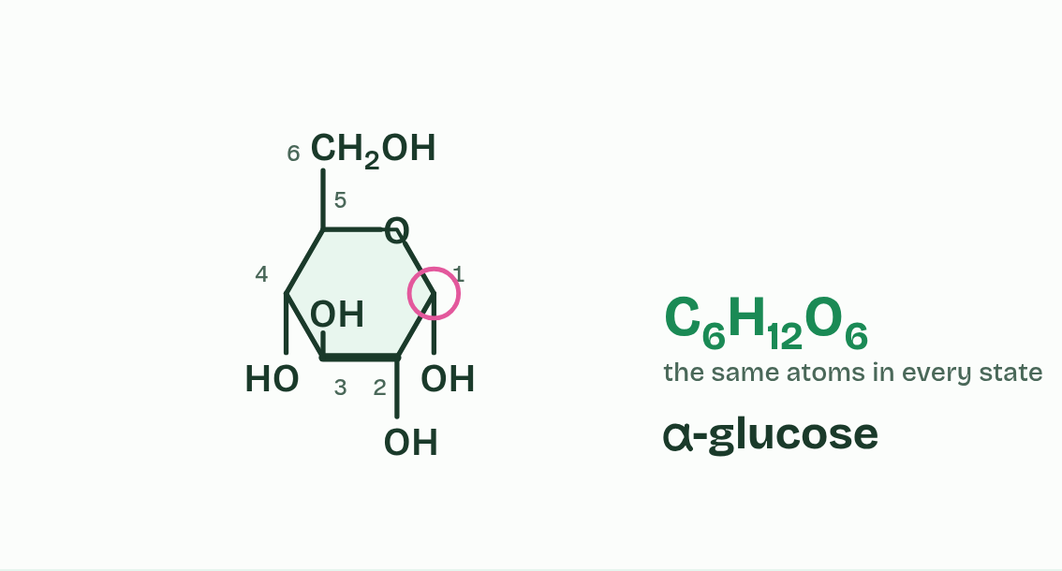  1 α-glucose  2 β-glucose  3 Both  ANNOTATE THE FIGURE  Label each part and say what it does: α-glucose, ribose, fructose, β-glucose, deoxyribose.  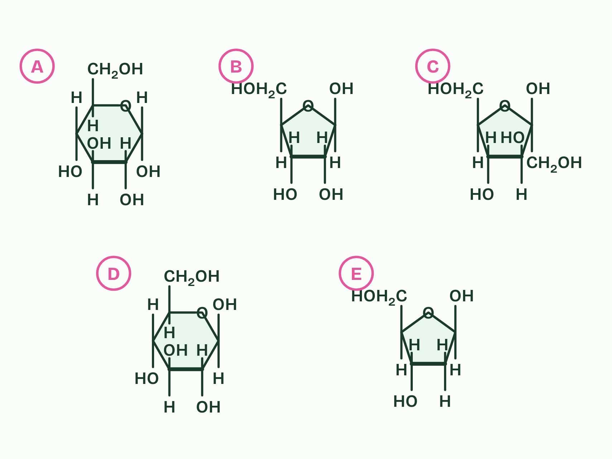  1 α-glucose: A hexose: six carbons, five in the ring and one in the CH2OH group. It is the sugar dissolved in your blood, the one cells use for energy.  2 Ribose: A pentose: five carbons, four in the ring and one in the CH2OH group. It is the sugar in RNA.  3 Fructose: A hexose: six carbons, four in the ring and two in CH2OH groups outside it. It is found in fruit and, joined to glucose, in sucrose.  4 β-glucose: A hexose: the same six carbons as sugar A, but the OH on carbon 1 points the other way. Its units make up cellulose.  5 Deoxyribose: A pentose: five carbons, like ribose, but with an H where ribose has an OH on carbon 2. It is the sugar in DNA.  REMEMBER IT  ABBA: which way carbon 1’s OH points  REMEMBER IT  Why glucose is the sugar on the move
  A  Alpha | B  Beta
  Below  the OH on carbon 1 points down, away from the CH2OH | Above  the OH on carbon 1 points up, on the same side as the CH2OH
  S  Sweet | T  Treats | S  Stay | E  Energetic
  Soluble  its OH groups hydrogen-bond with water | Transportable  dissolved, it travels in blood plasma | Stable  it keeps until an enzyme acts on it | Energy yield  oxidised in respiration, it releases energy
  SPOT THE MISTAKE
  What do students often get wrong about monosaccharides? Write the mistake, then put it right.
  α-glucose and β-glucose are not different sugars with different formulas. Both are C6H12O6: only the OH on carbon 1 differs.
SUMMARY
Sum up section 03 in two or three sentences of your own.
• Soluble. Its many OH groups form hydrogen bonds with water (A1.1), so it dissolves in cytoplasm and in blood plasma.
• Transportable. Dissolved in plasma, it is carried to every cell.
• Chemically stable. It does not react or break down by itself, so it keeps while it is stored and carried, until an enzyme acts on it.
• Yields energy. Oxidised in respiration to carbon dioxide and water, it releases about 16 kJ per gram (C1.2).

04 Starch and glycogen: energy packed tight | B1.1.5
CUES  Predict: An amylose molecule and a glycogen molecule hold the same number of glucose units. A sprinter’s muscles suddenly need glucose. Which store can release it faster?  C: Glycogen: its many branches give enzymes many ends to work on. Glycogen. Enzymes take glucose off the ends of chains, one unit at a time. A heavily branched molecule has many ends, so many enzymes can work on it at once. That suits animals, which may need glucose in seconds.  What is meant by starch?  The energy store of plants: a mixture of amylose and amylopectin, both polymers of alpha glucose.  What is meant by glycogen?  The energy store of animals and fungi: a highly branched polymer of alpha glucose, found in liver and muscle cells.  What is meant by amylose?  An unbranched chain of alpha glucose that coils into a helix. One of the two polysaccharides in starch.  What is meant by amylopectin?  A chain of alpha glucose that coils and also has branches. The other polysaccharide in starch.  What is meant by branches?  Side chains of glucose units coming off the main chain of a polysaccharide. | NOTES  1 Plants store energy as starch and animals (and fungi) store it as glycogen.  2 Starch is a mixture of two polysaccharides. Amylose is an unbranched chain that coils into a helix. Amylopectin is a coiled chain with branches coming off it.  Your own notes  ANNOTATE THE FIGURE  The figure shows it as Amylose, Amylopectin and Glycogen. Note what changes each time.  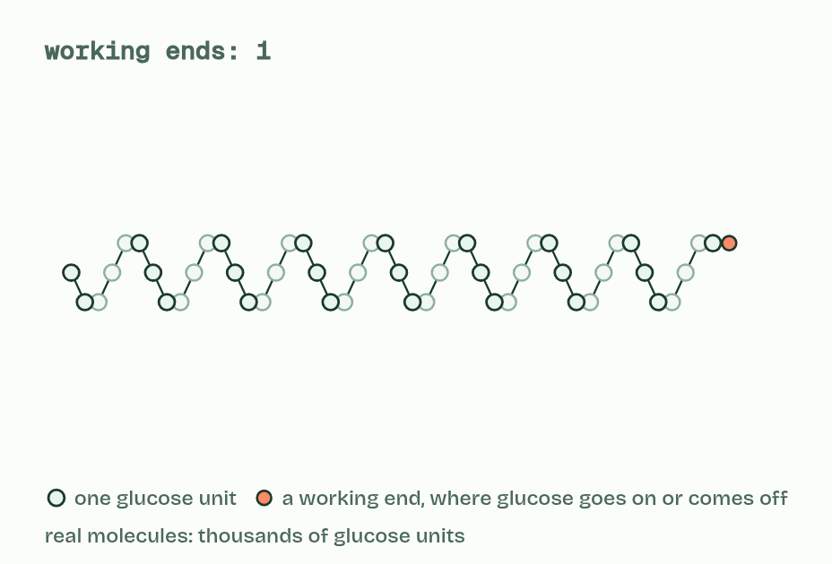  1 Amylose  2 Amylopectin  3 Glycogen  ANNOTATE THE FIGURE  Annotate this still from the animation (Watch it happen: building and using a store): what is happening, and why?  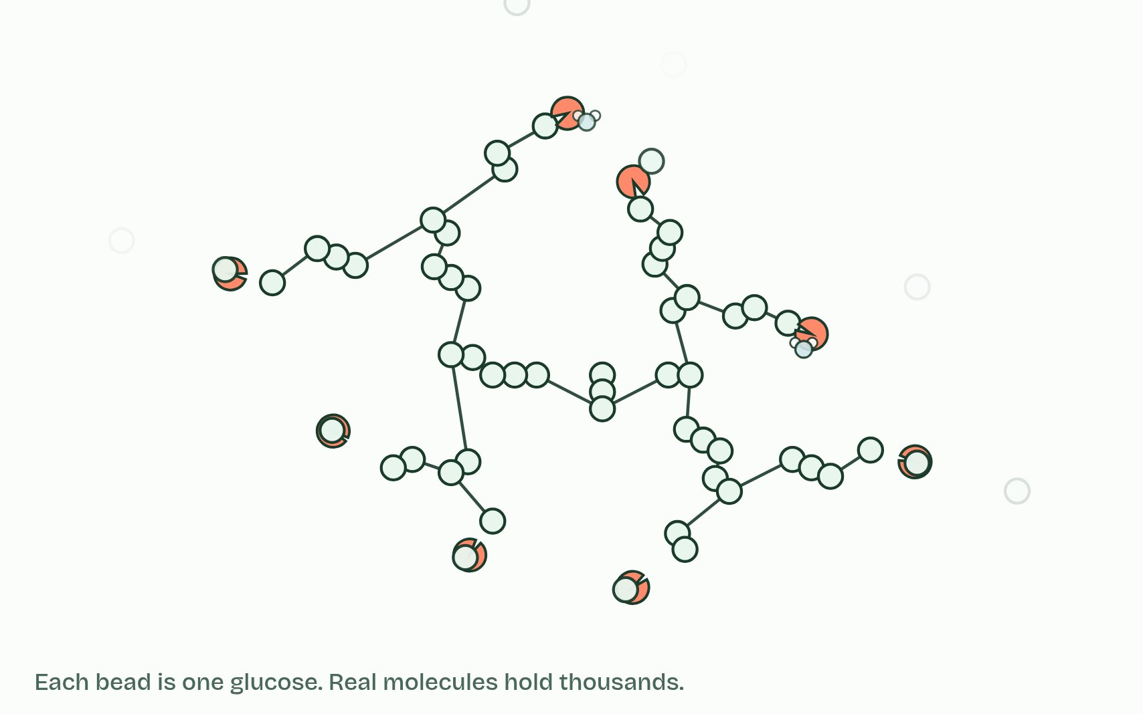  1 Glucose units join one at a time; a water molecule leaves at each link.  2 Amylose coils into a helix: a lot of glucose in a small space.  3 Amylopectin and glycogen branch, so they have many ends.  4 Enzymes take glucose off the ends, using a water molecule each time.
  SPOT THE MISTAKE
  What do students often get wrong about starch and glycogen? Write the mistake, then put it right.
  Insoluble does not mean hydrophobic. Starch and glycogen are covered in OH groups: they barely dissolve because each molecule is so large.
SUMMARY
Sum up section 04 in two or three sentences of your own.
• Plants store energy as starch and animals (and fungi) store it as glycogen.
• Starch is a mixture of two polysaccharides. Amylose is an unbranched chain that coils into a helix. Amylopectin is a coiled chain with branches coming off it.

05 Turn every other glucose over and the chain runs straight | B1.1.6
CUES  Predict: Cellulose chains lie side by side in bundles. What holds neighbouring chains together?  B: Hydrogen bonds between OH groups on neighbouring chains. Hydrogen bonds. Each is weak, but there are thousands along every chain, so together they hold the bundle firmly. Glycosidic bonds link glucose units within a chain, not chain to chain.  What is meant by cellulose?  An unbranched polymer of beta glucose, and the main material of plant cell walls.  What is meant by cell walls?  The tough layer outside the plasma membrane of a plant cell. Its main material is cellulose.  What is meant by hydrogen bonds?  Weak attractions between a slightly positive hydrogen and a slightly negative atom such as oxygen on a neighbouring molecule or chain (A1.1).  What is meant by microfibrils?  Bundles of cellulose chains held together by hydrogen bonds. They are very strong when pulled.  What is meant by tensile strength?  How much pulling force a material can withstand before it breaks. | NOTES  1 Cellulose is an unbranched polymer of β-glucose and the main material of plant cell walls. β-glucose does not join to itself the way α-glucose does.  2 Straight chains lie side by side, and OH groups on neighbouring chains form hydrogen bonds that cross-link them into bundles called microfibrils.  3 One hydrogen bond is weak, but there are thousands along every chain, and together they make a microfibril very strong when pulled: it has high tensile strength.  4 Two beta glucose molecules. Their OH groups point opposite ways.  5 Turn one over and they can join: water leaves and a bond forms.  6 Every other unit is turned over, so the chain runs straight.  Your own notes  ANNOTATE THE FIGURE  Number the 6 steps on the figure and note what happens at each: 1 beta glucose; 2 over; 3 straight; 4 hydrogen bonds; 5 microfibrils; 6 cell wall.  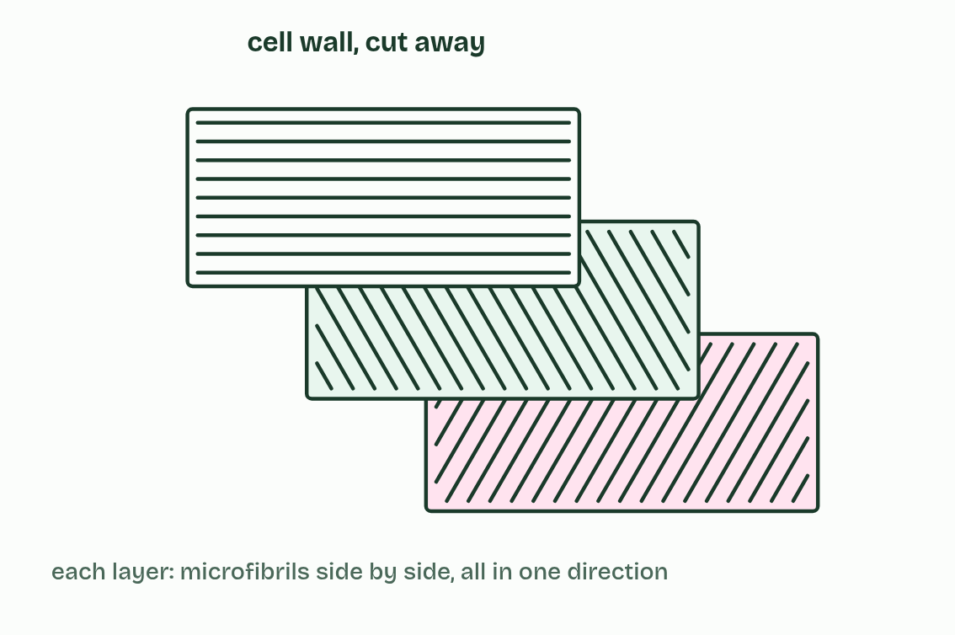  1 Two beta glucose molecules. Their OH groups point opposite ways.  2 Turn one over and they can join: water leaves and a bond forms.  3 Every other unit is turned over, so the chain runs straight.  4 Neighbouring chains are linked by many hydrogen bonds.  5 Bundles of chains form microfibrils.  6 Layers of microfibrils give the cell wall its strength.  ANNOTATE THE FIGURE  Number the 4 steps on the figure and note what happens at each: 1 beta glucose; 2 carbon 1, carbon 4; 3 water, 1,4 glycosidic bond, cellulose, condensation; 4 hydrolysis.  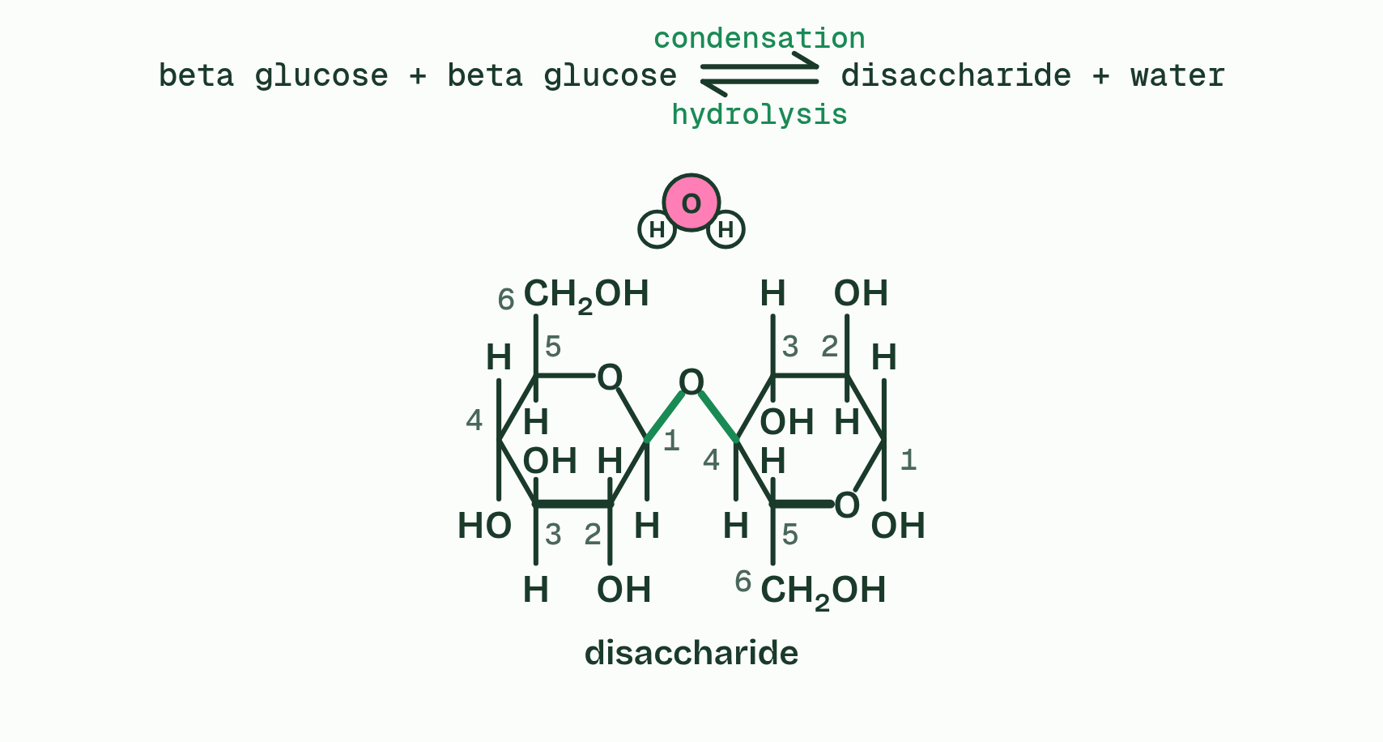  1 Two beta glucose molecules, their carbons numbered.  2 The OH on carbon 1 of one points up, and the OH on carbon 4 of the other points down: they cannot meet.  3 Turn the second over and they meet. They leave as water, and a 1,4 glycosidic bond joins the rings, as in cellulose: condensation.  4 Add water and the bond splits again, the H to one sugar and the OH to the other: hydrolysis.
  SPOT THE MISTAKE
  What do students often get wrong about cellulose? Write the mistake, then put it right.
  Cellulose is the plant’s structure, not its energy store: it is built to stay in the wall.
SUMMARY
Sum up section 05 in two or three sentences of your own.
• Cellulose is an unbranched polymer of β-glucose and the main material of plant cell walls. β-glucose does not join to itself the way α-glucose does.
• Straight chains lie side by side, and OH groups on neighbouring chains form hydrogen bonds that cross-link them into bundles called microfibrils.
• One hydrogen bond is weak, but there are thousands along every chain, and together they make a microfibril very strong when pulled: it has high tensile strength.

06 Sugar name tags on the cell surface | B1.1.7
CUES  Predict: What makes a group A red blood cell different from a group B one?  C: One different sugar at the tip of each sugar chain. One sugar. Both carry the same glycoprotein chains. The enzyme a person’s alleles make adds one sugar to the tip, a different one for A and for B. That single sugar is enough for immune cells to tell the cells apart.  What is meant by glycoprotein?  A protein with carbohydrate chains attached to it. In the plasma membrane its carbohydrate chains face outwards.  What is meant by cell-cell recognition?  One cell identifying another by the molecules on its surface, such as the sugar chains of glycoproteins.  What is meant by antigens?  Molecules that the immune system can recognise. The A and B sugars on red blood cells are antigens. | NOTES  1 A glycoprotein is a protein with carbohydrate chains attached.  2 Carbohydrate chains can differ in which monosaccharides they contain, in the order of those sugars and in how the chain branches, so they can take a huge number of forms. That makes them good identity tags, and other cells read them: this is cell-cell recognition.  3 The A and B forms are antigens.  Your own notes  ANNOTATE THE FIGURE  Label each part and say what it does: protein part, no A or B sugar, no A or B sugar, protein part, no A or B sugar, no A or B sugar, protein part, no A or B sugar, no A or B sugar.  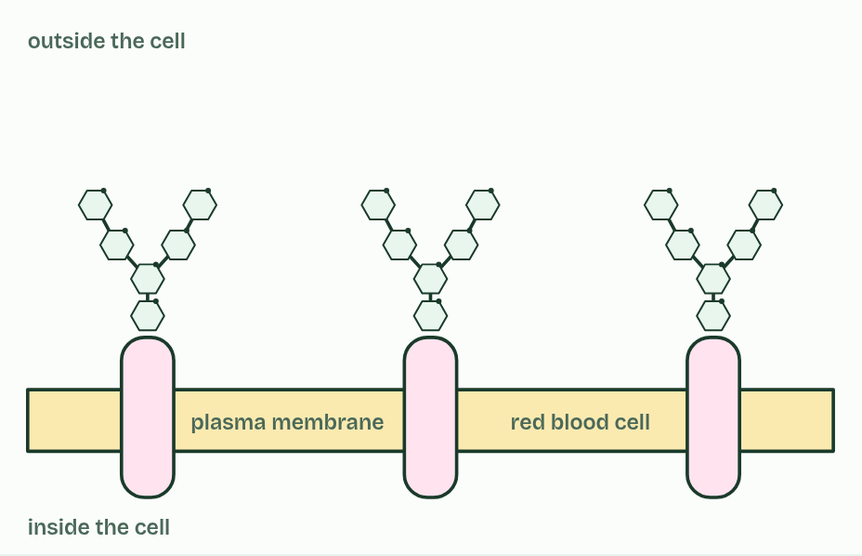  1 Protein part: Through the membrane.  2 No A or B sugar: This chain stops at its base. (Its last sugar is fucose.)  3 No A or B sugar: This chain stops at its base. (Its last sugar is fucose.)  4 Protein part: Through the membrane.  5 No A or B sugar: This chain stops at its base. (Its last sugar is fucose.)  6 No A or B sugar: This chain stops at its base. (Its last sugar is fucose.)  7 Protein part: Through the membrane.  8 No A or B sugar: This chain stops at its base. (Its last sugar is fucose.)  9 No A or B sugar: This chain stops at its base. (Its last sugar is fucose.)
  SPOT THE MISTAKE
  What do students often get wrong about glycoproteins? Write the mistake, then put it right.
  Group O cells are not bare. They carry the same base sugar chain: they only lack the extra A or B sugar on its tip.
SUMMARY
Sum up section 06 in two or three sentences of your own.
• A glycoprotein is a protein with carbohydrate chains attached.
• Carbohydrate chains can differ in which monosaccharides they contain, in the order of those sugars and in how the chain branches, so they can take a huge number of forms. That makes them good identity tags, and other cells read them: this is cell-cell recognition.
• The A and B forms are antigens.

07 Lipids keep their distance from water | B1.1.8 B1.1.9
CUES  Predict: You have salted butter but need it unsalted. What could you do?  B: Melt it, leave it to settle, then pour the fat off the water. Melt it and let it settle. Butter is a mixture: mostly fat, with some water. Salt dissolves in water but not in fat, so it stays in the watery layer at the bottom while the fat floats above. Pour or ladle the fat off and it is almost salt-free: this is clarified butter. Stirring into water fails because the fat does not dissolve, and salt does not evaporate at kitchen temperatures.  What is meant by lipids?  Substances made by living things that dissolve in non-polar solvents such as hexane but only sparingly in water. Fats, oils, waxes and steroids are lipids.  What is meant by non-polar solvents?  Solvents such as hexane whose molecules have no partial charges. Lipids dissolve in them.  What is meant by fats?  Lipids, mostly triglycerides, that are solid at room temperature.  What is meant by oils?  Lipids, mostly triglycerides, that are liquid at room temperature.  What is meant by waxes?  Lipids that form a waterproof coating, such as the wax on a leaf.  What is meant by hydrophobic?  Not attracted to water. Non-polar substances such as lipids are hydrophobic.  What is meant by triglycerides?  Lipids made of one glycerol molecule joined to three fatty acids by ester bonds.  What is meant by glycerol?  A small molecule of three carbon atoms, each with an OH group, that fatty acids join to.  What is meant by fatty acids?  Molecules with a long hydrocarbon chain and a carboxyl group at one end.  What is meant by carboxyl group?  The group COOH, found at one end of a fatty acid. It is the part that joins to glycerol.  What is meant by ester bond?  The covalent bond between a fatty acid and glycerol, formed by condensation.  What is meant by phospholipid?  A lipid made of glycerol joined to two fatty acids and one phosphate group.  What is meant by phosphate group?  A group of one phosphorus atom and four oxygen atoms. It carries a negative charge and attracts water. | NOTES  1 Lipids are substances made by living things that dissolve in non-polar solvents, such as hexane, but only sparingly in water.  2 Lipids include fats, oils, waxes and steroids.  3 Water molecules stay bonded to each other and push the lipid out into droplets or a separate layer: lipids are hydrophobic.  4 Fats and oils are mostly triglycerides: one glycerol (three carbons, each with an OH group) joined to three fatty acids.  5 A fatty acid is a hydrocarbon chain with a carboxyl group, COOH, at one end.  6 Each one joins glycerol by condensation: the OH of the carboxyl group and the H of one of glycerol’s OH groups leave as water, and an ester bond forms.  7 A phospholipid is glycerol joined to two fatty acids and one phosphate group, also by condensation.  Your own notes  ANNOTATE THE FIGURE  Number the 5 steps on the figure and note what happens at each.  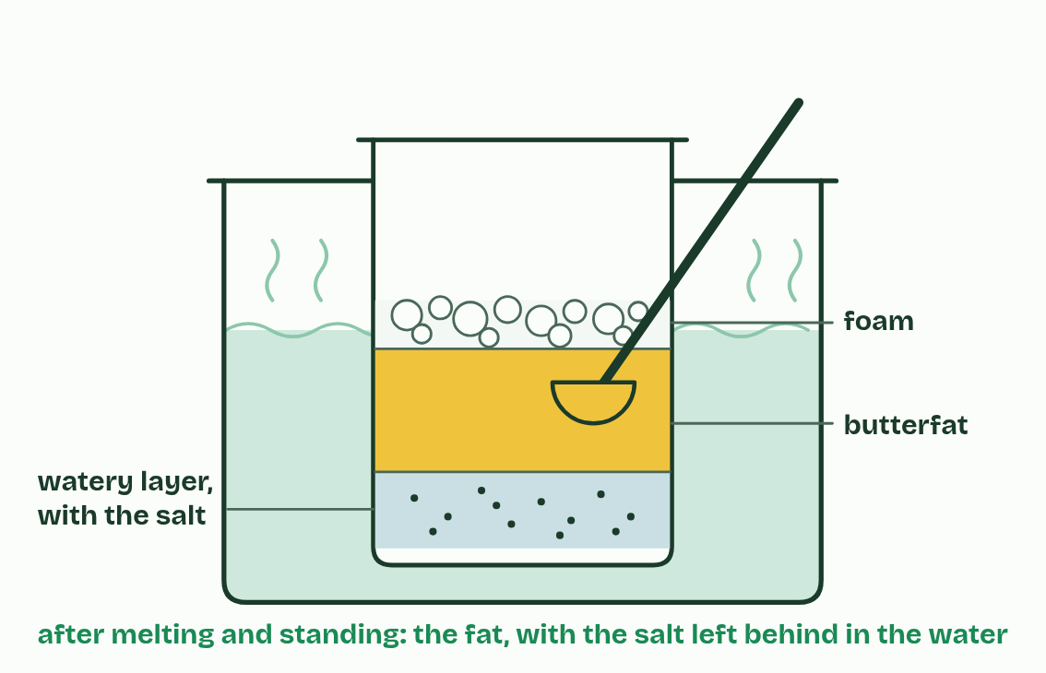  1 Shake oil with water,  2 and it separates and floats: it does not dissolve.  3 In a non-polar solvent such as hexane, it dissolves.  4 Butter is mostly fat, with some water and, in salted butter, salt.  5 Melted, the fat separates from the watery layer, and the salt stays dissolved in the water.  ANNOTATE THE FIGURE  The figure shows it as Triglyceride and Phospholipid. Note what changes each time.  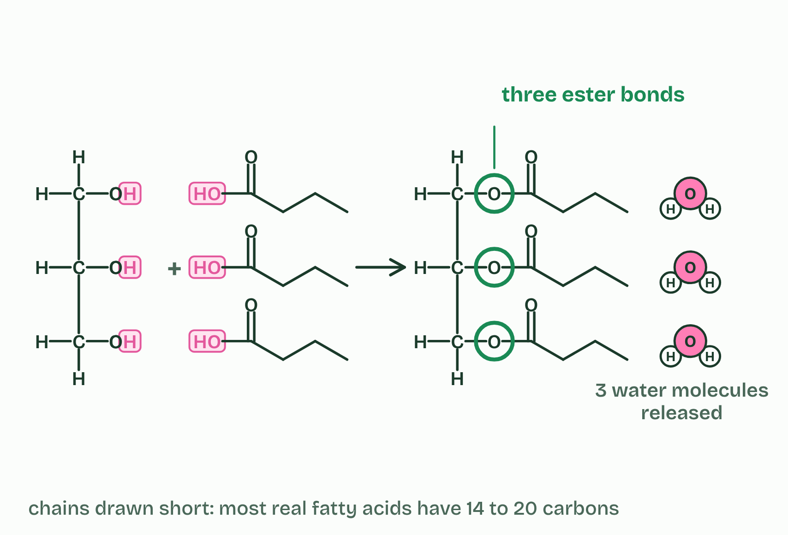  1 Triglyceride  2 Phospholipid
  SPOT THE MISTAKE
  What do students often get wrong about lipids, triglycerides and phospholipids? Write the mistake, then put it right.
  A fat is not a chain of “fat molecules”, and it is not a polymer: it is one glycerol carrying three fatty acids.
SUMMARY
Sum up section 07 in two or three sentences of your own.
• Lipids are substances made by living things that dissolve in non-polar solvents, such as hexane, but only sparingly in water.
• Lipids include fats, oils, waxes and steroids.
• Water molecules stay bonded to each other and push the lipid out into droplets or a separate layer: lipids are hydrophobic.
• Fats and oils are mostly triglycerides: one glycerol (three carbons, each with an OH group) joined to three fatty acids.

08 Every double bond puts a kink in the tail | B1.1.10
CUES  Predict: Olive oil’s fatty acids are mostly monounsaturated, and ordinary sunflower oil’s are mostly polyunsaturated. Both are liquid at room temperature. You put a bottle of each in the fridge at 5 °C. Which turns cloudy and thick?  B: Olive oil: fewer double bonds per chain, so a higher melting point. Olive oil. With mostly one double bond per chain, its chains pack better than sunflower oil’s, so it starts to solidify at fridge temperatures while sunflower oil stays clear. More double bonds, lower melting point. The dry lab lets you measure it.  What is meant by saturated?  A fatty acid with no C=C double bonds in its chain. Every carbon holds as many hydrogen atoms as it can.  What is meant by unsaturated?  A fatty acid with at least one C=C double bond in its chain.  What is meant by monounsaturated?  A fatty acid with one C=C double bond.  What is meant by polyunsaturated?  A fatty acid with two or more C=C double bonds.  What is meant by cis?  A double bond with the two parts of the chain on the same side of it, so the chain bends there.  What is meant by melting point?  The temperature at which a solid turns to a liquid.  What is meant by endotherm?  An animal that keeps its body warm with heat made inside it, such as a bird or a mammal. | NOTES  1 A saturated fatty acid has none: each carbon holds as many hydrogen atoms as it can, so the chain is saturated with hydrogen.  2 An unsaturated fatty acid has at least one C=C. With one it is monounsaturated, and with two or more it is polyunsaturated.  3 In natural fatty acids the double bonds are almost all cis: the chain continues on the same side at both ends of the double bond, so it bends there, by about 30°.  4 Kinks decide the melting point.  5 An endotherm keeps its body warm, about 37 °C in a mammal, so its fat can hold a far larger share of saturated fatty acids: often a third to a half, against about a tenth in plant oils.  Your own notes  ANNOTATE THE FIGURE  The figure shows it as Saturated, Monounsaturated and Polyunsaturated. Note what changes each time.  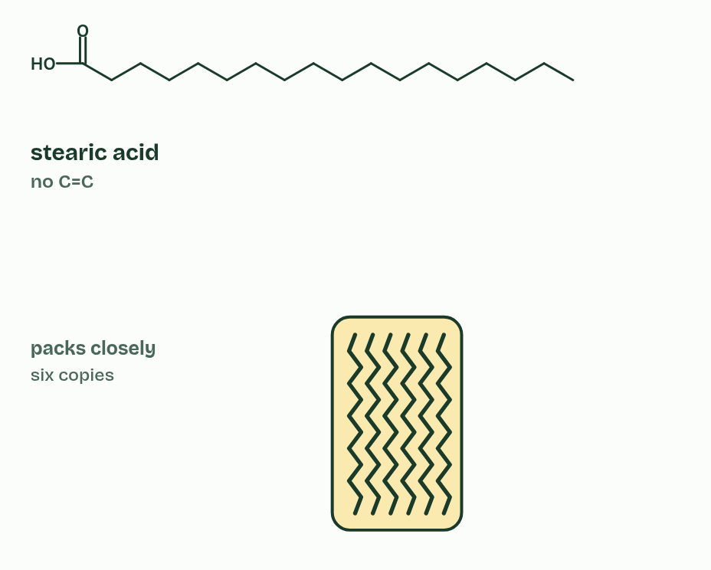  1 Saturated  2 Monounsaturated  3 Polyunsaturated  REMEMBER IT  Why unsaturated fats are oils
  D  Double | K  Kinks | L  Leave | L  Liquids
  C=C double bond  one in a monounsaturated chain, two or more in a polyunsaturated one | Kinked chain  each cis double bond bends the chain | Loose packing  bent chains cannot lie close, so they attract each other less | Lower melting point  less heat separates them: an oil at room temperature
  SPOT THE MISTAKE
  What do students often get wrong about saturated and unsaturated fatty acids? Write the mistake, then put it right.
  Melting does not break double bonds or any other covalent bond: it separates whole molecules.
SUMMARY
Sum up section 08 in two or three sentences of your own.
• A saturated fatty acid has none: each carbon holds as many hydrogen atoms as it can, so the chain is saturated with hydrogen.
• An unsaturated fatty acid has at least one C=C. With one it is monounsaturated, and with two or more it is polyunsaturated.
• In natural fatty acids the double bonds are almost all cis: the chain continues on the same side at both ends of the double bond, so it bends there, by about 30°.
• Kinks decide the melting point.

09 Fat: the lightest way to carry energy | B1.1.11
CUES  Predict: A seal and a cod swim in the same polar sea. Which needs a thick layer of fat to insulate it?  A: The seal: its body stays near 37 °C, much warmer than the water. The seal. It is an endotherm, holding its body near 37 °C in water close to freezing, and water draws heat away fast, so without blubber it would lose heat faster than it could make it. The cod is an ectotherm: its body sits at about the water’s temperature, so there is no warmth to keep in.  What is meant by adipose tissue?  Tissue made of cells that each hold a large droplet of triglyceride, under the skin and round organs.  What is meant by thermal insulation?  A layer that slows the loss of heat from the body.  What is meant by endotherm?  An animal that keeps its body warm with heat made inside it, such as a bird or mammal.  What is meant by blubber?  The thick layer of fat under the skin of seals and whales. It insulates them in cold water. | NOTES  1 Adipose tissue is made of cells that each hold a large droplet of triglyceride, under the skin and round organs.  2 Triglycerides also give thermal insulation.  3 An endotherm loses heat to colder surroundings faster the bigger the difference, and far faster in water than in air (A1.1, the ringed seal).  4 So endotherms in cold habitats, above all in polar seas, have thick layers of fat called blubber, and tropical mammals have thin ones.  Your own notes  ANNOTATE THE FIGURE  Label the key parts and add a note on what it shows.  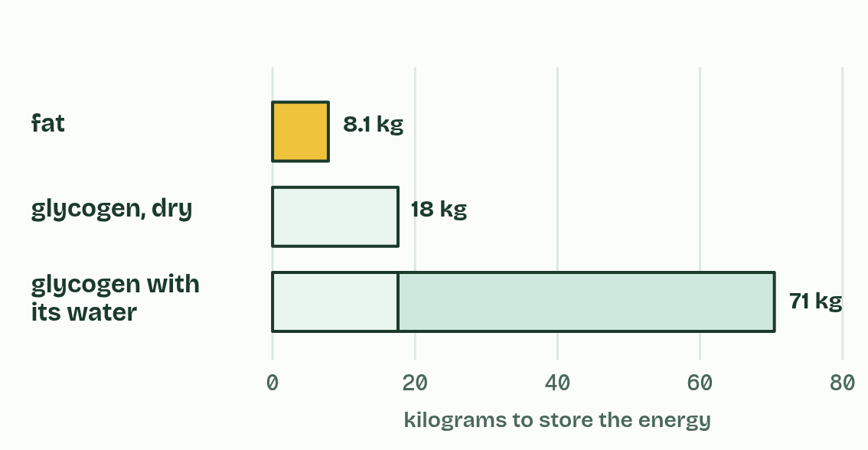  Assumes 10 000 kJ a day, 37 kJ g−1 for fat, 17 kJ g−1 for glycogen, and 3 g of water stored with every gram of glycogen.  ANNOTATE THE FIGURE  The figure shows it as Tropical sea 28 °C, Temperate sea 12 °C and Polar sea −2 °C. Note what changes each time.  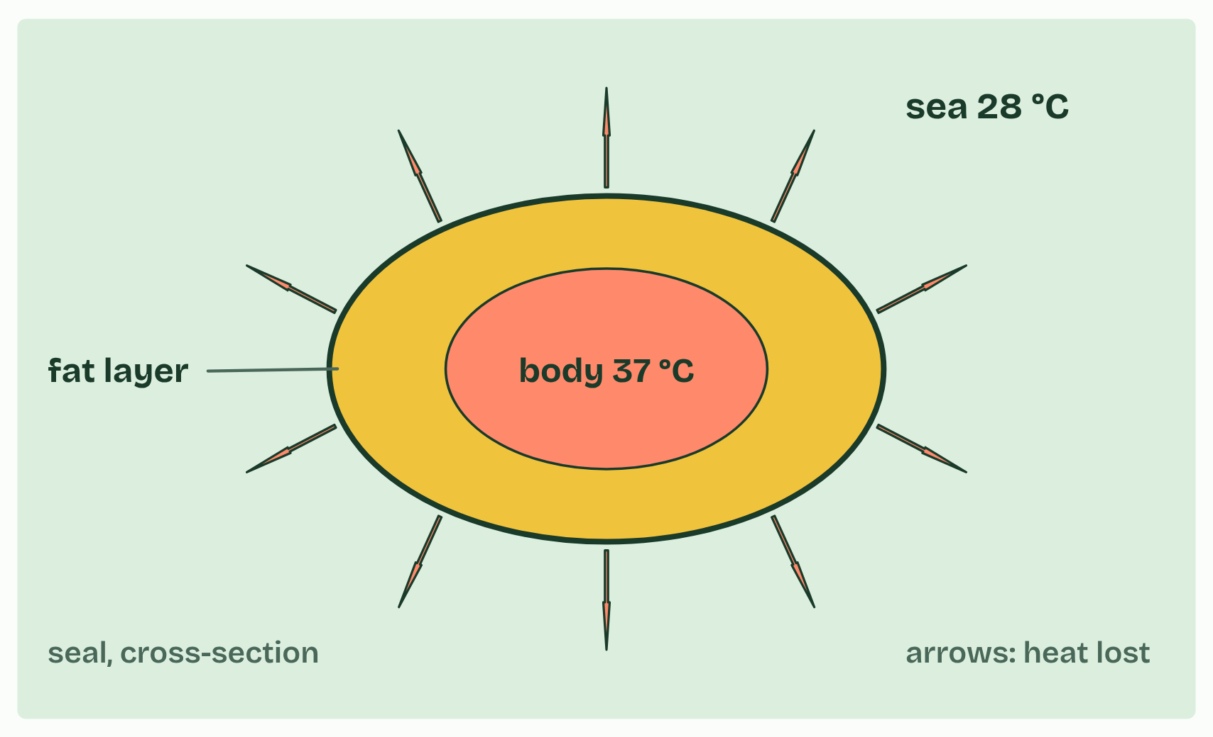  1 Tropical sea 28 °C  2 Temperate sea 12 °C  3 Polar sea −2 °C
  SPOT THE MISTAKE
  What do students often get wrong about adipose tissue? Write the mistake, then put it right.
  Not every carbohydrate store is short-term. Plants keep starch for months in seeds and tubers: “short-term” describes glycogen in animals.
SUMMARY
Sum up section 09 in two or three sentences of your own.
• Energy dense. Fat releases about twice the energy of carbohydrate for the same mass: about 37 kJ a gram, against about 17 kJ.
• Stored without water. Triglycerides are hydrophobic, so fat is stored dry. Glycogen is stored with about three times its own mass of water, so the same energy in fat weighs several times less. That matters to anything that moves, flies or migrates.
• Insoluble. Even a large store has no osmotic effect on the cell.
• Chemically stable. Fat keeps for months.

10 Half loves water, half does not | B1.1.12
CUES  Predict: Phospholipids are stirred into a beaker of water, well below the surface. What do they form?  C: A double layer: tails inside, heads facing the water on both sides. A bilayer. The tails cannot hydrogen-bond with water, so water molecules crowd them together, and the charged heads are attracted to water. Two layers, tails to tails, is the arrangement in which every head touches water and no tail does.  What is meant by amphipathic?  Having one part that is attracted to water and another part that is not.  What is meant by hydrophilic head?  The part of a phospholipid that is attracted to water: the phosphate group and glycerol.  What is meant by hydrophobic tails?  The two fatty acid chains of a phospholipid. They are non-polar and are pushed away by water.  What is meant by phospholipid bilayer?  A double layer of phospholipids, with the hydrophobic tails inside and the hydrophilic heads facing the water on both sides. | NOTES  1 A phospholipid is amphipathic: one part of the molecule is attracted to water and another part is not.  2 The phosphate group carries a negative charge and attracts water, and with the glycerol it forms the hydrophilic head.  3 The two fatty acid tails are non-polar, so they are the hydrophobic tails.  4 The result is two layers, with the tails pointing inwards and the heads facing the water on both sides: a phospholipid bilayer.  Your own notes  ANNOTATE THE FIGURE  Number the 4 steps on the figure and note what happens at each.  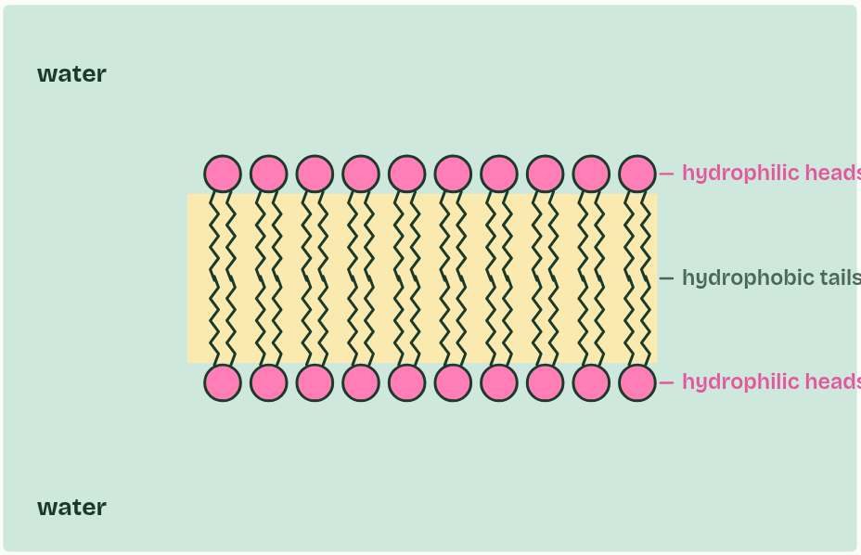  1 One molecule, two natures: amphipathic.  2 Mixed into water,  3 the tails turn away from water and the heads face it,  4 forming a bilayer, with water on both sides.  ANNOTATE THE FIGURE  Annotate this still from the animation (Watch it happen: a bilayer builds itself): what is happening, and why?  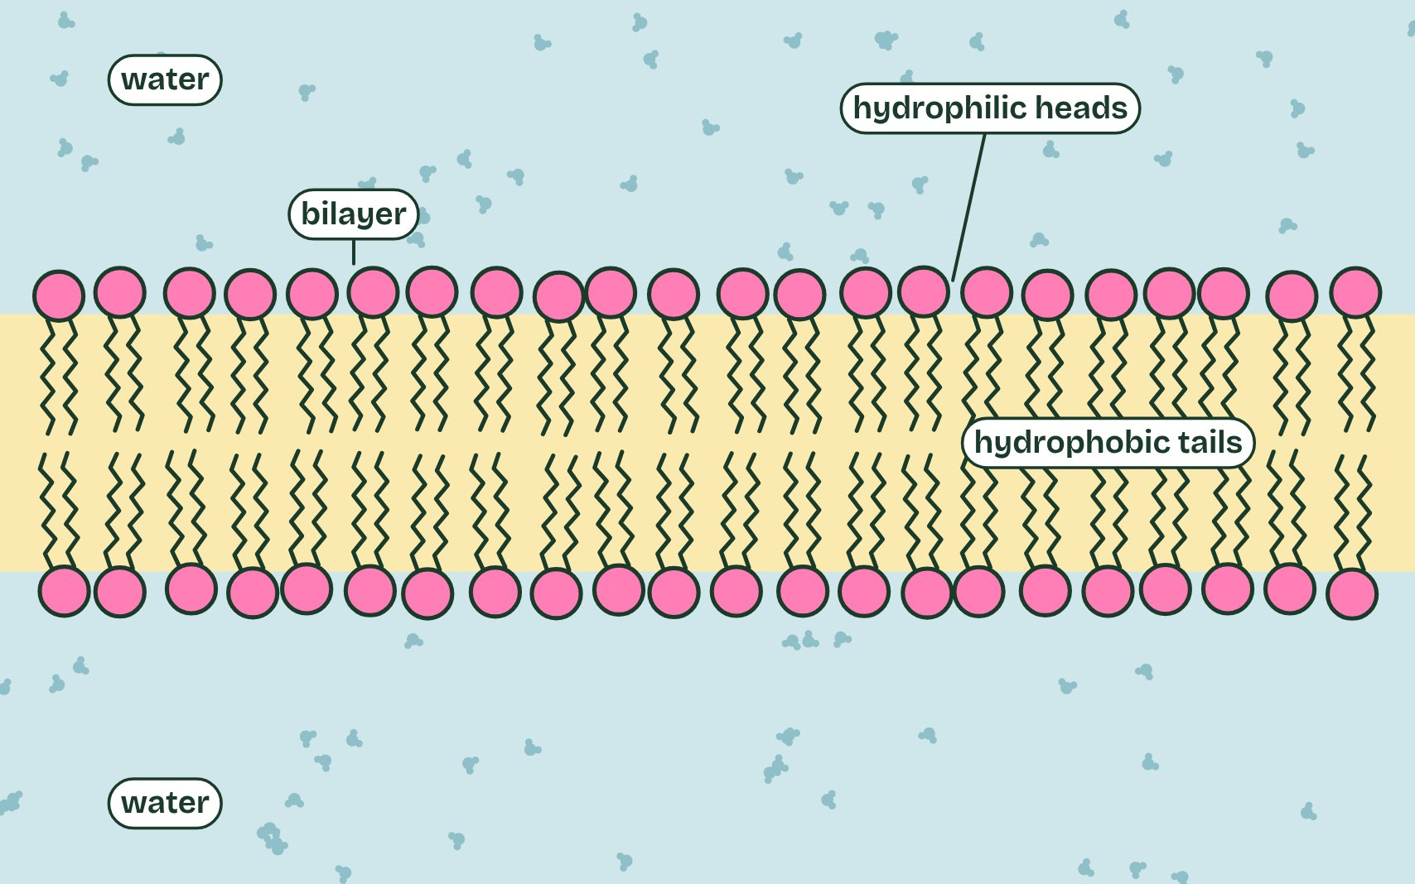  1 Phospholipids stirred into water point every which way.  2 The tails cannot form hydrogen bonds with water, so water crowds the tails together.  3 No enzyme placed them and no energy was spent: water arranged them.
  SPOT THE MISTAKE
  What do students often get wrong about the phospholipid bilayer? Write the mistake, then put it right.
  Cells do not build the bilayer by placing each phospholipid with an enzyme. Once the molecules are made, water arranges them.
SUMMARY
Sum up section 10 in two or three sentences of your own.
• A phospholipid is amphipathic: one part of the molecule is attracted to water and another part is not.
• The phosphate group carries a negative charge and attracts water, and with the glycerol it forms the hydrophilic head.
• The two fatty acid tails are non-polar, so they are the hydrophobic tails.
• The result is two layers, with the tails pointing inwards and the heads facing the water on both sides: a phospholipid bilayer.

11 Four rings, and straight through the membrane | B1.1.13
CUES  Predict: Testosterone crosses a membrane with no transport protein. Glucose cannot. Why?  B: Testosterone is non-polar, so it dissolves in the bilayer’s core. Polarity, not size. Testosterone (Mr 288) is bigger than glucose (Mr 180), but it is mostly hydrocarbon, so it mixes into the hydrophobic core. Glucose’s many OH groups bind water and are repelled by the core.  What is meant by steroids?  Lipids built on four fused rings of carbon atoms: three rings of six carbons and one of five, sharing edges.  What is meant by oestradiol?  A steroid sex hormone, the main oestrogen. It has two OH groups on its four rings.  What is meant by testosterone?  A steroid sex hormone, mainly made in the testes. It has an OH group and a C=O group on its four rings. | NOTES  1 Steroids are lipids built on four fused rings: three rings of six carbons and one of five, sharing edges.  2 Cholesterol, which sits in animal cell membranes (B2.1), is a steroid, and so are the sex hormones oestradiol and testosterone.  Your own notes  ANNOTATE THE FIGURE  Label each part and say what it does: testosterone, α-glucose, a steroid skeleton, part of an amylose chain, oestradiol, a triglyceride.  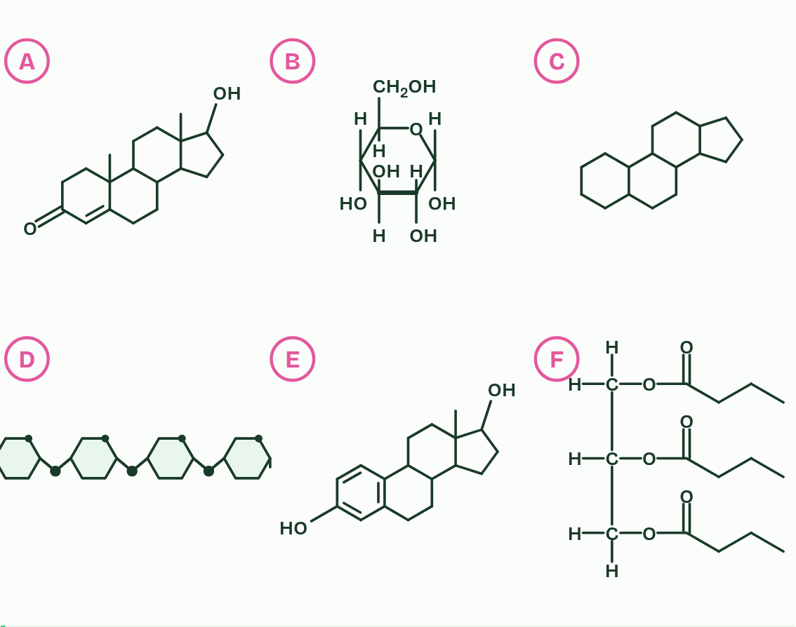  1 Testosterone: A steroid: four fused rings, three of six carbons and one of five, sharing edges.  2 α-glucose: Not a steroid: it has a single ring, of five carbons and an oxygen, with groups attached.  3 A steroid skeleton: A steroid: four fused rings, three of six carbons and one of five. Nothing is attached, but the block is what makes it a steroid. Cholesterol and the sex hormones are this block with groups added.  4 Part of an amylose chain: Not a steroid: it has four rings, but they are joined by oxygen bridges, not fused. Each ring is a whole glucose unit.  5 Oestradiol: A steroid: four fused rings, three of six carbons and one of five. The first ring is drawn with three double bonds.  6 A triglyceride: Not a steroid: one glycerol carrying three fatty acid chains. It is a lipid, but it has no fused rings.  ANNOTATE THE FIGURE  Number the 5 steps on the figure and note what happens at each.  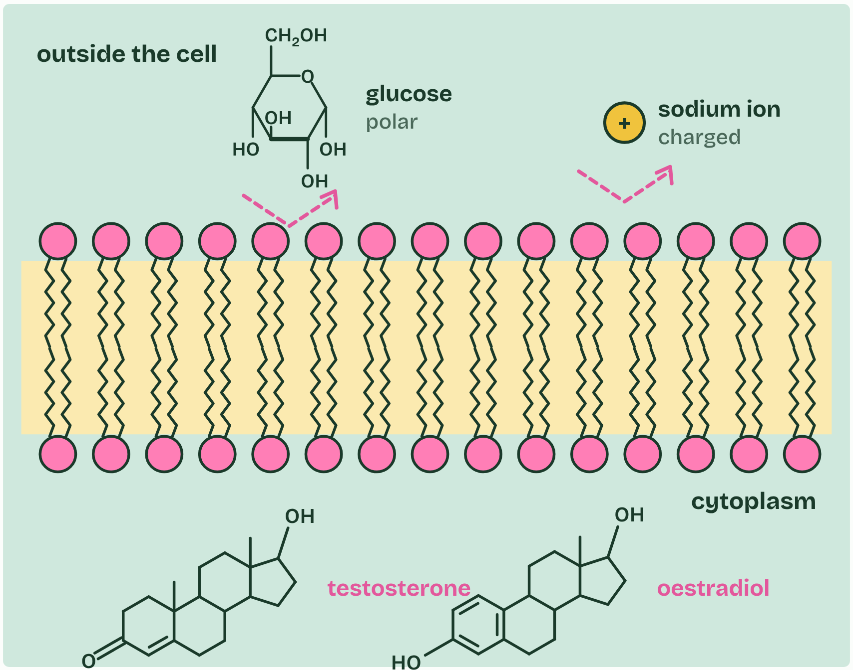  1 The bilayer’s core is hydrophobic.  2 Non-polar testosterone dissolves into the core,  3 and diffuses out the other side.  4 Oestradiol crosses the same way.  5 Polar glucose and charged ions cannot cross the core: they need proteins (B2.1).
  SPOT THE MISTAKE
  What do students often get wrong about steroids? Write the mistake, then put it right.
  Not every lipid is a steroid, and not every steroid is a hormone: cholesterol is a steroid that sits in membranes.
SUMMARY
Sum up section 11 in two or three sentences of your own.
• Steroids are lipids built on four fused rings: three rings of six carbons and one of five, sharing edges.
• Cholesterol, which sits in animal cell membranes (B2.1), is a steroid, and so are the sex hormones oestradiol and testosterone.

Check yourself
The check for this guide is online: a fresh paper of past-paper style questions from the exam bank on B1.1 each time, marked as you go, and saved to your Exam practice progress when you are signed in. Open the link:
biologybybradford.com/exam-maker/sit?topics=B1.1&level=HL&paper=quiz&marks=15&src=ep

