Name | Class | Date
IB BIOLOGY · B1.1

Carbohydrates and lipids
Notes to fill in alongside the guide. Each numbered block matches a chapter of the guide, and of the lesson slides. Write in the gaps, answer the cues, annotate the figures, and sum up each section in your own words.
BY THE END YOU CAN
Explain how carbon's four covalent bonds let it build chains, branches and rings B1.1.1
Describe how condensation joins monomers into polymers and hydrolysis splits them, saying where the water goes B1.1.2, B1.1.3
Tell pentoses from hexoses and alpha from beta glucose in ring diagrams, and link glucose's properties to its uses B1.1.4
Explain how coiling, branching and size suit starch and glycogen to storing energy B1.1.5
Explain how alternating beta glucose gives cellulose straight chains, bundled by hydrogen bonds B1.1.6
Explain how glycoproteins let cells recognise each other, using the ABO blood groups B1.1.7
Explain why lipids are hydrophobic, and how condensation builds triglycerides and phospholipids B1.1.8, B1.1.9
Compare saturated, monounsaturated and polyunsaturated fatty acids and explain their melting points B1.1.10
Explain why triglycerides suit long-term energy storage and insulation, and compare them with carbohydrates as stores B1.1.11
Explain how amphipathic phospholipids form a bilayer in water B1.1.12
Identify a steroid from its four rings and explain how oestradiol and testosterone cross the bilayer B1.1.13

01 Chains, branches and rings | B1.1.1
CUES  Predict: A drawing shows a carbon atom with a double bond to an oxygen, a single bond to another carbon and single bonds to two hydrogens. What is wrong with it?  What is meant by covalent bond?  What is meant by double bond?  What is meant by carbon compound?  What is meant by chain?  What is meant by ring? | NOTES  1 A __________________ is a pair of electrons shared by two atoms, and the shared pair holds them together.  2 A carbon atom has four electrons in its outer shell to share, so it can make up to four covalent bonds: four single bonds, or a _______________ plus two single bonds.  3 A ____________________ can have a ________, either unbranched, like the tail of a fatty acid, or branched; a single ________, like glucose; or several rings fused together, as in a steroid.  4 Carbon makes four bonds in total, and a _______________ counts as two.  Your own notes  ANNOTATE THE FIGURE  Number the 5 steps on the figure and note what happens at each: 1 covalent bond; 2 four; 3 double bond; 4 chains; 5 rings.  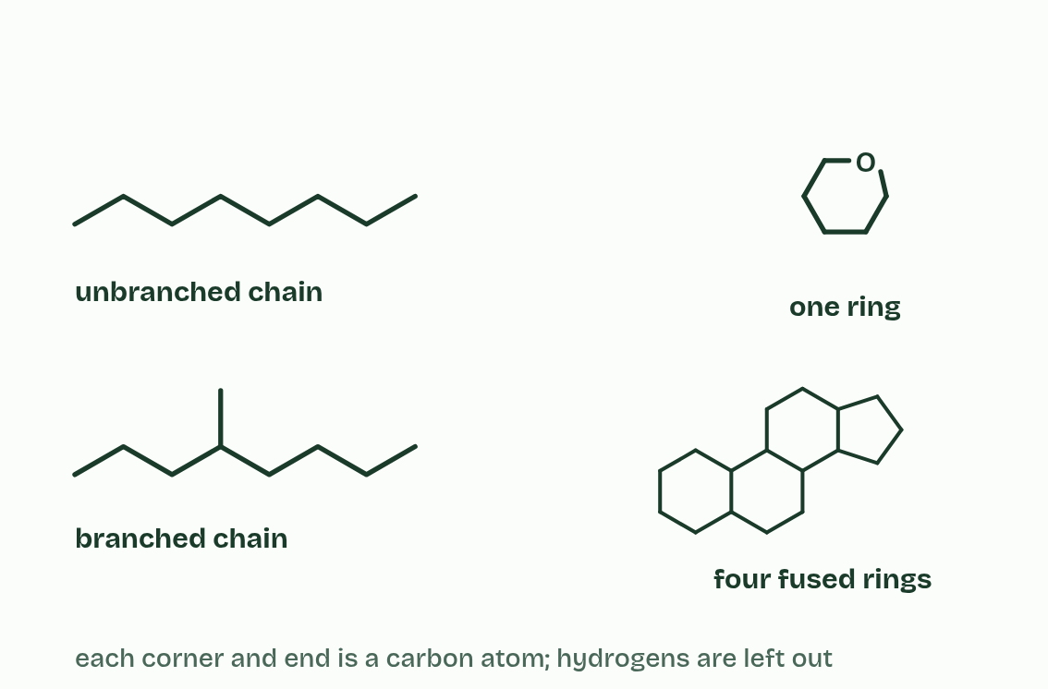  ANNOTATE THE FIGURE  Label each part and say what it does: kilo (k), × 1000., centi (c), ÷ 100., milli (m), ÷ 1000., micro (µ), ÷ 1 000 000., nano (n), ÷ 1 000 000 000..  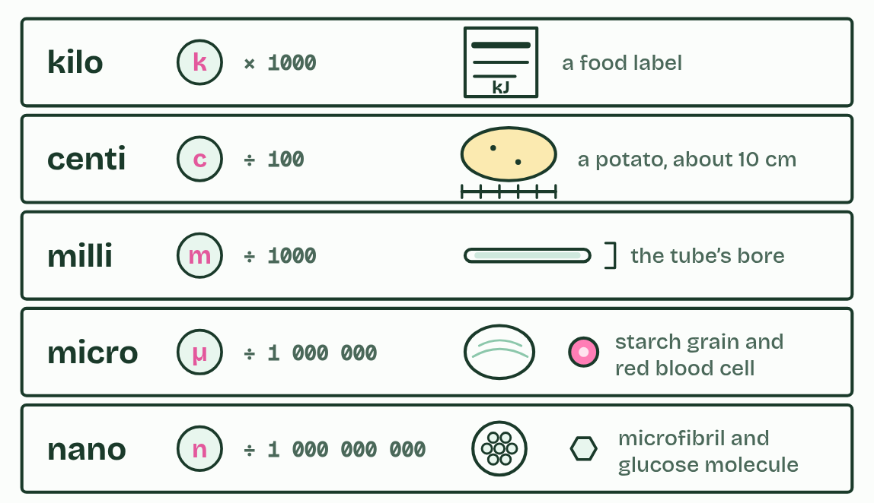
  SPOT THE MISTAKE
  What do students often get wrong about carbon compounds? Write the mistake, then put it right.
  The mistake
  Put it right
SUMMARY
Sum up section 01 in two or three sentences of your own.

02 Water out to build, water in to break | B1.1.2 B1.1.3
CUES  Predict: Ten glucose molecules are joined into one unbranched chain. How many water molecules were released?  What is meant by polymers?  What is meant by monomers?  What is meant by macromolecules?  What is meant by condensation reaction?  What is meant by polysaccharides?  What is meant by glycosidic bonds?  What is meant by hydrolysis? | NOTES  1 Many of life’s large molecules are ___________: long chains of similar small units called ___________.  2 Very large molecules like these are ___________________.  3 Monomers are joined by a ____________________________.  4 Three families of polymer are built this way. ____________________ are monosaccharides joined by ______________________.  5 ______________ runs the other way: hydro means water and lysis means splitting.  Your own notes  ANNOTATE THE FIGURE  Number the 5 steps on the figure and note what happens at each: 1 monomers; 2 Condensation; 3 glycosidic bond; 4 polymer; 5 Hydrolysis.  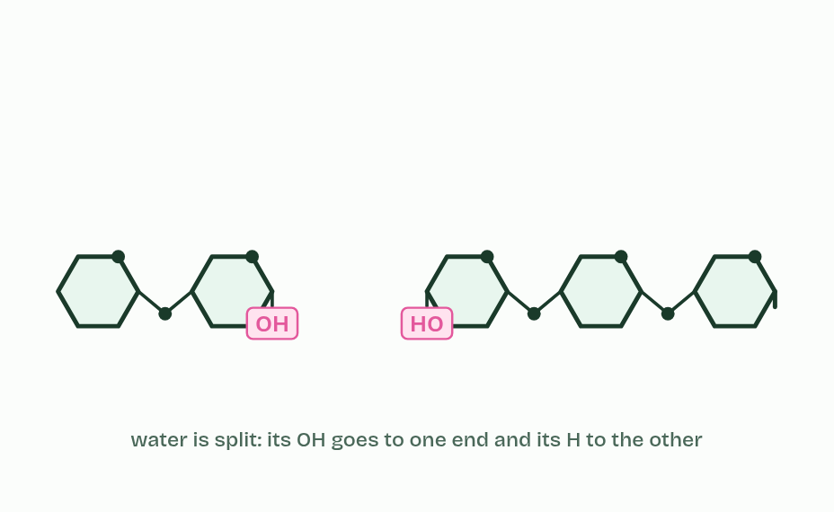  ANNOTATE THE FIGURE  Number the 4 steps on the figure and note what happens at each: 1 alpha glucose; 2 carbon 1, carbon 4; 3 water, 1,4 glycosidic bond, condensation; 4 hydrolysis.  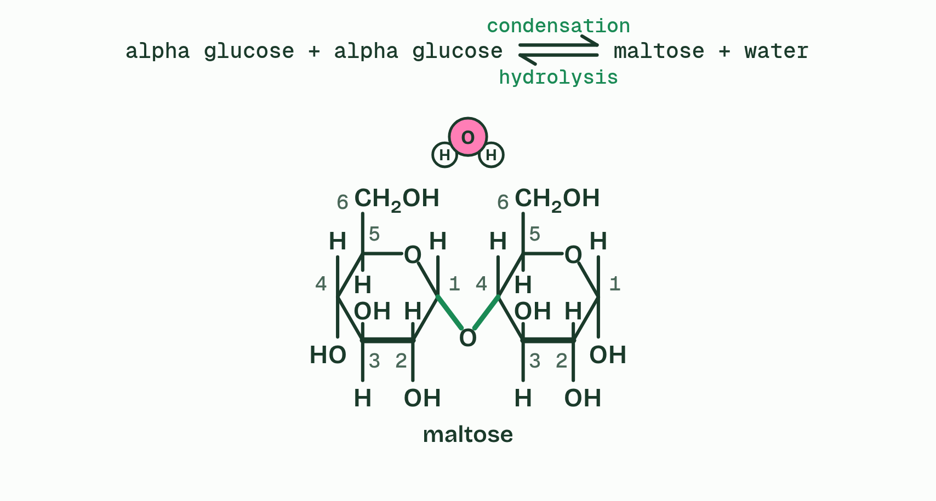
  SPOT THE MISTAKE
  What do students often get wrong about condensation and hydrolysis? Write the mistake, then put it right.
  The mistake
  Put it right
SUMMARY
Sum up section 02 in two or three sentences of your own.

03 Glucose: small, soluble and stable | B1.1.4
CUES  Predict: Sugar C in the second figure has a five-sided ring. Is it a pentose or a hexose?  What is meant by monosaccharide?  What is meant by pentose?  What is meant by hexose?  What is meant by alpha (α) glucose?  What is meant by beta (β) glucose?  What is meant by isomers? | NOTES  1 A ___________________ is one sugar unit, the monomer of carbohydrates.  2 In cells most monosaccharides exist as rings. They are named by their number of carbon atoms: a _________ has five (ribose, deoxyribose) and a ________ has six (glucose, fructose).  3 Glucose comes in two forms with the same formula, C₆H₁₂O₆: _______________________ and ______________________.  4 They are _________.  Your own notes  ANNOTATE THE FIGURE  The figure shows it as α-glucose, β-glucose and Both. Note what changes each time.  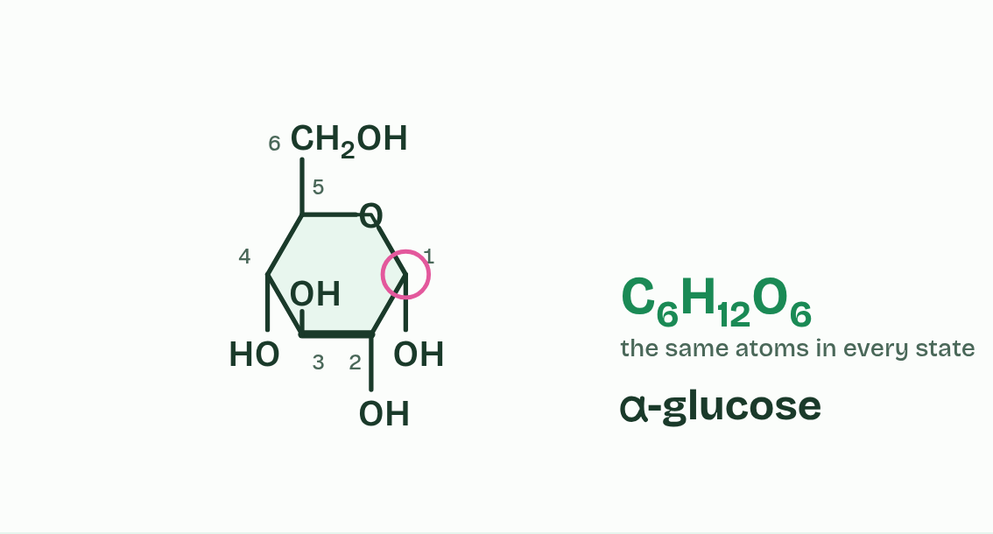  ANNOTATE THE FIGURE  Label each part and say what it does: α-glucose, ribose, fructose, β-glucose, deoxyribose.  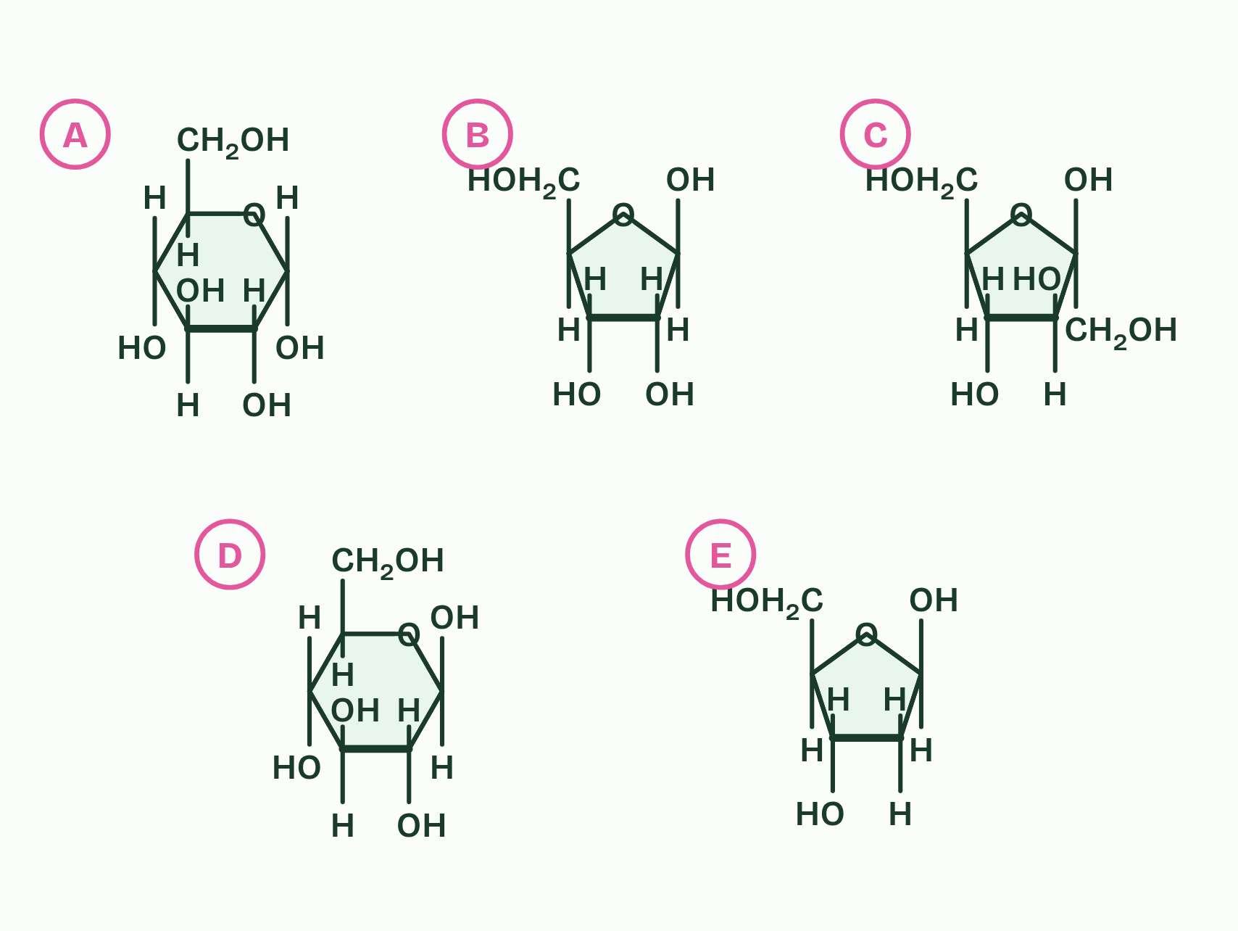  REMEMBER IT  ABBA: which way carbon 1’s OH points  REMEMBER IT  Why glucose is the sugar on the move
  A  Alpha | B  Beta
  A | B
  S  Sweet | T  Treats | S  Stay | E  Energetic
  S | T | S | E
  SPOT THE MISTAKE
  What do students often get wrong about monosaccharides? Write the mistake, then put it right.
  The mistake
  Put it right
SUMMARY
Sum up section 03 in two or three sentences of your own.

04 Starch and glycogen: energy packed tight | B1.1.5
CUES  Predict: An amylose molecule and a glycogen molecule hold the same number of glucose units. A sprinter’s muscles suddenly need glucose. Which store can release it faster?  What is meant by starch?  What is meant by glycogen?  What is meant by amylose?  What is meant by amylopectin?  What is meant by branches? | NOTES  1 Plants store energy as ________ and animals (and fungi) store it as ___________.  2 Starch is a mixture of two polysaccharides. _________ is an unbranched chain that coils into a helix. _______________ is a coiled chain with ___________ coming off it.  Your own notes  ANNOTATE THE FIGURE  The figure shows it as Amylose, Amylopectin and Glycogen. Note what changes each time.  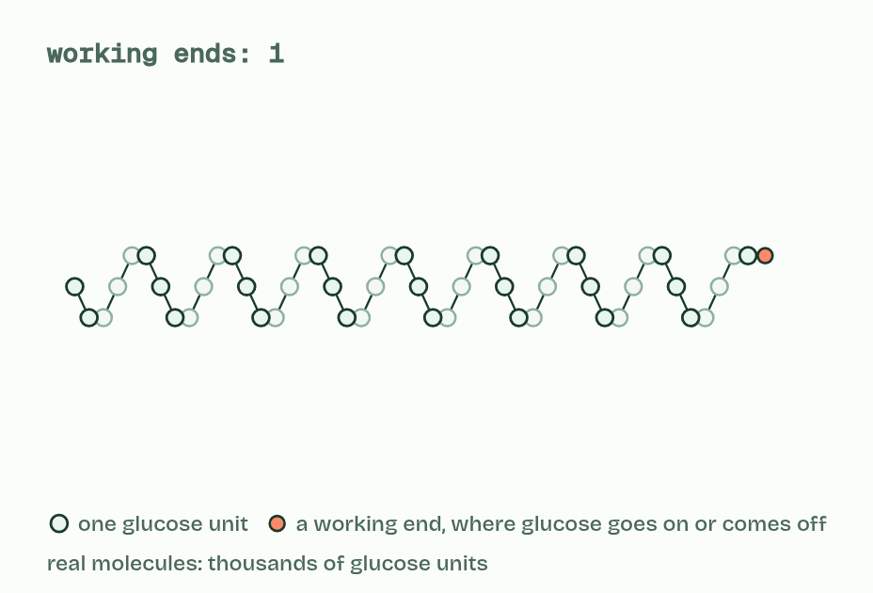  ANNOTATE THE FIGURE  Annotate this still from the animation (Watch it happen: building and using a store): what is happening, and why?  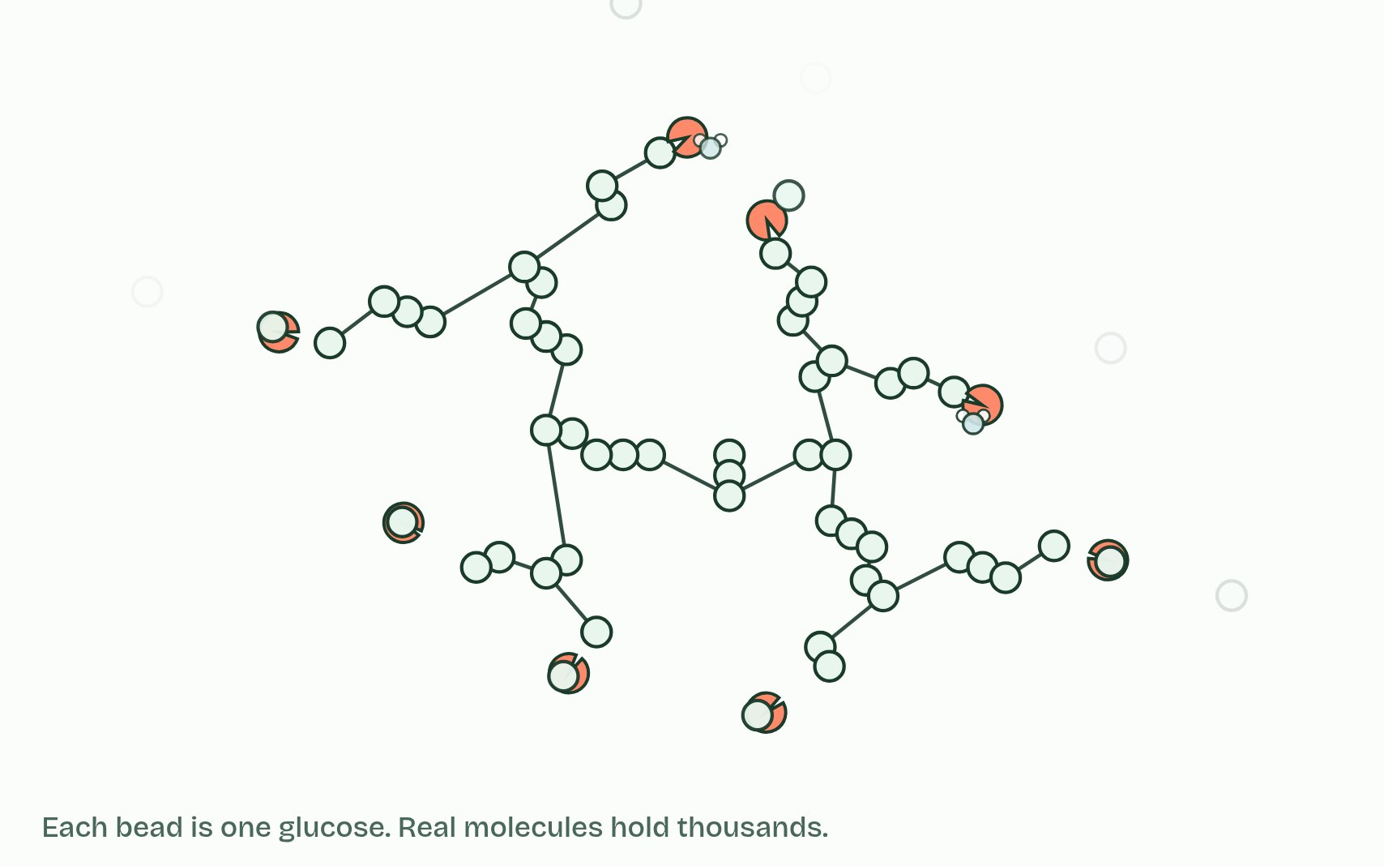
  SPOT THE MISTAKE
  What do students often get wrong about starch and glycogen? Write the mistake, then put it right.
  The mistake
  Put it right
SUMMARY
Sum up section 04 in two or three sentences of your own.

05 Turn every other glucose over and the chain runs straight | B1.1.6
CUES  Predict: Cellulose chains lie side by side in bundles. What holds neighbouring chains together?  What is meant by cellulose?  What is meant by cell walls?  What is meant by hydrogen bonds?  What is meant by microfibrils?  What is meant by tensile strength? | NOTES  1 ____________ is an unbranched polymer of β-glucose and the main material of plant ______________. β-glucose does not join to itself the way α-glucose does.  2 Straight chains lie side by side, and OH groups on neighbouring chains form ___________________ that cross-link them into bundles called ________________.  3 One hydrogen bond is weak, but there are thousands along every chain, and together they make a microfibril very strong when pulled: it has high ______________________.  4 Two ________________ molecules. Their OH groups point opposite ways.  5 Turn one ________ and they can join: water leaves and a bond forms.  6 Every other unit is turned over, so the chain runs ___________.  Your own notes  ANNOTATE THE FIGURE  Number the 6 steps on the figure and note what happens at each: 1 beta glucose; 2 over; 3 straight; 4 hydrogen bonds; 5 microfibrils; 6 cell wall.  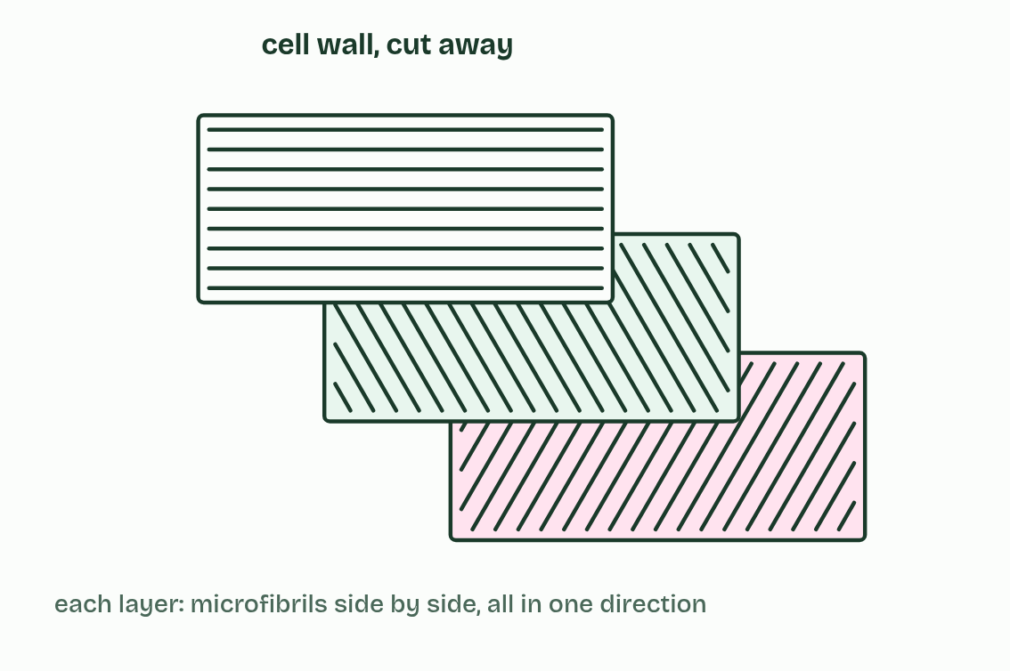  ANNOTATE THE FIGURE  Number the 4 steps on the figure and note what happens at each: 1 beta glucose; 2 carbon 1, carbon 4; 3 water, 1,4 glycosidic bond, cellulose, condensation; 4 hydrolysis.  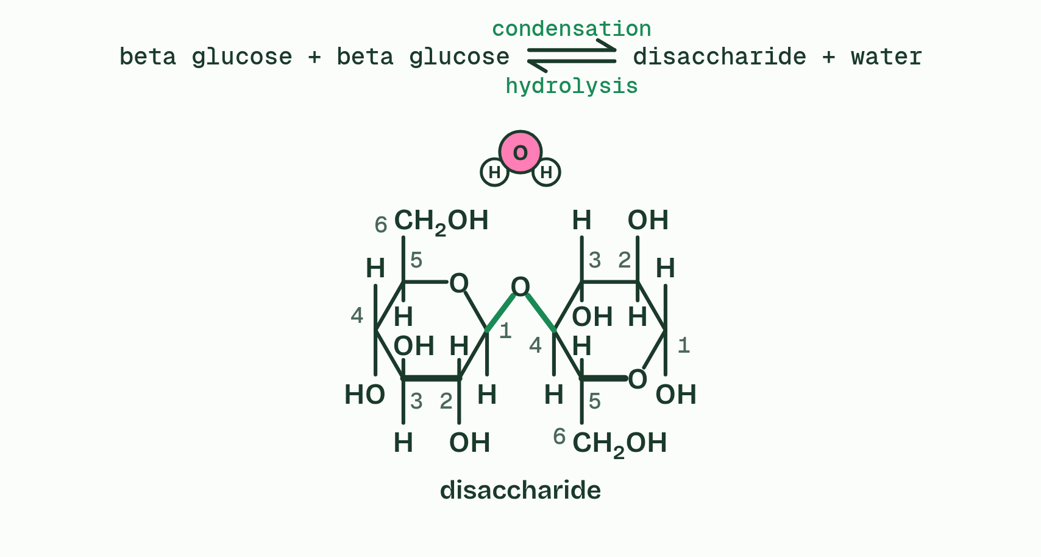
  SPOT THE MISTAKE
  What do students often get wrong about cellulose? Write the mistake, then put it right.
  The mistake
  Put it right
SUMMARY
Sum up section 05 in two or three sentences of your own.

06 Sugar name tags on the cell surface | B1.1.7
CUES  Predict: What makes a group A red blood cell different from a group B one?  What is meant by glycoprotein?  What is meant by cell-cell recognition?  What is meant by antigens? | NOTES  1 A ________________ is a protein with carbohydrate chains attached.  2 Carbohydrate chains can differ in which monosaccharides they contain, in the order of those sugars and in how the chain branches, so they can take a huge number of forms. That makes them good identity tags, and other cells read them: this is ____________________________.  3 The A and B forms are ___________.  Your own notes  ANNOTATE THE FIGURE  Label each part and say what it does: protein part, no A or B sugar, no A or B sugar, protein part, no A or B sugar, no A or B sugar, protein part, no A or B sugar, no A or B sugar.  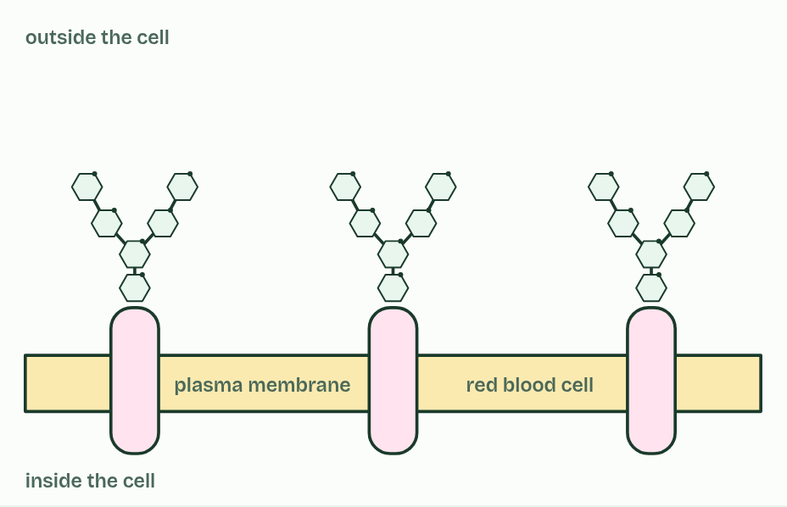
  SPOT THE MISTAKE
  What do students often get wrong about glycoproteins? Write the mistake, then put it right.
  The mistake
  Put it right
SUMMARY
Sum up section 06 in two or three sentences of your own.

07 Lipids keep their distance from water | B1.1.8 B1.1.9
CUES  Predict: You have salted butter but need it unsalted. What could you do?  What is meant by lipids?  What is meant by non-polar solvents?  What is meant by fats?  What is meant by oils?  What is meant by waxes?  What is meant by hydrophobic?  What is meant by triglycerides?  What is meant by glycerol?  What is meant by fatty acids?  What is meant by carboxyl group?  What is meant by ester bond?  What is meant by phospholipid?  What is meant by phosphate group? | NOTES  1 ________ are substances made by living things that dissolve in ________________________, such as hexane, but only sparingly in water.  2 Lipids include ________, ________, ________ and steroids.  3 Water molecules stay bonded to each other and push the lipid out into droplets or a separate layer: lipids are _______________.  4 Fats and oils are mostly __________________: one ___________ (three carbons, each with an OH group) joined to three _______________.  5 A fatty acid is a hydrocarbon chain with a ___________________, COOH, at one end.  6 Each one joins glycerol by condensation: the OH of the carboxyl group and the H of one of glycerol’s OH groups leave as water, and an ______________ forms.  7 A ________________ is glycerol joined to two fatty acids and one ____________________, also by condensation.  Your own notes  ANNOTATE THE FIGURE  Number the 5 steps on the figure and note what happens at each.  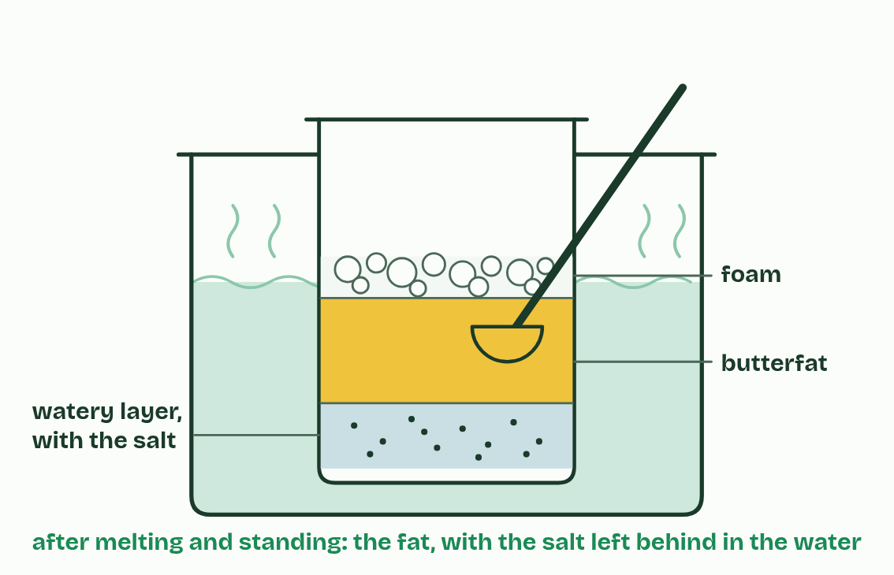  ANNOTATE THE FIGURE  The figure shows it as Triglyceride and Phospholipid. Note what changes each time.  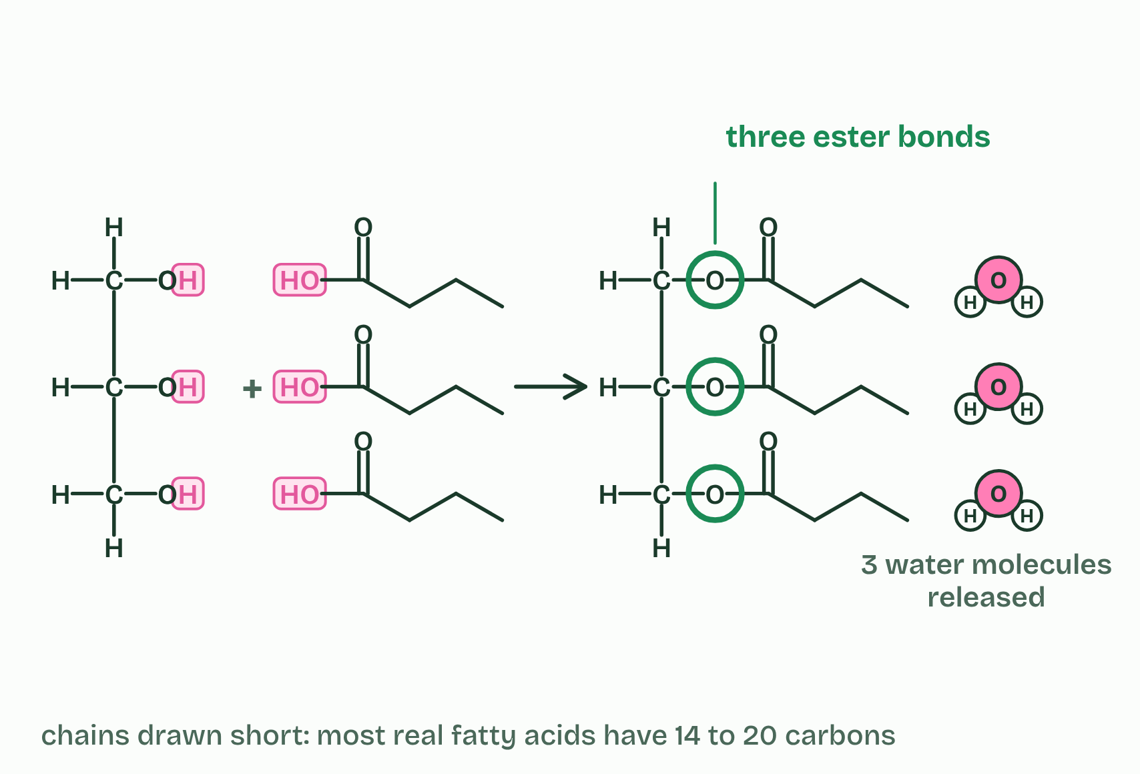
  SPOT THE MISTAKE
  What do students often get wrong about lipids, triglycerides and phospholipids? Write the mistake, then put it right.
  The mistake
  Put it right
SUMMARY
Sum up section 07 in two or three sentences of your own.

08 Every double bond puts a kink in the tail | B1.1.10
CUES  Predict: Olive oil’s fatty acids are mostly monounsaturated, and ordinary sunflower oil’s are mostly polyunsaturated. Both are liquid at room temperature. You put a bottle of each in the fridge at 5 °C. Which turns cloudy and thick?  What is meant by saturated?  What is meant by unsaturated?  What is meant by monounsaturated?  What is meant by polyunsaturated?  What is meant by cis?  What is meant by melting point?  What is meant by endotherm? | NOTES  1 A ____________ fatty acid has none: each carbon holds as many hydrogen atoms as it can, so the chain is saturated with hydrogen.  2 An _______________ fatty acid has at least one C=C. With one it is ____________________, and with two or more it is ____________________.  3 In natural fatty acids the double bonds are almost all ________: the chain continues on the same side at both ends of the double bond, so it bends there, by about 30°.  4 Kinks decide the __________________.  5 An ____________ keeps its body warm, about 37 °C in a mammal, so its fat can hold a far larger share of saturated fatty acids: often a third to a half, against about a tenth in plant oils.  Your own notes  ANNOTATE THE FIGURE  The figure shows it as Saturated, Monounsaturated and Polyunsaturated. Note what changes each time.  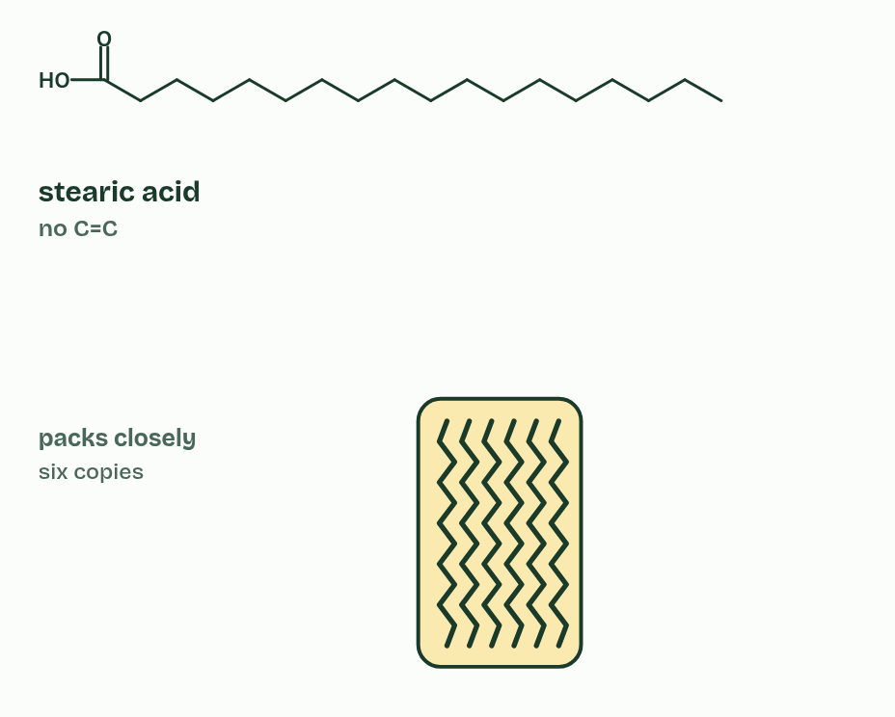  REMEMBER IT  Why unsaturated fats are oils
  D  Double | K  Kinks | L  Leave | L  Liquids
  D | K | L | L
  SPOT THE MISTAKE
  What do students often get wrong about saturated and unsaturated fatty acids? Write the mistake, then put it right.
  The mistake
  Put it right
SUMMARY
Sum up section 08 in two or three sentences of your own.

09 Fat: the lightest way to carry energy | B1.1.11
CUES  Predict: A seal and a cod swim in the same polar sea. Which needs a thick layer of fat to insulate it?  What is meant by adipose tissue?  What is meant by thermal insulation?  What is meant by endotherm?  What is meant by blubber? | NOTES  1 ___________________ is made of cells that each hold a large droplet of triglyceride, under the skin and round organs.  2 Triglycerides also give ________________________.  3 An ____________ loses heat to colder surroundings faster the bigger the difference, and far faster in water than in air (A1.1, the ringed seal).  4 So endotherms in cold habitats, above all in polar seas, have thick layers of fat called _________, and tropical mammals have thin ones.  Your own notes  ANNOTATE THE FIGURE  Label the key parts and add a note on what it shows.  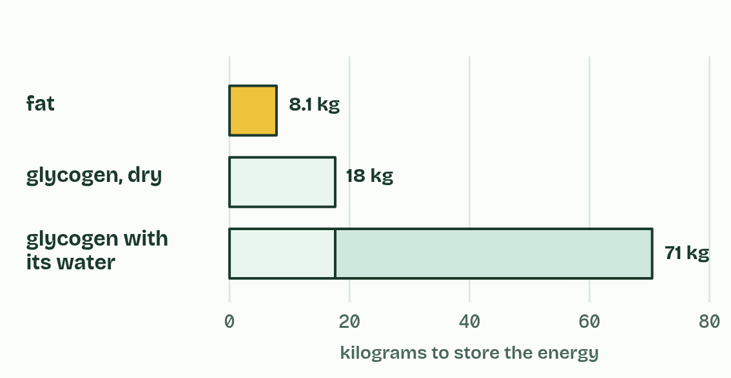  ANNOTATE THE FIGURE  The figure shows it as Tropical sea 28 °C, Temperate sea 12 °C and Polar sea −2 °C. Note what changes each time.  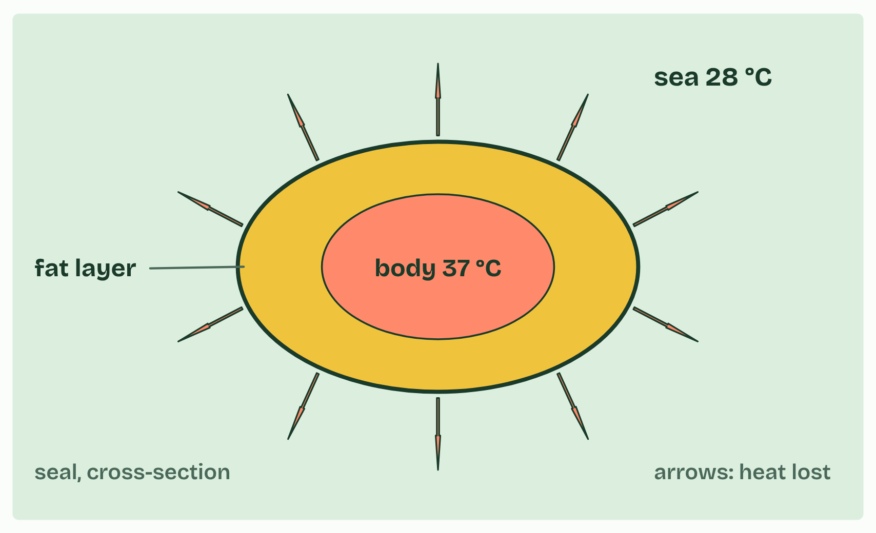
  SPOT THE MISTAKE
  What do students often get wrong about adipose tissue? Write the mistake, then put it right.
  The mistake
  Put it right
SUMMARY
Sum up section 09 in two or three sentences of your own.

10 Half loves water, half does not | B1.1.12
CUES  Predict: Phospholipids are stirred into a beaker of water, well below the surface. What do they form?  What is meant by amphipathic?  What is meant by hydrophilic head?  What is meant by hydrophobic tails?  What is meant by phospholipid bilayer? | NOTES  1 A phospholipid is _______________: one part of the molecule is attracted to water and another part is not.  2 The phosphate group carries a negative charge and attracts water, and with the glycerol it forms the ______________________.  3 The two fatty acid tails are non-polar, so they are the _______________________.  4 The result is two layers, with the tails pointing inwards and the heads facing the water on both sides: a ___________________________.  Your own notes  ANNOTATE THE FIGURE  Number the 4 steps on the figure and note what happens at each.  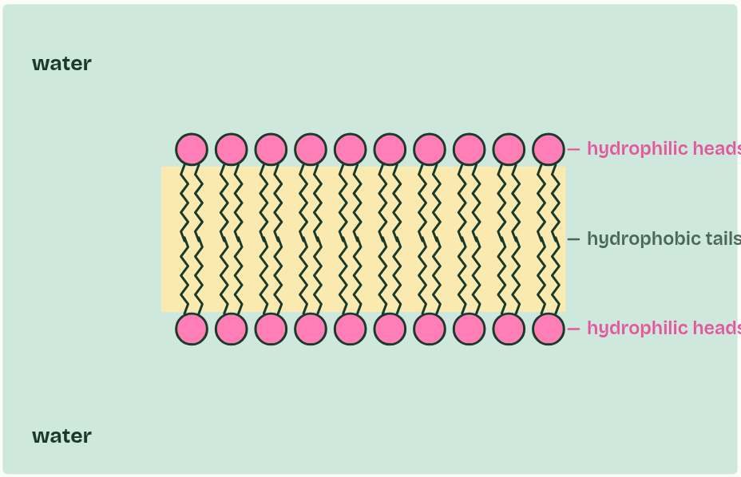  ANNOTATE THE FIGURE  Annotate this still from the animation (Watch it happen: a bilayer builds itself): what is happening, and why?  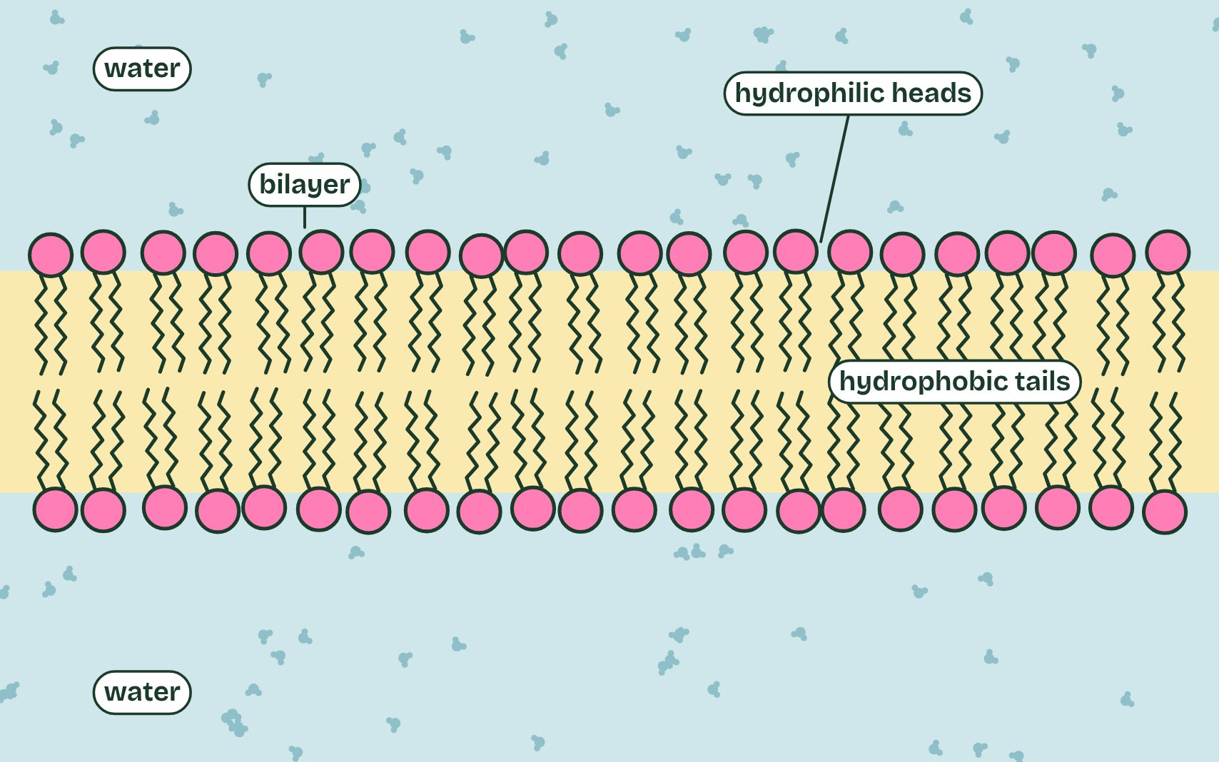
  SPOT THE MISTAKE
  What do students often get wrong about the phospholipid bilayer? Write the mistake, then put it right.
  The mistake
  Put it right
SUMMARY
Sum up section 10 in two or three sentences of your own.

11 Four rings, and straight through the membrane | B1.1.13
CUES  Predict: Testosterone crosses a membrane with no transport protein. Glucose cannot. Why?  What is meant by steroids?  What is meant by oestradiol?  What is meant by testosterone? | NOTES  1 ___________ are lipids built on four fused rings: three rings of six carbons and one of five, sharing edges.  2 Cholesterol, which sits in animal cell membranes (B2.1), is a steroid, and so are the sex hormones ______________ and ________________.  Your own notes  ANNOTATE THE FIGURE  Label each part and say what it does: testosterone, α-glucose, a steroid skeleton, part of an amylose chain, oestradiol, a triglyceride.  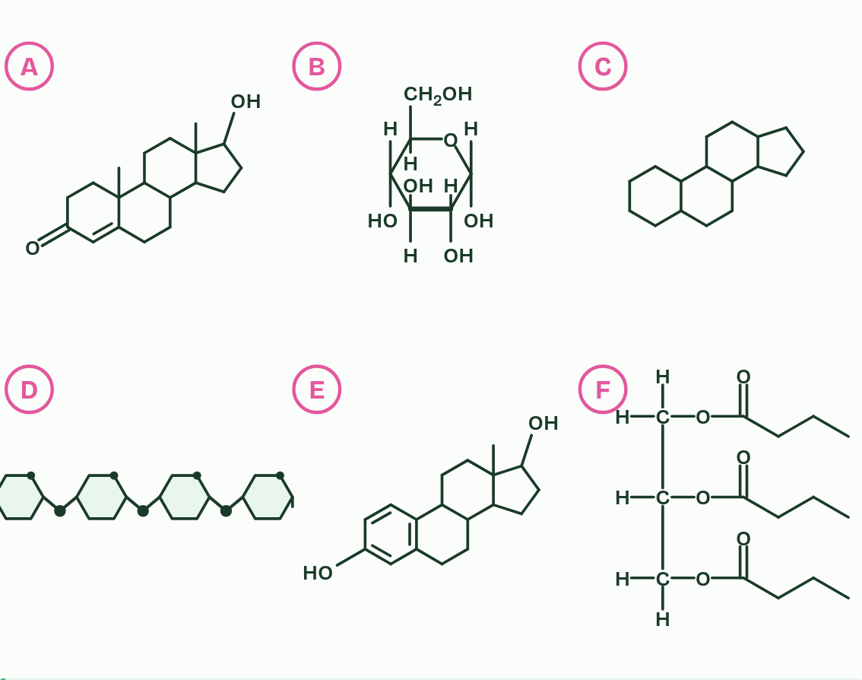  ANNOTATE THE FIGURE  Number the 5 steps on the figure and note what happens at each.  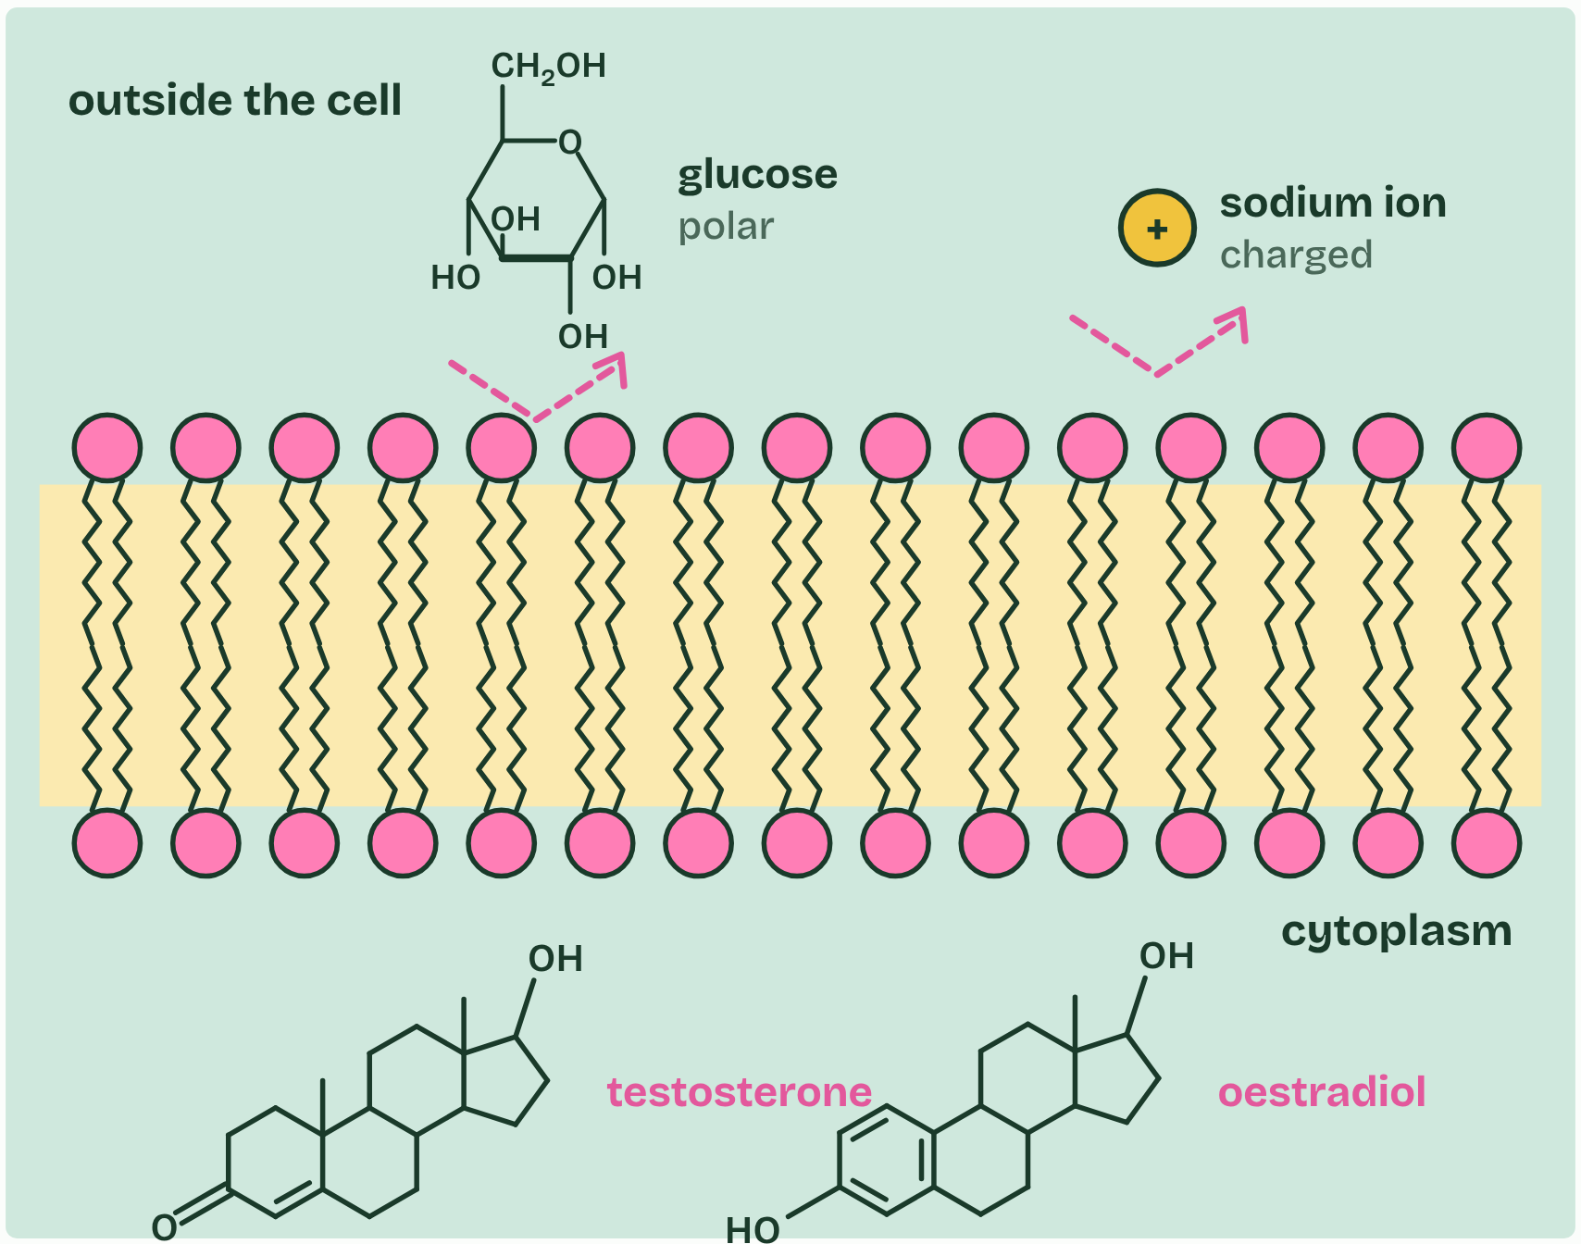
  SPOT THE MISTAKE
  What do students often get wrong about steroids? Write the mistake, then put it right.
  The mistake
  Put it right
SUMMARY
Sum up section 11 in two or three sentences of your own.

Check yourself
The check for this guide is online: a fresh paper of past-paper style questions from the exam bank on B1.1 each time, marked as you go, and saved to your Exam practice progress when you are signed in. Open the link:
biologybybradford.com/exam-maker/sit?topics=B1.1&level=HL&paper=quiz&marks=15&src=ep

