Name | Class | Date
IB BIOLOGY · B1.2

Proteins
Teacher’s copy: every blank filled in. Each numbered block matches a chapter of the guide, and of the lesson slides. Write in the gaps, answer the cues, annotate the figures, and sum up each section in your own words.
BY THE END YOU CAN
Draw a generalised amino acid and name the four groups on its alpha carbon B1.2.1
Explain how condensation joins amino acids with peptide bonds, write the word equation and draw a dipeptide B1.2.2
Explain why some amino acids must come from food, and what that means for a vegan diet B1.2.3
Explain why the number of possible polypeptides is practically endless B1.2.4
Explain how heat and pH denature a protein, and why it then stops working B1.2.5
Classify R groups and explain how they set the properties of a polypeptide B1.2.6
Explain how the sequence of amino acids gives every copy of a protein the same precise shape B1.2.7
Describe the alpha helix and beta-pleated sheet and the hydrogen bonds that hold them B1.2.8
Name the four kinds of bond that hold a tertiary structure, and say where polar and non-polar R groups end up B1.2.9, B1.2.10
Compare insulin, collagen and haemoglobin: chains, conjugated or not, globular or fibrous, and how form suits function B1.2.11, B1.2.12

01 Every amino acid is built on the same core | B1.2.1
CUES  Predict: A student draws an alpha carbon bonded to -NH2, -COOH, R and -OH. What is wrong with the drawing?  B: The fourth group should be a single hydrogen atom, not -OH. The alpha carbon always carries a single hydrogen atom. With -OH in its place the drawing is not an amino acid, and an examiner would not award the mark for the alpha carbon’s groups. Check every drawing for the H.  What is meant by amino acids?  The monomers of proteins. Each has an amine group, a carboxyl group, a hydrogen atom and an R group on one central carbon.  What is meant by alpha carbon?  The central carbon of an amino acid. It makes four single bonds, to an amine group, a carboxyl group, a hydrogen atom and an R group.  What is meant by amine group?  The group -NH2: a nitrogen atom bonded to two hydrogens. It is the amino part of the name.  What is meant by carboxyl group?  The group -COOH: a carbon with a double bond to one oxygen and a single bond to an OH. It can give up a hydrogen ion, which is why it is an acid.  What is meant by r group?  The side chain of an amino acid: the one part that differs between the twenty. R stands for whatever group it is, not for an element. | NOTES  1 The units are amino acids, and every one of them starts from the same pattern.  2 At the middle sits one carbon atom, the alpha carbon.  3 Carbon always makes four bonds, and here they go to four different things: an amine group (-NH₂), a carboxyl group (-COOH), a single hydrogen atom and an R group.  4 Draw the alpha carbon in the middle, the amine group on one side and the carboxyl group on the other, hydrogen and R above and below.  Your own notes  ANNOTATE THE FIGURE  Number the 6 steps on the figure and note what happens at each: 1 alpha carbon; 2 amine group; 3 carboxyl group; 4 hydrogen; 5 R group; 6 R group.  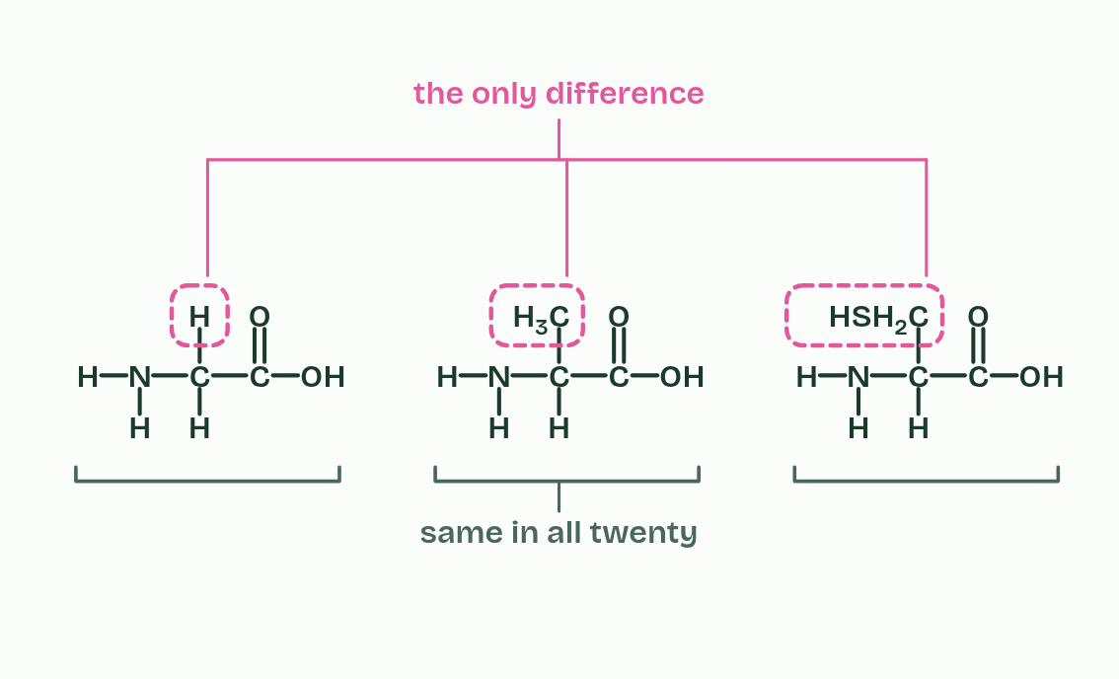  1 The alpha carbon makes four bonds.  2 An amine group goes on the left bond: a nitrogen with two hydrogens.  3 A carboxyl group goes on the right bond: a carbon with a double bond to one oxygen and a single bond to an OH.  4 One hydrogen atom goes on the bottom bond.  5 The last bond carries the R group. It stands for whatever side chain this amino acid has.  6 Three different amino acids: the same core in each, and only the R group differs.  REMEMBER IT  The four groups on the alpha carbon
  A  A | C  Cat | H  Has | R  Rhythm
  Amine group  -NH2, on one side | Carboxyl group  -COOH, on the other side | Hydrogen  one H atom | R group  the only part that varies
  SPOT THE MISTAKE
  What do students often get wrong about generalised structure of an amino acid? Write the mistake, then put it right.
  R is not an element. It stands for the side chain, whatever it is in that amino acid. And check every drawing by counting bonds: four on every carbon, three on nitrogen, two on oxygen, one on hydrogen.
SUMMARY
Sum up section 01 in two or three sentences of your own.
• Draw the alpha carbon in the middle, the amine group on one side and the carboxyl group on the other, hydrogen and R above and below.
• Show every atom and every bond, in the un-ionised form (-NH2 and -COOH), as the markschemes do.
• Count the bonds: four on carbon, three on nitrogen, two on oxygen, one on hydrogen.

02 Peptide bonds join amino acids, and water leaves | B1.2.2
CUES  Predict: Two different amino acids, A and B, are joined by one peptide bond. How many different dipeptides could they make?  C: Two: A’s carboxyl to B’s amine, or B’s carboxyl to A’s amine, and these are different molecules. Two. A peptide bond always joins a carboxyl group to an amine group, so every dipeptide has an amine end and a carboxyl end. In A-B, A keeps its free amine group; in B-A, B does. The same amino acids make different molecules, which is why the order of amino acids matters (chapter 4). Try both ways round in the bond builder.  What is meant by peptide bond?  The covalent bond between the carbon of one amino acid’s carboxyl group and the nitrogen of the next amino acid’s amine group. It forms in a condensation reaction.  What is meant by dipeptide?  Two amino acids joined by one peptide bond.  What is meant by polypeptide?  A chain of many amino acids joined by peptide bonds. | NOTES  1 The carbon of the carboxyl group is then left bonded to the nitrogen of the amine group, and that C-N bond is a peptide bond, a strong covalent bond.  2 Two amino acids make a dipeptide.  3 The word equation is amino acid + amino acid → dipeptide + water.  4 A long chain is a polypeptide (a short chain of a few amino acids is sometimes called an oligopeptide).  Your own notes  ANNOTATE THE FIGURE  Number the 4 steps on the figure and note what happens at each: 1 R1, R2; 2 OH, H, water; 3 peptide bond; 4 dipeptide.  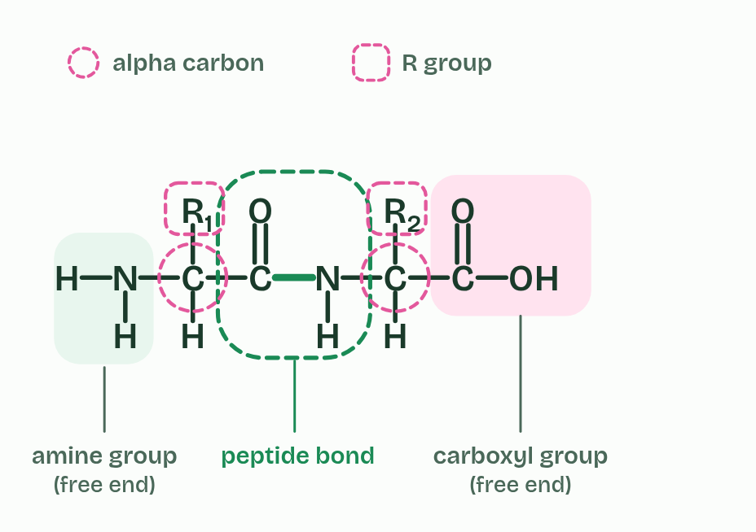  1 Two amino acids, R1 and R2, with the carboxyl group of the first facing the amine group of the second.  2 The OH from the carboxyl group and one H from the amine group are lit: they will leave as water.  3 The carbon bonds to the nitrogen and the water drifts away. The new C-N bond is a peptide bond.  4 A dipeptide, drawn as an examiner wants it. It still has an amine group at one end and a carboxyl group at the other.  ANNOTATE THE FIGURE  Number the 4 steps on the figure and note what happens at each: 1 amino acids; 2 carboxyl group, amine group; 3 water, peptide bond, condensation, dipeptide; 4 hydrolysis.  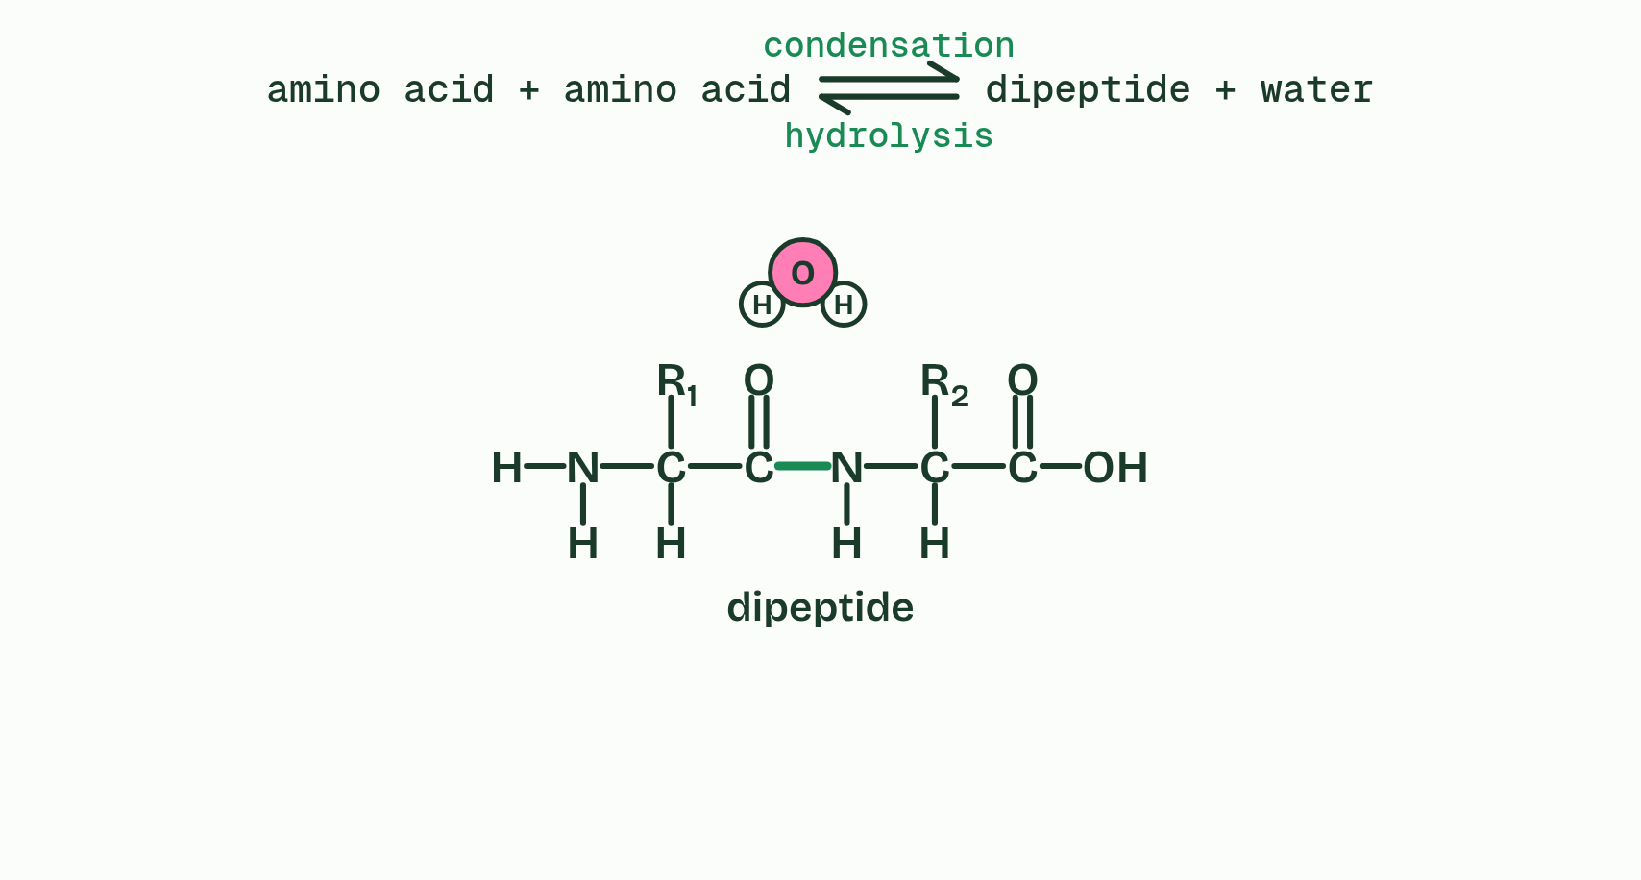  1 Two amino acids.  2 The OH of one's carboxyl group and an H of the other's amine group face each other.  3 They leave as water, and a peptide bond joins the carbon to the nitrogen: condensation, making a dipeptide.  4 Add water and the peptide bond splits again, the OH back to the carbon and the H to the nitrogen: hydrolysis.
  SPOT THE MISTAKE
  What do students often get wrong about condensation reactions forming dipeptides and longer chains? Write the mistake, then put it right.
  The peptide bond is not between the two alpha carbons, not through an oxygen (C-O-N), and never involves an R group. And the water takes its OH from one amino acid and its H from the other, not both from the same one.
SUMMARY
Sum up section 02 in two or three sentences of your own.
• The carbon of the carboxyl group is then left bonded to the nitrogen of the amine group, and that C-N bond is a peptide bond, a strong covalent bond.
• Two amino acids make a dipeptide.
• A long chain is a polypeptide (a short chain of a few amino acids is sometimes called an oligopeptide).

03 Some amino acids you must eat | B1.2.3
CUES  Predict: You eat plenty of protein, but it lacks one essential amino acid. What happens to the proteins that need it?  A: They cannot be completed, because no other amino acid can take its place in the sequence. They cannot be completed. Your cells cannot make an essential amino acid, and the gene sets the sequence, so no other amino acid can take its place. Every protein that needs it stalls at that point. That is why the total amount of protein is not the whole story: the mix matters.  What is meant by non-essential amino acids?  Amino acids that the body can make from other amino acids, so they do not have to come from food.  What is meant by essential amino acids?  Amino acids that the body cannot make, so they must be obtained from food. | NOTES  1 Your cells need all twenty amino acids to build their proteins. They can make some of them from other amino acids: these are non-essential amino acids.  2 They cannot make the rest, which must come from food: essential amino acids.  3 Twenty jars feed the line, and the chain grows in one order, set by the gene.  4 Eleven jars are filled by a pipe from the cells: non-essential amino acids, which your cells can make from other amino acids.  5 Nine jars are filled only from the plate: essential amino acids, which must come from food.  6 A varied plant plate: grain runs a little low in one jar and pulses in a different one, and together they fill every jar. A vegan diet covers all nine with variety.  Your own notes  ANNOTATE THE FIGURE  Number the 5 steps on the figure and note what happens at each.  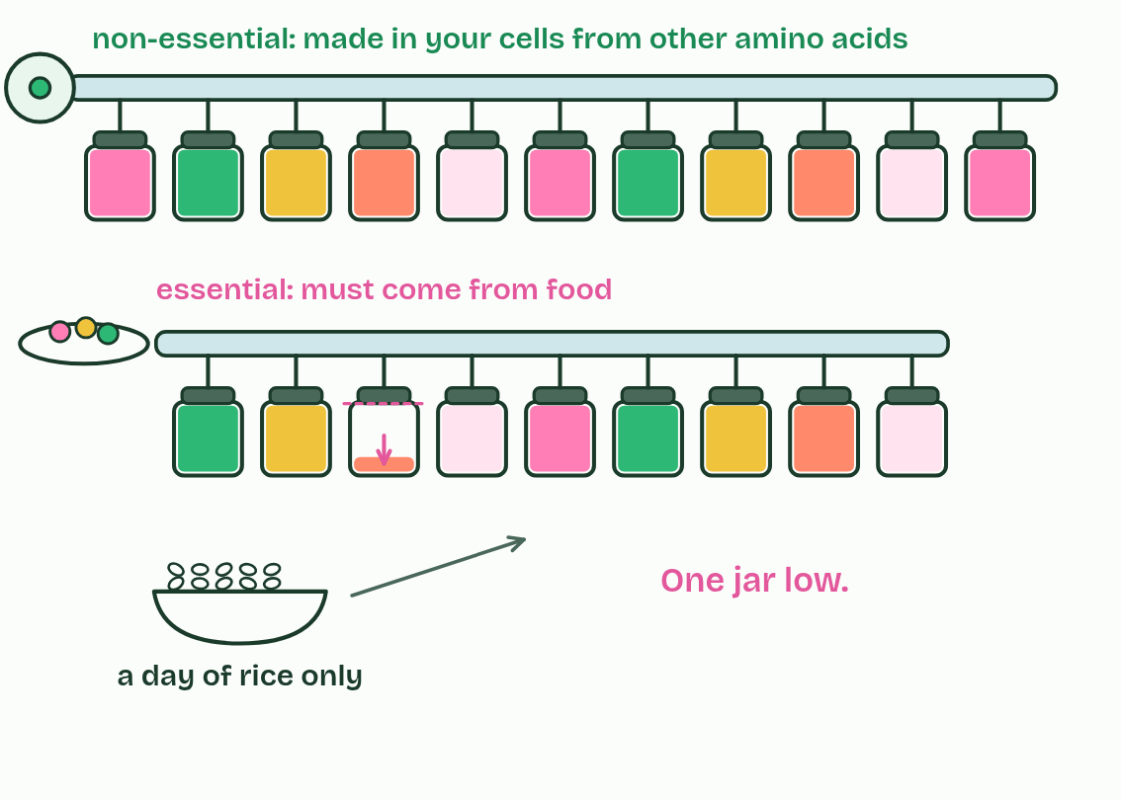  1 Twenty jars feed the line, and the chain grows in one order, set by the gene.  2 Eleven jars are filled by a pipe from the cells: non-essential amino acids, which your cells can make from other amino acids.  3 Nine jars are filled only from the plate: essential amino acids, which must come from food.  4 A varied plant plate: grain runs a little low in one jar and pulses in a different one, and together they fill every jar. A vegan diet covers all nine with variety.  5 A day of rice only: one jar runs low.
  SPOT THE MISTAKE
  What do students often get wrong about dietary requirements for amino acids? Write the mistake, then put it right.
  Non-essential amino acids are not unimportant: they are in your proteins too, you just do not need them in food. And “vegans cannot get essential amino acids” is false: they need a variety of plant proteins.
SUMMARY
Sum up section 03 in two or three sentences of your own.
• Your cells need all twenty amino acids to build their proteins. They can make some of them from other amino acids: these are non-essential amino acids.
• They cannot make the rest, which must come from food: essential amino acids.

04 Twenty amino acids, endless chains | B1.2.4
CUES  Predict: How many different dipeptides can be made from the 20 amino acids?  D: 400, because there are twenty choices at each of the two positions. 400. There are 20 choices for the first amino acid and 20 for the second. Order matters (one way round is a different molecule from the other), and the same amino acid can appear twice. Move the slider to 2 to check, then try 3.  What is meant by genetic code?  The rules a cell uses to turn the sequence of bases in a gene into the sequence of amino acids in a polypeptide. It codes for twenty amino acids.  What is meant by proteome?  All the proteins that an organism, or a cell, makes. | NOTES  1 The genetic code (A1.2) codes for twenty amino acids.  2 Most protein-coding genes code for one polypeptide, and all the proteins an organism makes are its proteome.  3 Glucagon, a hormone, has 29 amino acids.  4 Insulin, a hormone, has 51 in two chains of 21 and 30.  5 Lysozyme, an enzyme in egg white and tears, has 129.  6 Each haemoglobin chain has 141 or 146.  7 A collagen chain has about 1,000.  8 Titin, a springy protein inside muscle, has about 34,000, the largest known in humans.  Your own notes  ANNOTATE THE FIGURE  The figure shows it as 2, 10, 51, 62, 100 and 146. Note what changes each time.  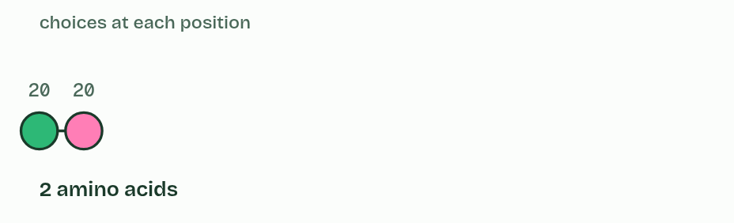  1 2  2 10  3 51  4 62  5 100  6 146  ANNOTATE THE FIGURE  Number the 2 steps on the figure and note what happens at each: 1 ROSALIND FRANKLIN; 2 weak bonds.  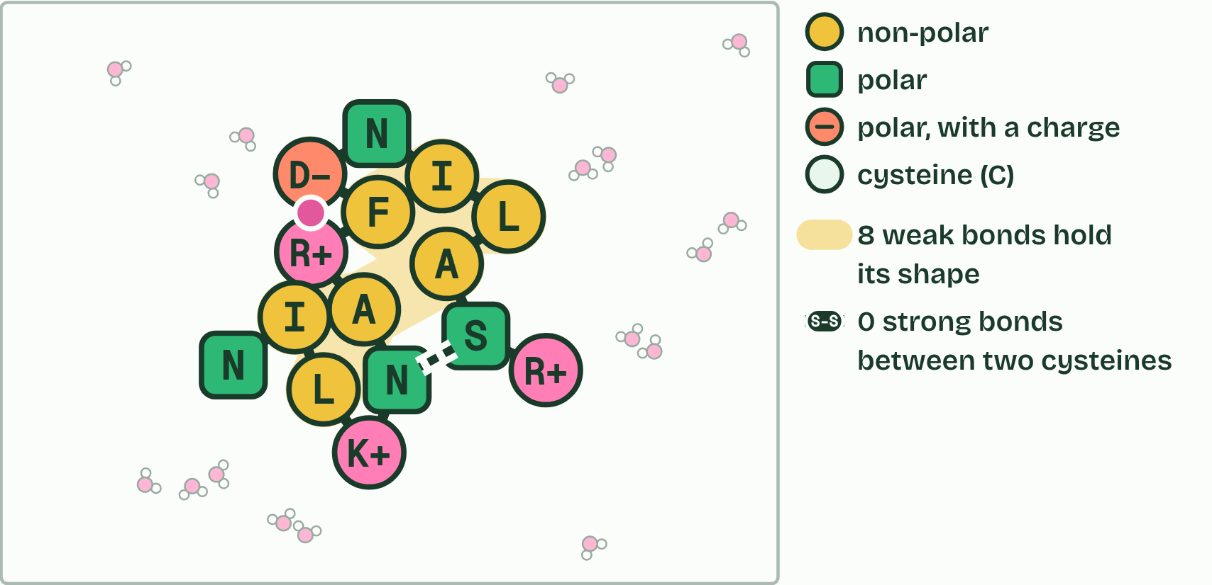  1 Type ROSALIND FRANKLIN: each letter is the code for one amino acid (the O is skipped: no amino acid has that letter). Its 15 amino acids are joined by 14 peptide bonds: one of 2015 (about 3 × 1019) possible chains this long. A ribosome makes the chain one amino acid at a time, and it starts to fold as it comes out.  2 It folds into a shape of its own, held by weak bonds between its side chains.
  SPOT THE MISTAKE
  What do students often get wrong about infinite variety of possible peptide chains? Write the mistake, then put it right.
  Twenty amino acids do not mean twenty proteins. And a protein’s identity is its order: the same amino acids in a different order make a different polypeptide.
SUMMARY
Sum up section 04 in two or three sentences of your own.
• Glucagon, a hormone, has 29 amino acids.
• Insulin, a hormone, has 51 in two chains of 21 and 30.
• Lysozyme, an enzyme in egg white and tears, has 129.
• Each haemoglobin chain has 141 or 146.
• A collagen chain has about 1,000.
• Titin, a springy protein inside muscle, has about 34,000, the largest known in humans.

05 Heat and pH unfold a protein | B1.2.5
CUES  Predict: When an egg sets in a hot pan, which bonds break?  C: The weak bonds that hold the fold, while the peptide bonds stay intact. Only the weak bonds that hold the fold. The chain of amino acids is still whole: a cooked egg is digested into exactly the same amino acids as a raw one. What heat destroys is the shape, and with it the job.  What is meant by denatured?  Having lost its three-dimensional shape because the bonds that hold it have broken, so that the protein can no longer do its job. The amino acid sequence is unchanged. | NOTES  1 The chain unfolds, its shape is lost and it can no longer do its job: it is denatured.  2 Raw egg white: clear and runny. Magnified, the proteins are folded, each on its own among the water molecules.  3 Heat makes the molecules jiggle harder and breaks the bonds that hold the folds.  4 The chains unfold: with the bonds gone, their shape is gone.  5 Unfolded chains tangle together and the egg white sets, white and solid. The proteins are denatured.  Your own notes  ANNOTATE THE FIGURE  Number the 4 steps on the figure and note what happens at each: 1 folded; 2 Heat; 3 unfold; 4 tangle, denatured.  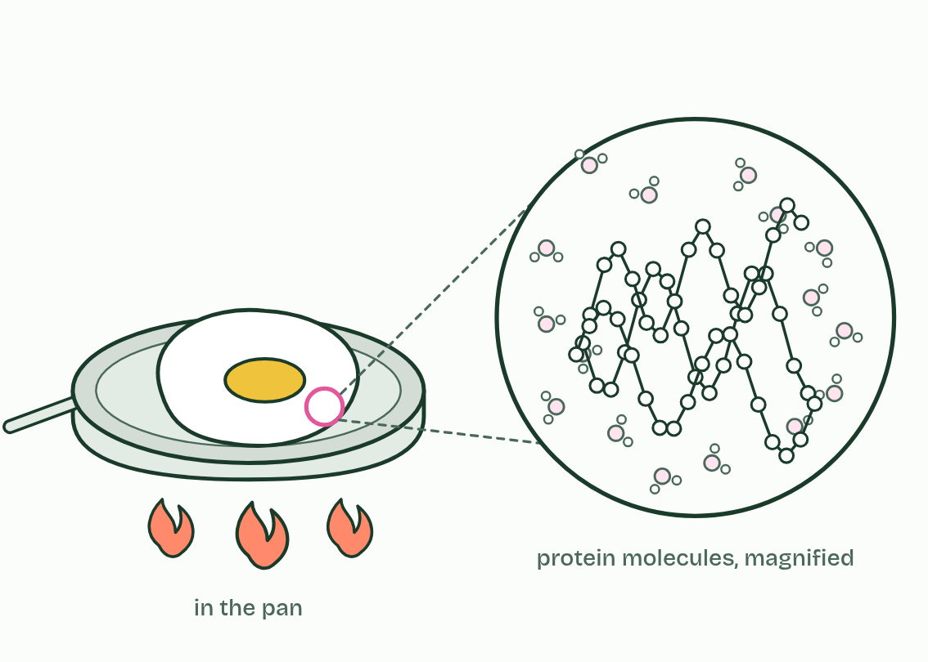  1 Raw egg white: clear and runny. Magnified, the proteins are folded, each on its own among the water molecules.  2 Heat makes the molecules jiggle harder and breaks the bonds that hold the folds.  3 The chains unfold: with the bonds gone, their shape is gone.  4 Unfolded chains tangle together and the egg white sets, white and solid. The proteins are denatured.  ANNOTATE THE FIGURE  Annotate this still from the animation (Heat it, change the pH): what is happening, and why?  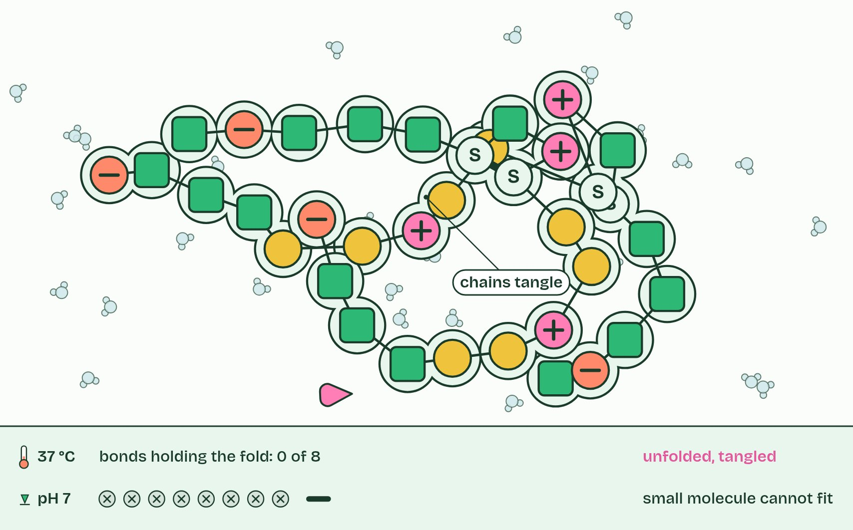  1 A new chain of amino acids among water molecules: as yet it has no shape.  2 A small molecule fits its pocket: one precise shape, one job.  3 Cooled again, it does not refold: the unfolded chains tangle together instead.
  SPOT THE MISTAKE
  What do students often get wrong about effect of pH and temperature on protein structure? Write the mistake, then put it right.
  Denatured does not mean dead (a protein was never alive), melted or dissolved. Cold does not denature: a protein in the fridge is slow but whole. And cooling a heat-denatured protein does not usually bring its shape back.
SUMMARY
Sum up section 05 in two or three sentences of your own.
• The chain unfolds, its shape is lost and it can no longer do its job: it is denatured.
• Raw egg white: clear and runny. Magnified, the proteins are folded, each on its own among the water molecules.
• Heat makes the molecules jiggle harder and breaks the bonds that hold the folds.
• The chains unfold: with the bonds gone, their shape is gone.
• Unfolded chains tangle together and the egg white sets, white and solid. The proteins are denatured.

06 The R groups decide how a chain behaves | B1.2.6 HL
CUES  Predict: An R group contains a carboxyl group. Inside a cell, at about pH 7, it is:  B: Negatively charged, because it has lost a hydrogen ion. Negatively charged. A carboxyl group gives up its hydrogen ion and is left negative: an acidic R group. An amine group does the opposite, gaining a hydrogen ion to become positive: a basic R group. Both are hydrophilic.  What is meant by hydrophobic?  Not attracted to water. Hydrophobic R groups are non-polar, made mostly of carbon and hydrogen.  What is meant by hydrophilic?  Attracted to water. Hydrophilic R groups are either polar or charged.  What is meant by polar?  Having slightly positive and slightly negative regions, as in an O-H or N-H group, so that it can form hydrogen bonds with water.  What is meant by charged?  Carrying a whole positive or negative charge, because a group in the R group has gained or lost a hydrogen ion.  What is meant by acidic?  An acidic R group contains a carboxyl group, which loses a hydrogen ion and becomes negatively charged.  What is meant by basic?  A basic R group contains an amine group, which gains a hydrogen ion and becomes positively charged. | NOTES  1 There are two big classes. Hydrophobic R groups are non-polar, mostly carbon and hydrogen, and water does not attract them. Hydrophilic R groups are attracted to water, and they are either polar, with partial charges that let them form hydrogen bonds, or charged.  2 Charged R groups are acidic or basic.  Your own notes  ANNOTATE THE FIGURE  Label the key parts and add a note on what it shows.  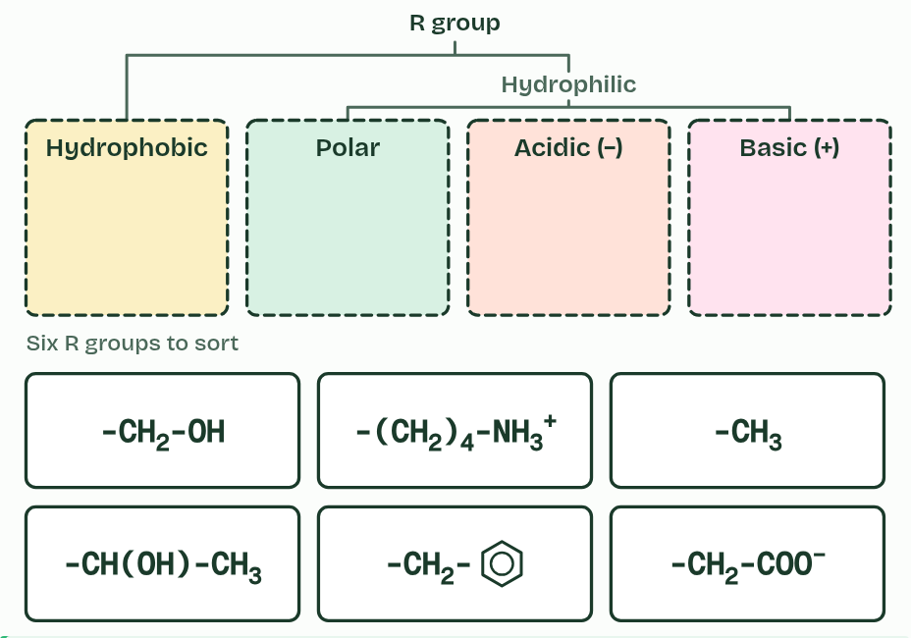  Six R groups, drawn as condensed formulas, and four bins. Which bin does each belong in, and what tells you?  REMEMBER IT  The four kinds of R group
  H  Hungry | P  Pandas | A  Ate | B  Bamboo
  Hydrophobic  non-polar, hides from water | Polar  partial charges, hydrogen bonds | Acidic  loses H+, negative | Basic  gains H+, positive
  SPOT THE MISTAKE
  What do students often get wrong about chemical diversity in the R groups? Write the mistake, then put it right.
  Hydrophilic does not mean charged: polar R groups are hydrophilic with no overall charge. Acidic R groups are negative, not positive. And a charge can come and go with pH.
SUMMARY
Sum up section 06 in two or three sentences of your own.
• There are two big classes. Hydrophobic R groups are non-polar, mostly carbon and hydrogen, and water does not attract them. Hydrophilic R groups are attracted to water, and they are either polar, with partial charges that let them form hydrogen bonds, or charged.
• Charged R groups are acidic or basic.

07 The sequence sets the shape | B1.2.7 HL
CUES  Predict: Two people make insulin from the same gene sequence. Do their insulin molecules have the same shape?  A: Yes, exactly: the same sequence folds the same way every time. Yes. Proteins have precise, repeatable shapes. The sequence of R groups decides which bonds can form and where, so the same sequence folds the same way every time. That is why one hormone fits the same receptor in every cell, and why a protein’s shape can be predicted from its sequence.  What is meant by primary structure?  The sequence of amino acids in a polypeptide, set by its gene. | NOTES  1 The primary structure of a protein is the sequence of amino acids in its polypeptide, and a gene sets it.  2 Primary structure: a sequence of amino acids, each joined to the next by a peptide bond.  3 Secondary structure: one stretch coils and another pleats beside itself, held by dashed hydrogen bonds.  4 Tertiary structure: the whole chain folded into a compact shape.  5 Quaternary structure: two or more folded chains together. Not every protein has one.  6 A second copy of the same sequence folds into the same shape: same sequence, same shape, every time.  Your own notes  ANNOTATE THE FIGURE  Number the 5 steps on the figure and note what happens at each: 1 Primary; 2 Secondary; 3 Tertiary; 4 Quaternary; 5 same shape.  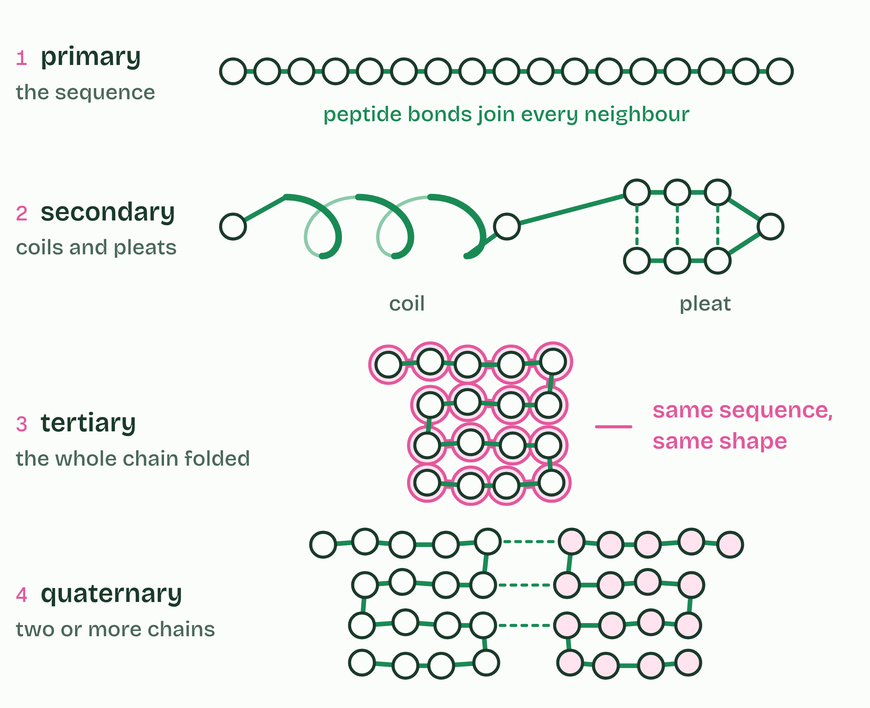  1 Primary structure: a sequence of amino acids, each joined to the next by a peptide bond.  2 Secondary structure: one stretch coils and another pleats beside itself, held by dashed hydrogen bonds.  3 Tertiary structure: the whole chain folded into a compact shape.  4 Quaternary structure: two or more folded chains together. Not every protein has one.  5 A second copy of the same sequence folds into the same shape: same sequence, same shape, every time.
  SPOT THE MISTAKE
  What do students often get wrong about impact of primary structure on conformation? Write the mistake, then put it right.
  Primary structure is the sequence, not a shape, but it decides every level after it. Folding is not random.
SUMMARY
Sum up section 07 in two or three sentences of your own.
• The primary structure of a protein is the sequence of amino acids in its polypeptide, and a gene sets it.
• Primary structure: a sequence of amino acids, each joined to the next by a peptide bond.
• Secondary structure: one stretch coils and another pleats beside itself, held by dashed hydrogen bonds.
• Tertiary structure: the whole chain folded into a compact shape.
• Quaternary structure: two or more folded chains together. Not every protein has one.

08 Coils and pleats held by hydrogen bonds | B1.2.8 HL
CUES  Predict: Which groups form the hydrogen bonds that hold an alpha helix?  D: The C=O and N-H groups of the peptide bonds in the backbone. The backbone’s own C=O and N-H groups, in regular positions four amino acids apart. That is why almost any stretch of chain can coil or pleat: the groups that bond are in every amino acid. The R groups decide which stretches do.  What is meant by secondary structure?  The regular coils and pleats that a polypeptide forms, held by hydrogen bonds between groups in the backbone.  What is meant by alpha helix?  A secondary structure in which the polypeptide is coiled like a spring. Each C=O forms a hydrogen bond with the N-H four amino acids further along.  What is meant by beta-pleated sheet?  A secondary structure in which stretches of the polypeptide lie side by side, held by hydrogen bonds between their backbones. The chain zigzags, so the sheet is pleated. | NOTES  1 Where the chain makes these bonds in regular positions, it settles into a regular shape, its secondary structure.  2 In an alpha helix the chain coils, and each C=O bonds with the N-H four amino acids further along.  3 In a beta-pleated sheet, stretches of the chain lie side by side, running the same way or opposite ways, and C=O groups in one stretch bond to N-H groups in the next.  Your own notes  ANNOTATE THE FIGURE  Label each part and say what it does: hydrogen bond, hydrogen bond, hydrogen bond, hydrogen bond, hydrogen bond, hydrogen bond, hydrogen bond, hydrogen bond, hydrogen bond.  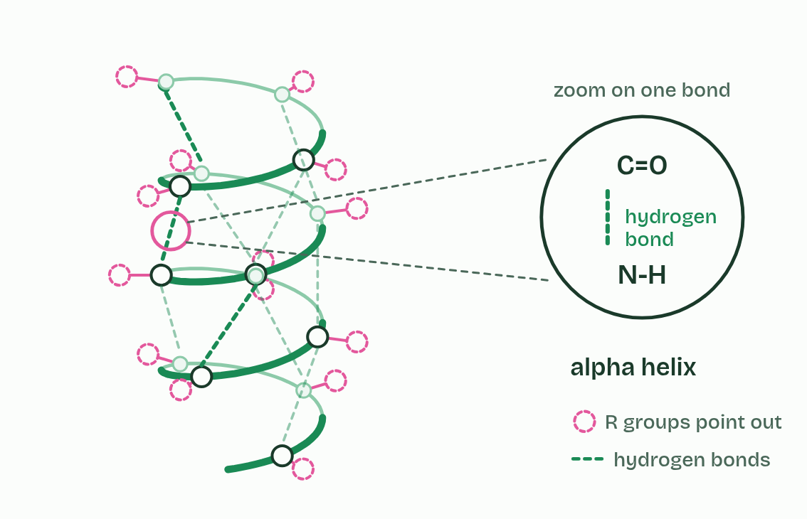  1 Hydrogen bond: the O of a C=O group in one amino acid and the H of an N-H group four amino acids further along. Both groups are in the backbone.  2 Hydrogen bond: the O of a C=O group in one amino acid and the H of an N-H group four amino acids further along. Both groups are in the backbone.  3 Hydrogen bond: the O of a C=O group in one amino acid and the H of an N-H group four amino acids further along. Both groups are in the backbone.  4 Hydrogen bond: the O of a C=O group in one amino acid and the H of an N-H group four amino acids further along. Both groups are in the backbone.  5 Hydrogen bond: the O of a C=O group in one amino acid and the H of an N-H group four amino acids further along. Both groups are in the backbone.  6 Hydrogen bond: the O of a C=O group in one amino acid and the H of an N-H group four amino acids further along. Both groups are in the backbone.  7 Hydrogen bond: the O of a C=O group in one amino acid and the H of an N-H group four amino acids further along. Both groups are in the backbone.  8 Hydrogen bond: the O of a C=O group in one amino acid and the H of an N-H group four amino acids further along. Both groups are in the backbone.  9 Hydrogen bond: the O of a C=O group in one amino acid and the H of an N-H group four amino acids further along. Both groups are in the backbone.
  SPOT THE MISTAKE
  What do students often get wrong about pleating and coiling of secondary structure? Write the mistake, then put it right.
  Secondary structure bonds are between backbone groups, not R groups. An alpha helix is one coiled polypeptide, nothing to do with the double helix of DNA. And collagen’s helix is not an alpha helix (chapter 11).
SUMMARY
Sum up section 08 in two or three sentences of your own.
• Where the chain makes these bonds in regular positions, it settles into a regular shape, its secondary structure.
• In an alpha helix the chain coils, and each C=O bonds with the N-H four amino acids further along.
• In a beta-pleated sheet, stretches of the chain lie side by side, running the same way or opposite ways, and C=O groups in one stretch bond to N-H groups in the next.

09 Four kinds of bond hold the fold | B1.2.9 HL
CUES  Predict: An ionic bond holds two parts of a protein together. The pH falls to 2. Why might the bond break?  B: The negative carboxyl R group gains a hydrogen ion and loses its charge. In acid, a -COO− picks up a hydrogen ion and becomes -COOH, with no charge, so nothing attracts it to the positive R group. Press Lower the pH to watch it. In strong alkali the opposite happens: -NH3+ loses its hydrogen ion.  What is meant by tertiary structure?  The three-dimensional shape of a whole polypeptide, held by bonds between R groups that are often far apart in the sequence.  What is meant by ionic bonds?  The attraction between a positively charged R group and a negatively charged one.  What is meant by disulfide bonds?  A covalent bond between the sulfur atoms of two cysteines.  What is meant by cysteines?  The amino acid whose R group ends in a sulfur atom, so that two of them can form a disulfide bond. It is the only amino acid you need to name.  What is meant by hydrophobic interactions?  The clustering of non-polar R groups together, away from water, in the middle of a folded protein. | NOTES  1 Tertiary structure is the three-dimensional shape of the whole polypeptide.  2 Hydrogen bonds between polar R groups.  3 Ionic bonds between a positively charged (basic) and a negatively charged (acidic) R group. The amine and carboxyl groups in R groups become charged by gaining or losing a hydrogen ion, and only then can they form ionic bonds.  4 Disulfide bonds, covalent bonds between the sulfur atoms of two cysteines, the only amino acid you need to name. This is the strongest of the four.  5 Hydrophobic interactions: non-polar R groups cluster together, away from water.  Your own notes  ANNOTATE THE FIGURE  The figure shows it as Hydrogen, Ionic, Disulfide, Hydrophobic, All and Lower the pH. Note what changes each time.  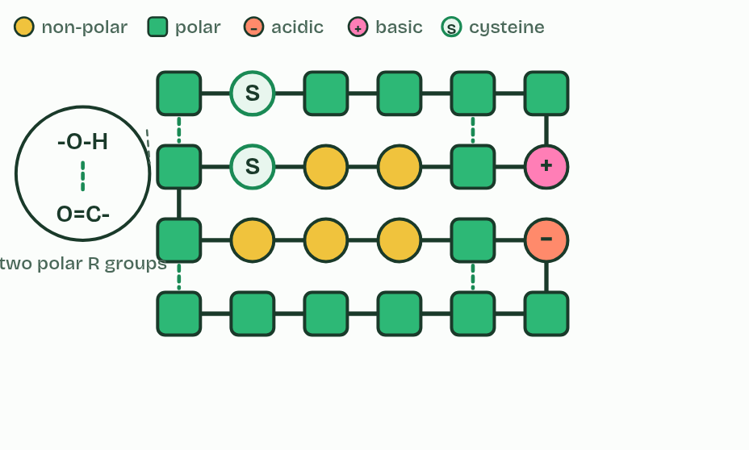  1 Hydrogen  2 Ionic  3 Disulfide  4 Hydrophobic  5 All  6 Lower the pH  REMEMBER IT  The bonds that hold a tertiary structure
  H  Happy | H  Hippos | I  Ignore | D  Dentists
  Hydrogen bonds  between polar R groups | Hydrophobic interactions  non-polar R groups huddle away from water | Ionic bonds  between + and − R groups | Disulfide bonds  two cysteines; the only covalent one
  SPOT THE MISTAKE
  What do students often get wrong about dependence of tertiary structure on four kinds of bond? Write the mistake, then put it right.
  A disulfide bond is covalent and forms only between two cysteines: it is not a kind of hydrogen bond. Ionic bonds need charged R groups, not just polar ones. And hydrophobic interactions are not attractions between the R groups and water.
SUMMARY
Sum up section 09 in two or three sentences of your own.
• Hydrogen bonds between polar R groups.
• Ionic bonds between a positively charged (basic) and a negatively charged (acidic) R group. The amine and carboxyl groups in R groups become charged by gaining or losing a hydrogen ion, and only then can they form ionic bonds.
• Disulfide bonds, covalent bonds between the sulfur atoms of two cysteines, the only amino acid you need to name. This is the strongest of the four.
• Hydrophobic interactions: non-polar R groups cluster together, away from water.

10 Oily inside, watery outside | B1.2.10 HL
CUES  Predict: A protein dissolves in blood plasma. Where are most of its hydrophobic R groups?  C: Clustered in the core of the protein, away from the water. In the core. Hydrophobic R groups are not attracted to water, so in the folded protein they end up together inside, while hydrophilic ones cover the surface and keep it in solution. Fold a protein below and watch a chain do the same as it folds.  What is meant by integral proteins?  Proteins that are embedded in a cell membrane, with part of the chain lying among the hydrophobic tails of the phospholipids. | NOTES  1 Integral proteins work the other way round.  Your own notes  ANNOTATE THE FIGURE  The figure shows it as Unfolded, In water and In a membrane. Note what changes each time.  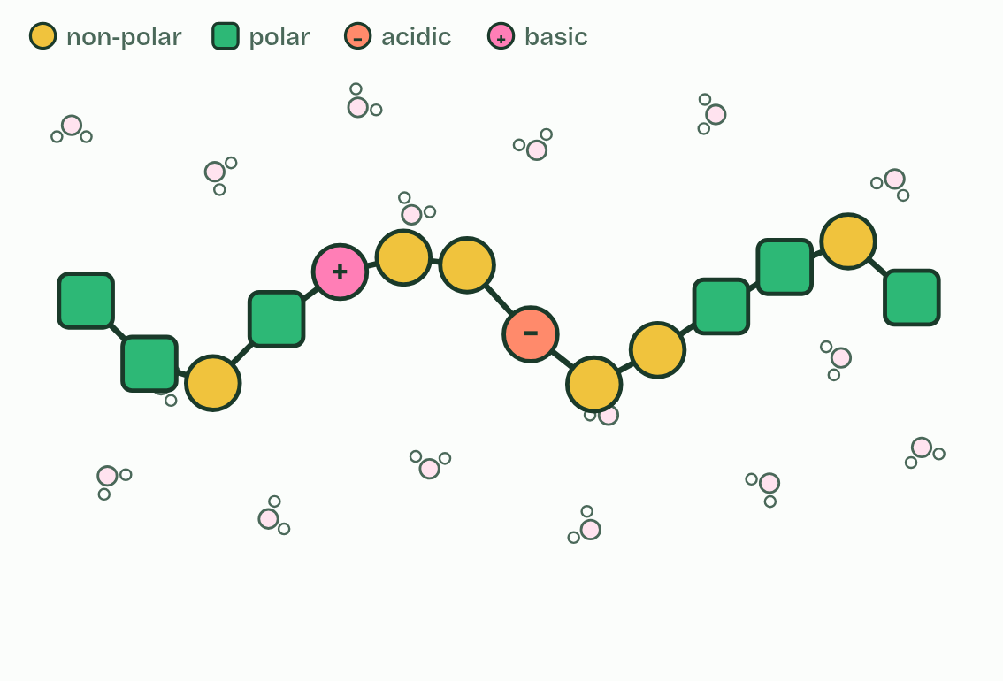  1 Unfolded  2 In water  3 In a membrane  ANNOTATE THE FIGURE  Number the 2 steps on the figure and note what happens at each: 1 ROSALIND FRANKLIN; 2 non-polar.  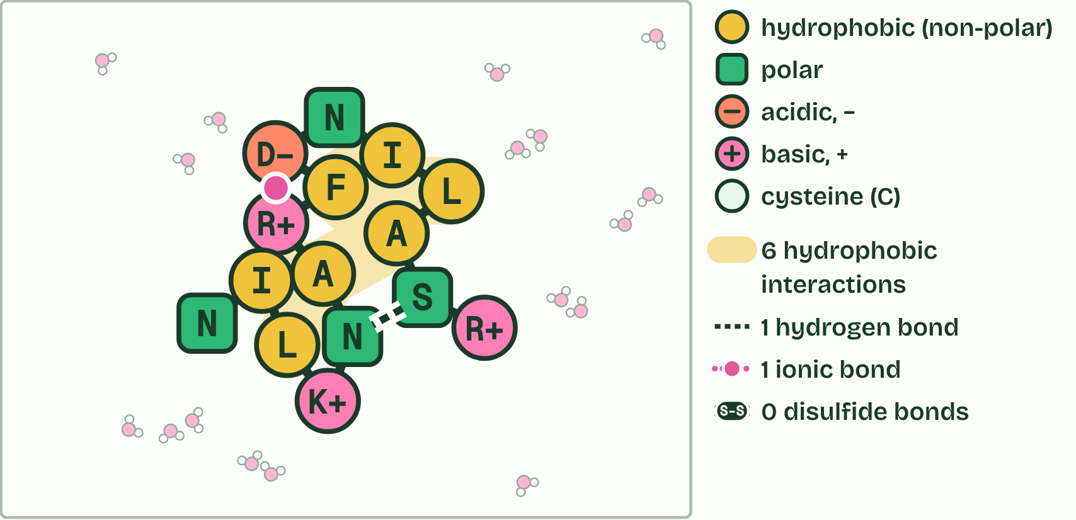  1 Type ROSALIND FRANKLIN: each letter is the code for one amino acid (the O is skipped: no amino acid has that letter). A ribosome makes the chain one amino acid at a time, and it starts to fold as it comes out.  2 In water it folds: the non-polar ones gather inside, away from the water (6 of 7), and the polar ones face outwards. Hydrophobic interactions, hydrogen bonds and ionic bonds hold it.
  SPOT THE MISTAKE
  What do students often get wrong about effect of polar and non-polar amino acids on tertiary structure? Write the mistake, then put it right.
  Hydrophobic amino acids are not “bad”: without them there would be no core and no membrane protein. And a chain does not fold because someone puts it there: it folds by itself as it jostles in water.
SUMMARY
Sum up section 10 in two or three sentences of your own.
• Integral proteins work the other way round.
• Type ROSALIND FRANKLIN: each letter is the code for one amino acid (the O is skipped: no amino acid has that letter). A ribosome makes the chain one amino acid at a time, and it starts to fold as it comes out.
• In water it folds: the non-polar ones gather inside, away from the water (6 of 7), and the polar ones face outwards. Hydrophobic interactions, hydrogen bonds and ionic bonds hold it.

11 More than one chain: quaternary structure | B1.2.11 HL
CUES  Predict: A haemoglobin molecule is about 5 to 6 nm across. Could you see one with the best light microscope?  B: No: it is far smaller than the smallest thing light can resolve, about 200 nm. No. A light microscope cannot separate details closer than about 200 nm, some 40 times the size of a haemoglobin molecule. Electron microscopes, and now cryo-EM, image single molecules: technology extends our senses.  What is meant by quaternary structure?  The arrangement of two or more polypeptides in one protein, held by the same kinds of bond as the tertiary structure.  What is meant by non-conjugated protein?  A protein made of polypeptide only.  What is meant by conjugated protein?  A protein that includes a part that is not polypeptide, called a prosthetic group.  What is meant by prosthetic group?  The non-polypeptide part of a conjugated protein, such as the haem group of haemoglobin.  What is meant by cryogenic electron microscopy?  Cryo-EM: freezing proteins so fast that the water around them turns to glass-like ice, then imaging single molecules with electrons and combining thousands of images into a 3D structure. | NOTES  1 Others are two or more polypeptides held together, and their arrangement is the quaternary structure, held by the same kinds of bond as the tertiary.  2 A non-conjugated protein is made of polypeptide only. Insulin has two polypeptides, of 21 and 30 amino acids, linked by two disulfide bonds, with a third disulfide bond within the shorter chain. Collagen has three polypeptides, each about 1,000 amino acids long, wound round each other into a triple helix like a rope.  3 A conjugated protein includes a part that is not polypeptide, a prosthetic group. Haemoglobin has four polypeptides, two of one kind and two of another, each holding a haem group with an iron ion at its centre.  Your own notes  ANNOTATE THE FIGURE  The figure shows it as Insulin, Collagen and Haemoglobin. Note what changes each time.  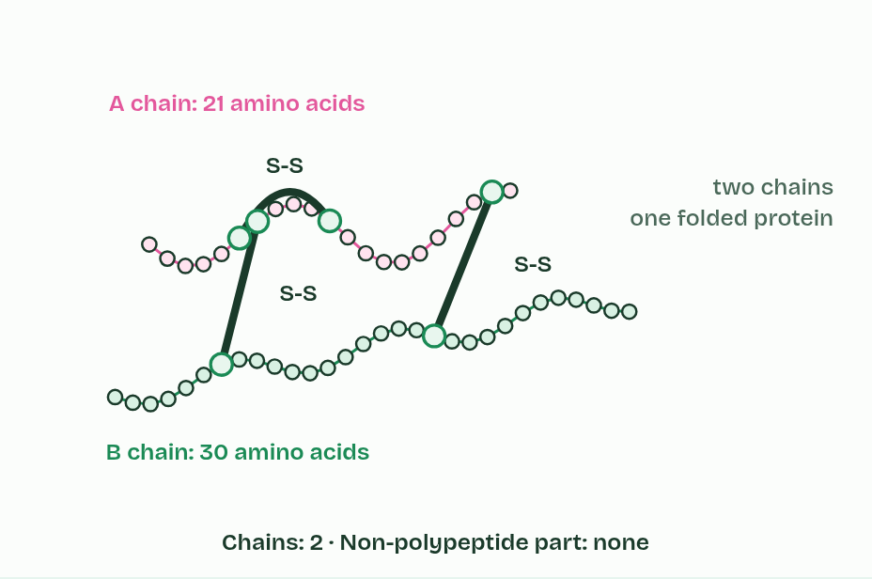  1 Insulin  2 Collagen  3 Haemoglobin  REMEMBER IT  The three named proteins, in order of chains
  I  I | S  See | H  Him
  Insulin  2 chains; globular; non-conjugated | Collagen  3 chains; fibrous; non-conjugated | Haemoglobin  4 chains plus haem; globular; conjugated
  SPOT THE MISTAKE
  What do students often get wrong about quaternary structure of non-conjugated and conjugated proteins? Write the mistake, then put it right.
  Quaternary means more than one chain, not four (haemoglobin just happens to have four). Conjugated means joined to a non-protein group, not to another protein. And collagen’s triple helix is not three alpha helices: each chain is a narrower helix of its own.
SUMMARY
Sum up section 11 in two or three sentences of your own.
• Others are two or more polypeptides held together, and their arrangement is the quaternary structure, held by the same kinds of bond as the tertiary.
• A non-conjugated protein is made of polypeptide only. Insulin has two polypeptides, of 21 and 30 amino acids, linked by two disulfide bonds, with a third disulfide bond within the shorter chain. Collagen has three polypeptides, each about 1,000 amino acids long, wound round each other into a triple helix like a rope.
• A conjugated protein includes a part that is not polypeptide, a prosthetic group. Haemoglobin has four polypeptides, two of one kind and two of another, each holding a haem group with an iron ion at its centre.

12 Balls and ropes: globular and fibrous proteins | B1.2.12 HL
CUES  Predict: A protein is long and thin, has a repeating sequence and does not dissolve in water. What is its most likely job?  D: A structural protein, as found in tendons, skin and blood vessel walls. A structural one. Long, repetitive and insoluble are the marks of a fibrous protein: strength, not binding. Hormones, enzymes and antibodies have to dissolve and fit specific molecules, which needs a compact, globular shape.  What is meant by globular proteins?  Proteins folded into compact, rounded shapes. Most are soluble in water and bind specific molecules: enzymes, hormones, transport proteins and antibodies.  What is meant by fibrous proteins?  Proteins that are long and narrow, often with a repeating sequence. Most are insoluble and strong, and have structural jobs. | NOTES  1 Globular proteins are folded into compact, rounded shapes.  2 Insulin shows how form suits function.  3 Fibrous proteins are long and narrow, often with a repeating sequence, usually insoluble and strong, and have structural jobs. Collagen is three chains wound into a rope.  4 One insulin molecule is a small rounded knot among water molecules. One collagen molecule is a long, thin rope, about 100 times longer than the knot is wide.  5 Insulin is soluble: dissolved in the plasma, it is carried round the body in the blood.  6 Insulin has a precise shape that fits the receptor on its target cells, liver, muscle and fat cells, like a key in a lock.  Your own notes  ANNOTATE THE FIGURE  Number the 5 steps on the figure and note what happens at each: 1 insulin, collagen; 2 soluble; 3 precise shape; 4 cross-linked; 5 insoluble.  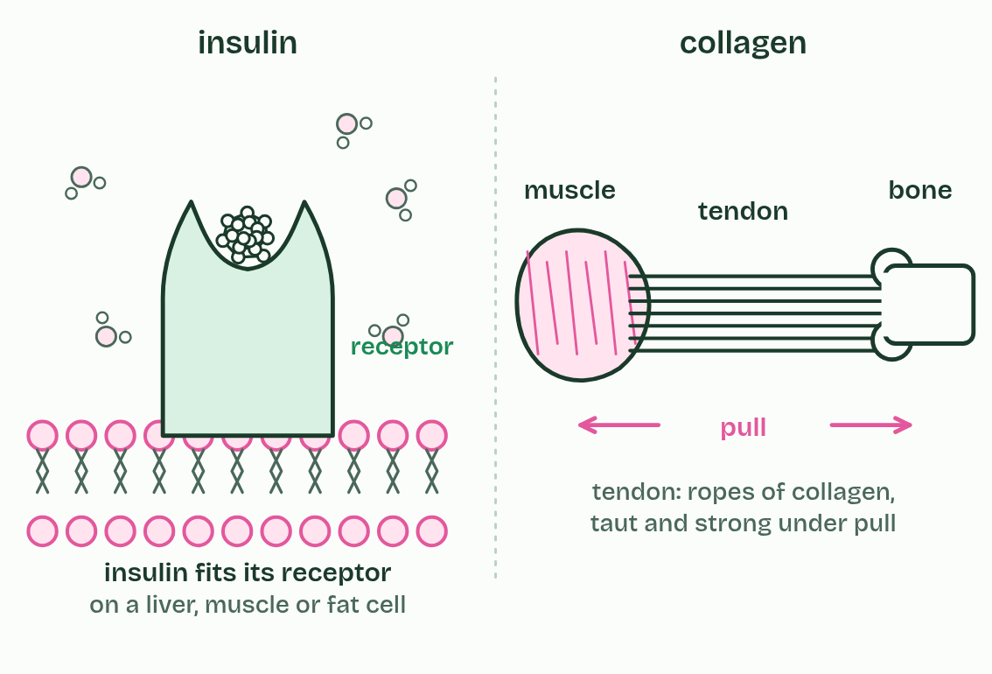  1 One insulin molecule is a small rounded knot among water molecules. One collagen molecule is a long, thin rope, about 100 times longer than the knot is wide.  2 Insulin is soluble: dissolved in the plasma, it is carried round the body in the blood.  3 Insulin has a precise shape that fits the receptor on its target cells, liver, muscle and fat cells, like a key in a lock.  4 Collagen ropes lie side by side, staggered and cross-linked, into fibrils, and fibrils are bundled into fibres.  5 In a tendon, collagen fibres are insoluble and strong: they stay taut when muscle pulls on bone.
  SPOT THE MISTAKE
  What do students often get wrong about relationship of form and function in globular and fibrous proteins? Write the mistake, then put it right.
  The functional and structural rule is only a rule of thumb (actin and tubulin). And a fibrous protein is fibrous in shape as a single molecule: it is not “made of fibres”.
SUMMARY
Sum up section 12 in two or three sentences of your own.
• Globular proteins are folded into compact, rounded shapes.
• Fibrous proteins are long and narrow, often with a repeating sequence, usually insoluble and strong, and have structural jobs. Collagen is three chains wound into a rope.

Check yourself
The check for this guide is online: a fresh paper of past-paper style questions from the exam bank on B1.2 each time, marked as you go, and saved to your Exam practice progress when you are signed in. Open the link:
biologybybradford.com/exam-maker/sit?topics=B1.2&level=HL&paper=quiz&marks=15&src=ep

