Name | Class | Date
IB BIOLOGY · B1.2

Proteins
Notes to fill in alongside the guide. Each numbered block matches a chapter of the guide, and of the lesson slides. Write in the gaps, answer the cues, annotate the figures, and sum up each section in your own words.
BY THE END YOU CAN
Draw a generalised amino acid and name the four groups on its alpha carbon B1.2.1
Explain how condensation joins amino acids with peptide bonds, write the word equation and draw a dipeptide B1.2.2
Explain why some amino acids must come from food, and what that means for a vegan diet B1.2.3
Explain why the number of possible polypeptides is practically endless B1.2.4
Explain how heat and pH denature a protein, and why it then stops working B1.2.5
Classify R groups and explain how they set the properties of a polypeptide B1.2.6
Explain how the sequence of amino acids gives every copy of a protein the same precise shape B1.2.7
Describe the alpha helix and beta-pleated sheet and the hydrogen bonds that hold them B1.2.8
Name the four kinds of bond that hold a tertiary structure, and say where polar and non-polar R groups end up B1.2.9, B1.2.10
Compare insulin, collagen and haemoglobin: chains, conjugated or not, globular or fibrous, and how form suits function B1.2.11, B1.2.12

01 Every amino acid is built on the same core | B1.2.1
CUES  Predict: A student draws an alpha carbon bonded to -NH2, -COOH, R and -OH. What is wrong with the drawing?  What is meant by amino acids?  What is meant by alpha carbon?  What is meant by amine group?  What is meant by carboxyl group?  What is meant by r group? | NOTES  1 The units are _______________, and every one of them starts from the same pattern.  2 At the middle sits one carbon atom, the ________________.  3 Carbon always makes four bonds, and here they go to four different things: an _______________ (-NH₂), a ___________________ (-COOH), a single hydrogen atom and an _________.  4 Draw the ________________ in the middle, the amine group on one side and the carboxyl group on the other, hydrogen and R above and below.  Your own notes  ANNOTATE THE FIGURE  Number the 6 steps on the figure and note what happens at each: 1 alpha carbon; 2 amine group; 3 carboxyl group; 4 hydrogen; 5 R group; 6 R group.  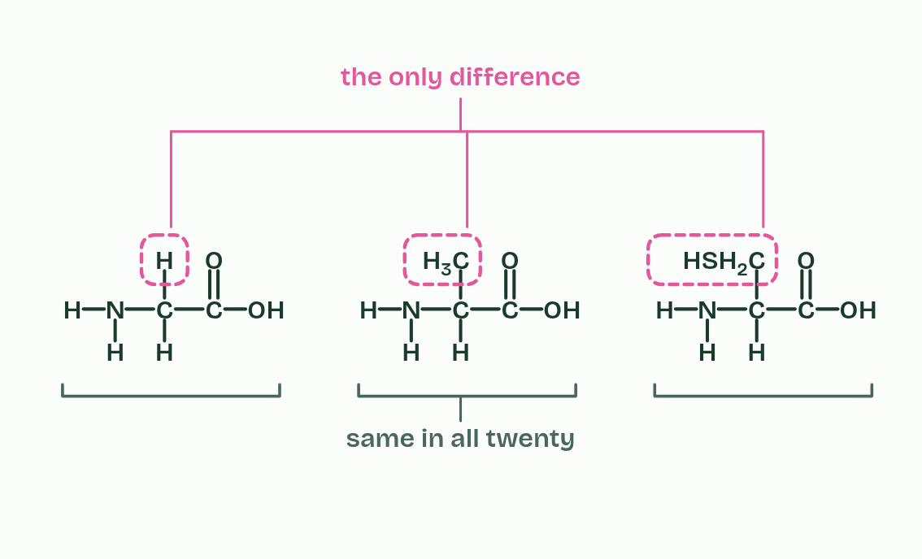  REMEMBER IT  The four groups on the alpha carbon
  A  A | C  Cat | H  Has | R  Rhythm
  A | C | H | R
  SPOT THE MISTAKE
  What do students often get wrong about generalised structure of an amino acid? Write the mistake, then put it right.
  The mistake
  Put it right
SUMMARY
Sum up section 01 in two or three sentences of your own.

02 Peptide bonds join amino acids, and water leaves | B1.2.2
CUES  Predict: Two different amino acids, A and B, are joined by one peptide bond. How many different dipeptides could they make?  What is meant by peptide bond?  What is meant by dipeptide?  What is meant by polypeptide? | NOTES  1 The carbon of the carboxyl group is then left bonded to the nitrogen of the amine group, and that C-N bond is a ________________, a strong covalent bond.  2 Two amino acids make a ____________.  3 The word equation is __________________________________.  4 A long chain is a _______________ (a short chain of a few amino acids is sometimes called an oligopeptide).  Your own notes  ANNOTATE THE FIGURE  Number the 4 steps on the figure and note what happens at each: 1 R1, R2; 2 OH, H, water; 3 peptide bond; 4 dipeptide.  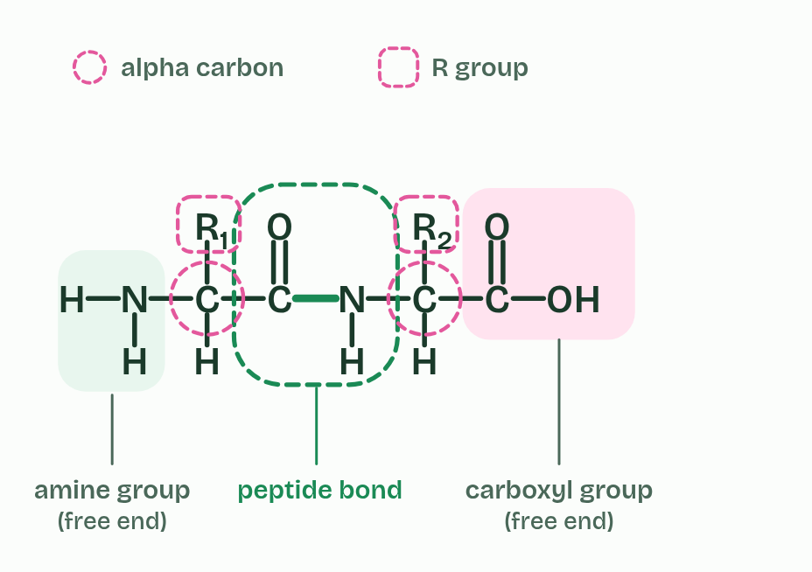  ANNOTATE THE FIGURE  Number the 4 steps on the figure and note what happens at each: 1 amino acids; 2 carboxyl group, amine group; 3 water, peptide bond, condensation, dipeptide; 4 hydrolysis.  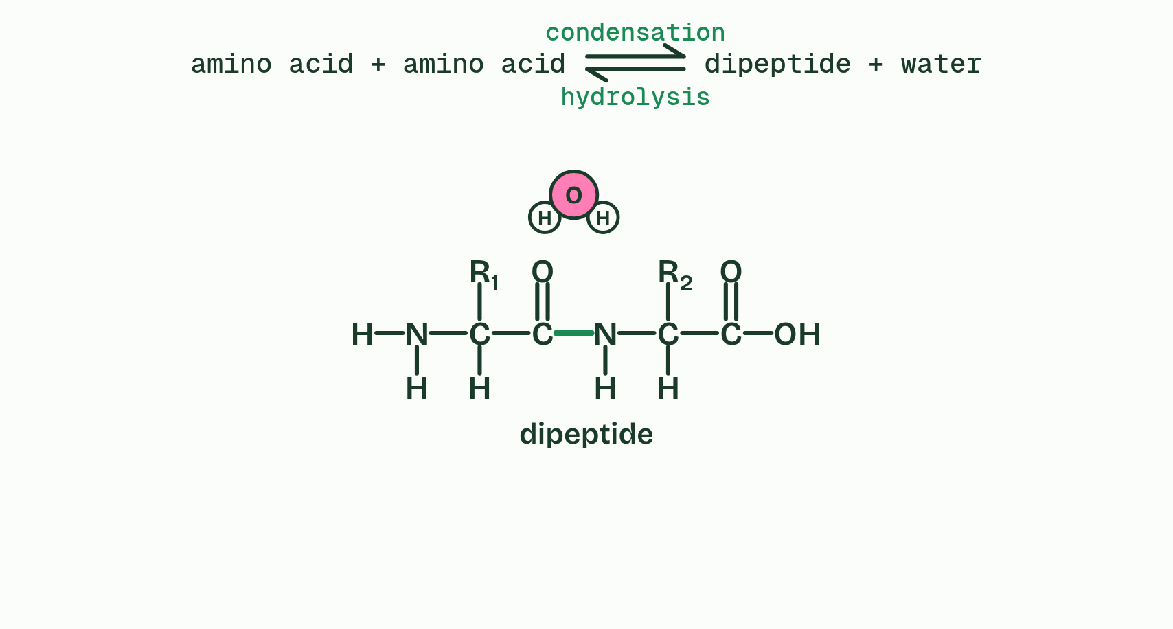
  SPOT THE MISTAKE
  What do students often get wrong about condensation reactions forming dipeptides and longer chains? Write the mistake, then put it right.
  The mistake
  Put it right
SUMMARY
Sum up section 02 in two or three sentences of your own.

03 Some amino acids you must eat | B1.2.3
CUES  Predict: You eat plenty of protein, but it lacks one essential amino acid. What happens to the proteins that need it?  What is meant by non-essential amino acids?  What is meant by essential amino acids? | NOTES  1 Your cells need all twenty amino acids to build their proteins. They can make some of them from other amino acids: these are __________________________________.  2 They cannot make the rest, which must come from food: ____________________________.  3 Twenty jars feed the line, and the chain grows in ____________, set by the gene.  4 Eleven jars are filled by a pipe from the cells: __________________ amino acids, which your cells can make from other amino acids.  5 Nine jars are filled only from the plate: ____________ amino acids, which must come from food.  6 A varied plant plate: grain runs a little low in one jar and pulses in a different one, and together they fill every jar. A ________ diet covers all nine with _________.  Your own notes  ANNOTATE THE FIGURE  Number the 5 steps on the figure and note what happens at each.  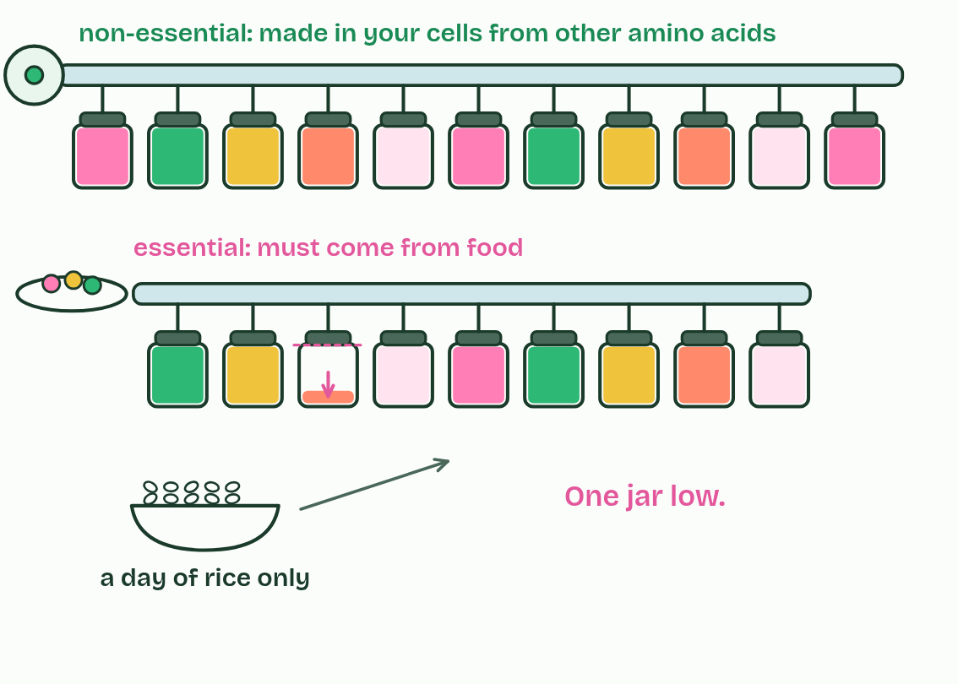
  SPOT THE MISTAKE
  What do students often get wrong about dietary requirements for amino acids? Write the mistake, then put it right.
  The mistake
  Put it right
SUMMARY
Sum up section 03 in two or three sentences of your own.

04 Twenty amino acids, endless chains | B1.2.4
CUES  Predict: How many different dipeptides can be made from the 20 amino acids?  What is meant by genetic code?  What is meant by proteome? | NOTES  1 The ________________ (A1.2) codes for twenty amino acids.  2 Most protein-coding genes code for one polypeptide, and all the proteins an organism makes are its ___________.  3 ___________, a hormone, has 29 amino acids.  4 _________, a hormone, has 51 in two chains of 21 and 30.  5 ___________, an enzyme in egg white and tears, has 129.  6 Each _______________ chain has 141 or 146.  7 A ___________ chain has about 1,000.  8 ________, a springy protein inside muscle, has about 34,000, the largest known in humans.  Your own notes  ANNOTATE THE FIGURE  The figure shows it as 2, 10, 51, 62, 100 and 146. Note what changes each time.  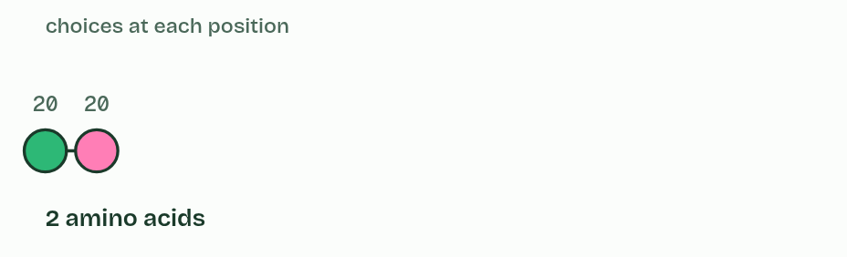  ANNOTATE THE FIGURE  Number the 2 steps on the figure and note what happens at each: 1 ROSALIND FRANKLIN; 2 weak bonds.  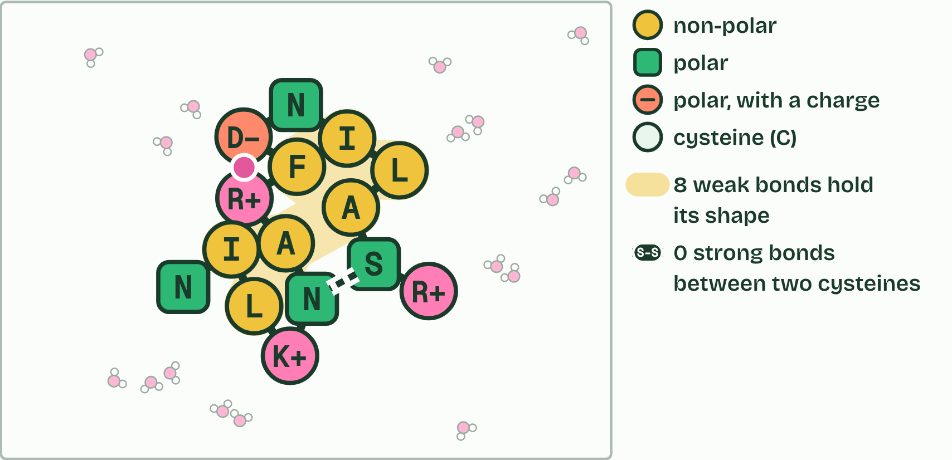
  SPOT THE MISTAKE
  What do students often get wrong about infinite variety of possible peptide chains? Write the mistake, then put it right.
  The mistake
  Put it right
SUMMARY
Sum up section 04 in two or three sentences of your own.

05 Heat and pH unfold a protein | B1.2.5
CUES  Predict: When an egg sets in a hot pan, which bonds break?  What is meant by denatured? | NOTES  1 The chain unfolds, its shape is lost and it can no longer do its job: it is ____________.  2 Raw egg white: clear and runny. Magnified, the proteins are ________, each on its own among the water molecules.  3 ________ makes the molecules jiggle harder and breaks the bonds that hold the folds.  4 The chains ________: with the bonds gone, their shape is gone.  5 Unfolded chains ________ together and the egg white sets, white and solid. The proteins are ____________.  Your own notes  ANNOTATE THE FIGURE  Number the 4 steps on the figure and note what happens at each: 1 folded; 2 Heat; 3 unfold; 4 tangle, denatured.  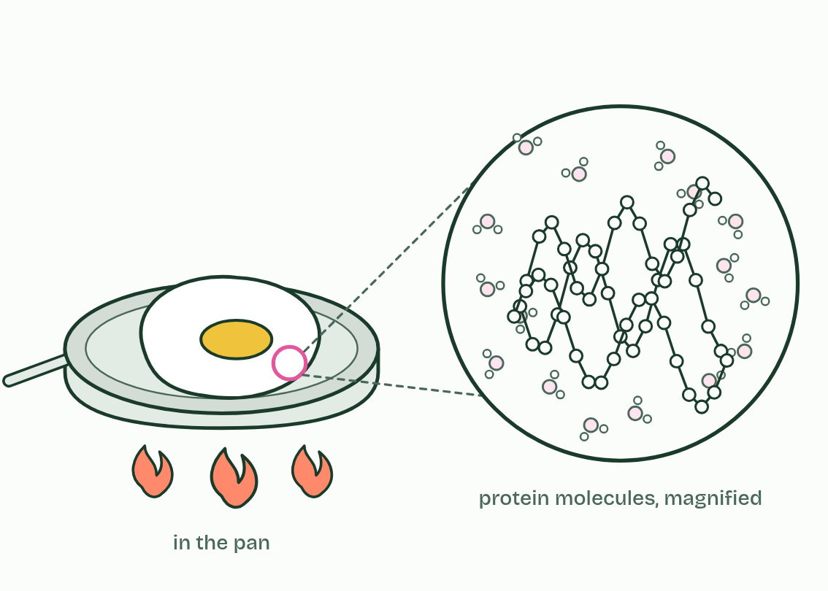  ANNOTATE THE FIGURE  Annotate this still from the animation (Heat it, change the pH): what is happening, and why?  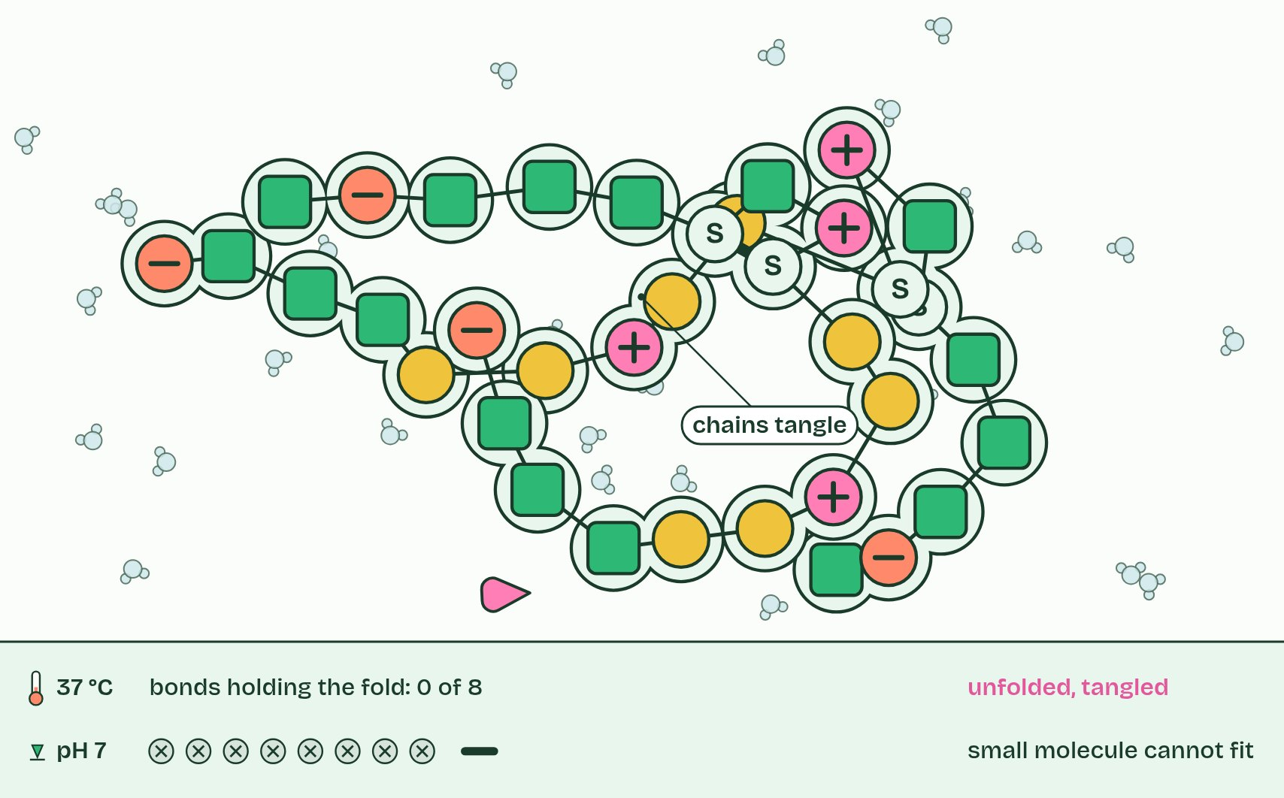
  SPOT THE MISTAKE
  What do students often get wrong about effect of pH and temperature on protein structure? Write the mistake, then put it right.
  The mistake
  Put it right
SUMMARY
Sum up section 05 in two or three sentences of your own.

06 The R groups decide how a chain behaves | B1.2.6 HL
CUES  Predict: An R group contains a carboxyl group. Inside a cell, at about pH 7, it is:  What is meant by hydrophobic?  What is meant by hydrophilic?  What is meant by polar?  What is meant by charged?  What is meant by acidic?  What is meant by basic? | NOTES  1 There are two big classes. _______________ R groups are non-polar, mostly carbon and hydrogen, and water does not attract them. _______________ R groups are attracted to water, and they are either ________, with partial charges that let them form hydrogen bonds, or _________.  2 Charged R groups are ________ or ________.  Your own notes  ANNOTATE THE FIGURE  Label the key parts and add a note on what it shows.  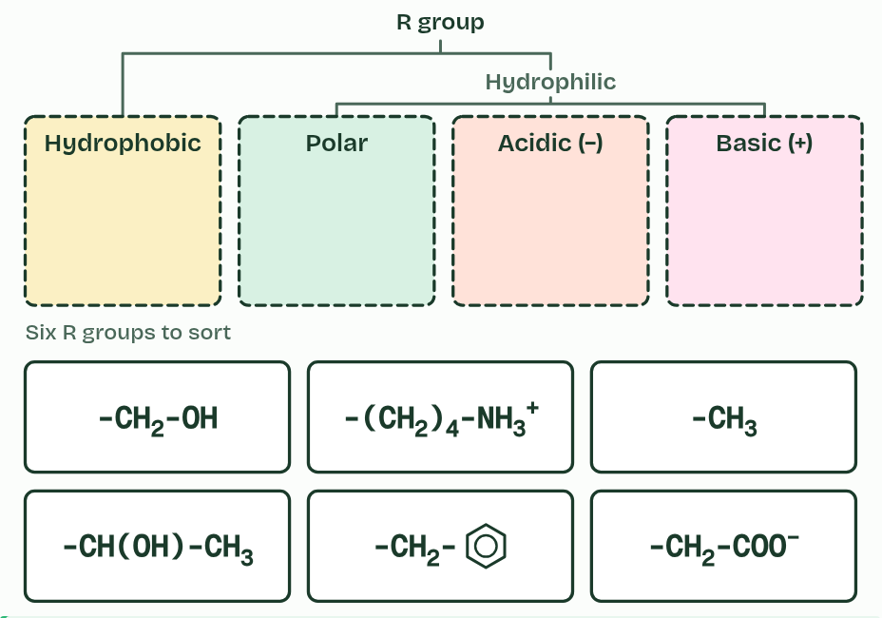  REMEMBER IT  The four kinds of R group
  H  Hungry | P  Pandas | A  Ate | B  Bamboo
  H | P | A | B
  SPOT THE MISTAKE
  What do students often get wrong about chemical diversity in the R groups? Write the mistake, then put it right.
  The mistake
  Put it right
SUMMARY
Sum up section 06 in two or three sentences of your own.

07 The sequence sets the shape | B1.2.7 HL
CUES  Predict: Two people make insulin from the same gene sequence. Do their insulin molecules have the same shape?  What is meant by primary structure? | NOTES  1 The _______________________ of a protein is the sequence of amino acids in its polypeptide, and a gene sets it.  2 _________ structure: a sequence of amino acids, each joined to the next by a peptide bond.  3 ____________ structure: one stretch coils and another pleats beside itself, held by dashed hydrogen bonds.  4 ___________ structure: the whole chain folded into a compact shape.  5 ______________ structure: two or more folded chains together. Not every protein has one.  6 A second copy of the same sequence folds into the same shape: same sequence, ______________, every time.  Your own notes  ANNOTATE THE FIGURE  Number the 5 steps on the figure and note what happens at each: 1 Primary; 2 Secondary; 3 Tertiary; 4 Quaternary; 5 same shape.  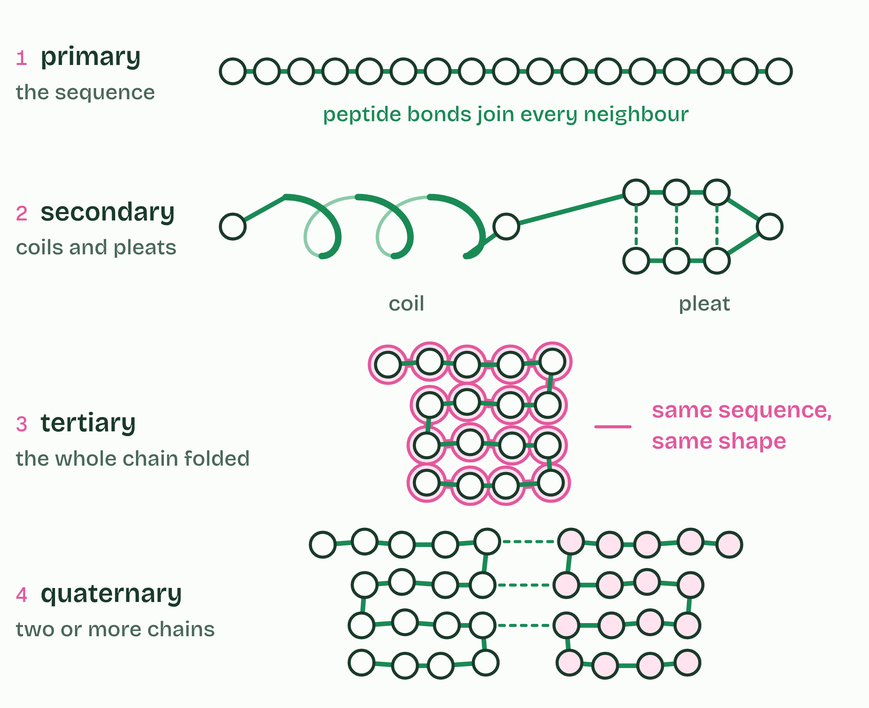
  SPOT THE MISTAKE
  What do students often get wrong about impact of primary structure on conformation? Write the mistake, then put it right.
  The mistake
  Put it right
SUMMARY
Sum up section 07 in two or three sentences of your own.

08 Coils and pleats held by hydrogen bonds | B1.2.8 HL
CUES  Predict: Which groups form the hydrogen bonds that hold an alpha helix?  What is meant by secondary structure?  What is meant by alpha helix?  What is meant by beta-pleated sheet? | NOTES  1 Where the chain makes these bonds in regular positions, it settles into a regular shape, its __________________________.  2 In an _______________ the chain coils, and each C=O bonds with the N-H four amino acids further along.  3 In a ________________________, stretches of the chain lie side by side, running the same way or opposite ways, and C=O groups in one stretch bond to N-H groups in the next.  Your own notes  ANNOTATE THE FIGURE  Label each part and say what it does: hydrogen bond, hydrogen bond, hydrogen bond, hydrogen bond, hydrogen bond, hydrogen bond, hydrogen bond, hydrogen bond, hydrogen bond.  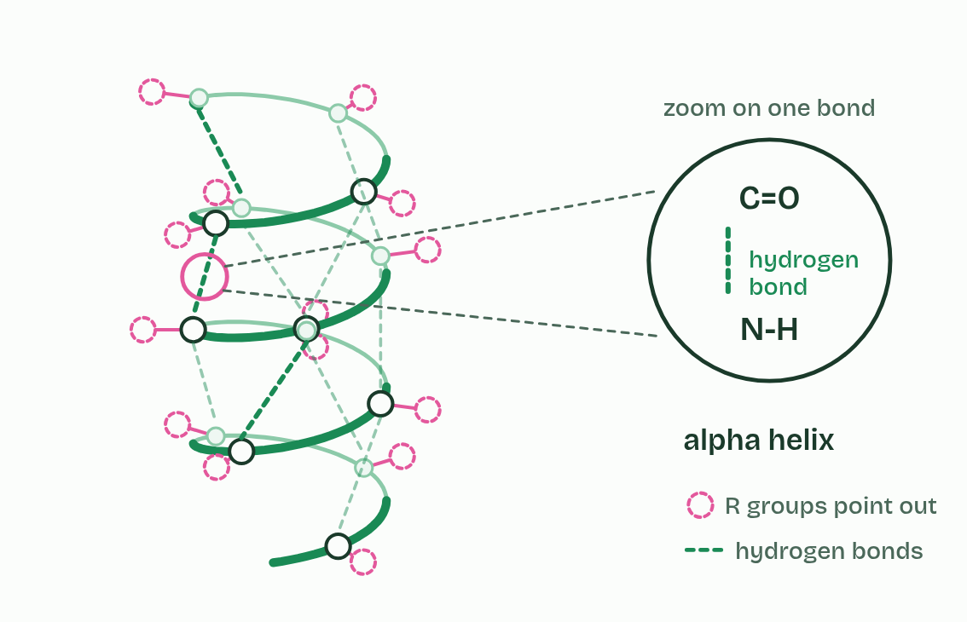
  SPOT THE MISTAKE
  What do students often get wrong about pleating and coiling of secondary structure? Write the mistake, then put it right.
  The mistake
  Put it right
SUMMARY
Sum up section 08 in two or three sentences of your own.

09 Four kinds of bond hold the fold | B1.2.9 HL
CUES  Predict: An ionic bond holds two parts of a protein together. The pH falls to 2. Why might the bond break?  What is meant by tertiary structure?  What is meant by ionic bonds?  What is meant by disulfide bonds?  What is meant by cysteines?  What is meant by hydrophobic interactions? | NOTES  1 ________________________ is the three-dimensional shape of the whole polypeptide.  2 ___________________ between polar R groups.  3 _______________ between a positively charged (basic) and a negatively charged (acidic) R group. The amine and carboxyl groups in R groups become charged by gaining or losing a hydrogen ion, and only then can they form ionic bonds.  4 ____________________, covalent bonds between the sulfur atoms of two ____________, the only amino acid you need to name. This is the strongest of the four.  5 ________________________________: non-polar R groups cluster together, away from water.  Your own notes  ANNOTATE THE FIGURE  The figure shows it as Hydrogen, Ionic, Disulfide, Hydrophobic, All and Lower the pH. Note what changes each time.  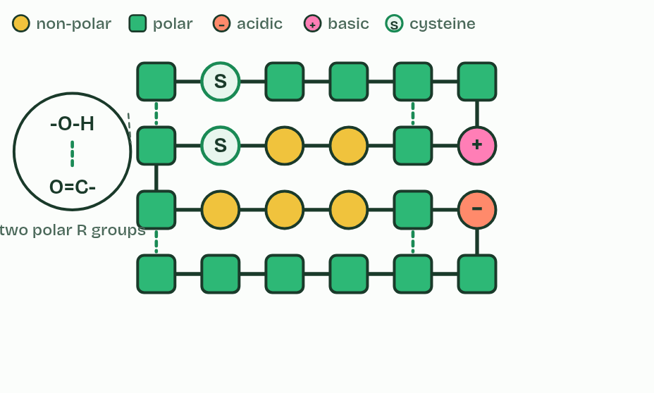  REMEMBER IT  The bonds that hold a tertiary structure
  H  Happy | H  Hippos | I  Ignore | D  Dentists
  H | H | I | D
  SPOT THE MISTAKE
  What do students often get wrong about dependence of tertiary structure on four kinds of bond? Write the mistake, then put it right.
  The mistake
  Put it right
SUMMARY
Sum up section 09 in two or three sentences of your own.

10 Oily inside, watery outside | B1.2.10 HL
CUES  Predict: A protein dissolves in blood plasma. Where are most of its hydrophobic R groups?  What is meant by integral proteins? | NOTES  1 _______________________ work the other way round.  Your own notes  ANNOTATE THE FIGURE  The figure shows it as Unfolded, In water and In a membrane. Note what changes each time.  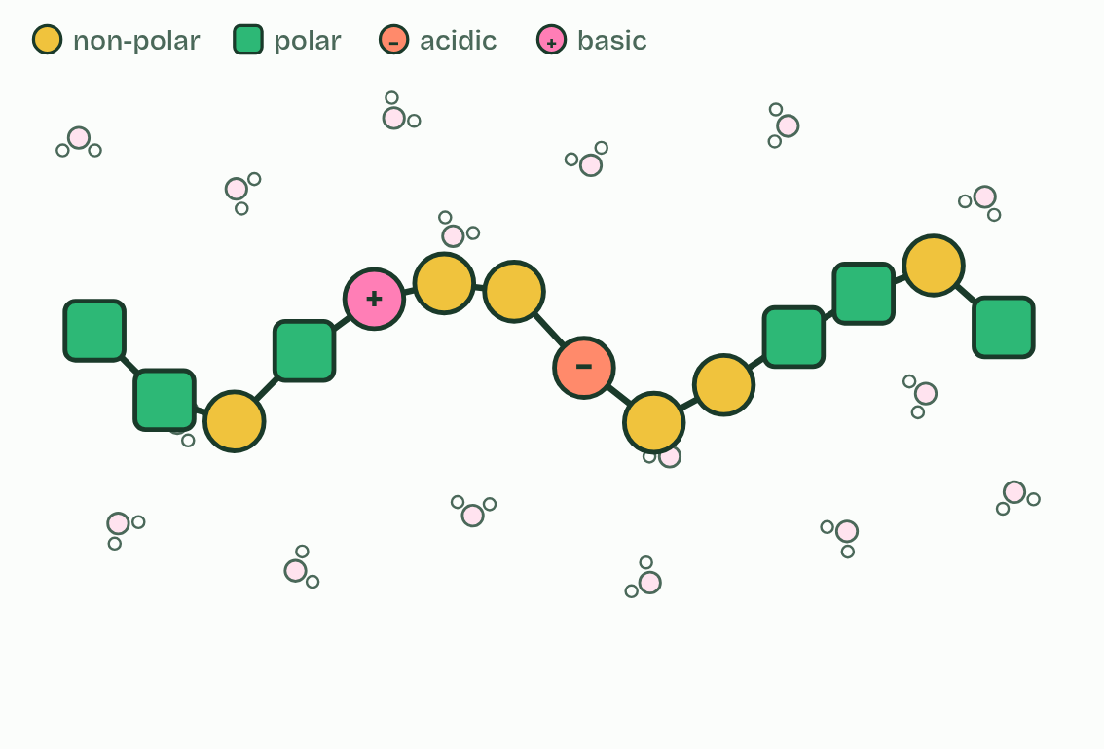  ANNOTATE THE FIGURE  Number the 2 steps on the figure and note what happens at each: 1 ROSALIND FRANKLIN; 2 non-polar.  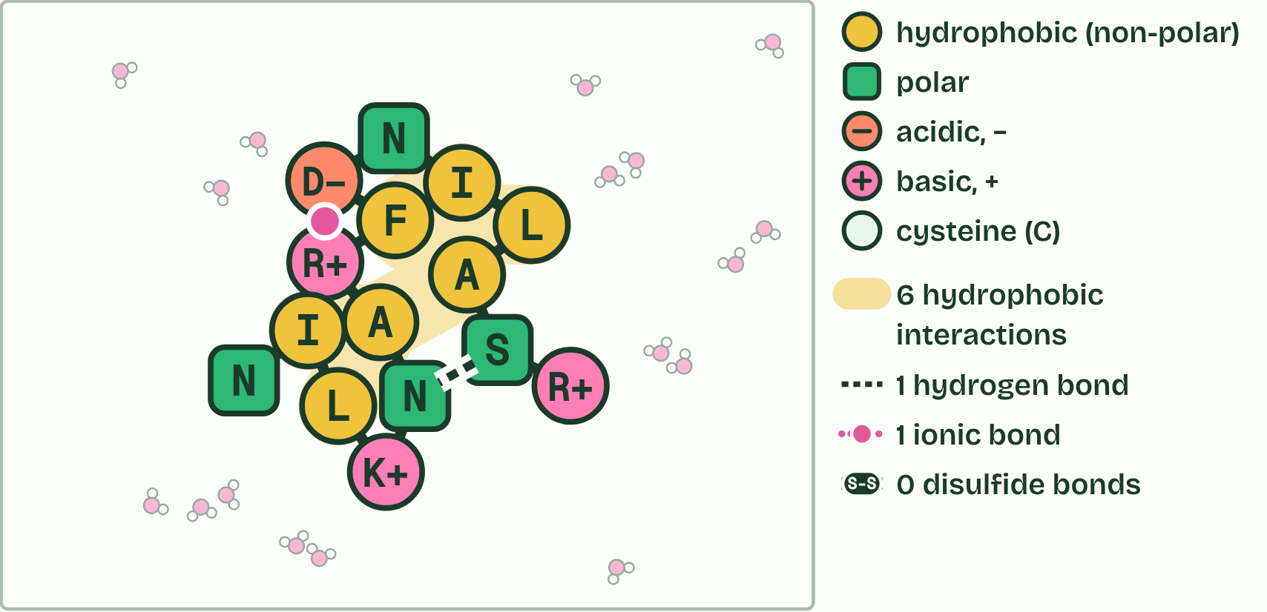
  SPOT THE MISTAKE
  What do students often get wrong about effect of polar and non-polar amino acids on tertiary structure? Write the mistake, then put it right.
  The mistake
  Put it right
SUMMARY
Sum up section 10 in two or three sentences of your own.

11 More than one chain: quaternary structure | B1.2.11 HL
CUES  Predict: A haemoglobin molecule is about 5 to 6 nm across. Could you see one with the best light microscope?  What is meant by quaternary structure?  What is meant by non-conjugated protein?  What is meant by conjugated protein?  What is meant by prosthetic group?  What is meant by cryogenic electron microscopy? | NOTES  1 Others are two or more polypeptides held together, and their arrangement is the ___________________________, held by the same kinds of bond as the tertiary.  2 A ______________________________ is made of polypeptide only. _________ has two polypeptides, of 21 and 30 amino acids, linked by two disulfide bonds, with a third disulfide bond within the shorter chain. ___________ has three polypeptides, each about 1,000 amino acids long, wound round each other into a triple helix like a rope.  3 A ________________________ includes a part that is not polypeptide, a ______________________. _______________ has four polypeptides, two of one kind and two of another, each holding a haem group with an iron ion at its centre.  Your own notes  ANNOTATE THE FIGURE  The figure shows it as Insulin, Collagen and Haemoglobin. Note what changes each time.  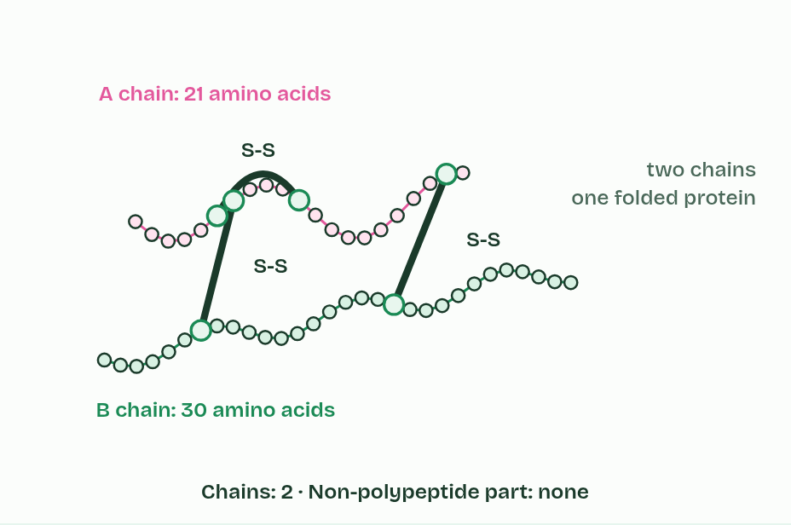  REMEMBER IT  The three named proteins, in order of chains
  I  I | S  See | H  Him
  I | S | H
  SPOT THE MISTAKE
  What do students often get wrong about quaternary structure of non-conjugated and conjugated proteins? Write the mistake, then put it right.
  The mistake
  Put it right
SUMMARY
Sum up section 11 in two or three sentences of your own.

12 Balls and ropes: globular and fibrous proteins | B1.2.12 HL
CUES  Predict: A protein is long and thin, has a repeating sequence and does not dissolve in water. What is its most likely job?  What is meant by globular proteins?  What is meant by fibrous proteins? | NOTES  1 _______________________ are folded into compact, rounded shapes.  2 _________ shows how form suits function.  3 ______________________ are long and narrow, often with a repeating sequence, usually insoluble and strong, and have structural jobs. ___________ is three chains wound into a rope.  4 One _________ molecule is a small rounded knot among water molecules. One ___________ molecule is a long, thin rope, about 100 times longer than the knot is wide.  5 Insulin is _________: dissolved in the plasma, it is carried round the body in the blood.  6 Insulin has a __________________ that fits the receptor on its target cells, liver, muscle and fat cells, like a key in a lock.  Your own notes  ANNOTATE THE FIGURE  Number the 5 steps on the figure and note what happens at each: 1 insulin, collagen; 2 soluble; 3 precise shape; 4 cross-linked; 5 insoluble.  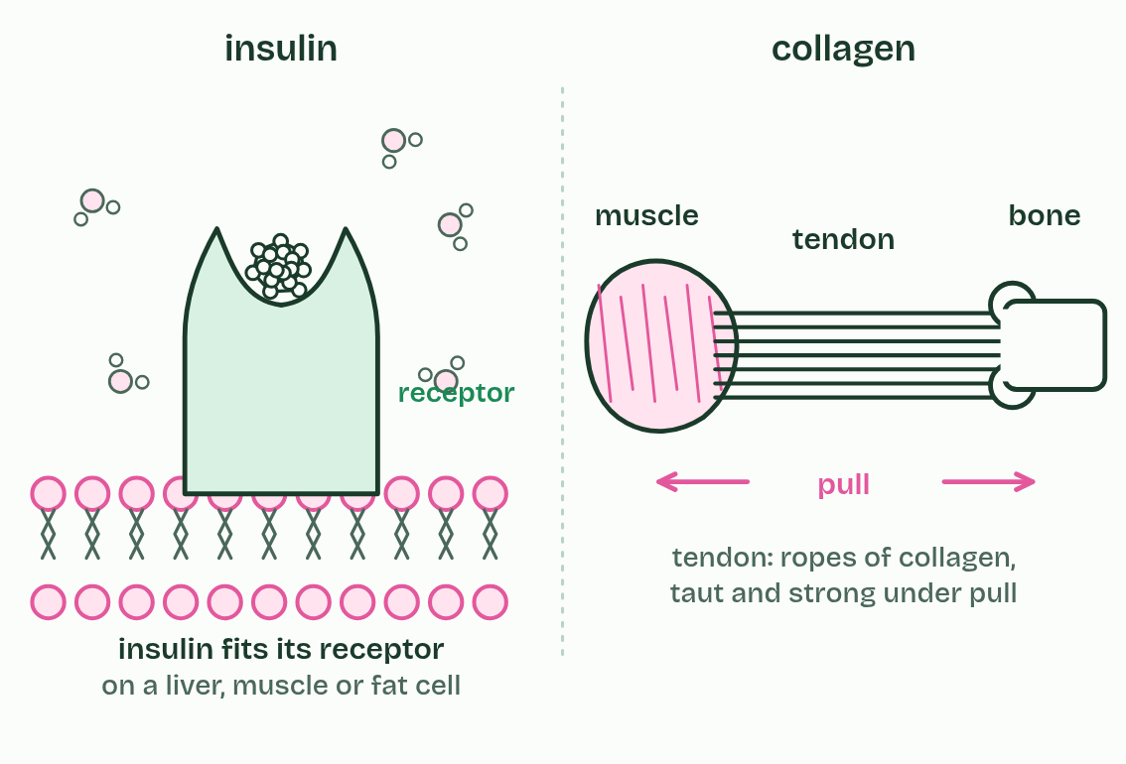
  SPOT THE MISTAKE
  What do students often get wrong about relationship of form and function in globular and fibrous proteins? Write the mistake, then put it right.
  The mistake
  Put it right
SUMMARY
Sum up section 12 in two or three sentences of your own.

Check yourself
The check for this guide is online: a fresh paper of past-paper style questions from the exam bank on B1.2 each time, marked as you go, and saved to your Exam practice progress when you are signed in. Open the link:
biologybybradford.com/exam-maker/sit?topics=B1.2&level=HL&paper=quiz&marks=15&src=ep

