Name | Class | Date
IB BIOLOGY · C1.1

Enzymes and metabolism
Teacher’s copy: every blank filled in. Each numbered block matches a chapter of the guide, and of the lesson slides. Write in the gaps, answer the cues, annotate the figures, and sum up each section in your own words.
BY THE END YOU CAN
Explain why cells need catalysts, and what an enzyme's speed does for digestion, growth and keeping cool enough to live C1.1.1
Describe metabolism as a web of linked reactions, and sort reactions into anabolic and catabolic with an example of each C1.1.2, C1.1.3
Read an energy diagram and explain how an enzyme lowers the activation energy without changing the energy released C1.1.10
Explain how a few amino acids, held in place by the whole folded protein, make an active site, and how induced fit works C1.1.4, C1.1.5
Explain why substrate and active site must collide, and how enzymes fixed in membranes still meet their substrates C1.1.6
Explain how the shape of the active site makes an enzyme specific, and why denaturation stops it working C1.1.7
Sketch and explain the effects of temperature, pH and substrate concentration on the rate, using collision theory and denaturation C1.1.8
Work out a rate from your own results or from secondary data, including the initial rate from a tangent C1.1.9
Compare enzymes at work inside cells and outside them, and linear pathways with cycles C1.1.11, C1.1.13
Explain why metabolism always releases heat, and how mammals and birds use it C1.1.12
Explain how a molecule binding an allosteric site stops an enzyme, and why the binding can be undone C1.1.14
Explain how statins inhibit an enzyme competitively, and contrast competitive and non-competitive inhibition on a graph C1.1.15
Explain how isoleucine controls its own pathway by feedback inhibition C1.1.16
Explain how penicillin inhibits transpeptidase for good, and how a changed transpeptidase makes bacteria resistant C1.1.17

01 Seconds, not millions of years | C1.1.1
CUES  Predict: With no enzyme at all, how long would water at room temperature take to break half the bonds between the glucose units in starch?  C: About five million years. About five million years, by one careful measurement. The reaction is possible, but so slow it might as well not happen. Amylase in your saliva does the same job in a fraction of a second. That gap, repeated across thousands of reactions, is why life needs enzymes.  What is meant by catalyst?  A substance that speeds up a chemical reaction without being used up or changed by it, so the same molecule can work again and again.  What is meant by enzymes?  The catalysts of living things. Nearly all of them are proteins.  What is meant by rate of reaction?  How much substrate is used up, or how much product is made, in a given time. | NOTES  1 A catalyst is a substance that speeds up a chemical reaction without being used up by it.  2 The same molecule works again and again. Enzymes are the catalysts of living things, and nearly all of them are proteins (chapter 4 shows how their shape does the job).  3 The rate of reaction has to be fast enough for life, and an enzyme raises it enormously.  4 With water alone at room temperature, half the bonds take millions of years to break.  5 Amylase breaks each one in about a thousandth of a second, at body temperature.  Your own notes  ANNOTATE THE FIGURE  Number the 3 steps on the figure and note what happens at each.  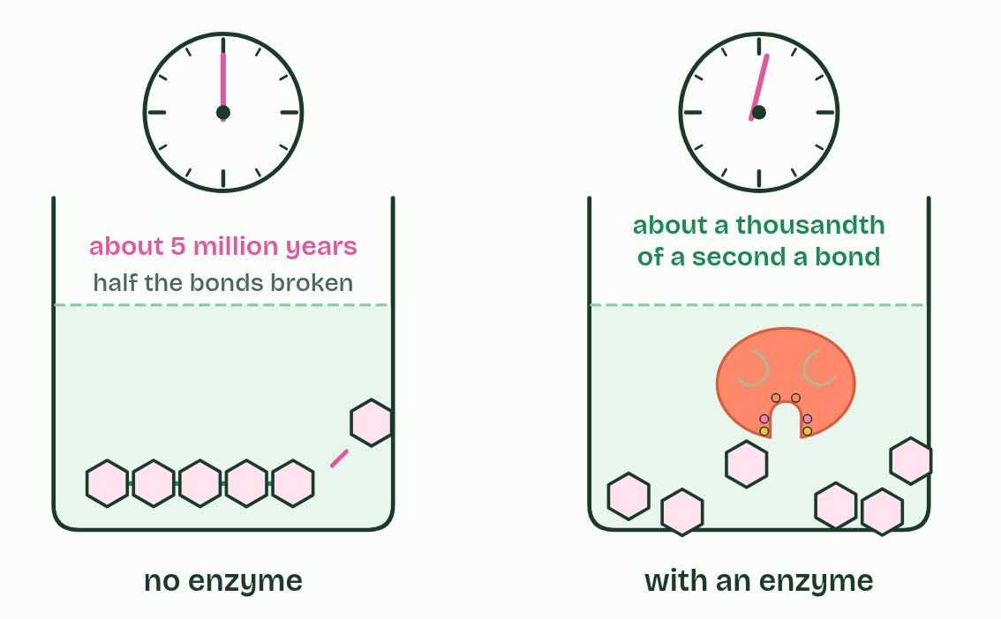  1 The same bond in starch, broken two ways.  2 With water alone at room temperature, half the bonds take millions of years to break.  3 Amylase breaks each one in about a thousandth of a second, at body temperature.
  SPOT THE MISTAKE
  What do students often get wrong about enzymes as catalysts? Write the mistake, then put it right.
  An enzyme is not used up by the reaction it catalyses. The substrate changes; the enzyme comes out as it went in.
SUMMARY
Sum up section 01 in two or three sentences of your own.
• Digestion. Food spends only a few hours in your gut. Its starch, protein and fat must be broken down in that time, or the food leaves unabsorbed.
• Growth. A cell has to copy all of its DNA before it divides.
• Response. A nerve or a muscle has to respond in a fraction of a second.

02 A web of reactions, an enzyme for each | C1.1.2 C1.1.3
CUES  Predict: A liver cell makes thousands of different enzymes. Why so many?  A: Each enzyme catalyses one kind of reaction. Each enzyme fits one substrate, or one kind of substrate, so it catalyses one kind of reaction. Thousands of reactions need thousands of enzymes, and having a separate enzyme for each step is also what lets the cell control each step on its own.  What is meant by metabolism?  All the chemical reactions in an organism: a complex network of interdependent, interacting reactions.  What is meant by metabolic pathway?  A series of enzyme-catalysed reactions in which the product of one is the substrate of the next.  What is meant by enzyme specificity?  An enzyme catalyses only one reaction, or a few very similar ones, because only certain substrates fit its active site.  What is meant by anabolic?  Reactions that build larger molecules from smaller ones. They take in energy.  What is meant by condensation?  A reaction that joins two molecules and releases a water molecule for every bond made.  What is meant by catabolic?  Reactions that break larger molecules into smaller ones. They release energy.  What is meant by hydrolysis?  A reaction that breaks a bond by adding a water molecule, one for every bond broken.  What is meant by oxidation?  A reaction in which a substance loses electrons or hydrogen, or gains oxygen. In respiration, glucose is oxidised. | NOTES  1 Metabolism is every chemical reaction going on in an organism.  2 A metabolic pathway is one thread of it, a series of steps with an enzyme for each.  3 Each enzyme catalyses one reaction, or one kind of reaction. This enzyme specificity (chapter 6 shows why) is why a cell needs thousands of different enzymes, one for each step.  4 Metabolic reactions fall into two groups. Anabolic reactions build larger molecules from smaller ones and take in energy.  5 Monomers are joined into macromolecules by condensation, as when amino acids become a polypeptide in protein synthesis, or glucose becomes glycogen.  6 Catabolic reactions break larger molecules into smaller ones and release energy.  7 In digestion, macromolecules are broken into monomers by hydrolysis.  8 In respiration, substrates such as glucose are broken down by oxidation.  Your own notes  ANNOTATE THE FIGURE  Number the 3 steps on the figure and note what happens at each.  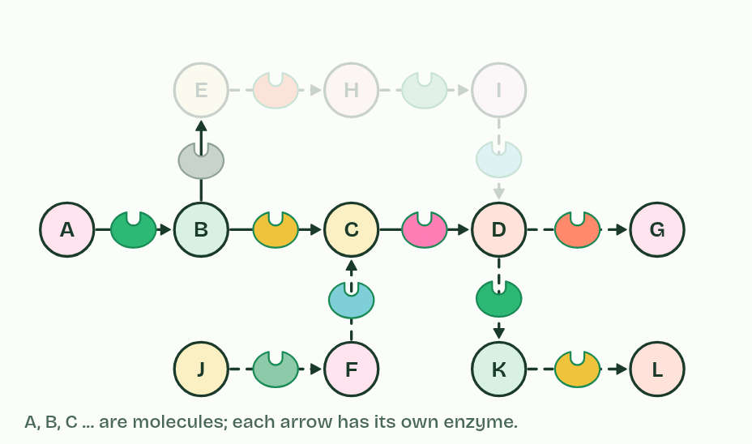  1 One reaction, one enzyme.  2 The product of one reaction is the substrate of the next.  3 Thousands of linked reactions make metabolism. Switch off one enzyme and one step stops.  ANNOTATE THE FIGURE  Label the key parts and add a note on what it shows.  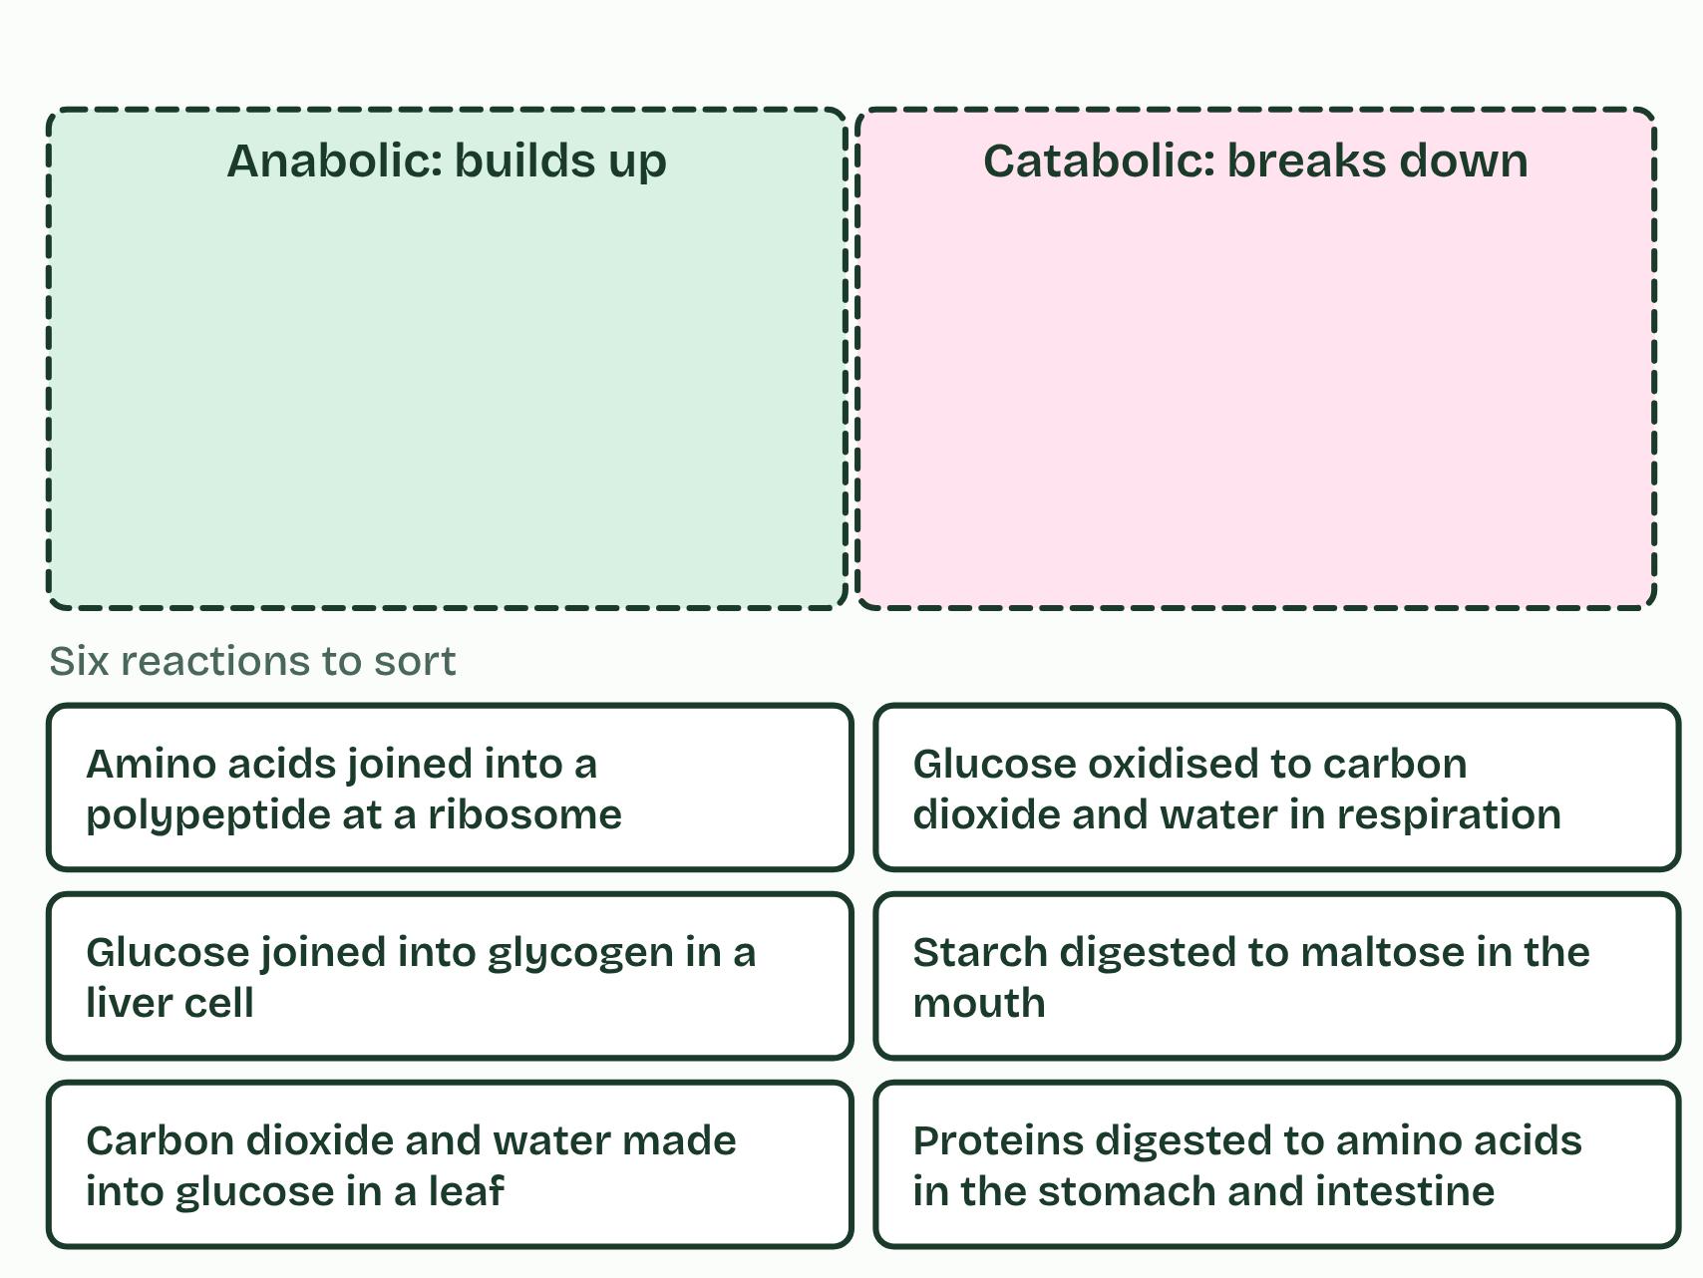  Six reactions in a cell or an organism. Is a bigger molecule being made, or a big one being taken apart?  ANNOTATE THE FIGURE  Annotate this still from the animation (Build glycogen, then break it down): what is happening, and why?  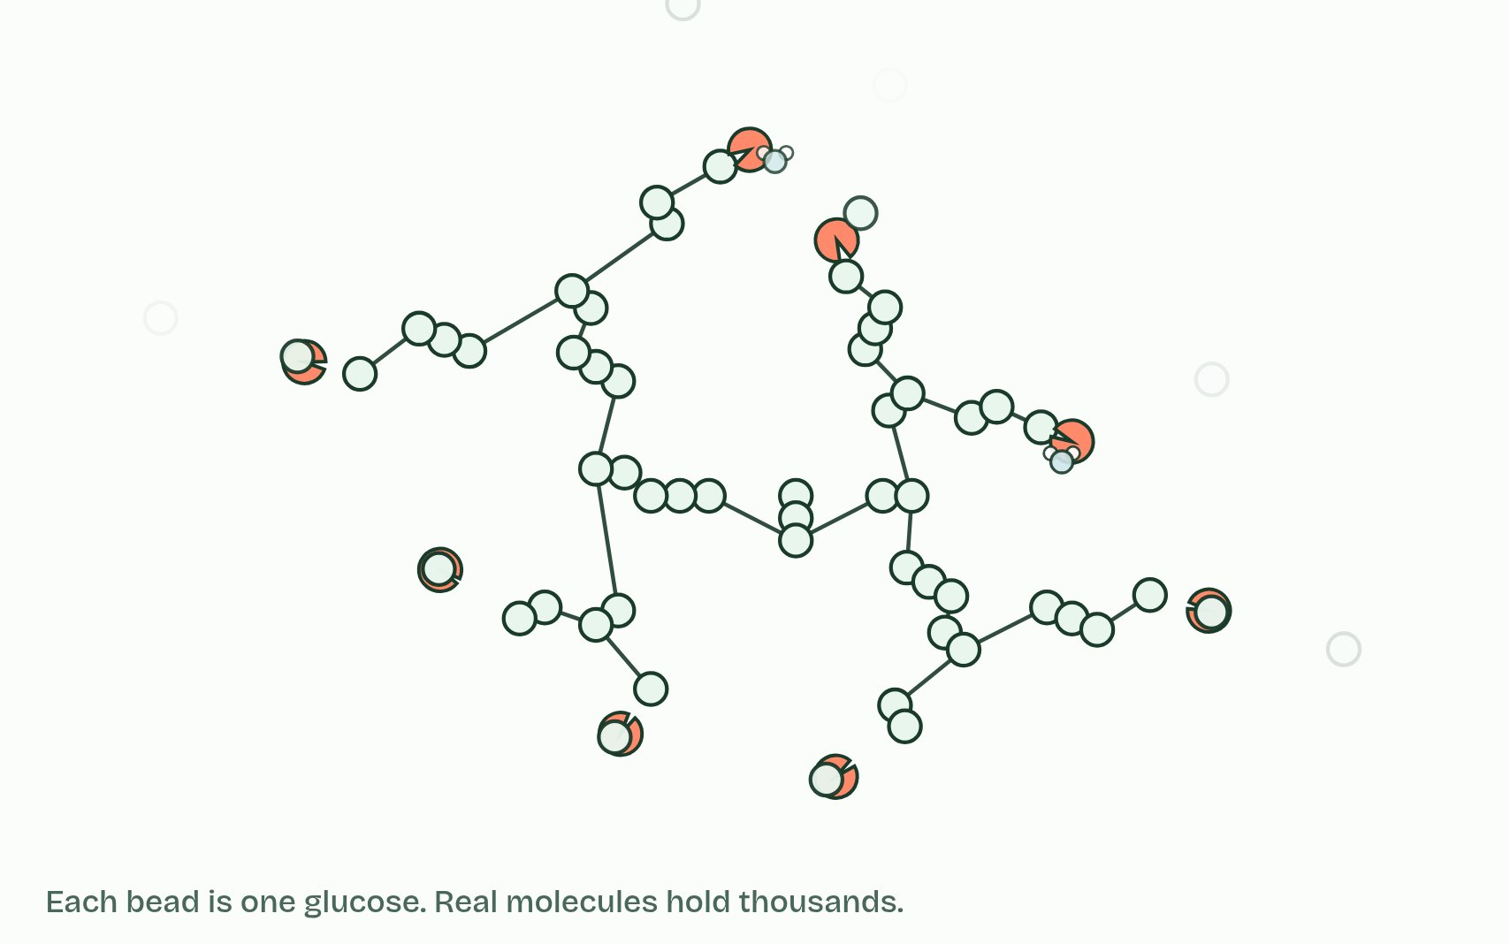  1 Glucose units join one at a time; a water molecule leaves at each link.  2 Amylose coils into a helix: a lot of glucose in a small space.  3 Amylopectin and glycogen branch, so they have many ends.  4 Enzymes take glucose off the ends, using a water molecule each time.  REMEMBER IT  The two halves of metabolism
  A  Add | C  Cut
  Anabolic  builds bigger molecules from smaller ones, takes in energy | Catabolic  breaks bigger molecules into smaller ones, releases energy
  SPOT THE MISTAKE
  What do students often get wrong about role of enzymes in metabolism; anabolic and catabolic reactions? Write the mistake, then put it right.
  In science, metabolism is not how fast you burn food. It is every reaction in the body, building as well as breaking.
SUMMARY
Sum up section 02 in two or three sentences of your own.
• Metabolism is every chemical reaction going on in an organism.
• A metabolic pathway is one thread of it, a series of steps with an enzyme for each.
• Each enzyme catalyses one reaction, or one kind of reaction. This enzyme specificity (chapter 6 shows why) is why a cell needs thousands of different enzymes, one for each step.
• Metabolic reactions fall into two groups. Anabolic reactions build larger molecules from smaller ones and take in energy.

03 A lower hill to climb | C1.1.10
CUES  Predict: An enzyme lowers the activation energy of a reaction that releases energy. What happens to the energy released overall?  D: Nothing: the start and end levels stay put. Nothing changes it. The energy released overall is the difference between the substrate and the products, and the enzyme changes neither. It lowers only the hill between them, so the reaction gets going more easily and runs faster.  What is meant by activation energy?  The energy needed to strain and break the substrate's bonds so that a reaction can start.  What is meant by energy diagram?  A graph with energy on the vertical axis and the progress of a reaction across, showing the hill of activation energy and the levels of substrate and products.  What is meant by bond breaking?  Splitting a bond takes in energy.  What is meant by bond making?  Forming a new bond releases energy. | NOTES  1 The energy needed before the reaction can run is the activation energy.  2 On an energy diagram it is a hill that the reaction has to climb: energy up the side, progress of the reaction along the bottom.  3 Bond breaking takes in energy. Bond making releases it.  4 Activation energy is the energy needed to strain and break bonds so the reaction can start.  5 On an energy diagram, activation energy is the climb from the substrate up to the peak.  Your own notes  ANNOTATE THE FIGURE  Number the 5 steps on the figure and note what happens at each.  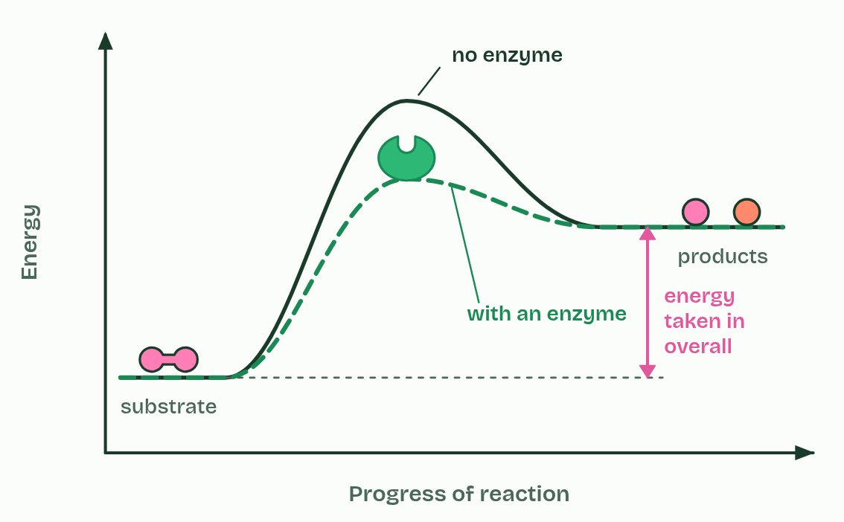  1 A substrate, before it reacts.  2 Breaking its bonds needs energy first: the activation energy.  3 Making new bonds releases energy. Here more comes out than went in.  4 With an enzyme, the hill is lower. Start and end do not move.  5 A building reaction ends higher than it starts. An enzyme lowers its hill too.
  SPOT THE MISTAKE
  What do students often get wrong about effect of enzymes on activation energy? Write the mistake, then put it right.
  An enzyme does not give the substrate energy, and it does not change how much energy a reaction releases. It lowers the energy needed to get the reaction started.
SUMMARY
Sum up section 03 in two or three sentences of your own.
• Activation energy is the energy needed to strain and break bonds so the reaction can start.
• Breaking bonds takes in energy; making bonds releases it.
• On an energy diagram, activation energy is the climb from the substrate up to the peak.

04 A pocket held in shape | C1.1.4 C1.1.5
CUES  Predict: An enzyme has 300 amino acids, and only about six touch the substrate. A mutation changes one amino acid far from the active site, and the enzyme stops working. How?  B: It changed how the chain folds, so the site lost its shape. The active site's shape and chemistry depend on the whole fold, and the fold is held by interactions between amino acids all through the chain. Change one, and the fold can shift enough to change the site, so the substrate no longer binds well or no longer reacts.  What is meant by globular proteins?  Proteins whose polypeptide chains are folded into a compact, roughly round shape. Most dissolve in water.  What is meant by active site?  The small region of an enzyme where the substrate binds and the reaction happens. It is made of a few amino acids.  What is meant by substrate?  The molecule an enzyme acts on.  What is meant by enzyme-substrate complex?  The enzyme with its substrate bound in the active site.  What is meant by induced fit?  The change in shape of both the active site and the substrate as they bind, which strains the substrate's bonds.  What is meant by products?  The molecules made from the substrate in an enzyme-catalysed reaction. | NOTES  1 Enzymes are globular proteins: one or more polypeptide chains folded into a compact, roughly round shape that dissolves in water (B1.2).  2 The active site is the small region where the substrate binds and the reaction happens.  3 When the substrate binds, the two form an enzyme-substrate complex.  4 Both change shape as it forms: the active site closes in around the substrate, and the substrate is pulled and bent, straining the bonds that are about to break. This is induced fit.  5 The substrate is converted into products, which no longer fit and leave, and the enzyme returns to its starting shape, ready for another substrate.  Your own notes  ANNOTATE THE FIGURE  Number the 5 steps on the figure and note what happens at each.  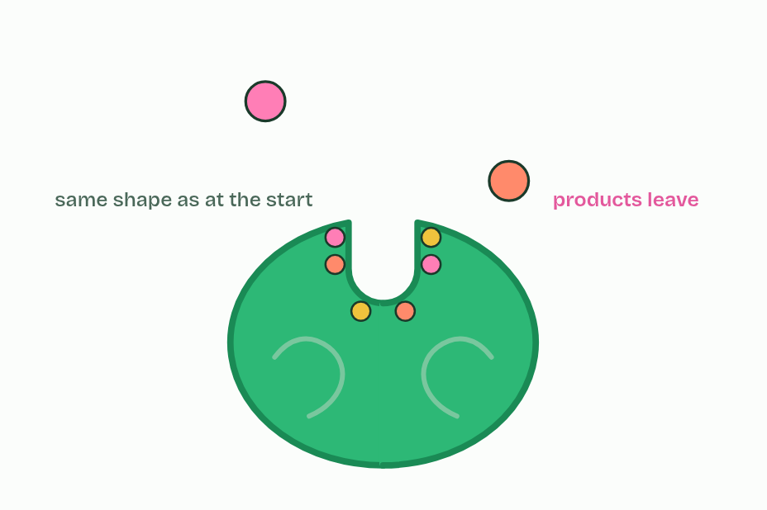  1 Only a few amino acids will form the site, far apart in the chain.  2 Folding brings them together: the active site.  3 The substrate binds: an enzyme-substrate complex.  4 Both change shape: induced fit strains the substrate's bonds.  5 Products leave; the enzyme is unchanged.  REMEMBER IT  What happens at the active site
  B  Bind | B  Bend | B  Break | B  Bye
  Binding  the substrate binds the active site | Induced fit  both change shape; the substrate's bonds are strained | Reaction  bonds break and new ones form: products | Release  the products leave; the enzyme is free again
  SPOT THE MISTAKE
  What do students often get wrong about globular proteins with an active site; induced-fit binding? Write the mistake, then put it right.
  The active site is not the whole enzyme, and not a fixed, rigid hole. It is a few amino acids that move as the substrate binds.
SUMMARY
Sum up section 04 in two or three sentences of your own.
• Enzymes are globular proteins: one or more polypeptide chains folded into a compact, roughly round shape that dissolves in water (B1.2).
• The active site is the small region where the substrate binds and the reaction happens.
• When the substrate binds, the two form an enzyme-substrate complex.
• Both change shape as it forms: the active site closes in around the substrate, and the substrate is pulled and bent, straining the bonds that are about to break. This is induced fit.

05 Meeting by chance | C1.1.6
CUES  Predict: Lactase sits fixed in the membrane of cells lining your small intestine. It cannot move. How does lactose reach its active site?  D: Lactose molecules move at random and collide with it. Lactose molecules in the gut contents move at random, like every dissolved molecule. Some collide with the membrane, a few of those with a lactase active site the right way round, and those bind. Only one partner has to move for a collision.  What is meant by molecular motion?  The constant random movement of molecules in a liquid or gas, caused by their energy and by collisions with other molecules.  What is meant by collision?  Two molecules striking each other. An enzyme reaction needs a collision between a substrate and an active site.  What is meant by orientation?  The way a molecule faces when it collides. A substrate must meet the active site the right way round to bind.  What is meant by immobilised enzyme?  Here, an enzyme held in place, for example embedded in a membrane, so that the substrate moves to it. | NOTES  1 Their molecules move all the time and at random, jostled by the water molecules around them. This molecular motion is what brings them together.  2 A reaction can happen only when a substrate and an active site meet in a collision, and only if the substrate arrives the right way round (its orientation) and close enough to bind.  3 Sometimes an immobilised enzyme is held still, embedded in a membrane.  Your own notes  ANNOTATE THE FIGURE  The figure shows it as In solution, Enzyme fixed in a membrane and Substrate held still. Note what changes each time.  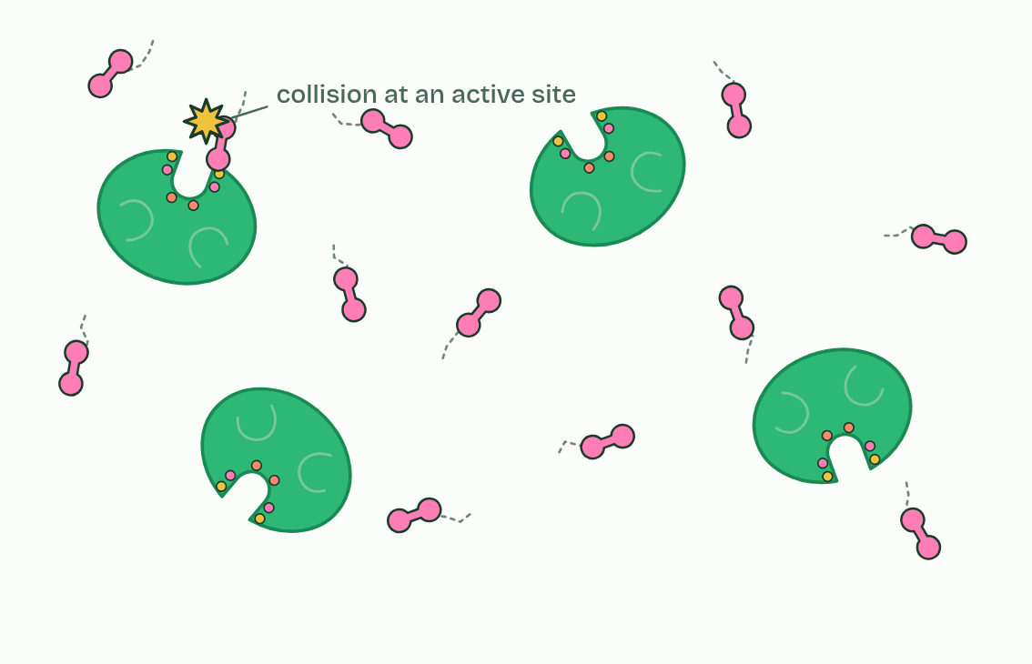  1 In solution  2 Enzyme fixed in a membrane  3 Substrate held still
SUMMARY
Sum up section 05 in two or three sentences of your own.
• Their molecules move all the time and at random, jostled by the water molecules around them. This molecular motion is what brings them together.
• A reaction can happen only when a substrate and an active site meet in a collision, and only if the substrate arrives the right way round (its orientation) and close enough to bind.
• Sometimes an immobilised enzyme is held still, embedded in a membrane.

06 Lose the shape, lose the fit | C1.1.7
CUES  Predict: Pepsin digests protein in the stomach at about pH 2. Carried on into the small intestine at about pH 8, what happens to it?  A: It denatures: its active site changes shape and charge. Pepsin's shape is held partly by ionic bonds that suit pH 2. At pH 8 its R groups lose hydrogen ions, the charges change, the bonds break and the active site changes shape. Pepsin stops working in the intestine, where other proteases suited to pH 8 take over.  What is meant by enzyme-substrate specificity?  Only a substrate whose shape and charges match the active site can bind, so each enzyme acts on one substrate, or a few similar ones.  What is meant by denaturation?  A change in the three-dimensional shape of a protein, caused by heat or a pH far from its normal one, so that it can no longer do its job. It is usually permanent. | NOTES  1 The active site's shape and charges match its substrate's, so few other molecules bind. This is enzyme-substrate specificity.  2 Either way the substrate no longer binds, or binds and does not react. This is denaturation.  Your own notes  ANNOTATE THE FIGURE  The figure shows it as Its substrate, A different molecule, Too hot and Wrong pH. Note what changes each time.  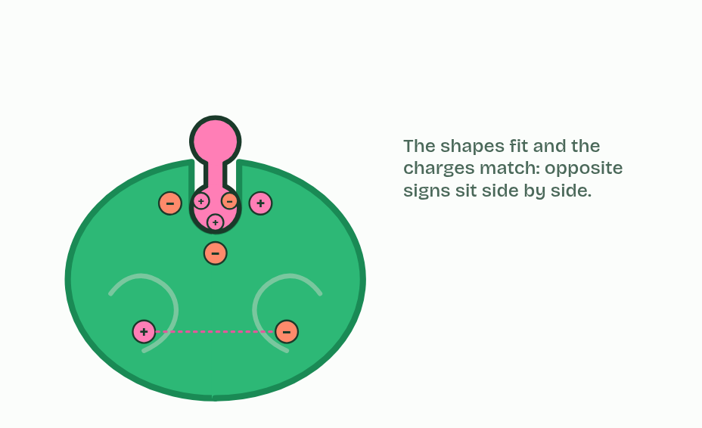  1 Its substrate  2 A different molecule  3 Too hot  4 Wrong pH
  SPOT THE MISTAKE
  What do students often get wrong about active site structure, specificity and denaturation? Write the mistake, then put it right.
  Enzymes are not killed by heat, and cold does not denature them. Heat denatures; cold only slows.
SUMMARY
Sum up section 06 in two or three sentences of your own.
• The active site's shape and charges match its substrate's, so few other molecules bind. This is enzyme-substrate specificity.
• Either way the substrate no longer binds, or binds and does not react. This is denaturation.

07 Three graphs to know | C1.1.8
CUES  Predict: On a graph of rate against substrate concentration, the curve levels off. Why?  C: Nearly every active site is already busy. At high substrate concentration nearly every active site is occupied at any moment. A substrate molecule arriving at a busy enzyme has to wait, so adding more substrate barely raises the rate. This is saturation. The substrate has not run out: there is more of it than ever. Only more enzyme can raise the maximum.  What is meant by optimum?  The value of temperature or pH at which an enzyme's rate is highest.  What is meant by collision theory?  The idea that a reaction needs a collision, with enough energy and the right orientation, between the reacting particles.  What is meant by sketch graphs?  Generalised graphs of a relationship. They are models in biology: they show the general pattern, not the data of any one enzyme.  What is meant by saturation?  With nearly every active site occupied at any moment, so that more substrate barely raises the rate. | NOTES  1 Temperature. Below the optimum, warming the solution makes enzyme and substrate move faster, so they collide more often and more collisions have enough energy to react.  2 All three effects follow from collision theory and denaturation.  3 Describe a graph in parts, with numbers from its axes: "rises steadily to an optimum near 40 °C, then falls steeply". These smooth curves are sketch graphs: models of the general pattern, not the data of one enzyme.  4 Temperature: faster collisions, then denaturation.  5 pH: each enzyme has its own optimum.  6 Substrate: the rate rises, then levels off.  Your own notes  ANNOTATE THE FIGURE  Number the 4 steps on the figure and note what happens at each.  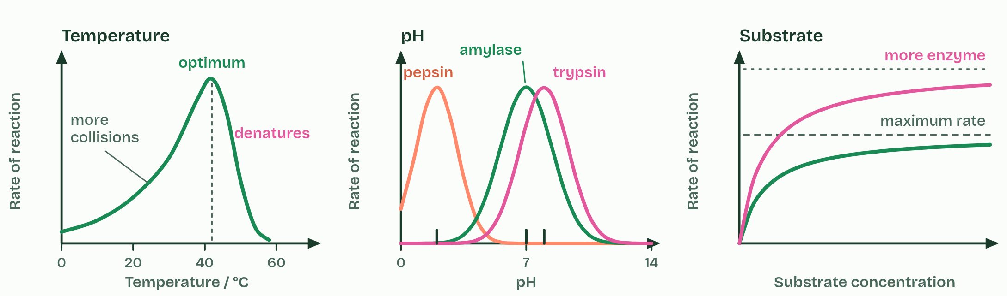  1 Temperature: faster collisions, then denaturation.  2 pH: each enzyme has its own optimum.  3 Substrate: the rate rises, then levels off.  4 More enzyme raises the maximum.  ANNOTATE THE FIGURE  Annotate this still from the animation (Watch it happen: collisions, substrate and heat): what is happening, and why?  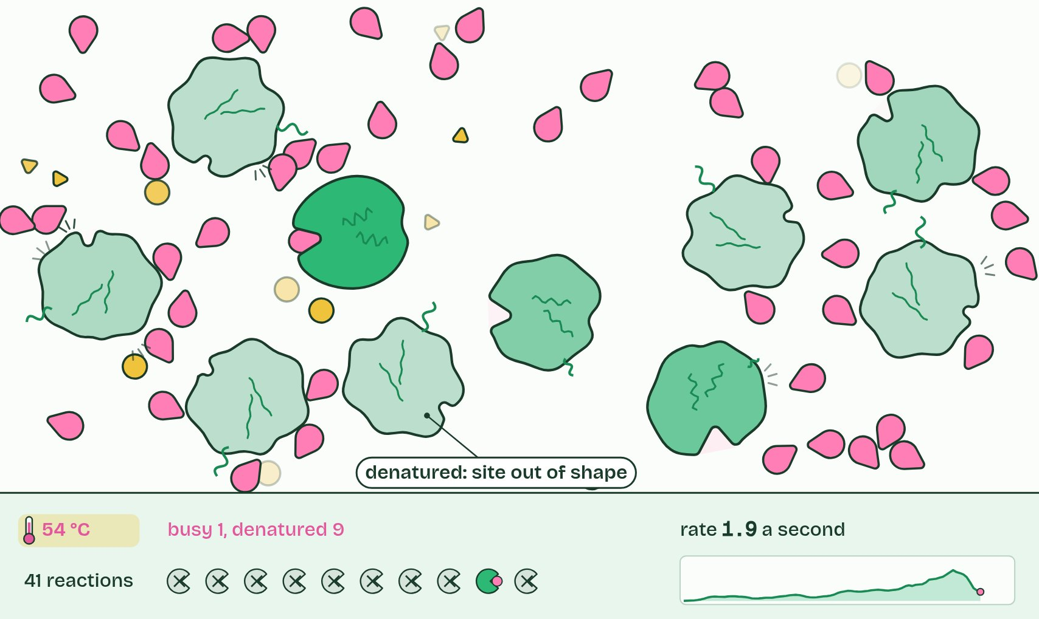  1 Molecules move at random, and most collisions miss the active site.  2 A successful collision: it binds and reacts, and the enzyme is unchanged.  3 Too hot: enzymes denature. Active sites lose their shape, and the rate falls.  REMEMBER IT  The three factors you must explain
  T  Tigers | P  Prefer | S  Steak
  Temperature  collisions, then denaturation | pH  charges in the active site | Substrate concentration  collisions, then saturation
  SPOT THE MISTAKE
  What do students often get wrong about effects of temperature, pH and substrate concentration? Write the mistake, then put it right.
  The optimum is not always 37 °C. That is roughly where many human enzymes peak; enzymes from other organisms peak far higher or lower.
SUMMARY
Sum up section 07 in two or three sentences of your own.
• Temperature. Below the optimum, warming the solution makes enzyme and substrate move faster, so they collide more often and more collisions have enough energy to react.
• All three effects follow from collision theory and denaturation.
• Describe a graph in parts, with numbers from its axes: "rises steadily to an optimum near 40 °C, then falls steeply". These smooth curves are sketch graphs: models of the general pattern, not the data of one enzyme.

08 Measuring a rate | C1.1.9
CUES  Predict: A drop of a starch and amylase mixture stops turning iodine blue-black after 40 s at 30 °C and after 80 s at 20 °C. Compare the rates.  B: The rate at 30 °C is double: rate is 1 ÷ time. Rate = 1 ÷ time: 1 ÷ 40 s = 0.025 s⁻¹ at 30 °C and 1 ÷ 80 s = 0.0125 s⁻¹ at 20 °C. Half the time means twice the rate.  What is meant by rate of reaction?  How much substrate is used up, or how much product is made, in a given time.  What is meant by initial rate?  The rate at the very start of a reaction, found as the gradient of a tangent to the curve at time zero, before the substrate runs low.  What is meant by tangent?  A straight line that touches a curve at one point and has the same gradient as the curve there.  What is meant by secondary data?  Data collected by someone else, such as results in a table or a graph in a paper, that you analyse yourself. | NOTES  1 A rate of reaction is a change per unit time.  2 The initial rate is the gradient at the very start, before the substrate runs low, and it measures the enzyme under the conditions you set.  3 Draw a tangent to the curve at time zero and work out its gradient: rise over run, with units.  4 You can also work out rates from secondary data: someone else's results in a table or graph.  Your own notes  ANNOTATE THE FIGURE  Number the 4 steps on the figure and note what happens at each.  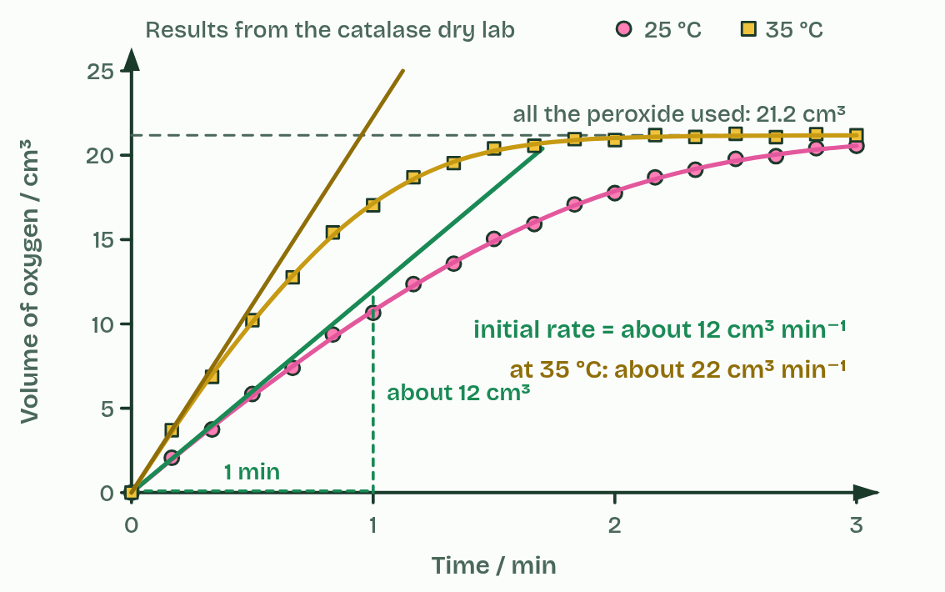  1 Oxygen collected every 10 seconds.  2 Fast at first, then slower as the substrate runs out.  3 The initial rate is the gradient of a tangent at the start.  4 Warmer: a steeper start, the same total.
  SPOT THE MISTAKE
  What do students often get wrong about measurements in enzyme-catalysed reactions? Write the mistake, then put it right.
  The total amount of product at the end measures how much substrate you put in, not how fast the enzyme works. Use the initial rate.
SUMMARY
Sum up section 08 in two or three sentences of your own.
• A rate of reaction is a change per unit time.
• The initial rate is the gradient at the very start, before the substrate runs low, and it measures the enzyme under the conditions you set.
• Draw a tangent to the curve at time zero and work out its gradient: rise over run, with units.
• You can also work out rates from secondary data: someone else's results in a table or graph.

09 Chains, cycles, inside and out | C1.1.11 HL C1.1.13 HL
CUES  Predict: Glycolysis runs in the cytoplasm, the Krebs cycle inside mitochondria, and protein digestion in your stomach. Which are intracellular?  D: Glycolysis and the Krebs cycle: both inside cells. Intracellular means inside a cell, in any part of it, so glycolysis and the Krebs cycle both count. The stomach's contents are outside every cell, even though they are inside your body: digestion there is extracellular.  What is meant by intracellular?  Inside a cell: in the cytoplasm or inside an organelle.  What is meant by extracellular?  Outside the cells that made the enzymes. Chemical digestion in the gut is the example.  What is meant by linear pathway?  A pathway in which the first substrate is converted step by step into a different end product.  What is meant by glycolysis?  The first stage of respiration: a linear pathway of about ten steps in the cytoplasm that converts glucose to pyruvate.  What is meant by cyclical pathway?  A pathway that ends by remaking the molecule it started from, so that a small amount of that carrier keeps the cycle turning.  What is meant by krebs cycle?  A cyclical pathway in the matrix of the mitochondrion, part of aerobic respiration (C1.2).  What is meant by calvin cycle?  A cyclical pathway in the stroma of the chloroplast that builds sugar from carbon dioxide (C1.3). | NOTES  1 Intracellular reactions happen inside cells, catalysed by enzymes that stay there.  2 "Inside" means anywhere inside: in the cytoplasm, as glycolysis, the first stage of respiration, does, or inside an organelle, as the Krebs cycle does in the matrix of a mitochondrion. Extracellular reactions happen outside the cells that made the enzymes.  3 In a linear pathway the first substrate is turned, step by step, into a different end product. Glycolysis is the example: glucose goes in at the start and pyruvate comes out about ten steps later.  4 A cyclical pathway ends by remaking the molecule it started from.  5 The Krebs cycle (C1.2) and the Calvin cycle (C1.3) are the examples.  Your own notes  ANNOTATE THE FIGURE  Label each part and say what it does: the gut contents, duct from the pancreas, inside a cell, the cell's own membrane, an organelle inside the cell.  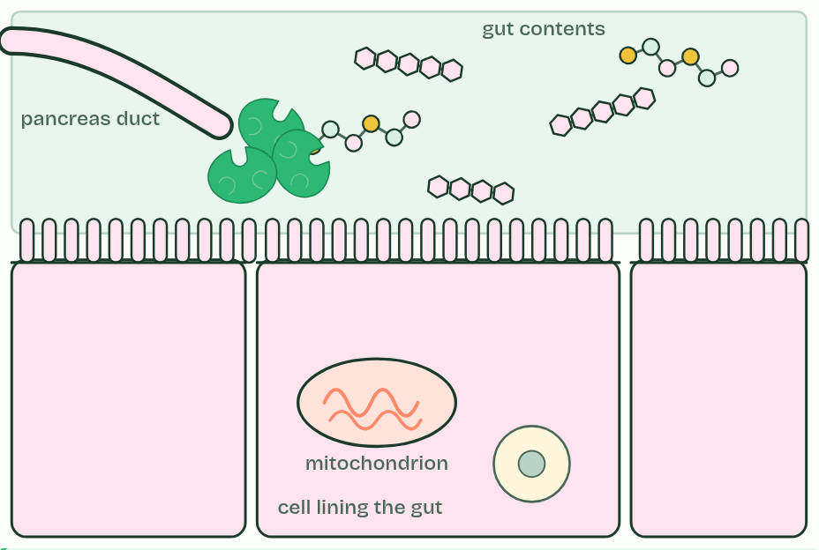  1 The gut contents: This is outside every cell. Digestive enzymes that were secreted into the gut break the food down here: an extracellular reaction.  2 Duct from the pancreas: Cells in the pancreas make digestive enzymes and secrete them along this duct into the gut.  3 Inside a cell: Glycolysis runs here, in the cytoplasm. Everything inside the cell's membrane is intracellular.  4 The cell's own membrane: Microvilli, its fingers, carry enzymes fixed in the membrane that finish digestion at the cell surface (chapter 5).  5 An organelle inside the cell: The Krebs cycle runs in the matrix of the mitochondrion. This is inside a cell too, so it is intracellular.  ANNOTATE THE FIGURE  Annotate this still from the animation (Three pathways on one map): what is happening, and why?  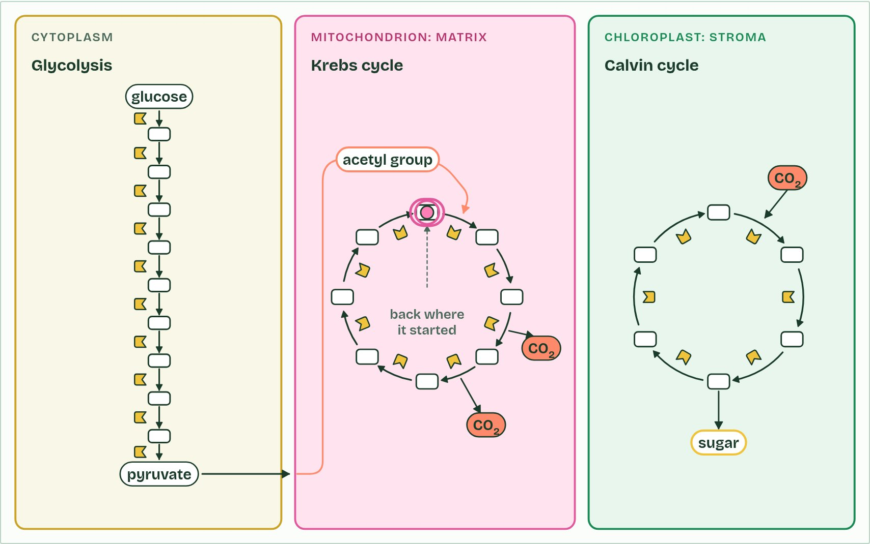  1 Glycolysis, in the cytoplasm: glucose is changed a step at a time, each step by its own enzyme.  2 A linear pathway: what goes in at one end leaves at the other as something else, pyruvate.  3 Back where it started: the last step remakes the molecule the first step needs. A cycle.
  SPOT THE MISTAKE
  What do students often get wrong about intracellular and extracellular reactions; linear and cyclical pathways? Write the mistake, then put it right.
  A cycle does not make something from nothing. Molecules join at each turn and products leave; what comes back round is the carrier molecule.
SUMMARY
Sum up section 09 in two or three sentences of your own.
• Intracellular reactions happen inside cells, catalysed by enzymes that stay there.
• "Inside" means anywhere inside: in the cytoplasm, as glycolysis, the first stage of respiration, does, or inside an organelle, as the Krebs cycle does in the matrix of a mitochondrion. Extracellular reactions happen outside the cells that made the enzymes.
• In a linear pathway the first substrate is turned, step by step, into a different end product. Glycolysis is the example: glucose goes in at the start and pyruvate comes out about ten steps later.
• A cyclical pathway ends by remaking the molecule it started from.

10 Warm from the inside | C1.1.12 HL
CUES  Predict: A mouse and a lizard of the same mass sit at 20 °C for a day. Which needs more food, and why?  C: The mouse: heat from respiration keeps it at 37 °C. The mouse. To stay at 37 °C in air at 20 °C it loses heat all the time and replaces it from respiration, so it respires far faster and needs several times the food. The lizard's body cools to near 20 °C, its reactions slow, and it needs much less.  What is meant by efficiency?  The share of the energy put into a process that ends up where it is wanted, rather than as heat.  What is meant by heat?  The form of energy that is given off by every metabolic reaction, because no energy transfer is completely efficient.  What is meant by endotherms?  Animals that keep a constant body temperature, above that of their surroundings, by generating heat from their own metabolism. | NOTES  1 The efficiency of a transfer is the share of the energy that ends up where it is wanted.  2 When respiration releases the energy in glucose, only about a third is captured in ATP, and the rest is released as heat.  3 They keep a high and constant body temperature, about 37 °C in most mammals and about 40 to 42 °C in most birds, mostly well above the air around them, by generating heat from their metabolism. They are endotherms.  Your own notes  ANNOTATE THE FIGURE  The figure shows it as Energy from glucose and Body against air temperature. Note what changes each time.  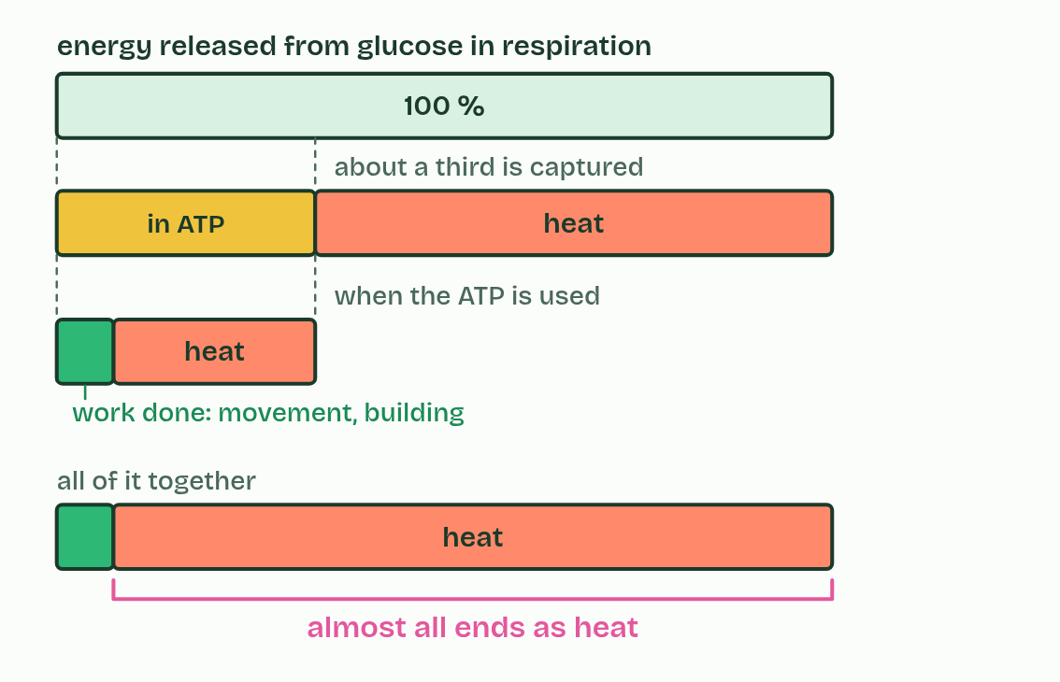  1 Energy from glucose  2 Body against air temperature
  SPOT THE MISTAKE
  What do students often get wrong about generation of heat by metabolism? Write the mistake, then put it right.
  Heat from metabolism is not a fault to be fixed. It is unavoidable, and for mammals and birds it is what keeps every enzyme near its optimum.
SUMMARY
Sum up section 10 in two or three sentences of your own.
• The efficiency of a transfer is the share of the energy that ends up where it is wanted.
• When respiration releases the energy in glucose, only about a third is captured in ATP, and the rest is released as heat.
• They keep a high and constant body temperature, about 37 °C in most mammals and about 40 to 42 °C in most birds, mostly well above the air around them, by generating heat from their metabolism. They are endotherms.

11 A second site | C1.1.14 HL
CUES  Predict: An allosteric inhibitor binds nowhere near the active site. How can it stop the enzyme?  A: Binding changes the enzyme's shape, active site included. Binding at the allosteric site changes interactions between amino acids within the enzyme, so the whole protein shifts shape, the active site with it. The substrate no longer fits. Nothing is broken: when the inhibitor leaves, the shape returns.  What is meant by inhibitor?  A molecule that binds to an enzyme and slows or stops its reaction.  What is meant by allosteric site?  A site on an enzyme, away from the active site, where only a specific molecule can bind. Binding changes the enzyme's shape and so its active site.  What is meant by conformational change?  A change in the three-dimensional shape of a protein, here caused by something binding at the allosteric site.  What is meant by non-competitive inhibition?  Inhibition by a molecule that binds an allosteric site, changing the active site, so it does not compete with the substrate for the active site.  What is meant by reversible?  Able to be undone: the molecule can leave again, and the enzyme returns to its working shape. | NOTES  1 An inhibitor is a molecule that binds to an enzyme and slows or stops its reaction.  2 Many enzymes have, as well as the active site, a second site elsewhere on the molecule: an allosteric site.  3 When one binds, it changes the interactions inside the enzyme, so the enzyme's shape changes, a conformational change, and that alters the active site enough to stop catalysis.  4 The substrate no longer binds, or binds and does not react. This is non-competitive inhibition: the inhibitor does not compete with the substrate for the active site.  5 The binding is reversible.  Your own notes  ANNOTATE THE FIGURE  Number the 4 steps on the figure and note what happens at each.  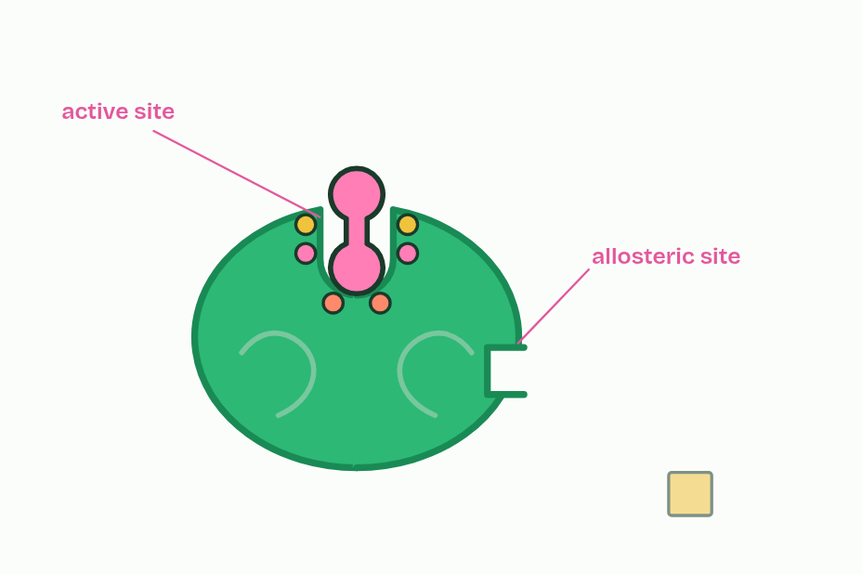  1 An active site, and a second site elsewhere: the allosteric site.  2 Only a specific molecule fits the allosteric site.  3 Binding changes the enzyme's shape, and with it the active site.  4 The binding is reversible: the inhibitor leaves, the enzyme works again.
  SPOT THE MISTAKE
  What do students often get wrong about allosteric sites and non-competitive inhibition? Write the mistake, then put it right.
  Not every inhibitor blocks the active site. A non-competitive inhibitor never touches it.
SUMMARY
Sum up section 11 in two or three sentences of your own.
• An inhibitor is a molecule that binds to an enzyme and slows or stops its reaction.
• Many enzymes have, as well as the active site, a second site elsewhere on the molecule: an allosteric site.
• When one binds, it changes the interactions inside the enzyme, so the enzyme's shape changes, a conformational change, and that alters the active site enough to stop catalysis.
• The substrate no longer binds, or binds and does not react. This is non-competitive inhibition: the inhibitor does not compete with the substrate for the active site.

12 A look-alike in the active site | C1.1.15 HL
CUES  Predict: Two samples of an enzyme: one with a competitive inhibitor, one with a non-competitive inhibitor. You add far more substrate to both. In which does the inhibitor's effect fade?  D: The competitive one: substrate wins the site back. With far more substrate than competitive inhibitor, substrate molecules win almost every active site, so the rate climbs back towards its maximum. The non-competitive inhibitor binds elsewhere; substrate cannot compete for that site, so the enzyme molecules holding it stay off, however much substrate you add.  What is meant by competitive inhibitor?  A molecule similar enough to the substrate to bind the active site, so substrate and inhibitor compete for it. The binding is reversible.  What is meant by statins?  Drugs taken to lower blood cholesterol. They are competitive inhibitors of HMG-CoA reductase.  What is meant by HMG-CoA reductase?  The liver enzyme that converts HMG-CoA to mevalonate, an early step on the pathway that makes cholesterol.  What is meant by cholesterol?  A steroid made in the liver and taken in from food. Too much in the blood is a risk to health. | NOTES  1 A competitive inhibitor is similar enough in shape and chemistry to the substrate to bind the active site.  2 Statins are the example.  3 In liver cells the enzyme HMG-CoA reductase converts HMG-CoA to mevalonate, an early step on the pathway that makes cholesterol.  4 HMG-CoA reductase: an early step on the way to cholesterol.  5 Part of a statin looks like the substrate and binds the active site.  6 It binds and leaves: competitive and reversible.  Your own notes  ANNOTATE THE FIGURE  Number the 4 steps on the figure and note what happens at each.  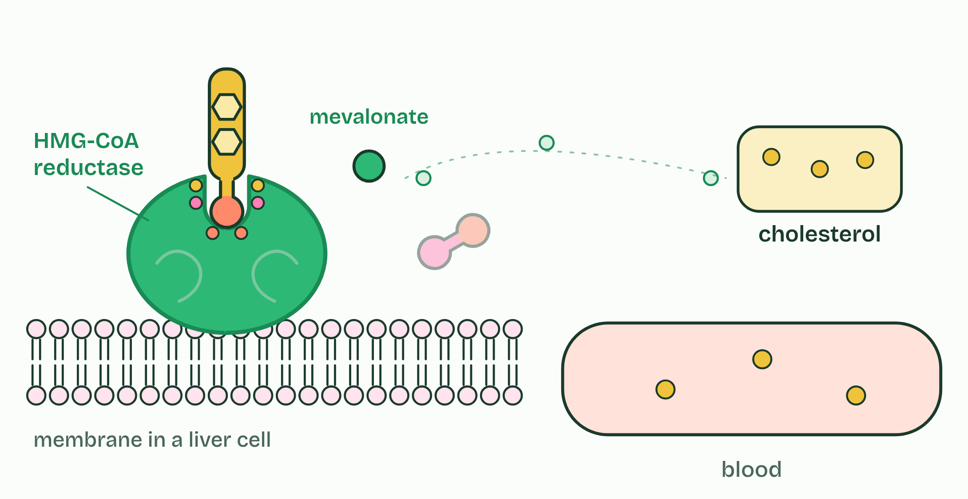  1 HMG-CoA reductase: an early step on the way to cholesterol.  2 Part of a statin looks like the substrate and binds the active site.  3 It binds and leaves: competitive and reversible.  4 Less cholesterol is made, and blood cholesterol falls.  ANNOTATE THE FIGURE  The figure shows it as No inhibitor, Competitive, Non-competitive and All three. Note what changes each time.  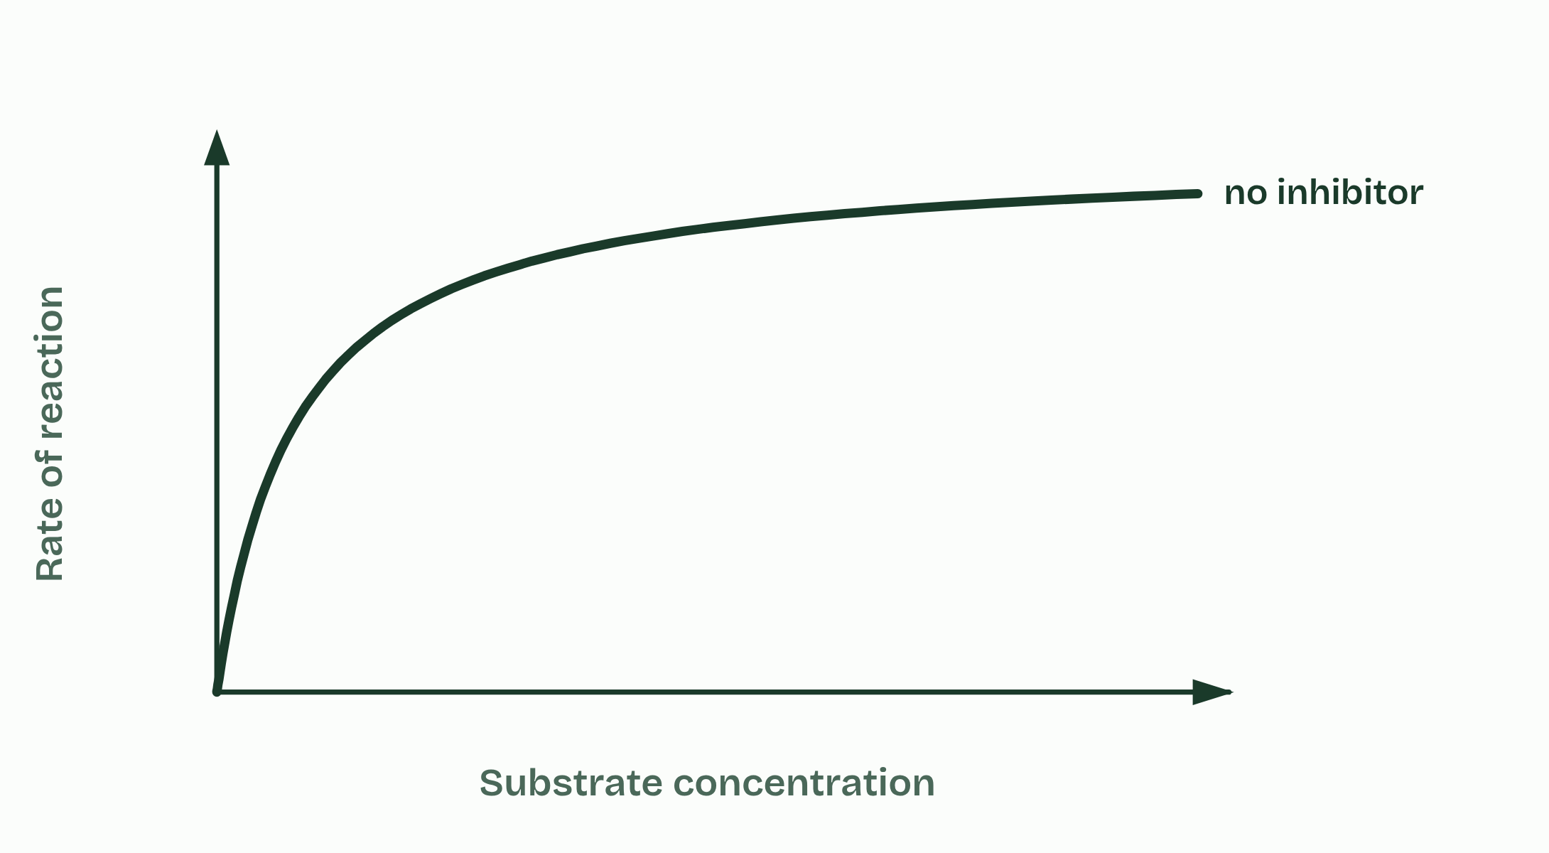  1 No inhibitor  2 Competitive  3 Non-competitive  4 All three  ANNOTATE THE FIGURE  Number the 2 steps on the figure and note what happens at each.  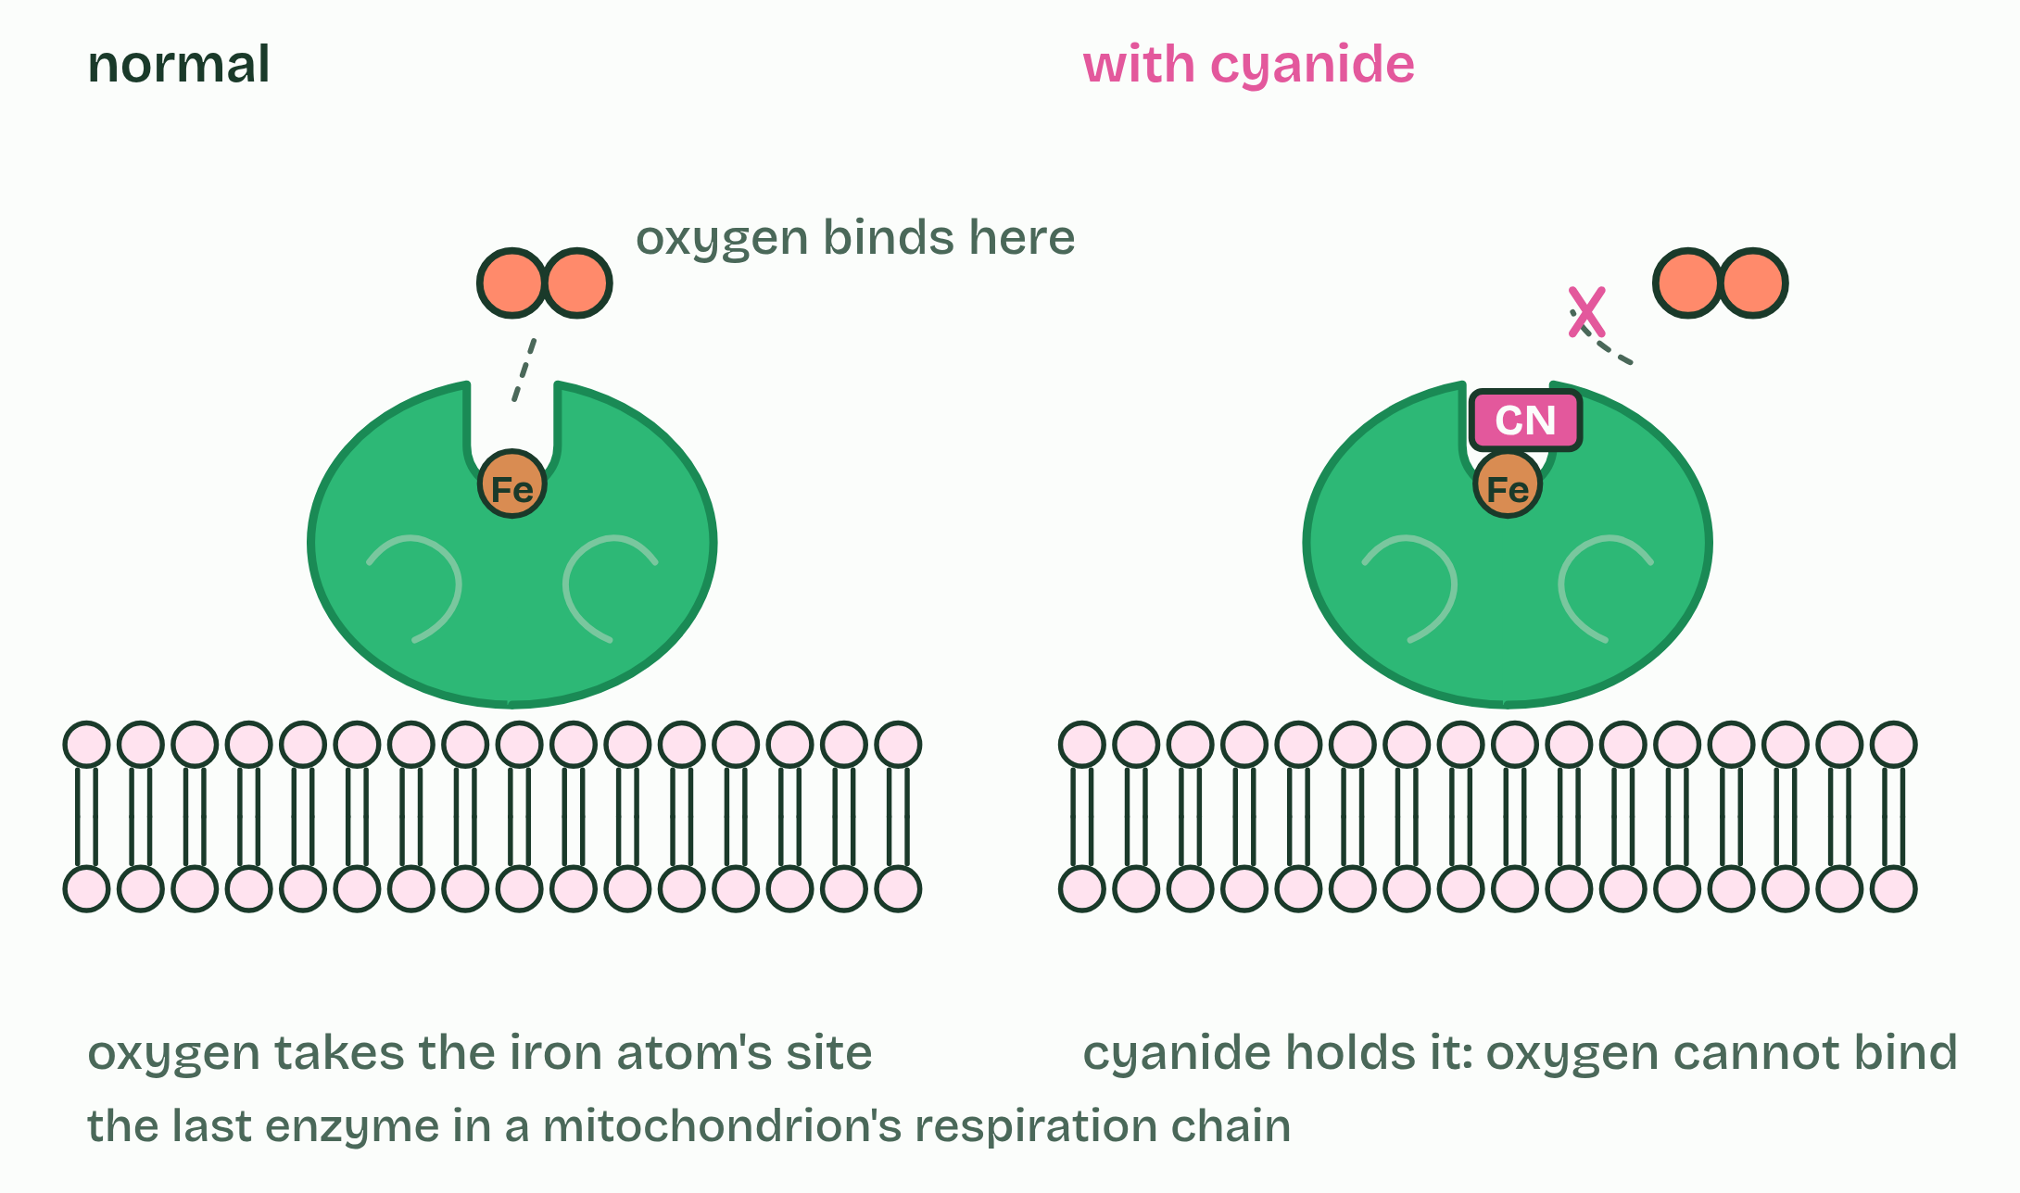  1 Relenza: a competitive inhibitor designed to fit a virus's enzyme.  2 Cyanide: a poison that takes the place where oxygen binds.  ANNOTATE THE FIGURE  Annotate this still from the animation (Add an inhibitor): what is happening, and why?  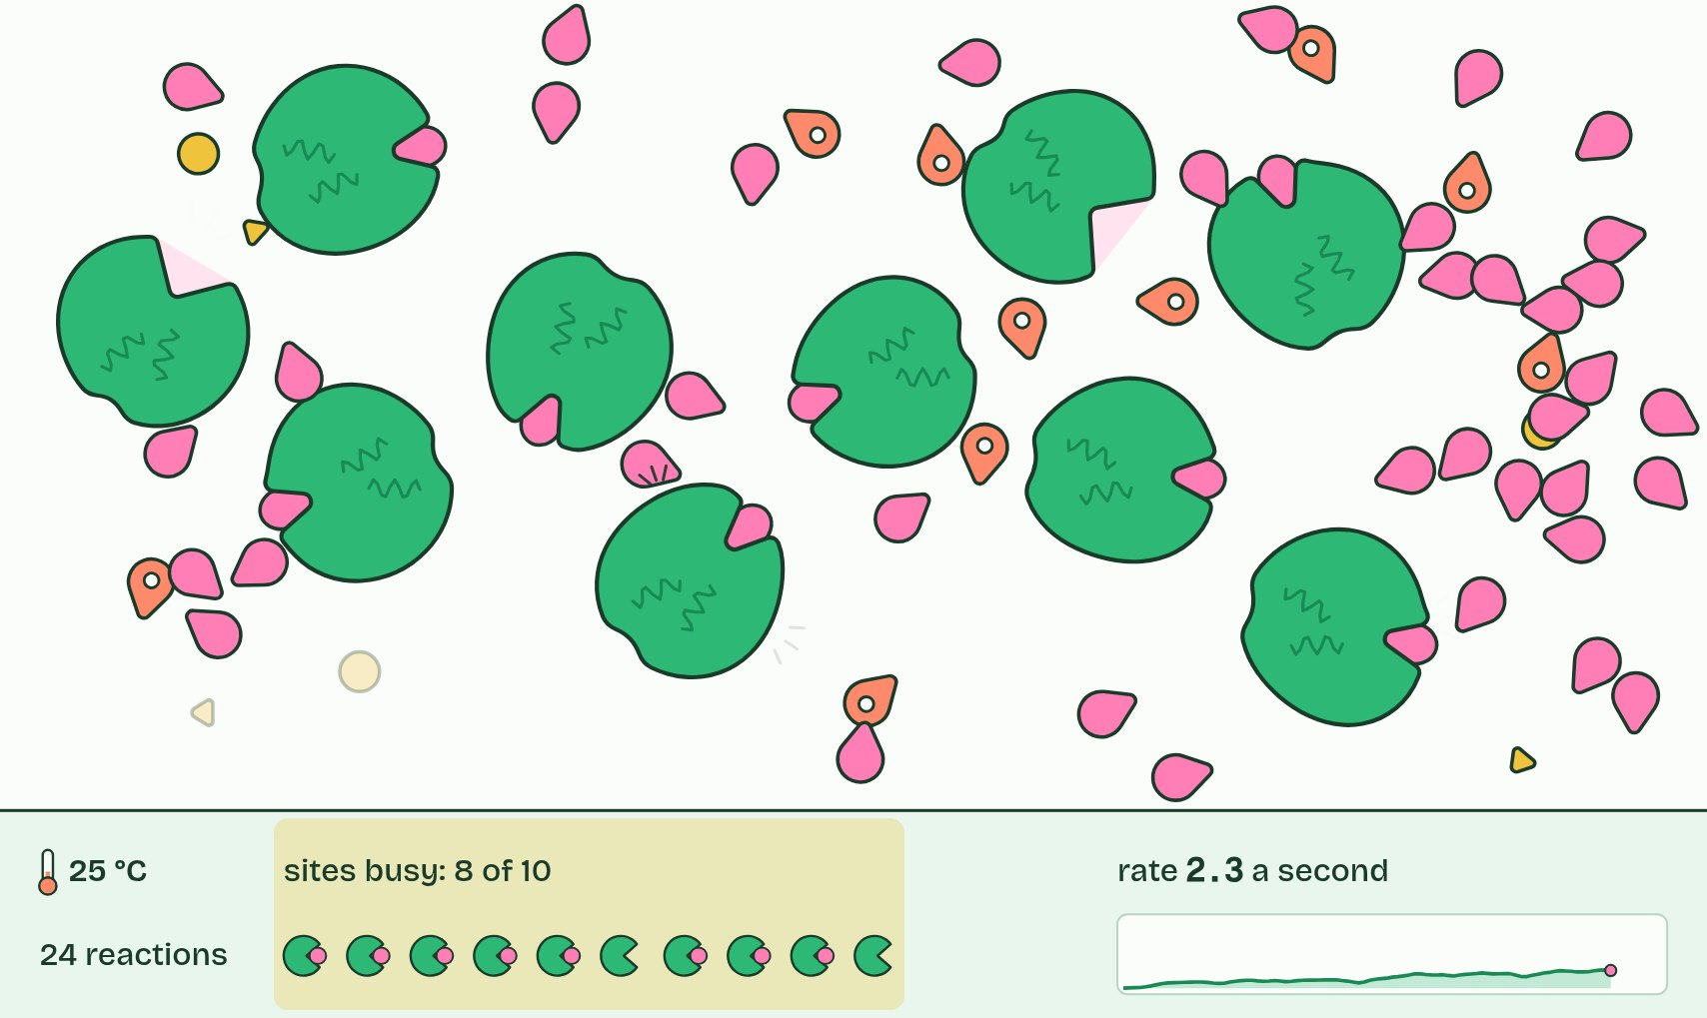  1 Molecules move at random, and most collisions miss the active site.  2 A successful collision: it binds and reacts, and the enzyme is unchanged.  3 Plenty of substrate outcompetes it, so the rate climbs back near its maximum.
SUMMARY
Sum up section 12 in two or three sentences of your own.
• A competitive inhibitor is similar enough in shape and chemistry to the substrate to bind the active site.
• Statins are the example.
• In liver cells the enzyme HMG-CoA reductase converts HMG-CoA to mevalonate, an early step on the pathway that makes cholesterol.

13 The end product shuts the gate | C1.1.16 HL
CUES  Predict: Isoleucine inhibits the first enzyme of its five-step pathway, not the last. Why the first?  B: So no threonine is spent on intermediates nobody needs. Stopping the first step stops the whole pathway at its entrance. If the last enzyme were inhibited instead, the first four would keep using threonine and filling the cell with intermediates that go nowhere. Untick "Allosteric site working" to see what happens without the brake.  What is meant by feedback inhibition?  The last product of a pathway acts as an inhibitor of an enzyme near the start of the pathway, usually the first, by binding to its allosteric site. Also called end-product inhibition.  What is meant by isoleucine?  An amino acid that plants and bacteria make from threonine. Humans cannot make it, so they need it in their diet.  What is meant by threonine?  An amino acid. Plants and bacteria convert it to isoleucine in five steps.  What is meant by threonine deaminase?  The first enzyme of the pathway from threonine to isoleucine. Isoleucine binds its allosteric site and inhibits it. | NOTES  1 In feedback inhibition (end-product inhibition), the last product of a pathway inhibits an enzyme near its start, usually the first, by binding to its allosteric site (chapter 11).  2 The example is the pathway that makes the amino acid isoleucine.  3 Plants and bacteria make it from another amino acid, threonine, in five steps, each with its own enzyme.  4 Isoleucine binds the allosteric site of the first enzyme, threonine deaminase.  Your own notes  ANNOTATE THE FIGURE  The figure shows it as Slow, Normal and Fast. Note what changes each time.  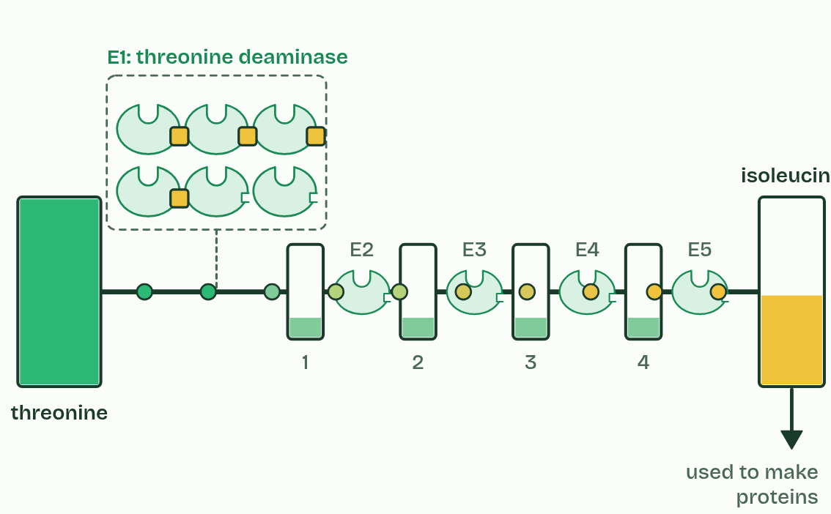  1 Slow  2 Normal  3 Fast
  SPOT THE MISTAKE
  What do students often get wrong about regulation of metabolic pathways by feedback inhibition? Write the mistake, then put it right.
  Feedback inhibition is not permanent and not an on and off switch. It is reversible binding, and the share of the enzyme inhibited follows the end product's concentration.
SUMMARY
Sum up section 13 in two or three sentences of your own.
• In feedback inhibition (end-product inhibition), the last product of a pathway inhibits an enzyme near its start, usually the first, by binding to its allosteric site (chapter 11).
• The example is the pathway that makes the amino acid isoleucine.
• Plants and bacteria make it from another amino acid, threonine, in five steps, each with its own enzyme.
• Isoleucine binds the allosteric site of the first enzyme, threonine deaminase.

14 A trap that springs once | C1.1.17 HL
CUES  Predict: A strain of bacteria keeps building strong walls in penicillin. Its transpeptidase still makes cross-links. What has most likely changed?  C: Its transpeptidase's active site binds penicillin poorly. The strain has a changed transpeptidase. Its active site still joins the peptide ends, but its shape no longer lets penicillin bind well, so the trap never springs. A mutation made the change; using penicillin selects the bacteria that carry it.  What is meant by mechanism-based inhibition?  Inhibition in which the inhibitor enters the active site as if it were a substrate and the enzyme starts to act on it, but the reaction stops part way, with the inhibitor held by a covalent bond.  What is meant by covalent bond?  A strong bond in which two atoms share electrons. It does not break easily.  What is meant by irreversible?  Not able to be undone: the inhibitor stays bound, and the enzyme molecule is out of action for good.  What is meant by transpeptidase?  The bacterial enzyme that makes the cross-links between the sugar chains of the cell wall.  What is meant by antibiotic resistance?  The ability of bacteria to keep growing in the presence of an antibiotic. | NOTES  1 In mechanism-based inhibition an inhibitor enters the active site as if it were a substrate, and the enzyme starts to act on it.  2 But the reaction stops part way, with the inhibitor held by a covalent bond.  3 The active site is chemically changed and stays blocked for good: the inhibition is irreversible.  4 A bacterial cell wall (A2.2) is made of long sugar chains cross-linked by short peptides, and the enzyme transpeptidase makes those cross-links.  5 They show antibiotic resistance: they carry a changed transpeptidase, whose active site has a different shape that penicillin binds poorly but that still makes cross-links, so their walls are built normally in penicillin.  Your own notes  ANNOTATE THE FIGURE  Number the 5 steps on the figure and note what happens at each.  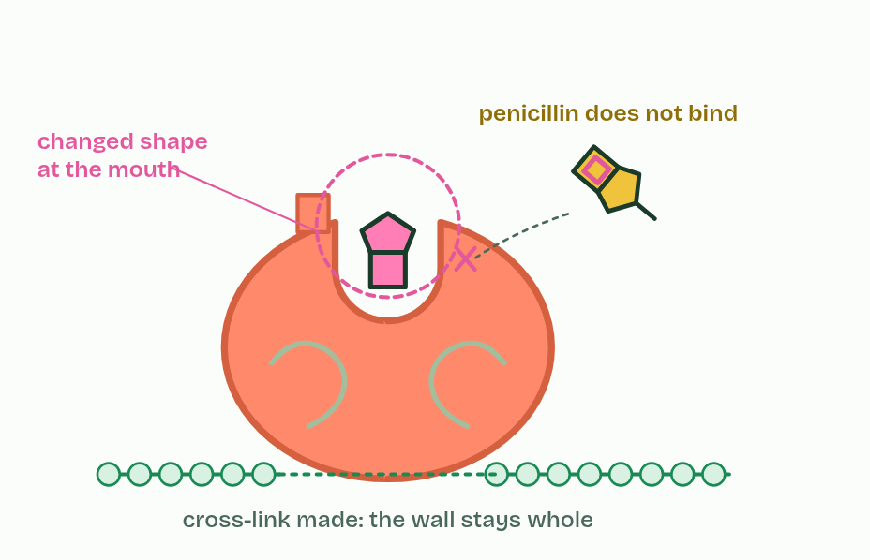  1 Transpeptidase cross-links the wall's sugar chains.  2 Penicillin looks like the peptide the enzyme joins.  3 The enzyme starts to act on it, and is trapped by a covalent bond: irreversible.  4 Without cross-links, the wall gives way and the cell bursts.  5 A changed transpeptidase binds penicillin poorly: resistance.  REMEMBER IT  Three ways to stop an enzyme
  C  Copycat | N  Nudge | M  Mousetrap
  Competitive  a look-alike takes the active site, reversibly | Non-competitive  binds the allosteric site and changes the active site, reversibly | Mechanism-based  springs once in the active site and holds for good
  SPOT THE MISTAKE
  What do students often get wrong about mechanism-based inhibition? Write the mistake, then put it right.
  Penicillin is not a competitive inhibitor that "stays a long time". It is bonded covalently and the enzyme never recovers.
SUMMARY
Sum up section 14 in two or three sentences of your own.
• In mechanism-based inhibition an inhibitor enters the active site as if it were a substrate, and the enzyme starts to act on it.
• But the reaction stops part way, with the inhibitor held by a covalent bond.
• The active site is chemically changed and stays blocked for good: the inhibition is irreversible.
• A bacterial cell wall (A2.2) is made of long sugar chains cross-linked by short peptides, and the enzyme transpeptidase makes those cross-links.

Check yourself
The check for this guide is online: a fresh paper of past-paper style questions from the exam bank on C1.1 each time, marked as you go, and saved to your Exam practice progress when you are signed in. Open the link:
biologybybradford.com/exam-maker/sit?topics=C1.1&level=HL&paper=quiz&marks=15&src=ep

