Name | Class | Date
IB BIOLOGY · C1.1

Enzymes and metabolism
Notes to fill in alongside the guide. Each numbered block matches a chapter of the guide, and of the lesson slides. Write in the gaps, answer the cues, annotate the figures, and sum up each section in your own words.
BY THE END YOU CAN
Explain why cells need catalysts, and what an enzyme's speed does for digestion, growth and keeping cool enough to live C1.1.1
Describe metabolism as a web of linked reactions, and sort reactions into anabolic and catabolic with an example of each C1.1.2, C1.1.3
Read an energy diagram and explain how an enzyme lowers the activation energy without changing the energy released C1.1.10
Explain how a few amino acids, held in place by the whole folded protein, make an active site, and how induced fit works C1.1.4, C1.1.5
Explain why substrate and active site must collide, and how enzymes fixed in membranes still meet their substrates C1.1.6
Explain how the shape of the active site makes an enzyme specific, and why denaturation stops it working C1.1.7
Sketch and explain the effects of temperature, pH and substrate concentration on the rate, using collision theory and denaturation C1.1.8
Work out a rate from your own results or from secondary data, including the initial rate from a tangent C1.1.9
Compare enzymes at work inside cells and outside them, and linear pathways with cycles C1.1.11, C1.1.13
Explain why metabolism always releases heat, and how mammals and birds use it C1.1.12
Explain how a molecule binding an allosteric site stops an enzyme, and why the binding can be undone C1.1.14
Explain how statins inhibit an enzyme competitively, and contrast competitive and non-competitive inhibition on a graph C1.1.15
Explain how isoleucine controls its own pathway by feedback inhibition C1.1.16
Explain how penicillin inhibits transpeptidase for good, and how a changed transpeptidase makes bacteria resistant C1.1.17

01 Seconds, not millions of years | C1.1.1
CUES  Predict: With no enzyme at all, how long would water at room temperature take to break half the bonds between the glucose units in starch?  What is meant by catalyst?  What is meant by enzymes?  What is meant by rate of reaction? | NOTES  1 A ___________ is a substance that speeds up a chemical reaction without being used up by it.  2 The same molecule works again and again. _________ are the catalysts of living things, and nearly all of them are proteins (chapter 4 shows how their shape does the job).  3 The ______________________ has to be fast enough for life, and an enzyme raises it enormously.  4 With water alone at room temperature, half the bonds take _______________________ to break.  5 Amylase breaks each one in about ________________________________, at body temperature.  Your own notes  ANNOTATE THE FIGURE  Number the 3 steps on the figure and note what happens at each.  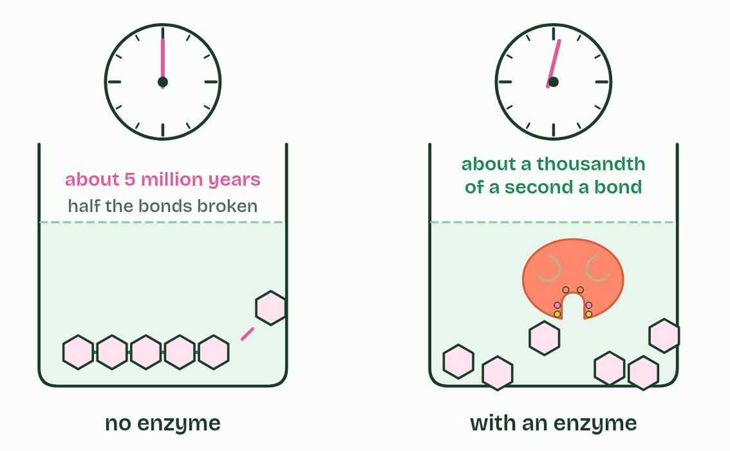
  SPOT THE MISTAKE
  What do students often get wrong about enzymes as catalysts? Write the mistake, then put it right.
  The mistake
  Put it right
SUMMARY
Sum up section 01 in two or three sentences of your own.

02 A web of reactions, an enzyme for each | C1.1.2 C1.1.3
CUES  Predict: A liver cell makes thousands of different enzymes. Why so many?  What is meant by metabolism?  What is meant by metabolic pathway?  What is meant by enzyme specificity?  What is meant by anabolic?  What is meant by condensation?  What is meant by catabolic?  What is meant by hydrolysis?  What is meant by oxidation? | NOTES  1 ______________ is every chemical reaction going on in an organism.  2 A _______________________ is one thread of it, a series of steps with an enzyme for each.  3 Each enzyme catalyses one reaction, or one kind of reaction. This ________________________ (chapter 6 shows why) is why a cell needs thousands of different enzymes, one for each step.  4 Metabolic reactions fall into two groups. ___________ reactions build larger molecules from smaller ones and take in energy.  5 Monomers are joined into macromolecules by ________________, as when amino acids become a polypeptide in protein synthesis, or glucose becomes glycogen.  6 ____________ reactions break larger molecules into smaller ones and release energy.  7 In digestion, macromolecules are broken into monomers by ______________.  8 In respiration, substrates such as glucose are broken down by ____________.  Your own notes  ANNOTATE THE FIGURE  Number the 3 steps on the figure and note what happens at each.  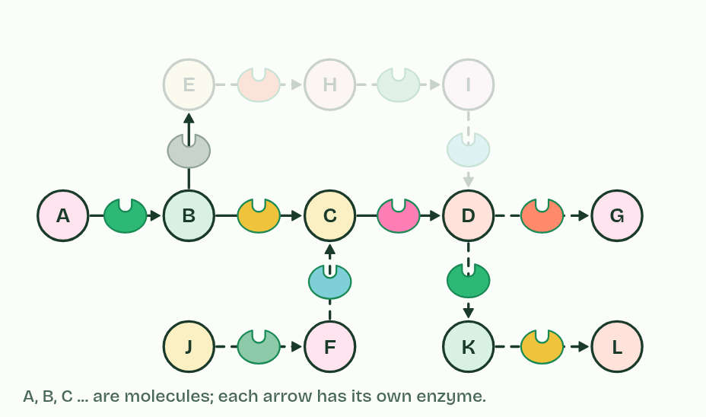  ANNOTATE THE FIGURE  Label the key parts and add a note on what it shows.  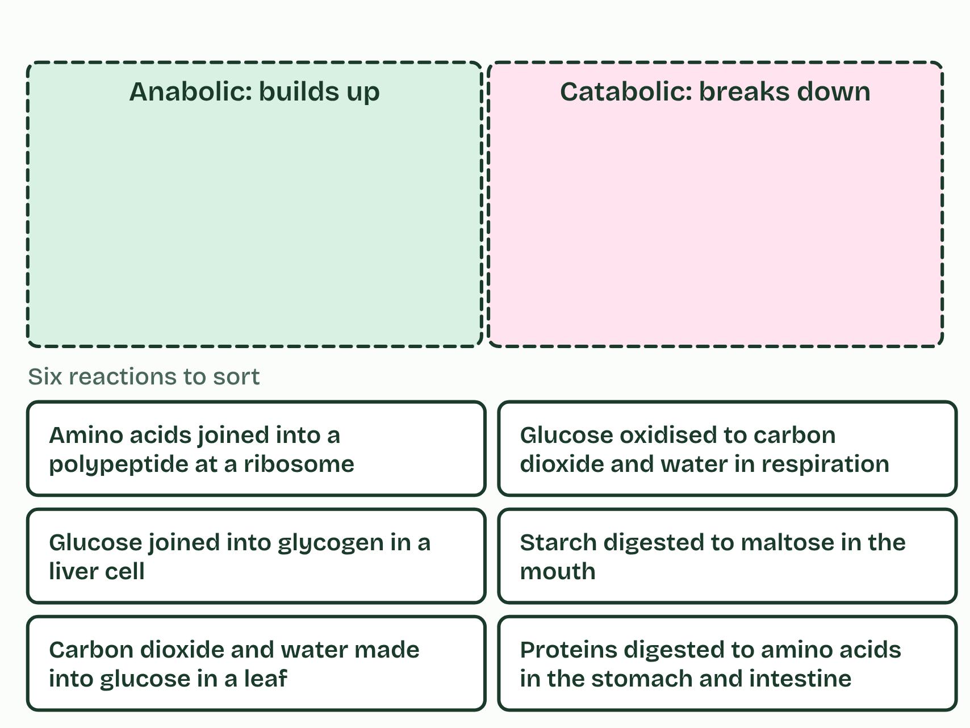  ANNOTATE THE FIGURE  Annotate this still from the animation (Build glycogen, then break it down): what is happening, and why?  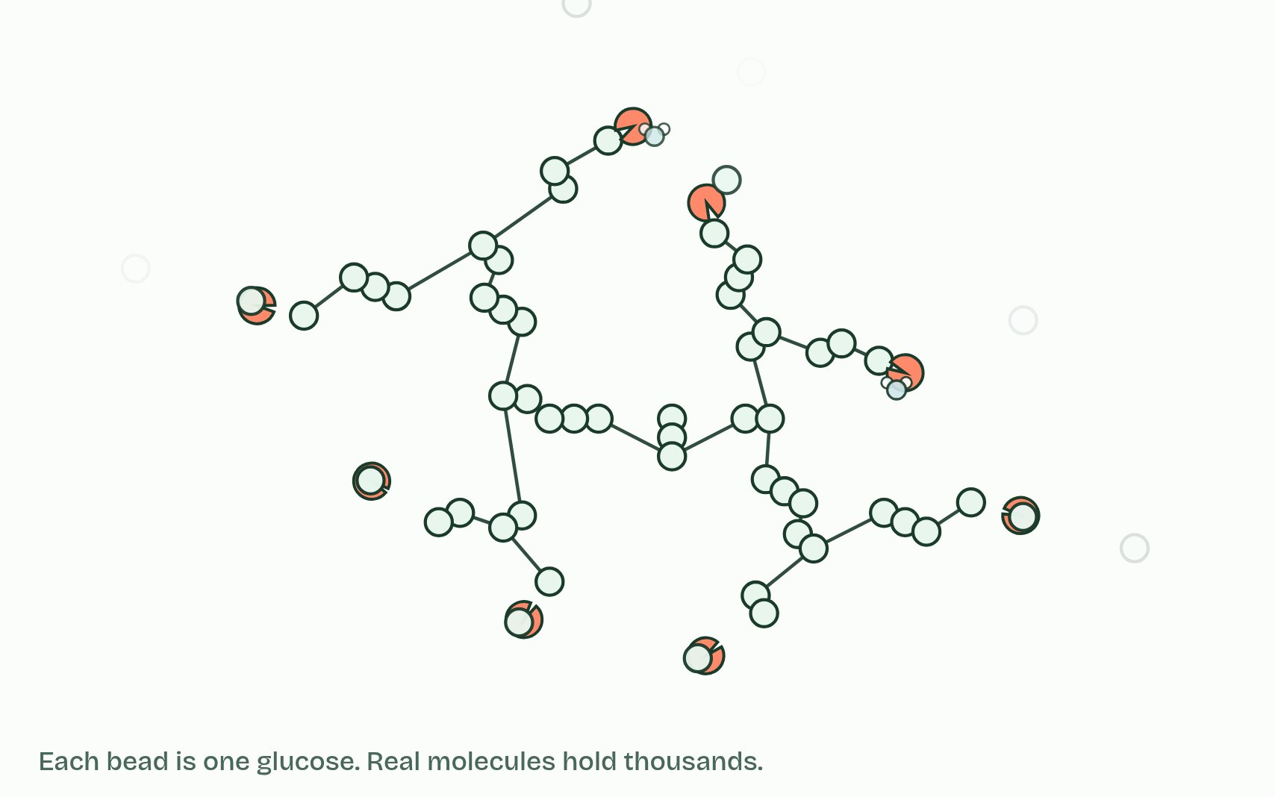  REMEMBER IT  The two halves of metabolism
  A  Add | C  Cut
  A | C
  SPOT THE MISTAKE
  What do students often get wrong about role of enzymes in metabolism; anabolic and catabolic reactions? Write the mistake, then put it right.
  The mistake
  Put it right
SUMMARY
Sum up section 02 in two or three sentences of your own.

03 A lower hill to climb | C1.1.10
CUES  Predict: An enzyme lowers the activation energy of a reaction that releases energy. What happens to the energy released overall?  What is meant by activation energy?  What is meant by energy diagram?  What is meant by bond breaking?  What is meant by bond making? | NOTES  1 The energy needed before the reaction can run is the _______________________.  2 On an ___________________ it is a hill that the reaction has to climb: energy up the side, progress of the reaction along the bottom.  3 __________________ takes in energy. _______________ releases it.  4 _______________________ is the energy needed to strain and break bonds so the reaction can start.  5 On an ___________________, activation energy is the climb from the substrate up to the peak.  Your own notes  ANNOTATE THE FIGURE  Number the 5 steps on the figure and note what happens at each.  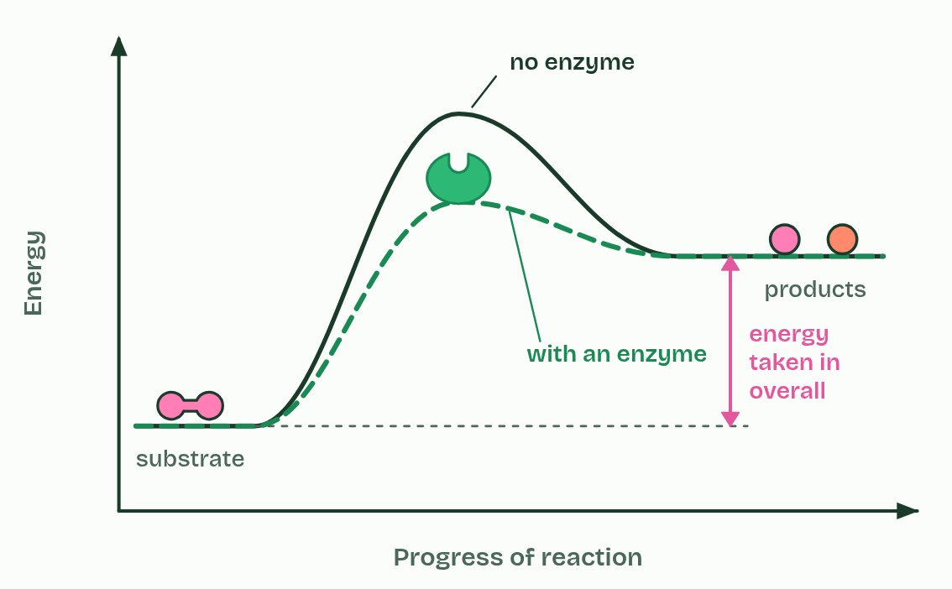
  SPOT THE MISTAKE
  What do students often get wrong about effect of enzymes on activation energy? Write the mistake, then put it right.
  The mistake
  Put it right
SUMMARY
Sum up section 03 in two or three sentences of your own.

04 A pocket held in shape | C1.1.4 C1.1.5
CUES  Predict: An enzyme has 300 amino acids, and only about six touch the substrate. A mutation changes one amino acid far from the active site, and the enzyme stops working. How?  What is meant by globular proteins?  What is meant by active site?  What is meant by substrate?  What is meant by enzyme-substrate complex?  What is meant by induced fit?  What is meant by products? | NOTES  1 Enzymes are _______________________: one or more polypeptide chains folded into a compact, roughly round shape that dissolves in water (B1.2).  2 The _______________ is the small region where the ____________ binds and the reaction happens.  3 When the substrate binds, the two form an ________________________________.  4 Both change shape as it forms: the active site closes in around the substrate, and the substrate is pulled and bent, straining the bonds that are about to break. This is _______________.  5 The substrate is converted into ___________, which no longer fit and leave, and the enzyme returns to its starting shape, ready for another substrate.  Your own notes  ANNOTATE THE FIGURE  Number the 5 steps on the figure and note what happens at each.  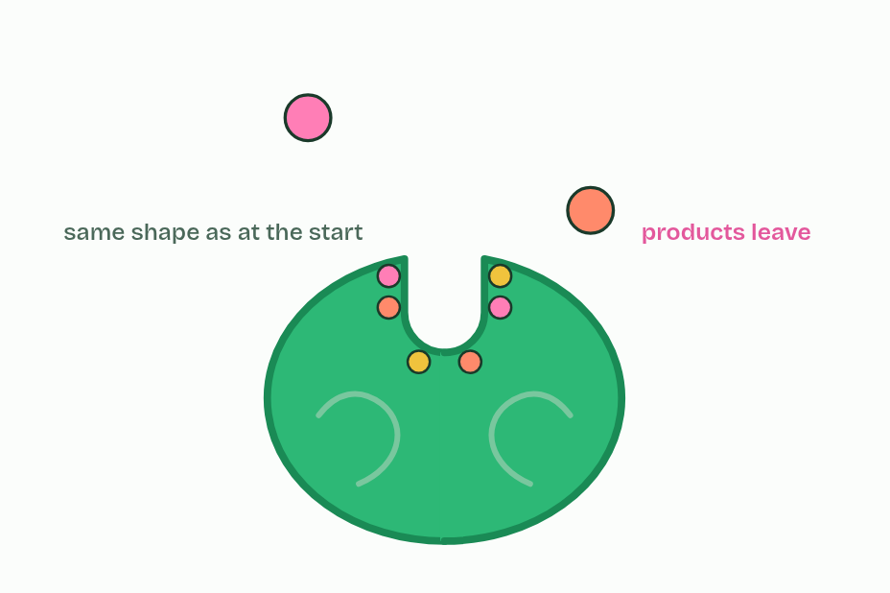  REMEMBER IT  What happens at the active site
  B  Bind | B  Bend | B  Break | B  Bye
  B | B | B | B
  SPOT THE MISTAKE
  What do students often get wrong about globular proteins with an active site; induced-fit binding? Write the mistake, then put it right.
  The mistake
  Put it right
SUMMARY
Sum up section 04 in two or three sentences of your own.

05 Meeting by chance | C1.1.6
CUES  Predict: Lactase sits fixed in the membrane of cells lining your small intestine. It cannot move. How does lactose reach its active site?  What is meant by molecular motion?  What is meant by collision?  What is meant by orientation?  What is meant by immobilised enzyme? | NOTES  1 Their molecules move all the time and at random, jostled by the water molecules around them. This ______________________ is what brings them together.  2 A reaction can happen only when a substrate and an active site meet in a ____________, and only if the substrate arrives the right way round (its _______________) and close enough to bind.  3 Sometimes an ________________________ is held still, embedded in a membrane.  Your own notes  ANNOTATE THE FIGURE  The figure shows it as In solution, Enzyme fixed in a membrane and Substrate held still. Note what changes each time.  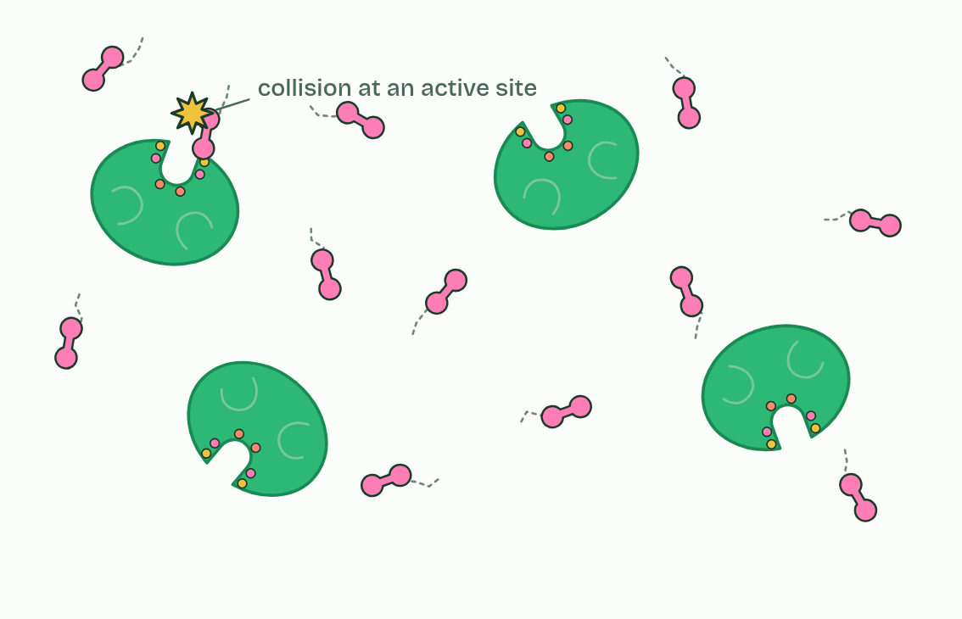
SUMMARY
Sum up section 05 in two or three sentences of your own.

06 Lose the shape, lose the fit | C1.1.7
CUES  Predict: Pepsin digests protein in the stomach at about pH 2. Carried on into the small intestine at about pH 8, what happens to it?  What is meant by enzyme-substrate specificity?  What is meant by denaturation? | NOTES  1 The active site's shape and charges match its substrate's, so few other molecules bind. This is __________________________________.  2 Either way the substrate no longer binds, or binds and does not react. This is ________________.  Your own notes  ANNOTATE THE FIGURE  The figure shows it as Its substrate, A different molecule, Too hot and Wrong pH. Note what changes each time.  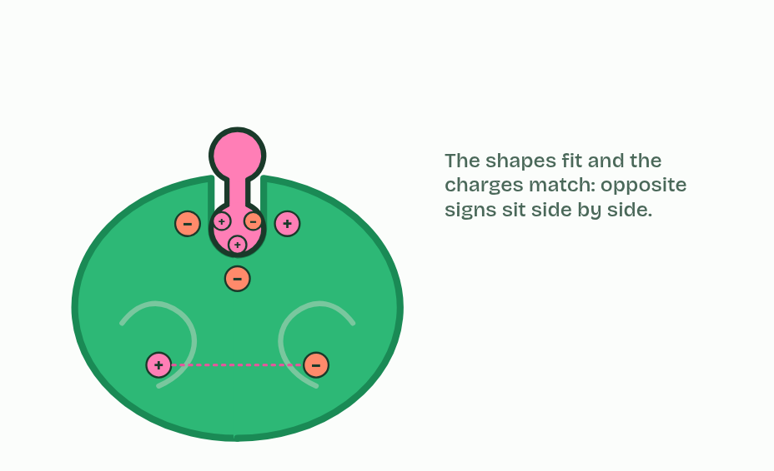
  SPOT THE MISTAKE
  What do students often get wrong about active site structure, specificity and denaturation? Write the mistake, then put it right.
  The mistake
  Put it right
SUMMARY
Sum up section 06 in two or three sentences of your own.

07 Three graphs to know | C1.1.8
CUES  Predict: On a graph of rate against substrate concentration, the curve levels off. Why?  What is meant by optimum?  What is meant by collision theory?  What is meant by sketch graphs?  What is meant by saturation? | NOTES  1 Temperature. Below the _________, warming the solution makes enzyme and substrate move faster, so they collide more often and more collisions have enough energy to react.  2 All three effects follow from ______________________ and denaturation.  3 Describe a graph in parts, with numbers from its axes: "rises steadily to an optimum near 40 °C, then falls steeply". These smooth curves are __________________: models of the general pattern, not the data of one enzyme.  4 Temperature: faster collisions, then ________________.  5 pH: each enzyme has its own _________.  6 Substrate: the rate rises, then ______________.  Your own notes  ANNOTATE THE FIGURE  Number the 4 steps on the figure and note what happens at each.  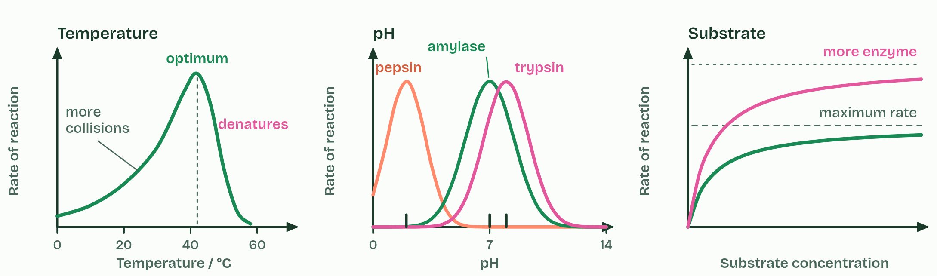  ANNOTATE THE FIGURE  Annotate this still from the animation (Watch it happen: collisions, substrate and heat): what is happening, and why?  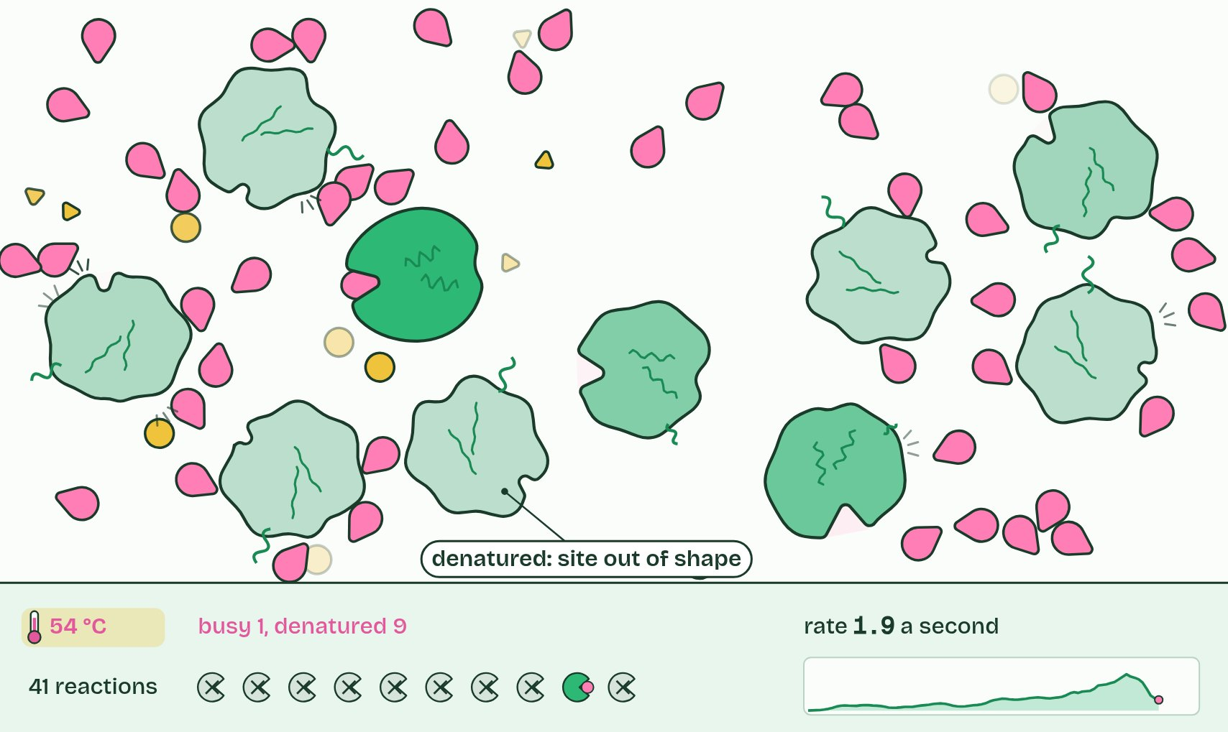  REMEMBER IT  The three factors you must explain
  T  Tigers | P  Prefer | S  Steak
  T | P | S
  SPOT THE MISTAKE
  What do students often get wrong about effects of temperature, pH and substrate concentration? Write the mistake, then put it right.
  The mistake
  Put it right
SUMMARY
Sum up section 07 in two or three sentences of your own.

08 Measuring a rate | C1.1.9
CUES  Predict: A drop of a starch and amylase mixture stops turning iodine blue-black after 40 s at 30 °C and after 80 s at 20 °C. Compare the rates.  What is meant by rate of reaction?  What is meant by initial rate?  What is meant by tangent?  What is meant by secondary data? | NOTES  1 A ______________________ is a change per unit time.  2 The ________________ is the gradient at the very start, before the substrate runs low, and it measures the enzyme under the conditions you set.  3 Draw a _________ to the curve at time zero and work out its gradient: rise over run, with units.  4 You can also work out rates from ___________________: someone else's results in a table or graph.  Your own notes  ANNOTATE THE FIGURE  Number the 4 steps on the figure and note what happens at each.  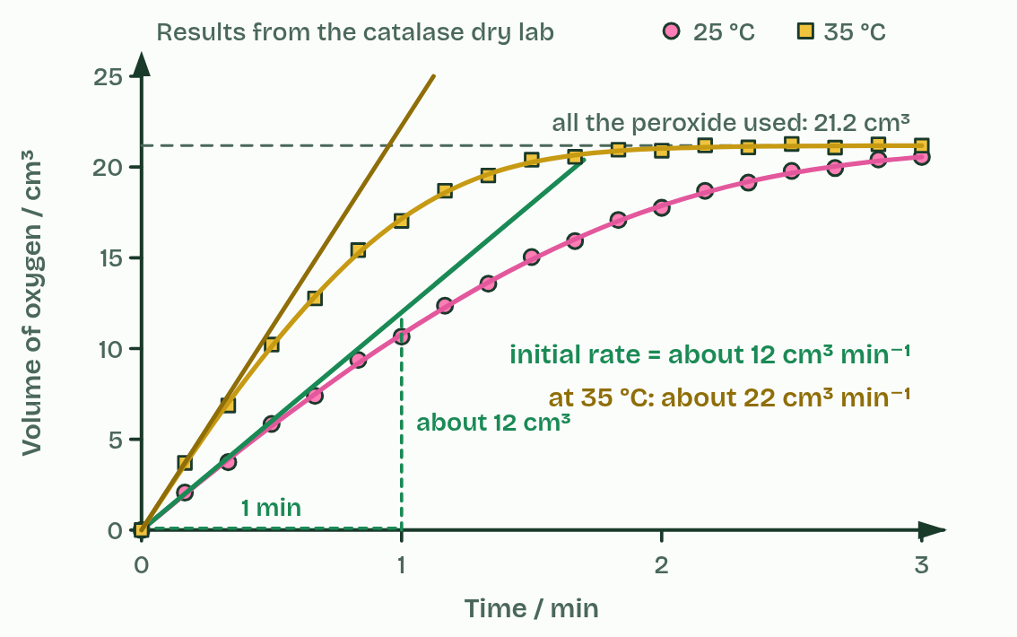
  SPOT THE MISTAKE
  What do students often get wrong about measurements in enzyme-catalysed reactions? Write the mistake, then put it right.
  The mistake
  Put it right
SUMMARY
Sum up section 08 in two or three sentences of your own.

09 Chains, cycles, inside and out | C1.1.11 HL C1.1.13 HL
CUES  Predict: Glycolysis runs in the cytoplasm, the Krebs cycle inside mitochondria, and protein digestion in your stomach. Which are intracellular?  What is meant by intracellular?  What is meant by extracellular?  What is meant by linear pathway?  What is meant by glycolysis?  What is meant by cyclical pathway?  What is meant by krebs cycle?  What is meant by calvin cycle? | NOTES  1 __________________ reactions happen inside cells, catalysed by enzymes that stay there.  2 "Inside" means anywhere inside: in the cytoplasm, as glycolysis, the first stage of respiration, does, or inside an organelle, as the Krebs cycle does in the matrix of a mitochondrion. __________________ reactions happen outside the cells that made the enzymes.  3 In a ___________________ the first substrate is turned, step by step, into a different end product. ______________ is the example: glucose goes in at the start and pyruvate comes out about ten steps later.  4 A ______________________ ends by remaking the molecule it started from.  5 The _______________ (C1.2) and the ________________ (C1.3) are the examples.  Your own notes  ANNOTATE THE FIGURE  Label each part and say what it does: the gut contents, duct from the pancreas, inside a cell, the cell's own membrane, an organelle inside the cell.  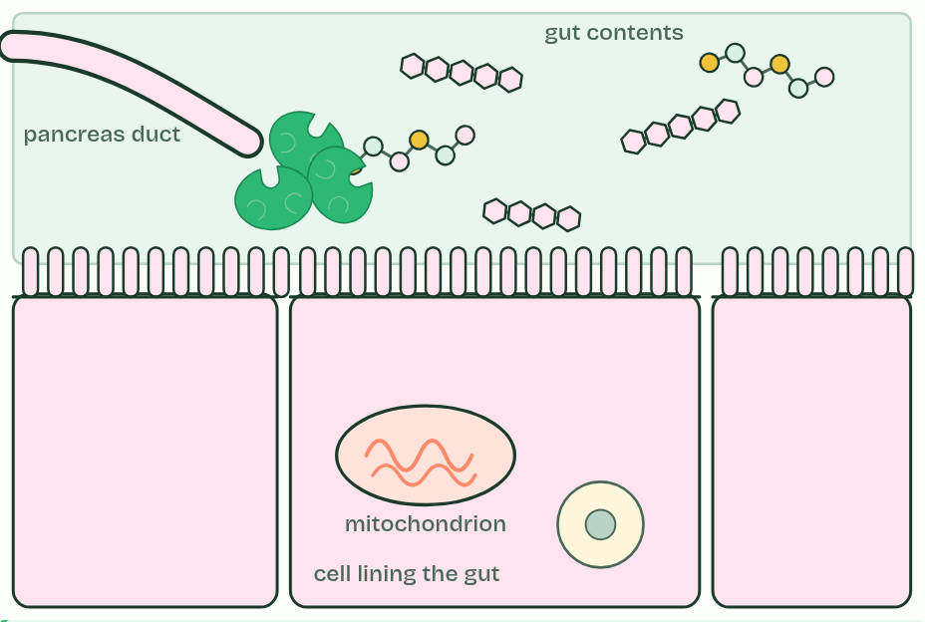  ANNOTATE THE FIGURE  Annotate this still from the animation (Three pathways on one map): what is happening, and why?  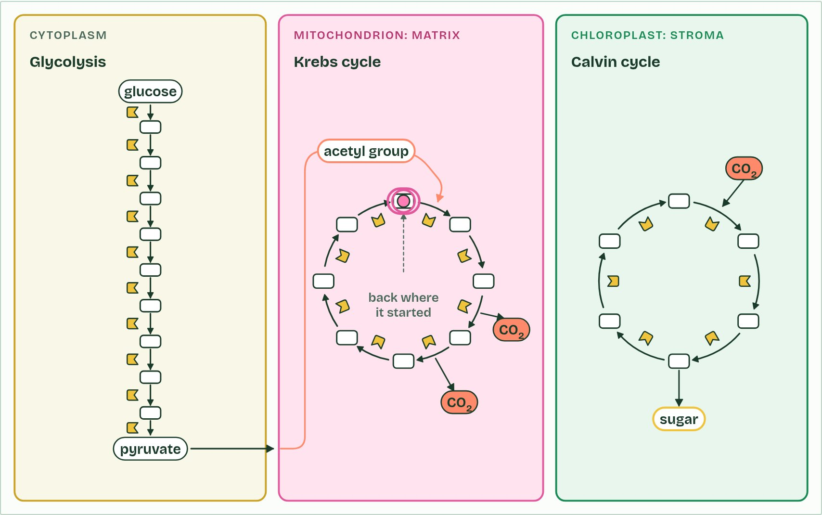
  SPOT THE MISTAKE
  What do students often get wrong about intracellular and extracellular reactions; linear and cyclical pathways? Write the mistake, then put it right.
  The mistake
  Put it right
SUMMARY
Sum up section 09 in two or three sentences of your own.

10 Warm from the inside | C1.1.12 HL
CUES  Predict: A mouse and a lizard of the same mass sit at 20 °C for a day. Which needs more food, and why?  What is meant by efficiency?  What is meant by heat?  What is meant by endotherms? | NOTES  1 The ______________ of a transfer is the share of the energy that ends up where it is wanted.  2 When respiration releases the energy in glucose, only about a third is captured in ATP, and the rest is released as ________.  3 They keep a high and constant body temperature, about 37 °C in most mammals and about 40 to 42 °C in most birds, mostly well above the air around them, by generating heat from their metabolism. They are ______________.  Your own notes  ANNOTATE THE FIGURE  The figure shows it as Energy from glucose and Body against air temperature. Note what changes each time.  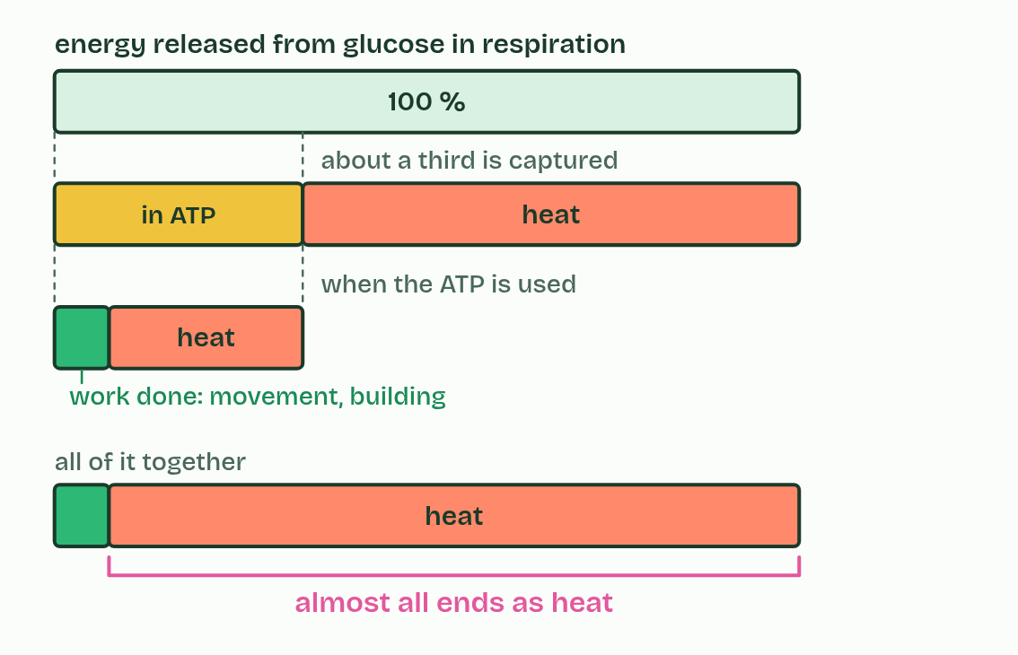
  SPOT THE MISTAKE
  What do students often get wrong about generation of heat by metabolism? Write the mistake, then put it right.
  The mistake
  Put it right
SUMMARY
Sum up section 10 in two or three sentences of your own.

11 A second site | C1.1.14 HL
CUES  Predict: An allosteric inhibitor binds nowhere near the active site. How can it stop the enzyme?  What is meant by inhibitor?  What is meant by allosteric site?  What is meant by conformational change?  What is meant by non-competitive inhibition?  What is meant by reversible? | NOTES  1 An ____________ is a molecule that binds to an enzyme and slows or stops its reaction.  2 Many enzymes have, as well as the active site, a second site elsewhere on the molecule: an ____________________.  3 When one binds, it changes the interactions inside the enzyme, so the enzyme's shape changes, a ____________________________, and that alters the active site enough to stop catalysis.  4 The substrate no longer binds, or binds and does not react. This is __________________________________: the inhibitor does not compete with the substrate for the active site.  5 The binding is ______________.  Your own notes  ANNOTATE THE FIGURE  Number the 4 steps on the figure and note what happens at each.  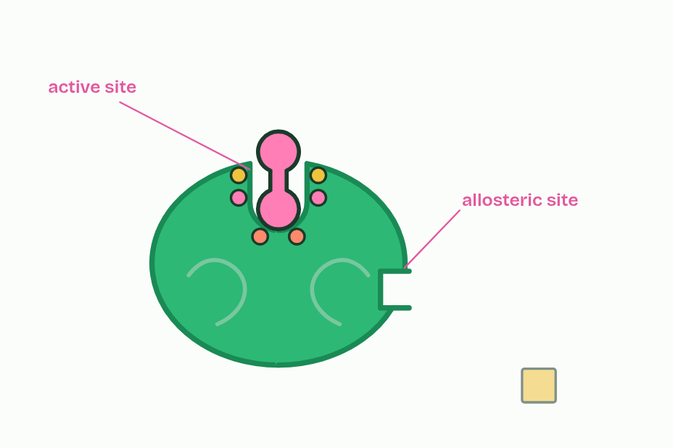
  SPOT THE MISTAKE
  What do students often get wrong about allosteric sites and non-competitive inhibition? Write the mistake, then put it right.
  The mistake
  Put it right
SUMMARY
Sum up section 11 in two or three sentences of your own.

12 A look-alike in the active site | C1.1.15 HL
CUES  Predict: Two samples of an enzyme: one with a competitive inhibitor, one with a non-competitive inhibitor. You add far more substrate to both. In which does the inhibitor's effect fade?  What is meant by competitive inhibitor?  What is meant by statins?  What is meant by HMG-CoA reductase?  What is meant by cholesterol? | NOTES  1 A ____________________________ is similar enough in shape and chemistry to the substrate to bind the active site.  2 _________ are the example.  3 In liver cells the enzyme _______________________ converts HMG-CoA to mevalonate, an early step on the pathway that makes _______________.  4 HMG-CoA reductase: an early step on the way to _______________.  5 Part of a ________ looks like the substrate and binds the active site.  6 It binds and leaves: _______________ and ______________.  Your own notes  ANNOTATE THE FIGURE  Number the 4 steps on the figure and note what happens at each.  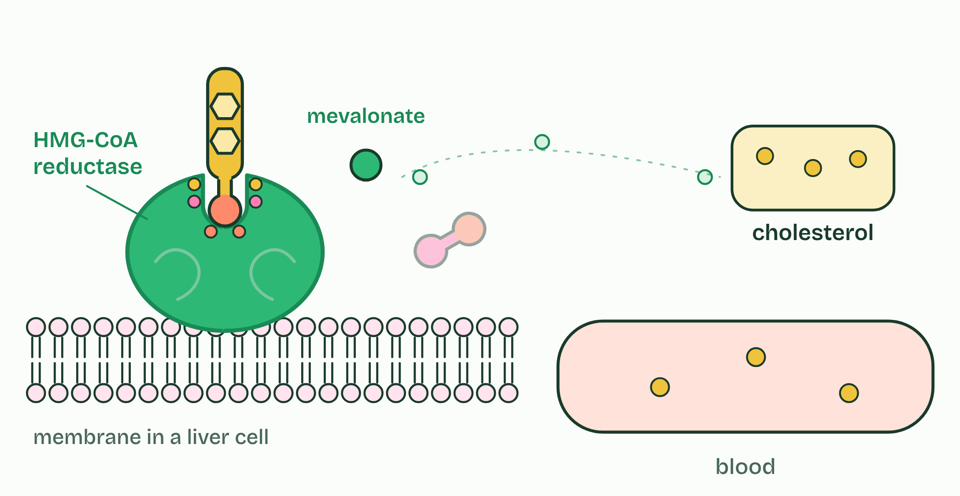  ANNOTATE THE FIGURE  The figure shows it as No inhibitor, Competitive, Non-competitive and All three. Note what changes each time.  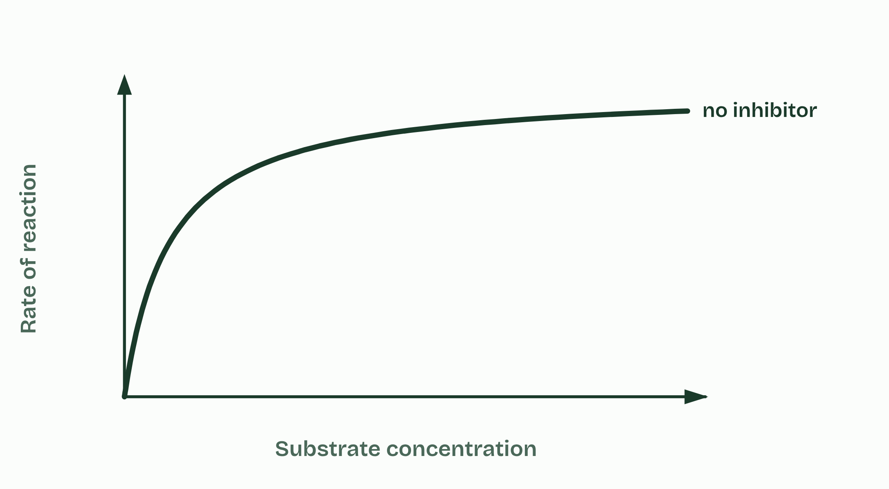  ANNOTATE THE FIGURE  Number the 2 steps on the figure and note what happens at each.  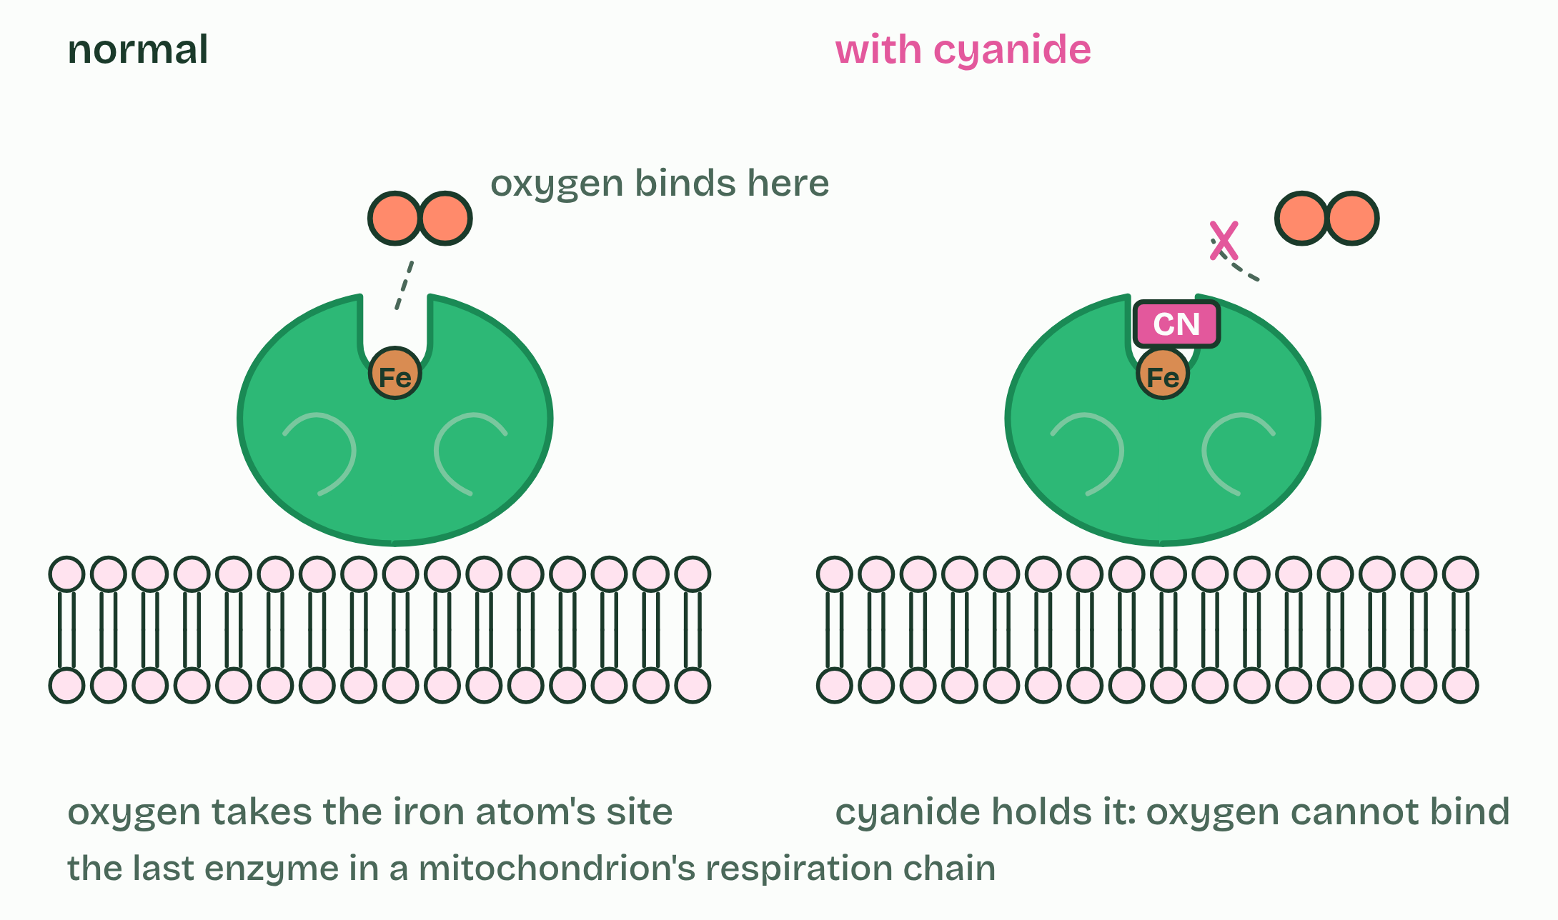  ANNOTATE THE FIGURE  Annotate this still from the animation (Add an inhibitor): what is happening, and why?  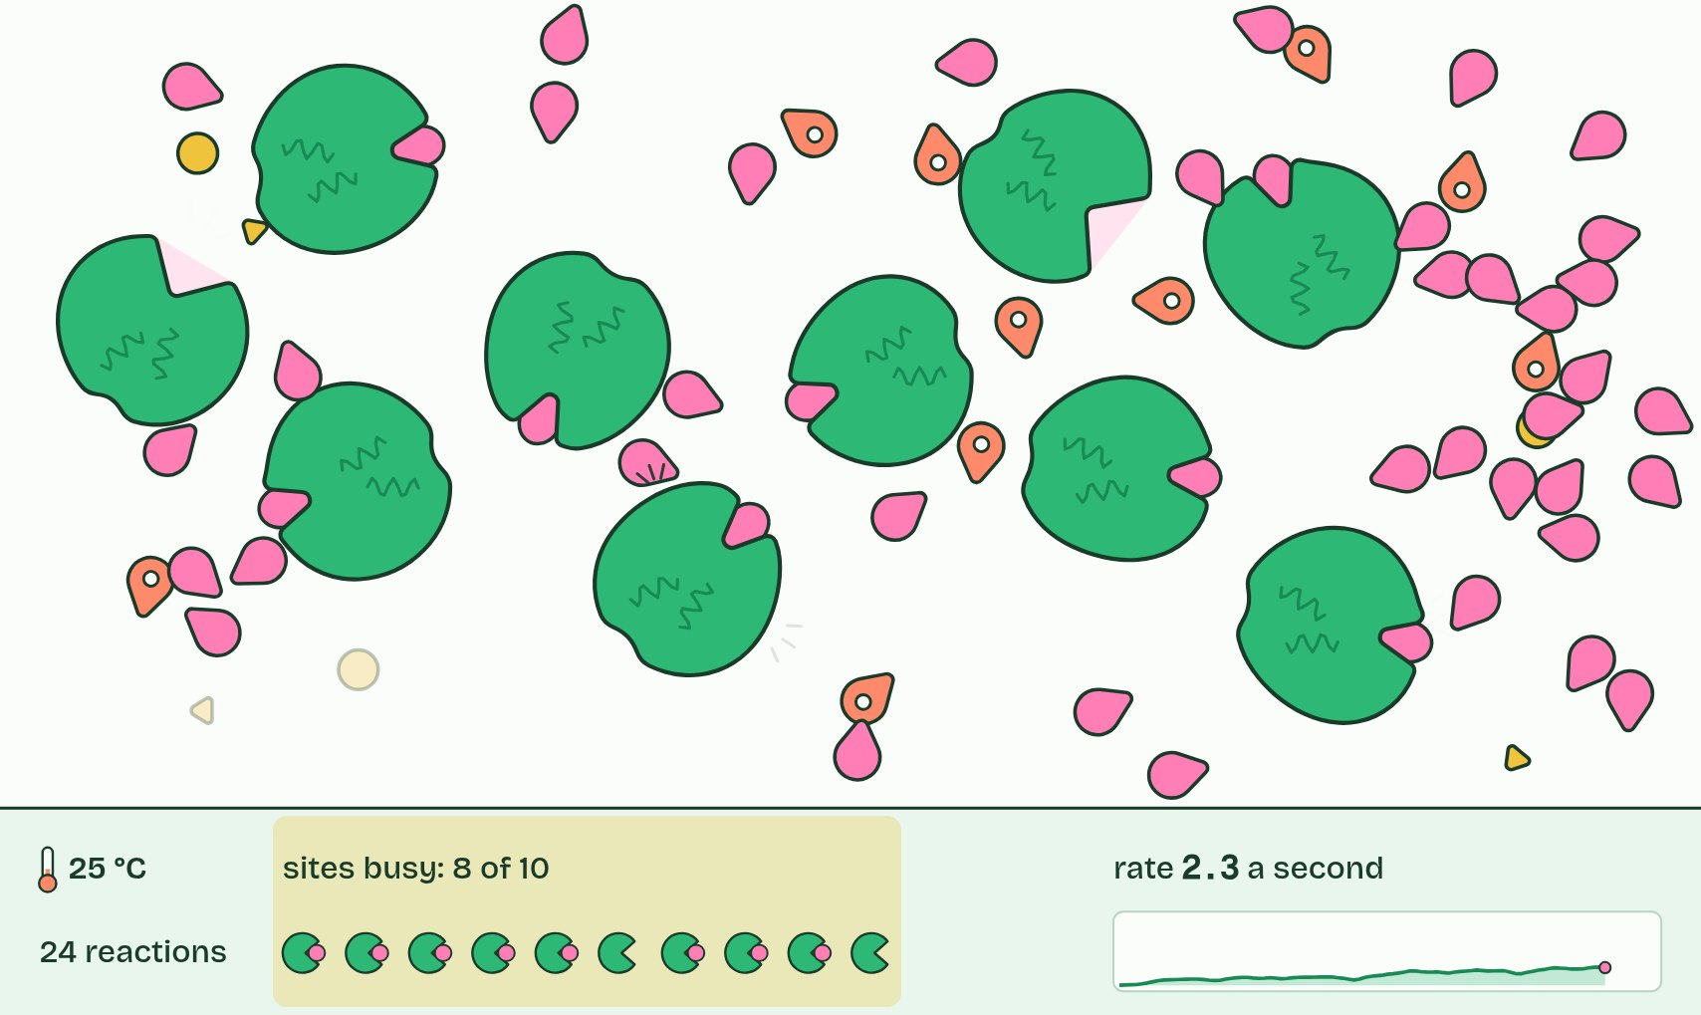
SUMMARY
Sum up section 12 in two or three sentences of your own.

13 The end product shuts the gate | C1.1.16 HL
CUES  Predict: Isoleucine inhibits the first enzyme of its five-step pathway, not the last. Why the first?  What is meant by feedback inhibition?  What is meant by isoleucine?  What is meant by threonine?  What is meant by threonine deaminase? | NOTES  1 In __________________________ (end-product inhibition), the last product of a pathway inhibits an enzyme near its start, usually the first, by binding to its allosteric site (chapter 11).  2 The example is the pathway that makes the amino acid ______________.  3 Plants and bacteria make it from another amino acid, ____________, in five steps, each with its own enzyme.  4 Isoleucine binds the allosteric site of the first enzyme, __________________________.  Your own notes  ANNOTATE THE FIGURE  The figure shows it as Slow, Normal and Fast. Note what changes each time.  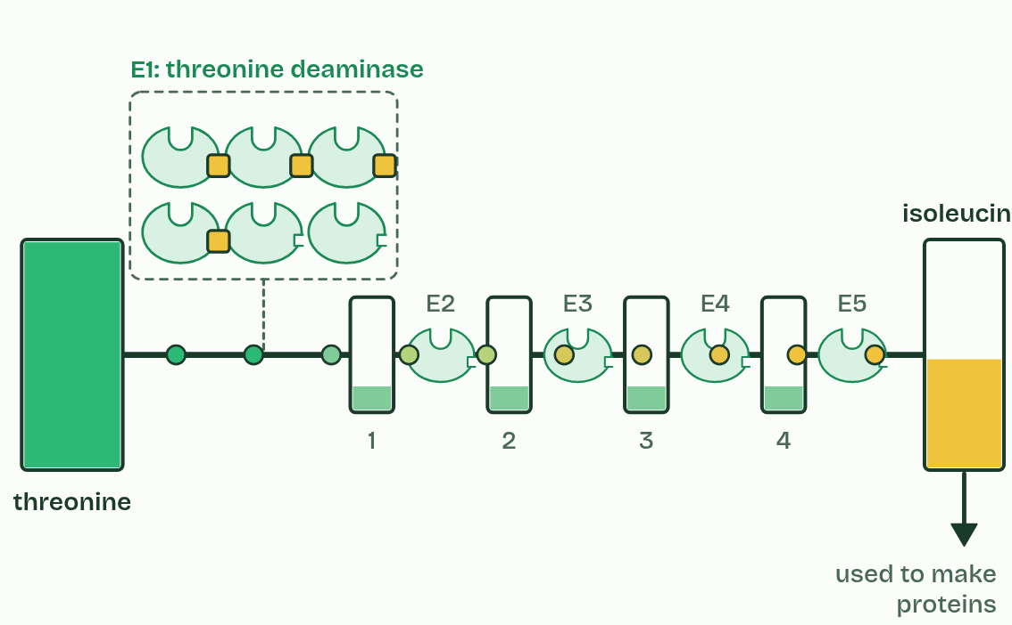
  SPOT THE MISTAKE
  What do students often get wrong about regulation of metabolic pathways by feedback inhibition? Write the mistake, then put it right.
  The mistake
  Put it right
SUMMARY
Sum up section 13 in two or three sentences of your own.

14 A trap that springs once | C1.1.17 HL
CUES  Predict: A strain of bacteria keeps building strong walls in penicillin. Its transpeptidase still makes cross-links. What has most likely changed?  What is meant by mechanism-based inhibition?  What is meant by covalent bond?  What is meant by irreversible?  What is meant by transpeptidase?  What is meant by antibiotic resistance? | NOTES  1 In __________________________________ an inhibitor enters the active site as if it were a substrate, and the enzyme starts to act on it.  2 But the reaction stops part way, with the inhibitor held by a __________________.  3 The active site is chemically changed and stays blocked for good: the inhibition is ________________.  4 A bacterial cell wall (A2.2) is made of long sugar chains cross-linked by short peptides, and the enzyme ___________________ makes those cross-links.  5 They show ____________________________: they carry a changed transpeptidase, whose active site has a different shape that penicillin binds poorly but that still makes cross-links, so their walls are built normally in penicillin.  Your own notes  ANNOTATE THE FIGURE  Number the 5 steps on the figure and note what happens at each.  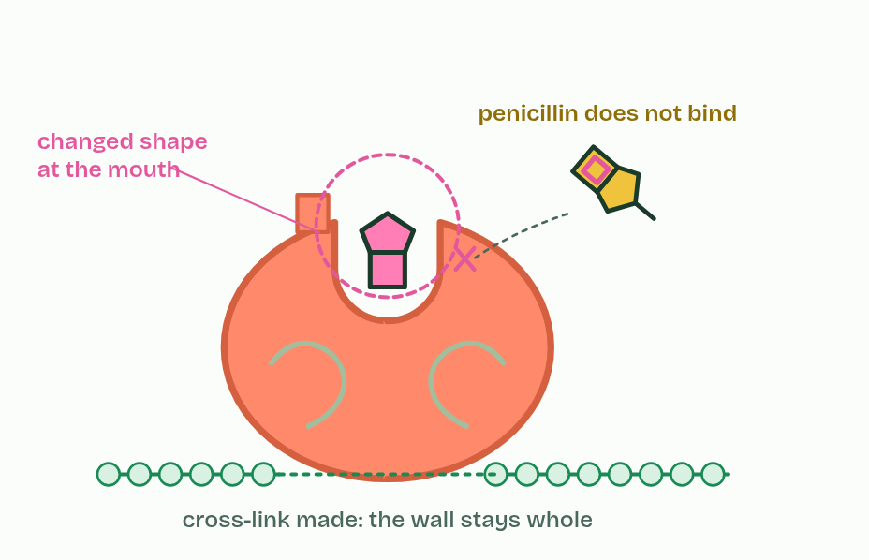  REMEMBER IT  Three ways to stop an enzyme
  C  Copycat | N  Nudge | M  Mousetrap
  C | N | M
  SPOT THE MISTAKE
  What do students often get wrong about mechanism-based inhibition? Write the mistake, then put it right.
  The mistake
  Put it right
SUMMARY
Sum up section 14 in two or three sentences of your own.

Check yourself
The check for this guide is online: a fresh paper of past-paper style questions from the exam bank on C1.1 each time, marked as you go, and saved to your Exam practice progress when you are signed in. Open the link:
biologybybradford.com/exam-maker/sit?topics=C1.1&level=HL&paper=quiz&marks=15&src=ep

