Name | Class | Date
IB BIOLOGY · C1.2

Cell respiration
Teacher’s copy: every blank filled in. Each numbered block matches a chapter of the guide, and of the lesson slides. Write in the gaps, answer the cues, annotate the figures, and sum up each section in your own words.
BY THE END YOU CAN
Describe ATP as a nucleotide and explain what makes it suit the job of moving energy around a cell C1.2.1
Explain how hydrolysis of ATP releases energy for active transport, building molecules and movement, and why remaking it takes energy C1.2.2, C1.2.3
Explain respiration as the cell's way of making ATP from carbon compounds, and tell it apart from gas exchange C1.2.4
Compare aerobic and anaerobic respiration in humans, with word equations for both C1.2.5
Measure the rate of respiration with a respirometer and work it out from raw or secondary data C1.2.6
Explain oxidation as the removal of hydrogen, and NAD as the carrier that is reduced when it accepts it C1.2.7
Outline glycolysis: phosphorylation, lysis, oxidation and ATP formation, with its net yield C1.2.8
Explain how making lactate, or ethanol and carbon dioxide in yeast, gives NAD back so glycolysis can go on, and how bakers and brewers use yeast C1.2.9, C1.2.10
Outline the link reaction and the Krebs cycle: where the carbon dioxide and the reduced NAD come from C1.2.11, C1.2.12
Explain how electrons passed along the chain build a proton gradient across the inner membrane C1.2.13, C1.2.14
Explain how ATP synthase uses the proton gradient to make ATP, and why oxygen is needed at the end of the chain C1.2.15, C1.2.16
Compare lipids and carbohydrates as fuels: energy per gram, and which routes each can take C1.2.17

01 The cell's small change | C1.2.1
CUES  Predict: Removing one phosphate from ATP releases only a modest amount of energy. Why does that suit a cell?  B: A job can take what it needs, with little wasted. Most jobs in a cell come in small steps: one stroke of a pump, one step in building a protein. A packet of energy close to the size of the job means little is wasted as heat, and a big job simply uses many ATP. A glucose molecule holds far more energy than any one job needs, which is why the cell turns it into ATP first.  What is meant by ATP?  Adenosine triphosphate: the molecule that carries energy to jobs all over a cell. Adenine and ribose with a chain of three phosphate groups.  What is meant by adenine?  One of the four bases of nucleic acids. In ATP it is the part joined to the sugar.  What is meant by ribose?  A five-carbon sugar. It is the sugar in RNA and in ATP.  What is meant by phosphate group?  A phosphorus atom bonded to four oxygens. It is the unit that is added to ADP to make ATP, and removed from ATP to release energy.  What is meant by nucleotide?  A monomer of nucleic acids: a base, a sugar and a phosphate group.  What is meant by energy currency?  A molecule that every job in a cell accepts as payment for its energy, so that energy from many different sources can be spent in the same way. ATP is the cell’s energy currency. | NOTES  1 Each of those jobs needs energy, and in every living cell the energy arrives in the same form. It is carried by one molecule, ATP.  2 Take the base adenine, join it to the sugar ribose and add one phosphate group, and you have a nucleotide, the same kind of unit that RNA is built from (A1.2).  3 That is why ATP is called the cell's energy currency.  4 A nucleotide: adenine, ribose and one phosphate.  5 Add a phosphate: ADP.  6 Add another: ATP, adenosine triphosphate.  Your own notes  ANNOTATE THE FIGURE  Number the 4 steps on the figure and note what happens at each: 1 nucleotide; 2 ADP; 3 ATP; 4 energy currency.  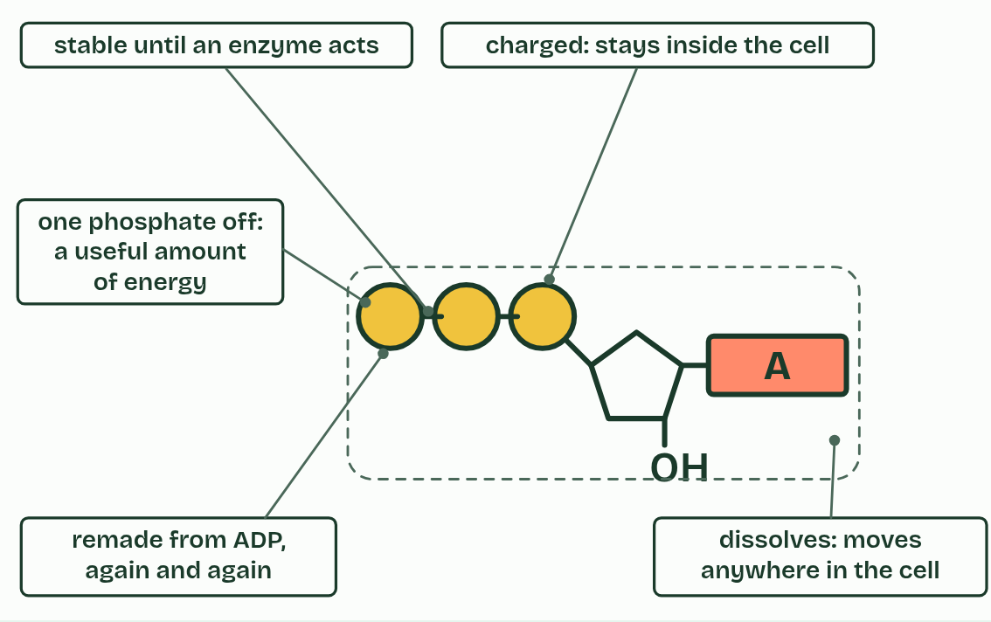  1 A nucleotide: adenine, ribose and one phosphate.  2 Add a phosphate: ADP.  3 Add another: ATP, adenosine triphosphate.  4 What makes it the cell's energy currency.
  SPOT THE MISTAKE
  What do students often get wrong about ATP as the molecule that distributes energy within cells? Write the mistake, then put it right.
  ATP is not the cell's energy store. A cell keeps only a little and remakes it constantly; the stores are glycogen, starch and fat.
SUMMARY
Sum up section 01 in two or three sentences of your own.
• It dissolves in water, so it moves freely through the cytoplasm to wherever it is needed.
• It is stable in the watery cytoplasm until an enzyme acts on it, so its energy is not wasted on the way.
• Taking off one phosphate releases a modest amount of energy, enough for one step of a pump or one step in building a molecule, so little is lost as heat.
• The phosphate can be passed on to another molecule, making that molecule more reactive.
• Its charged phosphate groups keep it from leaking out through the membrane.
• It is remade from ADP and phosphate quickly and endlessly, so a cell needs only a small stock.

02 Spend it, remake it | C1.2.2 C1.2.3
CUES  Predict: Remaking ATP from ADP and phosphate needs energy. Where does a muscle cell get it?  A: From respiring glucose or fat. From respiration. The energy released step by step as glucose or fat is broken down is used to join phosphate back onto ADP. Body warmth cannot do it: heat is energy that has already been lost from reactions, and it cannot be put back into a molecule.  What is meant by hydrolysis?  A reaction in which a molecule is split by the addition of water. Hydrolysis of ATP removes its last phosphate group and releases energy.  What is meant by ADP?  Adenosine diphosphate: ATP with one phosphate group fewer. It is what ATP becomes when it is hydrolysed, and what is remade into ATP in respiration.  What is meant by ATP and ADP cycle?  ATP is hydrolysed to ADP and phosphate, releasing energy, and ADP and phosphate are joined back into ATP using energy from respiration or light. The molecules go round; the energy flows through.  What is meant by active transport?  Moving a substance across a membrane against its concentration gradient, using a pump protein and energy from ATP.  What is meant by anabolism?  The building up of large molecules from small ones, using energy. Making a protein from amino acids is anabolism. | NOTES  1 In hydrolysis, a water molecule is used to take the last phosphate group off, and ATP becomes ADP (adenosine diphosphate) and a free phosphate.  2 So the ATP, the ADP and the phosphate go round and round, in the ATP and ADP cycle.  3 Active transport: a pump in the membrane moves ions against their concentration gradient (B2.1).  4 Building macromolecules, anabolism: a ribosome joins amino acids into a protein, and nucleotides are joined into DNA (C1.1).  Your own notes  ANNOTATE THE FIGURE  Number the 4 steps on the figure and note what happens at each.  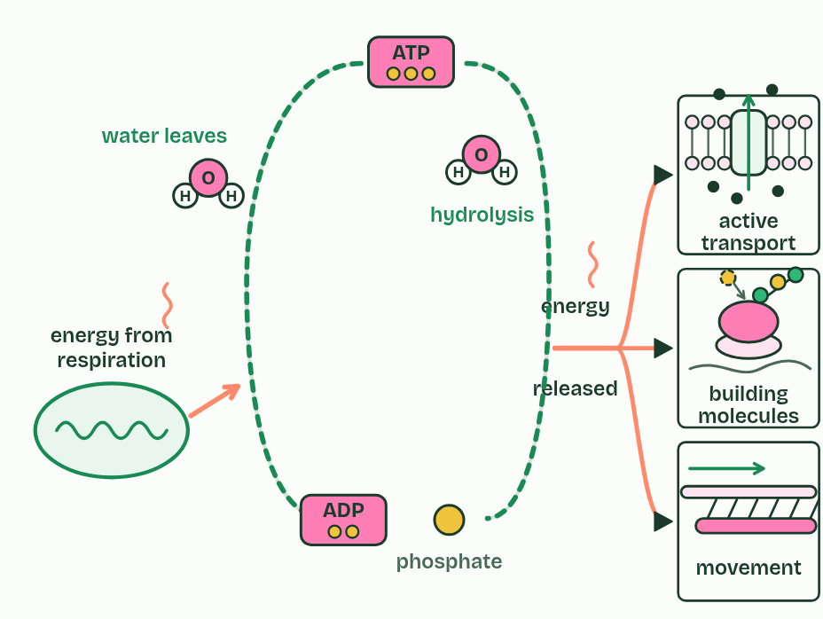  1 ATP, ADP and phosphate: the same molecules, used again and again.  2 Hydrolysis: water splits off the last phosphate. Energy is released for pumps, building and movement.  3 Remaking ATP needs energy: from respiration.  4 Spent and remade, over and over: the energy flows through, and some is lost as heat.  REMEMBER IT  What ATP pays for
  B  B | A  A | M  M
  Building  joining small molecules into large ones (anabolism) | Active transport  pumping against the gradient | Movement  of the whole cell or of its parts
  SPOT THE MISTAKE
  What do students often get wrong about what ATP pays for, and the energy it moves? Write the mistake, then put it right.
  Energy is not “stored in the bond” between phosphates, and breaking that bond does not release energy. Breaking a bond always takes energy; the energy released by hydrolysis is the difference between ATP and water before, and ADP and phosphate after.
SUMMARY
Sum up section 02 in two or three sentences of your own.
• Active transport: a pump in the membrane moves ions against their concentration gradient (B2.1).
• Building macromolecules, anabolism: a ribosome joins amino acids into a protein, and nucleotides are joined into DNA (C1.1).
• Movement: of the whole cell, as a sperm’s tail or a muscle fibre moves, or of parts of it, as chromosomes are pulled apart in mitosis.

03 Fuel in, ATP out | C1.2.4
CUES  Predict: A leaf in bright light takes in carbon dioxide and gives out oxygen. Is it respiring?  C: Yes: all its living cells respire all the time. Yes. Every living cell respires all the time, because every cell needs ATP every second. In bright light the leaf photosynthesises faster than it respires, so overall it takes in carbon dioxide and gives out oxygen: the gas exchange you measure is the difference between the two (C1.3).  What is meant by cell respiration?  The release of energy from carbon compounds in a cell, step by step, and its transfer to ATP.  What is meant by respiratory substrates?  The carbon compounds a cell breaks down in respiration. Glucose and fatty acids are the main ones.  What is meant by glucose?  A six-carbon sugar, C6H12O6. It is the main fuel of respiration in most cells.  What is meant by fatty acids?  The long chains of carbon and hydrogen that make up most of a fat. They are respired for a large share of a cell’s ATP.  What is meant by combustion?  Burning: a fuel reacting quickly with oxygen and releasing its energy as heat and light.  What is meant by gas exchange?  The movement of oxygen into, and carbon dioxide out of, an organism or its cells by diffusion across a surface such as the lungs, gills or a leaf. | NOTES  1 Cell respiration is how a cell makes ATP, using energy released from carbon compounds.  2 The fuels are called respiratory substrates.  3 The main two are glucose and fatty acids, but a cell can use a wide range of carbon compounds, amino acids among them when food is short.  4 Burning glucose is combustion.  5 Respiration is not gas exchange.  Your own notes  ANNOTATE THE FIGURE  The figure shows it as Burning, Cell respiration and Gas exchange. Note what changes each time.  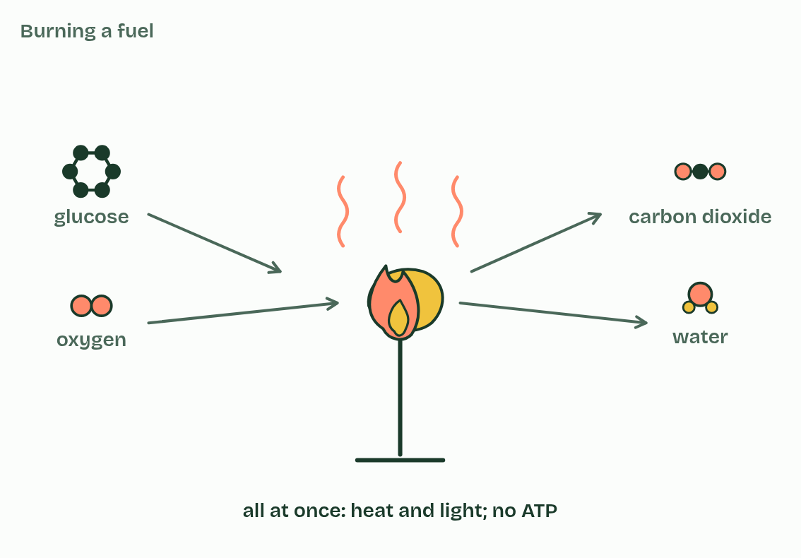  1 Burning  2 Cell respiration  3 Gas exchange
  SPOT THE MISTAKE
  What do students often get wrong about cell respiration as a system for producing ATP using energy from carbon compounds? Write the mistake, then put it right.
  “Respiration” in everyday English means breathing. In biology it is the chemistry that makes ATP in every cell. Breathing moves air; gas exchange moves gases across a surface; neither releases energy.
SUMMARY
Sum up section 03 in two or three sentences of your own.
• Cell respiration is how a cell makes ATP, using energy released from carbon compounds.
• The fuels are called respiratory substrates.
• The main two are glucose and fatty acids, but a cell can use a wide range of carbon compounds, amino acids among them when food is short.
• Burning glucose is combustion.

04 With oxygen and without | C1.2.5
CUES  Predict: A sprinter’s leg muscles run short of oxygen. Per glucose, how much ATP does anaerobic respiration make compared with aerobic?  C: About one fifteenth as much. About one fifteenth: 2 ATP against about 30 to 32. Without oxygen the glucose is only split, not broken down completely, so most of its energy is still locked in the lactate. The sprinter’s muscles burn through glucose far faster to keep up, which is one reason a sprint cannot last.  What is meant by pyruvate?  A three-carbon molecule. Glycolysis makes two of them from each glucose.  What is meant by glycolysis?  The splitting of glucose into two pyruvate in the cytoplasm. It releases enough energy to make a small amount of ATP, and it does not need oxygen.  What is meant by yield?  How much of a product a process makes from a set amount of starting material: here, the number of ATP made from each glucose.  What is meant by aerobic respiration?  Respiration that needs oxygen. Glucose is broken down completely to carbon dioxide and water in the mitochondria, making a large amount of ATP.  What is meant by mitochondrion?  The organelle where aerobic respiration is completed. It makes most of a cell’s ATP.  What is meant by anaerobic respiration?  Respiration without oxygen. In humans pyruvate is turned into lactate in the cytoplasm, and only a small amount of ATP is made.  What is meant by lactate?  The waste product of anaerobic respiration in humans. It is made from pyruvate in the cytoplasm. | NOTES  1 A glucose molecule is split into two molecules of pyruvate in a process called glycolysis, which releases enough energy to make a small amount of ATP.  2 After that the routes divide, according to whether there is oxygen, and they differ most in their yield of ATP for each glucose.  3 Aerobic respiration goes on with oxygen.  4 The pyruvate goes into a mitochondrion and is broken down completely, to carbon dioxide and water, and a large amount of ATP is made.  5 The word equation is glucose + oxygen → carbon dioxide + water.  6 Anaerobic respiration in humans stops early.  7 When there is not enough oxygen, the pyruvate stays in the cytoplasm and is turned into lactate.  8 The word equation is glucose → lactate.  Your own notes  ANNOTATE THE FIGURE  The figure shows it as Plenty of oxygen and Not enough oxygen. Note what changes each time.  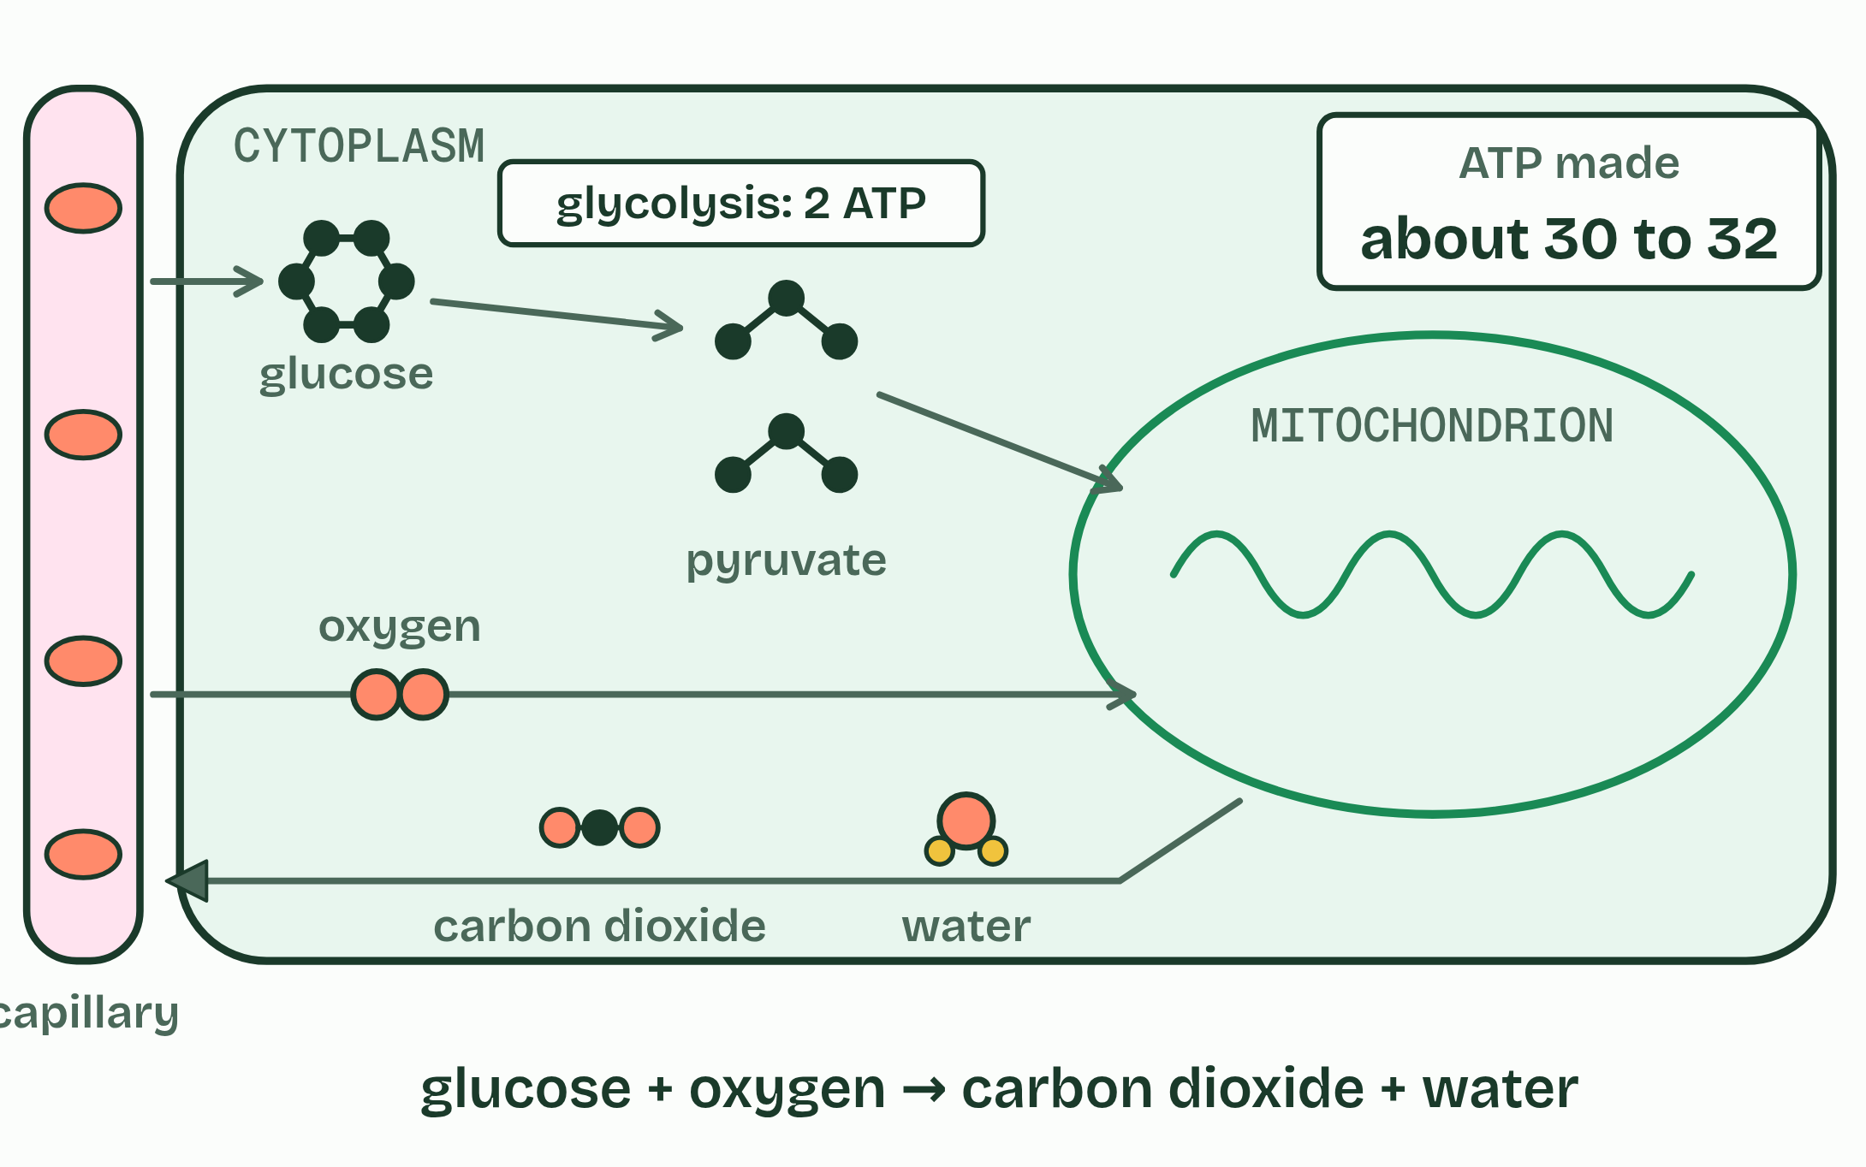  1 Plenty of oxygen  2 Not enough oxygen  ANNOTATE THE FIGURE  Annotate this still from the animation (Follow one glucose): what is happening, and why?  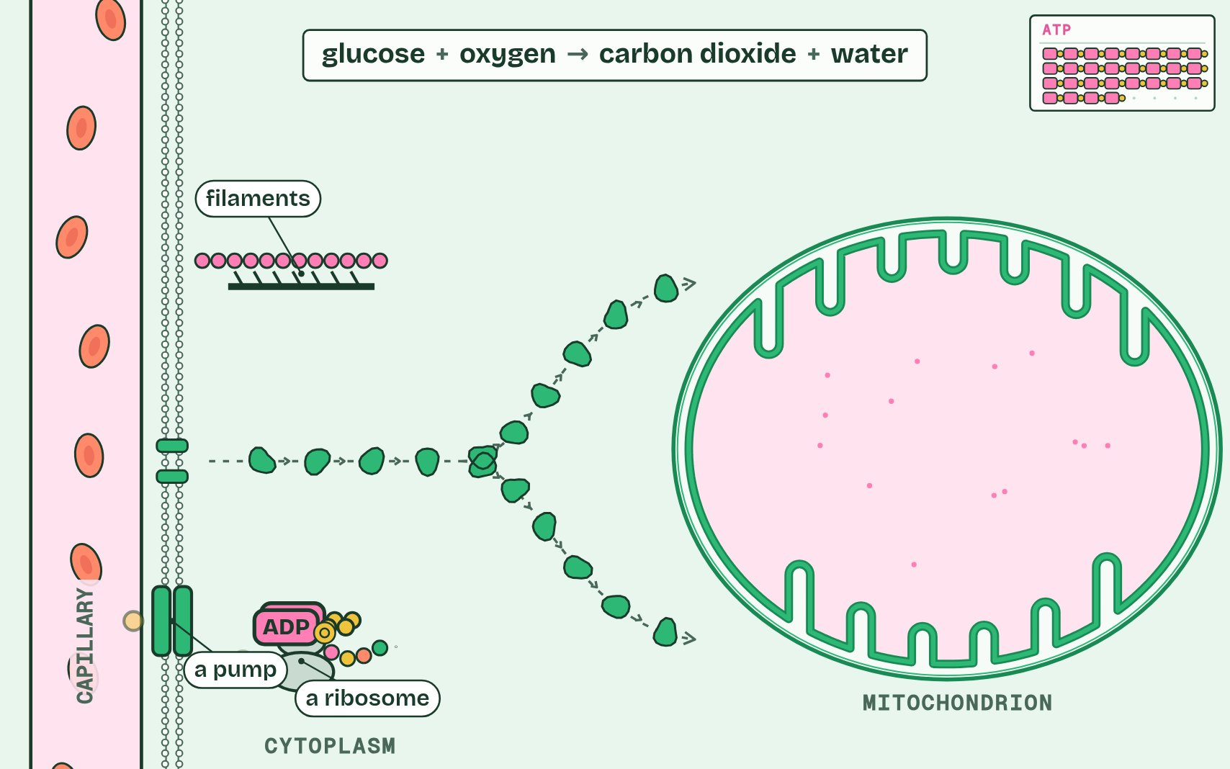  1 One mitochondrion. Its inner membrane is deeply folded.  2 Splitting glucose into two pyruvate in the cytoplasm gives a little ATP: 2.  3 With oxygen, pyruvate goes into a mitochondrion. Its carbon leaves as carbon dioxide; its hydrogen goes to the folds of the inner membrane.  4 Oxygen joins the hydrogen to make water. Here, at the folds, most of the ATP is made: about 30 to 32 from one glucose.  5 Aerobic respiration: glucose + oxygen → carbon dioxide + water. The energy released remakes ATP for the cell’s work.  ANNOTATE THE FIGURE  Number the 4 steps on the figure and note what happens at each.  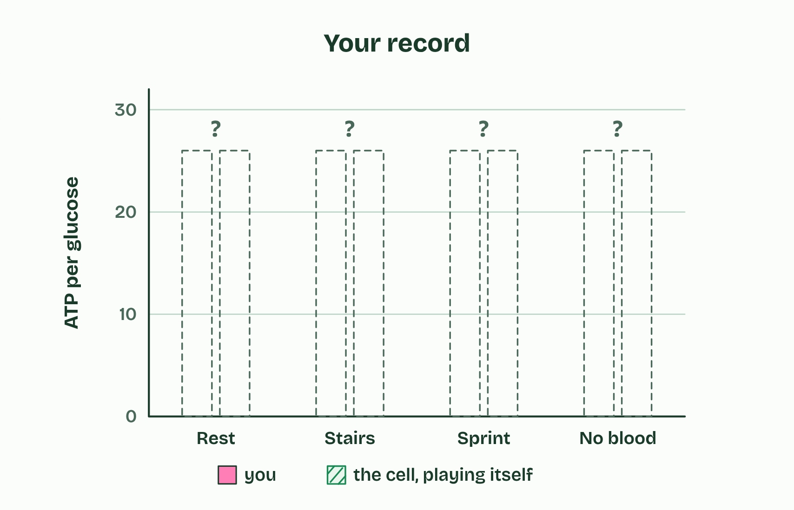  1 Rest: the mitochondria keep up easily.  2 A sprint: demand outruns the oxygen supply.  3 No oxygen: what happens to the ATP from each glucose?  4 Play the rounds to fill in the record.  REMEMBER IT  Anaerobic in humans is LOW
  L  L | O  O | W  W
  Lactate  the waste product | Only 2 ATP  per glucose | Without oxygen  in the cytoplasm
  SPOT THE MISTAKE
  What do students often get wrong about differences between anaerobic and aerobic cell respiration in humans? Write the mistake, then put it right.
  Glycolysis happens in the cytoplasm in both routes; only what follows it happens in the mitochondria.
SUMMARY
Sum up section 04 in two or three sentences of your own.
• A glucose molecule is split into two molecules of pyruvate in a process called glycolysis, which releases enough energy to make a small amount of ATP.
• After that the routes divide, according to whether there is oxygen, and they differ most in their yield of ATP for each glucose.
• Aerobic respiration goes on with oxygen.
• The pyruvate goes into a mitochondrion and is broken down completely, to carbon dioxide and water, and a large amount of ATP is made.

05 A rate you cannot see | C1.2.6
CUES  Predict: In the respirometer the seeds respire and the potassium hydroxide absorbs their carbon dioxide. Which way does the drop move?  B: Towards the seeds, as they take in oxygen. Towards the seeds. They take oxygen out of the air in the tube; the carbon dioxide they give out is absorbed as fast as it is made, so the gas shrinks and the drop is pulled in. How far it moves each minute is how fast they take up oxygen. Take the potassium hydroxide away and the drop hardly moves (the dry lab lets you try).  What is meant by rate of respiration?  The amount of oxygen taken up, carbon dioxide given out or fuel used, in each unit of time.  What is meant by per gram per minute?  A way of giving a rate that allows for the mass of living material, so that samples of different mass can be compared. Written g⁻¹ min⁻¹.  What is meant by respirometer?  An apparatus that measures the rate of respiration from the change in the volume of gas in a sealed tube of living material.  What is meant by potassium hydroxide?  An alkali that absorbs carbon dioxide. It is used in a respirometer so that the carbon dioxide given out does not hide the oxygen taken up.  What is meant by capillary?  A very thin tube. In a respirometer the drop moves along it as the volume of gas changes.  What is meant by control?  A set-up kept the same as the experiment in every way except the one thing being tested. The bead tube shows what moves the drop that is not respiration. | NOTES  1 The rate of respiration is the amount changed divided by the time taken, and for living material it is given per gram per minute as well, so that samples of different mass can be compared.  2 A second tube, the same in every way but with glass beads in place of the seeds, is the control.  3 Oxygen uptake in a respirometer: germinating seeds in a sealed tube, with potassium hydroxide to absorb the carbon dioxide they give out, and a drop of coloured liquid in a capillary whose movement shows the change in gas volume.  4 Carbon dioxide output: a gas sensor or data logger in a sealed chamber, or hydrogencarbonate indicator changing colour. With yeast, the rise of a dough or the gas collected over a sugar solution works too (the dry lab's dough mode).  5 Fuel used: the fall in the glucose in a yeast culture, measured with test strips.  Your own notes  ANNOTATE THE FIGURE  Label each part and say what it does: water bath and thermometer, potassium hydroxide, wire gauze, germinating seeds, glass bead tube, bung and screw clip, capillary and coloured drop, scale.  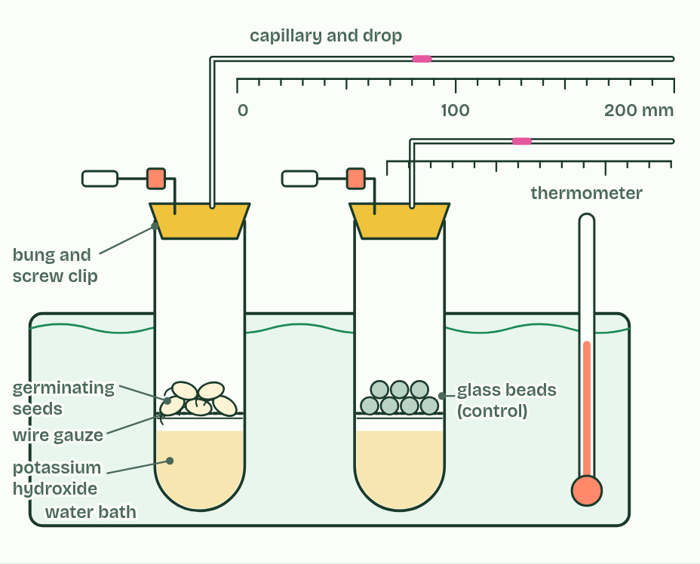  1 Water bath and thermometer: Keep the temperature steady, because gas expands as it warms.  2 Potassium hydroxide: An alkali that absorbs carbon dioxide. Without it, the carbon dioxide given out would make up for the oxygen taken in.  3 Wire gauze: Holds the seeds above the potassium hydroxide, so they never touch it.  4 Germinating seeds: Soaked a few days ago, respiring hard, and kept in the dark. Weighed first, so the rate can be given per gram.  5 Glass bead tube: The control: the same volume of glass beads, the same everything else. Anything that moves its drop is not respiration.  6 Bung and screw clip: Seal the tube. Left open while the tube warms to the bath, then closed to start.  7 Capillary and coloured drop: The drop moves as the gas inside shrinks. The bore sets how far it moves for each mm³.  8 Scale: Read in mm. Each reading is ± 0.5 mm.  ANNOTATE THE FIGURE  Number the 4 steps on the figure and note what happens at each.  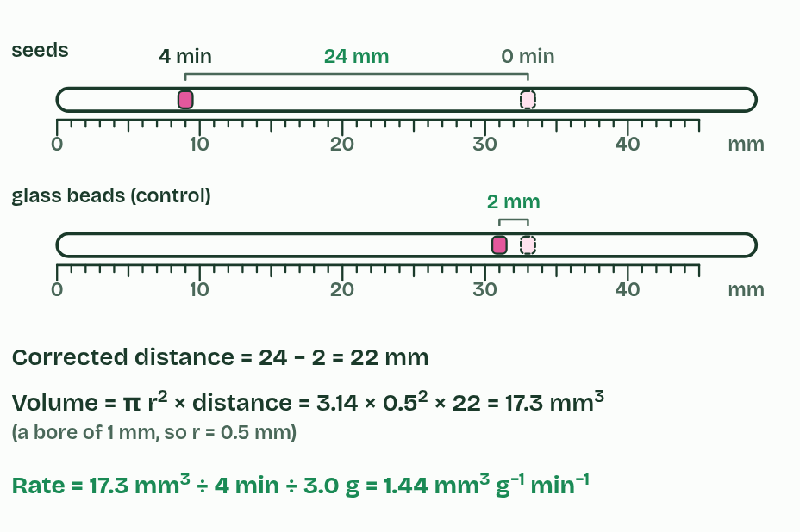  1 Read both drops at the start and the end.  2 Take off the control’s movement.  3 Turn distance into volume with the bore.  4 Divide by time and by mass.
  SPOT THE MISTAKE
  What do students often get wrong about variables affecting the rate of cell respiration? Write the mistake, then put it right.
  The drop does not move because the seeds give out carbon dioxide: that is removed. It moves because of what the seeds take up.
SUMMARY
Sum up section 05 in two or three sentences of your own.
• Oxygen uptake in a respirometer: germinating seeds in a sealed tube, with potassium hydroxide to absorb the carbon dioxide they give out, and a drop of coloured liquid in a capillary whose movement shows the change in gas volume.
• Carbon dioxide output: a gas sensor or data logger in a sealed chamber, or hydrogencarbonate indicator changing colour. With yeast, the rise of a dough or the gas collected over a sugar solution works too (the dry lab's dough mode).
• Fuel used: the fall in the glucose in a yeast culture, measured with test strips.

06 Taking hydrogen away | C1.2.7 HL
CUES  Predict: A dehydrogenase takes two hydrogens off a molecule of fuel. What has happened to that molecule?  D: It is oxidised: it has lost electrons. It is oxidised. Each hydrogen taken away carries an electron with it, and losing electrons is oxidation. The NAD that accepts them gains the electrons and is reduced. In respiration, oxidation almost always means hydrogen being taken off the fuel.  What is meant by oxidation?  The loss of electrons. In respiration it is mostly the removal of hydrogen from a molecule, because each hydrogen takes an electron with it.  What is meant by reduction?  The gain of electrons.  What is meant by redox reaction?  A reaction in which one substance is oxidised and another is reduced.  What is meant by dehydrogenation?  The removal of hydrogen (a proton and an electron) from a molecule. It oxidises the molecule. Enzymes that do it are dehydrogenases.  What is meant by NAD?  A hydrogen carrier built from nucleotides. It accepts hydrogen and is reduced, becoming reduced NAD, and gives it up again where the hydrogen is used.  What is meant by reduced NAD?  NAD that has accepted hydrogen. It carries the hydrogen, and the energy that comes with it, to the electron transport chain.  What is meant by hydrogen carrier?  A molecule that picks up hydrogen in one place and delivers it in another. NAD is the hydrogen carrier of respiration. | NOTES  1 To see why, you need two words. Oxidation is the loss of electrons, and reduction is the gain of electrons.  2 A reaction that does both is a redox reaction.  3 So when hydrogen is removed from a molecule, which is called dehydrogenation, it loses electrons too, and has been oxidised.  4 The hydrogen has to go somewhere. It is accepted by NAD, a molecule built from nucleotides, like ATP.  5 When NAD accepts hydrogen it is reduced, and is then called reduced NAD.  6 So NAD is a hydrogen carrier.  Your own notes  ANNOTATE THE FIGURE  Number the 4 steps on the figure and note what happens at each.  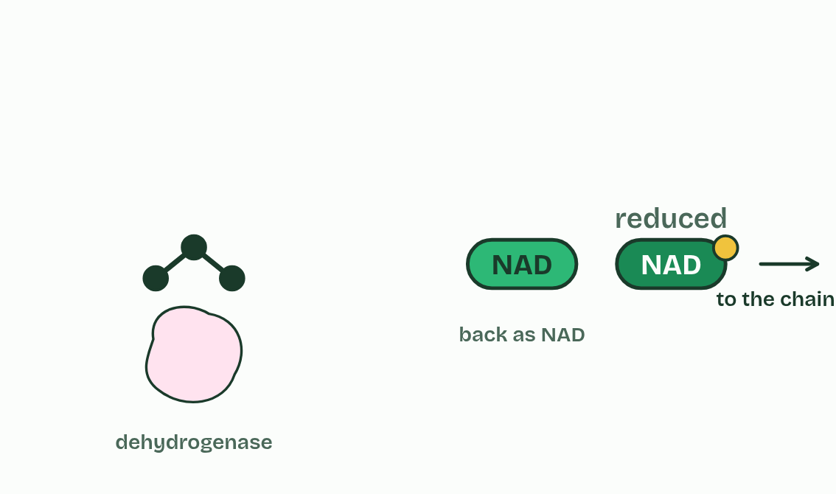  1 A substrate, an enzyme, and NAD.  2 Hydrogen is removed: dehydrogenation. Each hydrogen is a proton and an electron.  3 The substrate is oxidised; NAD is reduced. A redox reaction.  4 Reduced NAD carries the hydrogen away and comes back as NAD.  REMEMBER IT  Oxidation and reduction
  O  Oil | R  Rig
  Oxidation Is Loss  of electrons | Reduction Is Gain  of electrons
  SPOT THE MISTAKE
  What do students often get wrong about role of NAD as a carrier of hydrogen, and oxidation by removal of hydrogen? Write the mistake, then put it right.
  Reduced NAD carries hydrogen, protons and electrons together, and the energy that comes with them. It is not ATP and it is not “energy” itself.
SUMMARY
Sum up section 06 in two or three sentences of your own.
• To see why, you need two words. Oxidation is the loss of electrons, and reduction is the gain of electrons.
• A reaction that does both is a redox reaction.
• So when hydrogen is removed from a molecule, which is called dehydrogenation, it loses electrons too, and has been oxidised.
• The hydrogen has to go somewhere. It is accepted by NAD, a molecule built from nucleotides, like ATP.

07 Two ATP in, four out | C1.2.8 HL
CUES  Predict: Glycolysis spends 2 ATP at the start. How many does it make by the end, from one glucose?  A: 4, so the cell gains 2. Four, for a net gain of two. The two spent at the start make the sugar reactive enough to split; the four made later come from energy released as the 3-carbon sugars are oxidised and changed into pyruvate. So for one glucose the net yield is 2 ATP, with 2 reduced NAD and 2 pyruvate. No oxygen is used anywhere in glycolysis, so it is the same in aerobic and anaerobic respiration. The big yield comes later, in the mitochondrion.  What is meant by phosphorylation?  The addition of a phosphate group to a molecule. In glycolysis two ATP each give a phosphate group to the sugar, which makes it reactive.  What is meant by lysis?  Splitting. In glycolysis the 6-carbon sugar with two phosphates is split into two 3-carbon sugars.  What is meant by oxidation?  In glycolysis, the removal of hydrogen from each 3-carbon sugar by a dehydrogenase, with NAD accepting it.  What is meant by ATP formation?  The making of ATP from ADP and a phosphate group. In glycolysis each 3-carbon sugar passes its phosphates to ADP, and ends as pyruvate. | NOTES  1 Phosphorylation: two ATP each give a phosphate group to the glucose. That costs 2 ATP, but a sugar carrying two charged phosphates is made reactive and ready to split.  2 Lysis: the 6-carbon sugar with its two phosphates splits into two 3-carbon sugars, each with one phosphate.  3 Oxidation: hydrogen is taken off each 3-carbon sugar and accepted by NAD, so two reduced NAD are made for the glucose. The energy released lets each 3-carbon sugar take on a second phosphate, a free one from the cytoplasm, not one from ATP.  4 ATP formation: each 3-carbon sugar passes its two phosphates to ADP, making ATP directly, and ends as pyruvate.  Your own notes  ANNOTATE THE FIGURE  Number the 6 steps on the figure and note what happens at each.  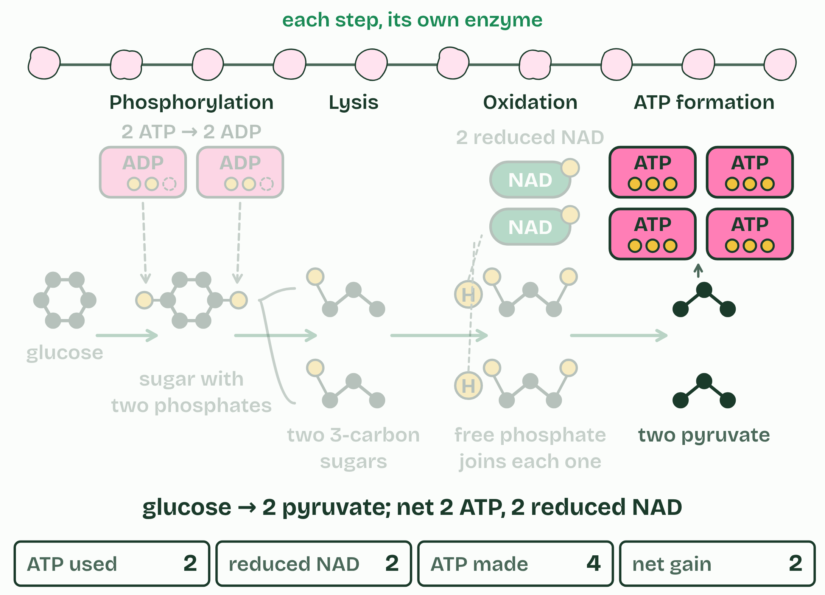  1 One glucose, in the cytoplasm.  2 Phosphorylation: 2 ATP spent, the sugar made reactive.  3 Lysis: split into two 3-carbon sugars.  4 Oxidation: hydrogen to NAD, making 2 reduced NAD.  5 ATP formation: 4 ATP made, so 2 gained.  6 Ten steps, ten enzymes, two pyruvate.  REMEMBER IT  The four stages of glycolysis, in order
  P  Penguins | L  Love | O  Orange | A  Anchovies
  Phosphorylation  2 ATP spent | Lysis  6 carbons split into 3 and 3 | Oxidation  hydrogen to NAD | ATP formation  4 ATP made
  SPOT THE MISTAKE
  What do students often get wrong about conversion of glucose to pyruvate in glycolysis, with a net yield of ATP and reduced NAD? Write the mistake, then put it right.
  Glycolysis does not need oxygen, and it does not happen in the mitochondrion.
SUMMARY
Sum up section 07 in two or three sentences of your own.
• Phosphorylation: two ATP each give a phosphate group to the glucose. That costs 2 ATP, but a sugar carrying two charged phosphates is made reactive and ready to split.
• Lysis: the 6-carbon sugar with its two phosphates splits into two 3-carbon sugars, each with one phosphate.
• Oxidation: hydrogen is taken off each 3-carbon sugar and accepted by NAD, so two reduced NAD are made for the glucose. The energy released lets each 3-carbon sugar take on a second phosphate, a free one from the cytoplasm, not one from ATP.
• ATP formation: each 3-carbon sugar passes its two phosphates to ADP, making ATP directly, and ends as pyruvate.

08 Giving NAD back | C1.2.9 HL C1.2.10 HL
CUES  Predict: Without oxygen, why does a muscle cell turn pyruvate into lactate instead of leaving it as pyruvate?  D: It gives NAD back, so glycolysis can go on. To give NAD back. Glycolysis turns NAD into reduced NAD, and without oxygen nothing else can unload it. Turning pyruvate into lactate takes the hydrogen off reduced NAD, so NAD is free to collect more, and glycolysis keeps making its 2 ATP per glucose.  What is meant by regeneration of NAD?  Turning reduced NAD back into NAD, so that it can accept hydrogen again. It lets glycolysis go on.  What is meant by yeast?  A single-celled fungus. Baker’s and brewer’s yeast respire sugars, with or without oxygen.  What is meant by ethanol?  A two-carbon alcohol. It is the product of anaerobic respiration in yeast, with carbon dioxide.  What is meant by baking?  Making bread. Yeast in the dough respire its sugars, and the carbon dioxide they give out makes the dough rise.  What is meant by brewing?  Making drinks such as beer and wine. Yeast in a sugary liquid, with little air, make ethanol, which is kept.  What is meant by fermentation?  Anaerobic respiration in yeast (making ethanol and carbon dioxide) or in muscle (making lactate), especially when it is put to use, as in brewing and baking. | NOTES  1 Giving NAD back is called the regeneration of NAD.  2 Yeast follow the same pathway as far as pyruvate.  3 Without oxygen, each pyruvate loses a carbon as carbon dioxide, and what is left takes the hydrogen from reduced NAD to become ethanol.  4 In baking, yeast respire the sugars in the dough and the carbon dioxide forms bubbles that stretch it, so the dough rises; the ethanol evaporates in the oven.  5 In brewing, yeast in a sugary liquid made from barley or grapes, with little air, make ethanol, which is kept, while the carbon dioxide escapes or is kept in for fizz.  6 Anaerobic respiration in yeast is often called fermentation.  Your own notes  ANNOTATE THE FIGURE  The figure shows it as Glycolysis alone, Muscle and Yeast. Note what changes each time.  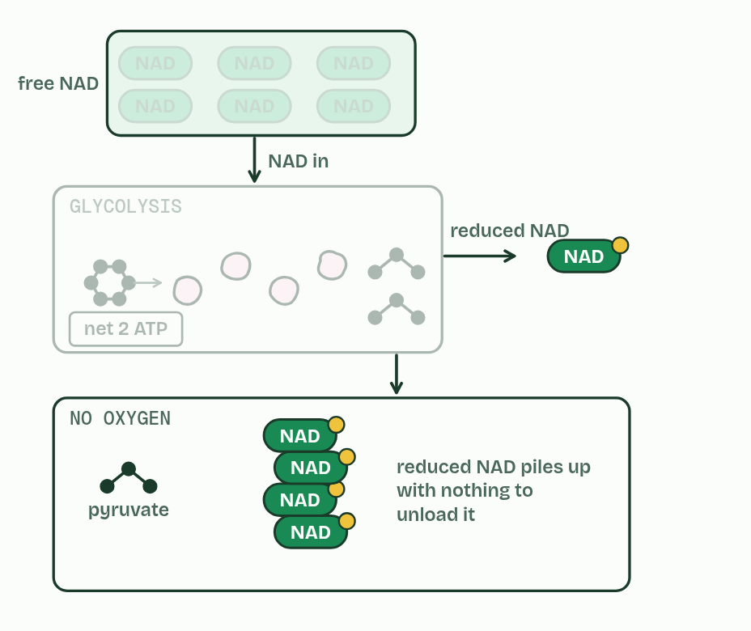  1 Glycolysis alone  2 Muscle  3 Yeast
  SPOT THE MISTAKE
  What do students often get wrong about lactate and ethanol as ways of regenerating NAD, and brewing and baking? Write the mistake, then put it right.
  Yeast without oxygen make ethanol and carbon dioxide, not lactate; humans make lactate, not ethanol or carbon dioxide.
SUMMARY
Sum up section 08 in two or three sentences of your own.
• Giving NAD back is called the regeneration of NAD.
• Yeast follow the same pathway as far as pyruvate.
• Without oxygen, each pyruvate loses a carbon as carbon dioxide, and what is left takes the hydrogen from reduced NAD to become ethanol.
• In baking, yeast respire the sugars in the dough and the carbon dioxide forms bubbles that stretch it, so the dough rises; the ethanol evaporates in the oven.

09 The carbon leaves as carbon dioxide | C1.2.11 HL C1.2.12 HL
CUES  Predict: Each turn of the Krebs cycle takes in a 2-carbon acetyl group. Why does the cycle not fill up with carbon?  B: Two carbons leave as carbon dioxide each turn. Two carbons leave as carbon dioxide in every turn, in the two decarboxylations, and the cycle ends where it started, with the 4-carbon oxaloacetate. Two carbons in, two out: this is where most of the carbon dioxide you breathe out is made. Count the carbons: glucose has 6; two leave as carbon dioxide in the link reactions and four in the two turns of the cycle, so all six are gone. The carriers, not the ATP, are the main product so far: per glucose the cycle makes only 2 ATP, and the chain turns the reduced NAD into most of the ATP (chapters 10 and 11).  What is meant by matrix?  The fluid inside the inner membrane of a mitochondrion. The link reaction and the Krebs cycle happen in it.  What is meant by link reaction?  The step between glycolysis and the Krebs cycle. Pyruvate is decarboxylated and oxidised, and the acetyl group left over is carried on by coenzyme A.  What is meant by decarboxylated?  Having a carbon removed as carbon dioxide. Decarboxylation takes place in the link reaction and in the Krebs cycle.  What is meant by acetyl group?  A group of two carbon atoms, left when pyruvate loses a carbon. Fatty acids are also broken down to acetyl groups.  What is meant by coenzyme A?  A carrier of acetyl groups. It carries the acetyl group to the Krebs cycle and goes back for more.  What is meant by krebs cycle?  A cycle of reactions in the matrix. An acetyl group joins oxaloacetate to make citrate, and the cycle gives off carbon dioxide, loads hydrogen carriers and makes a little ATP.  What is meant by oxaloacetate?  A 4-carbon compound. It joins an acetyl group to make citrate, and is remade at the end of each turn of the Krebs cycle.  What is meant by citrate?  A 6-carbon compound, the first made in the Krebs cycle from an acetyl group and oxaloacetate. | NOTES  1 With oxygen, pyruvate is carried from the cytoplasm into the matrix, the fluid inside the inner membrane of the mitochondrion.  2 The link reaction links glycolysis to the Krebs cycle.  3 Each pyruvate (3C) is decarboxylated, which takes a carbon off as carbon dioxide, and oxidised: hydrogen is removed and accepted by NAD.  4 The 2-carbon acetyl group that is left is picked up by coenzyme A and carried to the cycle.  5 In the Krebs cycle, the acetyl group is transferred to oxaloacetate (4C) to make citrate (6C).  Your own notes  ANNOTATE THE FIGURE  Number the 6 steps on the figure and note what happens at each.  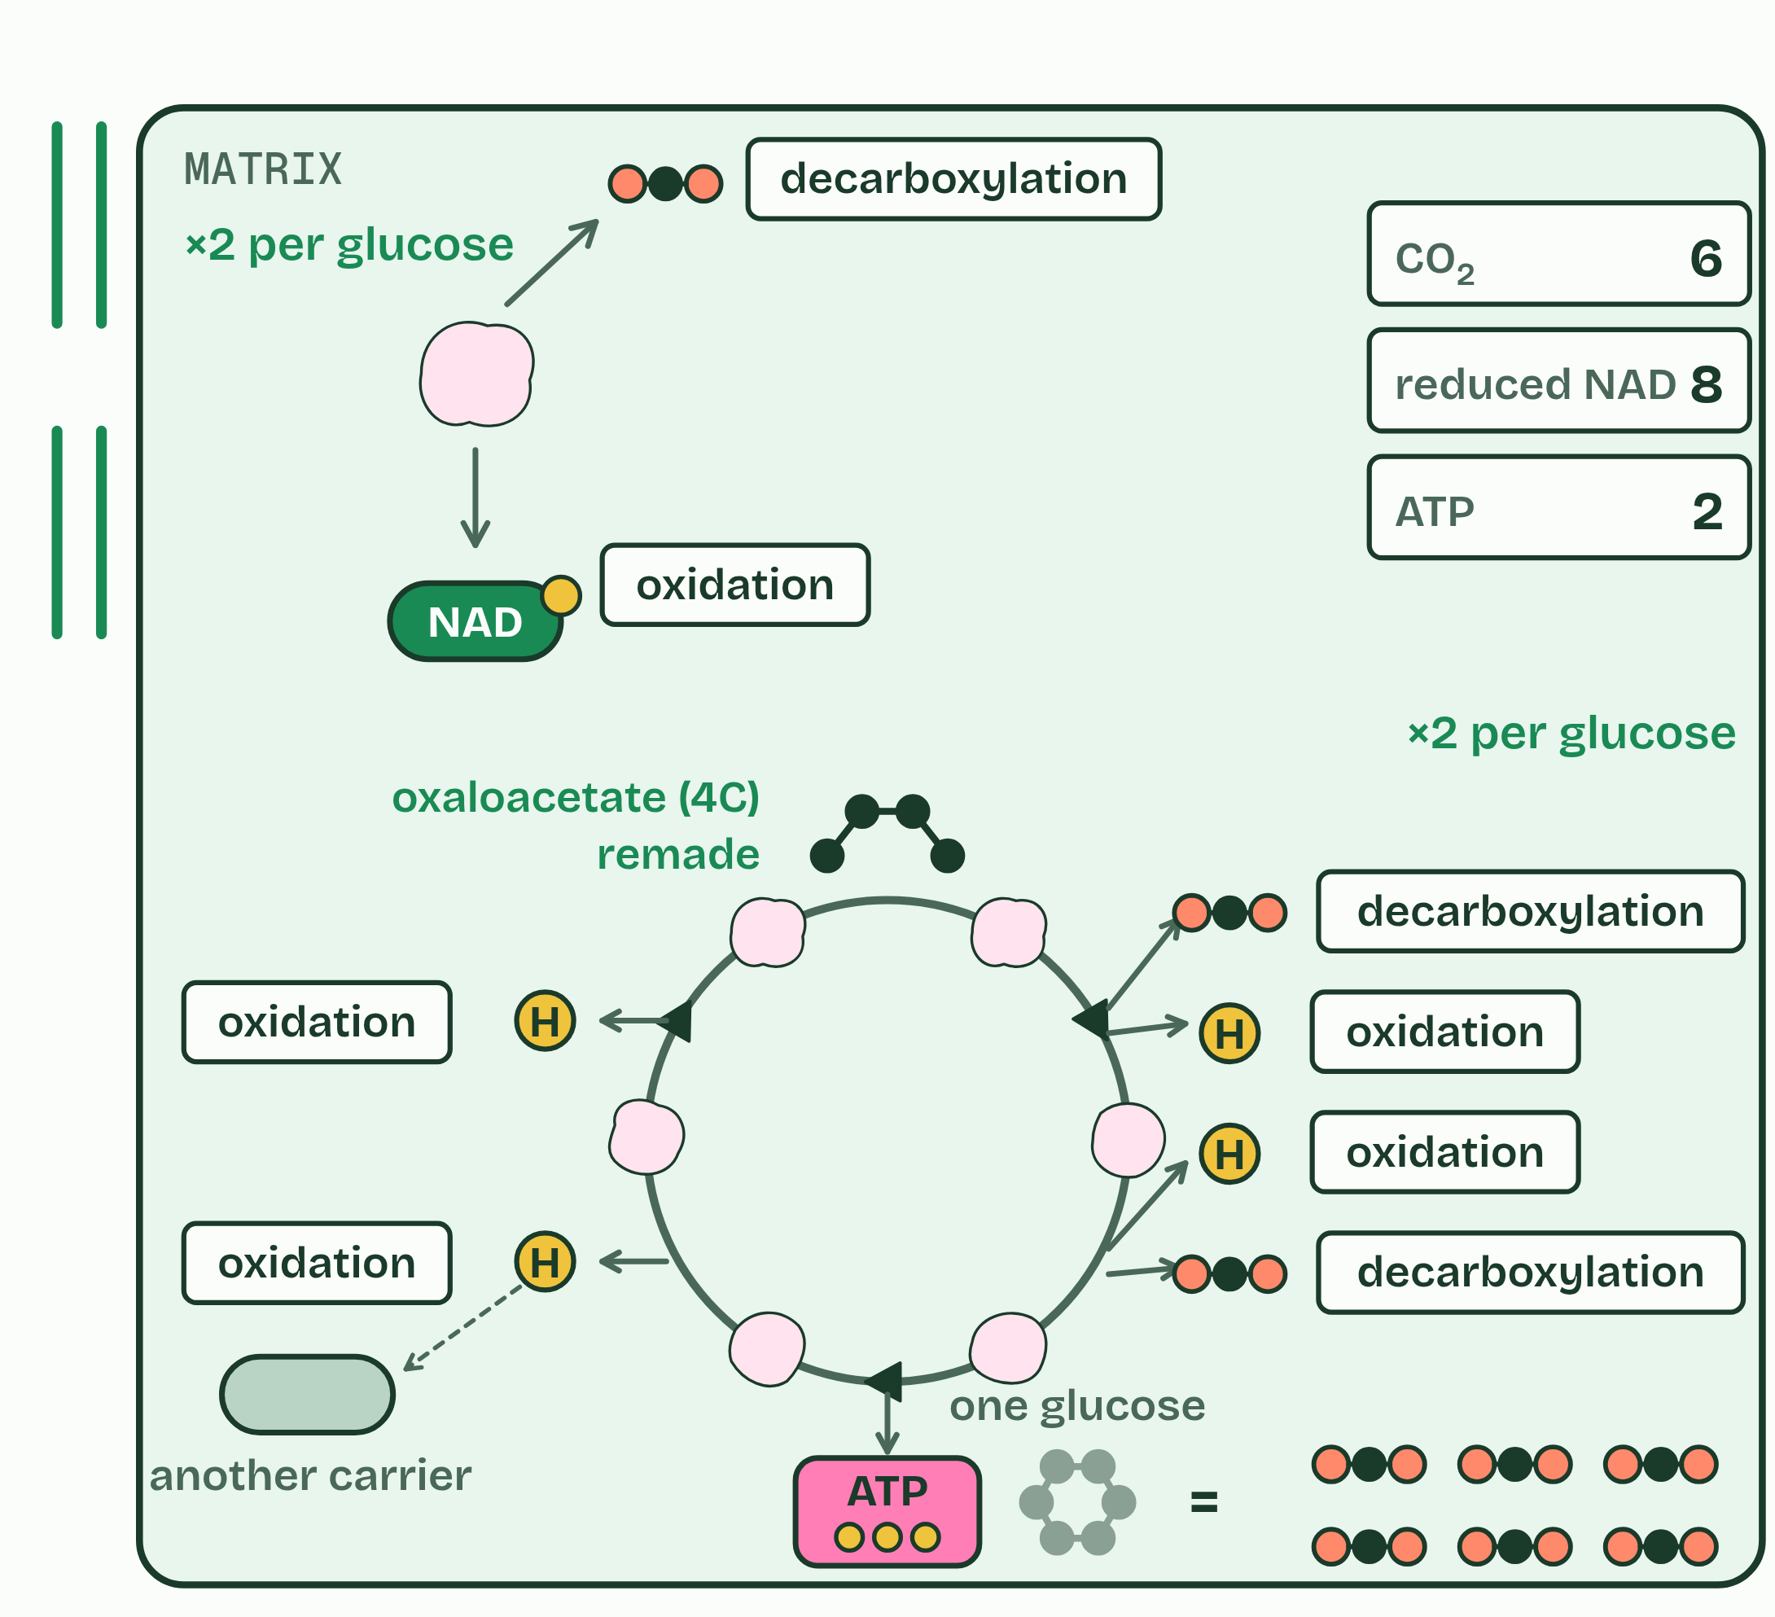  1 Pyruvate goes into the matrix.  2 Link reaction: a carbon off as CO2 (decarboxylation), hydrogen to NAD (oxidation). The acetyl group goes on with coenzyme A.  3 Acetyl (2C) + oxaloacetate (4C) → citrate (6C).  4 Two decarboxylations, four oxidations, one ATP.  5 Oxaloacetate is remade: a cycle.  6 Two turns per glucose: all six carbons gone as CO2.  ANNOTATE THE FIGURE  Label the key parts and add a note on what it shows.  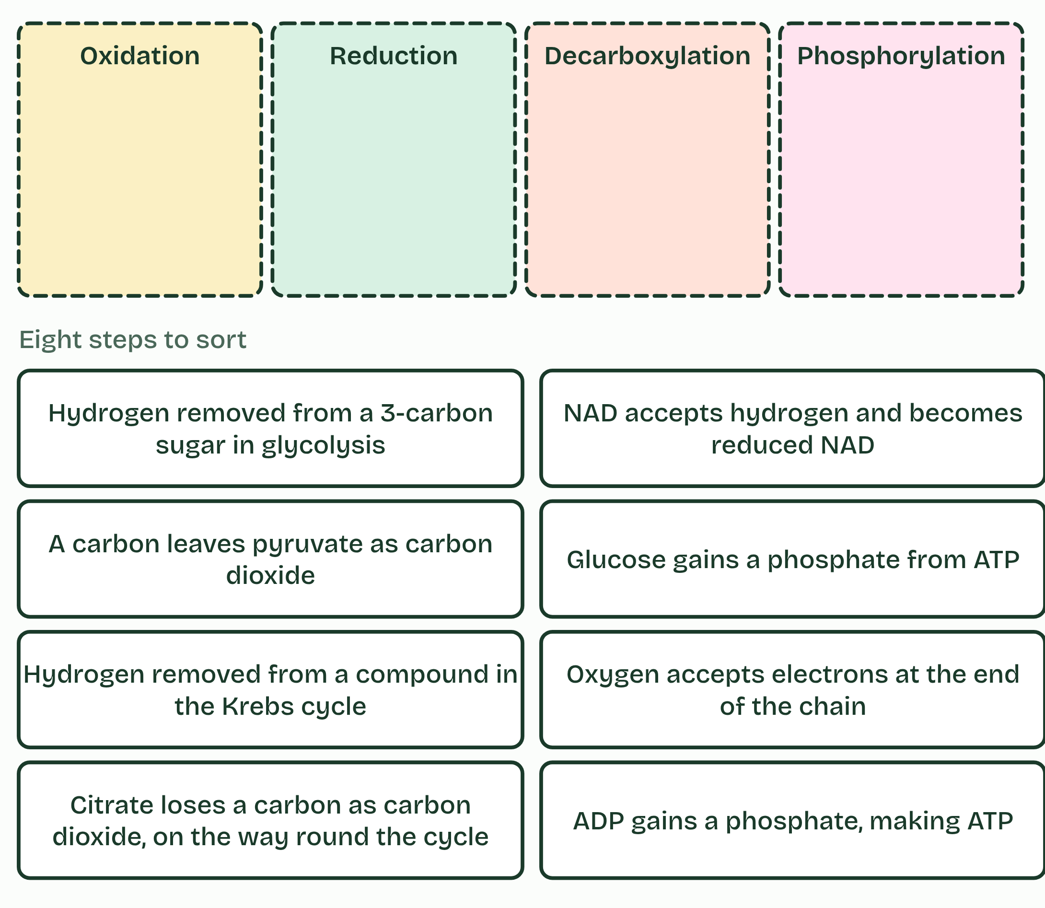  Name the reaction: eight steps of respiration and four kinds of reaction. Which bin does each belong in, and what tells you?
  SPOT THE MISTAKE
  What do students often get wrong about the link reaction, and the Krebs cycle? Write the mistake, then put it right.
  The Krebs cycle makes little ATP directly, only one a turn. Its main product is reduced NAD, which the chain turns into most of the ATP.
SUMMARY
Sum up section 09 in two or three sentences of your own.
• With oxygen, pyruvate is carried from the cytoplasm into the matrix, the fluid inside the inner membrane of the mitochondrion.
• The link reaction links glycolysis to the Krebs cycle.
• Each pyruvate (3C) is decarboxylated, which takes a carbon off as carbon dioxide, and oxidised: hydrogen is removed and accepted by NAD.
• The 2-carbon acetyl group that is left is picked up by coenzyme A and carried to the cycle.

10 Down the chain | C1.2.13 HL C1.2.14 HL
CUES  Predict: Electrons pass along the chain of carriers, releasing a little energy at each step. What is that energy used for?  D: Pumping protons across the inner membrane. Pumping protons, from the matrix into the intermembrane space. No ATP is made at the carriers themselves; the energy is first stored as a gradient of protons, and the gradient is spent making ATP in chapter 11.  What is meant by inner membrane?  The inner of the two membranes of a mitochondrion. It is folded into cristae and holds the electron transport chain and ATP synthase.  What is meant by cristae?  The folds of the inner mitochondrial membrane. They give a large area for the electron transport chain and ATP synthase.  What is meant by electron transport chain?  A series of electron carriers in the inner mitochondrial membrane. Electrons are passed along it, and the energy released is used to pump protons.  What is meant by electron carriers?  Molecules that pass electrons on, one to the next. In the chain, some of them are proton pumps.  What is meant by protons?  Hydrogen ions, H+: a hydrogen atom that has lost its electron.  What is meant by intermembrane space?  The narrow gap between the inner and outer membranes of a mitochondrion. Protons are pumped into it.  What is meant by proton gradient?  A difference in the concentration of protons across a membrane. In a mitochondrion it is high in the intermembrane space and low in the matrix, and it stores energy. | NOTES  1 The electrons they carry all end up at the inner membrane of the mitochondrion, which is folded into cristae to give room for many copies of what happens there.  2 In that membrane sits the electron transport chain: a series of electron carriers, some of them proton pumps.  3 The pumps use that energy to move protons (hydrogen ions) from the matrix, across the inner membrane, into the narrow intermembrane space.  4 They pile up there, so there are far more protons in the space than in the matrix: a proton gradient.  Your own notes  ANNOTATE THE FIGURE  Number the 4 steps on the figure and note what happens at each.  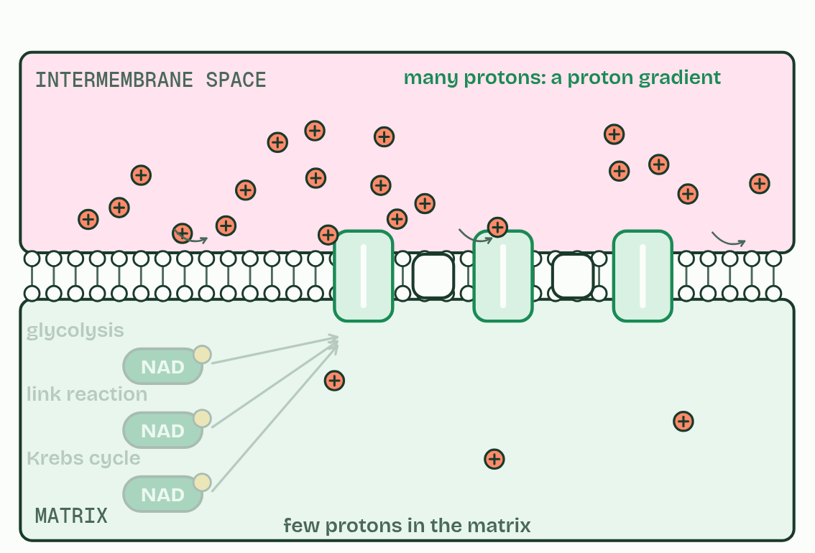  1 Reduced NAD from all three stages arrives at the inner membrane.  2 It hands a pair of electrons to the first carrier, and becomes NAD again.  3 Each step down releases a little energy, used to pump protons.  4 Protons pile up in the intermembrane space: a proton gradient.
  SPOT THE MISTAKE
  What do students often get wrong about reduced NAD and the electron transport chain; the proton gradient? Write the mistake, then put it right.
  The chain does not make ATP; it makes a proton gradient. And “proton” here means a hydrogen ion, not a hydrogen atom.
SUMMARY
Sum up section 10 in two or three sentences of your own.
• The electrons they carry all end up at the inner membrane of the mitochondrion, which is folded into cristae to give room for many copies of what happens there.
• In that membrane sits the electron transport chain: a series of electron carriers, some of them proton pumps.
• The pumps use that energy to move protons (hydrogen ions) from the matrix, across the inner membrane, into the narrow intermembrane space.
• They pile up there, so there are far more protons in the space than in the matrix: a proton gradient.

11 Protons through the turbine | C1.2.15 HL C1.2.16 HL
CUES  Predict: A cell’s mitochondria run out of oxygen. What happens to the electron transport chain?  A: Electrons back up and the pumping stops. The electrons back up. With nothing to take them at the end, the last carrier stays full, then the one before it, all the way back. No electrons flow, so no protons are pumped, the gradient runs down and ATP synthase stops. Reduced NAD cannot be unloaded either. Try it in the film below.  What is meant by ATP synthase?  The enzyme that makes ATP using the flow of protons down their gradient through it. It spans the inner mitochondrial membrane, with a part that turns and a head in the matrix.  What is meant by chemiosmosis?  The making of ATP using the energy released as protons flow down their gradient through ATP synthase.  What is meant by terminal electron acceptor?  The last molecule to receive electrons from the electron transport chain. In aerobic respiration it is oxygen.  What is meant by metabolic water?  Water made in respiration, when oxygen accepts electrons and protons at the end of the chain. | NOTES  1 Protons can return to the matrix through one protein only: ATP synthase.  2 Making ATP with the energy of a proton gradient across a membrane is called chemiosmosis.  3 Oxygen is the terminal electron acceptor: it takes the electrons from the last carrier, and protons from the matrix, and becomes water, called metabolic water.  4 One way back for the protons: ATP synthase.  5 Protons flowing down the gradient turn it, and their energy joins ADP and phosphate: ATP.  6 Oxygen takes the electrons and protons at the end, making water.  Your own notes  ANNOTATE THE FIGURE  Number the 4 steps on the figure and note what happens at each: 1 ATP synthase; 2 ADP and phosphate; 3 Oxygen, water; 4 Chemiosmosis.  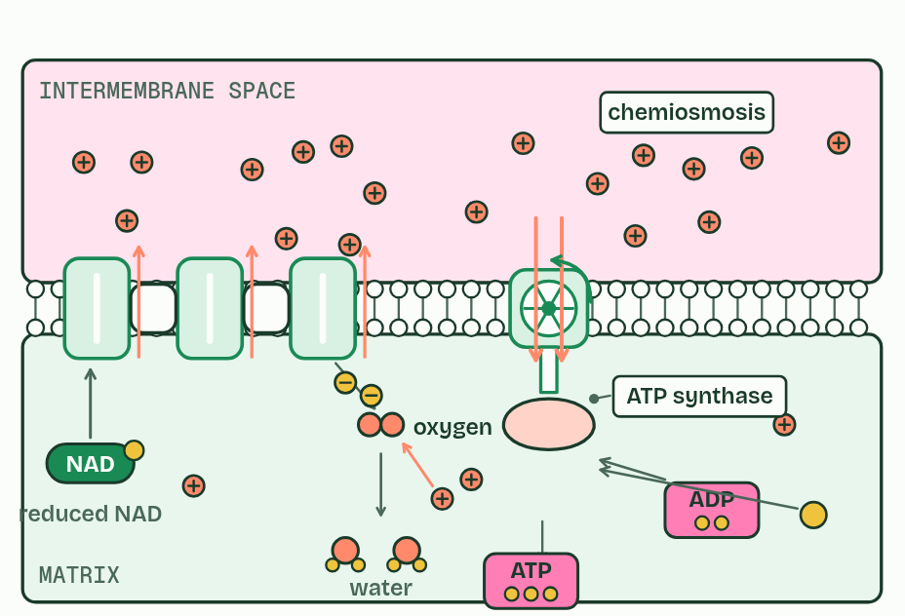  1 One way back for the protons: ATP synthase.  2 Protons flowing down the gradient turn it, and their energy joins ADP and phosphate: ATP.  3 Oxygen takes the electrons and protons at the end, making water.  4 Chemiosmosis: the gradient makes ATP, and oxygen keeps the chain flowing.  ANNOTATE THE FIGURE  Annotate this still from the animation (The chain and the turbine): what is happening, and why?  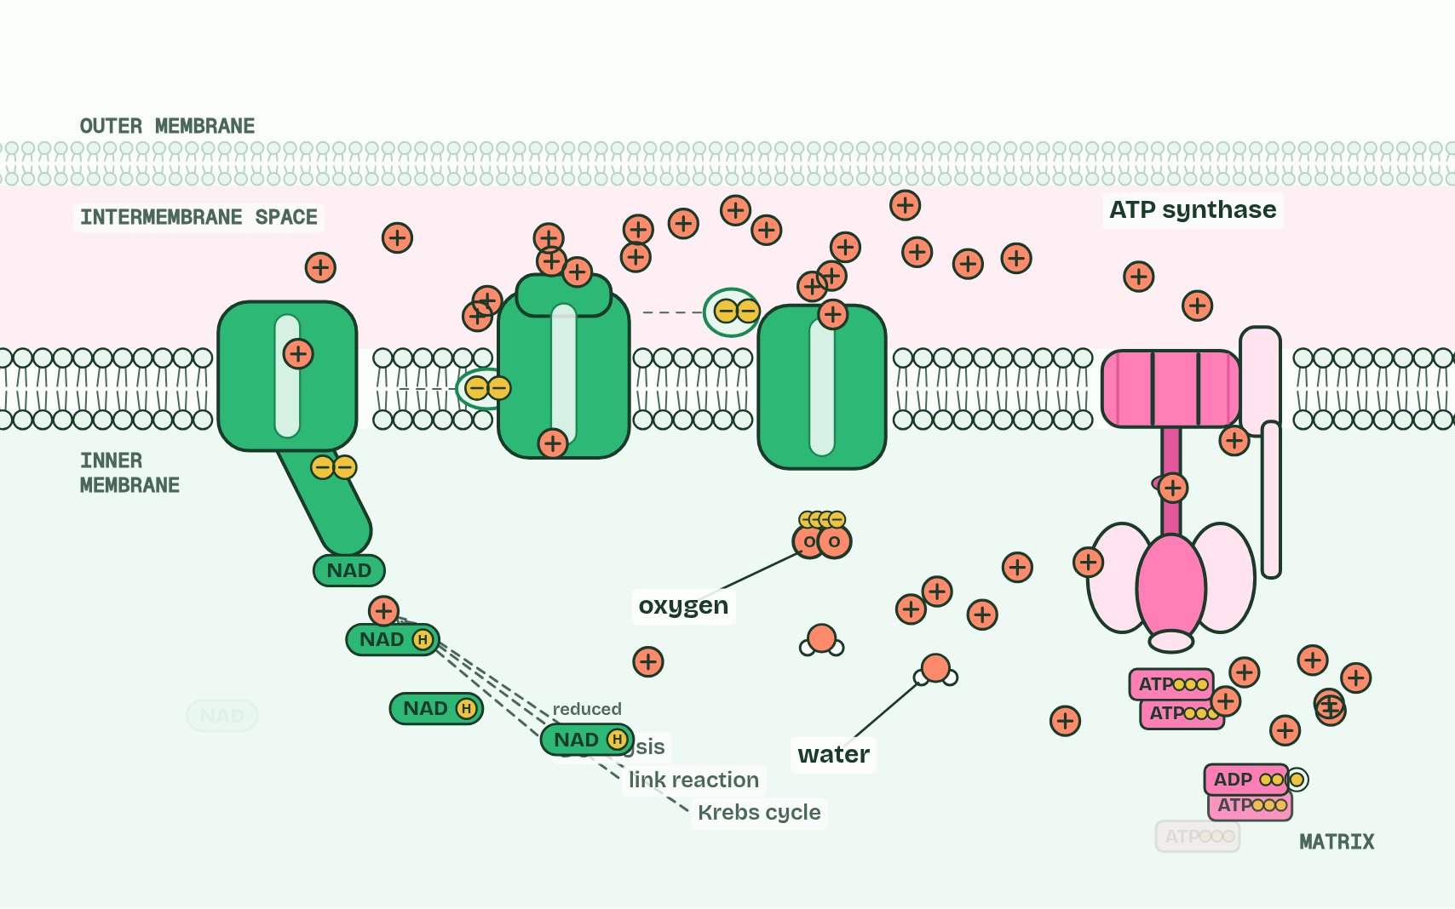  1 Reduced NAD from glycolysis, the link reaction and the Krebs cycle hands a pair of electrons to the first carrier, and becomes NAD again.  2 As the electrons pass along the chain they give up energy, which the carriers use to pump protons into the intermembrane space.  3 Protons pile up in the narrow space: a proton gradient. The membrane will not let them back through, except at one place.  4 Protons flow back down their gradient through ATP synthase, turning it. The energy joins ADP and phosphate: ATP.  5 Oxygen takes the electrons at the end of the chain, with protons from the matrix, making water. That keeps the electrons flowing.
  SPOT THE MISTAKE
  What do students often get wrong about chemiosmosis and ATP synthesis; oxygen as the terminal electron acceptor? Write the mistake, then put it right.
  ATP synthase is not a pump: protons flow through it, down their gradient, and that flow drives it. The pumps are in the chain.
SUMMARY
Sum up section 11 in two or three sentences of your own.
• Protons can return to the matrix through one protein only: ATP synthase.
• Making ATP with the energy of a proton gradient across a membrane is called chemiosmosis.
• Oxygen is the terminal electron acceptor: it takes the electrons from the last carrier, and protons from the matrix, and becomes water, called metabolic water.

12 Fat or sugar? | C1.2.17 HL
CUES  Predict: Gram for gram, fat releases about twice the energy of carbohydrate when respired. Why?  C: Fat holds less oxygen and more hydrogen to oxidise. A fatty acid is mostly carbon and hydrogen, with very little oxygen: palmitic acid, a common fatty acid, is only about one eighth oxygen by mass, and glucose about a half. So a gram of fat has far more oxidisable hydrogen and carbon to oxidise, and respiring it takes about 2.7 times as much oxygen per gram: 23 oxygen molecules for one palmitic acid, against 6 for one glucose. Size does not matter (a gram is a gram), and fat cannot be respired anaerobically at all.  What is meant by lipids?  A group of molecules that includes fats and oils. They are respired for much of the energy in long, steady work.  What is meant by carbohydrates?  Sugars, starch and glycogen. Glucose, the main fuel of respiration, is a carbohydrate.  What is meant by acetyl CoA?  Acetyl coenzyme A: an acetyl group carried by coenzyme A. Fatty acids and carbohydrates both supply it to the Krebs cycle.  What is meant by oxidisable hydrogen?  Hydrogen in a molecule that can be removed in respiration and passed on, carrying energy. Fats have much more of it per gram than carbohydrates. | NOTES  1 Glucose and fatty acids are the two main fuels, and they are not equal. Lipids release about twice as much energy per gram as carbohydrates when they are respired: about 37 kJ in each gram against about 17.  2 A fatty acid is cut into 2-carbon acetyl groups, which enter the Krebs cycle at once as acetyl CoA (acetyl coenzyme A).  Your own notes  ANNOTATE THE FIGURE  The figure shows it as What is in them and How they are respired. Note what changes each time.  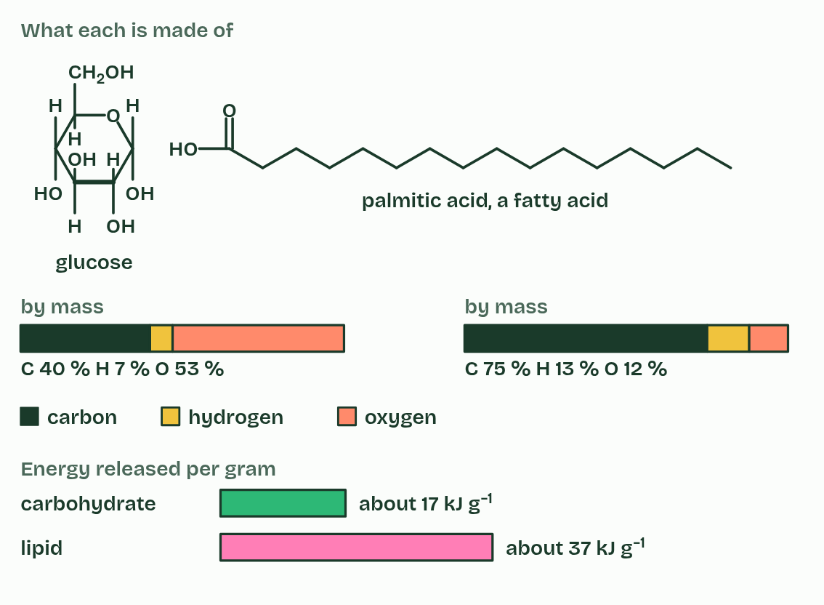  1 What is in them  2 How they are respired  ANNOTATE THE FIGURE  Annotate this still from the animation (The whole journey): what is happening, and why?  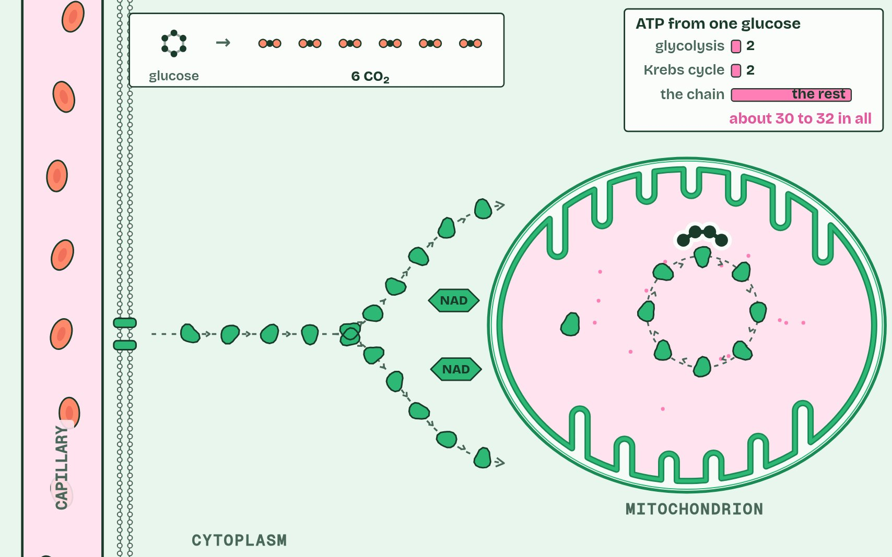  1 Inside a muscle fibre, one mitochondrion: the folded inner membrane (cristae), the matrix inside it.  2 Net from one glucose: 2 ATP, 2 reduced NAD and 2 pyruvate.  3 The link reaction, in the matrix: pyruvate loses a carbon as CO2 (decarboxylation) and hydrogen to NAD (oxidation).  4 One ATP is made, and a fourth oxidation passes hydrogen to another carrier.  5 Protons flow back through ATP synthase, turning it: most of the ATP is made here. Oxygen takes the electrons at the end, making water.  6 From one glucose: 6 CO2, water, and about 30 to 32 ATP, nearly all of it from the chain.
  SPOT THE MISTAKE
  What do students often get wrong about differences between lipids and carbohydrates as respiratory substrates? Write the mistake, then put it right.
  Fat cannot be used anaerobically: fatty acids enter at the Krebs cycle, which needs the chain, which needs oxygen. A sprint runs on carbohydrate.
SUMMARY
Sum up section 12 in two or three sentences of your own.
• Glucose and fatty acids are the two main fuels, and they are not equal. Lipids release about twice as much energy per gram as carbohydrates when they are respired: about 37 kJ in each gram against about 17.
• A fatty acid is cut into 2-carbon acetyl groups, which enter the Krebs cycle at once as acetyl CoA (acetyl coenzyme A).

Check yourself
The check for this guide is online: a fresh paper of past-paper style questions from the exam bank on C1.2 each time, marked as you go, and saved to your Exam practice progress when you are signed in. Open the link:
biologybybradford.com/exam-maker/sit?topics=C1.2&level=HL&paper=quiz&marks=15&src=ep

