Name | Class | Date
IB BIOLOGY · C1.2

Cell respiration
Notes to fill in alongside the guide. Each numbered block matches a chapter of the guide, and of the lesson slides. Write in the gaps, answer the cues, annotate the figures, and sum up each section in your own words.
BY THE END YOU CAN
Describe ATP as a nucleotide and explain what makes it suit the job of moving energy around a cell C1.2.1
Explain how hydrolysis of ATP releases energy for active transport, building molecules and movement, and why remaking it takes energy C1.2.2, C1.2.3
Explain respiration as the cell's way of making ATP from carbon compounds, and tell it apart from gas exchange C1.2.4
Compare aerobic and anaerobic respiration in humans, with word equations for both C1.2.5
Measure the rate of respiration with a respirometer and work it out from raw or secondary data C1.2.6
Explain oxidation as the removal of hydrogen, and NAD as the carrier that is reduced when it accepts it C1.2.7
Outline glycolysis: phosphorylation, lysis, oxidation and ATP formation, with its net yield C1.2.8
Explain how making lactate, or ethanol and carbon dioxide in yeast, gives NAD back so glycolysis can go on, and how bakers and brewers use yeast C1.2.9, C1.2.10
Outline the link reaction and the Krebs cycle: where the carbon dioxide and the reduced NAD come from C1.2.11, C1.2.12
Explain how electrons passed along the chain build a proton gradient across the inner membrane C1.2.13, C1.2.14
Explain how ATP synthase uses the proton gradient to make ATP, and why oxygen is needed at the end of the chain C1.2.15, C1.2.16
Compare lipids and carbohydrates as fuels: energy per gram, and which routes each can take C1.2.17

01 The cell's small change | C1.2.1
CUES  Predict: Removing one phosphate from ATP releases only a modest amount of energy. Why does that suit a cell?  What is meant by ATP?  What is meant by adenine?  What is meant by ribose?  What is meant by phosphate group?  What is meant by nucleotide?  What is meant by energy currency? | NOTES  1 Each of those jobs needs energy, and in every living cell the energy arrives in the same form. It is carried by one molecule, ________.  2 Take the base _________, join it to the sugar ________ and add one ____________________, and you have a ______________, the same kind of unit that RNA is built from (A1.2).  3 That is why ATP is called the cell's ____________________.  4 A ______________: adenine, ribose and one phosphate.  5 Add a phosphate: ________.  6 Add another: ________, adenosine triphosphate.  Your own notes  ANNOTATE THE FIGURE  Number the 4 steps on the figure and note what happens at each: 1 nucleotide; 2 ADP; 3 ATP; 4 energy currency.  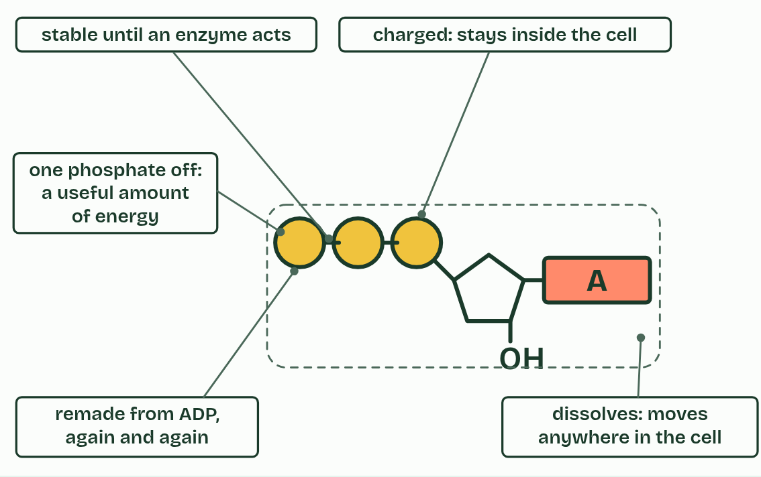
  SPOT THE MISTAKE
  What do students often get wrong about ATP as the molecule that distributes energy within cells? Write the mistake, then put it right.
  The mistake
  Put it right
SUMMARY
Sum up section 01 in two or three sentences of your own.

02 Spend it, remake it | C1.2.2 C1.2.3
CUES  Predict: Remaking ATP from ADP and phosphate needs energy. Where does a muscle cell get it?  What is meant by hydrolysis?  What is meant by ADP?  What is meant by ATP and ADP cycle?  What is meant by active transport?  What is meant by anabolism? | NOTES  1 In ______________, a water molecule is used to take the last phosphate group off, and ATP becomes ________ (adenosine diphosphate) and a free phosphate.  2 So the ATP, the ADP and the phosphate go round and round, in the _______________________.  3 ______________________: a pump in the membrane moves ions against their concentration gradient (B2.1).  4 Building macromolecules, ____________: a ribosome joins amino acids into a protein, and nucleotides are joined into DNA (C1.1).  Your own notes  ANNOTATE THE FIGURE  Number the 4 steps on the figure and note what happens at each.  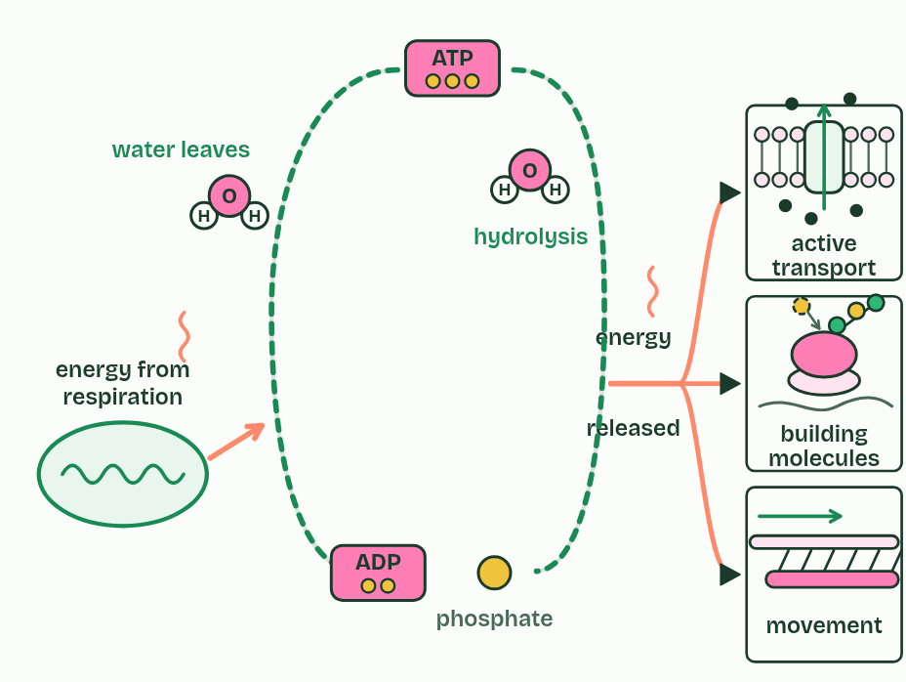  REMEMBER IT  What ATP pays for
  B  B | A  A | M  M
  B | A | M
  SPOT THE MISTAKE
  What do students often get wrong about what ATP pays for, and the energy it moves? Write the mistake, then put it right.
  The mistake
  Put it right
SUMMARY
Sum up section 02 in two or three sentences of your own.

03 Fuel in, ATP out | C1.2.4
CUES  Predict: A leaf in bright light takes in carbon dioxide and gives out oxygen. Is it respiring?  What is meant by cell respiration?  What is meant by respiratory substrates?  What is meant by glucose?  What is meant by fatty acids?  What is meant by combustion?  What is meant by gas exchange? | NOTES  1 ______________________ is how a cell makes ATP, using energy released from carbon compounds.  2 The fuels are called ______________________________.  3 The main two are _________ and _______________, but a cell can use a wide range of carbon compounds, amino acids among them when food is short.  4 Burning glucose is ______________.  5 Respiration is not ________________.  Your own notes  ANNOTATE THE FIGURE  The figure shows it as Burning, Cell respiration and Gas exchange. Note what changes each time.  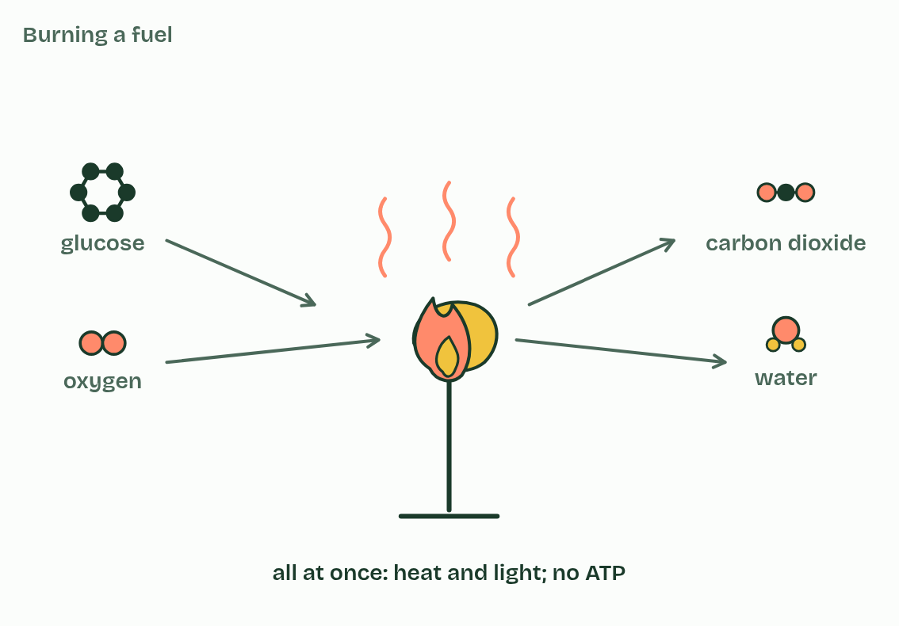
  SPOT THE MISTAKE
  What do students often get wrong about cell respiration as a system for producing ATP using energy from carbon compounds? Write the mistake, then put it right.
  The mistake
  Put it right
SUMMARY
Sum up section 03 in two or three sentences of your own.

04 With oxygen and without | C1.2.5
CUES  Predict: A sprinter’s leg muscles run short of oxygen. Per glucose, how much ATP does anaerobic respiration make compared with aerobic?  What is meant by pyruvate?  What is meant by glycolysis?  What is meant by yield?  What is meant by aerobic respiration?  What is meant by mitochondrion?  What is meant by anaerobic respiration?  What is meant by lactate? | NOTES  1 A glucose molecule is split into two molecules of ___________ in a process called ______________, which releases enough energy to make a small amount of ATP.  2 After that the routes divide, according to whether there is oxygen, and they differ most in their ________ of ATP for each glucose.  3 __________________________ goes on with oxygen.  4 The pyruvate goes into a __________________ and is broken down completely, to carbon dioxide and water, and a large amount of ATP is made.  5 The word equation is __________________________________.  6 ____________________________ in humans stops early.  7 When there is not enough oxygen, the pyruvate stays in the cytoplasm and is turned into _________.  8 The word equation is _______________________.  Your own notes  ANNOTATE THE FIGURE  The figure shows it as Plenty of oxygen and Not enough oxygen. Note what changes each time.  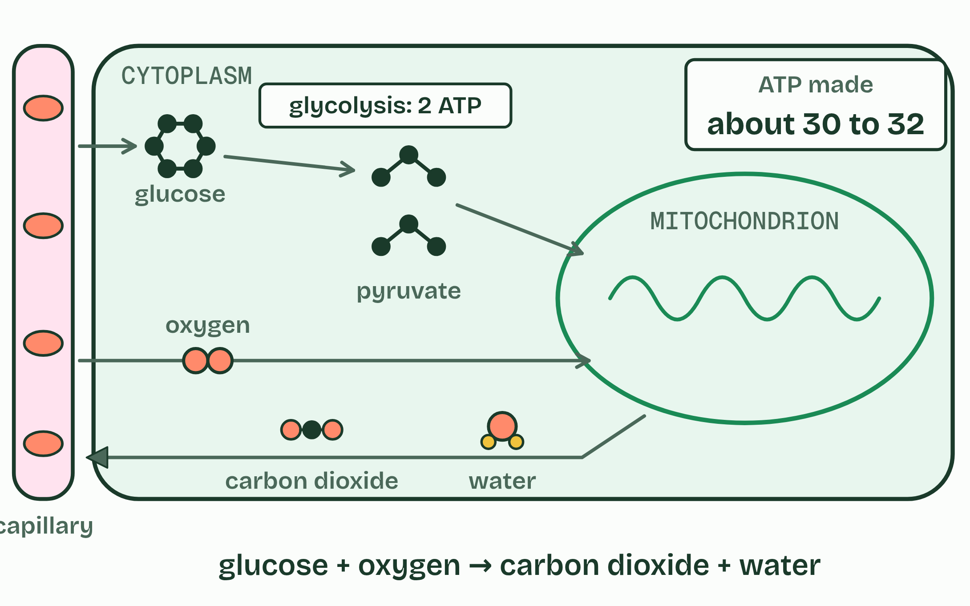  ANNOTATE THE FIGURE  Annotate this still from the animation (Follow one glucose): what is happening, and why?  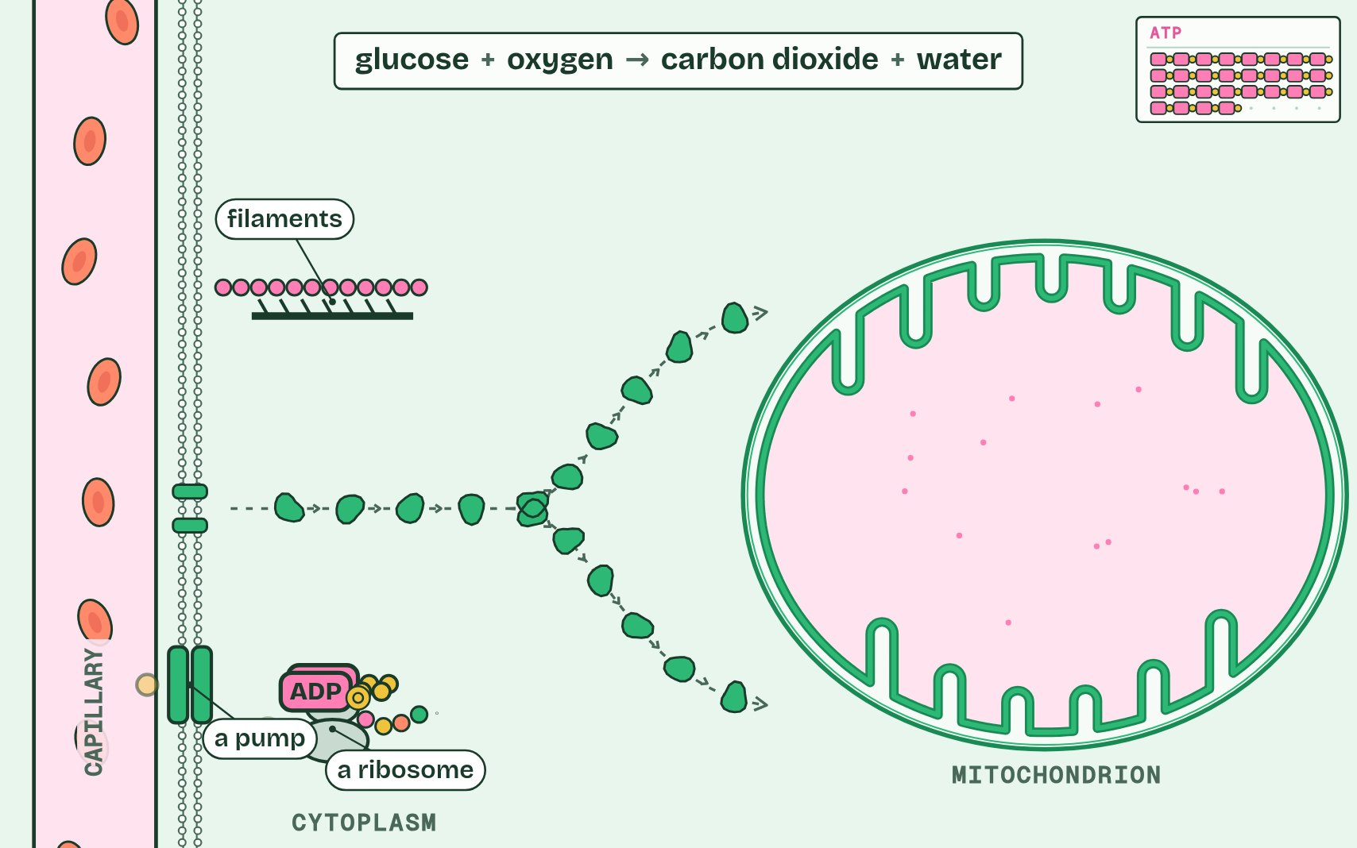  ANNOTATE THE FIGURE  Number the 4 steps on the figure and note what happens at each.  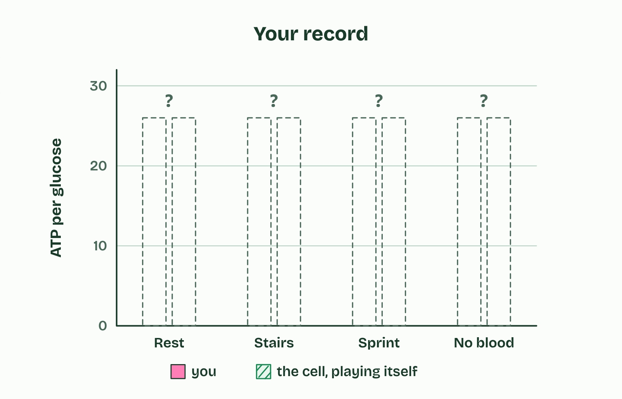  REMEMBER IT  Anaerobic in humans is LOW
  L  L | O  O | W  W
  L | O | W
  SPOT THE MISTAKE
  What do students often get wrong about differences between anaerobic and aerobic cell respiration in humans? Write the mistake, then put it right.
  The mistake
  Put it right
SUMMARY
Sum up section 04 in two or three sentences of your own.

05 A rate you cannot see | C1.2.6
CUES  Predict: In the respirometer the seeds respire and the potassium hydroxide absorbs their carbon dioxide. Which way does the drop move?  What is meant by rate of respiration?  What is meant by per gram per minute?  What is meant by respirometer?  What is meant by potassium hydroxide?  What is meant by capillary?  What is meant by control? | NOTES  1 The __________________________ is the amount changed divided by the time taken, and for living material it is given __________________________ as well, so that samples of different mass can be compared.  2 A second tube, the same in every way but with glass beads in place of the seeds, is the _________.  3 __________________ in a ________________: germinating seeds in a sealed tube, with __________________________ to absorb the carbon dioxide they give out, and a drop of coloured liquid in a ____________ whose movement shows the change in gas volume.  4 ____________________________: a gas sensor or data logger in a sealed chamber, or hydrogencarbonate indicator changing colour. With yeast, the rise of a dough or the gas collected over a sugar solution works too (the dry lab's dough mode).  5 ____________: the fall in the glucose in a yeast culture, measured with test strips.  Your own notes  ANNOTATE THE FIGURE  Label each part and say what it does: water bath and thermometer, potassium hydroxide, wire gauze, germinating seeds, glass bead tube, bung and screw clip, capillary and coloured drop, scale.  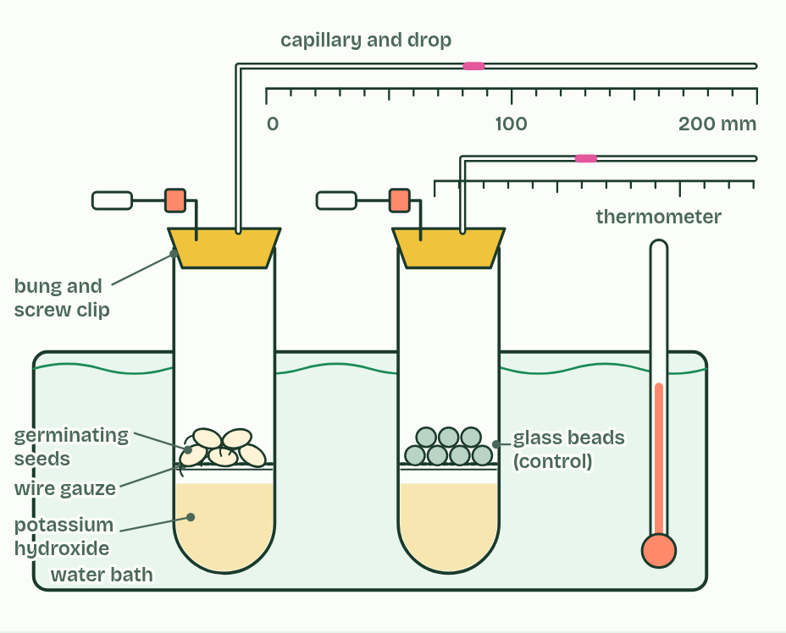  ANNOTATE THE FIGURE  Number the 4 steps on the figure and note what happens at each.  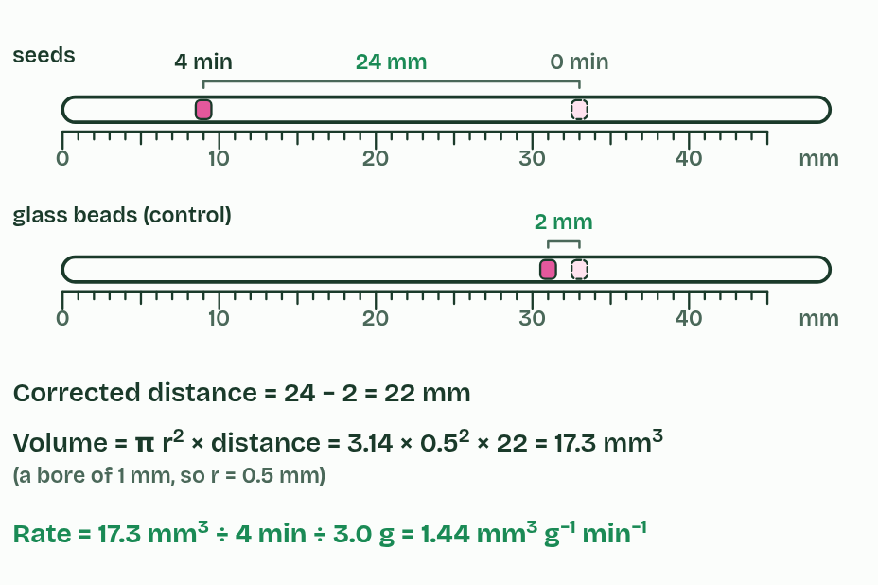
  SPOT THE MISTAKE
  What do students often get wrong about variables affecting the rate of cell respiration? Write the mistake, then put it right.
  The mistake
  Put it right
SUMMARY
Sum up section 05 in two or three sentences of your own.

06 Taking hydrogen away | C1.2.7 HL
CUES  Predict: A dehydrogenase takes two hydrogens off a molecule of fuel. What has happened to that molecule?  What is meant by oxidation?  What is meant by reduction?  What is meant by redox reaction?  What is meant by dehydrogenation?  What is meant by NAD?  What is meant by reduced NAD?  What is meant by hydrogen carrier? | NOTES  1 To see why, you need two words. ____________ is the loss of electrons, and ____________ is the gain of electrons.  2 A reaction that does both is a ___________________.  3 So when hydrogen is removed from a molecule, which is called ____________________, it loses electrons too, and has been oxidised.  4 The hydrogen has to go somewhere. It is accepted by ________, a molecule built from nucleotides, like ATP.  5 When NAD accepts hydrogen it is reduced, and is then called _______________.  6 So NAD is a ______________________.  Your own notes  ANNOTATE THE FIGURE  Number the 4 steps on the figure and note what happens at each.  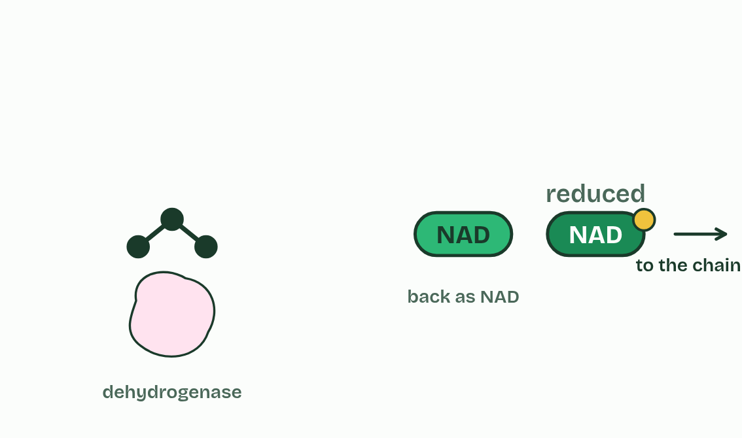  REMEMBER IT  Oxidation and reduction
  O  Oil | R  Rig
  O | R
  SPOT THE MISTAKE
  What do students often get wrong about role of NAD as a carrier of hydrogen, and oxidation by removal of hydrogen? Write the mistake, then put it right.
  The mistake
  Put it right
SUMMARY
Sum up section 06 in two or three sentences of your own.

07 Two ATP in, four out | C1.2.8 HL
CUES  Predict: Glycolysis spends 2 ATP at the start. How many does it make by the end, from one glucose?  What is meant by phosphorylation?  What is meant by lysis?  What is meant by oxidation?  What is meant by ATP formation? | NOTES  1 ____________________: two ATP each give a phosphate group to the glucose. That costs 2 ATP, but a sugar carrying two charged phosphates is made reactive and ready to split.  2 ________: the 6-carbon sugar with its two phosphates splits into two 3-carbon sugars, each with one phosphate.  3 ____________: hydrogen is taken off each 3-carbon sugar and accepted by NAD, so two reduced NAD are made for the glucose. The energy released lets each 3-carbon sugar take on a second phosphate, a free one from the cytoplasm, not one from ATP.  4 __________________: each 3-carbon sugar passes its two phosphates to ADP, making ATP directly, and ends as pyruvate.  Your own notes  ANNOTATE THE FIGURE  Number the 6 steps on the figure and note what happens at each.  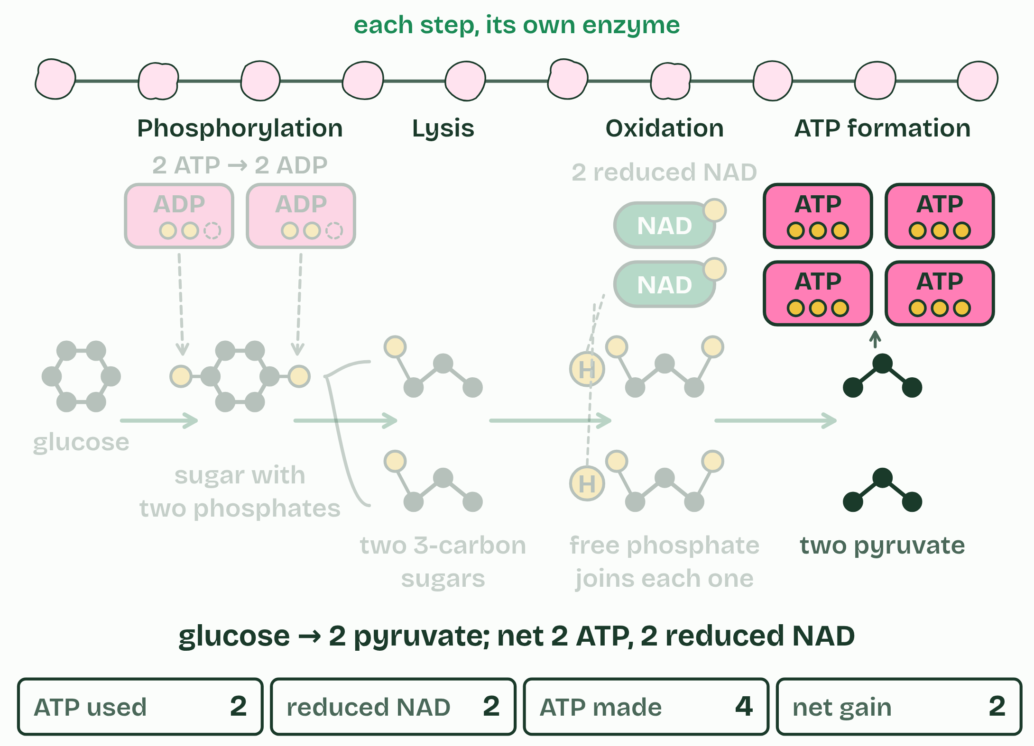  REMEMBER IT  The four stages of glycolysis, in order
  P  Penguins | L  Love | O  Orange | A  Anchovies
  P | L | O | A
  SPOT THE MISTAKE
  What do students often get wrong about conversion of glucose to pyruvate in glycolysis, with a net yield of ATP and reduced NAD? Write the mistake, then put it right.
  The mistake
  Put it right
SUMMARY
Sum up section 07 in two or three sentences of your own.

08 Giving NAD back | C1.2.9 HL C1.2.10 HL
CUES  Predict: Without oxygen, why does a muscle cell turn pyruvate into lactate instead of leaving it as pyruvate?  What is meant by regeneration of NAD?  What is meant by yeast?  What is meant by ethanol?  What is meant by baking?  What is meant by brewing?  What is meant by fermentation? | NOTES  1 Giving NAD back is called the __________________________.  2 ________ follow the same pathway as far as pyruvate.  3 Without oxygen, each pyruvate loses a carbon as carbon dioxide, and what is left takes the hydrogen from reduced NAD to become _________.  4 In ________, yeast respire the sugars in the dough and the carbon dioxide forms bubbles that stretch it, so the dough rises; the ethanol evaporates in the oven.  5 In _________, yeast in a sugary liquid made from barley or grapes, with little air, make ethanol, which is kept, while the carbon dioxide escapes or is kept in for fizz.  6 Anaerobic respiration in yeast is often called ________________.  Your own notes  ANNOTATE THE FIGURE  The figure shows it as Glycolysis alone, Muscle and Yeast. Note what changes each time.  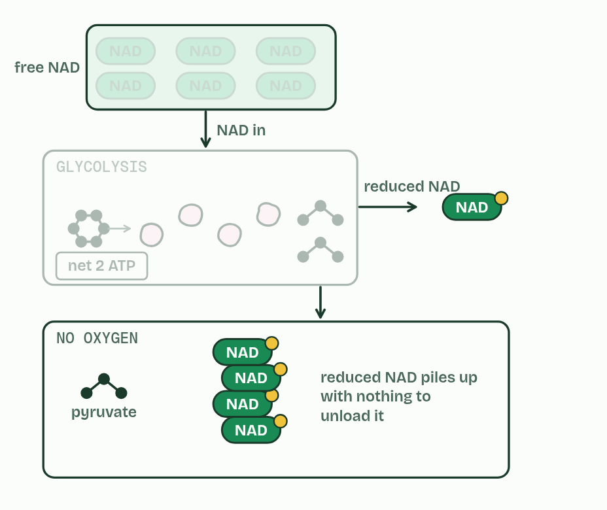
  SPOT THE MISTAKE
  What do students often get wrong about lactate and ethanol as ways of regenerating NAD, and brewing and baking? Write the mistake, then put it right.
  The mistake
  Put it right
SUMMARY
Sum up section 08 in two or three sentences of your own.

09 The carbon leaves as carbon dioxide | C1.2.11 HL C1.2.12 HL
CUES  Predict: Each turn of the Krebs cycle takes in a 2-carbon acetyl group. Why does the cycle not fill up with carbon?  What is meant by matrix?  What is meant by link reaction?  What is meant by decarboxylated?  What is meant by acetyl group?  What is meant by coenzyme A?  What is meant by krebs cycle?  What is meant by oxaloacetate?  What is meant by citrate? | NOTES  1 With oxygen, pyruvate is carried from the cytoplasm into the ________, the fluid inside the inner membrane of the mitochondrion.  2 The __________________ links glycolysis to the Krebs cycle.  3 Each pyruvate (3C) is ___________________, which takes a carbon off as carbon dioxide, and oxidised: hydrogen is removed and accepted by NAD.  4 The 2-carbon ________________ that is left is picked up by ______________ and carried to the cycle.  5 In the _______________, the acetyl group is transferred to ________________ (4C) to make _________ (6C).  Your own notes  ANNOTATE THE FIGURE  Number the 6 steps on the figure and note what happens at each.  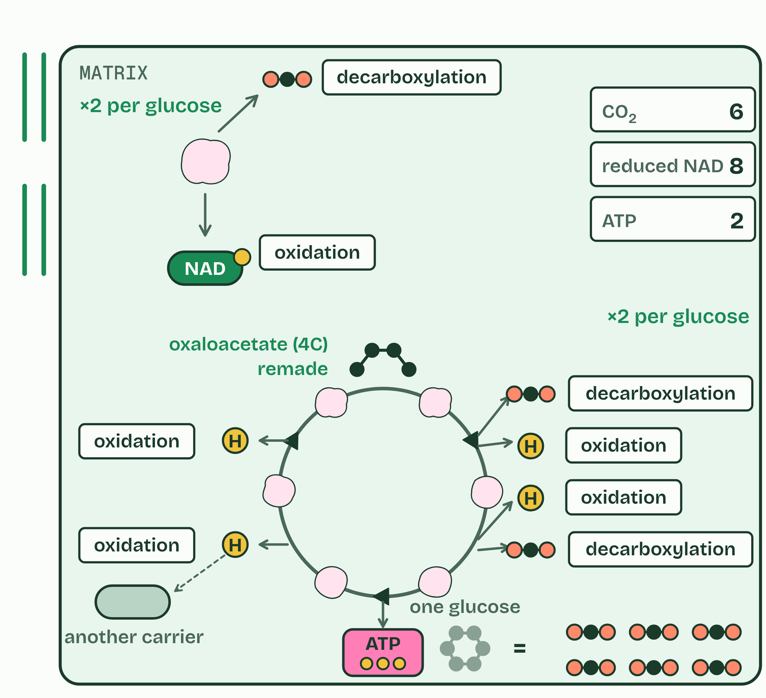  ANNOTATE THE FIGURE  Label the key parts and add a note on what it shows.  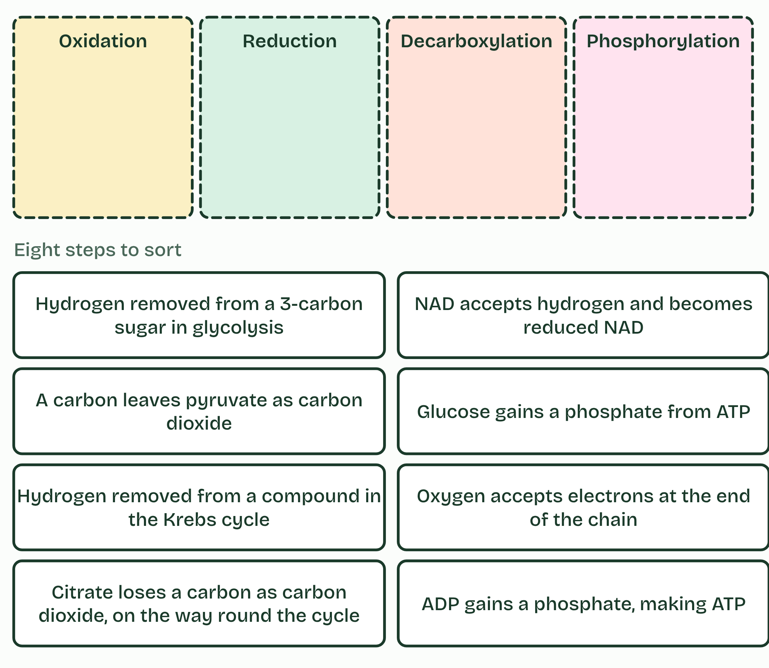
  SPOT THE MISTAKE
  What do students often get wrong about the link reaction, and the Krebs cycle? Write the mistake, then put it right.
  The mistake
  Put it right
SUMMARY
Sum up section 09 in two or three sentences of your own.

10 Down the chain | C1.2.13 HL C1.2.14 HL
CUES  Predict: Electrons pass along the chain of carriers, releasing a little energy at each step. What is that energy used for?  What is meant by inner membrane?  What is meant by cristae?  What is meant by electron transport chain?  What is meant by electron carriers?  What is meant by protons?  What is meant by intermembrane space?  What is meant by proton gradient? | NOTES  1 The electrons they carry all end up at the ___________________ of the mitochondrion, which is folded into _________ to give room for many copies of what happens there.  2 In that membrane sits the ________________________________: a series of _______________________, some of them proton pumps.  3 The pumps use that energy to move _________ (hydrogen ions) from the matrix, across the inner membrane, into the narrow __________________________.  4 They pile up there, so there are far more protons in the space than in the matrix: a ____________________.  Your own notes  ANNOTATE THE FIGURE  Number the 4 steps on the figure and note what happens at each.  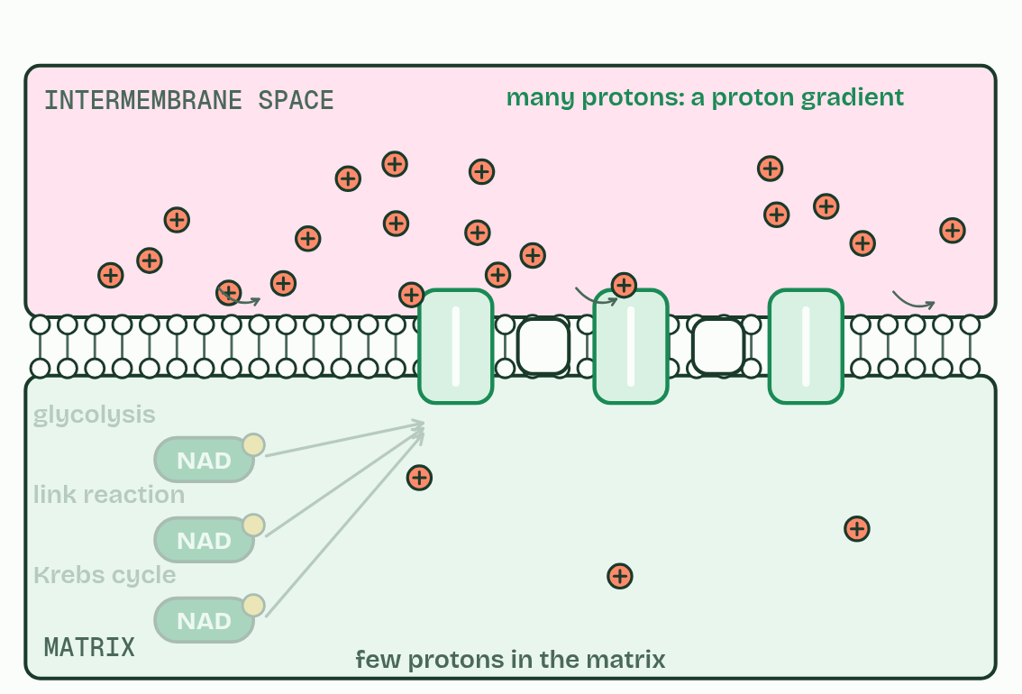
  SPOT THE MISTAKE
  What do students often get wrong about reduced NAD and the electron transport chain; the proton gradient? Write the mistake, then put it right.
  The mistake
  Put it right
SUMMARY
Sum up section 10 in two or three sentences of your own.

11 Protons through the turbine | C1.2.15 HL C1.2.16 HL
CUES  Predict: A cell’s mitochondria run out of oxygen. What happens to the electron transport chain?  What is meant by ATP synthase?  What is meant by chemiosmosis?  What is meant by terminal electron acceptor?  What is meant by metabolic water? | NOTES  1 Protons can return to the matrix through one protein only: ________________.  2 Making ATP with the energy of a proton gradient across a membrane is called ________________.  3 Oxygen is the __________________________________: it takes the electrons from the last carrier, and protons from the matrix, and becomes water, called ____________________.  4 One way back for the protons: ________________.  5 Protons flowing down the gradient turn it, and their energy joins _______________________: ATP.  6 ________ takes the electrons and protons at the end, making ________.  Your own notes  ANNOTATE THE FIGURE  Number the 4 steps on the figure and note what happens at each: 1 ATP synthase; 2 ADP and phosphate; 3 Oxygen, water; 4 Chemiosmosis.  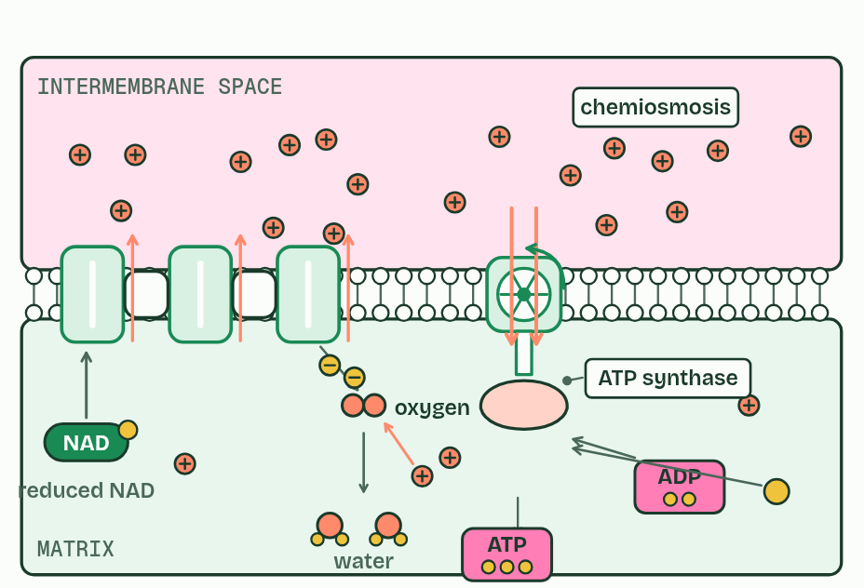  ANNOTATE THE FIGURE  Annotate this still from the animation (The chain and the turbine): what is happening, and why?  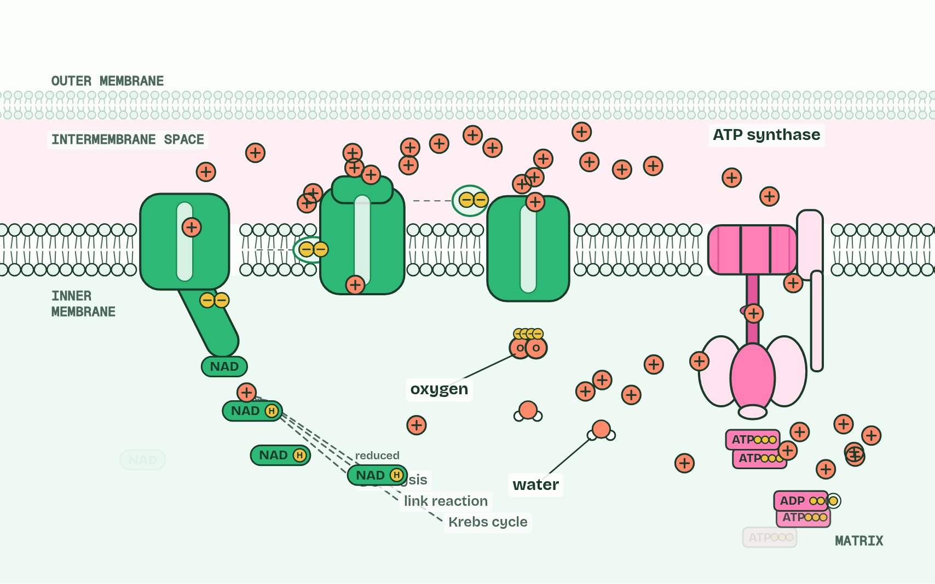
  SPOT THE MISTAKE
  What do students often get wrong about chemiosmosis and ATP synthesis; oxygen as the terminal electron acceptor? Write the mistake, then put it right.
  The mistake
  Put it right
SUMMARY
Sum up section 11 in two or three sentences of your own.

12 Fat or sugar? | C1.2.17 HL
CUES  Predict: Gram for gram, fat releases about twice the energy of carbohydrate when respired. Why?  What is meant by lipids?  What is meant by carbohydrates?  What is meant by acetyl CoA?  What is meant by oxidisable hydrogen? | NOTES  1 Glucose and fatty acids are the two main fuels, and they are not equal. ________ release about twice as much energy per gram as __________________ when they are respired: about 37 kJ in each gram against about 17.  2 A fatty acid is cut into 2-carbon acetyl groups, which enter the Krebs cycle at once as ______________ (acetyl coenzyme A).  Your own notes  ANNOTATE THE FIGURE  The figure shows it as What is in them and How they are respired. Note what changes each time.  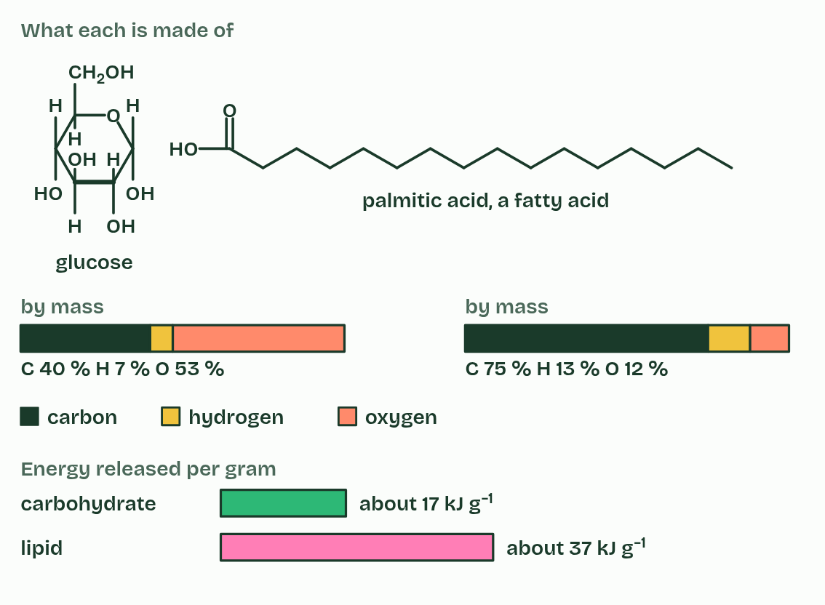  ANNOTATE THE FIGURE  Annotate this still from the animation (The whole journey): what is happening, and why?  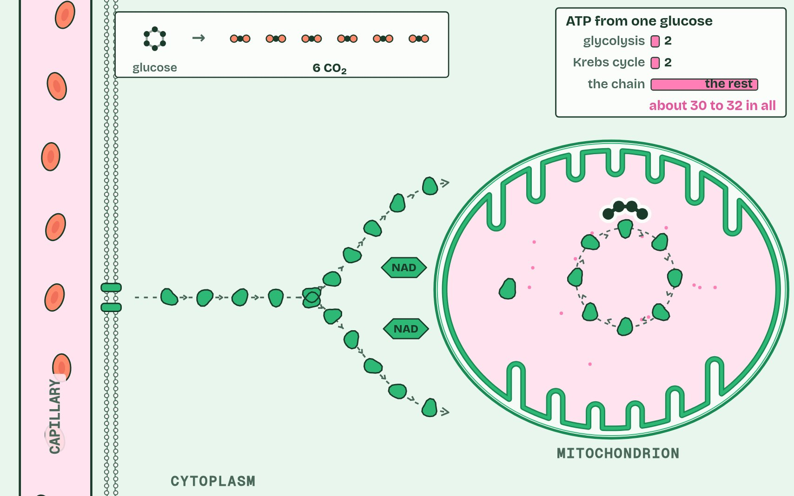
  SPOT THE MISTAKE
  What do students often get wrong about differences between lipids and carbohydrates as respiratory substrates? Write the mistake, then put it right.
  The mistake
  Put it right
SUMMARY
Sum up section 12 in two or three sentences of your own.

Check yourself
The check for this guide is online: a fresh paper of past-paper style questions from the exam bank on C1.2 each time, marked as you go, and saved to your Exam practice progress when you are signed in. Open the link:
biologybybradford.com/exam-maker/sit?topics=C1.2&level=HL&paper=quiz&marks=15&src=ep

