Name | Class | Date
IB BIOLOGY · C1.3

Photosynthesis
Teacher’s copy: every blank filled in. Each numbered block matches a chapter of the guide, and of the lesson slides. Write in the gaps, answer the cues, annotate the figures, and sum up each section in your own words.
BY THE END YOU CAN
Explain how photosynthesis turns light energy into the chemical energy of carbon compounds, and why ecosystems depend on it C1.3.1
Write the word equation, say where each atom of glucose comes from, and explain why the oxygen given off comes from water C1.3.2, C1.3.3
Separate leaf pigments by chromatography, work out Rf values and identify each pigment by colour and Rf C1.3.4
Explain why pigments absorb only some wavelengths, and read and sketch an absorption spectrum with wavelengths and colours C1.3.5
Compare absorption and action spectra, and plot an action spectrum from oxygen or carbon dioxide data C1.3.6
Suggest and test hypotheses about light, carbon dioxide and temperature as limiting factors, naming the variables C1.3.7
Compare greenhouse and FACE experiments as ways of predicting how plants will grow in tomorrow's air C1.3.8
Describe a photosystem and explain why pigments work only as an array round a reaction centre C1.3.9, C1.3.10
Explain how photolysis at photosystem II supplies electrons and protons, and what its waste oxygen did to the Earth C1.3.11
Explain how a proton gradient and ATP synthase make ATP in the thylakoid, by cyclic and non-cyclic photophosphorylation C1.3.12
Explain how photosystem I reduces NADP, and where in a thylakoid each light-dependent step happens C1.3.13, C1.3.14
Explain how Rubisco fixes carbon dioxide onto RuBP, and why the stroma needs so much of it C1.3.15
Follow the carbon through the Calvin cycle: GP reduced to TP, and five TP in six remade into RuBP C1.3.16, C1.3.17
Explain how every carbon compound in a plant is made from the Calvin cycle's products with mineral nutrients C1.3.18
Explain why the light-dependent and light-independent reactions stop without each other C1.3.19

01 Sunlight in, chemical energy out | C1.3.1
CUES  Predict: The chemical energy in a slice of cheese: where did it first come from?  B: Light caught by the grass it ate. From sunlight, caught by grass. The cow turned some of the grass’s chemical energy into milk; the cheese holds what is left. Follow the energy in almost any food back far enough and you reach a leaf in the light.  What is meant by photosynthesis?  The process that turns the energy of light into chemical energy held in the bonds of carbon compounds. It happens in the chloroplasts of plants and algae, and in cyanobacteria.  What is meant by light energy?  Energy carried by light. A pigment absorbs it.  What is meant by chemical energy?  Energy stored in the bonds between atoms, and released when those bonds are rearranged.  What is meant by carbon compounds?  Molecules built on a skeleton of carbon atoms, such as sugars, lipids, proteins and nucleic acids.  What is meant by energy transformation?  A change of energy from one form into another, for example light into chemical energy. Energy is not made or destroyed, and some is lost as heat at every step.  What is meant by producers?  Organisms that make their own carbon compounds from simple inorganic substances, using light energy in photosynthesis. | NOTES  1 Photosynthesis transforms light energy into chemical energy.  2 In a leaf, pigments absorb light, and that energy ends up in the bonds of carbon compounds the plant builds: first sugars, then everything else it is made of.  3 Light is not stored. It is changed into a different form, an energy transformation.  4 Plants, algae and cyanobacteria are producers.  5 Photosynthesis transforms light energy into the chemical energy of carbon compounds.  6 Producers make the carbon compounds that every consumer in a food chain depends on.  7 Energy flows light, then chemical energy in sugar, then ATP, then work and heat.  Your own notes  ANNOTATE THE FIGURE  Number the 4 steps on the figure and note what happens at each.  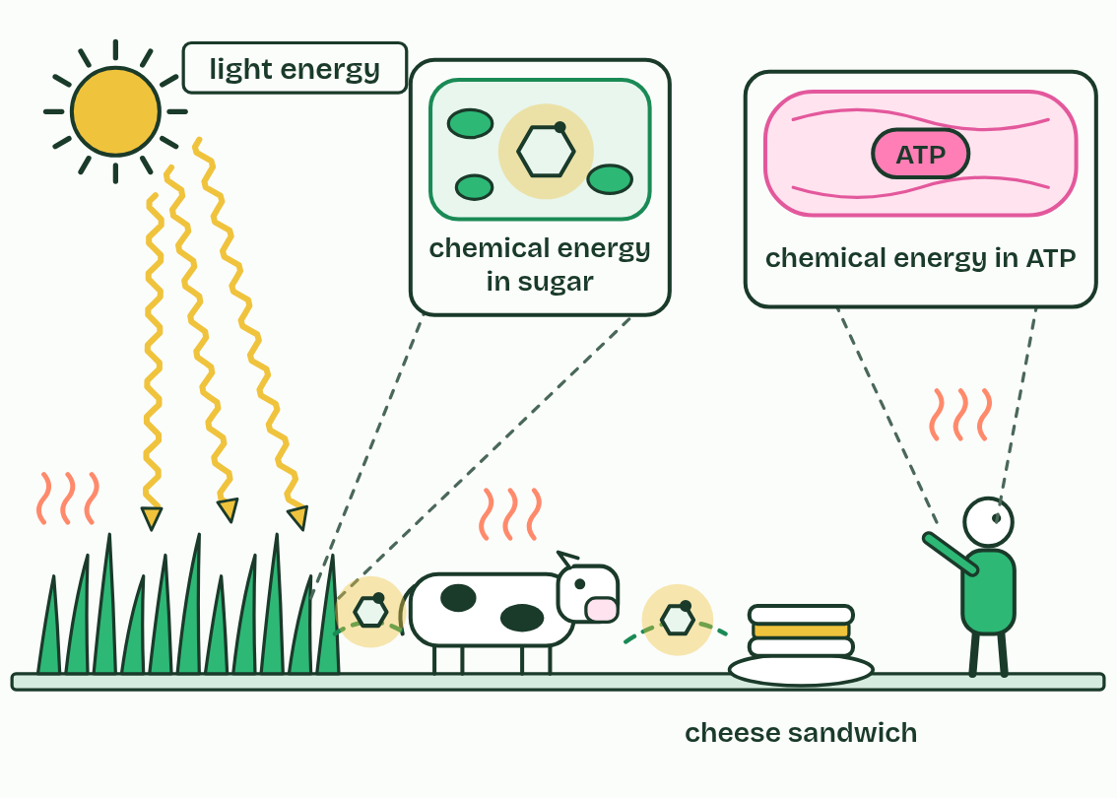  1 Light energy from the Sun reaches a leaf.  2 Photosynthesis turns it into chemical energy in the bonds of sugar.  3 The cow lives on that energy, and stores some of it in milk.  4 You release it in respiration, as ATP, and every step loses some as heat.
  SPOT THE MISTAKE
  What do students often get wrong about light energy to chemical energy? Write the mistake, then put it right.
  Photosynthesis does not make energy; it changes light energy into chemical energy. And plants respire too, in the dark and in the light: they use some of the sugar they make.
SUMMARY
Sum up section 01 in two or three sentences of your own.
• Photosynthesis transforms light energy into the chemical energy of carbon compounds.
• Producers make the carbon compounds that every consumer in a food chain depends on.
• Energy flows light, then chemical energy in sugar, then ATP, then work and heat.

02 Carbon from the air, hydrogen from water | C1.3.2 C1.3.3
CUES  Predict: Where does the oxygen gas a leaf gives off come from?  D: From the water it splits. From water. The plant splits water to get hydrogen, and the oxygen left over is given off. Ruben’s heavy-oxygen experiment showed it: heavy oxygen in the water came out as heavy oxygen gas; heavy oxygen in the carbon dioxide did not.  What is meant by word equation?  The chemicals of a reaction written as words: the reactants, an arrow, then the products. For photosynthesis, carbon dioxide + water becomes glucose + oxygen.  What is meant by glucose?  A six-carbon sugar, C6H12O6. It is the first carbohydrate that photosynthesis is usually said to make, and the fuel that respiration releases energy from.  What is meant by photolysis?  The splitting of water, using energy from light absorbed by chlorophyll. At higher level it is the job of photosystem II.  What is meant by by-product?  A substance made in a process that is not the aim of it. The oxygen from photosynthesis is a by-product of splitting water: the plant needs the hydrogen, not the oxygen.  What is meant by algae?  Eukaryotic organisms that photosynthesise but are not plants, from single-celled species to the seaweeds.  What is meant by cyanobacteria?  Photosynthetic bacteria. They were the first organisms to split water and give off oxygen. | NOTES  1 The word equation for photosynthesis is carbon dioxide + water → glucose + oxygen, with light energy and chlorophyll written over the arrow.  2 In symbols it reads 6CO₂ + 6H₂O → C₆H₁₂O₆ + 6O₂, and the product that matters is glucose.  3 It splits water using energy from the light that chlorophyll absorbs, a step called photolysis, and the hydrogen is added to carbon dioxide to build glucose.  4 The oxygen gas a leaf gives off is a by-product.  5 Every organism that photosynthesises this way gives off oxygen: plants, algae (from single cells to seaweeds) and cyanobacteria.  6 Carbon dioxide + water → glucose + oxygen, with light energy and chlorophyll over the arrow.  7 Glucose’s carbon and oxygen come from carbon dioxide; its hydrogen comes from water.  8 The oxygen given off comes from the water that is split, and is a by-product.  Your own notes  ANNOTATE THE FIGURE  Number the 4 steps on the figure and note what happens at each.  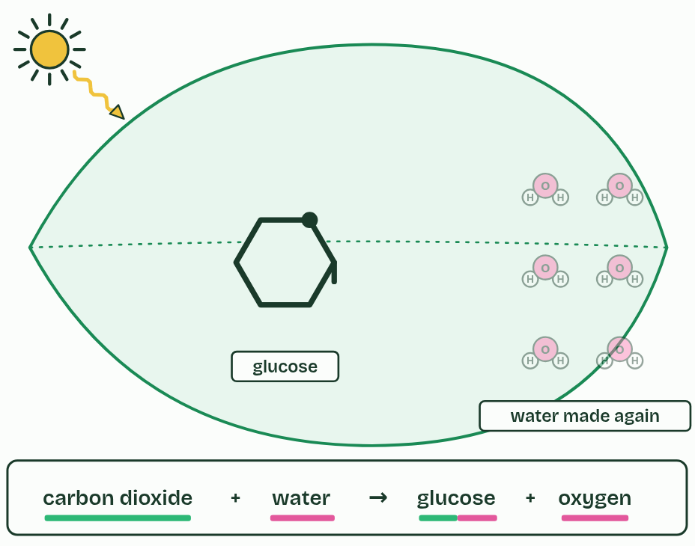  1 What goes in: carbon dioxide from the air, water from the soil.  2 Light energy splits water. The oxygen leaves as a by-product.  3 The hydrogen is added to carbon dioxide, building glucose.  4 carbon dioxide + water → glucose + oxygen. The bars show where each atom came from: green, carbon dioxide; pink, water.  ANNOTATE THE FIGURE  Label the key parts and add a note on what it shows.  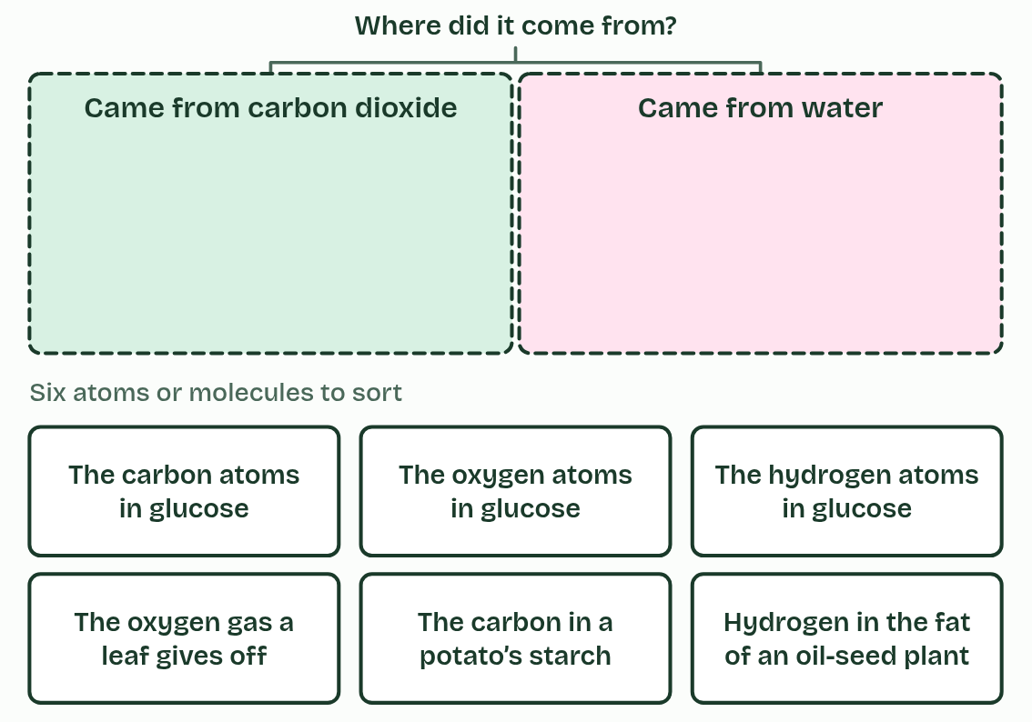  Six atoms or molecules and two bins. Which molecule going in had the atom at all, and what tells you?  ANNOTATE THE FIGURE  Annotate this still from the animation (From light to sugar): what is happening, and why?  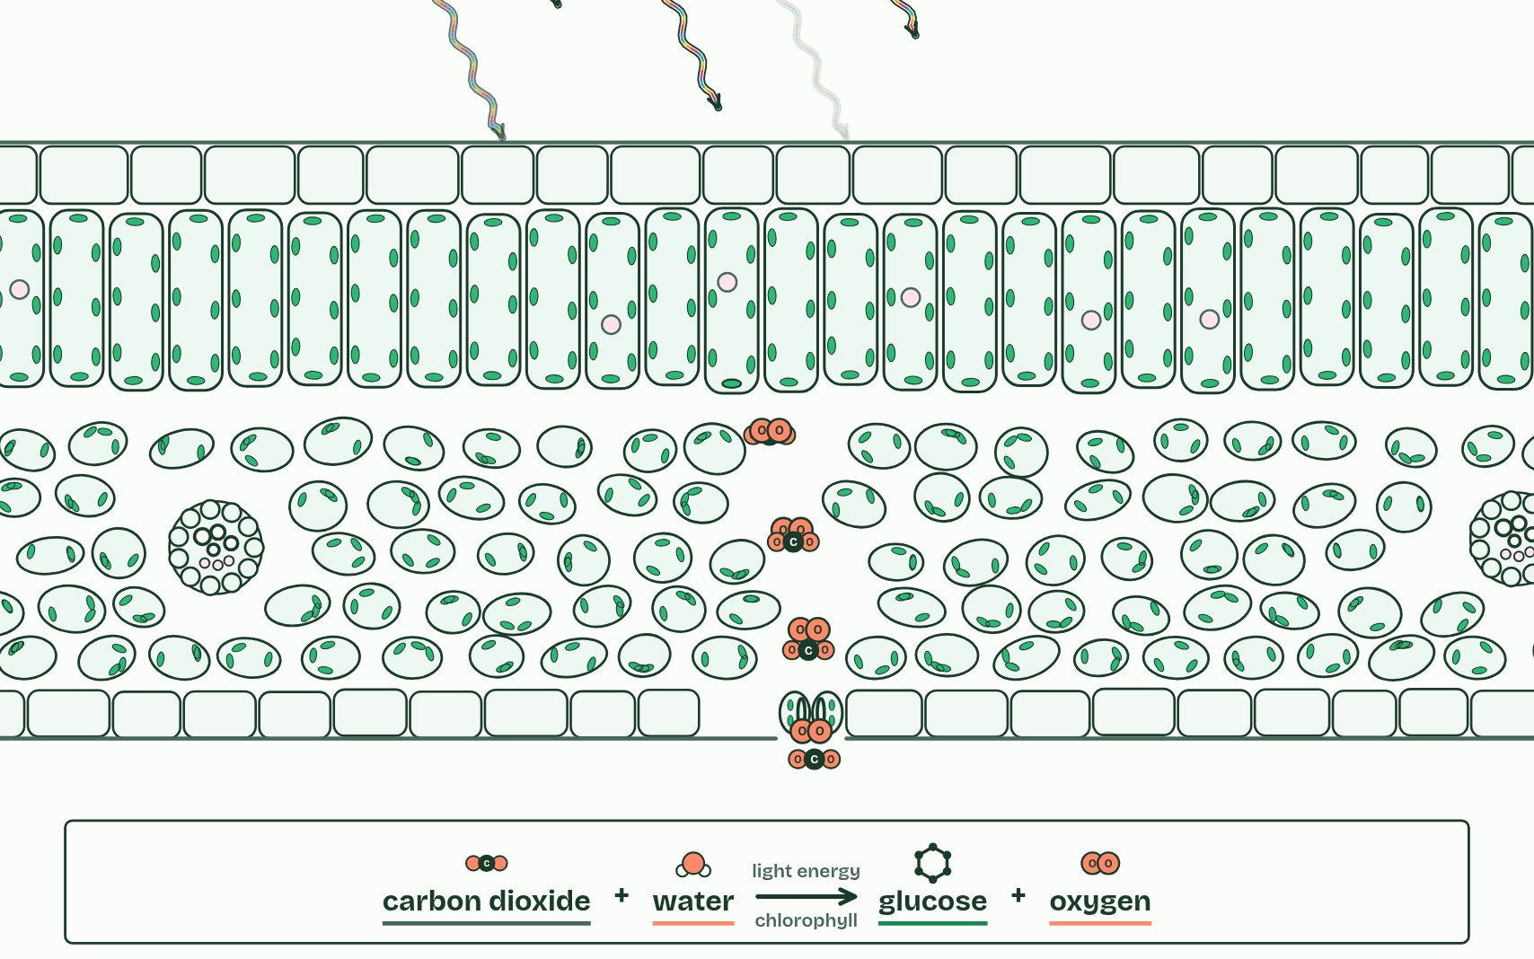  1 Into a leaf, a palisade cell, a chloroplast and the thylakoids where its pigments sit.  2 Chlorophyll absorbs red and blue light and reflects green.  3 Energy absorbed by chlorophyll splits water. The oxygen is given off as a by-product.  4 Carbon dioxide diffuses in from the air.  5 Hydrogen from water is added to carbon dioxide, building glucose, which can be stored as starch.  6 carbon dioxide + water → glucose + oxygen
  SPOT THE MISTAKE
  A student writes: “The oxygen comes from carbon dioxide.” Spot the mistake, then put it right.
  “The oxygen comes from carbon dioxide” is the commonest slip, because the equation seems to say so. Carbon dioxide’s oxygen ends up in the glucose and in the water that is made again. And light does not split water by itself: chlorophyll catches the light first (chapter 9).
SUMMARY
Sum up section 02 in two or three sentences of your own.
• Carbon dioxide + water → glucose + oxygen, with light energy and chlorophyll over the arrow.
• Glucose’s carbon and oxygen come from carbon dioxide; its hydrogen comes from water.
• The oxygen given off comes from the water that is split, and is a by-product.

03 More than one green | C1.3.4
CUES  Predict: The solvent front has moved 8.0 cm from the origin and a yellow band 5.7 cm. What is the band’s Rf?  B: 0.71. 5.7 ÷ 8.0 = 0.71. Pigment distance over solvent distance, both from the origin; Rf is always less than 1, so 1.40 has the division upside down. In propanone on paper, a yellow band at 0.71 is a xanthophyll.  What is meant by pigment?  A coloured substance that absorbs some wavelengths of light and reflects or passes on the others.  What is meant by chlorophyll a?  The main photosynthetic pigment: blue-green.  What is meant by chlorophyll b?  An accessory pigment: yellow-green.  What is meant by carotenes?  Orange-yellow carotenoid pigments. The carotene of a leaf runs furthest in chromatography.  What is meant by xanthophylls?  Yellow carotenoid pigments that contain oxygen.  What is meant by chromatography?  A way of separating a mixture. The substances travel at different speeds through a stationary phase carried by a moving solvent.  What is meant by origin?  The pencil line on a chromatogram where the spot of mixture is put.  What is meant by stationary phase?  The paper or plate that stays still in chromatography. Substances cling to it to different extents.  What is meant by solvent?  The liquid that climbs the paper and carries the pigments with it.  What is meant by mobile phase?  The solvent that moves in chromatography, carrying the substances along the stationary phase.  What is meant by solvent front?  The furthest point the solvent has reached. Mark it at once when you take the strip out, before it dries.  What is meant by rf value?  The distance a pigment moved divided by the distance the solvent front moved, both measured from the origin. It has no units and is always less than 1. | NOTES  1 A leaf’s green is not one pigment but several, mixed. Chlorophyll a is the main one, blue-green. Chlorophyll b is yellow-green.  2 Beside them are the yellow and orange carotenoids: carotenes and xanthophylls.  3 Chromatography separates a mixture.  4 A small, dark spot of leaf extract goes on a pencil line, the origin, near the bottom of a strip of chromatography paper (or a thin-layer plate, the stationary phase).  5 The strip stands in a shallow layer of solvent (the mobile phase) below the spot, in a closed tube.  6 The solvent front marks how far the solvent went, and the Rf value compares the two:  7 Pencil, not ink, for the origin: ink is a mixture and runs too.  8 Solvent below the origin, and a lid on the tube.  Your own notes  ANNOTATE THE FIGURE  The figure shows it at time 0 and 100. Note what changes each time.  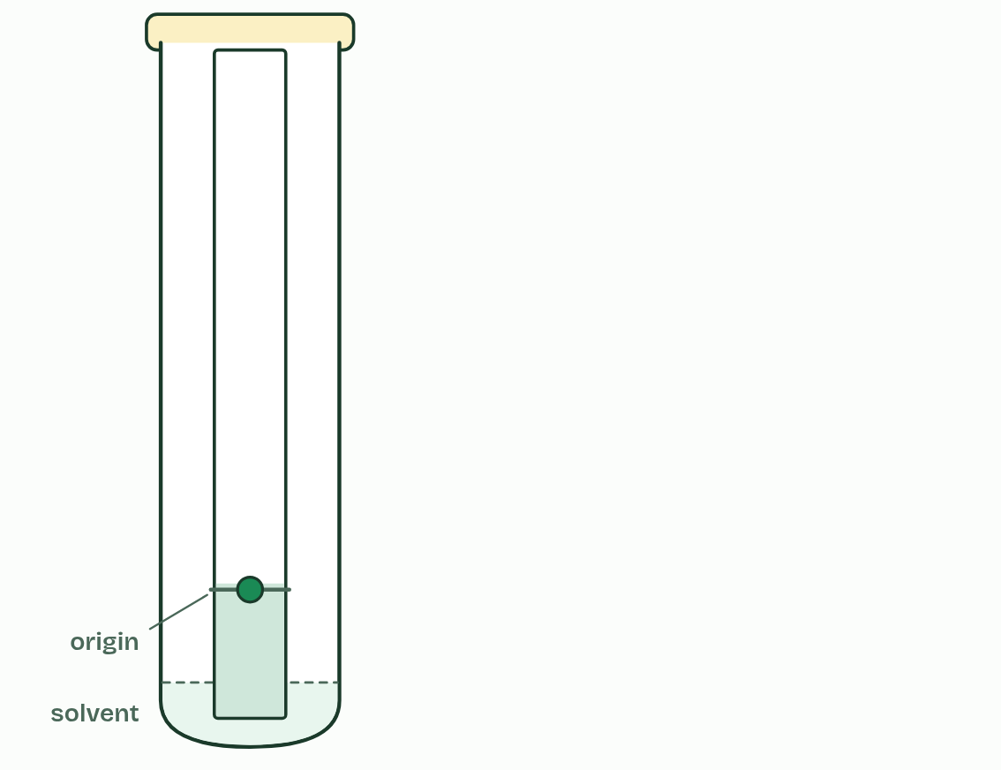  1 Time 0  2 Time 100  ANNOTATE THE FIGURE  Number the 3 steps on the figure and note what happens at each.  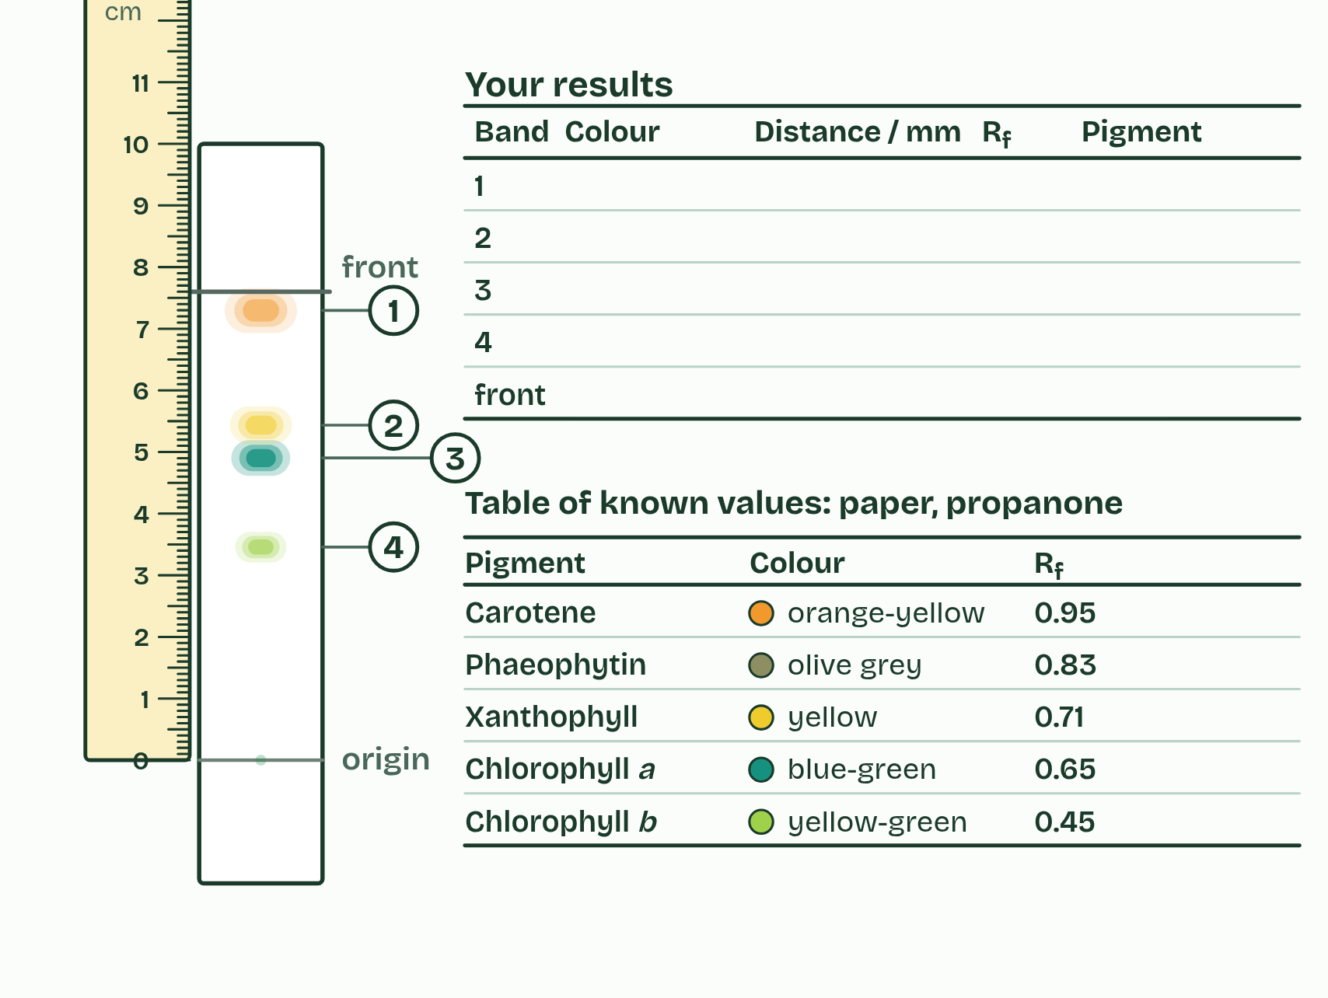  1 Grind a leaf with a little sand and a few drops of propanone. Spot the extract on a pencil line 2 cm from the bottom of the strip, then stand the strip in propanone, below the line, with the lid on.  2 Take the strip out before the solvent reaches the top and mark the front in pencil at once. The pigments have separated into bands. The table beside it lists known values for this solvent.  3 Measure from the origin line to the middle of each band and to the front. Work out Rf for each band, then name each pigment from its colour and its Rf.
  SPOT THE MISTAKE
  What do students often get wrong about separation and identification of pigments by chromatography? Write the mistake, then put it right.
  Measure from the origin line, not from the bottom of the paper, and to the middle of the band. And an Rf only means something beside a table made with the same solvent.
SUMMARY
Sum up section 03 in two or three sentences of your own.
• Pencil, not ink, for the origin: ink is a mixture and runs too.
• A small, dark spot, built up by drying between drops.
• Solvent below the origin, and a lid on the tube.
• Take the strip out before the front reaches the top, and mark the front at once.
• Work quickly: pigments fade in the light.

04 Why some colours and not others | C1.3.5
CUES  Predict: Why does chlorophyll absorb red and blue light but very little green?  D: Red and blue photons match jumps its electrons can make. A photon is absorbed only if its energy matches a jump an electron in the pigment can make. Chlorophyll’s electrons have jumps that match red and blue photons, not green ones, so green passes through or bounces off. (Green photons carry more energy than red ones: it is the match that matters, not the amount.)  What is meant by visible light?  The wavelengths the human eye sees, from about 400 nm (violet) to about 700 nm (red). White light is all of them together.  What is meant by wavelengths?  The distance from one wave crest to the next. For light it is measured in nanometres (nm).  What is meant by absorbs?  Takes in the energy of light, so that the light does not come out again.  What is meant by excited?  Raised to a higher energy level by absorbing a photon.  What is meant by reflection?  Light bouncing off a surface instead of being absorbed.  What is meant by accessory pigments?  Pigments that absorb light chlorophyll a absorbs less, and pass the energy on. In leaves they are the carotenoids and chlorophyll b.  What is meant by absorption spectrum?  A graph of how much light a pigment absorbs at each wavelength. | NOTES  1 Visible light is the band of wavelengths from about 400 nm (violet) to about 700 nm (red).  2 A pigment absorbs a photon only if the photon’s energy matches a jump one of its electrons can make to a higher energy level.  3 The electron is then excited.  4 Photons with other energies are not absorbed: they pass through the pigment or bounce off it, which is reflection.  5 Accessory pigments, the carotenoids, absorb blue and blue-green light that chlorophyll a takes up less, and widen the range of light a leaf can use.  6 An absorption spectrum shows, wavelength by wavelength, how much of the light a pigment takes in.  7 Visible light runs from about 400 nm (violet) to about 700 nm (red).  8 Chlorophyll absorbs blue and red strongly and reflects green, so a leaf looks green.  Your own notes  ANNOTATE THE FIGURE  Number the 4 steps on the figure and note what happens at each: 1 White light; 2 blue, red, green; 3 absorption spectrum; 4 Accessory pigments.  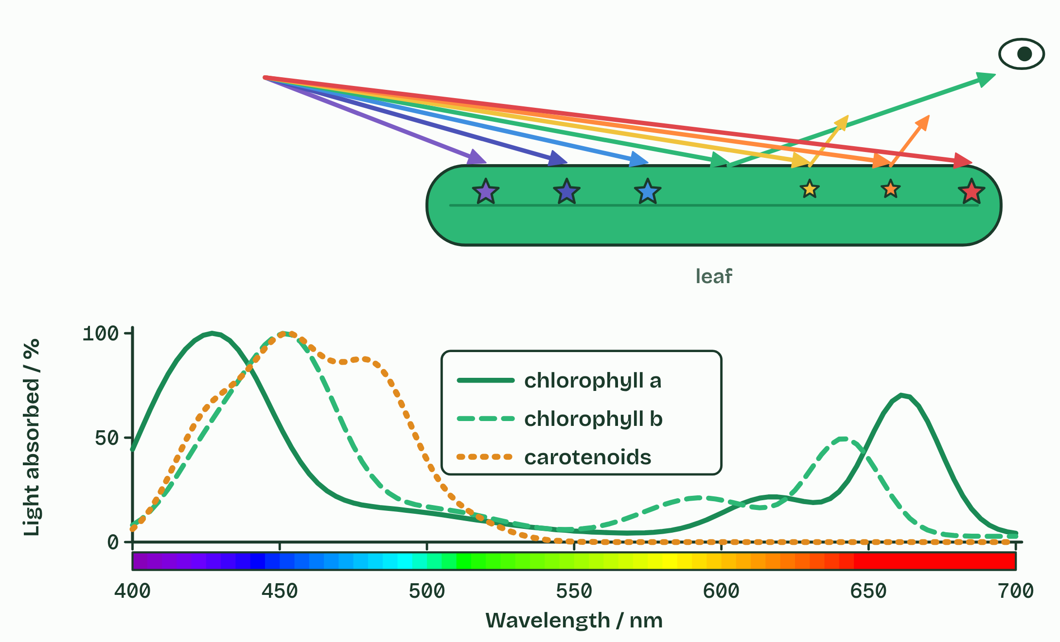  1 White light is every colour together.  2 Chlorophyll absorbs blue and red and reflects most green.  3 An absorption spectrum: how much of each wavelength a pigment absorbs. These are for pigments dissolved in a solvent.  4 Accessory pigments absorb where chlorophyll a absorbs least.  ANNOTATE THE FIGURE  Label the key parts and add a note on what it shows.  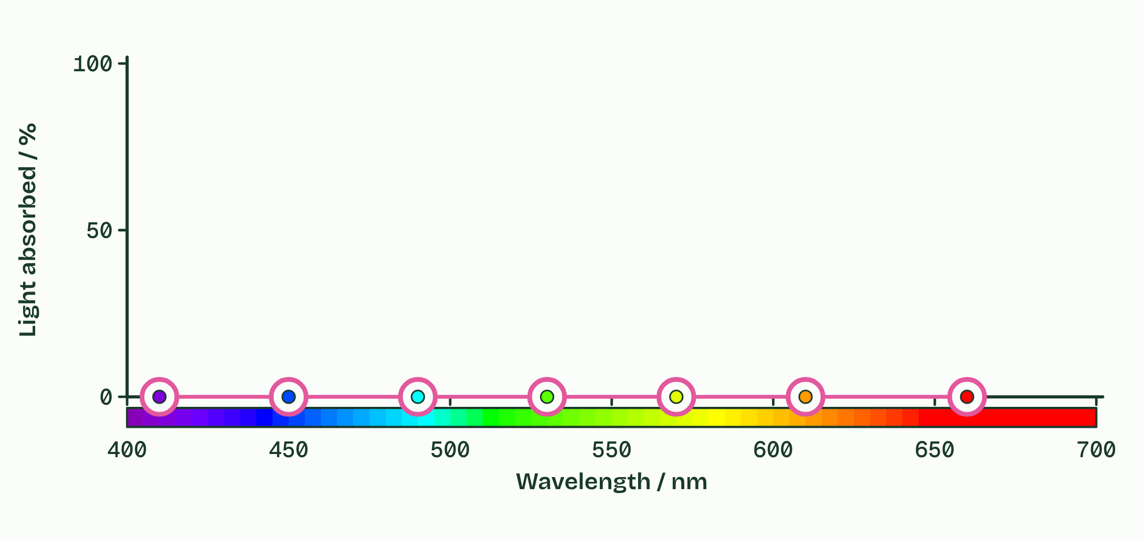  Sketch chlorophyll’s absorption spectrum: seven handles, one for each colour band. Chlorophyll a is the pigment to draw.  REMEMBER IT  The colours, longest wavelength first
  R  Richard | O  Of | Y  York | G  Gave | B  Battle | I  In | V  Vain
  Red  about 700 nm, absorbed | Orange  about 610 nm | Yellow  about 580 nm | Green  about 530 nm, mostly reflected | Blue  about 450 nm, absorbed | Indigo  about 440 nm | Violet  about 400 nm
  SPOT THE MISTAKE
  What do students often get wrong about absorption of specific wavelengths by photosynthetic pigments? Write the mistake, then put it right.
  A leaf is not green because chlorophyll makes green light. Green is the light it did not absorb.
SUMMARY
Sum up section 04 in two or three sentences of your own.
• Visible light runs from about 400 nm (violet) to about 700 nm (red).
• A photon is absorbed only if its energy matches a jump an electron in the pigment can make.
• Chlorophyll absorbs blue and red strongly and reflects green, so a leaf looks green.
• The horizontal axis of an absorption spectrum carries wavelengths and colours.

05 Absorbed is not the same as used | C1.3.6
CUES  Predict: Engelmann shone a spectrum along a strand of alga and added bacteria that swim towards oxygen. Where did the bacteria gather?  A: Under the red and the blue light. Under the red and the blue. Those are the colours the alga’s pigments absorb and use, so those parts of the strand gave off most oxygen. Engelmann measured an action spectrum with no instruments but a microscope and a prism.  What is meant by action spectrum?  A graph of the rate of photosynthesis against the wavelength of the light given.  What is meant by rate of photosynthesis?  How much oxygen is produced, or carbon dioxide consumed, in a given time, for example in cm3 per minute. | NOTES  1 An action spectrum plots how fast photosynthesis runs against the wavelength of the light a plant is given.  2 The rate of photosynthesis is the amount of oxygen produced (or carbon dioxide consumed) divided by the time taken, for example cm³ of oxygen ÷ 10 minutes, in cm³ min⁻¹.  3 Rate of photosynthesis = oxygen produced (or carbon dioxide consumed) ÷ time.  4 Different: the action spectrum is a rate, its green dip is shallower, and its blue peak is lower than the absorption there.  Your own notes  ANNOTATE THE FIGURE  Label the key parts and add a note on what it shows.  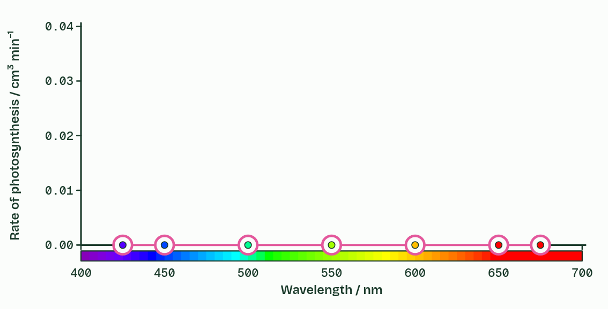  Seven wavelengths of light, the oxygen a sprig gave off in 10 minutes in each, and empty axes. Rate = volume of oxygen ÷ time.  ANNOTATE THE FIGURE  Annotate this still from the animation (Engelmann’s bacteria): what is happening, and why?  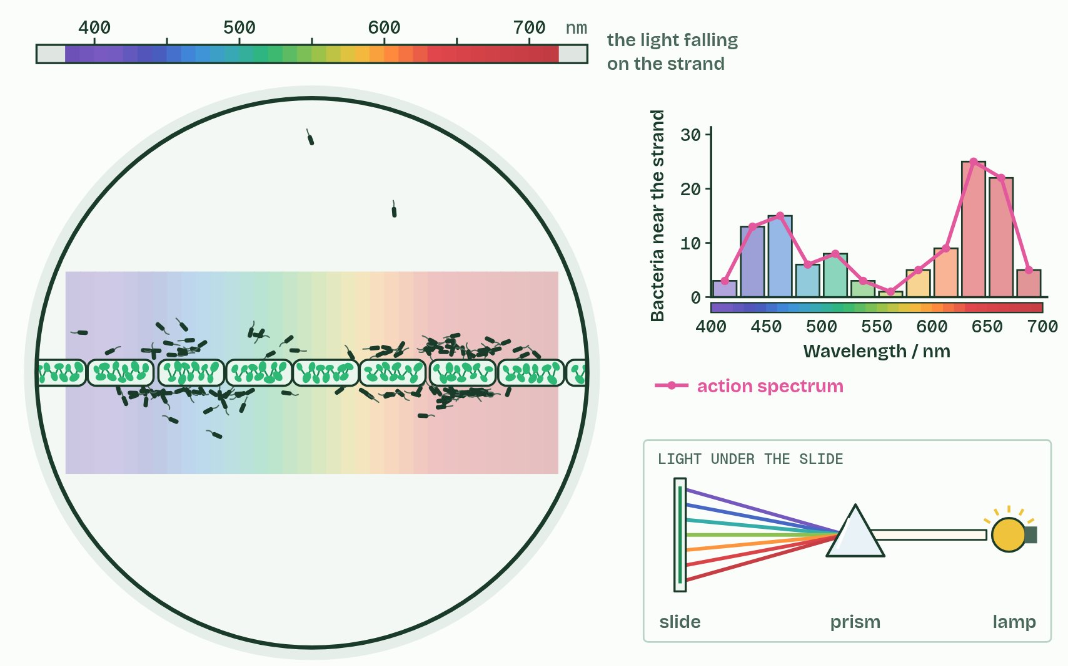  1 A strand of green alga, and bacteria that swim towards oxygen.  2 In white light the whole strand gives off oxygen. The bacteria gather evenly.  3 Engelmann put a prism under the slide. What will the bacteria do?  4 The bacteria crowd where red and blue light fall. Counted, they draw an action spectrum.
  SPOT THE MISTAKE
  What do students often get wrong about absorption and action spectra compared? Write the mistake, then put it right.
  An action spectrum is not “the light a plant absorbs”. It is what the plant does with each colour: its rate of photosynthesis.
SUMMARY
Sum up section 05 in two or three sentences of your own.
• Rate of photosynthesis = oxygen produced (or carbon dioxide consumed) ÷ time.
• Similar: both spectra peak in blue and red and dip in green.
• Different: the action spectrum is a rate, its green dip is shallower, and its blue peak is lower than the absorption there.

06 Whatever runs short sets the pace | C1.3.7
CUES  Predict: A plant at 15 °C is given more and more light until its rate levels off. Then it is warmed to 25 °C. What happens to the rate?  B: It rises to a higher plateau. On the plateau, light was no longer limiting: temperature was. Warming speeds up the enzymes, so the rate climbs to a new, higher plateau, until something else (carbon dioxide, perhaps) limits it.  What is meant by limiting factor?  The factor in shortest supply, which sets the rate of a process. Raising it speeds the process up; raising any other factor does nothing until it takes over as the limit.  What is meant by light intensity?  How much light falls on the plant. It limits the energy available to split water.  What is meant by carbon dioxide concentration?  How much carbon dioxide the plant has to build into sugar. It limits how much carbon can be taken in.  What is meant by hypothesis?  A provisional explanation that has to be tested again and again. It may be based on a theory and tested in an experiment, or based on the evidence of an experiment already done.  What is meant by independent variable?  The variable you change on purpose.  What is meant by dependent variable?  The variable you measure, to see the effect of the change.  What is meant by controlled variables?  Everything else that could affect the result, kept the same. | NOTES  1 Raising that limiting factor speeds the process up, and raising the others does nothing, until one of them becomes the shortest.  2 Light intensity limits the supply of energy for splitting water.  3 The rate rises with light, then levels off when something else limits. Carbon dioxide concentration limits the fixing of carbon in the same way.  4 A hypothesis is a provisional explanation that must be tested again and again.  5 Either way you name the independent variable (what you change), the dependent variable (what you measure) and the controlled variables (everything else, kept the same).  6 Limiting factor: the factor in shortest supply, which sets the rate.  7 A hypothesis names the independent, dependent and controlled variables.  Your own notes  ANNOTATE THE FIGURE  Label the key parts and add a note on what it shows.  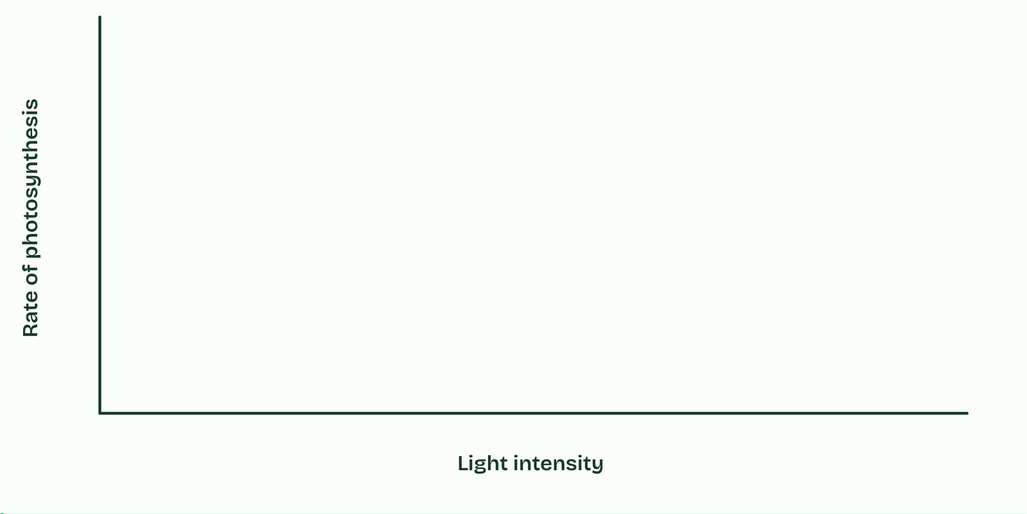  Sketch a hypothesis as a graph, then check it. Three stages: light, then temperature, then carbon dioxide at high and low light.  REMEMBER IT  The three limiting factors
  L  Lazy | C  Cats | T  Toast
  Light intensity  the supply of energy for splitting water | Carbon dioxide concentration  the carbon to fix | Temperature  the speed of the enzymes, up to their optimum
  SPOT THE MISTAKE
  What do students often get wrong about varying light, carbon dioxide and temperature to test limiting factors? Write the mistake, then put it right.
  A limiting factor is not “a factor that stops photosynthesis”. It is the one in shortest supply, setting the rate. Raise it and the rate rises, until another one takes over.
SUMMARY
Sum up section 06 in two or three sentences of your own.
• Limiting factor: the factor in shortest supply, which sets the rate.
• Light, carbon dioxide and temperature are the three to know; raise the limiting one and the rate rises, until another takes over.
• A hypothesis names the independent, dependent and controlled variables.

07 Tomorrow’s air, today | C1.3.8
CUES  Predict: Crops given extra carbon dioxide gained less yield in FACE rings than in enclosures. What is the most likely reason?  C: In fields, another factor soon limits. In a field, water, nitrogen or temperature soon becomes limiting, so extra carbon dioxide helps less than it did where everything else was kept ideal. That is why the field experiments are the better guide to tomorrow’s harvests, even though they control fewer variables.  What is meant by carbon dioxide enrichment?  Growing plants in the carbon dioxide level expected later this century, beside plants in today’s air, to predict how plants will respond.  What is meant by greenhouse?  A glass or plastic building in which temperature, light, water and the air can be controlled. In an enrichment experiment, carbon dioxide from a cylinder holds the air at the chosen level.  What is meant by free-air carbon dioxide enrichment (FACE)?  A field experiment in which a ring of pipes, up to about 20 to 30 m across, releases carbon dioxide round growing plants in the open air. Control rings have the same pipes but no added gas.  What is meant by laboratory or greenhouse?  A place where the variables can be controlled closely.  What is meant by field?  The natural setting: real soil, weather and competition, where variables cannot be controlled but the results apply to real ecosystems. | NOTES  1 Carbon dioxide enrichment experiments grow plants in the carbon dioxide expected later this century (about 550 to 600 ppm) beside plants in today’s air, and compare photosynthesis, growth and yield.  2 In an enclosed greenhouse experiment, carbon dioxide from a gas cylinder holds the air at the chosen level.  3 In free-air carbon dioxide enrichment (FACE), a ring of pipes up to about 20 to 30 m across stands in a field or a forest.  4 Careful control of variables is part of designing an experiment. It is easier in a laboratory or greenhouse, but some questions can only be answered in the field.  5 A greenhouse controls more variables; FACE keeps field conditions and real ecosystems.  6 Name a controlled variable for each: the greenhouse’s temperature, FACE’s crop variety and sowing date.  Your own notes  ANNOTATE THE FIGURE  Number the 3 steps on the figure and note what happens at each.  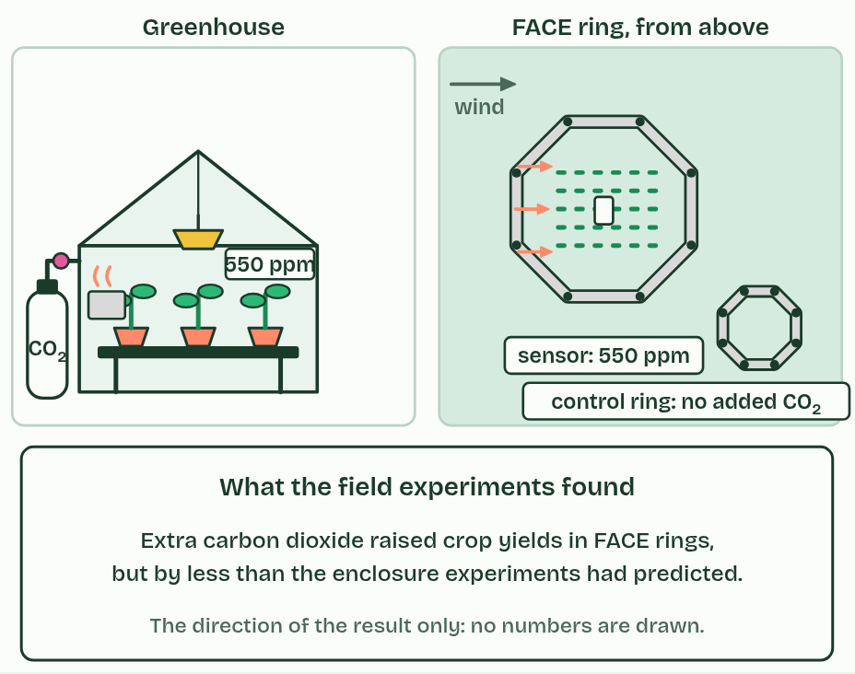  1 Two ways to grow plants in tomorrow’s air.  2 A greenhouse controls more variables; a FACE ring keeps real field conditions.  3 In the field, the gain in yield was smaller.
  SPOT THE MISTAKE
  What do students often get wrong about carbon dioxide enrichment experiments? Write the mistake, then put it right.
  More carbon dioxide does not mean more growth for ever. It helps only while carbon dioxide is the limiting factor (chapter 6).
SUMMARY
Sum up section 07 in two or three sentences of your own.
• Enrichment experiments predict how plants will respond to the carbon dioxide of the future.
• A greenhouse controls more variables; FACE keeps field conditions and real ecosystems.
• Name a controlled variable for each: the greenhouse’s temperature, FACE’s crop variety and sowing date.

08 Pigments in an array | C1.3.9 HL C1.3.10 HL
CUES  Predict: Chlorophyll dissolved in propanone glows red under a bright light. Chlorophyll in a leaf hardly glows at all. Why?  D: In a leaf the energy is passed on and used. In the leaf, chlorophyll is part of a photosystem. The energy it absorbs is passed inwards to a reaction centre and used to emit an electron. In the tube there is no array and nowhere to pass the energy, so it comes back out as red light.  What is meant by photosystem?  An array of a few hundred pigment molecules, chlorophylls and accessory pigments, held in fixed positions by proteins in a membrane, with a reaction centre at its heart.  What is meant by thylakoid membranes?  The membranes inside a chloroplast where the light-dependent reactions happen. In cyanobacteria the photosystems are in internal membranes.  What is meant by reaction centre?  A special chlorophyll a at the heart of a photosystem, from which an excited electron is emitted.  What is meant by excited electron?  An electron raised to a higher energy level. In the reaction centre it is emitted, passing to an electron acceptor.  What is meant by photosystem II?  The photosystem that splits water and passes its electrons to the chain. Electrons pass through it first, though it was discovered second.  What is meant by photosystem I?  The photosystem that passes electrons on to reduce NADP. | NOTES  1 A photosystem is an array of a few hundred pigment molecules, chlorophylls and accessory pigments, held in fixed positions by proteins.  2 Photosystems are always in a membrane: the thylakoid membranes of a chloroplast, or the internal membranes of a cyanobacterium.  3 At the heart of each is the reaction centre, a special chlorophyll a.  4 There an excited electron is emitted: it leaves the chlorophyll altogether, passing to an electron acceptor beside it in the membrane.  5 There are two kinds of photosystem, photosystem II and photosystem I, numbered in the order they were discovered.  6 A photosystem is an array of pigments round a reaction centre, always in a membrane.  7 Pigments pass on energy; only the reaction centre emits an excited electron.  Your own notes  ANNOTATE THE FIGURE  Number the 5 steps on the figure and note what happens at each.  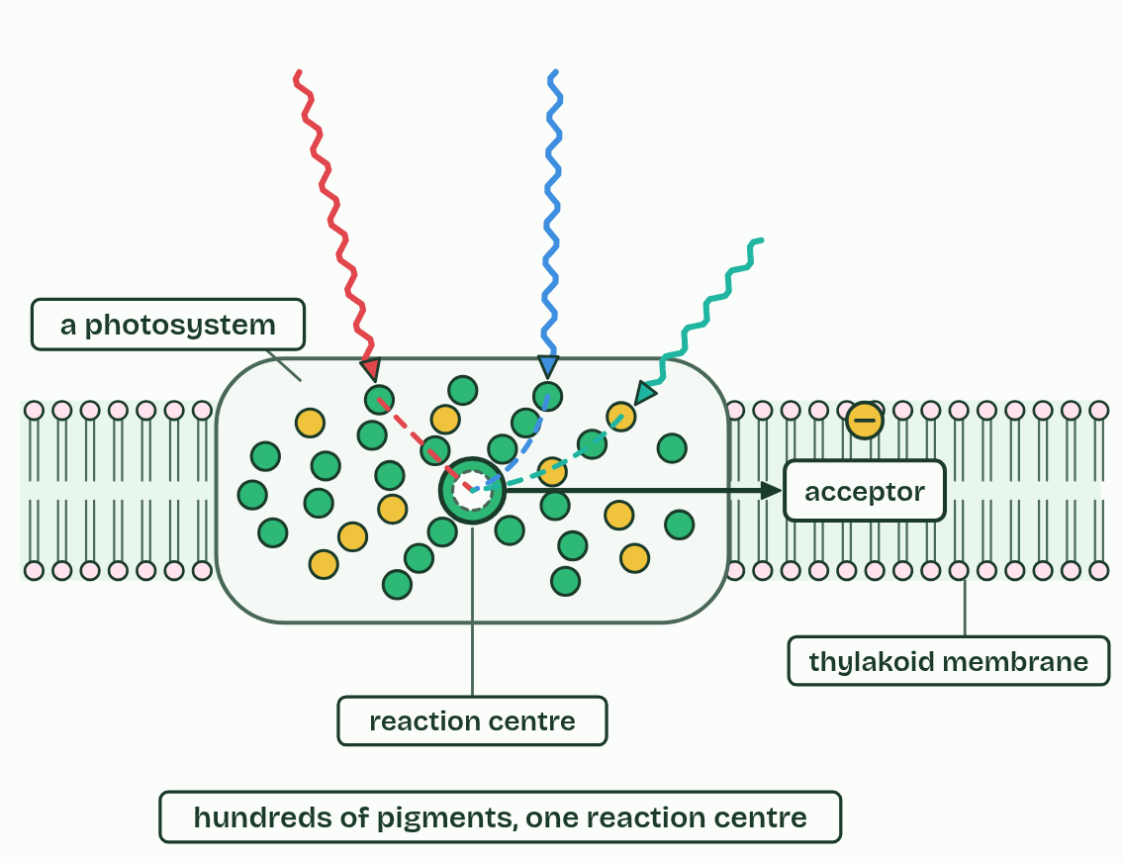  1 On its own, chlorophyll gives the energy straight back, as red light.  2 A photosystem: hundreds of pigments around a reaction centre, in a membrane.  3 The energy hops from pigment to pigment, inwards.  4 The reaction centre emits an excited electron.  5 Many pigments, many colours, all feeding one reaction centre.
  SPOT THE MISTAKE
  What do students often get wrong about photosystems, and the advantage of the array? Write the mistake, then put it right.
  Pigments in the array pass on energy, not electrons. Only the reaction centre emits an electron.
SUMMARY
Sum up section 08 in two or three sentences of your own.
• A photosystem is an array of pigments round a reaction centre, always in a membrane.
• Pigments pass on energy; only the reaction centre emits an excited electron.
• One pigment alone could not do any part of photosynthesis.

09 Water split, oxygen spare | C1.3.11 HL
CUES  Predict: Cyanobacteria were splitting water for a long time before oxygen built up in the air. Where did their oxygen go at first?  A: Into iron dissolved in the oceans. Into iron. The oceans held dissolved iron, which oxygen turned into insoluble iron oxide that settled as red bands in the rock. Only when that iron was used up could oxygen build up in the air.  What is meant by photolysis?  The splitting of water by light-driven photosystem II, giving electrons, protons and oxygen. Two water molecules give four electrons, four protons and one oxygen molecule.  What is meant by protons?  Hydrogen ions, H+. Photolysis releases them into the thylakoid lumen.  What is meant by waste product?  A substance a process makes but does not use. The oxygen from photolysis diffuses out of the chloroplast, the cell and the leaf.  What is meant by banded iron formations?  Layers of iron oxide in ancient rock, laid down when oxygen from cyanobacteria reacted with iron dissolved in the oceans.  What is meant by great Oxidation Event?  The rise of oxygen in the Earth’s atmosphere, about 2.4 billion years ago, after cyanobacteria had been splitting water for a long time. | NOTES  1 The splitting of water, photolysis, is done by an enzyme on the lumen side of photosystem II.  2 The protons are released into the lumen, where they add to the proton gradient (chapter 10).  3 The oxygen is a waste product: it diffuses out of the chloroplast, the cell and the leaf.  4 The oxygen they released first reacted with iron dissolved in the oceans, which settled as layers of iron oxide on the sea floor: the banded iron formations.  5 When the iron was used up, oxygen built up in the air, in the Great Oxidation Event, about 2.4 billion years ago.  6 Photolysis at photosystem II: 2 water give 4 electrons, 4 protons and 1 oxygen.  7 The electrons and protons are used; the oxygen is waste.  Your own notes  ANNOTATE THE FIGURE  Number the 4 steps on the figure and note what happens at each.  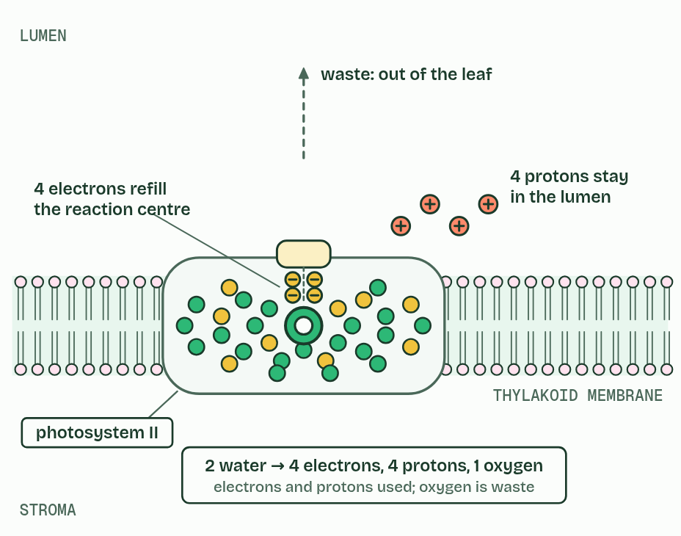  1 Photosystem II has lost electrons.  2 It takes more from water.  3 Photolysis: electrons refill the reaction centre; protons stay in the lumen.  4 The oxygen is a waste product.  ANNOTATE THE FIGURE  Label the key parts and add a note on what it shows.  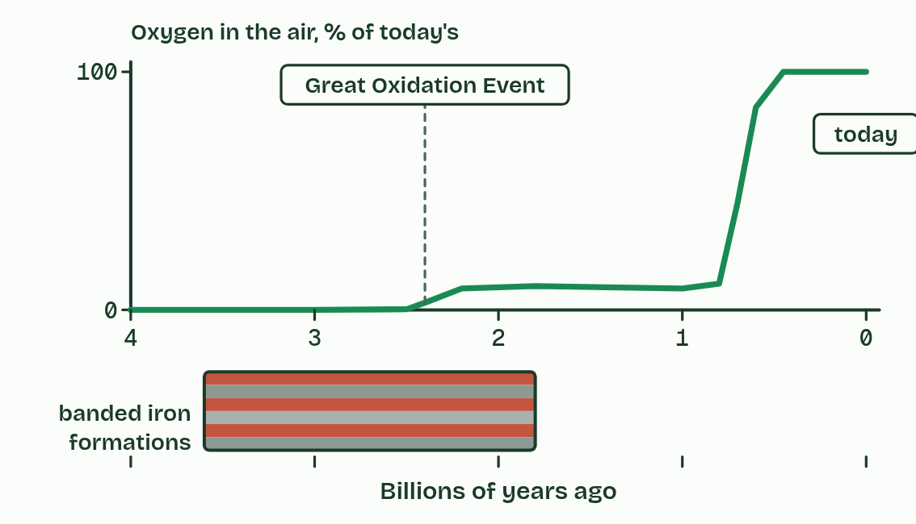  The shape of the rise is known better than the numbers, so only 0 and today’s level are marked. Banded iron formations are mostly older than about 1.8 billion years.  REMEMBER IT  What photolysis gives
  P  Please | E  Eat | O  Oranges
  Protons  into the lumen, for the gradient | Electrons  back into photosystem II’s reaction centre | Oxygen  thrown away as waste
  SPOT THE MISTAKE
  What do students often get wrong about oxygen from the photolysis of water in photosystem II? Write the mistake, then put it right.
  The protons and electrons from water are used; only the oxygen is waste. And it is photosystem II, not photosystem I, that splits water.
SUMMARY
Sum up section 09 in two or three sentences of your own.
• Photolysis at photosystem II: 2 water give 4 electrons, 4 protons and 1 oxygen.
• The electrons and protons are used; the oxygen is waste.
• Light excites the reaction centre; the reaction centre takes electrons from water.

10 Protons downhill make ATP | C1.3.12 HL
CUES  Predict: In a working chloroplast, where do protons build up?  C: In the lumen, inside each thylakoid. In the lumen. The chain pumps protons in from the stroma, and photolysis releases more there. The lumen’s small volume lets a steep gradient build fast, and ATP synthase lets them back out into the stroma, where the ATP is made.  What is meant by chain of electron carriers?  A series of carrier molecules in the thylakoid membrane. An electron passes from one to the next, giving up energy at each step.  What is meant by proton pumping?  Moving protons across a membrane against their gradient, using the energy of electrons passing along a chain of carriers. In a thylakoid the protons go from the stroma into the lumen.  What is meant by thylakoid lumen?  The space inside a thylakoid, where protons collect.  What is meant by proton gradient?  A difference in the concentration of protons across a membrane. The protons flow back down it through ATP synthase.  What is meant by ATP synthase?  A protein that spans a membrane. Protons flowing down their gradient through it turn part of it, and the energy joins ADP and phosphate to make ATP.  What is meant by chemiosmosis?  Making ATP using energy from a proton gradient across a membrane, through ATP synthase.  What is meant by non-cyclic photophosphorylation?  ATP made using electrons from photosystem II, passed along the chain to photosystem I and on to NADP. Water is split and oxygen is given off.  What is meant by cyclic photophosphorylation?  ATP made using electrons that come from photosystem I and return to the chain, then to photosystem I again. It makes ATP only: no NADP is reduced, no water is split and no oxygen is given off. | NOTES  1 The excited electron from photosystem II passes along a chain of electron carriers in the thylakoid membrane towards photosystem I, giving up energy at each step.  2 One carrier uses that energy for proton pumping: it moves protons across the membrane from the stroma into the thylakoid lumen.  3 The lumen is small, so their concentration rises fast, and the membrane does not let them back. That difference is the proton gradient.  4 The only way back to the stroma is through ATP synthase, a protein that spans the membrane.  5 Making ATP with energy from a proton gradient is chemiosmosis, and when light is the first source the whole process is photophosphorylation.  6 In non-cyclic photophosphorylation the electrons come from photosystem II, pass along the chain to photosystem I and on to NADP (chapter 11).  7 In cyclic photophosphorylation, electrons excited at photosystem I go back to the chain, pump more protons and return to photosystem I.  8 Protons flow back through ATP synthase, which makes ATP on the stroma side.  Your own notes  ANNOTATE THE FIGURE  Number the 5 steps on the figure and note what happens at each: 1 photosystems, chain of carriers, ATP synthase; 2 pumps protons; 3 proton gradient; 4 ATP synthase, ATP, chemiosmosis; 5 Non-cyclic, Cyclic.  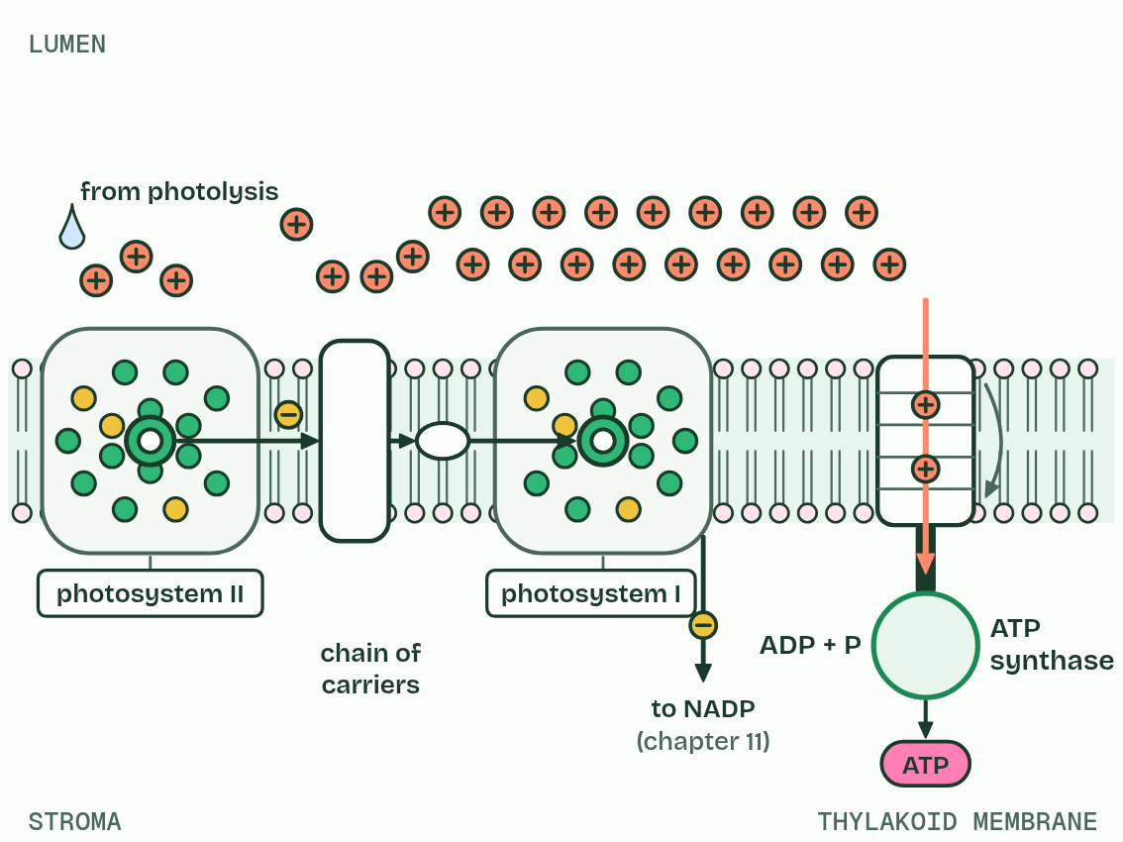  1 The thylakoid membrane: photosystems, a chain of carriers and ATP synthase.  2 Electrons give up energy along the chain, which pumps protons into the lumen.  3 Protons pile up in the small lumen: a proton gradient.  4 They flow back through ATP synthase, which makes ATP in the stroma: chemiosmosis.  5 Non-cyclic: on to NADP. Cyclic: back round the chain, for more ATP.
  SPOT THE MISTAKE
  What do students often get wrong about ATP production by chemiosmosis in thylakoids? Write the mistake, then put it right.
  Protons do not collect in an “intermembrane space”, as they do in a mitochondrion. In a chloroplast they collect in the thylakoid lumen.
SUMMARY
Sum up section 10 in two or three sentences of your own.
• Electrons along the chain pump protons from the stroma into the lumen; photolysis adds more.
• Protons flow back through ATP synthase, which makes ATP on the stroma side.
• Non-cyclic: electrons from photosystem II to NADP. Cyclic: electrons from photosystem I round the chain again, for ATP only.

11 NADP reduced, and the thylakoid as a system | C1.3.13 HL C1.3.14 HL
CUES  Predict: On which side of the thylakoid membrane is NADP reduced, and why does that side make sense?  A: The stroma side, where the Calvin cycle uses it. The stroma side. Photosystem I hands its electrons to NADP there, with a proton from the stroma, and the reduced NADP is made exactly where the Calvin cycle will use it. Nothing has to cross the membrane.  What is meant by NADP?  A carrier molecule that picks up electrons and a proton and delivers them to the Calvin cycle. It is written NADP when empty and reduced NADP when it holds them.  What is meant by reduced NADP?  NADP carrying two electrons and a proton. It is the carrier of hydrogen to the Calvin cycle.  What is meant by reduction?  The gain of electrons (or hydrogen) by a molecule.  What is meant by stroma?  The fluid inside a chloroplast around the thylakoids. The Calvin cycle runs here.  What is meant by grana?  Stacks of thylakoids (one is a granum). Stacking gives a large area of membrane. | NOTES  1 Light absorbed by photosystem I’s array excites them again, and from its reaction centre they pass, by a short carrier on the stroma side, to NADP.  2 NADP picks up two electrons from photosystem I and one hydrogen ion (a proton) from the stroma, and becomes reduced NADP.  3 This is a reduction, and taking that proton from the stroma steepens the gradient a little.  4 Reduced NADP carries the hydrogen, as electrons and a proton, to the Calvin cycle in the stroma, where it reduces carbon compounds (chapter 13).  5 Thylakoids are stacked in grana, joined by single unstacked sheets of membrane that run through the stroma; the stacking gives a large area of membrane, and the small lumen builds a steep gradient fast.  6 NADP is reduced at photosystem I, by two electrons from it and a proton from the stroma.  7 Photolysis and the proton store are on the lumen side; ATP and reduced NADP are made on the stroma side.  Your own notes  ANNOTATE THE FIGURE  Label each part and say what it does: stroma, envelope, granum, granum, granum, thylakoid lumen, stroma, photosystem II, chain of carriers, photosystem I, NADP, ATP synthase.  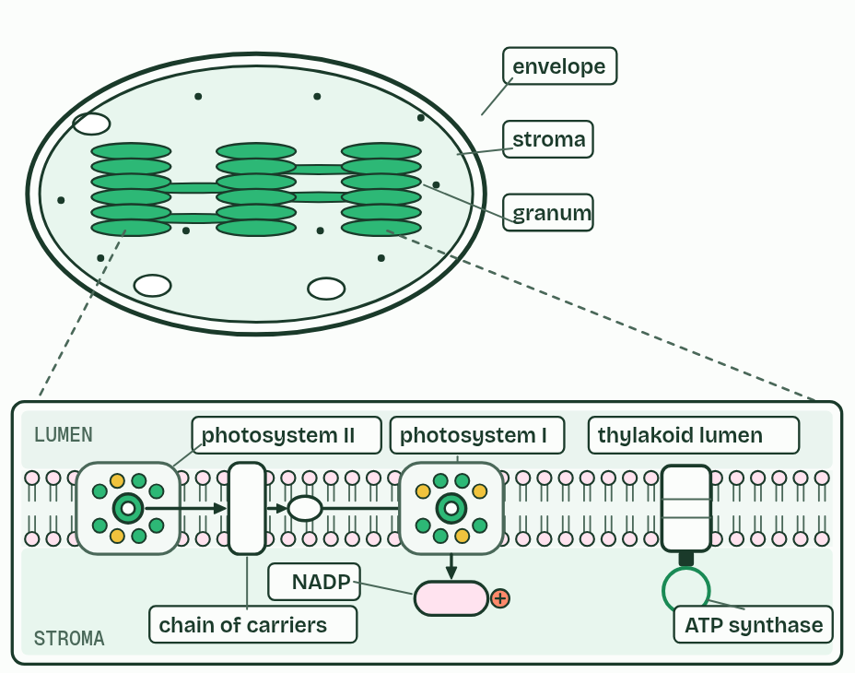  1 Stroma: The fluid round the thylakoids. The Calvin cycle runs here, and ATP and reduced NADP are made and used here.  2 Envelope: Two membranes round the chloroplast. The thylakoids are a separate system inside it.  3 Granum: A stack of thylakoids. Stacking gives a large area of membrane in a small space, and single sheets join one stack to the next.  4 Granum: A stack of thylakoids. Stacking gives a large area of membrane in a small space, and single sheets join one stack to the next.  5 Granum: A stack of thylakoids. Stacking gives a large area of membrane in a small space, and single sheets join one stack to the next.  6 Thylakoid lumen: The small space inside a thylakoid. Photolysis happens on its side of photosystem II, and protons pile up here.  7 Stroma: The fluid round the thylakoids. The Calvin cycle runs here, and ATP and reduced NADP are made and used here.  8 Photosystem II: Splits water on the lumen side and passes its electrons on.  9 Chain of carriers: Passes electrons from photosystem II towards photosystem I, and pumps protons into the lumen.  10 Photosystem I: Its excited electrons pass on, on the stroma side, to NADP.  11 NADP: Reduced here, on the stroma side, by two electrons from photosystem I and a proton from the stroma.  12 ATP synthase: Lets protons flow back from the lumen to the stroma and makes ATP on the stroma side.  ANNOTATE THE FIGURE  Annotate this still from the animation (The thylakoid at work): what is happening, and why?  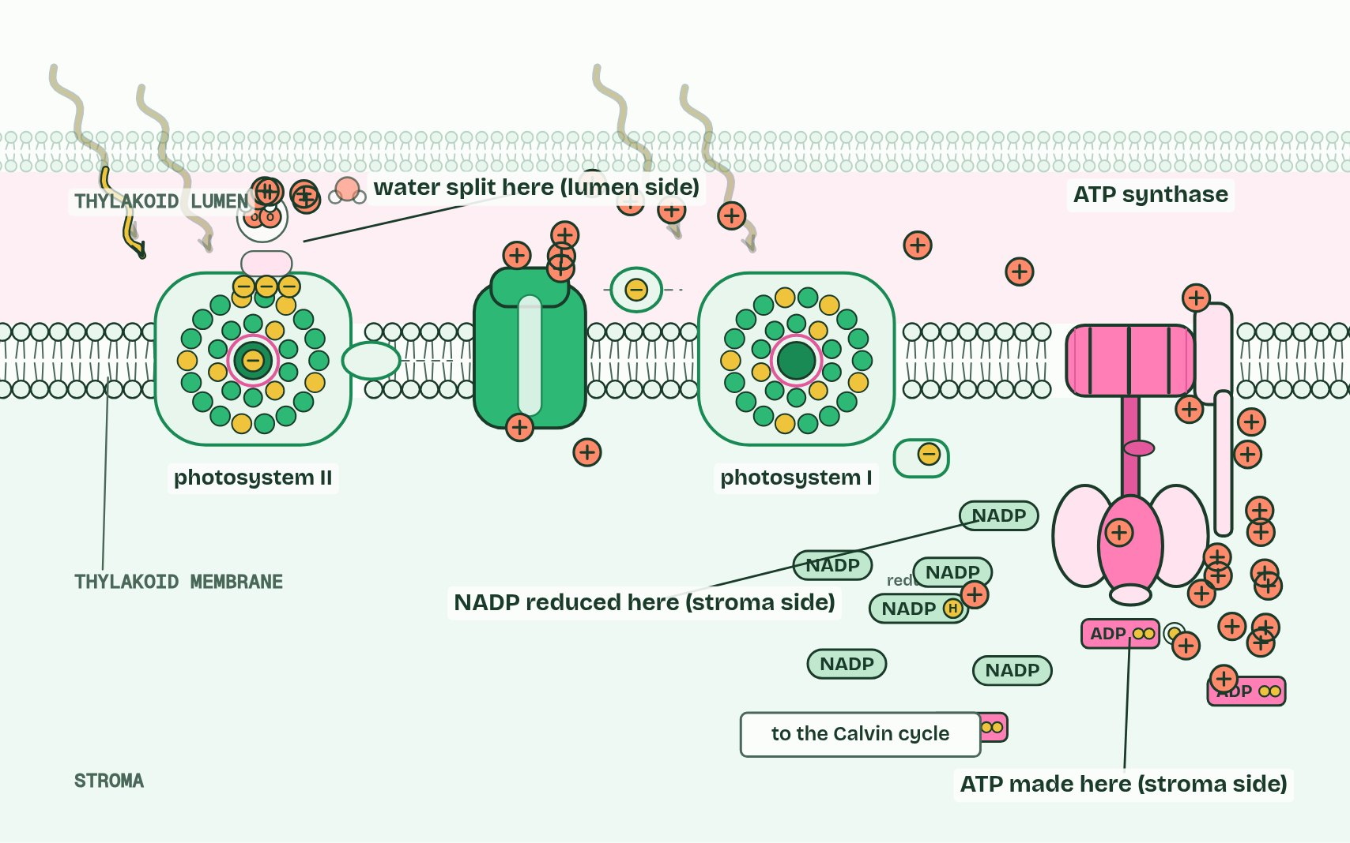  1 Light energy is passed through an array of pigments to the reaction centre, a special chlorophyll, which gives off an excited electron.  2 The reaction centre replaces its lost electrons by splitting water (photolysis). The protons stay in the lumen; the oxygen is a waste product.  3 The electron passes along a chain of carriers, which uses its energy to pump protons from the stroma into the lumen.  4 At photosystem I light lifts the electron again. Two electrons and a proton from the stroma reduce NADP.  5 Protons flow out of the lumen through ATP synthase, making ATP in the stroma, where the Calvin cycle will use it.  6 The thylakoid as a system: water split on the lumen side, ATP and reduced NADP made on the stroma side.  REMEMBER IT  Two sides of the thylakoid
  L  Loads | S  Spends
  Lumen  where protons pile up and water is split | Stroma  where ATP and reduced NADP are made, then spent by the Calvin cycle
  SPOT THE MISTAKE
  What do students often get wrong about NADP reduced by photosystem I, and the thylakoid as a system? Write the mistake, then put it right.
  NADP is reduced at photosystem I, not photosystem II; photosystem II splits water. Electrons go through II first: the numbers record the order of discovery.
SUMMARY
Sum up section 11 in two or three sentences of your own.
• NADP is reduced at photosystem I, by two electrons from it and a proton from the stroma.
• Photolysis and the proton store are on the lumen side; ATP and reduced NADP are made on the stroma side.
• Grana give a large area of membrane; the small lumen gives a steep gradient fast.

12 Fixing carbon, slowly | C1.3.15 HL
CUES  Predict: A leaf cell could save a lot of protein by making less Rubisco. Why doesn’t it?  D: Each Rubisco fixes only a few CO2 a second. Rubisco is slow, and slower still when carbon dioxide is low. To fix carbon dioxide as fast as the light reactions supply ATP and reduced NADP, a leaf needs a great many Rubisco molecules. That is why it is the most abundant enzyme on Earth.  What is meant by calvin cycle?  The cycle of reactions in the stroma that fixes carbon dioxide into carbon compounds, using ATP and reduced NADP from the light-dependent reactions. Melvin Calvin worked it out in the 1950s, using radioactive carbon in algae.  What is meant by carbon fixation?  Turning carbon from a gas, carbon dioxide, into part of an organic molecule.  What is meant by ribulose bisphosphate (RuBP)?  The five-carbon sugar that carbon dioxide joins in carbon fixation. It is remade by the Calvin cycle.  What is meant by glycerate 3-phosphate (GP)?  The three-carbon compound that RuBP and carbon dioxide make. Two GP form from each fixation.  What is meant by rubisco?  The enzyme that fixes carbon dioxide onto RuBP. It is slow, so a leaf needs a great deal of it, and it is the most abundant enzyme on Earth. | NOTES  1 The light-independent reactions are a cycle in the stroma, the Calvin cycle, named after Melvin Calvin, who worked it out with radioactive carbon in algae.  2 Its first step is carbon fixation.  3 Carbon dioxide joins a five-carbon sugar already in the stroma, ribulose bisphosphate (RuBP).  4 The six carbons split at once into two molecules of the three-carbon glycerate 3-phosphate (GP).  5 The enzyme is Rubisco.  6 Carbon fixation: carbon dioxide joins RuBP (5 carbons), which splits into two GP (3 carbons each).  7 The enzyme is Rubisco: slow, and poor at low carbon dioxide concentrations.  8 The stroma needs a high concentration of Rubisco for that reason.  Your own notes  ANNOTATE THE FIGURE  Number the 4 steps on the figure and note what happens at each: 1 RuBP, Rubisco; 2 Carbon dioxide, carbon fixation; 3 GP; 4 a lot.  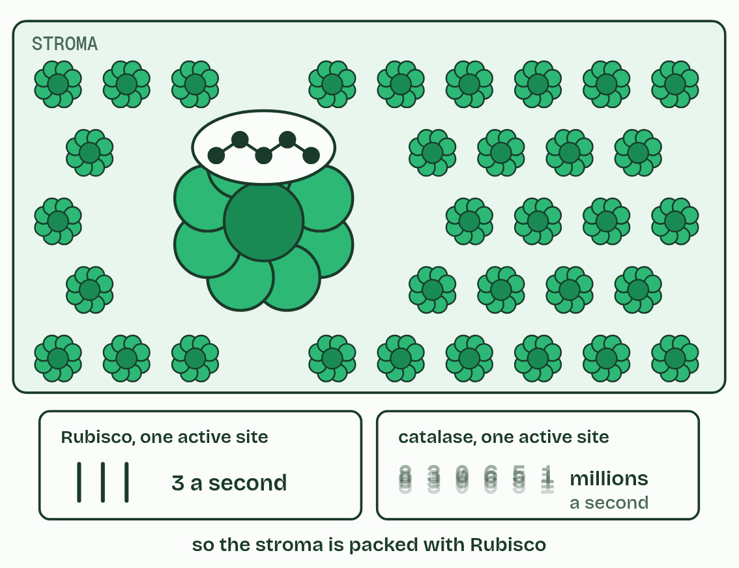  1 RuBP, a five-carbon sugar, waits in Rubisco’s active site.  2 Carbon dioxide joins it: carbon fixation.  3 The six carbons split into two GP.  4 Rubisco is slow, so a leaf makes a lot of it.  ANNOTATE THE FIGURE  Number the 4 steps on the figure and note what happens at each.  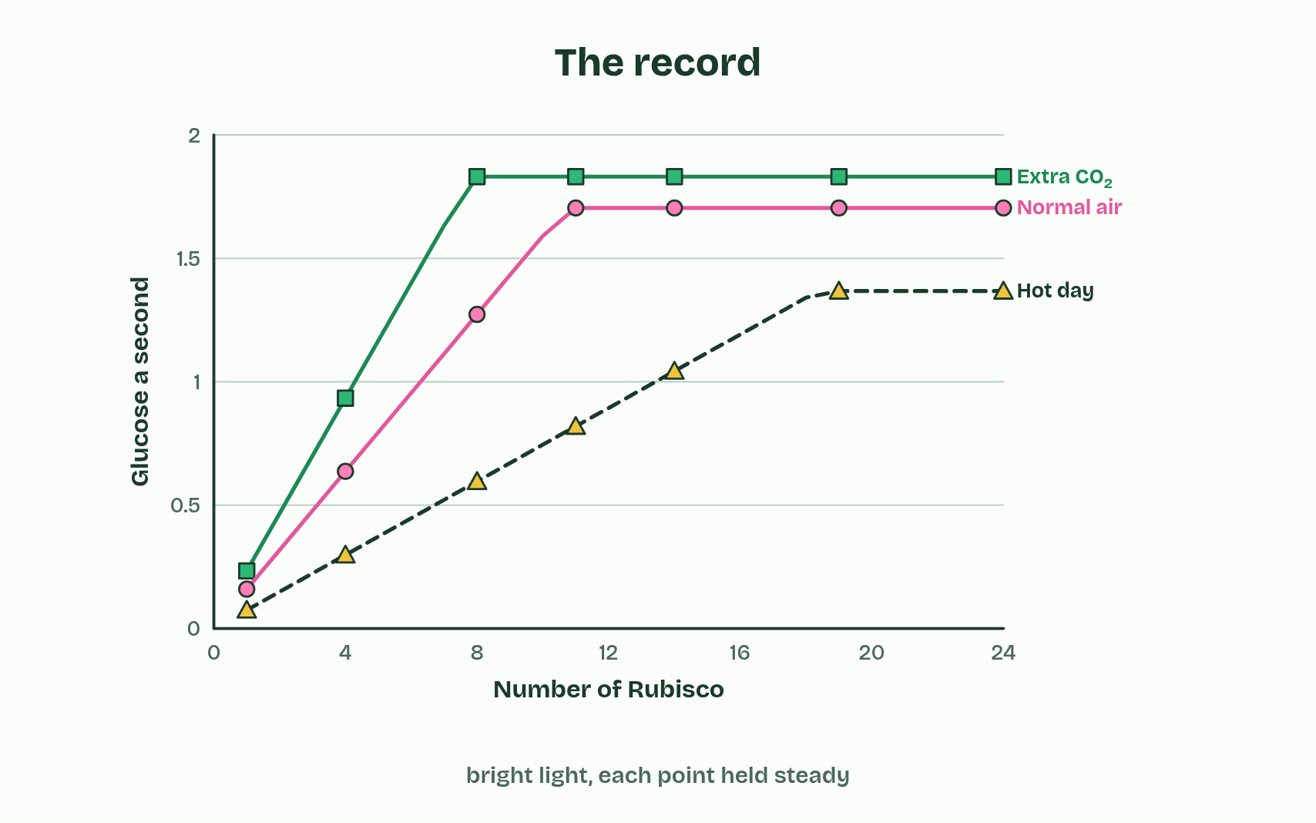  1 One Rubisco cannot keep up.  2 Eleven keep pace with bright light.  3 With little carbon dioxide, each does less and fumbles more.  4 More Rubisco helps until light is the limit.
  SPOT THE MISTAKE
  What do students often get wrong about carbon fixation by Rubisco? Write the mistake, then put it right.
  Rubisco is an enzyme, not a product of the cycle, and it is not used up. It is abundant because it is slow, not because it is special in any other way.
SUMMARY
Sum up section 12 in two or three sentences of your own.
• Carbon fixation: carbon dioxide joins RuBP (5 carbons), which splits into two GP (3 carbons each).
• The enzyme is Rubisco: slow, and poor at low carbon dioxide concentrations.
• The stroma needs a high concentration of Rubisco for that reason.

13 GP to TP, and RuBP made again | C1.3.16 HL C1.3.17 HL
CUES  Predict: Of every six TP the Calvin cycle makes, how many must be used to remake RuBP?  C: Five. Five. They hold fifteen carbons, exactly enough for three RuBP, so the cycle can fix three more carbon dioxide. Only one TP in six, three carbons, leaves: the three carbons that came in as carbon dioxide.  What is meant by triose phosphate (TP)?  The three-carbon sugar phosphate made when ATP and reduced NADP reduce GP. It is the first sugar and the product of the cycle.  What is meant by regeneration?  Remaking RuBP from triose phosphate, using ATP, so the cycle can fix more carbon dioxide. | NOTES  1 Reduced NADP and ATP from the light-dependent reactions turn GP into triose phosphate (TP), a three-carbon sugar, in the stroma.  2 Five TP (fifteen carbons) are rearranged into three RuBP (fifteen carbons), so the cycle can fix carbon dioxide again. This is regeneration.  3 Three RuBP wait for three carbon dioxide.  4 Rubisco fixes them: six GP.  5 Reduced NADP and ATP turn GP into TP.  6 Five TP are remade into three RuBP, using ATP.  Your own notes  ANNOTATE THE FIGURE  Number the 6 steps on the figure and note what happens at each.  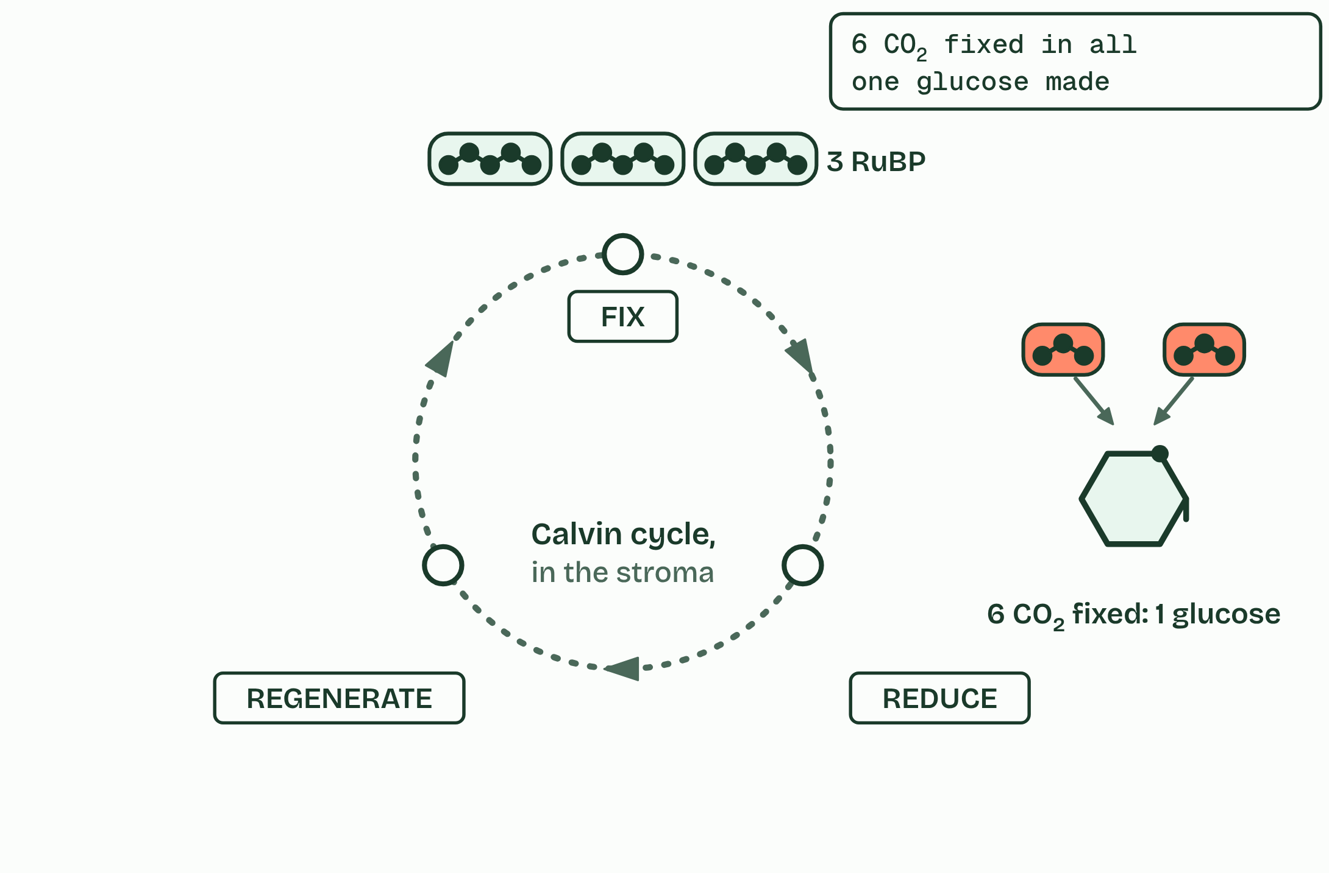  1 Three RuBP wait for three carbon dioxide.  2 Rubisco fixes them: six GP.  3 Reduced NADP and ATP turn GP into TP.  4 One TP in six leaves the cycle.  5 Five TP are remade into three RuBP, using ATP.  6 Six turns, six carbon dioxide: one glucose.  REMEMBER IT  The Calvin cycle’s three stages
  F  Fresh | R  Rolls | R  Rise
  Fix  Rubisco joins carbon dioxide to RuBP, making GP | Reduce  ATP and reduced NADP turn GP into TP | Regenerate  five TP in six remade into RuBP, using ATP
  SPOT THE MISTAKE
  What do students often get wrong about triose phosphate from GP, and RuBP regenerated? Write the mistake, then put it right.
  It is GP (glycerate 3-phosphate) that is reduced, to TP. “Glyceraldehyde 3-phosphate” is another name for a triose phosphate, so “the reduction of glyceraldehyde 3-phosphate” has the stages muddled.
SUMMARY
Sum up section 13 in two or three sentences of your own.
• GP is reduced to TP, using reduced NADP and ATP.
• Five TP of every six made are remade into three RuBP, using ATP; one in six leaves.
• Six turns of the cycle fix six carbon dioxide and make one glucose.

14 Every carbon came this way | C1.3.18 HL
CUES  Predict: A plant has plenty of light, water and carbon dioxide, but its soil has no nitrate. Which will it fail to make?  A: Proteins. Proteins. Their amino acids need nitrogen, and nitrate is the plant’s source of it. It can still fix carbon and make sugars, starch and cellulose, but it cannot build enzymes, Rubisco included, so it soon grows poorly and its leaves yellow.  What is meant by mineral nutrients?  Inorganic ions the plant takes up from the soil, such as nitrate and phosphate. They supply the elements that carbon dioxide and water do not. | NOTES  1 Nucleotides need nitrogen for their bases and phosphorus for their phosphate. These mineral nutrients come in through the roots by active transport (B2.1).  2 Amino acids and nucleotides also need mineral nutrients: nitrate, and phosphate.  3 From TP: sugars, starch and cellulose.  4 Lipids.  5 Amino acids, with nitrogen from nitrate.  6 Nucleotides, with nitrogen and phosphate.  Your own notes  ANNOTATE THE FIGURE  Number the 4 steps on the figure and note what happens at each: 1 sugars, starch, cellulose; 2 Lipids; 3 Amino acids, nitrate; 4 Nucleotides, phosphate.  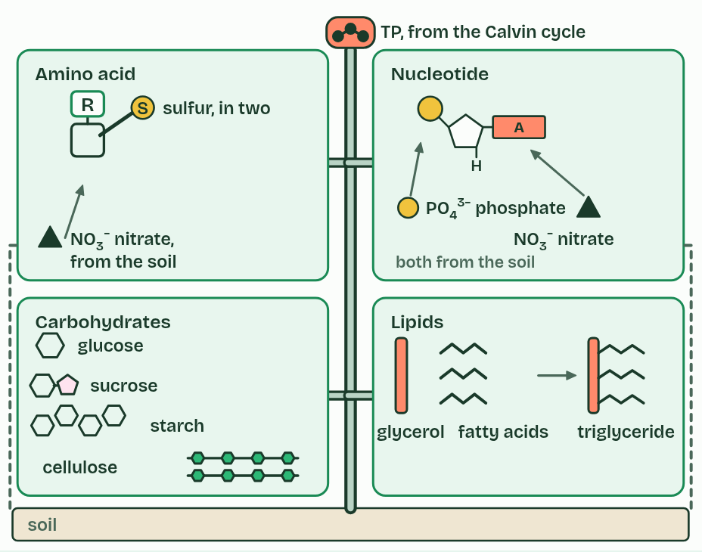  1 From TP: sugars, starch and cellulose.  2 Lipids.  3 Amino acids, with nitrogen from nitrate.  4 Nucleotides, with nitrogen and phosphate.  ANNOTATE THE FIGURE  Annotate this still from the animation (Follow one carbon atom): what is happening, and why?  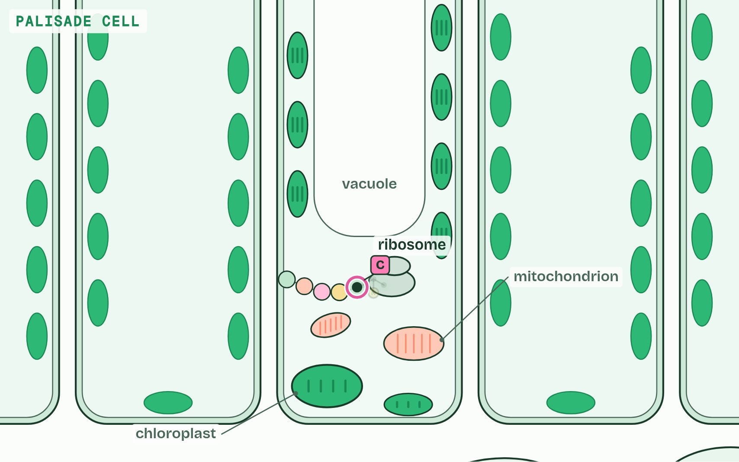  1 One carbon atom, in a molecule of carbon dioxide in the air.  2 It diffuses in through a stoma and into a chloroplast.  3 Rubisco joins the CO2 to RuBP; the product splits into two molecules of GP.  4 GP is reduced to TP with ATP and reduced NADP. One TP in six leaves the cycle; the rest remake RuBP.  5 Every carbon compound in the plant is made from the Calvin cycle’s products. Here, with nitrogen from nitrate in the soil, an amino acid.  6 Joined into a protein, the atom stays in the plant until the plant, or whatever eats it, respires it.
  SPOT THE MISTAKE
  What do students often get wrong about carbohydrates, amino acids and other compounds from the Calvin cycle? Write the mistake, then put it right.
  Plants do not take carbon from the soil. Every carbon atom came from carbon dioxide, in the air or dissolved in water, through the Calvin cycle.
SUMMARY
Sum up section 14 in two or three sentences of your own.
• All the carbon in a plant’s compounds was fixed in the Calvin cycle.
• Sugars, starch, cellulose, lipids, amino acids and nucleotides are made by pathways that start from TP.
• Amino acids and nucleotides also need mineral nutrients: nitrate, and phosphate.

15 Each half needs the other | C1.3.19 HL
CUES  Predict: A leaf in bright light is suddenly given no carbon dioxide. What happens to photosystem II?  C: It stops, as NADP runs out further on. It stops. With no carbon dioxide the Calvin cycle stops using reduced NADP, so no NADP comes back. Photosystem I has nowhere to put its electrons, the chain fills up, and photosystem II cannot pass its electrons on. Water stops being split, and no oxygen is given off.  What is meant by light-dependent reactions?  The reactions in the thylakoids that need light: photolysis, the chain and ATP synthase, and the reduction of NADP. They make ATP and reduced NADP.  What is meant by light-independent reactions?  The Calvin cycle in the stroma. They do not use light directly, but need the ATP and reduced NADP of the light-dependent reactions.  What is meant by interdependence?  Each half of photosynthesis relying on the products of the other, so neither can run alone for long. | NOTES  1 The light-dependent reactions in the thylakoids make ATP and reduced NADP.  2 The light-independent reactions, the Calvin cycle in the stroma, use them and hand back ADP, phosphate and NADP.  3 Each half needs what the other makes: that is their interdependence.  4 Light-dependent reactions make ATP and reduced NADP; the Calvin cycle uses them and returns ADP, phosphate and NADP.  Your own notes  ANNOTATE THE FIGURE  The figure shows it as Light and carbon dioxide, Lights off and No carbon dioxide. Note what changes each time.  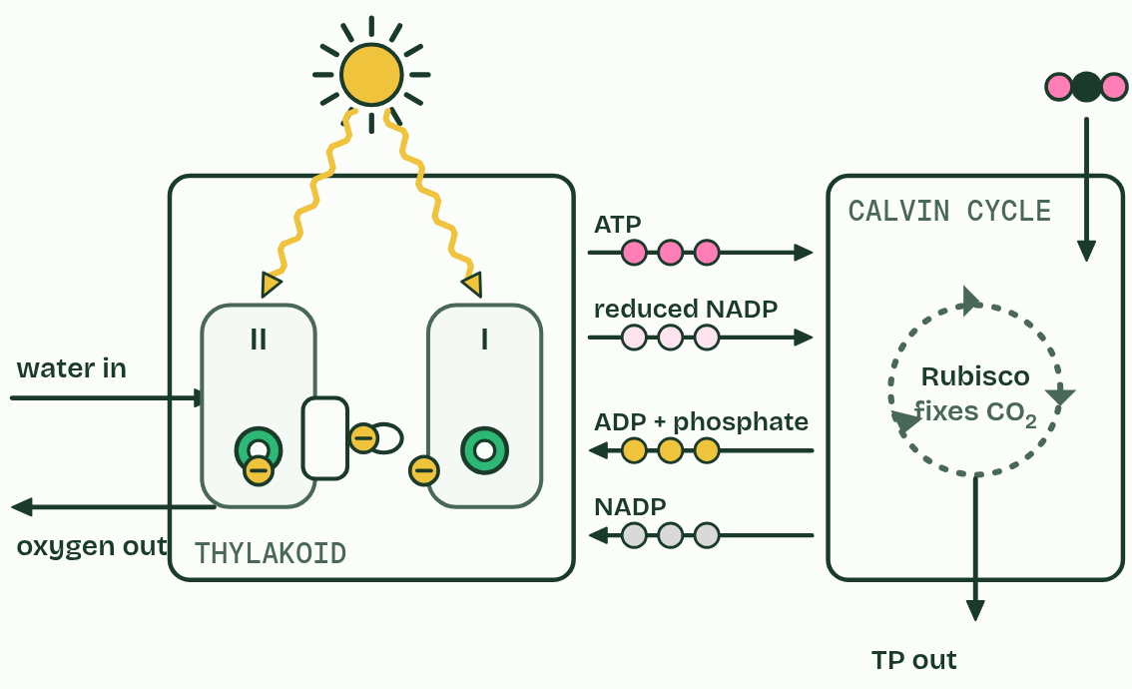  1 Light and carbon dioxide  2 Lights off  3 No carbon dioxide  ANNOTATE THE FIGURE  Annotate this still from the animation (Photosynthesis, the whole system): what is happening, and why?  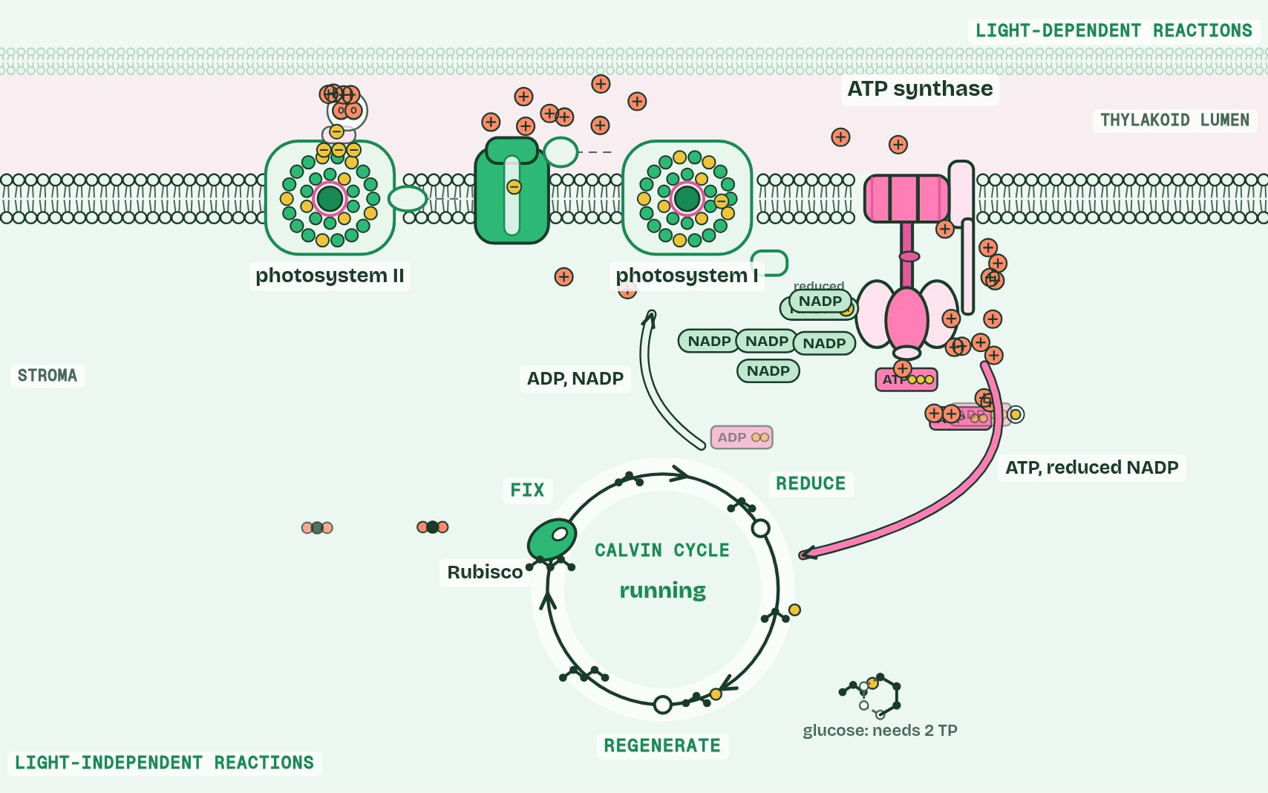  1 Into a leaf, a palisade cell, a chloroplast, and one thylakoid membrane.  2 Light energy passes through an array of pigments to the reaction centre, which emits an excited electron.  3 Photolysis: water is split. Its electrons refill photosystem II, its protons stay in the lumen, and its oxygen is a waste product.  4 Electrons passing along the chain pump protons into the lumen; protons flowing back through ATP synthase make ATP.  5 At photosystem I the electrons are lifted again and reduce NADP, with a proton from the stroma.  6 Sometimes the electron from photosystem I goes back round the chain (cyclic): more ATP, and no NADP reduced.  7 Rubisco fixes 3 CO2 onto 3 RuBP: 6 GP.  8 ATP and reduced NADP turn 6 GP into 6 TP; ADP and NADP go back to the thylakoid.  9 1 TP leaves the cycle; the other 5 are remade into 3 RuBP, using ATP.  10 Two halves, each running on what the other makes: ATP and reduced NADP one way, ADP and NADP the other.  ANNOTATE THE FIGURE  Annotate this still from the animation (Respiration and photosynthesis on one map): what is happening, and why?  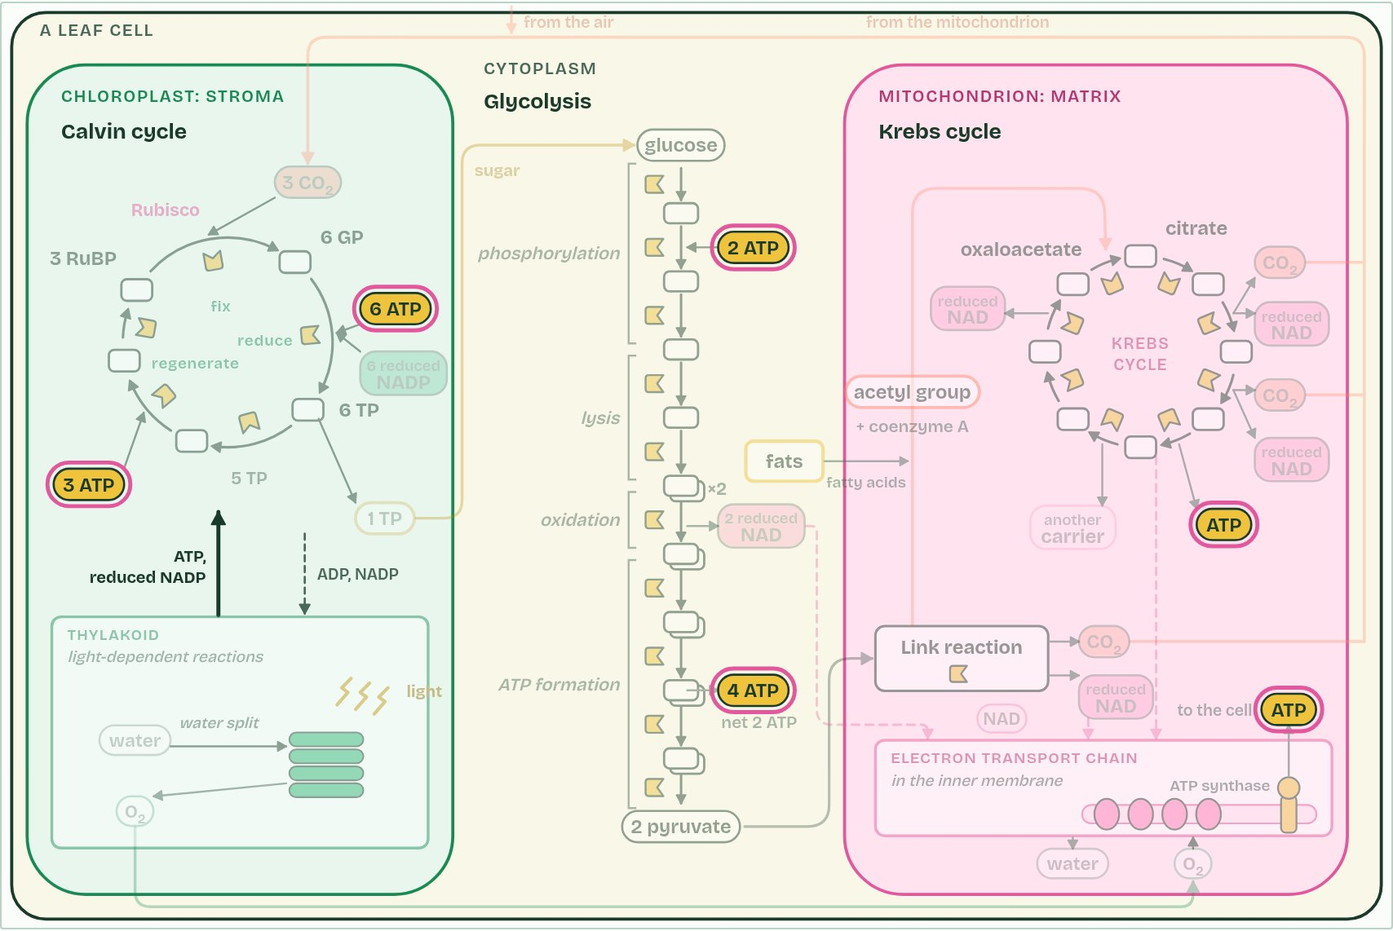  1 The link reaction, in the matrix: each pyruvate loses carbon dioxide and is oxidised, making reduced NAD, and coenzyme A carries the acetyl group on.  2 Reduced NAD from glycolysis, the link reaction and the Krebs cycle hands its electrons to the electron transport chain, and goes back as NAD.  3 ATP and reduced NADP from the thylakoid reduce GP to TP. One TP in six leaves; the other five, with more ATP, remake RuBP.  4 Follow ATP: made in glycolysis, the Krebs cycle, at the electron transport chain and in the thylakoid; used in glycolysis, the Calvin cycle and all over the cell.
  SPOT THE MISTAKE
  What do students often get wrong about interdependence of the light-dependent and light-independent reactions? Write the mistake, then put it right.
  “Light-independent” does not mean “happens in the dark”. The Calvin cycle needs the products of the light reactions, so in a leaf it runs only in the light.
SUMMARY
Sum up section 15 in two or three sentences of your own.
• Light-dependent reactions make ATP and reduced NADP; the Calvin cycle uses them and returns ADP, phosphate and NADP.
• No light: the Calvin cycle stops a few seconds later.
• No carbon dioxide: NADP is not returned, so photosystem I fills, then the chain, then photosystem II stops.

Check yourself
The check for this guide is online: a fresh paper of past-paper style questions from the exam bank on C1.3 each time, marked as you go, and saved to your Exam practice progress when you are signed in. Open the link:
biologybybradford.com/exam-maker/sit?topics=C1.3&level=HL&paper=quiz&marks=15&src=ep

