Name | Class | Date
IB BIOLOGY · C1.3

Photosynthesis
Notes to fill in alongside the guide. Each numbered block matches a chapter of the guide, and of the lesson slides. Write in the gaps, answer the cues, annotate the figures, and sum up each section in your own words.
BY THE END YOU CAN
Explain how photosynthesis turns light energy into the chemical energy of carbon compounds, and why ecosystems depend on it C1.3.1
Write the word equation, say where each atom of glucose comes from, and explain why the oxygen given off comes from water C1.3.2, C1.3.3
Separate leaf pigments by chromatography, work out Rf values and identify each pigment by colour and Rf C1.3.4
Explain why pigments absorb only some wavelengths, and read and sketch an absorption spectrum with wavelengths and colours C1.3.5
Compare absorption and action spectra, and plot an action spectrum from oxygen or carbon dioxide data C1.3.6
Suggest and test hypotheses about light, carbon dioxide and temperature as limiting factors, naming the variables C1.3.7
Compare greenhouse and FACE experiments as ways of predicting how plants will grow in tomorrow's air C1.3.8
Describe a photosystem and explain why pigments work only as an array round a reaction centre C1.3.9, C1.3.10
Explain how photolysis at photosystem II supplies electrons and protons, and what its waste oxygen did to the Earth C1.3.11
Explain how a proton gradient and ATP synthase make ATP in the thylakoid, by cyclic and non-cyclic photophosphorylation C1.3.12
Explain how photosystem I reduces NADP, and where in a thylakoid each light-dependent step happens C1.3.13, C1.3.14
Explain how Rubisco fixes carbon dioxide onto RuBP, and why the stroma needs so much of it C1.3.15
Follow the carbon through the Calvin cycle: GP reduced to TP, and five TP in six remade into RuBP C1.3.16, C1.3.17
Explain how every carbon compound in a plant is made from the Calvin cycle's products with mineral nutrients C1.3.18
Explain why the light-dependent and light-independent reactions stop without each other C1.3.19

01 Sunlight in, chemical energy out | C1.3.1
CUES  Predict: The chemical energy in a slice of cheese: where did it first come from?  What is meant by photosynthesis?  What is meant by light energy?  What is meant by chemical energy?  What is meant by carbon compounds?  What is meant by energy transformation?  What is meant by producers? | NOTES  1 ___________________ transforms ________________ into ____________________.  2 In a leaf, pigments absorb light, and that energy ends up in the bonds of ______________________ the plant builds: first sugars, then everything else it is made of.  3 Light is not stored. It is changed into a different form, an ____________________________.  4 Plants, algae and cyanobacteria are ____________.  5 ___________________ transforms light energy into the chemical energy of carbon compounds.  6 ____________ make the carbon compounds that every consumer in a food chain depends on.  7 Energy flows light, then ____________________ in sugar, then ATP, then work and heat.  Your own notes  ANNOTATE THE FIGURE  Number the 4 steps on the figure and note what happens at each.  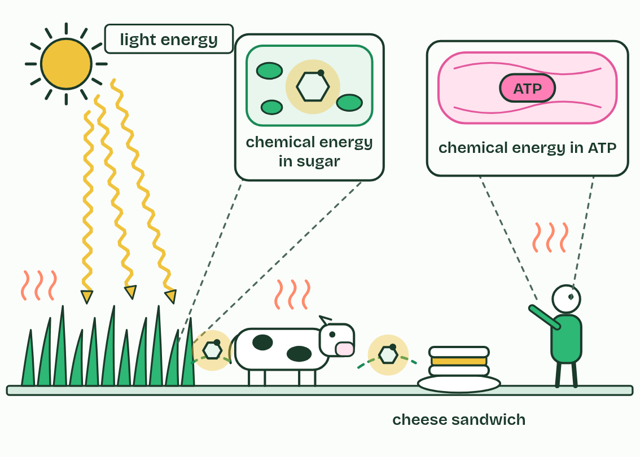
  SPOT THE MISTAKE
  What do students often get wrong about light energy to chemical energy? Write the mistake, then put it right.
  The mistake
  Put it right
SUMMARY
Sum up section 01 in two or three sentences of your own.

02 Carbon from the air, hydrogen from water | C1.3.2 C1.3.3
CUES  Predict: Where does the oxygen gas a leaf gives off come from?  What is meant by word equation?  What is meant by glucose?  What is meant by photolysis?  What is meant by by-product?  What is meant by algae?  What is meant by cyanobacteria? | NOTES  1 The __________________ for photosynthesis is __________________________________, with light energy and chlorophyll written over the arrow.  2 In symbols it reads 6CO₂ + 6H₂O → C₆H₁₂O₆ + 6O₂, and the product that matters is _________.  3 It splits water using energy from the light that chlorophyll absorbs, a step called ______________, and the hydrogen is added to carbon dioxide to build glucose.  4 The oxygen gas a leaf gives off is a ______________.  5 Every organism that photosynthesises this way gives off oxygen: plants, ________ (from single cells to seaweeds) and __________________.  6 Carbon dioxide + water → _________ + oxygen, with light energy and chlorophyll over the arrow.  7 _________’s carbon and oxygen come from carbon dioxide; its hydrogen comes from water.  8 The oxygen given off comes from the water that is split, and is a ______________.  Your own notes  ANNOTATE THE FIGURE  Number the 4 steps on the figure and note what happens at each.  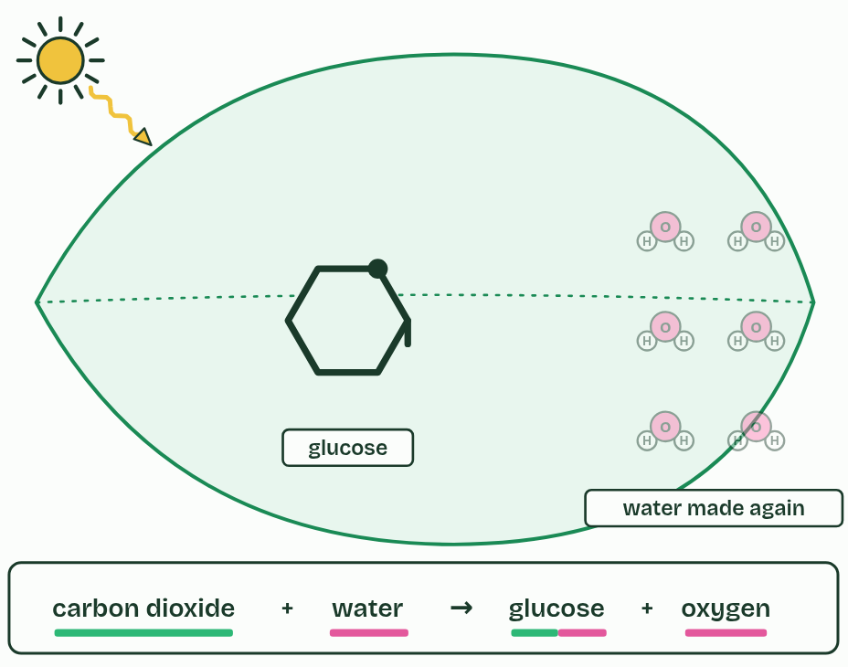  ANNOTATE THE FIGURE  Label the key parts and add a note on what it shows.  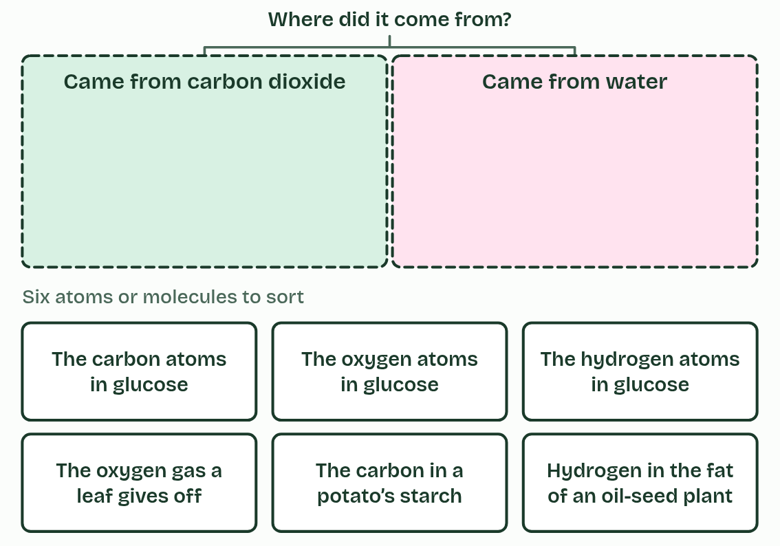  ANNOTATE THE FIGURE  Annotate this still from the animation (From light to sugar): what is happening, and why?  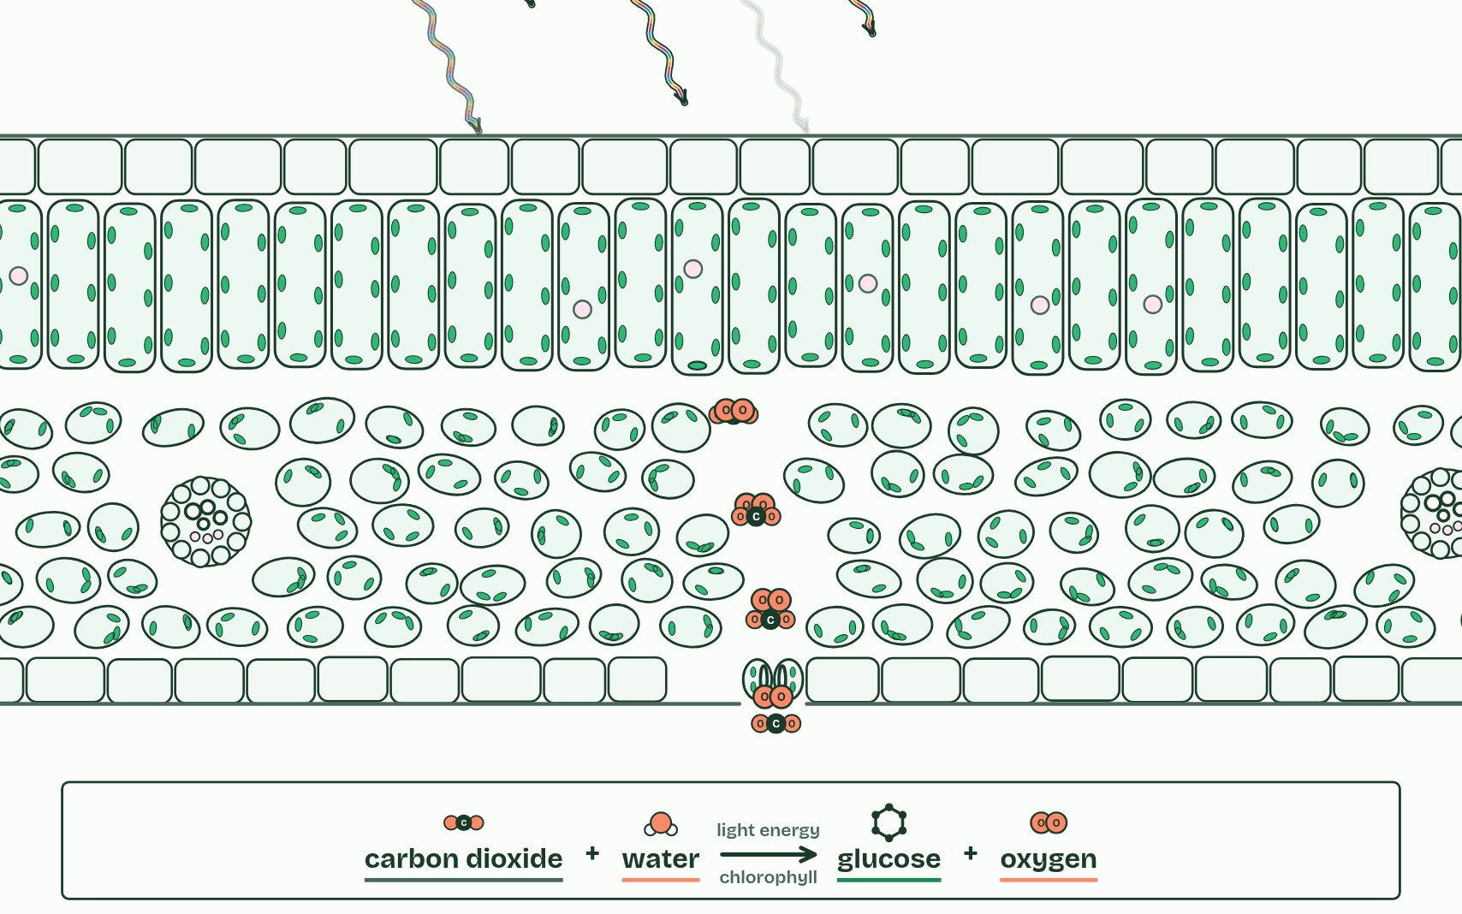
  SPOT THE MISTAKE
  A student writes: “The oxygen comes from carbon dioxide.” Spot the mistake, then put it right.
  The mistake
  Put it right
SUMMARY
Sum up section 02 in two or three sentences of your own.

03 More than one green | C1.3.4
CUES  Predict: The solvent front has moved 8.0 cm from the origin and a yellow band 5.7 cm. What is the band’s Rf?  What is meant by pigment?  What is meant by chlorophyll a?  What is meant by chlorophyll b?  What is meant by carotenes?  What is meant by xanthophylls?  What is meant by chromatography?  What is meant by origin?  What is meant by stationary phase?  What is meant by solvent?  What is meant by mobile phase?  What is meant by solvent front?  What is meant by rf value? | NOTES  1 A leaf’s green is not one _________ but several, mixed. __________________ is the main one, blue-green. __________________ is yellow-green.  2 Beside them are the yellow and orange carotenoids: ____________ and ________________.  3 ___________________ separates a mixture.  4 A small, dark spot of leaf extract goes on a pencil line, the ________, near the bottom of a strip of chromatography paper (or a thin-layer plate, the ______________________).  5 The strip stands in a shallow layer of _________ (the ________________) below the spot, in a closed tube.  6 The __________________ marks how far the solvent went, and the ___________ compares the two:  7 Pencil, not ink, for the ________: ink is a mixture and runs too.  8 _________ below the origin, and a lid on the tube.  Your own notes  ANNOTATE THE FIGURE  The figure shows it at time 0 and 100. Note what changes each time.  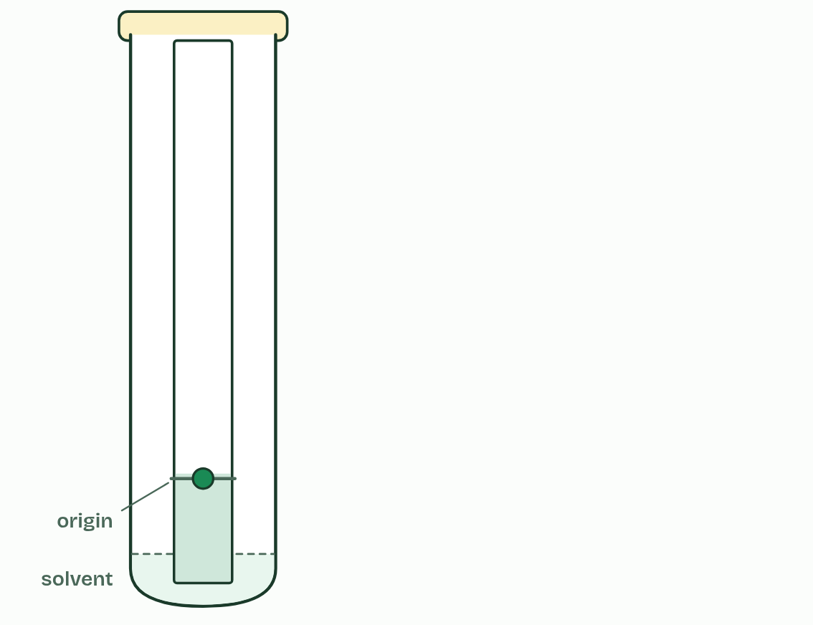  ANNOTATE THE FIGURE  Number the 3 steps on the figure and note what happens at each.  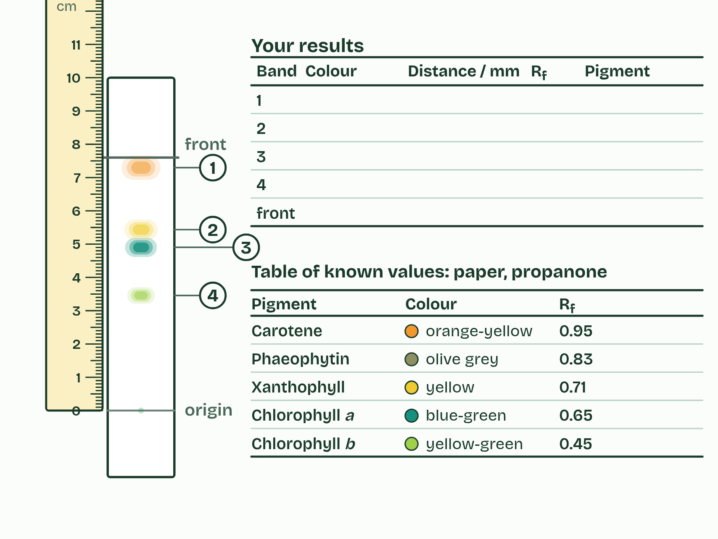
  SPOT THE MISTAKE
  What do students often get wrong about separation and identification of pigments by chromatography? Write the mistake, then put it right.
  The mistake
  Put it right
SUMMARY
Sum up section 03 in two or three sentences of your own.

04 Why some colours and not others | C1.3.5
CUES  Predict: Why does chlorophyll absorb red and blue light but very little green?  What is meant by visible light?  What is meant by wavelengths?  What is meant by absorbs?  What is meant by excited?  What is meant by reflection?  What is meant by accessory pigments?  What is meant by absorption spectrum? | NOTES  1 __________________ is the band of _______________ from about 400 nm (violet) to about 700 nm (red).  2 A pigment _________ a photon only if the photon’s energy matches a jump one of its electrons can make to a higher energy level.  3 The electron is then _________.  4 Photons with other energies are not absorbed: they pass through the pigment or bounce off it, which is ______________.  5 ________________________, the carotenoids, absorb blue and blue-green light that chlorophyll a takes up less, and widen the range of light a leaf can use.  6 An __________________________ shows, wavelength by wavelength, how much of the light a pigment takes in.  7 __________________ runs from about 400 nm (violet) to about 700 nm (red).  8 Chlorophyll _________ blue and red strongly and reflects green, so a leaf looks green.  Your own notes  ANNOTATE THE FIGURE  Number the 4 steps on the figure and note what happens at each: 1 White light; 2 blue, red, green; 3 absorption spectrum; 4 Accessory pigments.  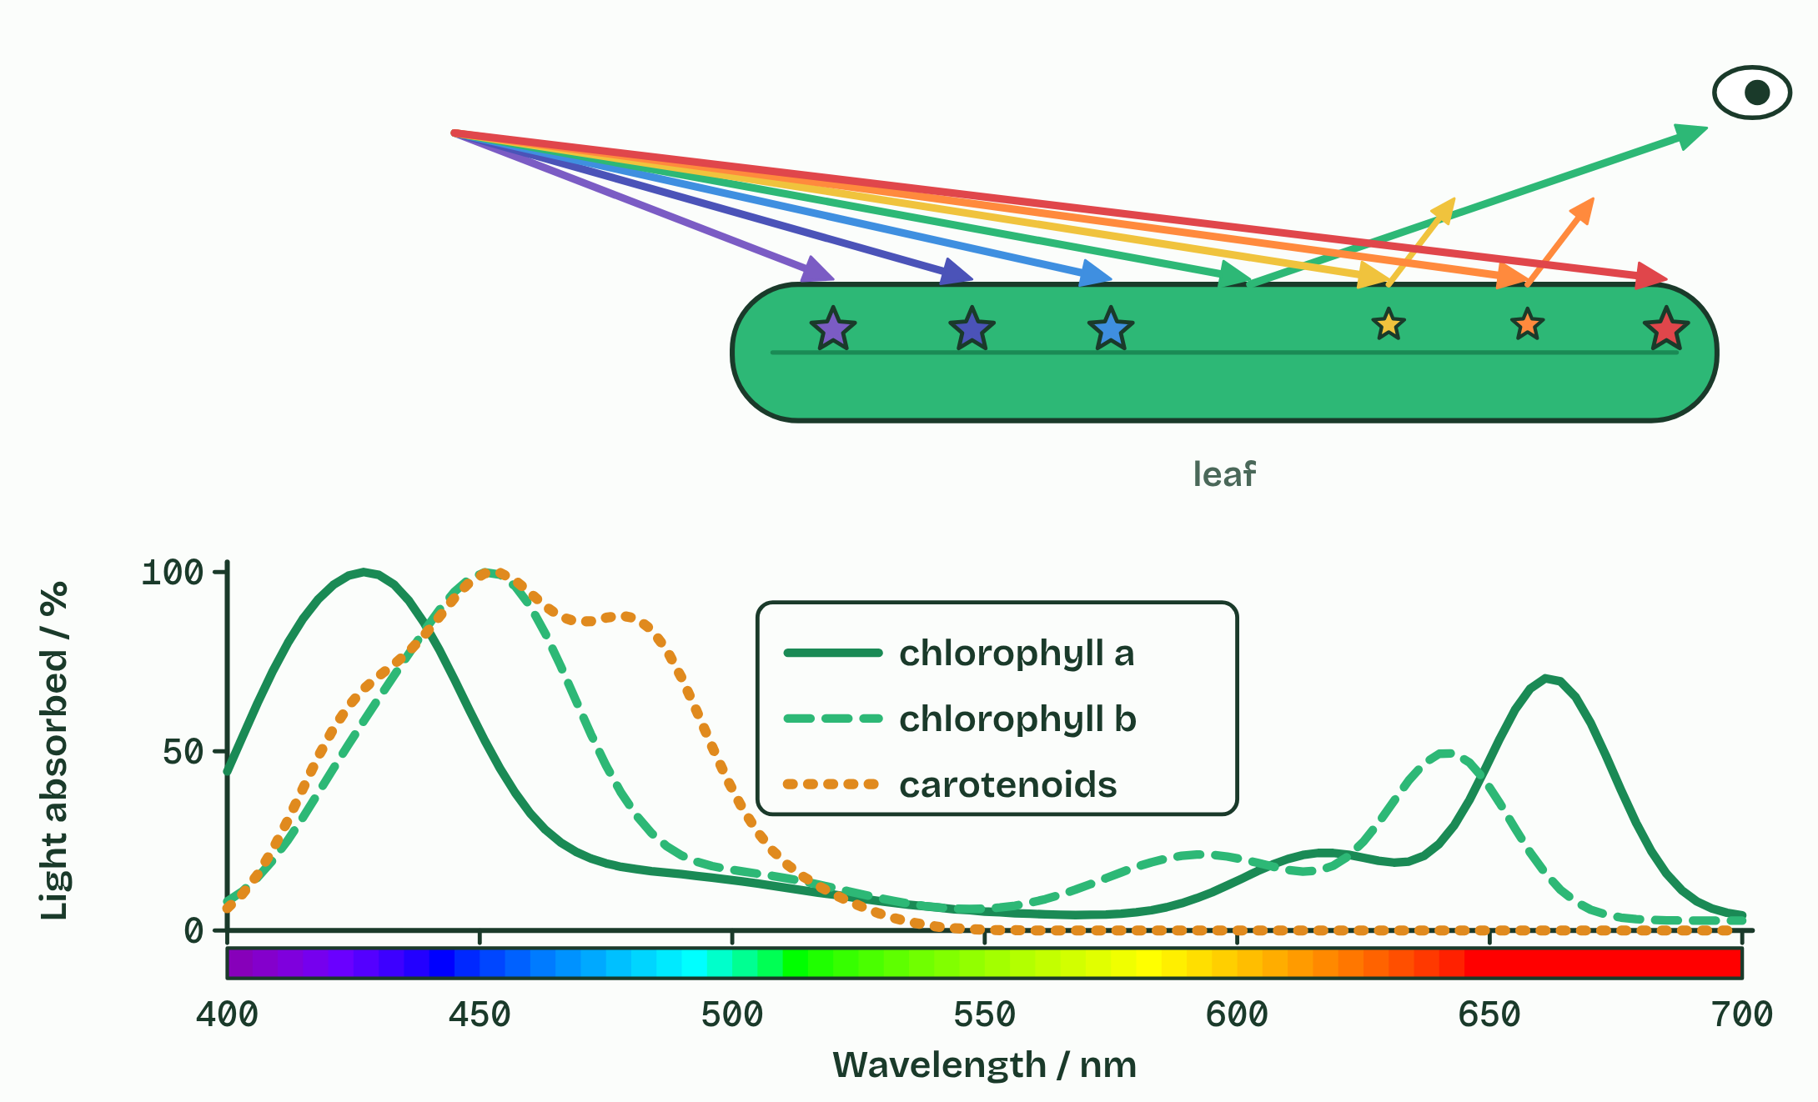  ANNOTATE THE FIGURE  Label the key parts and add a note on what it shows.  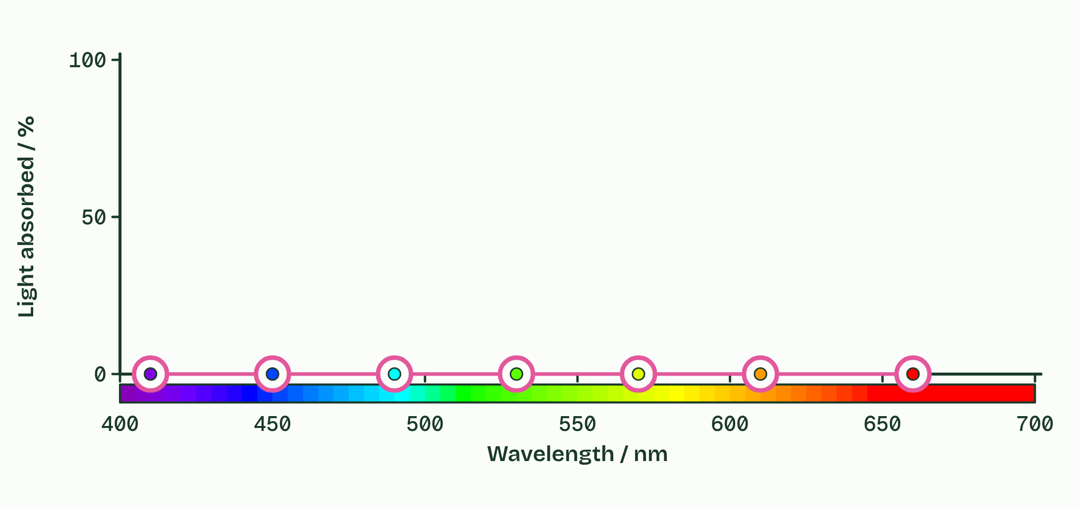  REMEMBER IT  The colours, longest wavelength first
  R  Richard | O  Of | Y  York | G  Gave | B  Battle | I  In | V  Vain
  R | O | Y | G | B | I | V
  SPOT THE MISTAKE
  What do students often get wrong about absorption of specific wavelengths by photosynthetic pigments? Write the mistake, then put it right.
  The mistake
  Put it right
SUMMARY
Sum up section 04 in two or three sentences of your own.

05 Absorbed is not the same as used | C1.3.6
CUES  Predict: Engelmann shone a spectrum along a strand of alga and added bacteria that swim towards oxygen. Where did the bacteria gather?  What is meant by action spectrum?  What is meant by rate of photosynthesis? | NOTES  1 An ____________________ plots how fast photosynthesis runs against the wavelength of the light a plant is given.  2 The ______________________________ is the amount of oxygen produced (or carbon dioxide consumed) divided by the time taken, for example cm³ of oxygen ÷ 10 minutes, in cm³ min⁻¹.  3 ______________________________ = oxygen produced (or carbon dioxide consumed) ÷ time.  4 Different: the ____________________ is a rate, its green dip is shallower, and its blue peak is lower than the absorption there.  Your own notes  ANNOTATE THE FIGURE  Label the key parts and add a note on what it shows.  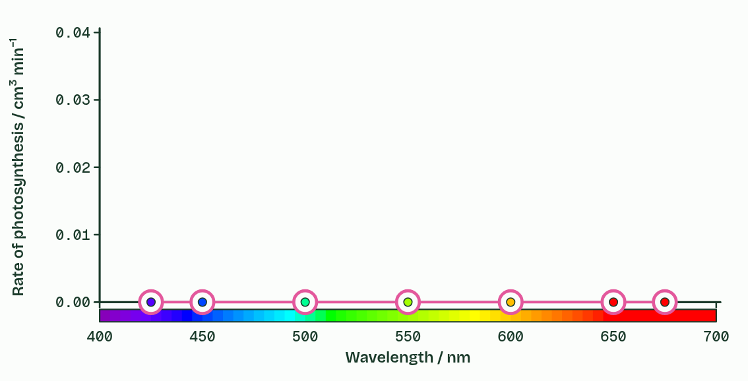  ANNOTATE THE FIGURE  Annotate this still from the animation (Engelmann’s bacteria): what is happening, and why?  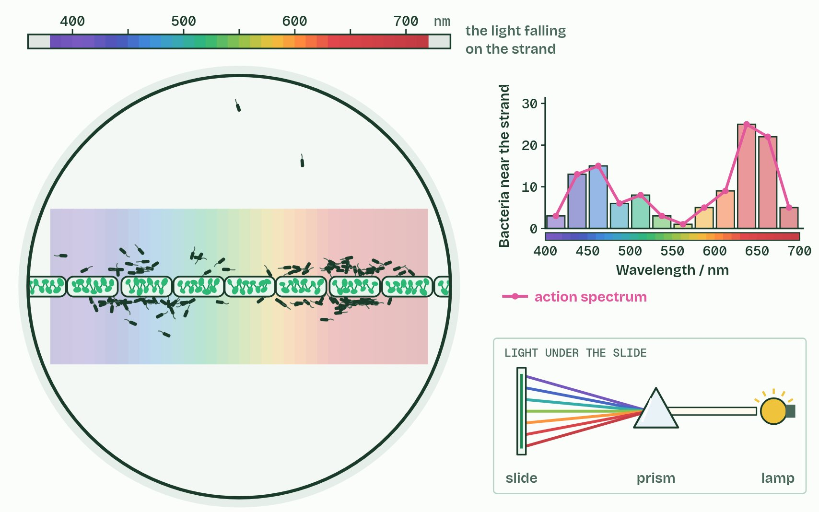
  SPOT THE MISTAKE
  What do students often get wrong about absorption and action spectra compared? Write the mistake, then put it right.
  The mistake
  Put it right
SUMMARY
Sum up section 05 in two or three sentences of your own.

06 Whatever runs short sets the pace | C1.3.7
CUES  Predict: A plant at 15 °C is given more and more light until its rate levels off. Then it is warmed to 25 °C. What happens to the rate?  What is meant by limiting factor?  What is meant by light intensity?  What is meant by carbon dioxide concentration?  What is meant by hypothesis?  What is meant by independent variable?  What is meant by dependent variable?  What is meant by controlled variables? | NOTES  1 Raising that ____________________ speeds the process up, and raising the others does nothing, until one of them becomes the shortest.  2 ____________________ limits the supply of energy for splitting water.  3 The rate rises with light, then levels off when something else limits. __________________________________ limits the fixing of carbon in the same way.  4 A ______________ is a provisional explanation that must be tested again and again.  5 Either way you name the ___________________________ (what you change), the ________________________ (what you measure) and the ___________________________ (everything else, kept the same).  6 ____________________: the factor in shortest supply, which sets the rate.  7 A ______________ names the independent, dependent and controlled variables.  Your own notes  ANNOTATE THE FIGURE  Label the key parts and add a note on what it shows.  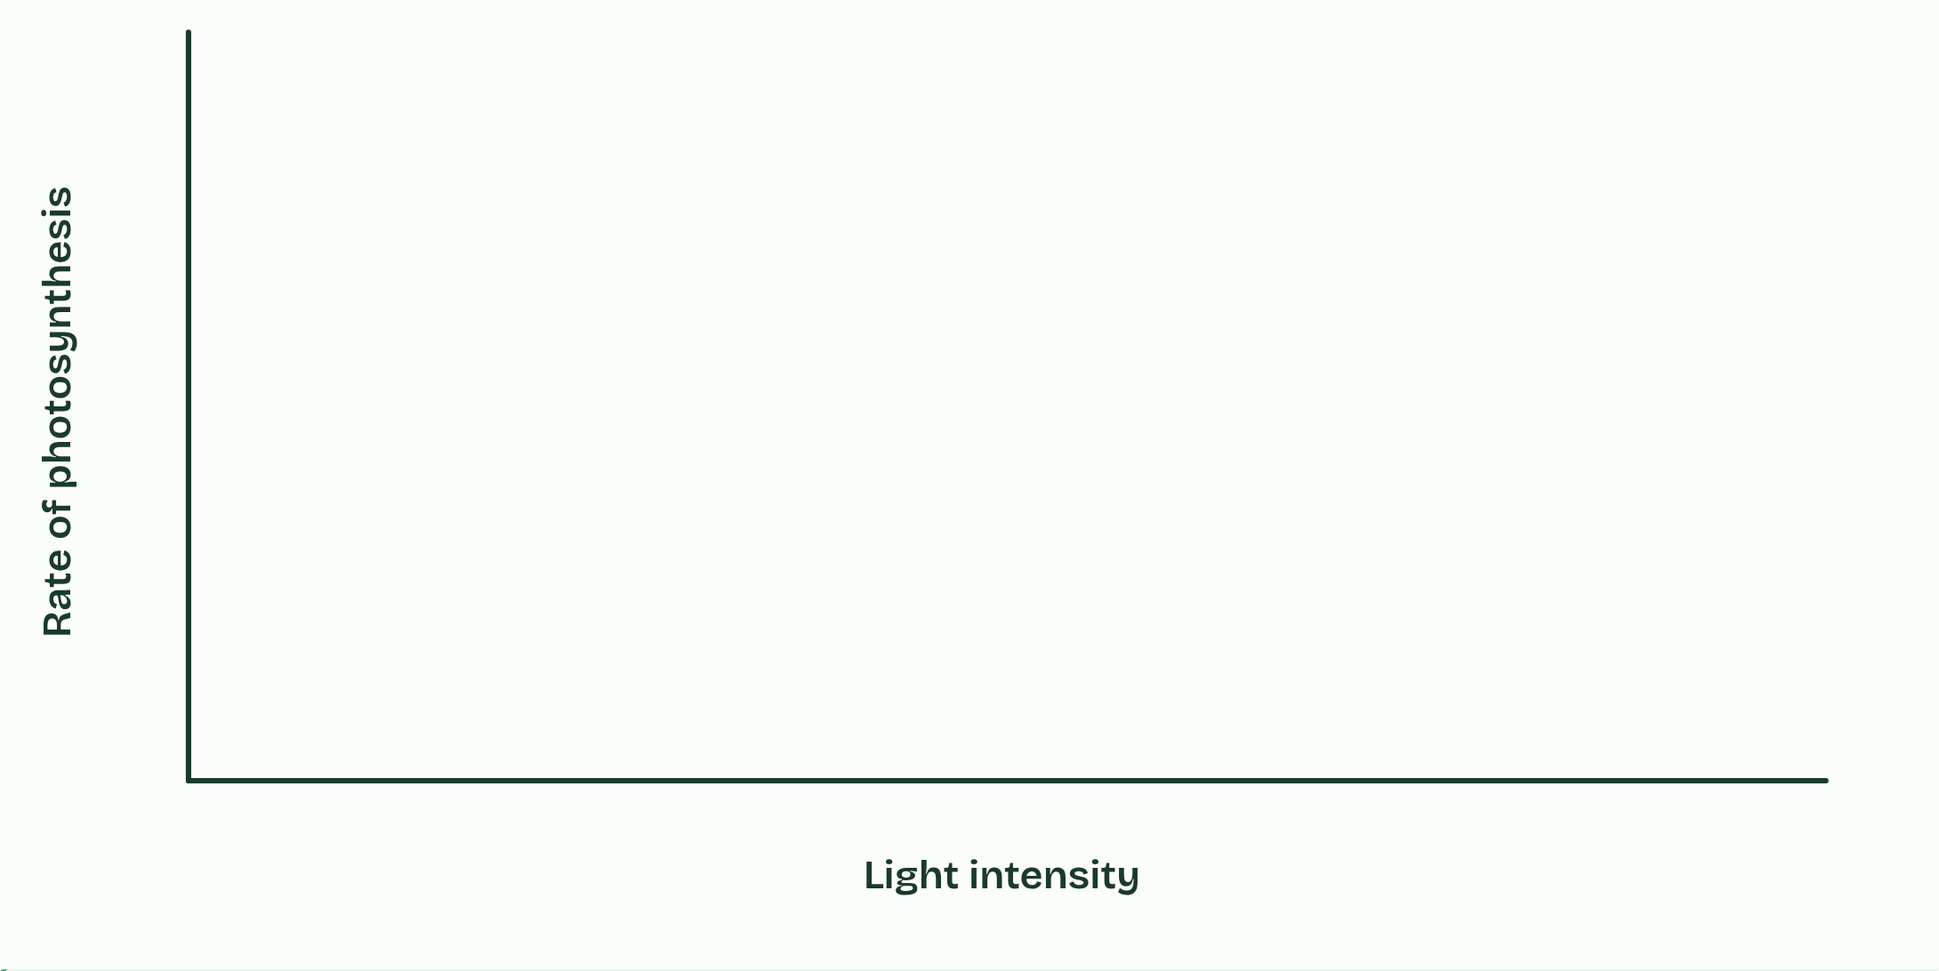  REMEMBER IT  The three limiting factors
  L  Lazy | C  Cats | T  Toast
  L | C | T
  SPOT THE MISTAKE
  What do students often get wrong about varying light, carbon dioxide and temperature to test limiting factors? Write the mistake, then put it right.
  The mistake
  Put it right
SUMMARY
Sum up section 06 in two or three sentences of your own.

07 Tomorrow’s air, today | C1.3.8
CUES  Predict: Crops given extra carbon dioxide gained less yield in FACE rings than in enclosures. What is the most likely reason?  What is meant by carbon dioxide enrichment?  What is meant by greenhouse?  What is meant by free-air carbon dioxide enrichment (FACE)?  What is meant by laboratory or greenhouse?  What is meant by field? | NOTES  1 __________________________________ experiments grow plants in the carbon dioxide expected later this century (about 550 to 600 ppm) beside plants in today’s air, and compare photosynthesis, growth and yield.  2 In an enclosed ______________ experiment, carbon dioxide from a gas cylinder holds the air at the chosen level.  3 In __________________________________, a ring of pipes up to about 20 to 30 m across stands in a field or a forest.  4 Careful control of variables is part of designing an experiment. It is easier in a ________________________________, but some questions can only be answered in the ________.  5 A ______________ controls more variables; FACE keeps field conditions and real ecosystems.  6 Name a controlled variable for each: the ______________’s temperature, FACE’s crop variety and sowing date.  Your own notes  ANNOTATE THE FIGURE  Number the 3 steps on the figure and note what happens at each.  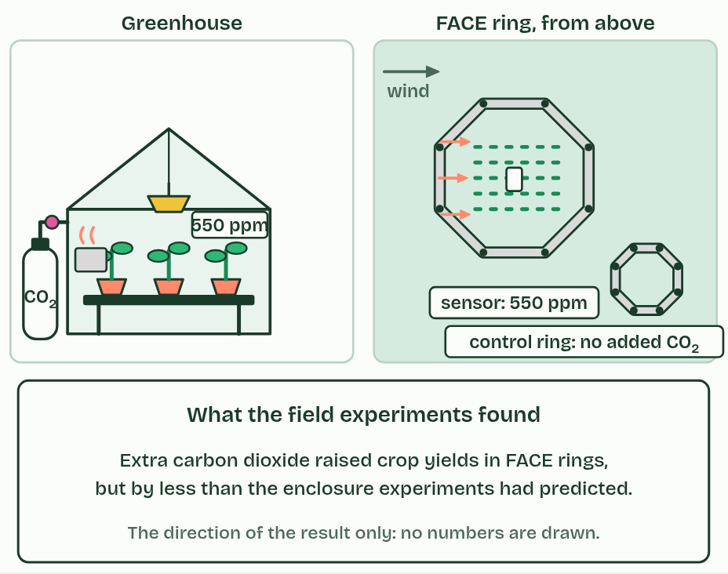
  SPOT THE MISTAKE
  What do students often get wrong about carbon dioxide enrichment experiments? Write the mistake, then put it right.
  The mistake
  Put it right
SUMMARY
Sum up section 07 in two or three sentences of your own.

08 Pigments in an array | C1.3.9 HL C1.3.10 HL
CUES  Predict: Chlorophyll dissolved in propanone glows red under a bright light. Chlorophyll in a leaf hardly glows at all. Why?  What is meant by photosystem?  What is meant by thylakoid membranes?  What is meant by reaction centre?  What is meant by excited electron?  What is meant by photosystem II?  What is meant by photosystem I? | NOTES  1 A _______________ is an array of a few hundred pigment molecules, chlorophylls and accessory pigments, held in fixed positions by proteins.  2 Photosystems are always in a membrane: the __________________________ of a chloroplast, or the internal membranes of a cyanobacterium.  3 At the heart of each is the ____________________, a special chlorophyll a.  4 There an ______________________ is emitted: it leaves the chlorophyll altogether, passing to an electron acceptor beside it in the membrane.  5 There are two kinds of photosystem, ___________________ and __________________, numbered in the order they were discovered.  6 A _______________ is an array of pigments round a reaction centre, always in a membrane.  7 Pigments pass on energy; only the ____________________ emits an excited electron.  Your own notes  ANNOTATE THE FIGURE  Number the 5 steps on the figure and note what happens at each.  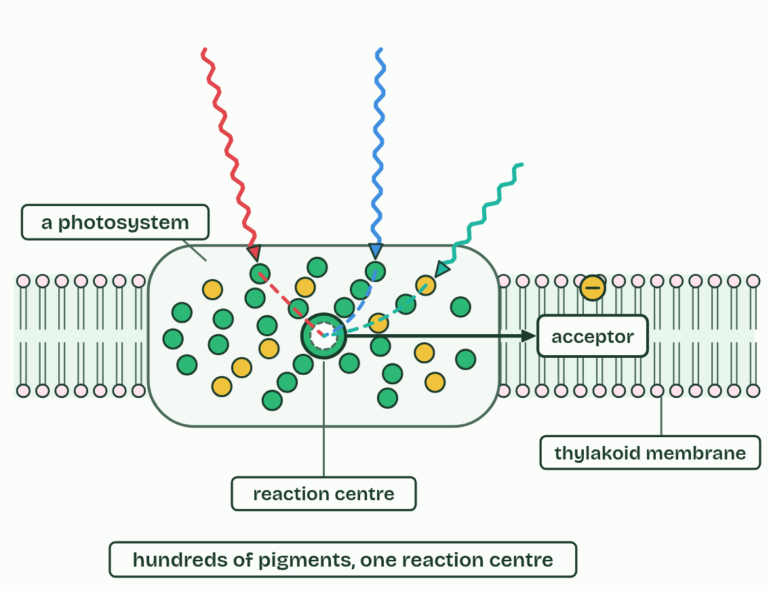
  SPOT THE MISTAKE
  What do students often get wrong about photosystems, and the advantage of the array? Write the mistake, then put it right.
  The mistake
  Put it right
SUMMARY
Sum up section 08 in two or three sentences of your own.

09 Water split, oxygen spare | C1.3.11 HL
CUES  Predict: Cyanobacteria were splitting water for a long time before oxygen built up in the air. Where did their oxygen go at first?  What is meant by photolysis?  What is meant by protons?  What is meant by waste product?  What is meant by banded iron formations?  What is meant by great Oxidation Event? | NOTES  1 The splitting of water, ______________, is done by an enzyme on the lumen side of photosystem II.  2 The _________ are released into the lumen, where they add to the proton gradient (chapter 10).  3 The oxygen is a __________________: it diffuses out of the chloroplast, the cell and the leaf.  4 The oxygen they released first reacted with iron dissolved in the oceans, which settled as layers of iron oxide on the sea floor: the ______________________________.  5 When the iron was used up, oxygen built up in the air, in the ____________________________, about 2.4 billion years ago.  6 ______________ at photosystem II: 2 water give 4 electrons, 4 protons and 1 oxygen.  7 The electrons and _________ are used; the oxygen is waste.  Your own notes  ANNOTATE THE FIGURE  Number the 4 steps on the figure and note what happens at each.  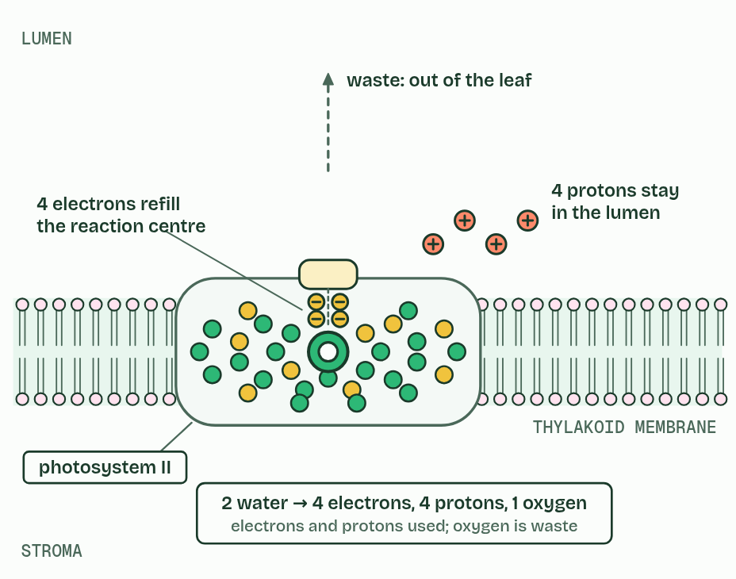  ANNOTATE THE FIGURE  Label the key parts and add a note on what it shows.  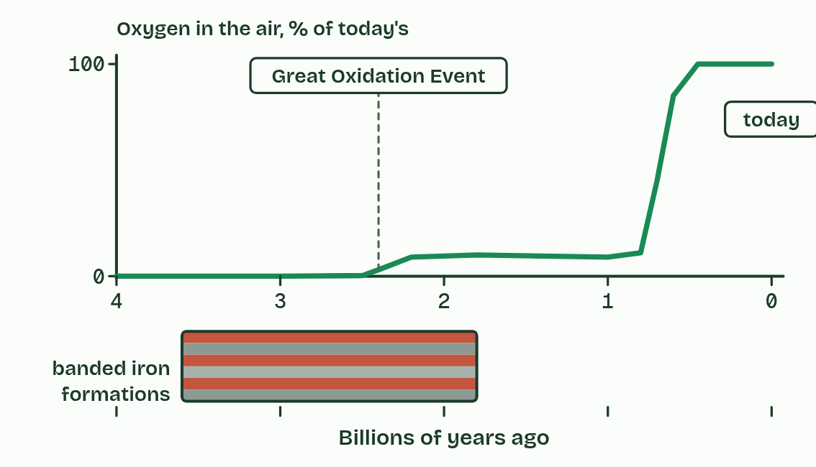  REMEMBER IT  What photolysis gives
  P  Please | E  Eat | O  Oranges
  P | E | O
  SPOT THE MISTAKE
  What do students often get wrong about oxygen from the photolysis of water in photosystem II? Write the mistake, then put it right.
  The mistake
  Put it right
SUMMARY
Sum up section 09 in two or three sentences of your own.

10 Protons downhill make ATP | C1.3.12 HL
CUES  Predict: In a working chloroplast, where do protons build up?  What is meant by chain of electron carriers?  What is meant by proton pumping?  What is meant by thylakoid lumen?  What is meant by proton gradient?  What is meant by ATP synthase?  What is meant by chemiosmosis?  What is meant by non-cyclic photophosphorylation?  What is meant by cyclic photophosphorylation? | NOTES  1 The excited electron from photosystem II passes along a __________________________________ in the thylakoid membrane towards photosystem I, giving up energy at each step.  2 One carrier uses that energy for ___________________: it moves protons across the membrane from the stroma into the ____________________.  3 The lumen is small, so their concentration rises fast, and the membrane does not let them back. That difference is the ____________________.  4 The only way back to the stroma is through ________________, a protein that spans the membrane.  5 Making ATP with energy from a proton gradient is ________________, and when light is the first source the whole process is photophosphorylation.  6 In __________________________________ the electrons come from photosystem II, pass along the chain to photosystem I and on to NADP (chapter 11).  7 In __________________________________, electrons excited at photosystem I go back to the chain, pump more protons and return to photosystem I.  8 Protons flow back through ________________, which makes ATP on the stroma side.  Your own notes  ANNOTATE THE FIGURE  Number the 5 steps on the figure and note what happens at each: 1 photosystems, chain of carriers, ATP synthase; 2 pumps protons; 3 proton gradient; 4 ATP synthase, ATP, chemiosmosis; 5 Non-cyclic, Cyclic.  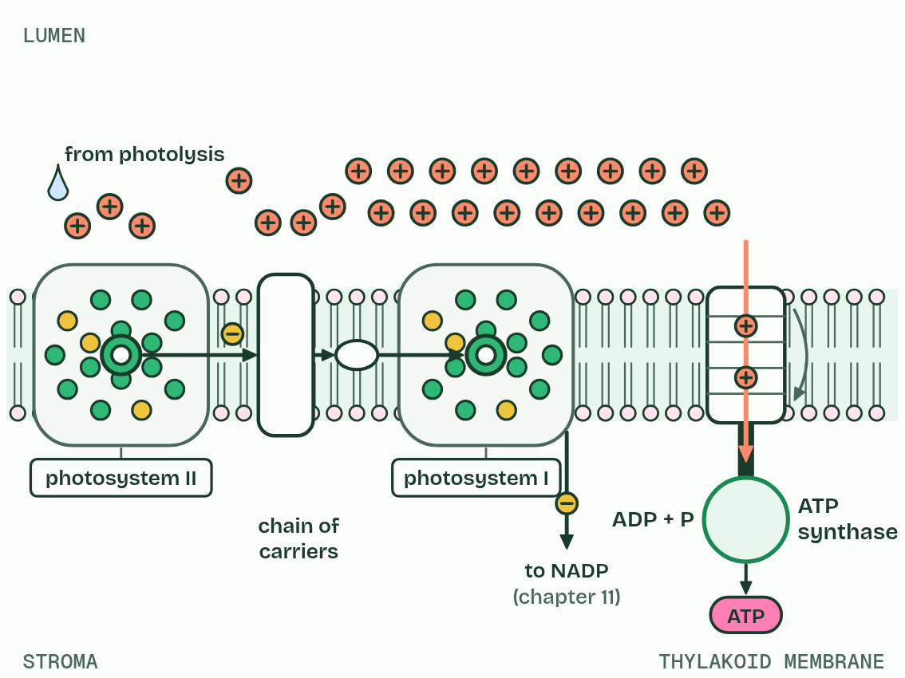
  SPOT THE MISTAKE
  What do students often get wrong about ATP production by chemiosmosis in thylakoids? Write the mistake, then put it right.
  The mistake
  Put it right
SUMMARY
Sum up section 10 in two or three sentences of your own.

11 NADP reduced, and the thylakoid as a system | C1.3.13 HL C1.3.14 HL
CUES  Predict: On which side of the thylakoid membrane is NADP reduced, and why does that side make sense?  What is meant by NADP?  What is meant by reduced NADP?  What is meant by reduction?  What is meant by stroma?  What is meant by grana? | NOTES  1 Light absorbed by photosystem I’s array excites them again, and from its reaction centre they pass, by a short carrier on the stroma side, to ________.  2 NADP picks up two electrons from photosystem I and one hydrogen ion (a proton) from the stroma, and becomes ________________.  3 This is a ____________, and taking that proton from the stroma steepens the gradient a little.  4 Reduced NADP carries the hydrogen, as electrons and a proton, to the Calvin cycle in the ________, where it reduces carbon compounds (chapter 13).  5 Thylakoids are stacked in ________, joined by single unstacked sheets of membrane that run through the stroma; the stacking gives a large area of membrane, and the small lumen builds a steep gradient fast.  6 NADP is reduced at photosystem I, by two electrons from it and a proton from the ________.  7 Photolysis and the proton store are on the lumen side; ATP and ________________ are made on the stroma side.  Your own notes  ANNOTATE THE FIGURE  Label each part and say what it does: stroma, envelope, granum, granum, granum, thylakoid lumen, stroma, photosystem II, chain of carriers, photosystem I, NADP, ATP synthase.  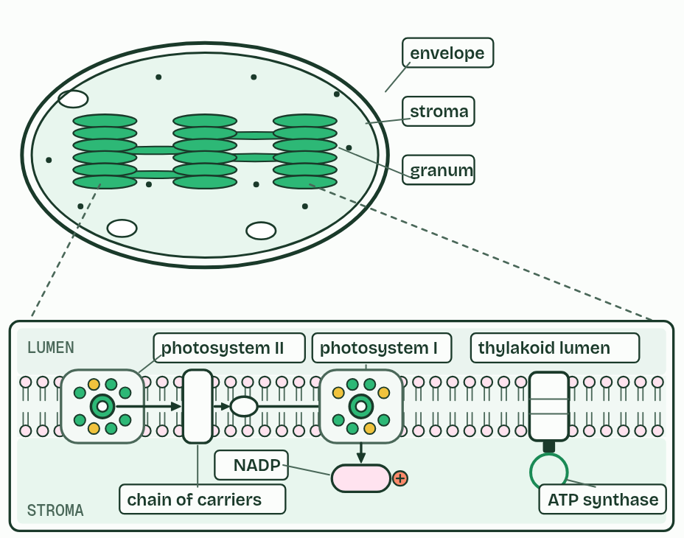  ANNOTATE THE FIGURE  Annotate this still from the animation (The thylakoid at work): what is happening, and why?  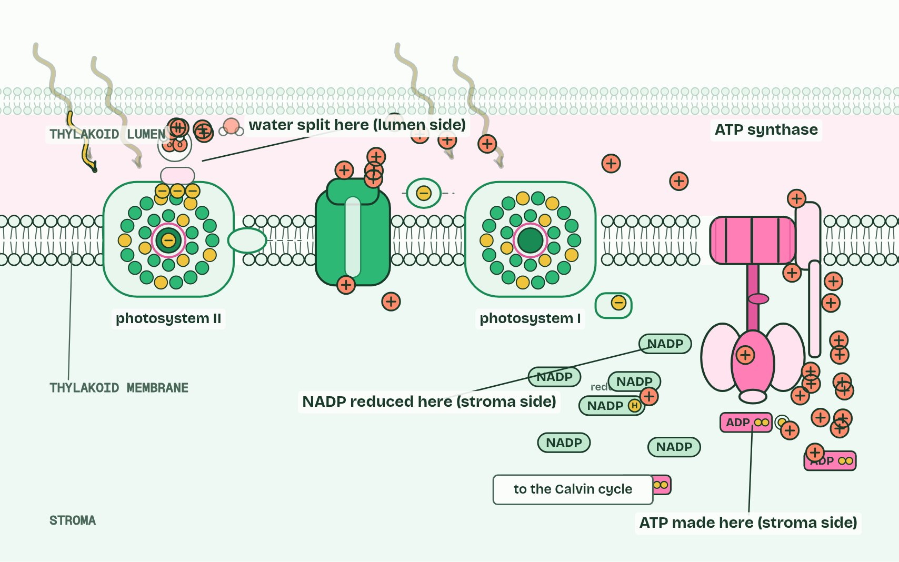  REMEMBER IT  Two sides of the thylakoid
  L  Loads | S  Spends
  L | S
  SPOT THE MISTAKE
  What do students often get wrong about NADP reduced by photosystem I, and the thylakoid as a system? Write the mistake, then put it right.
  The mistake
  Put it right
SUMMARY
Sum up section 11 in two or three sentences of your own.

12 Fixing carbon, slowly | C1.3.15 HL
CUES  Predict: A leaf cell could save a lot of protein by making less Rubisco. Why doesn’t it?  What is meant by calvin cycle?  What is meant by carbon fixation?  What is meant by ribulose bisphosphate (RuBP)?  What is meant by glycerate 3-phosphate (GP)?  What is meant by rubisco? | NOTES  1 The light-independent reactions are a cycle in the stroma, the ________________, named after Melvin Calvin, who worked it out with radioactive carbon in algae.  2 Its first step is ____________________.  3 Carbon dioxide joins a five-carbon sugar already in the stroma, __________________________________.  4 The six carbons split at once into two molecules of the three-carbon __________________________________.  5 The enzyme is _________.  6 ____________________: carbon dioxide joins RuBP (5 carbons), which splits into two GP (3 carbons each).  7 The enzyme is _________: slow, and poor at low carbon dioxide concentrations.  8 The stroma needs a high concentration of _________ for that reason.  Your own notes  ANNOTATE THE FIGURE  Number the 4 steps on the figure and note what happens at each: 1 RuBP, Rubisco; 2 Carbon dioxide, carbon fixation; 3 GP; 4 a lot.  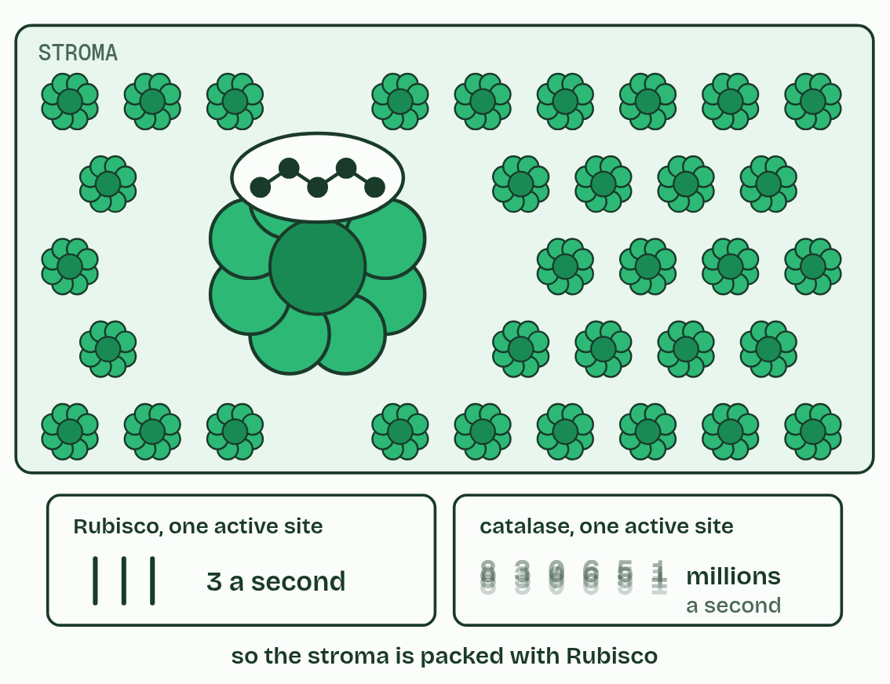  ANNOTATE THE FIGURE  Number the 4 steps on the figure and note what happens at each.  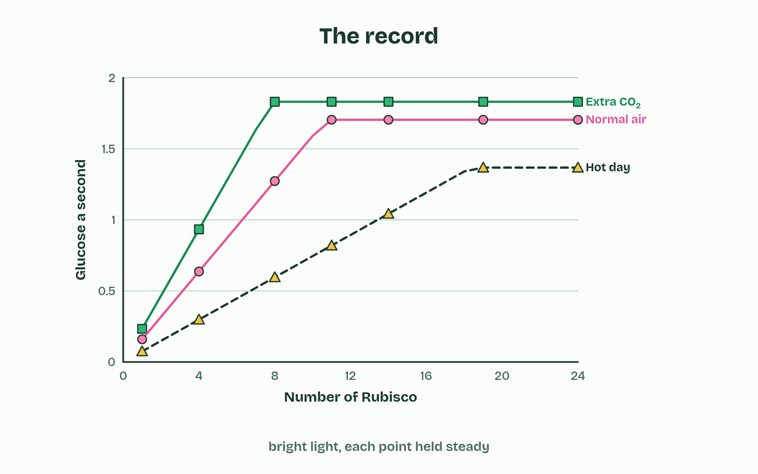
  SPOT THE MISTAKE
  What do students often get wrong about carbon fixation by Rubisco? Write the mistake, then put it right.
  The mistake
  Put it right
SUMMARY
Sum up section 12 in two or three sentences of your own.

13 GP to TP, and RuBP made again | C1.3.16 HL C1.3.17 HL
CUES  Predict: Of every six TP the Calvin cycle makes, how many must be used to remake RuBP?  What is meant by triose phosphate (TP)?  What is meant by regeneration? | NOTES  1 Reduced NADP and ATP from the light-dependent reactions turn GP into ____________________________, a three-carbon sugar, in the stroma.  2 Five TP (fifteen carbons) are rearranged into three RuBP (fifteen carbons), so the cycle can fix carbon dioxide again. This is ________________.  3 Three ________ wait for three ___________________.  4 _________ fixes them: six ________.  5 ________________ and ________ turn GP into ________.  6 Five ________ are remade into three ________, using ATP.  Your own notes  ANNOTATE THE FIGURE  Number the 6 steps on the figure and note what happens at each.  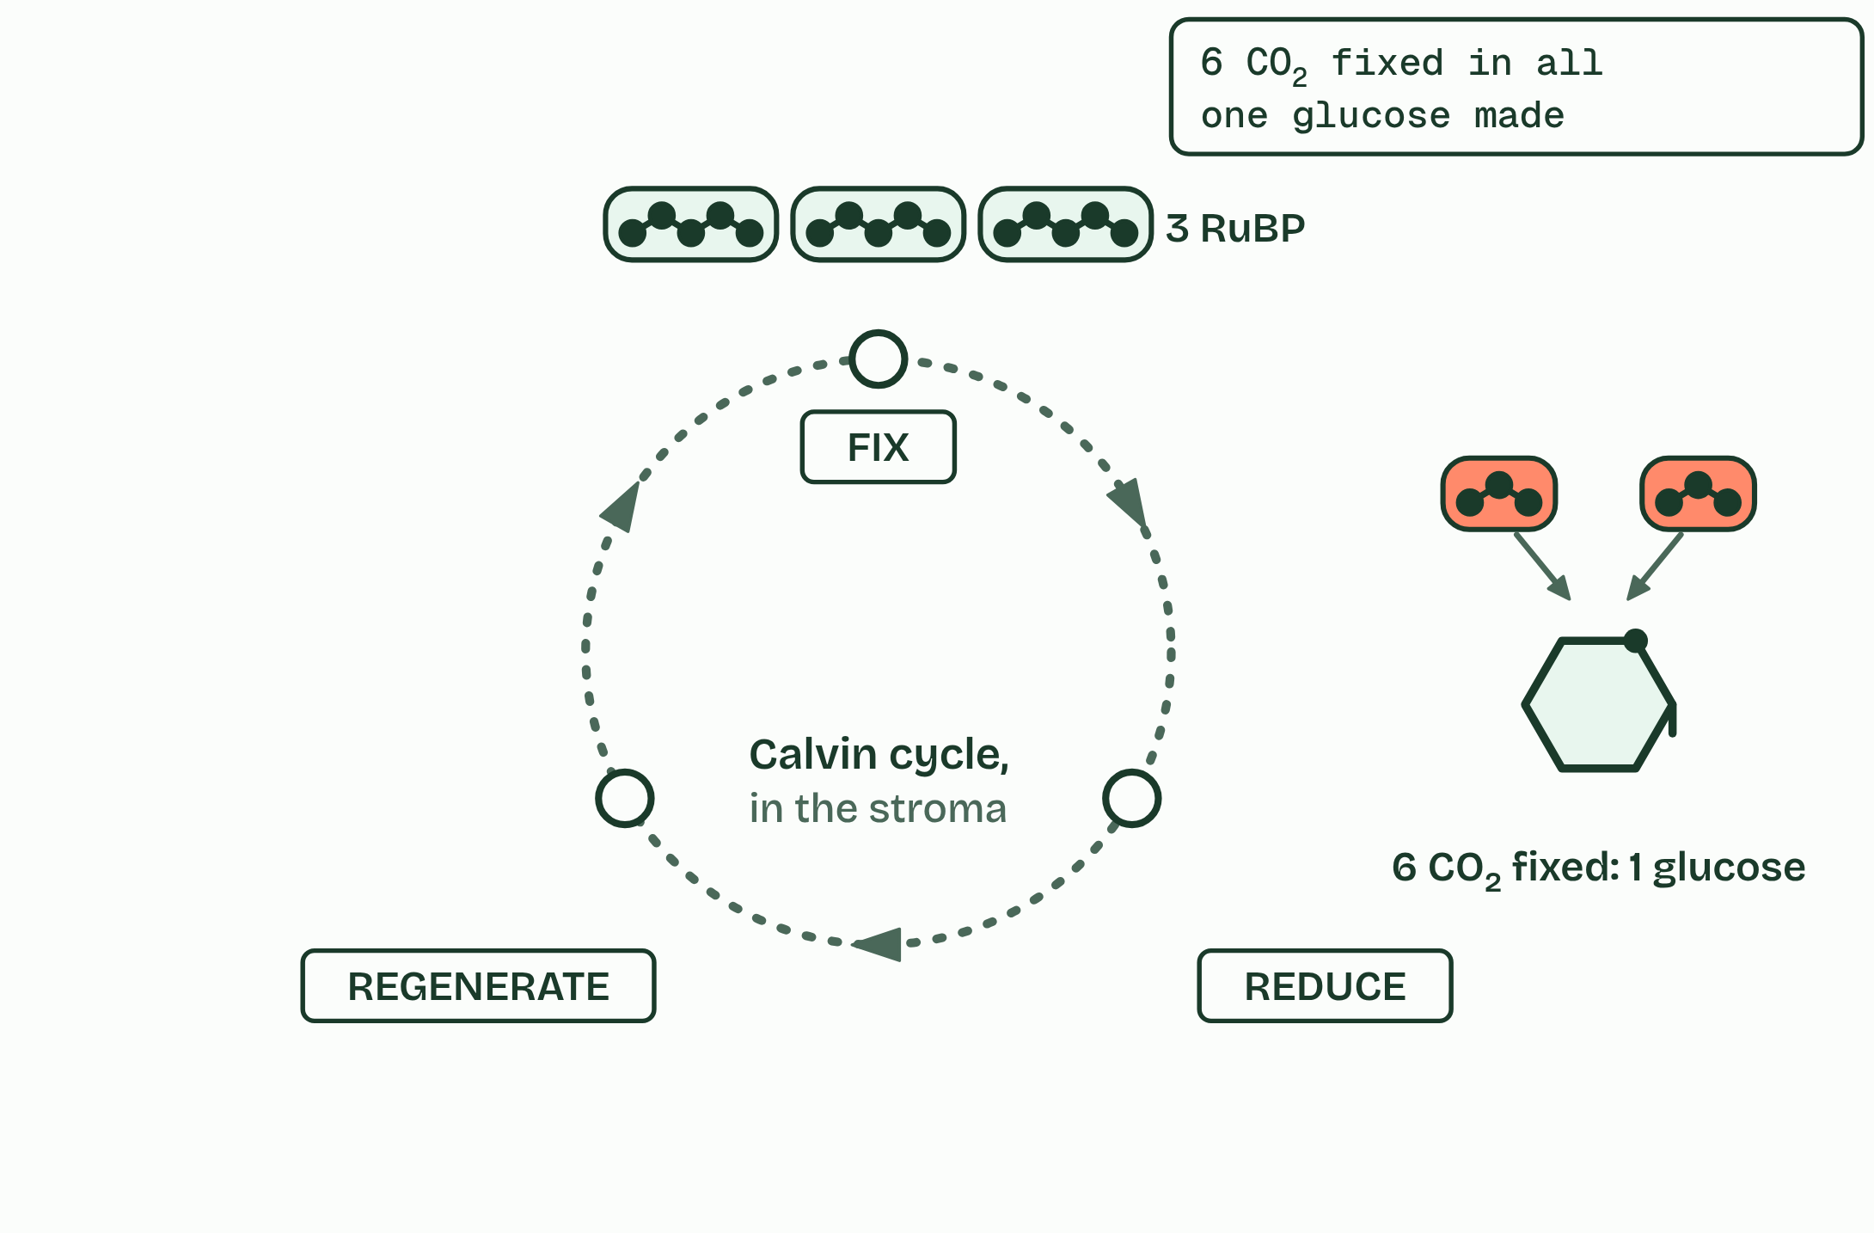  REMEMBER IT  The Calvin cycle’s three stages
  F  Fresh | R  Rolls | R  Rise
  F | R | R
  SPOT THE MISTAKE
  What do students often get wrong about triose phosphate from GP, and RuBP regenerated? Write the mistake, then put it right.
  The mistake
  Put it right
SUMMARY
Sum up section 13 in two or three sentences of your own.

14 Every carbon came this way | C1.3.18 HL
CUES  Predict: A plant has plenty of light, water and carbon dioxide, but its soil has no nitrate. Which will it fail to make?  What is meant by mineral nutrients? | NOTES  1 Nucleotides need nitrogen for their bases and phosphorus for their phosphate. These _______________________ come in through the roots by active transport (B2.1).  2 Amino acids and nucleotides also need _______________________: nitrate, and phosphate.  3 From TP: ________, ________ and ____________.  4 ________.  5 _______________, with nitrogen from _________.  6 _______________, with nitrogen and ____________.  Your own notes  ANNOTATE THE FIGURE  Number the 4 steps on the figure and note what happens at each: 1 sugars, starch, cellulose; 2 Lipids; 3 Amino acids, nitrate; 4 Nucleotides, phosphate.  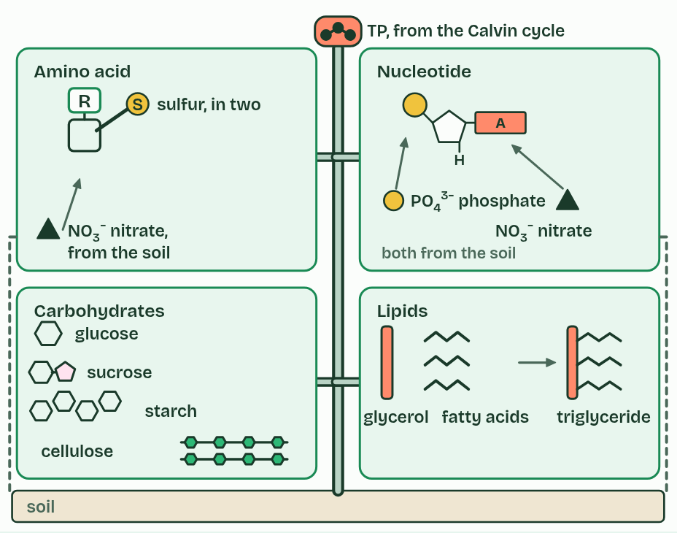  ANNOTATE THE FIGURE  Annotate this still from the animation (Follow one carbon atom): what is happening, and why?  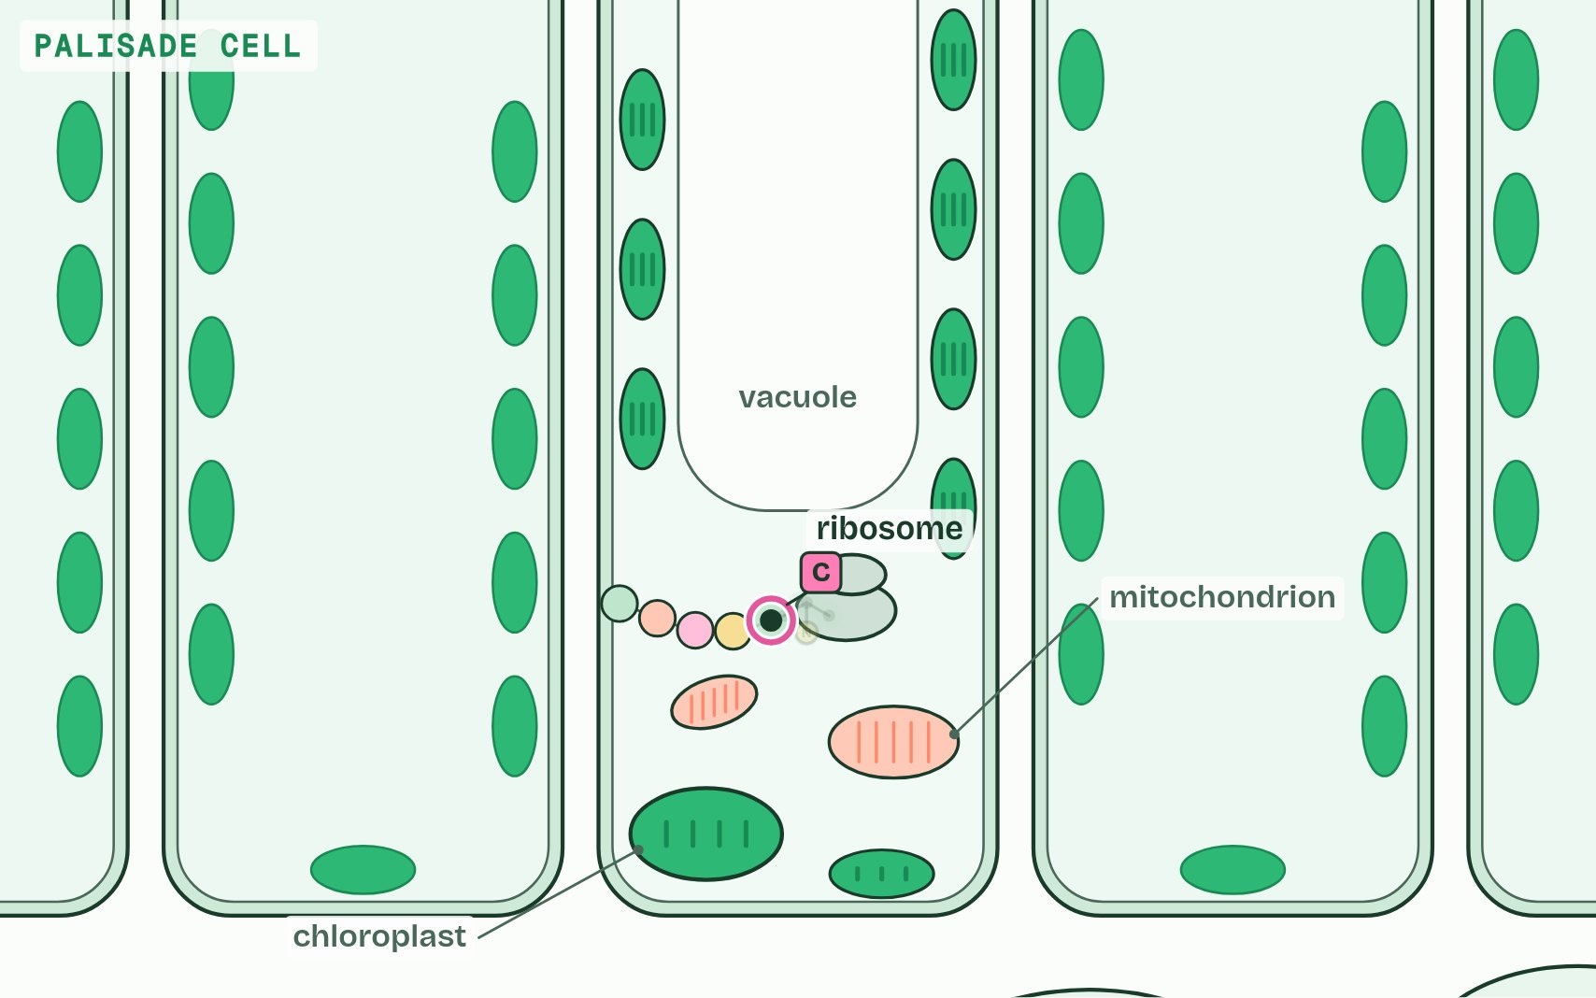
  SPOT THE MISTAKE
  What do students often get wrong about carbohydrates, amino acids and other compounds from the Calvin cycle? Write the mistake, then put it right.
  The mistake
  Put it right
SUMMARY
Sum up section 14 in two or three sentences of your own.

15 Each half needs the other | C1.3.19 HL
CUES  Predict: A leaf in bright light is suddenly given no carbon dioxide. What happens to photosystem II?  What is meant by light-dependent reactions?  What is meant by light-independent reactions?  What is meant by interdependence? | NOTES  1 The __________________________________ in the thylakoids make ATP and reduced NADP.  2 The __________________________________, the Calvin cycle in the stroma, use them and hand back ADP, phosphate and NADP.  3 Each half needs what the other makes: that is their ____________________.  4 __________________________________ make ATP and reduced NADP; the Calvin cycle uses them and returns ADP, phosphate and NADP.  Your own notes  ANNOTATE THE FIGURE  The figure shows it as Light and carbon dioxide, Lights off and No carbon dioxide. Note what changes each time.  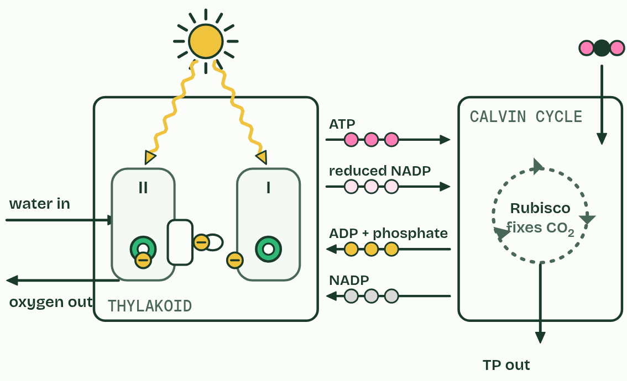  ANNOTATE THE FIGURE  Annotate this still from the animation (Photosynthesis, the whole system): what is happening, and why?  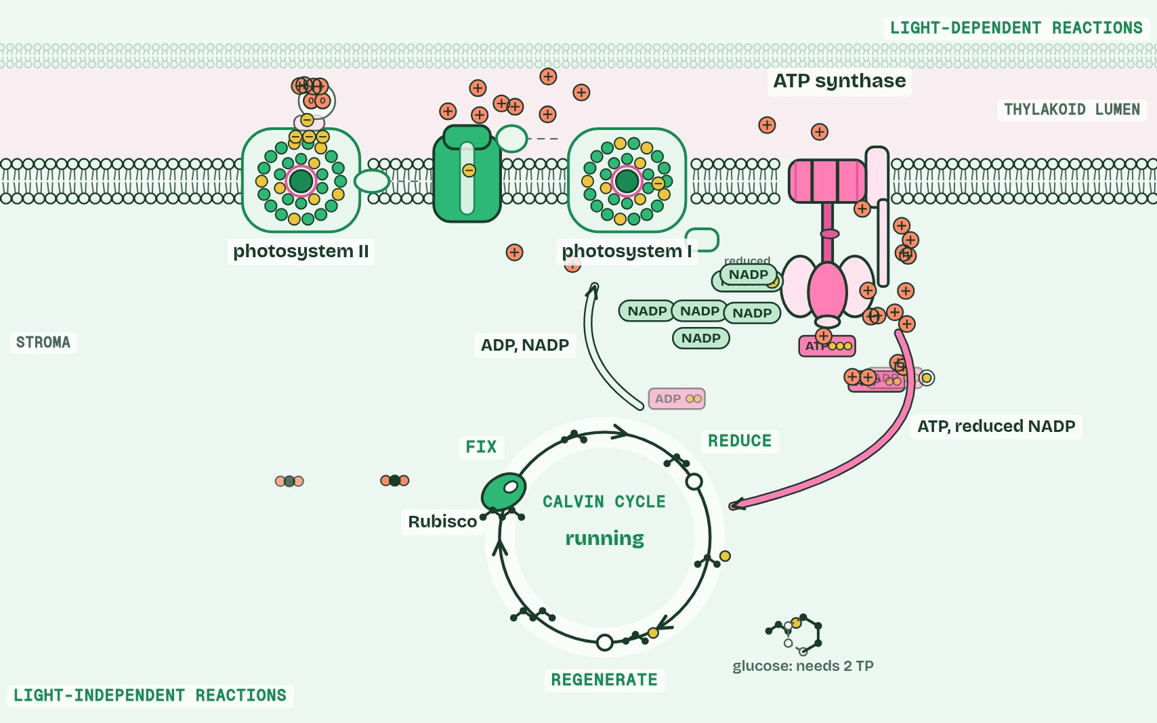  ANNOTATE THE FIGURE  Annotate this still from the animation (Respiration and photosynthesis on one map): what is happening, and why?  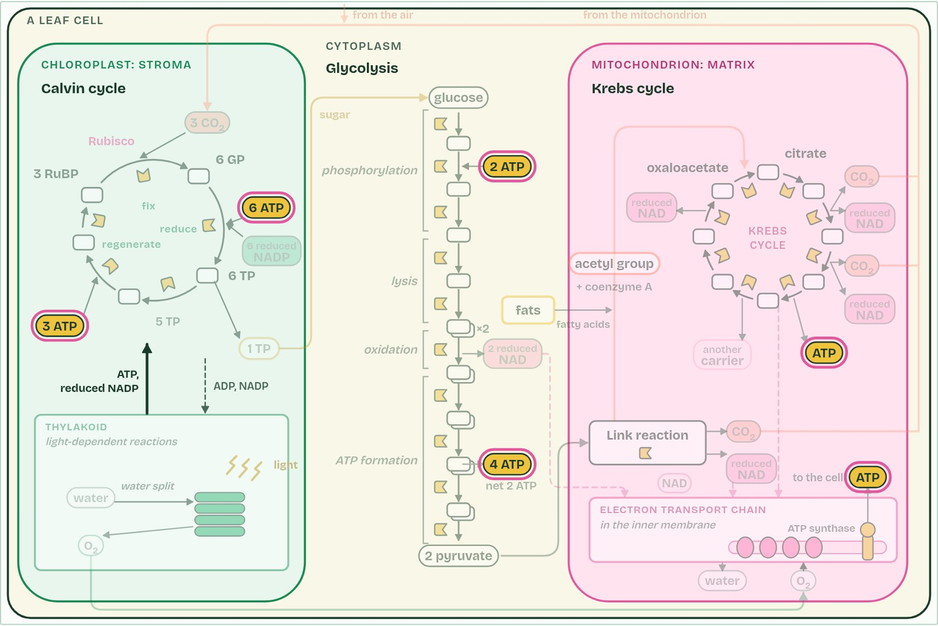
  SPOT THE MISTAKE
  What do students often get wrong about interdependence of the light-dependent and light-independent reactions? Write the mistake, then put it right.
  The mistake
  Put it right
SUMMARY
Sum up section 15 in two or three sentences of your own.

Check yourself
The check for this guide is online: a fresh paper of past-paper style questions from the exam bank on C1.3 each time, marked as you go, and saved to your Exam practice progress when you are signed in. Open the link:
biologybybradford.com/exam-maker/sit?topics=C1.3&level=HL&paper=quiz&marks=15&src=ep

