Name | Class | Date
IB BIOLOGY · D1.1

DNA replication
Teacher’s copy: every blank filled in. Each numbered block matches a chapter of the guide, and of the lesson slides. Write in the gaps, answer the cues, annotate the figures, and sum up each section in your own words.
BY THE END YOU CAN
Explain why cells copy their DNA, and why every copy must carry the same base sequence D1.1.1
Explain what semi-conservative means, and how complementary base pairing makes copying accurate D1.1.2
Describe what helicase and DNA polymerase do at a replication fork D1.1.3
Outline how PCR copies a small sample of DNA, with primers, three temperatures and Taq polymerase D1.1.4
Explain how gel electrophoresis separates DNA fragments by size, and read sizes against a ladder D1.1.4
Use DNA profiles to settle paternity and forensic cases, and explain why more markers mean fewer false matches D1.1.5
Explain why DNA polymerases add nucleotides only to the 3′ end, so new strands grow 5′ to 3′ D1.1.6
Compare replication on the leading and lagging strands, with Okazaki fragments and RNA primers D1.1.7
State what DNA primase, DNA polymerase I, DNA polymerase III and DNA ligase each do D1.1.8
Explain how DNA polymerase III proofreads the strand it is building D1.1.9

01 A copy for every new cell | D1.1.1
CUES  Predict: You began as one fertilised egg and now have about 30 trillion cells. If every cell divided in step, about how many rounds of copying and dividing would it take?  B: About 45. About 45. Each round doubles the number of cells, so 45 rounds give 245, about 35 trillion. Real cells do not divide in step, and many die and are replaced, so your DNA has been copied far more times than that in all, and every one of those copies had to be exact. Doubling comes back in chapter 4, where it is the secret of PCR.  What is meant by DNA replication?  Making a copy of a DNA molecule, so that the copy has exactly the same base sequence as the original.  What is meant by base sequence?  The order of the bases along a strand of DNA. It is the message, and every copy must carry the same one.  What is meant by cell division?  One cell splitting into two. The DNA is copied first, so that each new cell gets a full set.  What is meant by asexual reproduction?  Making offspring from one parent by cell division, so each offspring starts with a copy of the parent’s DNA.  What is meant by growth?  An increase in the number of cells in a body, made by division.  What is meant by tissue replacement?  Making new cells by division to replace those that are worn out, lost or damaged. | NOTES  1 Making a copy of a DNA molecule is called DNA replication.  2 The message in DNA is the order of its bases, the base sequence (A1.2), so a faithful copy has the same bases in the same order.  3 Copying comes before every cell division.  4 Reproduction. A bacterium splits in two, yeast buds and a strawberry plant sends out runners: asexual reproduction. Even the cells that become eggs and sperm come from cells that copied their DNA first.  5 Growth. A fertilised egg becomes a body of about 30 trillion cells, every one made by division. This is growth.  6 Tissue replacement. Skin, the lining of the gut and blood cells are replaced all the time, and a cut heals with new cells: tissue replacement.  Your own notes  ANNOTATE THE FIGURE  Number the 4 steps on the figure and note what happens at each: 1 DNA; 2 copies; 3 reproduce, grow, replace; 4 division.  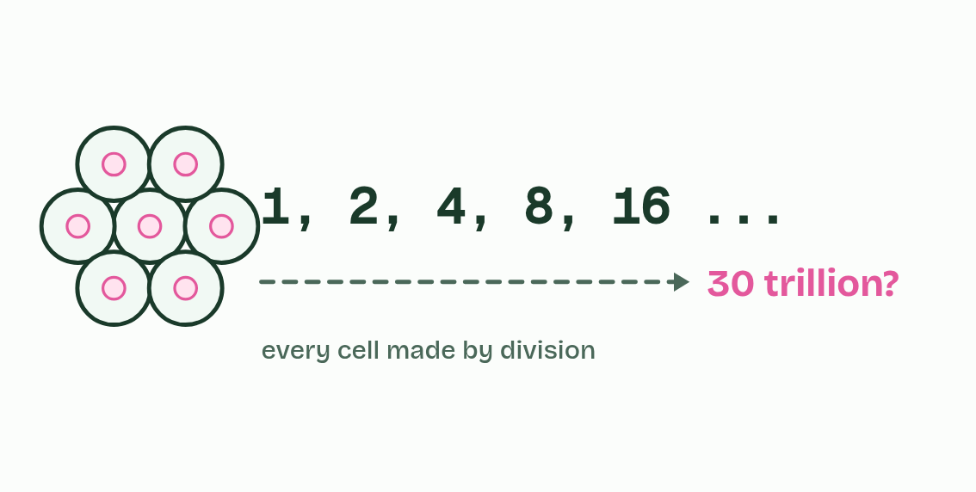  1 A cell holds one copy of its DNA.  2 Before it divides, it copies it, so each new cell has a full set.  3 Cells divide to reproduce, to grow and to replace what is lost.  4 Every one of your cells came from one by division.
  SPOT THE MISTAKE
  What do students often get wrong about exact copies? Write the mistake, then put it right.
  Replication is not the same as cell division. Replication copies the DNA; the cell divides afterwards. And the copy is of the whole molecule, not of one gene.
SUMMARY
Sum up section 01 in two or three sentences of your own.
• Reproduction. A bacterium splits in two, yeast buds and a strawberry plant sends out runners: asexual reproduction. Even the cells that become eggs and sperm come from cells that copied their DNA first.
• Growth. A fertilised egg becomes a body of about 30 trillion cells, every one made by division. This is growth.
• Tissue replacement. Skin, the lining of the gut and blood cells are replaced all the time, and a cut heals with new cells: tissue replacement.

02 One old strand, one new | D1.1.2
CUES  Predict: A DNA molecule is copied, and then both copies are copied again. Of the four molecules, how many still contain a strand from the original?  C: Two: each old strand sits in one molecule. Two. The original’s two strands are never broken up or thrown away: each stays whole and ends up in one molecule, paired with a new partner. The other two molecules are made entirely of new strands. Every round after that, the two old strands are still in just two molecules, however many copies there are.  What is meant by template?  A strand of DNA that a new strand is built against. The new strand’s bases are set by the template’s.  What is meant by complementary base pairing?  The rule that A pairs only with T and C only with G, held by hydrogen bonds. It fixes which base can sit opposite each base of the template.  What is meant by daughter molecule?  One of the two molecules made when a DNA molecule is copied. Each holds one old strand and one new one.  What is meant by semi-conservative?  Describes DNA replication in which each daughter molecule keeps one of the two original strands and gains one new strand. | NOTES  1 Each old strand then acts as a template: free nucleotides line up against its exposed bases, A opposite T and C opposite G, and are joined into a new strand.  2 That is complementary base pairing, and nothing else fits.  3 So each new molecule, a daughter molecule, is made of one old strand and one new one.  4 That is what semi-conservative means: half of each molecule is conserved from the one before.  5 Each old strand is a template for one new strand.  6 Base pairing, A with T and C with G, makes each new strand the complement of its template.  7 Each daughter molecule: one whole old strand and one whole new strand.  Your own notes  ANNOTATE THE FIGURE  The figure shows it as Conservative, Semi-conservative, Dispersive and What they saw. Note what changes each time.  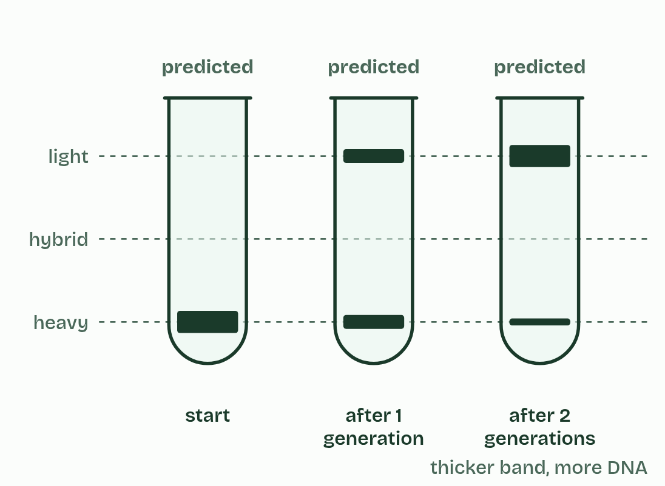  1 Conservative  2 Semi-conservative  3 Dispersive  4 What they saw  ANNOTATE THE FIGURE  Number the 5 steps on the figure and note what happens at each.  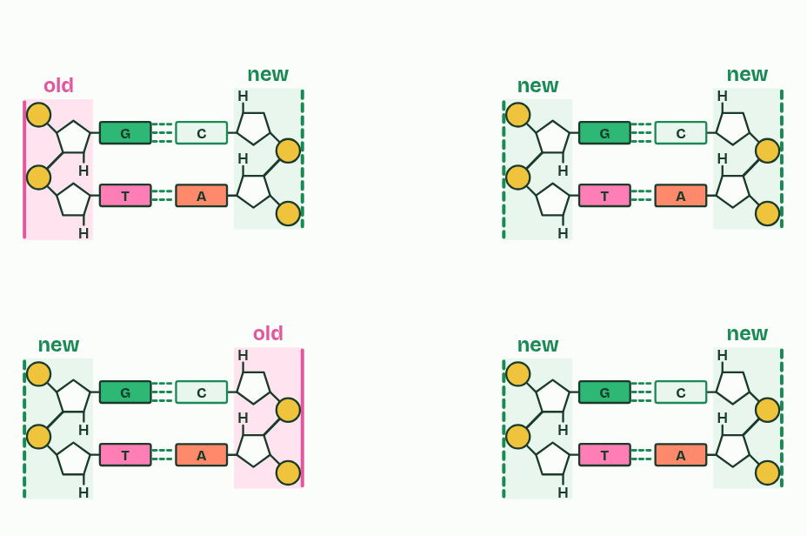  1 One molecule: two old strands.  2 A new partner is built along each strand: its template.  3 Each new molecule keeps one old strand: semi-conservative.  4 Copied again: every strand is a template.  5 Count the old strands.
  SPOT THE MISTAKE
  What do students often get wrong about semi-conservative replication? Write the mistake, then put it right.
  Semi-conservative does not mean each new strand is half old and half new. Every strand is entirely old or entirely new; it is the molecule that is half and half.
SUMMARY
Sum up section 02 in two or three sentences of your own.
• Each old strand is a template for one new strand.
• Base pairing, A with T and C with G, makes each new strand the complement of its template.
• Each daughter molecule: one whole old strand and one whole new strand.

03 Unzip, then build | D1.1.3
CUES  Predict: A drug stops helicase but leaves DNA polymerase working. What happens to replication?  A: It stops: polymerase needs single strands to read. It stops. DNA polymerase can only pair new nucleotides with bases it can reach, and in the double helix every base is already paired and tucked inside. No unzipping, no templates, no copying. (Some antibiotics and anti-cancer drugs work by jamming the copying enzymes of fast-dividing cells.)  What is meant by helicase?  The enzyme that unwinds the double helix and breaks the hydrogen bonds between its base pairs, so the two strands separate.  What is meant by replication fork?  The Y-shaped point where the double helix is being unwound and copied: the unopened helix below, two single strands above.  What is meant by DNA polymerase?  The enzyme that builds new DNA. It joins free nucleotides into a strand, each one matched to the template by base pairing.  What is meant by free nucleotides?  A single nucleotide floating loose in the nucleus (or the cytoplasm of a bacterium), ready to be added to a new strand. | NOTES  1 Helicase is the unzipper.  2 The point where the helix is opening is the replication fork.  3 DNA polymerase is the builder. Free nucleotides drift in the nucleus, or in the cytoplasm of a bacterium.  4 Helicase unwinds the helix and breaks the hydrogen bonds between bases.  5 DNA polymerase joins free nucleotides into a new strand, matched to the template by base pairing.  Your own notes  ANNOTATE THE FIGURE  Label each part and say what it does: an old strand, an old strand, hydrogen bonds, a new strand, a new strand, exposed bases., exposed bases., a free nucleotide, a free nucleotide, DNA polymerase, DNA polymerase, helicase.  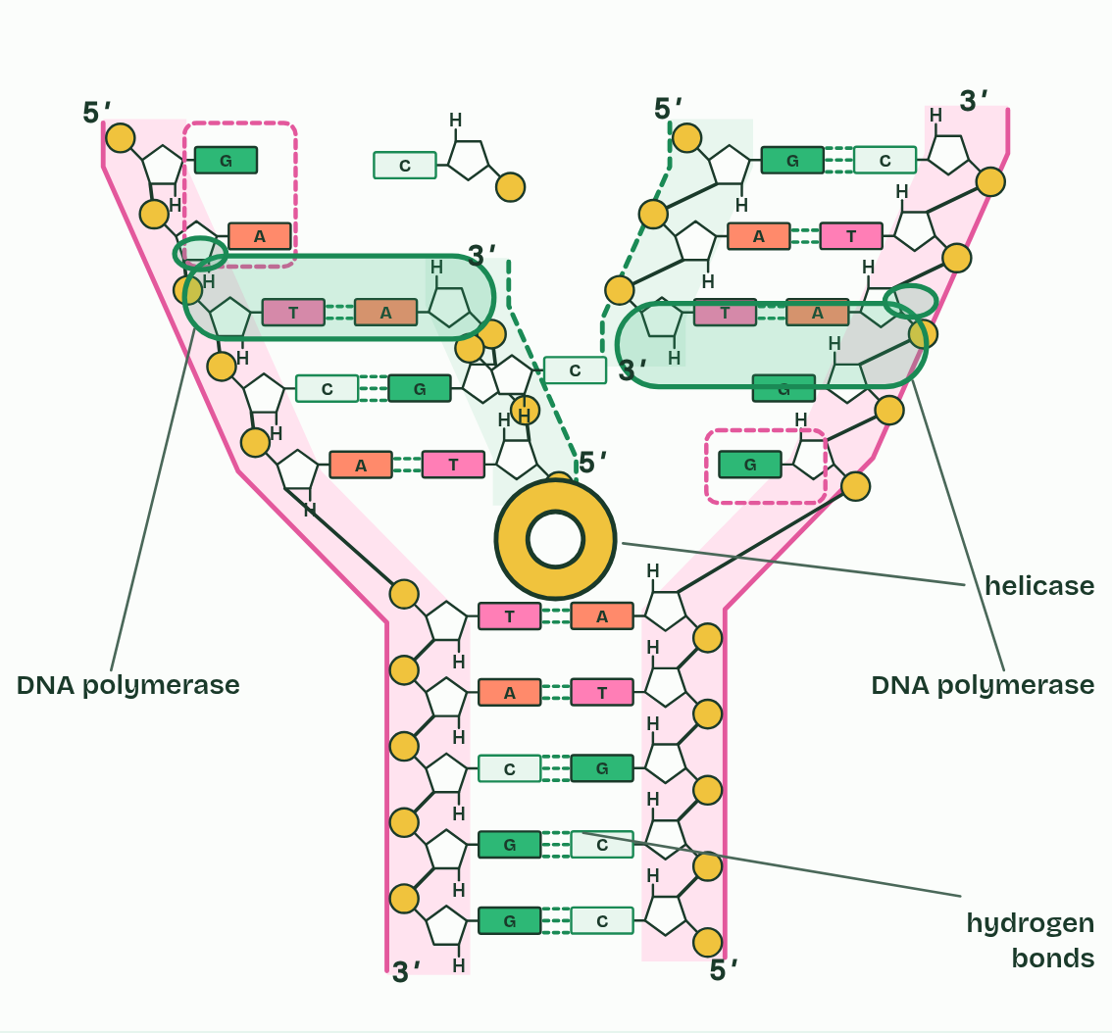  1 An old strand: of the parent molecule. Where the helix has opened, it is a template for a new strand.  2 An old strand: of the parent molecule. Where the helix has opened, it is a template for a new strand.  3 Hydrogen bonds: hold the base pairs together. They are weak one by one, so they can be broken without harm.  4 A new strand: , complementary to its template.  5 A new strand: , complementary to its template.  6 Exposed bases.: Only one kind of nucleotide can pair with each.  7 Exposed bases.: Only one kind of nucleotide can pair with each.  8 A free nucleotide: a phosphate, deoxyribose and one of four bases, waiting to pair.  9 A free nucleotide: a phosphate, deoxyribose and one of four bases, waiting to pair.  10 DNA polymerase: joins each new nucleotide to the strand it is building, after its base has paired with the template.  11 DNA polymerase: joins each new nucleotide to the strand it is building, after its base has paired with the template.  12 Helicase: unwinds the helix and pulls the base pairs apart, breaking only the hydrogen bonds that held them. Each strand stays whole.  ANNOTATE THE FIGURE  Number the 4 steps on the figure and note what happens at each: 1 old; 2 Helicase; 3 DNA polymerase; 4 old, new.  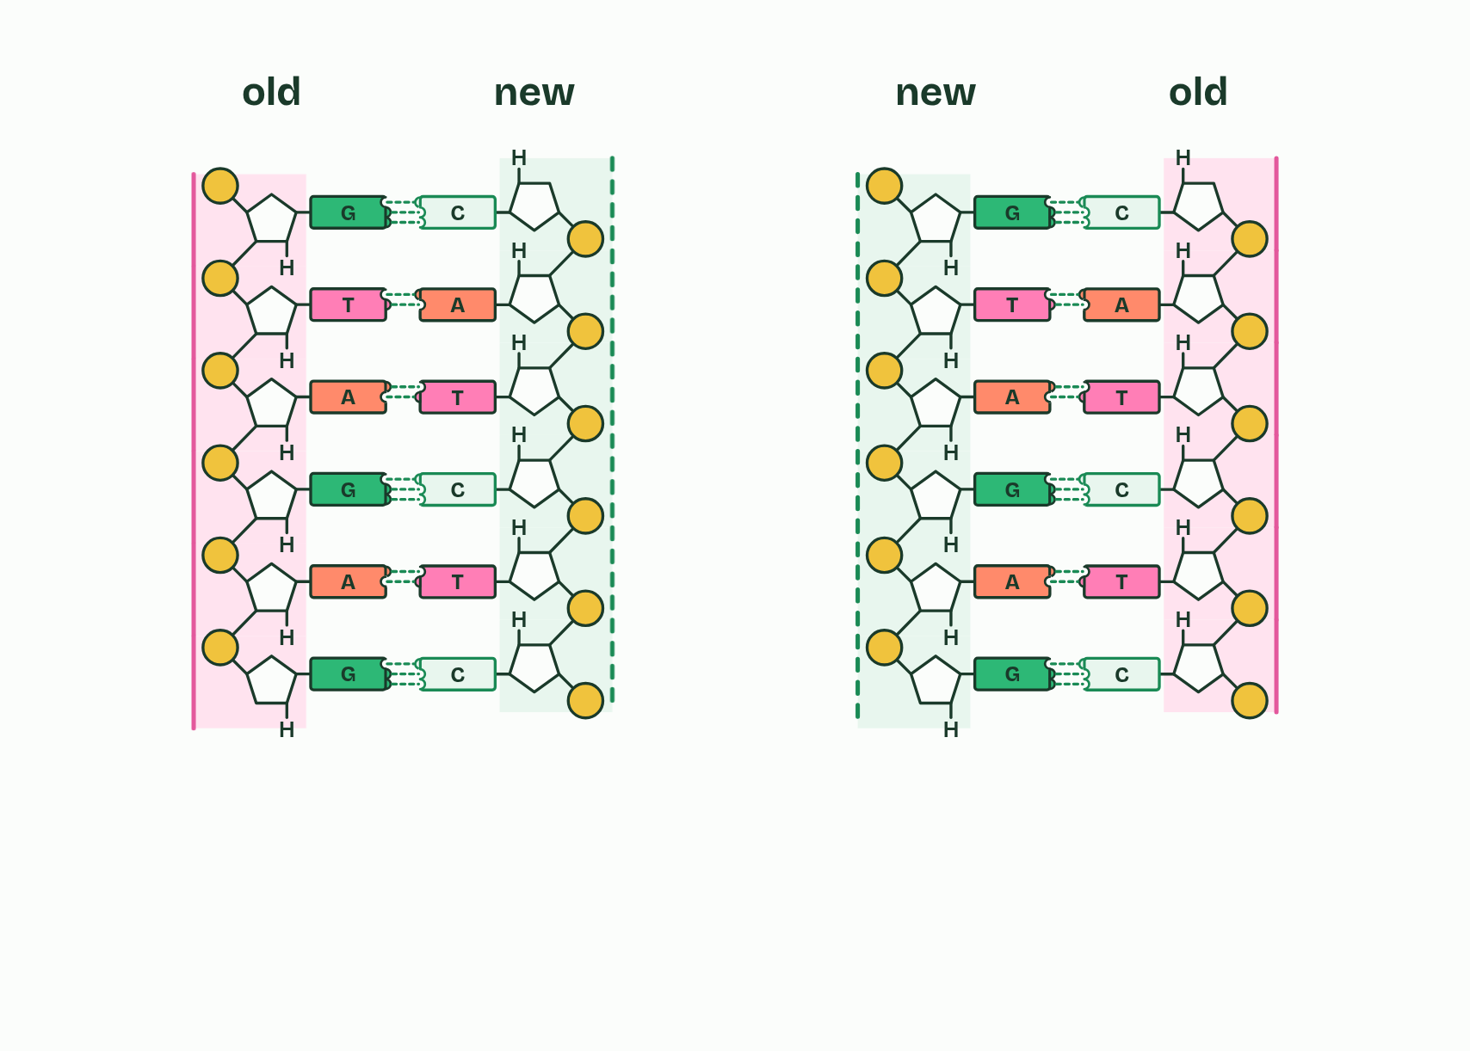  1 One molecule: two old strands.  2 Helicase unwinds the helix and breaks the hydrogen bonds.  3 DNA polymerase joins nucleotides that pair with each exposed base.  4 Two molecules, each with one old strand and one new.
  SPOT THE MISTAKE
  What do students often get wrong about helicase and DNA polymerase? Write the mistake, then put it right.
  Helicase breaks the hydrogen bonds between the bases, not the bonds between sugar and phosphate. And DNA polymerase does not “make bases”: it joins whole nucleotides, already made, into the new strand.
SUMMARY
Sum up section 03 in two or three sentences of your own.
• Helicase unwinds the helix and breaks the hydrogen bonds between bases.
• DNA polymerase joins free nucleotides into a new strand, matched to the template by base pairing.
• One polymerase works on each template strand.

04 A millionfold copy | D1.1.4
CUES  Predict: PCR uses a DNA polymerase from bacteria that live in hot springs. Why not a polymerase from human cells?  B: A human polymerase would be denatured at 95 °C each cycle. Every cycle heats the tube to about 95 °C to separate the strands. A human polymerase, made to work at 37 °C, would lose its shape in the first heating and never work again. Taq polymerase, from a bacterium that lives in hot springs, keeps its shape through 30 heatings, so it can be added once at the start. (It still needs primers, like every DNA polymerase.)  What is meant by polymerase chain reaction (PCR)?  A method that copies one chosen stretch of DNA again and again in a tube, so that a tiny sample becomes enough to study.  What is meant by amplify?  To make many copies of a small amount of DNA, as PCR does.  What is meant by primers?  A short single strand of DNA, about 20 nucleotides long, that binds to one end of the stretch to be copied and gives the polymerase a place to start.  What is meant by thermal cycler?  A machine that raises and lowers the temperature of PCR tubes, over and over, on a set cycle.  What is meant by denaturation?  The first step of a PCR cycle, at about 95 °C: heat breaks the hydrogen bonds and the two strands separate.  What is meant by annealing?  The second step of a PCR cycle, at about 55 °C: the mixture cools and a primer binds to its matching sequence at each end of the target.  What is meant by extension?  The third step of a PCR cycle, at about 72 °C: the polymerase adds nucleotides to each primer, building a complementary strand.  What is meant by taq polymerase?  A DNA polymerase from Thermus aquaticus, a bacterium that lives in hot springs. It is used in PCR. | NOTES  1 The polymerase chain reaction (PCR) copies one chosen stretch of DNA over and over until there is plenty.  2 Making many copies of a small amount of DNA is to amplify it.  3 The tube holds the sample, plenty of free nucleotides, a buffer, a polymerase and two primers: short single strands of DNA, one matching each end of the stretch to be copied.  4 A thermal cycler then changes the temperature again and again.  5 The polymerase used is Taq polymerase, from Thermus aquaticus, a bacterium found in hot springs.  Your own notes  ANNOTATE THE FIGURE  Number the 6 steps on the figure and note what happens at each.  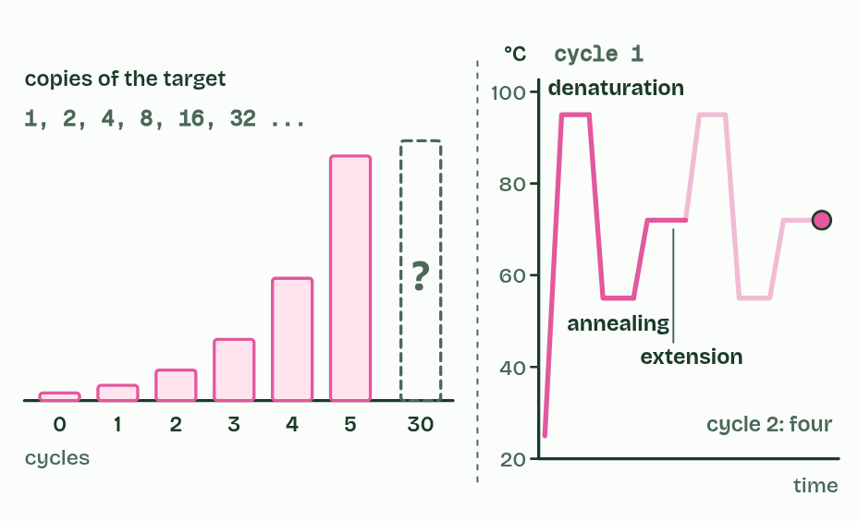  1 A sample of DNA, too little to study.  2 About 95 °C: the strands separate.  3 About 55 °C: primers bind at each end of the target.  4 About 72 °C: Taq polymerase extends each primer.  5 One cycle: the copies double.  6 Thirty cycles later: how many?  REMEMBER IT  One PCR cycle
  D  Dragons | A  Always | E  Exhale
  Denaturation  about 95 °C: the strands separate | Annealing  about 55 °C: primers bind | Extension  about 72 °C: Taq builds the new strands
  SPOT THE MISTAKE
  What do students often get wrong about the polymerase chain reaction? Write the mistake, then put it right.
  PCR does not copy a whole genome, and it does not make a new organism. It copies one short stretch chosen by the primers. And denaturing DNA is harmless to it: the strands come apart and pair again, unlike a protein that loses its shape for good.
SUMMARY
Sum up section 04 in two or three sentences of your own.
• Denaturation, about 95 °C. Heat breaks the hydrogen bonds and the strands separate. It does helicase’s job.
• Annealing, about 55 °C. The mixture cools and a primer binds, by hydrogen bonds, to its matching sequence at each end of the target.
• Extension, about 72 °C. The polymerase adds nucleotides onto each primer and builds a complementary strand.

05 Sorted by size | D1.1.4
CUES  Predict: Fragments of 300, 1,000 and 5,000 base pairs are run on the same gel. Which ends up nearest the wells?  C: 5,000 base pairs: long fragments move slowest. The longest, 5,000 base pairs. All three carry the same charge per base pair, so the pull per base pair is the same. What differs is how easily each threads through the mesh of the gel: long fragments snag more and move slowest, so they stay nearest the wells. Nothing sticks to the gel.  What is meant by gel electrophoresis?  A method that separates DNA fragments by length, by pulling them through a gel with an electric field.  What is meant by fragments?  A piece of DNA of a particular length.  What is meant by base pairs (bp)?  The unit for the length of a DNA fragment: the number of base pairs it contains.  What is meant by wells?  One of the small pits at the end of a gel, where a sample is loaded.  What is meant by electrodes?  A metal lead that carries current into the tank. One is positive and one negative.  What is meant by DNA ladder?  A mixture of DNA fragments of known sizes, run in its own lane to give a scale for reading the sizes of the other bands. | NOTES  1 To see what is in it, you sort the DNA by size. Gel electrophoresis does that: it separates DNA fragments by their length, counted in base pairs (bp).  2 A slab of gel, a jelly made from seaweed, has a row of small pits at one end, the wells.  3 The slab lies in a tank of salty buffer between two electrodes.  4 A DNA ladder, a mix of fragments of known sizes, runs in its own lane and gives a scale.  5 The mesh holds long fragments back more, so short ones travel furthest.  Your own notes  ANNOTATE THE FIGURE  The figure shows it at run time (min) 0, time (min) 30 and time (min) 58. Note what changes each time.  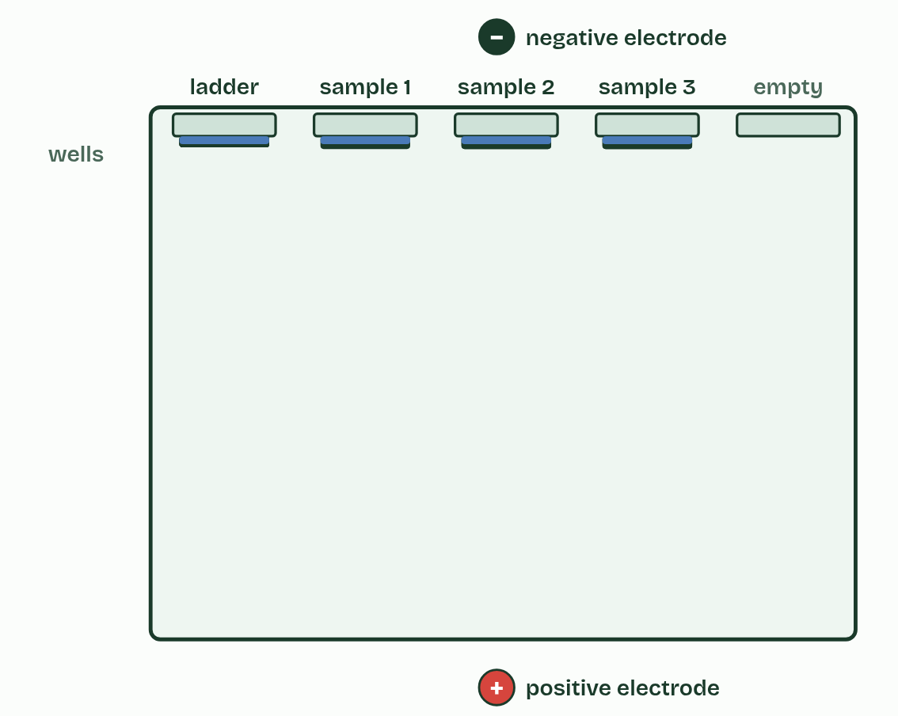  1 Run time (min) 0  2 Run time (min) 30  3 Run time (min) 58
  SPOT THE MISTAKE
  What do students often get wrong about gel electrophoresis? Write the mistake, then put it right.
  Bigger fragments do not travel further because they are “heavier” or “more charged”: they travel less far, because the gel holds them back. And DNA moves to the positive electrode, because it is negative.
SUMMARY
Sum up section 05 in two or three sentences of your own.
• The negative charge of the phosphates pulls DNA towards the positive electrode.
• The mesh holds long fragments back more, so short ones travel furthest.
• The ladder gives the scale for reading sizes.

06 Profiles, parents and crime scenes | D1.1.5
CUES  Predict: At one marker, 1 person in 10 shares the crime-scene pattern by chance. With ten independent markers, each 1 in 10, how many people in a city of 10 million would you expect to match by chance?  A: Almost certainly none of them. Almost certainly none. The chances multiply, not add: 1 in 10, ten times over, is 1 in 10 billion. In a city of 10 million that is an expected 0.001 people, so a chance match is very unlikely. That is why a profile uses many markers: each one makes a false match far rarer.  What is meant by short tandem repeat (STR)?  A short sequence of bases, such as GATA, repeated over and over end to end. The number of repeats differs from person to person.  What is meant by marker?  A place in the DNA, such as an STR, that is compared between people in DNA profiling.  What is meant by allele?  One version of a gene or a marker. For an STR it is a particular number of repeats. Each person has two at each marker, one from each parent.  What is meant by DNA profiling?  Comparing the alleles of a few markers, found by PCR and gel electrophoresis, between a sample and the people it might have come from.  What is meant by forensic?  To do with finding evidence for a court of law.  What is meant by paternity?  To do with who a child’s father is.  What is meant by false match?  Two different people having the same profile by chance. | NOTES  1 Most of our DNA is the same from one person to the next, but some places hold a short sequence repeated over and over, end to end: a short tandem repeat (STR), such as GATA GATA GATA.  2 Such a place is a marker, each version (a number of repeats) is an allele, and each person has two alleles at each marker, one from each parent.  3 DNA profiling starts with a sample: blood, saliva, a hair root, or skin cells left on a handle.  4 In a forensic investigation, the profile from the scene is compared with those of the suspects and the victim.  5 In a paternity test, a child has at each marker one allele from the mother and one from the father.  6 Each extra independent marker is another test that a person must pass by luck, so the chance of a false match is multiplied by another small number and falls very fast.  7 Forensic investigations and paternity tests, by DNA profiling.  Your own notes  ANNOTATE THE FIGURE  The figure shows it as Paternity and Crime scene. Note what changes each time.  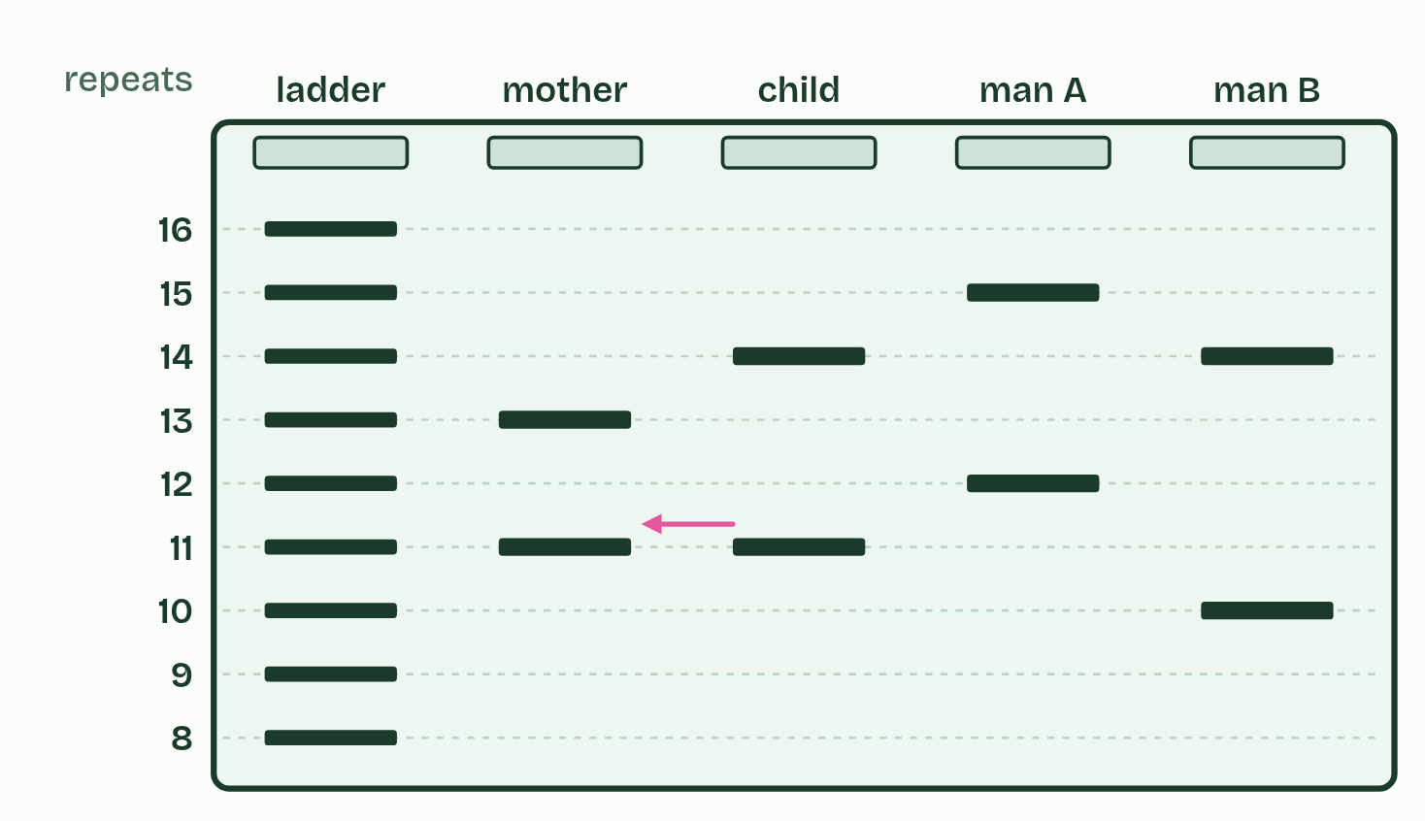  1 Paternity  2 Crime scene  ANNOTATE THE FIGURE  The figure shows it as 1 marker, 3, 10 and 20. Note what changes each time.  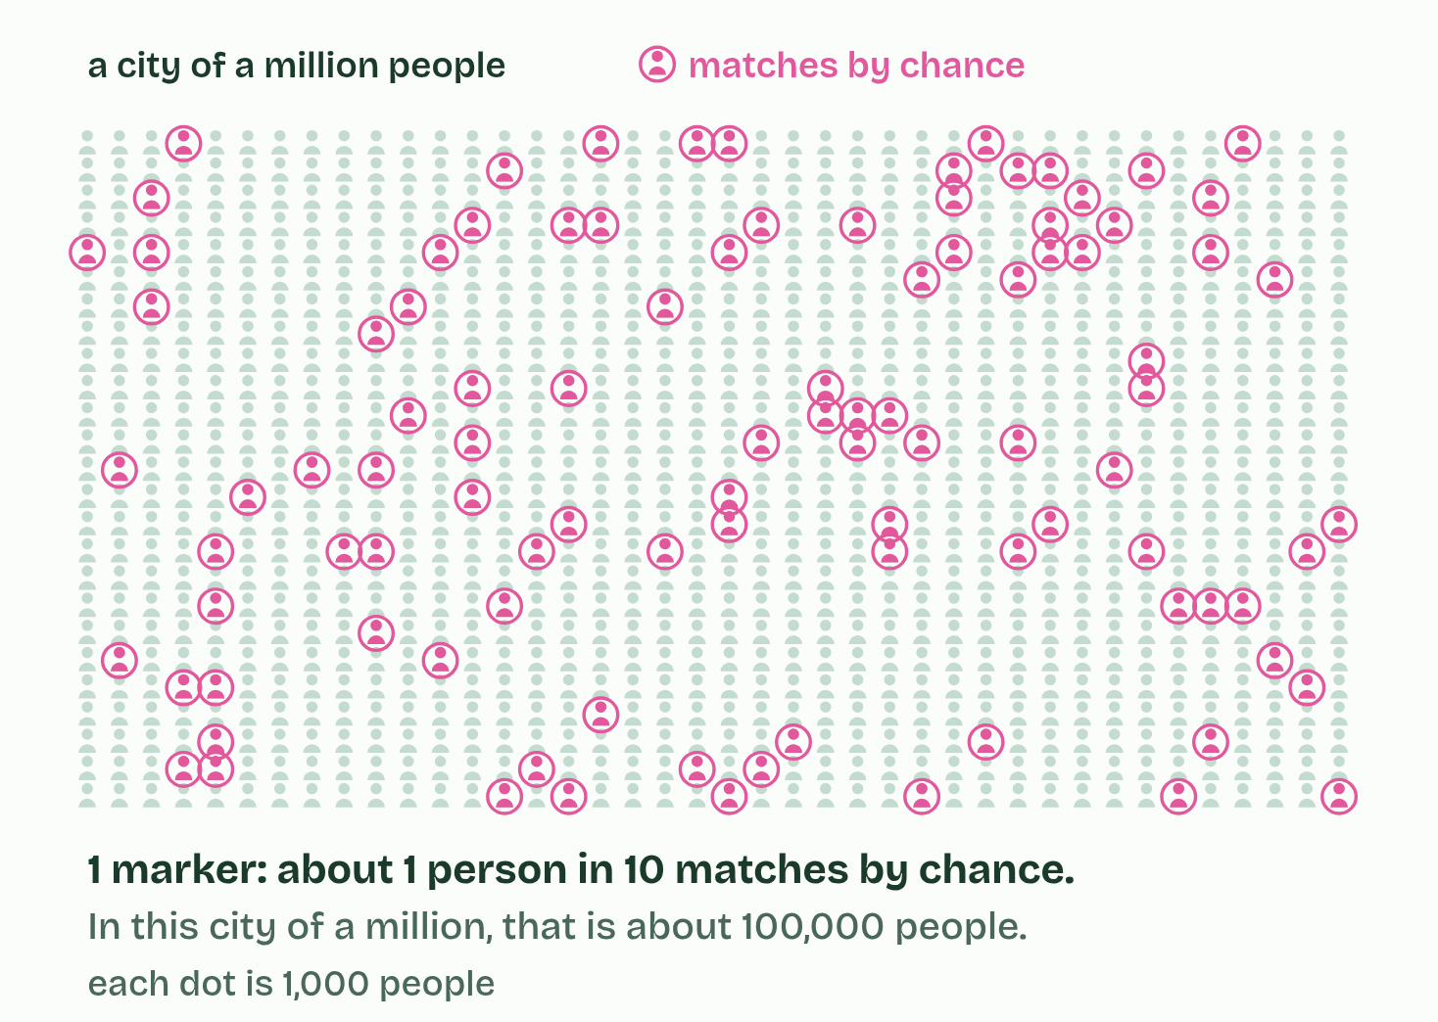  1 1 marker  2 3  3 10  4 20
  SPOT THE MISTAKE
  What do students often get wrong about applications of PCR and gel electrophoresis? Write the mistake, then put it right.
  A child does not share half of each parent’s bands in some fixed way. At each marker the child has exactly one allele from each parent, and those may happen to be the same size as the other parent’s. And a profile is not the person’s whole genome: it is a handful of repeat counts.
SUMMARY
Sum up section 06 in two or three sentences of your own.
• Forensic investigations and paternity tests, by DNA profiling.
• Diagnosing infections. The COVID-19 test copies a stretch of the virus’s genes (the virus’s RNA is first copied into DNA).
• Testing for inherited conditions.
• Identifying species: a fish sold as cod that is not, the source of a meat sample, wildlife trading.
• Copying a gene so that it can be studied or moved.
• Studying ancient DNA from bones.

07 Only ever at the 3′ end | D1.1.6 HL
CUES  Predict: A free nucleotide arrives at the 5′ end of a growing new strand, and its base pairs with the template. What happens?  B: It is not joined: there is no free 3′ OH there. It is not joined. DNA polymerase only makes the bond between a nucleotide’s 5′ phosphate and the 3′ OH of the strand. At the 5′ end there is a phosphate, not an OH, so there is nothing to join to, however well the base pairs. Every DNA polymerase works this way, so every new strand grows 5′ to 3′.  What is meant by 5′ terminal?  The end of a strand of nucleotides that has a free phosphate group on a 5′ carbon.  What is meant by 3′ terminal?  The end of a strand of nucleotides that has a free hydroxyl group on a 3′ carbon. It is where new nucleotides are added.  What is meant by directionality?  Working in one direction only. DNA polymerases add nucleotides at the 3′ end of a strand, so a new strand grows 5′ to 3′. | NOTES  1 One end has a free phosphate on a 5′ carbon, the 5′ terminal.  2 The other has a free hydroxyl group (OH) on a 3′ carbon, the 3′ terminal.  3 So nucleotides are only ever added at the 3′ end, and a new strand grows 5′ to 3′. This one-way working is the directionality of DNA polymerases.  4 Every strand has a 5′ end and a 3′ end.  5 DNA polymerase joins a nucleotide’s 5′ phosphate to the 3′ end.  6 There is nothing to join to at the 5′ end.  Your own notes  ANNOTATE THE FIGURE  Number the 5 steps on the figure and note what happens at each: 1 5′, 3′; 2 3′ end; 3 5′ end; 4 5′ to 3′; 5 opposite.  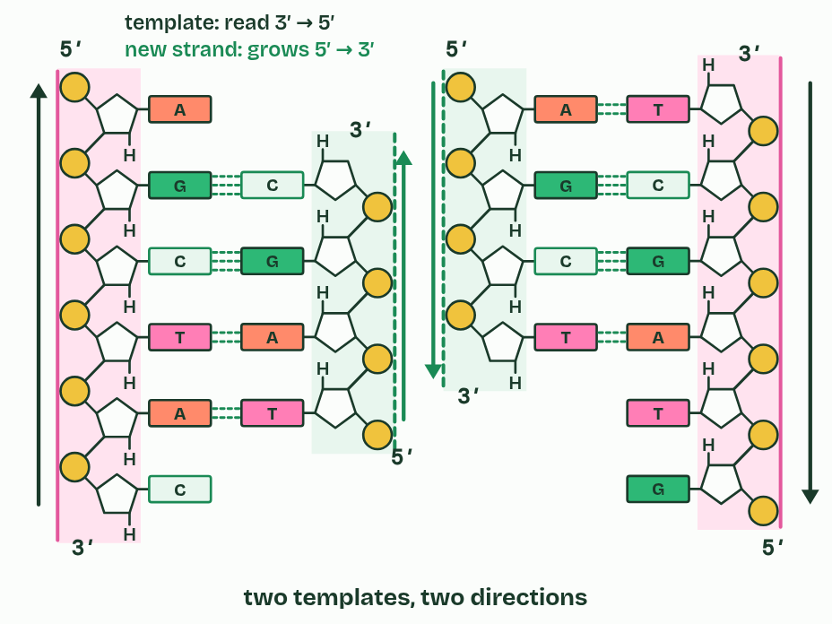  1 Every strand has a 5′ end and a 3′ end.  2 DNA polymerase joins a nucleotide’s 5′ phosphate to the 3′ end.  3 There is nothing to join to at the 5′ end.  4 So new strands grow 5′ to 3′.  5 The templates are antiparallel, so the new strands grow in opposite directions.
  SPOT THE MISTAKE
  What do students often get wrong about directionality of DNA polymerases? Write the mistake, then put it right.
  “5′ to 3′” describes the new strand. The template is read 3′ to 5′. And 5′ and 3′ name carbons of the sugar, not ends of a gene.
SUMMARY
Sum up section 07 in two or three sentences of your own.
• Nucleotides are added only at the 3′ end of the new strand.
• So a new strand grows 5′ to 3′, and its template is read 3′ to 5′.
• Antiparallel templates mean the two new strands at a fork grow in opposite directions.

08 One strand smooth, one in pieces | D1.1.7 HL
CUES  Predict: A fork opens 10,000 bases of a bacterial chromosome. Okazaki fragments there are about 1,000 to 2,000 nucleotides long. How many RNA primers does each new strand need?  C: Leading just 1, lagging about 5 to 10. The leading strand is primed once and then built continuously as the fork moves, so it needs one primer. The lagging strand is built in fragments, each started from its own primer: 10,000 bases in pieces of 1,000 to 2,000 is about 5 to 10 fragments, so about 5 to 10 primers.  What is meant by leading strand?  The new strand that is built towards the fork, in the same direction as the fork moves. It needs only one primer.  What is meant by continuously?  Built in one piece, without stopping, as the leading strand is.  What is meant by lagging strand?  The new strand that is built away from the fork, in pieces, each started again as the fork opens more template.  What is meant by discontinuously?  Built in separate pieces, each started again, as the lagging strand is.  What is meant by okazaki fragments?  One of the short pieces of the lagging strand, named after Reiji and Tsuneko Okazaki, who found them in the 1960s.  What is meant by RNA primer?  A short strand of RNA, made by an enzyme, that is paired with the template and gives DNA polymerase a 3′ end to add to. | NOTES  1 DNA polymerase follows right behind helicase and builds without stopping. This is the leading strand, made continuously.  2 Then the fork opens a little more and the polymerase starts again. This is the lagging strand, made discontinuously in short pieces called Okazaki fragments.  3 So every new piece of DNA begins with a short RNA primer, made by an enzyme you meet in chapter 9, which gives the polymerase a 3′ end to add to.  4 Leading strand: built continuously towards the fork, from one primer.  5 Lagging strand: built discontinuously, away from the fork, as Okazaki fragments, each from its own primer.  Your own notes  ANNOTATE THE FIGURE  Number the 6 steps on the figure and note what happens at each.  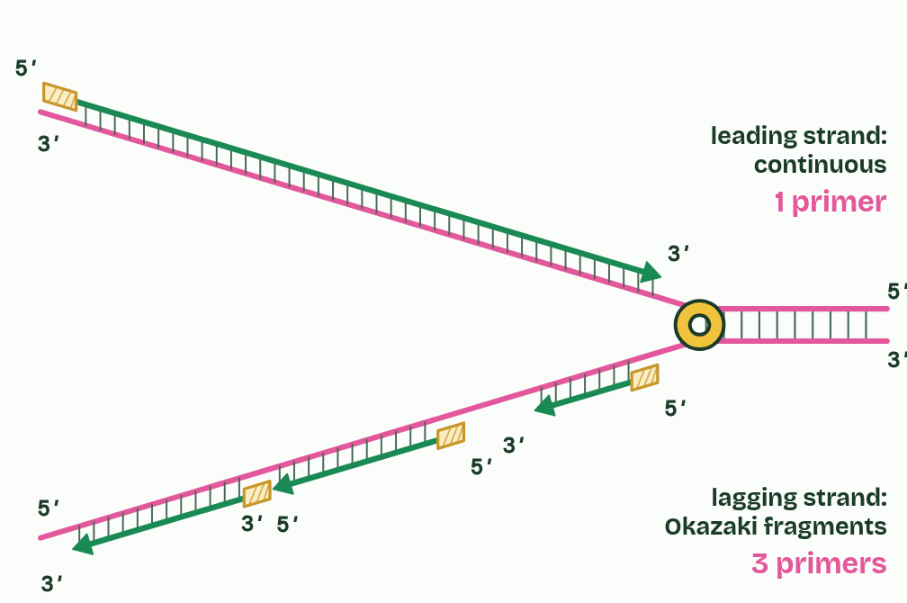  1 Helicase opens the fork and moves on.  2 Leading strand: one primer, then built continuously, towards the fork.  3 Lagging strand: built away from the fork, so it must start again.  4 Each new stretch gets its own primer.  5 The lagging strand comes in Okazaki fragments.  6 One primer on the leading strand; one per fragment on the lagging strand.
  SPOT THE MISTAKE
  What do students often get wrong about leading and lagging strands? Write the mistake, then put it right.
  The lagging strand is not copied later, after the leading strand is finished: both are made at the same fork at the same time. And “continuous” and “discontinuous” describe how each new strand is built, not the template.
SUMMARY
Sum up section 08 in two or three sentences of your own.
• Leading strand: built continuously towards the fork, from one primer.
• Lagging strand: built discontinuously, away from the fork, as Okazaki fragments, each from its own primer.
• Both are made at the same fork at the same time.

09 Four enzymes at the fork | D1.1.8 HL
CUES  Predict: A bacterium makes a faulty DNA ligase. What would you find in its newly copied DNA?  A: Lagging strands left as short fragments. Without ligase, nothing seals the last bond between one fragment and the next, so the lagging strand stays in pieces (and the leading strand keeps one nick where its primer was). Primase and polymerase III still start and build the strands, and polymerase I still swaps the primers for DNA. Only the joining fails.  What is meant by DNA primase?  The enzyme that makes a short RNA primer on a template strand, to give DNA polymerase III a 3′ end to start from.  What is meant by DNA polymerase III?  The main DNA polymerase of a bacterium. It extends each primer from its 3′ end, builds almost all of each new strand, and proofreads.  What is meant by DNA polymerase I?  The DNA polymerase that removes the RNA primers and replaces their nucleotides with DNA nucleotides.  What is meant by DNA ligase?  The enzyme that joins two fragments of DNA by making the last covalent bond in the sugar and phosphate backbone.  What is meant by nick?  A gap in the sugar and phosphate backbone of DNA, between two fragments that sit side by side with one bond missing. | NOTES  1 DNA primase makes a short RNA primer (about ten nucleotides in E. coli) on the template, complementary to it: once at the start of the leading strand, and once for each Okazaki fragment.  2 DNA polymerase III extends each primer from its 3′ end, one nucleotide at a time, each paired with the template, so it builds almost all of each new strand, 5′ to 3′. It also proofreads (chapter 10).  3 DNA polymerase I removes the RNA primers and replaces their nucleotides with DNA nucleotides. Like every DNA polymerase it needs a 3′ end to add to, so it works from the 3′ end of the newer fragment that has grown up to the primer, taking out RNA ahead of it and filling in DNA behind. A primer is only replaced once the next fragment has reached it.  4 DNA ligase joins the fragments. It makes the last covalent bond in the sugar and phosphate backbone, where one fragment’s 3′ end meets the next fragment’s 5′ end. The unjoined gap is a nick.  Your own notes  ANNOTATE THE FIGURE  Label each part and say what it does: the leading strand, an RNA primer, an Okazaki fragment, an RNA primer, an RNA primer, a nick, DNA ligase, DNA polymerase I, DNA polymerase III, DNA polymerase III, DNA primase, helicase.  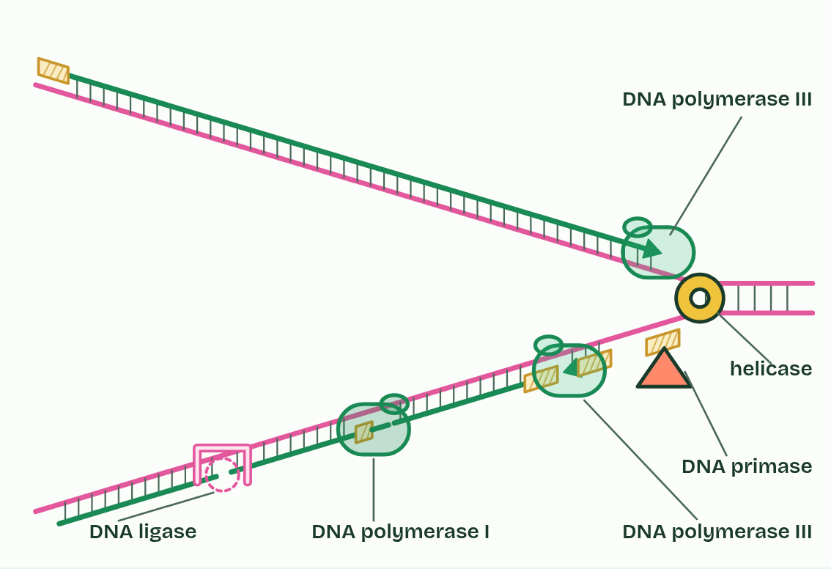  1 The leading strand: is built continuously towards the fork, from a single primer.  2 An RNA primer: a few RNA nucleotides that give DNA polymerase III a 3′ end to start from.  3 An Okazaki fragment: one short piece of the lagging strand. In E. coli it is 1,000 to 2,000 nucleotides long; here it is drawn much shorter.  4 An RNA primer: a few RNA nucleotides that give DNA polymerase III a 3′ end to start from.  5 An RNA primer: a few RNA nucleotides that give DNA polymerase III a 3′ end to start from.  6 A nick: two DNA fragments side by side, with one bond missing in the backbone.  7 DNA ligase: joins fragments: it makes the last covalent bond in the sugar and phosphate backbone where one fragment’s 3′ end meets the next fragment’s 5′ end.  8 DNA polymerase I: removes the RNA primers and fills the gap with DNA nucleotides. It works from the 3′ end of the newer fragment, taking out RNA ahead of it and adding DNA behind.  9 DNA polymerase III: extends each primer from its 3′ end, one nucleotide at a time, each paired with the template. It builds almost all of each new strand, 5′ to 3′, and checks its work (chapter 10).  10 DNA polymerase III: extends each primer from its 3′ end, one nucleotide at a time, each paired with the template. It builds almost all of each new strand, 5′ to 3′, and checks its work (chapter 10).  11 DNA primase: makes a short RNA primer on the template, complementary to it: once at the start of the leading strand, and once for each Okazaki fragment.  12 Helicase: opens the fork ahead of the other enzymes, unwinding the helix and breaking the hydrogen bonds between the base pairs.  REMEMBER IT  The enzymes at the fork, in order
  H  Hungry | P  Pandas | P  Prefer | P  Plain | L  Lettuce
  Helicase  unwinds and breaks hydrogen bonds | DNA primase  lays an RNA primer | DNA polymerase III  builds the new strand 5′ to 3′, and proofreads | DNA polymerase I  swaps RNA primers for DNA | DNA ligase  seals the nicks
  SPOT THE MISTAKE
  What do students often get wrong about primase, polymerases I and III, ligase? Write the mistake, then put it right.
  DNA polymerase III does not remove primers: polymerase I does. Ligase does not add nucleotides: it makes one bond where two pieces meet. And primers are RNA, which is why they must be replaced.
SUMMARY
Sum up section 09 in two or three sentences of your own.
• DNA primase makes a short RNA primer (about ten nucleotides in E. coli) on the template, complementary to it: once at the start of the leading strand, and once for each Okazaki fragment.
• DNA polymerase III extends each primer from its 3′ end, one nucleotide at a time, each paired with the template, so it builds almost all of each new strand, 5′ to 3′. It also proofreads (chapter 10).
• DNA polymerase I removes the RNA primers and replaces their nucleotides with DNA nucleotides. Like every DNA polymerase it needs a 3′ end to add to, so it works from the 3′ end of the newer fragment that has grown up to the primer, taking out RNA ahead of it and filling in DNA behind. A primer is only replaced once the next fragment has reached it.
• DNA ligase joins the fragments. It makes the last covalent bond in the sugar and phosphate backbone, where one fragment’s 3′ end meets the next fragment’s 5′ end. The unjoined gap is a nick.

10 Checking as it goes | D1.1.9 HL
CUES  Predict: Without proofreading, DNA polymerase III gets about 1 base in 100,000 wrong. With it, about 1 in 10 million. Copying a bacterial chromosome means adding about 9 million new bases. About how many mistakes would each give?  B: About 90 without, about 1 with it. 9 million ÷ 100,000 is 90 mistakes a copy without proofreading, and 9 million ÷ 10 million is about 1 with it: proofreading makes copying about a hundred times more accurate. Not zero, though: the odd mismatch still gets through, which is one source of mutations.  What is meant by mismatch?  A nucleotide in a new strand whose base does not pair with the template’s base opposite it.  What is meant by proofreading?  DNA polymerase III checking the nucleotide it has just added. If the base is a mismatch it removes the nucleotide from the 3′ terminal and adds a correct one.  What is meant by mutation?  A change in the base sequence of DNA. | NOTES  1 Base pairing makes the right base far likelier than a wrong one, but now and then DNA polymerase III joins a nucleotide whose base does not pair with the template. That is a mismatch.  2 Proofreading deals with it.  3 A mismatch that is left in becomes a mutation in one of the two daughter molecules after the next copying (D1.3).  4 A mismatch is a new nucleotide whose base does not pair with the template.  Your own notes  ANNOTATE THE FIGURE  Number the 5 steps on the figure and note what happens at each.  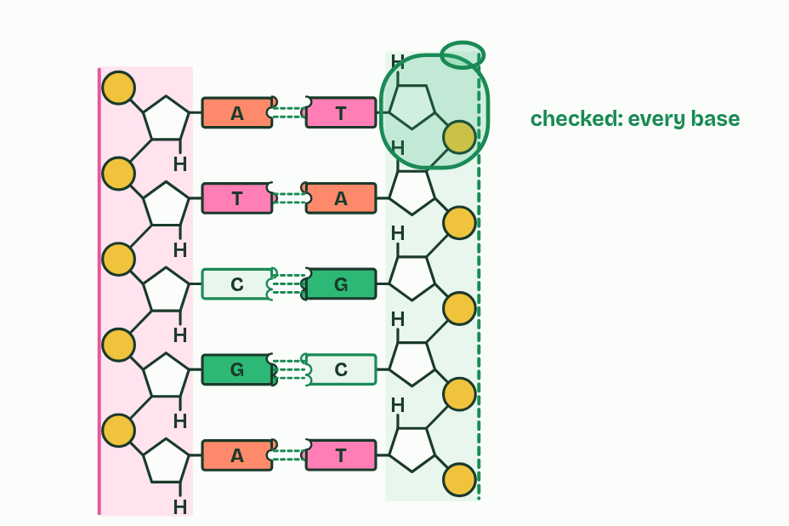  1 DNA polymerase III adds nucleotides at the 3′ end.  2 Rarely, a mismatch is joined in.  3 It backs up and removes the mismatched nucleotide.  4 It adds the correct one.  5 Then it carries on: about 1 mistake in 10 million survives.  ANNOTATE THE FIGURE  Number the 5 steps on the figure and note what happens at each: 1 primer; 2 primer; 3 DNA polymerase I; 4 DNA ligase; 5 mismatch.  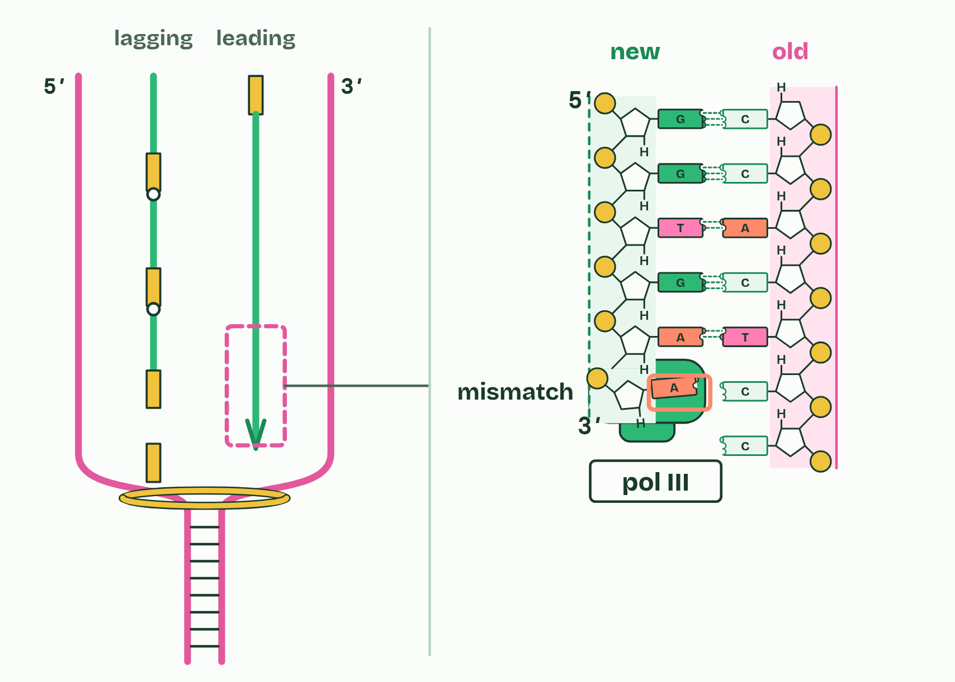  1 One primer starts the leading strand.  2 On the lagging strand: a new primer for every fragment.  3 DNA polymerase I swaps the RNA primer for DNA.  4 DNA ligase makes the last bond in the backbone.  5 A mismatch at the 3′ end: what does DNA polymerase III do next?
  SPOT THE MISTAKE
  What do students often get wrong about DNA proofreading? Write the mistake, then put it right.
  Proofreading does not check the whole strand afterwards: it removes the nucleotide just added at the 3′ end, while the strand is being built. And it is DNA polymerase III that proofreads (in the IB’s account), not polymerase I or ligase.
SUMMARY
Sum up section 10 in two or three sentences of your own.
• A mismatch is a new nucleotide whose base does not pair with the template.
• DNA polymerase III backs up, removes it from the 3′ end and adds the correct one.
• It checks as it builds, not afterwards.

Check yourself
The check for this guide is online: a fresh paper of past-paper style questions from the exam bank on D1.1 each time, marked as you go, and saved to your Exam practice progress when you are signed in. Open the link:
biologybybradford.com/exam-maker/sit?topics=D1.1&level=HL&paper=quiz&marks=15&src=ep

