Name | Class | Date
IB BIOLOGY · D1.1

DNA replication
Notes to fill in alongside the guide. Each numbered block matches a chapter of the guide, and of the lesson slides. Write in the gaps, answer the cues, annotate the figures, and sum up each section in your own words.
BY THE END YOU CAN
Explain why cells copy their DNA, and why every copy must carry the same base sequence D1.1.1
Explain what semi-conservative means, and how complementary base pairing makes copying accurate D1.1.2
Describe what helicase and DNA polymerase do at a replication fork D1.1.3
Outline how PCR copies a small sample of DNA, with primers, three temperatures and Taq polymerase D1.1.4
Explain how gel electrophoresis separates DNA fragments by size, and read sizes against a ladder D1.1.4
Use DNA profiles to settle paternity and forensic cases, and explain why more markers mean fewer false matches D1.1.5
Explain why DNA polymerases add nucleotides only to the 3′ end, so new strands grow 5′ to 3′ D1.1.6
Compare replication on the leading and lagging strands, with Okazaki fragments and RNA primers D1.1.7
State what DNA primase, DNA polymerase I, DNA polymerase III and DNA ligase each do D1.1.8
Explain how DNA polymerase III proofreads the strand it is building D1.1.9

01 A copy for every new cell | D1.1.1
CUES  Predict: You began as one fertilised egg and now have about 30 trillion cells. If every cell divided in step, about how many rounds of copying and dividing would it take?  What is meant by DNA replication?  What is meant by base sequence?  What is meant by cell division?  What is meant by asexual reproduction?  What is meant by growth?  What is meant by tissue replacement? | NOTES  1 Making a copy of a DNA molecule is called ____________________.  2 The message in DNA is the order of its bases, the __________________ (A1.2), so a faithful copy has the same bases in the same order.  3 Copying comes before every __________________.  4 Reproduction. A bacterium splits in two, yeast buds and a strawberry plant sends out runners: ___________________________. Even the cells that become eggs and sperm come from cells that copied their DNA first.  5 Growth. A fertilised egg becomes a body of about 30 trillion cells, every one made by division. This is ________.  6 Tissue replacement. Skin, the lining of the gut and blood cells are replaced all the time, and a cut heals with new cells: ________________________.  Your own notes  ANNOTATE THE FIGURE  Number the 4 steps on the figure and note what happens at each: 1 DNA; 2 copies; 3 reproduce, grow, replace; 4 division.  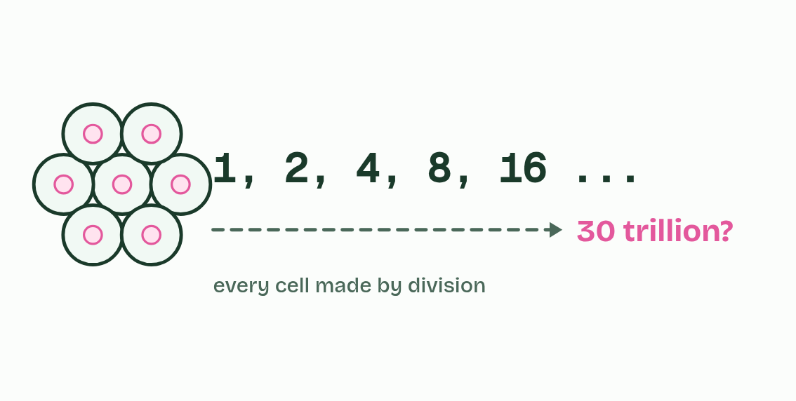
  SPOT THE MISTAKE
  What do students often get wrong about exact copies? Write the mistake, then put it right.
  The mistake
  Put it right
SUMMARY
Sum up section 01 in two or three sentences of your own.

02 One old strand, one new | D1.1.2
CUES  Predict: A DNA molecule is copied, and then both copies are copied again. Of the four molecules, how many still contain a strand from the original?  What is meant by template?  What is meant by complementary base pairing?  What is meant by daughter molecule?  What is meant by semi-conservative? | NOTES  1 Each old strand then acts as a ___________: free nucleotides line up against its exposed bases, A opposite T and C opposite G, and are joined into a new strand.  2 That is __________________________________, and nothing else fits.  3 So each new molecule, a _______________________, is made of one old strand and one new one.  4 That is what _______________________ means: half of each molecule is conserved from the one before.  5 Each old strand is a ___________ for one new strand.  6 Base pairing, A with T and C with G, makes each new strand the complement of its ___________.  7 Each _______________________: one whole old strand and one whole new strand.  Your own notes  ANNOTATE THE FIGURE  The figure shows it as Conservative, Semi-conservative, Dispersive and What they saw. Note what changes each time.  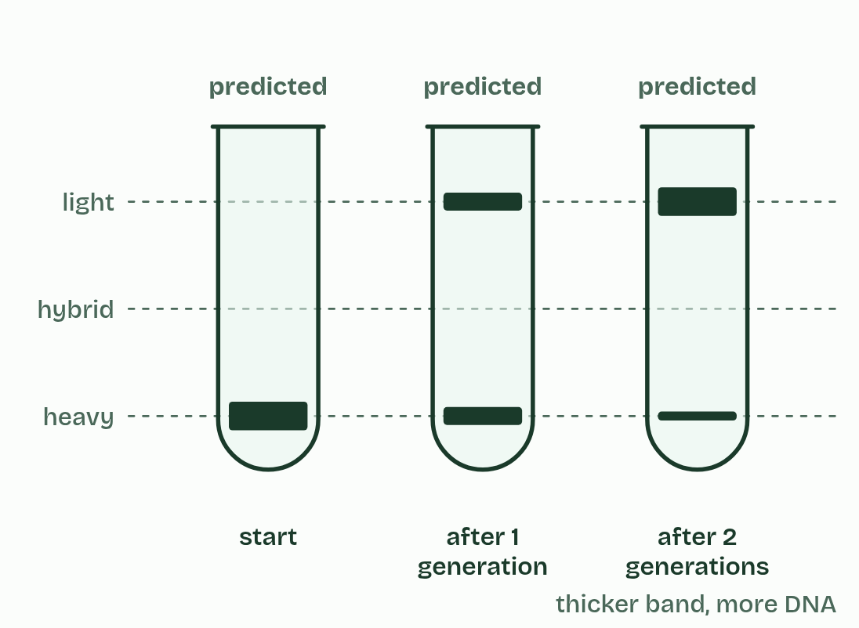  ANNOTATE THE FIGURE  Number the 5 steps on the figure and note what happens at each.  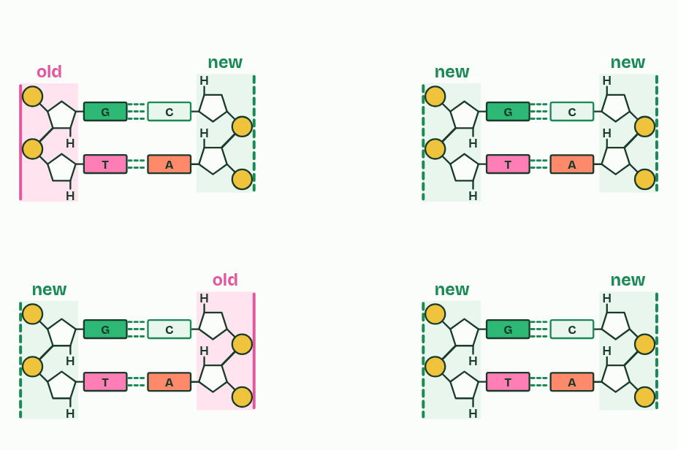
  SPOT THE MISTAKE
  What do students often get wrong about semi-conservative replication? Write the mistake, then put it right.
  The mistake
  Put it right
SUMMARY
Sum up section 02 in two or three sentences of your own.

03 Unzip, then build | D1.1.3
CUES  Predict: A drug stops helicase but leaves DNA polymerase working. What happens to replication?  What is meant by helicase?  What is meant by replication fork?  What is meant by DNA polymerase?  What is meant by free nucleotides? | NOTES  1 ___________ is the unzipper.  2 The point where the helix is opening is the ______________________.  3 ___________________ is the builder. ______________________ drift in the nucleus, or in the cytoplasm of a bacterium.  4 ___________ unwinds the helix and breaks the hydrogen bonds between bases.  5 ___________________ joins free nucleotides into a new strand, matched to the template by base pairing.  Your own notes  ANNOTATE THE FIGURE  Label each part and say what it does: an old strand, an old strand, hydrogen bonds, a new strand, a new strand, exposed bases., exposed bases., a free nucleotide, a free nucleotide, DNA polymerase, DNA polymerase, helicase.  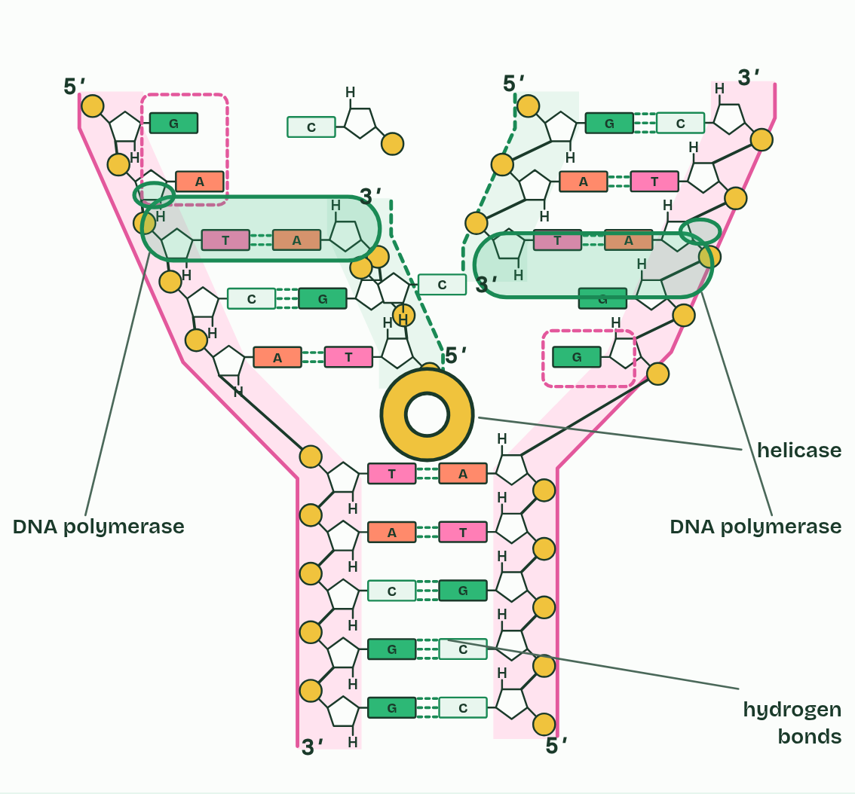  ANNOTATE THE FIGURE  Number the 4 steps on the figure and note what happens at each: 1 old; 2 Helicase; 3 DNA polymerase; 4 old, new.  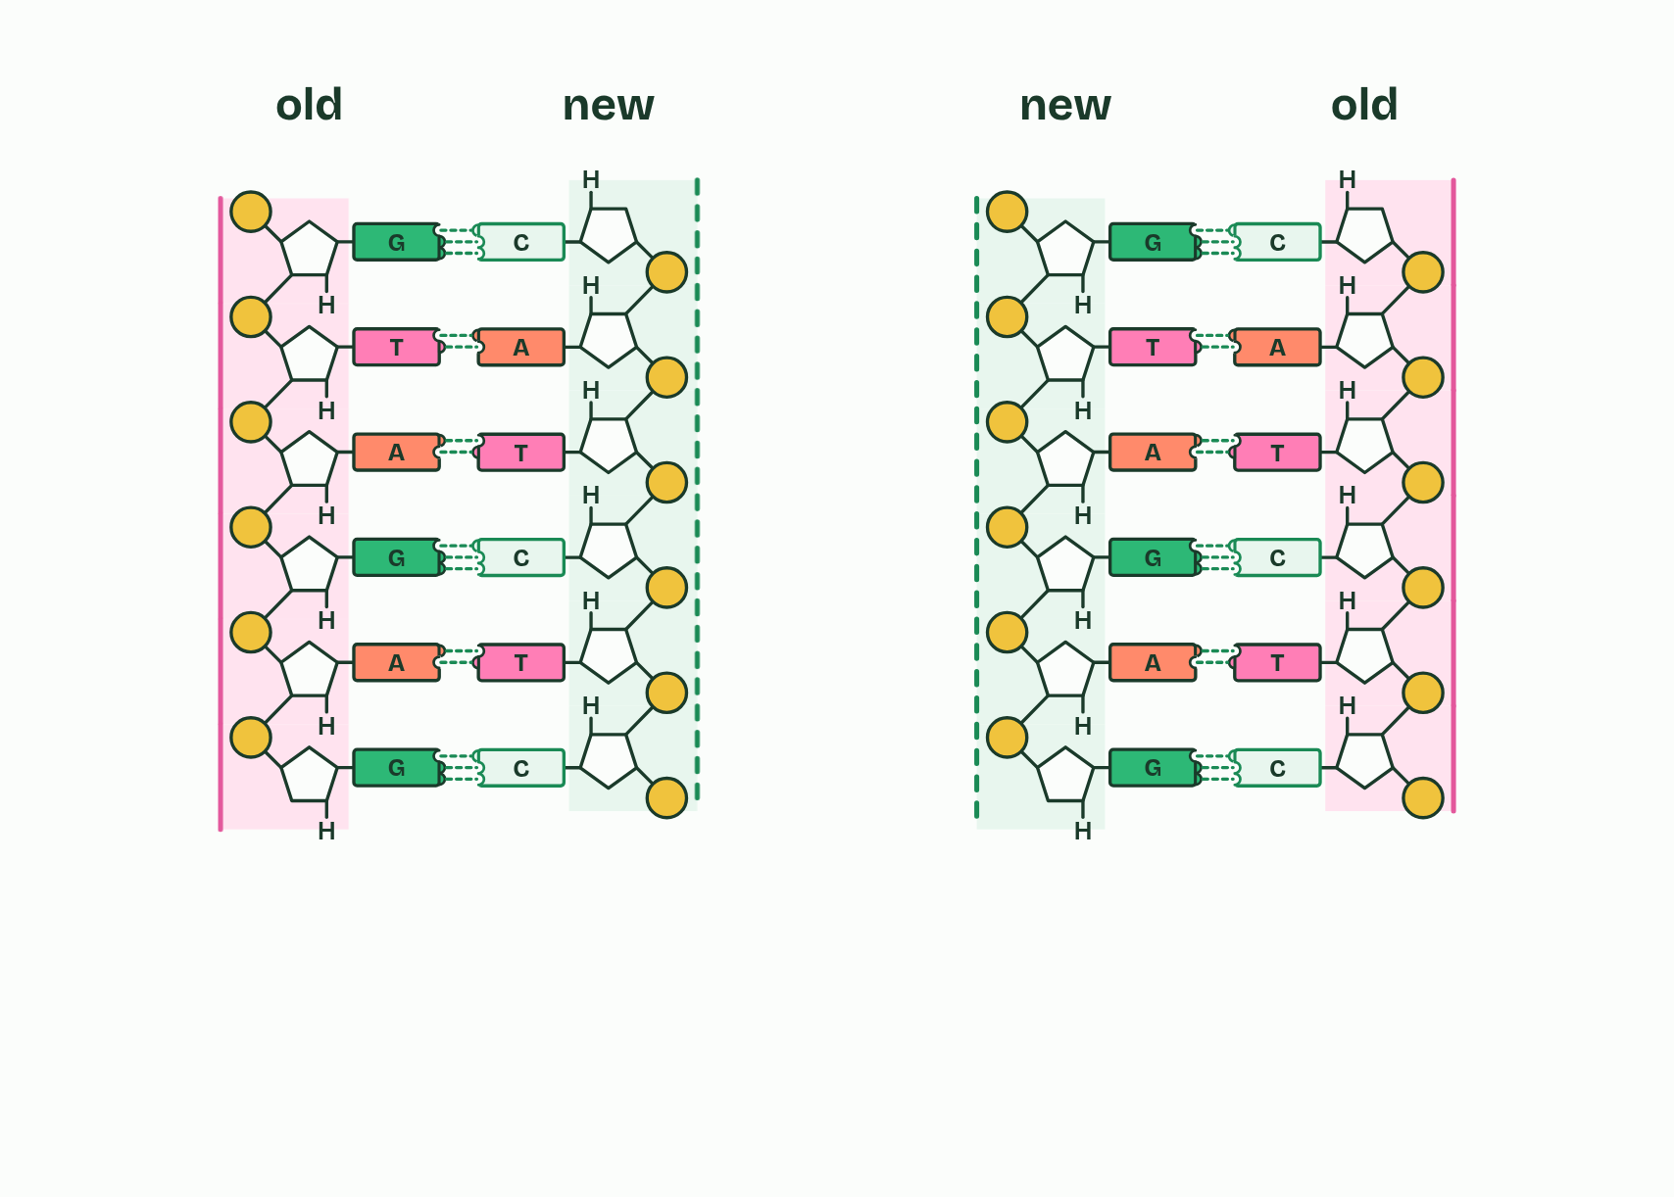
  SPOT THE MISTAKE
  What do students often get wrong about helicase and DNA polymerase? Write the mistake, then put it right.
  The mistake
  Put it right
SUMMARY
Sum up section 03 in two or three sentences of your own.

04 A millionfold copy | D1.1.4
CUES  Predict: PCR uses a DNA polymerase from bacteria that live in hot springs. Why not a polymerase from human cells?  What is meant by polymerase chain reaction (PCR)?  What is meant by amplify?  What is meant by primers?  What is meant by thermal cycler?  What is meant by denaturation?  What is meant by annealing?  What is meant by extension?  What is meant by taq polymerase? | NOTES  1 The __________________________________ copies one chosen stretch of DNA over and over until there is plenty.  2 Making many copies of a small amount of DNA is to _________ it.  3 The tube holds the sample, plenty of free nucleotides, a buffer, a polymerase and two _________: short single strands of DNA, one matching each end of the stretch to be copied.  4 A ___________________ then changes the temperature again and again.  5 The polymerase used is ___________________, from Thermus aquaticus, a bacterium found in hot springs.  Your own notes  ANNOTATE THE FIGURE  Number the 6 steps on the figure and note what happens at each.  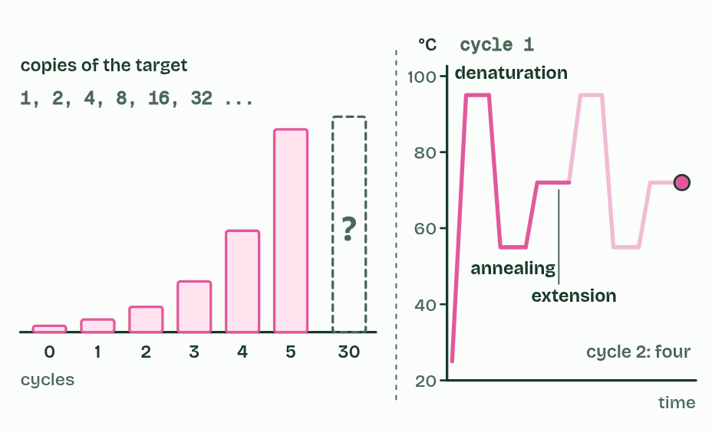  REMEMBER IT  One PCR cycle
  D  Dragons | A  Always | E  Exhale
  D | A | E
  SPOT THE MISTAKE
  What do students often get wrong about the polymerase chain reaction? Write the mistake, then put it right.
  The mistake
  Put it right
SUMMARY
Sum up section 04 in two or three sentences of your own.

05 Sorted by size | D1.1.4
CUES  Predict: Fragments of 300, 1,000 and 5,000 base pairs are run on the same gel. Which ends up nearest the wells?  What is meant by gel electrophoresis?  What is meant by fragments?  What is meant by base pairs (bp)?  What is meant by wells?  What is meant by electrodes?  What is meant by DNA ladder? | NOTES  1 To see what is in it, you sort the DNA by size. __________________________ does that: it separates DNA ____________ by their length, counted in ____________________.  2 A slab of gel, a jelly made from seaweed, has a row of small pits at one end, the ________.  3 The slab lies in a tank of salty buffer between two ______________.  4 A ______________, a mix of fragments of known sizes, runs in its own lane and gives a scale.  5 The mesh holds long ____________ back more, so short ones travel furthest.  Your own notes  ANNOTATE THE FIGURE  The figure shows it at run time (min) 0, time (min) 30 and time (min) 58. Note what changes each time.  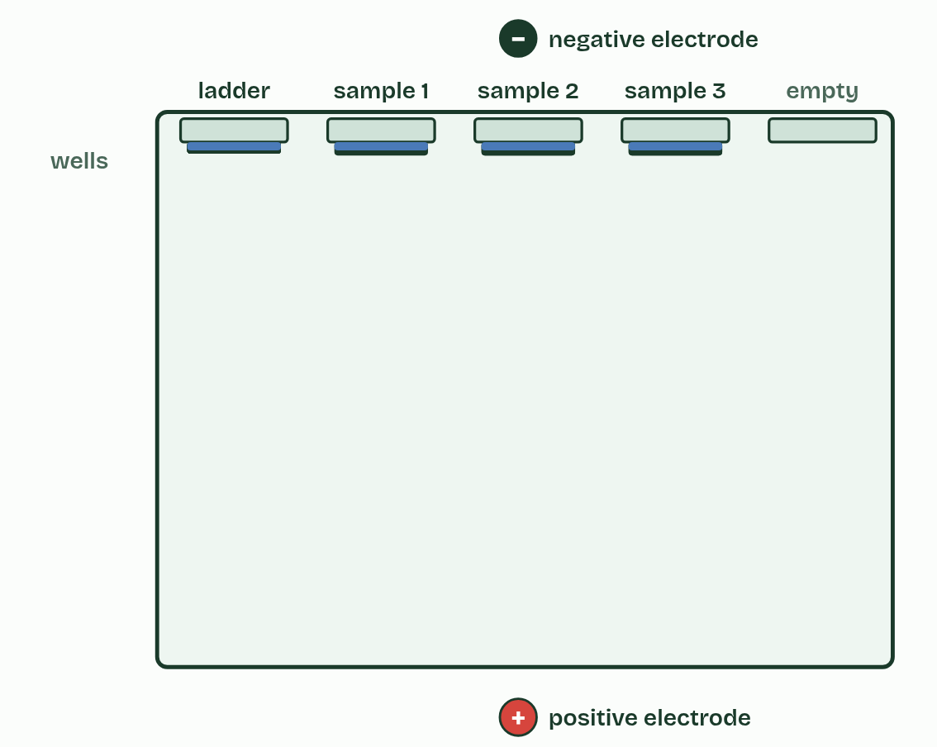
  SPOT THE MISTAKE
  What do students often get wrong about gel electrophoresis? Write the mistake, then put it right.
  The mistake
  Put it right
SUMMARY
Sum up section 05 in two or three sentences of your own.

06 Profiles, parents and crime scenes | D1.1.5
CUES  Predict: At one marker, 1 person in 10 shares the crime-scene pattern by chance. With ten independent markers, each 1 in 10, how many people in a city of 10 million would you expect to match by chance?  What is meant by short tandem repeat (STR)?  What is meant by marker?  What is meant by allele?  What is meant by DNA profiling?  What is meant by forensic?  What is meant by paternity?  What is meant by false match? | NOTES  1 Most of our DNA is the same from one person to the next, but some places hold a short sequence repeated over and over, end to end: a __________________________________, such as GATA GATA GATA.  2 Such a place is a ________, each version (a number of repeats) is an ________, and each person has two alleles at each marker, one from each parent.  3 __________________ starts with a sample: blood, saliva, a hair root, or skin cells left on a handle.  4 In a ___________ investigation, the profile from the scene is compared with those of the suspects and the victim.  5 In a ____________ test, a child has at each marker one allele from the mother and one from the father.  6 Each extra independent marker is another test that a person must pass by luck, so the chance of a _______________ is multiplied by another small number and falls very fast.  7 ___________ investigations and paternity tests, by DNA profiling.  Your own notes  ANNOTATE THE FIGURE  The figure shows it as Paternity and Crime scene. Note what changes each time.  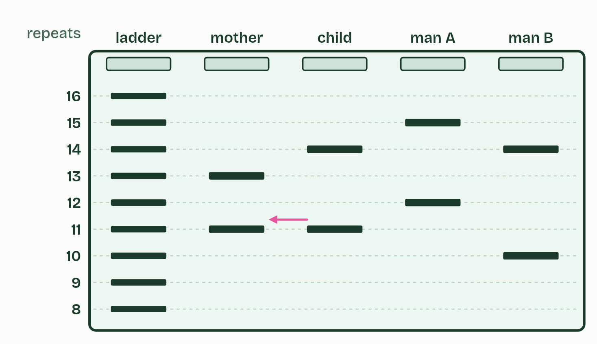  ANNOTATE THE FIGURE  The figure shows it as 1 marker, 3, 10 and 20. Note what changes each time.  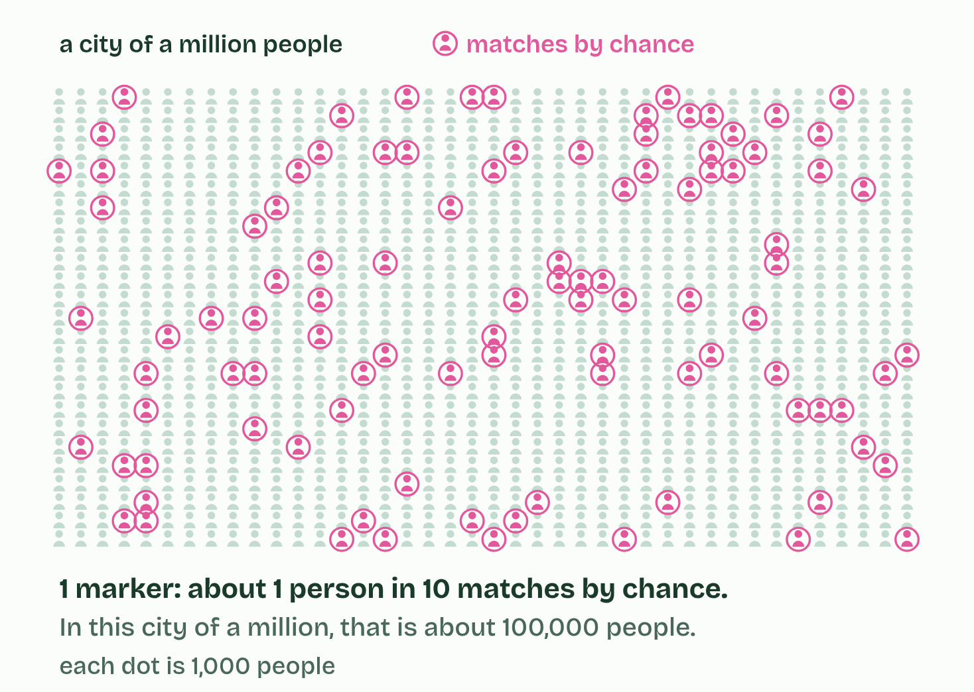
  SPOT THE MISTAKE
  What do students often get wrong about applications of PCR and gel electrophoresis? Write the mistake, then put it right.
  The mistake
  Put it right
SUMMARY
Sum up section 06 in two or three sentences of your own.

07 Only ever at the 3′ end | D1.1.6 HL
CUES  Predict: A free nucleotide arrives at the 5′ end of a growing new strand, and its base pairs with the template. What happens?  What is meant by 5′ terminal?  What is meant by 3′ terminal?  What is meant by directionality? | NOTES  1 One end has a free phosphate on a 5′ carbon, the _______________.  2 The other has a free hydroxyl group (OH) on a 3′ carbon, the _______________.  3 So nucleotides are only ever added at the 3′ end, and a new strand grows 5′ to 3′. This one-way working is the ___________________ of DNA polymerases.  4 Every strand has a ________ end and a ________ end.  5 DNA polymerase joins a nucleotide’s 5′ phosphate to the ________.  6 There is nothing to join to at the ________.  Your own notes  ANNOTATE THE FIGURE  Number the 5 steps on the figure and note what happens at each: 1 5′, 3′; 2 3′ end; 3 5′ end; 4 5′ to 3′; 5 opposite.  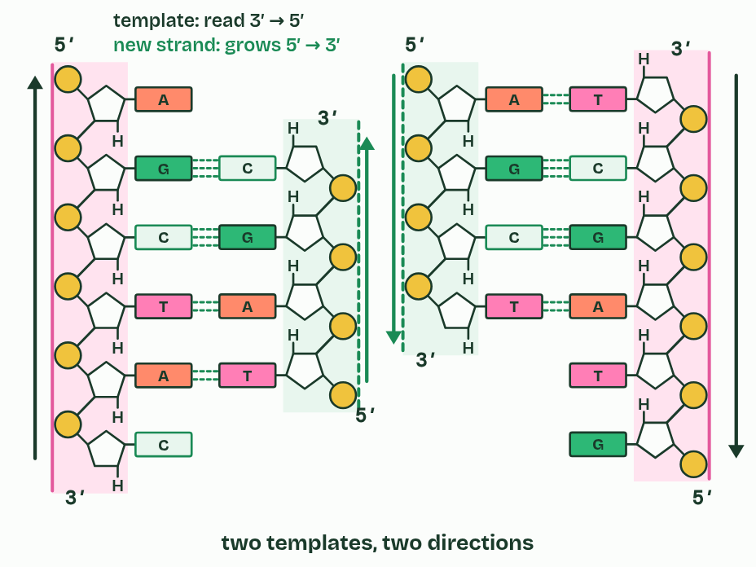
  SPOT THE MISTAKE
  What do students often get wrong about directionality of DNA polymerases? Write the mistake, then put it right.
  The mistake
  Put it right
SUMMARY
Sum up section 07 in two or three sentences of your own.

08 One strand smooth, one in pieces | D1.1.7 HL
CUES  Predict: A fork opens 10,000 bases of a bacterial chromosome. Okazaki fragments there are about 1,000 to 2,000 nucleotides long. How many RNA primers does each new strand need?  What is meant by leading strand?  What is meant by continuously?  What is meant by lagging strand?  What is meant by discontinuously?  What is meant by okazaki fragments?  What is meant by RNA primer? | NOTES  1 DNA polymerase follows right behind helicase and builds without stopping. This is the ___________________, made ________________.  2 Then the fork opens a little more and the polymerase starts again. This is the ___________________, made ____________________ in short pieces called _______________________.  3 So every new piece of DNA begins with a short ______________, made by an enzyme you meet in chapter 9, which gives the polymerase a 3′ end to add to.  4 ___________________: built continuously towards the fork, from one primer.  5 ___________________: built discontinuously, away from the fork, as Okazaki fragments, each from its own primer.  Your own notes  ANNOTATE THE FIGURE  Number the 6 steps on the figure and note what happens at each.  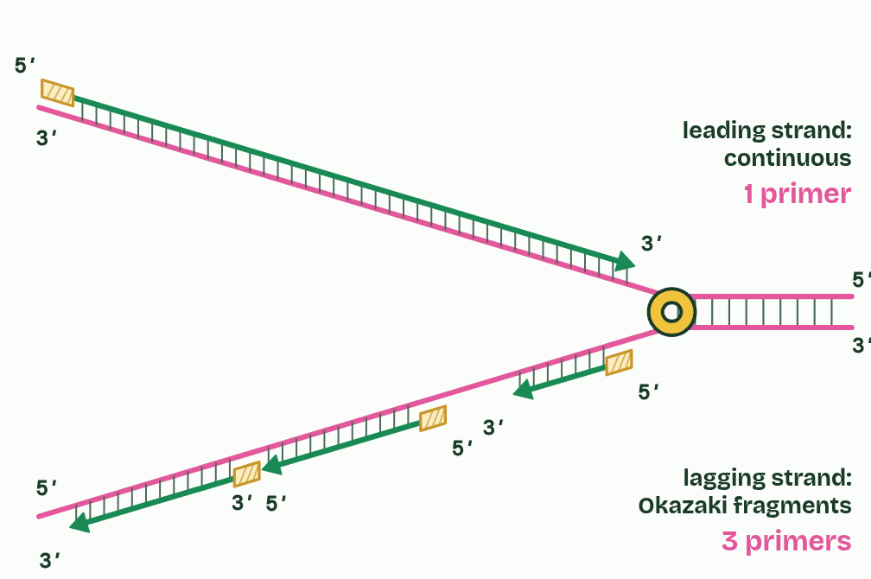
  SPOT THE MISTAKE
  What do students often get wrong about leading and lagging strands? Write the mistake, then put it right.
  The mistake
  Put it right
SUMMARY
Sum up section 08 in two or three sentences of your own.

09 Four enzymes at the fork | D1.1.8 HL
CUES  Predict: A bacterium makes a faulty DNA ligase. What would you find in its newly copied DNA?  What is meant by DNA primase?  What is meant by DNA polymerase III?  What is meant by DNA polymerase I?  What is meant by DNA ligase?  What is meant by nick? | NOTES  1 _______________ makes a short RNA primer (about ten nucleotides in E. coli) on the template, complementary to it: once at the start of the leading strand, and once for each Okazaki fragment.  2 ________________________ extends each primer from its 3′ end, one nucleotide at a time, each paired with the template, so it builds almost all of each new strand, 5′ to 3′. It also proofreads (chapter 10).  3 ______________________ removes the RNA primers and replaces their nucleotides with DNA nucleotides. Like every DNA polymerase it needs a 3′ end to add to, so it works from the 3′ end of the newer fragment that has grown up to the primer, taking out RNA ahead of it and filling in DNA behind. A primer is only replaced once the next fragment has reached it.  4 ______________ joins the fragments. It makes the last covalent bond in the sugar and phosphate backbone, where one fragment’s 3′ end meets the next fragment’s 5′ end. The unjoined gap is a ________.  Your own notes  ANNOTATE THE FIGURE  Label each part and say what it does: the leading strand, an RNA primer, an Okazaki fragment, an RNA primer, an RNA primer, a nick, DNA ligase, DNA polymerase I, DNA polymerase III, DNA polymerase III, DNA primase, helicase.  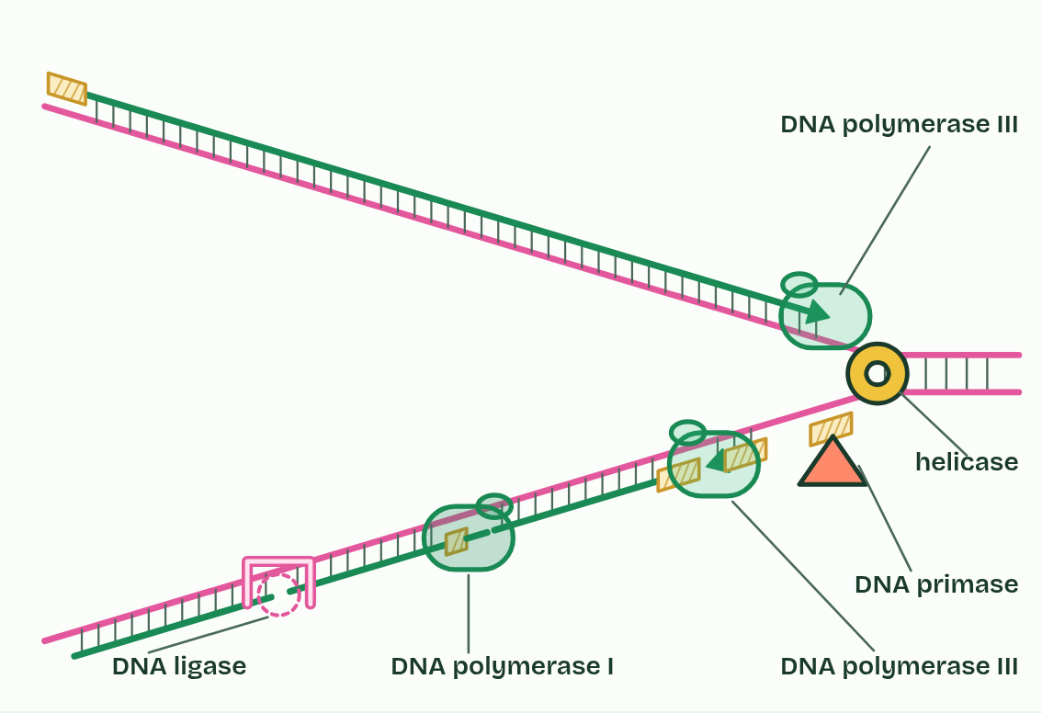  REMEMBER IT  The enzymes at the fork, in order
  H  Hungry | P  Pandas | P  Prefer | P  Plain | L  Lettuce
  H | P | P | P | L
  SPOT THE MISTAKE
  What do students often get wrong about primase, polymerases I and III, ligase? Write the mistake, then put it right.
  The mistake
  Put it right
SUMMARY
Sum up section 09 in two or three sentences of your own.

10 Checking as it goes | D1.1.9 HL
CUES  Predict: Without proofreading, DNA polymerase III gets about 1 base in 100,000 wrong. With it, about 1 in 10 million. Copying a bacterial chromosome means adding about 9 million new bases. About how many mistakes would each give?  What is meant by mismatch?  What is meant by proofreading?  What is meant by mutation? | NOTES  1 Base pairing makes the right base far likelier than a wrong one, but now and then DNA polymerase III joins a nucleotide whose base does not pair with the template. That is a ___________.  2 ________________ deals with it.  3 A mismatch that is left in becomes a ___________ in one of the two daughter molecules after the next copying (D1.3).  4 A ___________ is a new nucleotide whose base does not pair with the template.  Your own notes  ANNOTATE THE FIGURE  Number the 5 steps on the figure and note what happens at each.  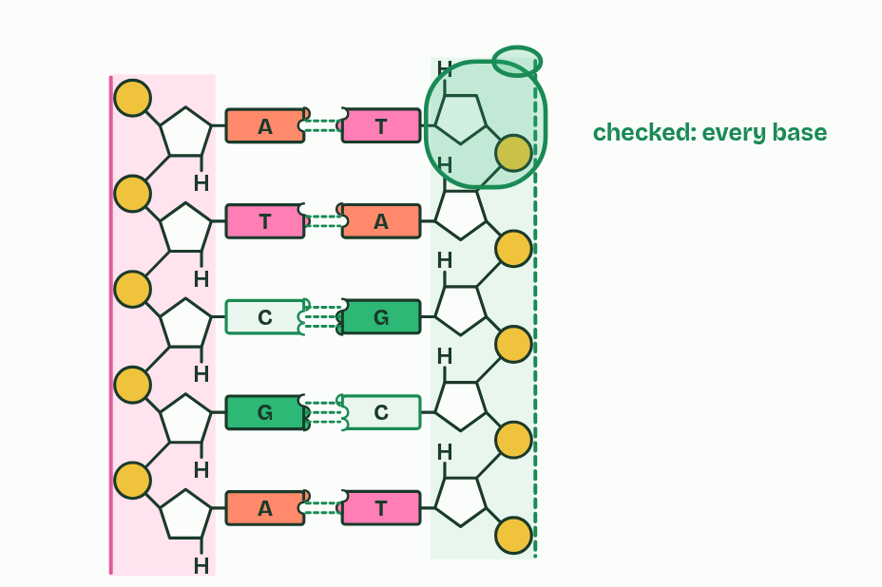  ANNOTATE THE FIGURE  Number the 5 steps on the figure and note what happens at each: 1 primer; 2 primer; 3 DNA polymerase I; 4 DNA ligase; 5 mismatch.  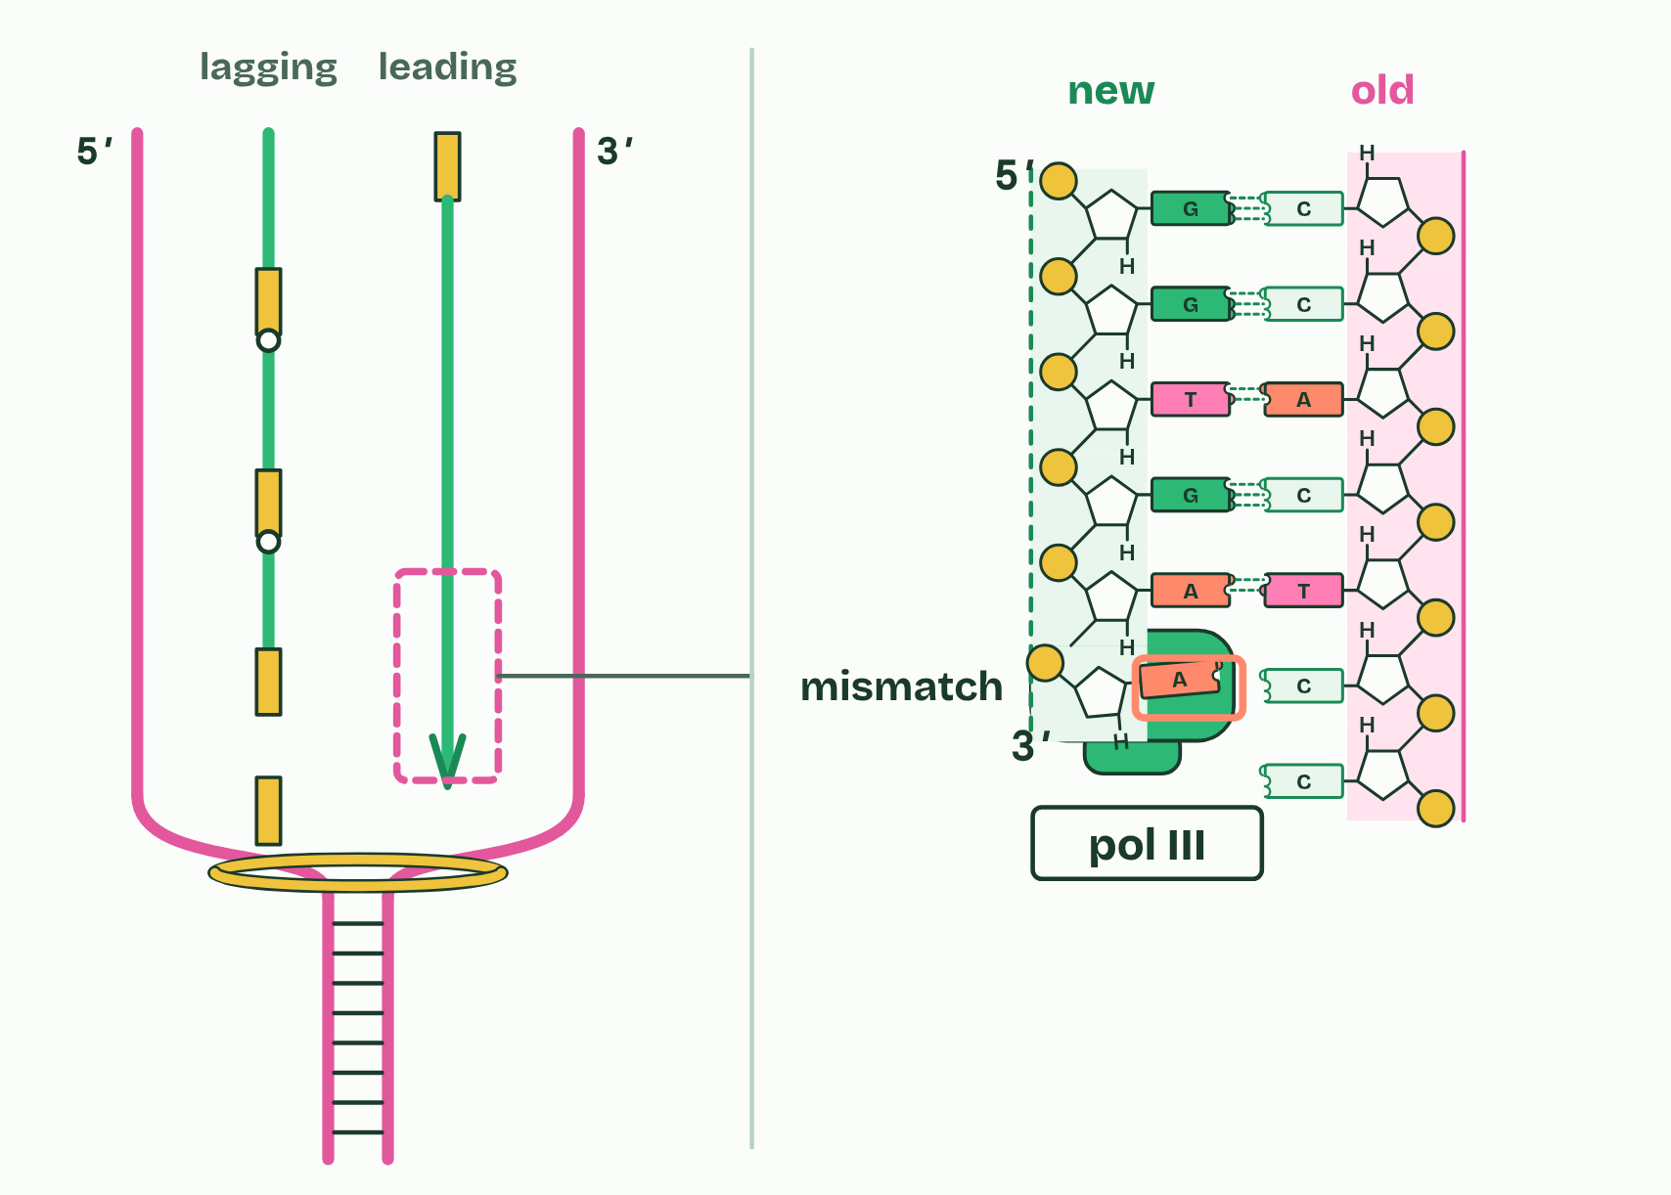
  SPOT THE MISTAKE
  What do students often get wrong about DNA proofreading? Write the mistake, then put it right.
  The mistake
  Put it right
SUMMARY
Sum up section 10 in two or three sentences of your own.

Check yourself
The check for this guide is online: a fresh paper of past-paper style questions from the exam bank on D1.1 each time, marked as you go, and saved to your Exam practice progress when you are signed in. Open the link:
biologybybradford.com/exam-maker/sit?topics=D1.1&level=HL&paper=quiz&marks=15&src=ep

