Name | Class | Date
IB BIOLOGY · D1.2

Protein synthesis
Teacher’s copy: every blank filled in. Each numbered block matches a chapter of the guide, and of the lesson slides. Write in the gaps, answer the cues, annotate the figures, and sum up each section in your own words.
BY THE END YOU CAN
Explain how RNA polymerase uses one strand of a gene as a template, pairing U in the RNA with A on the template D1.2.1, D1.2.2
Explain why a template can be read for a lifetime without changing, and why transcription is where a gene is switched on or off D1.2.3, D1.2.4
Describe what mRNA, the two ribosome subunits and tRNA each do in translation D1.2.5, D1.2.6
Pair a codon with its anticodon, and explain how pairing brings the right amino acid D1.2.7
Explain why the code uses threes and what degenerate and universal mean, and use a codon table to deduce a polypeptide D1.2.8, D1.2.9
Describe how the ribosome moves one codon at a time, joining each amino acid to the chain with a peptide bond D1.2.10
Explain how one base change in the haemoglobin gene causes sickle cell anaemia D1.2.11
Explain what 5′ to 3′ means for transcription and for translation D1.2.12
Explain how transcription factors start transcription at a promoter, and name four kinds of DNA that code for no polypeptide D1.2.13, D1.2.14
Describe how pre-mRNA is capped, tailed and spliced, and how alternative splicing makes several polypeptides from one gene D1.2.15, D1.2.16
Describe how translation starts, and what the A, P and E sites do D1.2.17
Explain how pre-proinsulin becomes insulin, and why proteasomes keep breaking proteins down D1.2.18, D1.2.19

01 Copying a gene into RNA | D1.2.1 D1.2.2
CUES  Predict: A gene's template strand reads T A C C T G. Which RNA does RNA polymerase make from it?  B: A U G G A C. Each RNA base pairs with the template base opposite it: T takes A, A takes U, C takes G and G takes C. So T A C C T G gives A U G G A C. “A T G G A C” has the right pairs but uses T, which RNA never has (it is the coding strand, written as DNA). “U A C C U G” copies the template with U for T instead of pairing with it.  What is meant by gene?  A length of DNA whose base sequence codes for a polypeptide, or for an RNA that does a job of its own.  What is meant by transcription?  Making an RNA copy of a gene, using one strand of the DNA as a template.  What is meant by messenger RNA?  RNA copied from a gene. It carries the gene's base sequence to a ribosome, where it is read.  What is meant by RNA polymerase?  The enzyme that makes RNA. It parts the two DNA strands over a short stretch, pairs free RNA nucleotides with one strand and joins them with covalent bonds.  What is meant by template strand?  The DNA strand that RNA polymerase reads. The RNA is built complementary to it.  What is meant by coding strand?  The DNA strand that is not read. Its base sequence matches the RNA, with T in place of U.  What is meant by complementary base pairing?  The rule that each base pairs with one particular other base: A with T (or U), and C with G.  What is meant by uracil?  The base U, found in RNA in place of thymine. It pairs with adenine.  What is meant by hydrogen bonds?  Weak attractions between a slightly positive hydrogen atom on one molecule and a slightly negative atom on another. | NOTES  1 A gene is a stretch of DNA whose base sequence codes for a polypeptide.  2 Making RNA with a DNA template is transcription, and the RNA that carries a gene's message to the ribosomes is messenger RNA (mRNA).  3 One enzyme does the whole job. RNA polymerase binds at the start of a gene and parts the two DNA strands over a short stretch (it needs no helicase: that enzyme unzips DNA when the whole molecule is copied, in D1.1).  4 Free RNA nucleotides pair with the exposed bases of one strand only, the template strand.  5 The other strand is the coding strand, because the RNA ends up with its sequence.  6 Complementary base pairing chooses every RNA base.  7 A on the template takes uracil (U), T takes A, C takes G and G takes C. The pairs are held by hydrogen bonds: weak enough to form and break as the enzyme passes, but specific, because only the right base fits.  8 The RNA is complementary to the template, and has the same sequence as the coding strand, with U where DNA has T.  Your own notes  ANNOTATE THE FIGURE  Number the 5 steps on the figure and note what happens at each.  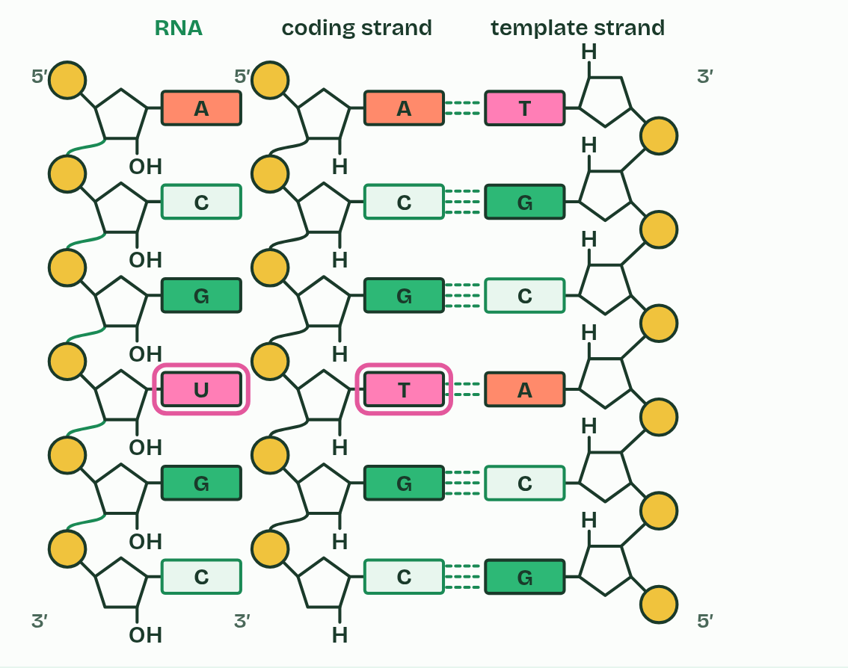  1 A gene: two strands of DNA, held by hydrogen bonds.  2 RNA polymerase parts the strands.  3 RNA nucleotides pair with the template strand: U opposite A.  4 The enzyme joins them into a strand and moves on; the DNA closes behind it.  5 The RNA has the coding strand's sequence, with U in place of T.  REMEMBER IT  Which base pairs with which in transcription
  A  Apples | U  Under | C  Cars | G  Garage
  A on the template  pairs with U in the RNA | U in the RNA  uracil, where DNA has T | C on the template  pairs with G in the RNA | G on the template  pairs with C in the RNA
  SPOT THE MISTAKE
  What do students often get wrong about transcription? Write the mistake, then put it right.
  RNA polymerase, not helicase, parts the DNA in transcription. And the RNA is not a copy of the template: it is complementary to it, and matches the coding strand (with U for T).
SUMMARY
Sum up section 01 in two or three sentences of your own.
• The RNA is complementary to the template, and has the same sequence as the coding strand, with U where DNA has T.
• Only the template is read. The coding strand takes no part.

02 Read for a lifetime, read when needed | D1.2.3 D1.2.4
CUES  Predict: A nerve cell in your brain is 60 years old and has never divided. Its genes have been transcribed all that time. What has happened to their base sequences?  C: Read many times, and still the same. Transcription only opens the hydrogen bonds for a moment; it never breaks the backbone or changes a base. So a template can be read thousands of times and stay the same, which is just as well in a cell that must last a lifetime. (Damage from other causes does happen, and cells repair it: D1.3.)  What is meant by somatic cells?  Body cells: any cell of an organism except the cells that make eggs or sperm.  What is meant by conserved?  Kept unchanged over a long time, for the whole life of a cell or through many generations.  What is meant by genome?  All the DNA of a cell or organism, with all its genes.  What is meant by gene expression?  The use of the information in a gene to make its product, starting with transcription.  What is meant by switched on?  Being transcribed, so that its product is made.  What is meant by switched off?  Not being transcribed, so that its product is not made. | NOTES  1 That matters most in somatic cells that never divide again.  2 Their base sequences must be conserved: held without change for the whole life of the cell.  3 Every somatic cell of one person has the same genome, yet no cell uses all of its genes.  4 That is gene expression, and it has two main steps: transcription copies the gene into mRNA, and translation (chapter 3) uses the mRNA to build a polypeptide.  5 A gene that is being transcribed is switched on, and one that is not is switched off.  6 Not all genes are expressed in a cell at one time, and transcription is where a gene is switched on or off.  Your own notes  ANNOTATE THE FIGURE  The figure shows it as Pancreatic beta cell, Developing red blood cell and Skin cell. Note what changes each time.  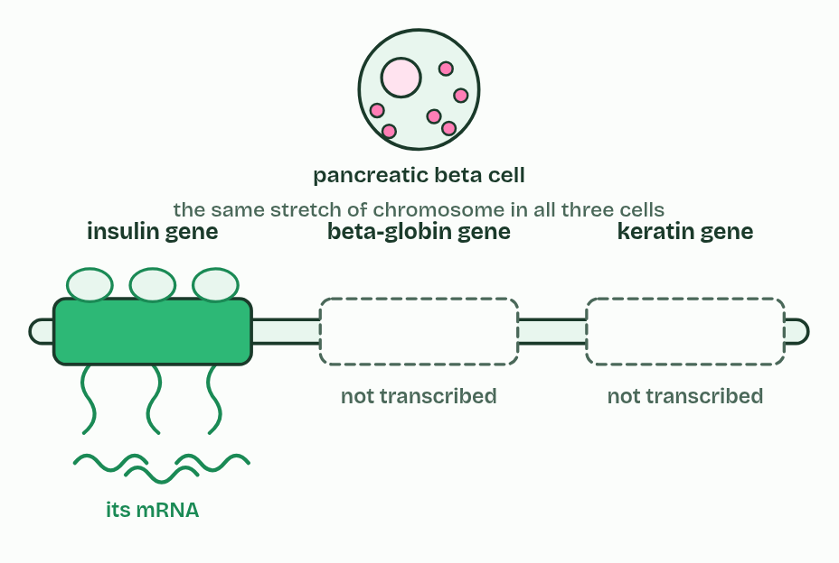  1 Pancreatic beta cell  2 Developing red blood cell  3 Skin cell  ANNOTATE THE FIGURE  Annotate this still from the animation (One gene, copied): what is happening, and why?  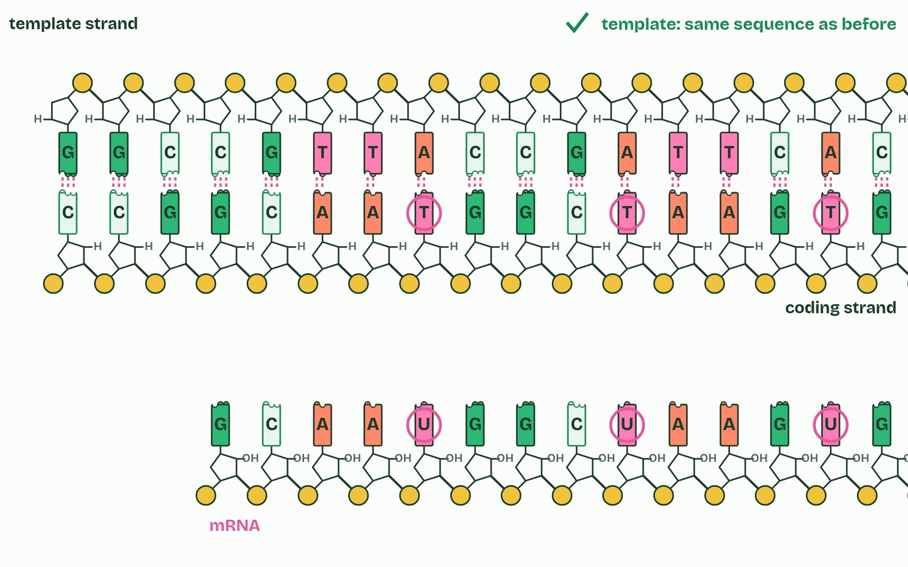  1 RNA polymerase unzips a short stretch of the gene: the hydrogen bonds holding its bases together give way.  2 Free RNA nucleotides pair with the template by complementary base pairing, U opposite A.  3 Behind the enzyme the RNA peels off and the DNA closes up again.  4 The RNA has the coding strand’s sequence, with U in place of T. The template has not changed.
  SPOT THE MISTAKE
  What do students often get wrong about stable templates, gene expression? Write the mistake, then put it right.
  Different cells do not have different genes. They have the same genes and transcribe different ones.
SUMMARY
Sum up section 02 in two or three sentences of your own.
• Transcription reads a template without changing it, so one gene gives many identical mRNAs.
• Not all genes are expressed in a cell at one time, and transcription is where a gene is switched on or off.

03 Three kinds of RNA build a protein | D1.2.5 D1.2.6
CUES  Predict: The large subunit holds two tRNAs at the same moment. Why two, and not one?  B: So one amino acid can be joined to the next. A peptide bond joins two amino acids, so both have to be held side by side: the growing chain on one tRNA and the newly arrived amino acid on the other. Codons are on the mRNA, not on a tRNA, and tRNAs do not check each other: each one pairs with its own codon.  What is meant by translation?  Making a polypeptide by reading the codons of an mRNA: the base sequence sets the amino acid sequence.  What is meant by polypeptide?  A chain of amino acids joined by peptide bonds.  What is meant by amino acids?  The monomers of polypeptides. Twenty kinds are used in cells, each with a different R group.  What is meant by ribosomes?  Structures in the cytoplasm that read mRNA and join amino acids into polypeptides. Each is made of rRNA and protein, in two subunits.  What is meant by ribosomal RNA (rRNA)?  RNA that, with protein, makes up the two subunits of a ribosome.  What is meant by small subunit?  The smaller part of a ribosome. The mRNA binds to it.  What is meant by large subunit?  The larger part of a ribosome. It can hold two tRNAs at once and joins their amino acids.  What is meant by transfer RNA (tRNA)?  Small RNA molecules that each carry one particular amino acid and have three exposed bases, the anticodon, that pair with an mRNA codon. | NOTES  1 Translation makes a polypeptide whose order of amino acids is set by the base sequence of an mRNA.  2 It happens at ribosomes, some free in the cytoplasm and some on the rough endoplasmic reticulum.  3 A ribosome is made of ribosomal RNA (rRNA) and protein, in two parts.  4 The mRNA binds to the small subunit.  5 The large subunit can hold two tRNAs at once, side by side, and it joins their amino acids (the rRNA is what speeds up that joining).  6 Transfer RNA (tRNA) molecules are short, single strands of RNA that fold back on themselves into a compact shape.  7 mRNA binds to the small subunit of the ribosome.  8 Two tRNAs can bind at the same time, in the large subunit.  Your own notes  ANNOTATE THE FIGURE  Label each part and say what it does: small subunit, mRNA, large subunit, rRNA, tRNA, amino acid, polypeptide.  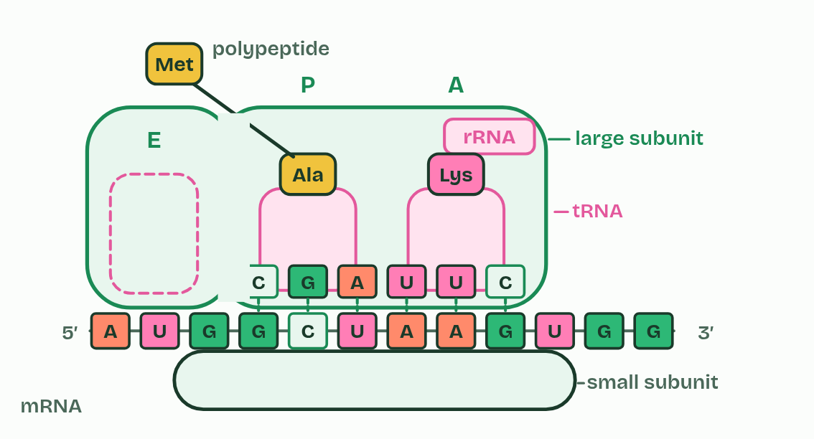  1 Small subunit: Holds the mRNA in place on the ribosome.  2 mRNA: The message: the gene's base sequence, copied in the nucleus. The ribosome reads it three bases at a time.  3 Large subunit: Holds two tRNAs at a time and joins their amino acids together.  4 rRNA: Ribosomal RNA. With proteins, it makes up both subunits, and it is the rRNA that speeds up the joining of amino acids.  5 tRNA: Transfer RNA. Each kind brings one particular amino acid, and has three exposed bases at its foot.  6 Amino acid: One of 20 kinds, carried on the top end of a tRNA.  7 Polypeptide: The growing chain of amino acids, hanging from one of the tRNAs.
  SPOT THE MISTAKE
  What do students often get wrong about translation? Write the mistake, then put it right.
  Ribosomes do not make amino acids. They join the amino acids that tRNAs bring.
SUMMARY
Sum up section 03 in two or three sentences of your own.
• mRNA binds to the small subunit of the ribosome.
• Two tRNAs can bind at the same time, in the large subunit.

04 Codon meets anticodon | D1.2.7
CUES  Predict: A codon reads U G G. Which anticodon pairs with it?  A: A C C. Pair each base: U with A, G with C, G with C, so the anticodon is A C C. “T C C” uses T, which no RNA has, and “U G G” is the codon itself, and identical bases do not pair. (At higher level you write the ends: codon 5′-UGG-3′, anticodon 3′-ACC-5′.)  What is meant by codon?  A group of three bases on an mRNA that codes for one amino acid (or a stop).  What is meant by anticodon?  The three exposed bases of a tRNA, complementary to an mRNA codon. | NOTES  1 Each group of three is a codon.  2 A tRNA carries a matching group of three exposed bases at one end, its anticodon, and one particular amino acid at the other end.  3 A codon sits on mRNA, an anticodon on tRNA.  Your own notes  ANNOTATE THE FIGURE  The figure shows it as Three codons, a rack of tRNAs, One tRNA docked and Each codon has found its tRNA. Note what changes each time.  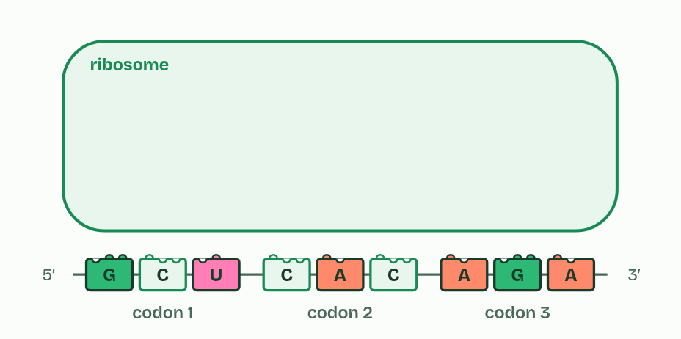  1 Three codons, a rack of tRNAs  2 One tRNA docked  3 Each codon has found its tRNA
  SPOT THE MISTAKE
  What do students often get wrong about codons and anticodons? Write the mistake, then put it right.
  Codons are on mRNA and anticodons are on tRNA. DNA has neither: its triplets are just triplets.
SUMMARY
Sum up section 04 in two or three sentences of your own.
• A codon sits on mRNA, an anticodon on tRNA.
• Pairing is complementary, A with U and C with G, so a codon decides which tRNA fits.

05 A code written in threes | D1.2.8 D1.2.9
CUES  Predict: Why can the code not use pairs of bases for each amino acid?  C: Pairs give only 16 codons for 20 amino acids. With four bases, pairs make 4 × 4 = 16 different codons, and there are 20 amino acids to code for (and a stop signal as well). Triplets make 64: enough, with plenty over, which is why most amino acids have several codons.  What is meant by genetic code?  The rules that say which amino acid each codon stands for.  What is meant by triplet code?  A code in which each codon is three bases long.  What is meant by stop codons?  Codons that code for no amino acid and end translation: UAA, UAG and UGA.  What is meant by start codon?  The codon AUG, where translation begins. It codes for methionine.  What is meant by degenerate?  Having more than one codon for most amino acids. A codon never stands for two amino acids.  What is meant by universal?  Shared by almost all living things: a codon means the same amino acid in nearly every organism.  What is meant by reading frame?  The way the bases of an mRNA are grouped into codons. A different start gives different codons. | NOTES  1 The genetic code says which amino acid each codon stands for.  2 So the code is a triplet code.  3 The other three, UAA, UAG and UGA, are stop codons: they code for nothing and end the chain.  4 AUG codes for methionine and is also the start codon, where translation begins.  5 With 61 codons for 20 amino acids, most amino acids have more than one codon, so the code is degenerate: leucine, serine and arginine have six each, methionine and tryptophan only one.  6 The code is also universal: almost every living thing reads each codon as the same amino acid, from bacteria to people.  Your own notes  ANNOTATE THE FIGURE  The figure shows it at bases in each codon 1, in each codon 2 and in each codon 3. Note what changes each time.  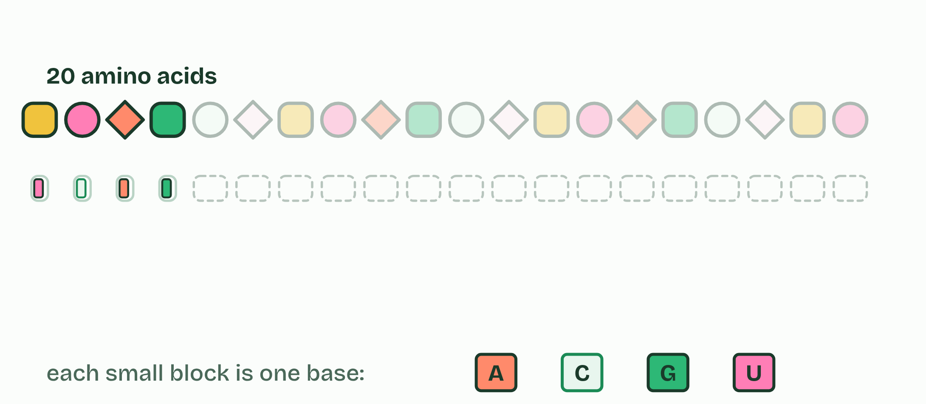  1 Bases in each codon 1  2 Bases in each codon 2  3 Bases in each codon 3  ANNOTATE THE FIGURE  Number the 3 steps on the figure and note what happens at each: 1 genetic code; 2 first, second, third; 3 wheel.  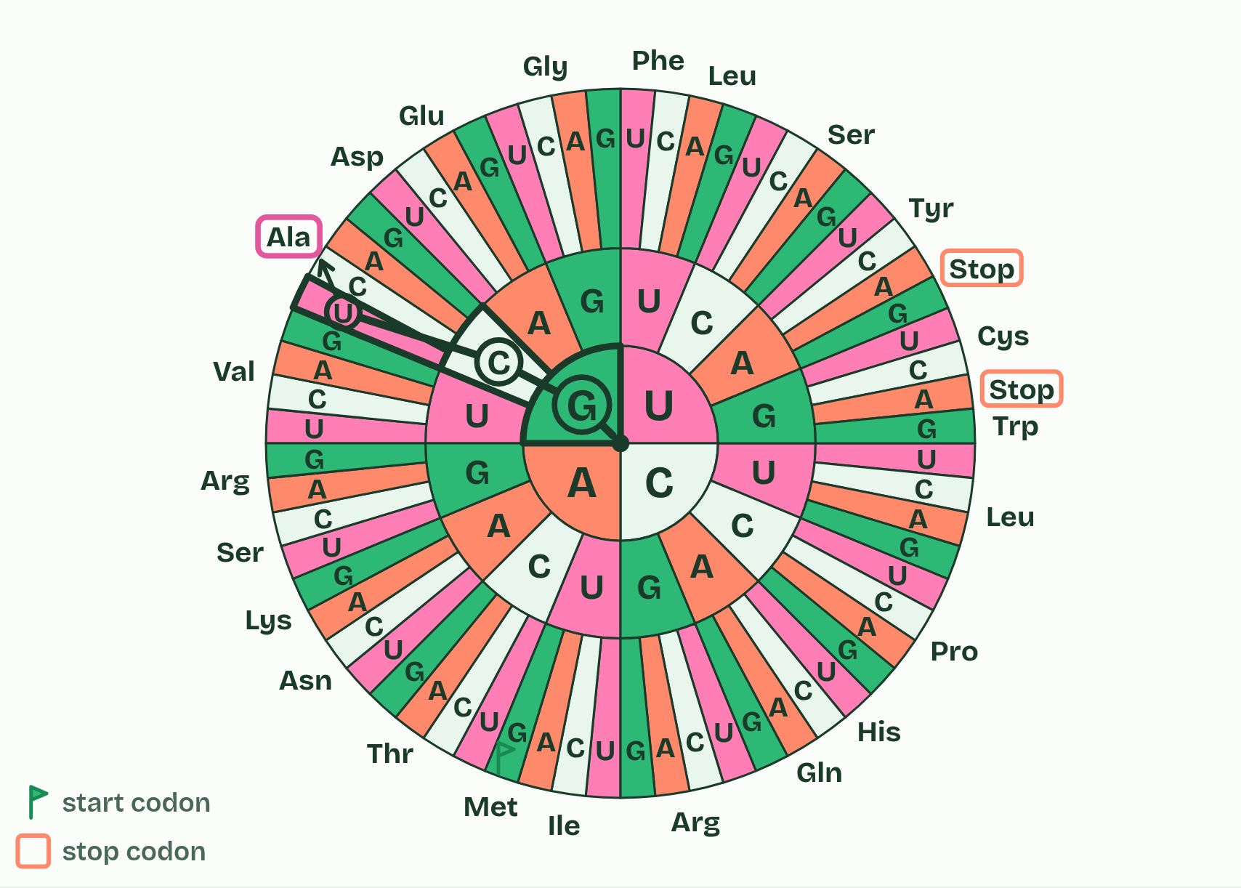  1 The genetic code: 64 codons, read from the first base to the third.  2 Find the first base, then the second, then the third: GCU is alanine.  3 The wheel holds the same code, read from the centre out.
SUMMARY
Sum up section 05 in two or three sentences of your own.
• The genetic code says which amino acid each codon stands for.
• So the code is a triplet code.
• The other three, UAA, UAG and UGA, are stop codons: they code for nothing and end the chain.
• AUG codes for methionine and is also the start codon, where translation begins.

06 One codon at a time | D1.2.10
CUES  Predict: A polypeptide is 150 amino acids long. How many codons did the ribosome read to make it, counting the codon that ended it?  B: 151. One codon for each amino acid, 150, plus the stop codon that ended the chain: 151. That is 453 bases of mRNA. 450 is the number of bases for the 150 amino acids alone, not the number of codons.  What is meant by elongation?  The stage of translation in which the polypeptide grows by one amino acid for each codon read.  What is meant by peptide bond?  The covalent bond between the carbon of one amino acid and the nitrogen of the next. It holds a polypeptide together.  What is meant by condensation?  A reaction that joins two molecules and releases a molecule of water. | NOTES  1 Once translation has started, the polypeptide grows by a cycle that repeats for every codon. This is elongation, and it is the part of translation this chapter follows. How translation starts is chapter 11.  2 The ribosome joins the chain to that amino acid with a peptide bond. This is a condensation reaction, so a molecule of water is released, and the chain now hangs from the newest tRNA.  3 The next tRNA pairs with the open codon.  4 A peptide bond joins the chain to its amino acid.  5 The ribosome moves one codon along.  6 The empty tRNA leaves. Repeat.  Your own notes  ANNOTATE THE FIGURE  Number the 4 steps on the figure and note what happens at each: 1 pairs; 2 peptide bond; 3 moves; 4 leaves.  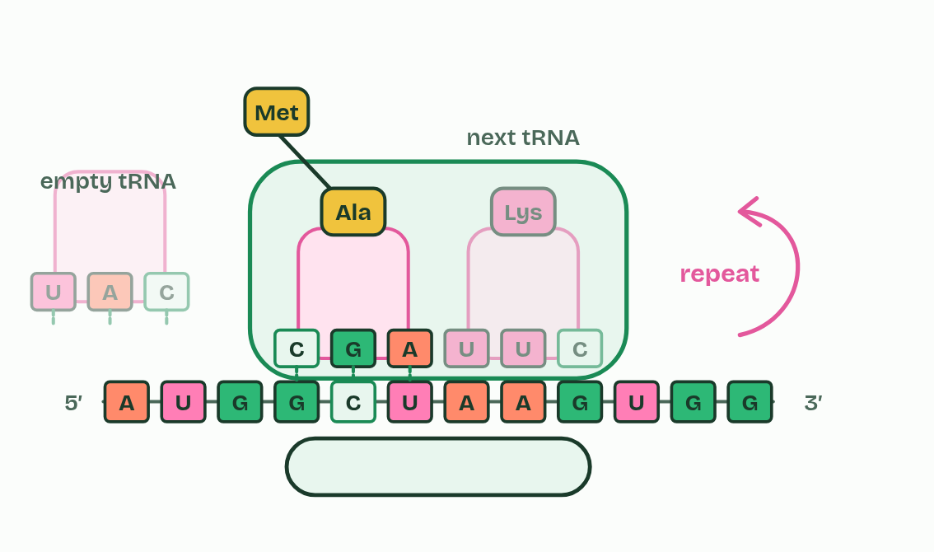  1 The next tRNA pairs with the open codon.  2 A peptide bond joins the chain to its amino acid.  3 The ribosome moves one codon along.  4 The empty tRNA leaves. Repeat.  ANNOTATE THE FIGURE  Annotate this still from the animation (One codon at a time): what is happening, and why?  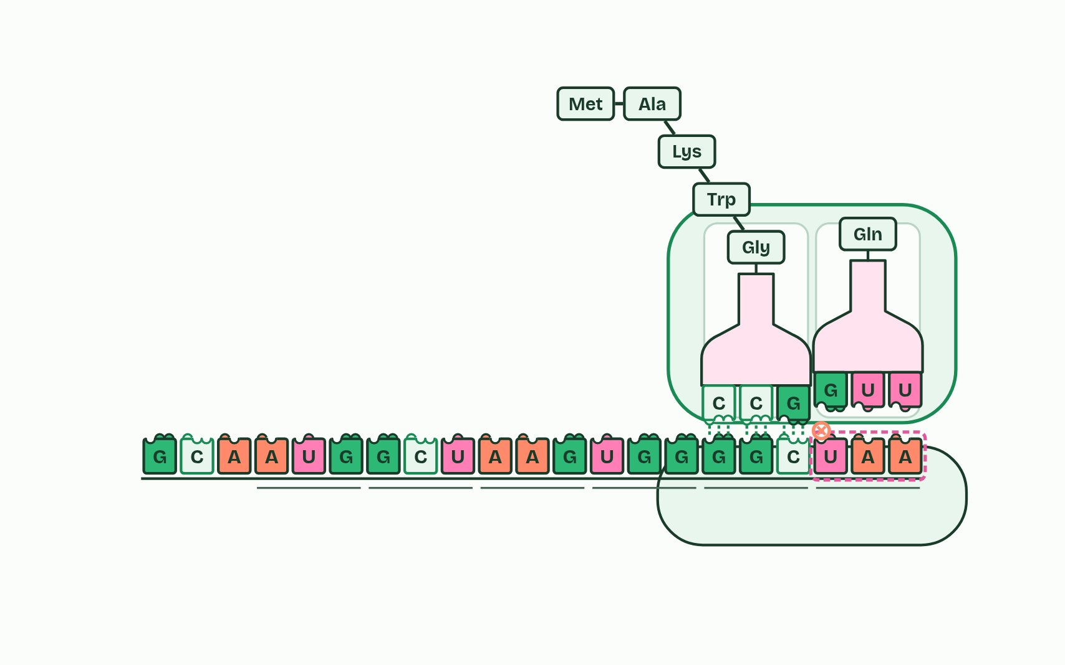  1 A tRNA whose anticodon pairs with the codon brings the right amino acid.  2 A peptide bond joins the chain to the new amino acid.  3 The ribosome moves along one codon, and the empty tRNA leaves to collect another amino acid.  4 At a stop codon no tRNA fits, and the polypeptide is released.
  SPOT THE MISTAKE
  What do students often get wrong about elongation? Write the mistake, then put it right.
  Amino acids in the chain are joined by peptide bonds, not hydrogen bonds. The hydrogen bonds are between codon and anticodon, and they break as each tRNA leaves.
SUMMARY
Sum up section 06 in two or three sentences of your own.
• A tRNA whose anticodon pairs with the codon in the free place binds, bringing its amino acid.
• The ribosome joins the chain to that amino acid with a peptide bond. This is a condensation reaction, so a molecule of water is released, and the chain now hangs from the newest tRNA.
• The ribosome moves one codon, three bases, along the mRNA, towards its 3′ end.
• The tRNA that handed over the chain leaves, free to collect another amino acid.

07 One base, one amino acid | D1.2.11
CUES  Predict: In a gene, one base changes so that an mRNA codon GAA becomes GAG. What happens to the polypeptide?  C: No change: GAG also codes for Glu. GAA and GAG both code for glutamic acid (the code is degenerate), so the polypeptide is the same: a silent mutation. Compare the sickle cell change, GAG to GUG, where the second base changes and Glu becomes Val.  What is meant by mutation?  A change in the base sequence of a gene.  What is meant by point mutation?  A mutation that changes a single base.  What is meant by base substitution?  A point mutation in which one base is swapped for another. It changes one codon.  What is meant by silent?  A substitution that does not change the amino acid, because the new codon codes for the same one.  What is meant by missense?  A substitution that changes one amino acid in the polypeptide.  What is meant by nonsense?  A substitution that makes a stop codon, so the chain ends early.  What is meant by haemoglobin?  The protein in red blood cells that carries oxygen.  What is meant by sickle cell anaemia?  An inherited disease in which a changed haemoglobin forms fibres that bend red blood cells into sickles, block small vessels and are destroyed early. | NOTES  1 A mutation is a change in the base sequence of a gene.  2 A point mutation changes one base, and the commonest kind is a base substitution: one base swapped for another, which changes one codon.  3 If it stands for the same amino acid, the mutation is silent, which the code's degeneracy allows.  4 If it stands for a different amino acid, it is missense.  5 If it is a stop codon, it is nonsense, and the chain ends early, usually too short to work.  6 Sickle cell anaemia is the guide's example of a point mutation that changes a protein. Haemoglobin carries oxygen in red blood cells.  7 The sickled cells block small blood vessels, which causes pain and damage to organs, and they are destroyed early, so the person has too few red blood cells, which is sickle cell anaemia.  Your own notes  ANNOTATE THE FIGURE  Number the 5 steps on the figure and note what happens at each.  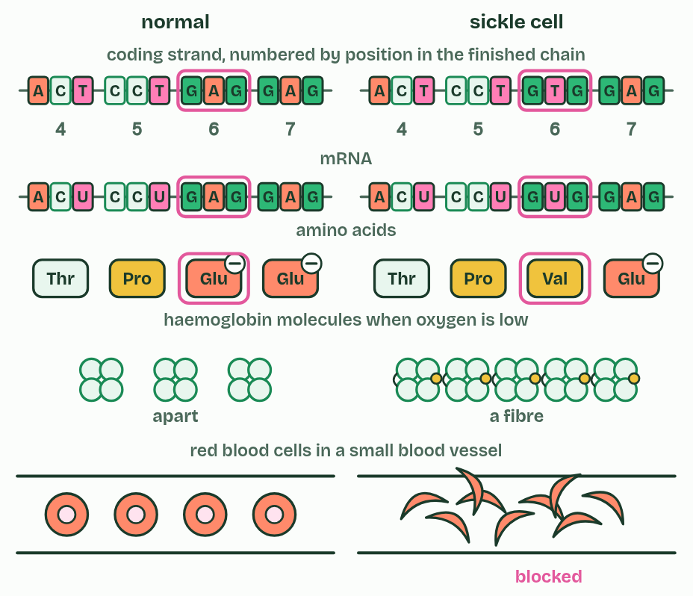  1 One base differs in the gene for haemoglobin's beta chain.  2 So one codon in the mRNA differs.  3 So one amino acid differs: valine for glutamic acid.  4 The non-polar valine makes the molecules stick into fibres.  5 Fibres bend the cells into sickles that block small vessels.  ANNOTATE THE FIGURE  Number the 2 steps on the figure and note what happens at each.  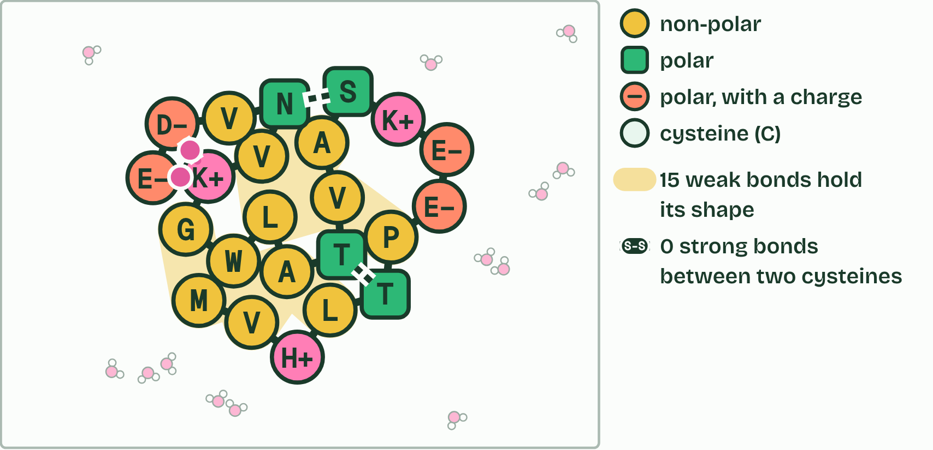  1 The gene is transcribed and translated: Its 23 amino acids are joined by 22 peptide bonds: one of 2023 (about 8 × 1029) possible chains this long. A ribosome makes the chain one amino acid at a time, and it starts to fold as it comes out.  2 It folds into a shape of its own, held by weak bonds between its side chains.  ANNOTATE THE FIGURE  Number the 4 steps on the figure and note what happens at each.  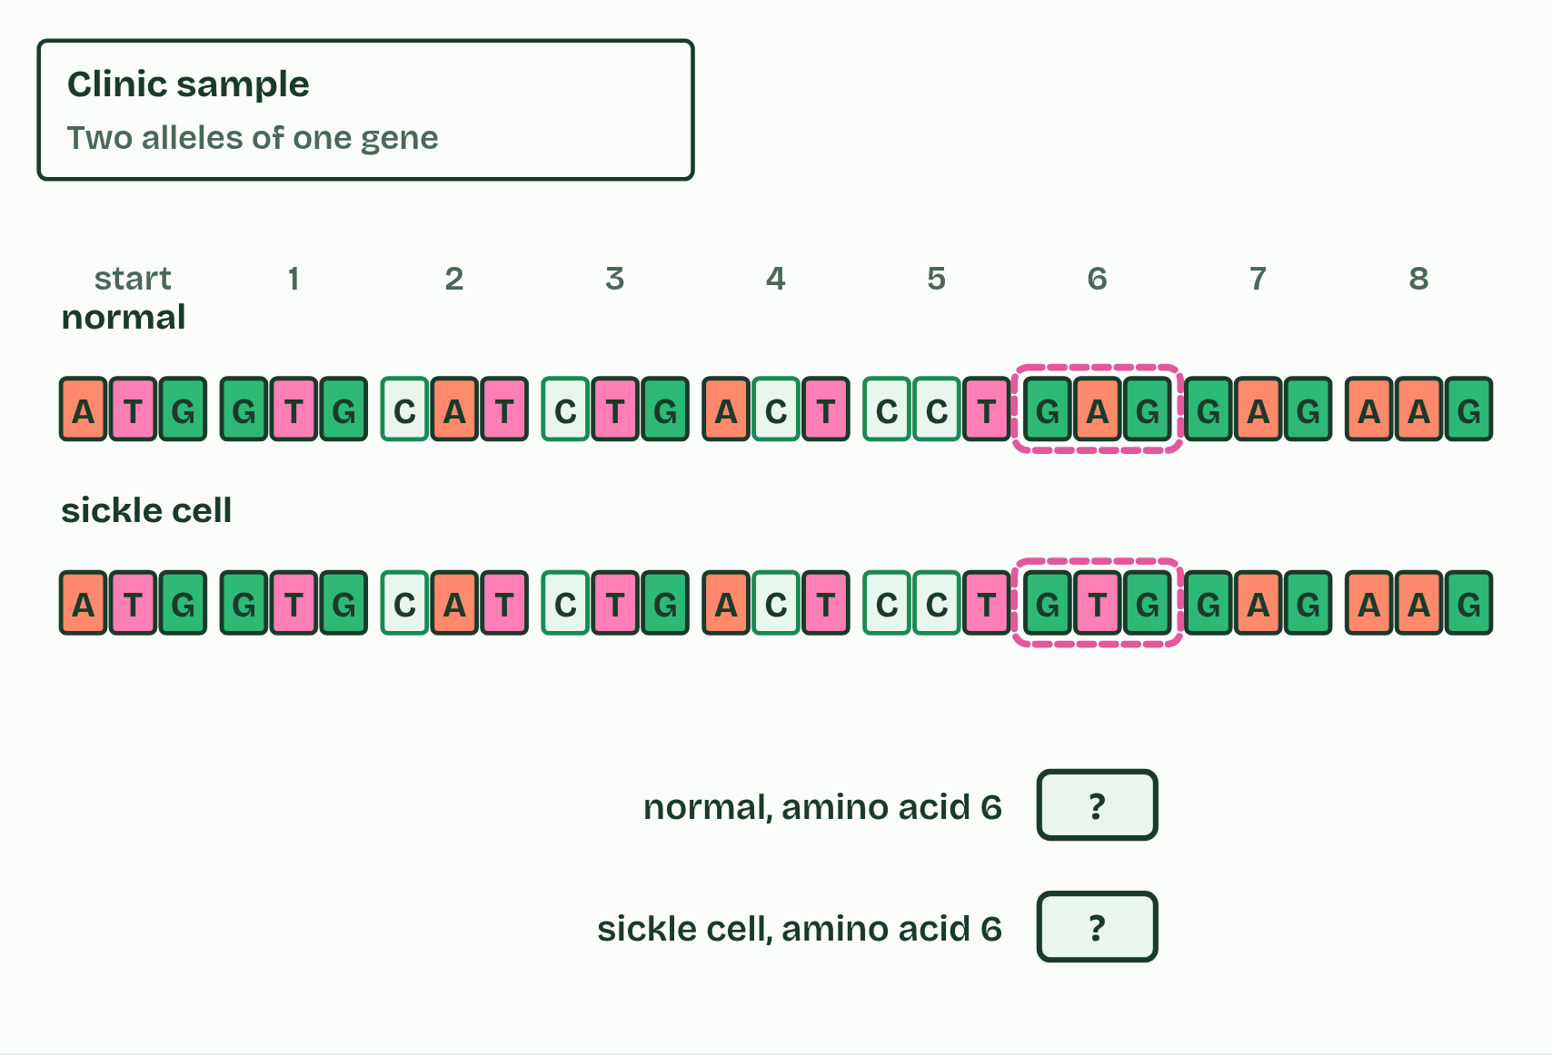  1 Which strand will you copy?  2 Pick the base that pairs: RNA has U, not T.  3 Which tRNA’s anticodon pairs with this codon?  4 One base differs. What does it do to the protein?  REMEMBER IT  What a substitution can do
  S  Same | S  Swapped | S  Stopped
  Silent  the same amino acid | Missense  a different amino acid | Nonsense  a stop codon: the chain ends early
  SPOT THE MISTAKE
  What do students often get wrong about mutations that change protein structure? Write the mistake, then put it right.
  A mutation changes the gene, not the protein directly: the changed protein follows from the changed codon. And not every substitution changes the protein.
SUMMARY
Sum up section 07 in two or three sentences of your own.
• A mutation is a change in the base sequence of a gene.
• A point mutation changes one base, and the commonest kind is a base substitution: one base swapped for another, which changes one codon.
• If it stands for the same amino acid, the mutation is silent, which the code's degeneracy allows.
• If it stands for a different amino acid, it is missense.

08 Five prime to three prime, both times | D1.2.12 HL
CUES  Predict: A template strand reads 3′-TACAAGCGT-5′. Written 5′ to 3′, what is the mRNA?  B: 5′-AUGUUCGCA-3′. Pair each base, keeping the template's order: T A C A A G C G T gives A U G U U C G C A. The template runs 3′ to 5′, so the mRNA opposite it runs 5′ to 3′: 5′-AUGUUCGCA-3′ (it starts with the start codon). “5′-ACGCUUGUA-3′” has the right bases written backwards, and “5′-UACAAGCGU-3′” copies the template instead of pairing with it.  What is meant by 5′ end?  The end of a strand where the last nucleotide has a free phosphate on its carbon 5′.  What is meant by 3′ end?  The end of a strand where the last nucleotide has a free OH on its carbon 3′.  What is meant by 5′ to 3′?  The direction of a strand: from its 5′ end to its 3′ end. RNA is built this way, and mRNA is read this way. | NOTES  1 A strand has a 5′ end, where the last nucleotide has a phosphate on its carbon 5′, and a 3′ end, where the last nucleotide has a free OH on its carbon 3′.  2 5′ to 3′ transcription means that RNA polymerase joins the 5′ phosphate of each incoming RNA nucleotide to the 3′ OH at the end of the growing RNA (the sugar is ribose, because this is RNA).  3 The polymerase reads the template 3′ to 5′.  4 Each new nucleotide joins the RNA's 3′ end.  5 The ribosome reads the mRNA 5′ to 3′ too.  Your own notes  ANNOTATE THE FIGURE  Number the 4 steps on the figure and note what happens at each.  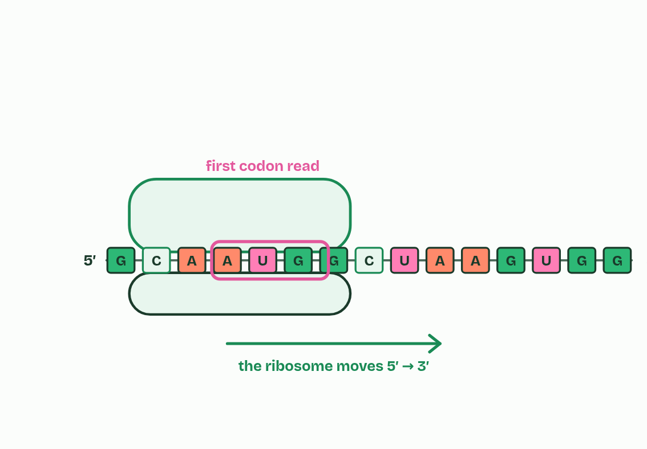  1 The polymerase reads the template 3′ to 5′.  2 Each new nucleotide joins the RNA's 3′ end.  3 Nothing can join at the 5′ end.  4 The ribosome reads the mRNA 5′ to 3′ too.
  SPOT THE MISTAKE
  What do students often get wrong about directionality? Write the mistake, then put it right.
  5′ and 3′ name carbons of the sugar. The polymerase moves along the template from its 3′ end towards its 5′ end, while the RNA it makes grows 5′ to 3′: two directions, one movement.
SUMMARY
Sum up section 08 in two or three sentences of your own.
• A strand has a 5′ end, where the last nucleotide has a phosphate on its carbon 5′, and a 3′ end, where the last nucleotide has a free OH on its carbon 3′.
• 5′ to 3′ transcription means that RNA polymerase joins the 5′ phosphate of each incoming RNA nucleotide to the 3′ OH at the end of the growing RNA (the sugar is ribose, because this is RNA).

09 Where a gene starts, and DNA that codes for nothing | D1.2.13 HL D1.2.14 HL
CUES  Predict: A gene for a tRNA is transcribed in every cell, but its RNA is never translated. Is it coding or non-coding DNA?  A: Non-coding: its RNA is the product. “Coding” here means coding for a polypeptide. A tRNA gene is transcribed, and the tRNA itself does the job: no polypeptide is ever made from it. So it is non-coding DNA, even though it is a gene and is transcribed. The same is true of rRNA genes.  What is meant by promoter?  A region of DNA just before a gene, where transcription factors and RNA polymerase bind to start transcription. It is not itself transcribed.  What is meant by transcription factors?  Proteins that bind to DNA at a promoter, or other regulatory sequences, and control whether a gene is transcribed.  What is meant by non-coding sequences?  DNA that codes for no polypeptide, such as promoters, introns, telomeres and genes for rRNA and tRNA.  What is meant by regulators of gene expression?  Sequences where transcription factors bind, such as promoters, that control how often a gene is transcribed.  What is meant by introns?  Stretches inside a gene that are transcribed but cut out of the RNA before it is used.  What is meant by telomeres?  Repeats of a short sequence at the ends of a chromosome. They protect the genes near the ends from being lost each time the DNA is copied. | NOTES  1 The promoter is a stretch of DNA just before the part of a gene that is transcribed.  2 It is where transcription starts. Transcription factors are proteins that attach to the promoter, and RNA polymerase can bind and start only when the right ones are in place (you do not have to name any).  3 Non-coding sequences are stretches of DNA that code for no polypeptide.  4 regulators of gene expression: promoters, and other sequences where factors bind;  5 introns: stretches inside a gene that are transcribed but cut out of the RNA (chapter 10);  6 telomeres: repeats of a short sequence (TTAGGG in humans) at each end of a chromosome, which protect the genes near the ends when the DNA is copied;  Your own notes  ANNOTATE THE FIGURE  The figure shows it as Absent and Present. Note what changes each time.  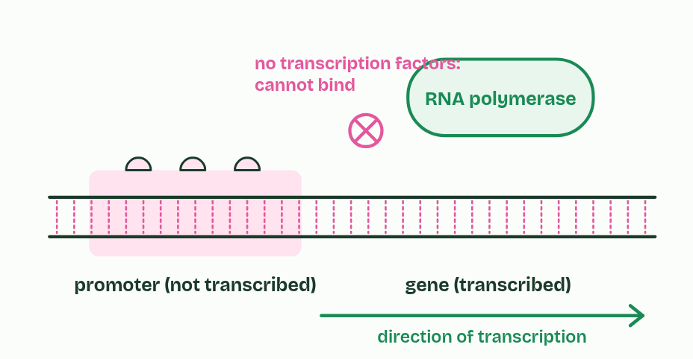  1 Absent  2 Present  ANNOTATE THE FIGURE  Label each part and say what it does: telomere, tRNA gene, regulatory sequence, promoter, exon, intron, exon, intron, exon, rRNA gene, telomere.  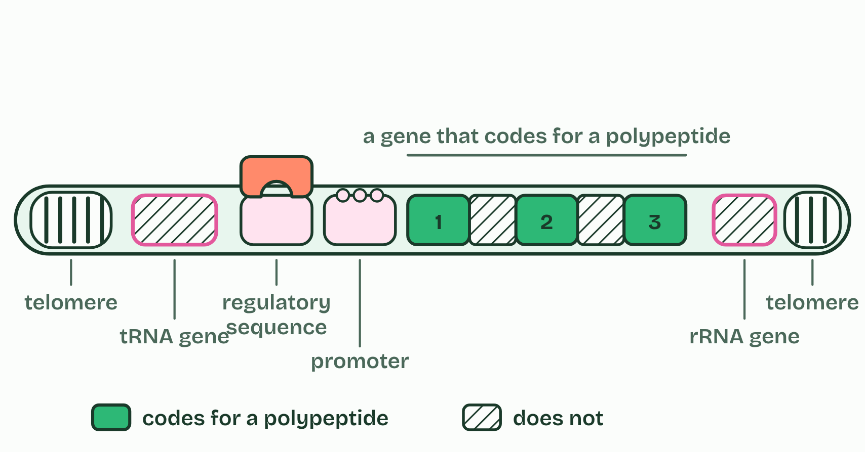  1 Telomere: Many repeats of a short sequence (TTAGGG in humans) at each end of a chromosome. They protect the genes near the end from being lost when the DNA is copied, and code for no polypeptide.  2 tRNA gene: Transcribed into tRNA, which is never translated: the RNA is the product. It is a gene, but it codes for no polypeptide.  3 Regulatory sequence: Another stretch where transcription factors bind and change how often the gene is transcribed. It is not transcribed.  4 Promoter: Where transcription factors and RNA polymerase bind, just before the gene. It is not transcribed.  5 Exon: Transcribed and kept in the mRNA: it codes for part of the polypeptide.  6 Intron: Transcribed, then cut out of the RNA before it is used. It codes for nothing.  7 Exon: Transcribed and kept in the mRNA: it codes for part of the polypeptide.  8 Intron: Transcribed, then cut out of the RNA before it is used. It codes for nothing.  9 Exon: Transcribed and kept in the mRNA: it codes for part of the polypeptide.  10 rRNA gene: Transcribed into rRNA, which makes up the ribosomes. It is never translated.  11 Telomere: Many repeats of a short sequence (TTAGGG in humans) at each end of a chromosome. They protect the genes near the end from being lost when the DNA is copied, and code for no polypeptide.
  SPOT THE MISTAKE
  What do students often get wrong about promoters and non-coding DNA? Write the mistake, then put it right.
  Non-coding is not the same as not transcribed. Introns and the genes for rRNA and tRNA are transcribed, while the promoter is not, and is never part of the mRNA. Telomeres code for no polypeptide.
SUMMARY
Sum up section 09 in two or three sentences of your own.
• regulators of gene expression: promoters, and other sequences where factors bind;
• introns: stretches inside a gene that are transcribed but cut out of the RNA (chapter 10);
• telomeres: repeats of a short sequence (TTAGGG in humans) at each end of a chromosome, which protect the genes near the ends when the DNA is copied;
• genes for rRNA and tRNA: they are transcribed, and the RNA is the product. It is never translated.

10 Capped, cut and tailed | D1.2.15 HL D1.2.16 HL
CUES  Predict: A gene has four exons. Exons 1 and 4 are always kept, and exons 2 and 3 can each be kept or left out. How many different mature mRNAs can it make?  C: 4. 1-2-3-4, 1-2-4, 1-3-4 and 1-4: each of the two optional exons is in or out, so 2 × 2 = 4. That is four polypeptides from one gene, without a single change to the DNA.  What is meant by pre-mRNA?  The first RNA made from a eukaryotic gene, with its introns still in. It is processed in the nucleus.  What is meant by post-transcriptional modification?  Changes made to an RNA after it is transcribed, such as capping, tailing and splicing.  What is meant by mature mRNA?  The finished mRNA, capped, tailed and spliced, that leaves the nucleus to be translated.  What is meant by splicing?  Cutting the introns out of pre-mRNA and joining the exons end to end.  What is meant by exons?  Parts of a gene that stay in the mature mRNA and code for the polypeptide.  What is meant by 5′ cap?  A modified guanine nucleotide added to the 5′ end of an mRNA. It protects the mRNA and helps the ribosome find it.  What is meant by poly-A tail?  A long run of adenine nucleotides added to the 3′ end of an mRNA, to protect it.  What is meant by alternative splicing?  Splicing the exons of one gene together in different combinations, so that one gene codes for more than one polypeptide. | NOTES  1 In a eukaryotic cell, the RNA that RNA polymerase makes from a protein-coding gene is pre-mRNA.  2 It is changed in the nucleus before it leaves, a stage called post-transcriptional modification, and the result is mature mRNA.  3 In splicing, the introns are cut out and the exons joined end to end, so the mature mRNA carries only sequence that codes for the polypeptide.  4 A 5′ cap, a modified guanine nucleotide, is added to the 5′ end, and a poly-A tail, a long run of adenine nucleotides (often about 200), to the 3′ end.  5 Alternative splicing: in many genes, which exons are kept can vary.  Your own notes  ANNOTATE THE FIGURE  Number the 5 steps on the figure and note what happens at each.  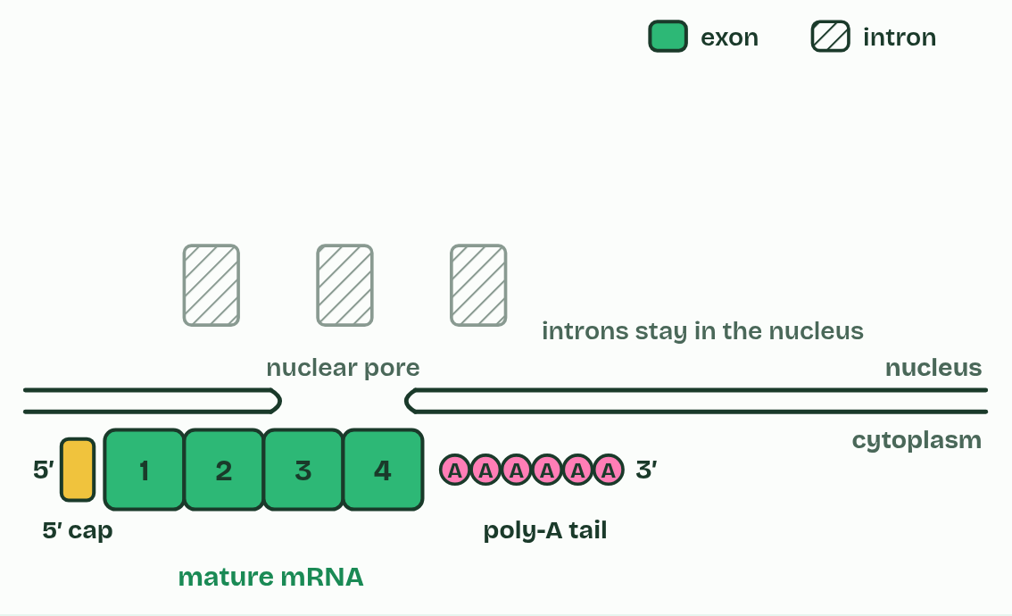  1 Pre-mRNA: exons and introns.  2 A 5′ cap is added.  3 A poly-A tail is added.  4 Introns are cut out and the exons spliced together.  5 Mature mRNA leaves the nucleus.  ANNOTATE THE FIGURE  The figure shows it as All four exons and Leave out exon 2. Note what changes each time.  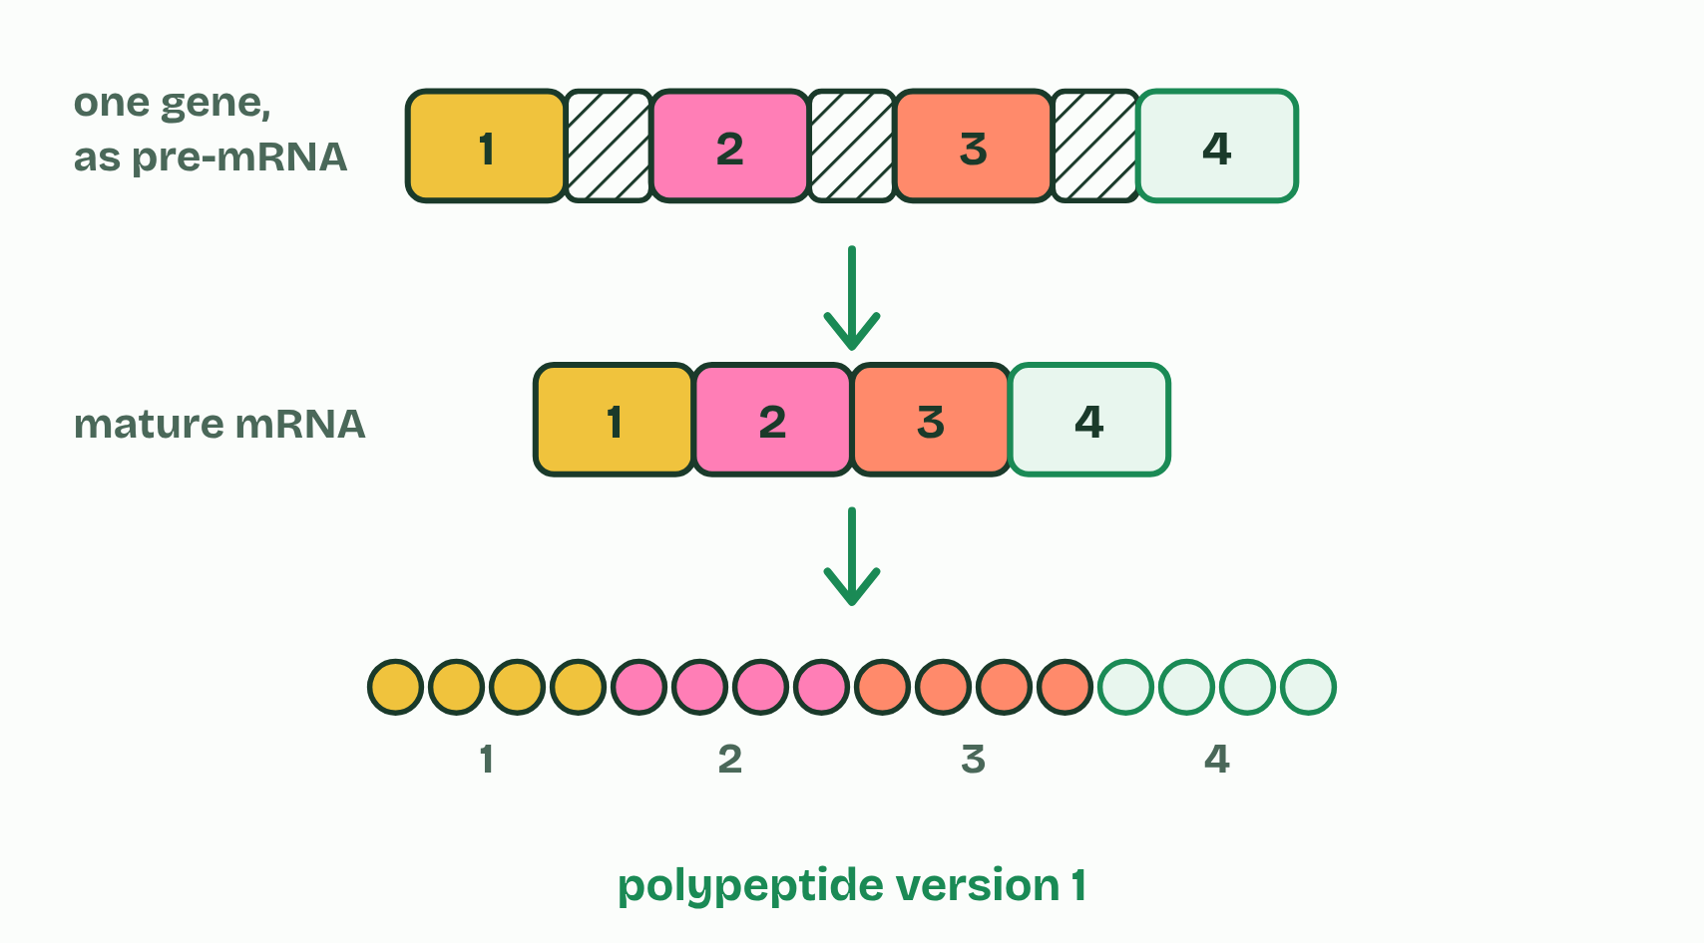  1 All four exons  2 Leave out exon 2  ANNOTATE THE FIGURE  Annotate this still from the animation (From promoter to mature mRNA): what is happening, and why?  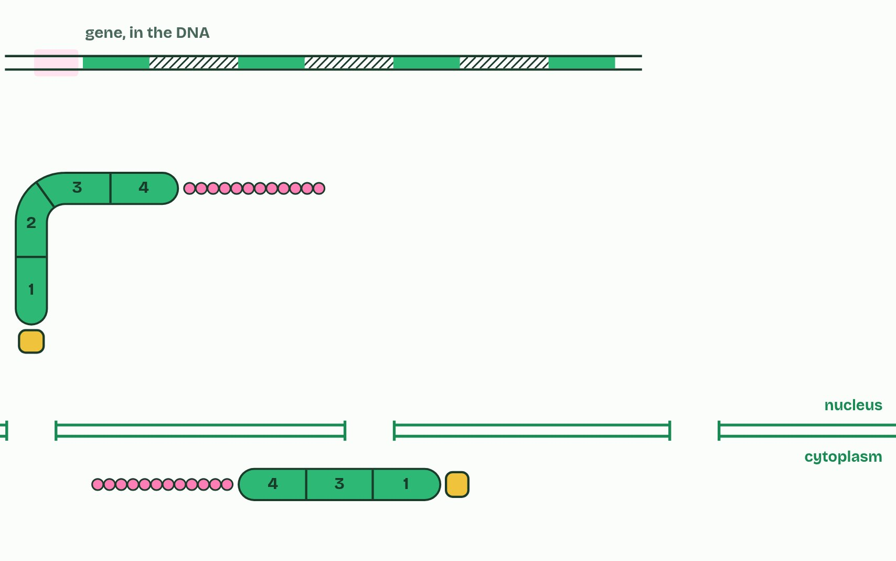  1 Transcription factors bind the promoter. Only then can RNA polymerase bind and begin.  2 The RNA grows 5′ to 3′: every new nucleotide joins its 3′ end.  3 In a eukaryote the first RNA is pre-mRNA: exons, with introns between them.  4 A 5′ cap and a poly-A tail are added. The introns are cut out and the exons spliced together.  5 Spliced another way, the same gene gives a different polypeptide.  6 Capped, tailed and spliced, the mature mRNA leaves the nucleus.  REMEMBER IT  Introns and exons
  I  In | E  Exit
  Introns  cut out and broken down in the nucleus | Exons  joined, and leave in the mature mRNA
  SPOT THE MISTAKE
  What do students often get wrong about RNA processing and alternative splicing? Write the mistake, then put it right.
  Introns are cut out of the RNA, not out of the gene: the DNA keeps them. And alternative splicing changes which exons are kept, not the gene's sequence.
SUMMARY
Sum up section 10 in two or three sentences of your own.
• In a eukaryotic cell, the RNA that RNA polymerase makes from a protein-coding gene is pre-mRNA.
• It is changed in the nucleus before it leaves, a stage called post-transcriptional modification, and the result is mature mRNA.
• In splicing, the introns are cut out and the exons joined end to end, so the mature mRNA carries only sequence that codes for the polypeptide.
• A 5′ cap, a modified guanine nucleotide, is added to the 5′ end, and a poly-A tail, a long run of adenine nucleotides (often about 200), to the 3′ end.

11 Starting the chain | D1.2.17 HL
CUES  Predict: The first peptide bond has just formed, joining methionine to the second amino acid. Before the ribosome moves, which site holds the tRNA carrying both amino acids?  A: A site. The bond joins methionine to the amino acid on the tRNA in the A site, so the two-amino-acid chain now hangs from that tRNA, still in the A site. The tRNA in the P site is empty. Only when the ribosome moves one codon does the chain's tRNA shift into the P site and the empty one into the E site.  What is meant by initiation?  The first stage of translation: the ribosome assembles on the mRNA at the start codon, with the initiator tRNA in place.  What is meant by 5′ terminal?  The 5′ end of an mRNA, where its first nucleotide lies.  What is meant by initiator tRNA?  The tRNA that starts translation. Its anticodon is UAC, it carries methionine, and it pairs with the start codon AUG.  What is meant by a site?  The place in the ribosome where each new tRNA arrives with its amino acid.  What is meant by p site?  The place in the ribosome that holds the tRNA carrying the growing chain.  What is meant by e site?  The place in the ribosome where an empty tRNA goes after the ribosome moves one codon, and from where it leaves. | NOTES  1 Initiation is how translation starts.  2 The A site is where each new tRNA arrives with its amino acid.  3 The P site holds the tRNA carrying the growing chain, which is joined by a peptide bond to the amino acid in the A site.  4 The E site is where an empty tRNA goes when the ribosome moves one codon, and where it leaves from.  5 the small subunit attaches to the mRNA at its 5′ terminal, its 5′ end (in eukaryotes the 5′ cap helps);  6 the initiator tRNA, anticodon UAC, carrying methionine, pairs with AUG;  7 the large subunit joins, so the ribosome is complete, with the initiator tRNA in the P site;  8 another tRNA, matching the next codon, binds in the A site.  Your own notes  ANNOTATE THE FIGURE  Number the 6 steps on the figure and note what happens at each.  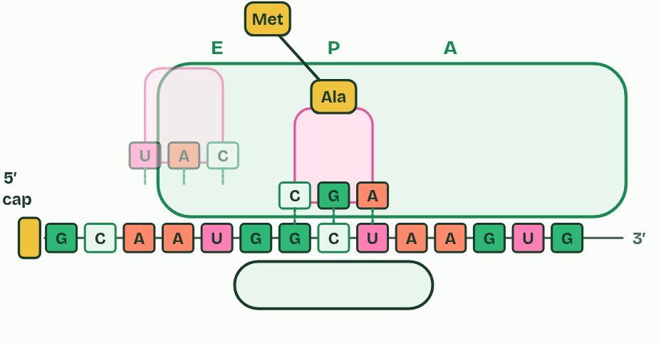  1 The small subunit attaches at the mRNA's 5′ end.  2 It moves to the start codon, AUG, where the initiator tRNA pairs.  3 The large subunit joins: the initiator tRNA is in the P site.  4 The next tRNA arrives in the A site.  5 A peptide bond joins the two amino acids.  6 The ribosome moves one codon; the empty tRNA leaves from the E site.  ANNOTATE THE FIGURE  Annotate this still from the animation (Start, then A, P and E): what is happening, and why?  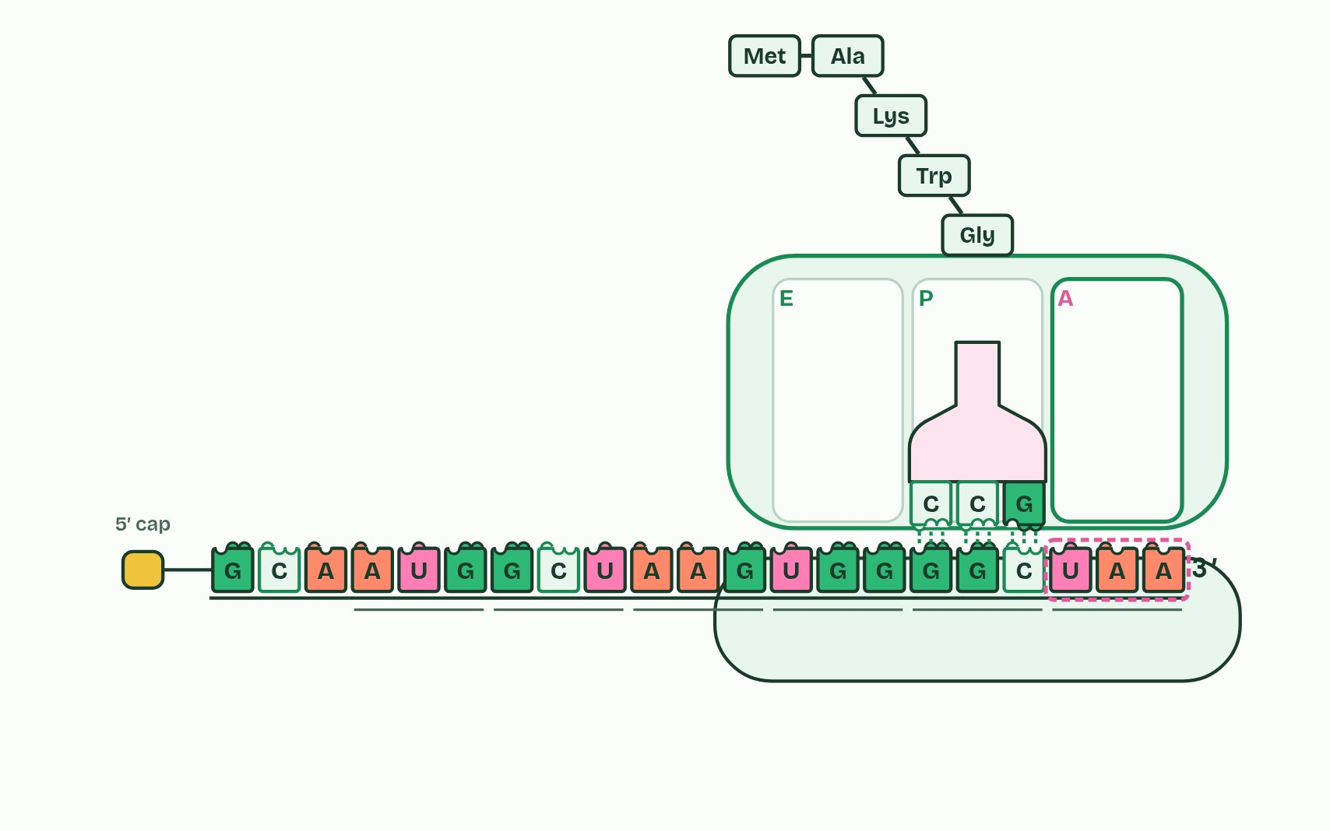  1 The small subunit attaches to the mRNA at its 5′ end.  2 It moves towards the 3′ end until it reaches the start codon, AUG. The initiator tRNA pairs with it.  3 The large subunit joins. The initiator tRNA sits in the P site.  4 Another tRNA arrives in the A site. A peptide bond joins methionine to its amino acid.  5 The ribosome moves one codon. The empty tRNA leaves from the E site; the chain’s tRNA is now in P.  6 At the stop codon the chain is released and the subunits come apart.  REMEMBER IT  The three sites
  A  Arrive | P  Pass | E  Exit
  A site  a loaded tRNA arrives | P site  holds the chain and passes it on | E site  the empty tRNA leaves
  SPOT THE MISTAKE
  What do students often get wrong about initiation of translation? Write the mistake, then put it right.
  The initiator tRNA starts in the P site, not the A site. Every other tRNA enters at the A site and reaches the P site only when the ribosome moves. And the small subunit binds the mRNA first, the large subunit after it.
SUMMARY
Sum up section 11 in two or three sentences of your own.
• the small subunit attaches to the mRNA at its 5′ terminal, its 5′ end (in eukaryotes the 5′ cap helps);
• it moves along the mRNA, 5′ to 3′, to the first AUG, the start codon (the short stretch before it is not translated);
• the initiator tRNA, anticodon UAC, carrying methionine, pairs with AUG;
• the large subunit joins, so the ribosome is complete, with the initiator tRNA in the P site;
• another tRNA, matching the next codon, binds in the A site.

12 Finished, then recycled | D1.2.18 HL D1.2.19 HL
CUES  Predict: Insulin's two chains are 21 and 30 amino acids long, and pre-proinsulin is 110. How many amino acids are cut away in all?  B: 59. 21 + 30 = 51 amino acids stay in insulin, so 110 − 51 = 59 are cut away: the signal peptide (24) in the ER, then the C-peptide (31) and four more at its ends in the Golgi vesicles. (51 is what is kept, and 80 is 110 − 30, forgetting the A chain.)  What is meant by post-translational modification?  Changes made to a polypeptide after it has been translated, such as cutting, folding, bonding or adding groups, so that it can work.  What is meant by pre-proinsulin?  The first polypeptide made from the insulin gene, 110 amino acids long, with a signal peptide at its start.  What is meant by signal peptide?  A short stretch at the start of a polypeptide that sends the ribosome making it to the rough ER. It is cut off in the ER.  What is meant by proinsulin?  A single polypeptide of 86 amino acids made from pre-proinsulin. It folds, forms disulfide bonds and is cut again to make insulin.  What is meant by disulfide bonds?  Strong covalent bonds between the sulfur atoms of two cysteines, which hold a folded protein, or two chains, together.  What is meant by proteasome?  A barrel-shaped complex of proteins in the cytoplasm and nucleus that breaks proteins down into short pieces, which are then split into amino acids.  What is meant by proteome?  All the proteins that a cell, or an organism, makes. | NOTES  1 They are modified first, which is called post-translational modification: they are cut, folded and bonded, or given extra groups such as sugars or phosphates.  2 It starts as pre-proinsulin, 110 amino acids long, which begins with a signal peptide of 24 amino acids.  3 In stage 1, in the rough ER, the signal peptide is cut off, leaving proinsulin (86 amino acids).  4 Proinsulin folds, and three disulfide bonds form: two join what will become the B chain to the A chain, and one lies within the A chain.  5 A proteasome is a barrel-shaped complex of proteins, in the cytoplasm and the nucleus, that hydrolyses the peptide bonds of a protein into short pieces, which other enzymes then split into single amino acids for the cell to use again in building new proteins.  6 The proteome is all the proteins a cell makes.  Your own notes  ANNOTATE THE FIGURE  Number the 5 steps on the figure and note what happens at each: 1 signal peptide; 2 proinsulin; 3 disulfide bonds; 4 C-peptide; 5 Insulin.  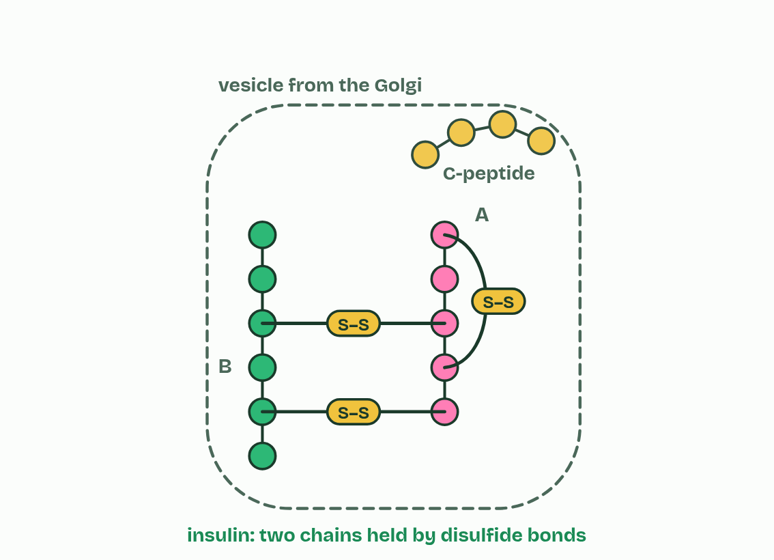  1 Pre-proinsulin: a signal peptide sends it into the rough ER.  2 Stage 1: the signal peptide is cut off, leaving proinsulin.  3 Proinsulin folds and disulfide bonds form.  4 Stage 2: the C-peptide is cut out.  5 Insulin: two chains held by disulfide bonds.  ANNOTATE THE FIGURE  Number the 3 steps on the figure and note what happens at each.  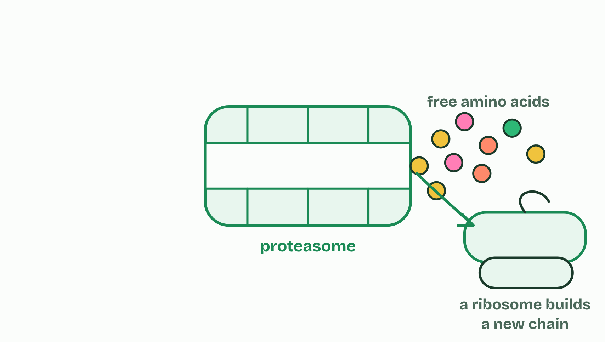  1 A tagged protein reaches a proteasome.  2 Its peptide bonds are hydrolysed.  3 The amino acids are used again to build new proteins.
  SPOT THE MISTAKE
  What do students often get wrong about modification and proteasomes? Write the mistake, then put it right.
  A polypeptide straight off the ribosome is not always a working protein. And proteasomes do not only destroy faulty proteins: they also clear healthy ones the cell no longer needs.
SUMMARY
Sum up section 12 in two or three sentences of your own.
• They are modified first, which is called post-translational modification: they are cut, folded and bonded, or given extra groups such as sugars or phosphates.
• It starts as pre-proinsulin, 110 amino acids long, which begins with a signal peptide of 24 amino acids.
• In stage 1, in the rough ER, the signal peptide is cut off, leaving proinsulin (86 amino acids).
• Proinsulin folds, and three disulfide bonds form: two join what will become the B chain to the A chain, and one lies within the A chain.

Check yourself
The check for this guide is online: a fresh paper of past-paper style questions from the exam bank on D1.2 each time, marked as you go, and saved to your Exam practice progress when you are signed in. Open the link:
biologybybradford.com/exam-maker/sit?topics=D1.2&level=HL&paper=quiz&marks=15&src=ep

