Name | Class | Date
IB BIOLOGY · D1.2

Protein synthesis
Notes to fill in alongside the guide. Each numbered block matches a chapter of the guide, and of the lesson slides. Write in the gaps, answer the cues, annotate the figures, and sum up each section in your own words.
BY THE END YOU CAN
Explain how RNA polymerase uses one strand of a gene as a template, pairing U in the RNA with A on the template D1.2.1, D1.2.2
Explain why a template can be read for a lifetime without changing, and why transcription is where a gene is switched on or off D1.2.3, D1.2.4
Describe what mRNA, the two ribosome subunits and tRNA each do in translation D1.2.5, D1.2.6
Pair a codon with its anticodon, and explain how pairing brings the right amino acid D1.2.7
Explain why the code uses threes and what degenerate and universal mean, and use a codon table to deduce a polypeptide D1.2.8, D1.2.9
Describe how the ribosome moves one codon at a time, joining each amino acid to the chain with a peptide bond D1.2.10
Explain how one base change in the haemoglobin gene causes sickle cell anaemia D1.2.11
Explain what 5′ to 3′ means for transcription and for translation D1.2.12
Explain how transcription factors start transcription at a promoter, and name four kinds of DNA that code for no polypeptide D1.2.13, D1.2.14
Describe how pre-mRNA is capped, tailed and spliced, and how alternative splicing makes several polypeptides from one gene D1.2.15, D1.2.16
Describe how translation starts, and what the A, P and E sites do D1.2.17
Explain how pre-proinsulin becomes insulin, and why proteasomes keep breaking proteins down D1.2.18, D1.2.19

01 Copying a gene into RNA | D1.2.1 D1.2.2
CUES  Predict: A gene's template strand reads T A C C T G. Which RNA does RNA polymerase make from it?  What is meant by gene?  What is meant by transcription?  What is meant by messenger RNA?  What is meant by RNA polymerase?  What is meant by template strand?  What is meant by coding strand?  What is meant by complementary base pairing?  What is meant by uracil?  What is meant by hydrogen bonds? | NOTES  1 A ________ is a stretch of DNA whose base sequence codes for a polypeptide.  2 Making RNA with a DNA template is __________________, and the RNA that carries a gene's message to the ribosomes is __________________ (mRNA).  3 One enzyme does the whole job. ___________________ binds at the start of a gene and parts the two DNA strands over a short stretch (it needs no helicase: that enzyme unzips DNA when the whole molecule is copied, in D1.1).  4 Free RNA nucleotides pair with the exposed bases of one strand only, the ____________________.  5 The other strand is the __________________, because the RNA ends up with its sequence.  6 __________________________________ chooses every RNA base.  7 A on the template takes ________ (U), T takes A, C takes G and G takes C. The pairs are held by ___________________: weak enough to form and break as the enzyme passes, but specific, because only the right base fits.  8 The RNA is complementary to the template, and has the same sequence as the __________________, with U where DNA has T.  Your own notes  ANNOTATE THE FIGURE  Number the 5 steps on the figure and note what happens at each.  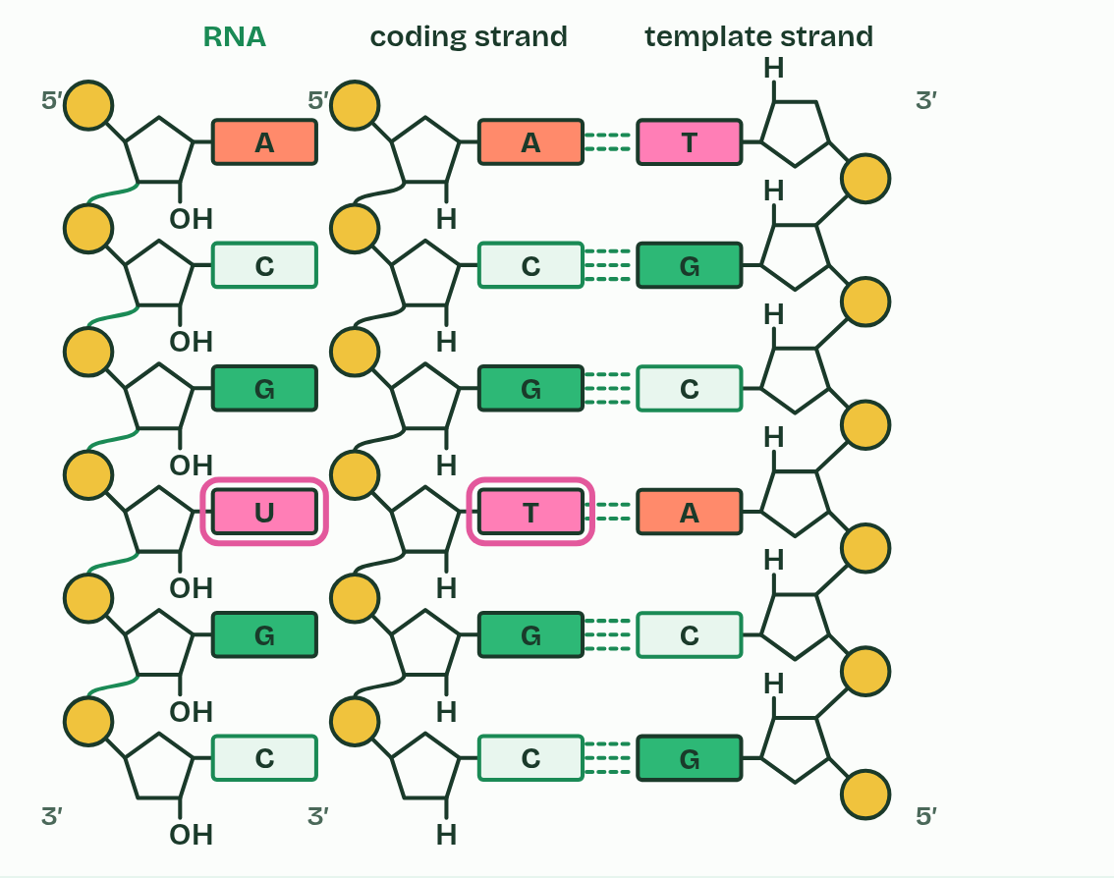  REMEMBER IT  Which base pairs with which in transcription
  A  Apples | U  Under | C  Cars | G  Garage
  A | U | C | G
  SPOT THE MISTAKE
  What do students often get wrong about transcription? Write the mistake, then put it right.
  The mistake
  Put it right
SUMMARY
Sum up section 01 in two or three sentences of your own.

02 Read for a lifetime, read when needed | D1.2.3 D1.2.4
CUES  Predict: A nerve cell in your brain is 60 years old and has never divided. Its genes have been transcribed all that time. What has happened to their base sequences?  What is meant by somatic cells?  What is meant by conserved?  What is meant by genome?  What is meant by gene expression?  What is meant by switched on?  What is meant by switched off? | NOTES  1 That matters most in __________________ that never divide again.  2 Their base sequences must be ____________: held without change for the whole life of the cell.  3 Every somatic cell of one person has the same ________, yet no cell uses all of its genes.  4 That is ____________________, and it has two main steps: transcription copies the gene into mRNA, and translation (chapter 3) uses the mRNA to build a polypeptide.  5 A gene that is being transcribed is _______________, and one that is not is ________________.  6 Not all genes are expressed in a cell at one time, and transcription is where a gene is _______________ or off.  Your own notes  ANNOTATE THE FIGURE  The figure shows it as Pancreatic beta cell, Developing red blood cell and Skin cell. Note what changes each time.  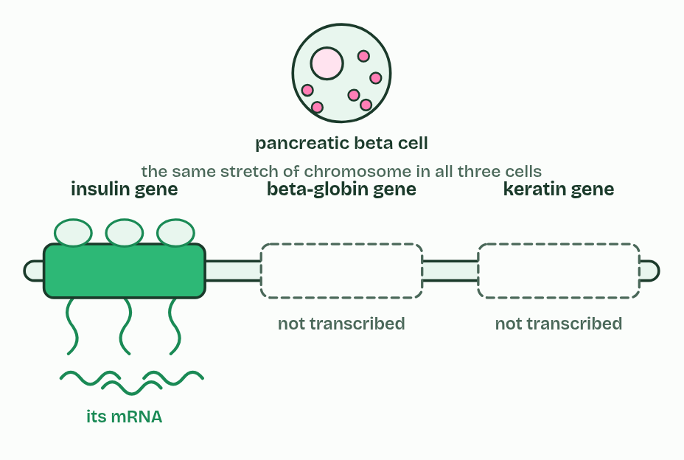  ANNOTATE THE FIGURE  Annotate this still from the animation (One gene, copied): what is happening, and why?  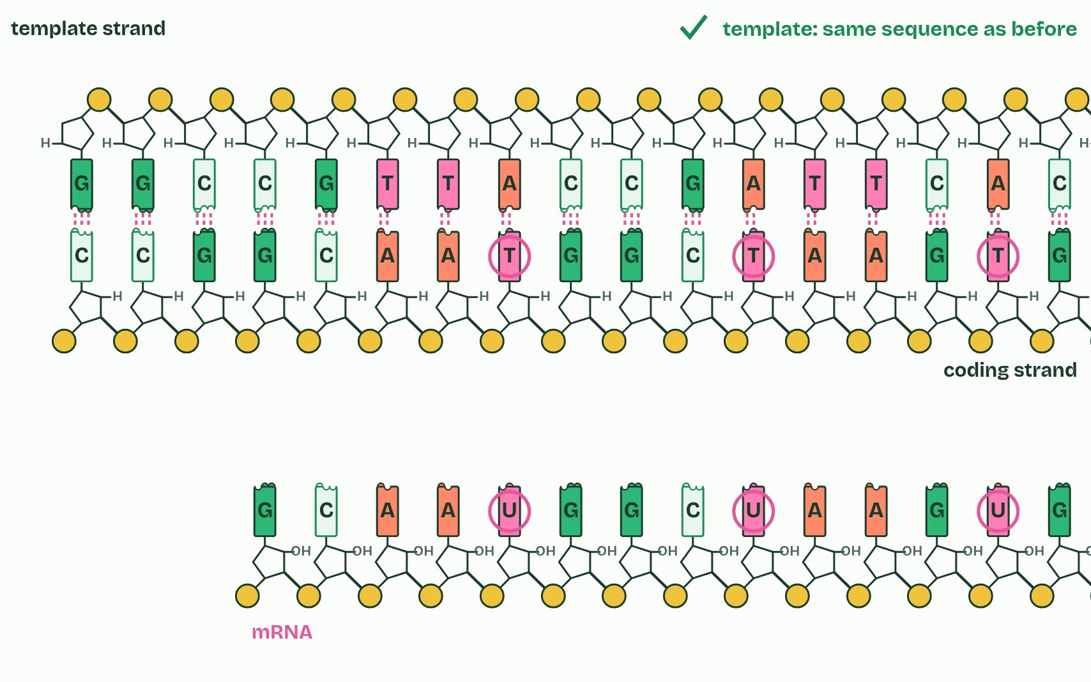
  SPOT THE MISTAKE
  What do students often get wrong about stable templates, gene expression? Write the mistake, then put it right.
  The mistake
  Put it right
SUMMARY
Sum up section 02 in two or three sentences of your own.

03 Three kinds of RNA build a protein | D1.2.5 D1.2.6
CUES  Predict: The large subunit holds two tRNAs at the same moment. Why two, and not one?  What is meant by translation?  What is meant by polypeptide?  What is meant by amino acids?  What is meant by ribosomes?  What is meant by ribosomal RNA (rRNA)?  What is meant by small subunit?  What is meant by large subunit?  What is meant by transfer RNA (tRNA)? | NOTES  1 _______________ makes a _______________ whose order of _______________ is set by the base sequence of an mRNA.  2 It happens at ____________, some free in the cytoplasm and some on the rough endoplasmic reticulum.  3 A ribosome is made of ___________________________ and protein, in two parts.  4 The mRNA binds to the __________________.  5 The __________________ can hold two tRNAs at once, side by side, and it joins their amino acids (the rRNA is what speeds up that joining).  6 __________________________ molecules are short, single strands of RNA that fold back on themselves into a compact shape.  7 mRNA binds to the __________________ of the ribosome.  8 Two tRNAs can bind at the same time, in the __________________.  Your own notes  ANNOTATE THE FIGURE  Label each part and say what it does: small subunit, mRNA, large subunit, rRNA, tRNA, amino acid, polypeptide.  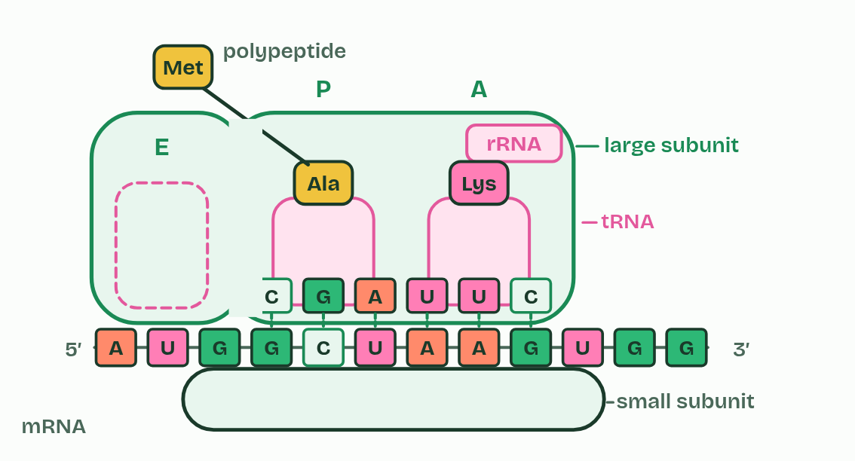
  SPOT THE MISTAKE
  What do students often get wrong about translation? Write the mistake, then put it right.
  The mistake
  Put it right
SUMMARY
Sum up section 03 in two or three sentences of your own.

04 Codon meets anticodon | D1.2.7
CUES  Predict: A codon reads U G G. Which anticodon pairs with it?  What is meant by codon?  What is meant by anticodon? | NOTES  1 Each group of three is a ________.  2 A tRNA carries a matching group of three exposed bases at one end, its ____________, and one particular amino acid at the other end.  3 A codon sits on mRNA, an ____________ on tRNA.  Your own notes  ANNOTATE THE FIGURE  The figure shows it as Three codons, a rack of tRNAs, One tRNA docked and Each codon has found its tRNA. Note what changes each time.  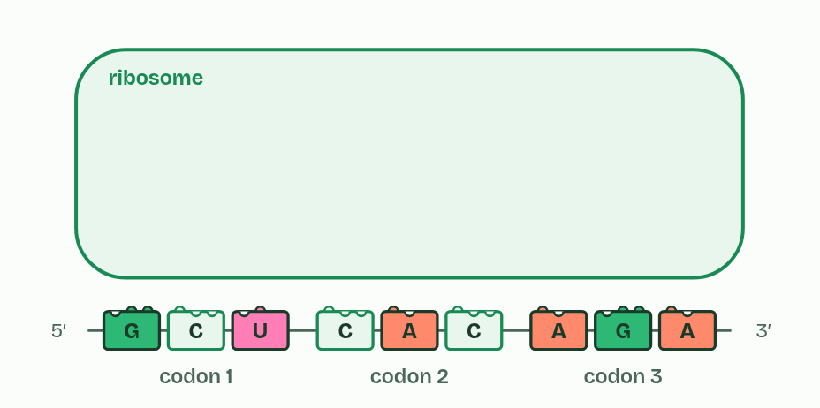
  SPOT THE MISTAKE
  What do students often get wrong about codons and anticodons? Write the mistake, then put it right.
  The mistake
  Put it right
SUMMARY
Sum up section 04 in two or three sentences of your own.

05 A code written in threes | D1.2.8 D1.2.9
CUES  Predict: Why can the code not use pairs of bases for each amino acid?  What is meant by genetic code?  What is meant by triplet code?  What is meant by stop codons?  What is meant by start codon?  What is meant by degenerate?  What is meant by universal?  What is meant by reading frame? | NOTES  1 The ________________ says which amino acid each codon stands for.  2 So the code is a ________________.  3 The other three, UAA, UAG and UGA, are _______________: they code for nothing and end the chain.  4 AUG codes for methionine and is also the _______________, where translation begins.  5 With 61 codons for 20 amino acids, most amino acids have more than one codon, so the code is ______________: leucine, serine and arginine have six each, methionine and tryptophan only one.  6 The code is also ____________: almost every living thing reads each codon as the same amino acid, from bacteria to people.  Your own notes  ANNOTATE THE FIGURE  The figure shows it at bases in each codon 1, in each codon 2 and in each codon 3. Note what changes each time.  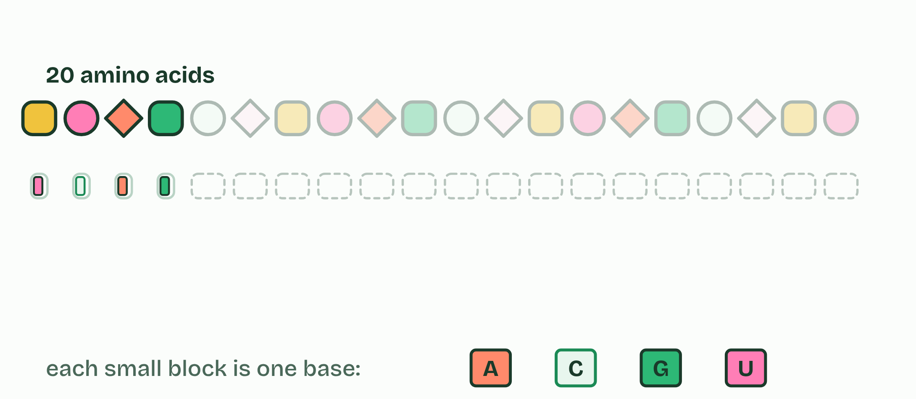  ANNOTATE THE FIGURE  Number the 3 steps on the figure and note what happens at each: 1 genetic code; 2 first, second, third; 3 wheel.  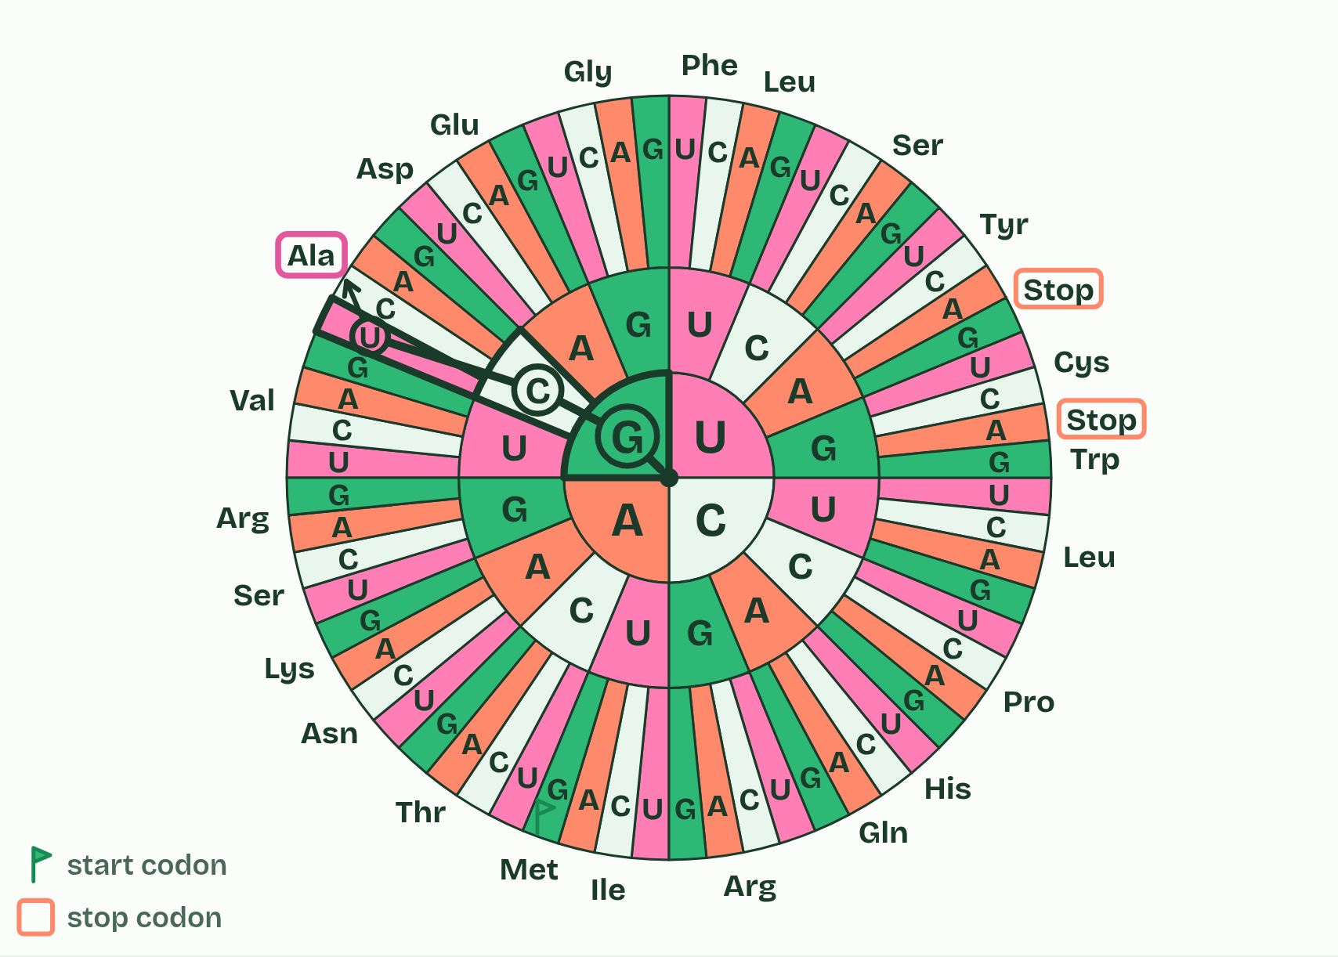
SUMMARY
Sum up section 05 in two or three sentences of your own.

06 One codon at a time | D1.2.10
CUES  Predict: A polypeptide is 150 amino acids long. How many codons did the ribosome read to make it, counting the codon that ended it?  What is meant by elongation?  What is meant by peptide bond?  What is meant by condensation? | NOTES  1 Once translation has started, the polypeptide grows by a cycle that repeats for every codon. This is ______________, and it is the part of translation this chapter follows. How translation starts is chapter 11.  2 The ribosome joins the chain to that amino acid with a ________________. This is a ________________ reaction, so a molecule of water is released, and the chain now hangs from the newest tRNA.  3 The next tRNA ________ with the open codon.  4 A ________________ joins the chain to its amino acid.  5 The ribosome ________ one codon along.  6 The empty tRNA ________. Repeat.  Your own notes  ANNOTATE THE FIGURE  Number the 4 steps on the figure and note what happens at each: 1 pairs; 2 peptide bond; 3 moves; 4 leaves.  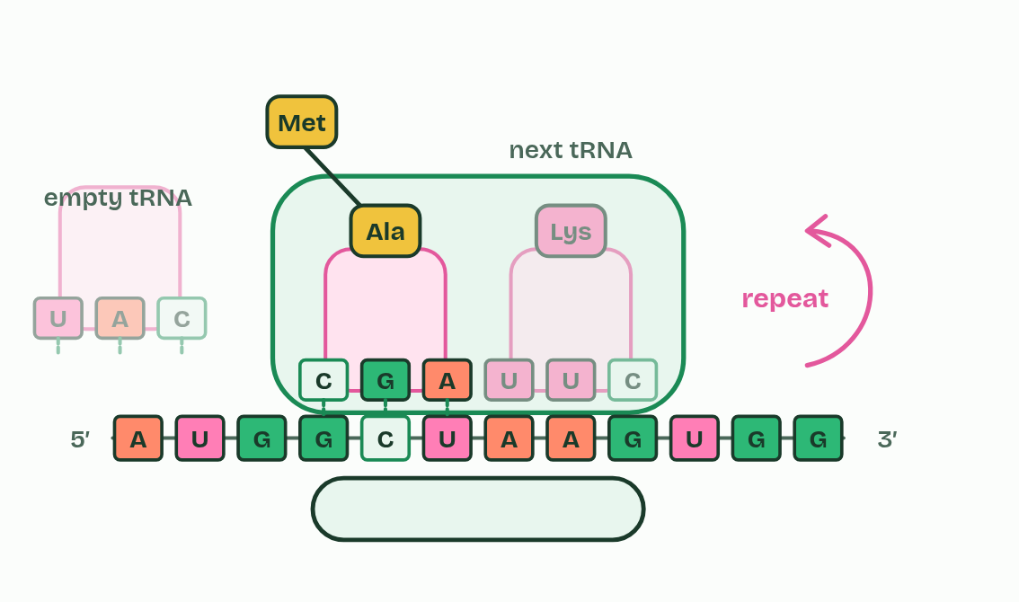  ANNOTATE THE FIGURE  Annotate this still from the animation (One codon at a time): what is happening, and why?  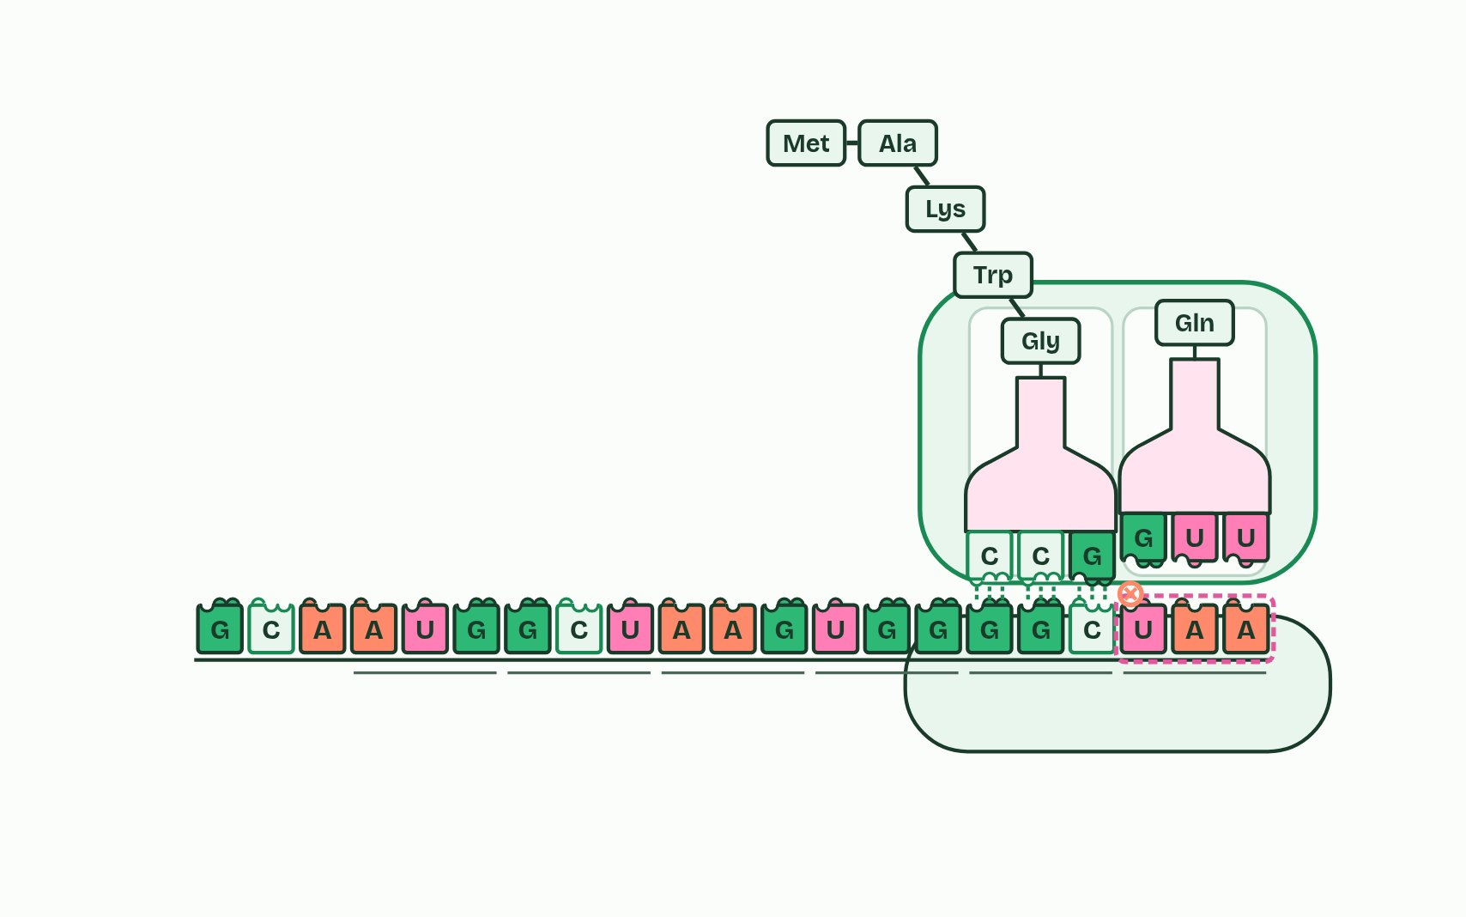
  SPOT THE MISTAKE
  What do students often get wrong about elongation? Write the mistake, then put it right.
  The mistake
  Put it right
SUMMARY
Sum up section 06 in two or three sentences of your own.

07 One base, one amino acid | D1.2.11
CUES  Predict: In a gene, one base changes so that an mRNA codon GAA becomes GAG. What happens to the polypeptide?  What is meant by mutation?  What is meant by point mutation?  What is meant by base substitution?  What is meant by silent?  What is meant by missense?  What is meant by nonsense?  What is meant by haemoglobin?  What is meant by sickle cell anaemia? | NOTES  1 A ___________ is a change in the base sequence of a gene.  2 A ___________________ changes one base, and the commonest kind is a _______________________: one base swapped for another, which changes one codon.  3 If it stands for the same amino acid, the mutation is ________, which the code's degeneracy allows.  4 If it stands for a different amino acid, it is ___________.  5 If it is a stop codon, it is ___________, and the chain ends early, usually too short to work.  6 Sickle cell anaemia is the guide's example of a point mutation that changes a protein. _______________ carries oxygen in red blood cells.  7 The sickled cells block small blood vessels, which causes pain and damage to organs, and they are destroyed early, so the person has too few red blood cells, which is __________________________.  Your own notes  ANNOTATE THE FIGURE  Number the 5 steps on the figure and note what happens at each.  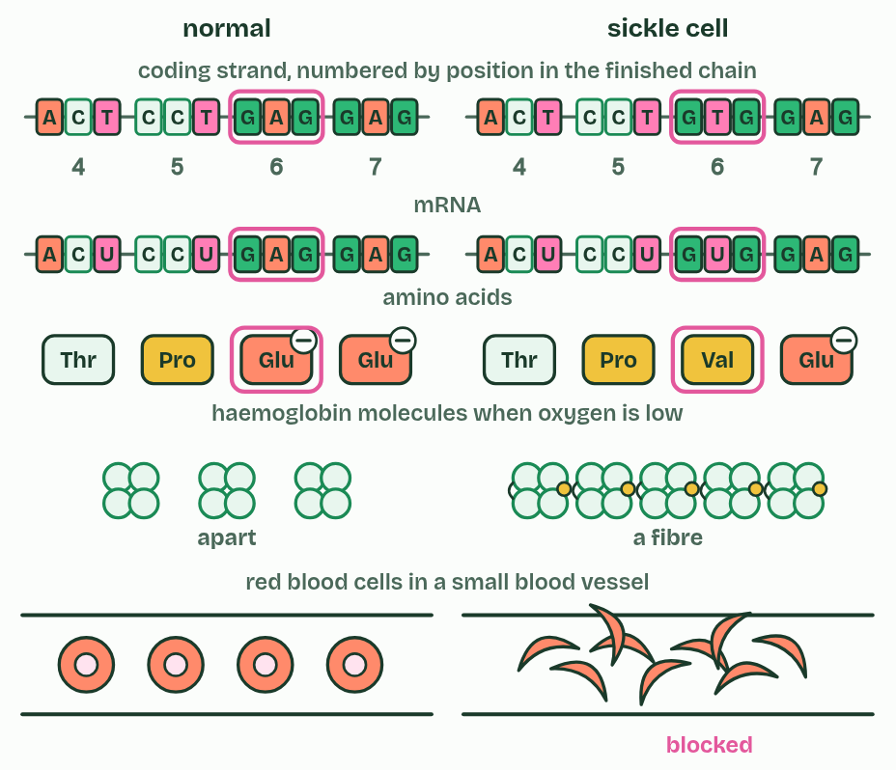  ANNOTATE THE FIGURE  Number the 2 steps on the figure and note what happens at each.  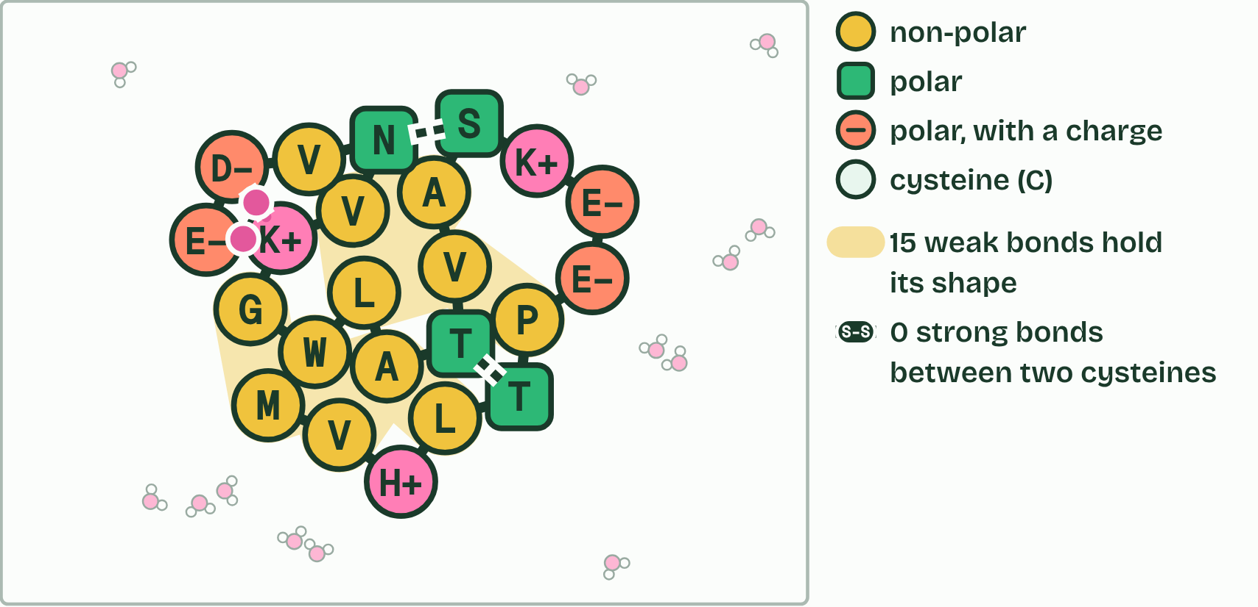  ANNOTATE THE FIGURE  Number the 4 steps on the figure and note what happens at each.  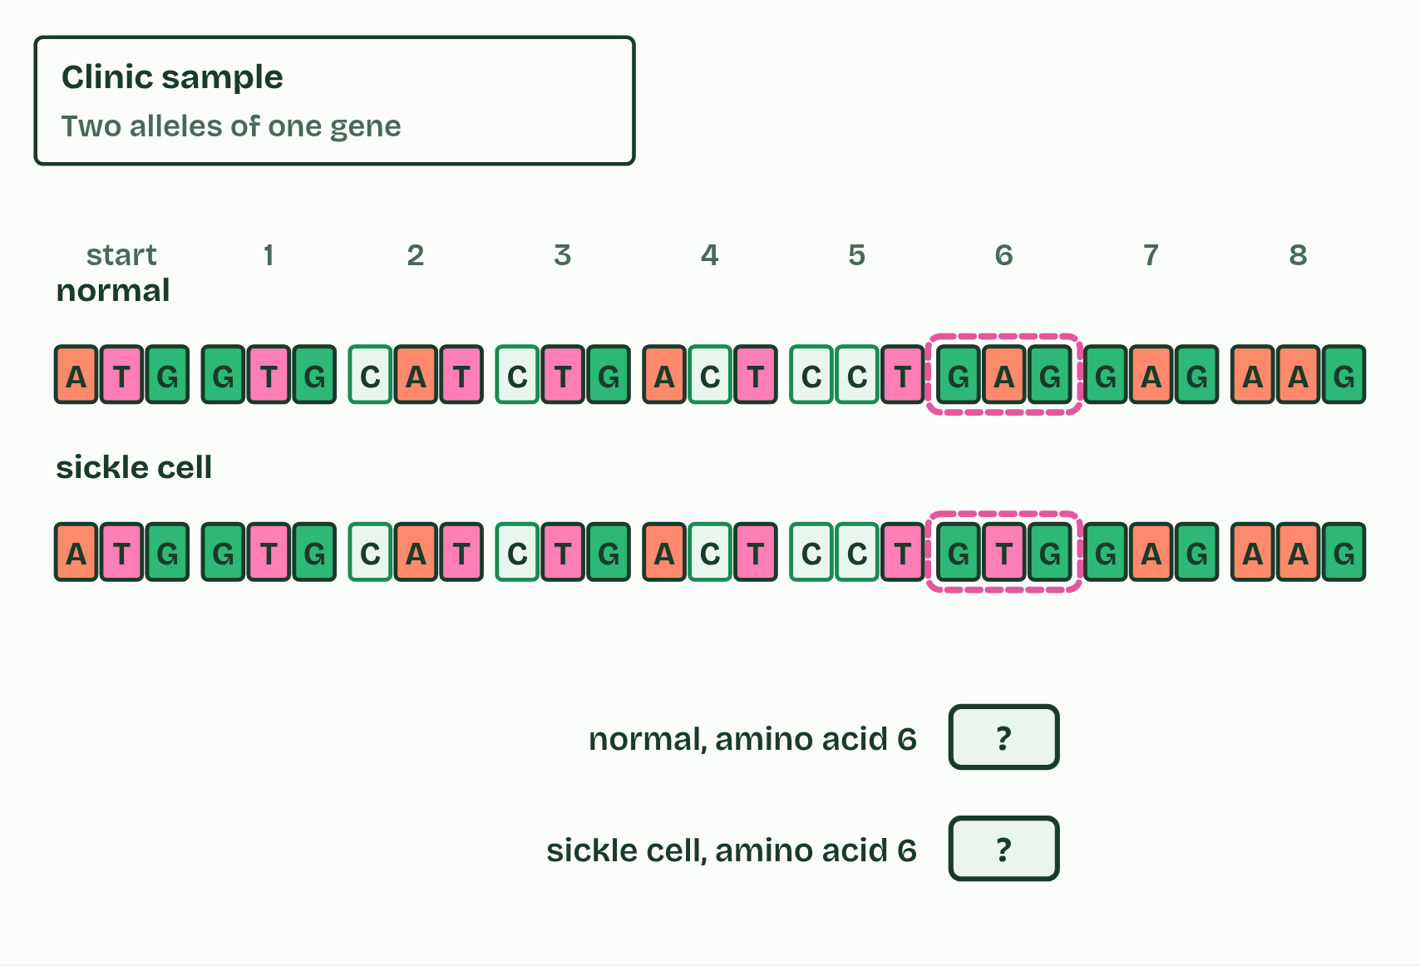  REMEMBER IT  What a substitution can do
  S  Same | S  Swapped | S  Stopped
  S | S | S
  SPOT THE MISTAKE
  What do students often get wrong about mutations that change protein structure? Write the mistake, then put it right.
  The mistake
  Put it right
SUMMARY
Sum up section 07 in two or three sentences of your own.

08 Five prime to three prime, both times | D1.2.12 HL
CUES  Predict: A template strand reads 3′-TACAAGCGT-5′. Written 5′ to 3′, what is the mRNA?  What is meant by 5′ end?  What is meant by 3′ end?  What is meant by 5′ to 3′? | NOTES  1 A strand has a ________, where the last nucleotide has a phosphate on its carbon 5′, and a ________, where the last nucleotide has a free OH on its carbon 3′.  2 ___________ transcription means that RNA polymerase joins the 5′ phosphate of each incoming RNA nucleotide to the 3′ OH at the end of the growing RNA (the sugar is ribose, because this is RNA).  3 The polymerase reads the _______________________.  4 Each new nucleotide joins the RNA's ________.  5 The ribosome reads the mRNA ___________ too.  Your own notes  ANNOTATE THE FIGURE  Number the 4 steps on the figure and note what happens at each.  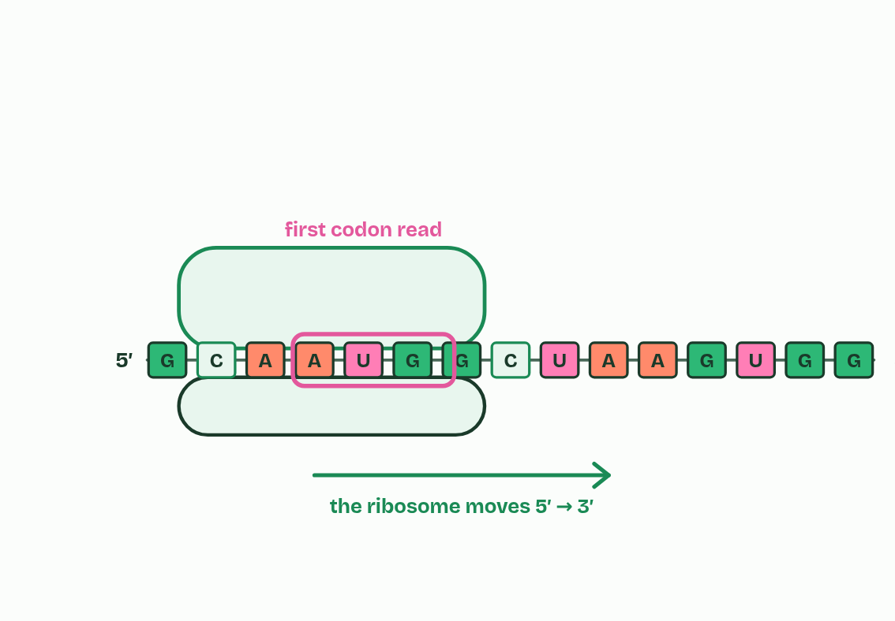
  SPOT THE MISTAKE
  What do students often get wrong about directionality? Write the mistake, then put it right.
  The mistake
  Put it right
SUMMARY
Sum up section 08 in two or three sentences of your own.

09 Where a gene starts, and DNA that codes for nothing | D1.2.13 HL D1.2.14 HL
CUES  Predict: A gene for a tRNA is transcribed in every cell, but its RNA is never translated. Is it coding or non-coding DNA?  What is meant by promoter?  What is meant by transcription factors?  What is meant by non-coding sequences?  What is meant by regulators of gene expression?  What is meant by introns?  What is meant by telomeres? | NOTES  1 The ___________ is a stretch of DNA just before the part of a gene that is transcribed.  2 It is where transcription starts. ____________________________ are proteins that attach to the promoter, and RNA polymerase can bind and start only when the right ones are in place (you do not have to name any).  3 ___________________________ are stretches of DNA that code for no polypeptide.  4 __________________________________: promoters, and other sequences where factors bind;  5 _________: stretches inside a gene that are transcribed but cut out of the RNA (chapter 10);  6 ____________: repeats of a short sequence (TTAGGG in humans) at each end of a chromosome, which protect the genes near the ends when the DNA is copied;  Your own notes  ANNOTATE THE FIGURE  The figure shows it as Absent and Present. Note what changes each time.  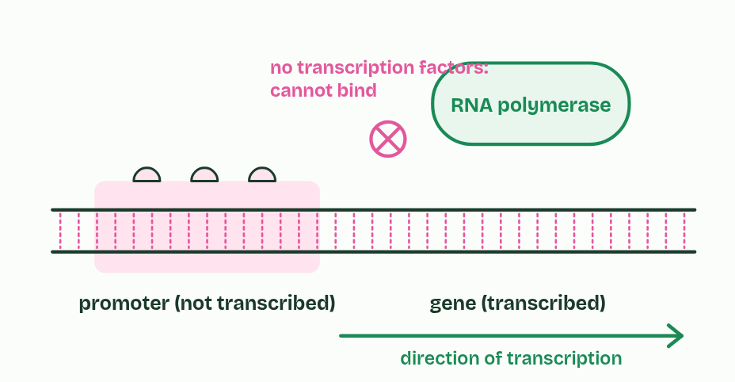  ANNOTATE THE FIGURE  Label each part and say what it does: telomere, tRNA gene, regulatory sequence, promoter, exon, intron, exon, intron, exon, rRNA gene, telomere.  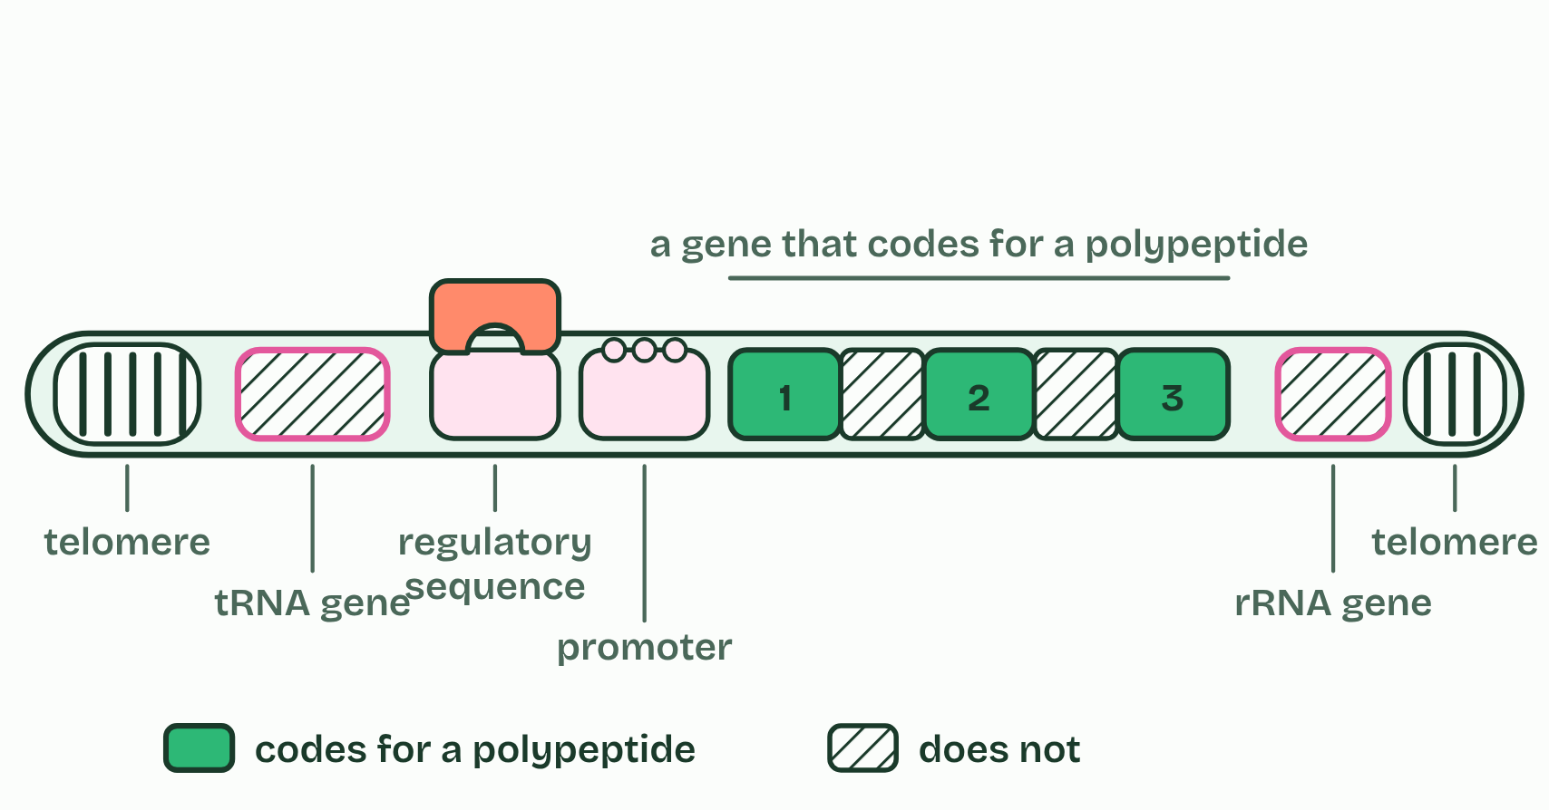
  SPOT THE MISTAKE
  What do students often get wrong about promoters and non-coding DNA? Write the mistake, then put it right.
  The mistake
  Put it right
SUMMARY
Sum up section 09 in two or three sentences of your own.

10 Capped, cut and tailed | D1.2.15 HL D1.2.16 HL
CUES  Predict: A gene has four exons. Exons 1 and 4 are always kept, and exons 2 and 3 can each be kept or left out. How many different mature mRNAs can it make?  What is meant by pre-mRNA?  What is meant by post-transcriptional modification?  What is meant by mature mRNA?  What is meant by splicing?  What is meant by exons?  What is meant by 5′ cap?  What is meant by poly-A tail?  What is meant by alternative splicing? | NOTES  1 In a eukaryotic cell, the RNA that RNA polymerase makes from a protein-coding gene is ___________.  2 It is changed in the nucleus before it leaves, a stage called __________________________________, and the result is _______________.  3 In ___________, the introns are cut out and the ________ joined end to end, so the mature mRNA carries only sequence that codes for the polypeptide.  4 A ________, a modified guanine nucleotide, is added to the 5′ end, and a _______________, a long run of adenine nucleotides (often about 200), to the 3′ end.  5 ___________________________: in many genes, which exons are kept can vary.  Your own notes  ANNOTATE THE FIGURE  Number the 5 steps on the figure and note what happens at each.  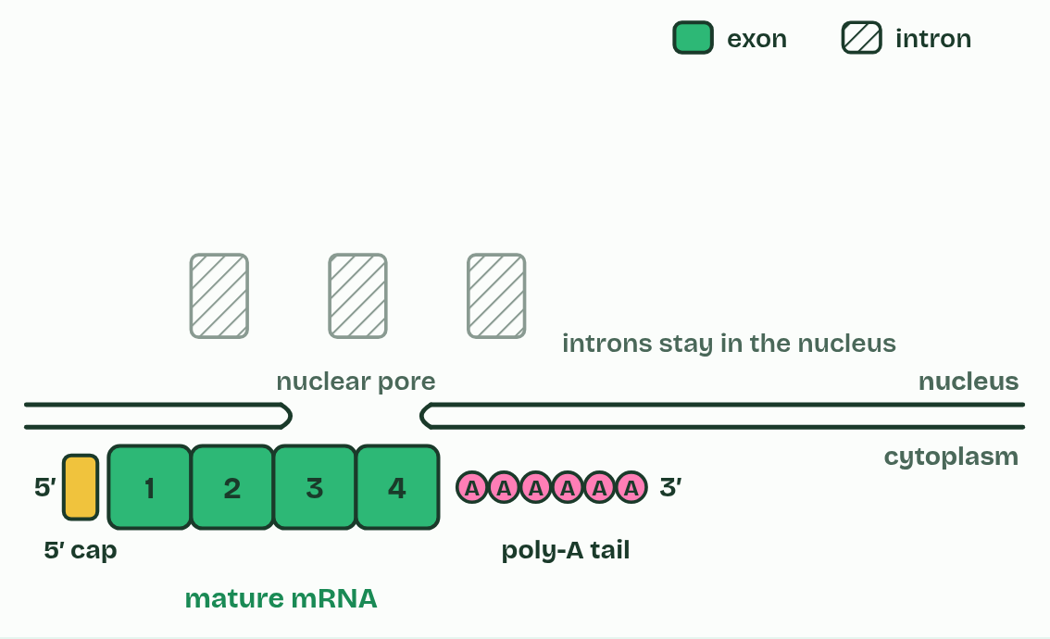  ANNOTATE THE FIGURE  The figure shows it as All four exons and Leave out exon 2. Note what changes each time.  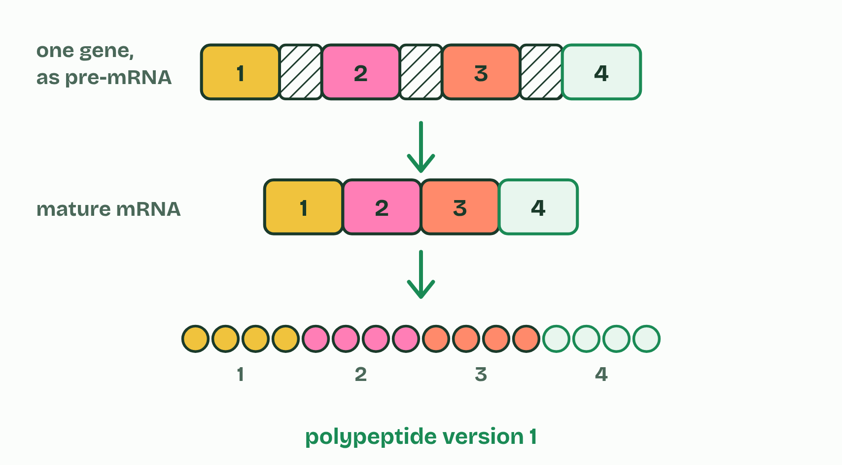  ANNOTATE THE FIGURE  Annotate this still from the animation (From promoter to mature mRNA): what is happening, and why?  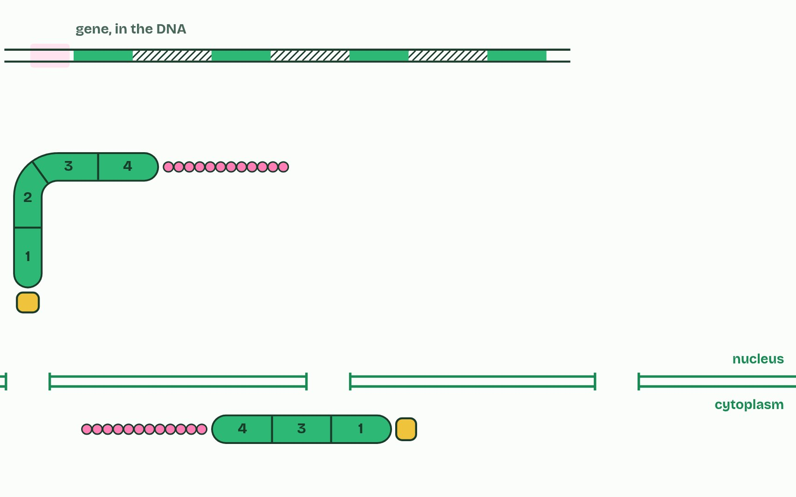  REMEMBER IT  Introns and exons
  I  In | E  Exit
  I | E
  SPOT THE MISTAKE
  What do students often get wrong about RNA processing and alternative splicing? Write the mistake, then put it right.
  The mistake
  Put it right
SUMMARY
Sum up section 10 in two or three sentences of your own.

11 Starting the chain | D1.2.17 HL
CUES  Predict: The first peptide bond has just formed, joining methionine to the second amino acid. Before the ribosome moves, which site holds the tRNA carrying both amino acids?  What is meant by initiation?  What is meant by 5′ terminal?  What is meant by initiator tRNA?  What is meant by a site?  What is meant by p site?  What is meant by e site? | NOTES  1 ______________ is how translation starts.  2 The ________ is where each new tRNA arrives with its amino acid.  3 The ________ holds the tRNA carrying the growing chain, which is joined by a peptide bond to the amino acid in the A site.  4 The ________ is where an empty tRNA goes when the ribosome moves one codon, and where it leaves from.  5 the small subunit attaches to the mRNA at its _______________, its 5′ end (in eukaryotes the 5′ cap helps);  6 the ___________________, anticodon UAC, carrying methionine, pairs with AUG;  7 the large subunit joins, so the ribosome is complete, with the ___________________ in the P site;  8 another tRNA, matching the next codon, binds in the ________.  Your own notes  ANNOTATE THE FIGURE  Number the 6 steps on the figure and note what happens at each.  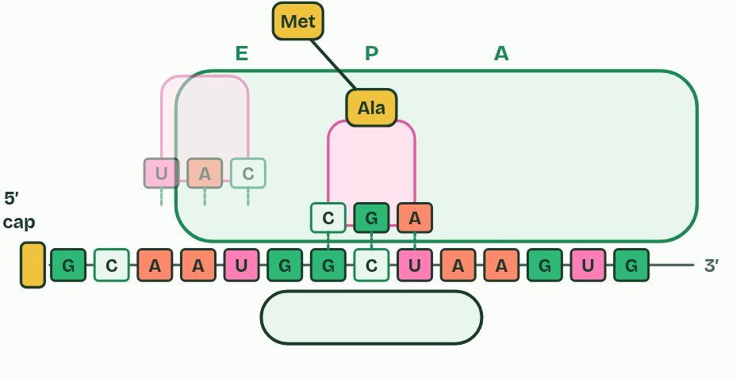  ANNOTATE THE FIGURE  Annotate this still from the animation (Start, then A, P and E): what is happening, and why?  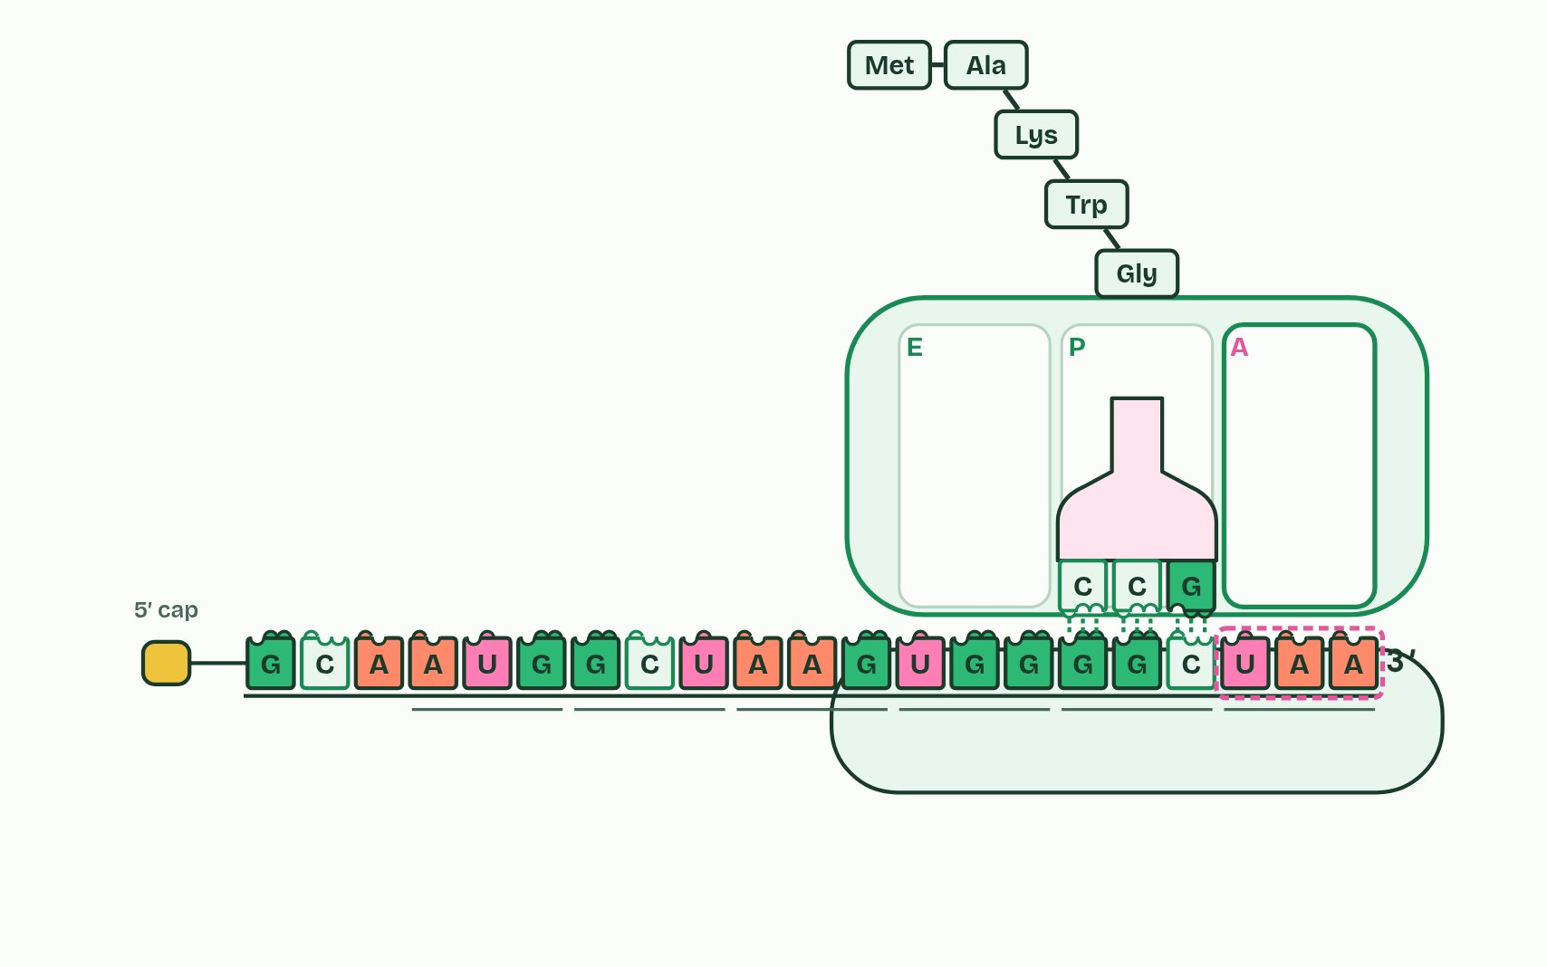  REMEMBER IT  The three sites
  A  Arrive | P  Pass | E  Exit
  A | P | E
  SPOT THE MISTAKE
  What do students often get wrong about initiation of translation? Write the mistake, then put it right.
  The mistake
  Put it right
SUMMARY
Sum up section 11 in two or three sentences of your own.

12 Finished, then recycled | D1.2.18 HL D1.2.19 HL
CUES  Predict: Insulin's two chains are 21 and 30 amino acids long, and pre-proinsulin is 110. How many amino acids are cut away in all?  What is meant by post-translational modification?  What is meant by pre-proinsulin?  What is meant by signal peptide?  What is meant by proinsulin?  What is meant by disulfide bonds?  What is meant by proteasome?  What is meant by proteome? | NOTES  1 They are modified first, which is called __________________________________: they are cut, folded and bonded, or given extra groups such as sugars or phosphates.  2 It starts as ___________________, 110 amino acids long, which begins with a ___________________ of 24 amino acids.  3 In stage 1, in the rough ER, the signal peptide is cut off, leaving ______________ (86 amino acids).  4 Proinsulin folds, and three ____________________ form: two join what will become the B chain to the A chain, and one lies within the A chain.  5 A ______________ is a barrel-shaped complex of proteins, in the cytoplasm and the nucleus, that hydrolyses the peptide bonds of a protein into short pieces, which other enzymes then split into single amino acids for the cell to use again in building new proteins.  6 The ___________ is all the proteins a cell makes.  Your own notes  ANNOTATE THE FIGURE  Number the 5 steps on the figure and note what happens at each: 1 signal peptide; 2 proinsulin; 3 disulfide bonds; 4 C-peptide; 5 Insulin.  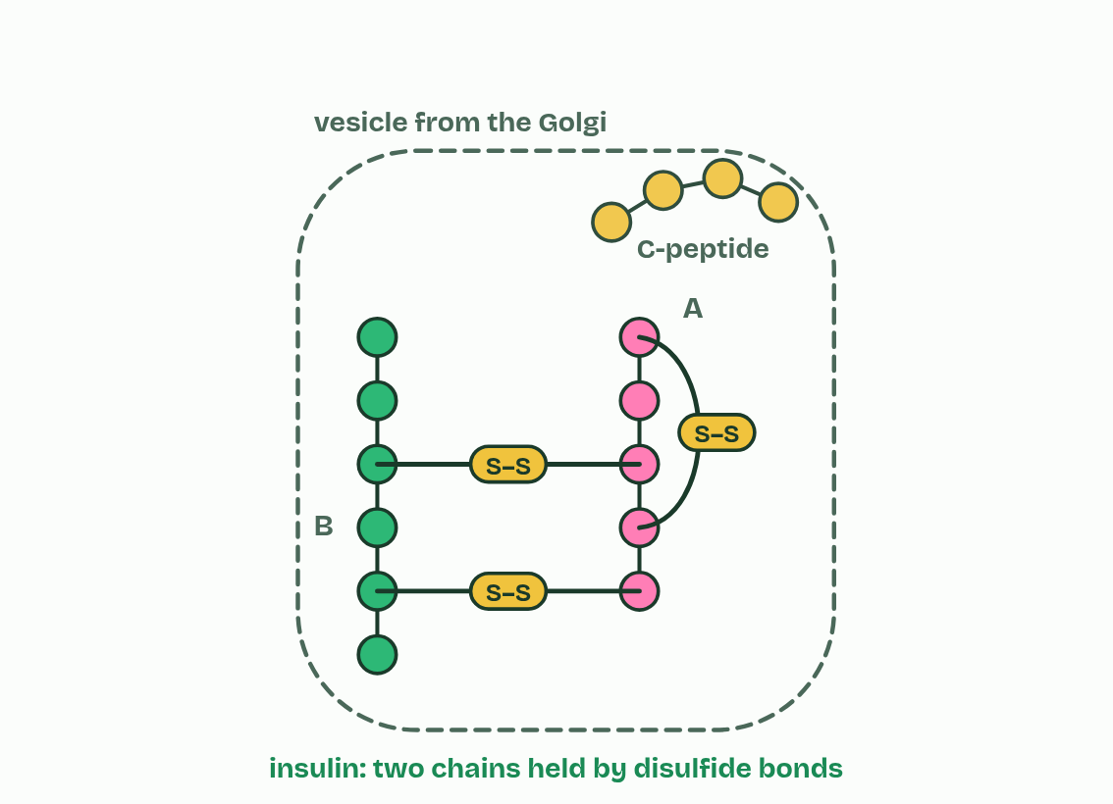  ANNOTATE THE FIGURE  Number the 3 steps on the figure and note what happens at each.  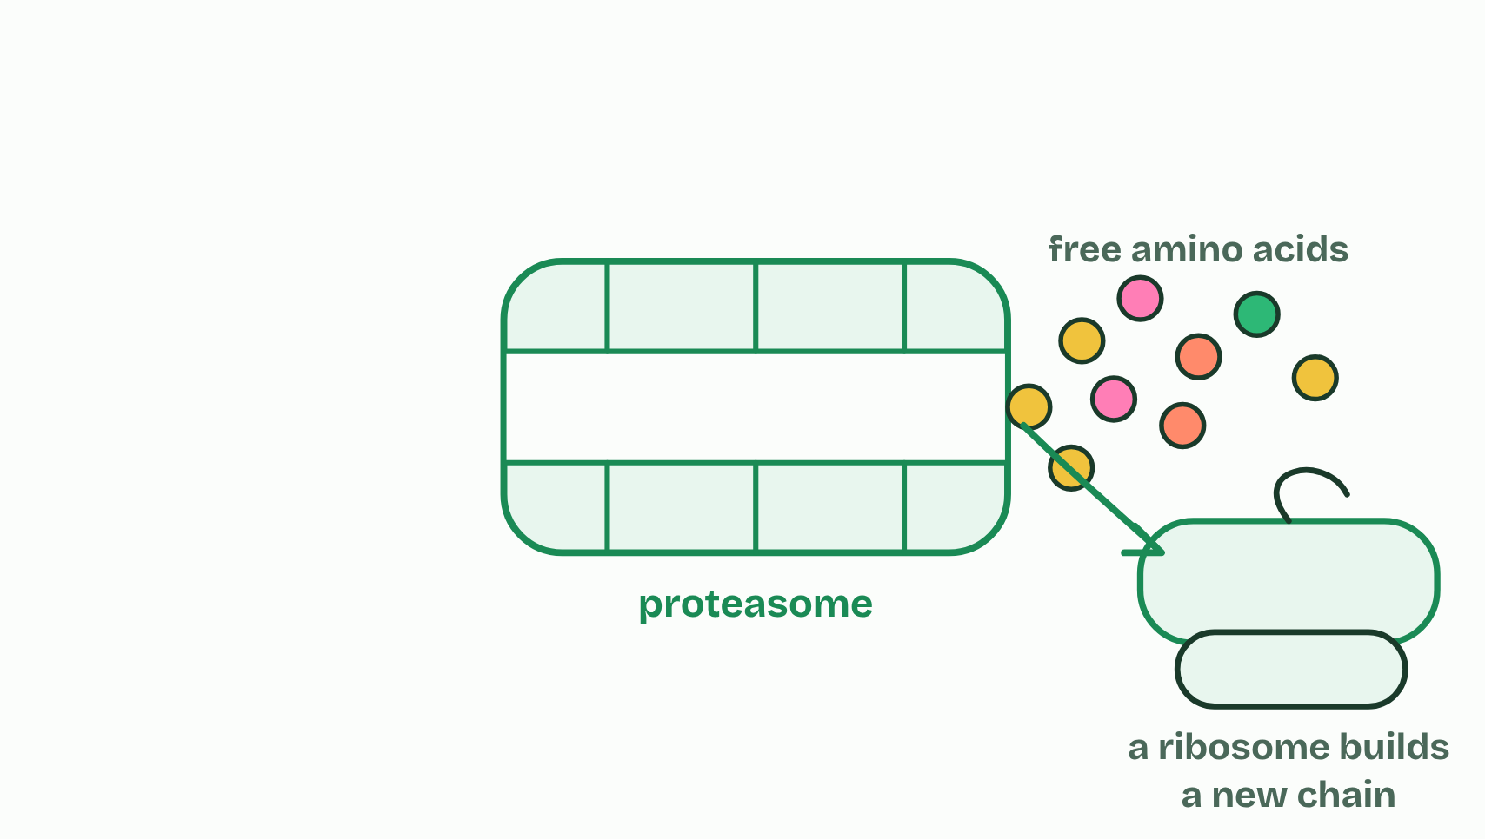
  SPOT THE MISTAKE
  What do students often get wrong about modification and proteasomes? Write the mistake, then put it right.
  The mistake
  Put it right
SUMMARY
Sum up section 12 in two or three sentences of your own.

Check yourself
The check for this guide is online: a fresh paper of past-paper style questions from the exam bank on D1.2 each time, marked as you go, and saved to your Exam practice progress when you are signed in. Open the link:
biologybybradford.com/exam-maker/sit?topics=D1.2&level=HL&paper=quiz&marks=15&src=ep

