Name | Class | Date
IB BIOLOGY · D3.2

Inheritance
Teacher’s copy: every blank filled in. Each numbered block matches a chapter of the guide, and of the lesson slides. Write in the gaps, answer the cues, annotate the figures, and sum up each section in your own words.
BY THE END YOU CAN
Explain how meiosis halves the chromosome number to make haploid gametes, and how fusion gives a diploid zygote D3.2.1
Describe how a genetic cross is made in flowering plants, using the terms P generation, F1 generation, F2 generation and Punnett grid D3.2.2
Define genotype, and use homozygous, heterozygous, gene and allele correctly D3.2.3
Explain how phenotype comes from genotype and the environment, with examples of each D3.2.4
Predict the effects of dominant and recessive alleles on phenotype D3.2.5
Explain phenotypic plasticity as a change in gene expression, not in the genes themselves D3.2.6
Explain phenylketonuria as a disease caused by a recessive allele D3.2.7
Describe single-nucleotide polymorphisms and multiple alleles in a gene pool D3.2.8
Use the ABO blood groups to show how multiple alleles are inherited D3.2.9
Distinguish incomplete dominance from codominance D3.2.10
Explain sex determination in humans and the inheritance of genes on the sex chromosomes D3.2.11
Use haemophilia to explain a sex-linked genetic disorder D3.2.12
Use pedigree charts to deduce patterns of inheritance of genetic disorders D3.2.13
Explain continuous variation as the result of polygenic inheritance and the environment D3.2.14
Draw and read box-and-whisker plots for a continuous variable such as student height D3.2.15
Explain segregation and independent assortment of unlinked genes in meiosis D3.2.16
Use Punnett grids to predict genotypic and phenotypic ratios in dihybrid crosses of unlinked autosomal genes D3.2.17
Find the loci of human genes and their polypeptide products in a database D3.2.18
Explain autosomal gene linkage D3.2.19
Identify recombinants in crosses involving two linked or unlinked genes D3.2.20
Use a chi-squared test on data from a dihybrid cross D3.2.21

01 Halve, then fuse | D3.2.1
CUES  Predict: A human body cell has 46 chromosomes. How many chromosomes are in a sperm, and how many in the zygote it helps to form?  B: 23 in the sperm and 46 in the zygote. 23 and 46. Meiosis halves the number, so a sperm is haploid with one chromosome from each of the 23 pairs. The zygote gets 23 from the sperm and 23 from the egg, so it is diploid again. If gametes were made by an ordinary division, the number would double every generation.  What is meant by diploid?  A cell with two sets of chromosomes, one from each parent (2n). It carries two copies of each autosomal gene.  What is meant by autosomes?  Any chromosome that is not a sex chromosome. Autosomes come in matching pairs.  What is meant by meiosis?  A type of cell division that halves the chromosome number. It makes the gametes of an organism that reproduces sexually.  What is meant by gametes?  A sex cell, such as a sperm, an egg or a pollen grain, with one set of chromosomes.  What is meant by haploid?  A cell with one set of chromosomes (n), such as a gamete.  What is meant by zygote?  The diploid cell made when two gametes fuse. It divides and grows into a new organism. | NOTES  1 A cell like that is diploid.  2 Most of them are autosomes, so a diploid cell has two copies of each autosomal gene: one on each chromosome of a pair.  3 Special cells divide by meiosis to make gametes, and each gamete gets one chromosome from every pair.  4 A cell with a single set is haploid.  5 Their nuclei fuse to make a zygote, which is diploid again, with one set from each parent.  Your own notes  ANNOTATE THE FIGURE  Number the 4 steps on the figure and note what happens at each: 1 diploid; 2 Meiosis, haploid; 3 Fusion; 4 same gene.  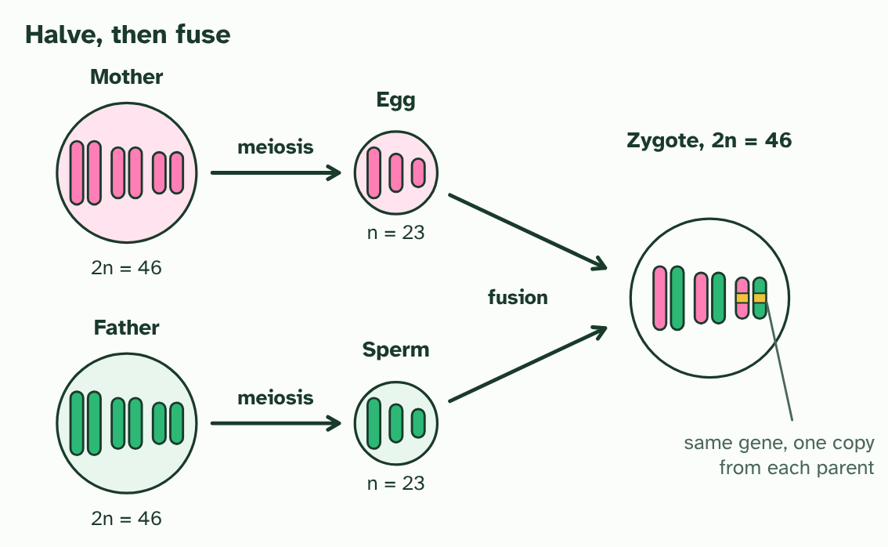  1 Two parents, each with diploid body cells (2n = 46). Three of the 23 pairs are drawn.  2 Meiosis makes gametes with one chromosome from each pair: an egg and a sperm, each haploid (n = 23).  3 Fusion of the two gametes makes a zygote. It is diploid again, with one set from each parent.  4 In the zygote, a pair of chromosomes carries the same gene twice, one copy from each parent.  ANNOTATE THE FIGURE  Annotate this still from the animation (Watch it happen: halving, then fusing): what is happening, and why?  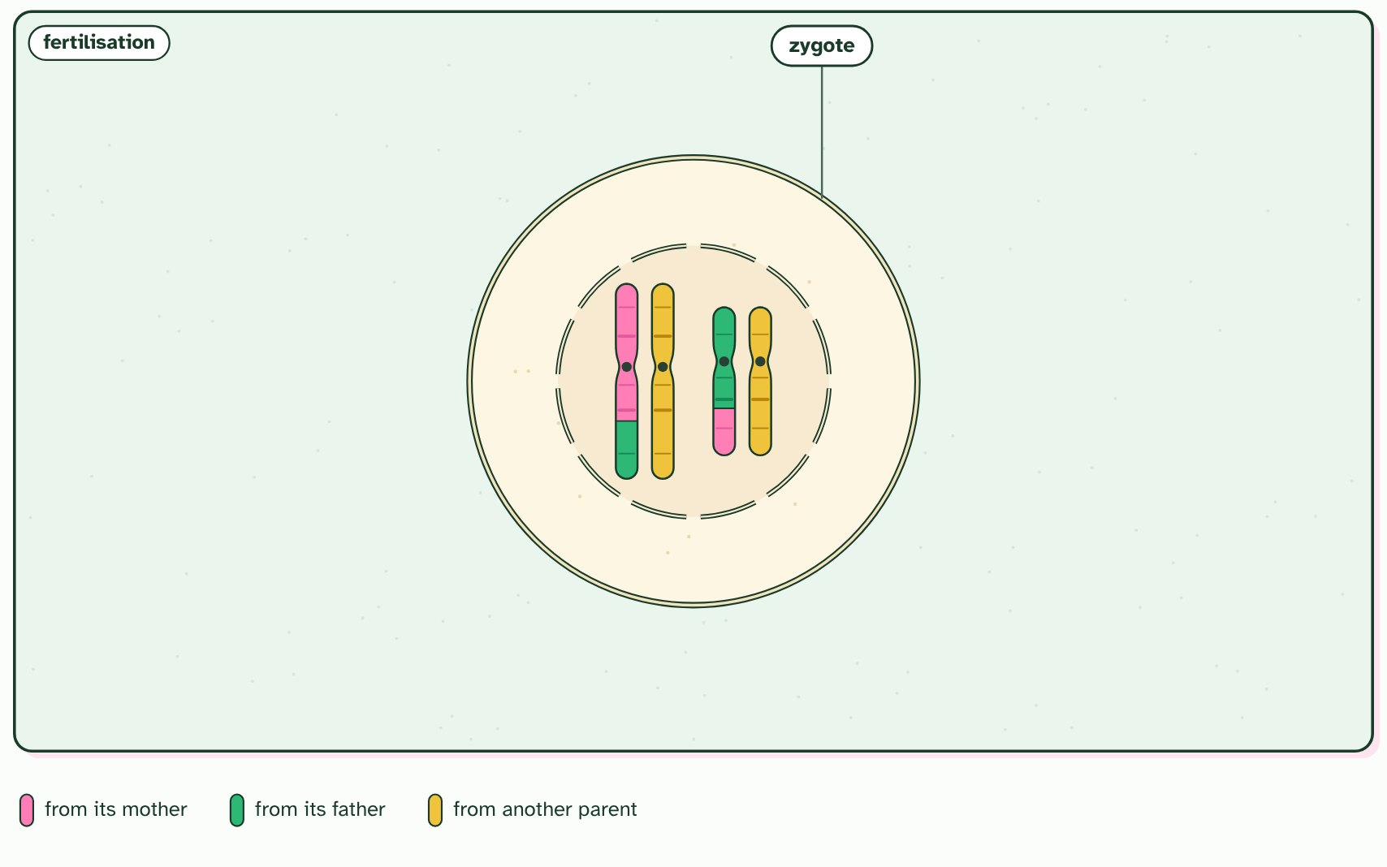  1 A diploid cell of a parent. Its chromosomes are in pairs: one of each pair came from its mother (pink), one from its father (green).  2 First the DNA is copied: each chromosome becomes two identical sister chromatids, joined at a centromere.  3 The nucleus breaks down and each chromosome lies beside its partner: a homologous pair, with the same genes in the same order.  4 Crossing over: chromatids of a pair swap matching sections, making new mixes of the mother's and the father's alleles.  5 A spindle forms and the pairs line up across the middle. Which way round each pair lies is down to chance: random orientation.  6 Meiosis I: one chromosome of each pair is pulled to each end, and the cell divides. Each new cell has half the number of chromosomes.  7 Meiosis II: in each cell the sister chromatids are pulled apart, and both cells divide again.  8 Four haploid gametes, each with one chromosome of every pair, and no two alike.  9 Fertilisation: the gamete fuses with one from another parent (yellow). The zygote is diploid again, with one of each pair from each parent.
  SPOT THE MISTAKE
  What do students often get wrong about halving and doubling? Write the mistake, then put it right.
  A gamete is not "half a cell". It is a whole cell with half the number of chromosomes. And a parent does not pass both of its copies of a gene to a gamete: it passes one.
SUMMARY
Sum up section 01 in two or three sentences of your own.
• A cell like that is diploid.
• Most of them are autosomes, so a diploid cell has two copies of each autosomal gene: one on each chromosome of a pair.
• Special cells divide by meiosis to make gametes, and each gamete gets one chromosome from every pair.
• A cell with a single set is haploid.

02 How to make a cross | D3.2.2
CUES  Predict: A student wants to cross a purple-flowered pea plant with a white-flowered one, but forgets to remove the anthers from the white plant. What is likely to happen?  A: Some seeds will come from self-fertilisation, so not all will be from the cross. Some seeds will come from self-fertilisation. A pea flower makes both pollen and ovules and normally pollinates itself, so unless the anthers are removed early, its own pollen can fertilise some of the ovules. The offspring would be a mixture of crossed and self-fertilised seeds, and the results would be hard to read.  What is meant by pollen?  The tiny grains made in the anthers of a flower. Each pollen grain contains male gametes.  What is meant by pollination?  The transfer of pollen from an anther to a stigma.  What is meant by self-fertilisation?  Fertilisation of a plant's own ovules by its own pollen.  What is meant by true-breeding?  Plants or animals that always produce offspring like themselves when bred with their own kind, because both alleles of the gene are the same.  What is meant by punnett grid?  A grid that shows every way the gametes of two parents can combine, so you can read off the genotypes of the offspring and how likely each is. | NOTES  1 The male gametes are in pollen, which forms in the anthers.  2 A pollen grain has to reach the stigma before it can fertilise an ovule, so a cross needs pollination.  3 One flower makes both pollen and ovules, so it can pollinate itself: self-fertilisation.  4 The two parents you choose are the P generation.  5 Parents that are true-breeding give the F1 generation (F is for filial, meaning of a son or daughter).  6 Let the F1 plants pollinate each other, or themselves, and you get the F2 generation.  7 A Punnett grid predicts what the F2 should look like.  Your own notes  ANNOTATE THE FIGURE  Number the 5 steps on the figure and note what happens at each: 1 Pollen, ovules; 2 pollinates itself; 3 cross; 4 P generation, F1 generation; 5 F2 generation, Punnett grid.  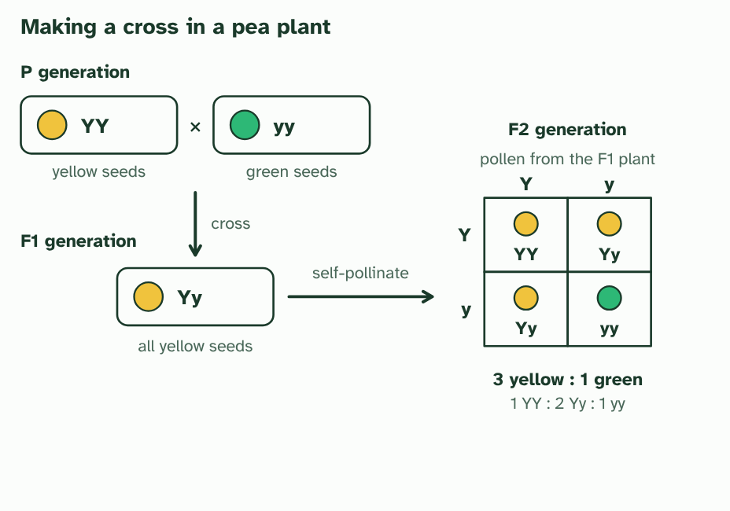  1 A pea flower makes both kinds of gamete. Pollen forms in the anthers and holds the male gametes. The ovules in the ovary hold the female gametes.  2 Left alone, a pea flower pollinates itself: its pollen reaches its own stigma.  3 For a cross, the anthers are removed from the receiving flower, and pollen is carried from the donor to its stigma.  4 Cross two true-breeding parents (the P generation). Every seed of the F1 generation has one allele from each parent.  5 Let the F1 plants self-pollinate to make the F2 generation. The Punnett grid shows every way their gametes can combine: 3 yellow seeds for every 1 green.  REMEMBER IT  The generations of a cross
  P  Parents | F  First | F  Follows
  P generation  the plants you choose to cross | F1 generation  their offspring | F2 generation  the offspring of two F1 plants
  SPOT THE MISTAKE
  What do students often get wrong about genetic crosses in flowering plants? Write the mistake, then put it right.
  A Punnett grid gives chances, not promises. It predicts the proportions you should expect in a large number of offspring, not exactly which seeds you will get.
SUMMARY
Sum up section 02 in two or three sentences of your own.
• The male gametes are in pollen, which forms in the anthers.
• A pollen grain has to reach the stigma before it can fertilise an ovule, so a cross needs pollination.
• One flower makes both pollen and ovules, so it can pollinate itself: self-fertilisation.
• Parents that are true-breeding give the F1 generation (F is for filial, meaning of a son or daughter).

03 Genes, alleles and the traits you see | D3.2.3 D3.2.4
CUES  Predict: Two plants have the same genotype for every gene, but one grows much taller because it was given more water and fertiliser. What does this show?  B: The environment affects the phenotype as well as the genotype. The environment affects the phenotype as well as the genotype. The two plants have the same alleles, so the difference in height comes from the conditions they grew in. Fertiliser does not change the alleles in the plant’s cells.  What is meant by gene?  A length of DNA at one place (locus) on a chromosome, with the instructions for making a polypeptide.  What is meant by alleles?  Alternative forms of the same gene, found at the same place on a chromosome. They differ in their base sequences.  What is meant by genotype?  The combination of alleles an organism has, usually for one gene.  What is meant by homozygous?  Having two identical alleles of a gene.  What is meant by heterozygous?  Having two different alleles of a gene.  What is meant by phenotype?  The observable traits of an organism, which result from its genotype and the environment. | NOTES  1 A gene is a length of DNA at one place on a chromosome.  2 Different versions of the same gene are alleles.  3 The pair of alleles is your genotype for that gene.  4 If the two alleles are the same, you are homozygous (YY or yy).  5 If they differ, you are heterozygous (Yy).  6 Your phenotype is what can be observed: the colour of a seed, your blood group, your height, even your behaviour.  Your own notes  ANNOTATE THE FIGURE  Number the 3 steps on the figure and note what happens at each: 1 gene, allele; 2 genotype, homozygous, heterozygous; 3 phenotype.  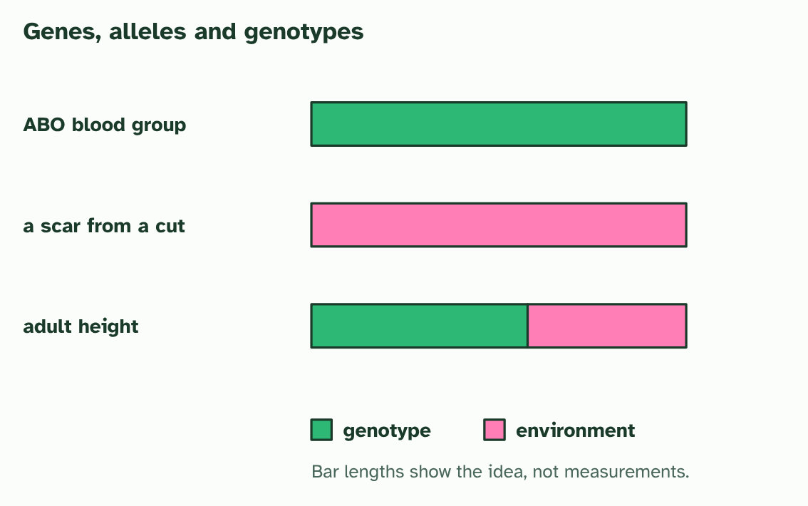  1 A pair of homologous chromosomes. The gene is one place on the chromosome. Each chromosome carries one allele of it, here Y and y.  2 The two alleles make the genotype. Two the same is homozygous. Two different is heterozygous.  3 The phenotype comes from the genotype, the environment, or both: blood group, a scar and height.
  SPOT THE MISTAKE
  What do students often get wrong about genotype and phenotype? Write the mistake, then put it right.
  There is no "gene for yellow seeds". There is a gene for seed colour, and the Y allele of it makes the seed yellow. A gene has alleles; a trait is made by a genotype.
SUMMARY
Sum up section 03 in two or three sentences of your own.
• A gene is a length of DNA at one place on a chromosome.
• Different versions of the same gene are alleles.
• The pair of alleles is your genotype for that gene.
• If the two alleles are the same, you are homozygous (YY or yy).

04 Dominant and recessive alleles | D3.2.5
CUES  Predict: Two yellow-seeded pea plants are crossed, and some of their offspring have green seeds. What must be true of both parents?  B: Both are heterozygous Yy: each carries a hidden y allele. Both are Yy. A green seed is yy, so each parent must have given it a y. A parent that shows the dominant trait yet carries y must be heterozygous. A YY parent has no y to give, so one YY parent could never produce a green seed.  What is meant by dominant allele?  An allele whose effect shows in the phenotype of a heterozygote as well as of a homozygote.  What is meant by recessive allele?  An allele whose effect shows only when there is no dominant allele, so the organism is homozygous for it. | NOTES  1 A dominant allele shows its effect when it is present, in one copy or in two.  2 A recessive allele shows only when there is no dominant allele alongside it.  3 Three genotypes of the seed colour gene: two homozygous and one heterozygous.  4 Each gene makes a protein. A Y allele makes a working one, and one working copy makes enough to give the trait. With no working copy, the trait changes.  5 The phenotypes: YY and Yy are both yellow, so the dominant allele shows in a heterozygote. Only yy is green.  6 Each parent makes gametes by meiosis, one allele of each gene in each. The female parent's go down the side of the Punnett grid, the male parent's along the top.  Your own notes  ANNOTATE THE FIGURE  Number the 3 steps on the figure and note what happens at each: 1 homozygous, heterozygous; 2 Y, enough; 3 YY, Yy, yy.  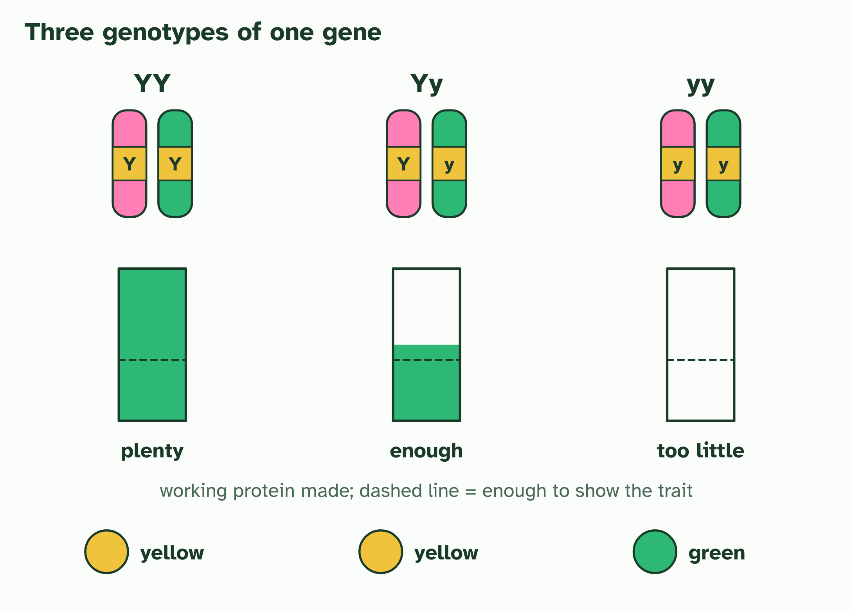  1 Three genotypes of the seed colour gene: two homozygous and one heterozygous.  2 Each gene makes a protein. A Y allele makes a working one, and one working copy makes enough to give the trait. With no working copy, the trait changes.  3 The phenotypes: YY and Yy are both yellow, so the dominant allele shows in a heterozygote. Only yy is green.  ANNOTATE THE FIGURE  Number the 2 steps on the figure and note what happens at each.  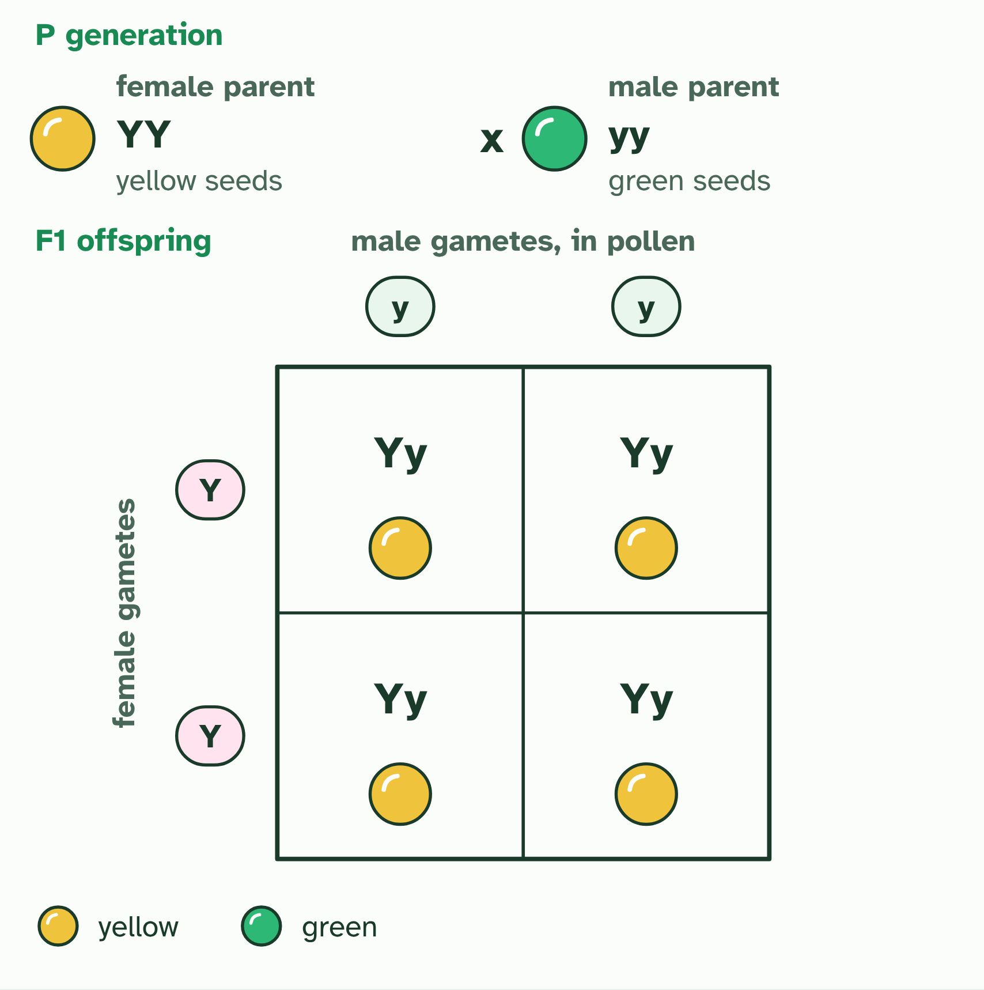  1 Each parent makes gametes by meiosis, one allele of each gene in each. The female parent's go down the side of the Punnett grid, the male parent's along the top.  2 Each cell joins one gamete from each parent: a possible offspring, every cell as likely as the next. The F1: genotypes all Yy; phenotypes all yellow.
  SPOT THE MISTAKE
  What do students often get wrong about dominant and recessive alleles? Write the mistake, then put it right.
  Dominant does not mean common, strong or better. Some dominant alleles are rare, and some cause disease. Dominant only describes what shows in a heterozygote. Recessive alleles do not fade away either: in a heterozygote they are still there, and they can reappear in a later generation.
SUMMARY
Sum up section 04 in two or three sentences of your own.
• A dominant allele shows its effect when it is present, in one copy or in two.
• A recessive allele shows only when there is no dominant allele alongside it.

05 Same genes, different outcomes | D3.2.6
CUES  Predict: Two clones grow differently, one in sun and one in shade. What explains the difference?  B: The light changed how their genes were expressed. The light changed how their genes were expressed. Clones start with identical alleles, and nothing in this story changes them. The environment changes which genes are switched on and how strongly, and that changes the phenotype.  What is meant by phenotypic plasticity?  The ability of one genotype to produce different phenotypes, by changing which genes are expressed, in response to the environment the organism experiences.  What is meant by gene expression?  The use of the information in a gene to make a product, so that the gene affects the phenotype. | NOTES  1 One individual, with one set of alleles, can develop different traits in different conditions, and the change often suits the conditions. That is phenotypic plasticity.  2 The difference is in gene expression: which genes are switched on, where, and how strongly.  3 Because the alleles are the same, the change can be reversible during the life of the individual: move the shaded plant into the sun, and its new growth comes in short and sturdy, like the sun plant's.  4 Two cuttings from it carry exactly the same alleles.  5 One cutting grows in sun and one in shade. Same alleles, but different gene expression makes a short, sturdy plant and a tall one with broad leaves.  6 Move the shaded plant into the sun, and its new growth comes in like the sun plant’s. The change is reversible, and the alleles never changed.  Your own notes  ANNOTATE THE FIGURE  Number the 4 steps on the figure and note what happens at each.  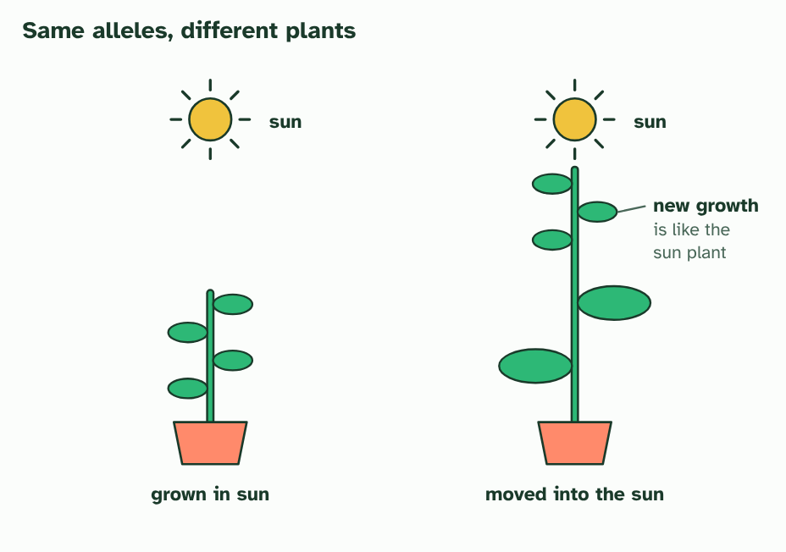  1 One parent plant, with its alleles.  2 Two cuttings from it carry exactly the same alleles.  3 One cutting grows in sun and one in shade. Same alleles, but different gene expression makes a short, sturdy plant and a tall one with broad leaves.  4 Move the shaded plant into the sun, and its new growth comes in like the sun plant’s. The change is reversible, and the alleles never changed.
  SPOT THE MISTAKE
  What do students often get wrong about phenotypic plasticity? Write the mistake, then put it right.
  A plastic change is not passed to the next generation through the alleles: the shaded plant's seeds do not inherit its stretching. The individual does not choose to change either. The capacity to respond is itself in the genotype, and the environment triggers it.
SUMMARY
Sum up section 05 in two or three sentences of your own.
• One individual, with one set of alleles, can develop different traits in different conditions, and the change often suits the conditions. That is phenotypic plasticity.
• The difference is in gene expression: which genes are switched on, where, and how strongly.

06 One faulty enzyme: PKU | D3.2.7
CUES  Predict: Two parents do not have PKU, but their first child does. What is the chance that their second child has PKU?  C: 1 in 4, because both parents must be carriers. 1 in 4. The child is nn, so each unaffected parent must be Nn. Two Nn parents have a 1 in 4 chance of nn for every child. Alleles are not used up: each new baby is made from fresh gametes.  What is meant by phenylketonuria?  A recessive genetic condition in which the body cannot convert phenylalanine to tyrosine, because the enzyme that does this is not working.  What is meant by carrier?  Someone who has one copy of a recessive allele for a condition, is not affected by it, and can pass the allele on. | NOTES  1 Phenylketonuria (PKU) is a human disease caused by a recessive allele of an autosomal gene.  2 Because the allele is recessive, a person with one working and one faulty allele has no symptoms. That person is a carrier.  3 In a person with a working allele, the enzyme converts phenylalanine to tyrosine, which has one extra OH group.  4 In a person with two faulty alleles the enzyme does not work. Little tyrosine is made and phenylalanine builds up.  5 A diet low in phenylalanine gives the body less to build up. The genotype is the same, and the phenotype changes.  6 Two carrier parents (Nn): each child has a 1 in 4 chance of nn, so of PKU.  Your own notes  ANNOTATE THE FIGURE  Number the 4 steps on the figure and note what happens at each: 1 enzyme; 2 phenylalanine builds up; 3 diet low in phenylalanine; 4 carrier.  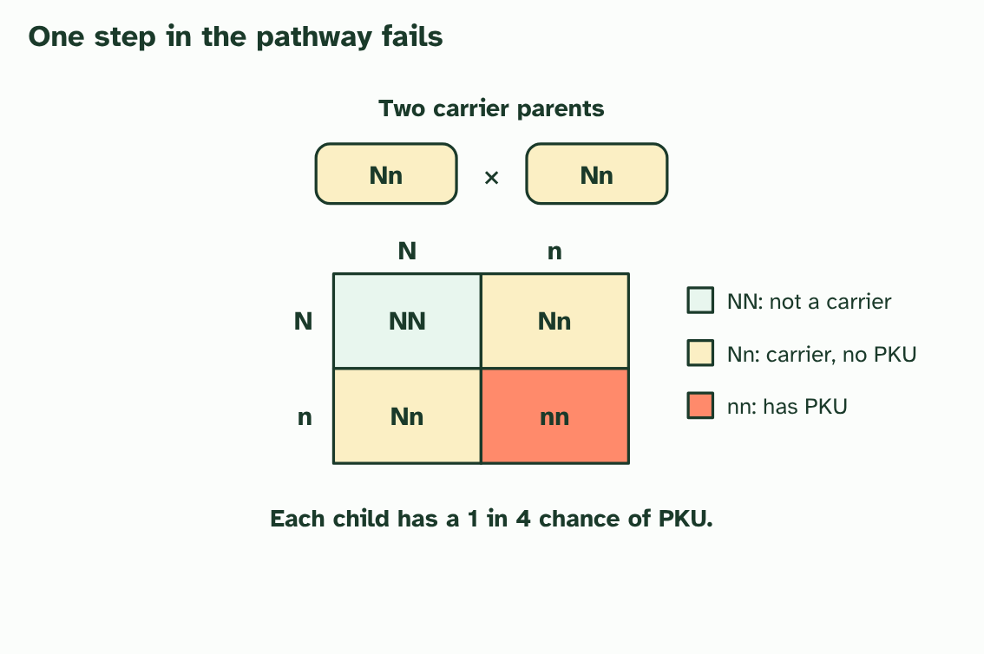  1 In a person with a working allele, the enzyme converts phenylalanine to tyrosine, which has one extra OH group.  2 In a person with two faulty alleles the enzyme does not work. Little tyrosine is made and phenylalanine builds up.  3 A diet low in phenylalanine gives the body less to build up. The genotype is the same, and the phenotype changes.  4 Two carrier parents (Nn): each child has a 1 in 4 chance of nn, so of PKU.
  SPOT THE MISTAKE
  What do students often get wrong about phenylketonuria: a recessive disease? Write the mistake, then put it right.
  The chance is 1 in 4 for each child, every time. One child with PKU does not make the next three safe.
SUMMARY
Sum up section 06 in two or three sentences of your own.
• Phenylketonuria (PKU) is a human disease caused by a recessive allele of an autosomal gene.
• Because the allele is recessive, a person with one working and one faulty allele has no symptoms. That person is a carrier.

07 Many alleles, not just two | D3.2.8 D3.2.9
CUES  Predict: A man with blood group AB (IAIB) and a woman with group O (ii) have children. Which groups are possible?  C: A and B only. A and B only. The man's gametes carry IA or IB. The woman's all carry i. So every child is IAi (group A) or IBi (group B). Neither AB nor O can occur, even though the parents are AB and O.  What is meant by single-nucleotide polymorphism?  Single-nucleotide polymorphism: a position in the genome where individuals differ by one base, and where each version is common in the population.  What is meant by gene pool?  All the alleles of all the genes in a population.  What is meant by ABO blood group?  The system of human blood groups A, B, AB and O, controlled by one gene with three alleles. | NOTES  1 A place in the genome where people differ by a single base, and where each version is common enough to count (often taken as more than 1 in 100), is a single-nucleotide polymorphism, or SNP ("snip").  2 All the alleles of all the genes in a population make up its gene pool.  3 The ABO blood group is the textbook example.  4 DNA from four people at one place. They differ at a single base: a SNP.  5 Across a whole population a gene can have many alleles. The gene pool holds them all.  6 Each person inherits just two of them.  Your own notes  ANNOTATE THE FIGURE  Number the 4 steps on the figure and note what happens at each.  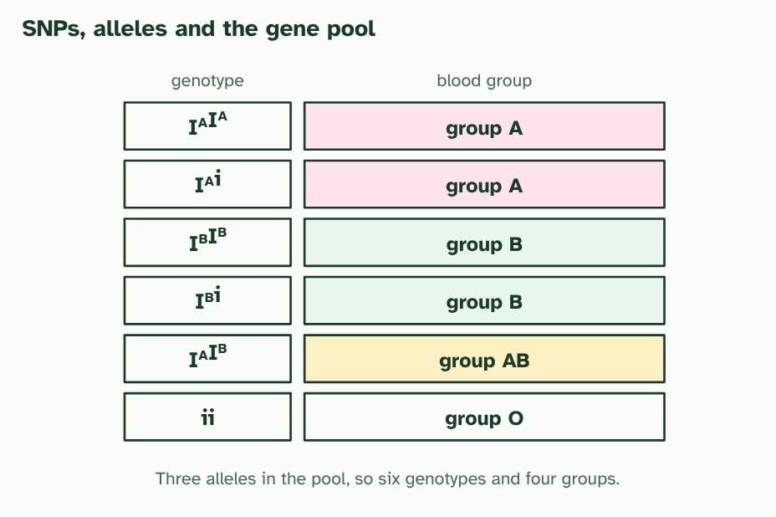  1 DNA from four people at one place. They differ at a single base: a SNP.  2 Across a whole population a gene can have many alleles. The gene pool holds them all.  3 Each person inherits just two of them.  4 ABO: three alleles in the pool give six genotypes and four blood groups.  REMEMBER IT  The four blood groups
  A  Apple | B  Banana | B  Both | O  Orange
  Group A  IAIA or IAi | Group B  IBIB or IBi | Group AB  IAIB, with both markers | Group O  ii, with neither marker
  SPOT THE MISTAKE
  What do students often get wrong about SNPs, multiple alleles and ABO blood groups? Write the mistake, then put it right.
  A person never has three ABO alleles. The gene pool has three; each person has two. And group O is not "no gene": the i allele is a real allele, and a person with ii has two copies of it.
SUMMARY
Sum up section 07 in two or three sentences of your own.
• A place in the genome where people differ by a single base, and where each version is common enough to count (often taken as more than 1 in 100), is a single-nucleotide polymorphism, or SNP ("snip").
• All the alleles of all the genes in a population make up its gene pool.
• The ABO blood group is the textbook example.

08 Neither wins, or both do | D3.2.10
CUES  Predict: A red four o’clock plant is crossed with a white one. What colour are the F1 flowers?  C: All pink. All pink. Every F1 plant is CRCW, a heterozygote, and in incomplete dominance the heterozygote is intermediate. Crossing two of these pink plants then gives 1 red : 2 pink : 1 white.  What is meant by incomplete dominance?  A pattern of inheritance in which the heterozygote has a phenotype in between those of the two homozygotes.  What is meant by codominance?  A pattern of inheritance in which both alleles of a heterozygote are fully expressed, giving a dual phenotype. | NOTES  1 In incomplete dominance the heterozygote has an intermediate phenotype.  2 In codominance both alleles are expressed fully, and the heterozygote has a dual phenotype.  3 Incomplete dominance: the heterozygote is in between.  4 Codominance: the heterozygote shows both at once.  Your own notes  ANNOTATE THE FIGURE  Number the 3 steps on the figure and note what happens at each: 1 Incomplete dominance; 2 1 red : 2 pink : 1 white; 3 Codominance.  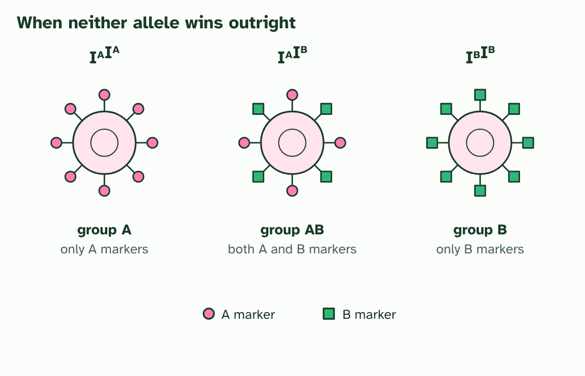  1 Incomplete dominance in four o’clocks: red (CRCR), pink (CRCW) and white (CWCW). The heterozygote is intermediate.  2 Cross two pink plants and the offspring are 1 red : 2 pink : 1 white. The phenotype ratio matches the genotype ratio, and red and white reappear.  3 Codominance in blood: a red blood cell of group AB carries both markers, so the heterozygote has a dual phenotype.
  SPOT THE MISTAKE
  What do students often get wrong about incomplete dominance and codominance? Write the mistake, then put it right.
  Incomplete dominance is not blending. If the red and white alleles mixed like paints, pink plants could never give red or white again. They do, in the F2, because each allele stays whole and separates in the gametes.
SUMMARY
Sum up section 08 in two or three sentences of your own.
• Complete dominance: the heterozygote looks like one homozygote.
• Incomplete dominance: the heterozygote is in between.
• Codominance: the heterozygote shows both at once.

09 X, Y and sex | D3.2.11 D3.2.12
CUES  Predict: A man with haemophilia (XhY) and a woman who is not a carrier (XHXH) have children. What are the children like?  C: All daughters are carriers; all sons are unaffected. All daughters are carriers and all sons are unaffected. Every daughter gets her father’s Xh and her mother’s XH, so she is a carrier. Every son gets the father’s Y and the mother’s XH, so he is unaffected.  What is meant by sex-linked?  A gene on a sex chromosome, so its pattern of inheritance differs between males and females.  What is meant by haemophilia?  An X-linked recessive disorder in which blood clots slowly or not at all, because a protein needed for clotting is missing or does not work. | NOTES  1 A sex-linked gene is one that sits on a sex chromosome, and in practice nearly all of them are on the X.  2 Haemophilia is the standard example.  3 The X is big and carries many genes. The Y is small and carries far fewer. Two Xs develop female, an X and a Y develop male.  4 Every egg carries an X. A sperm carries X or Y, so the sperm decides the sex: half girls, half boys.  5 Haemophilia: a carrier mother (X^{H}X^{h}) and an unaffected father (X^{H}Y). Half the sons have haemophilia and half the daughters are carriers. No daughter is affected.  Your own notes  ANNOTATE THE FIGURE  Number the 3 steps on the figure and note what happens at each: 1 X, Y; 2 sperm decides; 3 Haemophilia.  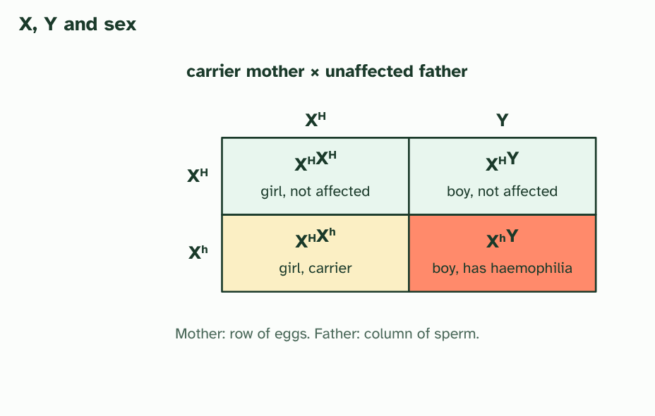  1 The X is big and carries many genes. The Y is small and carries far fewer. Two Xs develop female, an X and a Y develop male.  2 Every egg carries an X. A sperm carries X or Y, so the sperm decides the sex: half girls, half boys.  3 Haemophilia: a carrier mother (XHXh) and an unaffected father (XHY). Half the sons have haemophilia and half the daughters are carriers. No daughter is affected.
  SPOT THE MISTAKE
  What do students often get wrong about sex determination and sex linkage? Write the mistake, then put it right.
  A father cannot pass an X-linked allele to his son. A son gets his Y from his father and his X from his mother. A father does pass his X to every daughter.
SUMMARY
Sum up section 09 in two or three sentences of your own.
• A sex-linked gene is one that sits on a sex chromosome, and in practice nearly all of them are on the X.
• Haemophilia is the standard example.

10 Reading a family tree | D3.2.13
CUES  Predict: In a pedigree, two unaffected parents have an affected daughter. Which statement is correct?  C: It is recessive and autosomal, so both parents carry it. Recessive and autosomal. Unaffected parents with an affected child must both carry a hidden recessive allele. And an affected daughter with an unaffected father rules out an X-linked recessive condition, because she would need an affected father to get the X allele from him.  What is meant by pedigree chart?  A chart of the members of a family over several generations, showing who is affected by a genetic condition.  What is meant by inductive reasoning?  Reasoning from observations of some cases to a general conclusion or theory. The conclusion is probable, not certain.  What is meant by deductive reasoning?  Reasoning from a general rule to a conclusion about a particular case. If the rule and the facts are true, the conclusion is certain. | NOTES  1 A pedigree chart follows a trait through a family.  2 Looking over the family and deciding "this pattern fits a recessive trait" is inductive reasoning: you generalise from the cases you can see.  3 Once you have the pattern, you use deductive reasoning to find the genotype of a particular person: if the trait is recessive, an affected woman must be nn, and her unaffected parents must both be Nn.  4 The key: squares are males, circles are females, filled symbols are affected. A line across joins a couple, and lines down lead to their children.  5 Two unaffected parents (generation I) have an affected daughter (generation II). The condition was hidden in both parents.  6 Deducing the genotypes: a recessive condition needs nn in the daughter and one n from each parent, so both parents are Nn.  Your own notes  ANNOTATE THE FIGURE  Number the 3 steps on the figure and note what happens at each: 1 squares, circles; 2 hidden; 3 Deducing, nn, n, Nn.  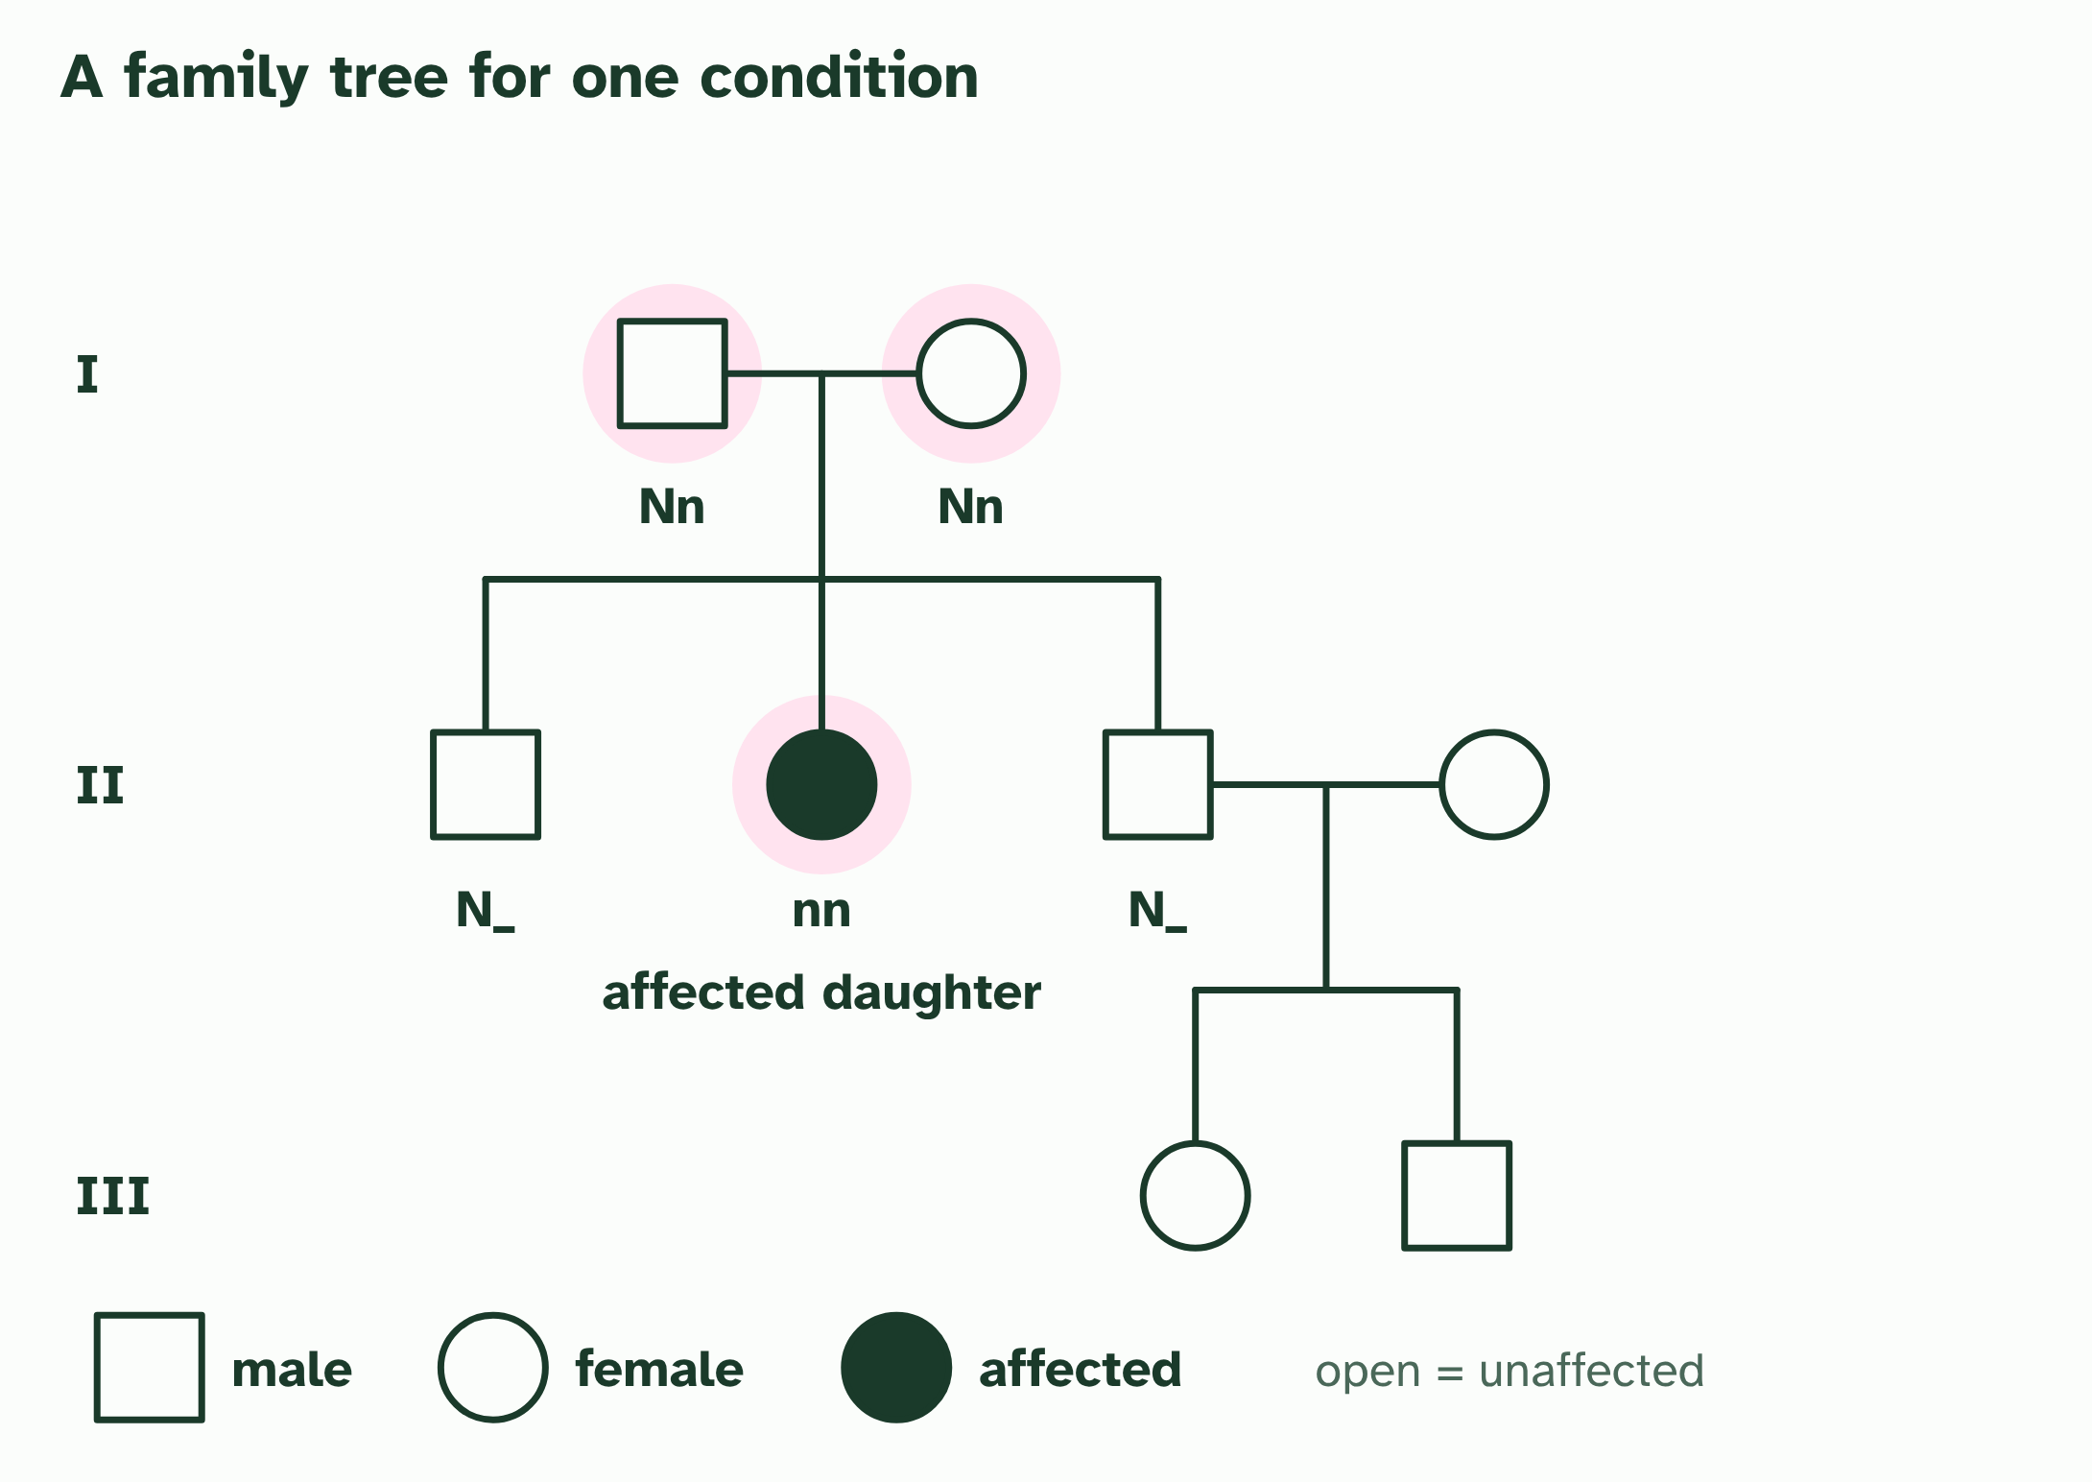  1 The key: squares are males, circles are females, filled symbols are affected. A line across joins a couple, and lines down lead to their children.  2 Two unaffected parents (generation I) have an affected daughter (generation II). The condition was hidden in both parents.  3 Deducing the genotypes: a recessive condition needs nn in the daughter and one n from each parent, so both parents are Nn.  ANNOTATE THE FIGURE  Number the 2 steps on the figure and note what happens at each: 1 affected; 2 ruled out.  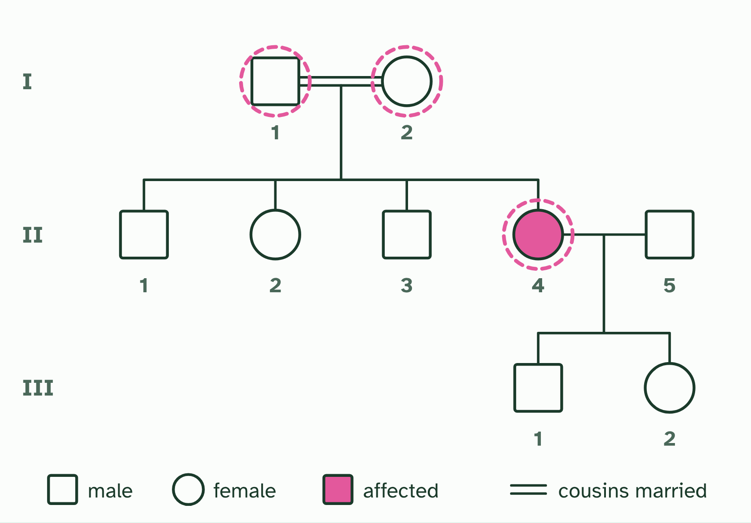  1 A condition no one in the family had heard of appears in a daughter. Her parents are first cousins. Squares are men, circles women; a filled symbol is affected. Roman numerals number the generations.  2 Look first at I-1, I-2 and II-4, ringed: they rule out at least one way of inheriting. Which patterns could give this tree, and which are ruled out?  REMEMBER IT  Four clues for reading a pedigree
  Q  Quiet | L  Loud | D  Dad | B  Boys
  Unaffected parents, affected child  recessive: both parents carry the allele | Affected parents, unaffected child  dominant: both parents carry a recessive allele | Affected daughter, unaffected father  not X-linked recessive | Mostly sons, skipping generations  suggests X-linked recessive
  SPOT THE MISTAKE
  What do students often get wrong about pedigree charts? Write the mistake, then put it right.
  A pattern that fits is not proof. A small family may fit more than one inheritance pattern, so say "consistent with" unless the chart rules the others out.
SUMMARY
Sum up section 10 in two or three sentences of your own.
• A pedigree chart follows a trait through a family.
• Looking over the family and deciding "this pattern fits a recessive trait" is inductive reasoning: you generalise from the cases you can see.
• Once you have the pattern, you use deductive reasoning to find the genotype of a particular person: if the trait is recessive, an affected woman must be nn, and her unaffected parents must both be Nn.

11 A spread, not a few types | D3.2.14
CUES  Predict: Which of these shows discrete variation?  B: The blood groups of students in a class. The blood groups. Every student is A, B, AB or O, with nothing in between, so the variation falls into separate categories. Height and seed mass can take any value in a range, which is continuous variation.  What is meant by discrete variation?  Variation in which individuals fall into separate categories with nothing in between, such as blood group.  What is meant by continuous variation?  Variation in which individuals can have any value across a range, with no separate categories, such as height or skin colour.  What is meant by polygenic?  Controlled by several genes, each adding a small effect. | NOTES  1 ABO blood group is A, B, AB or O, and nobody is halfway. That is discrete variation, and it usually comes from one gene with a few alleles.  2 Other traits, such as height, skin colour or the mass of a seed, form a smooth range with every value in between. That is continuous variation.  3 A trait can be polygenic: controlled by several genes whose small effects add up.  4 And the environment blurs the steps further, because it nudges every genotype a little up or down.  5 The mean is the sum divided by the number of values.  6 The median is the middle value when they are in order.  7 The mode is the most frequent value.  Your own notes  ANNOTATE THE FIGURE  Number the 3 steps on the figure and note what happens at each: 1 Discrete; 2 polygenic; 3 environment, continuous.  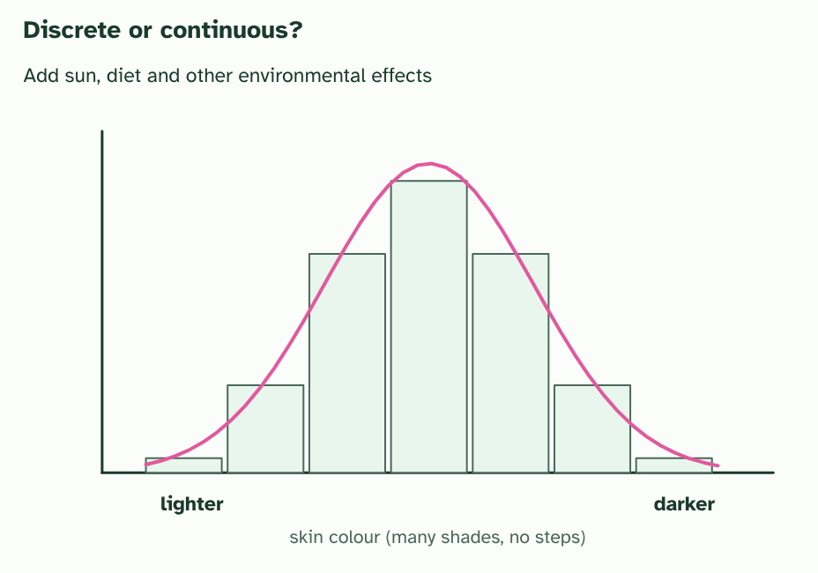  1 Discrete variation: the bars are separate, because nobody is halfway between two blood groups.  2 A simple model of a polygenic trait: six alleles, each lighter or darker. Combinations with three darker alleles are commonest, and the extremes are rare.  3 Add the environment and the steps blur into a smooth, continuous spread.
  SPOT THE MISTAKE
  What do students often get wrong about continuous variation? Write the mistake, then put it right.
  Continuous does not mean "not genetic". Height is strongly affected by genes. And polygenic does not mean "no dominance": each of the genes can still have dominant and recessive alleles.
SUMMARY
Sum up section 11 in two or three sentences of your own.
• ABO blood group is A, B, AB or O, and nobody is halfway. That is discrete variation, and it usually comes from one gene with a few alleles.
• Other traits, such as height, skin colour or the mass of a seed, form a smooth range with every value in between. That is continuous variation.
• A trait can be polygenic: controlled by several genes whose small effects add up.

12 Showing a spread with a box plot | D3.2.15
CUES  Predict: In a box plot, what fraction of the data lie inside the box?  B: One half. One half. The box runs from the first quartile to the third quartile, and a quarter of the data are below the first quartile and a quarter above the third, so the middle half is in the box.  What is meant by box-and-whisker plot?  A graph that shows the minimum, first quartile, median, third quartile and maximum of a data set as a box with two whiskers, and any outliers as separate points.  What is meant by quartiles?  The values that split ordered data into four equal groups. A quarter of the data lie below the first quartile (Q1) and a quarter above the third (Q3).  What is meant by interquartile range?  Interquartile range: Q3 minus Q1, the spread of the middle half of the data.  What is meant by outlier?  A data point more than 1.5 times the IQR above the third quartile or below the first quartile. | NOTES  1 A box-and-whisker plot does it with six aspects of the data: the minimum, the first quartile, the median, the third quartile, the maximum and any outliers.  2 The quartiles split each half again: a quarter of the values are below Q1 and a quarter are above Q3.  3 The length of the box, Q3 − Q1, is the interquartile range (IQR).  4 A value is an outlier if it is more than 1.5 × IQR above Q3 or below Q1.  Your own notes  ANNOTATE THE FIGURE  Number the 4 steps on the figure and note what happens at each.  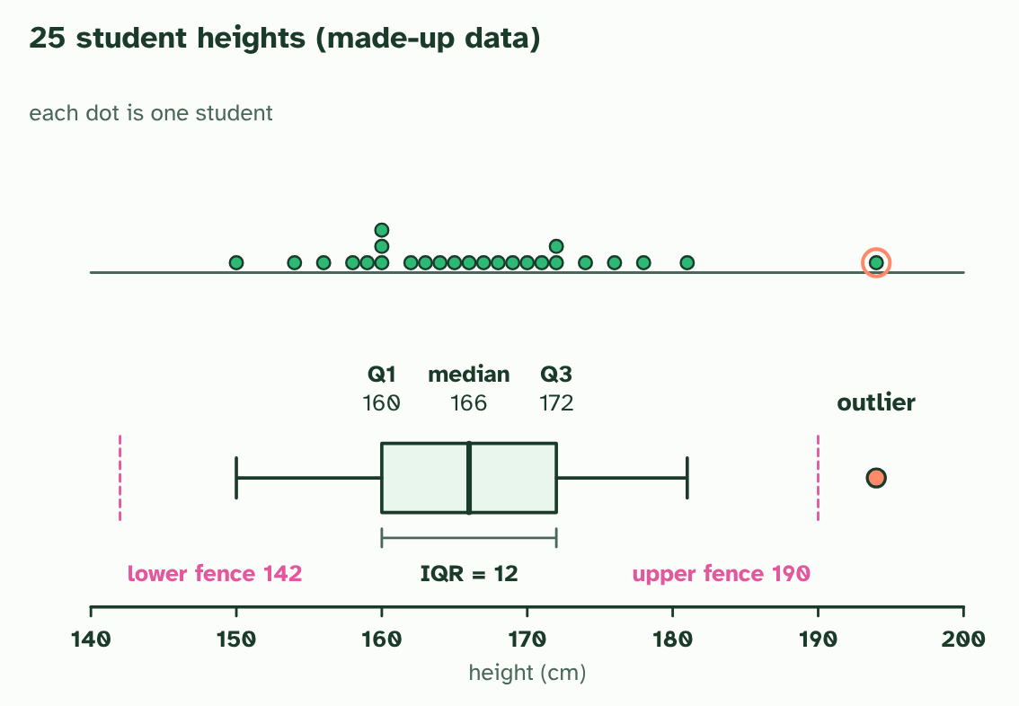  1 25 student heights, one dot each (made up). Where is the middle, and how spread out are they?  2 The box runs from Q1 to Q3 with the median marked. The whiskers run to the smallest and largest values that are not outliers.  3 IQR = 172 − 160 = 12. The fences lie 1.5 × IQR beyond the box, at 142 and 190.  4 A value beyond a fence is an outlier: 194 is above 190, so it is plotted on its own.  ANNOTATE THE FIGURE  Number the 2 steps on the figure and note what happens at each: 1 continuously; 2 box, median, outlier.  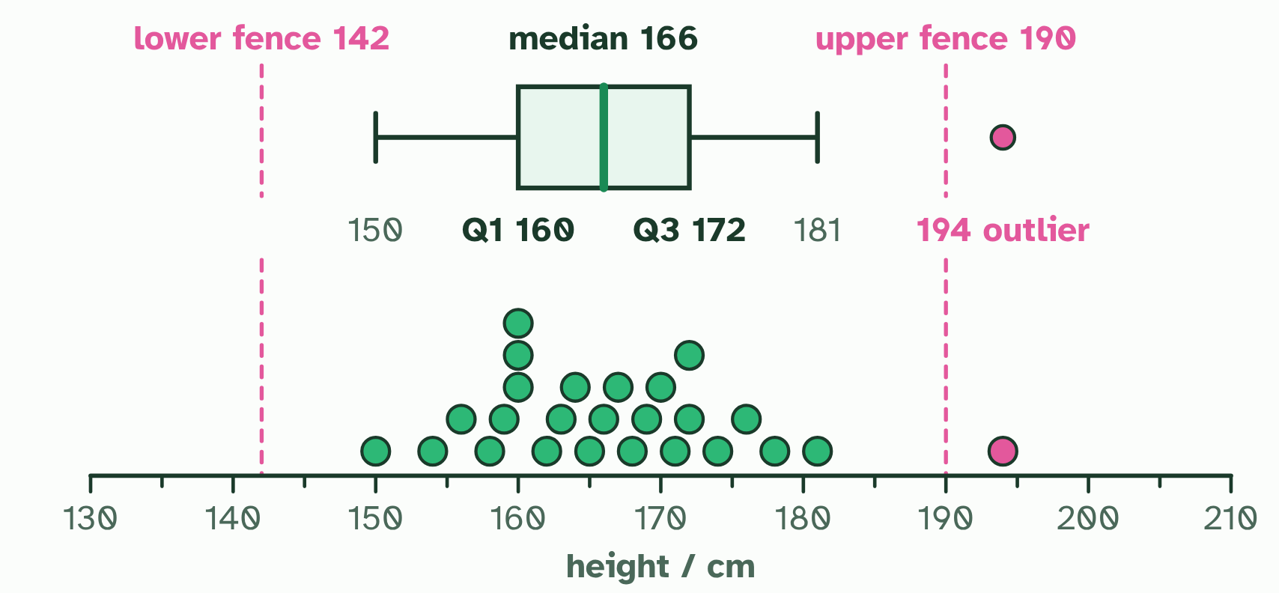  1 Heights of 25 students in one class (made-up data). Height varies continuously: each dot is one student, and the values spread out with most near the middle.  2 The box runs from Q1 (160) to Q3 (172) with the median (166) inside; the whiskers reach the furthest values within 1.5 x IQR of the box (the dashed fences, 142 and 190). Beyond them, 194 is an outlier.
SUMMARY
Sum up section 12 in two or three sentences of your own.
• A box-and-whisker plot does it with six aspects of the data: the minimum, the first quartile, the median, the third quartile, the maximum and any outliers.
• The quartiles split each half again: a quarter of the values are below Q1 and a quarter are above Q3.
• The length of the box, Q3 − Q1, is the interquartile range (IQR).
• A value is an outlier if it is more than 1.5 × IQR above Q3 or below Q1.

13 Two genes at once | D3.2.16 HL D3.2.17 HL
CUES  Predict: A plant YyRr is crossed with a plant yyrr. What proportion of the offspring are yellow and round?  B: One quarter. One quarter. The yyrr parent makes only yr gametes, so the offspring show the four gametes of the YyRr parent, in equal numbers: YyRr (yellow round), Yyrr (yellow wrinkled), yyRr (green round) and yyrr (green wrinkled). One of the four is yellow and round.  What is meant by dihybrid cross?  A cross that follows two genes at once.  What is meant by segregation?  The separation of the two alleles of a gene into different gametes, because homologous chromosomes go to opposite poles in meiosis I.  What is meant by independent assortment?  The random and independent behaviour of different pairs of chromosomes in meiosis I, so alleles of genes on different chromosomes are inherited independently. | NOTES  1 A dihybrid cross follows two genes.  2 In meiosis I the two chromosomes of a homologous pair go to opposite poles, so the two alleles of a gene end up in different gametes: each gamete gets one. That is segregation.  3 Both are equally likely, so it makes four kinds of gamete, YR, Yr, yR and yr, in equal numbers. This is independent assortment.  4 Count the phenotypes: 9 yellow round, 3 yellow wrinkled, 3 green round and 1 green wrinkled. That is 9 : 3 : 3 : 1.  5 Cross a double heterozygote YyRr with a double recessive yyrr and the recessive parent adds only yr, so the offspring show the heterozygote's four gametes: 1 : 1 : 1 : 1.  Your own notes  ANNOTATE THE FIGURE  Number the 5 steps on the figure and note what happens at each.  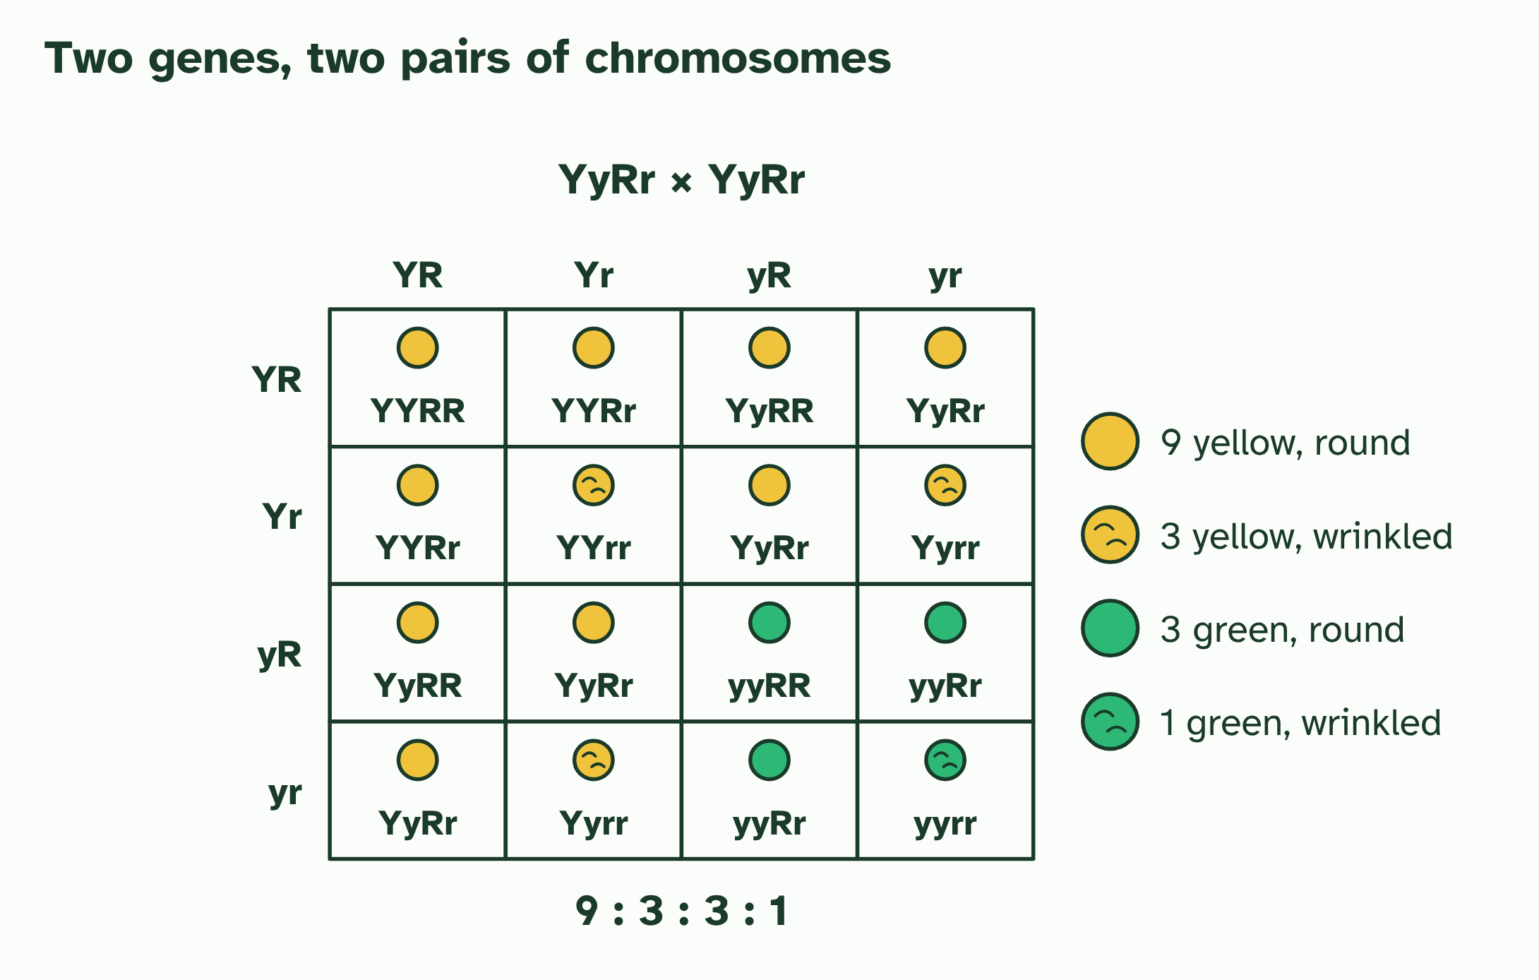  1 In meiosis I each pair of homologous chromosomes lines up at the equator, and the partners go to opposite poles.  2 The pairs line up either way round, independently. Two equally likely ways give four kinds of gamete: YR, yr, Yr and yR.  3 A YyRr × YyRr cross: put each parent’s four kinds of gamete along the sides of a 4 × 4 grid.  4 Fill in the 16 genotypes, each equally likely.  5 Read off the phenotypes: 9 : 3 : 3 : 1.  ANNOTATE THE FIGURE  Annotate this still from the animation (Watch it happen: two genes line up independently): what is happening, and why?  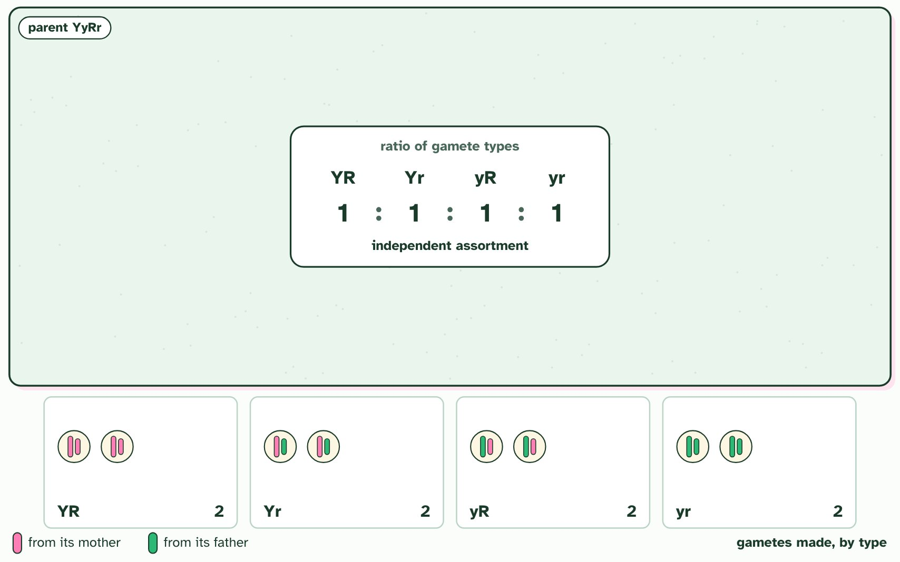  1 One cell of an YyRr parent, its DNA already copied. Gene Y is on one pair of chromosomes and gene R on another: capitals from its mother (pink), lower case from its father (green).  2 Each chromosome pairs with its homologue, so the two alleles of each gene lie side by side.  3 The pairs line up. In this cell both pink chromosomes face the same end, so Y will go with R, and y with r.  4 Segregation: in meiosis I the alleles of each gene separate, Y from y and R from r.  5 Meiosis II separates the sister chromatids, which carry the same alleles.  6 This cell makes two kinds of gamete: YR and yr.  7 In another cell the pairs line up the other way round: now Y goes with r, and y with R.  8 That cell makes Yr and yR gametes.  9 Both line-ups are equally likely, so the four types are made in equal numbers, 1 : 1 : 1 : 1. This is independent assortment.  ANNOTATE THE FIGURE  Number the 2 steps on the figure and note what happens at each.  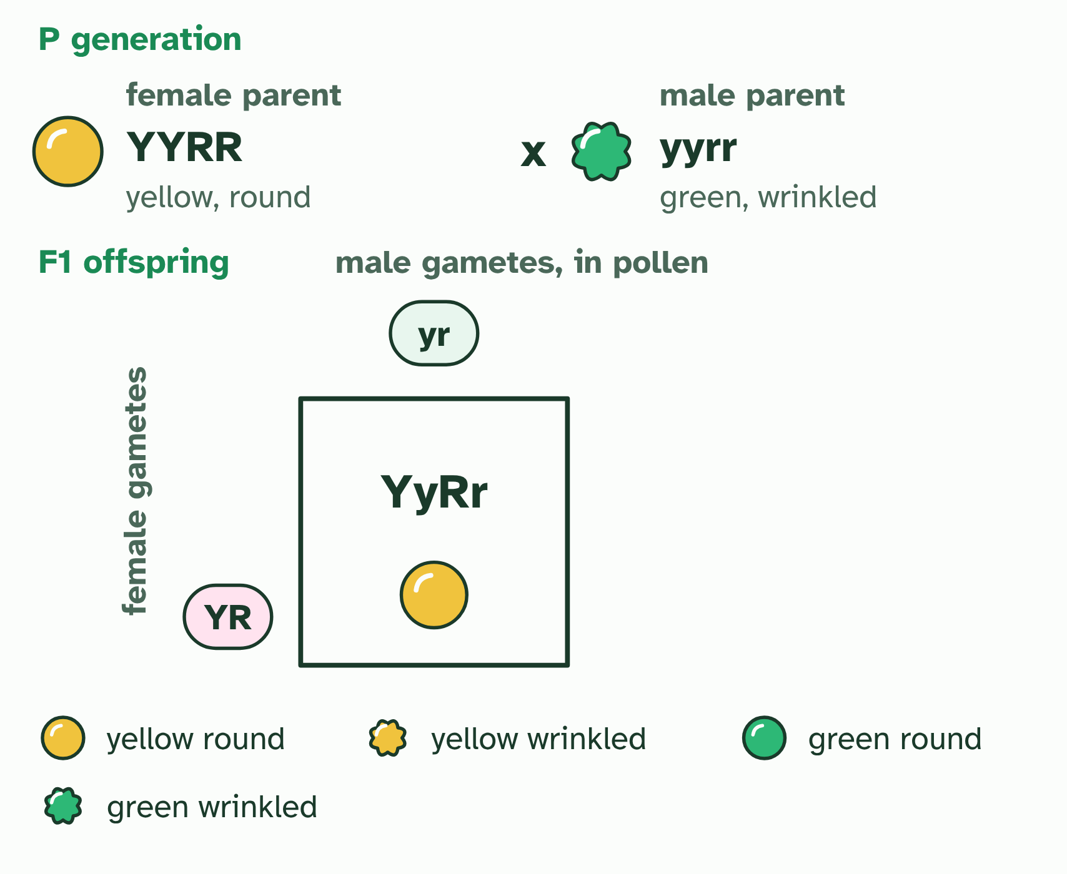  1 Each parent makes gametes by meiosis, one allele of each gene in each. The female parent's go down the side of the Punnett grid, the male parent's along the top.  2 Each cell joins one gamete from each parent: a possible offspring, every cell as likely as the next. The F1: genotypes all YyRr; phenotypes all yellow round.
SUMMARY
Sum up section 13 in two or three sentences of your own.
• A dihybrid cross follows two genes.
• In meiosis I the two chromosomes of a homologous pair go to opposite poles, so the two alleles of a gene end up in different gametes: each gamete gets one. That is segregation.
• Both are equally likely, so it makes four kinds of gamete, YR, Yr, yR and yr, in equal numbers. This is independent assortment.

14 Genes that travel together | D3.2.18 HL D3.2.19 HL D3.2.20 HL
CUES  Predict: A test cross AaBb × aabb gives 48 AB, 47 ab, 3 Ab and 2 aB. What does this suggest?  C: The genes are linked, and crossovers are rare between them. The genes are linked, and crossovers between them are rare. The two parental types, AB and ab, are far commoner than the recombinants Ab and aB. Unlinked genes would give four roughly equal classes.  What is meant by linked?  Genes with their loci on the same chromosome, whose alleles tend to be inherited together.  What is meant by recombinant?  A gamete, genotype or phenotype with a combination of alleles that the parent chromosomes did not have, made by crossing over or by independent assortment.  What is meant by test cross?  A cross between an individual heterozygous for both genes and one homozygous recessive for both. The offspring's phenotypes show which gametes the heterozygote made. | NOTES  1 Genes on the same chromosome are linked: they travel together in meiosis because they sit on the same piece of DNA.  2 With no crossing over, only two kinds of gamete form, AB and ab: the combinations that were already on the chromosomes, called parental types.  3 A gamete, a genotype or a phenotype with a combination of alleles that differs from the combinations on the parent's chromosomes is a recombinant.  4 The test cross shows this.  5 The recombinant frequency is the recombinants divided by all the offspring.  Your own notes  ANNOTATE THE FIGURE  Number the 4 steps on the figure and note what happens at each: 1 Unlinked; 2 Linked, parental; 3 Crossing over, recombinant; 4 test cross.  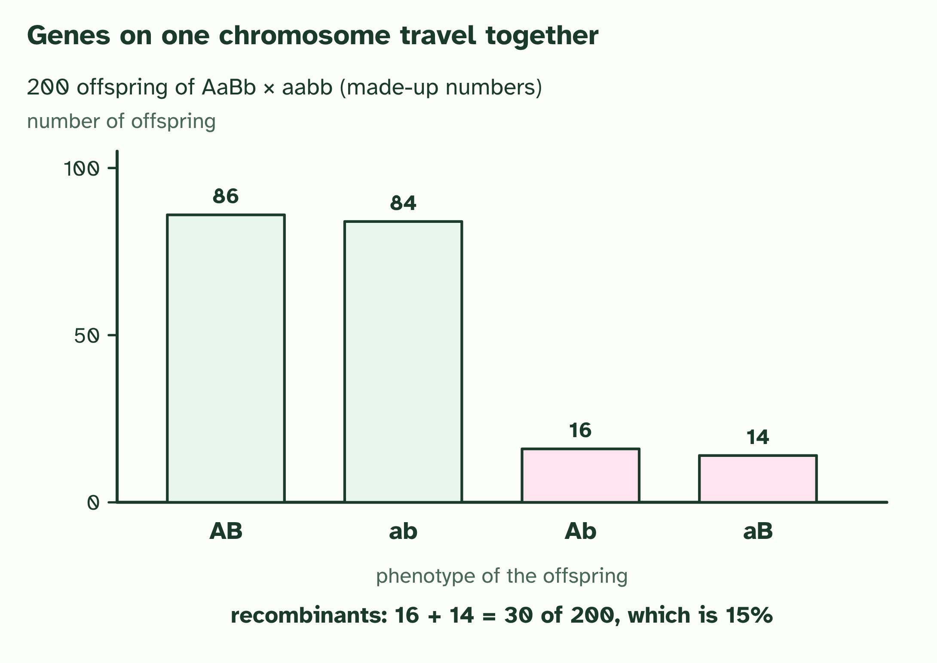  1 Unlinked genes sit on different chromosome pairs, so all four kinds of gamete are equally likely.  2 Linked genes sit on the same chromosome. With no crossing over, only the two parental gametes, AB and ab, are made.  3 Crossing over between the genes swaps the ends of two chromatids and makes the recombinant gametes Ab and aB. The other two chromatids are unchanged, so recombinants are few.  4 A test cross (AaBb × aabb) shows it: mostly parental types and a few recombinants. Recombinant frequency = 30 ÷ 200 = 15%.
  SPOT THE MISTAKE
  What do students often get wrong about gene loci, linkage and recombinants? Write the mistake, then put it right.
  Linked genes are not "always inherited together": crossing over separates them sometimes. And a recombinant is not a mutant. No allele has changed; only the combination of alleles is new.
SUMMARY
Sum up section 14 in two or three sentences of your own.
• Genes on the same chromosome are linked: they travel together in meiosis because they sit on the same piece of DNA.
• A gamete, a genotype or a phenotype with a combination of alleles that differs from the combinations on the parent's chromosomes is a recombinant.
• The test cross shows this.

15 Is it chance? The chi-squared test | D3.2.21 HL
CUES  Predict: A chi-squared value of 2.1 with 3 degrees of freedom is compared with a critical value of 7.81. What do you conclude?  B: Do not reject the null: chance could explain it. Do not reject the null hypothesis. 2.1 is below 7.81, so a difference this size can easily arise by chance when the genes are unlinked. The numbers do differ from the expected ones, but not by more than chance alone would explain.  What is meant by chi-squared test?  A statistical test that compares observed counts with the counts expected if a hypothesis is true, to judge whether the difference could be due to chance alone.  What is meant by null hypothesis?  The hypothesis that there is no real difference between the observed and expected results, so that any difference is due to chance. | NOTES  1 A chi-squared test answers that.  2 The null hypothesis says there is no real difference between observed and expected: the genes are unlinked, and chance explains the scatter.  3 160 F2 plants: the expected counts from 9 : 3 : 3 : 1 (90, 30, 30 and 10) against observed counts (made up).  4 χ² is the sum of (O − E)² ÷ E over the four classes: 2.13.  5 With 3 degrees of freedom and p = 0.05 the critical value is 7.81. 2.13 is below it, so you do not reject the null hypothesis: chance can explain the difference.  6 A test cross of linked genes (made-up counts 112, 21, 18 and 109 from 260 offspring) gives χ² = 127.5, far past 7.81. Reject the null: the genes are probably linked.  Your own notes  ANNOTATE THE FIGURE  Number the 4 steps on the figure and note what happens at each: 1 expected, observed; 2 2.13; 3 critical value; 4 127.5.  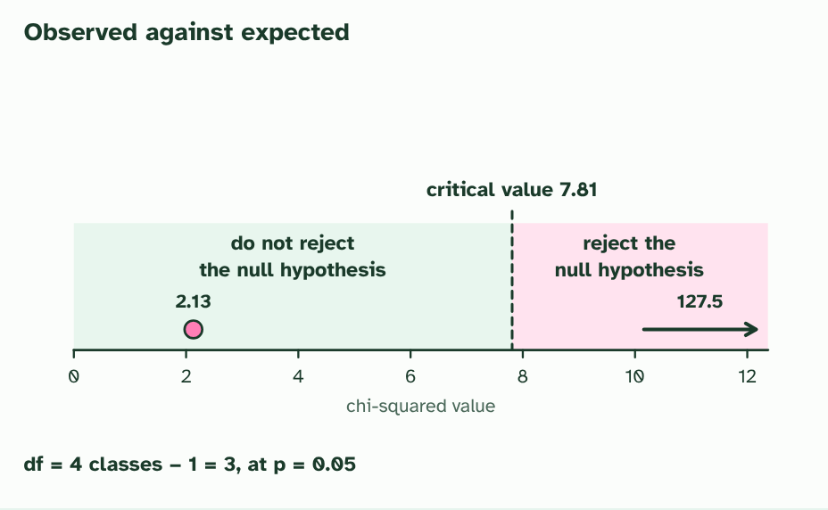  1 160 F2 plants: the expected counts from 9 : 3 : 3 : 1 (90, 30, 30 and 10) against observed counts (made up).  2 χ² is the sum of (O − E)² ÷ E over the four classes: 2.13.  3 With 3 degrees of freedom and p = 0.05 the critical value is 7.81. 2.13 is below it, so you do not reject the null hypothesis: chance can explain the difference.  4 A test cross of linked genes (made-up counts 112, 21, 18 and 109 from 260 offspring) gives χ² = 127.5, far past 7.81. Reject the null: the genes are probably linked.  REMEMBER IT  The five steps of a chi-squared test
  H  Hungry | E  Elves | C  Cook | D  Delicious | C  Cakes
  Hypotheses  state the null and the alternative | Expected  work out the expected counts | Calculate  χ² = sum of (O − E)² ÷ E | Degrees of freedom  number of classes minus 1 | Compare  with the critical value at p = 0.05
  SPOT THE MISTAKE
  What do students often get wrong about the chi-squared test? Write the mistake, then put it right.
  A result that is not significant does not prove the null hypothesis: it means these data are not enough to reject it. And a significant result says the data differ from the expected ratio, not why. Linkage is the explanation to test next. The 5% level is a convention: about 1 test in 20 on unlinked genes would look significant by chance alone.
SUMMARY
Sum up section 15 in two or three sentences of your own.
• A chi-squared test answers that.
• The null hypothesis says there is no real difference between observed and expected: the genes are unlinked, and chance explains the scatter.

Check yourself
The check for this guide is online: a fresh paper of past-paper style questions from the exam bank on D3.2 each time, marked as you go, and saved to your Exam practice progress when you are signed in. Open the link:
biologybybradford.com/exam-maker/sit?topics=D3.2&level=HL&paper=quiz&marks=15&src=ep

