Name | Class | Date
IB BIOLOGY · D3.2

Inheritance
Notes to fill in alongside the guide. Each numbered block matches a chapter of the guide, and of the lesson slides. Write in the gaps, answer the cues, annotate the figures, and sum up each section in your own words.
BY THE END YOU CAN
Explain how meiosis halves the chromosome number to make haploid gametes, and how fusion gives a diploid zygote D3.2.1
Describe how a genetic cross is made in flowering plants, using the terms P generation, F1 generation, F2 generation and Punnett grid D3.2.2
Define genotype, and use homozygous, heterozygous, gene and allele correctly D3.2.3
Explain how phenotype comes from genotype and the environment, with examples of each D3.2.4
Predict the effects of dominant and recessive alleles on phenotype D3.2.5
Explain phenotypic plasticity as a change in gene expression, not in the genes themselves D3.2.6
Explain phenylketonuria as a disease caused by a recessive allele D3.2.7
Describe single-nucleotide polymorphisms and multiple alleles in a gene pool D3.2.8
Use the ABO blood groups to show how multiple alleles are inherited D3.2.9
Distinguish incomplete dominance from codominance D3.2.10
Explain sex determination in humans and the inheritance of genes on the sex chromosomes D3.2.11
Use haemophilia to explain a sex-linked genetic disorder D3.2.12
Use pedigree charts to deduce patterns of inheritance of genetic disorders D3.2.13
Explain continuous variation as the result of polygenic inheritance and the environment D3.2.14
Draw and read box-and-whisker plots for a continuous variable such as student height D3.2.15
Explain segregation and independent assortment of unlinked genes in meiosis D3.2.16
Use Punnett grids to predict genotypic and phenotypic ratios in dihybrid crosses of unlinked autosomal genes D3.2.17
Find the loci of human genes and their polypeptide products in a database D3.2.18
Explain autosomal gene linkage D3.2.19
Identify recombinants in crosses involving two linked or unlinked genes D3.2.20
Use a chi-squared test on data from a dihybrid cross D3.2.21

01 Halve, then fuse | D3.2.1
CUES  Predict: A human body cell has 46 chromosomes. How many chromosomes are in a sperm, and how many in the zygote it helps to form?  What is meant by diploid?  What is meant by autosomes?  What is meant by meiosis?  What is meant by gametes?  What is meant by haploid?  What is meant by zygote? | NOTES  1 A cell like that is _________.  2 Most of them are ____________, so a diploid cell has two copies of each autosomal gene: one on each chromosome of a pair.  3 Special cells divide by _________ to make _________, and each gamete gets one chromosome from every pair.  4 A cell with a single set is _________.  5 Their nuclei fuse to make a ________, which is diploid again, with one set from each parent.  Your own notes  ANNOTATE THE FIGURE  Number the 4 steps on the figure and note what happens at each: 1 diploid; 2 Meiosis, haploid; 3 Fusion; 4 same gene.  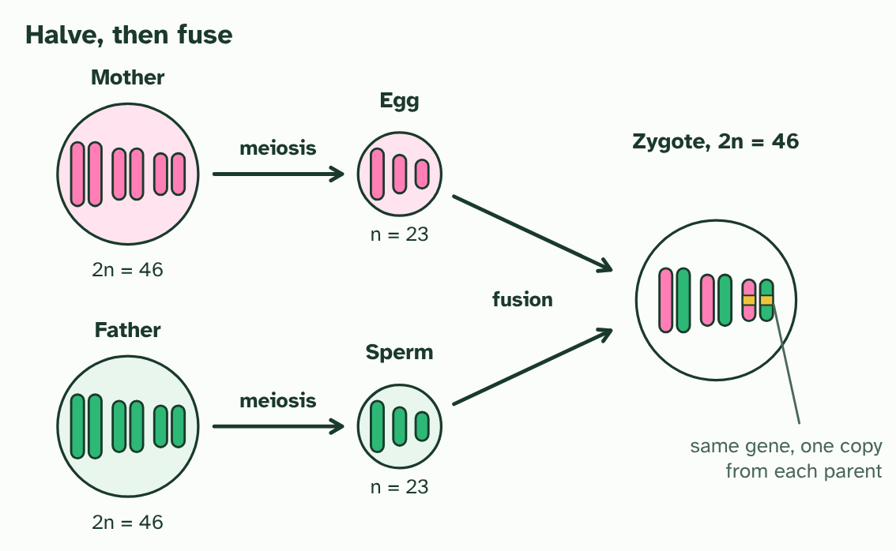  ANNOTATE THE FIGURE  Annotate this still from the animation (Watch it happen: halving, then fusing): what is happening, and why?  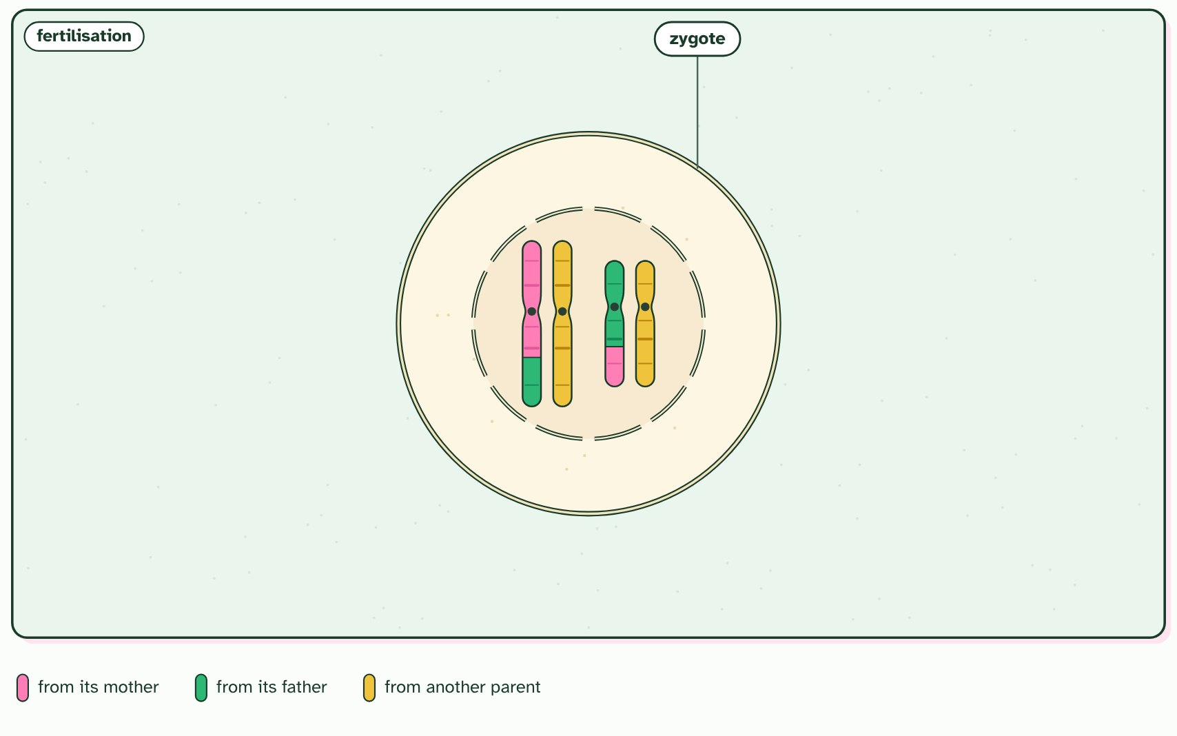
  SPOT THE MISTAKE
  What do students often get wrong about halving and doubling? Write the mistake, then put it right.
  The mistake
  Put it right
SUMMARY
Sum up section 01 in two or three sentences of your own.

02 How to make a cross | D3.2.2
CUES  Predict: A student wants to cross a purple-flowered pea plant with a white-flowered one, but forgets to remove the anthers from the white plant. What is likely to happen?  What is meant by pollen?  What is meant by pollination?  What is meant by self-fertilisation?  What is meant by true-breeding?  What is meant by punnett grid? | NOTES  1 The male gametes are in ________, which forms in the anthers.  2 A pollen grain has to reach the stigma before it can fertilise an ovule, so a cross needs _______________.  3 One flower makes both pollen and ovules, so it can pollinate itself: ________________________.  4 The two parents you choose are the ________________.  5 Parents that are __________________ give the __________________ (F is for filial, meaning of a son or daughter).  6 Let the F1 plants pollinate each other, or themselves, and you get the __________________.  7 A ________________ predicts what the F2 should look like.  Your own notes  ANNOTATE THE FIGURE  Number the 5 steps on the figure and note what happens at each: 1 Pollen, ovules; 2 pollinates itself; 3 cross; 4 P generation, F1 generation; 5 F2 generation, Punnett grid.  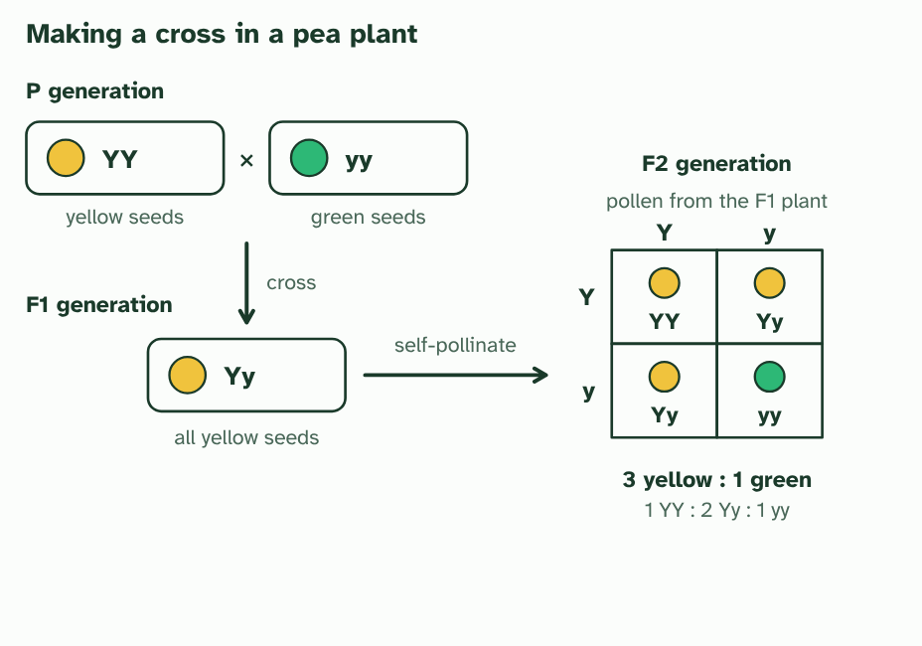  REMEMBER IT  The generations of a cross
  P  Parents | F  First | F  Follows
  P | F | F
  SPOT THE MISTAKE
  What do students often get wrong about genetic crosses in flowering plants? Write the mistake, then put it right.
  The mistake
  Put it right
SUMMARY
Sum up section 02 in two or three sentences of your own.

03 Genes, alleles and the traits you see | D3.2.3 D3.2.4
CUES  Predict: Two plants have the same genotype for every gene, but one grows much taller because it was given more water and fertiliser. What does this show?  What is meant by gene?  What is meant by alleles?  What is meant by genotype?  What is meant by homozygous?  What is meant by heterozygous?  What is meant by phenotype? | NOTES  1 A ________ is a length of DNA at one place on a chromosome.  2 Different versions of the same gene are _________.  3 The pair of alleles is your ___________ for that gene.  4 If the two alleles are the same, you are ______________ (YY or yy).  5 If they differ, you are ________________ (Yy).  6 Your ____________ is what can be observed: the colour of a seed, your blood group, your height, even your behaviour.  Your own notes  ANNOTATE THE FIGURE  Number the 3 steps on the figure and note what happens at each: 1 gene, allele; 2 genotype, homozygous, heterozygous; 3 phenotype.  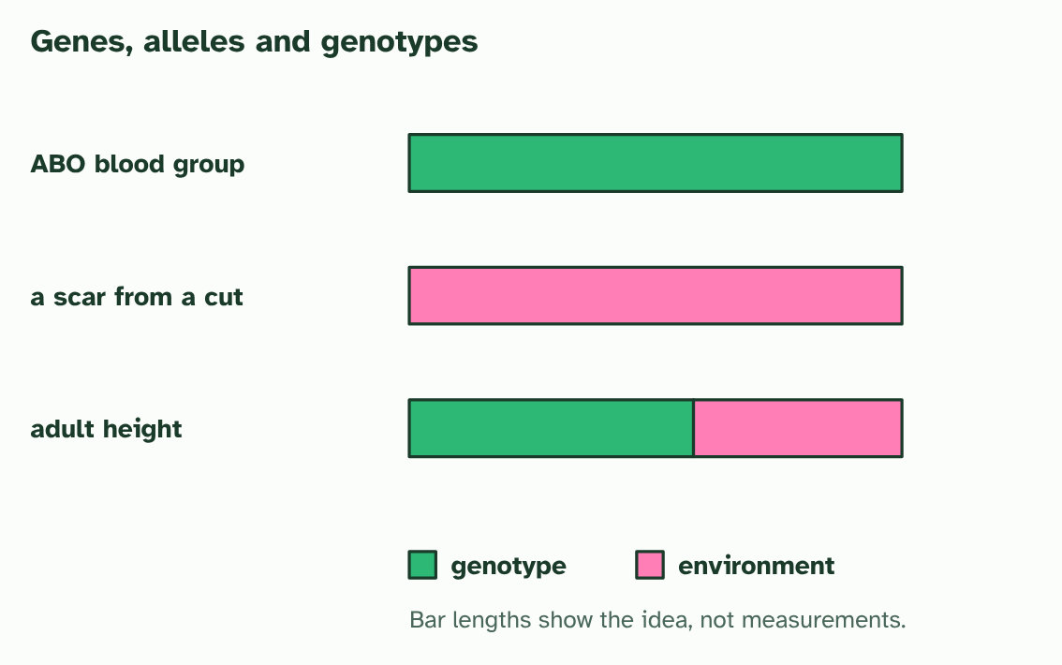
  SPOT THE MISTAKE
  What do students often get wrong about genotype and phenotype? Write the mistake, then put it right.
  The mistake
  Put it right
SUMMARY
Sum up section 03 in two or three sentences of your own.

04 Dominant and recessive alleles | D3.2.5
CUES  Predict: Two yellow-seeded pea plants are crossed, and some of their offspring have green seeds. What must be true of both parents?  What is meant by dominant allele?  What is meant by recessive allele? | NOTES  1 A ____________________ shows its effect when it is present, in one copy or in two.  2 A ______________________ shows only when there is no dominant allele alongside it.  3 Three genotypes of the seed colour gene: two ______________ and one ________________.  4 Each gene makes a protein. A ________ allele makes a working one, and one working copy makes ________ to give the trait. With no working copy, the trait changes.  5 The phenotypes: ________ and ________ are both yellow, so the dominant allele shows in a heterozygote. Only ________ is green.  6 Each parent makes gametes by meiosis, one allele of each gene in each. The female parent's go down the side of the ________________, the male parent's along the top.  Your own notes  ANNOTATE THE FIGURE  Number the 3 steps on the figure and note what happens at each: 1 homozygous, heterozygous; 2 Y, enough; 3 YY, Yy, yy.  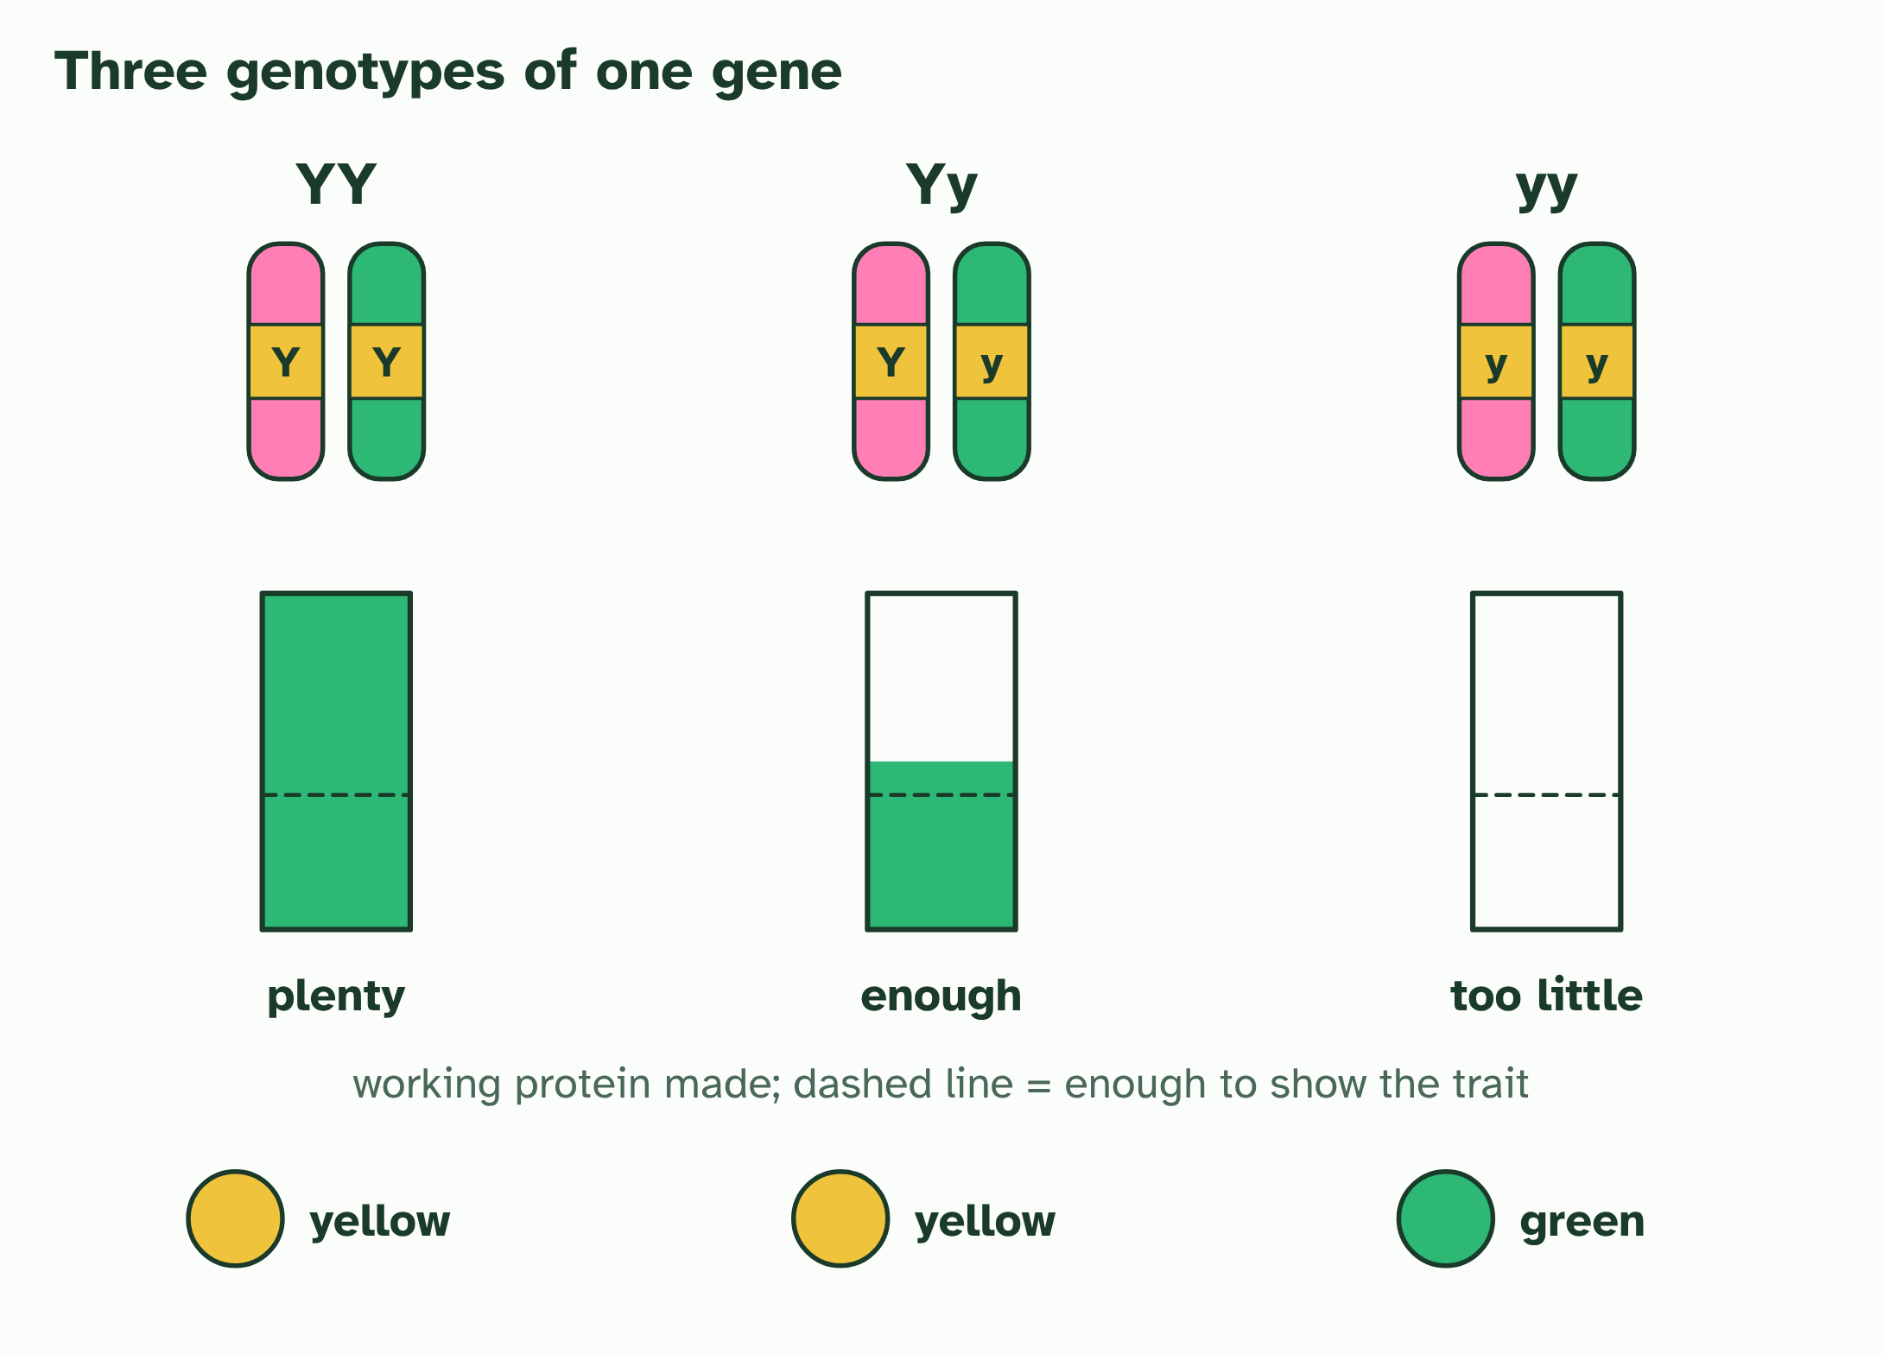  ANNOTATE THE FIGURE  Number the 2 steps on the figure and note what happens at each.  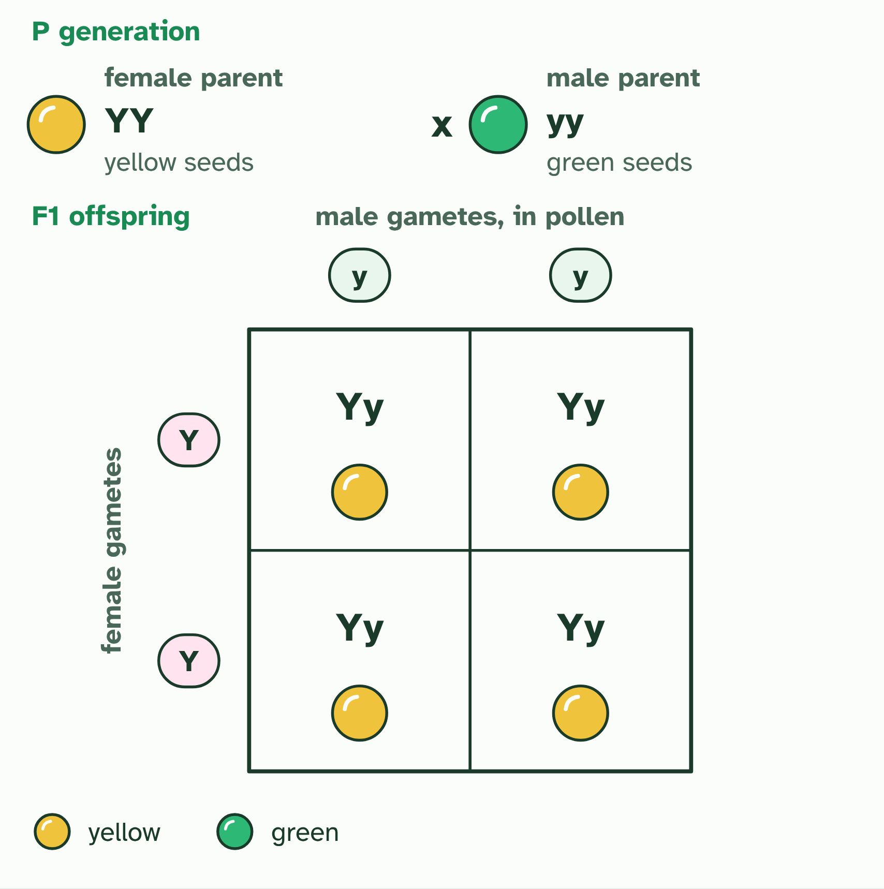
  SPOT THE MISTAKE
  What do students often get wrong about dominant and recessive alleles? Write the mistake, then put it right.
  The mistake
  Put it right
SUMMARY
Sum up section 04 in two or three sentences of your own.

05 Same genes, different outcomes | D3.2.6
CUES  Predict: Two clones grow differently, one in sun and one in shade. What explains the difference?  What is meant by phenotypic plasticity?  What is meant by gene expression? | NOTES  1 One individual, with one set of alleles, can develop different traits in different conditions, and the change often suits the conditions. That is ____________________________.  2 The difference is in ____________________: which genes are switched on, where, and how strongly.  3 Because the alleles are the same, the change can be ______________ during the life of the individual: move the shaded plant into the sun, and its new growth comes in short and sturdy, like the sun plant's.  4 Two ___________ from it carry exactly the same alleles.  5 One cutting grows in ________ and one in ________. Same alleles, but different gene expression makes a short, sturdy plant and a tall one with broad leaves.  6 Move the shaded plant into the sun, and its ______________ comes in like the sun plant’s. The change is reversible, and the alleles never changed.  Your own notes  ANNOTATE THE FIGURE  Number the 4 steps on the figure and note what happens at each.  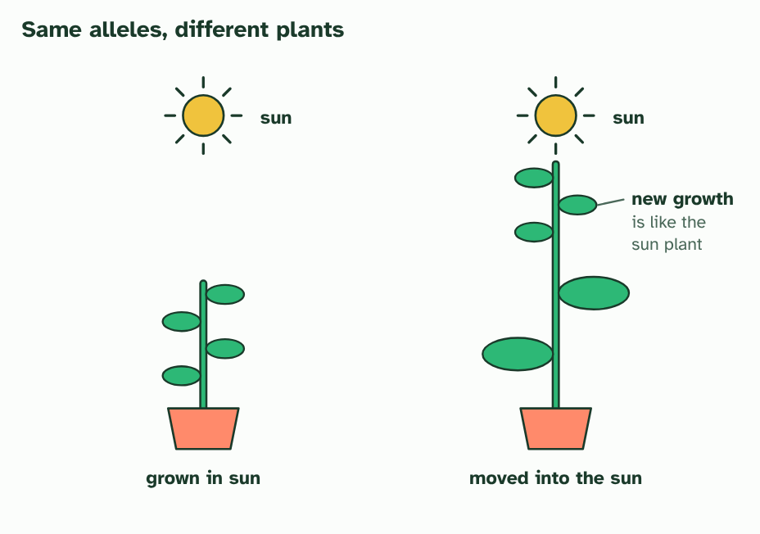
  SPOT THE MISTAKE
  What do students often get wrong about phenotypic plasticity? Write the mistake, then put it right.
  The mistake
  Put it right
SUMMARY
Sum up section 05 in two or three sentences of your own.

06 One faulty enzyme: PKU | D3.2.7
CUES  Predict: Two parents do not have PKU, but their first child does. What is the chance that their second child has PKU?  What is meant by phenylketonuria?  What is meant by carrier? | NOTES  1 ____________________ (PKU) is a human disease caused by a recessive allele of an autosomal gene.  2 Because the allele is recessive, a person with one working and one faulty allele has no symptoms. That person is a _________.  3 In a person with a working allele, the ________ converts phenylalanine to tyrosine, which has one extra OH group.  4 In a person with two faulty alleles the enzyme does not work. Little tyrosine is made and _______________________________.  5 A __________________________________ gives the body less to build up. The genotype is the same, and the phenotype changes.  6 Two _________ parents (Nn): each child has a 1 in 4 chance of nn, so of PKU.  Your own notes  ANNOTATE THE FIGURE  Number the 4 steps on the figure and note what happens at each: 1 enzyme; 2 phenylalanine builds up; 3 diet low in phenylalanine; 4 carrier.  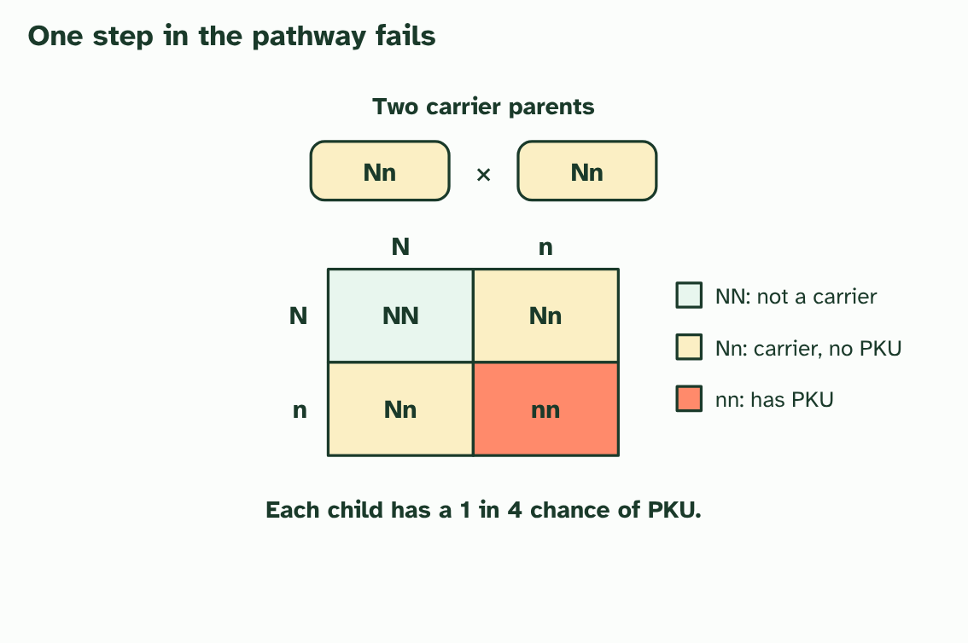
  SPOT THE MISTAKE
  What do students often get wrong about phenylketonuria: a recessive disease? Write the mistake, then put it right.
  The mistake
  Put it right
SUMMARY
Sum up section 06 in two or three sentences of your own.

07 Many alleles, not just two | D3.2.8 D3.2.9
CUES  Predict: A man with blood group AB (IAIB) and a woman with group O (ii) have children. Which groups are possible?  What is meant by single-nucleotide polymorphism?  What is meant by gene pool?  What is meant by ABO blood group? | NOTES  1 A place in the genome where people differ by a single base, and where each version is common enough to count (often taken as more than 1 in 100), is a __________________________________, or SNP ("snip").  2 All the alleles of all the genes in a population make up its ____________.  3 The ____________________ is the textbook example.  4 DNA from four people at one place. They differ at a single base: a ________.  5 Across a whole population a gene can have many _________. The ____________ holds them all.  6 Each person inherits just ________ of them.  Your own notes  ANNOTATE THE FIGURE  Number the 4 steps on the figure and note what happens at each.  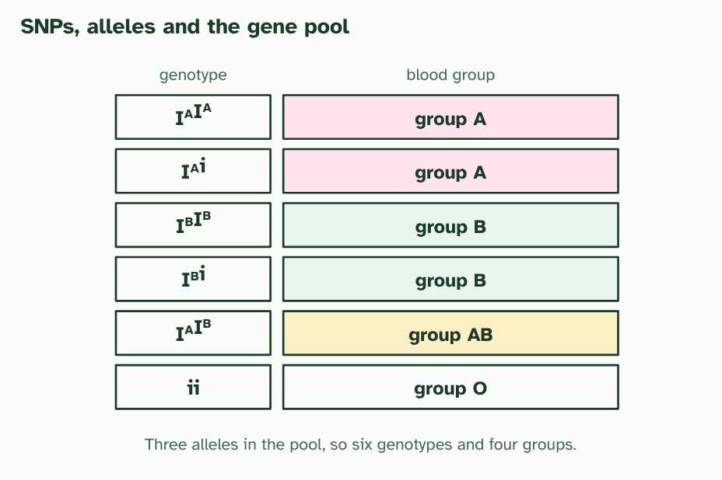  REMEMBER IT  The four blood groups
  A  Apple | B  Banana | B  Both | O  Orange
  A | B | B | O
  SPOT THE MISTAKE
  What do students often get wrong about SNPs, multiple alleles and ABO blood groups? Write the mistake, then put it right.
  The mistake
  Put it right
SUMMARY
Sum up section 07 in two or three sentences of your own.

08 Neither wins, or both do | D3.2.10
CUES  Predict: A red four o’clock plant is crossed with a white one. What colour are the F1 flowers?  What is meant by incomplete dominance?  What is meant by codominance? | NOTES  1 In ___________________________ the heterozygote has an ________________ phenotype.  2 In _______________ both alleles are expressed fully, and the heterozygote has a ________ phenotype.  3 ___________________________: the heterozygote is in between.  4 _______________: the heterozygote shows both at once.  Your own notes  ANNOTATE THE FIGURE  Number the 3 steps on the figure and note what happens at each: 1 Incomplete dominance; 2 1 red : 2 pink : 1 white; 3 Codominance.  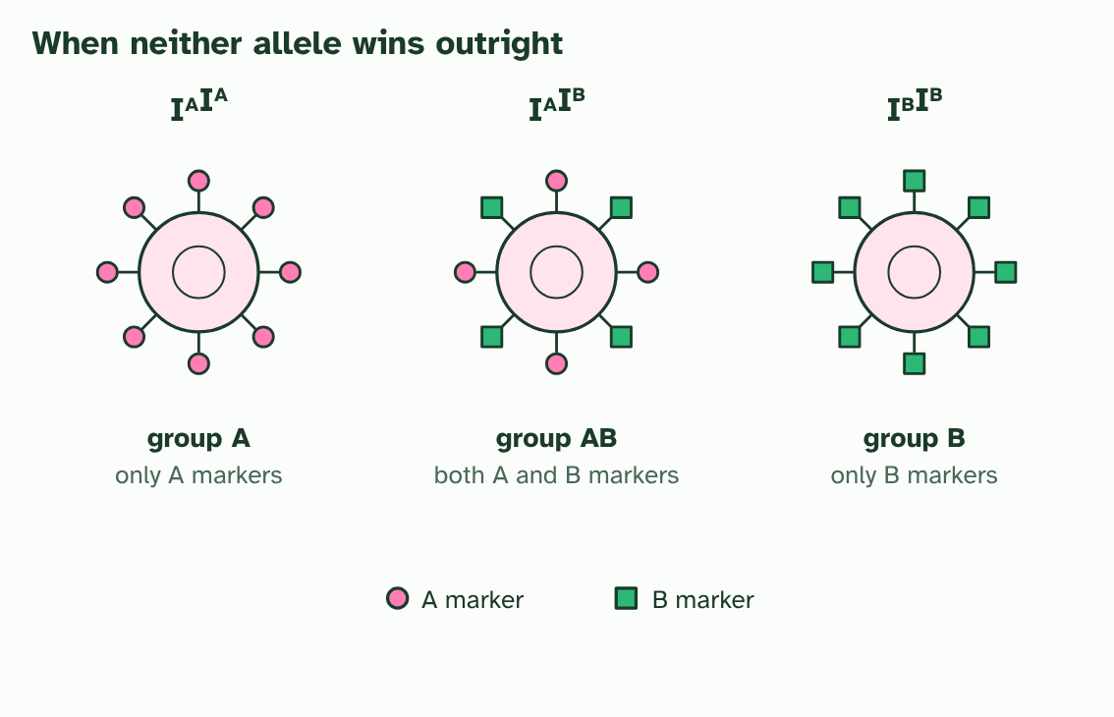
  SPOT THE MISTAKE
  What do students often get wrong about incomplete dominance and codominance? Write the mistake, then put it right.
  The mistake
  Put it right
SUMMARY
Sum up section 08 in two or three sentences of your own.

09 X, Y and sex | D3.2.11 D3.2.12
CUES  Predict: A man with haemophilia (XhY) and a woman who is not a carrier (XHXH) have children. What are the children like?  What is meant by sex-linked?  What is meant by haemophilia? | NOTES  1 A ______________ gene is one that sits on a sex chromosome, and in practice nearly all of them are on the X.  2 _______________ is the standard example.  3 The ________ is big and carries many genes. The ________ is small and carries far fewer. Two Xs develop female, an X and a Y develop male.  4 Every egg carries an X. A sperm carries X or Y, so the __________________ the sex: half girls, half boys.  5 _______________: a carrier mother (X^{H}X^{h}) and an unaffected father (X^{H}Y). Half the sons have haemophilia and half the daughters are carriers. No daughter is affected.  Your own notes  ANNOTATE THE FIGURE  Number the 3 steps on the figure and note what happens at each: 1 X, Y; 2 sperm decides; 3 Haemophilia.  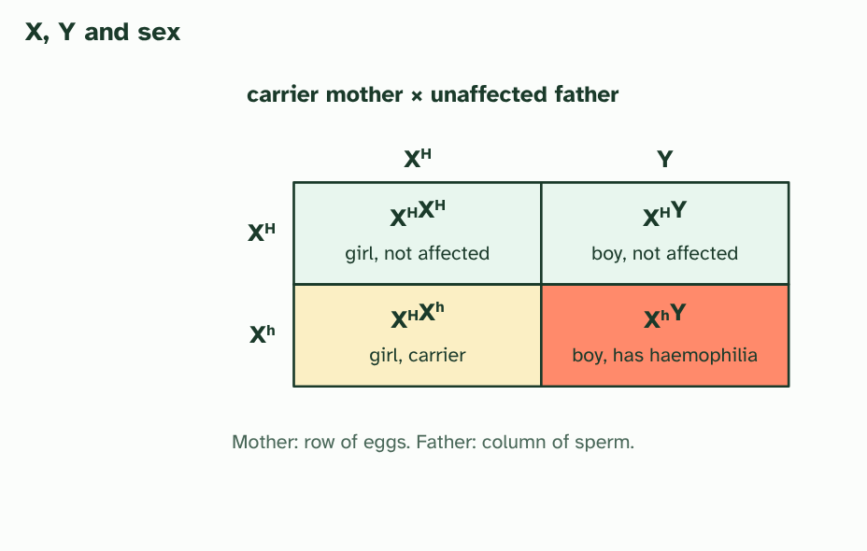
  SPOT THE MISTAKE
  What do students often get wrong about sex determination and sex linkage? Write the mistake, then put it right.
  The mistake
  Put it right
SUMMARY
Sum up section 09 in two or three sentences of your own.

10 Reading a family tree | D3.2.13
CUES  Predict: In a pedigree, two unaffected parents have an affected daughter. Which statement is correct?  What is meant by pedigree chart?  What is meant by inductive reasoning?  What is meant by deductive reasoning? | NOTES  1 A ___________________ follows a trait through a family.  2 Looking over the family and deciding "this pattern fits a recessive trait" is __________________________: you generalise from the cases you can see.  3 Once you have the pattern, you use __________________________ to find the genotype of a particular person: if the trait is recessive, an affected woman must be nn, and her unaffected parents must both be Nn.  4 The key: _________ are males, _________ are females, filled symbols are affected. A line across joins a couple, and lines down lead to their children.  5 Two unaffected parents (generation I) have an affected daughter (generation II). The condition was ________ in both parents.  6 ___________ the genotypes: a recessive condition needs ________ in the daughter and one ________ from each parent, so both parents are ________.  Your own notes  ANNOTATE THE FIGURE  Number the 3 steps on the figure and note what happens at each: 1 squares, circles; 2 hidden; 3 Deducing, nn, n, Nn.  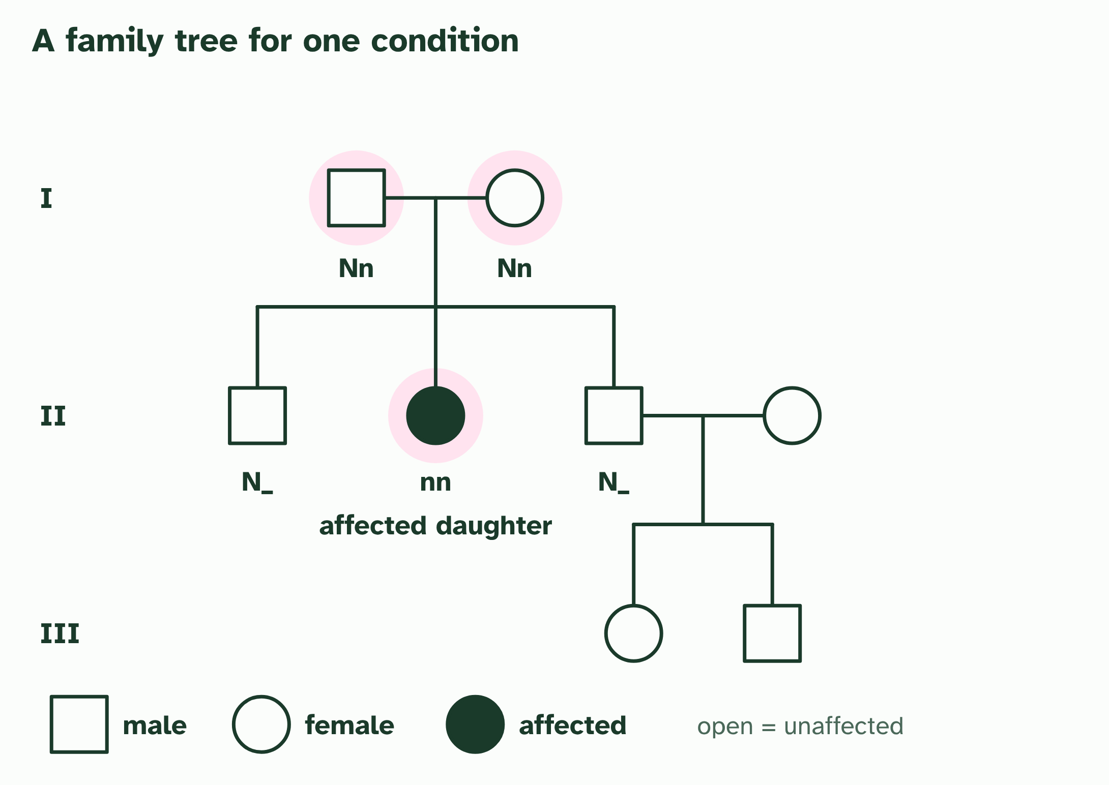  ANNOTATE THE FIGURE  Number the 2 steps on the figure and note what happens at each: 1 affected; 2 ruled out.  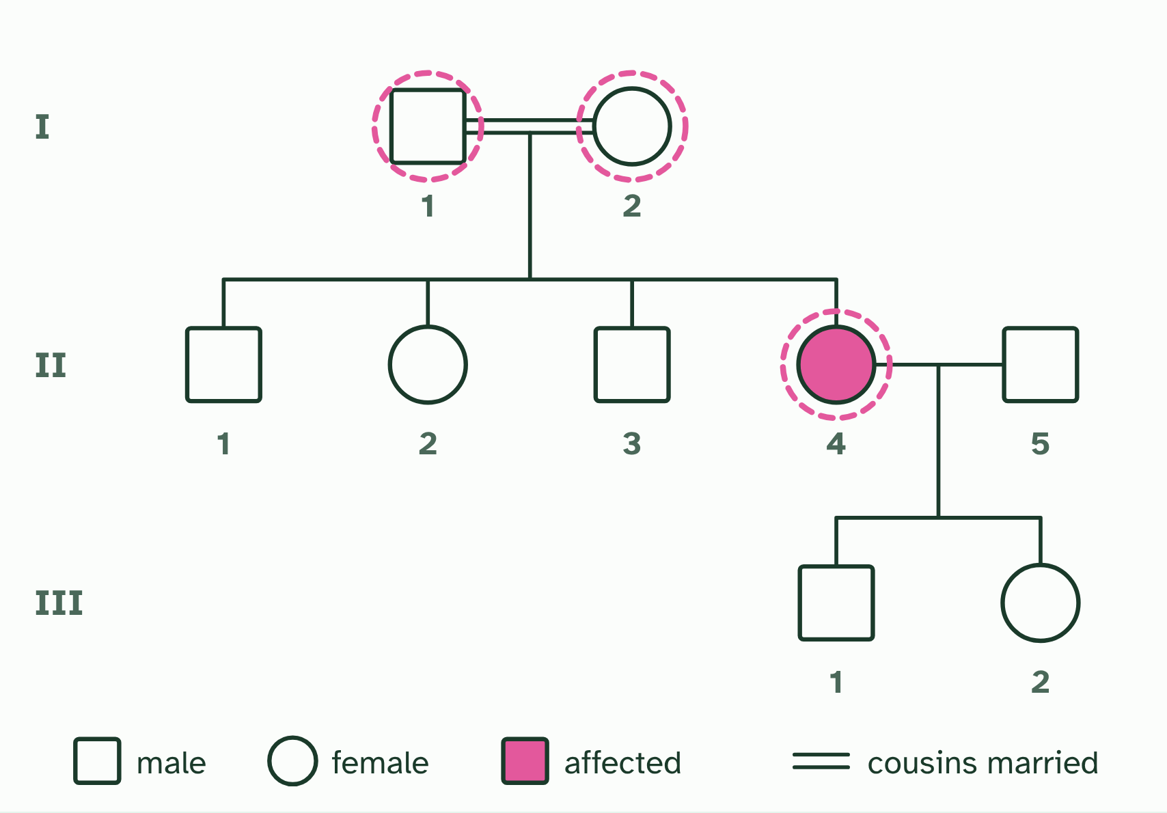  REMEMBER IT  Four clues for reading a pedigree
  Q  Quiet | L  Loud | D  Dad | B  Boys
  Q | L | D | B
  SPOT THE MISTAKE
  What do students often get wrong about pedigree charts? Write the mistake, then put it right.
  The mistake
  Put it right
SUMMARY
Sum up section 10 in two or three sentences of your own.

11 A spread, not a few types | D3.2.14
CUES  Predict: Which of these shows discrete variation?  What is meant by discrete variation?  What is meant by continuous variation?  What is meant by polygenic? | NOTES  1 ABO blood group is A, B, AB or O, and nobody is halfway. That is ________________________, and it usually comes from one gene with a few alleles.  2 Other traits, such as height, skin colour or the mass of a seed, form a smooth range with every value in between. That is ___________________________.  3 A trait can be ____________: controlled by several genes whose small effects add up.  4 And the _______________ blurs the steps further, because it nudges every genotype a little up or down.  5 The ________ is the sum divided by the number of values.  6 The ________ is the middle value when they are in order.  7 The ________ is the most frequent value.  Your own notes  ANNOTATE THE FIGURE  Number the 3 steps on the figure and note what happens at each: 1 Discrete; 2 polygenic; 3 environment, continuous.  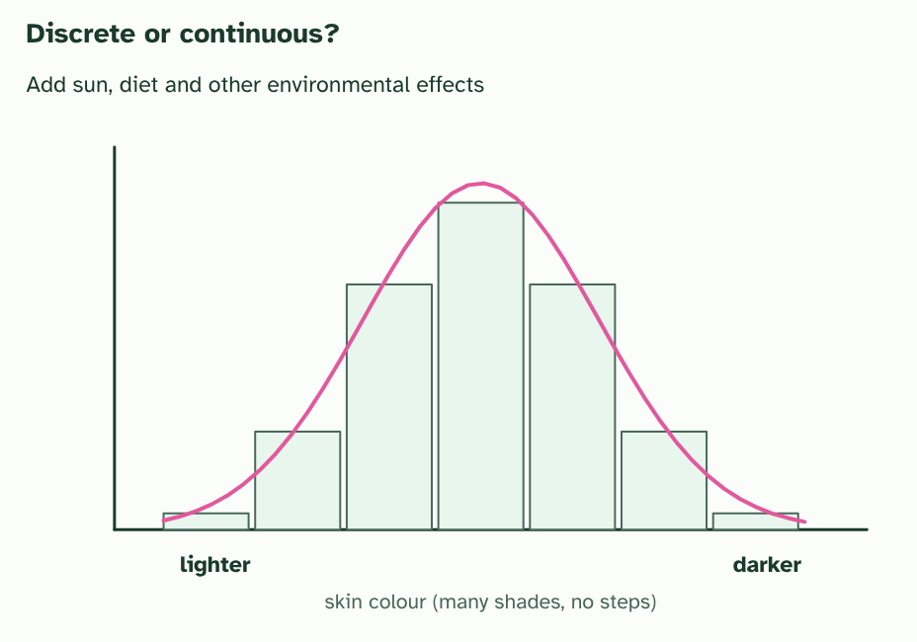
  SPOT THE MISTAKE
  What do students often get wrong about continuous variation? Write the mistake, then put it right.
  The mistake
  Put it right
SUMMARY
Sum up section 11 in two or three sentences of your own.

12 Showing a spread with a box plot | D3.2.15
CUES  Predict: In a box plot, what fraction of the data lie inside the box?  What is meant by box-and-whisker plot?  What is meant by quartiles?  What is meant by interquartile range?  What is meant by outlier? | NOTES  1 A ___________________________ does it with six aspects of the data: the minimum, the first quartile, the median, the third quartile, the maximum and any outliers.  2 The ____________ split each half again: a quarter of the values are below Q1 and a quarter are above Q3.  3 The length of the box, Q3 − Q1, is the __________________________ (IQR).  4 A value is an _________ if it is more than 1.5 × IQR above Q3 or below Q1.  Your own notes  ANNOTATE THE FIGURE  Number the 4 steps on the figure and note what happens at each.  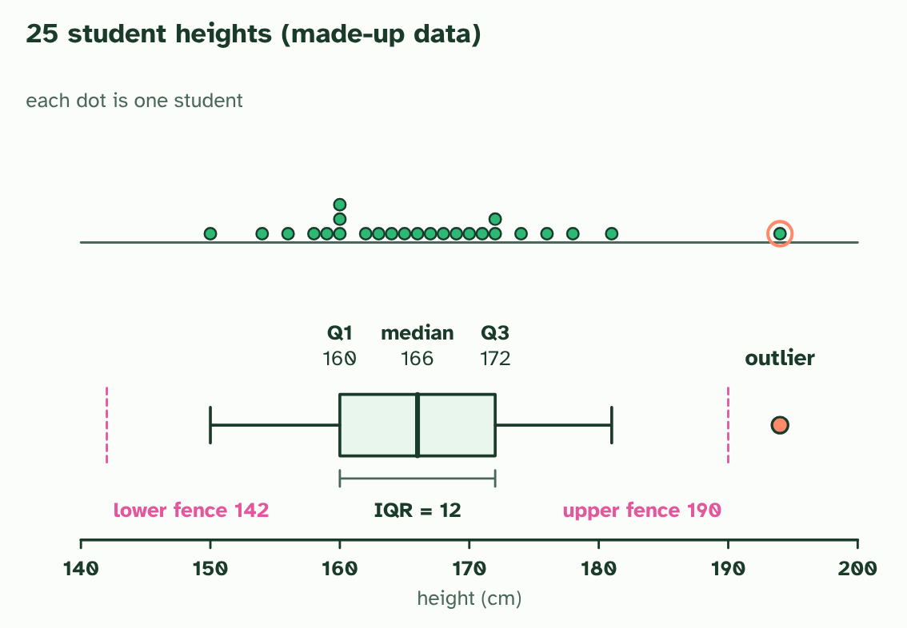  ANNOTATE THE FIGURE  Number the 2 steps on the figure and note what happens at each: 1 continuously; 2 box, median, outlier.  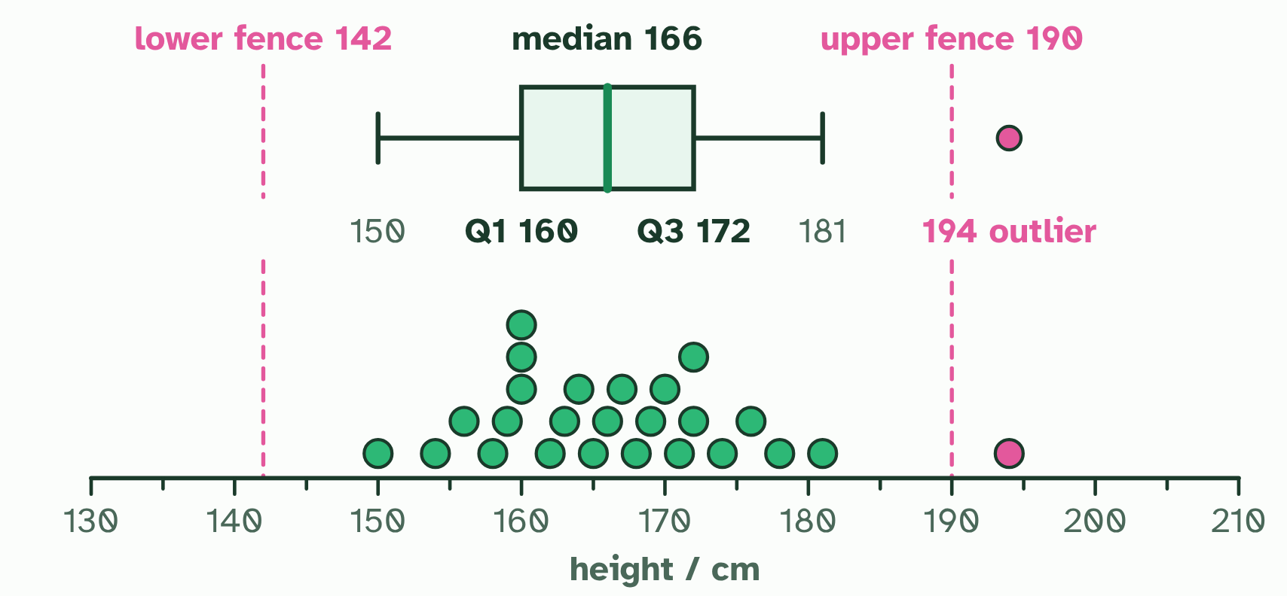
SUMMARY
Sum up section 12 in two or three sentences of your own.

13 Two genes at once | D3.2.16 HL D3.2.17 HL
CUES  Predict: A plant YyRr is crossed with a plant yyrr. What proportion of the offspring are yellow and round?  What is meant by dihybrid cross?  What is meant by segregation?  What is meant by independent assortment? | NOTES  1 A ___________________ follows two genes.  2 In meiosis I the two chromosomes of a homologous pair go to opposite poles, so the two alleles of a gene end up in different gametes: each gamete gets one. That is _______________.  3 Both are equally likely, so it makes four kinds of gamete, YR, Yr, yR and yr, in equal numbers. This is ______________________________.  4 Count the phenotypes: 9 yellow round, 3 yellow wrinkled, 3 green round and 1 green wrinkled. That is __________________.  5 Cross a double heterozygote YyRr with a double recessive yyrr and the recessive parent adds only yr, so the offspring show the heterozygote's four gametes: __________________.  Your own notes  ANNOTATE THE FIGURE  Number the 5 steps on the figure and note what happens at each.  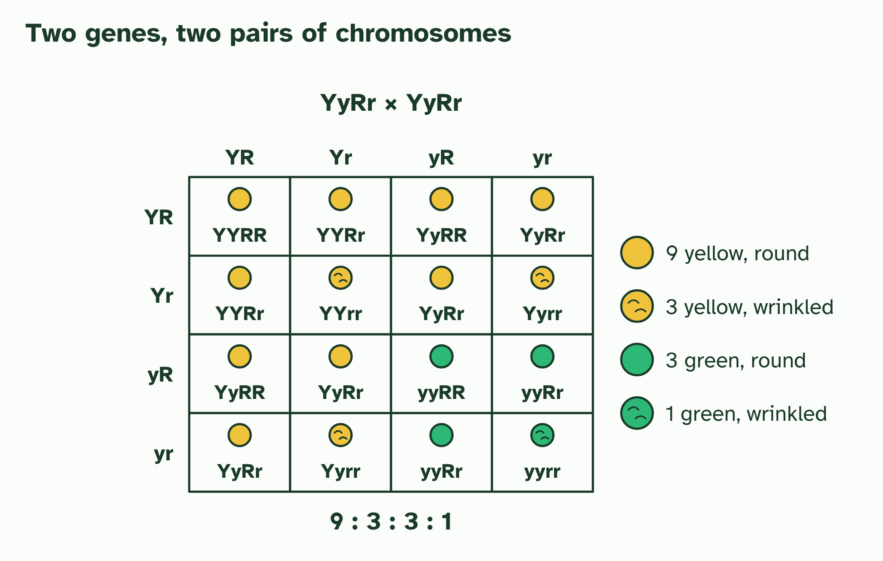  ANNOTATE THE FIGURE  Annotate this still from the animation (Watch it happen: two genes line up independently): what is happening, and why?  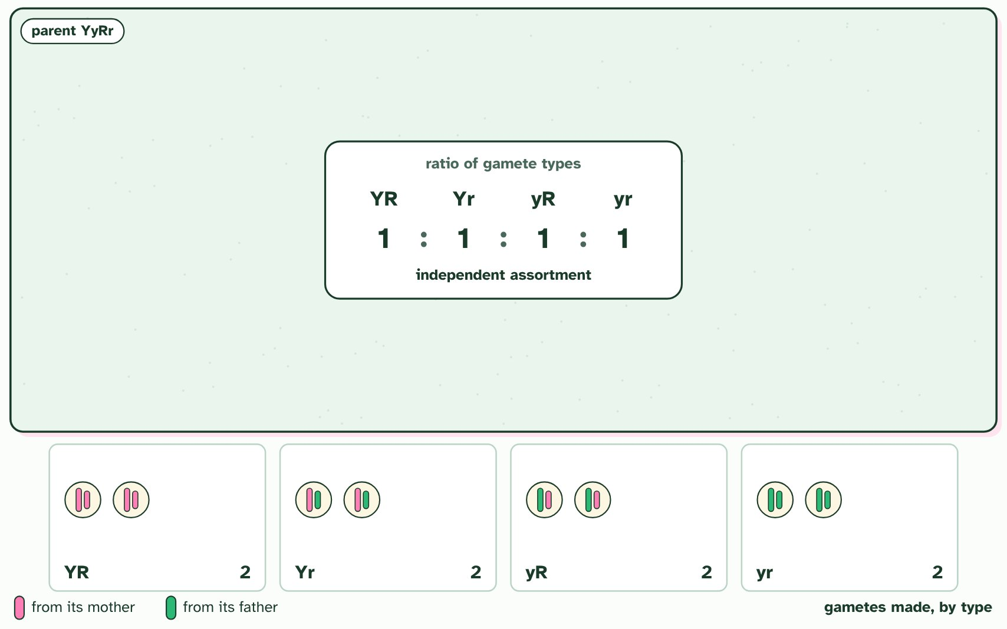  ANNOTATE THE FIGURE  Number the 2 steps on the figure and note what happens at each.  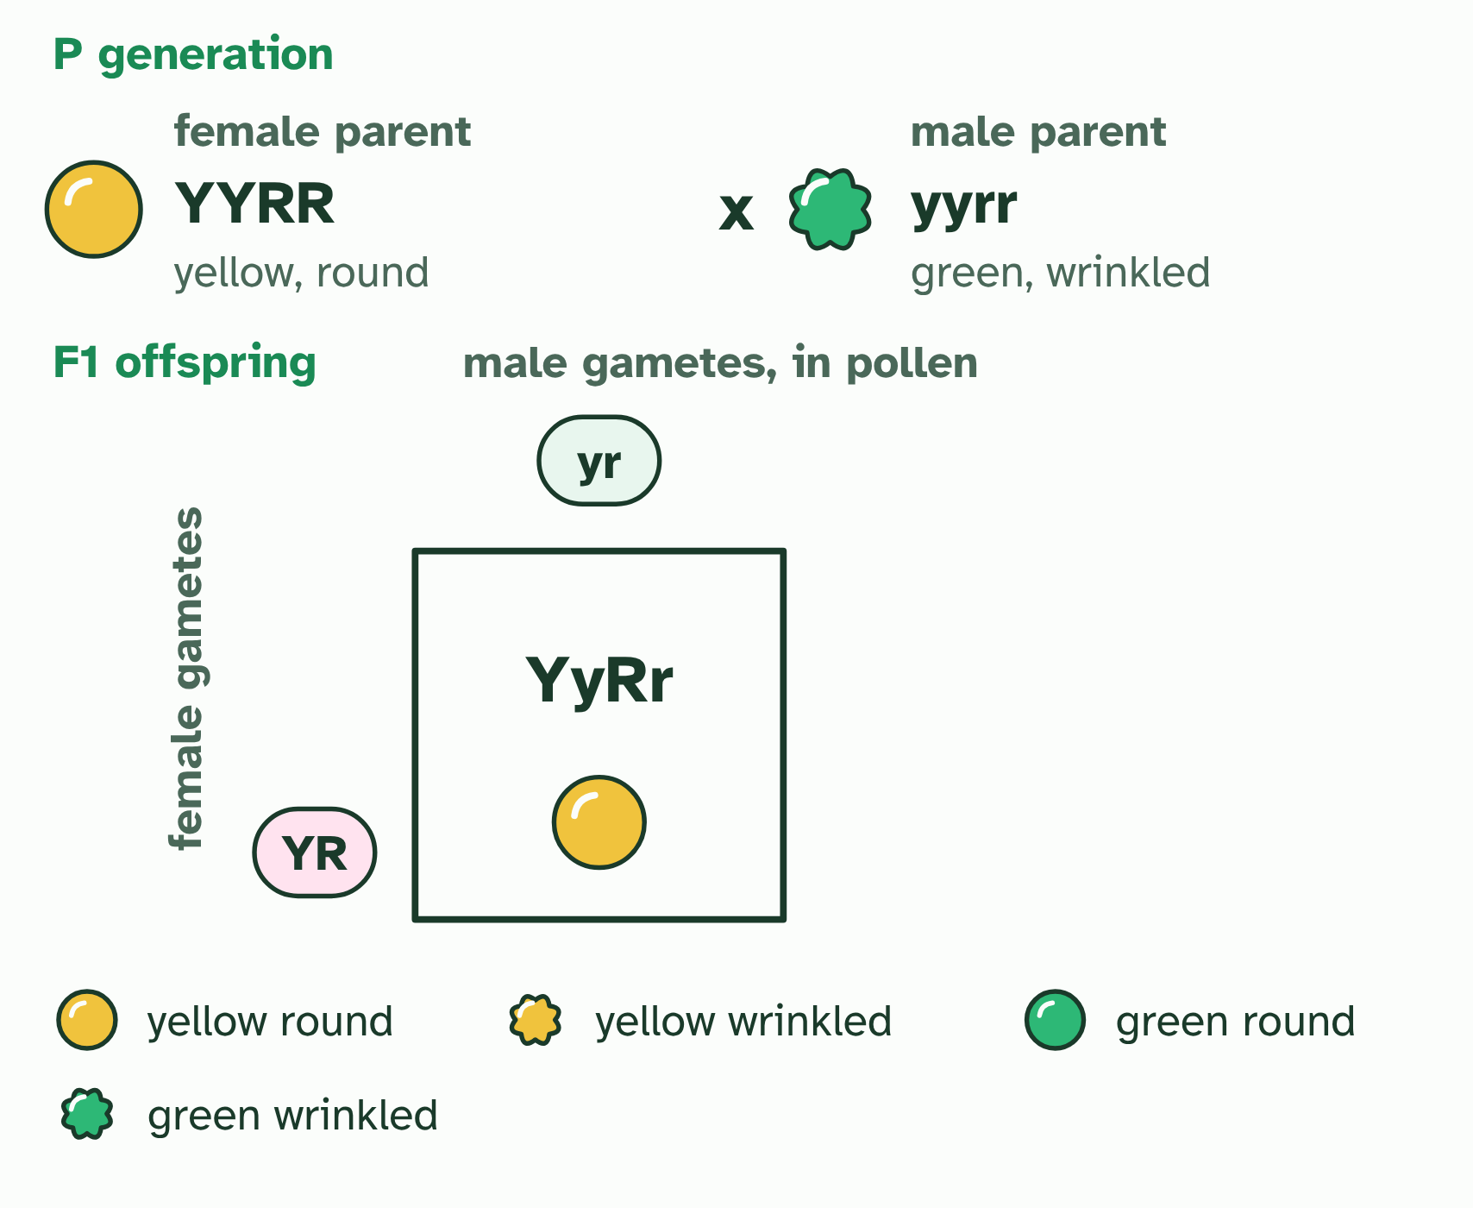
SUMMARY
Sum up section 13 in two or three sentences of your own.

14 Genes that travel together | D3.2.18 HL D3.2.19 HL D3.2.20 HL
CUES  Predict: A test cross AaBb × aabb gives 48 AB, 47 ab, 3 Ab and 2 aB. What does this suggest?  What is meant by linked?  What is meant by recombinant?  What is meant by test cross? | NOTES  1 Genes on the same chromosome are ________: they travel together in meiosis because they sit on the same piece of DNA.  2 With no crossing over, only two kinds of gamete form, AB and ab: the combinations that were already on the chromosomes, called ___________ types.  3 A gamete, a genotype or a phenotype with a combination of alleles that differs from the combinations on the parent's chromosomes is a _______________.  4 The ______________ shows this.  5 The ____________________________ is the recombinants divided by all the offspring.  Your own notes  ANNOTATE THE FIGURE  Number the 4 steps on the figure and note what happens at each: 1 Unlinked; 2 Linked, parental; 3 Crossing over, recombinant; 4 test cross.  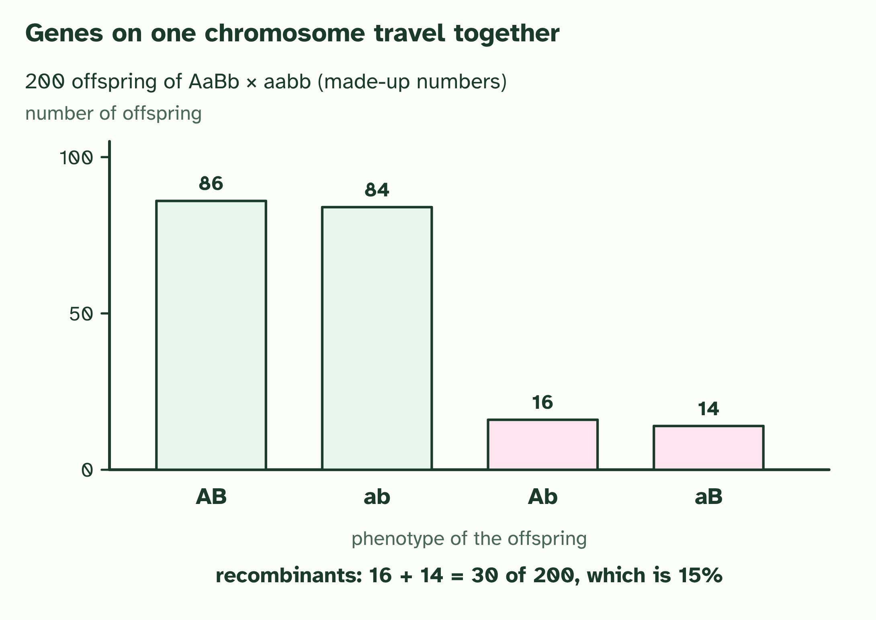
  SPOT THE MISTAKE
  What do students often get wrong about gene loci, linkage and recombinants? Write the mistake, then put it right.
  The mistake
  Put it right
SUMMARY
Sum up section 14 in two or three sentences of your own.

15 Is it chance? The chi-squared test | D3.2.21 HL
CUES  Predict: A chi-squared value of 2.1 with 3 degrees of freedom is compared with a critical value of 7.81. What do you conclude?  What is meant by chi-squared test?  What is meant by null hypothesis? | NOTES  1 A ______________________ answers that.  2 The ____________________ says there is no real difference between observed and expected: the genes are unlinked, and chance explains the scatter.  3 160 F2 plants: the ___________ counts from 9 : 3 : 3 : 1 (90, 30, 30 and 10) against ___________ counts (made up).  4 χ² is the sum of (O − E)² ÷ E over the four classes: ________.  5 With 3 degrees of freedom and p = 0.05 the ___________________ is 7.81. 2.13 is below it, so you do not reject the null hypothesis: chance can explain the difference.  6 A test cross of linked genes (made-up counts 112, 21, 18 and 109 from 260 offspring) gives χ² = ________, far past 7.81. Reject the null: the genes are probably linked.  Your own notes  ANNOTATE THE FIGURE  Number the 4 steps on the figure and note what happens at each: 1 expected, observed; 2 2.13; 3 critical value; 4 127.5.  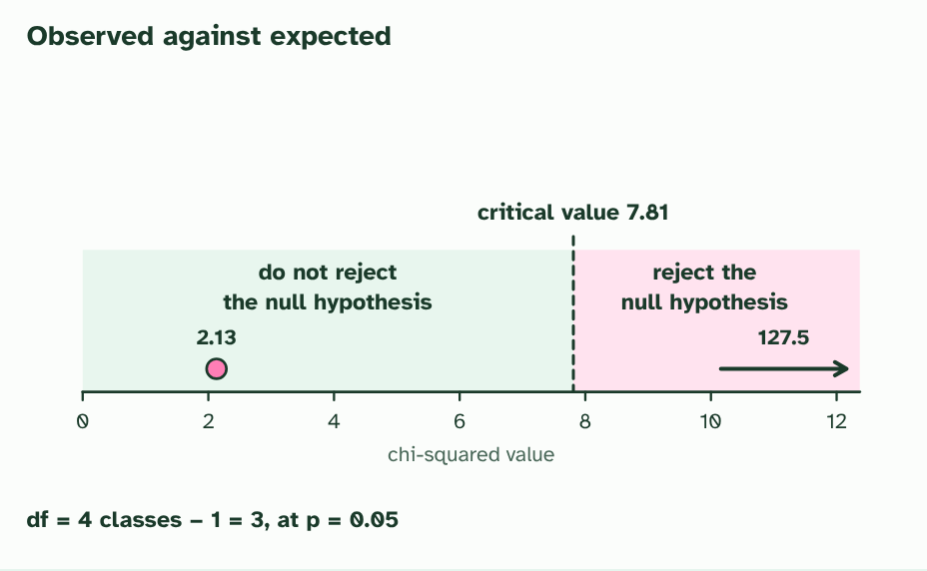  REMEMBER IT  The five steps of a chi-squared test
  H  Hungry | E  Elves | C  Cook | D  Delicious | C  Cakes
  H | E | C | D | C
  SPOT THE MISTAKE
  What do students often get wrong about the chi-squared test? Write the mistake, then put it right.
  The mistake
  Put it right
SUMMARY
Sum up section 15 in two or three sentences of your own.

Check yourself
The check for this guide is online: a fresh paper of past-paper style questions from the exam bank on D3.2 each time, marked as you go, and saved to your Exam practice progress when you are signed in. Open the link:
biologybybradford.com/exam-maker/sit?topics=D3.2&level=HL&paper=quiz&marks=15&src=ep

