Name | Class | Date
IB BIOLOGY · D4.1

Natural selection
Teacher’s copy: every blank filled in. Each numbered block matches a chapter of the guide, and of the lesson slides. Write in the gaps, answer the cues, annotate the figures, and sum up each section in your own words.
BY THE END YOU CAN
Explain natural selection as the mechanism of evolution, and why Darwin's explanation replacing Lamarck's was a paradigm shift D4.1.1
Explain how mutation makes new alleles and sexual reproduction makes new combinations of them D4.1.2
Explain how overproduction of offspring and competition for limited resources promote natural selection D4.1.3
Explain how abiotic factors such as a hard frost act as density-independent selection pressures D4.1.4
Use fitness, adaptation, survival and reproduction to explain why some individuals leave more offspring than others D4.1.5
Explain why only heritable traits can be selected, and why traits acquired in a lifetime cannot D4.1.6
Explain how competing for mates and being chosen drive the evolution of traits such as the plumage of birds of paradise D4.1.7
Interpret data from Endler's guppy experiments, and explain how controlling the predator separates sexual from natural selection D4.1.8
Describe a gene pool, and calculate and compare allele frequencies in a population, using a database for a human example D4.1.9, D4.1.10
Explain neo-Darwinism: how selection between individuals changes allele frequencies in the gene pool D4.1.11
Distinguish directional, stabilising and disruptive selection, and explain why all three change allele frequencies D4.1.12
Use the Hardy-Weinberg equation to calculate allele and genotype frequencies, and say what its five conditions tell you D4.1.13, D4.1.14
Distinguish artificial selection from natural selection, and explain antibiotic resistance as natural selection D4.1.15

01 Evolution has a mechanism | D4.1.1
CUES  Predict: Claim 1: "Natural selection gives organisms what they need to survive."  B: False: it favours only variation that already exists, and it cannot know what is needed. False. Natural selection has no foresight. It can only favour versions of a trait that already exist in the population. If no individual happens to carry a helpful version, the population simply does badly.  What is meant by natural selection?  The process by which individuals whose heritable traits suit their environment survive and reproduce more than others, so those traits become more common in the population.  What is meant by paradigm shift?  A change in the basic framework scientists use to explain a whole area of knowledge, when a new theory that explains more replaces the old one. | NOTES  1 In 1859 Charles Darwin published a different mechanism, natural selection.  2 Darwin's idea replacing Lamarck's is a classic paradigm shift.  3 Lamarck's idea: a giraffe stretches for leaves, its neck lengthens, and it passes the change on.  4 In fact the calf hatches with an ordinary neck: a change gained in life is not inherited (chapter 4).  5 Darwin's idea starts with variation: the necks in a population are not all the same.  6 Long necks feed best in the lean season and leave more young. The alleles go with them.  Your own notes  ANNOTATE THE FIGURE  Number the 5 steps on the figure and note what happens at each: 1 neck lengthens; 2 not inherited; 3 variation; 4 leave more young; 5 replaced.  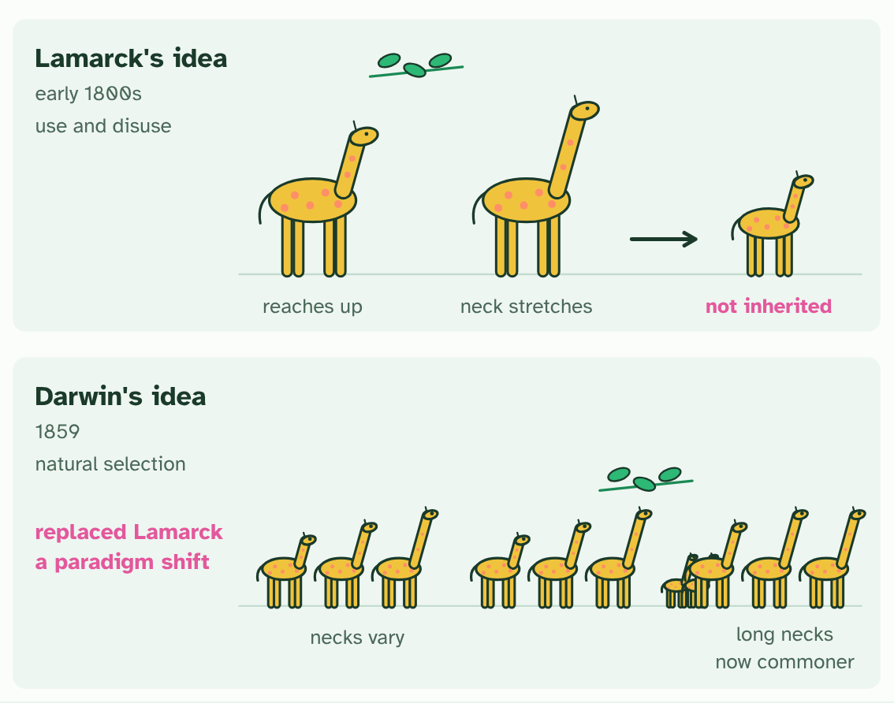  1 Lamarck's idea: a giraffe stretches for leaves, its neck lengthens, and it passes the change on.  2 In fact the calf hatches with an ordinary neck: a change gained in life is not inherited (chapter 4).  3 Darwin's idea starts with variation: the necks in a population are not all the same.  4 Long necks feed best in the lean season and leave more young. The alleles go with them.  5 Generations later, long necks are commoner. The explanation was replaced: a paradigm shift.  ANNOTATE THE FIGURE  Annotate this still from the animation (Watch it happen: ICE AGE in one population): what is happening, and why?  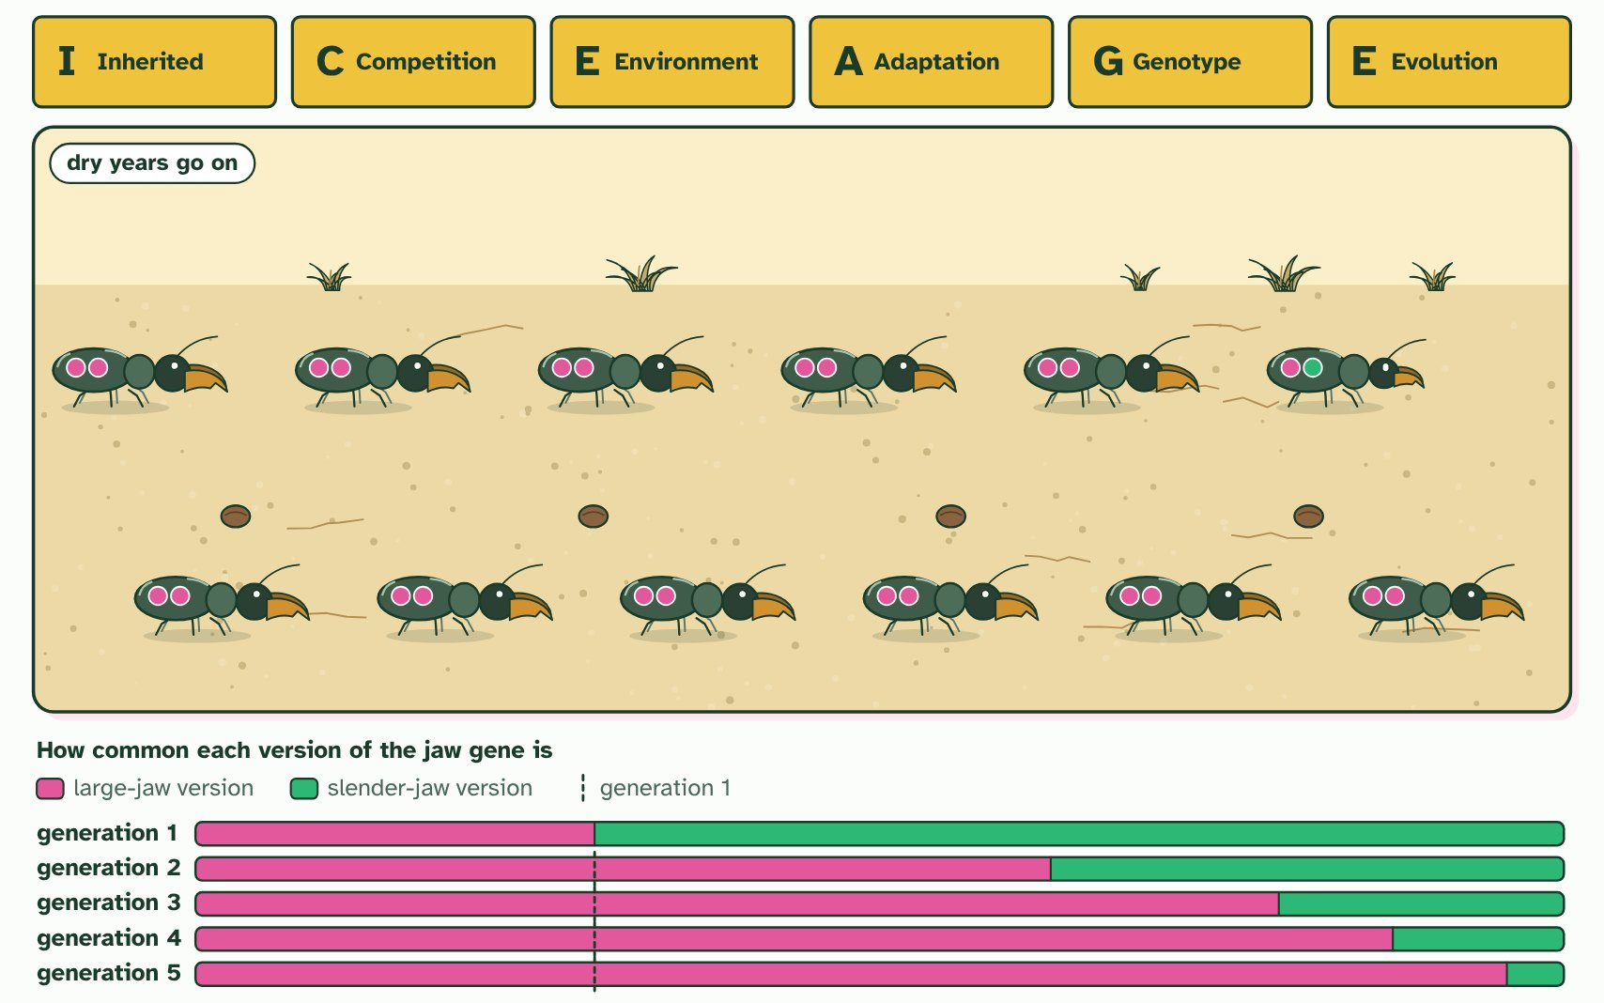  1 Inherited variation. Jaws differ, set by the two versions of a jaw gene that each beetle carries (the pips): pink large, green slender.  2 Competition. Twelve beetles leave thirty-six young, three times as many as the ground can feed.  3 Environmental pressure. A drought leaves only tough seeds. Large jaws crack them; slender jaws cannot, and those beetles starve.  4 Adaptation. The twelve survivors all have large or medium jaws, the trait that suits a dry year. Every one carries the large-jaw version.  5 Genotype frequencies change. Only survivors breed, so the large-jaw version of the gene is more common in generation 2.  6 Evolution. The dry years go on. By generation 5 nearly every beetle has large jaws: no beetle changed, the population did.  REMEMBER IT  The logic of natural selection: ICE AGE
  I  Icy | C  Cubs | E  Eat | A  Anything | G  Growing | E  Enormous
  Inherited variation  the population varies, and the variation is heritable | Competition  more young are born than resources can support | Environmental pressure  some survive and breed more than others | Adaptations  helpful traits are selected for | Genes (alleles)  allele frequencies change from one generation to the next | Evolution  the population has changed
  SPOT THE MISTAKE
  What do students often get wrong about natural selection drives evolution? Write the mistake, then put it right.
  Three more slips. Individuals do not evolve: a population does, across generations. Mutations do not happen because they are needed: they are chance changes (chapter 2). Natural selection does not make perfect organisms: it sorts what variation is on offer, under today's conditions, so every organism is a compromise.
SUMMARY
Sum up section 01 in two or three sentences of your own.
• In 1859 Charles Darwin published a different mechanism, natural selection.
• Darwin's idea replacing Lamarck's is a classic paradigm shift.

02 Variation to select from | D4.1.2
CUES  Predict: Where does the very first copy of a new allele come from?  B: A mutation in the DNA of a cell that goes on to make gametes. A mutation. Crossing over and independent assortment only recombine alleles that are already in the population, and natural selection can only sort alleles that exist. A change in the base sequence is the one event that makes an allele that was not there before.  What is meant by mutation?  A random change in the base sequence of DNA. A mutation in a gene can make a new allele. | NOTES  1 Mutation is the only source of brand new alleles.  2 Sexual reproduction makes new combinations of the alleles that already exist.  3 A gene is a sequence of bases. This version is one allele of the gene.  4 A copying error changes one base. The changed sequence is a new allele: mutation makes new alleles.  5 In meiosis, crossing over swaps pieces between a pair of chromosomes that carry the alleles A, B and a, b.  6 The gametes carry combinations that neither chromosome had before: sexual reproduction makes new combinations of alleles.  Your own notes  ANNOTATE THE FIGURE  Number the 4 steps on the figure and note what happens at each: 1 bases; 2 one base, new allele; 3 crossing over; 4 combinations.  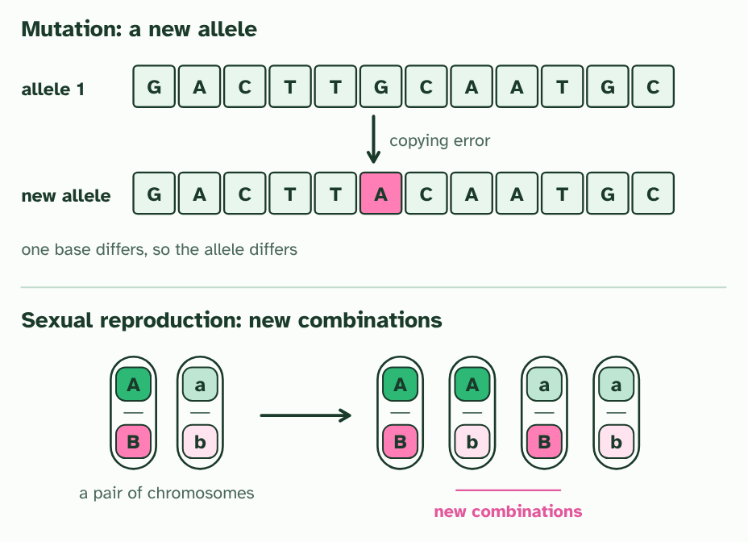  1 A gene is a sequence of bases. This version is one allele of the gene.  2 A copying error changes one base. The changed sequence is a new allele: mutation makes new alleles.  3 In meiosis, crossing over swaps pieces between a pair of chromosomes that carry the alleles A, B and a, b.  4 The gametes carry combinations that neither chromosome had before: sexual reproduction makes new combinations of alleles.
  SPOT THE MISTAKE
  What do students often get wrong about where variation comes from (I in ICE AGE)? Write the mistake, then put it right.
  A mutation is not a response to a problem. A bacterium does not mutate because an antibiotic is near, and a beetle does not mutate because the winter is cold. The mutation arrives by chance, and the environment decides whether it helps.
SUMMARY
Sum up section 02 in two or three sentences of your own.
• Mutation is the only source of brand new alleles.
• A gene is a sequence of bases. This version is one allele of the gene.
• A copying error changes one base. The changed sequence is a new allele: mutation makes new alleles.
• In meiosis, crossing over swaps pieces between a pair of chromosomes that carry the alleles A, B and a, b.
• The gametes carry combinations that neither chromosome had before: sexual reproduction makes new combinations of alleles.

03 More offspring than the world can feed | D4.1.3 D4.1.4
CUES  Predict: A late frost kills 60% of the seedlings in a sparse patch. How will a crowded patch of the same plant fare?  C: About the same share will die: the frost does not count heads. About the same share. A density-independent factor affects individuals in the same way whether they are crowded or sparse. The ones with a heritable tolerance of cold, in either patch, are the ones that survive. (Competition is different: it grows worse as the crowd grows.)  What is meant by carrying capacity?  The largest population an environment can support for a long time, set by the resources that run short first.  What is meant by compete?  To use or try to win the same limited resource, such as food, a territory or a mate.  What is meant by abiotic factor?  A non-living part of the environment, such as temperature, water, light, pH or salinity.  What is meant by density-independent?  Affecting a population in the same way whatever its density, so the same share of individuals is hit whether it is crowded or sparse.  What is meant by selection pressure?  An environmental factor that makes individuals with some heritable traits more likely to survive and reproduce than others. | NOTES  1 The carrying capacity is that limit.  2 When there are more young than the resources can supply, they compete.  3 An abiotic factor such as a heatwave, a hard frost, a drought or a flood can kill or spare individuals according to their traits.  4 These are density-independent factors: a frost that kills half of a sparse patch of seedlings kills about half of a crowded patch too.  5 Any factor that makes some individuals more likely to survive and reproduce than others is a selection pressure.  Your own notes  ANNOTATE THE FIGURE  Number the 5 steps on the figure and note what happens at each: 1 four places; 2 twelve young; 3 compete; 4 sparse, crowded; 5 density-independent.  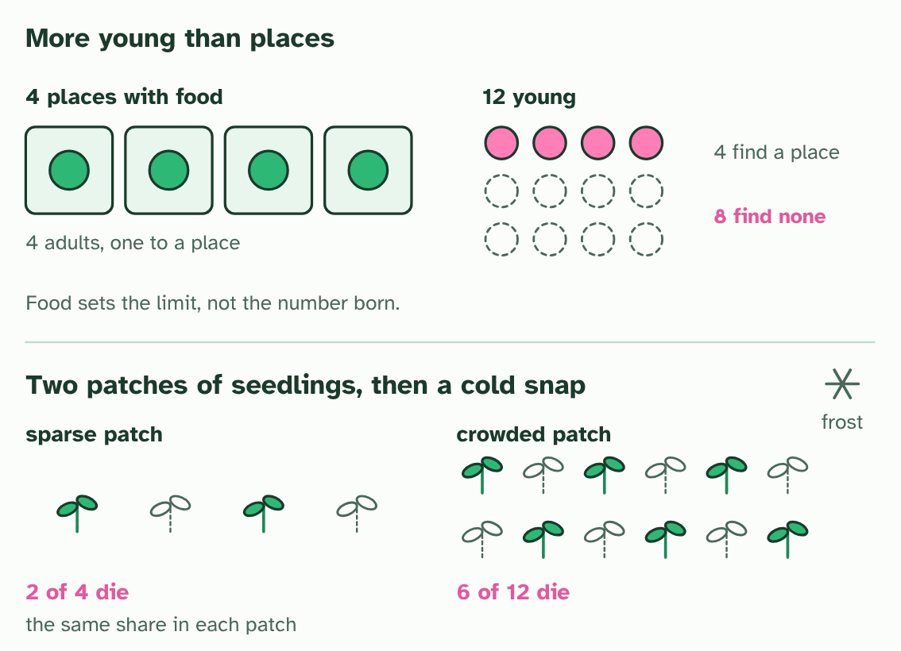  1 A habitat has four places with enough food, and four adults hold them.  2 The adults raise twelve young: far more than the places can hold.  3 The young compete. Only four find a place; eight find none. The limit is the food, not the number born.  4 A different pressure: two patches of seedlings, one sparse and one crowded.  5 A cold snap kills half of each. It is density-independent: the share lost does not depend on the crowd.
SUMMARY
Sum up section 03 in two or three sentences of your own.
• The carrying capacity is that limit.
• When there are more young than the resources can supply, they compete.
• An abiotic factor such as a heatwave, a hard frost, a drought or a flood can kill or spare individuals according to their traits.
• These are density-independent factors: a frost that kills half of a sparse patch of seedlings kills about half of a crowded patch too.

04 Who survives, who breeds | D4.1.5 D4.1.6
CUES  Predict: A cat lives 15 years but raises no surviving kittens. A second cat lives 6 years and raises 8 kittens that all breed. Which has the higher fitness?  A: The second, because it left more offspring that went on to breed. The second cat. Fitness is about the alleles that reach the next generation, so offspring that survive to breed are what count. The first cat survived well but its fitness, as far as evolution is concerned, is zero.  What is meant by adaptation?  A heritable feature that makes an organism better suited to its environment, so it survives and reproduces better.  What is meant by fitness?  How well an individual or genotype does at surviving and at leaving offspring that survive to breed. It combines survival value and reproductive potential.  What is meant by heritable?  Passed from parents to offspring in the base sequence of their genes. | NOTES  1 Each of these helpful differences is an adaptation.  2 What selection really measures is fitness.  3 Fitness has two parts: the survival value of a genotype (how likely it is to live long enough to breed) and its reproductive potential (how many offspring it tends to leave).  4 The trait must be heritable.  Your own notes  ANNOTATE THE FIGURE  Number the 5 steps on the figure and note what happens at each: 1 lived; 2 breeding age; 3 highest fitness; 4 acquired; 5 not heritable.  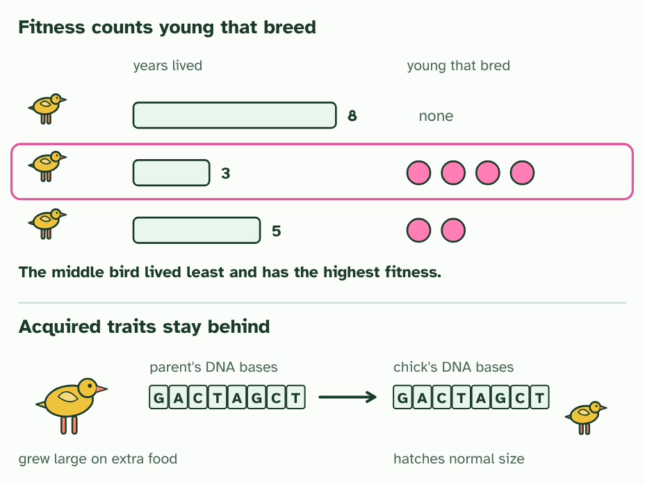  1 Three birds, and how many years each lived.  2 And how many young each raised that reached breeding age.  3 The bird that lived least has the highest fitness. Survival matters only because it lets an animal reproduce.  4 A parent grew large on extra food. Its DNA bases are the same as before: the size was acquired.  5 The chick inherits the same bases and hatches a normal size: an acquired trait is not heritable.  ANNOTATE THE FIGURE  Annotate this still from the animation (Watch it happen: a population changes): what is happening, and why?  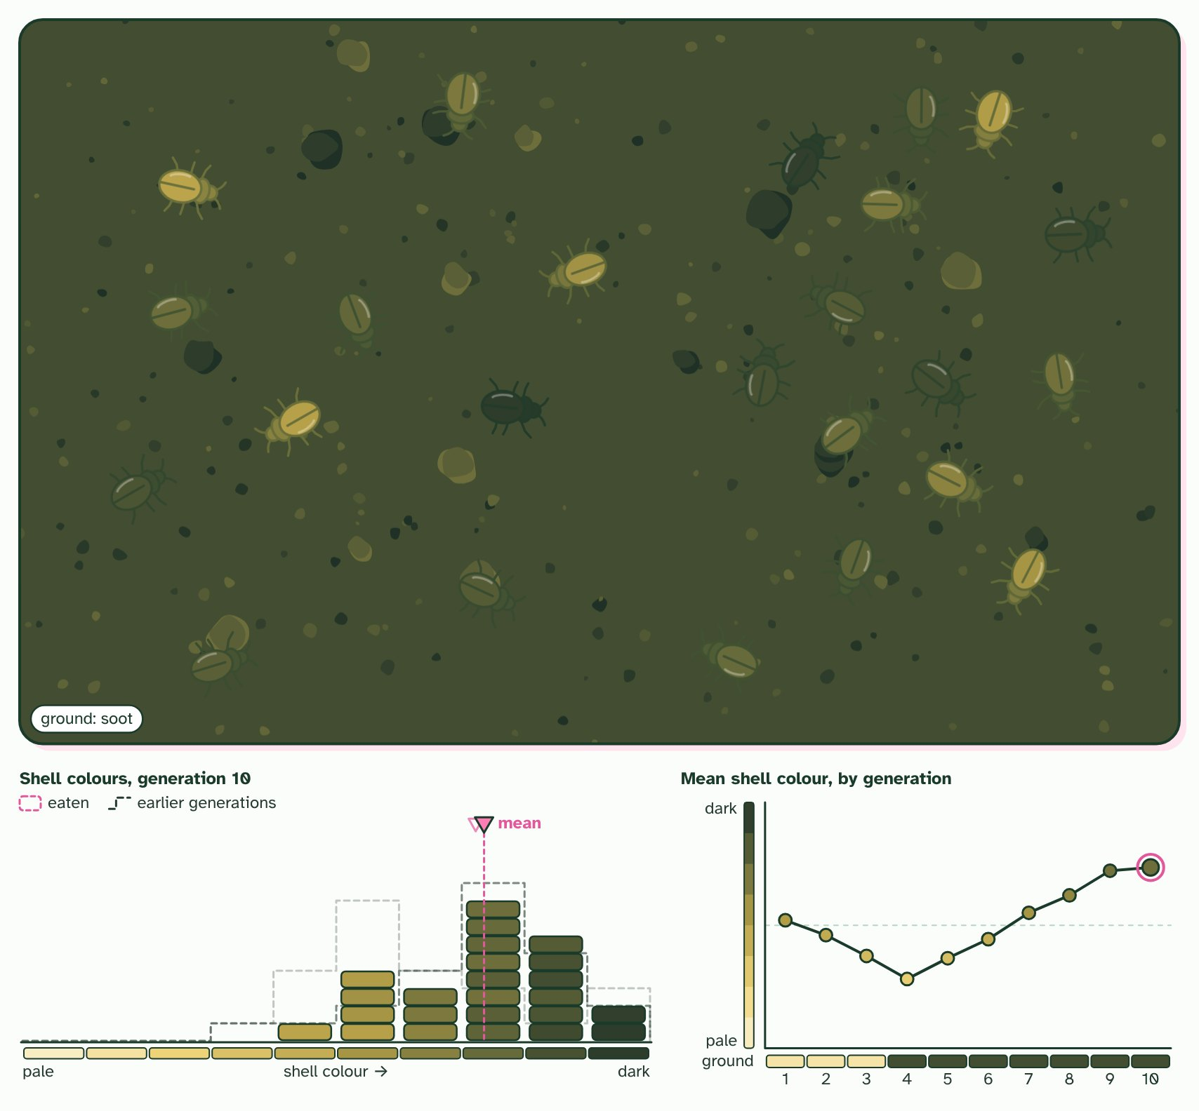  1 Birds spot the beetles that stand out. The best hidden survive and breed.  2 Then soot from a fire darkens the ground. Now the pale beetles stand out.  3 No beetle ever changed its shell. The population changed: that is evolution.  ANNOTATE THE FIGURE  Number the 3 steps on the figure and note what happens at each.  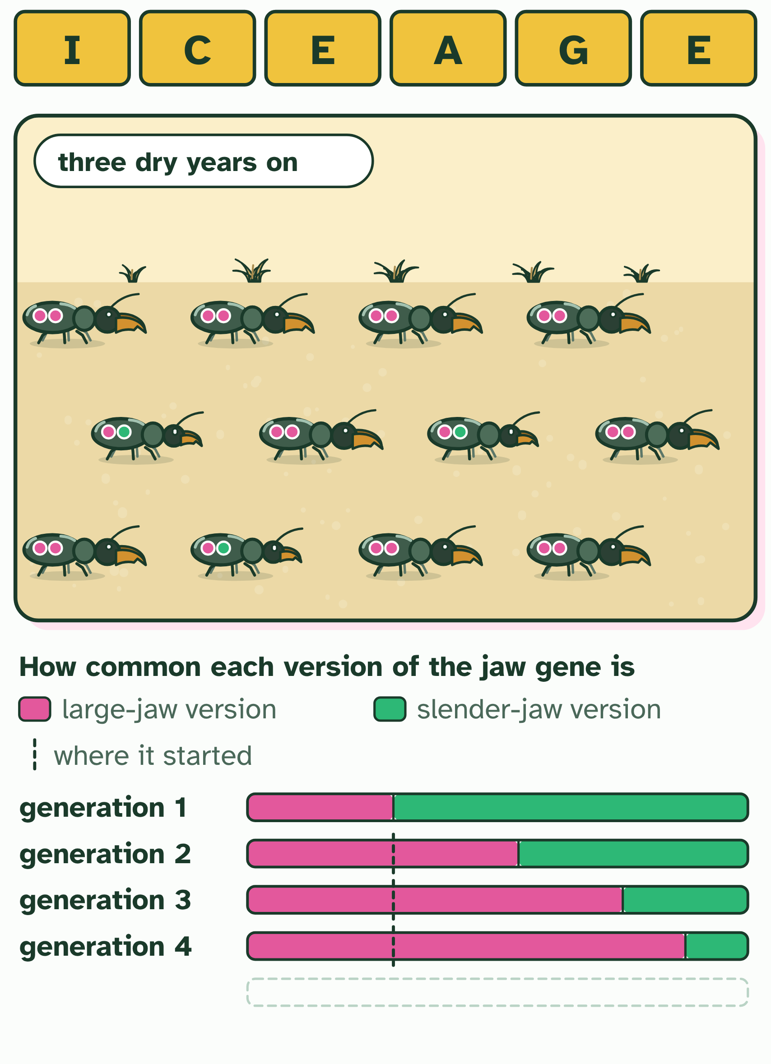  1 Generation 1: the beetles' jaws vary, slender to large, and each carries two copies of the jaw gene (the pips: pink for large, green for slender). Which letter is this?  2 A drought leaves only tough seeds: who cracks them, and who starves? Predict before you run it.  3 Three dry years on. What has happened to the population, and to any one beetle?
  SPOT THE MISTAKE
  What do students often get wrong about fitness and heredity (A, G and E in ICE AGE)? Write the mistake, then put it right.
  Fitness is not fitness training. Nothing you gain by exercise, diet or injury changes the alleles you pass on, and a long life is worth nothing to evolution unless it comes with offspring.
SUMMARY
Sum up section 04 in two or three sentences of your own.
• Each of these helpful differences is an adaptation.
• What selection really measures is fitness.
• The trait must be heritable.

05 Choosing a mate | D4.1.7
CUES  Predict: A male's bright tail makes him easier for predators to catch. How can the trait still spread through the population?  B: Only if the extra matings it brings outweigh the extra risk of being caught. It can spread only if the extra matings it brings outweigh the extra risk. A trait that costs survival can still raise fitness if the males that carry it leave more offspring. Where the risk wins, the trait is selected against, which is what the next chapter shows.  What is meant by sexual selection?  Selection for traits that improve an animal's success in getting mates, even where the trait does nothing for survival or makes it harder.  What is meant by intrasexual selection?  Competition between members of the same sex, usually males, for access to mates, as when stags fight with their antlers.  What is meant by intersexual selection?  Choice of a mate by members of one sex, usually females, among the members of the other sex, based on their traits. | NOTES  1 In many animals that is a contest of its own, and the traits that win it can be different from the ones that help you survive. Sexual selection is selection for success in getting mates.  2 In intrasexual selection members of one sex, usually males, compete with each other for access to mates: stags fight, and males display at one another.  3 In intersexual selection one sex, usually females, chooses among the other.  4 Four males of one species, with plumes of different lengths.  5 A female looks them over, and chooses the longest plume.  6 The male she chooses sires the most young, and they inherit his alleles for a long plume.  Your own notes  ANNOTATE THE FIGURE  Number the 4 steps on the figure and note what happens at each: 1 plumes; 2 chooses; 3 most young; 4 cost.  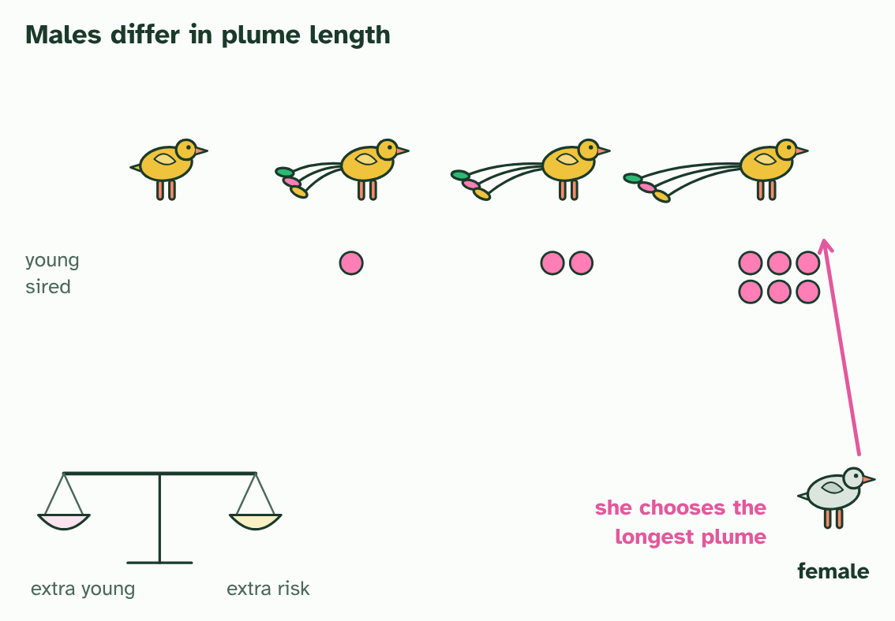  1 Four males of one species, with plumes of different lengths.  2 A female looks them over, and chooses the longest plume.  3 The male she chooses sires the most young, and they inherit his alleles for a long plume.  4 But a long plume has a cost: it spreads only while the extra young outweigh the extra risk.
  SPOT THE MISTAKE
  What do students often get wrong about sexual selection? Write the mistake, then put it right.
  Sexual selection is not "survival of the fittest" in the sense of the strongest staying alive. A male that is eaten the day after mating has still passed on his alleles, and one that lives for years but never mates has not.
SUMMARY
Sum up section 05 in two or three sentences of your own.
• In many animals that is a contest of its own, and the traits that win it can be different from the ones that help you survive. Sexual selection is selection for success in getting mates.
• In intrasexual selection members of one sex, usually males, compete with each other for access to mates: stags fight, and males display at one another.
• In intersexual selection one sex, usually females, chooses among the other.

06 Two pressures, tested | D4.1.8
CUES  Predict: In the pond with the dangerous predator, males end up with fewer spots. What is the best explanation?  A: Males that show a lot of colour are caught more often, so duller males leave more offspring. Colourful males are caught more often, so duller males leave more young and the alleles for fewer spots become commoner. It is natural selection by predation against sexual selection by females. The change shows up between generations, not within one male's life. | NOTES  1 The experiment models the streams: it is simpler than nature, so one pressure can be isolated and measured.  2 In the wild, males in streams with fierce predators are duller than males in streams with few.  3 Endler set up three ponds with the same starting guppies: no predator, a weak predator and a dangerous one.  4 He changed one thing, the predator, measured the males' spots, and kept everything else the same.  5 After the generations: more colour with no or a weak predator, less colour with the dangerous one.  Your own notes  ANNOTATE THE FIGURE  Number the 4 steps on the figure and note what happens at each: 1 fierce predators; 2 three ponds; 3 one thing; 4 less colour.  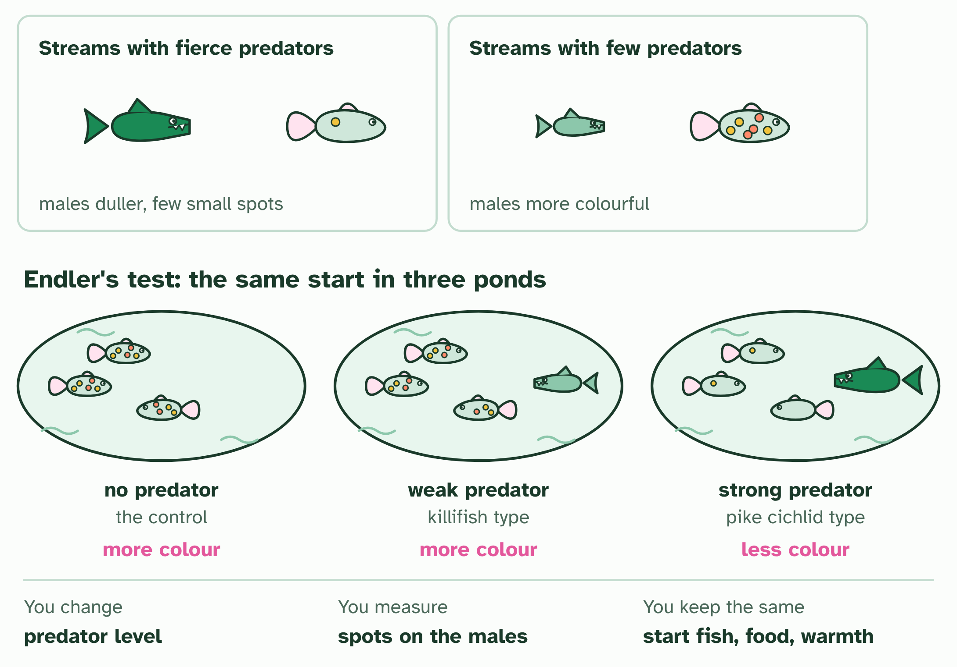  1 In the wild, males in streams with fierce predators are duller than males in streams with few.  2 Endler set up three ponds with the same starting guppies: no predator, a weak predator and a dangerous one.  3 He changed one thing, the predator, measured the males' spots, and kept everything else the same.  4 After the generations: more colour with no or a weak predator, less colour with the dangerous one.
  SPOT THE MISTAKE
  What do students often get wrong about modelling selection: Endler's guppies? Write the mistake, then put it right.
  A single male does not change colour in response to the predator. The change is in the population, across generations, as males with some alleles leave more young than others. Check which one a result is claiming.
SUMMARY
Sum up section 06 in two or three sentences of your own.
• In the wild, males in streams with fierce predators are duller than males in streams with few.
• Endler set up three ponds with the same starting guppies: no predator, a weak predator and a dangerous one.
• He changed one thing, the predator, measured the males' spots, and kept everything else the same.
• After the generations: more colour with no or a weak predator, less colour with the dangerous one.

07 The gene pool | D4.1.9 HL D4.1.10 HL
CUES  Predict: A population of 50 diploid individuals has 30 copies of allele B in its gene pool. What is the frequency of B?  B: 0.30, because there are 100 alleles in the pool and 30 are B. Frequency 0.30. Each of the 50 diploid individuals has two alleles of the gene, so the gene pool holds 100 alleles. The 30 copies of B are 30 out of 100, which is 0.30. Counting individuals instead of alleles is the usual slip.  What is meant by gene pool?  All the genes, and all the different alleles of them, present in a population.  What is meant by allele frequency?  The proportion of all the alleles of a gene in a gene pool that are one particular allele, as a decimal or a percentage. | NOTES  1 A gene pool is all the genes and their different alleles in a population.  2 The useful number to take from a gene pool is an allele frequency: how common each allele is.  3 Ten individuals, each carrying two alleles of one gene: allele A in green, allele a in pink.  4 Tip every allele into one jar: the gene pool, 20 alleles, 14 of them A and 6 of them a.  5 The allele frequency of A is 14 out of 20, which is 0.7. The frequencies of A and a add to 1.  6 A second population, cut off from the first, has different frequencies: 0.4 and 0.6.  Your own notes  ANNOTATE THE FIGURE  Number the 4 steps on the figure and note what happens at each: 1 two alleles; 2 gene pool; 3 allele frequency; 4 different.  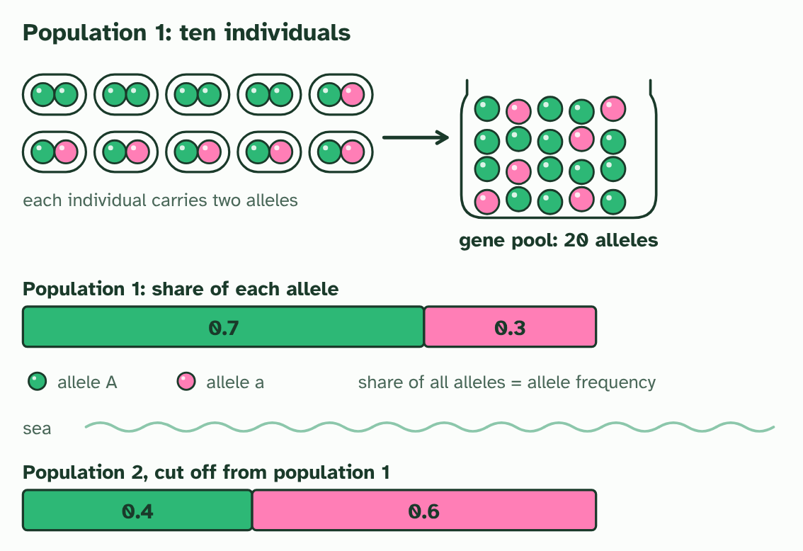  1 Ten individuals, each carrying two alleles of one gene: allele A in green, allele a in pink.  2 Tip every allele into one jar: the gene pool, 20 alleles, 14 of them A and 6 of them a.  3 The allele frequency of A is 14 out of 20, which is 0.7. The frequencies of A and a add to 1.  4 A second population, cut off from the first, has different frequencies: 0.4 and 0.6.
SUMMARY
Sum up section 07 in two or three sentences of your own.
• A gene pool is all the genes and their different alleles in a population.
• The useful number to take from a gene pool is an allele frequency: how common each allele is.

08 Selection shifts allele frequencies | D4.1.11 HL
CUES  Predict: In the beetle example, the J share of the gene pool was 0.5 before the drought and 20 of the 32 alleles of the survivors. What is it among the survivors?  A: 0.625, because 20 of the 32 surviving alleles are J. 0.625. After the drought the 16 survivors carry 32 alleles, 20 of them J. The frequency is 20 out of 32. Some j alleles were lost with the jj beetles but most survive in the Jj beetles, so the pool shifts toward J without j disappearing.  What is meant by neo-Darwinism?  The modern theory of evolution, combining Darwin's natural selection with genetics: evolution is a change in the allele frequencies of a gene pool. | NOTES  1 Biologists joined Darwin's natural selection to genetics in what is now called neo-Darwinism.  2 Evolution is a change in the allele frequencies of a gene pool over generations.  3 Selection acts on phenotypes, the traits that individuals show, but evolution is read in alleles, in the population.  4 Twenty beetles, each with two alleles of a jaw gene. Across the population, J and j are equally common: p = 0.5.  5 A drought leaves only tough seeds. The four jj beetles cannot feed and do not breed.  6 Count the alleles of the 16 survivors: 20 J and 12 j. The frequency of J is now 0.625.  Your own notes  ANNOTATE THE FIGURE  Number the 4 steps on the figure and note what happens at each: 1 p = 0.5; 2 jj; 3 0.625; 4 The allele frequency has changed: evolution..  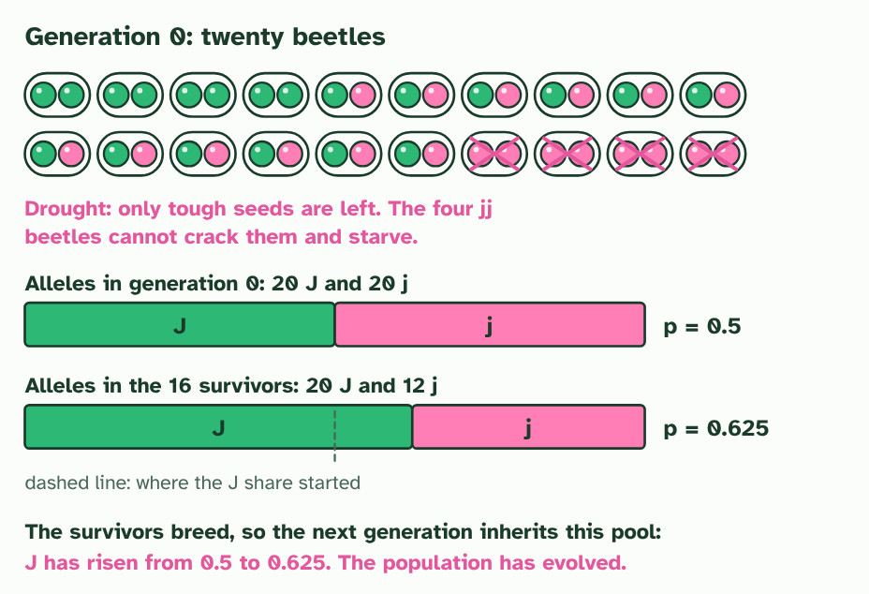  1 Twenty beetles, each with two alleles of a jaw gene. Across the population, J and j are equally common: p = 0.5.  2 A drought leaves only tough seeds. The four jj beetles cannot feed and do not breed.  3 Count the alleles of the 16 survivors: 20 J and 12 j. The frequency of J is now 0.625.  4 The survivors breed, so their gene pool is the next generation's. The allele frequency has changed: evolution.  ANNOTATE THE FIGURE  Annotate this still from the animation (Watch it happen: allele frequencies shift): what is happening, and why?  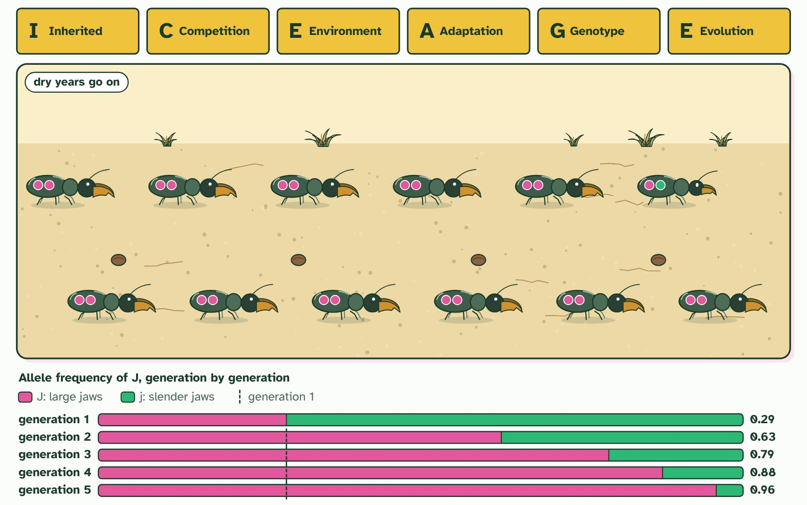  1 Inherited variation. Jaws differ, set by the two alleles of a jaw gene that each beetle carries (the pips): pink J large, green j slender.  2 Competition. Twelve beetles leave thirty-six young, three times as many as the ground can feed.  3 Environmental pressure. A drought leaves only tough seeds. Large jaws crack them; slender jaws cannot, and those beetles starve.  4 Adaptation. The twelve survivors all have large or medium jaws, the trait that suits a dry year. Every one carries J.  5 Genotype frequencies change. Only survivors breed, so the allele frequency of J rises in generation 2.  6 Evolution. The dry years go on. By generation 5 nearly every beetle has large jaws: no beetle changed, the population did.
  SPOT THE MISTAKE
  What do students often get wrong about selection changes allele frequencies? Write the mistake, then put it right.
  The frequency of an allele can change without any one individual changing at all. Do not write "the beetles evolved"; write "the allele frequency in the population changed".
SUMMARY
Sum up section 08 in two or three sentences of your own.
• Biologists joined Darwin's natural selection to genetics in what is now called neo-Darwinism.
• Twenty beetles, each with two alleles of a jaw gene. Across the population, J and j are equally common: p = 0.5.
• A drought leaves only tough seeds. The four jj beetles cannot feed and do not breed.
• Count the alleles of the 16 survivors: 20 J and 12 j. The frequency of J is now 0.625.
• The survivors breed, so their gene pool is the next generation's. The allele frequency has changed: evolution.

09 Three ways selection can act | D4.1.12 HL
CUES  Predict: Babies of very low and very high birth weight are less likely to survive than babies of average weight. Which kind of selection is this?  C: Stabilising selection, because both extremes are removed. Stabilising selection. Both the smallest and the largest are removed, so the range narrows around the average and the average itself stays the same. It still changes allele frequencies: the alleles that push weight to the extremes become rarer.  What is meant by directional selection?  Selection that favours one extreme of a trait, so the population's average shifts in that direction.  What is meant by stabilising selection?  Selection that favours the intermediate form and removes both extremes, so the range narrows and the average stays put.  What is meant by disruptive selection?  Selection that favours both extremes and removes the intermediate form, so the population may split into two groups. | NOTES  1 In directional selection one extreme is favoured, so the whole population shifts towards it.  2 In stabilising selection the middle is favoured and both extremes are removed.  3 In disruptive selection both extremes are favoured and the middle is removed.  4 Directional: one tail of the curve is removed, and the whole curve shifts. Alleles for large beaks become commoner.  5 Stabilising: both tails are removed and the curve narrows. Alleles for the extremes become rarer.  6 Disruptive: the middle is removed and the curve splits in two. Alleles for both extremes become commoner.  Your own notes  ANNOTATE THE FIGURE  Number the 3 steps on the figure and note what happens at each: 1 Directional; 2 Stabilising; 3 Disruptive.  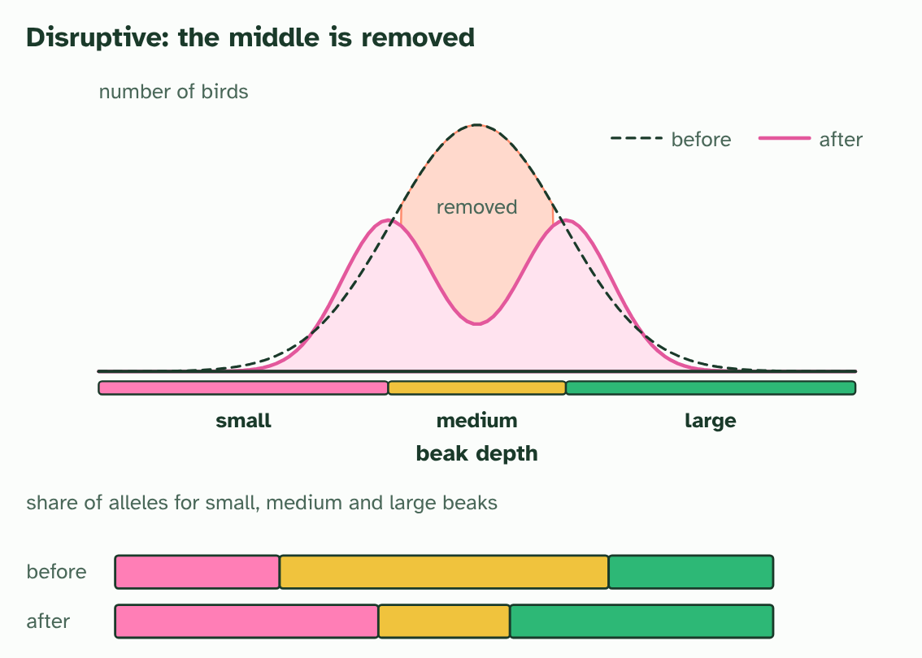  1 Directional: one tail of the curve is removed, and the whole curve shifts. Alleles for large beaks become commoner.  2 Stabilising: both tails are removed and the curve narrows. Alleles for the extremes become rarer.  3 Disruptive: the middle is removed and the curve splits in two. Alleles for both extremes become commoner.  ANNOTATE THE FIGURE  Annotate this still from the animation (Watch it happen: one population, three kinds of selection): what is happening, and why?  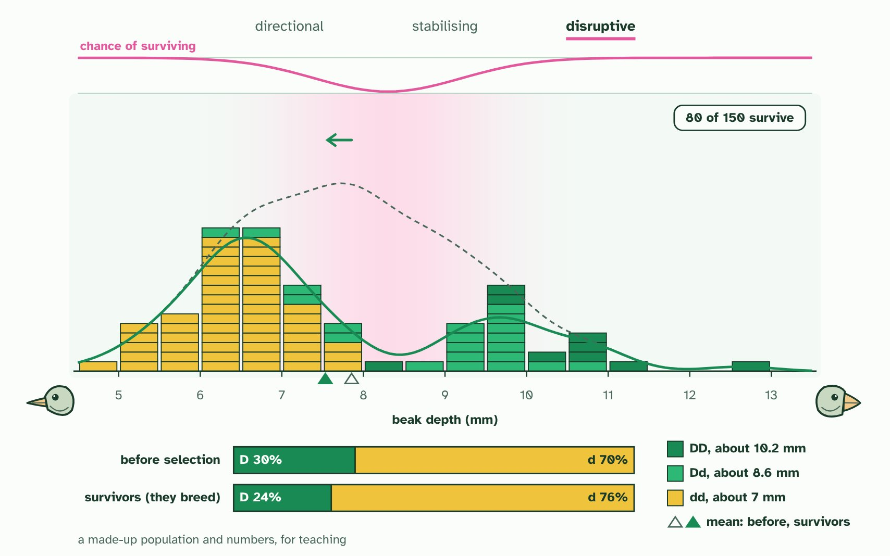  1 One population of 150 finches: how deep each beak is. One gene adds about 1.6 mm for each D allele; other genes and food add the rest. D is 30% of the alleles.  2 The survivors breed. Their mean moves deeper, and D rises from 30% to 61% of the alleles they pass on.  3 The spread narrows. D still shifts, 30% to 35%: the favoured middle is mostly Dd, so more D is kept than before.  4 Two peaks are left. The middle was mostly Dd, so D falls, 30% to 24%. All three kinds change allele frequency.  REMEMBER IT  The three kinds of selection
  D  Drive | S  Squeeze | D  Divide
  Directional  one end is removed and the mean shifts | Stabilising  both ends are removed and the range narrows | Disruptive  the middle is removed and two groups emerge
  SPOT THE MISTAKE
  What do students often get wrong about directional, stabilising and disruptive selection? Write the mistake, then put it right.
  Stabilising selection is not "no selection". The average stays the same because selection is at work: it keeps removing the extremes. Remember that all three kinds change allele frequencies.
SUMMARY
Sum up section 09 in two or three sentences of your own.
• In directional selection one extreme is favoured, so the whole population shifts towards it.
• In stabilising selection the middle is favoured and both extremes are removed.
• In disruptive selection both extremes are favoured and the middle is removed.

10 What a population would be like if it were not evolving | D4.1.13 HL D4.1.14 HL
CUES  Predict: A recessive condition affects 1 person in 2500. Roughly how many people in the population are carriers (heterozygous)?  A: About 1 in 25, since 2pq is about 0.04. About 1 in 25. q² = 1/2500 = 0.0004, so q = 0.02 and p = 0.98. The carriers are 2pq = 2 × 0.98 × 0.02 = 0.039, which is about 1 in 25. Carriers are far commoner than affected people because most copies of a rare recessive allele sit hidden in heterozygotes.  What is meant by hardy-Weinberg equation?  For a gene with two alleles, p + q = 1 and p² + 2pq + q² = 1, which predict the genotype frequencies from the allele frequencies in a population in genetic equilibrium. | NOTES  1 The Hardy-Weinberg equation gives it: the genotype frequencies you would expect in a population in genetic equilibrium, where the allele frequencies stay the same from one generation to the next.  2 For a gene with two alleles, let p be the frequency of one (A) and q the frequency of the other (a). They are the only alleles, so p + q = 1.  3 With random mating, any egg can meet any sperm, so the genotype frequencies are the square of that: p² + 2pq + q² = 1, where p² is AA, 2pq is Aa and q² is aa.  4 Egg and sperm alleles meet at random. If the frequency of A is p = 0.6 and of a is q = 0.4, each edge of the square is split in those proportions.  5 The four areas are the four ways eggs and sperm can combine: p², pq, pq and q².  6 AA is p² = 0.36, Aa is 2pq = 0.48 and aa is q² = 0.16. Together they make 1.  Your own notes  ANNOTATE THE FIGURE  Number the 4 steps on the figure and note what happens at each: 1 p = 0.6, q = 0.4; 2 p², pq, pq, q²; 3 1; 4 q = 0.4, p = 0.6.  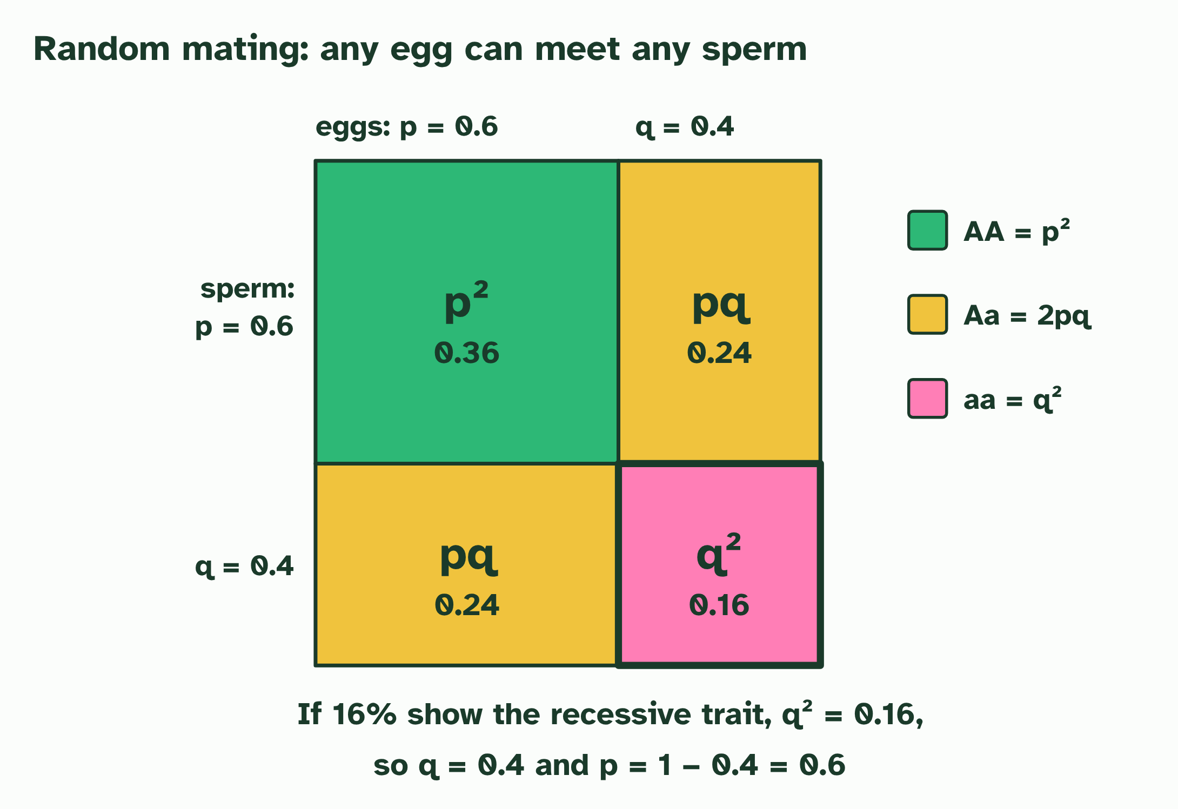  1 Egg and sperm alleles meet at random. If the frequency of A is p = 0.6 and of a is q = 0.4, each edge of the square is split in those proportions.  2 The four areas are the four ways eggs and sperm can combine: p², pq, pq and q².  3 AA is p² = 0.36, Aa is 2pq = 0.48 and aa is q² = 0.16. Together they make 1.  4 Working back: if 16% show the recessive trait, q² = 0.16, so q = 0.4 and p = 0.6.  ANNOTATE THE FIGURE  Number the 3 steps on the figure and note what happens at each: 1 p, q; 2 p² + 2pq + q² = 1; 3 carriers.  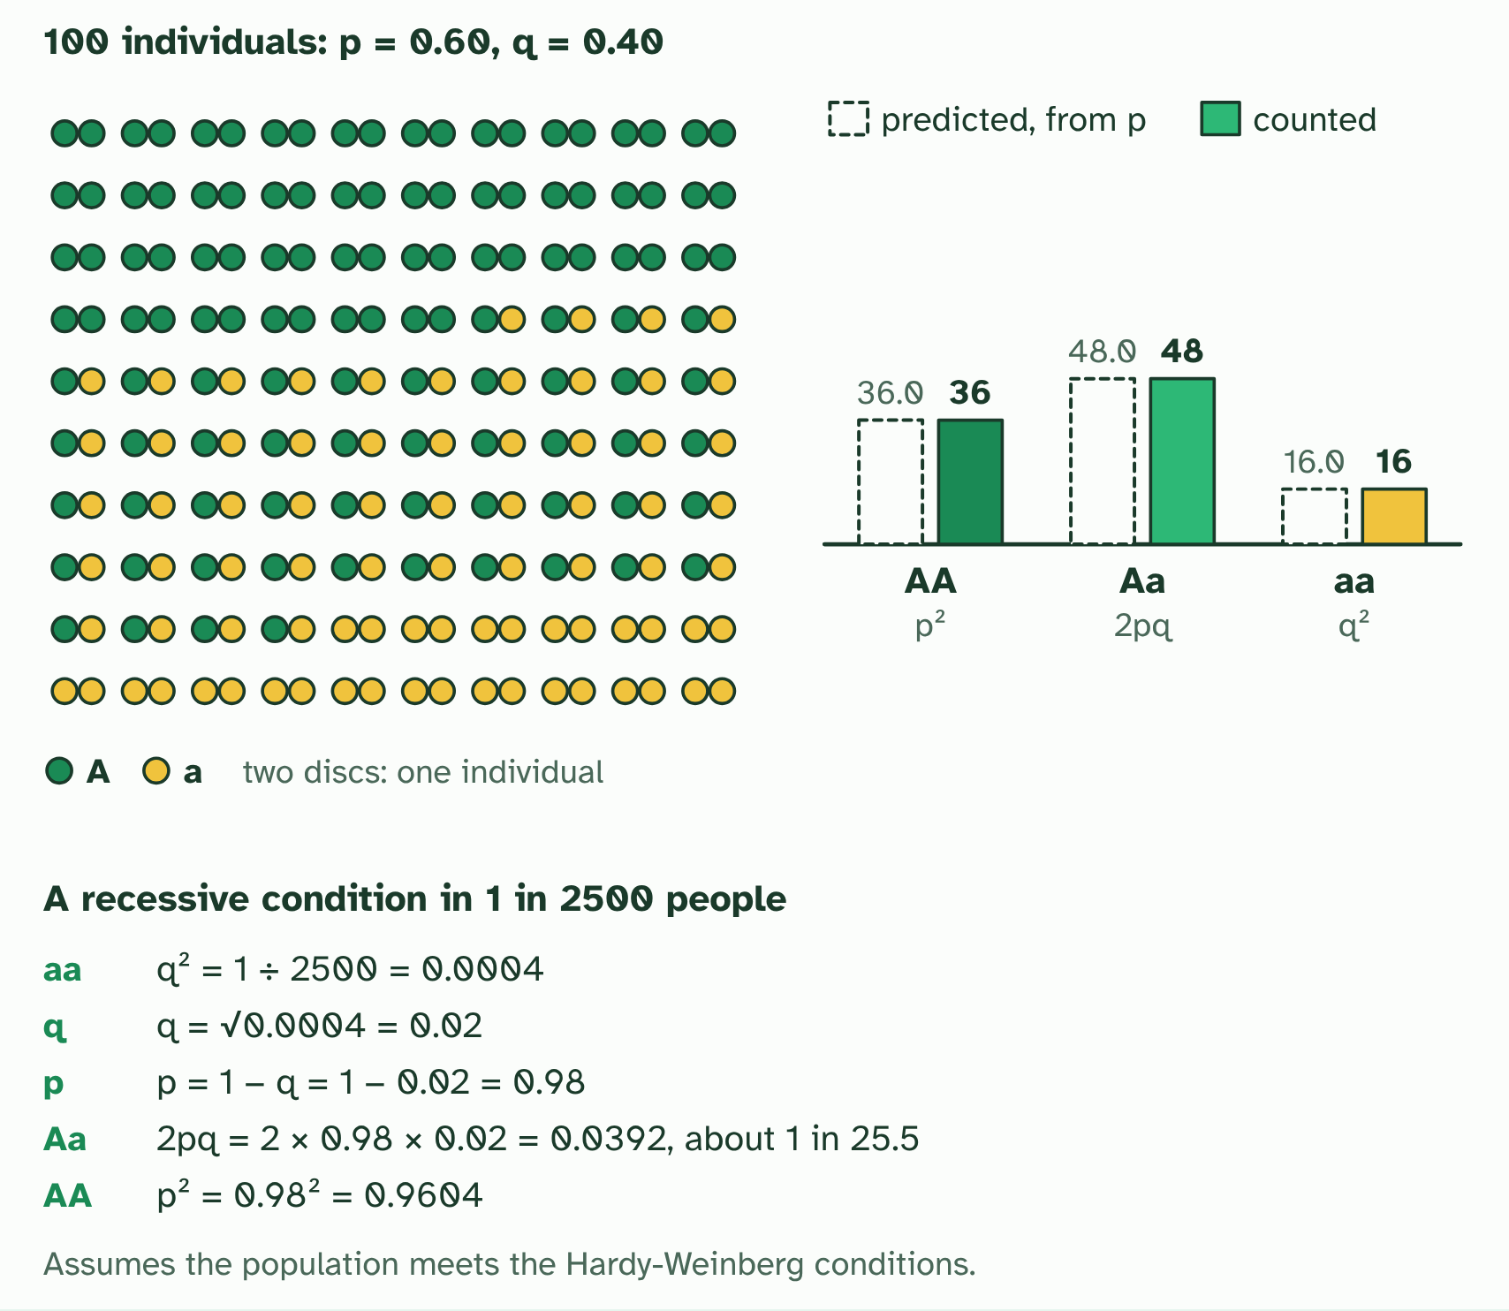  1 One gene, two alleles: p is the frequency of A, q of a, and p + q = 1. Here p = 0.60.  2 Hardy-Weinberg predicts the genotypes from p and q: p² + 2pq + q² = 1. When every condition is met, the counts fit.  3 It works backwards too. From the aa frequency, 1 in 2500: q = 0.02, p = 0.98, and carriers 2pq = 0.0392, about 1 in 26.  REMEMBER IT  The five Hardy-Weinberg conditions
  L  Large | R  Rats | M  Make | M  Most | S  Spaghetti
  Large population  big enough that chance does not shift the frequencies | Random mating  no mate choice by genotype, no inbreeding | Migration: none  no alleles arrive or leave | Mutation: none  no new alleles appear | Selection: none  every genotype survives and breeds equally well
SUMMARY
Sum up section 10 in two or three sentences of your own.
• The Hardy-Weinberg equation gives it: the genotype frequencies you would expect in a population in genetic equilibrium, where the allele frequencies stay the same from one generation to the next.
• Egg and sperm alleles meet at random. If the frequency of A is p = 0.6 and of a is q = 0.4, each edge of the square is split in those proportions.
• The four areas are the four ways eggs and sperm can combine: p², pq, pq and q².
• AA is p² = 0.36, Aa is 2pq = 0.48 and aa is q² = 0.16. Together they make 1.
• Working back: if 16% show the recessive trait, q² = 0.16, so q = 0.4 and p = 0.6.

11 Artificial selection and its side effects | D4.1.15 HL
CUES  Predict: Farmers spray a crop with an insecticide. After some years most of the pests resist it. Which kind of selection has taken place?  B: Natural selection, because the insecticide killed some pests and spared others. Natural selection. The farmers did not choose which pests would breed, and they did not mean to produce resistant ones. The insecticide was a selection pressure that spared the pests with a heritable resistance, and the resistance alleles became commoner. Artificial selection needs a deliberate choice of the parents.  What is meant by artificial selection?  Breeding in which humans deliberately choose which individuals reproduce, according to traits they want, so those traits become commoner. | NOTES  1 Artificial selection is natural selection with a person choosing the parents.  2 The key word is deliberate.  3 The antibiotic acted as a selection pressure on variation that already existed, so this is natural selection, an unintended consequence of a human action, not artificial selection.  4 A crop varies in the size of its cobs. Each plant's size is partly heritable.  5 The breeder picks the largest and lets only those breed.  6 Repeat for a few generations: the cobs get steadily bigger, as the alleles for size become commoner.  Your own notes  ANNOTATE THE FIGURE  Number the 5 steps on the figure and note what happens at each: 1 heritable; 2 largest; 3 bigger; 4 one; 5 Nobody chose it.  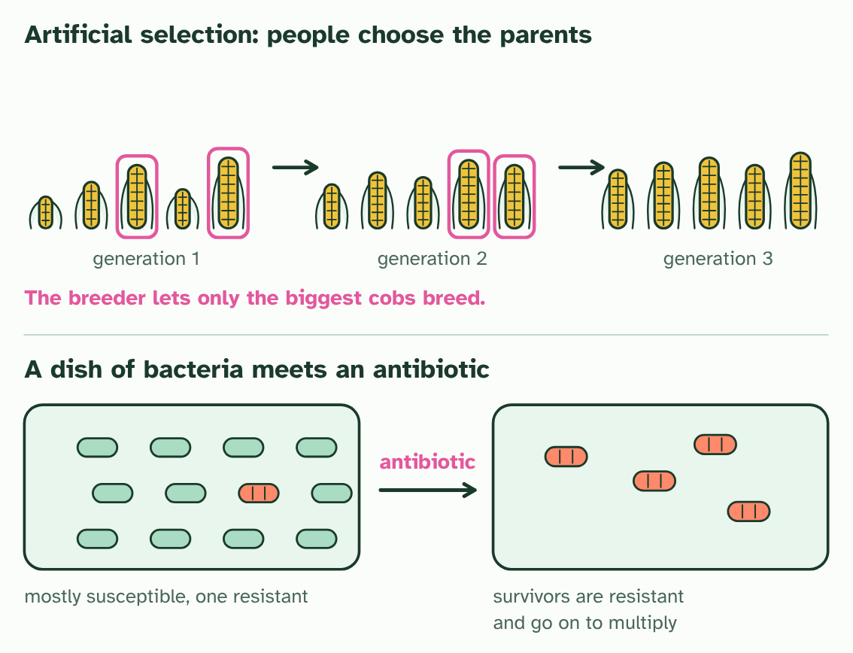  1 A crop varies in the size of its cobs. Each plant's size is partly heritable.  2 The breeder picks the largest and lets only those breed.  3 Repeat for a few generations: the cobs get steadily bigger, as the alleles for size become commoner.  4 A dish of bacteria with one resistant cell among many susceptible ones.  5 Add an antibiotic: the susceptible cells die, the resistant one multiplies. Nobody chose it, so this is natural selection.
  SPOT THE MISTAKE
  What do students often get wrong about artificial selection? Write the mistake, then put it right.
  The resistance did not appear "because" of the antibiotic, and the bacteria did not learn to resist. The mutation was already there, or arose by chance. The antibiotic only changed who survived.
SUMMARY
Sum up section 11 in two or three sentences of your own.
• Artificial selection is natural selection with a person choosing the parents.
• A crop varies in the size of its cobs. Each plant's size is partly heritable.
• The breeder picks the largest and lets only those breed.
• Repeat for a few generations: the cobs get steadily bigger, as the alleles for size become commoner.
• A dish of bacteria with one resistant cell among many susceptible ones.

Check yourself
The check for this guide is online: a fresh paper of past-paper style questions from the exam bank on D4.1 each time, marked as you go, and saved to your Exam practice progress when you are signed in. Open the link:
biologybybradford.com/exam-maker/sit?topics=D4.1&level=HL&paper=quiz&marks=15&src=ep

