Name | Class | Date
IB BIOLOGY · D4.1

Natural selection
Notes to fill in alongside the guide. Each numbered block matches a chapter of the guide, and of the lesson slides. Write in the gaps, answer the cues, annotate the figures, and sum up each section in your own words.
BY THE END YOU CAN
Explain natural selection as the mechanism of evolution, and why Darwin's explanation replacing Lamarck's was a paradigm shift D4.1.1
Explain how mutation makes new alleles and sexual reproduction makes new combinations of them D4.1.2
Explain how overproduction of offspring and competition for limited resources promote natural selection D4.1.3
Explain how abiotic factors such as a hard frost act as density-independent selection pressures D4.1.4
Use fitness, adaptation, survival and reproduction to explain why some individuals leave more offspring than others D4.1.5
Explain why only heritable traits can be selected, and why traits acquired in a lifetime cannot D4.1.6
Explain how competing for mates and being chosen drive the evolution of traits such as the plumage of birds of paradise D4.1.7
Interpret data from Endler's guppy experiments, and explain how controlling the predator separates sexual from natural selection D4.1.8
Describe a gene pool, and calculate and compare allele frequencies in a population, using a database for a human example D4.1.9, D4.1.10
Explain neo-Darwinism: how selection between individuals changes allele frequencies in the gene pool D4.1.11
Distinguish directional, stabilising and disruptive selection, and explain why all three change allele frequencies D4.1.12
Use the Hardy-Weinberg equation to calculate allele and genotype frequencies, and say what its five conditions tell you D4.1.13, D4.1.14
Distinguish artificial selection from natural selection, and explain antibiotic resistance as natural selection D4.1.15

01 Evolution has a mechanism | D4.1.1
CUES  Predict: Claim 1: "Natural selection gives organisms what they need to survive."  What is meant by natural selection?  What is meant by paradigm shift? | NOTES  1 In 1859 Charles Darwin published a different mechanism, _______________________.  2 Darwin's idea replacing Lamarck's is a classic ___________________.  3 Lamarck's idea: a giraffe stretches for leaves, its ___________________, and it passes the change on.  4 In fact the calf hatches with an ordinary neck: a change gained in life is __________________ (chapter 4).  5 Darwin's idea starts with ____________: the necks in a population are not all the same.  6 Long necks feed best in the lean season and ______________________. The alleles go with them.  Your own notes  ANNOTATE THE FIGURE  Number the 5 steps on the figure and note what happens at each: 1 neck lengthens; 2 not inherited; 3 variation; 4 leave more young; 5 replaced.  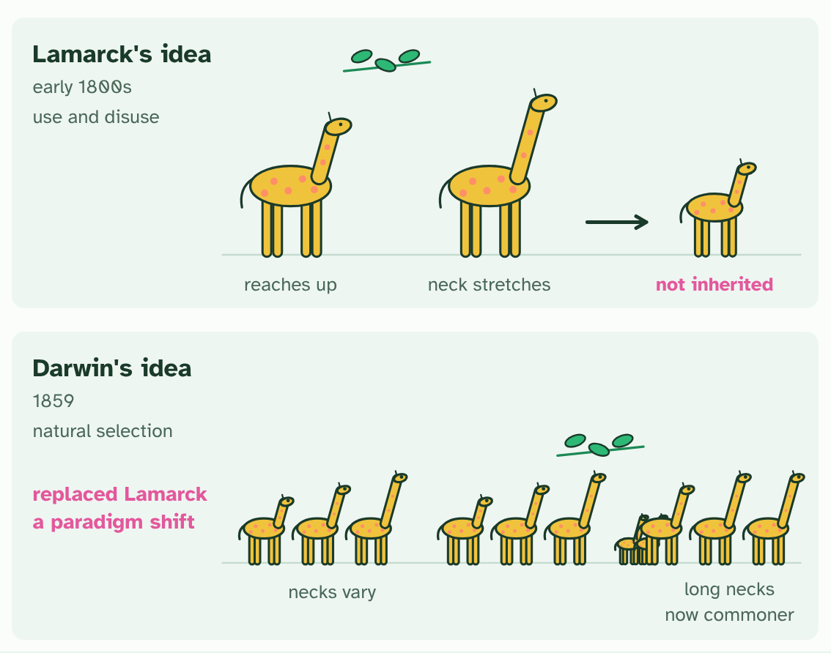  ANNOTATE THE FIGURE  Annotate this still from the animation (Watch it happen: ICE AGE in one population): what is happening, and why?  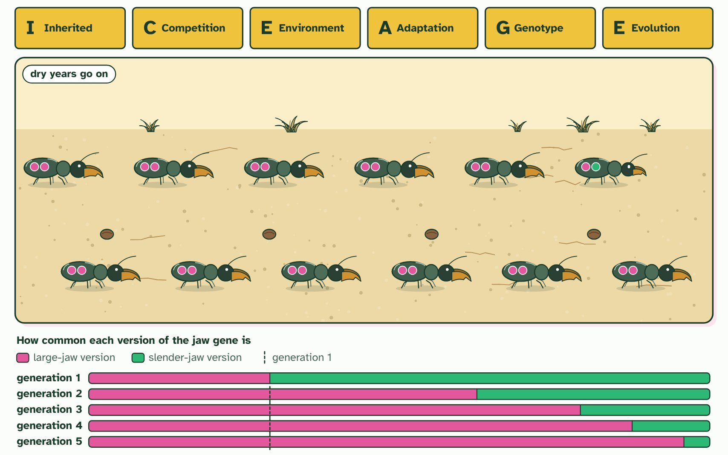  REMEMBER IT  The logic of natural selection: ICE AGE
  I  Icy | C  Cubs | E  Eat | A  Anything | G  Growing | E  Enormous
  I | C | E | A | G | E
  SPOT THE MISTAKE
  What do students often get wrong about natural selection drives evolution? Write the mistake, then put it right.
  The mistake
  Put it right
SUMMARY
Sum up section 01 in two or three sentences of your own.

02 Variation to select from | D4.1.2
CUES  Predict: Where does the very first copy of a new allele come from?  What is meant by mutation? | NOTES  1 ___________ is the only source of brand new alleles.  2 Sexual reproduction makes ______________________ of the alleles that already exist.  3 A gene is a sequence of ________. This version is one allele of the gene.  4 A copying error changes ___________. The changed sequence is a ______________: mutation makes new alleles.  5 In meiosis, __________________ swaps pieces between a pair of chromosomes that carry the alleles A, B and a, b.  6 The gametes carry ________________ that neither chromosome had before: sexual reproduction makes new combinations of alleles.  Your own notes  ANNOTATE THE FIGURE  Number the 4 steps on the figure and note what happens at each: 1 bases; 2 one base, new allele; 3 crossing over; 4 combinations.  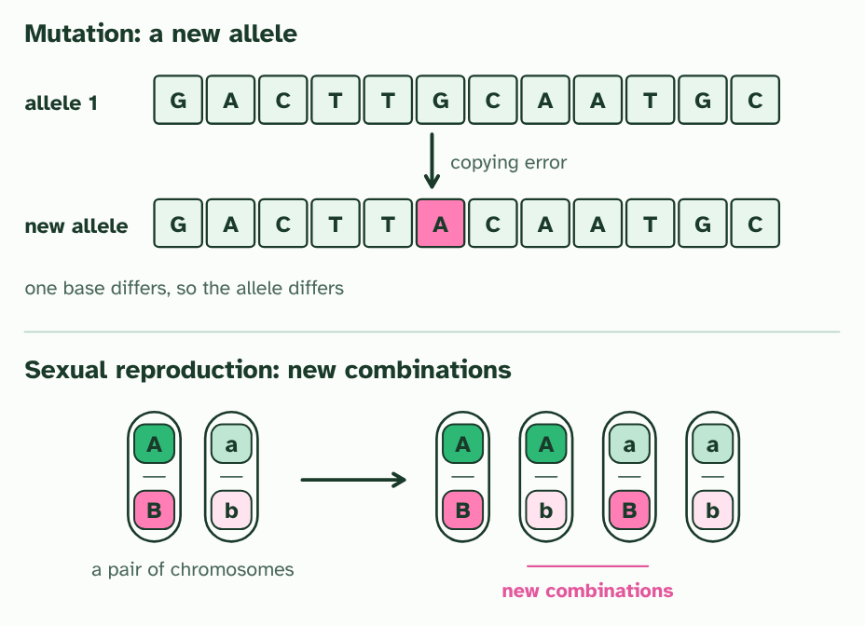
  SPOT THE MISTAKE
  What do students often get wrong about where variation comes from (I in ICE AGE)? Write the mistake, then put it right.
  The mistake
  Put it right
SUMMARY
Sum up section 02 in two or three sentences of your own.

03 More offspring than the world can feed | D4.1.3 D4.1.4
CUES  Predict: A late frost kills 60% of the seedlings in a sparse patch. How will a crowded patch of the same plant fare?  What is meant by carrying capacity?  What is meant by compete?  What is meant by abiotic factor?  What is meant by density-independent?  What is meant by selection pressure? | NOTES  1 The _______________________ is that limit.  2 When there are more young than the resources can supply, they _________.  3 An ___________________ such as a heatwave, a hard frost, a drought or a flood can kill or spare individuals according to their traits.  4 These are __________________________ factors: a frost that kills half of a sparse patch of seedlings kills about half of a crowded patch too.  5 Any factor that makes some individuals more likely to survive and reproduce than others is a ________________________.  Your own notes  ANNOTATE THE FIGURE  Number the 5 steps on the figure and note what happens at each: 1 four places; 2 twelve young; 3 compete; 4 sparse, crowded; 5 density-independent.  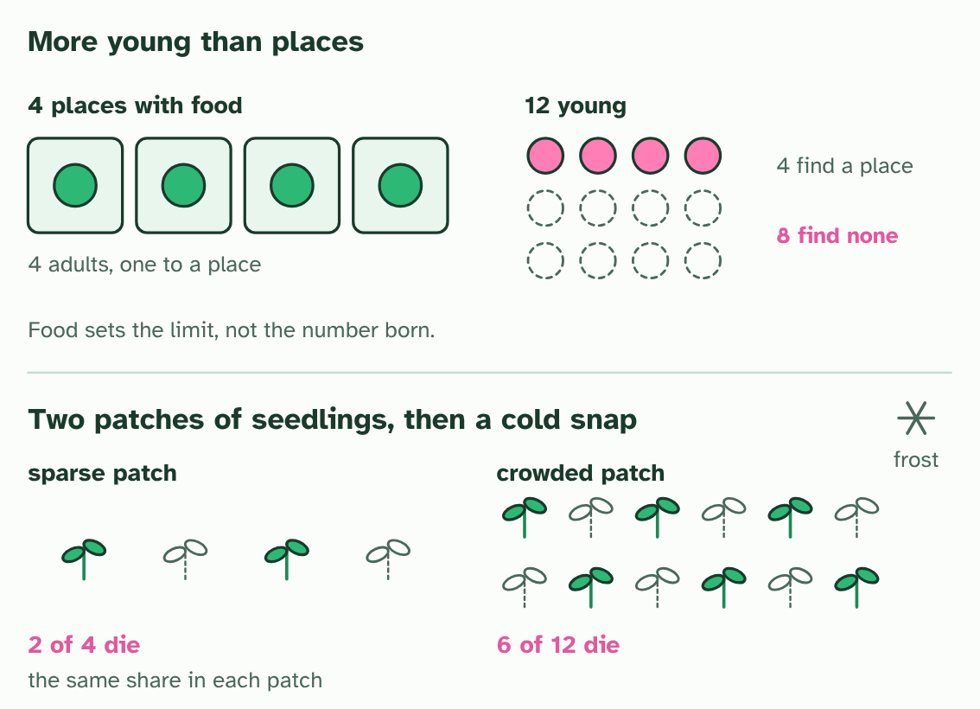
SUMMARY
Sum up section 03 in two or three sentences of your own.

04 Who survives, who breeds | D4.1.5 D4.1.6
CUES  Predict: A cat lives 15 years but raises no surviving kittens. A second cat lives 6 years and raises 8 kittens that all breed. Which has the higher fitness?  What is meant by adaptation?  What is meant by fitness?  What is meant by heritable? | NOTES  1 Each of these helpful differences is an ______________.  2 What selection really measures is _________.  3 Fitness has two parts: the ___________________ of a genotype (how likely it is to live long enough to breed) and its ______________________________ (how many offspring it tends to leave).  4 The trait must be ____________.  Your own notes  ANNOTATE THE FIGURE  Number the 5 steps on the figure and note what happens at each: 1 lived; 2 breeding age; 3 highest fitness; 4 acquired; 5 not heritable.  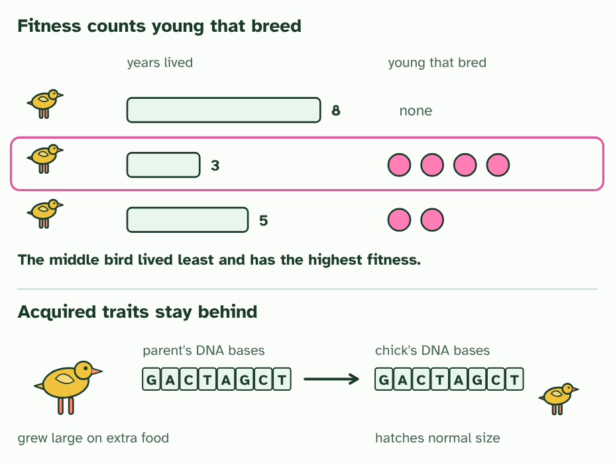  ANNOTATE THE FIGURE  Annotate this still from the animation (Watch it happen: a population changes): what is happening, and why?  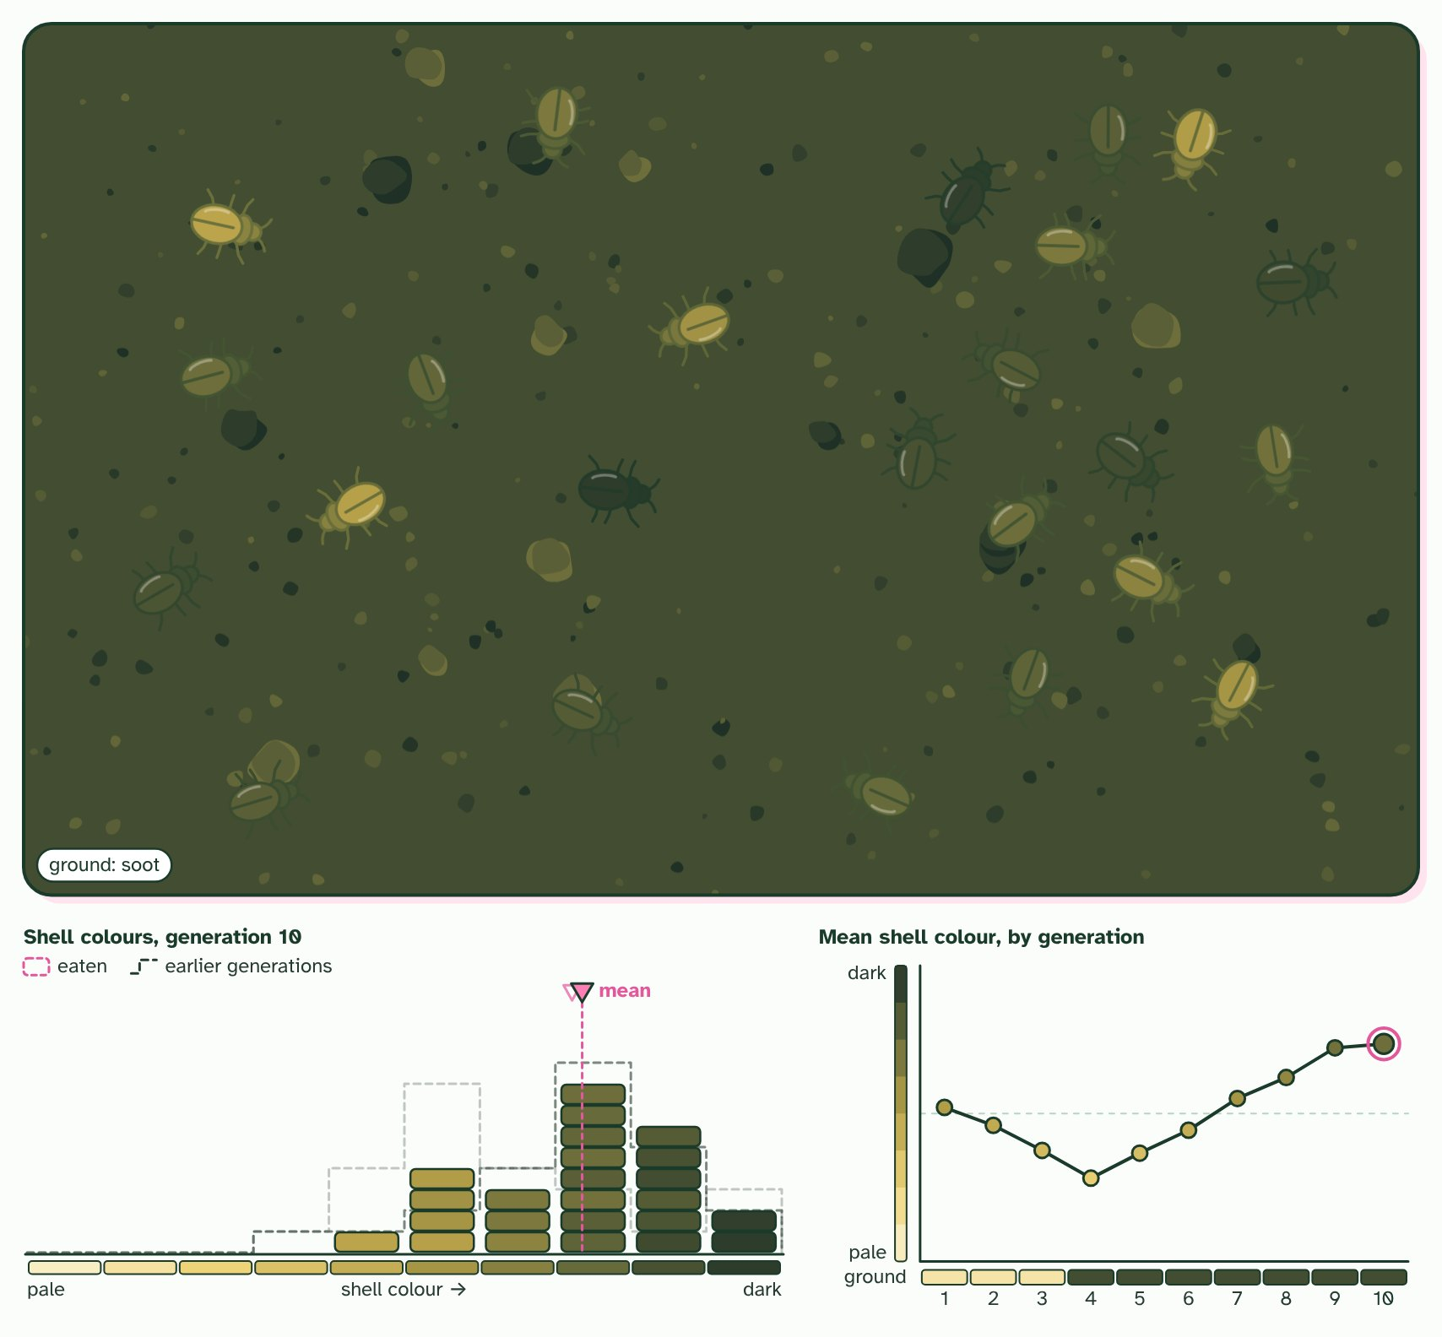  ANNOTATE THE FIGURE  Number the 3 steps on the figure and note what happens at each.  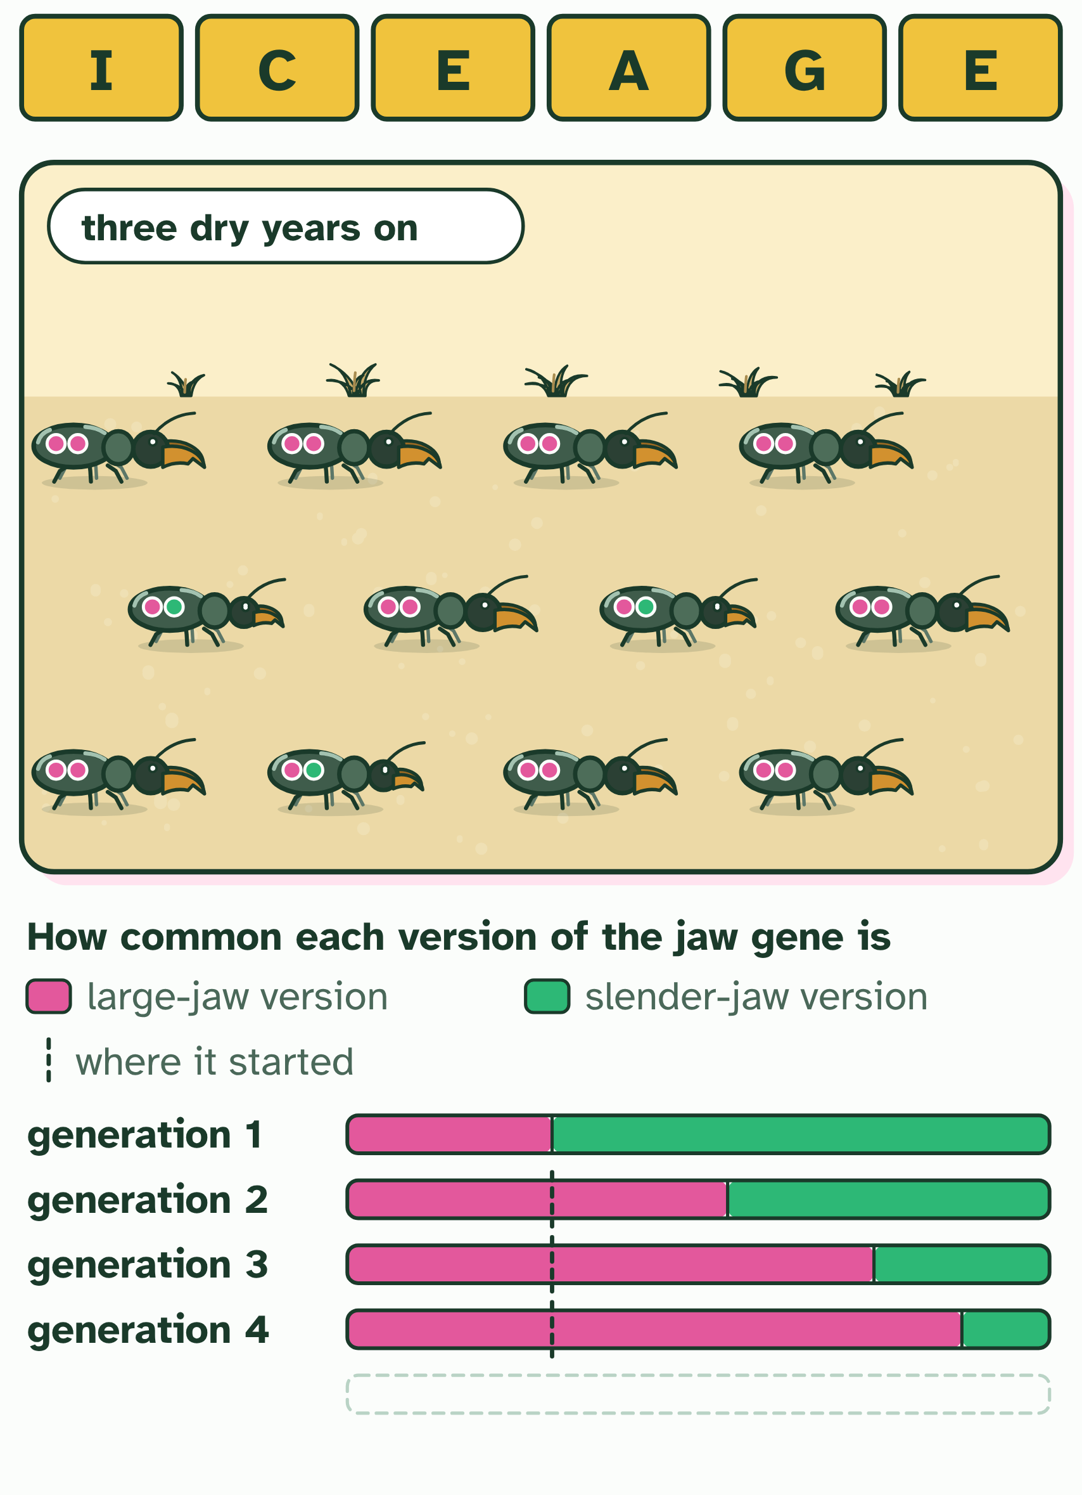
  SPOT THE MISTAKE
  What do students often get wrong about fitness and heredity (A, G and E in ICE AGE)? Write the mistake, then put it right.
  The mistake
  Put it right
SUMMARY
Sum up section 04 in two or three sentences of your own.

05 Choosing a mate | D4.1.7
CUES  Predict: A male's bright tail makes him easier for predators to catch. How can the trait still spread through the population?  What is meant by sexual selection?  What is meant by intrasexual selection?  What is meant by intersexual selection? | NOTES  1 In many animals that is a contest of its own, and the traits that win it can be different from the ones that help you survive. ______________________ is selection for success in getting mates.  2 In ____________________________ members of one sex, usually males, compete with each other for access to mates: stags fight, and males display at one another.  3 In ____________________________ one sex, usually females, chooses among the other.  4 Four males of one species, with ________ of different lengths.  5 A female looks them over, and _________ the longest plume.  6 The male she chooses sires the ______________, and they inherit his alleles for a long plume.  Your own notes  ANNOTATE THE FIGURE  Number the 4 steps on the figure and note what happens at each: 1 plumes; 2 chooses; 3 most young; 4 cost.  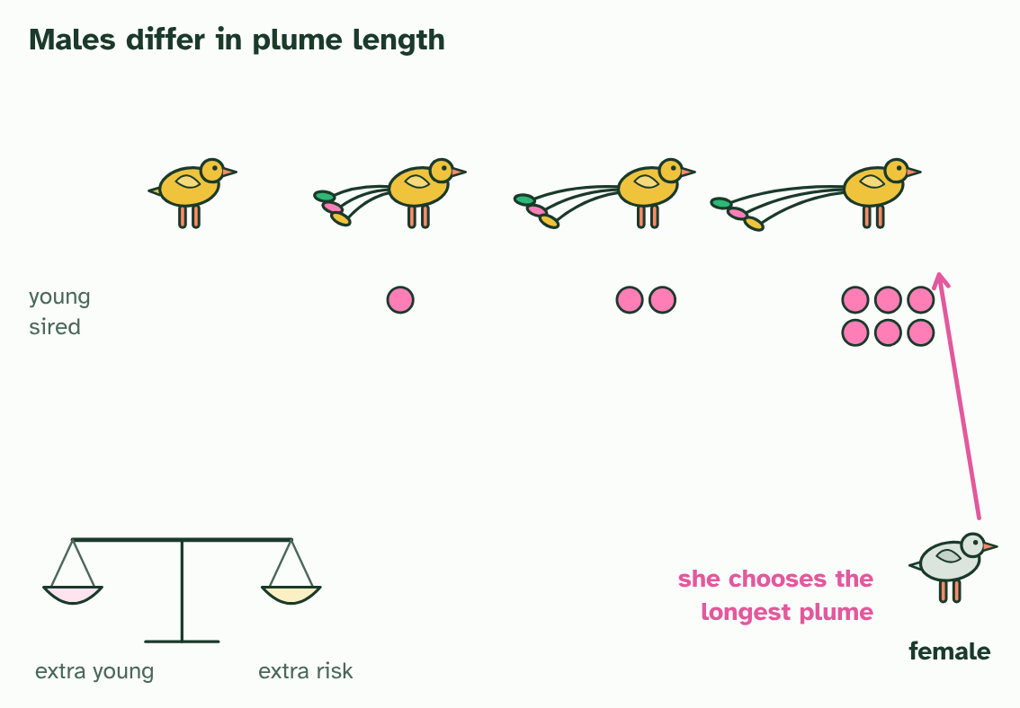
  SPOT THE MISTAKE
  What do students often get wrong about sexual selection? Write the mistake, then put it right.
  The mistake
  Put it right
SUMMARY
Sum up section 05 in two or three sentences of your own.

06 Two pressures, tested | D4.1.8
CUES  Predict: In the pond with the dangerous predator, males end up with fewer spots. What is the best explanation? | NOTES  1 The experiment ________ the streams: it is simpler than nature, so one pressure can be isolated and measured.  2 In the wild, males in streams with ______________________ are duller than males in streams with few.  3 Endler set up _______________ with the same starting guppies: no predator, a weak predator and a dangerous one.  4 He changed ____________, the predator, measured the males' spots, and kept everything else the same.  5 After the generations: more colour with no or a weak predator, _______________ with the dangerous one.  Your own notes  ANNOTATE THE FIGURE  Number the 4 steps on the figure and note what happens at each: 1 fierce predators; 2 three ponds; 3 one thing; 4 less colour.  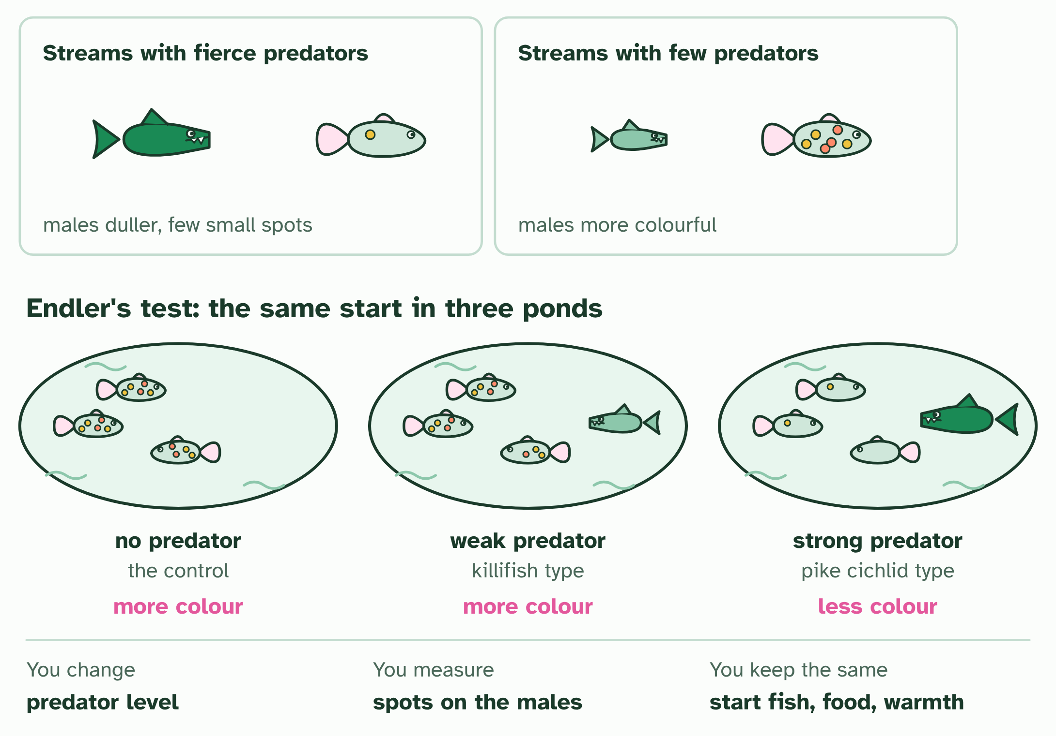
  SPOT THE MISTAKE
  What do students often get wrong about modelling selection: Endler's guppies? Write the mistake, then put it right.
  The mistake
  Put it right
SUMMARY
Sum up section 06 in two or three sentences of your own.

07 The gene pool | D4.1.9 HL D4.1.10 HL
CUES  Predict: A population of 50 diploid individuals has 30 copies of allele B in its gene pool. What is the frequency of B?  What is meant by gene pool?  What is meant by allele frequency? | NOTES  1 A ____________ is all the genes and their different alleles in a population.  2 The useful number to take from a gene pool is an ______________________: how common each allele is.  3 Ten individuals, each carrying _______________ of one gene: allele A in green, allele a in pink.  4 Tip every allele into one jar: the ____________, 20 alleles, 14 of them A and 6 of them a.  5 The ______________________ of A is 14 out of 20, which is 0.7. The frequencies of A and a add to 1.  6 A second population, cut off from the first, has ____________ frequencies: 0.4 and 0.6.  Your own notes  ANNOTATE THE FIGURE  Number the 4 steps on the figure and note what happens at each: 1 two alleles; 2 gene pool; 3 allele frequency; 4 different.  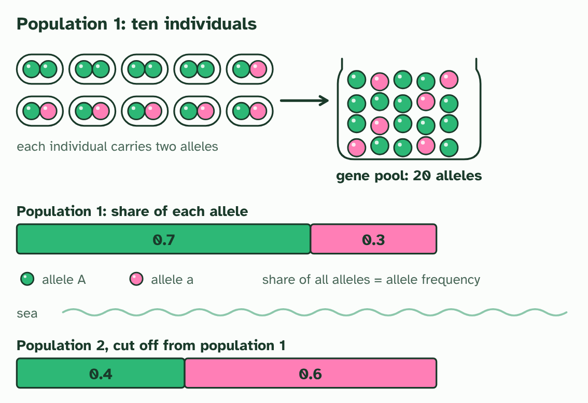
SUMMARY
Sum up section 07 in two or three sentences of your own.

08 Selection shifts allele frequencies | D4.1.11 HL
CUES  Predict: In the beetle example, the J share of the gene pool was 0.5 before the drought and 20 of the 32 alleles of the survivors. What is it among the survivors?  What is meant by neo-Darwinism? | NOTES  1 Biologists joined Darwin's natural selection to genetics in what is now called __________________.  2 Evolution is a __________________________________ over generations.  3 Selection acts on ______________, the traits that individuals show, but evolution is read in _________, in the population.  4 Twenty beetles, each with two alleles of a jaw gene. Across the population, J and j are equally common: _________.  5 A drought leaves only tough seeds. The four ________ beetles cannot feed and do not breed.  6 Count the alleles of the 16 survivors: 20 J and 12 j. The frequency of J is now ________.  Your own notes  ANNOTATE THE FIGURE  Number the 4 steps on the figure and note what happens at each: 1 p = 0.5; 2 jj; 3 0.625; 4 The allele frequency has changed: evolution..  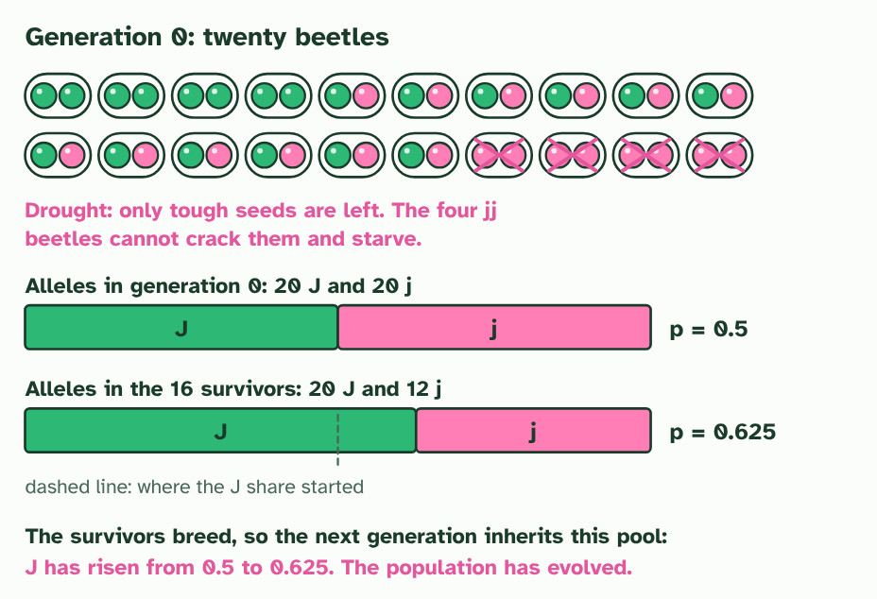  ANNOTATE THE FIGURE  Annotate this still from the animation (Watch it happen: allele frequencies shift): what is happening, and why?  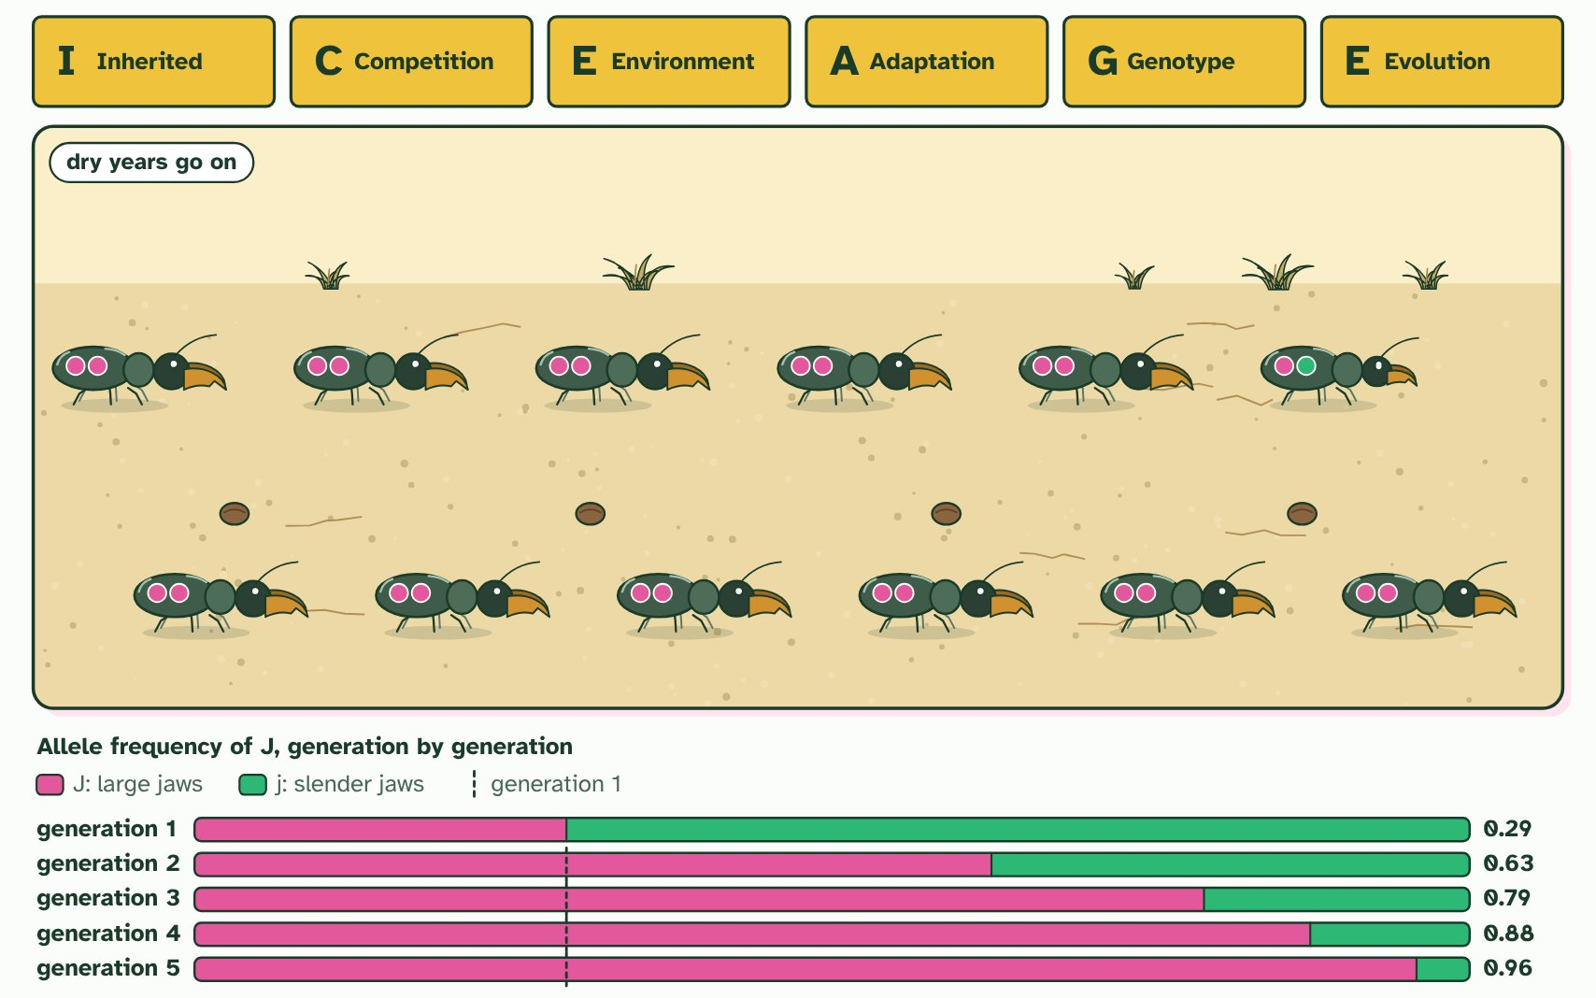
  SPOT THE MISTAKE
  What do students often get wrong about selection changes allele frequencies? Write the mistake, then put it right.
  The mistake
  Put it right
SUMMARY
Sum up section 08 in two or three sentences of your own.

09 Three ways selection can act | D4.1.12 HL
CUES  Predict: Babies of very low and very high birth weight are less likely to survive than babies of average weight. Which kind of selection is this?  What is meant by directional selection?  What is meant by stabilising selection?  What is meant by disruptive selection? | NOTES  1 In ____________________________ one extreme is favoured, so the whole population shifts towards it.  2 In ____________________________ the middle is favoured and both extremes are removed.  3 In ___________________________ both extremes are favoured and the middle is removed.  4 _______________: one tail of the curve is removed, and the whole curve shifts. Alleles for large beaks become commoner.  5 _______________: both tails are removed and the curve narrows. Alleles for the extremes become rarer.  6 ______________: the middle is removed and the curve splits in two. Alleles for both extremes become commoner.  Your own notes  ANNOTATE THE FIGURE  Number the 3 steps on the figure and note what happens at each: 1 Directional; 2 Stabilising; 3 Disruptive.  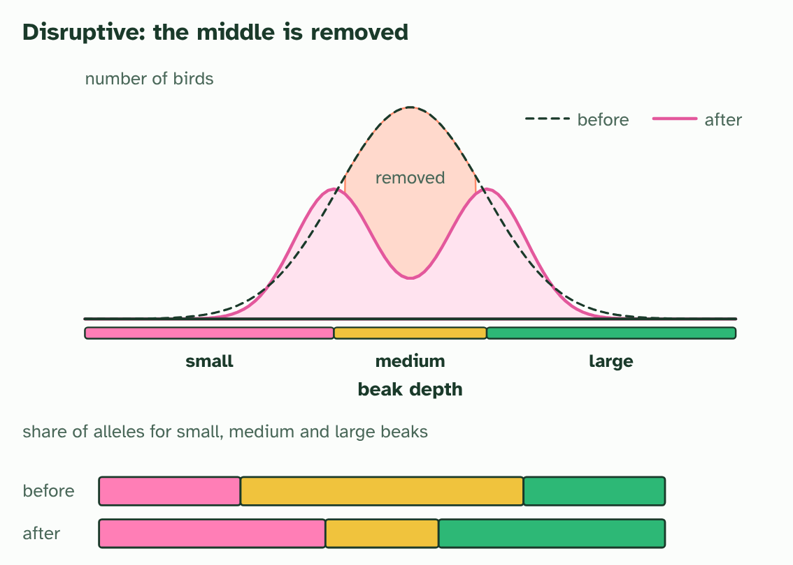  ANNOTATE THE FIGURE  Annotate this still from the animation (Watch it happen: one population, three kinds of selection): what is happening, and why?  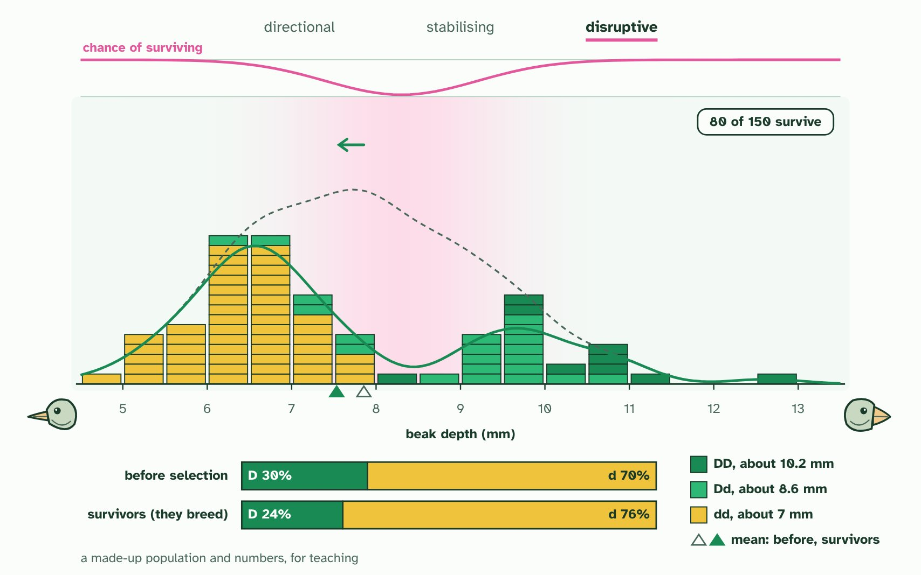  REMEMBER IT  The three kinds of selection
  D  Drive | S  Squeeze | D  Divide
  D | S | D
  SPOT THE MISTAKE
  What do students often get wrong about directional, stabilising and disruptive selection? Write the mistake, then put it right.
  The mistake
  Put it right
SUMMARY
Sum up section 09 in two or three sentences of your own.

10 What a population would be like if it were not evolving | D4.1.13 HL D4.1.14 HL
CUES  Predict: A recessive condition affects 1 person in 2500. Roughly how many people in the population are carriers (heterozygous)?  What is meant by hardy-Weinberg equation? | NOTES  1 The _______________________________ gives it: the genotype frequencies you would expect in a population in genetic equilibrium, where the allele frequencies stay the same from one generation to the next.  2 For a gene with two alleles, let p be the frequency of one (A) and q the frequency of the other (a). They are the only alleles, so ____________.  3 With random mating, any egg can meet any sperm, so the genotype frequencies are the square of that: _______________________, where p² is AA, 2pq is Aa and q² is aa.  4 Egg and sperm alleles meet at random. If the frequency of A is _________ and of a is _________, each edge of the square is split in those proportions.  5 The four areas are the four ways eggs and sperm can combine: ________, ________, ________ and ________.  6 AA is p² = 0.36, Aa is 2pq = 0.48 and aa is q² = 0.16. Together they make ________.  Your own notes  ANNOTATE THE FIGURE  Number the 4 steps on the figure and note what happens at each: 1 p = 0.6, q = 0.4; 2 p², pq, pq, q²; 3 1; 4 q = 0.4, p = 0.6.  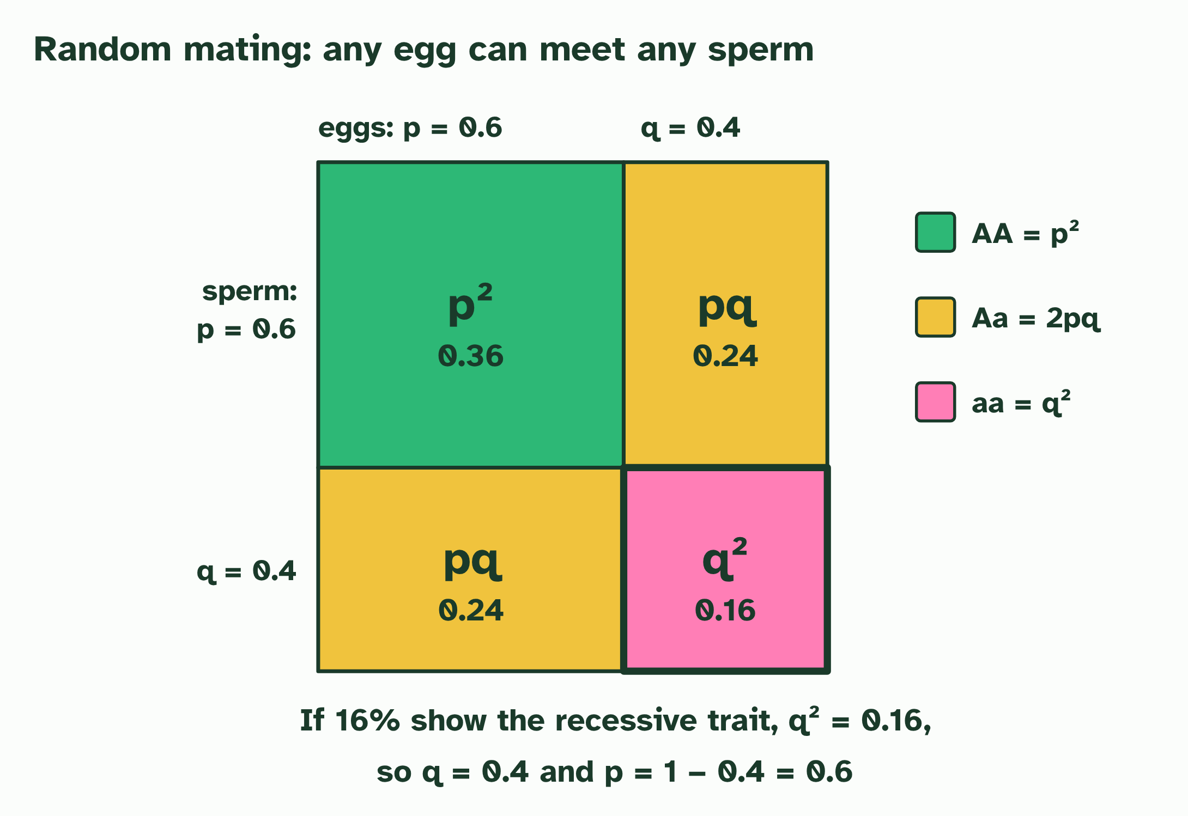  ANNOTATE THE FIGURE  Number the 3 steps on the figure and note what happens at each: 1 p, q; 2 p² + 2pq + q² = 1; 3 carriers.  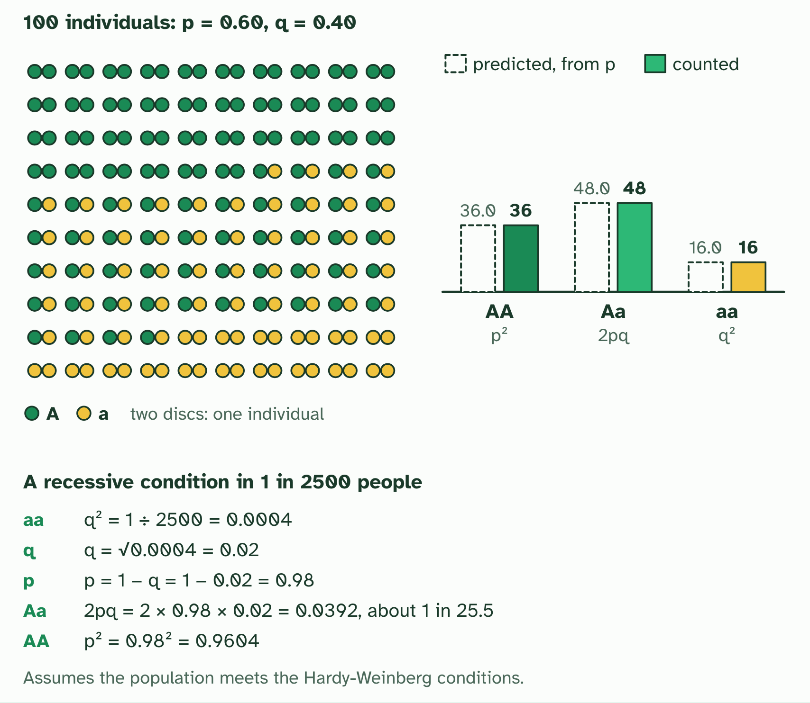  REMEMBER IT  The five Hardy-Weinberg conditions
  L  Large | R  Rats | M  Make | M  Most | S  Spaghetti
  L | R | M | M | S
SUMMARY
Sum up section 10 in two or three sentences of your own.

11 Artificial selection and its side effects | D4.1.15 HL
CUES  Predict: Farmers spray a crop with an insecticide. After some years most of the pests resist it. Which kind of selection has taken place?  What is meant by artificial selection? | NOTES  1 ___________________________ is natural selection with a person choosing the parents.  2 The key word is ______________.  3 The antibiotic acted as a selection pressure on variation that already existed, so this is _______________________, an unintended consequence of a human action, not artificial selection.  4 A crop varies in the size of its cobs. Each plant's size is partly ____________.  5 The breeder picks the _________ and lets only those breed.  6 Repeat for a few generations: the cobs get steadily ________, as the alleles for size become commoner.  Your own notes  ANNOTATE THE FIGURE  Number the 5 steps on the figure and note what happens at each: 1 heritable; 2 largest; 3 bigger; 4 one; 5 Nobody chose it.  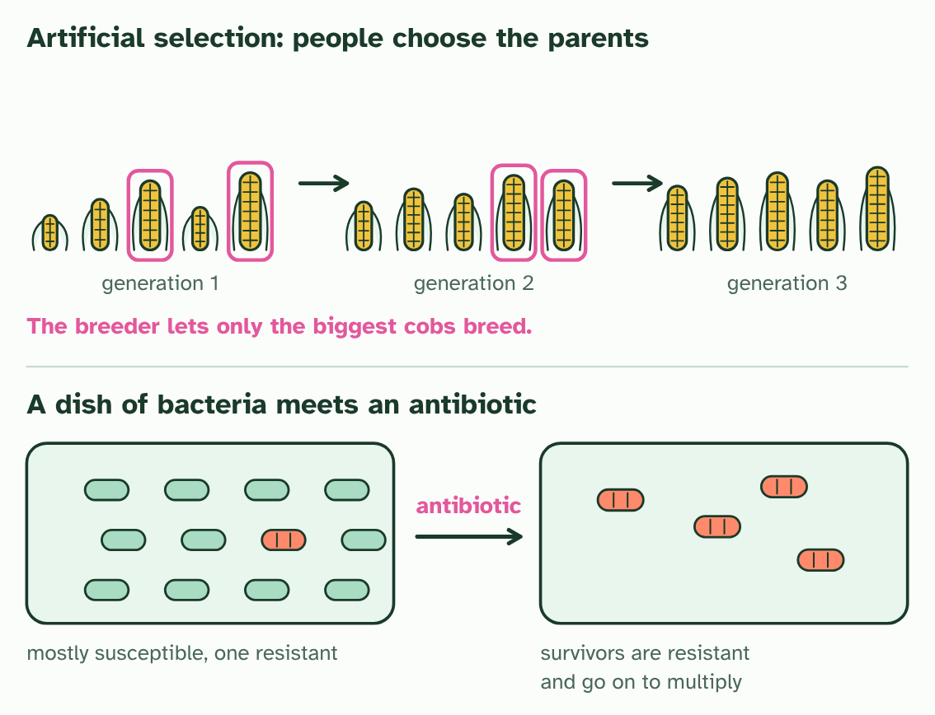
  SPOT THE MISTAKE
  What do students often get wrong about artificial selection? Write the mistake, then put it right.
  The mistake
  Put it right
SUMMARY
Sum up section 11 in two or three sentences of your own.

Check yourself
The check for this guide is online: a fresh paper of past-paper style questions from the exam bank on D4.1 each time, marked as you go, and saved to your Exam practice progress when you are signed in. Open the link:
biologybybradford.com/exam-maker/sit?topics=D4.1&level=HL&paper=quiz&marks=15&src=ep

